Methods

Estimating the number of sessions required for stable individual activation maps using the Midnight Scan Club dataset
To estimate how many sessions are needed to obtain a stable individual activation pattern in a block-design task-fMRI paradigm, we analyzed the language-related blocked verbal discrimination task from the Midnight Scan Club (MSC) dataset ¹, in which participants categorized visually presented words as nouns or verbs across ten separate visits. This dense repeated-measures design allowed us to quantify how closely activation maps estimated from fewer sessions approximated the corresponding 10-session reference maps. The resulting stability estimate provided an empirical benchmark for balancing acquisition time against individual-level activation-map stability, and informed the session number adopted in the CAS block-design dataset.
For each participant and session, we estimated a first-level GLM in CIFTI grayordinate space using Nilearn. The model included a block regressor for the word condition, convolved with the canonical Glover haemodynamic response function, together with third-order polynomial drift terms and six rigid-body motion parameters as nuisance regressors. We computed a word-versus-baseline contrast for each session and converted the resulting t-statistics to Z-statistics, yielding one activation Z map per participant per session.
We then assessed how activation-map stability increased with session count. For each participant, we averaged the Z maps across all ten sessions and thresholded the resulting map at a vertex-wise one-sided threshold of P < 0.005 (Z > 2.56) to define the 10-session reference set, B_10. For each k = 1, 2, 3…, 9, we averaged the Z maps from the first k sessions, applied the same threshold and defined the corresponding k-session activation set, B_k. Spatial overlap between B_k and B_10 was quantified using the Dice coefficient:
$$Dice(B_{k},B_{10})=\frac{2∣B_{k}∩B_{10}∣}{∣B_{k}∣+∣B_{10}∣}$$
This produced, for each participant, a Dice-by-session curve indicating how closely activation maps estimated from fewer sessions approximated the 10-session reference map.
The minimum session count was selected using an elbow/plateau criterion. For each participant, we identified the smallest k after which adding further sessions produced only minimal gains in Dice overlap with the 10-session reference map. This value was treated as the participant-specific session count required to obtain a stable individual activation pattern while limiting acquisition burden.

Individual-specific brain parcellation based on gMS-HBM
To derive participant-specific functional parcels, we applied the gradient-informed multi-session hierarchical Bayesian model (gMS-HBM Kong et al., 2021) to each participant’s 15-min resting-state scan from the CAS dataset. This approach estimates individualized cortical parcels while preserving correspondence with a group-level parcellation.
For each participant, resting-state time series were represented on the fs_LR 32k cortical surface. Functional connectivity features were computed for each cortical vertex as Pearson correlations between its time series and those of 1,483 uniformly distributed reference vertices across the cortex, yielding a vertex-by-reference connectivity matrix. To emphasize the strongest functional relationships, we retained the top 10% of correlations for each vertex and binarized the remaining connectivity profile.
Individualized parcellation was initialized from a Schaefer-900 group-level prior pretrained on 40 HCP participants. Subject-specific parcels were then estimated using gMS-HBM with parameters w = 30, c = 30 and β = 50, following ². The resulting parcellations comprised 900 cortical parcels per participant and were used for subsequent parcel-level analyses in the CAS dataset.

Regions of interest definition for dynamic causal modelling analyses
Dynamic causal modelling (DCM) analyses used an eight-node word-processing network spanning input-related regions (auditory and visual cortex), lexical and language-related regions (area 55b, SFL, IFJ, and anterior fusiform gyrus), and output-related motor regions supporting spoken naming and writing (ventral laryngeal–orofacial and dorsal hand motor cortex).
To ensure cross-participant correspondence while preserving individual functional anatomy, all regions of interest (ROIs) were defined on each participant’s individualized Schaefer–Kong 900-parcel parcellation. For each target region, we selected the corresponding atlas parcel IDs and grouped them into the eight ROIs used as nodes in the DCM analysis: IFJ, parcels 125 and 127; SFL, parcels 97 and 273; area 55b, parcels 100, 290 and 363; auditory cortex, parcels 106, 306, 307 and 308; visual cortex, parcels 387, 388, 389, 390, 392, 393, 399 and 440–445; anterior fusiform gyrus, parcels 25 and 400; ventral laryngeal–orofacial motor cortex, parcels 366 and 367; and dorsal hand motor cortex, parcels 323, 326 and 329. For each participant, parcel-defined ROIs were mapped to the corresponding first-level SPM volume space. Within each ROI, volumes of interest (VOIs) were constrained to task-responsive voxels. Specifically, voxels were retained if they responded to both the word condition and its matched control condition for the corresponding task, using an initial uncorrected threshold of P < 0.05. For example, listening VOIs were constrained to voxels responsive to both auditory words and auditory controls, whereas reading VOIs were constrained to voxels responsive to both written words and visual controls. Analogous task-specific criteria were applied to naming and writing. This procedure ensured that DCM time series were extracted from task-engaged voxels within each individualized ROI, rather than from voxels selected solely on the basis of lexical selectivity.
If no voxel survived the initial threshold within a given ROI, the inclusion threshold was progressively relaxed in increments of 0.05 until at least one voxel was retained, following standard recommendations for DCM VOI extraction. For each VOI, the first principal component of the adjusted BOLD signal across retained voxels was extracted and used as the regional time series.
DCM model specification and interpretive scope
Model-estimated directed coupling was analyzed using DCM in SPM12. For each participant and task, we estimated one eight-node model. Because the hypothesis concerned task-dependent coupling on area 55b-centred edges, we specified a sparse 55b-centred architecture rather than a fully connected network. This constraint reduced unnecessary parameters for direct non-55b connections but also limits inference to the specified architecture: the estimates should not be interpreted as proof that 55b is the unique causal source of network-wide interactions. Hidden neuronal activity x was modelled using a bilinear state equation:
$$dx/dt = (A + ∑j ujB(j))x + Cu.$$
In this equation, A denotes endogenous connectivity among regions, $B_{(j)}$ denotes modulation of connectivity by the $j-th$ experimental input, and C denotes the direct driving effects of experimental inputs on regional activity. We specified the endogenous A matrix as a sparse 55b-star architecture. Diagonal self-connections were retained for all eight regions. In addition, bidirectional connections were enabled only between area 55b and each of the seven other nodes. Thus, the model estimated directed influences from each non-55b node to area 55b and from area 55b to each non-55b node, but did not estimate direct connections among non-55b regions.
The bilinear $B$ matrix was used to test lexical modulation of area 55b-centred connections. For each task, the lexical-processing contrast between the word condition and its matched control condition was specified as a modulatory input on the bidirectional area 55b-centred connections. Therefore, the parameters of interest were the Task-minus-Control modulatory effects on directed connections between area 55b and each sensory, lexical-related or motor-effector node. Positive B-matrix parameters indicated increased effective coupling during lexical processing relative to the matched control condition, whereas negative parameters indicated decreased coupling.
Task-specific sensory driving inputs were specified in the C matrix. For listening, the event input entered auditory cortex. For reading and writing, the event input entered visual cortex. For naming, the event input entered auditory and visual cortices when both auditory and visual inputs were present. The Task-minus-Control regressor was treated as a modulatory input and was not specified as a direct driving input. Nonlinear D-matrix effects were not modelled.
Each participant- and task-specific DCM was inverted using Bayesian model inversion in SPM12. Because all participants and tasks shared the same sparse 55b-centred architecture, the estimated parameters were directly comparable across task states. DCMs were then entered into a parametric empirical Bayes framework to estimate group-level effects and empirical-prior-updated subject-level parameters ^{3,4}. This hierarchical procedure increased the precision of subject-level estimates while preserving individual variability in effective connectivity.
After PEB estimation, we extracted the posterior expectations of the Task-minus-Control modulatory parameters from the B matrix for each participant, task and directed 55b-centred edge. These parameters quantified how lexical processing changed the effective influence between area 55b and each sensory, lexical-related or motor-effector node.
To test whether production induced stronger area 55b-centred modulation than comprehension, we first averaged task-specific modulatory estimates within production tasks and comprehension tasks. Production was defined as the average of naming and writing, and comprehension was defined as the average of listening and reading. We then computed the production–comprehension contrast:
$$(naming + writing)/2 - (listening + reading)/2.$$
This contrast identified directed 55b-centred edges whose model-estimated lexical modulation differed between production and comprehension. Edge-wise group statistics were performed on the PEB-refined parameters, with false discovery rate correction across the tested directed edges. The results quantify task-dependent coupling within the hypothesis-constrained model rather than direct neuronal information flow.

Parcel-triplet sampling for regional embedding along the sensory-to-association axis
This analysis included the four conjunction-defined regions (SFL, area 55b, anterior fusiform gyrus, and IFJ) and three canonical language-network comparison regions (inferior frontal gyrus, triangular part; mid–middle temporal gyrus; and posterior middle temporal gyrus). For each target, the same local parcel-triplet scheme was applied using the Schaefer–Kong 900-parcel parcellation ². Each triplet comprised the central target parcel and two contiguous neighboring parcels positioned toward unimodal or early sensory/sensorimotor cortex and higher-order association cortex. The triplets therefore test regional embedding around each target; they do not measure vertexwise alignment between a hierarchy map and the internal connectivity gradient of the target parcel.
For the conjunction-defined regions, the central parcels were 273 for SFL, 363 for area 55b, 400 for fusiform gyrus and 90 for IFJ. Their paired neighboring parcels were 97/272, 100/362, 25/397 and 92/211, respectively. Within each triplet, sensory- and association-adjacent parcels were assigned according to their relative anatomical position within the local cortical territory, rather than by applying a fixed anterior–posterior, dorsal–ventral or medial–lateral rule across all regions.
The same procedure was applied to the three canonical language-network comparison regions. The corresponding triplets were 212/127/126 for inferior frontal gyrus, triangular part; 314/102/59 for mid–middle temporal gyrus; and 23/21/157 for posterior middle temporal gyrus. This anatomically local sampling scheme enabled comparison of ordered sensory-to-association transitions around area 55b and the other regions while preserving continuity within each regional neighborhood.

Results

Three sessions provide a stable estimate of individual activation patterns
Across MSC participants, the similarity between lower-session activation maps and the corresponding 10-session reference map increased rapidly as additional sessions were included (Supplementary Fig. 2). The mean dice coefficient reached approximately 0.932 after three sessions, indicating that a three-session estimate already closely approximated the 10-session activation pattern. Beyond three sessions, the stability curve showed a marked plateau, with only modest additional gains across subsequent session counts.
These results suggest that, for this block-design word task, three sessions provide a practical balance between acquisition time and individual-level activation-map stability. Guided by this empirical benchmark, we adopted a three-session design for the CAS multimodal word-processing dataset and collected complete three-session datasets from 30 participants.

Independent validation of the multimodal lexical candidate network
We assessed the four regions identified in the primary dataset in an independent Peking University sample. The validation tested whether each region was recruited during comprehension and production relative to its control baseline, with Bonferroni correction across regions. This analysis evaluated reproducibility of the candidate network rather than cortical exclusivity.
The validation analysis broadly replicated the activation profile observed in the primary dataset (Supplementary Fig. 4). Three of the four candidate regions—area 55b, IFJ and anterior fusiform gyrus—showed significant activation during both comprehension and production. Specifically, area 55b was activated during comprehension (t(96) = 3.227, P = 0.007, Cohen’s d = 0.328) and production (t(95) = 3.075, P = 0.011, Cohen’s d = 0.314); IFJ was activated during comprehension (t(93) = 8.146, P < 0.001, Cohen’s d = 0.840) and production (t(95) = 12.503, P < 0.001, Cohen’s d = 1.276); and anterior fusiform gyrus was activated during comprehension (t(95) = 2.704, P = 0.032, Cohen’s d = 0.276) and production (t(94) = 14.683, P < 0.001, Cohen’s d = 1.506). SFL showed significant activation during comprehension (t(96) = 4.467, P < 0.001, Cohen’s d = 0.454), but its production activation did not reach significance in this cohort (t(96) = 1.050, P = 1.000, Cohen’s d = 0.107). Together, these results provide independent support for the recruitment of the candidate lexical network during multimodal word processing, while indicating that production-related activation in SFL was weaker in the validation dataset.

Validation of production-biased activation in the Peking University dataset
We next examined whether the production-biased activation profile observed in the primary dataset was replicated in the independent Peking University dataset. Consistent with the primary analysis, direct production–comprehension contrasts showed significant production bias in area 55b (t(96) = 12.475, P < 0.001, Cohen’s d = 1.267) and SFL (t(96) = 5.781, P < 0.001, Cohen’s d = 0.587), whereas IFJ showed no significant production–comprehension difference (t(95) = −0.691, P = 1.000, Cohen’s d = −0.070) (Supplementary Fig. 4). In this validation dataset, anterior fusiform gyrus also showed stronger activation during production than comprehension (t(93) = 5.109, P < 0.001, Cohen’s d = 0.527) (Supplementary Fig. 4). All P values were Bonferroni-corrected across the four candidate regions.

Orthographic form does not explain task-domain decoding, but picture–word format remains a limitation
Using the cross-modal classification framework, we tested whether candidate regions distinguished tasks with written word forms (reading and writing) from tasks without written word forms (listening and naming). No region showed reliable above-chance classification after Bonferroni correction: area 55b, mean accuracy = 0.49, SD = 0.10, t(29) = −0.64, P = 1.000, Cohen’s d = −0.12; IFJ, mean = 0.54, SD = 0.10, t(29) = 2.30, P = 0.117, Cohen’s d = 0.42; SFL, mean = 0.49, SD = 0.10, t(29) = −0.48, P = 1.000, Cohen’s d = −0.09; anterior fusiform gyrus, mean = 0.52, SD = 0.09, t(29) = 1.18, P = 0.984, Cohen’s d = 0.22. The task-domain dissociation in area 55b and SFL therefore cannot be explained by simple orthographic grouping. However, both production tasks were picture-cued whereas comprehension used spoken or written words, so the analysis does not eliminate all stimulus-format differences.

Semantic-category decoding in IFJ and anterior fusiform gyrus
For completeness, we examined semantic-category decoding in IFJ and anterior fusiform gyrus (Supplementary Fig. 6a), the two regions that did not show the full task-domain differentiation observed in area 55b and SFL. IFJ showed above-chance category decoding during production (mean accuracy = 0.55, SD = 0.08, FDR-q = 0.006) and comprehension (mean = 0.56, SD = 0.09, FDR-q = 0.006), but no difference between domains (t(29) = 0.16, FDR-q = 0.87, Cohen’s d = 0.03). Anterior fusiform gyrus showed no reliable above-chance decoding during production (mean = 0.54, SD = 0.11, FDR-q = 0.06) or comprehension (mean = 0.52, SD = 0.09, FDR-q = 0.11), and no task-domain difference (t(29) = −0.62, FDR-q = 0.87). Thus, neither region showed production-selective enhancement of semantic-category information.

An SFL gradient does not reproduce the representational dissociation observed in area 55b
To test whether anterior–posterior organization was specific to area 55b or reflected a broader feature of superior frontal cortex, we applied the same local-gradient analysis to SFL. The first gradient separated SFL into anterior high-gradient and posterior low-gradient sectors (Supplementary Fig. 6b). Among the templates tested, anterior SFL aligned most strongly with the language network (Dice = 0.44), whereas posterior SFL aligned most strongly with SCAN (Dice = 0.67). Thus, a language-to-action shift in network alignment was not unique to area 55b; the critical specificity test was whether the gradient was also accompanied by the same representational differentiation.
Despite this clear anterior–posterior organization, SFL did not show the representational dissociation observed in area 55b. The anterior SFL subregion retained sensorimotor-related task sensitivity, exhibiting a modest but significant univariate production bias (Meanβ_production–comprehension = 0.24, t(29) = 2.90, FDR-q = 0.014; Supplementary Fig. 6c). However, its multivariate activity patterns did not distinguish comprehension from production above chance (chance = 0.50; mean accuracy = 0.53, SD = 0.11; t(29) = 1.47, FDR-q = 0.151). The posterior subregion showed a stronger production-dominant profile, with a robust univariate production–comprehension difference (Meanβ_production–comprehension = 0.80; t(29) = 7.41, FDR-q < 0.001) and significant comprehension–production decoding from multi-vertex activity patterns (chance = 0.50; mean accuracy = 0.61, SD = 0.15; t(29) = 3.92, FDR-q = 0.002).
The SFL sectors did not differ in representational content. Semantic-category decoding was comparable (anterior mean = 0.51, SD = 0.04; posterior mean = 0.49, SD = 0.05; t(29) = −1.34, FDR-q = 0.255; Supplementary Fig. 6c), as was articulatory-feature encoding (posterior mean = 0.68, SD = 0.23; anterior mean = 0.61, SD = 0.42; t(29) = −0.76, FDR-q = 0.300). SFL therefore showed an anterior–posterior connectivity gradient and differences in production bias without the crossed semantic-category versus articulatory-feature dissociation observed in area 55b. This comparison indicates that the representational consequences of the 55b gradient are not an inevitable property of every language-to-SCAN transition.

Experimental design and timing of the multimodal word-processing tasks
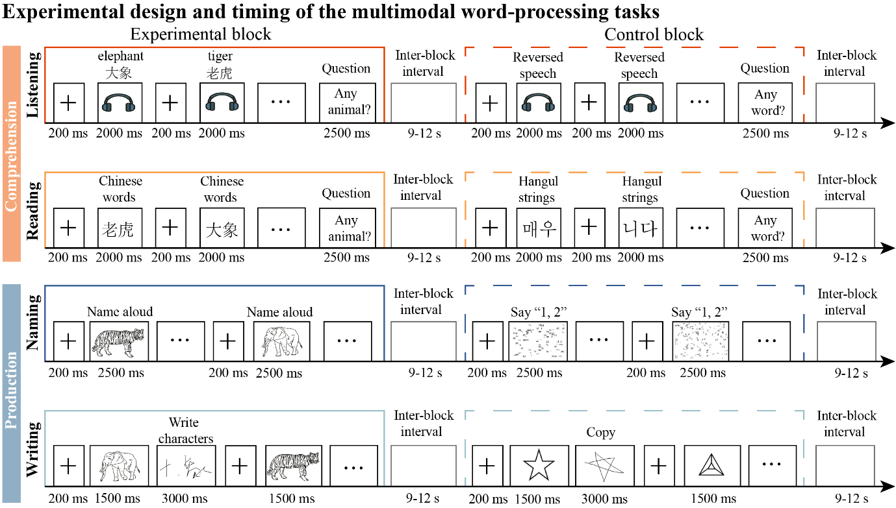
Fig. S1 | Experimental design and timing of the multimodal word-processing tasks. Block-design schematic for the four word-level language tasks, comprising two comprehension tasks (listening and reading) and two production tasks (naming and writing). Each task contrasted lexical experimental blocks with its modality-matched control blocks designed to preserve basic sensory or motor demands while minimizing lexical-semantic content. In the comprehension tasks, participants either listened to spoken Chinese words versus reversed speech or read Chinese words versus Hangul strings. In the production tasks, participants either named object pictures aloud versus produced a fixed number (1,2) to scrambled pictures, or wrote picture names versus copied non-linguistic line drawings. Each block began with a 200-ms fixation cross. Stimulus durations were 2,000 ms for listening and reading, 2,500 ms for naming, and 1,500 ms for writing, followed by the task-specific response period. Listening and reading blocks ended with a 2,500-ms probe question. Blocks were separated by fixation intervals of 9–12 s (mean, 11 s).
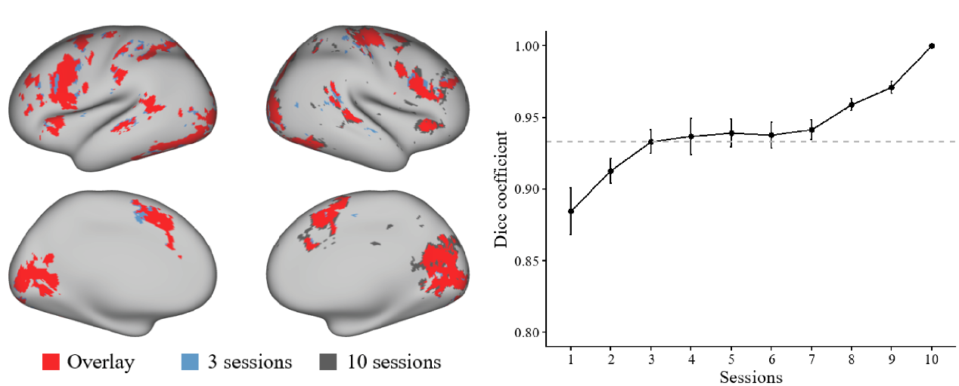
Fig. S2 | Three sessions provide a stable approximation of the 10-session activation map in the MSC dataset. Left, cortical surface visualization of the group-averaged activation pattern derived from the first three sessions and the corresponding 10-session reference map. Blue regions indicate activation detected using the first three sessions, dark grey regions indicate activation detected using all ten sessions, and red regions indicate their spatial overlap. Right, dice similarity between activation maps estimated from increasing numbers of sessions and the corresponding 10-session reference map, averaged across MSC participants. The dashed grey line marks the mean dice coefficient achieved after three sessions (Dice = 0.932). Similarity increased rapidly from one to three sessions and showed only modest additional gains thereafter. Error bars indicate the standard error of the mean.
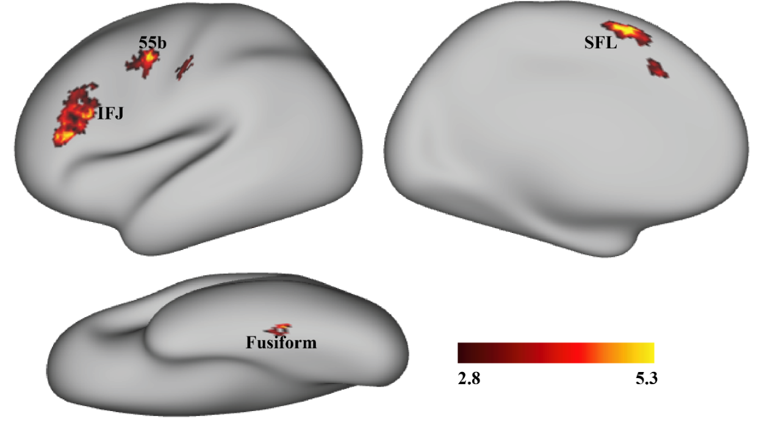
Fig. S3 Vertex-wise replication of the modality-invariant lexical network. Vertex-wise conjunction map across listening, reading, naming and writing contrasts, each compared with its modality-matched control condition. The analysis identified four consistent lexical clusters: area 55b, superior frontal language area (SFL), inferior frontal junction (IFJ) and anterior fusiform gyrus. This replicated the parcel-based conjunction result in the main text, showing that the identification of the modality-invariant lexical network was not dependent on parcel granularity. The colour scale indicates t-statistic values.
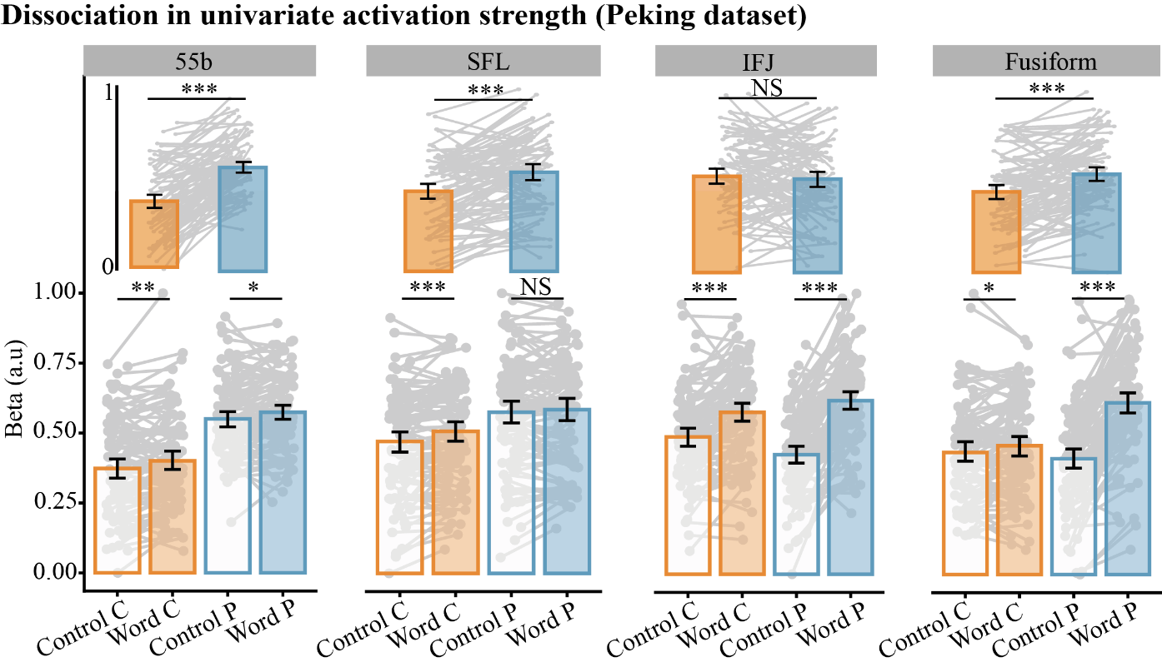
Fig. S4 | Validation of production-biased activation in the Peking University dataset. Univariate activation strength is shown for the four candidate lexical regions in the independent Peking University dataset: area 55b, superior frontal language area (SFL), inferior frontal junction (IFJ) and anterior fusiform gyrus. Lower bars show mean activation magnitude for control and word conditions in comprehension (C, orange) and production (P, blue) domains; upper bars show the direct production–versus–comprehension contrast for word tasks. Consistent with the primary dataset, area 55b and SFL showed stronger activation during production than comprehension, whereas IFJ showed no significant production–comprehension difference. In this validation dataset, anterior fusiform gyrus also showed a significant production bias. Error bars denote s.e.m.; grey lines indicate individual participants. Asterisks indicate Bonferroni-corrected significance (*P < 0.05, **P < 0.01, ***P < 0.001); NS, not significant.
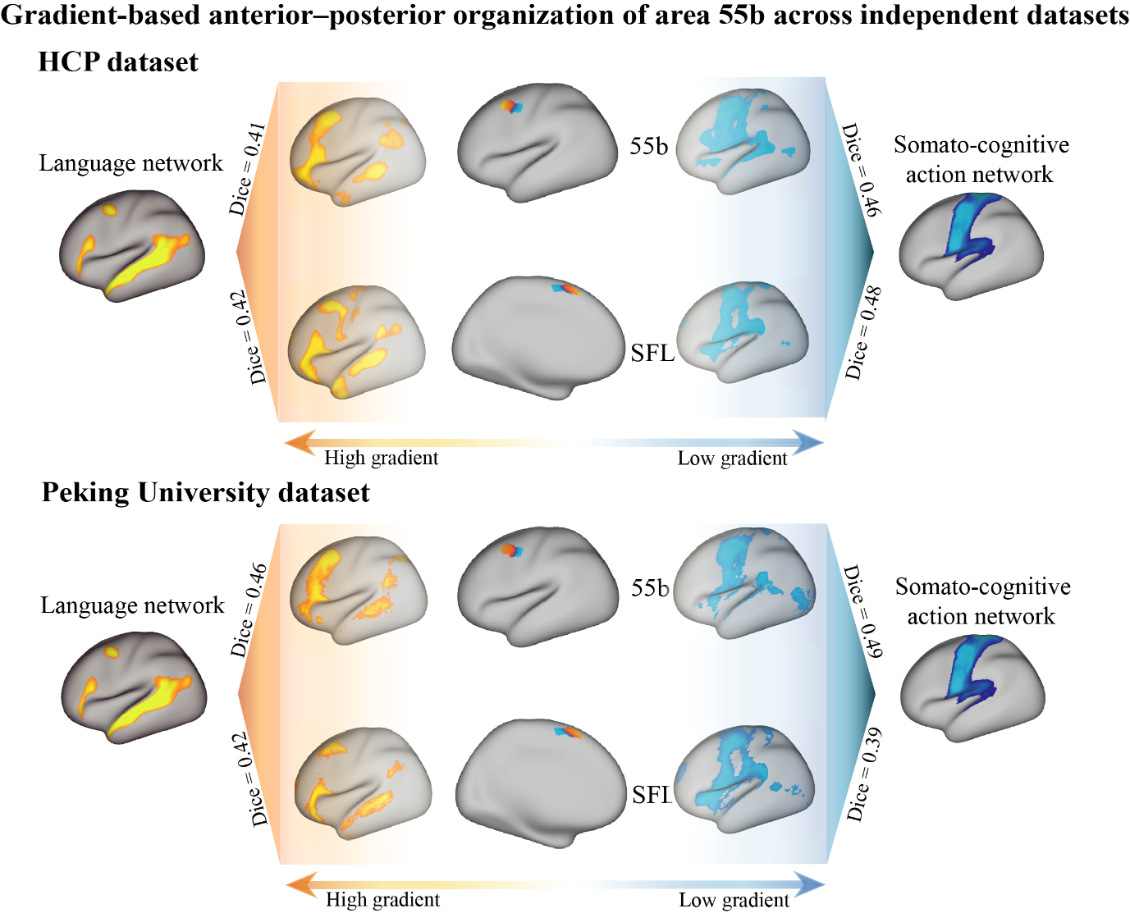
Fig. S5 | Reproducibility of anterior–posterior connectivity gradients in area 55b and SFL. In the Human Connectome Project and Peking University datasets, the dominant local gradient separated each region into anterior high-gradient and posterior low-gradient sectors. Network-template profiling reproduced the same preferential alignment: anterior sectors matched the language network more strongly, whereas posterior sectors matched SCAN more strongly. Dice coefficients quantify spatial overlap with the tested canonical templates and are interpreted as preferential alignment rather than categorical network membership.

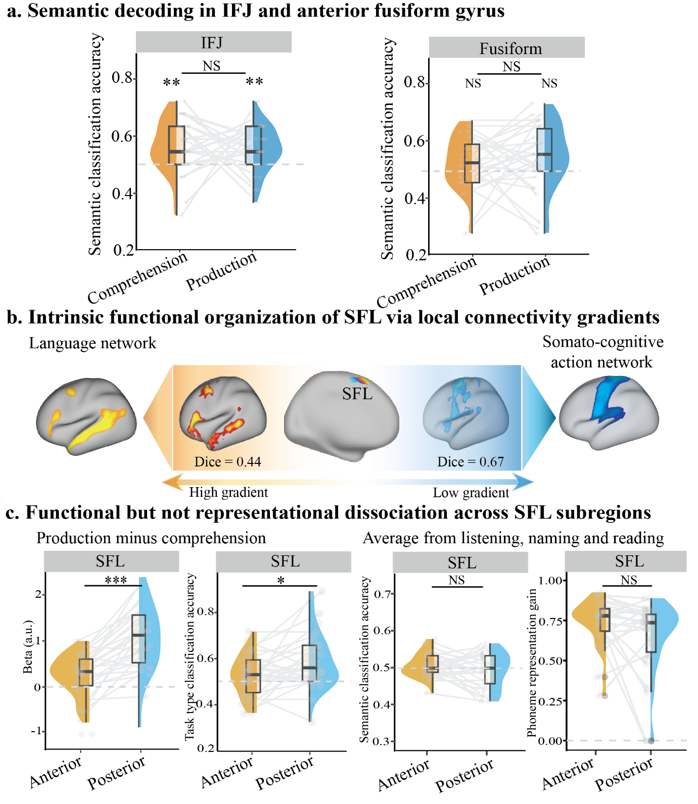
Fig. S6 | Semantic-category decoding in IFJ and anterior fusiform gyrus, and local-gradient organization of SFL. a, IFJ showed above-chance category decoding in both task domains but no production-specific enhancement; anterior fusiform gyrus showed neither reliable decoding nor a task-domain difference. b, The dominant SFL connectivity gradient separated anterior and posterior sectors preferentially aligned with the language network and SCAN, respectively. c, SFL sectors differed in production bias and comprehension–production classification, but not in semantic-category decoding or articulatory-feature encoding. Dashed lines indicate chance or zero, as appropriate. Box plots show medians and interquartile ranges; grey lines connect participants. Significance levels are FDR-corrected: ***P < 0.001, **P < 0.01, *P < 0.05; NS, not significant.

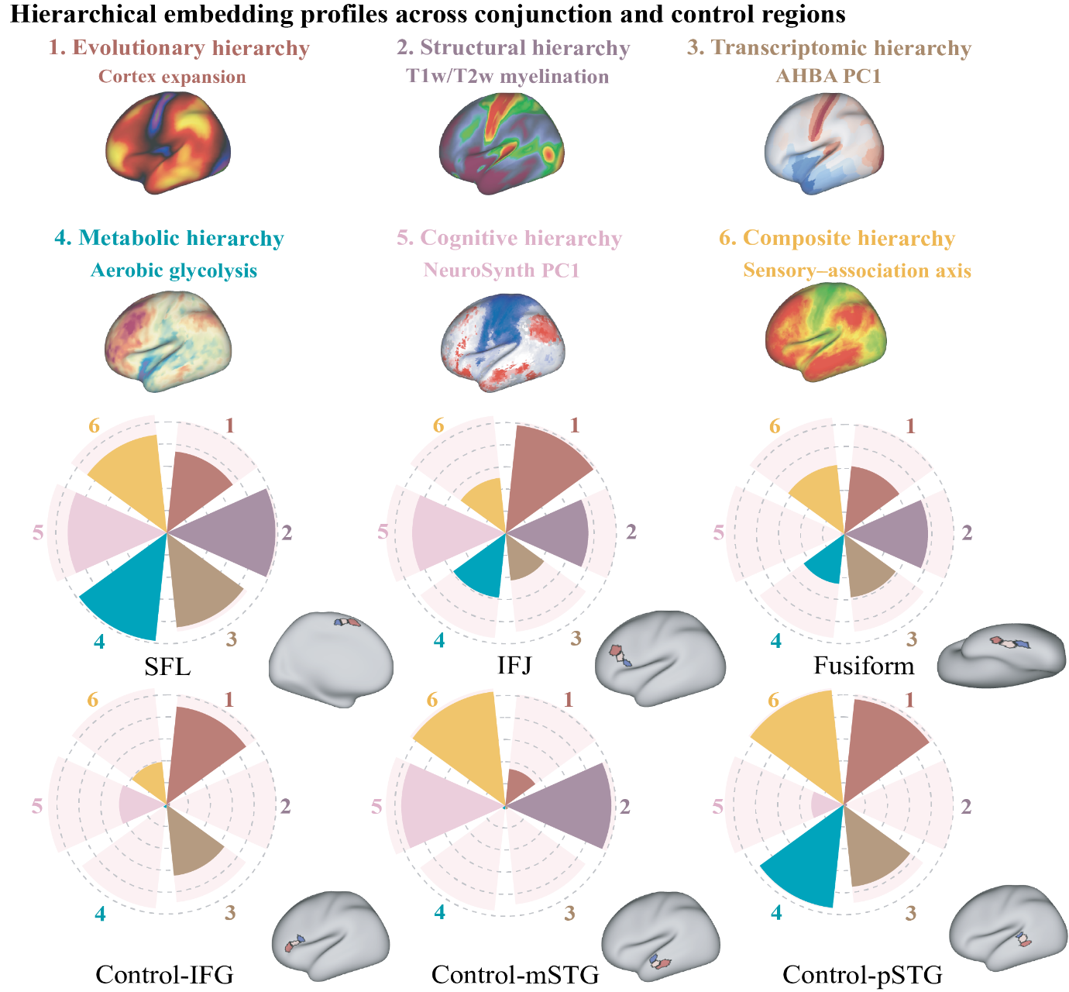
Fig. S7 | Regional hierarchy-transition profiles across conjunction-defined and comparison regions. Polar plots summarize ordered local transitions across six macroscale hierarchy maps for SFL, IFJ, anterior fusiform gyrus, and three language-network comparison regions, using the same three-parcel sensory-to-association sampling procedure as Fig. 5 in the main text. The area 55b profile is shown as a pink reference underlay. Area 55b showed the most consistent regional transition profile across the sampled biological, functional, and metabolic maps. The outer ring denotes the descriptive threshold for ordered trends (Z > 5.1). The six maps index macaque-to-human expansion, T1w/T2w myeloarchitecture, AHBA PC1, PET-derived aerobic glycolysis, NeuroSynth PC1, and a composite sensory-to-association hierarchy. These profiles establish regional embedding around each target parcel, not direct alignment with an internal vertexwise functional gradient.

Table S1. Production–comprehension comparisons of model-estimated incoming directed coupling to area 55b.
Source | Target | Comprehension  (Mean) | Comprehension (SEM) | Production  (Mean) | Production  (SEM) | Difference (Mean) | Difference (SEM) | Cohens_d | t | df | FDR-q
IFJ | 55b | -0.061 | 0.040 | -0.071 | 0.060 | -0.010 | 0.054 | -0.034 | -0.182 | 27.00 | 0.939
SFL | 55b | -0.056 | 0.027 | -0.017 | 0.043 | 0.038 | 0.034 | 0.236 | 1.131 | 22.00 | 0.657
Fus | 55b | -0.002 | 0.026 | -0.043 | 0.027 | -0.041 | 0.037 | -0.212 | -1.100 | 26.00 | 0.657
Ven-M | 55b | 0.037 | 0.045 | -0.057 | 0.074 | -0.093 | 0.060 | -0.302 | -1.567 | 26.00 | 0.657
Dor-M | 55b | 0.010 | 0.058 | 0.016 | 0.068 | 0.006 | 0.083 | 0.016 | 0.077 | 21.00 | 0.939
VIS | 55b | 0.001 | 0.064 | 0.044 | 0.065 | 0.043 | 0.075 | 0.108 | 0.572 | 27.00 | 0.801
AUD | 55b | 0.110 | 0.131 | 0.015 | 0.079 | -0.095 | 0.137 | -0.134 | -0.698 | 26.00 | 0.801
Note: Difference values are production minus comprehension. Parameters are model-estimated coupling within the sparse 55b-centred DCM and should not be interpreted as direct neuronal information flow.

Table S2. Z-trend values quantifying local hierarchical transitions across six macroscale cortical axes.
Map type | Z trend value
Map type | 55b | SFL | Fusiform | IFJ | Control IFG | Control mSTG | Control pSTG
Evolution Expansion | 15.20 | 11.03 | 9.32 | 14.71 | 14.60 | 5.02 | 14.48
PC1.AHBA | 13.43 | 12.85 | 8.70 | 6.44 | 12.58 | 0.00 | 11.24
PC1.Neurosynth | 16.21 | 13.40 | 0.00 | 12.67 | 0.00 | 14.12 | 4.40
PET.AG | 14.28 | 14.68 | 6.86 | 8.78 | 10.22 | 0.00 | 14.12
S-A Axis | 16.00 | 13.30 | 9.49 | 7.54 | 0.00 | 15.57 | 15.73
Myelin | 15.01 | 14.68 | 11.47 | 11.21 | 0.00 | 14.38 | 0.00
Note: Z-trend values describe the strength of monotonic progression from sensory-adjacent to central to association-adjacent parcels within each region of interest. Higher values indicate a stronger ordered regional transition; values of 0.00 indicate non-significant or non-monotonic trends. Because the sampled cortical vertices are spatially dependent, the values are interpreted descriptively. Abbreviations: Evolution Expansion, cortical evolutionary expansion; PC1.AHBA, first principal component of the Allen Human Brain Atlas; PC1.Neurosynth, first principal component of NeuroSynth; PET.AG, aerobic glycolysis measured with positron emission tomography; S-A Axis, macroscale sensory-to-association axis; MyelinMap, T1w/T2w-based myeloarchitecture; SFL, superior frontal language area; IFJ, inferior frontal junction; IFG, inferior frontal gyrus; mSTG, middle superior temporal gyrus; pSTG, posterior superior temporal gyrus.

Table S3. Word frequency, first-syllable frequency, character frequency, and stroke count.
Word | Stroke count | first-syllable frequency | character frequency | word frequency per million | Zipf (Laplace trans word frequency per billion) | Block type | Block name
商场 | 18.00 | 1425.42 | 1152.35 | 32.12 | 4.51 | Semantic | places
教室 | 19.00 | 1683.87 | 1576.71 | 6.65 | 3.82 | Semantic | places
医院 | 16.00 | 13760.10 | 497.76 | 74.53 | 4.87 | Semantic | places
工厂 | 5.00 | 7625.21 | 3486.49 | 48.02 | 4.68 | Semantic | places
老虎 | 14.00 | 1094.49 | 1089.73 | 8.26 | 3.92 | Semantic | mammals
大象 | 15.00 | 6649.99 | 6677.88 | 2.67 | 3.43 | Semantic | mammals
袋鼠 | 24.00 | 3264.12 | 70.87 | 0.66 | 2.82 | Semantic | mammals
熊猫 | 25.00 | 196.06 | 35.83 | 5.68 | 3.75 | Semantic | mammals
飞机 | 10.00 | 1112.87 | 403.15 | 75.91 | 4.88 | Semantic | vehicles
轮船 | 19.00 | 333.73 | 222.71 | 6.85 | 3.84 | Semantic | vehicles
摩托 | 21.00 | 429.47 | 56.41 | 16.52 | 4.22 | Semantic | vehicles
卡车 | 9.00 | 252.10 | 251.39 | 5.34 | 3.73 | Semantic | vehicles
台灯 | 11.00 | 808.95 | 754.72 | 1.27 | 3.10 | Semantic | household appliances
冰箱 | 21.00 | 675.74 | 129.36 | 13.48 | 4.13 | Semantic | household appliances
电视 | 13.00 | 2533.82 | 2172.85 | 160.39 | 5.21 | Semantic | household appliances
风扇 | 14.00 | 1409.32 | 867.71 | 2.29 | 3.36 | Semantic | household appliances
骆驼 | 17.00 | 593.52 | 3.90 | 4.57 | 3.66 | Phonology | luo
萝卜 | 13.00 | 555.44 | 10.40 | 7.43 | 3.87 | Phonology | luo
螺丝 | 17.00 | 555.44 | 28.95 | 1.44 | 3.16 | Phonology | luo
罗盘 | 19.00 | 555.44 | 473.48 | 1.19 | 3.07 | Phonology | luo
落日 | 16.00 | 593.52 | 420.55 | 1.78 | 3.25 | Phonology | luo
香蕉 | 24.00 | 2292.65 | 343.86 | 3.39 | 3.53 | Phonology | xiang
项链 | 18.00 | 2986.35 | 521.26 | 2.94 | 3.47 | Phonology | xiang
橡皮 | 21.00 | 2986.35 | 11.22 | 2.36 | 3.37 | Phonology | xiang
相机 | 15.00 | 2986.35 | 1547.53 | 14.33 | 4.16 | Phonology | xiang
箱子 | 17.00 | 2292.65 | 123.14 | 5.98 | 3.78 | Phonology | xiang
警察 | 33.00 | 547.61 | 141.78 | 36.87 | 4.57 | Phonology | jing
鲸鱼 | 24.00 | 6299.10 | 1.35 | 0.87 | 2.94 | Phonology | jing
精灵 | 21.00 | 6299.10 | 814.67 | 3.15 | 3.50 | Phonology | jing
镜子 | 19.00 | 1155.54 | 84.37 | 8.06 | 3.91 | Phonology | jing
井盖 | 15.00 | 547.61 | 79.96 | 0.62 | 2.79 | Phonology | jing
食指 | 18.00 | 9332.48 | 418.34 | 2.24 | 3.35 | Phonology | shi
试管 | 20.00 | 18835.47 | 330.64 | 1.29 | 3.11 | Phonology | shi
士兵 | 10.00 | 18835.47 | 364.39 | 29.77 | 4.47 | Phonology | shi
石头 | 10.00 | 9332.48 | 518.22 | 15.47 | 4.19 | Phonology | shi
狮子 | 12.00 | 2154.67 | 10.72 | 7.11 | 3.85 | Phonology | shi
书包 | 9.00 | 1634.86 | 1195.62 | 3.12 | 3.49 | Phonology | shu
鼠标 | 22.00 | 562.37 | 18.16 | 5.02 | 3.70 | Phonology | shu
薯条 | 22.00 | 562.37 | 4.10 | 0.10 | 2.00 | Phonology | shu
树叶 | 14.00 | 2515.66 | 256.79 | 4.46 | 3.65 | Phonology | shu
竖琴 | 21.00 | 2515.66 | 16.09 | 0.81 | 2.91 | Phonology | shu

Reference
1. Gordon, E. M. et al. Precision Functional Mapping of Individual Human NeuroResource Precision Functional Mapping of Individual Human Brains. Neuron 95, 1–17 (2017).
2. Kong, R. et al. Individual-Specific Areal-Level Parcellations Improve Functional Connectivity Prediction of Behavior. Cerebral Cortex 31, 4477–4500 (2021).
3. Zeidman, P. et al. A guide to group effective connectivity analysis, part 1: First level analysis with DCM for fMRI. Neuroimage 200, 174–190 (2019).
4. Zhang, L. & Du, Y. Lip movements enhance speech representations and effective connectivity in auditory dorsal stream. Neuroimage 257, 119311 (2022).

