Supplementary Information

Metallic Transport in a Polymer‑Based Negative Bipolaron Network

Shaohua Tong^{1, 4}, Hanlin Gan^{1, 4}, Mengming Sun¹, Hongchao Peng³, Zhenghua Qu¹, Wei Cui¹, Yanuo Zhu¹, Jiaji Yang¹, Hio-Ieng Un¹, Liang Yao¹, Nan Zheng¹, Haoran Tang¹, Jiang Zhang^{3*}, Fei Huang¹, Reverant Crispin^{2*}, Qinglin Jiang^{1*}, Yuguang Ma¹

¹ Institute of Polymer Optoelectronic Materials and Devices, Guangdong Basic Research Center of Excellence for Energy and Information Polymer Materials, State Key Laboratory of Luminescent Materials and Devices, South China University of Technology, Guangzhou, 510640, China
² Laboratory of Organic Electronics, Department of Science and Technology, Linköping University, Norrköping, Sweden
³ Department of Physics, South China University of Technology, Guangzhou, 510640, China
⁴ These authors contributed equally: Shaohua Tong, Hanlin Gan.

*Corresponding emails: jiangql@scut.edu.cn; reverant.crispin@liu.se; jonney@scut.edu.cn

This file includes:

(1) Metallic conductivity of PBFDO for various synthetic routes.
(2) Electron energy loss spectra of PBFDO films.
(3) Ionic liquid treatment and corresponding characterization.
(4) Theoretical modelling of the bipolaron network.
(5) References.

Fig. S1 ~ Fig. S19
Table S1 ~ Table S4

(1) Metallic conductivity of PBFDO for various synthetic routes.
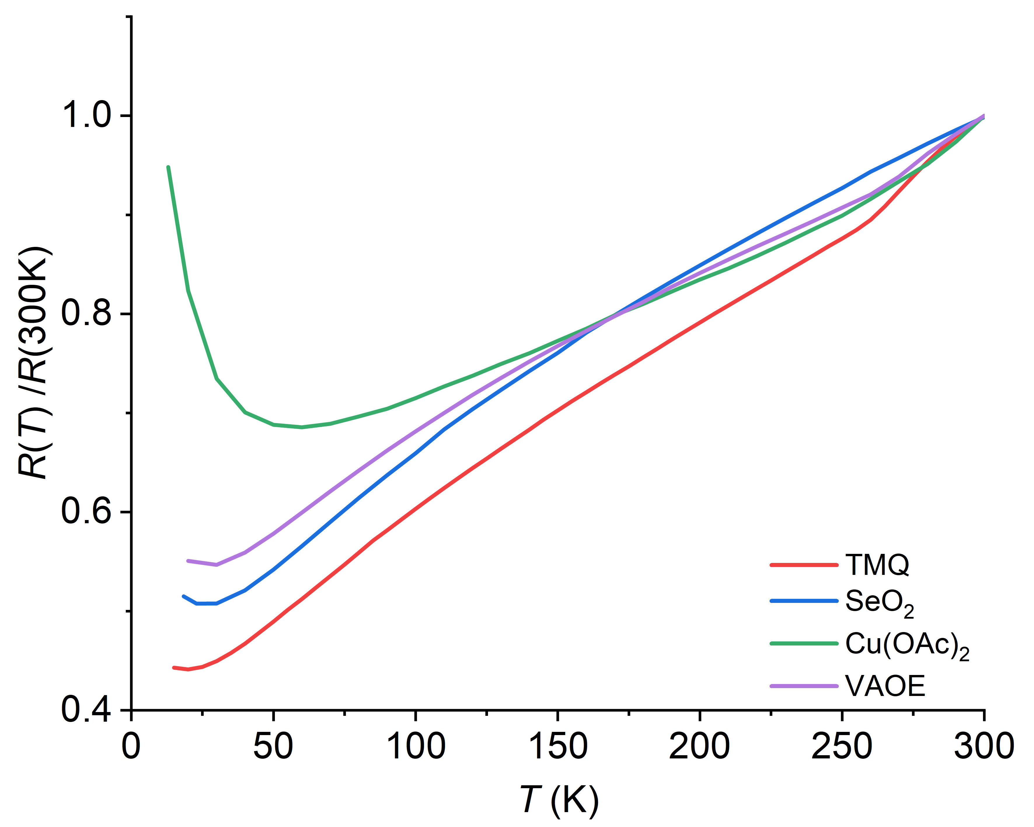
Fig. S1. Temperature dependence of normalized resistance for spin-coated PBFDO film prepared using different synthesis routes, TMQ (red), SeO₂ (blue), Cu(OAc)₂ (green), Volt-Amp OptoElectronics (violet).

(2) Electron energy loss spectra of PBFDO films.
In conventional metals, plasmons arise from the collective oscillation of conduction electrons in partially filled bands, which behave approximately as a free-electron gas. These collective excitations produce distinct peaks in EELS, typically in the 5–20 eV range, with widths of a few eV determined by damping mechanisms such as electron–electron, electron–phonon, and interband scattering. Although these modes are well-defined, their finite linewidth reflects ultrafast decay (femtosecond lifetimes) rather than long-lived oscillations.
In the present PBFDO samples, the situation is more heterogeneous. Structural disorder, evidenced by broad XRD reflections, coexists with preferentially edge-on crystalline domains that form interconnected metallic percolation pathways. Metallic transport is therefore dominated by specific regions possessing partially filled electronic bands and delocalized carriers, while other regions remain semiconducting and contribute little to the plasmon response. Consequently, the EELS plasmon is expected to arise primarily from the metallic crystalline network rather than from the average bulk structure of the film.
Because the metallic regions are spatially confined and electronically heterogeneous, the plasmon peak should remain broader than in crystalline metals. The linewidth is expected to reflect damping caused by a finite crystalline coherence length, interfacial scattering between metallic and semiconducting regions, local variations in carrier density, and residual disorder. Therefore, the PBFDO sample described here is more likely to display an intermediate plasmon linewidth, possibly 3–5 eV, characteristic of a percolative metallic electronic structure embedded within a partially disordered semiconducting matrix.
In a Drude model, the plasmon frequency is
$$ω_{p}^{2}=\frac{4πne^{2}}{m^{*}}$$
where $n$ is the density of charge carriers, $e$ is the electron charge and $m^{*}$ is the effective mass of the carriers. The plasma frequency rises with increasing electron density, which is why elemental metals typically exhibit their plasmon resonances in the ultraviolet, whereas conducting polymers show plasmonic behaviour in the infrared-visible range¹. The effective mass reflects how readily electrons accelerate in a solid and is determined by the curvature of the electronic band structure, $m^{*}=ℏ^{2}/\left(d^{2}E/dk^{2}\right)$. Recent first-principles calculations of various 3D networks of n-doped PBFDO chains estimate the charge-carrier density as n = (6.0 ± 0.2) × 10²¹ cm⁻³, assuming one carrier per monomer unit². From the 3D electronic structure of the bipolaron network presented in Fig. 5, we extract the carrier effective mass by locally fitting the dispersive bands near the Fermi level to a parabolic form. Only the partially filled bands, which are expected to contribute to the plasmonic response, are considered. The effective masses $m^{*}$ and plasmon energies ($E_{P}=ℏω_{P}$) are listed in Table S1.

Table S1 The effective mass of electrons for the 3D model of the bipolaron network (d_{lamellar} = 7.53 Å, d_{π-π} = 3.27 Å)
 | Fermi Band Index | DFT Band Index | |m*| | Plasmon Energy (eV)
Y–Γ | 1 | 135 | 0.052 m₀ | 12.6
Y–Γ | 2 | 136 | 0.043 m₀ | 13.9
R–Γ | 1 | 135 | 0.405 m₀ | 4.51
R–Γ | 2 | 136 | 0.169 m₀ | 6.99
Γ–T | 1 | 135 | 0.097 m₀ | 9.23
Γ–T | 2 | 136 | 0.130 m₀ | 7.95
Γ–V | 1 | 135 | 0.436 m₀ | 4.35
Γ–V | 2 | 136 | 0.791 m₀ | 3.23

Conducting polymers such as PBFDO are expected to exhibit relatively weak Coulomb coupling between electronic bands. As a result, partially filled π-bands that are only weakly interacting may support multiple plasmon modes at distinct frequencies. This behaviour contrasts with that of conventional metals, where stronger Coulomb coupling between bands typically results in a single dominant plasmon, even when several bands cross the Fermi level. Within a simplified model that neglects interband Coulomb coupling, we simulate the plasmon contribution to the EELS spectrum as a superposition of individual plasmon peaks corresponding to the energies listed in Table S1. Each contribution is represented by a Gaussian with a full width at half maximum (FWHM) of 4.7 eV, producing a broad feature centered at ~5.5 eV (Fig. S2). This is consistent with the broad plasmonic signal observed in the EELS spectrum between 1 and 10 eV, with a maximum near 5.6 eV (Fig. 2d). In addition to these π-intrachain plasmons, PBFDO has also been reported to exhibit an EELS absorption at 6.6 eV, attributed to the collective oscillation of π-electrons localized within the benzene rings³.
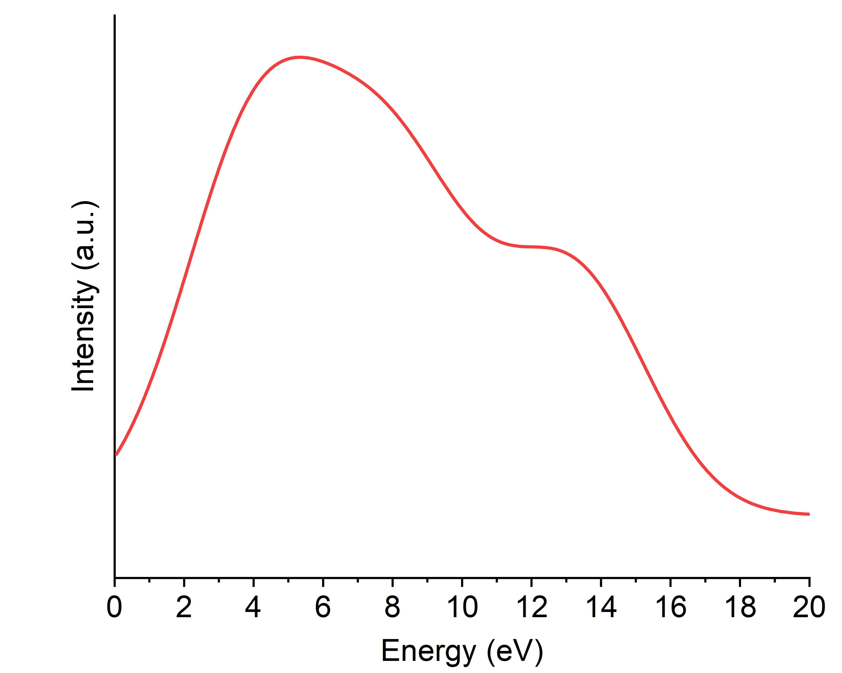
Fig. S2. Simulated EELS plasmon spectrum obtained as a superposition of Gaussian peaks (FWHM = 4.7 eV) at the energies listed in Table S1, yielding a broad feature centered around ~5.5 eV.

(3) Ionic liquid treatment and corresponding characterization.
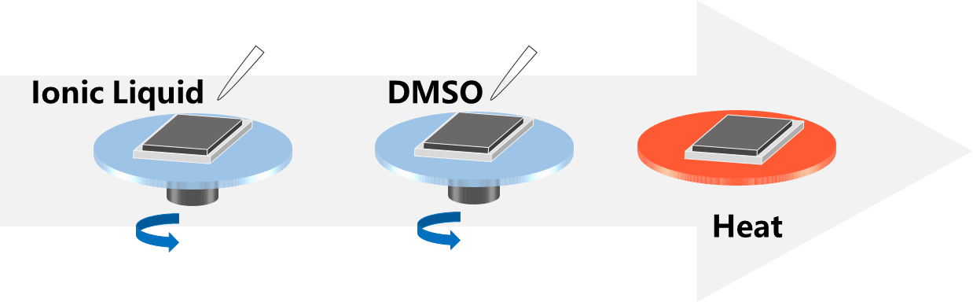
Fig. S3. Schematic diagram of ionic liquid treatment of films.

Table S2 Electrical conductivity of spin-coated films and drop-coated films before and after ionic liquid treatment at different temperatures
Material | Conductivity at 300 K  (S cm⁻¹) | Conductivity at 10 K  (S cm⁻¹) | Charge transport model
Drop-coated film | 3.39×10³ | 2.73×10³ | Semiconductor-like
Drop-coated film (IL) | 8.15×10³ | 9.54×10³ | Metal
Spin-coated film | 3.67×10³ | 8.16×10³ | Metal
Spin-coated film (IL) | 8.32×10³ | 2.03×10⁴ | Metal

Table S3 Films dimensions in the EPR test
Sample | Length (mm) | Width (mm) | Thickness (nm) | Volume (mm³)
Drop-coated film | 15 | 3 | 1702 | 7.66×10⁻²
Spin-coated film | 10 | 3 | 36 | 1.08×10⁻³

Fig. S4. Lorentz peak fitting of XRD data for a, Drop-coated PBFDO (black). b, IL-treated drop-coated PBFDO (blue). c, Spin-coated PBFDO (red). d, IL-treated spin-coated PBFDO (green).

Fig. S5. 2D GIWAXS patterns for a, Drop-coated PBFDO. b, IL-treated drop-coated PBFDO. c, Spin-coated PBFDO. d, IL-treated spin-coated PBFDO.

Fig. S6. Lorentz peak fitting of 1D GIWAXS data of out-of-plane Q_{z} for a, Drop-coated PBFDO (black). b, IL-treated drop-coated PBFDO (blue). c, Spin-coated PBFDO (red). d, IL-treated spin-coated PBFDO (green).

Fig. S7. Lorentz peak fitting of 1D GIWAXS data of in-plane Q_{xy} for a, Drop-coated PBFDO (black). b, IL-treated drop-coated PBFDO (blue). c, Spin-coated PBFDO (red). d, IL-treated spin-coated PBFDO (green).

Table S4 Structural changes of spin-coated films and drop-coated films before and after IL treatment
Sample | 2θ(degree) | d-spacing (Å) | Q_{z} (100) (Å⁻¹) | d₁₀₀ (Å) | Q_{xy} (010) (Å⁻¹) | d₀₁₀ (Å)
Drop-coated film | 8.224 | 10.74 | 0.590 | 10.65 | 1.901 | 3.31
Drop-coated film (IL) | 8.297 | 10.65 | 0.602 | 10.45 | 1.905 | 3.30
Spin-coated film | 8.426 | 10.48 | 0.625 | 10.05 | 1.903 | 3.30
Spin-coated film (IL) | 8.525 | 10.36 | 0.651 | 9.65 | 1.924 | 3.27

(4) Theoretical modelling of the bipolaron network.
4.1. Energetics of doubly protonated sites and the role of protonation in the 3D network
Here we examine the effect of protonation on a PBFDO chain, assuming that protons can reorganize by diffusing between adjacent chains. In these 3D models, the geometries were fully optimized. The aim is not to simulate the diffusion process itself—real samples have a larger lamellar spacing (9.65 Å), sufficient to host water molecules that hydrogen-bond to PBFDO—but rather to evaluate the relative energetics of different proton positions. The calculations show that the most stable configuration is the h–h protonation, which forms the bipolaron network and is taken as the zero-energy reference (Fig. S8a). Displacing a single proton within the unit cell destabilizes the system by 0.21 eV (Fig. S8b), while reorganizing two protons increases the energy by 0.17 eV per cell (Fig. S8c). The calculated values agree with those reported by Brédas et al.². These results illustrate that, if ionic-liquid swelling enables proton mobility, the system will relax toward the energetically preferred bipolaron-network configuration.
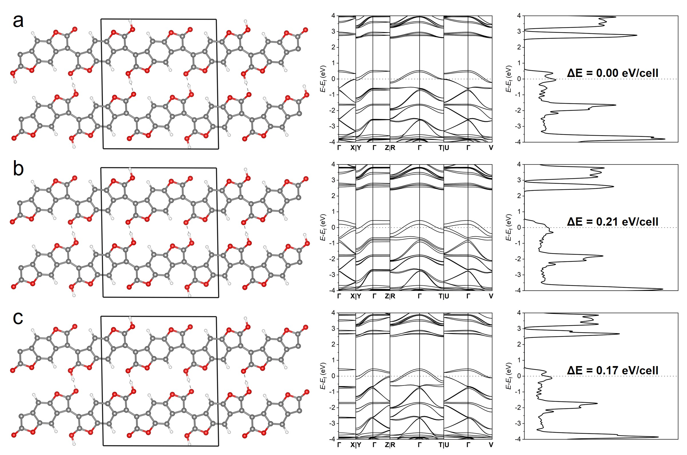
Fig. S8. Relative energetics of proton configurations in PBFDO. DFT calculations comparing a, the stable h–h bipolaron configuration with b-c, alternative single‑ and double‑proton displacements, which destabilize the unit cell.

Two protons interacting with the C=O groups can occupy several well-defined local minima to stabilize two negative charges on the π-system. Because protonation of only one C=O group leads to an asymmetric monomer, we denote the side bearing the C=O–H⁺ group as the “head” and the opposite side C=O as the “tail”.
In the work of Brédas et al.⁴, the energetics of diprotonation in an oligomer consisting of six BFDO units are examined in detail. Several protonation motifs involving two adjacent units are considered: head-to-tail (h-t), tail-to-tail (t-t), and head-to-head (h-h) (Fig. S9). The energies of these configurations are evaluated for both the singlet and triplet electronic states.
The results show that the (h–h) configuration in its singlet state is the most stable arrangement for accommodating two protons on the oligomer (reference energy set to 0 eV). This singlet ground state indicates that the doubly protonated oligomer forms a negative bipolaron localized near the (h-h) junction. The next most stable configurations are the (h-t) and (t-t) motifs in the triplet state, each more than 0.5 eV higher in energy. In other words, two separated polarons in the (h-t) or (t-t) configurations are significantly less stable than a single bipolaron in the (h-h) configuration.
Taken together, these findings suggest that protonation-induced n-doping in PBFDO preferentially leads to the formation of negative bipolarons, consistent with the absence of an EPR signal in the highly conductive, metallic PBFDO sample.
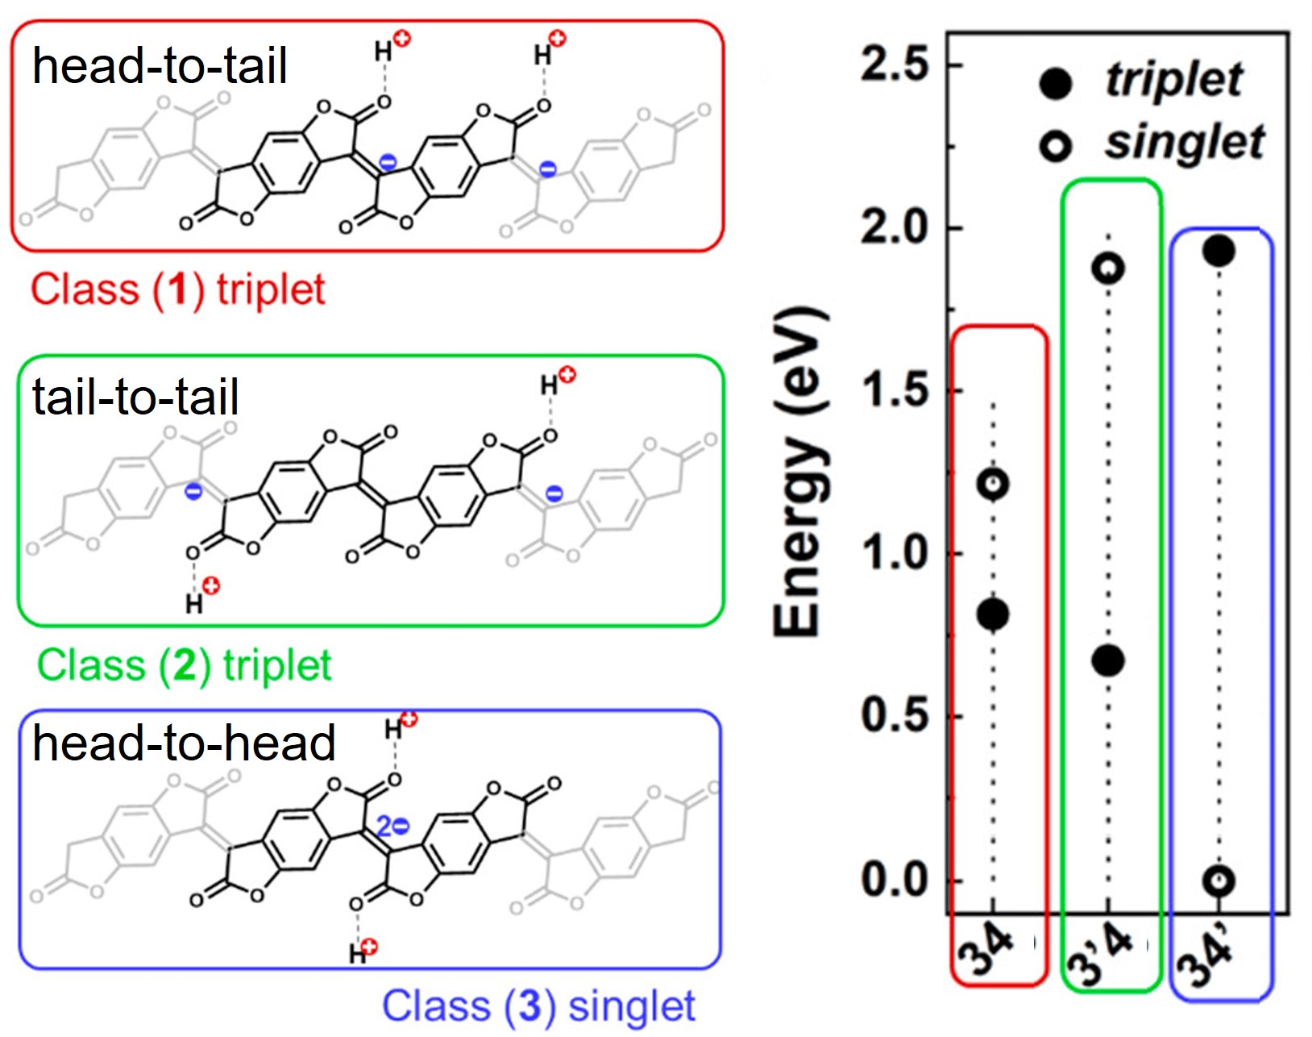
Fig. S9. Energetics of various configurations for a doubly protonated oligomer of 6 BFDO units⁴. Copyright © 2024, American Chemical Society.

To rationalize the nature of the HOMO of a single bipolaron in the oligomer, three molecular models are considered: (i) a neutral dimer, (ii) a doped dimer in the (h-h) configuration with two protons, and (iii) a doped trimer with the two protons in an (h-h) configuration located in the central unit. As shown in Fig. S10, the LUMO of the trimer is localized on the non-protonated (t-t) connection and is therefore similar to the LUMO of the neutral dimer. In contrast, the HOMO of the trimer is localized on the protonated (h-h) connection and resembles the HOMO of the protonated (doped) dimer. The HOMO−1 of the trimer is related to the HOMO of the neutral dimer, whereas the LUMO+1 of the trimer is related to the LUMO of the doped dimer.
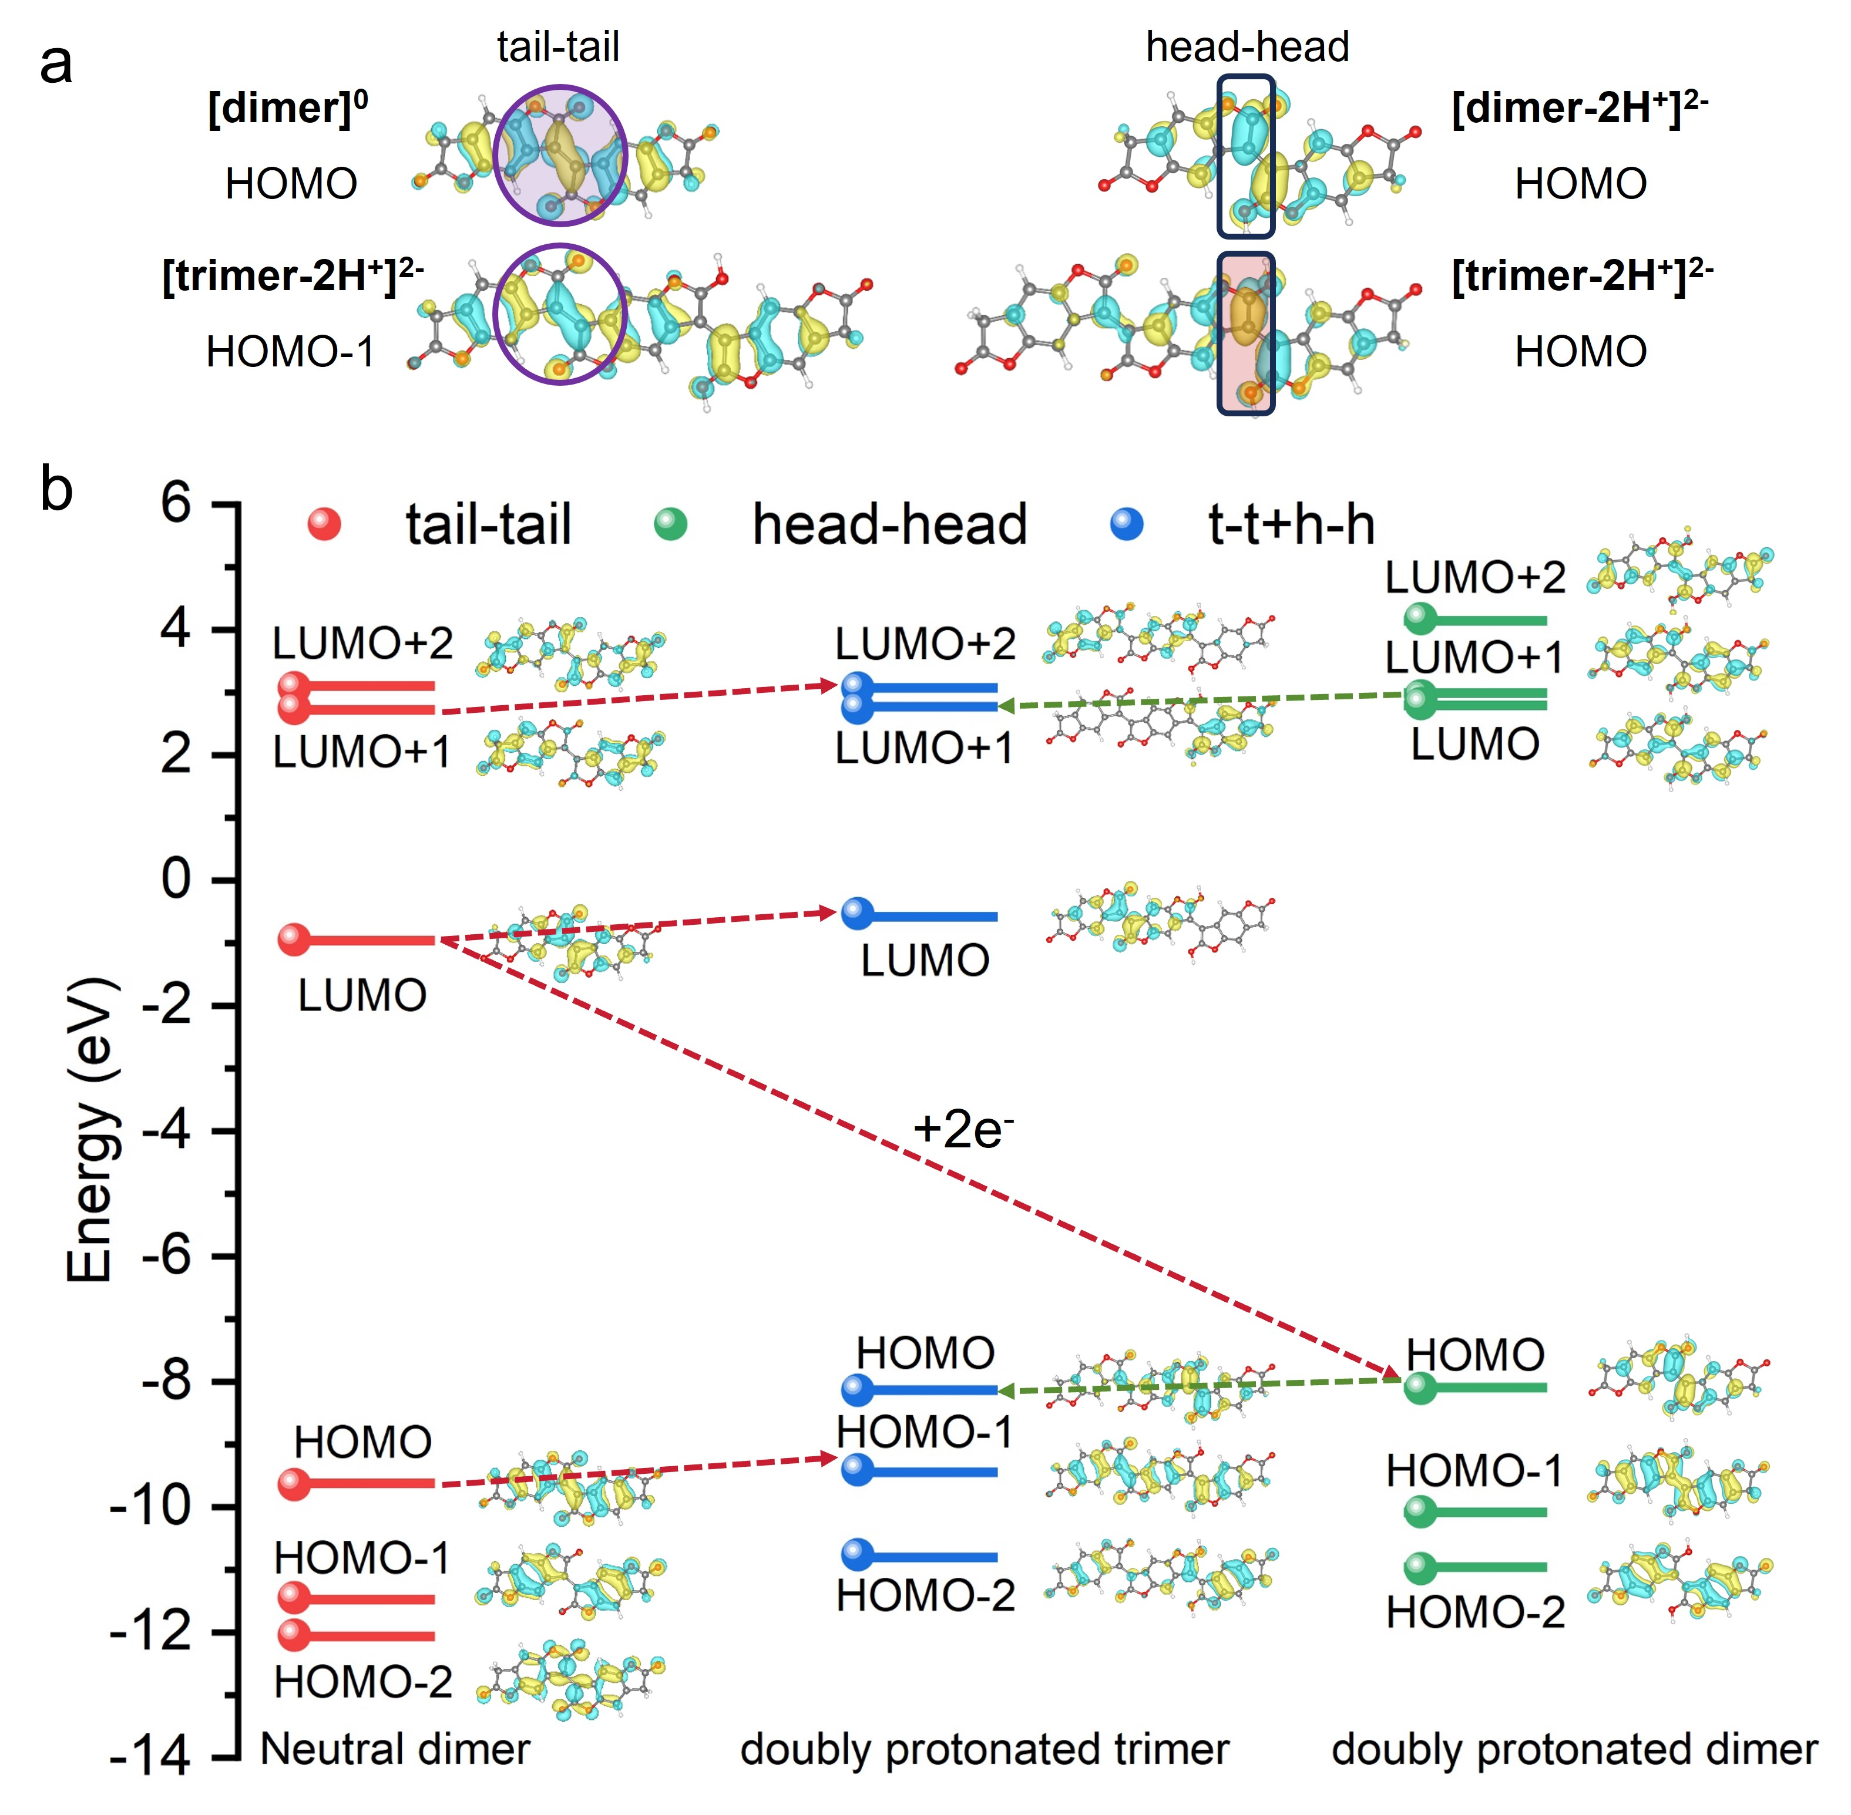
Fig. S10. a, Frontier filled orbitals for the neutral dimer, the doubly protonated (h-h) dimer and the doubly protonated (h-h) trimer. b, Energy of the molecular orbitals for the neutral dimer (tail-tail connection), the doubly protonated dimer (head-head), the doubly protonated trimer (t-t + h-h)

4.2. 1D bipolaron network
An oligomer composed of 20 BFDO units is employed as an initial model. Two adjacent BFDO units in the middle of the chain each carry one proton, forming an (h-h) connection, i.e., a single bipolaron located at the center of the oligomer. The wavefunction of the HOMO of this oligomer, containing a single bipolaron, is localized at the bipolaron site (Fig. S11a).
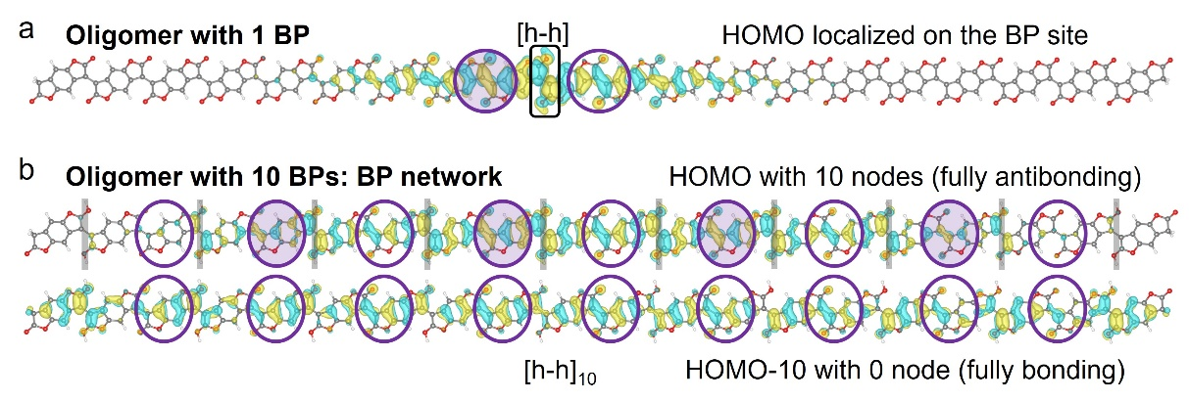
Fig. S11. a, HOMO of one bipolaron (h-h) in the middle of the oligomer. b, HOMO and HOMO-10 of the oligomer with 10 bipolarons (h-h)₁₀ forming a 1D network of negative bipolarons.

The HOMO of the oligomer containing a single bipolaron (Fig. S11a) is localized around the bipolaron site and resembles a combination of the HOMO and HOMO-1 of the doped trimer (Fig. S11). Alternatively, it can be viewed as a combination of the HOMOs of doped dimers located at non-protonated and protonated connections between BFDO molecules.
The next model considers an oligomer composed of 20 BFDO units forming a 1D bipolaron network. In this model, every second monomer unit is doubly protonated in an (h-h) configuration. The effective repeat unit thus consists of an alternating sequence of diprotonated (h-h) connections (doped segments) and non-protonated connections (neutral segments). This periodic alternation defines a regular array of negative bipolarons along the polymer backbone.
The HOMO of the oligomer modeling the 1D bipolaron network (Fig. S11b) corresponds to a fully antibonding combination (10 nodes) of the HOMO of the single bipolaron (Fig. S11a). The molecular-orbital coefficients alternate in phase (sign) from one repeat unit to the next, with empty and filled symbols denoting opposite phases of the wavefunction. In contrast, the HOMO-10 of the 1D bipolaron network corresponds to the fully bonding combination (0 nodes) of the HOMO of the single bipolaron. Consequently, the energy difference between the HOMO and HOMO-10 defines the width (1.25 eV) of the filled bipolaron quasi-band (Fig. S11-S13). All orbitals belonging to this quasi-band are shown in Fig. S13. Based on previous 1D periodic calculations⁴, these orbitals correspond to a quasi-band exhibiting energy dispersion from the Γ to X point in the Brillouin zone, as illustrated in Fig. S12f.

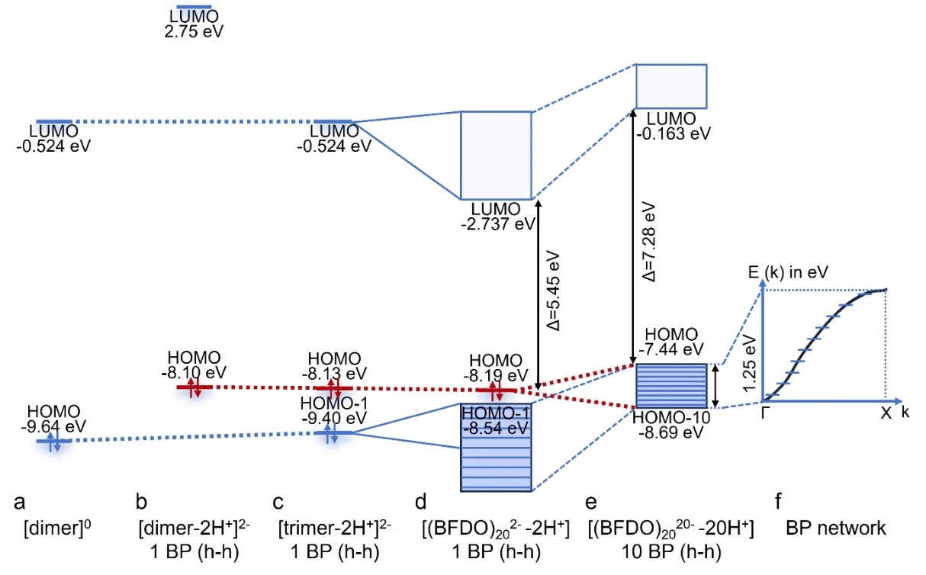
Fig. S12. HOMO and LUMO of PBFDO. a, the dimer. b, one bipolaron (h-h) of dimer. c, one bipolaron (h-h) of trimer. d, one bipolaron (h-h) in the middle of the oligomer. e, 10 bipolarons (h-h)₁₀ of the oligomer. f, 1D network of negative bipolarons.

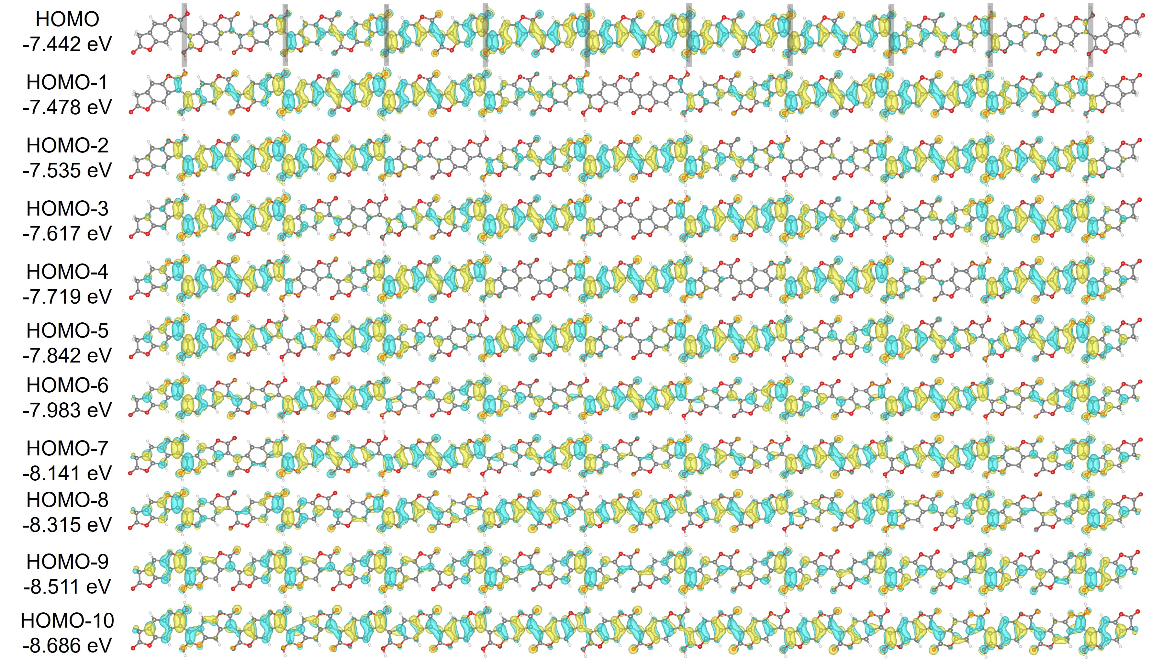
Fig. S13. Sketch of the molecular orbitals belonging to the filled bipolaron band of the 1D-bipolaron network oligomer model.

The LUMO of the 1D bipolaron network defines the bottom of the conduction quasi-band (Fig. S14). It arises from the interaction (combination) of the LUMOs of the doped trimer (or equivalently, the LUMO of the neutral dimer). The LUMO of the doped trimer is localized on the non-protonated linkage between two BFDO molecules, which explains its strong similarity to the LUMO of the neutral BFDO dimer.
As pointed out by Brédas et al.⁴, and consistent with the oligomer model presented here, there is a significant band gap between the conduction band and the filled negative bipolaron band. This electronic structure renders the bipolaron network semiconducting, which is inconsistent with the experimentally observed metallic conductivity. However, the 1D model is overly simplified, as other parameters—such as the π-stacking distance, lamellar packing with disorder between lamellae, and proton dynamics—may also significantly influence the electronic structure.
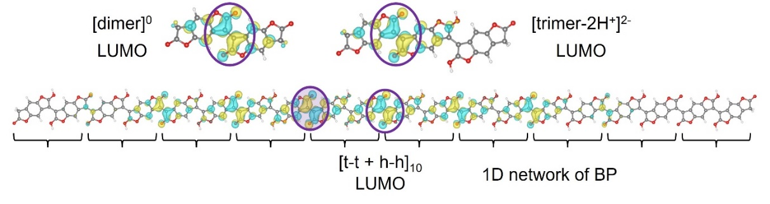
Fig. S14. Sketch of the LUMO of molecular models and doped oligomer representing the 1D-bipolaron network.

In the fully coplanar 1D model of PBFDO with one proton per monomer (one charge per monomer) (Fig. S15a), the system exhibits a half-filled polaronic band crossing the Fermi level, resulting in a metallic electronic structure with a substantial bandwidth of 1.29 eV. This pronounced dispersion reflects strong intrachain electronic coupling and suggests efficient charge transport along the polymer backbone. However, this metallic state is highly idealized and intrinsically unstable.
Introducing a more realistic structural motif—a two-unit repeat with a torsion angle of 29° (Fig. S15b)—breaks the symmetry and induces Brillouin-zone folding, opening a band gap of 0.18 eV, as shown by Brédas et al⁴. The resulting splitting into narrow filled and empty bands is characteristic of a Peierls-like instability, demonstrating that intrachain structural distortions and bipolaron formation inherently drive the system toward a semiconducting state.
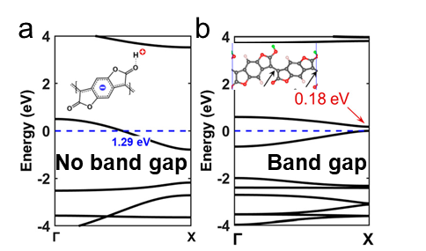
Fig. S15. a, n-doped coplanar PBFDO chains as calculated at the DFT-PBE0 level of theory. The bandwidth values are given in blue, and the band gap is given in red. The zero energy is set as the energy of the highest occupied level. b, DFT-PBE0 geometries and band structures of n-doped PBFDO chains with the repeating cell consisting of two BFDO units: top-top, the two protonated sites are on the top side⁴. Copyright © 2024, American Chemical Society.

4.3. 3D bipolaron network
The anisotropy of this metallic state can be directly inferred from the dispersion along specific high-symmetry directions. The Γ→X path shows strong dispersion, confirming efficient intrachain transport. Significant dispersion is also observed along Γ→R and Γ→V, which are associated with π-π stacking within a lamella, demonstrating that interchain coupling within the same lamellae contributes to charge delocalization. In contrast, the Γ→Z direction, corresponding to interlamellar stacking, exhibits essentially flat bands—one occupied and one unoccupied—indicating negligible electronic coupling between lamellae.
Finally, analysis of the wavefunctions of the 3D model at different points in the Brillouin zone close to the Fermi level (Fig. S16) shows that all bands—empty, filled, or half-filled—between -0.7 eV and +0.6 eV originate from interactions between the HOMO and HOMO-1 of the repeat units as captured by the doped-trimer model (e.g. highest occupied crystal orbital (HOCO) at Γ and X). None of these levels involve contributions from the LUMO, which lies much higher in energy. More specifically, the unprotonated connections contribute significantly to the wavefunctions of the empty electronic levels (e.g., lowest unoccupied crystal orbital (LUCO) at U and V), whereas the protonated (h-h) connections dominate the wavefunctions of the filled electronic levels (e.g., the HOCO at U and V).
Taken together, these results demonstrate that, whereas intrachain effects such as torsion and bipolaron formation favor gap opening, metallicity is restored through interchain π-π interactions within the lamellae. The system therefore exhibits a strongly anisotropic electronic structure, behaving as a quasi-two-dimensional conductor embedded in a three-dimensional crystal. Charge transport is enabled along the polymer backbone and within π-stacked chains of a given lamella, but remains suppressed between lamellae. This highlights the decisive role of supramolecular organization and interchain coupling in governing the emergence of metallic behaviour in doped conjugated polymers.
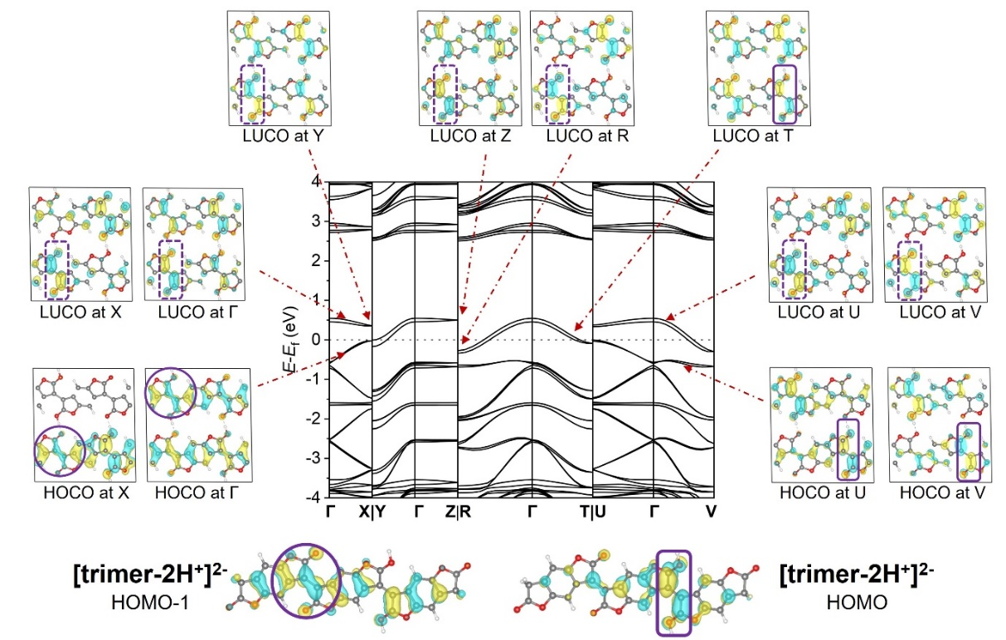
Fig. S16. Band structure of the stacked bipolaron network with the Fermi level set to 0 eV (center), together with selected HOCO and LUCO at high-symmetry k-points (X, Y, Z, R, T, U, V).
Significant dispersion is observed along Γ→X (intrachain) and along Γ→R and Γ→V (π–π stacking within a lamella), while negligible dispersion along Γ→Z indicates weak interlamellar coupling. The bottom panel shows the corresponding molecular orbitals of the [trimer-2H⁺]²⁻ model, illustrating the bonding and antibonding character underlying the bipolaron-derived bands.

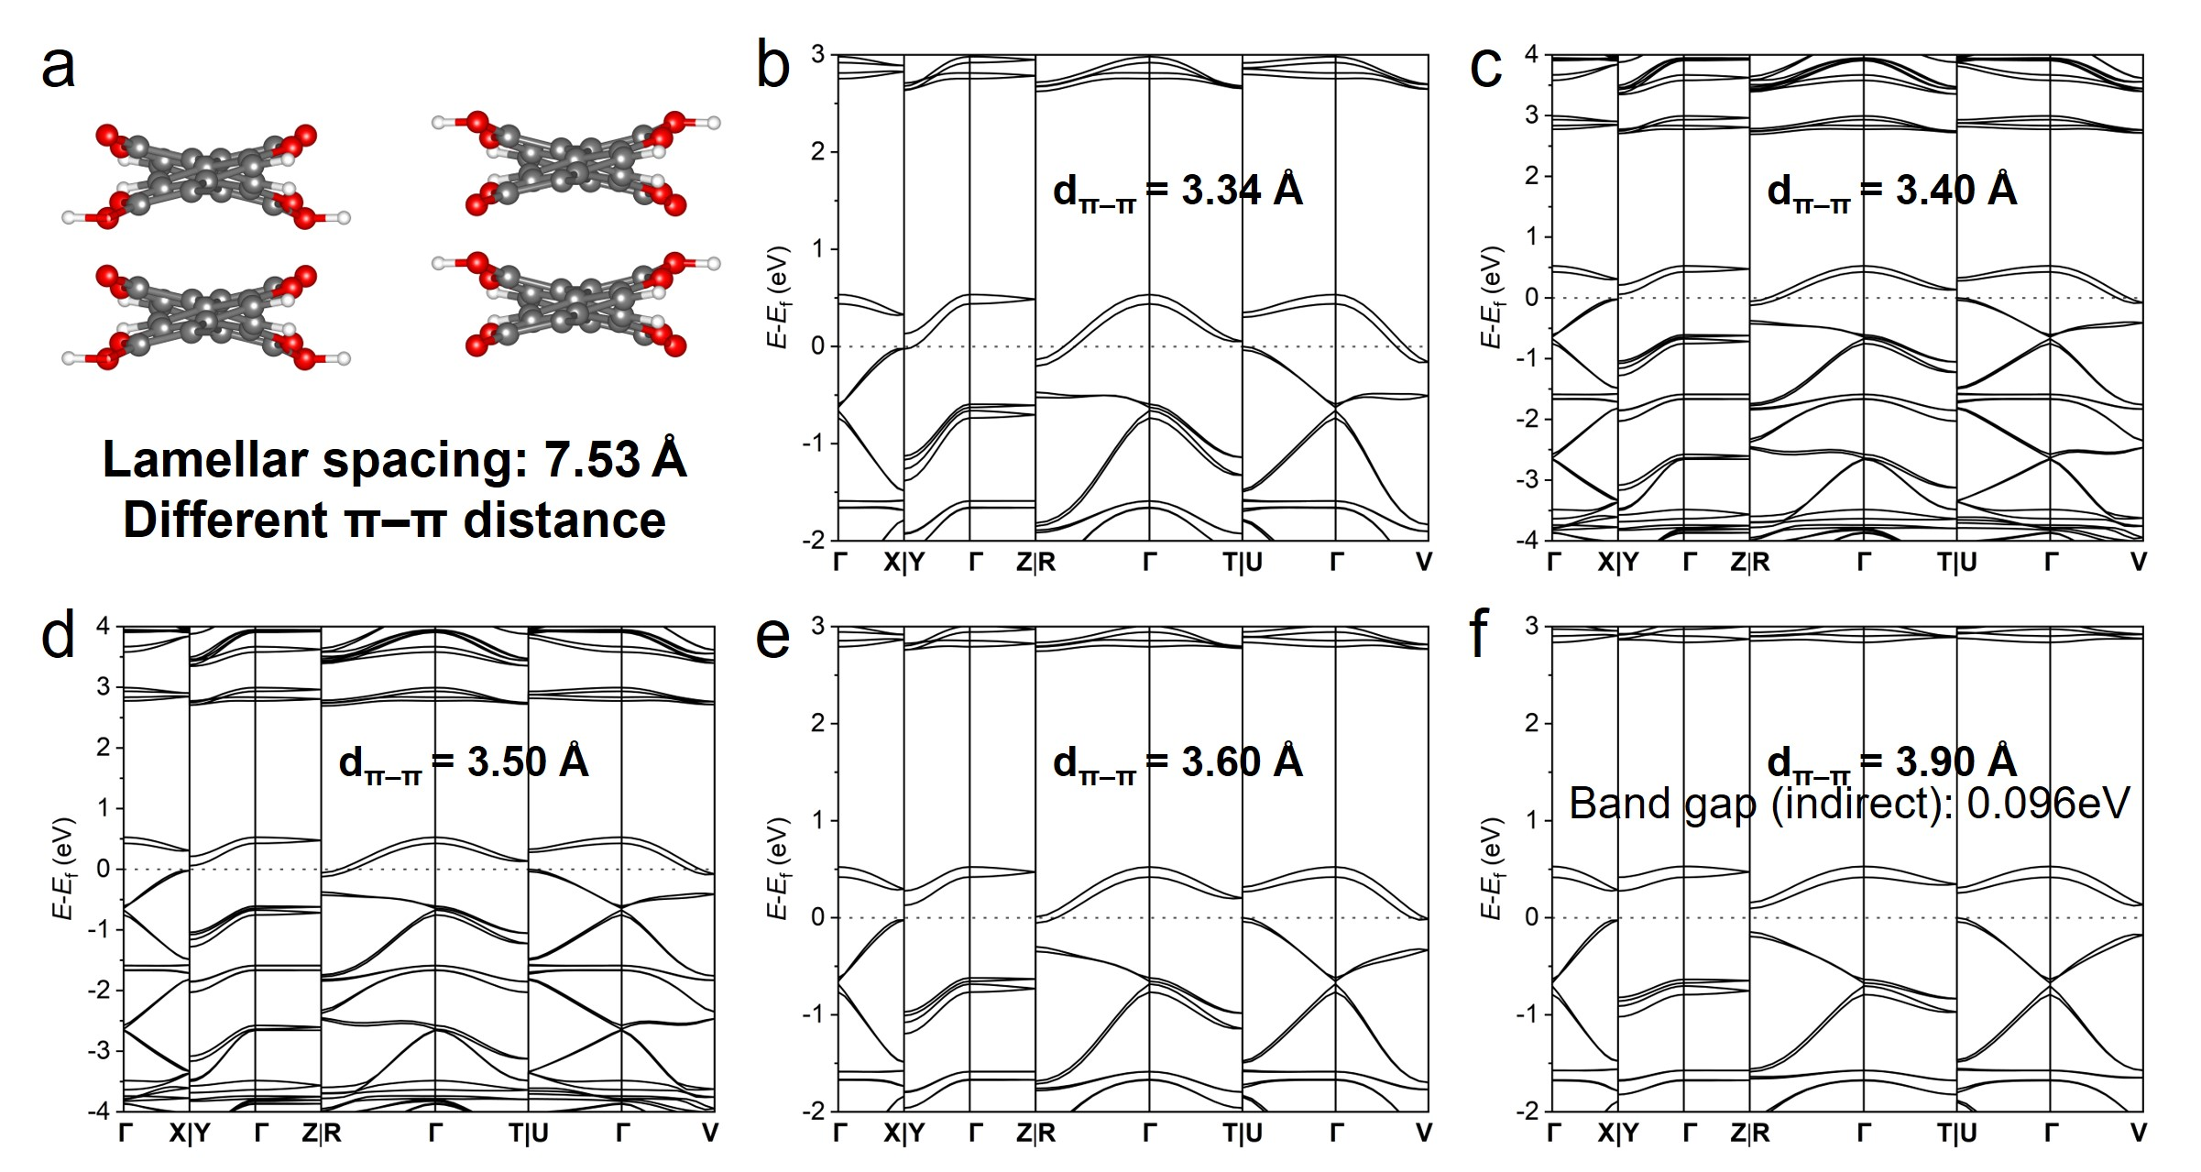
Fig. S17. Band structure diagram of PBFDO under different π-π distances at a lamellar spacing of 7.53 Å. a, Molecular structure diagram. b, π-π distance: 3.34 Å. c, π-π distance: 3.40 Å. d, π-π distance: 3.50 Å. e, π-π distance: 3.60 Å. f, π-π distance: 3.90 Å.

Figures S15 and S17 highlight the evolution of the electronic structure with increasing structural complexity, progressing from an idealized one-dimensional (1D) intrachain model to a more realistic three-dimensional (3D) stacked system. To disentangle intra- and interchain contributions, a model incorporating two adjacent polymer chains within a single unit cell was considered (Fig. 5a). Increasing the π-π stacking distance to 3.90 Å (Fig. S17f) effectively suppresses interchain electronic interactions while preserving the 3D periodicity of the lattice. In this limit, the band structure exhibits a small indirect gap of 0.096 eV at the R and V points, while retaining significant dispersion along Γ→X, corresponding to intrachain transport. The duplication of bands reflects the presence of two weakly interacting chains in the unit cell. Importantly, the gap emerges along directions involving transverse periodicity, indicating that the electronic structure is already influenced by the 3D crystal framework even in the absence of significant π–π overlap. In this regime, charge transport remains effectively quasi-1D.
A qualitatively different behaviour emerges when realistic π–π interactions are introduced by reducing the interchain distance to 3.27 Å (Fig. 5b), in agreement with the experimental diffraction data (Fig. 4d). The band gap then closes at the R and V points, leading to a metallic electronic structure. This transition does not originate from a significant modification of the intrachain dispersion, but rather from the emergence of interchain electronic coupling that induces band overlap in transverse directions. The system thus undergoes a dimensional crossover from a quasi-1D semiconducting state to a higher-dimensional metallic conductor.
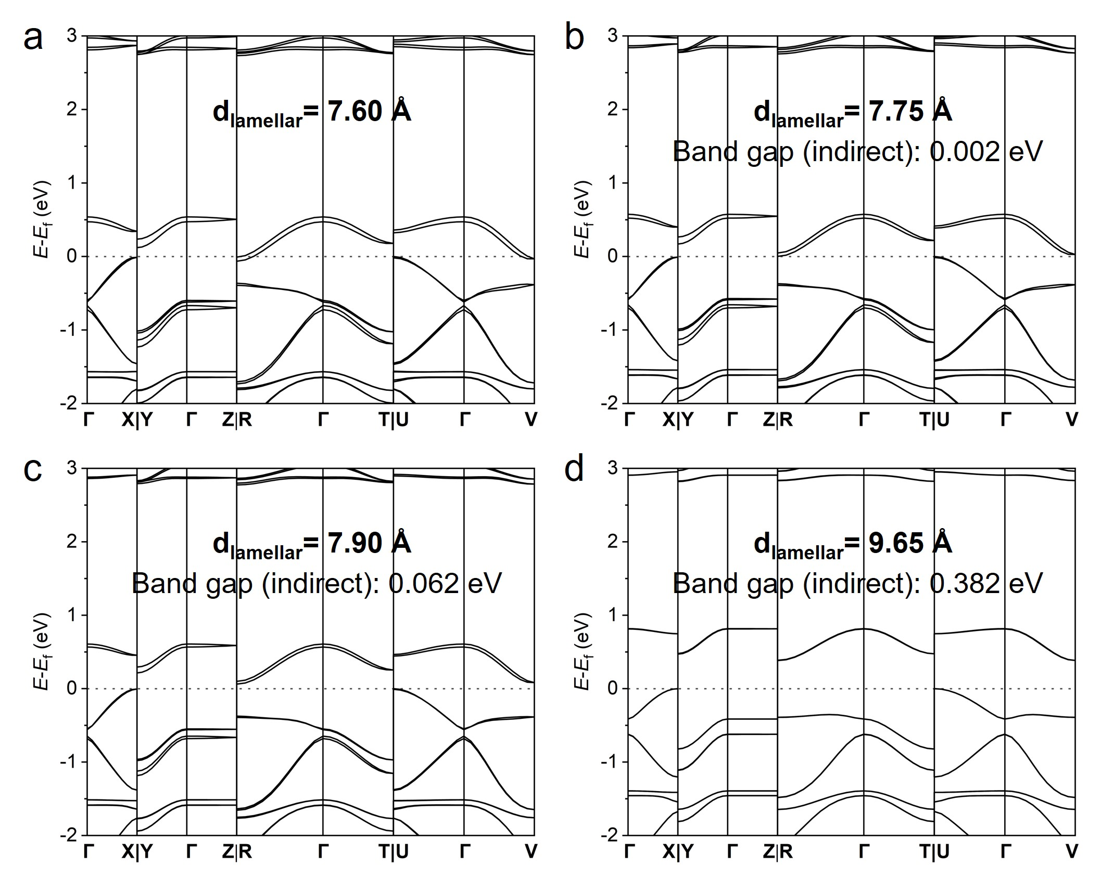
Fig. S18. Band structure diagram of PBFDO under different lamellar spacings at a π-π distance of 3.27 Å. a, Lamellar spacing: 7.60 Å. b, Lamellar spacing: 7.75 Å. c, Lamellar spacing: 7.90 Å. d, Lamellar spacing: 9.65 Å.

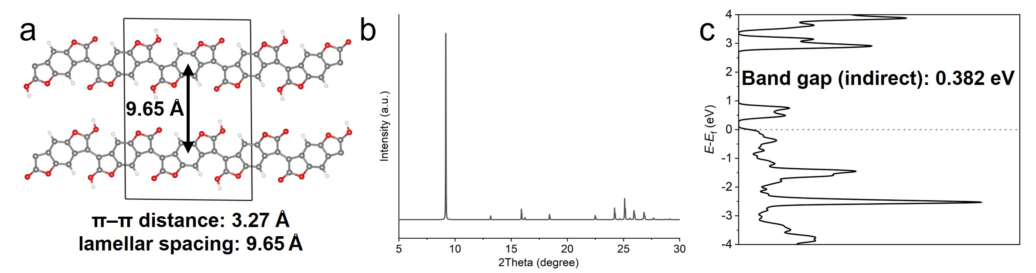
Fig. S19. Electronic structure for a lamellar distance of 9.65 Å and π-stacking of 3.27 Å in agreement with XRD. a, Molecular structure diagram. b, Simulated XRD. c, Density of states diagram, showing an indirect band gap of 0.382 eV.

(5) References
1. Fink, J., Nücker, N., Scheerer, B. & Neugebauer, H. Investigation of thiophene-based conducting polymers by electron diffraction and by electron energy-loss spectroscopy. Synth. Met. 18, 163–168 (1987).
2. Ni, X., Li, H., Coropceanu, V. & Brédas, J.-L. Dimensionality-Dependent Electronic Properties of the Highly Conducting n-Type Polymer, Poly(benzodifurandione). ACS Mater. Lett. 6, 2569–2576 (2024).
3. Zeng, F. et al. Two-Dimensional Electron Transport in N-Type Conducting Polymers by Dication Exchange. J. Am. Chem. Soc. 148, 9358–9366 (2026).
4. Ni, X., Li, H. & Brédas, J.-L. Electronic and Magnetic Properties of Oligomers and Chains of Poly(benzodifurandione) (PBDF), A Highly Conducting n-Type Polymer. Chem. Mater. 35, 5886–5894 (2023).

