Cell Line | Source | Culture Medium | Tissue Classification | GRN-300:CQ
OVCAR4 | Gordon Mills | RPMI1640 10%FBS | Ovarian Cancer | 1:6
OVCAR8 | Gordon Mills | RPMI1640 10%FBS | Ovarian Cancer | 1:3
OC316 | Gordon Mills | RPMI1640 10%FBS | Ovarian Cancer | 1:3
SKOv3 | ATCC | RPMI1640 10%FBS | Ovarian Cancer | 1:4
IGROV1 | ATCC | RPMI1640 10%FBS | Ovarian Cancer | 1:7
EFO21 | ATCC | RPMI1640 10%FBS | Ovarian Cancer | 1:7
OVCAR5 | Gordon Mills | RPMI1640 10%FBS | Ovarian Cancer | 1:4
OVCAR3 | ATCC | RPMI1640 10%FBS | Ovarian Cancer | 1:3
Supplementary Tables

Supplementary Table 1: Characteristics and culture conditions of ovarian cancer cell lines

Supplementary Figures
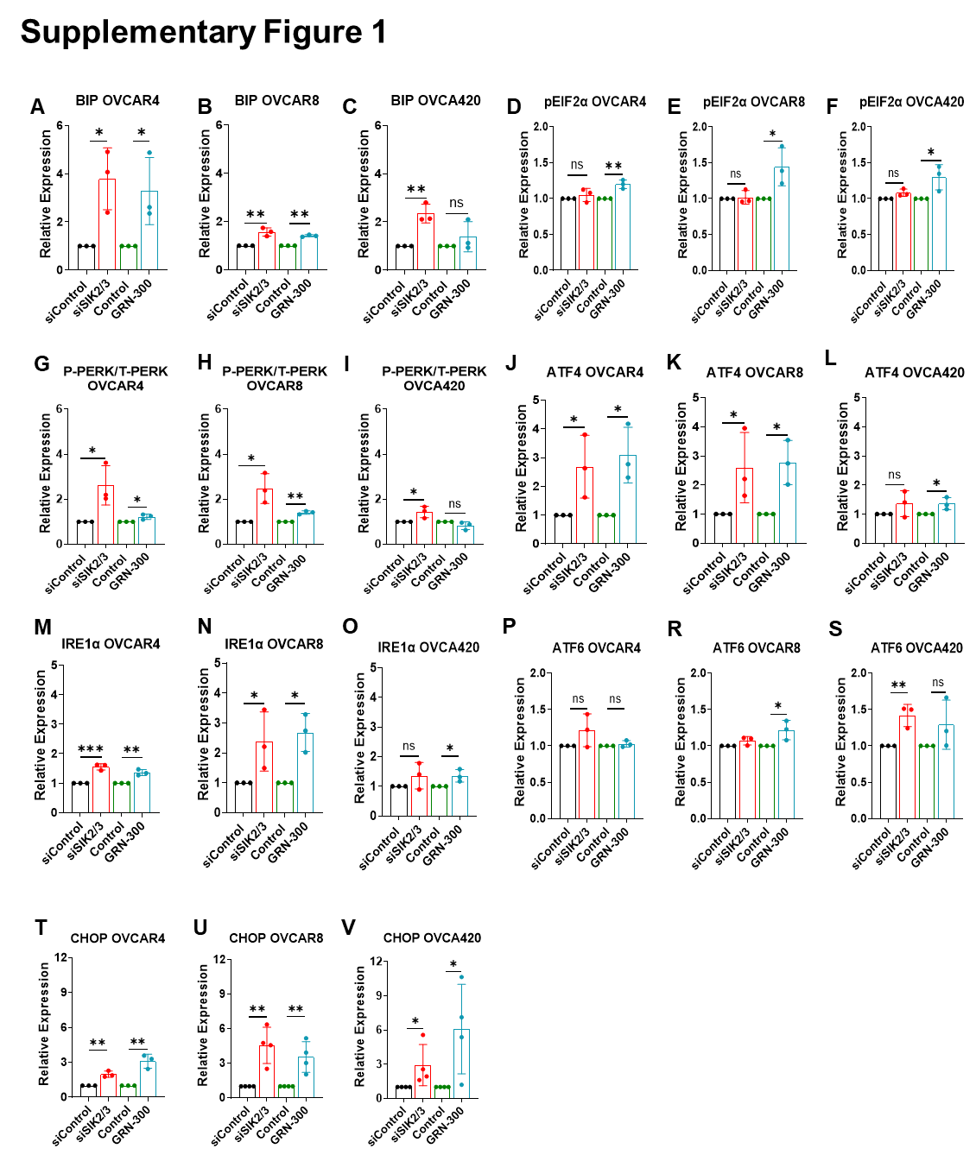
Figure S1. Quantification of the unfolded protein response components upon SIK2/SIK3 inhibition. Cells treated with GRN-300 or subjected to combined SIK2/SIK3 knockdown were analyzed by immunoblotting for UPR signaling components, including BIP (A-C), phosphorylated eIF2α (D-F), PERK (G-I), ATF4 (J-L), IRE1α (M-O), ATF6 (P-S) and CHOP (T-V). Protein levels were quantified using ImageJ, normalized to loading controls, and expressed relative to control conditions. All experiments were performed three times. Data are presented as mean ± SD. Statistical significance was determined by unpaired two-sided Student’s t-test; ns, p > 0.05; *p < 0.05; **p < 0.01; ***p < 0.001. Related to Figure 1H.

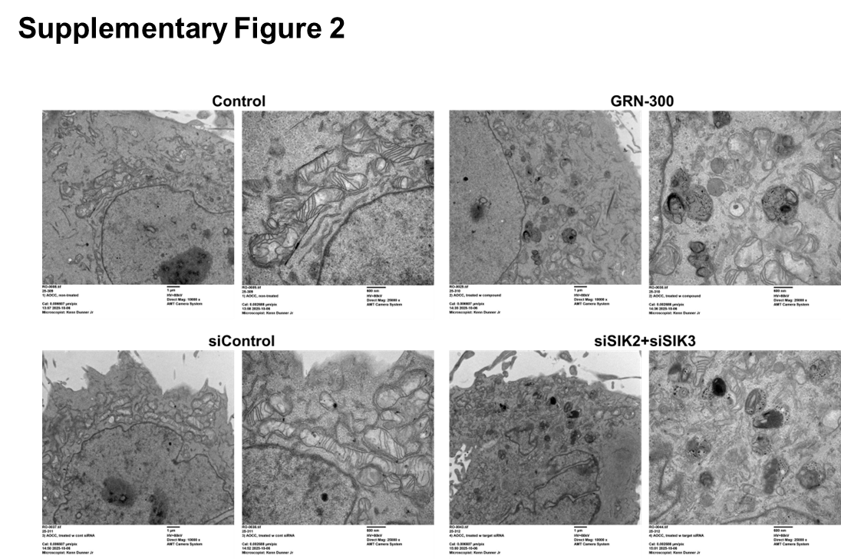

Figure S2. Autophagosome ultrastructure upon SIK2/SIK3 inhibition. Row data of transmission electron microscopy (TEM). OVCAR8 cells were treated with GRN-300 (2 µM) for 72 h or transfected with siRNAs targeting SIK2 and SIK3 for 72 h. Representative TEM images are shown. Scale bar: 1 µm. Related to Figure 2G-J.

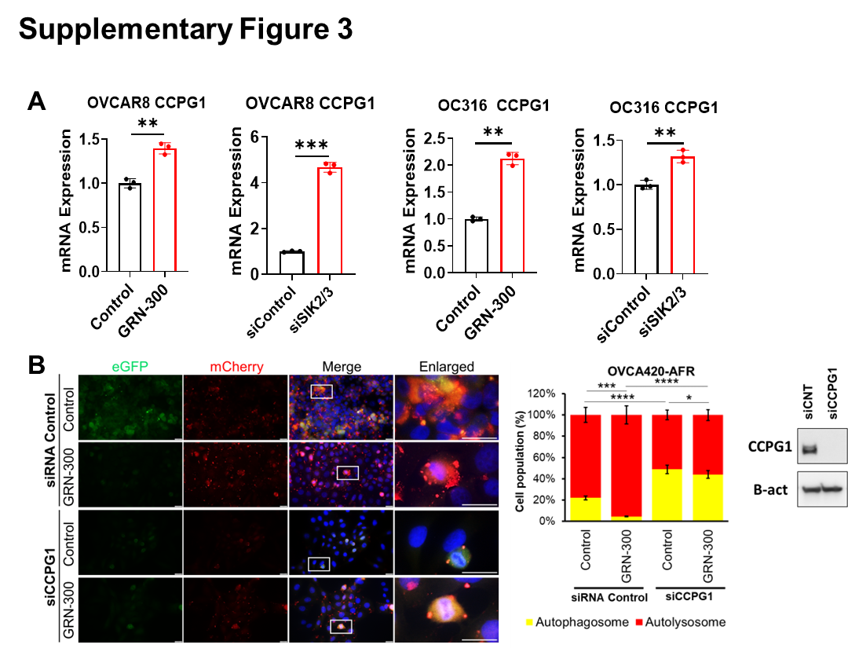
Figure S3. CCPG1 is required for GRN-300–induced autophagic flux. (A) RT-qPCR analysis of CCPG1 mRNA. OVCAR8 and OC316 cells were treated with the SIK2/3 inhibitor GRN-300 (2 µM,) for 72 h or transfected with siRNAs targeting SIK2 and SIK3 (35 nM) for 72 h. Samples were analyzed by RT-qPCR. The columns indicate the mean of relative fold-changes (calculated using the 2^–ΔΔCt method, with GAPDH serving as the internal reference gene) and the bars indicate the SD. Statistical significance was determined by unpaired two-sided Student’s t-test (**p < 0.001; ***p < 0.0001). Error bars represent SD. Experiments were repeated twice with similar results. (B) OVCAR8 ovarian cancer cells expressing the tandem mCherry–eGFP–LC3B reporter were transfected with control or CCPG1 siRNAs and treated with GRN-300 (2 µM). Statistical testing was performed from three independent high-power fields per condition using one-way ANOVA comparing the autolysosome (mCherry-LC3) signal between control and experimental groups; **p < 0.01, ****p < 0.0001 (scale bar, 50 µm). Error bars represent SD. Data represents 3 independent experiments. Related to Figure 3C-F.

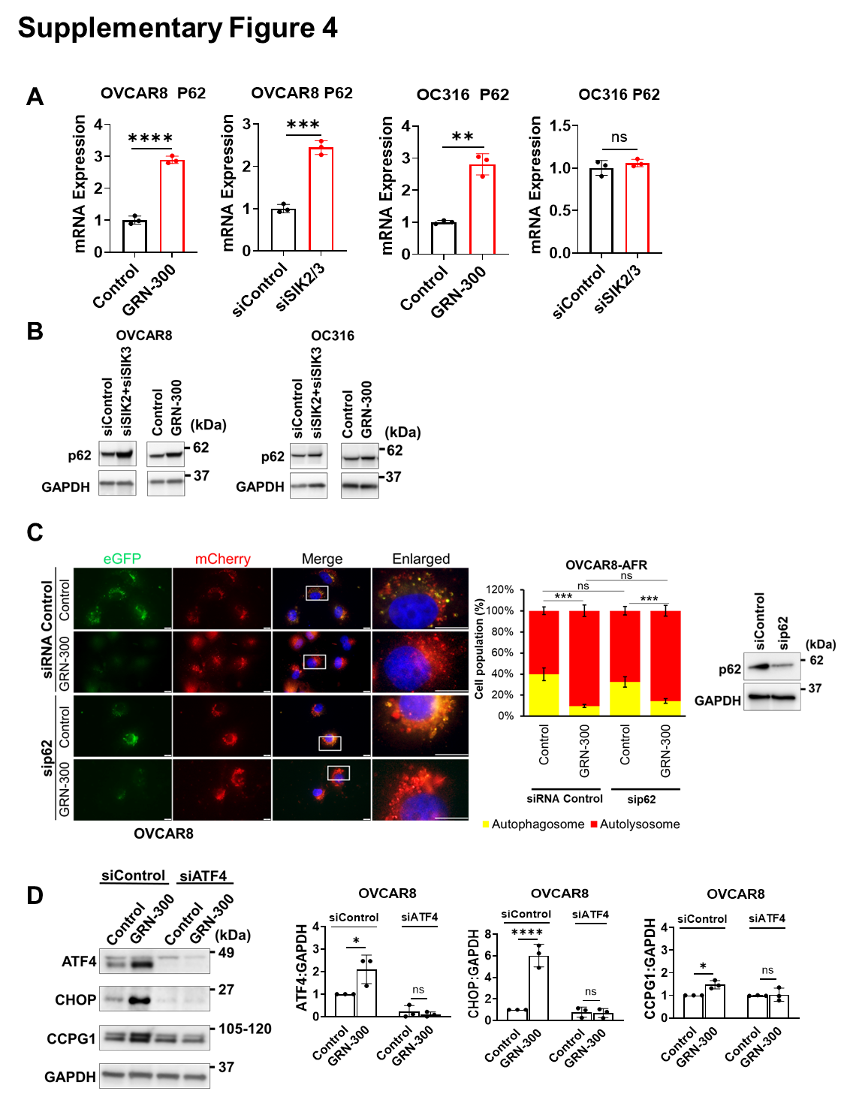
Figure S4. SIK2/3-mediated autophagic flux is not mediated by p62-driven bulk autophagy. (A) RT-qPCR analysis of p62 mRNA. OVCAR8 and OC316 cells were treated with the SIK2/3 inhibitor GRN-300 (2 µM) for 72 h or transfected with siRNAs targeting SIK2 and SIK3 (35 nM) for 72 h. Samples were analyzed by RT-qPCR. The columns indicate the mean of relative fold-changes (calculated using the 2^–ΔΔCt method, with GAPDH serving as the internal reference gene) and the bars indicate the SD. Statistical significance was determined by unpaired two-sided Student’s t-test (**p < 0.001; ***p < 0.0001). Error bars represent SD. Experiments were repeated twice with similar results. (B) Induction of the p62 following SIK2/SIK3 inhibition. OVCAR8 and OC316 cells were treated with GRN-300 (2 µM, 72 h) or transfected with siRNAs targeting SIK2 and SIK3 (35 nM, 72 h), and p62 protein levels were analyzed by immunoblotting (C) OVCAR8 ovarian cancer cells expressing the tandem mCherry–eGFP–LC3B reporter were transfected with control or p62 siRNAs and treated with GRN-300 (2 µM). Statistical testing was performed from three independent high-power fields per condition using one-way ANOVA comparing the autolysosome (mCherry-LC3) signal between control and experimental groups; ns p > 0.05, ***p < 0.001 (scale bar, 50 µm). Error bars represent SD. Data represents 3 independent experiments. Related to Figure 3E, 3F. (D) Regulation of CCPG1 expression by the PERK-ATF4 signaling axis. OVCAR8 ovarian cancer cells were transfected with control or ATF4 siRNAs and treated with GRN-300 as indicated. CCPG1 and ATF4 protein levels were analyzed by immunoblotting. Band intensities were quantified using ImageJ, normalized to loading controls, and expressed relative to control conditions. Experiments were repeated three times with similar results. Statistical significance was determined by unpaired two-sided Student’s t-test; ns: p > 0.05, *p < 0.05, **p < 0.01. Error bars represent SD. Related to Figure 3G-J.

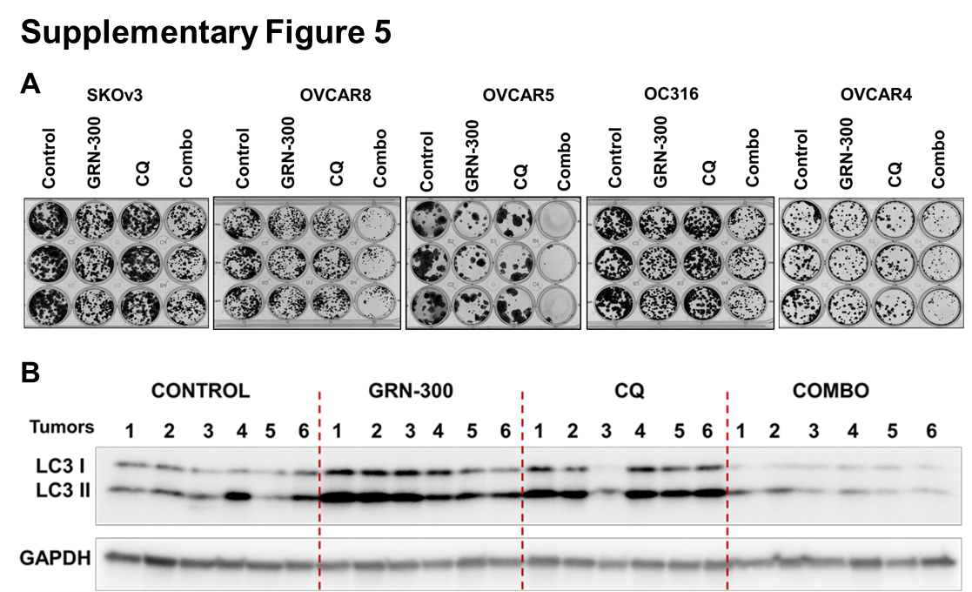
Figure S5. Combined GRN-300 and chloroquine treatment suppresses clonogenic growth and potentiates autophagy inhibition. (A) Triplicate images of clonogenic survival after treatment with GRN-300 and CQ. Ovarian cancer cells were treated with GRN-300 (2 µM), CQ (5 µM), or the combination as indicated, then replated at low density and cultured for 10–14 days. Colonies were fixed, stained, and quantified. Representative images are shown, and the colony area was normalized to control. Experiments were repeated three times with similar results. Statistical analysis was performed using one-way ANOVA; ns, p > 0.05; p < 0.05; *p < 0.01; **p < 0.001; ***p < 0.0001. Error bars represent SD. Related to Figure 4B-C. (B) Western blot analysis of OVCAR8 xenograft tumors. Tumors from six mice (n = 6) were collected after 40 days of treatment. Thirty micrograms of protein per sample were loaded, and blots were probed with the indicated antibodies.

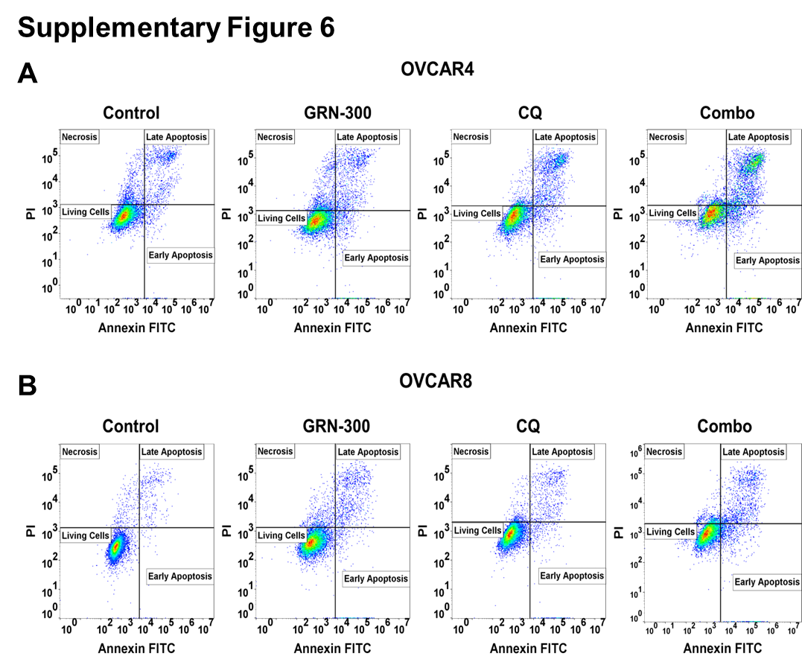
Figure S6. Representative flow cytometric analysis of apoptosis by Annexin V/PI staining. OVCAR4 (A) and OVCAR8 (B) cells were treated as described in Figure 6B and stained with Annexin V and propidium iodide (PI) to assess apoptotic cell death. Representative plots were generated using FlowJo software. Related to Figures 6E-G.

