Supplementary Information

Airport pavement roughness as an overlooked driver of aviation carbon emissions: global implications from Chinese airports

Supplementary Note 1. Airport dataset
Supplementary Note 2. Aircraft dataset
Supplementary Note3. Model validation
Supplementary Note 4. National-scale carbon emissions induced by pavement roughness
Supplementary Note5. Projection of carbon emissions across Chinese airports
Supplementary Note 6. Evolution of runway parameters at Shanghai Hongqiao International Airport
Supplementary Note7. Variation of aircraft fuel consumption coefficients with service age
Supplementary Note 8. CCI calculation framework and control standard
Supplementary Note 9. Economic assessment of runway maintenance strategies
Supplementary Note 10. Correlation analysis methodology
Supplementary Note 11. Carbon mitigation assessment for Shanghai Pudong International Airport
Supplementary Note 12. Emissions comparison between CCI- and IRI-based management
Supplementary Note 13. Comparison of runway roughness between US and Chinese airports
Supplementary Note 14. Coupled aircraft–runway dynamic model for energy consumption estimation

Supplementary Note 1. Airport dataset

1.1 Number of civil airports in China
A total of 237 civil airports were included as valid samples for the year 2019. The complete list of airports is provided in Table S1.1.
Table S1.1. Civil airports in China included in the 2019 analysis
Three-Letter Code | Airport Name | Three-Letter Code | Airport Name
AAT | Altay Xuedu Airport | LDS | Yichun Lindu Airport
ACX | Xingyi Wanfenglin Airport | LFQ | Linfen Yaodu Airport
AEB | Baise Bama Airport | LHW | Lanzhou Zhongchuan International Airport
AHJ | Aba Hongyuan Airport | LJG | Lijiang Sanyi International Airport
AKU | Aksu Hongqipao Airport | LLB | Qiannan Libo Airport
AOG | Anshan Teng'ao Airport | LLF | Yongzhou Lingling Airport
AQG | Anqing Tianzhushan Airport | LLV | Lüliang Dawu Airport
AVA | Anshun Huangguoshu Airport | LNJ | Lincang Bashang Airport
AXF | Alxa Left Banner Bayanhot Airport | LNL | Longnan Chengxian Airport
BAR | Qionghai Boao International Airport | LPF | Liupanshui Yuezhao Airport
BAV | Baotou Airport | LUM | Dehong Mangshi International Airport
BFG | Xilinhot Airport | LXA | Lhasa Gonggar International Airport
BFJ | Bijie Feixiong Airport | LYA | Luoyang Beijiao Airport
BHY | Beihai Fucheng Airport | LYG | Lianyungang Baitabu Airport
BPE | Beidaihe Airport | LYI | Linyi Qiyang Airport
BPL | Bole Alashankou Airport | LZH | Liuzhou Bailian Airport
BPX | Qamdo Bangda Airport | LZO | Luzhou Lantian Airport
BSD | Baoshan Yunrui Airport | LZY | Nyingchi Mainling Airport
BZX | Bazhong Enyang Airport | MDG | Mudanjiang Hailang International Airport
CAN | Guangzhou Baiyun International Airport | MIG | Mianyang Nanjiao Airport
CDE | Chengde Puning Airport | MXZ | Meizhou Meixian Airport
CGD | Changde Taohuayuan Airport | NAO | Nanchong Gaoping Airport
CGO | Zhengzhou Xinzheng International Airport | NAY | Beijing Nanyuan Airport
CGQ | Changchun Longjia International Airport | NBS | Baishan Changbaishan Airport
CHG | Chaoyang Airport | NDG | Qiqihar Sanjiazi Airport
CIF | Chifeng Yulong Airport | NGB | Ningbo Lishe International Airport
CIH | Changzhi Wangcun Airport | NGQ | Ngari Gunsa Airport
CKG | Chongqing Jiangbei International Airport | NKG | Nanjing Lukou International Airport
CSX | Changsha Huanghua International Airport | NLH | Ninglang Luguhu Airport
CTU | Chengdu Shuangliu International Airport | NLT | Xinyuan Nalati Airport
CWJ | Cangyuan Washan Airport | NNG | Nanning Wuxu International Airport
CZX | Changzhou Benniu International Airport | NNY | Nanyang Jiangying Airport
DAT | Datong Yungang International Airport | NTG | Nantong Xingdong International Airport
DAX | Dazhou Heshi Airport | NZH | Manzhouli Xijiao Airport
DBC | Baicheng Changan Airport | NZL | Zhalantun Genghis Khan Airport
DCY | Daocheng Yading Airport | OHE | Mohe Gulian Airport
DDG | Dandong Langtou Airport | PEK | Beijing Capital International Airport
DIG | Diqing Shangri-La Airport | PKX | Beijing Daxing International Airport
DLC | Dalian Zhoushuizi International Airport | PVG | Shanghai Pudong International Airport
DLU | Dali Fengyi Airport | PZI | Panzhihua Bao'anying Airport
DNH | Dunhuang Mogao International Airport | QSZ | Shache Yarkand Airport
DOY | Dongying Shengli Airport | RHT | Alxa Right Banner Badain Jaran Airport
DQA | Daqing Sartu Airport | RIZ | Rizhao Shanzihe Airport
DSN | Ordos Ejin Horo International Airport | RKZ | Xigazê Peace Airport
DTU | Wudalianchi Dedu Airport | RLK | Bayannur Tianjitai Airport
DYG | Zhangjiajie Hehua International Airport | RQA | Ruoqiang Loulan Airport
EJN | Ejina Banner Taolai Airport | SHA | Shanghai Hongqiao International Airport
ENH | Enshi Xujiaping International Airport | SHE | Shenyang Taoxian International Airport
ENY | Yan'an Nanniwan Airport | SHF | Shihezi Huayuan Airport
ERL | Erenhot Saiwusu International Airport | SJW | Shijiazhuang Zhengding International Airport
FOC | Fuzhou Changle International Airport | SQD | Shangrao Sanqingshan Airport
FUG | Fuyang Airport | SQJ | Sanming Shaxian Airport
FUO | Foshan Shadi Airport | SWA | Jieyang Chaoshan International Airport
FYJ | Fuyuan Dongji Airport | SYM | Pu'er Simao Airport
FYN | Fuyun Koktokay Airport | SYX | Sanya Phoenix International Airport
GMQ | Golog Maqin Airport | SZX | Shenzhen Bao'an International Airport
GOQ | Golmud Airport | TAO | Qingdao Jiaodong International Airport
GXH | Gannan Xiahe Airport | TCG | Tacheng Qianquan Airport
GYS | Guangyuan Panlong Airport | TCZ | Tengchong Tuofeng Airport
GYU | Guyuan Liupanshan Airport | TEN | Tongren Fenghuang Airport
GZG | Garzê Gesar Airport | TGO | Tongliao Airport
HAK | Haikou Meilan International Airport | THQ | Tianshui Maijishan Airport
HBQ | Haibei Qilian Airport | TLQ | Turpan Jiaohe Airport
HCJ | Hechi Jinchengjiang Airport | TNA | Jinan Yaoqiang International Airport
HDG | Handan Airport | TNH | Tonghua Sanyuanpu Airport
HEK | Heihe Aihui Airport | TSN | Tianjin Binhai International Airport
HET | Hohhot Baita International Airport | TVS | Tangshan Sannühe Airport
HFE | Hefei Xinqiao International Airport | TWC | Tumxuk Tangwangcheng Airport
HGH | Hangzhou Xiaoshan International Airport | TXN | Huangshan Tunxi International Airport
HIA | Huai'an Lianshui International Airport | TYN | Taiyuan Wusu International Airport
HJJ | Huaihua Zhijiang Airport | UCB | Ulanqab Jining Airport
HLD | Hulunbuir Hailar Airport | URC | Ürümqi Tianshan International Airport
HLH | Ulanhot Yilelite Airport | UYN | Yulin Yuyang Airport
HMI | Hami Yizhou Airport | WDS | Shiyan Wudangshan Airport
HNY | Hengyang Nanyue Airport | WEF | Weifang Airport
HPG | Shennongjia Hongping Airport | WEH | Weihai Dashuibo International Airport
HRB | Harbin Taiping International Airport | WGN | Shaoyang Wugang Airport
HSN | Zhoushan Putuoshan International Airport | WMT | Zunyi Maotai Airport
HTN | Hotan Kungang Airport | WNH | Wenshan Yanshan Airport
HTT | Haixi Huatugou Airport | WNZ | Wenzhou Longwan International Airport
HUO | Huolin Gol Huolinhe Airport | WSK | Chongqing Wushan Airport
HUZ | Huizhou Pingtan Airport | WUA | Wuhai Airport
HXD | Haixi Delingha Airport | WUH | Wuhan Tianhe International Airport
HYN | Taizhou Luqiao Airport | WUS | Wuyishan Airport
HZG | Hanzhong Chenggu Airport | WUT | Xinzhou Wutai Mountain Airport
HZH | Huizhou Pingtan Airport | WUX | Wuxi Shuofang Airport
INC | Yinchuan Hedong International Airport | WUZ | Wuzhou Xijiang Airport
IQM | Qiemo Yudu Airport | WXN | Wanzhou Wuqiao Airport
IQN | Qingyang Airport | XAI | Xinyang Minggang Airport
JDZ | Jingdezhen Luojia Airport | XFN | Xiangyang Liujia Airport
JGD | Greater Khingan Range Oroqen Airport | XIC | Xichang Qingshan Airport
JGN | Jiayuguan Jiuquan Airport | XIL | Xilinhot Airport
JGS | Ji'an Jinggangshan Airport | XIY | Xi'an Xianyang International Airport
JHG | Xishuangbanna Gasa International Airport | XMN | Xiamen Gaoqi International Airport
JIC | Jinchang Jinchuan Airport | XNN | Xining Caojiabao International Airport
JIQ | Qianjiang Wulingshan Airport | XUZ | Xuzhou Guanyin International Airport
JJN | Quanzhou Jinjiang International Airport | YBP | Yibin Wuliangye Airport
JMJ | Lancang Jingmai Airport | YCU | Yuncheng Yanhu International Airport
JMU | Jiamusi Dongjiao Airport | YIC | Yichun Mingyueshan Airport
JNG | Jining Qufu Airport | YIE | Arxan Yiershi Airport
JNZ | Jinzhou Jinzhouwan Airport | YIH | Yichang Sanxia International Airport
JSJ | Jiansanjiang Shidi Airport | YIN | Yining International Airport
JUH | Chizhou Jiuhuashan Airport | YIW | Yiwu Airport
JUZ | Quzhou Airport | YKH | Yingkou Lanqi Airport
JXA | Jixi Xingkaihu Airport | YNJ | Yanji Chaoyangchuan International Airport
JZH | Jiuzhai Huanglong Airport | YNT | Yantai Penglai International Airport
KCA | Kuqa Qiuci Airport | YNZ | Yancheng Nanyang International Airport
KGT | Garzê Kangding Airport | YSQ | Songyuan Chaganhu Airport
KHG | Kashgar Layi International Airport | YTY | Yangzhou Taizhou International Airport
KHN | Nanchang Changbei International Airport | YUS | Yushu Batang Airport
KJH | Kaili Huangping Airport | YYA | Yueyang Sanhe Airport
KJI | Burqin Kanas Airport | YZY | Zhangye Ganzhou Airport
KMG | Kunming Changshui International Airport | ZAT | Zhaotong Airport
KOW | Ganzhou Huangjin Airport | ZHA | Zhanjiang Airport
KRL | Korla Licheng Airport | ZHY | Zhongwei Shapotou Airport
KRY | Karamay Guhai Airport | ZQZ | Zhangjiakou Ningyuan Airport
KWE | Guiyang Longdongbao International Airport | ZUH | Zhuhai Jinwan Airport
KWL | Guilin Liangjiang International Airport | ZYI | Zunyi Xinzhou Airport
LCX | Liancheng Guanzhaishan Airport

1.2 Runway pavement roughness data
Runway pavement roughness constitutes a primary input to the aircraft–runway energy consumption model. Roughness data were obtained using two general approaches: direct measurement and indirect characterization.Direct measurement methods acquire surface elevation profiles using physical instruments, including static surveying techniques, vehicle-mounted profilometers, and three-dimensional laser scanning systems. These methods provide high-resolution geometric elevation data of the runway surface. Indirect characterization methods are represented by the International Roughness Index (IRI), which estimates pavement roughness conditions through mathematical filtering models applied to longitudinal profile data. The technical principles, data processing procedures, and applicability of these two approaches are described below.

1.2.1 Three-dimensional direct roughness measurement
Laser profilometer combined with BeiDou satellite positioning
Short-wavelength runway roughness (wavelength < 15 m) was measured using a vehicle-mounted laser profilometer. However, such systems inherently filter out long-wavelength components of surface geometry. To capture full-spectrum roughness, laser profilometer measurements were combined with high-precision BeiDou Navigation Satellite System (BDS) positioning to reconstruct long-wavelength elevation variations. In this approach, the laser distance sensor records the relative distance between the vehicle and the runway surface, while onboard accelerometers measure vehicle acceleration. Vehicle body vibrations are corrected through double integration to obtain short-wavelength surface roughness (Fig.S1.2a). Simultaneously, a mobile BDS receiver mounted on the test vehicle operates in real-time differential mode with a fixed airport base station to achieve fixed-solution positioning. The system outputs longitude, latitude, velocity, and absolute elevation at predefined sampling intervals. Current civil high-precision positioning systems achieve horizontal accuracy of approximately 1 mm and vertical accuracy of approximately 8 mm (Fig.S1.2b). Based on measurements from 21 survey lines, a three-dimensional runway elevation model was reconstructed (Fig.S1.3).
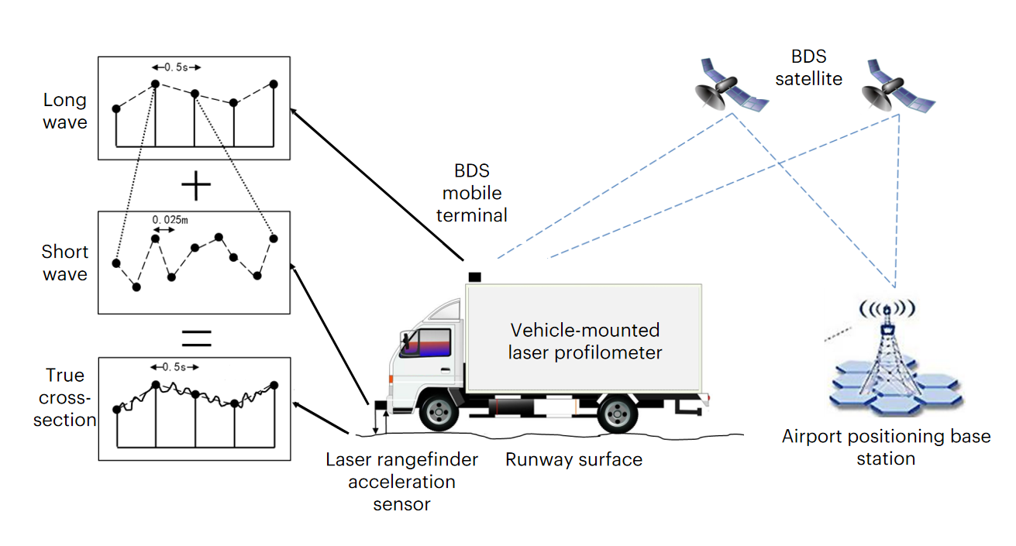
Fig.S1.1. Acquisition of absolute runway surface elevation.
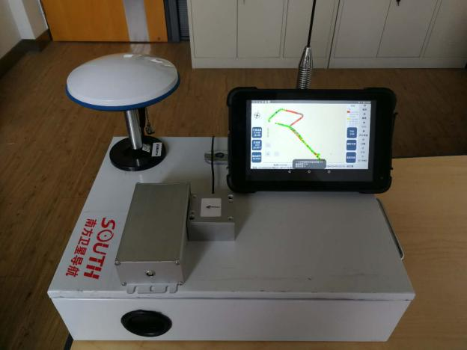
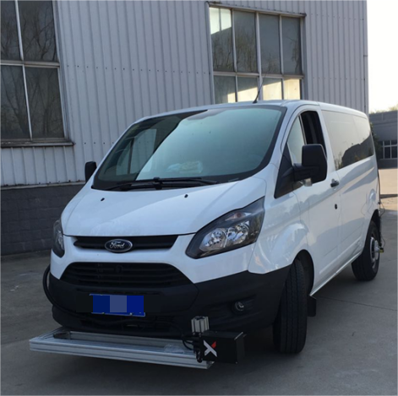
(a) Vehicle-mounted laser profilometer system.
(b) BeiDou Navigation Satellite System (BDS) positioning equipment.
Fig.S1.2. Runway roughness measurement system.

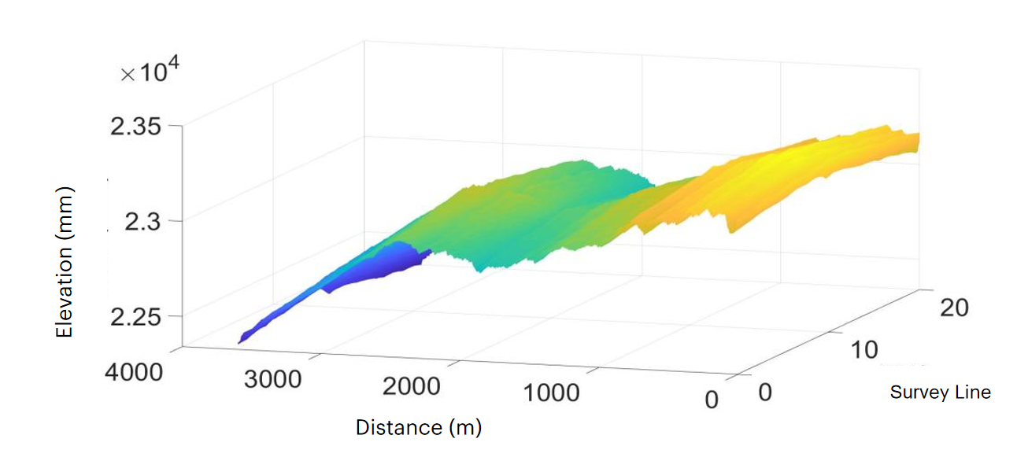
Fig.S1.3. Three-dimensional reconstruction of runway elevation.
Three-dimensional laser scanning for high-resolution roughness acquisition
To improve measurement efficiency and geometric fidelity, runway roughness was acquired using a three-dimensional laser scanning system (Fig.S1.4). The workflow comprised control surveying, multi-station scanning, point cloud registration, and standardized grid construction.
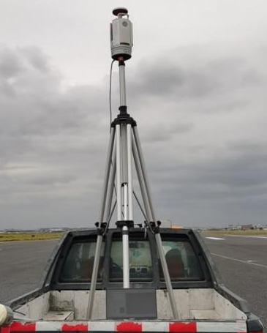
Fig.S1.4. Three-dimensional laser scanning system.
Control survey: Control measurements were conducted within the runway survey area using GNSS RTK to establish a geodetic reference framework (Fig.S1.5). The achieved positioning accuracy was: Horizontal accuracy: ±(8 +1.0×10⁻⁶×D) mm, Vertical accuracy: ±(15+1.0×10⁻⁶×D) mm. where D denotes the baseline distance in millimetres.
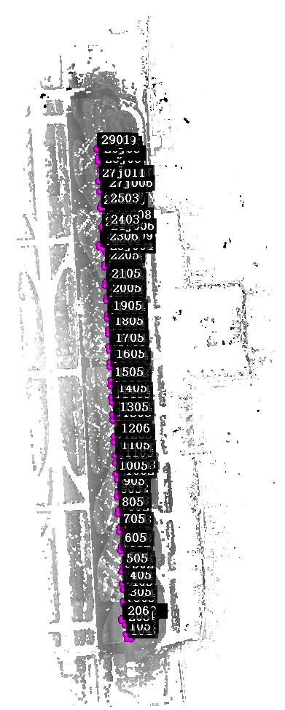
Fig.S1.5. Control survey results.
Multi-station scanning:For long runways exceeding the coverage of a single scan position, multi-station scanning was performed (Fig.S1.6). Scan station placement satisfied two conditions:Complete spatial coverage of the runway after point cloud registration;Sufficient overlap between adjacent stations to ensure accurate alignment. 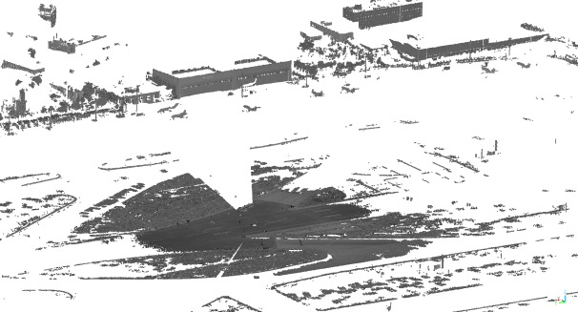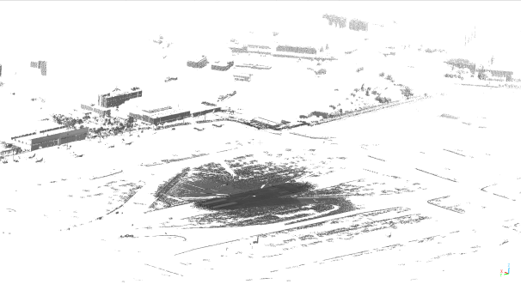
Fig.S1.6. Example of multi-station scanning data coverage.
Point cloud registration and processing:Point clouds were registered and fused based on control point accuracy constraints. The final registration error was controlled within twice the mean square error of control measurements (Fig.S1.7).
The fused dataset was then used to construct a standardized digital elevation model for roughness analysis.
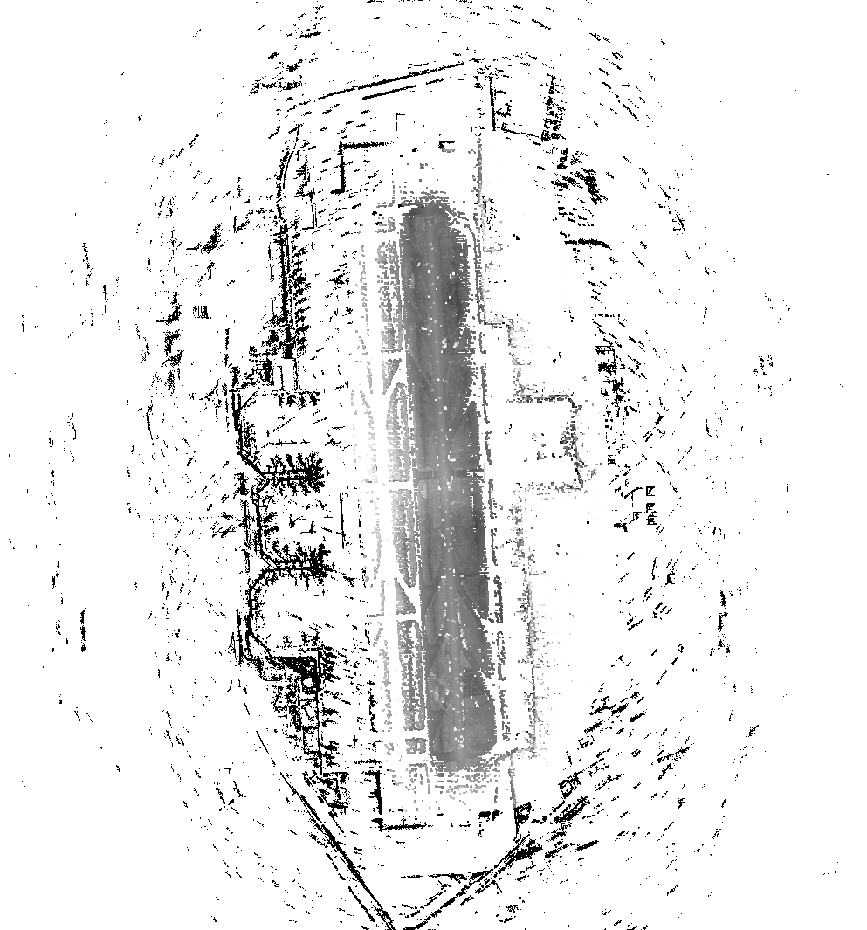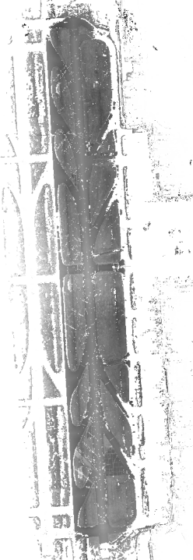
Fig.S1.7. Registered and fused point cloud dataset.
Standardized grid construction:Digital grids of 5 cm×5 cm and 10 cm×10 cm resolution were generated for subsequent roughness characterization. The three-dimensional standardized roughness grid of the runway at Shanghai Hongqiao International Airport is shown in Fig.S1.8¹.

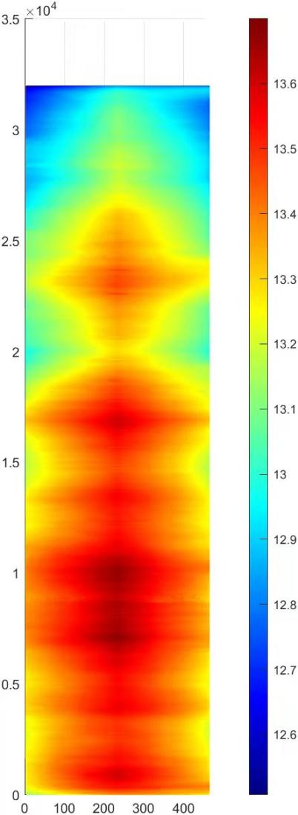
Fig.S1.8. Standardized three-dimensional roughness grid of the runway at Shanghai Hongqiao International Airport.

1.2.2 Statistical modelling and roughness reconstruction based on three-dimensional power spectral density
Based on directly measured three-dimensional elevation data, runway roughness was further characterized and modelled in the frequency domain using power spectral density (PSD) representations. Frequency-domain analysis of measured runway elevation datasets established a three-dimensional spectral modelling framework suitable for airport pavements.
Distinct spectral characteristics were observed for different pavement materials. Asphalt runways were adequately described using a Sussman-type spectral model, whereas concrete runways exhibited spectral discontinuities requiring piecewise representation. A transverse coherence function was additionally introduced to quantify the statistical correlation between longitudinal and transverse roughness components.
By combining the longitudinal PSD with the transverse coherence function, and incorporating transfer functions and stochastic reconstruction algorithms, three-dimensional roughness elevation fields were generated that satisfy the statistical properties of measured data. This modelling approach reduces reliance on high-density measurement datasets while preserving statistical consistency with observed roughness characteristics.
(1) Longitudinal power spectral density (PSD)
For asphalt runways, the roughness spectral model follows a Sussman-type formulation:
(S1.1)
where G_{d} denotes the power spectral density and 𝑛 represents the spatial frequency.
For concrete runways, a piecewise spectral model with a discontinuity at $n_{0}=0.1m^{−1 }$
was adopted:
$\left\{\begin{aligned}&G_{d}(n)=\frac{C_{1}}{α^{w_{1}}+n^{w_{1}}} ,n{<}n_{0} First paragraph \\ &G_{d}(n)=C_{2}n^{−w_{2}},n{≥}n_{0} Second paragraph\end{aligned}\right.$ (S1.2)
(2) Transverse coherence function
The transverse coherence function is fitted using:
$coh_{xy}(n{)}=ae^{−f\left(ρ\right)n}−a+1，f(ρ)>0$ (S1.3)
where a is the fitting coefficient and 𝜌 denotes the spacing between two survey lines.
The decay function is defined as $f(ρ)=b(ρ)^{c}$. The fitted parameter ranges are summarized in Table S1.2.
Table S1.2. Fitted parameter ranges of the transverse coherence function
a | b | c
0.81-0.89 | 5-17 | 0.46-0.53

(3) Three-dimensional roughness reconstruction
Three-dimensional roughness fields were reconstructed by combining the longitudinal PSD model with the transverse coherence function using a transfer-function-based stochastic reconstruction framework.
The longitudinal roughness of a single survey line was reconstructed via discrete Fourier transform (DFT). The transverse relationship between adjacent survey lines was formulated as an input–output system, in which the roughness of one survey line serves as the input and the adjacent line as the output.
The auto-power spectrum of the runway centreline is defined as $G_{xx}(w)$, The corresponding Fourier spectrum $F_{x}(w)$ is obtained from$G_{xx}(w)$. The frequency response function $H(w)$is derived from the fitted coherence function, yielding:
$F_{y}(w)=H(w)F_{x}(w)$ (S1.4)
Inverse Fourier transformation then provides the spatial-domain roughness profile for each survey line.
Assuming identical auto-power spectral densities for wheel tracks:
$G_{xx}(n{)}=G_{\text{yy}}(n{)}$ (S1.5)
the cross-power spectral density becomes:
$G_{xy}(n{)}=coh_{xy}(n{)}G_{xx}(n{)}$ (S1.6)
or in angular frequency form,
$G_{xy}(w)=coh_{xy}(w)G_{xx}(w)$ (S1.7)
According to random vibration theory:
$G_{xy}(w)=H(w)G_{xx}(w)$ (S1.8)
thus,
$\left|H(w)\right|=coh_{xy}(w)$ (S1.9)
A second-order transfer function was adopted:
$G_{21}(s{)}=\frac{W_{2}{(}s{)}}{W_{1}{(}s{)}}=\frac{a0+a_{1}(\operatorname{jw}{)}+a_{2}(\operatorname{jw}{)^{2}}+⋯+a_{n}(\operatorname{jw}{)^{n}}}{b0+b_{1}(\operatorname{jw}{)}+b_{2}(\operatorname{jw}{)^{2}}+⋯+b_{n}(\operatorname{jw}{)^{n}}}$ (S1.10)
where 𝑊₁(𝑠) and 𝑊₂(𝑠) denote the Laplace transforms of the input and output roughness profiles, respectively. The magnitude of the frequency response function is then given by:
$\left|H(w)\right|=G(jw)=\left|\frac{a_{0}+a_{1}(\operatorname{jw}{)}+a_{2}(\operatorname{jw}{)^{2}}+⋯+a_{n}(\operatorname{jw}{)^{n}}}{b_{0}+b_{1}(\operatorname{jw}{)}+b_{2}(\operatorname{jw}{)^{2}}+⋯+b_{n}(\operatorname{jw}{)^{n}}}\right|$ (S1.11)
where numerator and denominator coefficients were identified using a genetic algorithm. The objective function was defined as:
$\min{\sum_{i=0}^{n}{[|H(iw)−coh(iw)|]}}$ (S1.12)
subject to:
$|H(iw)−coh(iw)|<ε ε is a small positive number$ (S1.13)
As the coherence function accounts for wheel-track spacing, the reconstructed three-dimensional runway roughness model maintains general applicability².

1.2.3 Equivalent conversion from IRI to three-dimensional roughness
At the national scale, historical and routine runway roughness data are predominantly reported in terms of the International Roughness Index (IRI). IRI is a one-dimensional index derived from longitudinal elevation profiles using a quarter-car model and has long served as the standard metric for pavement condition management.
Although IRI does not explicitly contain spatial spectral information or transverse variability, it provides the only nationwide roughness dataset with consistent temporal coverage. An equivalent conversion between IRI and three-dimensional relative elevation fields was therefore established to integrate physical roughness mechanisms into national-scale emissions estimation.
A conversion framework was adopted in which the three-dimensional spectral model serves as the physical basis, and IRI acts as the constraint variable. Specifically, the established three-dimensional PSD model was used to back-calculate the corresponding IRI values, thereby constructing a quantitative mapping between IRI and longitudinal PSD parameters. Representative spectral parameters consistent with target IRI levels were then selected according to pavement type and runway classification. Combined with the transverse coherence function, three-dimensional roughness fields satisfying the prescribed IRI condition were reconstructed.
(1) Mapping between IRI and longitudinal PSD
The roughness index C characterizes the overall roughness level. Statistical analysis indicates a linear relationship between C and IRI for the same pavement type. The PSD shape parameters (α,ω) exhibit strong statistical stability within each pavement category. Accordingly, a single-variable mapping between IRI and PSD was constructed using C as the independent variable. Shape parameters were fixed at the modal values derived from measured datasets (Table S1.3).
Table S1.3. Fixed longitudinal PSD parameters
Pavement type | Parameter | Value
Asphalt | α | 0.0009
Asphalt | ω | 2.24
Concrete | α | 0.04
Concrete | ω₁ | 2.4
Concrete | ω₂ | 2.5

To establish the mapping between C and IRI, C was varied from 0.1 to 1.1 with increments of 0.1. A runway length of 1,400 m and an elevation sampling interval of 0.25 m were adopted. Longitudinal elevation profiles were reconstructed within the wavelength range 0.5–120 m using the discrete Fourier transform method described in Section 1.2. Each reconstructed elevation profile was processed in ProFAA to compute segmental IRI values over 100 m intervals and the mean IRI over the entire runway. Regression analysis between C and IRI yielded:

$\text{IRI}=5.324C^{0.5}$ (S1.14)
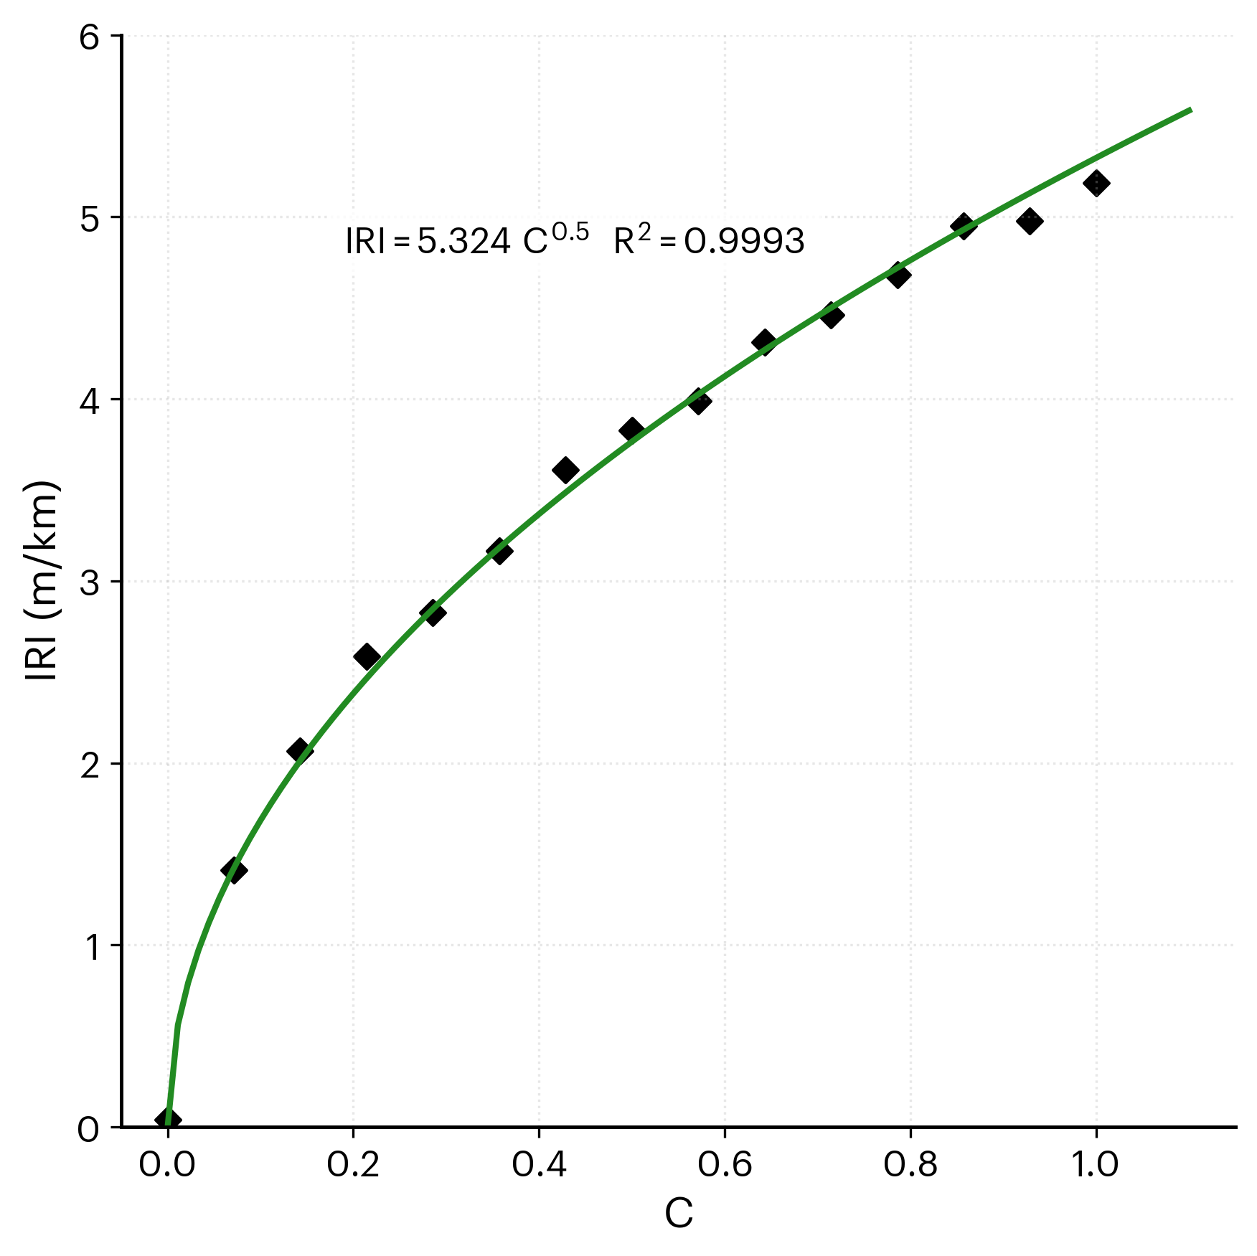
Fig.S1.9. Regression between longitudinal PSD parameter 𝐶 and IRI.
(2) Three-dimensional roughness reconstruction under IRI constraint
Given a target IRI value, the corresponding longitudinal PSD roughness parameter C is first determined using Eq.(S1.14). With fixed PSD shape parameters (Table S1.3), the complete longitudinal power spectral density is obtained. For transverse characteristics, the coherence function coh_{xy} captures the physical constraints imposed by pavement construction characteristics and wheel-track spacing. Fixed representative parameter values were adopted (Table S1.4).
Table S1.4. Fixed parameters of the transverse coherence model
Parameter | a | b | c
Value | 0.85 | 11.26 | 0.49

Based on the determined longitudinal PSD and transverse coherence function, the three-dimensional power spectral density matrix of the runway was constructed. The frequency-domain representation was then transformed into a spatial-domain three-dimensional elevation field using the reconstruction procedure described in Section 1.2, thereby generating an IRI-constrained three-dimensional runway roughness field.

1.2.3 Pavement roughness data sources used in this study
Pavement roughness data were compiled for approximately 80% of civil airports in China, including all 40 airports with annual passenger throughput exceeding 10 million. These airports account for approximately 90% of total national air traffic volume (Table S1.5). Due to data management regulations and archival practices, two primary data types were available: directly measured elevation profiles and International Roughness Index (IRI) records. In accordance with national airport pavement management standards, IRI serves as the recommended and routinely reported evaluation metric. Consequently, for most airports, long-term time series data are available in the form of IRI rather than raw elevation measurements. To ensure consistency across heterogeneous datasets, IRI values were converted into equivalent elevation-based roughness representations using the physically constrained mapping framework described in Section 1.2.3. For airports where both elevation and IRI data were available, the datasets were used for cross-validation and long-term trend analysis.
During multi-source data integration, high-resolution elevation datasets were adopted as the spatial reference baseline. Coordinate transformations and scale normalization were applied to achieve spatial alignment and maintain consistency in geometric accuracy and statistical properties across datasets. Due to data confidentiality constraints, the complete dataset cannot be publicly released. As a representative example, a 25-year roughness evolution dataset for Shanghai Hongqiao International Airport, covering multiple functional zones, is provided in Source Data 2.
Table S1.5. Summary of pavement roughness datasets across Chinese airports
Airport ID | Pavement Roughness Type | Data Collection Year | Airport ID | Pavement Roughness Type | Data Collection Year
1 | IRI | 2017 | 110 | IRI | 2015-2019
2 | IRI | 2019 | 111 | Elevation Data | 2017
3 | IRI | 2015-2023 | 112 | IRI | 2019
4 | Elevation Data | 2024 | 113 | IRI | 2020
5 | IRI | 2019 | 114 | IRI | 2018-2021
6 | IRI | 2017 | 115 | Elevation Data | 2009
7 | Elevation Data | 2008-2019 | 116 | Elevation Data | 2013-2024
8 | IRI | 2021 | 117 | IRI | 2021
9 | Elevation Data | 2018-2021 | 118 | IRI | 2016
10 | IRI | 2016 | 119 | IRI | 2008-2018
11 | Elevation Data | 2014 | 120 | IRI | 2022-2024
12 | IRI | 2017-2024 | 121 | IRI | 2006
13 | IRI | 2009-2018 | 122 | IRI | 2007
14 | IRI | 2012 | 123 | IRI | 2015
15 | IRI | 2007 | 124 | IRI | 2020
16 | Elevation Data、IRI | 2019 | 125 | IRI | 2019
17 | Elevation Data、IRI | 2009-2024 | 126 | IRI | 1999-2024
18 | IRI | 2011 | 127 | IRI | 2016
19 | Elevation Data | 2007 | 128 | IRI | 2017
20 | IRI | 2010-2017 | 129 | Elevation Data、IRI | 2014
21 | IRI | 2022 | 130 | Elevation Data | 2018
22 | IRI | 2015 | 131 | IRI | 2021
23 | IRI | 2013 | 132 | IRI | 2019-2021
24 | IRI | 2014 | 133 | IRI | 2012
25 | Elevation Data | 2010 | 134 | IRI | 2020
26 | IRI | 2009-2021 | 135 | IRI | 2023
27 | IRI | 2016 | 136 | Elevation Data、IRI | 2019-2021
28 | IRI | 2018 | 137 | IRI | 2021
29 | IRI | 2002-2024 | 138 | Elevation Data | 2001-2024
30 | IRI | 2017-2019 | 139 | IRI | 1999-2021
31 | IRI | 2021 | 140 | IRI | 2015
32 | Elevation Data、IRI | 2015-2019 | 141 | IRI | 2018
33 | IRI | 2024 | 142 | IRI | 2014
34 | Elevation Data | 2021 | 144 | IRI | 2002-2012
35 | IRI | 2023 | 145 | IRI | 2010-2022
36 | Elevation Data、IRI | 2012 | 146 | IRI | 2004-2008
37 | IRI | 2014 | 147 | IRI | 2006-2020
38 | IRI | 2023 | 148 | IRI | 2013-2024
39 | IRI | 2011-2021 | 149 | IRI | 2000-2015
40 | IRI | 2018 | 150 | IRI | 2001-2017
41 | IRI | 2019 | 151 | Elevation Data、IRI | 2004-2018
42 | IRI | 2023 | 152 | IRI | 2012-2023
43 | IRI | 2016 | 153 | IRI | 2000-2010
44 | IRI | 2013 | 154 | IRI | 2007-2021
45 | Elevation Data | 2020-2024 | 155 | IRI | 2005-2019
46 | IRI | 2023 | 156 | IRI | 2003-2014
47 | IRI | 2018 | 157 | IRI | 2002-2016
48 | IRI | 2015 | 158 | IRI | 2011-2024
49 | Elevation Data | 2013-2024 | 159 | IRI | 2001-2013
50 | IRI | 2020-2024 | 160 | Elevation Data、IRI | 2008-2022
51 | IRI | 2017-2021 | 161 | IRI | 2004-2017
52 | IRI | 2024 | 162 | IRI | 2010-2023
53 | Elevation Data | 2013 | 163 | IRI | 2003-2011
54 | IRI | 2017 | 164 | IRI | 2003-2018
55 | IRI | 2015 | 165 | IRI | 2006-2020
56 | IRI | 2016-2018 | 166 | IRI | 2005-2016
57 | IRI | 2014 | 167 | IRI | 2009-2022
58 | IRI | 2012-2023 | 168 | IRI | 2002-2015
59 | Elevation Data | 2018 | 169 | Elevation Data | 2001-2014
60 | IRI | 2011-2023 | 170 | Elevation Data | 2001-2009
61 | IRI | 2020 | 171 | Elevation Data | 2005-2018
62 | IRI | 2017 | 172 | IRI | 2007-2021
63 | IRI | 2010 | 173 | IRI | 2007-2012
64 | IRI | 2019 | 174 | IRI | 2011-2024
65 | IRI | 2007 | 175 | IRI | 2004-2019
66 | IRI | 2016 | 176 | IRI | 2001-2010
67 | IRI | 2021 | 177 | Elevation Data | 2003-2017
68 | IRI | 2015 | 178 | Elevation Data | 2008-2021
69 | Elevation Data | 2022 | 179 | IRI | 2006-2020
70 | IRI | 2014 | 180 | IRI | 2001-2015
71 | IRI | 2005-2018 | 181 | IRI | 2013-2024
72 | IRI | 2006 | 182 | IRI | 2002-2016
73 | IRI | 2006-2022 | 183 | IRI | 2005-2018
74 | IRI | 2007-2019 | 184 | IRI | 1999-2011
75 | IRI | 2018 | 185 | Elevation Data | 2004-2019
76 | IRI | 2013 | 186 | IRI | 2010-2023
77 | IRI | 2020 | 187 | IRI | 2000-2014
78 | IRI | 2019 | 188 | IRI | 2007-2021
79 | IRI | 2012 | 189 | IRI | 2003-2017
80 | Elevation Data | 2006 | 190 | IRI | 2008-2022
81 | IRI | 2016 | 191 | IRI | 2001-2012
82 | IRI | 2015 | 192 | IRI | 2011-2024
83 | IRI | 2022 | 193 | IRI | 2005-2019
84 | IRI | 2021 | 194 | IRI | 2002-2013
85 | IRI | 2008-2018 | 195 | IRI | 2002-2016
86 | IRI | 2011 | 196 | IRI | 2009-2022
87 | IRI | 2017 | 197 | IRI | 2000-2010
88 | Elevation Data | 2007 | 198 | IRI | 2004-2018
89 | IRI | 2006 | 199 | IRI | 2007-2021
90 | IRI | 2014 | 200 | IRI | 2012-2023
91 | IRI | 2020 | 201 | IRI | 2000-2011
92 | IRI | 2018-2021 | 202 | IRI | 2003-2019
93 | IRI | 2019 | 203 | IRI | 2006-2020
94 | IRI | 2022 | 204 | IRI | 2001-2015
95 | IRI | 2013 | 205 | IRI | 2008-2022
96 | Elevation Data | 2010-2019 | 206 | IRI | 2001-2017
97 | IRI | 2009-2022 | 207 | IRI | 2010-2023
98 | IRI | 2016 | 208 | IRI | 2006-2012
99 | IRI | 2021 | 209 | IRI | 2005-2018
100 | IRI | 2015 | 210 | IRI | 2009-2021
101 | IRI | 2017 | 211 | IRI | 2008-2014
102 | Elevation Data、IRI | 2020 | 212 | IRI | 2002-2016
103 | IRI | 2014 | 213 | IRI | 2007-2020
104 | IRI | 2014 | 214 | IRI | 2005-2011
105 | IRI | 2014-2017 | 215 | IRI | 2004-2019
106 | IRI | 2016 | 216 | IRI | 2011-2024
107 | Elevation Data | 2012 | 217 | Elevation Data | 2003-2018
108 | IRI | 2010 | 218 | IRI | 2006-2022
109 | IRI | 2018-2020

1.3 Structural parameters for different runway classifications
Runway classification in civil aviation is defined according to aircraft wingspan and operational requirements and includes categories 4C, 4D, 4E and 4F. In coupled aircraft–runway simulations of taxiing-induced carbon emissions, representative structural material parameters were specified for each runway class. The structural model includes surface layer, base layer and subgrade. For each layer, Young’s modulus (𝐸), density (𝜌), Poisson’s ratio (𝜇), and Rayleigh damping coefficients (α,𝛽) were defined.
Across runway classifications, material types remain comparable; differences in parameter values primarily reflect structural design adjustments required to accommodate different aircraft loading levels. Higher classifications (4E and 4F) are designed for larger aircraft with higher wheel loads, resulting in correspondingly increased structural stiffness and load-bearing capacity relative to 4C runways.
Rayleigh damping coefficients do not follow a mandatory classification-based standard. Their values were selected based on national civil airport pavement design specifications (MH/T 5004–2010) and published experimental studies. The mass-proportional coefficient (𝛼) was determined with reference to the fundamental natural frequency of the pavement structure, while the stiffness-proportional coefficient (𝛽) was calibrated according to measured material damping ratios.
Table S1.6. Representative structural material parameters for different runway classifications
Structural Layer | Material Type | Parameter | 4C/4D Class Airports | 4E/4F Class Airports
Surface Layer | Cement Concrete | Young’s Modulus (MPa) | 36000 - 37000 | 37000 - 38000
 |  | Density (kg/m³) | 2400 - 2500 | 2500
 |  | Poisson’s Ratio | 0.15 | 0.15
 |  | Rayleigh Damping  α(s⁻¹) | 13.09 | 13.09 - 15
 |  | Rayleigh Damping β (s) | 0.00019 | 0.00015 - 0.00019
 | Modified Asphalt Concrete | Young’s Modulus (MPa) | 1200 - 1800 | 1500 - 2000
 |  | Density (kg/m³) | 2300 - 2400 | 2350 - 2400
 |  | Poisson’s Ratio | 0.2 - 0.25 | 0.2 - 0.25
 |  | Rayleigh Damping  α (s⁻¹) | 8-12 | 10-14
 |  | Rayleigh Damping β (s) | 0.0003 - 0.0005 | 0.0002 - 0.0004
Base Layer | Cement-Stabilized Macadam | Young’s Modulus (MPa) | 1200 - 1500 | 1500 - 1800
Density (kg/m³) | 1900 - 2000 | Density (kg/m³) | 1900 - 2000 | 2000 - 2100
 |  | Poisson’s Ratio | 0.25 | 0.25
 |  | Rayleigh Damping α (s⁻¹) | 5-8 | 7-10
 |  | Rayleigh Damping β (s) | 0.0005 - 0.0008 | 0.0004 - 0.0007
Subgrade | Compacted Improved Soil | Young’s Modulus (MPa) | 80 - 100 | 90 - 120
 |  | Density (kg/m³) | 1700 - 1800 | 1800 - 1900
 |  | Poisson’s Ratio | 0.35 | 0.3 - 0.35
 |  | Rayleigh Damping α  (s⁻¹) | 2-5 | 3-6
 |  | Rayleigh Damping β (s) | 0.001 - 0.002 | 0.0008 - 0.0015

References
- Liu, S., Tian, Y. & Hou, T. Stochastic Vibration Analysis of Aircraft–Runway Systems (in Chinese). Tongji University Press, Shanghai (2023).
- Liu S F, Mao K Y, Hou T X, Ling J M, Sun Z Y. Three-dimensional characteristics and spectral model of the roughness of airport runway surface[J]. Journal of Road Engineering, 2026.

Supplementary Note 2. Aircraft dataset

2.1 Aircraft movements across airports
Aircraft movement data were obtained from the OAG database. Each landing–takeoff event of a given aircraft type at a specific airport was counted as one statistical unit. Aircraft movement records for Chinese airports from 2017 to 2019 are provided in Source Data 1. Airports are identified using standard ICAO airport codes.

2.2 Aircraft-specific parameters
(1) Aircraft taxiing speed data were obtained from the aviation data platform Aerocorner (https://aerocorner.com/aircraft/).For aircraft variants without explicitly reported taxiing speeds, equivalent substitution was performed based on airframe configuration similarity and mass equivalence principles. The following substitutions were adopted:A320 used for A320 (Sharklets); A321 for A321 (Sharklets);B737 for B737-200; B737-300 for B737-300 (Mixed Configuration) and B737-300 (Winglets);B737-800 for B737-800 (Winglets);B737-900 for B737-900ER (Winglets);B777-300 for B777-300ER;B787 for B787-8 and B787-9.
(2)Pollutant emission data for the taxiing phase were obtained from the ICAO Aircraft Engine Emissions Databank (EEDB). For each aircraft type, emission indices corresponding to unit fuel mass (kg) were extracted for: hydrocarbons (HC), carbon monoxide (CO), carbon dioxide (CO₂), nitrogen oxides (NOₓ), non-volatile particulate matter (nvPM). Emission indices were converted into energy-based emission factors (g /MJ) using aircraft-specific fuel efficiency parameters through standardized unit conversion procedures.
For aircraft types not directly listed in the EEDB, equivalent emission factors were assigned based on technological lineage, engine configuration similarity, and operational comparability. The following substitutions were applied: B717-200 for B727;B737-300 (Mixed Configuration) for B737-200;B737-500 for B737-400 (Mixed Configuration) and B737-600;B777-300 for B777;
B737 for McDonnell Douglas MD-88;B747 for B747-400.
The resulting energy-based emission factors for all aircraft types are summarized in Table S2.1.
Table S2.1. Aircraft operational and emission parameters used in this study
aircraft type | V_{takeoff}(km/h) | V_{landing}(km/h) | M(kg) | HC  (g/MJ) | CO  (g/MJ) | NO_{x}  (g/MJ) | nvPM  (g/MJ) | CO₂  (g/MJ)
A319 | 268.54 | 240.76 | 75500 | 0.002311 | 0.018489 | 0.455281 | 0.836607 | 73.029813
A320 | 290.76 | 253.72 | 77000 | 0.000925 | 0.006241 | 1.143782 | 0.041609 | 73.046694
A320（Sharklets） | 290.76 | 253.72 | 79015 | 0.000925 | 0.006241 | 1.143782 | 0.041609 | 73.046694
A320neo | 292.62 | 253.72 | 79015 | 0.000925 | 0.006241 | 1.143782 | 0.041609 | 73.046694
A321 | 290.76 | 259.28 | 93500 | 0.000462 | 0.005315 | 0.588398 | 2.156228 | 73.029813
A321（Sharklets） | 290.76 | 259.28 | 97000 | 0.000462 | 0.005315 | 0.588398 | 2.156228 | 73.029813
A321neo | 290.76 | 259.28 | 97000 | 0.000462 | 0.005315 | 0.588398 | 2.156228 | 73.029813
A330 | 292.62 | 277.8 | 242000 | 0.000926 | 0.000926 | 0.723907 | 0.893312 | 73.131220
A330-200 | 327.8 | 259.28 | 230000 | 0.000926 | 0.000926 | 0.723907 | 0.893312 | 73.131220
A330-300 | 327.8 | 277.8 | 242000 | 0.000232 | 0.004872 | 0.825058 | 1.686775 | 73.317865
A350 | 296.32 | 287.06 | 316000 | 0.000000 | 0.011529 | 1.312197 | 1.002997 | 72.861425
A350-1000 | 327.8 | 287.06 | 316000 | 0.000000 | 0.011529 | 1.312197 | 1.002997 | 72.861425
A350-900 | 327.8 | 287.06 | 280000 | 0.000000 | 0.011529 | 1.312197 | 1.002997 | 72.861425
A380 | 327.8 | 259.28 | 590000 | 0.000000 | 0.009045 | 0.932282 | 1.470315 | 73.283859
Atratr 72 500 | 303.73 | 192.6 | 22800 | 0.000927 | 0.006954 | 0.586463 | 0.533148 | 73.249884
Atratr 72 600 | 303.73 | 192.6 | 22800 | 0.000927 | 0.006954 | 0.586463 | 0.533148 | 73.249884
Avro RJ70/RJ85/RJ100 | 303.73 | 253.72 | 43091 | 0.000000 | 0.018001 | 0.553196 | 14.043388 | 72.928687
B727 | 303.73 | 196.3 | 95100 | 0.000000 | 0.018001 | 0.553196 | 14.043388 | 72.928687
B737(Mixed Configuration) | 303.73 | 259.28 | 78472 | 0.001156 | 0.004160 | 1.487405 | 0.002311 | 73.029813
B737 | 303.73 | 277.8 | 70080 | 0.000924 | 0.003467 | 0.702334 | 0.000000 | 73.029813
B737-200 | 303.73 | 277.8 | 52390 | 0.000924 | 0.020800 | 0.409059 | 1.818812 | 73.029813
B737-300(Mixed Configuration) | 303.73 | 250.02 | 62820 | 0.000924 | 0.020800 | 0.409059 | 1.818812 | 73.029813
B737-300 (winglets) | 303.73 | 250.02 | 62820 | 0.000924 | 0.020800 | 0.409059 | 1.123180 | 73.029813
B737-300 | 303.73 | 250.02 | 62820 | 0.000924 | 0.020800 | 0.409059 | 1.123180 | 73.029813
B737-400(Mixed Configuration) | 303.73 | 257.43 | 68039 | 0.000924 | 0.020800 | 0.409059 | 1.123180 | 73.029813
B737-500 | 303.73 | 237.06 | 68000 | 0.000924 | 0.020800 | 0.409059 | 1.123180 | 73.029813
B737-600 | 251.87 | 240.76 | 65554 | 0.000924 | 0.020800 | 0.409059 | 1.123180 | 73.029813
B737-700 | 264.84 | 253.72 | 70080 | 0.002311 | 0.009244 | 0.584701 | 1.123180 | 73.029813
B737-800 (winglets) | 303.73 | 253.72 | 78472 | 0.002311 | 0.004622 | 0.665588 | 1.428241 | 73.029813
B737-800 | 303.73 | 253.72 | 78472 | 0.002311 | 0.004622 | 0.665588 | 1.428241 | 73.029813
B737-900 | 303.73 | 268.54 | 85139 | 0.002311 | 0.004622 | 0.714121 | 1.636238 | 73.029813
B737-900 ER winglets | 303.73 | 268.54 | 85139 | 0.000693 | 0.007164 | 0.553270 | 1.636238 | 73.029813
B747 | 320.4 | 261.13 | 386915 | 0.016207 | 0.011577 | 0.717759 | 0.808057 | 73.165085
B747-400 | 327.8 | 270.39 | 396890 | 0.016207 | 0.011577 | 0.717759 | 0.808057 | 73.165085
B757 | 292.62 | 259.28 | 99800 | 0.000736 | 0.002874 | 1.174247 | 0.343533 | 72.660382
B777 | 327.8 | 259.28 | 347815 | 0.000736 | 0.002874 | 1.174247 | 0.343533 | 72.660382
B777-300 | 327.8 | 275.95 | 299370 | 0.000736 | 0.002874 | 1.174247 | 0.343533 | 72.660382
B777-300ER | 327.8 | 275.95 | 263990 | 0.000690 | 0.002989 | 1.174293 | 0.342607 | 72.660382
B787 | 327.8 | 259.28 | 351535 | 0.000463 | 0.007415 | 0.399041 | 0.038374 | 73.227030
B787-8 | 327.8 | 259.28 | 254011 | 0.000000 | 0.009922 | 1.063683 | 1.271343 | 72.911860
B787-9 | 327.8 | 259.28 | 254011 | 0.000000 | 0.009922 | 1.063683 | 1.271343 | 72.911860
Bombardier CRJ200ER | 268.54 | 250.02 | 24041 | 0.001391 | 0.000000 | 0.261474 | 4.835420 | 73.249884
Canadair Regional Jet 900 | 268.54 | 253.72 | 24041 | 0.000463 | 0.014819 | 0.340131 | 0.624859 | 73.166412
Comac ARJ21-700 | 290.76 | 259.28 | 43500 | 0.000000 | 0.009922 | 1.063683 | 1.271343 | 72.911860
Embraer 190 | 268.54 | 253.72 | 51800 | 0.001625 | 0.018802 | 0.412721 | 1.207057 | 73.351903
Embraer 195 | 268.54 | 253.72 | 52290 | 0.001161 | 0.013695 | 0.433148 | 1.207057 | 73.351903
Embraer EMB-505 Phenom 300 | 268.54 | 253.72 | 8150 | 0.001161 | 0.013695 | 0.433148 | 1.207057 | 73.351903
McDonnell Douglas MD-88 | 268.54 | 240.76 | 72600 | 0.000924 | 0.003467 | 0.702334 | 0.000000 | 73.029813
Xian MA60 | 268.54 | 253.72 | 21800 | 0.001612 | 0.006197 | 0.480499 | 0.673729 | 72.948553
B737MAX 8 | 268.54 | 253.72 | 78472 | 0.000924 | 0.020800 | 0.409059 | 1.818812 | 73.029813

Supplementary Note 3. Model validation
Under operational conditions, roughness-induced increments in fuel consumption and carbon emissions during a single taxiing event are typically dominated by engine thrust modulation, acceleration–deceleration patterns, queueing and operational variability. Consequently, isolating roughness-induced excess emissions directly from total taxiing emissions through end-to-end emission measurements is not practically feasible.
Because the emission pathway in this study is governed by vibration-induced energy dissipation, model validation was conducted at the level of dynamic response rather than direct emissions. The credibility of excess energy and carbon estimates therefore depends on the model’s ability to reproduce measured aircraft vibration responses under realistic operating conditions.
Validation strategy
Validation was performed using runway datasets from Shanghai Hongqiao International Airport and Dongying Shengli Airport, with B737 aircraft serving as the observation platform. Two complementary data sources were employed:
(1) Onboard QAR (Quick Access Recorder) data: QAR data provide continuous records of key flight parameters and capture overall low-frequency dynamic characteristics during taxiing. However, due to storage and system constraints, the sampling frequency is limited to 16 Hz, restricting resolution of high-frequency vibration components.
(2) External high-frequency tri-axial accelerometer measurements：To obtain higher temporal resolution, a tri-axial accelerometer (sampling frequency up to 1000 Hz) was deployed. The sensor was securely mounted on a passenger seat armrest during taxiing to comply with flight safety regulations. Acceleration signals in the X, Y and Z directions were recorded simultaneously.
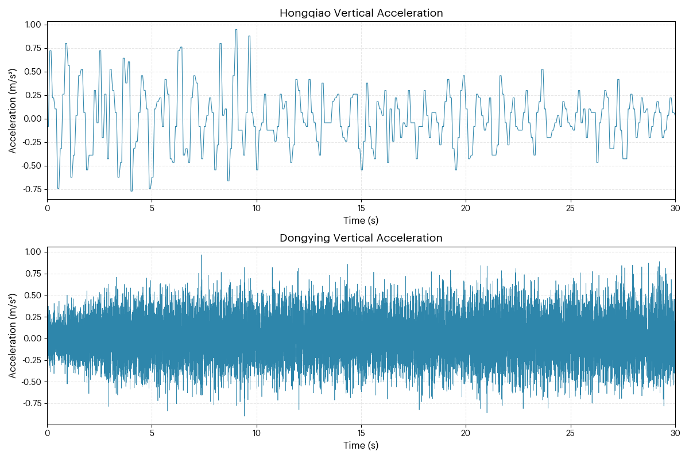
Fig.S3.1. Acceleration during landing and roll-out phase of the aircraft recorded by QAR data
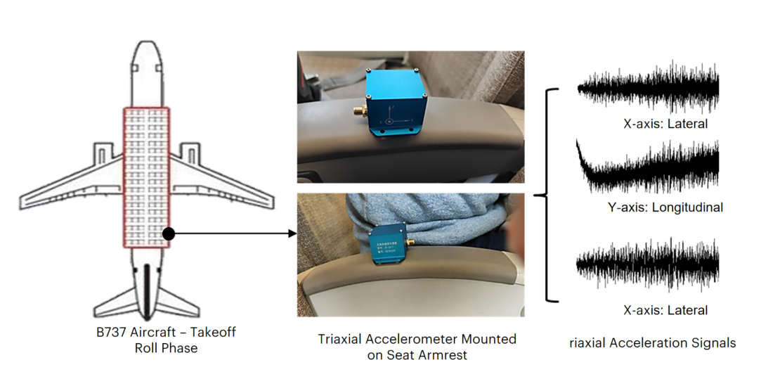
Fig.S3.2. Data Acquisition by External Sensors
Fig.S3.3. Acceleration during aircraft take-off roll phase
Simulation–measurement comparison
High-resolution runway elevation datasets (Fig.S3.4 and Fig.S3.5) were input into the coupled aircraft–runway dynamic model. Runway longitudinal geometry was reconstructed under a unified coordinate and scale framework and applied as external excitation to the coupled system. The resulting simulated acceleration time series were extracted for comparison.
To ensure comparability, simulated outputs were synchronized with measured signals in the time domain and resampled according to the sampling characteristics of each dataset. QAR data provided baseline low-frequency response trends, while high-frequency accelerometer data captured transient vibration features.
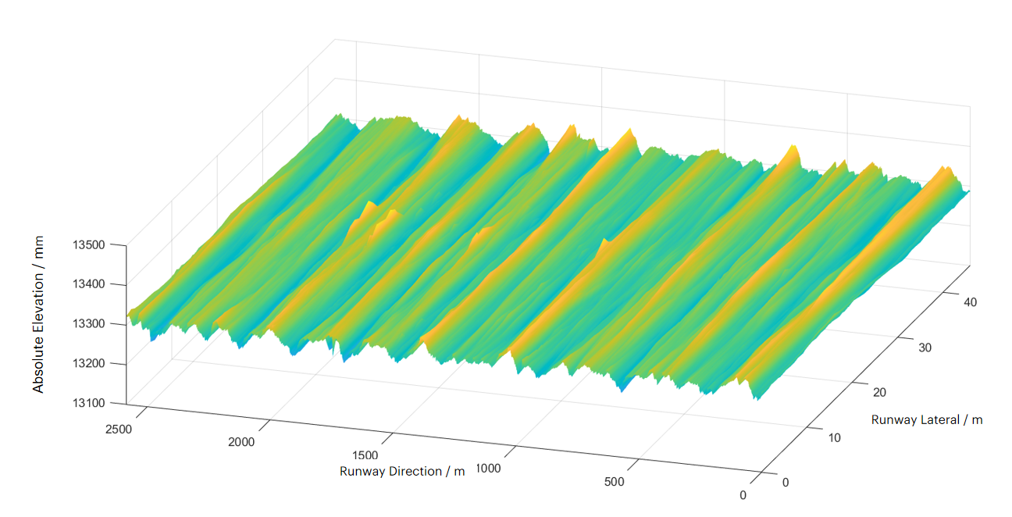
Fig.S3.4. Runway elevation profile of Shanghai Hongqiao International Airport.

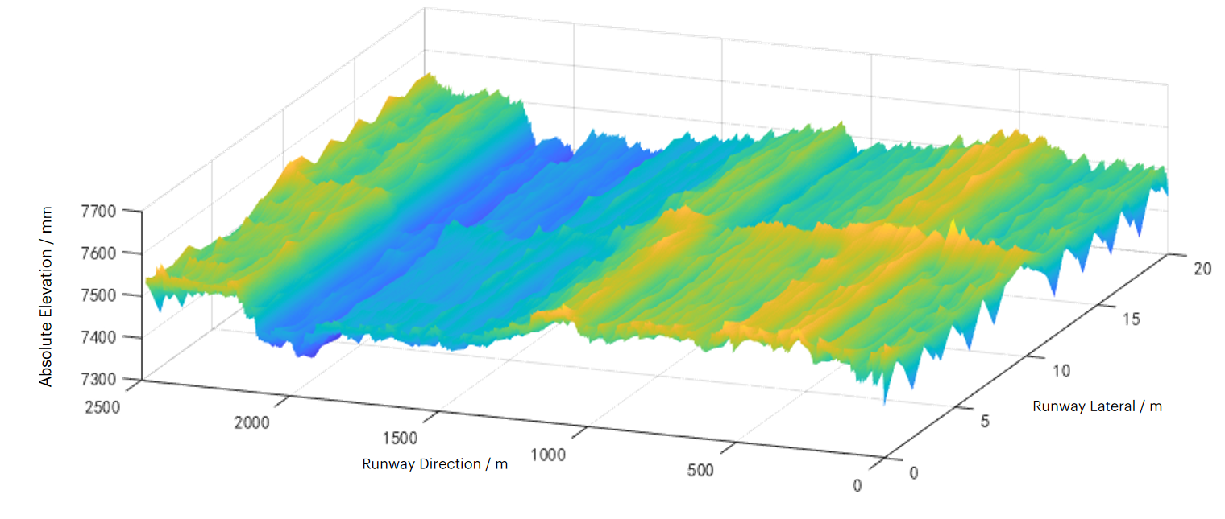
Fig.S3.5. Runway elevation profile of Dongying Shengli Airport.

Quantitative consistency assessment
Two sets of comparisons were performed: QAR-recorded acceleration versus simulated acceleration and external accelerometer acceleration versus simulated acceleration.
Time-domain feature matching and correlation analysis were conducted (Fig.S3.6). Across both airports and both measurement systems, simulated responses reproduced key statistical and structural characteristics of measured signals: (1) Peak acceleration amplitudes;(2) Dominant oscillation periods;(3) Root-mean-square (RMS) values. Relative deviations were below 11%.
Implications for energy-based emission estimation
The validation results demonstrate that the coupled aircraft–runway dynamic model reliably reproduces measured vibration responses across different runway geometries and measurement systems (QAR and high-frequency sensors).
Since excess fuel consumption and carbon emissions are derived from vibration-induced energy dissipation, accurate reconstruction of dynamic response provides indirect but physically grounded validation of the emission estimation pathway.
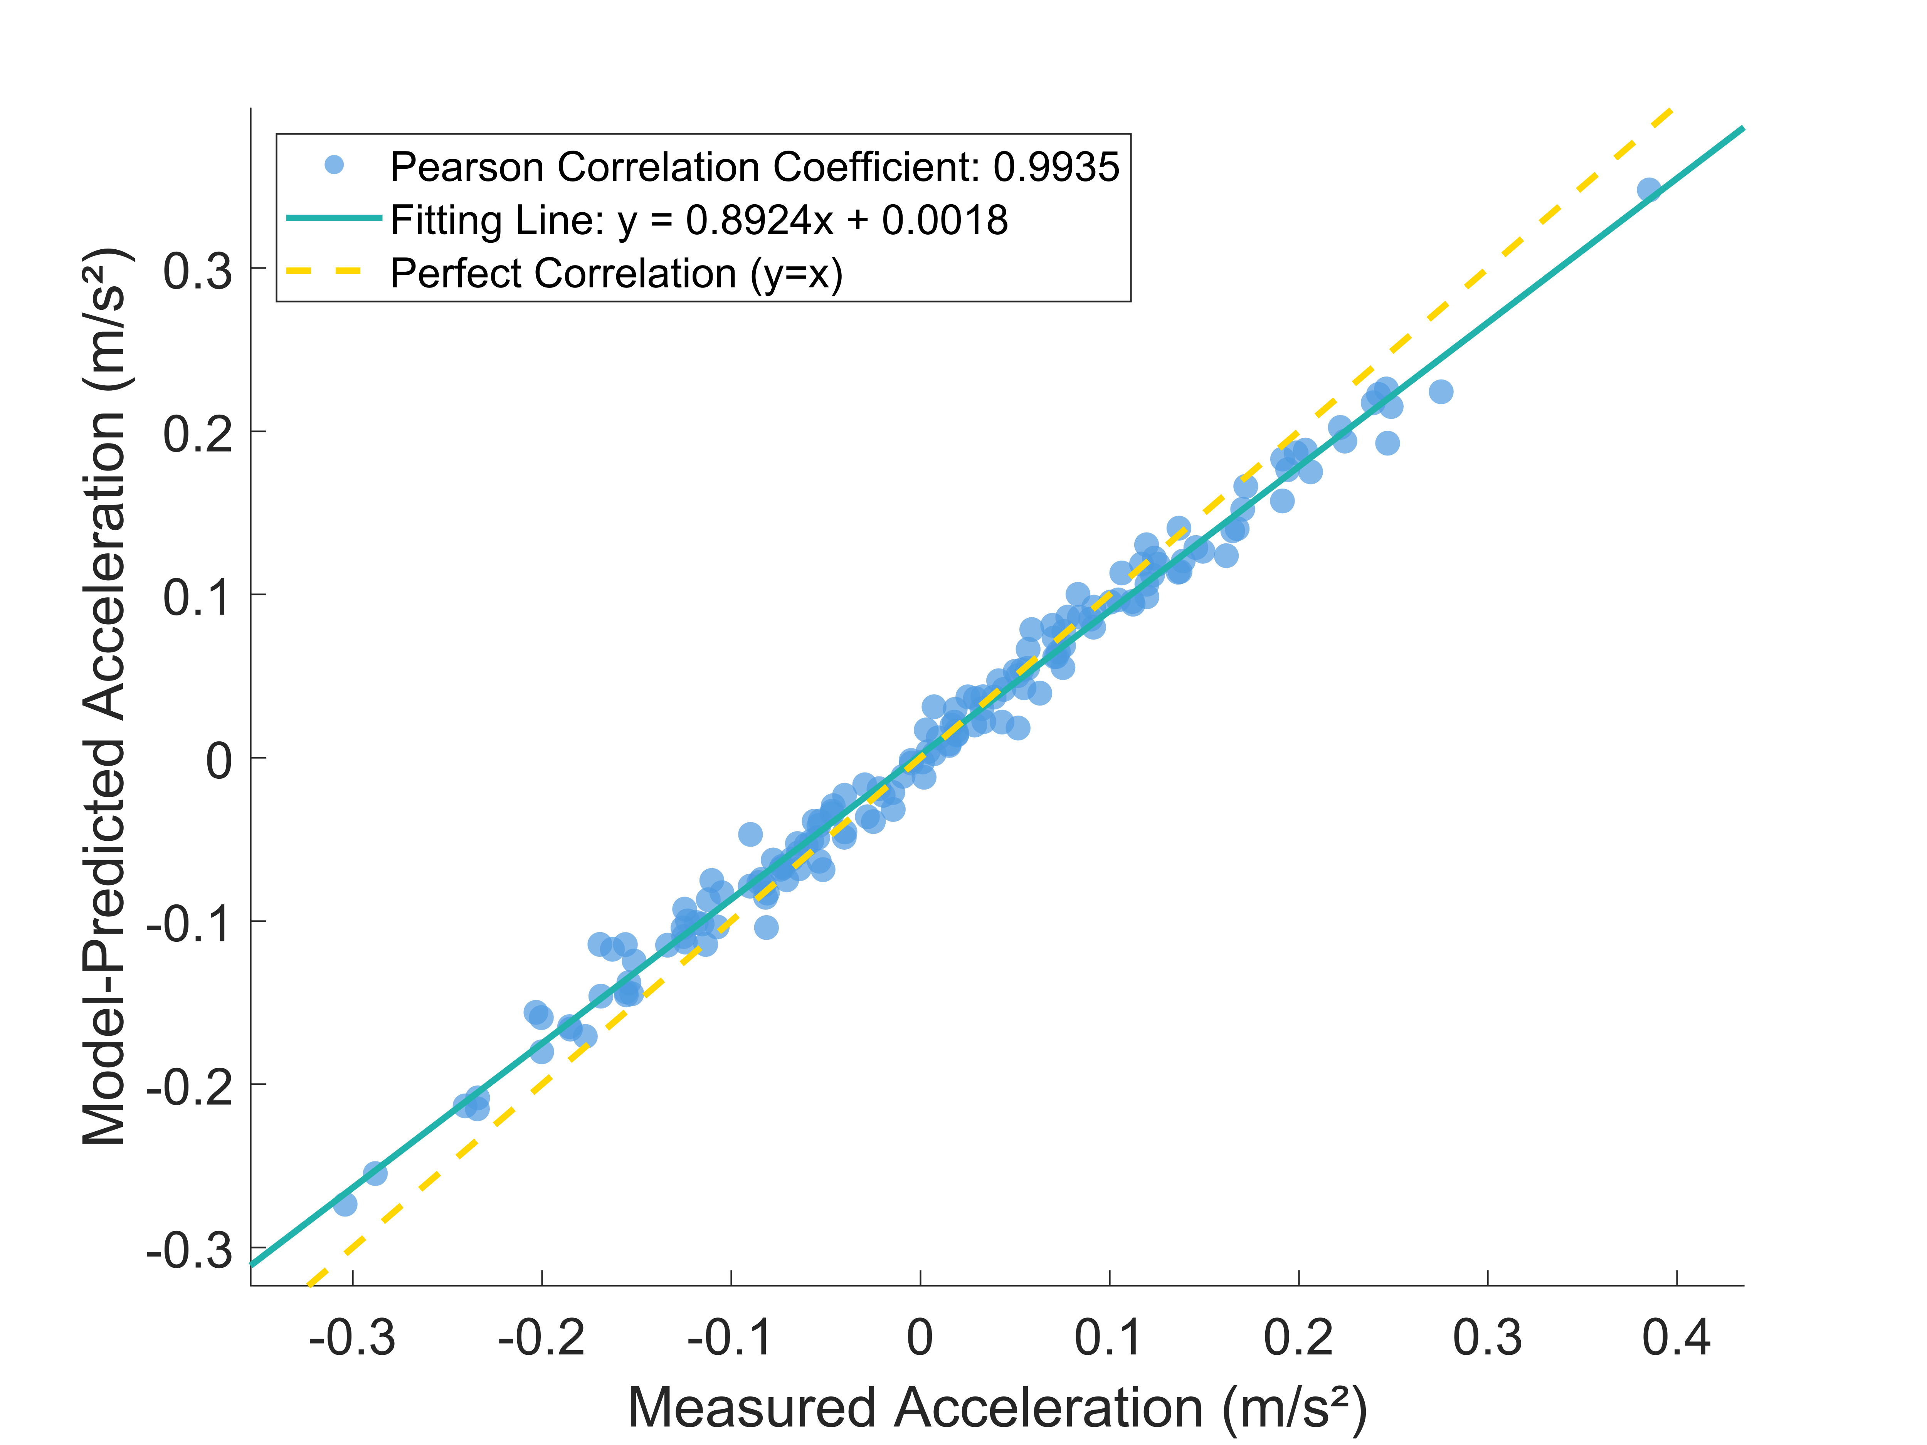
Fig.S3.6. Correlation analysis between measured and simulated acceleration responses.

Supplementary Note 4. National-scale calculation of roughness-induced carbon emissions

4.1 Computational framework
A standardized computational framework was established to quantify roughness-induced carbon emissions at the airport level. The basic accounting unit was defined as one airport in one calendar year. The workflow for a single accounting unit is illustrated in Fig.S4.1.
To generate the national emission inventory, this standardized procedure was iteratively applied to all sampled civil airports and all study years.
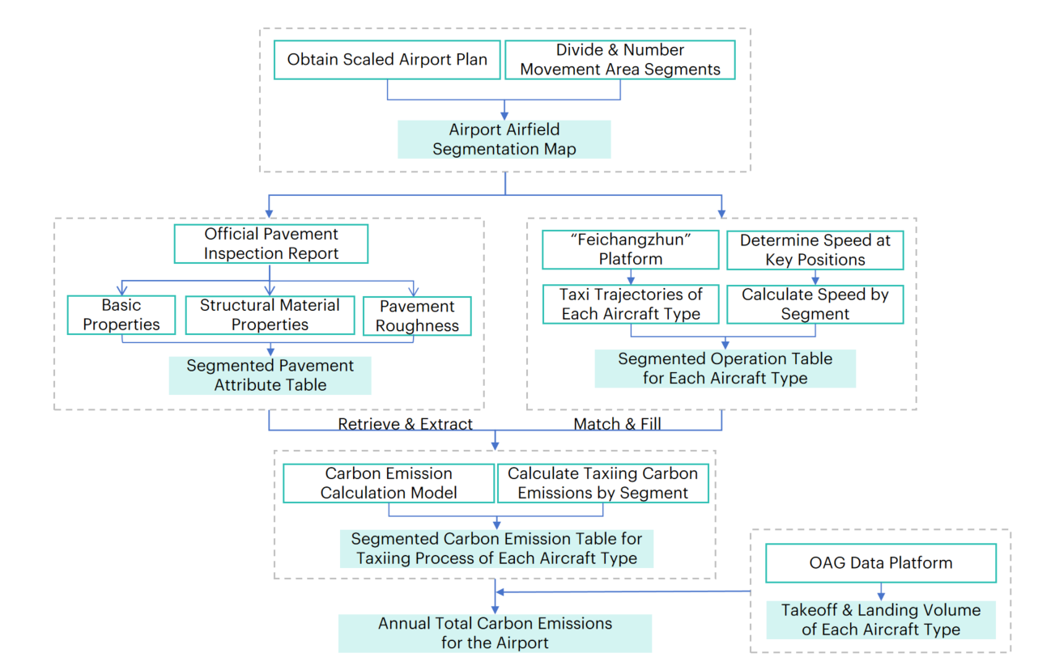
Fig.S4.1. Workflow for airport-level carbon emission calculation.
The framework consists of four sequential modules: spatial discretization, pavement parameterization, operational reconstruction, and coupled aggregation.
Step 1 Spatial discretization of airport movement areas
The continuous airport movement area was discretized into computational units.
(1) Base map processing
Airport layout drawings were digitized and imported into CAD software for spatial calibration.
(2) Segment division
The movement area was partitioned into grid segments with a standard length of 100 m. Adaptive segmentation (<100 m) was applied at functional transitions (e.g., runway–taxiway junctions) or structural discontinuities (e.g., asphalt–concrete interfaces).
(3) Unique indexing
Each segment was assigned a unique identifier, forming the spatial reference for linking pavement properties and aircraft operations.
Step 2 Pavement parameterization
For each segment, a static pavement attribute dataset was constructed using annual official pavement inspection reports.
(1) Attribute extraction
Structural and material parameters were assigned to each segment, including: segment length,
layer thicknesses, Young’s modulus, subgrade reaction modulus.
(2) Roughness assignment
Measured roughness data (IRI) were mapped to each segment. Where necessary, IRI values were converted into equivalent elevation-based representations using the method described in Supplementary Note 1.
(3) Data substitution
For years or airports with missing records, parameters were substituted based on:
runway classification consistency,
temporal proximity of construction period.
Replacement values were selected from airports with comparable structural design characteristics.
Step 3 Aircraft ground operation reconstruction
Dynamic operational inputs were reconstructed independently of pavement attributes.
(1) Trajectory reconstruction
High-resolution ADS-B data from the Feichangzhun platform were used to reconstruct taxiing trajectories during take-off and landing.
For each aircraft type, the sequence of traversed segments was identified.
(2) Speed determination
Reference operational speeds were assigned based on civil aviation engineering guidelines and ICAO recommendations:
standard taxiway speed: 50 km/h
rapid-exit taxiway speed: 90 km/h
Assuming uniform acceleration/deceleration, segment-level entry speeds and accelerations were calculated.
This procedure generated aircraft-type-specific segment operation tables.
Step 4 Coupled calculation and inventory aggregation
Static pavement attributes and dynamic aircraft operations were integrated at the segment level.
(1) Segment-level calculation: For each aircraft–speed–roughness combination, the coupled aircraft–runway model (Methods 2 and 3 in the main text) was invoked to compute vibration-induced energy dissipation and corresponding carbon emissions for each segment.
(2) Annual aggregation: Segment-level emissions per movement were multiplied by annual aircraft movement counts from the OAG database.
Summation across aircraft types yielded annual total emissions for each airport.
The procedure was repeated for all airports, producing the national-scale emission inventory.

4.2 Representative case: Shanghai Hongqiao International Airport (2019)
The national emission inventory includes 237 civil airports across a 30-year period. Given the scale of intermediate datasets, a representative airport is presented to illustrate the full implementation of the computational workflow described in Section 4.1.
Shanghai Hongqiao International Airport (2019) was selected as a demonstration case due to its structural and operational diversity. The airport exhibits:
(1) Multiple pavement types:Two runways comprising both asphalt concrete (flexible) and cement concrete (rigid) pavements;
(2) Diverse aircraft fleet composition:Aircraft movements in 2019 included a broad spectrum of aircraft classes, from regional jets to wide-body aircraft;
(3) Heterogeneous pavement history:Multiple rehabilitation and overlay stages resulting in spatially heterogeneous pavement zones.
These characteristics enable illustration of segment-level parameter assignment, aircraft–runway coupling, and aggregation procedures under complex operational conditions.

4.2.1 Spatial discretization of movement areas
The original airport layout drawings were digitized and geometrically calibrated using high-resolution satellite imagery and airport design documentation.
Following the segmentation principles defined in Section 4.1, the entire movement area was discretized into 413 computational units Fig.S4.2). Two rules governed the segmentation and indexing process:
(1) Spatial–functional indexing
Segments were indexed sequentially:
1) spatial order: north-to-south, west-to-east
2) functional hierarchy: runway→taxiway→connector→apron
Each segment was assigned a unique spatial identifier to enable linkage between pavement attributes and aircraft operations.
(2) Adaptive discretization strategy
Different discretization resolutions were applied according to functional characteristics:
- Runways and taxiways
Segmented at a standard 100 m interval (with adaptive adjustment at boundaries);
- Apron areas
Larger functional blocks were defined according to inspection and management zones,
reflecting structural homogeneity and low taxiing speeds in apron areas.
This strategy balances computational efficiency and spatial resolution without altering the physical coupling mechanism.

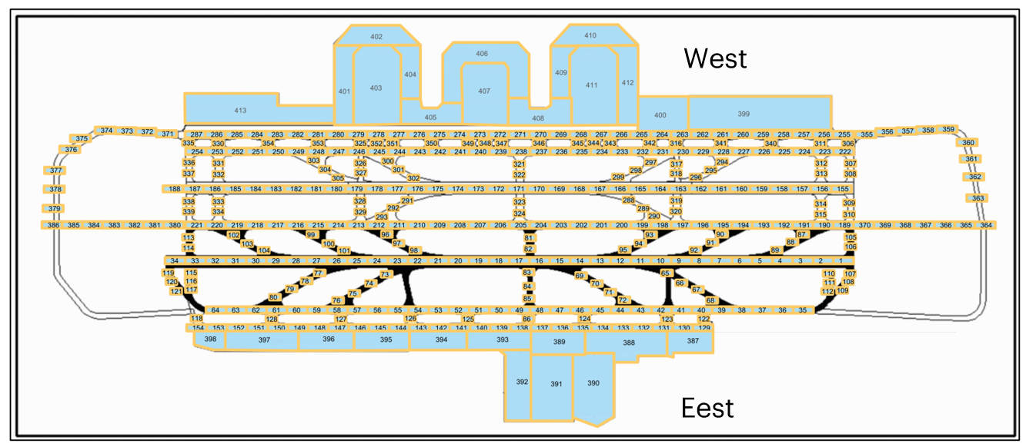
Fig. S4.2. Spatial segmentation and indexing of Shanghai Hongqiao International Airport movement areas (2019).

4.2.2 Pavement attribute matrix construction
Based on the 413 spatial segments defined in Section 4.2.1, a pavement attribute matrix was constructed for the entire movement area. The matrix includes four categories of parameters: inventory information (construction year, functional zone), structural configuration (layer surface/base/subbase composition, layer thickness, material type), mechanical properties (Young’s modulus of each layer, subgrade reaction modulus, California Bearing Ratio), surface functional indicator (roughness)
All input parameters were obtained from the Shanghai Hongqiao International Airport Apron Pavement System Testing and Evaluation Report (2019). The processed and matched attribute dataset is provided in Source Data 2.
Key components of the attribute matrix are presented below from three dimensions: construction chronology, structural mechanical properties, and roughness characteristics.

(1) Construction chronology
The pavement system at Shanghai Hongqiao International Airport was developed through multiple construction and rehabilitation phases. Construction years for major functional zones are summarized in Table S4.1.
Table S4.1. Construction timeline of selected movement-area zones at Shanghai Hongqiao International Airport
Part Location | Construction | Time
East runway | Southern End Section of Runway | 1992
East runway | Middle Area of Runway | 2011
East runway | Northern End Section of Runway | 1992
West runway | Total Length | 2010
Taxiway | Taxiway A | 1990
Taxiway | Taxiway B | 2010
Taxiway | Taxiway C | 2010
Rapid exit | Rapid exit A1–A4 (concrete) | 1990
Rapid exit | Rapid exit A1–A4 (asphalt overlay) | 2022
Rapid exit | Rapid exit B1–B6 (concrete) | 2010
Rapid exit | Rapid exit B1–B6 (asphalt overlay) | 2022
Rapid exit | Rapid exit B7–B8 | 2010
Rapid exit | Rapid exit C1–C4 | 2010
Connector | Connector D3–D17 | 2010
Connector | Connector H1–H7 | 2010
Connector | Connector T1 | 1990
Connector | Connector T6 | 1990
Connector | Connector H1 | 2010
Connector | Connector H4 | 2010
Connector | Connector H7 | 2010
Connector | Connector K0 | 1995
Connector | Connector K1 | 1995
Connector | Connector K2 | 1995
Connector | Connector K4 | 2018
Connector | Connector K5 | 2018
Connector | Connector K6 | 1995
Connector | Connector K7 | 1995

(2) Structural configuration and mechanical properties
For the coupled aircraft–runway dynamic model, the pavement structure was represented as three vertical functional layers: surface layer, base layer and subgrade. Physical and mechanical parameters were assigned separately for each layer.
- Surface layer
The surface layer directly interacts with aircraft tires and governs local contact deformation behavior. Parameters include structural configuration and mechanical properties.
(a) Structural configuration and thickness
Based on the 2019 inspection report, surface material type and layer thickness were extracted for each functional zone. Due to data confidentiality constraints, Table S4.2 presents representative, anonymized structural configurations.
(b) Mechanical properties
Mechanical parameters of surface materials were obtained from the 2019 field testing campaign conducted in accordance with: Technical Specification for Civil Airport Pavement Evaluation and Management (MH/T 5024–2019) and Technical Specification for Field Testing of Civil Airport Pavements (MH/T 5110–2015).
A total of 80 borehole core samples were collected across the movement area, followed by laboratory mechanical testing.
Table S4.2. Representative surface layer material types and thicknesses at Shanghai Hongqiao International Airport
Functional zone | Location | Surface material | Thickness (cm)
Runway section | South L1 | Cement concrete | 42
Runway section | Middle L2 | Cement concrete | 38
Runway section | North L3 | Cement concrete | 42
Runway section | South (partial) | Cement concrete | 30
Runway section | Middle (partial) | Asphalt concrete + cement concrete | 74+15
Runway section | Middle (partial) | Asphalt concrete | 24
Runway section | North (partial) | Cement concrete | 30
Taxiway section | South L4 | Cement concrete | 42
Taxiway section | Middle L5 | Cement concrete | 38
Taxiway section | North L6 | Cement concrete | 42
Connector taxiway | Sections 1–3 | Cement concrete | 42
Connector taxiway | Section 4 | Cement concrete | 38
Rapid-exit taxiway | Sections 1–4 | Cement concrete | 38
Apron | Apron 1 | Cement concrete | 39
Apron | Apron 6 | Cement concrete | 41
Apron | Apron 10 | Cement concrete | 38

Table S4.3. Representative measured mechanical properties of surface layer materials
Core ID | Diameter (mm) | Failure load (kN) | Splitting tensile strength (MPa) | Flexural strength (MPa) | Flexural modulus (GPa)
Runway 1# | 150 | 227.41 | 4.76 | 5.87 | 39.4
Apron 67# | 150 | 119.54 | 3.38 | 4.3 | 37.3

- Base layer structural configuration and mechanical properties
The base layer transfers and distributes pavement loads. Its representation includes structural configuration and mechanical properties.
(a) Structural configuration and thickness. The base material across the movement area consists of cement-stabilized crushed stone. Representative thickness values for selected functional zones are provided in Table S4.4 (anonymized for confidentiality).
(b) Mechanical properties
In-situ testing of base-layer elastic modulus for operating pavements is limited in practice. Parameter calibration was therefore conducted in accordance with Design of Civil Airport Cement Concrete Pavements (MH/T 5004–2025) and Design of Civil Airport Asphalt Pavements (MH/T 5010–2025)
Representative elastic modulus ranges were assigned for different functional zones to reflect structural design levels and service conditions. The adopted values are summarized in Table S4.5.
Table S4.4. Representative base layer material and thickness
Location | Base material | Thickness（cm）
Taxiway–bypass connection | Cement-stabilized crushed stone | 36
Apron zone | Cement-stabilized crushed stone | 46

Table S4.5. Representative elastic modulus ranges for base layer materials
Functional zone | Elastic modulus (MPa)
Runway | 2600~3000
Taxiway | 2400~2800
Apron | 2200~2600
Other zones | 2000~2400

- Subgrade support characteristics and modulus of subgrade reaction
In the aircraft–pavement coupled dynamic model, the modulus of subgrade reaction (k-value) governs the vertical support stiffness of the pavement system and directly influences structural deformation under wheel loading. Field measurements typically provide the composite reaction modulus at the top of the base layer, rather than the intrinsic subgrade modulus required as a model input. Therefore, a standardized back-calculation procedure was adopted to derive the subgrade parameters.
(a) Field measurements
Measured reaction moduli at the top of the base layer were extracted from the official pavement inspection report for different functional zones of the airfield. These values represent the combined structural stiffness of the base and subgrade system. Owing to data confidentiality requirements, only anonymized representative measurements are presented (Table S4.6).
(b) Standardized parameter back-calculation
To obtain the subgrade reaction modulus for model implementation, we followed the conversion methodology specified in the Code for Design of Civil Airport Cement Concrete Pavement (MH/T 5004–2025). The nomographic relationship between surface modulus, base thickness, and subgrade modulus (Fig.S4.3) was used to remove the structural contribution of the base layer and isolate the intrinsic subgrade stiffness.
The resulting subgrade reaction moduli for representative zones are reported in Table S4.7 (anonymized). These calibrated values were subsequently incorporated into the finite-element representation of the runway foundation.
Table S4.6. Measured reaction modulus at the top of the base layer
Zone | Base-top reaction modulus（MN/m³）
Runway segment A | 129
Runway segment B | 148
Runway segment C | 136
Taxiway 1 | 127
Taxiway 2 | 134
Apron 1 | 92
Apron 2 | 81
Apron 3 | 78

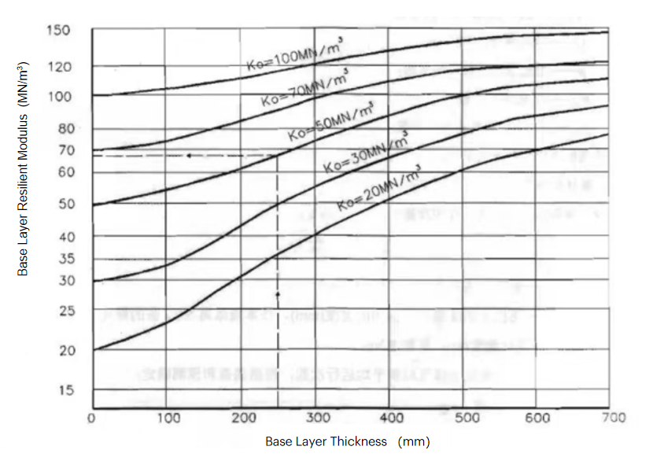
Fig.S4.3. Conversion relationship between base-top reaction modulus and subgrade reaction modulus

Table S4.7. Back-calculated subgrade reaction modulus
Zone | Subgrade reaction modulus（MN/m³）
Runway segment A | 87
Runway segment B | 106
Runway segment C | 90
Taxiway 1 | 85
Taxiway 2 | 90
Apron 1 | 39
Apron 2 | 29
Apron 3 | 27

(3) Roughness excitation characteristics
As the direct external excitation driving aircraft–pavement coupled vibration and the associated energy dissipation, the geometric characteristics of the pavement surface constitute a critical model input. In this study, the International Roughness Index (IRI) was adopted as the macroscopic descriptor to construct an excitation-source matrix covering the entire airfield.
a. Spatial distribution of measured roughness.
Based on the official pavement inspection report, measured IRI values were extracted for all functional zones within the airside area. The number of test sections and survey lines in representative areas are summarized in Table S4.8. Owing to data confidentiality requirements, only partially anonymized statistics are presented here.
b. Reconstruction from statistical index to time-domain excitation.
Because IRI is a single aggregated indicator, it cannot be directly used as input for time-domain dynamic simulation. Therefore, following the physically constrained conversion framework described in Supplementary Section 1.2, the measured IRI values for each segmented unit were transformed into equivalent three-dimensional stochastic roughness spectra. These spectra were subsequently reconstructed into spatial-domain elevation fields and used as excitation inputs in the coupled dynamic model.
Table S4.8. Measured IRI statistics for selected pavement zones at Hongqiao Airport
Zone | Number of survey lines | Number of test sections
Representative runway | 4 | 328
Taxiway 1 | 2 | 302
Taxiway 2 | 2 | 163
Connector 1 | 2 | 15
Connector 2 | 2 | 25
Connector 3 | 2 | 44

4.2.3 Reconstruction of aircraft ground-taxi operations
To parameterize aircraft-specific dynamic loading conditions in the coupled aircraft–pavement model, ground-taxi operations at Shanghai Hongqiao International Airport in 2019 were reconstructed by integrating fleet composition, spatial routing and segment-level speed profiles into a unified dynamic dataset.
(1) Fleet composition
Aircraft movement data were obtained from the OAG database. A total of 31 aircraft types operated at the airport in 2019 (Table S4.9), spanning regional, narrow-body and wide-body categories. The fleet included the ARJ21-700 regional jet, the dominant A320 and B737 narrow-body families, and wide-body aircraft such as A330/A350 and B747/B777/B787 series. This diversified fleet structure enables the model to capture variability in landing-gear configuration, wheel load distribution and structural dynamic response under identical pavement roughness excitation.
Table S4.9. Aircraft types operating at Shanghai Hongqiao International Airport in 2019
Aircraft category | Manufacturer | ICAO code family | Representative models | Operational routing class
Wide-body |  | A330/A350 | A330, A330-200, A330-300, A350, A350-900, A350-1000 | D/E
 | Boeing | B747/B777/B787 | B747, B747-400, B777, B777-300, B777-300ER, B787, B787-8, B787-9
Narrow-body |  | A320 Family | A319, A320, A320neo, A321, A321neo | C
 | Boeing | B737 Family | B737-200, B737-300 B737-300(winglets), B737-600, B737-700, B737-800, B737-800(winglets), B737 MAX 8
 | Boeing | B757 | B757
Regional | COMAC | ARJ21 | ARJ21-700 | C

(2) Trajectory clustering and standardized routing.
To ensure computational tractability while preserving physical realism, aircraft ground trajectories were clustered and standardized.
①Trajectory consistency verification.ADS-B trajectory data retrieved from the Feichangzhun platform were analyzed for representative aircraft types (e.g., A330, A321, B737; Fig.S4.4a–c). Spatial overlay analysis shows that aircraft within the same ICAO reference category exhibit highly consistent taxi patterns. In particular, Code C aircraft (e.g., B737/A320) and Code D aircraft (e.g., A330/B787) display strong overlap in their use of primary taxiways and connector segments.
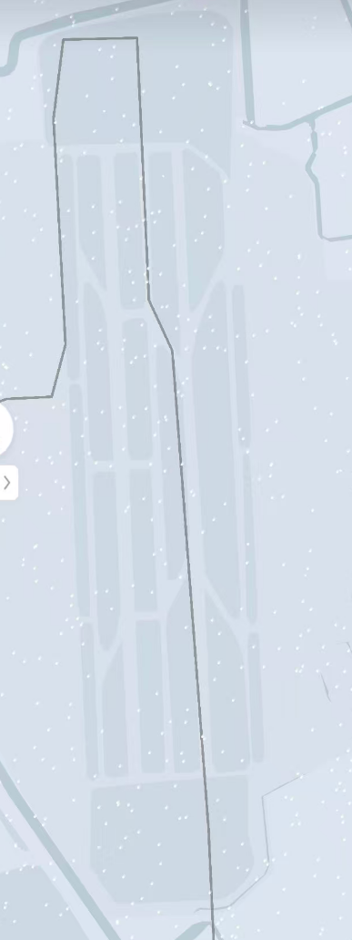
(a) A330 arrival taxi trajectory.
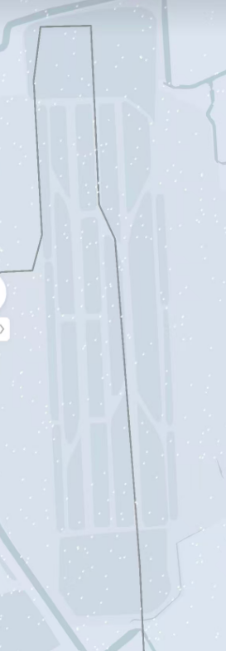
(b) A321 arrival taxi trajectory.
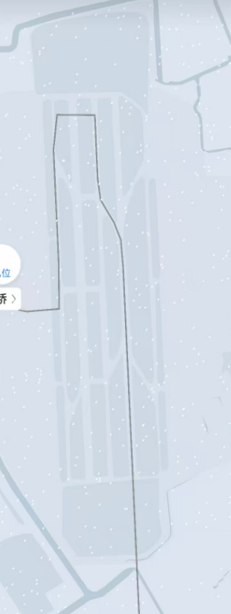
(c) B737 arrival taxi trajectory.
Fig.S4.4. Observed arrival taxi trajectories of representative aircraft types at Shanghai Hongqiao International Airport
②Standard route construction.Based on this consistency, a simplified “Code C–dominant” routing strategy was adopted. Standard taxi routes defined for Code C aircraft were used as the computational baseline for Code D aircraft. Combining official airport operational procedures and terminal layout, four standard arrival–departure routing configurations were defined according to terminal zone (east/west) and runway operating direction (north/south) (Fig. S4.5).
③Spatial matching.Each standard route was projected onto the segmented pavement map established in Supplementary Note 4.2.1. This generated aircraft-type-specific ordered segment lists, explicitly identifying the pavement units traversed during each arrival and departure operation.
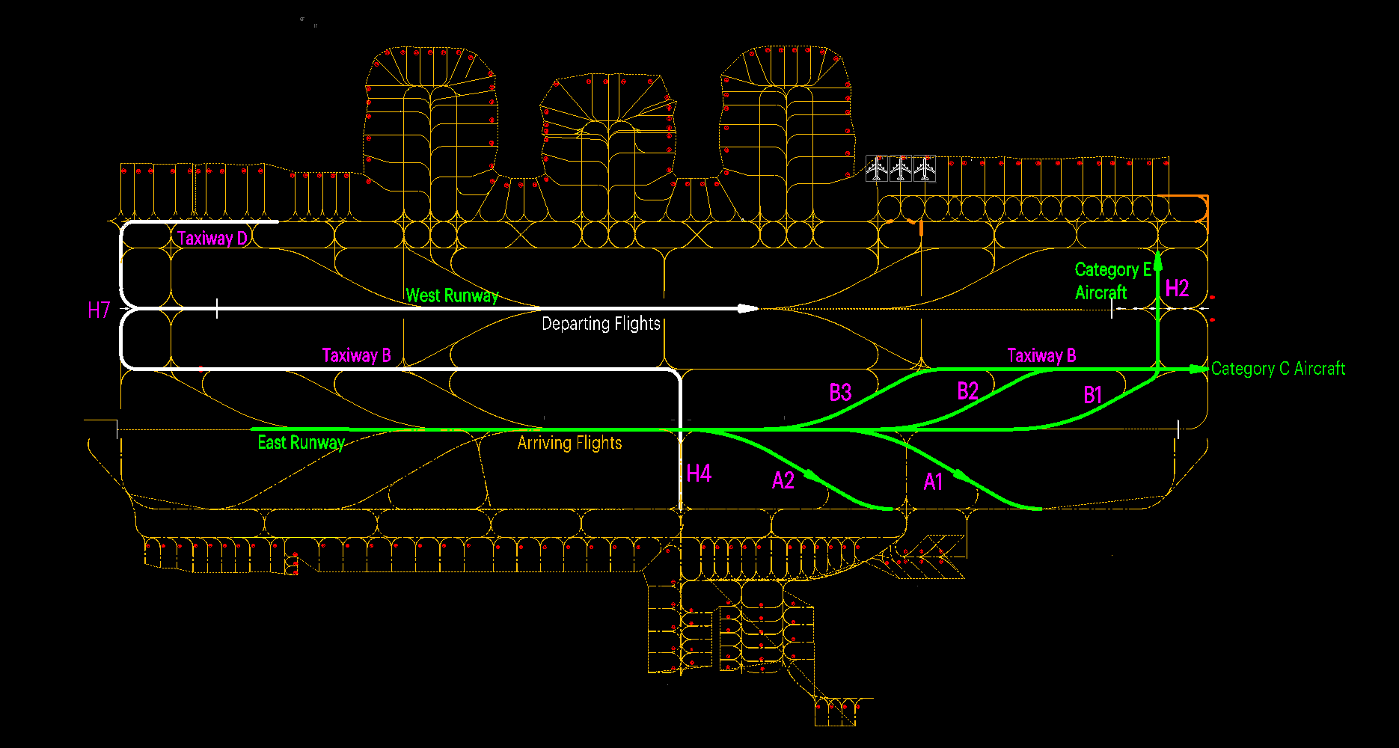
(a) Southbound runway operation.
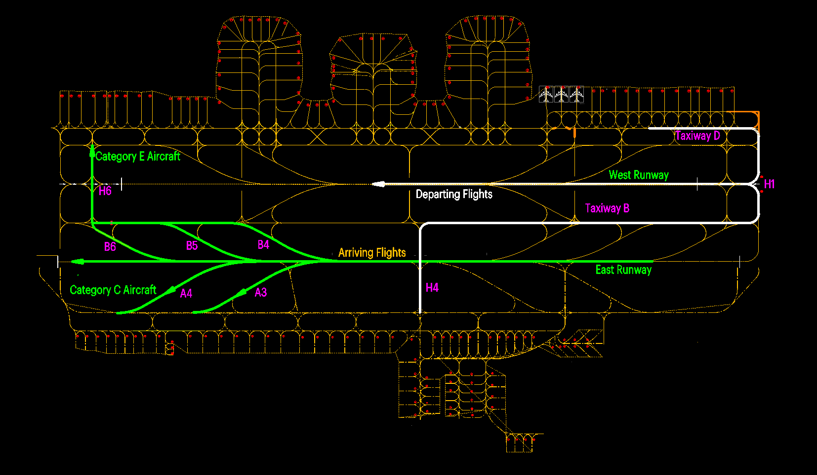
(b) Northbound runway operation.
Fig.4.5. Standardized arrival–departure routing configurations at Shanghai Hongqiao International Airport
(3) Speed control at key nodes and segment-level kinematic reconstruction. After spatial routes were determined, aircraft motion states were reconstructed at the segment level. Speed constraints were defined according to the Civil Airport Airfield Technical Standards and ICAO design recommendations:
① Runway exit speed (rapid-exit taxiway): 90 km/h (Code 4E/4F operational assumption);
②Maximum conventional taxiway speed: 50 km/h;
③Parking stand terminal speed: 0 km/h.
Between adjacent operational nodes (e.g., touchdown point, turning intersections, stand position), aircraft motion was assumed to follow uniformly accelerated or decelerated kinematics. For each 100 m pavement segment, entry speed, exit speed and acceleration were calculated using standard kinematic equations. This procedure was repeated for all 31 aircraft types under both arrival and departure scenarios. The resulting aircraft–segment dynamic dataset (Source Data 3) provides the time-resolved velocity and acceleration inputs required by the coupled vibration–energy dissipation model.

4.2.4 Segment-level calculation and annual aggregation
Following spatial discretization, pavement attribute parameterization and aircraft trajectory reconstruction, additional energy dissipation and emission inventories attributable to pavement roughness were calculated using the coupled aircraft–pavement dynamic model.
(1) Segment-level energy dissipation. The aircraft segment-operation table (Supplementary Note 4.2.3) was coupled with the pavement attribute matrix (Supplementary Note 4.2.2) through segment identifiers.
For each aircraft–segment combination, additional vibration-induced energy dissipation was calculated using the emission model described in Methods 2–3 of the main text. The calculation accounts for aircraft type–specific mass and landing gear configuration, segment-level structural parameters, andlocal pavement roughness excitation.
Traversing all segments along standardized taxi routes generated a segment-resolved additional energy consumption table (Source Data 4), providing energy dissipation per aircraft per metre of taxi distance.
Table S4.10. Aircraft movements by type (Shanghai Hongqiao International Airport, 2019)
Specific Aircraft Name | Frequency | Specific Aircraft Name | Frequency
A319 | 171 | B737-600 | 3
A320 | 28481 | B737-700 | 1632
A320 (Sharklets) | 710 | B737-800(winglets) | 3188
A320neo | 2 | B737-800 | 32041
A321 | 18481 | B737MAX8 | 89
A321neo | 351 | B747 | 365
A330 | 2648 | B747-400 | 133
A330-200 | 2776 | B757 | 351
A330-300 | 10655 | B777 | 10
A350 | 168 | B777-300 | 1787
A350-1000 | 40 | B777-300ER | 2155
A350-900 | 1850 | B787 | 187
B737 | 14867 | B787-8 | 402
B737-200 | 57 | B787-9 | 5178
B737-300(winglets) | 6 | ComacARJ21-700 | 157
B737-300 | 494
(2) Traffic volume allocation. Annual aircraft movement data for 2019 were obtained from the OAG database (Table S4.10). Because OAG data do not specify runway usage or operating direction, traffic was allocated according to published statistics from Shanghai Hongqiao International Airport:
West runway (west terminal zone): 84.6% of movements
East runway (east terminal zone): 15.4%
Northbound vs southbound operation: assumed 1:1
Arrival vs departure movements: assumed 1:1
Based on these proportions, annual aircraft movements were mapped to specific physical routing configurations defined in Supplementary Note 4.2.3.
Table S4.11. Additional Energy Consumption Caused by Pavement Unevenness During Single Taxiing of Different Aircraft Types at Hongqiao Airport in 2019
Aircraft Type | Energy / MJ | Aircraft Type | Energy / MJ
A319 | 0.114333333 | B737-600 | 0.114333333
A320 | 0.133 | B737-700 | 0.118666667
A320 (Sharklets) | 0.133 | B737-800(winglets) | 0.125333333
A320neo | 0.126 | B737-800 | 0.125333333
A321 | 0.126333333 | B737MAX8 | 0.125333333
A321neo | 0.126333333 | B747 | 0.141
A330 | 0.134 | B747-400 | 0.144
A330-200 | 0.143 | B757 | 0.124666667
A330-300 | 0.144666667 | B777 | 0.143
A350 | 0.145333333 | B777-300 | 0.143
A350-1000 | 0.145333333 | B777-300ER | 0.144333333
A350-900 | 0.145333333 | B787 | 0.143
B737 | 0.127 | B787-8 | 0.143
B737-200 | 0.127 | B787-9 | 0.143
B737-300(winglets) | 0.125 | ComacARJ21-700 | 0.126333333
B737-300 | 0.125

(3) Annual additional energy and emission inventory. For each aircraft type, the total additional mechanical energy consumption per taxi movement (Table S4.11) was multiplied by the allocated annual movement counts and summed across all route configurations. This yields the total additional mechanical energy attributable to pavement roughness in 2019.
Mechanical energy was then converted into pollutant mass emissions using the emission factors described in Supplementary Note 2 and Methods 3 of the main text. The resulting airport-level emission inventory for 2019 is shown in Table S4.12. In 2019, pavement roughness alone induced approximately 1.53×10⁶ g (≈153 kg) of additional CO₂ emissions at Shanghai Hongqiao International Airport.
Table S4.12. Additional emissions induced by pavement roughness at Shanghai Hongqiao International Airport (2019)
HC/g | CO/g | NO_{x}/g | nvPM/g | CO₂/g
24.49633293 | 104.726562 | 18136.05794 | 19628.3593 | 1530993.308

(4) Spatial heterogeneity of emissions. To examine spatial distribution characteristics, emissions were aggregated by functional area (Table S4.13). Results indicate strong spatial concentration of roughness-induced emissions. Although runways account for a limited share of total pavement area, they contribute approximately 79.6% of total additional CO₂ emissions. This dominance arises from: higher operating speeds, stronger vibration excitation intensity, and amplified dynamic energy dissipation.
Taxiways and apron areas, despite sometimes exhibiting higher roughness levels, contribute less additional emission due to lower operating speeds.
Table S4.13. Spatial distribution of roughness-induced emissions (2019)
Functional area | HC/g | CO/g | NO_{x}/g | nvPM/g | CO₂/g
Apron | 0.87835 | 2.993926667 | 603.0201267 | 605.4893767 | 49147.01037
Rapid-exit taxiway | 0.943 | 3.796176667 | 628.4844767 | 747.5119433 | 54975.10509
Taxiway | 3.34716 | 13.99891667 | 2519.99158 | 2585.18222 | 208513.8347
Runway | 19.32782 | 83.93754333 | 14384.56176 | 15690.17576 | 1218357.358

4.3 National-scale airport emission inventory
Building upon the standardized computational framework described in Supplementary Note 4.1 and the full-process validation presented in Supplementary Note 4.2, the methodology was extended to all available civil airports in China.
For aircraft trajectory reconstruction (Step 3 of the framework), segment-level taxi routing tables were established for each airport and aircraft category. Taxi path segmentation was determined by integrating publicly available aerodrome layout data with ADS-B trajectory records, enabling identification of representative routing configurations for each aircraft class (Source Data 5).
Pavement inspection reports covering the period 1999–2024 were compiled, providing roughness and structural data for up to 246 airports over a 25-year time span. The year 2019 represents the most comprehensive coverage in terms of airport sample size.
Using consistent parameterization and allocation procedures across all airports and years, annual roughness-induced emission inventories were generated at the national scale. The 2019 national emission inventory is provided in Source Data 6.

Supplementary Note 5. Multi-year projection of roughness-induced emissions in China

5.1 Projection of aircraft movements
Aircraft movement forecasts were constructed using 2019 as the baseline year. Historical annual aircraft movements (2019–2024) were obtained from official statistical bulletins published by the Civil Aviation Administration of China (CAAC). Reported values are: 2020: 9.049 million movements; 2021: 9.777 million; 2022: 7.152 million; 2023: 11.708 million; 2024: 12.400 million
The official 2019 total was 11.660 million movements. Due to database availability constraints, 9.868 million movements were used in the model calculations for 2019 to ensure internal consistency with aircraft-type-specific traffic data.
Growth model. A two-stage compound growth model was adopted to represent long-term aviation development dynamics.
Stage I (2024–2035): accelerated recovery and expansion phase
Based on national civil aviation development targets and post-pandemic recovery trends, annual aircraft movements were assumed to grow at a compound annual growth rate (CAGR) of 8.46%, yielding a projected 30 million movements by 2035. Projected values for 2025–2034 are shown in Table S5.1.
Stage II (2035–2050): mature market phase
To reflect structural saturation effects observed in mature aviation markets, the annual growth rate was reduced to 5% after 2035. Under this assumption, total aircraft movements reach approximately 62 million by 2050.
Table S5.1. Projected aircraft movements (2025–2034)
Year | Aircraft movements (million)
2025 | 1344.9
2026 | 1458.7
2027 | 1582.1
2028 | 1715.9
2029 | 1861.0
2030 | 2080.2
2031 | 2256.3
2032 | 2447.2
2033 | 2653.2
2034 | 2877.6

5.2 Projection of pavement roughness evolution
A long-term roughness dataset covering more than 20 years and up to 246 civil airports was compiled. Across airports, pavement roughness (expressed as IRI) generally increases with service time due to cumulative traffic loading and environmental exposure.
Two dominant evolutionary patterns were identified:
①Overlay–recovery cycle pattern. Roughness decreases significantly after resurfacing (overlay), followed by gradual deterioration during the subsequent service period.
②Monotonic deterioration pattern. In the absence of major overlay interventions, roughness increases continuously over time, with accelerating deterioration during mid-to-late service stages.
All airports with sufficient historical data were modeled under a unified framework using airport-specific deterioration rate estimation.
Representative large hub airport (overlay cycle case)
Shanghai Hongqiao International Airport provides a representative example of overlay-driven cyclic roughness evolution. Historical IRI data (2000–2024) indicate resurfacing events in 2005, 2011 and 2022.
The IRI trajectory exhibits a characteristic “post-overlay improvement–progressive deterioration–renewed restoration” cycle. The estimated average deterioration rate is approximately 0.25 m/km/ yr, corresponding to overlay intervals of 7–11 years.
Future projections (25-year horizon) assume continued cyclic maintenance with gradual reductions in deterioration rates due to improved structural design and maintenance practices.
Fig.S5.1. Runway IRI evolution at Shanghai Hongqiao International Airport (2000–2024)
Representative small regional airport (monotonic deterioration case)
A typical low-traffic regional airport in southeastern China exhibits a monotonic increase in IRI over time (2004–2018).
In early service years, deterioration is slow and IRI values remain low. As cumulative traffic loading increases, deterioration accelerates. Without major resurfacing interventions, roughness continues to rise into late-stage service, indicating structural fatigue accumulation and surface degradation.
Minor year-to-year fluctuations reflect localized maintenance activities but do not alter the overall upward trend.
Fig.S5.2. Runway IRI evolution at a representative regional airport (2004–2018)

Supplementary Note 6. Long-term evolution of runway structural parameters at Shanghai Hongqiao International Airport
To support the interpretation of roughness evolution and associated energy dissipation mechanisms, we analysed the long-term structural performance of the runway system at Shanghai Hongqiao International Airport using multi-period monitoring data from 2000–2024. Structural parameters were obtained from core sampling and in situ testing (Fig.S6.1 and Fig.S6.2), including base-layer resilient modulus, slab elastic modulus, structural thickness, and subgrade reaction modulus (Table S6.1–6.9). These parameters collectively characterise load-bearing capacity, stiffness degradation, and foundation–structure interaction.
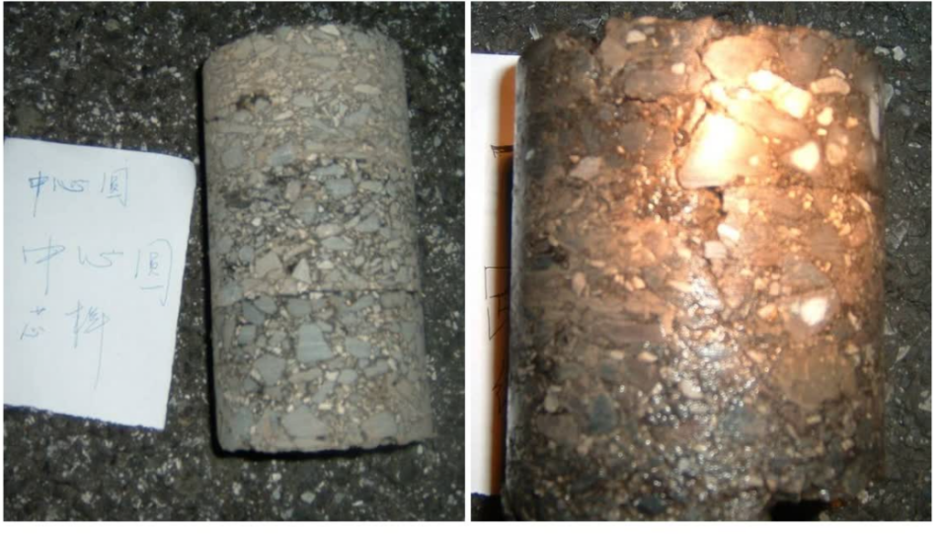
Fig.S6.1. Core samples extracted from the runway at Shanghai Hongqiao International Airport
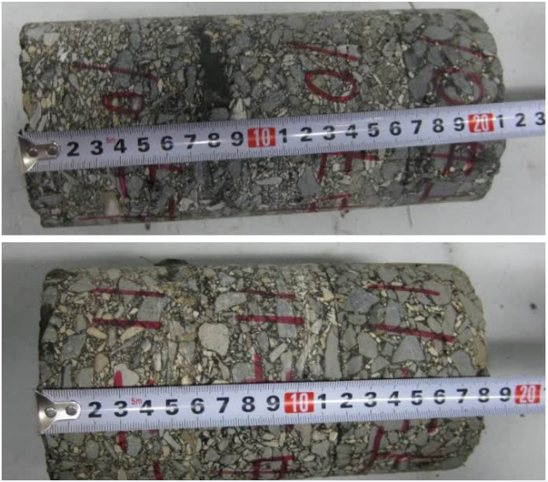
Fig.S6.2. Measurement of core sample data

Table S6.1. Runway structural parameters (2000)
Survey Line | Structural Layer Parameter | Mean | Maximum | Minimum | Coefficient of Variation (%)
1 | Resilient modulus of base-top surface, E₀（MPa） | 363 | 509 | 260 | 19.34
1 | Resilient modulus of cement concrete slab, E_{cc}（GPa） | 35.8 | 36 | 34 | 1.13
1 | Resilient modulus of asphalt overlay layer, E_{p}（MPa） | 2823 | 4600 | 1150 | 33.86
2 | Resilient modulus of base-top surface, E₀（MPa） | 363 | 536 | 194 | 21.38
2 | Resilient modulus of cement concrete slab, E_{cc}（GPa） | 35.9 | 36 | 34 | 1.13
2 | Resilient modulus of asphalt overlay layer, E_{p}（MPa） | 3223 | 4945 | 1185 | 30.53
3 | Resilient modulus of base-top surface, E₀（MPa） | 369 | 538 | 286 | 15.89
3 | Resilient modulus of cement concrete slab, E_{cc}（GPa） | 35.9 | 36 | 35 | 0.75

Table S6.2. Runway structural parameters (2001)
Survey Line | Structural Layer Parameter | Mean | Maximum | Minimum | Coefficient of Variation (%)
1 | Resilient modulus of base-top surface, E₀（MPa） | 363 | 509 | 260 | 19.34
1 | Resilient modulus of cement concrete slab, E_{cc}（GPa） | 35.8 | 36 | 34 | 1.13
1 | Resilient modulus of asphalt overlay layer, E_{p}（MPa） | 2823 | 4600 | 1150 | 33.86
2 | Resilient modulus of base-top surface, E₀（MPa） | 363 | 536 | 194 | 21.38
2 | Resilient modulus of cement concrete slab, E_{cc}（GPa） | 35.9 | 36 | 34 | 1.13
2 | Resilient modulus of asphalt overlay layer, E_{p}（MPa） | 3223 | 4945 | 1185 | 30.53
3 | Resilient modulus of base-top surface, E₀（MPa） | 369 | 538 | 286 | 15.89
3 | Resilient modulus of cement concrete slab, E_{cc}（GPa） | 35.9 | 36 | 35 | 0.75
3 | Resilient modulus of asphalt overlay layer, E_{p}（MPa） | 3310 | 4925 | 1370 | 28.73

Table S6.3. Runway structural parameters (2002)
Survey Line | Structural Layer Parameter | Mean | Maximum | Minimum | Coefficient of Variation (%)
R2 | Resilient modulus of base top surface, E₀（MPa） | 361 | 319 | 399 | 12.8
R2 | Resilient modulus of cement concrete slab, E_{cc}（GPa） | 34.6 | 31.2 | 35.7 | 11.5
R2 | Resilient modulus of asphalt overlay layer, E_{p}（MPa） | 2230 | 1700 | 3100 | 29.9
R3 | Resilient modulus of base top surface, E₀（MPa） | 327 | 285 | 398 | 10.3
R3 | Resilient modulus of cement concrete slab, E_{cc}（GPa） | 34.2 | 31.5 | 36.6 | 12.3
R3 | Resilient modulus of asphalt overlay layer, E_{p}（MPa） | 2430 | 1350 | 4350 | 36.1
R4 | Resilient modulus of base top surface, E₀（MPa） | 352 | 249 | 421 | 18.5
R4 | Resilient modulus of cement concrete slab, E_{cc}（GPa） | 33.4 | 30.5 | 37.2 | 15.6
R4 | Resilient modulus of asphalt overlay layer, E_{p}（MPa） | 2890 | 1685 | 4310 | 31.2
R5 | Resilient modulus of base top surface, E₀（MPa） | 369 | 321 | 418 | 16.7
R5 | Resilient modulus of cement concrete slab, E_{cc}（GPa） | 34.1 | 29.9 | 37.4 | 17.9
R5 | Resilient modulus of asphalt overlay layer, E_{p}（MPa） | 2812 | 1020 | 5310 | 39.7
R6 | Resilient modulus of base top surface, E₀（MPa） | 369 | 268 | 430 | 10.1
R6 | Resilient modulus of cement concrete slab, E_{cc}（GPa） | 35.3 | 34 | 38.7 | 14.8
R6 | Resilient modulus of asphalt overlay layer, E_{p}（MPa） | 2544 | 1355 | 3265 | 18
R7 | Resilient modulus of base top surface, E₀（MPa） | 318 | 278 | 356 | 12.4
R7 | Resilient modulus of cement concrete slab, E_{cc}（GPa） | 34.8 | 32.4 | 36.5 | 11.9

Table S6.4. Runway structural parameters (2015)
Component | Functional zone | Modulus at top of base layer（MN/m²） | Elastic modulus of pavement slab（GPa）
Runway (overlay section) | 180 m and 720 m from both ends | 149 | 35
 | Central 2300 m section | 187 | 33
Taxiway (concrete) | Taxiway A | 157 | 34

Table S6.5. Runway structural parameters (2016)
Component | Functional Area | Subgrade Reaction Modulus (（MN/m³） | Slab Elastic Modulus（GPa） | Subgrade Strength Grade
Runway | RW1 | 196 | 37 | A
Runway | RW2 | 273 | 37 | A
Runway | RW3 | 203 | 37 | A
Taxiway | Taxiway B | 239 | 37 | A
Taxiway | Taxiway C | 235 | 37 | A
Rapid-exit taxiway | Taxiway D | 156 | 37 | A
Rapid-exit taxiway | B7、B8、C1-C4 | 243 | 37 | A
Runway–taxiway connector (midfield) | H3、H4、H5 | 176 | 37 | A

Table S6.6. Runway structural parameters (2018)
Component | Thickness（cm） | Modulus of Subgrade Reaction at Base Top（MN/m³） | Pavement Slab Elastic Modulus（GPa） | Subgrade Strength Grade
A2-A | 36 | 101 | 46 | B
A2-B | 42 | 80 | 46 | B
A4 | 42 | 86.5 | 46 | B
A6 | 42 | 96 | 46 | B

Table S6.7. Runway structural parameters (2021)
Component | Subgrade Reaction Modulus（MN/m³） | Subgrade Strength Grade
TH4-1 | 101 | B
TH7-1 | 110 | B
TK0 | 81 | B
TK1 | 149 | A
TK2 | 144 | A
TK4 | 102 | B
TK5 | 158 | A
TK6 | 105 | B
TK7 | 97 | B
AA | 92 | B
AB | 81 | B
AC | 78 | B
AD | 66 | B
AE | 123 | A
AF | 148 | A
AG | 85 | B
AH | 83 | A
AI | 116 | A
AJ | 100 | B
AK | 106 | B
ACA | 75 | B

Table S6.8. Runway structural parameters (2023)
Component | Subgrade Reaction Modulus（MN/m³） | Subgrade Strength Grade
TD | 134 | A
A6 | 97 | B
A2-A | 101 | B
A2-B | 82 | B
A4A | 99 | B

Table S6.9. Runway structural parameters (2024)
Component | Subgrade Reaction Modulus（MN/m³） | Subgrade Strength Grade
East Runway | 112 | B
Taxiway A | 111 | B
Rapid-Exit Taxiway A1 | 92 | B
Rapid-Exit Taxiway A2 | 92 | B
Rapid-Exit Taxiway A3 | 86 | B
Rapid-Exit Taxiway A4 | 87 | B
Rapid-Exit Taxiway B1 | 103 | B
Rapid-Exit Taxiway B2 | 103 | B
Rapid-Exit Taxiway B3 | 70 | B
Rapid-Exit Taxiway B4 | 119 | B
Rapid-Exit Taxiway B5 | 87 | B
Rapid-Exit Taxiway B6 | 79 | B
Connector taxiway H1 | 123 | A
Connector taxiway H1（A-36R） | 100 | B
Connector taxiway H4 | 71 | B
Connector taxiway H7 | 71 | B
Connector taxiway T1 | 99 | B
Connector taxiway T6 | 154 | A
Connector taxiway K0 | 81 | B
Connector taxiway K1 | 149 | A
Connector taxiway K2 | 144 | A
Connector taxiway K4 | 102 | B
Connector taxiway K5 | 158 | A
Connector taxiway K6 | 105 | B
Connector taxiway K7 | 97 | B
Connector taxiway N | 158 | A
Connector taxiway BN | 105 | B
Connector taxiway S | 158 | A
Connector taxiway BS | 103 | B
Extraction and standardisation of key parameters
From the monitoring dataset, three representative mechanical indicators were extracted: Base-layer reaction modulus 𝐸₀ (MPa), Surface concrete elastic modulus 𝐸_{𝑐𝑐} (GPa), Subgrade reaction modulus 𝐾 (MN/m³). Outliers were removed and all data were standardised to ensure inter-annual comparability. The processed time series are shown in Fig.S6.3.
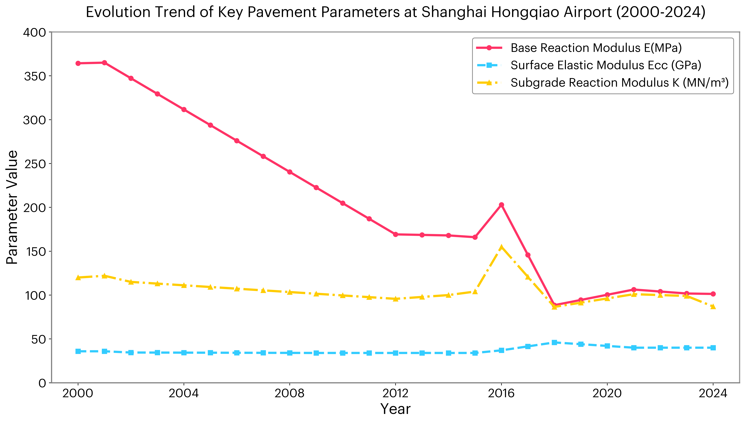
Fig.S6.3. Evolution of Runway Parameters at Shanghai Hongqiao International Airport
Evolution characteristics
Fig.S6.3 reveals distinct stage-wise behaviour over the 25-year observation period:
(1) Base-layer reaction modulus (E₀). E₀ decreased rapidly from approximately 365 MPa in the early 2000s to ~100 MPa prior to 2016, reflecting progressive stiffness degradation under cumulative traffic loading and environmental exposure. Following structural rehabilitation in 2016, E₀ stabilised within the range of 100–105MPa, indicating entry into a new equilibrium performance stage.
(2) Surface elastic modulus (Ecc). For an extended period, Ecc remained relatively stable at 35–40 GPa, suggesting limited material upgrading in early service years. After 2018, the adoption of high-performance concrete significantly increased Ecc to approximately 50 GPa, demonstrating the mechanical benefits of material enhancement on surface stiffness and load transfer efficiency.
(3) Subgrade reaction modulus (K). The evolution of K follows a three-stage pattern: gradual decline, short-term strengthening, and re-stabilisation. Initially decreasing from ~120 MN/m³ to ~100 MN/m³ due to consolidation and long-term settlement in soft soil conditions, K increased sharply to ~155 MN/m³ following foundation reinforcement in 2016. Subsequently, it reduced and stabilised at 90–100 MN/m³ after system re-adjustment. This trajectory is consistent with classical soft-soil behaviour under consolidation–reinforcement–reconsolidation cycles.
Engineering implications
Overall, the runway system exhibits a transition from stiffness degradation to performance restructuring driven by rehabilitation and material upgrading. These stage-wise mechanical changes provide a structural basis for interpreting: observed roughness evolution, variations in aircraft dynamic response, and corresponding changes in vibration-induced energy dissipation and carbon emissions.
The coupling between structural parameter evolution and roughness development highlights that infrastructure ageing and rehabilitation cycles directly influence aircraft–runway interaction intensity and associated emission increments.

Supplementary Note 7. Evolution of aircraft fuel-consumption coefficients with years of service
During long-term operation, aero-engine components experience performance degradation due to wear, fatigue accumulation, corrosion and deposit formation. These processes reduce thermodynamic efficiency and increase specific fuel consumption. To maintain airworthiness and restore engine performance, periodic overhauls are conducted, during which degraded components are repaired or replaced. Consequently, the effective fuel consumption of an aircraft depends not only on airframe age but also on engine maintenance cycles.
We adopt the engine degradation framework proposed by Seymour et al. to quantify age-dependent fuel-efficiency correction factorsr¹. This method models efficiency loss as a time-dependent function, incorporating both progressive performance decay and partial recovery during scheduled maintenance. Aircraft are classified according to mission range, using 4,000 km great-circle distance as the threshold: aircraft operating below this distance are categorized as medium-haul, and those above as long-haul.
Letη(t) denote the percentage efficiency loss at aircraft age t (years). The degradation process is approximated by a first-order model (Eqs.S7.1-S7.2), where efficiency declines gradually over time and is partially restored (≈1.0%) after each maintenance cycle. However, irreversible ageing effects accumulate, leading to progressive long-term performance deterioration even after overhaul.
(S7.1)
(S7.2)
Fig.S7 illustrates a representative degradation trajectory for a medium-haul aircraft engine, accounting for semiannual cleaning and scheduled overhaul cycles.
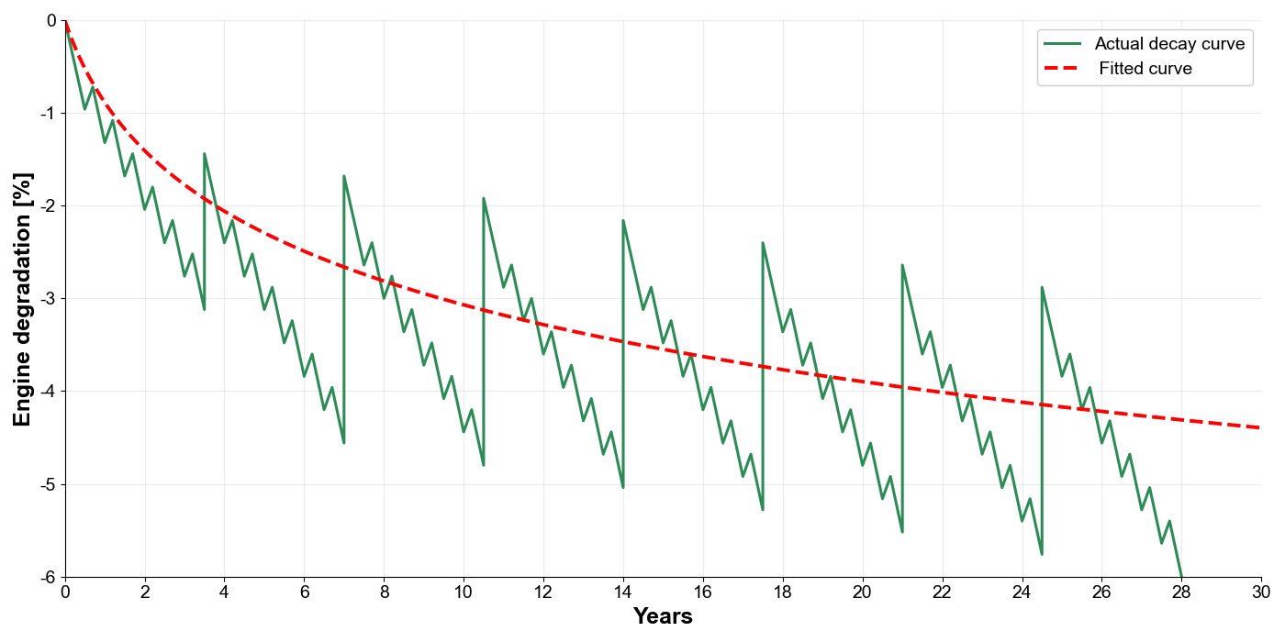
Fig.S7. Typical engine performance degradation curve for a medium-haul aircraft (including semi-annual engine washing and scheduled overhauls).
The corrected fuel consumption 𝐹_{corr} is calculated as:
(S7.3)
where 𝐹_{new} is the baseline fuel consumption of a new engine and 𝜂(𝑡) is the remaining efficiency loss fraction at age t. Age-specific correction factors are applied according to fleet-average aircraft age.
According to the 2019 Civil Aviation Industry Development Statistical Bulletin issued by the Civil Aviation Administration of China, the average stage length of domestic flights in 2019 was approximately 2,000 km. Therefore, the medium-haul degradation model is adopted as a conservative assumption for subsequent calculations.
Table S7 summarizes the projected evolution of fuel consumption over a 30-year service life.
Table S7. Age-dependent variation in aircraft fuel consumption
Years in service | Engine efficiency loss (%) |  |  | Corrected fuel ratio | Fuel increase (%)
1 |  | -0.89 | 1.01 |  | 0.90
5 |  | -2.29 | 1.02 |  | 2.35
10 |  | -3.07 | 1.03 |  | 3.17
15 |  | -3.55 | 1.04 |  | 3.68
20 |  | -3.90 | 1.04 |  | 4.06
25 |  | -4.17 | 1.04 |  | 4.35
30 |  | -4.40 | 1.05 |  | 4.60

The results indicate a diminishing marginal increase in fuel consumption with aircraft age. Fuel penalty grows more rapidly during early service years and gradually stabilizes thereafter. After 30 years of operation, fuel consumption increases by approximately 4.6%, consistent with the performance recovery effects of periodic overhaul.
Reference
- Seymour, K.P., Held, M., Georges, G., & Boulouchos, K. (2020). Fuel Estimation in Air Transportation: Modeling global fuel consumption for commercial aviation. Transportation Research Part D-transport and Environment, 88, 102528.

Supplementary Note 8. Calculation Method and Standard of the Carbon Condition Index (CCI)

8.1 CCI Calculation Framework
Runway roughness induces aircraft–pavement coupled vibrations during taxiing, generating additional mechanical energy dissipation within the landing gear system and pavement structure. To sustain a prescribed taxiing speed, this dissipated energy must be compensated by increased engine thrust, leading to incremental fuel consumption and carbon emissions. The full aircraft–pavement dynamic model developed in this study quantifies these dissipation pathways explicitly.
However, direct adoption of the complete coupled model for pavement evaluation is impractical. Structural parameters and subgrade conditions vary substantially across airports and are rarely standardized at scale. Moreover, CCI is intended to characterize the emission-driving potential of runway roughness itself, rather than the response of any specific aircraft–pavement configuration. The index must therefore be independent of site-specific structural properties.
Energy dissipation cannot be used directly as the evaluation metric. Dissipated power depends on damping coefficients and vibration velocity squared; since damping parameters vary among aircraft types, energy-based metrics would yield aircraft-dependent results for identical roughness conditions. Such dependence contradicts the requirement of cross-fleet comparability in pavement management.
To resolve these constraints, CCI adopts the vibration velocities of landing gear shock absorbers and tyres as the primary state variables. Vibration velocity represents the dynamic excitation intensity imposed by runway roughness and serves as the immediate precursor of energy dissipation. To eliminate aircraft-specific dynamic bias, a standardized aircraft model with normalized mass and stiffness parameters is introduced. This ensures that CCI reflects the intrinsic excitation strength of the roughness field rather than aircraft-dependent response characteristics.
Accordingly, the construction of CCI addresses three technical objectives:
(1) Extraction of a standardized aircraft-based evaluation model from the full coupled system, enabling decoupling from pavement structural parameters;
(2) Integration of multiple component velocities into a unified scalar index;
(3) Parameter normalization to ensure strong correlation between CCI and fleet-level energy dissipation.
The following sections detail these procedures.

8.1.1 Standardized aircraft model for CCI
In the full aircraft–runway coupled framework, total energy dissipation arises from both aircraft components and pavement structures. However, regression analysis reveals that vibration responses of key aircraft components—particularly the relative velocities of sprung and unsprung masses—exhibit an exceptionally strong correlation with total system energy dissipation (R² > 0.98; Fig. S8.1).
This finding indicates that aircraft vibration states can serve as a high-sensitivity proxy for total dissipated energy induced by runway roughness, eliminating the need to explicitly resolve detailed pavement structural responses. Accordingly, CCI is formulated based on a standardized aircraft dynamic model (Fig. S8.2), in which vibration response functions as a surrogate measure of roughness-induced energy amplification.
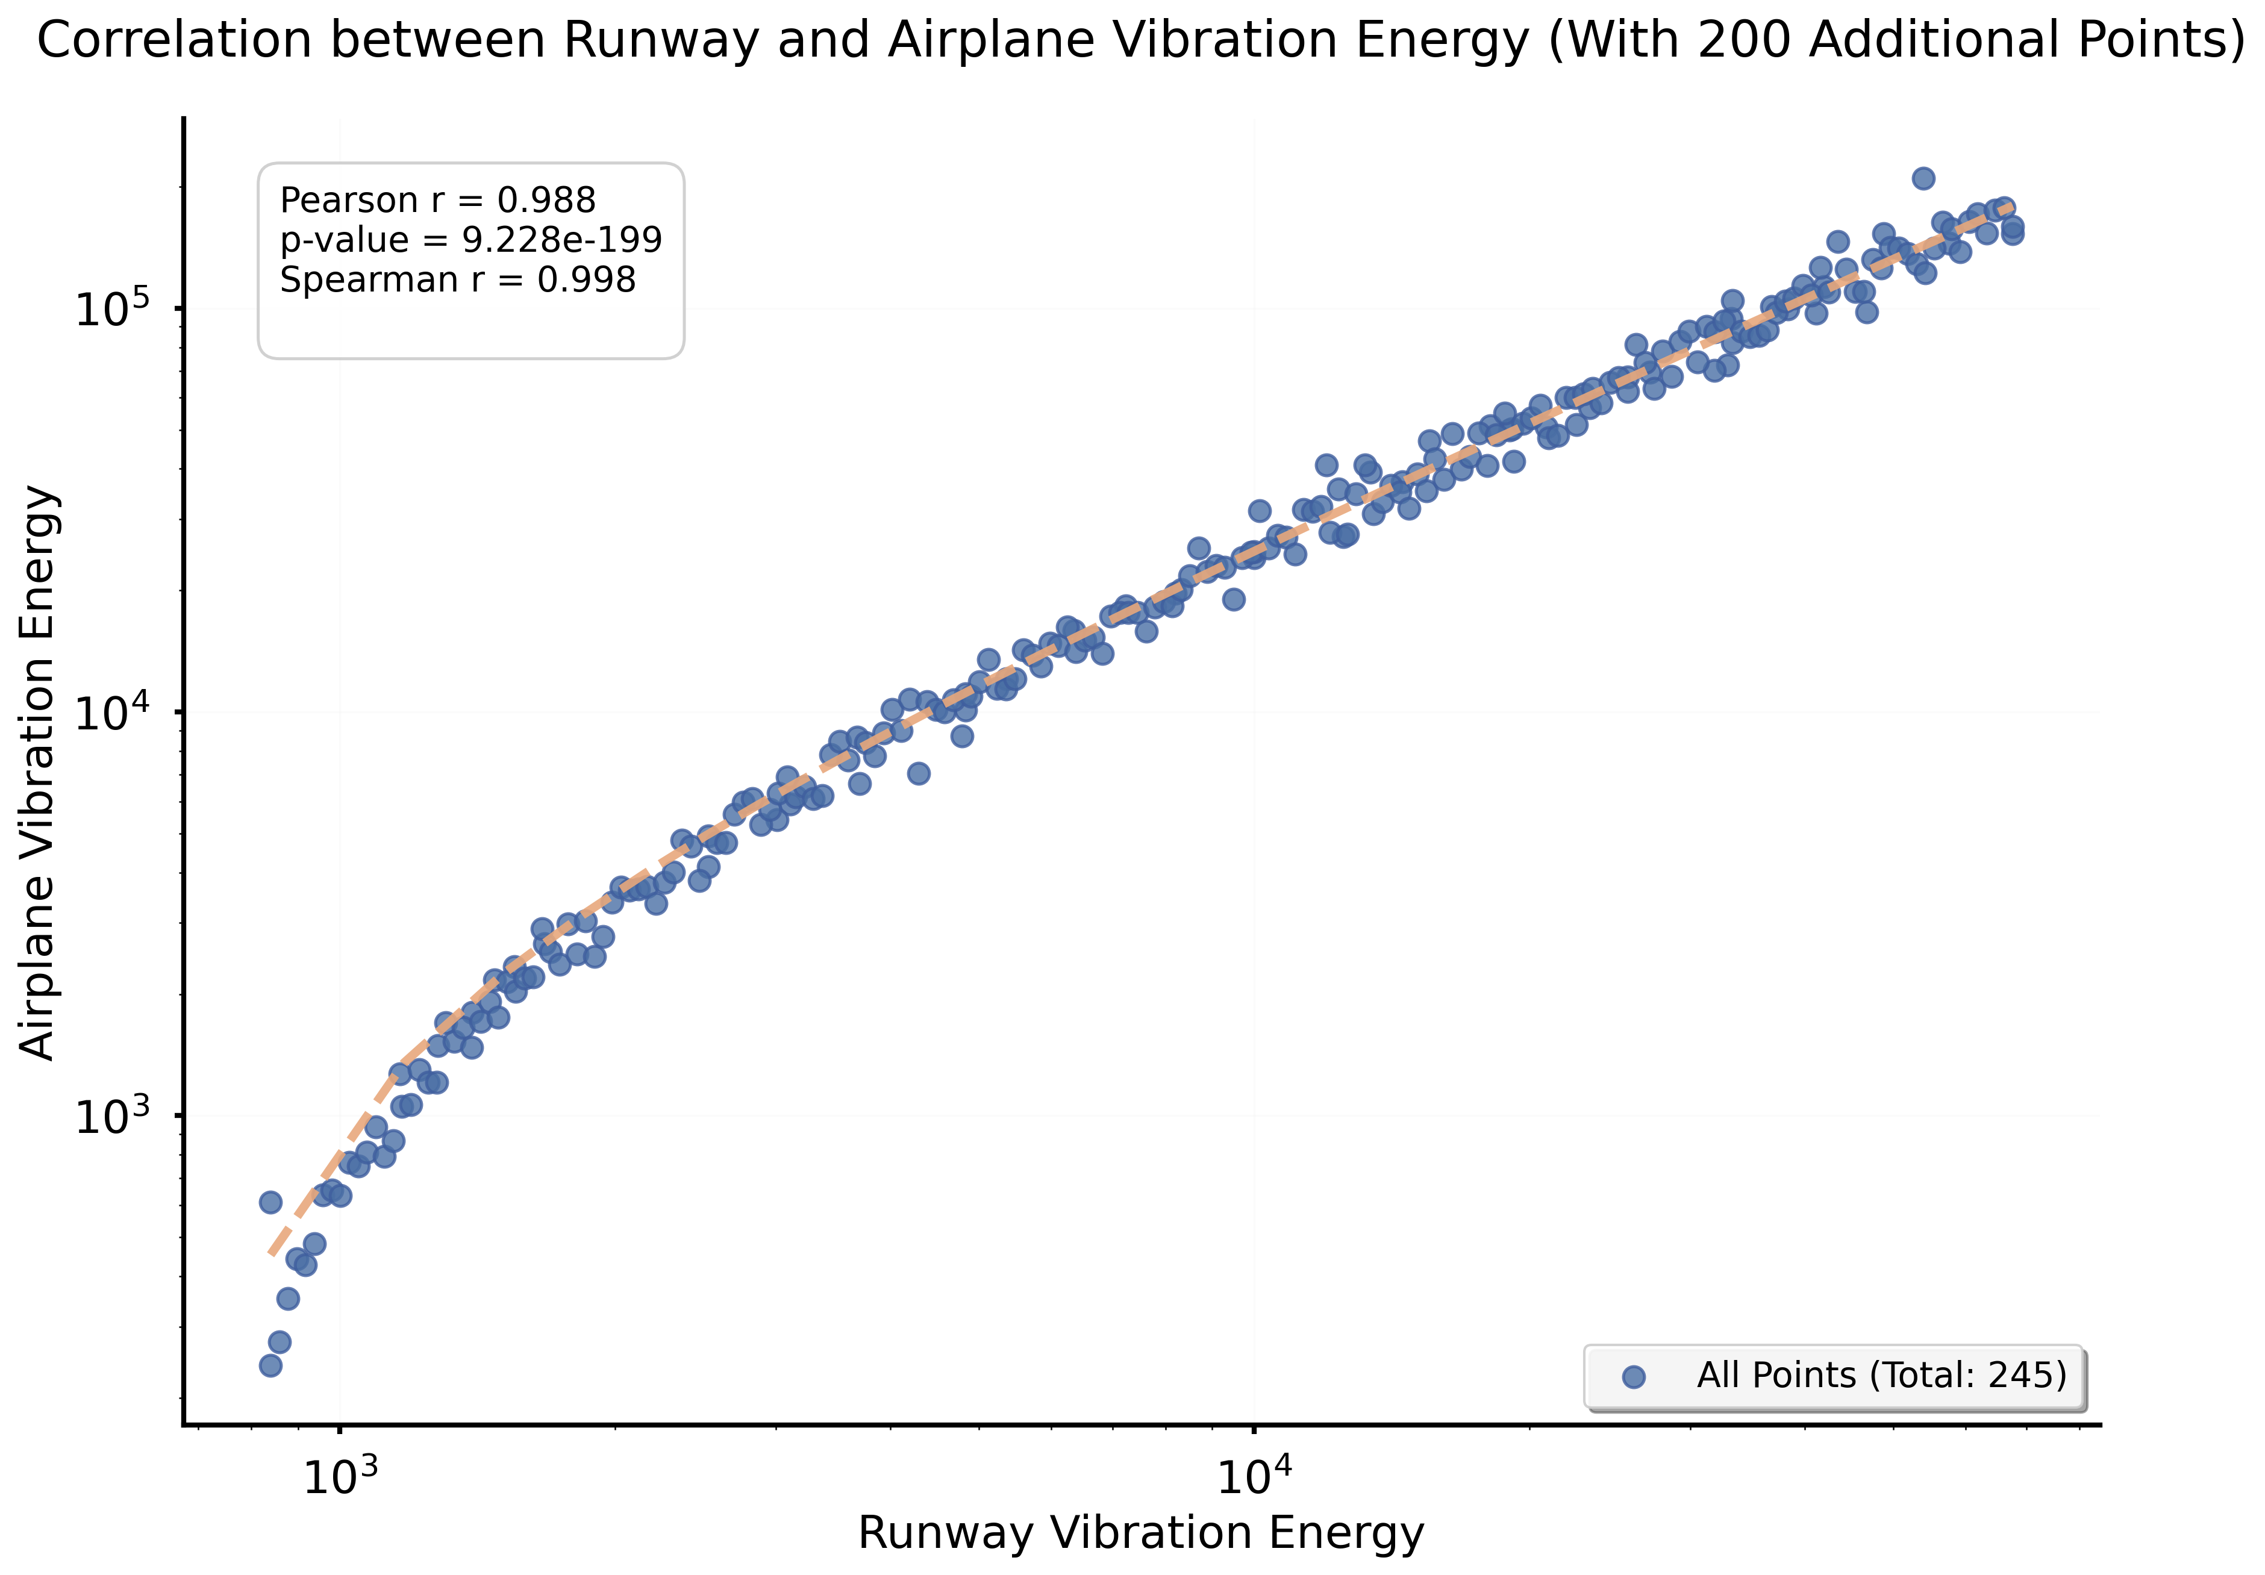
Fig.S8.1. Correlation between aircraft vibration response and total system energy dissipation
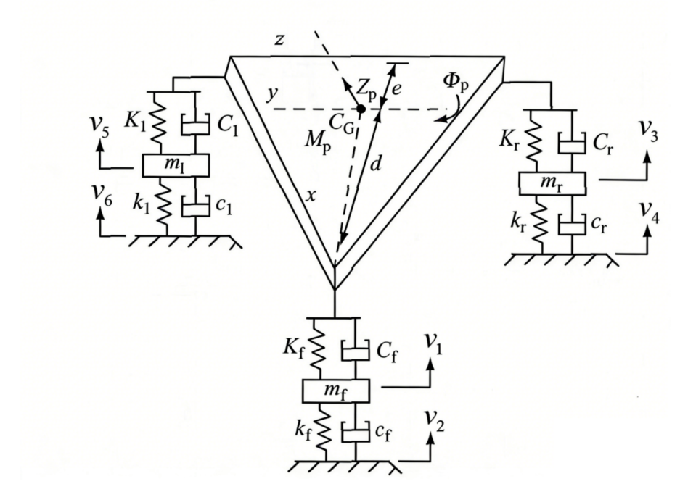
Fig.S8.2. Standardized aircraft-based framework for Carbon Condition Index (CCI) calculation
Decoupling from pavement heterogeneity
Runway structural properties (e.g., stiffness, damping, subgrade support) vary substantially across airports and are often difficult to obtain in a standardized manner. Incorporating such parameters directly into the CCI framework would compromise cross-airport comparability. By anchoring the evaluation to a standardized aircraft model—representing a globally consistent operational carrier—the index becomes inherently independent of local pavement structural variability. Under this configuration, runway roughness acts as the external excitation, and the vibration intensity induced in the standardized aircraft directly reflects its carbon amplification potential. The evaluation focus thus shifts from system-specific responses to the excitation strength of roughness itself.
Engineering scalability and computational efficiency
The aircraft-only formulation improves computational efficiency by more than two orders of magnitude compared with the full coupled model. This enables large-scale, near real-time CCI evaluation using routine roughness inspection datasets. Moreover, because the standardized model is independent of site-specific structural parameters, it facilitates broad international applicability and supports integration into existing pavement management systems.
In summary, extracting the CCI formulation from the complete aircraft–runway coupling system into a standardized aircraft-based vibration–energy framework ensures that:
(1) CCI remains physically grounded in energy dissipation mechanisms;
(2) Cross-airport comparability is preserved;
(3) The method is computationally scalable for large datasets;
(4) The index can be operationalized as a practical screening tool for carbon-sensitive pavement states.

8.1.2 Formulation of the Carbon Condition Index (CCI)
The aircraft dynamic system comprises multiple vibration components, including the sprung mass and the unsprung masses of the nose and main landing gears. During taxiing, each component generates velocity responses in different directions under pavement roughness excitation. To construct a unified pavement-oriented metric, these distributed velocity responses must be integrated into a single scalar indicator.
Given that vibration velocity is a vector quantity, the CCI is defined to reflect the overall intensity of vibration-induced energy dissipation while remaining independent of vibration direction. The formulation follows three steps:
- Directional normalization: Absolute values of velocity components are taken to eliminate directional cancellation effects and ensure that all vibration contributions are positively accumulated.
- Component aggregation: The absolute velocities of the six key vibration components are summed and averaged to obtain the instantaneous mean vibration velocity.
- Spatial normalization: The instantaneous mean velocity is integrated along the taxiing path and normalized by the calculation length, yielding the average vibration intensity per unit distance, defined as the CCI.
The CCI is therefore expressed as:
(S8.1)
The detailed expressions of the velocity components are given in Eqs.(S8.2)–(S8.7).
(S8.2)
(S8.3)
(S8.4)
(S8.5)
(S8.6)
(S8.7)
A larger CCI indicates stronger roughness-induced vibration intensity and, consequently, greater potential for additional carbon emissions during taxiing.

8.1.3 Standardized Aircraft Model Parameters for CCI
To ensure that the CCI model is not tied to a specific aircraft type or airport, a representative standardized aircraft model was constructed. The objective is to derive a parameter set capable of reproducing the energy dissipation trends of the current fleet under varying pavement conditions, thereby ensuring that CCI remains strongly correlated with actual fleet-level energy responses.
(1) Sample Selection and Data Construction
Aircraft samples. Based on 2019 civil aviation operational statistics in China, the 20 aircraft types with the highest movement frequencies were selected (Table S8.1). These aircraft account for approximately 80% of total annual movements, ensuring strong representativeness of the active fleet structure. Aircraft frequency proportions were introduced as weighting factors in the optimization process. For weighting stability, aircraft were grouped into three frequency categories:
①Top 2 aircraft types: 30.5% each (dominant fleet)
②Next 3 aircraft types: 7.5% each
③Remaining 15 aircraft types: 1.1% each
This weighted scheme ensures that the optimization emphasizes dominant fleet types while maintaining coverage of less frequent aircraft.
Table S8.1. Aircraft Movement Frequencies in 2019
Aircraft Type | Movements | Proportion
B737 - 800 | 1392047 | 0.322880432
A320 | 1262856 | 0.292915032
A321 | 380637 | 0.088287421
A319 | 287959 | 0.066791083
B737 | 287462 | 0.066675805
Embraer 190 | 120591 | 0.027970661
B737 - 700 | 102724 | 0.023826472
Canadair Regional Jet 900 | 97031 | 0.022506001
B 737 - 800 (winglets) | 68468 | 0.015880913
A330 - 300 | 63168 | 0.014651597
A330 | 45593 | 0.010575137
B787 - 9 | 33478 | 0.007765105
Embraer 195 | 32161 | 0.007459631
A330 - 200 | 30936 | 0.007175497
Xian Yunshuji Ma - 60 | 27578 | 0.006396621
A321neo | 22369 | 0.005188411
A321 (Sharklets) | 15421 | 0.003576847
B737 - 900 | 15279 | 0.003543911
B737 - 300 | 14661 | 0.003400568
A320 (Sharklets) | 10920 | 0.002532856

Runway samples. Ten measured runway roughness profiles were selected, covering four roughness levels (excellent, good, moderate, poor). The dataset includes newly constructed runways as well as aged pavements requiring maintenance, thereby representing full life-cycle roughness conditions.
Standard taxi speed determination. For the 20 aircraft types, energy dissipation was computed under IRI values ranging from 2.0 to 4.0 m/km and taxi speeds within 100–240 km/h.For each aircraft, the speed corresponding to maximum energy dissipation was identified. A frequency-weighted average across aircraft yielded a representative speed of 207.36 km/h, which was rounded to 210 km/h. This value was adopted as the standard operating speed for the CCI model.
Using these inputs, a 20×10 energy dissipation matrix was generated, representing energy responses of all aircraft across all runway samples at 210 km/h. This matrix serves as the reference dataset for parameter optimization.
(2) Optimization of Standard Aircraft Parameters
The standardized aircraft dynamic model contains 22 parameters, categorized as follows:
(i) Geometric parameters (fixed)
𝑙_{𝑓}, 𝑙_{𝑚}: longitudinal distances from aircraft CG to nose and main gear
𝑏_{𝑙},𝑏_{𝑟}: lateral distances to left/right main gear
𝐼_{𝑥},𝐼_{𝑦}: mass moments of inertia
Because geometric differences among dominant aircraft types are relatively limited, mean values of the top five aircraft (covering >80% of movements) were adopted as fixed geometric parameters.
(ii) Dynamic parameters (optimized)
Sixteen dynamic parameters, including:
Sprung mass 𝑚_{𝑠;}
Unsprung masses 𝑚_{𝑓}, 𝑚_{𝑙}, 𝑚_{𝑟;}
Suspension stiffness and damping parameters;
Tire stiffness and damping parameters
These parameters govern vibration response and were treated as optimization variables. Bounds were defined based on statistical ranges of the 20 aircraft samples to ensure physical feasibility.
(3) Optimization Method
The optimization problem exhibits: high dimensionality (16 variables), strong nonlinearity, implicit mapping between parameters and CCI, and no analytical gradient (Newmark–Beta time integration required)
Therefore, article Swarm Optimization (PSO) was employed due to its: derivative-free search capability, global exploration strength, and suitability for simulation-based fitness evaluation.
A swarm of 100 particles was initialized within the feasible domain and iterated for 100 generations using a linearly decreasing inertia weight strategy.
(4) Fitness Function Design
To align CCI with fleet energy dissipation trends:
①Aircraft energy values were normalized:
(S8.8)
②Standard aircraft CCI values were normalized:
(S8.9)
Pearson correlation coefficient r_{i} between normalized CCI and each aircraft’s normalized energy was computed：

(S8.10)
A weighted average correlation was defined:
(S8.11)
The fitness function was constructed as:
(S8.12)
Where α=0.7，β=0.3. The first term ensures fleet-level representativeness, while the second prevents severe mismatch for individual aircraft types.
Optimization converges when 𝐹→1, indicating strong positive correlation across all aircraft.
(5) Optimized Standard Parameter Set
The optimal parameter combination (Table S8.2) does not correspond to any specific aircraft, but instead represents a characteristic dynamic surrogate of the dominant fleet.
Table S8.2. Optimized Parameter Set of the CCI Model
m_{s} | 32217.87 | C_{l} | 159044.18
m_{f} | 361.22 | C_{r} | 159044.18
m_{l} | 1450.00 | c_{f} | 3950.00
m_{r} | 1450.00 | c_{l} | 4016.02
K_{f} | 406386.40 | c_{r} | 4016.02
K_{l} | 7286161.44 | I_{x} | 3394953
K_{r} | 7286161.44 | I_{y} | 1866711
k_{f} | 546250.00 | l_{f} | 13.4
k_{l} | 2585210.89 | l_{m} | 0.9
k_{r} | 2585210.89 | b_{l} | 3.4
C_{f} | 36531.50 | b_{r} | 3.4
Correlation results between standardized CCI and actual aircraft energy dissipation are shown in Fig.S8.3, demonstrating strong agreement across aircraft types.

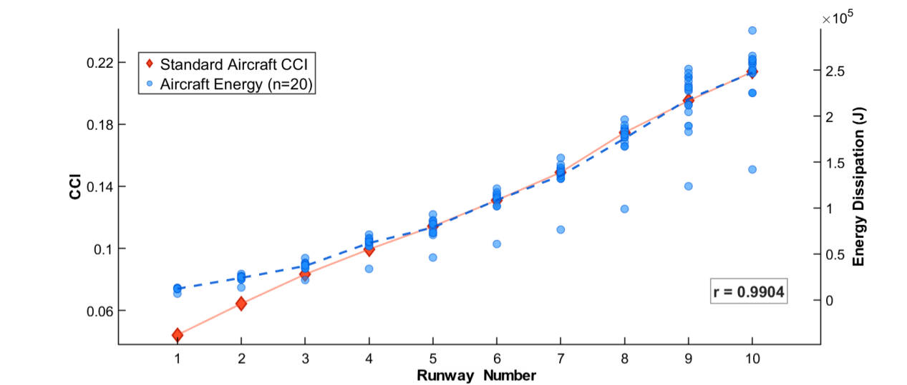
Fig.S8.3. Correlation Analysis Between Standardized Aircraft CCI and Energy Dissipation of Sample Aircraft

The optimized parameters were then substituted into the multibody dynamic equilibrium equations to obtain closed-form vibration velocity expressions for:
Sprung mass vertical velocity
(S8.13)
Nose gear vertical velocity
(S8.14)
Right main gear vertical velocity

(S8.15)
Left main gear vertical velocity
(S8.16)
The detailed expressions of the velocity components are given in Eqs. (S8.17)–(S8.22).
(S8.17)
(S8.18)
(S8.19)
(S8.20)
(S8.21)
(S8.22)

8.2 CCI Standard
According to the International Civil Aviation Organization (ICAO), international aviation has implemented the Carbon Neutral Growth (CNG 2020) target since 2020, aiming to stabilize net CO₂ emissions at the 2020 level¹. The year 2035 marks the end of the mandatory phase of the Carbon Offsetting and Reduction Scheme for International Aviation (CORSIA) and serves as a key milestone for evaluating CNG implementation². Therefore, international aviation CO₂ emissions in 2035 are expected to remain at the 2020 baseline level.
Based on this policy background, the present study establishes the CCI control threshold under the constraint that total carbon emissions in 2035 should not exceed the 2020 level. The procedure is summarized as follows:
(1) Baseline assumptions.
Due to the short interval between 2019 and 2020, runway roughness is assumed unchanged.
Total aircraft movements in China were 9.049 million in 2020.
Predicted aircraft movements in 2035 are 30 million.
(2) Single-event emission equivalence
The total CO₂ emissions induced by runway roughness in 2020 were calculated as 52.917 t. This corresponds to:
1.7639 g CO₂ per taxiing event;
0.02415 MJ additional mechanical energy per taxiing event;
These values serve as the reference constraint for CCI calibration.
(3) Scenario coverage
Taxiing distances vary significantly across hub, trunk, and regional airports. To ensure threshold universality, taxiing distances in the range [2600, 3300] m were evaluated at 100 m intervals, forming a multi-scenario dataset linking CCI to CO₂ emissions.
(4) Determination of CCI threshold
Under the constraint that 2035 total emissions equal the 2020 level, the quantitative mapping between CCI and CO₂ emissions yields a feasible CCI range of [3.508,4.085] s⁻¹, this interval satisfies the physical carbon constraint.
Economic constraint.
A life-cycle maintenance cost model (Supplementary Note 9) was introduced, incorporating both high-frequency preventive maintenance and low-frequency structural rehabilitation. The cost function exhibits a convex optimization characteristic. The minimum stable annual maintenance cost occurs when CCI=[3.72, 4.31] s⁻¹.
Final recommended CCI control range
The intersection of the physical and economic constraints yields: CCI=[3.508,4.085] s⁻¹. For practical implementation and standardization, this study recommends: CCI=3.9 s⁻¹ as the suggested control threshold.
Emission projection under CCI control (2025–2050).
Under the proposed CCI standard, cumulative emissions from 2025 to 2050 across Chinese airports are projected as: CO₂: 872462408.4g; HC: 17652.29g; CO: 81991.16g; NOₓ: 9247743.23 g; nvPM: 10858902.42g.
Applicability statement
The CCI evaluation framework and threshold calibration were established using a representative dual-slab pavement structure. However, its applicability does not depend on a specific structural configuration. The robustness of CCI originates from the fundamental roughness–vibration–energy dissipation mechanism. Sensitivity analyses indicate that the correlation between CCI and additional energy consumption remains stable across a broad range of pavement structural parameters and operational conditions, supporting its use as a standardized metric for airport pavement carbon assessment.

8.3 Runway Roughness Testing and Evaluation Procedure Based on CCI
The CCI-based testing approach builds upon the conventional runway relative elevation measurement systems widely adopted in airport pavement inspection practice (see Section 1.2.1 in Supplementary Note 1). By applying the computational framework described in Sections 8.1 and 8.2, longitudinal segmental CCI values can be obtained and compared against the prescribed threshold criteria to achieve carbon-oriented pavement condition evaluation.
The overall CCI-based runway roughness testing and evaluation workflow is illustrated in Fig.S8.4, taking the laser profilometer + BeiDou satellite positioning system (BDS) as an example.
Fig.S8.4. Workflow for runway roughness testing and evaluation based on CCI
The procedure consists of the following steps:
①System initialization
At the designated runway starting threshold, activate the rapid relative elevation acquisition system, ensuring that both the BDS positioning module and the laser profilometer operate simultaneously.
②Elevation data acquisition
Conduct measurements at a test speed of 60 km/h along the runway centerline, while simultaneously collecting data from 10 parallel longitudinal survey lines arranged at 1 m transverse intervals on each side of the centerline.
③Full-field elevation reconstruction
Based on synchronized time stamps, travel distance, and GPS planar coordinates, automatically integrate short-wavelength and long-wavelength components to generate a full-field relative elevation dataset of the runway.
④CCI computation
Input the reconstructed runway elevation data into the standardized CCI aircraft model. Using the CCI formulation, compute the longitudinal distribution of CCI values along the runway.
⑤Segmental evaluation
Specify a statistical segmentation interval (default: 100 m). Compare segmental CCI values with the recommended threshold to obtain a CCI-based runway roughness assessment result.

8.4 Airworthiness Validation of the CCI Model
The effectiveness of the Carbon Condition Index (CCI) in controlling additional carbon emissions has been demonstrated through the case study of Shanghai Pudong International Airport (Supplementary Note 11) and comparison with IRI (Supplementary Note 12). To ensure practical applicability in airport engineering, it is further necessary to verify that the CCI threshold guarantees aircraft ground operational safety while constraining carbon emissions.
Accordingly, correlation analyses were conducted between CCI and three key aircraft vibration response indicators: center-of-gravity acceleration (CGA), pilot-seat acceleration (PSA), and main landing gear dynamic load coefficient (DLC). The objective is to confirm that the recommended CCI threshold is consistent with established airworthiness safety criteria.

8.4.1 Selection of Airworthiness Indicators
Runway unevenness acts as an excitation source for the aircraft–runway system and affects aircraft structural integrity, runway durability, and operational comfort. CGA reflects overall aircraft vibration and passenger comfort. PSA characterizes pilot operational stability. DLC represents landing gear fatigue risk and dynamic interaction with the pavement.
Based on engineering practice and existing studies^{3,4}, the safety limits are defined as: CGA ≤ 0.27 g, PSA ≤ 0.27 g, DLC ≤ 1.2.
CGA and PSA increase monotonically with taxiing speed. DLC exhibits a speed-sensitive response due to the combined effects of lift and pavement excitation ^{5,6}.
To represent unfavorable operating conditions: CGA and PSA are evaluated at 210 km/h, and DLC is evaluated at 80 km/h.

8.4.2 Virtual Prototype Simulation
Four representative aircraft types (B737, B787, B777, and B747) were modeled using ADAMS/Aircraft to evaluate the robustness of CCI across different aircraft configurations^{7,8,9}. The modeling procedure includes:
(1)Geometric modeling
Three-dimensional models of the fuselage, landing gear, and tires were developed in CATIA and imported into ADAMS/Aircraft¹⁰.
(2)Parameter definition
Mass properties, geometric dimensions, aerodynamic forces, suspension forces, and constraint relationships were defined to construct subsystem templates^{11,12}.
(3)System assembly
Subsystems were integrated into a complete multi-body dynamic model (Fig.S8.5).
(4)Taxi simulation
Reconstructed runway unevenness profiles were used as excitation inputs. For each 100 m segment, peak values of CGA, PSA, and DLC were extracted.
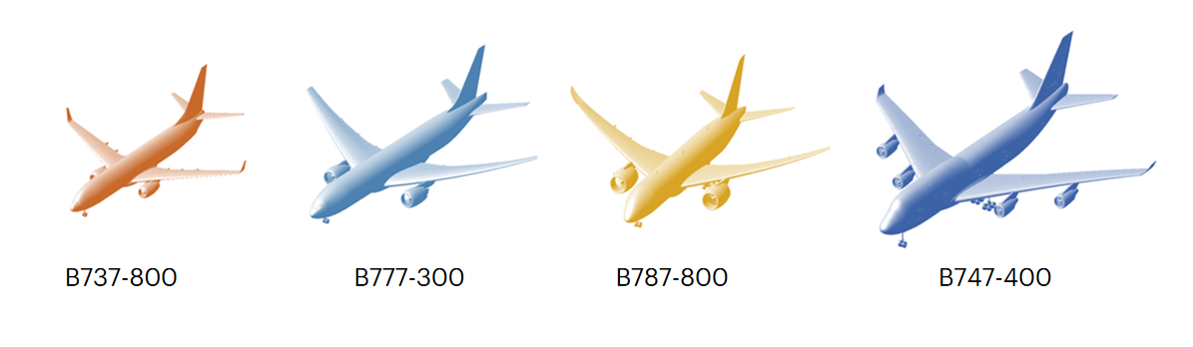
Fig.S8.5. Multi-body virtual aircraft model established in ADAMS/Aircraft for taxi dynamic simulation.

8.4.3 Correlation Analysis and Threshold Verification
Using simulation results from 21 virtual runway profiles (ranging from smooth to severely uneven conditions), correlation analyses were conducted between CCI and the three airworthiness indicators. Results (Fig.S8.6) show strong positive correlations: correlation coefficients range from 0.89 to 0.91, and CCI increases monotonically with center-of-gravity acceleration (CGA), pilot-seat acceleration (PSA), and main landing gear dynamic load coefficient (DLC). When CCI is controlled below the recommended threshold, all four aircraft types remain within the defined safety limits, with additional safety margins observed.
These results demonstrate that:
(1)CCI effectively captures pavement-induced vibration intensity.
(2)The recommended CCI threshold satisfies airworthiness safety requirements.
(3)CCI can simultaneously serve as a carbon-control and safety-consistent pavement evaluation index.
Compared with traditional roughness indices such as IRI and BBI, CCI directly links pavement unevenness to vibration energy dissipation and carbon emission potential, while maintaining compliance with aircraft ground operational safety standards.
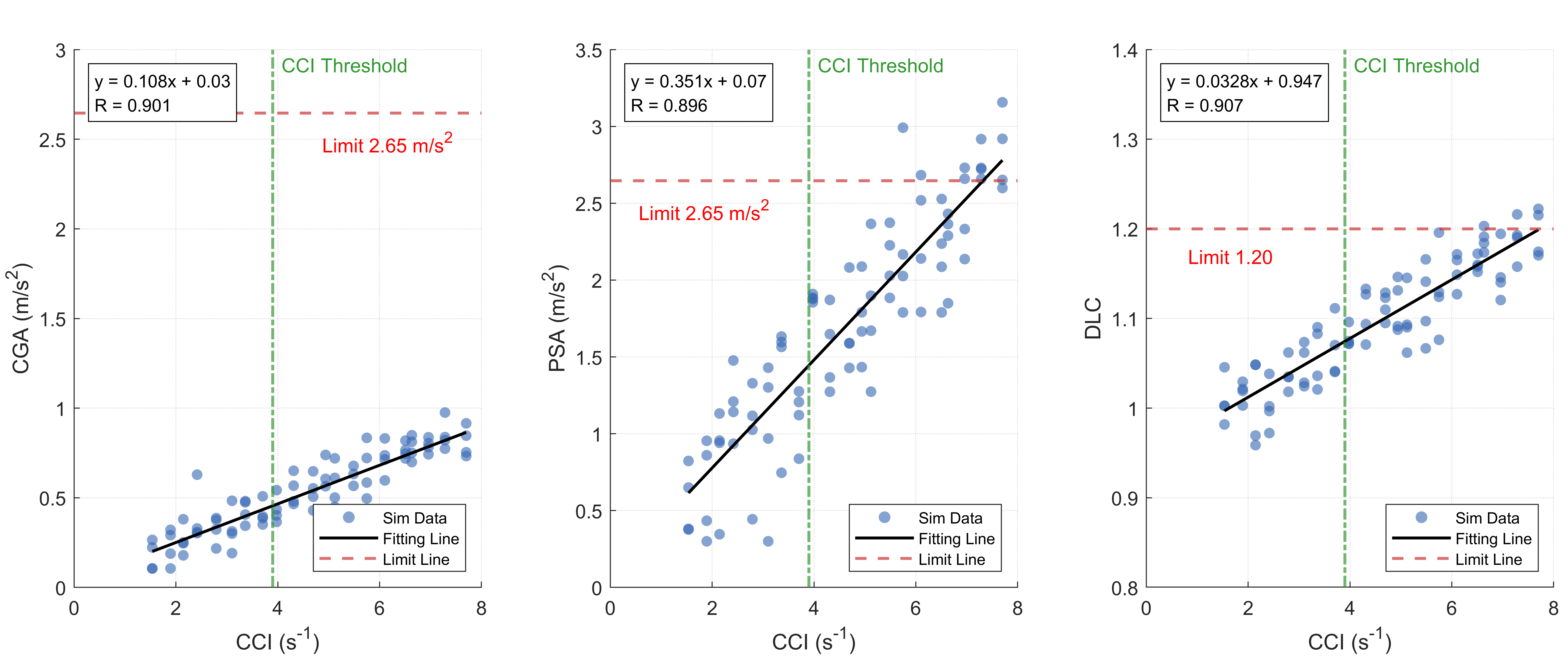
Fig.S8.6. Correlation between CCI and key aircraft vibration response indicators (CGA, PSA, and DLC).
References
- International Civil Aviation Organization. (2016). Resolution A39-3: Consolidated statement of continuing ICAO policies and practices related to environmental protection – Global Market-based Measure (MBM) scheme.
- International Civil Aviation Organization. (2025). Resolution A42-22: Consolidated statement of continuing ICAO policies and practices related to environmental protection - Carbon Offsetting and Reduction Scheme for International Aviation (CORSIA). International Civil Aviation Organization.
- Kuncas A. New index testing and verification-runway roughness index[R]. New Jersey: Federal Aviation Administration William J. Hughes Technical Center, 2021.
- Qian J S, Pan X W, Cen Y B, et al. Analysis of aircraft sliding dynamic load under runway unevenness excitation[J]. Journal of Vibration and Shock, 2022, 41(20): 176-184+269.
- Liu S F, Zhao J F, Hou T X, et al. Mechanism of unevenness excitation on dynamic response of aircraft-runway system[J]. Journal of Vibration and Shock, 2025, 44(10): 198-207.
- Qian J S, Cen Y B, Pan X W, et al. Spectrum parameters for runway roughness based on statistical and vibration analysis[J]. International Journal of Pavement Engineering, 2022, 23(11): 3757-3769.
- Liu S F, Zhu L G, Tian Y, et al. Airport runway rigid pavement dynamic response under multi-state ground operations of different aircraft using virtual prototypes[J]. International Journal of Pavement Engineering, 2025, 26(1): 2571737.
- Liu S F, Ling J M, Tian Y, et al. Assessment of aircraft landing gear cumulative stroke to develop a new runway roughness evaluation index[J]. International Journal of Pavement Engineering, 2022, 23(10): 3609-3620.
- Liu S F, Ling J M, Zhu L G, et al. A novel analytical approach for the spatial distribution of accumulated damage on the airport runway considering dynamic fatigue[J]. Engineering Failure Analysis, 2025: 110222.
- Liu S F, Tian Y, Liu L, et al. Improvement of Boeing Bump method considering aircraft vibration superposition effect[J]. Applied Sciences, 2021, 11(5): 2147.
- Tian Y, Liu S F, Liu L, et al. Optimization of International Roughness Index Model Parameters for Sustainable Runway[J]. Sustainability, 2021, 13(4): 2184.
- Qian J S, Cen Y B, Ling J M, Liu S F, et al. Dynamic stress in the ground of rigid pavement subjected to moving aircraft loads at various speeds[J]. International Journal of Pavement Engineering, 2023, 24(2): 2273327.

Supplementary Note 9. Economic assessment of runway roughness control
The main text proposes runway roughness control thresholds aimed at mitigating aviation carbon emissions. To evaluate the economic feasibility of these thresholds and ensure that the recommended control strategy does not impose excessive operational burdens, we develop a physically grounded cost–response model linking roughness evolution to maintenance expenditure.
The framework consists of four components:
(i) a physics-based model describing differential settlement–induced roughness evolution;
(ii) a probabilistic structural fragility model capturing major rehabilitation risk;
(iii) an annual expected total cost formulation integrating high-frequency minor repair and low-frequency structural reset; and
(iv) a mapping between the microscopic settlement threshold and the macroscopic CCI index.

9.1 Physical model of roughness evolution
To establish a mechanistic relationship between settlement and maintenance demand, a representative rigid pavement unit is idealized as two adjacent concrete slabs (5 m×5 m each, area $A_{slab}=25m^{2}$) connected by a joint. The subgrade is assumed to undergo non-uniform settlement at a constant rate. Based on long-term monitoring data from Shanghai Pudong International Airport (PVG), the average settlement rate is taken as: v_{sub}=3.6cm/year.
In the absence of intervention, differential settlement generates a V-shaped joint depression or faulting (Fig.S9.1). The maximum vertical displacement difference at the joint, $∆h$, is defined as the maintenance control variable.
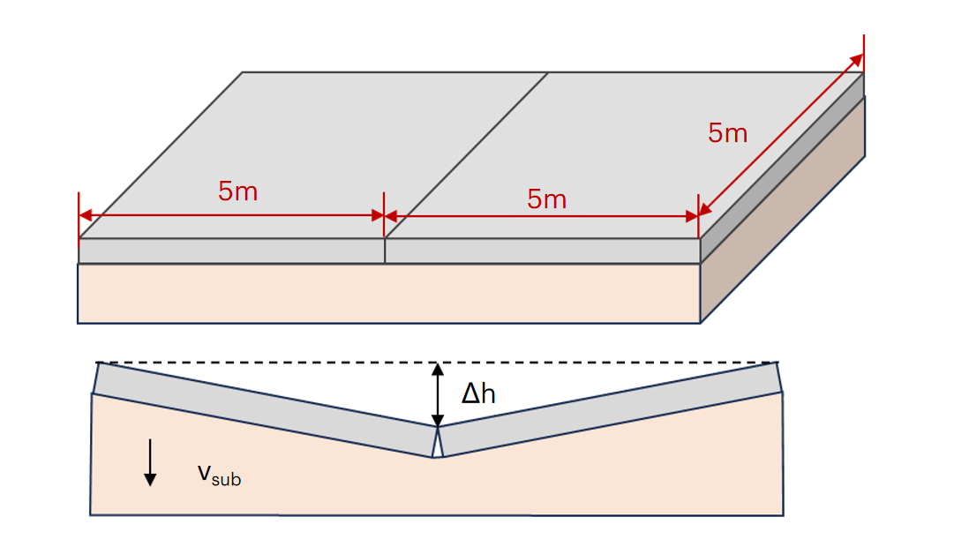
Fig.S9.1. Schematic illustration of the physical model for pavement roughness evolution
For small $∆h$, slab lifting by pressure grouting can restore surface levelness. Assuming a wedge-shaped void beneath the slab, the required grout volume is linearly related to settlement depth:
$V_{grout}\left(∆h\right)=η∙A_{slab}∙∆h$ (S9.1)
where 𝜂≈0.5 represents the geometric void factor for symmetric two-slab settlement.
A stricter threshold (smaller Δℎ) reduces per-event repair volume but increases intervention frequency.
When Δℎ becomes excessive, bending stress concentration may trigger slab cracking or structural failure, requiring overlay reconstruction. To describe this transition, a logistic fragility function is introduced:
$P_{fail}\left(∆h\right)=\frac{1}{1+exp⁡(−k\left(∆h−μ\right))}$ (S9.2)
with parameters $μ=1.5cm$，$k=12$. For $∆h<2.0 cm$, $P_{fail}→0$, as Δℎ→3.0cm, failure probability approaches unity.

9.2 Annual expected total cost model
Assuming continuous settlement, the annual intervention frequency is:
$N\left(∆h\right)=\frac{v_{sub}}{∆h}$ (S9.3)
The annual expected total maintenance cost is therefore:
$E\left[C_{total}\right]\left(∆h\right)=\frac{v_{sub}}{∆h}∙\left[\left(1−P_{fail}\right)∙C_{grout}\left(∆h\right)+P_{fail}∙C_{overlay}\right]$ (S9.4)
Where $C_{grout}\left(∆h\right)$ is the grouting cost, $C_{overlay}$is the structural overlay cost.
This formulation integrates frequent minor repair and probabilistic major rehabilitation within a unified framework.

9.3 Parameterization of maintenance costs
Cost parameters are calibrated using the Civil Aviation Engineering Consumption Standards and prevailing market prices.
(1) Grouting cost
$C_{grout}\left(∆h\right)=C_{mob}+C_{vol}∙V_{grout}\left(∆h\right)$ (S9.5)
Where: Mobilization cost $C_{mob}$= 4568.35CNY/event, Volumetric grouting cost $C_{vol}$= 457.59CNY/m³.
(2) Overlay cost
Overlay reconstruction, including surface removal and slab replacement, is estimated as: C_{overlay} =33470.03 CNY/event.

9.4 Mapping to CCI and optimal maintenance interval
Using the physical model described above, the microscopic settlement threshold Δℎ is mapped to the macroscopic Carbon Condition Index (CCI). Substituting the calibrated parameters into Eq.(S9.4) yields the CCI–annual cost response curve (Fig.S9.2). The resulting function exhibits a clear convex profile with a unique global minimum. This minimum corresponds to the optimal trade-off between minimizing carbon emissions induced by excessive roughness and minimizing lifecycle maintenance expenditure.
The economically optimal CCI interval coincides with the carbon-control interval identified in Supplementary Note 8, confirming that the recommended threshold achieves a balanced solution under both environmental and financial constraints.
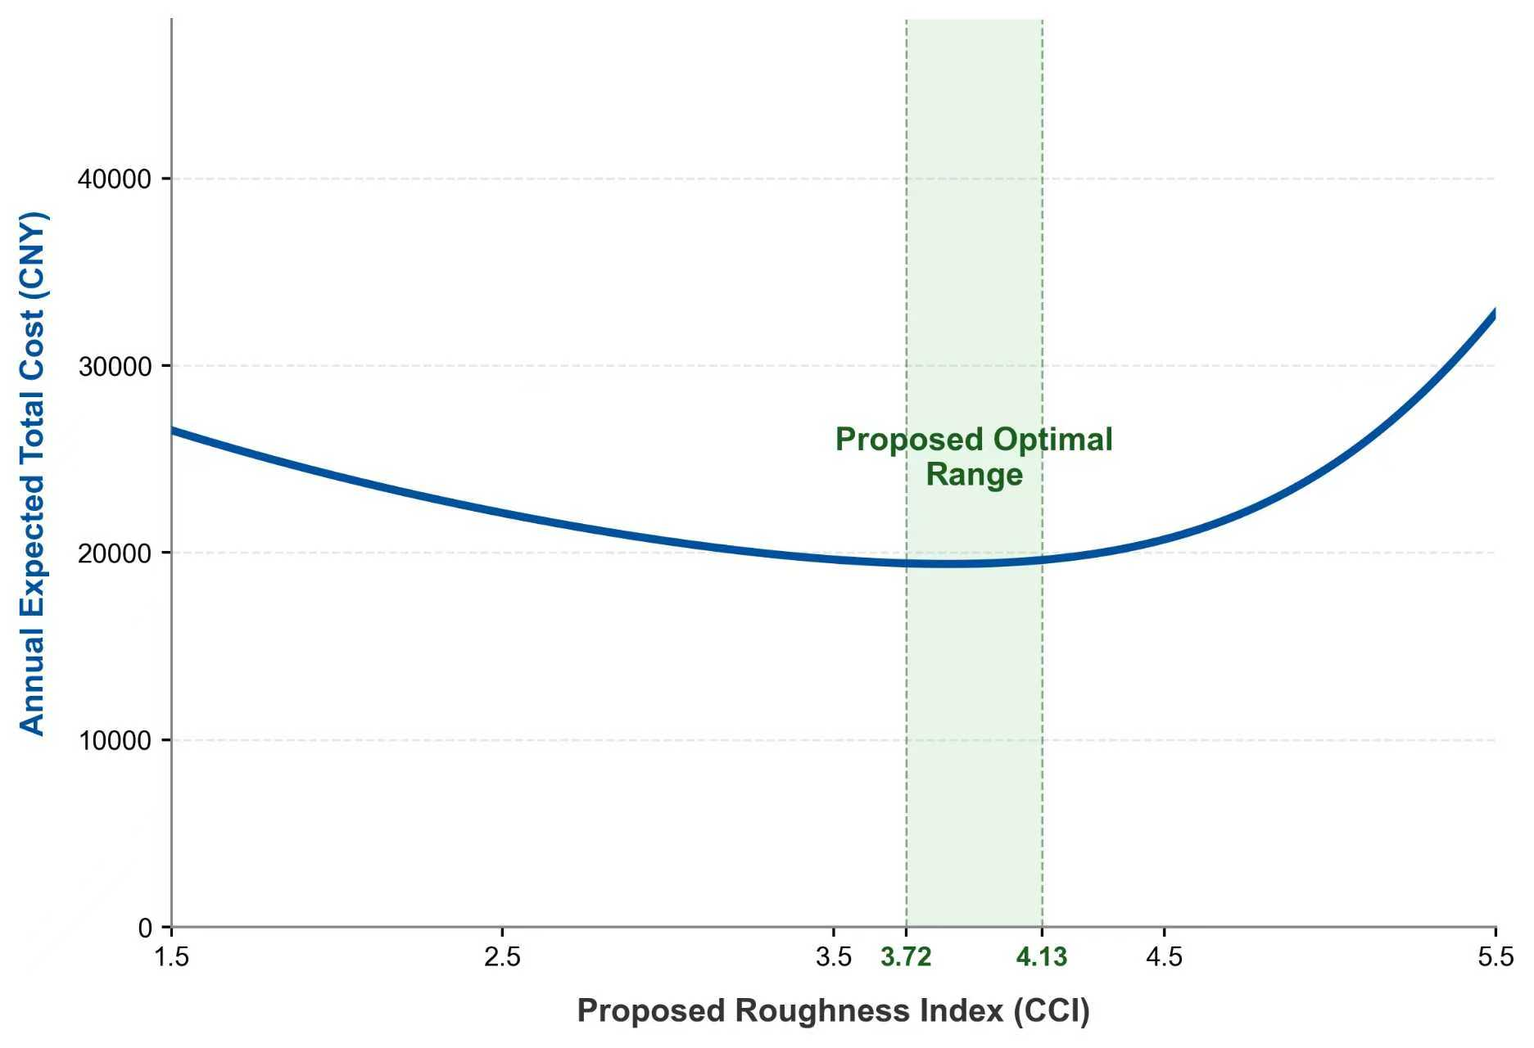
Fig.S9.2. Relationship between CCI and annual maintenance cost

Table S9.1. Mobilization and Demobilization Cost for Grouting Repair Equipment(Unit: operation)
No. | Item | Unit | Quantity | Unit Price (CNY) | Total (CNY)
1 | Direct Cost |  |  |  | 2815.75
1.1 | Basic Direct Cost |  |  |  | 2390.65
1.1.1 | Labor Cost |  |  |  | 1455.80
 | Composite Labor | Man-day | 5.800 | 251.00 | 1455.80
1.1.2 | Material Cost |  |  |  | 86.86
 | Galvanized Iron Wire | kg | 7.000 | 6.13 | 42.91
 | Straw Bags | ㎡ | 17.864 | 2.46 | 43.95
1.1.3 | Machinery Operation Cost |  |  |  | 848.00
 | Hydraulic Engineering Geological Drill | Machine-shift | 0.300 | 770.78 | 231.23
 | Truck Crane (Lifting Capacity 20t) | Machine-shift | 0.300 | 1396.90 | 419.07
 | Flatbed Trailer (Load Capacity 40t) | Machine-shift | 0.000 | 1863.38 | 0.00
 | Truck (Load Capacity 8t) | Machine-shift | 0.300 | 658.98 | 197.69
 | Truck (Load Capacity 15t) | Machine-shift | 0.000 | 958.46 | 0.00
1.2 | Other Direct Costs (Measure Costs) | CNY | 29.20% | 1455.80 | 425.09
2 | Indirect Costs | CNY |  |  | 902.60
2.1 | Statutory Fees |  |  |  | 465.86
2.1.1 | Social Security Fees | CNY | 26.81% | 1455.80 | 390.30
2.1.2 | Housing Provident Fund | CNY | 4.19% | 1455.80 | 61.00
2.1.3 | Hazardous Work Accident Insurance | CNY | 1.00% | 1455.80 | 14.56
2.2 | Enterprise Management Fees | CNY | 30.00% | 1455.80 | 436.74
3 | Profit | CNY | 30.00% | 1455.80 | 436.74
4 | Tax | CNY | 9.00% | 4591.82 | 413.26
 | Total | CNY |  |  | 4568.35

Table S9.2. Variable Maintenance Cost for Grouting Repair (Unit: 10m³)
No. | Item | Unit | Quantity | Unit Price (CNY) | Total (CNY)
1 | Direct Cost |  |  |  | 2770.02
1.1 | Basic Direct Costs |  |  |  | 2328.65
1.1.1 | Labor Cost |  |  |  | 1511.52
 | Composite Labor | Man-day | 6.022 | 251.00 | 1511.52
1.1.2 | Material Cost |  |  |  | 547.07
 | Cement P.O42.5 | t | 1.000 | 372.67 | 372.67
 | Fly Ash | t | 1.200 | 80.38 | 96.46
 | Bentonite | kg | 99.797 | 0.70 | 69.86
 | Other Material Cost | % | 0.015 | 538.98 | 8.08
1.1.3 | Machinery Operation Cost |  |  |  | 270.06
 | Hydraulic Engineering Geological Drill | Machine-shift | 0.142 | 770.78 | 109.45
 | Mud Pump 50mm | Machine-shift | 0.124 | 50.79 | 6.30
 | Electric Grouting Machine | Machine-shift | 0.354 | 28.18 | 9.98
 | Mortar Mixer | Machine-shift | 0.355 | 406.59 | 144.34
1.2 | Other Direct Costs (Measure Costs) | CNY | 29.20% | 1511.52 | 441.36
2 | Indirect Costs | CNY |  |  | 937.14
2.1 | Statutory Fees |  |  |  | 483.69
2.1.1 | Social Security Fees | CNY | 26.81% | 1511.52 | 405.24
2.1.2 | Housing Provident Fund | CNY | 4.19% | 1511.52 | 63.33
2.1.3 | Hazardous Work Accident Insurance | CNY | 1.00% | 1511.52 | 15.12
2.2 | Enterprise Management Fees | CNY | 30.00% | 1511.52 | 453.46
3 | Profit | CNY | 30.00% | 1511.52 | 453.46
4 | Tax | CNY | 9.00% | 4614.08 | 415.27
 | Total | CNY |  |  | 4575.89

Table S9.3(a) Overlay Repair Cost-Milling Old Pavement (Unit:100m²)
No. | Item | Unit | Quantity | Unit Price (CNY) | Total (CNY)
1 | Direct Cost |  |  |  | 18468.10
1.1 | Basic Direct Costs |  |  |  | 17845.12
1.1.1 | Labor Cost |  |  |  | 2133.50
 | Composite Labor | Man-day | 8.500 | 251.00 | 2133.50
1.1.2 | Material Cost |  |  |  | 9360.00
 | Milling Drum Edge Bits | piece | 18.000 | 520.00 | 9360.00
1.1.3 | Machinery Operation Cost |  |  |  | 6351.62
 | Pavement Milling Machine 2000mm | Machine-shift | 2.130 | 2981.98 | 6351.62
1.2 | Other Direct Costs (Measure Costs) | CNY | 29.20% | 2133.50 | 622.98
2 | Indirect Costs | CNY |  |  | 1322.77
2.1 | Statutory Fees |  |  |  | 682.72
2.1.1 | Social Security Fees | CNY | 26.81% | 2133.50 | 571.99
2.1.2 | Housing Provident Fund | CNY | 4.19% | 2133.50 | 89.39
2.1.3 | Hazardous Work Accident Insurance | CNY | 1.00% | 2133.50 | 21.34
2.2 | Enterprise Management Fees | CNY | 30.00% | 2133.50 | 640.05
3 | Profit | CNY | 30.00% | 2133.50 | 640.05
4 | Tax | CNY | 9.00% | 21070.97 | 1896.39
 | Total | CNY |  |  | 22327.31

Table S9.3(b) Overlay Repair Cost-Spraying Tack Coat (Unit: 100m²)
No. | Item | Unit | Quantity | Unit Price (CNY) | Total (CNY)
1 | Direct Cost |  |  |  | 368.01
1.1 | Basic Direct Costs |  |  |  | 349.84
1.1.1 | Labor Cost |  |  |  | 62.25
 | Composite Labor | Man-day | 0.248 | 251.00 | 62.25
1.1.2 | Material Cost |  |  |  | 269.84
 | Petroleum Asphalt 60~100 | t | 0.041 | 5839.05 | 239.40
 | Coal | kg | 12.000 | 1.00 | 12.00
 | Other Material Cost | % | 0.010 | 1843.86 | 18.44
1.1.3 | Machinery Operation Cost |  |  |  | 17.75
 | Truck-mounted Asphalt Distributor 4000L | Machine-shift | 0.029 | 612.07 | 17.75
1.2 | Other Direct Costs (Measure Costs) | CNY | 29.20% | 62.25 | 18.18
2 | Indirect Costs | CNY |  |  | 38.59
2.1 | Statutory Fees |  |  |  | 19.92
2.1.1 | Social Security Fees | CNY | 26.81% | 62.25 | 16.69
2.1.2 | Housing Provident Fund | CNY | 4.19% | 62.25 | 2.61
2.1.3 | Hazardous Work Accident Insurance | CNY | 1.00% | 62.25 | 0.62
2.2 | Enterprise Management Fees | CNY | 30.00% | 62.25 | 18.67
3 | Profit | CNY | 30.00% | 62.25 | 18.67
4 | Tax | CNY | 9.00% | 443.96 | 39.96
 | Total | CNY |  |  | 465.24

Table S9.3(c) Overlay Repair Cost-Laying Asphalt Layer (Unit: 100m²)
No. | Item | Unit | Quantity | Unit Price (CNY) | Total (CNY)
1 | Direct Cost |  |  |  | 16196.98
1.1 | Basic Direct Costs |  |  |  | 15917.00
1.1.1 | Labor Cost |  |  |  | 958.82
 | Composite Labor | Man-day | 3.820 | 251.00 | 958.82
1.1.2 | Material Cost |  |  |  | 14441.96
 | Stone Mastic Asphalt (SMA) | m³ | 6.090 | 2332.70 | 14206.14
 | Coal | kg | 23.000 | 2.00 | 46.00
 | Diesel Fuel | kg | 7.000 | 6.69 | 46.83
 | Other Material Cost | % | 0.010 | 14298.97 | 142.99
1.1.3 | Machinery Operation Cost |  |  |  | 516.22
 | Steel Wheel Roller 8t (Internal Comb.) | Machine-shift | 0.044 | 612.07 | 26.93
 | Steel Wheel Roller 15t (Internal Comb.) | Machine-shift | 0.250 | 1034.98 | 258.75
 | Asphalt Paver 8t | Machine-shift | 0.082 | 2811.50 | 230.54
1.2 | Other Direct Costs (Measure Costs) | CNY | 29.20% | 958.82 | 279.98
2 | Indirect Costs | CNY |  |  | 594.47
2.1 | Statutory Fees |  |  |  | 306.82
2.1.1 | Social Security Fees | CNY | 26.81% | 958.82 | 257.06
2.1.2 | Housing Provident Fund | CNY | 4.19% | 958.82 | 40.17
2.1.3 | Hazardous Work Accident Insurance | CNY | 1.00% | 958.82 | 9.59
2.2 | Enterprise Management Fees | CNY | 30.00% | 958.82 | 287.65
3 | Profit | CNY | 30.00% | 958.82 | 287.65
4 | Tax | CNY | 9.00% | 17366.74 | 1563.01
 | Total | CNY |  |  | 18642.10

Table S9.3(d) Mobilization Cost for Overlay Repair (Unit: operation)
No. | Item | Unit | Quantity | Unit Price (CNY) | Total (CNY)
1 | Pavement Milling Machine | Machine-shift | 1.00 | 4200.00 | 4200.00
2 | Truck-mounted Asphalt Distributor 4000L | Machine-shift | 1.00 | 4200.00 | 4200.00
3 | Rollers and paver | Machine-shift | 1.00 | 4200.00 | 4200.00

Supplementary Note 10. Correlation Analysis Methodology
This study selected 151 airport runways as research samples. The original elevation data were collected at 25 m intervals. To reduce the influence of local outliers, each runway was segmented into 100 m sections, and the average value of each indicator within a segment was taken as its representative value. This process ensured consistent spatial matching between elevation data and emission results.
Based on the processed elevation dataset, CO₂ emissions during taxiing were calculated for 14 representative aircraft types across all runways. Correlations among aircraft-specific CO₂ emissions were first examined.
Simultaneously, three pavement roughness indicators—BBI, IRI, and CCI—were computed using the same elevation dataset. The relationships between these indicators and aircraft CO₂ emissions were then quantified using Pearson correlation analysis and linear regression modeling. The analytical procedure is summarized as follows:
(1)Normality test: Data distributions were examined using the Shapiro–Wilk test (P > 0.05, indicating normality).
(2)Correlation analysis: Pearson correlation coefficients (r) were calculated to quantify linear relationships between roughness indicators and CO₂ emissions.
(3)Significance test: Statistical significance of correlation coefficients was verified using t-tests (α = 0.05).
(4)Regression modeling: Linear regression models were constructed, and the coefficient of determination (R²) was used to evaluate goodness of fit.
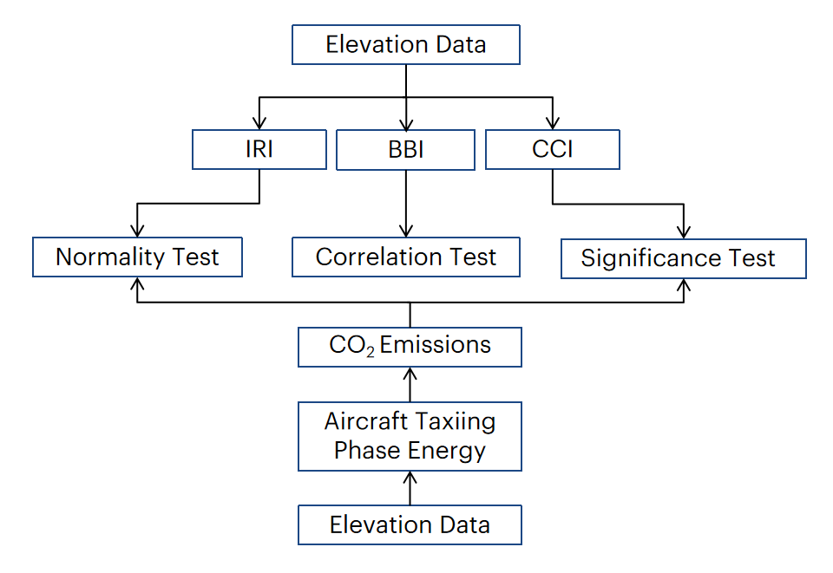
Fig.S10.1. Workflow of the correlation analysis procedure.
To ensure representativeness across the full spectrum of civil aviation operations, 14 aircraft types were selected, including: narrow-body jets (A319, A320neo, B737, B737-300, B757), wide-body jets (A330, A350, A380, B747, B777, B787), regional jets (CRJ900, E190), turboprop aircraft (ATR 500).
The inter-aircraft correlation results are shown in Fig.10.2. The high correlation observed in the original energy data primarily reflects the common excitation induced by pavement roughness. After removing the pavement-induced common effect via residual analysis, inter-aircraft residual correlations decreased significantly, and the residual standard deviations confirmed systematic differences among aircraft responses. This demonstrates that even under identical pavement excitation, aircraft energy responses exhibit clear heterogeneity.
Further analysis of correlations between aircraft energy consumption and the three roughness indicators shows:
CCI exhibits strong linear correlations (r≈0.8) with CO₂ emissions across all aircraft types;
BBI shows relatively higher correlations for smaller aircraft;
IRI generally demonstrates weaker correlations with CO₂ emissions.
These results indicate that CCI provides the strongest explanatory power in quantifying the effect of runway roughness on aircraft carbon emissions. In contrast, the sensitivities of BBI and IRI are strongly influenced by aircraft size and dynamic characteristics, resulting in pronounced aircraft-type dependence.
Fig.S10.2. Correlations between BBI, CCI, IRI and CO₂ emissions across different aircraft types.

Supplementary Note 11. Carbon Reduction Assessment for Shanghai Pudong International Airport
The subgrade beneath Runway 2 at Shanghai Pudong International Airport (PVG) consists of thick soft soil deposits with non-uniform consolidation rates. Long-term regional land subsidence has led to the gradual formation of pronounced long-wavelength surface irregularities over the runway life cycle. Based on multi-period field measurements, the dominant irregularity can be approximated as a sinusoidal profile with wavelength 𝐿=60m and geometric amplitude 𝐴=112.2 mm.
Although this long-wave unevenness amplifies aircraft dynamic responses, its BBI value remains 1.0, which is within the current regulatory limit. Consequently, the runway has remained in service for nearly 30 years without triggering maintenance under existing standards.
To quantify the carbon impact of this long-wave irregularity, aircraft taxiing over the affected section was simulated at 200 km/h, based on typical taxiway design speeds and operational averages. Using the dynamic model, the incremental energy dissipation and corresponding CO₂ emissions per aircraft passage in 2019 were calculated for major aircraft types. Combined with the actual annual movement frequencies (see Source Data 1), the total additional CO₂ emissions induced by pavement unevenness were obtained, as summarized in Table S11.
Table S11. Additional CO₂ emissions induced by subsidence at PVG (2019)
Aircraft type | Energy (J) | Number of Movements | CO₂ Emissions (g)
B747-400 | 5.31E+04 | 700 | 5435.446121
B787-9 | 7.27E+04 | 7338 | 77996.27516
B787-8 | 7.27E+04 | 2315 | 24606.34737
B787 | 7.30E+04 | 1457 | 15537.00377
B777-300ER | 6.96E+04 | 3034 | 30861.64352
B777-300 | 6.57E+04 | 3689 | 35435.4192
B757 | 3.97E+04 | 522 | 3026.144835
B747 | 5.31E+04 | 662 | 5140.379046
B737MAX 8 | 3.05E+04 | 784 | 3491.166639
B737-900 | 3.28E+04 | 388 | 1862.25536
B737-800 | 3.05E+04 | 74516 | 331821.1393
B737-800 (winglets) | 3.05E+04 | 2859 | 12731.18038
B737-700 | 2.73E+04 | 3453 | 13752.10146
B737-500 | 2.64E+04 | 52 | 200.7812904
B737-300 | 2.43E+04 | 534 | 1897.117006
B737-300 (Mixed Configuration) | 2.43E+04 | 67 | 238.0277892
B737-200 | 2.00E+04 | 8 | 23.39114268
B737 | 2.73E+04 | 5205 | 20729.70984
B737 (Mixed Configuration) | 2.73E+04 | 4 | 15.93061275
A380 | 6.31E+04 | 868 | 8002.067267
A350-900 | 6.80E+04 | 3114 | 30945.01233
A350-1000 | 7.37E+04 | 784 | 8446.762544
A350 | 7.37E+04 | 921 | 9922.791203
A330-300 | 7.12E+04 | 20531 | 213612.0428
A330-200 | 7.17E+04 | 5364 | 56163.24247
A330 | 7.12E+04 | 10368 | 107872.4689
A321neo | 3.66E+04 | 429 | 2295.061143
A321 (Sharklets) | 3.56E+04 | 417 | 2166.924471
A321 | 3.56E+04 | 39837 | 207011.4393
A320 (Sharklets) | 2.99E+04 | 11 | 48.10395796
A320 | 2.99E+04 | 30229 | 132194.0496
A319 | 2.94E+04 | 5949 | 25523.86091
Note: Each movement (take-off or landing) is counted as one taxiing event.
To evaluate the full life-cycle carbon impact of this long-wave irregularity, cumulative simulations were performed over a 30-year period (2020–2050), incorporating projected growth in aircraft movements and fleet structure evolution. Assuming the wavelength and amplitude remain unchanged, the irregularity would generate approximately 1.35×10⁸g of additional emissions over the 30-year life cycle. This amount represents a form of “hidden carbon emission” that cannot be effectively identified under the current BBI-based evaluation system.
Impact of Applying the CCI Standard
Under the proposed CCI control criterion (CCI≤3.9 s⁻¹), the allowable geometric amplitude must be reduced to satisfy carbon emission constraints. Keeping the wavelength L constant at 60 m, the amplitude must decrease from: 𝐴=112.2 mm→𝐴₂=82.4 mm.
Re-simulating the full taxiing process with the optimized amplitude shows that the cumulative additional CO₂ emissions over 30 years would be reduced to: 7.33×10⁷ g CO_{2.}
This represents a 46% reduction compared with the current condition.
These results demonstrate that, unlike BBI, the proposed CCI framework can effectively identify and regulate long-wavelength irregularities with significant carbon implications, thereby enabling targeted mitigation of hidden lifecycle emissions while maintaining operational feasibility.

Supplementary Note 12. Comparison of Carbon Emissions under CCI and IRI Control Scenarios
Based on the differentiated pavement roughness prediction results presented in Section 5.2, this study takes 2025 as the baseline year and further analyzes the long-term evolution of runway roughness at different airports. The analysis focuses on airport-specific IRI deterioration mechanisms, maintenance intervention thresholds, and adaptive operational strategies.

(1) Airport-specific IRI deterioration mechanisms
Runway roughness deterioration results from the coupled effects of material aging, cumulative traffic loading, and environmental exposure. The relative influence of these factors varies among airports, leading to distinct IRI evolution trajectories:
①Material properties: Differences in pavement type (asphalt vs. concrete), aggregate composition, binder characteristics, and construction quality result in varying oxidation rates and deformation accumulation patterns.
②Traffic loading: Hub airports and regional airports differ significantly in aircraft movements, fleet mix, and daily runway usage intensity, resulting in differentiated structural fatigue and plastic deformation rates.
③Environmental conditions: Variations in temperature cycles, annual precipitation, and freeze–thaw frequency further influence the rate of pavement deterioration.
These factors collectively determine airport-specific IRI deterioration rates.
(2) Maintenance threshold and intervention strategy
According to industry practice, major rehabilitation cycles typically range: 6–8 years for hub airports, 8–10 years for regional airports. In accordance with the 2019 Technical Specification for Airport Pavement Evaluation and Management, an intervention threshold of IRI = 4.3 m/km is adopted.
Using the predicted 2025 baseline IRI values and airport-specific deterioration rates established in Section 5.2, post-2025 IRI trajectories are projected. When IRI reaches 4.3 m/km, rolling resistance and tire wear increase significantly, triggering maintenance intervention. Maintenance strategies are adapted to pavement type:
Concrete runways: milling + overlay combined with crack repair
Asphalt runways: milling + overlay combined with surface sealing
Post-maintenance IRI recovery values are determined based on historical performance data for similar runway types at each airport.
(3)Carbon Emission Comparison under IRI and CCI Control
Based on the above IRI evolution scenarios, CO₂ emissions from 2025 to 2050 are calculated under: IRI-based control scenario and CCI-based control scenario. The comparison results are shown in Fig.S12.
Under the CCI control framework, carbon emissions are consistently lower than under the IRI control scenario, demonstrating that the CCI index provides a more direct and effective mechanism for limiting vibration-induced incremental carbon emissions.
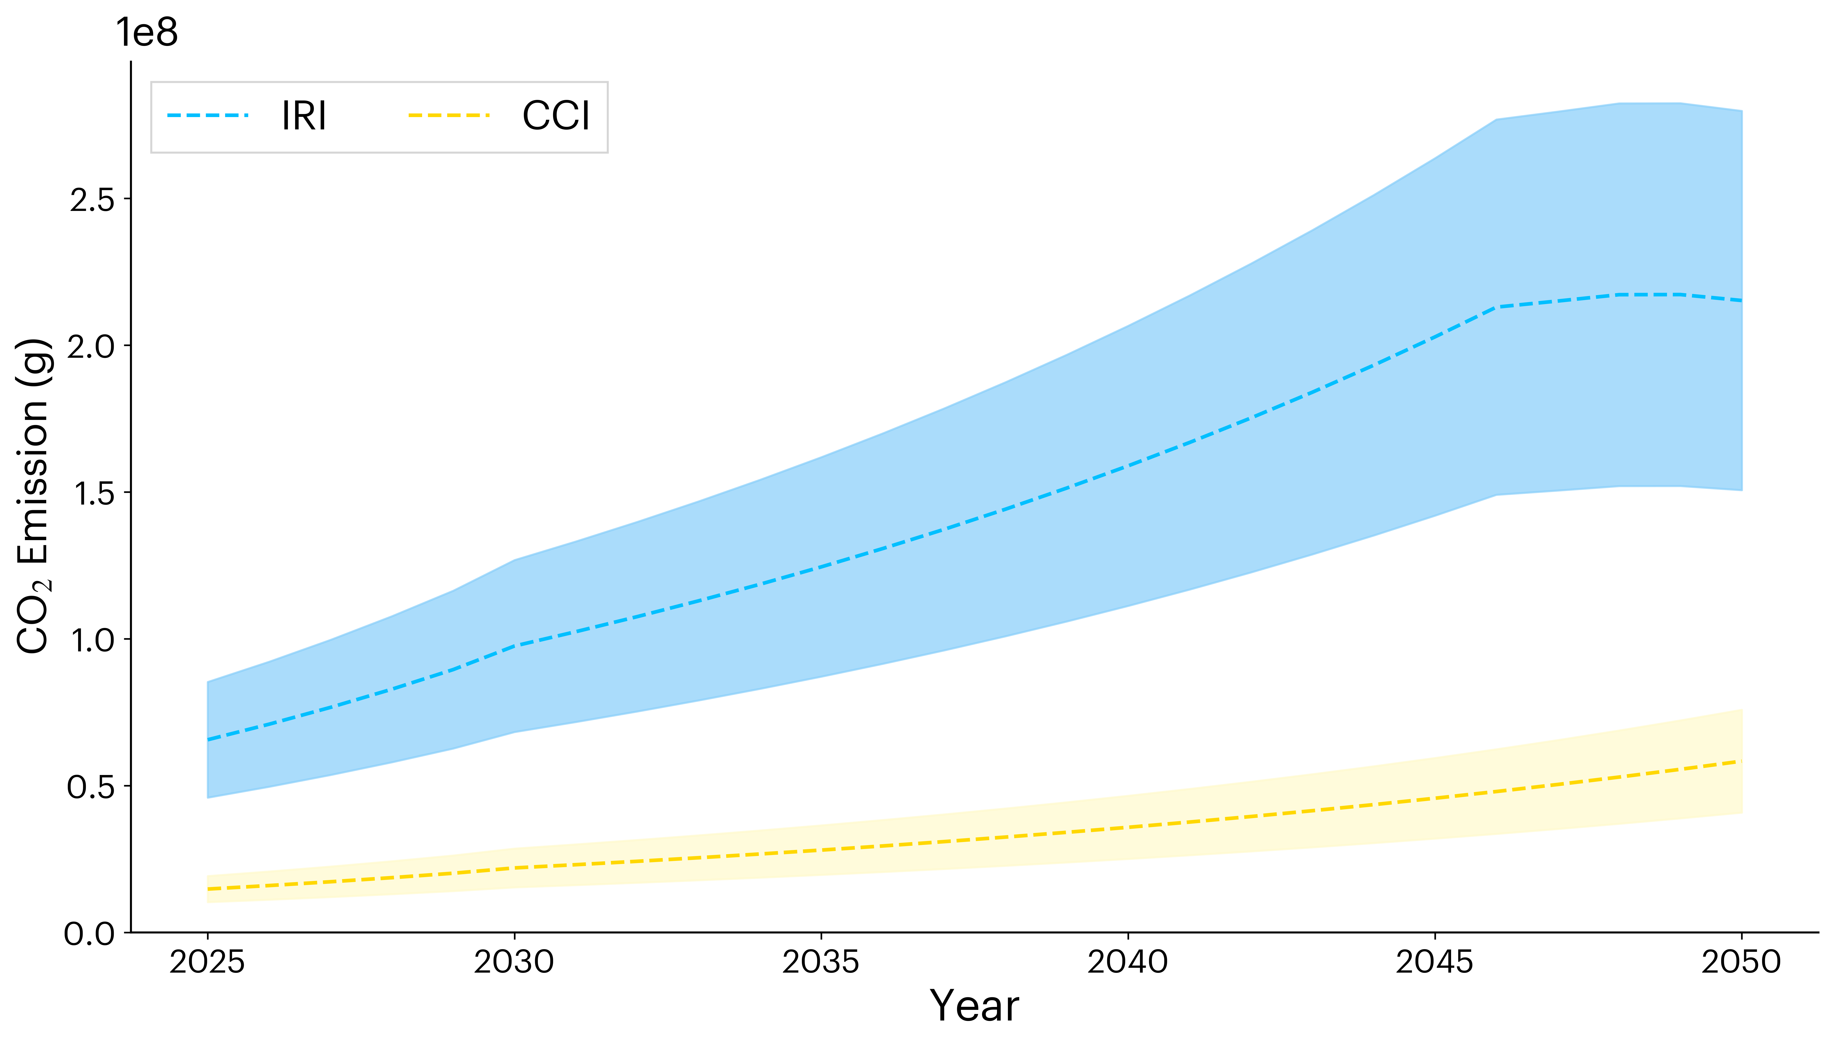
Fig.S12. Comparison of CO₂ emissions under IRI-based control and CCI-based control scenarios (2025–2050).

Supplementary Note 13. Comparison of Runway Roughness Between China and the United States and Global CE_{ctol} Extrapolation

13.1 Pavement Roughness Characteristics of Chinese and U.S. Airports
The Federal Aviation Administration (FAA) provides publicly available longitudinal roughness measurements for 37 runways and 37 taxiways in the United States. Table S13.1 lists the identifiers and airport codes of 18 representative U.S. runways selected for this study.
Due to the distinct spectral characteristics of asphalt and concrete pavements, separate power spectral density (PSD) models were adopted for the two pavement types in accordance with Equations (1.1) and (1.2) in Supplementary Note 1.
Table S13.1 Single-track roughness data for 18 U.S. runways
Runway ID | Airport Code | Runway ID | Airport Code
43 | SRQ | 62 | DFW
44 | DEN | 63 | MDT
45 | DEN | 64 | ACY
46 | SRQ | 67 | PHX
47 | MSY | 68 | ACY
48 | ORD | 56 | ACY
49 | MCI | 57 | ACY
50 | SRQ | 59 | EWR
51 | ORD | 54 | EWR
60 | MSY | 55 | ACY
(1) Asphalt Runways
The PSD of each asphalt runway was computed using Eq.(S1.1). Fitted parameter distributions for Chinese and U.S. runways are presented in Fig.S13.1.
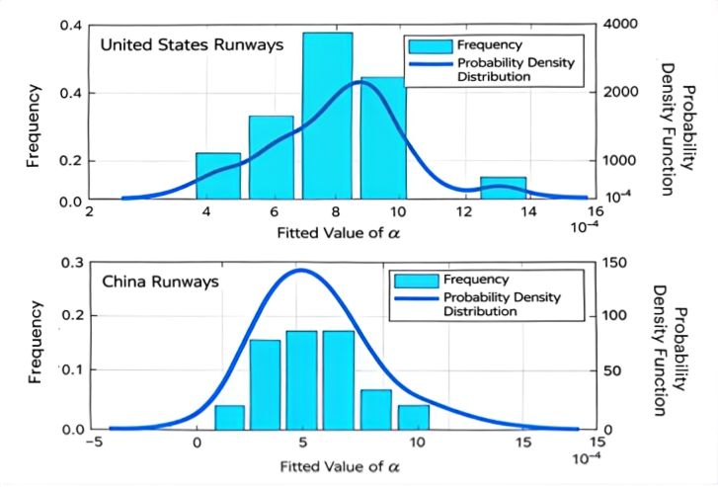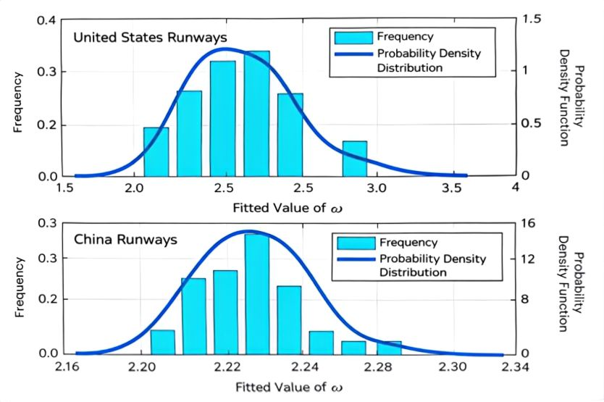
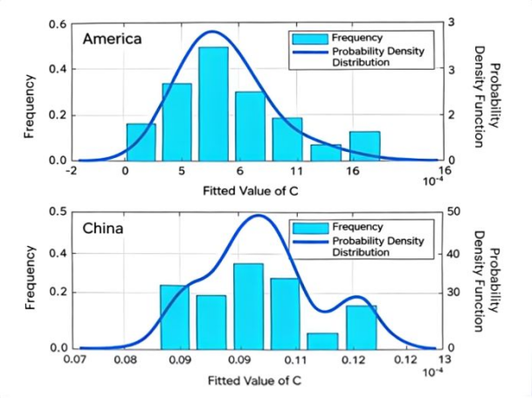
Fig.S13.1. Probability distribution and probability density of fitted PSD parameters for all asphalt runways
For the spectral coefficient C, U.S. runways exhibit a bimodal distribution, with peaks near 0.1 and 1.25. The first peak (≈0.1) accounts for approximately 85% of the probability density. In contrast, Chinese asphalt runways show a concentrated distribution within 0.09–0.12, located entirely within the primary U.S. peak. This indicates that U.S. airports cover a broader range of roughness conditions. For parameter ω, both countries exhibit largely overlapping distributions, although Chinese values tend to be slightly lower.
For parameter β, U.S. runways show maximum probability density near 2.3, while Chinese runways peak near 2.24. Although the most probable values are close, U.S. runways span a wider interval (2.0–3.2), fully covering the Chinese range. This reflects the larger and more diverse asphalt pavement sample in the U.S.
The corresponding parameter ranges are summarized in Table S13.2.
Table S13.2. Range of fitted PSD parameters for asphalt runways
Asphalt Runways | C
Chinese Runways | 0.0907~0.119（0.1） | 0.00054~0.0014（0.0009） | 2.199~2.285（2.24）
U.S. Runways | 0.0227~1.206（0.1） | 0.00019~0.00178（0.0005） | 2.042~3.162（2.3）
Note: Values in parentheses indicate the parameter corresponding to the maximum probability density.
(2) Concrete Runways
For concrete pavements, PSD was calculated using Eq.(S1.2), and two-segment fitting was performed.

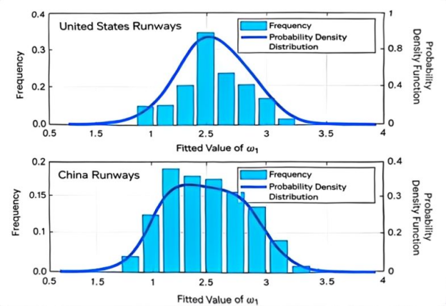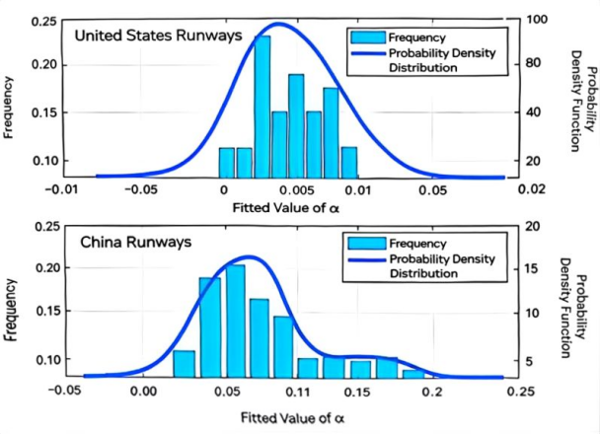
Fig.S13.2. Frequency distribution and probability density of first-segment fitted parameters for all concrete pavements
First Segment
The fitted parameter distributions for the first segment are shown in Fig.S13.2. For C₁, both countries exhibit similar distributions within 0–0.2, with the highest probability near 0.025. For ω₁, U.S. runways are mainly distributed within 0–0.015 (mode≈0.005), while Chinese runways extend to 0–0.15 (mode≈0.04). The larger magnitude observed for Chinese runways indicates comparatively smoother slab-level conditions. For β₁, both countries span similar overall ranges (approximately1.5–3.5), although U.S. distributions are more concentrated, whereas Chinese values are more evenly distributed.
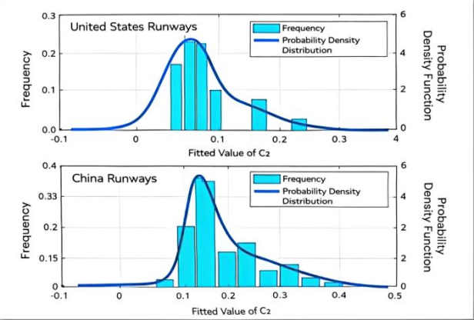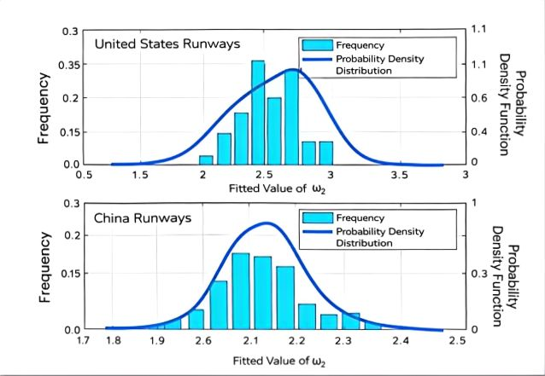
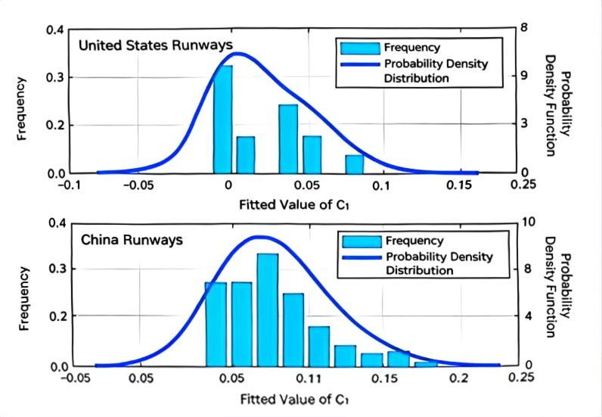
Fig.S13.3. Probability distribution and probability density of fitted parameters for all concrete pavements
Second Segment
The second-segment parameter distributions are presented in Fig.S13.3. For C₂, both countries show similar distributions within 0–0.4, with the most probable value near 0.08. For ω₂, both fall within 1.8–2.4, with U.S. runways peaking near 2.5 and Chinese runways near 2.2. These results indicate that, at the slab scale, roughness characteristics are highly comparable between Chinese and U.S. airports. This consistency is expected because severe structural defects (e.g., slab breakage) are not tolerated in operational runways. Within-slab roughness is primarily governed by surface texturing, patching, and minor cracking, which exhibit similar engineering standards internationally.
The fitted parameter ranges for concrete runways are summarized in Table S13.3.
Table S13.3. Range of fitted PSD parameters for concrete runways
Concrete Runways | C₁ |  | ω₁
Chinese Runways | 0.0089-0.235（0.025） | 0.00009-0.1503（0.04） | 1.369-3.527（2.4）
U.S. Runways | 0.007-0.147（0.025） | 0.0000152-0.0103（0.005） | 1.21-3.22（2.5）
Concrete Runways | C₂ | ω₂
Chinese Runways | 0.049-0.597（0.08） | 1.813-3.13（2.5）
U.S. Runways | 0.029-0.308（0.08） | 1.59-2.86（2.2）
Note: Values in parentheses indicate the parameter corresponding to the maximum probability density.

13.2 Global Extrapolation Strategy Based on “Mechanism Consistency and Regional Calibration”
The additional vibration-induced energy dissipation caused by aircraft–runway roughness interaction is governed by fundamental physical principles, including structural dynamics, material mechanics, and energy conservation. This mechanism is independent of geographic location, airport scale, and operational patterns. Therefore, although the model was constructed and validated using Chinese airport data, the underlying vibration–energy–emission coupling relationship is physically universal and can be applied to global airport systems.
From a macro perspective, China’s civil aviation sector emitted approximately 110 million tons of CO₂ in 2019, accounting for about 13% of global aviation emissions¹. As one of the largest aviation markets worldwide, China exhibits fleet composition, operational intensity, and airport development characteristics broadly consistent with global trends. This provides statistical representativeness for global extrapolation and reduces the risk of regional bias.
From an infrastructure perspective, most Chinese civil airports are relatively newly constructed and strictly comply with ICAO and CAAC pavement performance standards. Their runway smoothness levels generally meet or exceed international specifications. Therefore, Chinese runway performance can be regarded as a high-quality reference benchmark in the global context.
Based on this, we introduce Hypothesis 1:
The overall runway roughness level of global airports follows a similar trend to that of Chinese airports, and Chinese runway performance represents an upper-to-mid-level benchmark globally.
Given the universal vibration–emission mechanism and the validated proportion of roughness-induced emissions within total aviation emissions in China, this proportion can reasonably be extended to the global scale. Based on this extrapolation, the comprehensive emission cost (CE_{ctol}) induced by runway roughness in the global airport system in 2019 is estimated to be approximately 9.06×10⁸, which serves as a lower-bound reference under a high-performance pavement assumption.
To further define a realistic global interval and test robustness, we incorporate U.S. runway data as a comparative baseline. Eighteen representative U.S. airport runways were selected based on publicly available FAA measurements. Their statistical mean parameters were used to represent the average U.S. pavement condition. To eliminate fleet-structure bias, the 2019 Chinese fleet composition was applied under the U.S. runway parameter scenario, and vibration-induced energy dissipation and associated emissions were recalculated. Given that many U.S. airports are older and subject to long-term high-traffic loading, cumulative pavement deterioration effects are more pronounced. Therefore, U.S. runway performance can reasonably serve as a relatively conservative (lower-quality) benchmark.
We thus introduce Hypothesis 2:
The majority of global airport runway performance lies between Chinese and U.S. average levels, following consistent physical trends.
Under these two bounding scenarios: ①CE_{ctol} calculated using Chinese runway parameters (high-quality benchmark): 9.06×10⁸ (lower bound); ②CE_{ctol} calculated using U.S. runway parameters (lower-quality benchmark): 1.04×10⁹ (upper bound)
Accordingly, the global comprehensive emission cost induced by runway roughness in 2019 is reasonably estimated to lie within the interval: [9.06×10⁸, 1.04×10⁹]
This bounded extrapolation approach, grounded in mechanism universality and regional calibration, enhances robustness and mitigates the limitations of single-region inference, thereby supporting the global applicability of the study’s conclusions.
Reference
- International Air Transport Association. (2019, December 12). Carbon emissions per passenger decrease more than 50% since 1990. https://www.iata.org/en/pressroom/pressroom-archive/2019-press-releases/2019-12-12-01/

Supplementary Note 14. Aircraft–Runway Coupled System Model for Energy Dissipation Calculation

14.1 Aircraft–Runway Coupled System Model for Taxiing Energy Analysis
A coupled aircraft–runway dynamic model was developed to quantify vibration-induced energy dissipation during the ground roll phase. When an aircraft moves at high speed on a runway, pavement roughness acts as an external excitation source, inducing aircraft vibrations. The resulting dynamic wheel loads act on the pavement and generate structural vibration of the runway system. The pavement vibration displacement, superimposed with the geometric roughness profile, subsequently modifies the excitation input to the aircraft. This bidirectional interaction forms a fully coupled aircraft–runway dynamic system.
The vibration energy dissipated within both the aircraft and pavement subsystems represents the additional energy consumption induced by runway roughness during ground roll.Taking pavement roughness as the external excitation input, we constructed a full multi-body dynamic model of the aircraft, a three-dimensional finite element model of the pavement–subgrade structure, and a dynamic compatibility interface describing the wheel–roughness–pavement displacement interaction.
By integrating the aircraft submodel and runway submodel through dynamic coordination conditions, a complete aircraft–runway coupled system was established (Fig.S14.1). A numerical solution framework based on partitioned iteration and the Newmark-β time integration scheme was implemented in MATLAB to solve for displacement, velocity, and acceleration responses of both subsystems. Based on the dynamic responses, energy dissipation in the following components was calculated landing gear shock absorbers, tires, pavement structure, subgrade structure. This enables quantitative evaluation of system-level energy dissipation under roughness excitation.
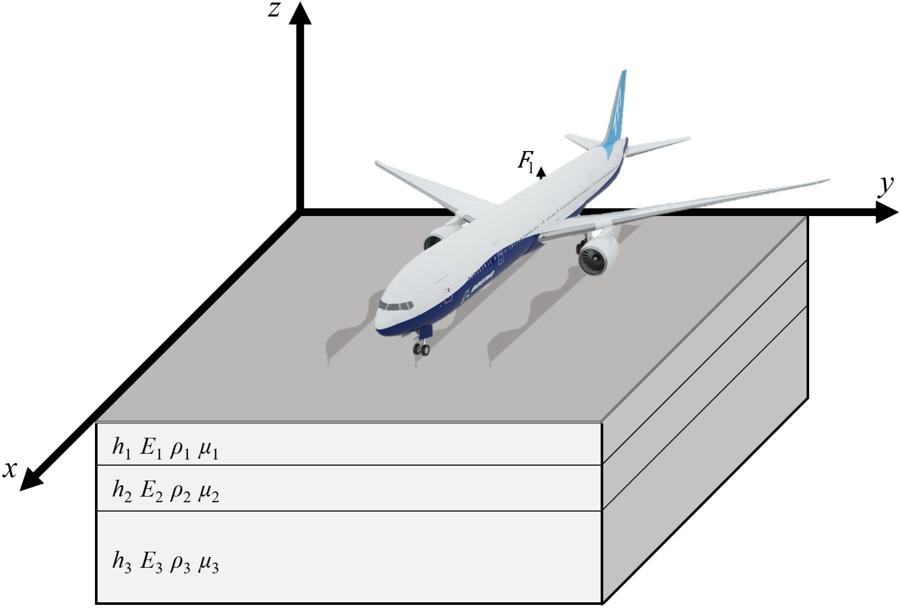
Fig.S14.1. Aircraft–runway coupled dynamic system model

14.1.1 Aircraft Submodel
In airport engineering research, three types of aircraft models are commonly adopted: the simplified main landing gear model, the half-aircraft model, and the full-aircraft model. Among them, the full-aircraft model consists of a fuselage and multiple landing gears, enabling representation of the spatial vibration of the fuselage under three-dimensional runway roughness excitation as well as the vertical vibration of each landing gear. This modeling approach has been widely applied in aircraft dynamic load calculation and vibration analysis under runway irregularity excitation.
Considering the large longitudinal spacing between the nose and main landing gears, as well as the significant lateral distance between the left and right main landing gears, non-uniform longitudinal and transverse runway roughness excitation during high-speed ground rolling induces noticeable pitch and roll motions of the fuselage. Therefore, to accurately capture the spatial vibration characteristics of the aircraft during taxiing and takeoff roll, a full-aircraft ground dynamic model is established in this study.
A six-degree-of-freedom (6-DOF) full-aircraft model is developed for typical three-point narrow-body aircraft such as the B737 and A320, as illustrated in Fig.S14.2. The model simultaneously considers vertical vibration of the sprung mass (fuselage), pitch rotation of the fuselage, roll rotation of the fuselage, vertical vibration of the unsprung masses of the nose, left main, and right main landing gears. The model parameters are defined as follows:
m_{s}: sprung mass of the aircraft
I_{x}、I_{y}:mass moments of inertia about the longitudinal (x) and lateral (y) axes；
m_{f}、m_{r}、m_{l}:unsprung masses of the nose, right main, and left main landing gears；
z_{s}: vertical displacement of the fuselage
Φ: pitch rotation
Ψ: roll rotation
z₁、z₂、z₃:vertical displacements of the nose, right main, and left main landing gears；
k_{s1}、k_{s2}、k_{s3}:stiffness coefficients of landing gear shock absorbers；
c_{s1}、c_{s2}、c_{s3}:damping coefficients of landing gear shock absorbers；
q₁、q₂、q₃:runway roughness excitation inputs；
k_{t1}、k_{t2}、k_{t3}:tire stiffness coefficients；
c_{t1}、c_{t2}、c_{t3}: tire damping coefficients；
l_{f}、l_{m}: longitudinal distances from nose and main landing gears to the aircraft reference axis；
b_{r}、b_{l}: lateral distances from right and left landing gears to the longitudinal axis；
F_{l}: aerodynamic lift；
f₁、f₂、f₃: wheel–runway contact forces (obtained from the wheel–runway interaction model in Section 14.1.3)

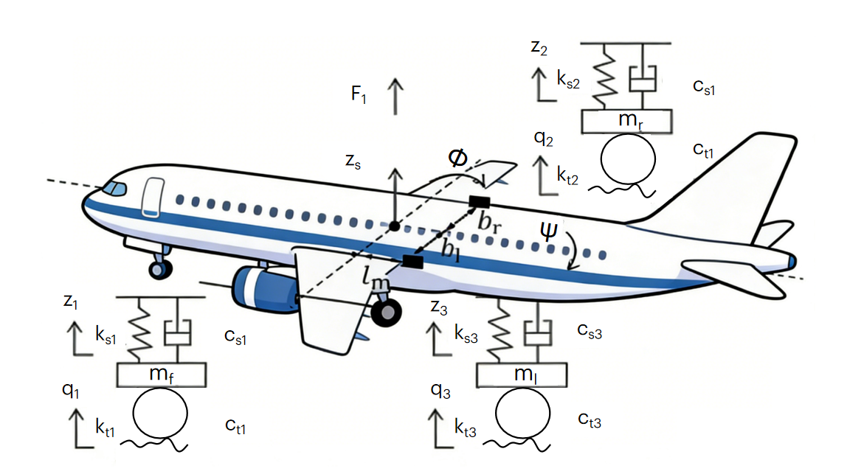
Fig.S14.2. Dynamic model of a three-point medium-sized passenger aircraft
Based on D’Alembert’s principle, the equilibrium equations of motion of the six-degree-of-freedom aircraft model under runway roughness excitation are established (Eqs. S14.1–S14.6), including:
Vertical vibration of the sprung mass：
(S14.1)
Pitch rotation of the sprung mass：

(S14.2)
Roll rotation of the sprung mass：
(S14.3)
Vertical vibration of the nose landing gear：
(S14.4)
Vertical vibration of the right main landing gear：
(S14.5)
Vertical vibration of the left main landing gear：
(S14.6)
The aerodynamic lift force is expressed as:
(S14.7)
where C_{l} denotes the lift coefficient, S_{w} is the wing area, ρ_{a} is the air density, and V_{a} represents the aircraft taxiing speed.
Since the aircraft performs straight-line ground rolling, the lift force is assumed to act at the center of gravity.
The system of equations can be expressed in matrix form as:
(S14.8)
where M_{a}, C_{a}, and K_{a} denote the mass, damping, and stiffness matrices of the aircraft, respectively; X_{a}、Ẋ_{a} and Ẍ_{a} represent the aircraft vibration displacement, velocity, and acceleration vectors; and F_{a} is the load vector.
(S14.9)
(S14.10)
(S14.11)
(S14.12)
(S14.13)
(2) Five-Point Large Wide-Body Aircraft Model
Based on the three-point model, a five-point full-aircraft dynamic model is further developed for large wide-body aircraft such as the B747 (Fig.S14.3). This model incorporates multiple main landing gears (outer and inner gears on both sides), allowing accurate representation of complex multi-gear dynamic interactions during ground rolling.
The governing equations are similarly derived using D’Alembert’s principle, including:
Vertical vibration equilibrium of the sprung mass:
(S14.14)
Pitch rotational equilibrium：
(S14.15)
Roll rotational equilibrium：
(S14.16)
Vertical vibration equilibrium of five unsprung landing gear masses：
(S14.17)
(S14.18)
(S14.19)
(S14.20)
(S14.21)
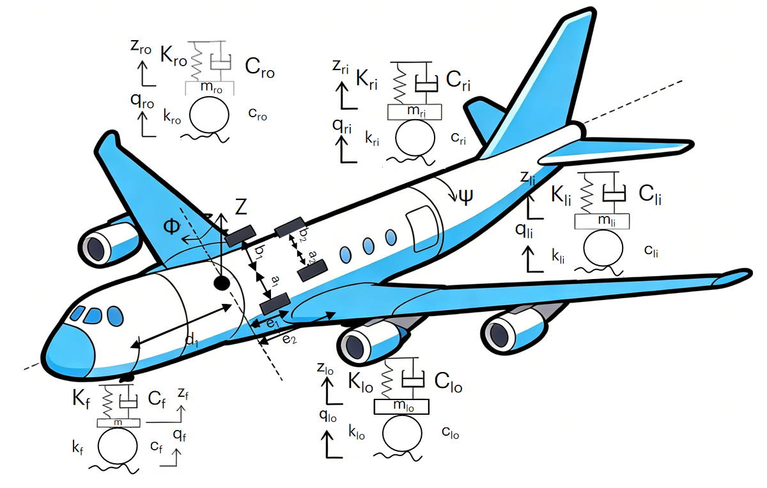
Fig.S14.3. Dynamic model of a five-point large passenger aircraft

14.1.2 Runway Submodel
A three-dimensional finite element (FE) model of the runway structure was established to represent the pavement system, including the surface layer, base layer, and subgrade. Eight-node hexahedral solid elements were employed for structural discretization.
Based on the direct stiffness method, the dynamic equilibrium equation of the runway subsystem can be expressed as:
(S14.22)
where M_{r}、C_{r}、K_{r} denote the global mass, damping, and stiffness matrices of the runway system, respectively;；X_{r}、Ẋ_{r}、Ẍ_{r} represent the displacement, velocity, and acceleration vectors; F_{r} is the external load vector acting on the runway.。
Using the principle of virtual work, and combining the geometric equations, constitutive relationships, and equilibrium equations, the element stiffness matrix (Eq.(S14.23)), mass matrix (Eq.(S14.24)), and nodal load vector (Eq.(S14.25)) are derived. For the damping matrix, the Rayleigh damping model—commonly adopted in airport pavement engineering—was employed (Eq.(S14.26)) to characterize energy dissipation within the pavement and subgrade layers.
Through standard finite element assembly procedures, the global stiffness matrix K_{r}, mass matrix M_{r}, damping matrix C_{r}, and external load vector F_{r} of the runway subsystem are obtained. Boundary conditions were defined as follows:
The bottom surface is fully constrained in the x-, y-, and z-directions.
The front, rear, left, and right faces are constrained only in the normal direction.
(S14.23)
(S14.24)
(S14.25)
(S14.26)
where N is the element shape function matrix; 𝜌 is the material density of the pavement; 𝛼 and 𝛽 are Rayleigh damping coefficients associated with the structural natural frequencies and damping ratios; and matrices 𝐵 and 𝐷 are derived from the geometric and constitutive equations, respectively:
(S14.27)
(S14.28)

14.1.3 Aircraft–Runway Coupled System Model Based on Wheel–Pavement Interaction and Its Solution
Runway roughness induces significant variations in aircraft wheel displacement, which excite fuselage vibration. The resulting landing gear forces act on the pavement and generate pavement vibration, which, together with the original runway roughness, further excites the wheels. Therefore, the tire compression of each wheel is jointly governed by wheel displacement, runway roughness input, and pavement vibration displacement, forming the wheel–pavement displacement compatibility condition. The radial tire compression Δzₙ and its rate Δżₙ are defined in Eq.(S14.29).
(S14.29)
where: n denotes the wheel number (3 for three-point aircraft and 5 for five-point aircraft).
The wheel–pavement interaction force acts upward on the aircraft and downward on the runway, constituting the only coupling mechanism between the two subsystems. To capture this interaction, a refined wheel model with continuously distributed radial spring–damper elements is adopted. The contact patch is assumed rectangular, and tire deformation is considered purely radial, neglecting circumferential shear (Fig.S14.4).
For a wheel center vertical displacement z, the radial compression at contact position x is given by Eq. (S14.30)
(S14.30)
where Rₜ is the tire radius, Δz₀ is the quasi-static deformation, and θ is defined in Eq. (S14.31).
(S14.31)
The interaction force f (Eq.(S14.32)) consists of elastic and damping components (fₑ, f_{d}). The contact width bₜ is constant, and the contact length lₜ is defined in Eq. (S14.33).
(S14.32)
(S14.33)
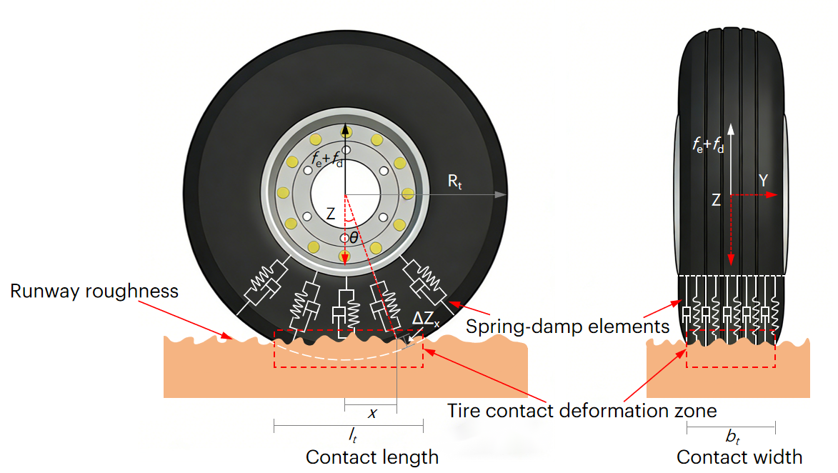Fig.S14.4. Wheel-runway interaction model
The interaction force incorporates wheel displacement, pavement vibration, and runway roughness, thereby coupling the aircraft and runway submodels into a unified system (Eq.(S14.34)).
(S14.34)
Direct assembly of the two subsystems into a single time-varying system would require continuous updating of stiffness and damping matrices at each time step, significantly increasing computational cost. To improve efficiency, a separation–iteration method is employed. The aircraft and runway subsystems are solved separately within each time step, and convergence is enforced through displacement compatibility and force equilibrium at the wheel–pavement interface. The runway mass, stiffness, and damping matrices remain constant during iteration.
Time integration is performed using the Newmark–β method (Eq.(S14.35)), where β and γ are integration parameters and Δt is the time step.
(S14.35)
Due to the numerous contact points between the wheels and the runway surface, as well as the large number of degrees of freedom in the finite element model of the runway, an improved separated iteration procedure is adopted in this paper to improve computational efficiency. The detailed algorithm flow is shown in Algorithm 1.
Algorithm 1 Calculation of{X}, {$\dot{X}$} and {$\ddot{X}$}using separation and iteration method
(1) Compute Newmark–β constants.：
(2) Precompute and store inverse equivalent stiffness matrices of aircraft and runway subsystems：
(3) Initialize displacement, velocity, and acceleration.、、、、、
(4) At time (k+1)Δt, initialize state variables using results at kΔt.
(5) Use the previous pavement vibration as the initial guess and compute aircraft external loads under current runway roughness.
(6) Solve aircraft dynamic response：
(7) Compute wheel–pavement interaction forces and update runway loads.
(8) Solve runway dynamic response.
(9) Check convergence based on pavement displacement difference.
(10) If converged, proceed to the next time step; otherwise, repeat steps 5–9.

14.1.4 Energy Dissipation of the Aircraft–Runway Coupled System
(1) Aircraft Energy Dissipation
The energy dissipation power of the aircraft shock absorbers and tires is calculated as the product of the damping coefficient and the square of the corresponding relative velocity:
(S14.36)
(S14.37)
(S14.38)
where P_{a}、P_{s}、P_{t} denote the total aircraft dissipation power, the shock absorber dissipation power, and the tire dissipation power, respectively. ż_{s1}、ż_{s2}、ż_{s3}、ż_{s4}、ż_{s5} represent the relative velocities of the landing gear shock absorbers, and ż_{t1}、ż_{t2}、ż_{t3}、ż_{t4}、ż_{t5} represent the relative velocities of the tires, obtained from the aircraft–runway coupled dynamic model under runway roughness excitation.
(2) Runway Energy Dissipation
The energy dissipation power of the runway structure is expressed as:
(S14.39)
which is calculated from the product of the damping matrix and the velocity vector of the runway system. The dissipation of the pavement layer and subgrade layer is summed to obtain the total runway energy dissipation power.
(3) Total Energy Dissipation of the Coupled System
The total energy dissipation of the aircraft–runway coupled system is obtained by integrating the dissipation power over time:
(S14.40)
That is, the energy dissipated at each time step is calculated as the product of power and the time increment, and the total energy is obtained by summing over all time steps.

14.2 Intelligent Surrogate Model for Rapid Energy Dissipation Prediction of the Aircraft–Runway System
Although the coupled aircraft–runway model developed above can accurately simulate vibration responses and energy dissipation induced by runway roughness, its computational cost is prohibitively high for large-scale assessments involving hundreds of airports, multiple aircraft types, varying structural conditions, and operational scenarios.
To address this limitation, a physics-informed multi-output neural network surrogate model is developed. The model predicts not only the total vibration energy dissipation induced by runway roughness but also its decomposition across key aircraft components (shock absorbers and tires) and runway layers (surface, base, and subgrade). Trained on high-fidelity coupled simulations, the model learns the nonlinear mapping between physical input parameters and energy outputs while incorporating physical constraints to ensure consistency.

14.2.1 Simulation Dataset and Feature Engineering
The surrogate model integrates key physical parameters governing aircraft–runway dynamic interaction, categorized into four groups:
- Runway structural parameters: surface modulus and thickness, base modulus and thickness, subgrade modulus;
- Roughness excitation parameters: runway roughness profiles beneath each landing gear;
- Aircraft dynamic parameters: sprung mass, pitch and roll inertia, unsprung masses, shock absorber stiffness and damping, tire stiffness and damping;
- Operational parameters: taxi speed and path length.
All inputs are normalized to eliminate dimensional and scale disparities. The outputs include:
total system energy dissipation, and component-wise energy dissipation (including Aircraft: shock absorbers and tires, and runway: surface, base, and subgrade layers).
Optimal Latin hypercube sampling (OLHS) is applied to generate uniformly distributed samples in the high-dimensional parameter space. For each sample, time-domain coupled simulations are performed to compute total and component-wise energy dissipation.
The dataset is randomly split into training (70%), validation (15%), and testing (15%) sets.

14.2.2 Physics-Informed Shared–Branch Neural Network Architecture
To jointly predict total and component energy dissipation while enforcing physical consistency, a multi-output neural network architecture is designed (Fig.S14.5). The structure consists of a shared feature encoder followed by specialized prediction branches, with energy conservation imposed as a physical constraint.
Fig.S14.5. Intelligent surrogate model for rapid estimation of aircraft–runway energy consumption.
(1) Shared Feature Encoder
The encoder comprises three fully connected layers (256→256→128 neurons), each followed by batch normalization, ReLU activation, and dropout (rate = 0.3). It extracts global dynamic features of the aircraft–runway system, such as dominant vibration modes and excitation intensity.
(2) Specialized Output Branches
Based on the shared latent representation, the network splits into three branches:
Total energy branch: predicts total vibration energy dissipation;
Aircraft energy branch: predicts shock absorber and tire energy;
Runway energy branch: predicts surface, base, and subgrade energy.
(3) Physics-Guided Regularization
Instead of explicitly enforcing total energy as the sum of components, physical consistency is achieved through a loss constraint. The shared encoder ensures coherent feature extraction, while a physics-based loss term drives agreement between total and summed component predictions.

14.2.3 Physics-Constrained Loss Function and Training Strategy
The composite loss function simultaneously optimizes prediction accuracy and physical consistency:
(S14.41)
①Component loss: Huber loss for robustness, weighted inversely by average magnitude;
②Total loss: Mean squared error for total energy prediction;
③Physics constraint loss: Penalizes discrepancies between predicted total energy and the sum of predicted components, embedding energy conservation into training.
The model is trained using the Adam optimizer (initial learning rate 3×10⁻⁴) with cosine annealing scheduling. Batch size is 64, and early stopping (patience = 50) is adopted. Training converges in approximately 400 epochs on an NVIDIA A100 GPU.

14.2.4 Model Accuracy and Computational Efficiency
On the independent test set, the surrogate model demonstrates high predictive accuracy and strong generalization capability (Table S14).
The prediction time per scenario is reduced from minutes (full coupled simulation) to seconds, achieving a speed-up exceeding 500, thereby enabling rapid national-scale carbon emission assessment.
Table S14. Prediction Accuracy of the Surrogate Model
Target | MAPE | R²
Shock absorber energy | 3.1% | 0.988
Tire energy | 2.7% | 0.990
Surface energy | 4.0% | 0.978
Base energy | 5.2% | 0.964
Subgrade energy | 6.3% | 0.953
Total energy | 1.3％ | 0.994

