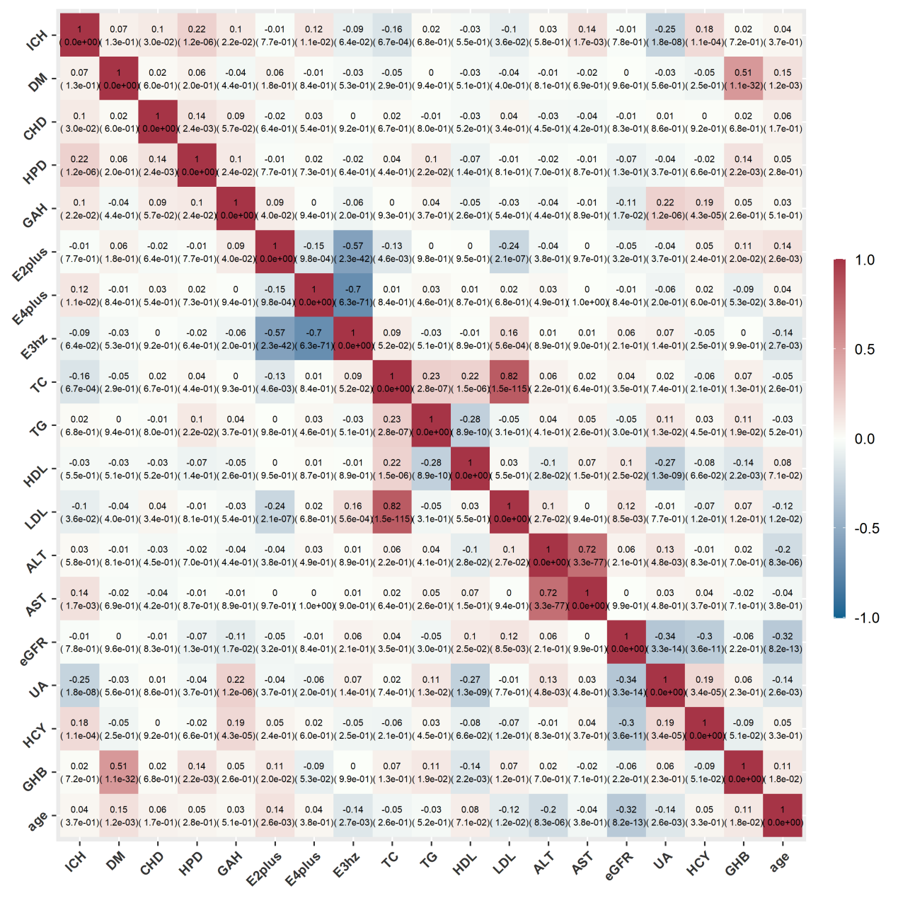

In each grid is the Pearson correlation coefficient (the corresponding P value). p < 0.05 means that two variables are correlated. The correlation coefficient greater/ less than 0 represents a positive/negative correlation.
ICH was related to the CHD (CC=0.10,P=0.03), HPD (CC=0.22,P<0.01), GAH (CC=0.10,P=0.02), ε4 allele (CC=0.12,P=0.01), TC (CC=-0.16,P<0.01), LDL (CC=-0.10,P=0.04), AST (CC=0.14,P<0.01), UA (CC=-0.25,P<0.01), HCY (CC=0.18,P<0.01), more-while, ε2 allele was related to GAH (CC=0.09,P=0.04), TC (CC=-0.13,P<0.01), and LDL (CC=-0.24,P<0.01), GHB (CC=0.11,P=0.02), age (CC=0.14,P<0.01) and that ε4 allele was only related to ICH but not with other clinical and biochemical parameters.

Figure 1. The heat map of univariate analyses among all variables in ICH cases

Table 1. Likelihood Ratio Test comparing Models

Full Model VS Model without APOE |  | Difference of Deviance | Degree of freedom | P-value
ICH cases | APOE Estimating*
All cases  (560 cases) | All gene-types | 7.3309 | 3 | 0.0621
All cases  (560 cases) | ε2 allele +/- # | 1.5764 | 2 | 0.4547
All cases  (560 cases) | ε4 allele +/- ^ | 4.8653 | 2 | 0.0878
Deep ICH  (314 cases) | All gene-types | 9.0097 | 3 | 0.0292*
Deep ICH  (314 cases) | ε2 allele +/- # | 4.3845 | 2 | 0.1117
Deep ICH  (314 cases) | ε4 allele +/- ^ | 3.3987 | 2 | 0.1828

*p < 0.05. Interpretation of LRT (take Full Model with APOE VS Model without APOE of all cases for example):Null hypothesis H0: the coefficients of the variables in APOE carriers are all equal to 0;Since p-value = 0.0621, we failed to conclude that at least one of the coefficients of variables in APOE carriers is not equal to 0. The interpretation of other comparison is likewise.
*APOE Estimating means the carrying status of APOE gene in each model.
# ε2 allele + includes ε2ε2, ε2ε3, ε2 allele - meas ε3ε3.
^ ε4 allele + includes ε4ε4, ε3ε4, ε2 allele - meas ε3ε3.

Table 2. AUC of different Prediction Models

ICH cases | Models  APOE  Estimating* | Full Model | Model without APOE
All cases  (560 cases) | All gene-types | 0.8139 | 0.8083
All cases  (560 cases) | ε2 allele +/- # | 0.8308 | 0.8306
All cases  (560 cases) | ε4 allele +/- ^ | 0.8204 | 0.8150
Deep ICH  (314 cases) | All gene-types | 0.8182 | 0.8076
Deep ICH  (314 cases) | ε2 allele +/- # | 0.8300 | 0.8293
Deep ICH  (314 cases) | ε4 allele +/- ^ | 0.8304 | 0.8223

*APOE Estimating means the carrying status of APOE gene in each model.
# ε2 allele + includes ε2ε2, ε2ε3, ε2ε4, ε2 allele - meas ε3ε3.
^ ε4 allele + includes ε4ε4, ε3ε4, ε2ε4, ε2 allele - meas ε3ε3.

