Supporting information
Comparative Evaluation of Multicellular Tumor Spheroid Fabrication Platforms for Reliable Drug Screening

Jaehun Lee ^{a,1}, Sunghan Lee ^{a,1}, Min Park ^{b,*}, Jiseok Lim ^{c,d,*}, and Bongseop Kwak ^{a,d, **}

ªDongguk University, College of Medicine, 32 Dongguk-ro, Ilsandong-gu, Goyangsi, Gyeonggi-do, 10326, Republic of Korea
^{b}Hallym University, Major in Materials Science and Engineering, Chuncheon-si, Gangwon-do, 24252, Republic of Korea
^{c}Yeungnam University, School of Mechanical Engineering, 280 Daehak-ro, Gyeongsan-si, Gyeongsanbuk-do, 38541, Republic of Korea
^{d}MediSphere Inc., 280, Daehak-ro, Gyeongsan-si, Gyeongsangbuk-do, 38541, Republic of Korea

*Co-Corresponding author
E-mail address: minpark@hallym.ac.kr
Telephone number: +82-33-248-2363
Mobile-phone number: +82-10-3050-3443
E-mail address: jlim@yu.ac.kr
Telephone number: +82-53-810-2577
Mobile-phone number: +82-10-5877-2352
**Corresponding author
E-mail address: bskwak@dongguk.ac.kr
Telephone number: +82-31-961-5803
Mobile-phone number: +82-10-4477-3865
¹These authors contributed equally to this paper.
- Design of droplet microfluidic system
We designed the droplet microfluidic system using the 3D printing method. The mold was fabricated by 3D printer (Object30 prime, Stratasys Ltd, MN, USA). 3D printed master mold was post-exposed to UV light for soft lithography. After the post-exposure, we fabricated a PDMS-based droplet system using polydimethylsiloxane (PDMS, Sylgard 184, Dow corning, MI, USA). The specific dimensions of the droplet junction are shown in Figure S1, and the depth is 650 µm.

- Fabrication rate and yield
The fabrication rate was defined as the number of MTS generated per unit fabrication time and expressed as MTS/sec. Fabrication time was measured from the point at which the cell suspension had been prepared at the required concentration for each platform to the point at which the fabrication setup was completed and the samples were ready for spheroid formation under incubation. The measured fabrication time included platform-specific operational steps required to initiate MTS formation, such as cell suspension loading, dispensing, and, for the DM platform, droplet generation.
Fabrication yield was evaluated on a single-batch basis for each platform. Specifically, one commercially available UB device containing 361 microwells, one 96-well ULA plate, and one 96-well HD plate were each considered as one batch. For the DM platform, the yield was calculated based on the number of MTS generated using 3 mL of cell-suspended medium.
For size uniformity analysis, MTS fabricated from each platform were collected into a 30-mm Petri dish, and images were randomly acquired for unbiased quantitative comparison. The size distribution was analyzed based on the collected MTS population from each platform to evaluate the overall size uniformity of MTS generated under each fabrication condition.

- E-cadherin expression
The expression of E-cadherin in MTS was measured by immunofluorescence staining. MTS was fixed for 1 hour at 25 degrees using 4% formaldehyde (Tech & Innovation, Gangwon-do, Republic of korea). Washing was performed three times using 1x DPBS (Gibco, MA, USA), and permeabilization was performed using 0.2% triton x-100 solution (Sigma Aldrich, MO, USA) at 25 degrees for 1 hour. After washing three times using 1x DPBS, blocking was performed for 1 hour at 25 degrees using 2% bovine serum albumin (BSA, diluted in 1x DPBS, Sigma Aldrich, MO, USA). After washing three times with 1x DPBS, E-cadherin primary antibody (ab219332, Abcam, MA, USA) was diluted 1:200 and reacted at 25 degrees for 12 hours. After washing away the remaining antibody, fluorescence expression for E-cadherin was induced using a secondary antibody (ab6785, Abcam, MA, USA). We specifically focused on E-cadherin because it senses rigidity to facilitate initial cell-cell contact, triggers intercellular interactions at the base of cell aggregation, and plays a role in forming compact MTS. Unfortunately, MTS from each platform exhibit little differences in the expression of E-cadherin, as shown in Figure S2 (a, b).

- Effect of MTS size on hypoxic core formation and drug response
We confirmed that DM allows for precise control over spheroid size while maintaining high MTS quality. Utilizing these advantages, we examined the formation of hypoxic cores, a critical factor known to introduce bias in size-dependent drug evaluation. Dark regions in microscopic images typically indicate structurally denser areas, and such compact cores are also interpreted as hypoxic microenvironments due to restricted diffusion of oxygen and nutrients.[15,19] As shown in Figure S3(a), MTS with a diameter < 300 µm did not exhibit a difference in brightness between the core and surface, while MTS with a diameter > 300 µm showed a clear difference. The heatmap images indicate a more distinct difference between the core and surface concerning MTS size. This result is also consistent with the findings from the fluorescent viability assay. In MTS with a diameter of 300 µm in the top left of Figure S3(b), dead cells (red color) were not observed, while in MTS with a 500 µm diameter in the bottom right of Figure S3(b), numerous dead cells were detected in the core region. It agrees with our previous work, which demonstrates that a hypoxic core theoretically develops in MTS with diameters in the range of 300 - 330 µm.[14]
MTS unfortunately, lacks the vascular network surrounding them, unlike solid tumors in vivo, leading to the development of a hypoxic core. Researchers need to acknowledge this fact and adopt MTS conditions that closely resemble solid tumors in vivo for reliable drug screening. Here, we assert that MTS with a diameter of 300 µm is most suitable for testing drug effects. Larger MTS more closely mimic solid tumors in vivo by exhibiting drug resistance, but they may bias the results of drug screening due to the hypoxic cores. On the other hand, although smaller MTS may minimize bias, they do not adequately mimic solid tumors in vivo. Additionally, because smaller MTS are formed with fewer cells, higher precision is required, which may hinder achieving the targeted size and uniform morphology. Indeed, smaller MTS exhibited a bumpy surface, whereas MTS with a diameter > 300 µm showed a smooth surface, as shown in Figure S3(c). Despite these concerns, given the limited ability to mimic in vivo tumor conditions and fabrication challenges, the use of smaller MTS is not recommended for reliable drug screening.

- Drug screening of heterogeneously sized MTS
We asserted that MTS with a diameter of 300 µm are suitable for drug screening based on Figure S3. To verify this claim, we conducted drug screening using heterogeneously sized MTS. Without the drug, MTS of all sizes showed a slight increase over 24 hours, while with the drug, they either decreased in size or nearly remained unchanged due to the collaboration of the drug effect and cell proliferation, as shown in Figure S4(a). Specifically, Figure S4(b) shows that MTS size with diameters ranging from 100 to 500 µm increased to 120.8 ± 9.5 %, 120.6 ± 1.4 %, 116.6 ± 5.0 %, 112.8 ± 3.1 %, and 109.0 ± 4.2 % over 24 hours, respectively, without the drug. On the other hand, the size of MTS decreased to 89.7 ± 8.1 %, 88.4 ± 6.2 %, 93.4 ± 5.4 %, 99.3 ± 2.7 %, and 99.7 ± 2.8 %, respectively, with the drug. As MTS sizes increased, the difference in size between MTS with and without the drug decreased, suggesting that larger MTS were more resistant to the drug. Cell viability within MTS was nearly 100% for MTS with a diameter < 300 µm without the drug, as shown in Figure S4(c). However, for MTS with diameters of 400 and 500 µm, cell viability decreased to 91.5 ± 2.6 % and 88.1 ± 2.8 %, respectively, due to the hypoxic core, even without the drug. Cell viability decreased with the drug, as the size of MTS with a diameter < 300 µm increased. For MTS with diameters of 100 µm, 200 µm, and 300 µm, cell viability was 89.8 ± 1.3%, 84.6 ± 3.7%, and 82.9 ± 3.5%, respectively. cell viability of MTS with diameters of 400 µm and 500 µm was 86.6 ± 2.3 % and 84.9 ± 2.3 %, respectively, which was the difference in cell viability with and without the drug was lower than that of small MTS (diameter < 300 µm) due to the collaboration of hypoxic core and drug resistance. As a result, we confirmed that larger MTS exhibited higher drug resistance, like solid tumors in vivo, but there was a biased result of cell viability. Indeed, MTS with diameters of 300 µm showed only drug-induced dead cells without bias, but large MTS (500 µm diameter) already harbored dead cells due to the hypoxic core, as shown in Figure S4(d). These results suggest that researchers should select appropriate MTS sizes for their research purposes. In research where the similarity to solid tumors in vivo is important, larger MTS must be used, and to accurately observe drug effects, MTS with a diameter of 300 µm must be used.

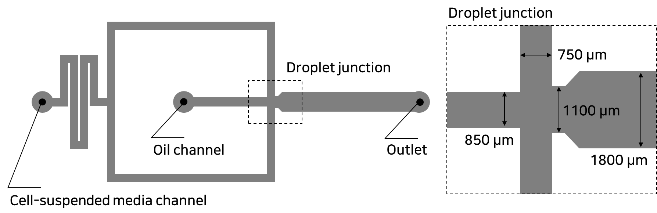
Figure S1. Schematic master mold drawing of droplet microfluidic system.

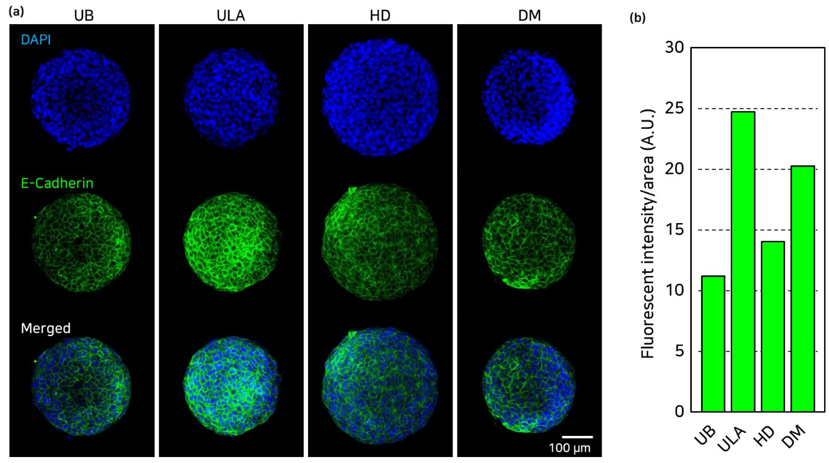
Figure S2. Confocal immunostaining images of multicellular tumor spheroid (MTS) under each platform condition. (a) MTS was stained for nucleus (blue) and E-cadherin (green). (b) The expression levels of E-cadherin in Multicellular Tumor Spheroids generated from each platform.

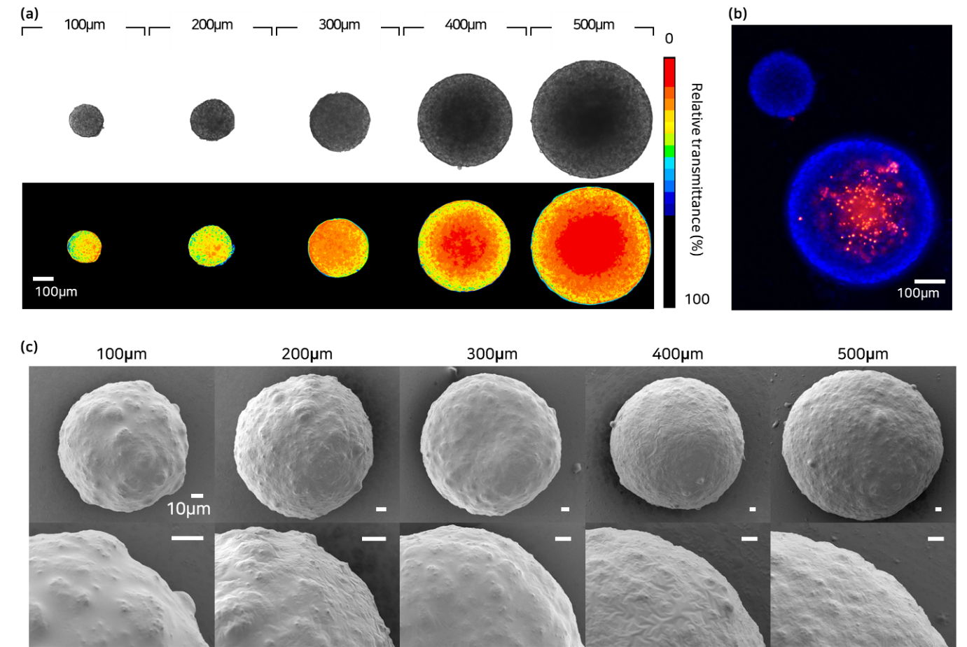
Figure S3. (a) Microscopic and heatmap images of heterogeneously sized MTS for detecting the hypoxic core. (b) DAPI/PI-stained MTS with diameters of 300 µm and 500 µm. Blue represents live cells, while red represents dead cells. (c) SEM images for observing the surface of MTS.
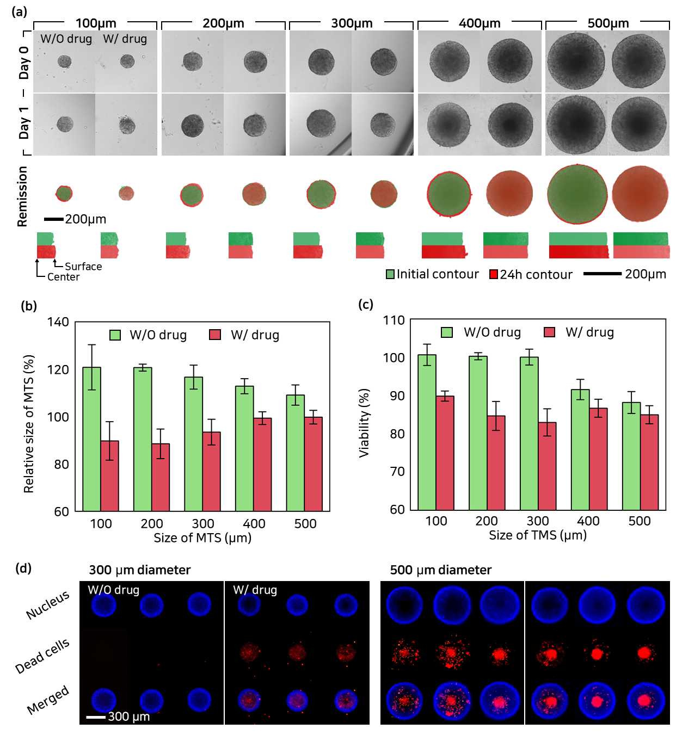Figure S4. (a) The drug-induced remission of heterogeneously sized MTS, without (or with) the drug states. (b) The relative size change and (c) cell viability within MTS according to the size of MTS. (d) DAPI/PI-stained MTS with diameters of 300 µm and 500 µm without or with the drug.

