Supplementary Information

Valence Band Offset Threshold and Recombination Junction Engineering for
Carrier Continuity Recovery in CZTS/In₂S₃/CZTSSe Kesterite Solar Cells:
A Calibrated SCAPS Study

K. H. Arunkumar

This document contains seven supplementary tables (S1–S7) and three supplementary figures (S1–S3). All data were generated in SCAPS-1D v3.3.10 under AM 1.5G illumination (100 mW/cm², 300 K) unless otherwise stated. Tables S3–S5 provide the complete numerical datasets plotted in main-text Figures 4–6. Table S6 provides the full thickness–doping co-sweep heatmap for In₂S₃ interlayer optimization. Table S7 summarizes all SCAPS computational settings.

Table S1. Full device architecture: layer stack, dimensions, and roles. Architecture applies to the optimized B1opt device. Baseline A1 omits the In₂S₃ interlayer entirely.
Layer | Material | Thickness (nm) | Doping (cm⁻³) | Role in Device
Back contact | Mo | 500 | — | Ohmic back contact; source of MoSe₂ passivation issue
Bottom absorber | CZTSSe (Eg = 1.13 eV) | 1500 | 1×10¹⁶ (p) | Low-bandgap photon harvesting (700–1100 nm)
Recombination junction | In₂S₃ (optimized) | 5 | 5×10¹⁸ (n) | Tunneling-mediated hole transport across ΔEv = 0.37 eV barrier
Top absorber | CZTS (Eg = 1.50 eV) | 2000 | 1×10¹⁶ (p) | High-energy photon harvesting (300–700 nm)
Buffer layer | CdS | 50 | 1×10¹⁷ (n) | Band alignment; electron extraction
Intrinsic window | i-ZnO | 80 | undoped | Electron transport; reduces shunting
Front window | Al:ZnO | 200 | 1×10²⁰ (n) | Transparent conducting electrode; front illumination entry
Note: ND = donor doping; NA = acceptor doping (not shown). Effective density-of-states values (Nc, Nv) for each layer are as used in the main text Table 1 input set. Mo layer is not simulated explicitly; its role is encoded through the back-contact boundary condition.

Table S2. One-at-a-time sensitivity analysis for the optimized B1opt device. Parameters varied individually while all others are held at their B1opt baseline values. Green-highlighted rows = Very High sensitivity parameters that govern device outcome most strongly.
Parameter | Baseline | Change | ΔVoc (+)(mV) | ΔVoc (−)(mV) | ΔFF (+)(%) | ΔFF (−)(%) | Sensitivity Rank
Interlayer thickness | 5 nm | ±1 nm | +12 | −19 | +2.9 | −4.1 | High
Interlayer doping | 5×10¹⁸ cm⁻³ | ±1 decade | +21 | −38 | +4.8 | −7.2 | Very High
CZTS bulk Nt | 10¹⁴ cm⁻³ | ×10 | N/A | −19 | N/A | −1.3 | Medium
CZTSSe thickness | 1500 nm | ±300 nm | +7 | −9 | +0.7 | −1.0 | Medium
Interface Nt | 10¹⁰ cm⁻² | ×10 | N/A | −13 | N/A | −2.4 | Medium
ΔEv at interface | 0.37 eV | ±0.05 eV | +31 | −48 | +6.1 | −9.4 | Very High
Temperature | 300 K | ±25 K | +16 | −21 | +2.8 | −3.7 | High
CdS thickness | 50 nm | ±10 nm | +2 | −5 | +0.4 | −0.7 | Low
Note: ΔVoc(+) and ΔFF(+) = change on increasing the parameter by the stated amount. ΔVoc(−) and ΔFF(−) = change on decreasing. N/A = unphysical direction for that parameter (e.g. Nt cannot be reduced below zero). Sensitivity Rank is qualitative, based on ΔFF magnitude.

Table S3. Complete temperature-dependent performance data (250–400 K) for devices A1 and B1opt. Green-highlighted row = 300 K standard reference condition. Tunneling-to-thermionic crossover in B1opt occurs between 270 and 300 K, identified by η(B1opt) reaching a maximum at 250 K. Data plotted in main-text Figure 5.
T (K) | Voc_A1(V) | Jsc_A1(mA/cm²) | FF_A1(%) | η_A1(%) | Voc_B1opt(V) | Jsc_B1opt(mA/cm²) | FF_B1opt(%) | η_B1opt(%) | Mechanism (B1opt)
250 | 0.512 | 19.41 | 34.22 | 3.41 | 0.943 | 30.65 | 73.16 | 21.1 | Tunneling-dominant
270 | 0.471 | 19.22 | 32.96 | 2.98 | 0.903 | 30.57 | 72.75 | 20.1 | Mixed tunneling + thermionic
300 | 0.418 | 18.92 | 31.52 | 2.50 | 0.843 | 30.80 | 71.57 | 18.7 | Reference (AM 1.5G)
320 | 0.381 | 18.70 | 30.09 | 2.15 | 0.802 | 30.67 | 68.42 | 16.9 | Thermionic + SRH
350 | 0.319 | 18.57 | 28.07 | 1.67 | 0.742 | 30.20 | 63.23 | 14.2 | SRH dominant
380 | 0.261 | 18.42 | 26.24 | 1.26 | 0.673 | 29.79 | 56.46 | 11.3 | SRH dominant
400 | 0.221 | 18.37 | 24.61 | 1.01 | 0.614 | 29.43 | 50.24 | 9.1 | SRH dominant
Note: A1 = no interlayer (carrier continuity failure device); B1opt = optimized In₂S₃ 5 nm / ND = 5×10¹⁸ cm⁻³ device. The positive temperature coefficient of efficiency in B1opt (η increasing as T decreases from 300 to 250 K) is the SCAPS-1D tunneling signature; compare with A1 which shows monotonically decreasing η with decreasing T.

Table S4. Complete J-V numerical data for all device variants (AM 1.5G, 300 K). Data plotted in main-text Figure 4a. Cells showing "—" indicate voltage beyond device Voc. Note that A1 reaches Voc at ≈0.42 V due to complete carrier continuity failure.
V (V) | J_A1(mA/cm²) | J_B1 In₂S₃(mA/cm²) | J_B2 ZTO(mA/cm²) | J_B3 TiO₂(mA/cm²) | J_B1opt(mA/cm²) | J_CZTS ref(mA/cm²)
0.0 | 18.89 | 30.08 | 29.57 | 28.38 | 30.82 | 19.18
0.1 | 18.82 | 30.05 | 29.51 | 28.34 | 30.72 | 19.12
0.2 | 18.56 | 29.81 | 29.31 | 28.08 | 30.49 | 18.97
0.3 | 17.71 | 29.32 | 28.79 | 27.56 | 30.07 | 18.58
0.35 | 16.93 | 28.84 | 28.27 | 27.11 | 29.49 | 18.20
0.4 | 15.57 | 28.12 | 27.56 | 26.50 | 28.88 | 17.73
0.42 | ~0 | 27.84 | 27.33 | 26.18 | 28.64 | 17.49
0.45 | — | 27.12 | 26.54 | 25.49 | 27.80 | 16.94
0.50 | — | 25.72 | 25.13 | 24.13 | 26.47 | 16.00
0.55 | — | 23.89 | 23.15 | 22.27 | 24.68 | 14.57
0.60 | — | 21.35 | 20.46 | 19.56 | 22.09 | 12.57
0.65 | — | 17.86 | 16.85 | 15.91 | 18.67 | 9.94
0.70 | — | 13.20 | 12.00 | 11.09 | 13.96 | 6.76
0.75 | — | 7.01 | 5.75 | 4.84 | 7.79 | 2.93
0.79 | — | 2.09 | — | — | 3.14 | —
0.81 | — | 0.02 | — | — | 0.87 | —
0.84 | — | — | — | — | 0.03 | —
Note: All J values in mA/cm². Voc for each device: A1 = 0.42 V, B1 In₂S₃ = 0.81 V, B2 ZTO = 0.79 V, B3 TiO₂ = 0.75 V, B1opt = 0.843 V, CZTS ref = 0.708 V. Jsc extracted at V = 0.

Table S5. Complete EQE spectral response data for key device variants. Pink-highlighted cells in the EQE_A1 column (700–1050 nm) highlight the spectral region of carrier continuity failure. Data plotted in main-text Figure 4b.
λ (nm) | Energy (eV) | EQE_A1 (%) | EQE_B1opt (%) | EQE_CZTS ref (%) | EQE_B2 ZTO (%) | Absorber / Region
300 | 4.13 | 31.0 | 37.0 | 34.0 | 37.0 | CZTS (front surface loss)
400 | 3.10 | 62.0 | 67.0 | 66.0 | 65.0 | CZTS
500 | 2.48 | 78.0 | 83.0 | 80.0 | 83.0 | CZTS
600 | 2.07 | 77.0 | 83.0 | 79.0 | 81.0 | CZTS
640 | 1.94 | 63.0 | 80.0 | 71.0 | 77.0 | Transition region
660 | 1.88 | 48.0 | 77.0 | 62.0 | 75.0 | Transition (CZTS cutoff onset)
700 | 1.77 | 17.0 | 69.0 | 25.0 | 64.0 | CZTSSe dominant — BLOCKED in A1
750 | 1.65 | 10.0 | 63.0 | 15.0 | 58.0 | CZTSSe
850 | 1.46 | 6.0 | 48.0 | 4.0 | 45.0 | CZTSSe (near bandgap)
950 | 1.31 | 3.0 | 34.0 | 0.0 | 33.0 | CZTSSe
1050 | 1.18 | 2.0 | 19.0 | 0.0 | 15.0 | CZTSSe
1100 | 1.13 | 0.0 | 4.0 | 0.0 | 3.0 | Near CZTSSe Eg cutoff
1130 | 1.10 | 0.0 | 0.0 | 0.0 | 0.0 | Complete absorption cutoff
Note: EQE_CZTS ref = calibrated single-junction CZTS reference device. The near-zero EQE in A1 above 700 nm confirms complete electrical decoupling of the CZTSSe sub-absorber — the CZTSSe absorbs photons but generated carriers cannot reach the external circuit. B1opt fully recovers EQE to 4% at 1100 nm (near CZTSSe bandgap edge).

Table S6. Thickness–doping co-sweep heatmap: η (%) for In₂S₃ interlayer (12 thickness × 11 doping combinations). Colour code: ■ Dark green ≥17% | ■ Light green 14–17% | ■ Yellow 10–14% | ■ Pink 7–10% | ■ Red <7%. Asterisked cells (*) mark η ≥ 18.5% (performance maximum region). All simulations: CZTS/CZTSSe realistic interface (Nt = 10¹² cm⁻²), AM 1.5G, 300 K. Data identify the optimum at 5 nm / 5×10¹⁸ cm⁻³ (η = 18.8*%).
Thick.(nm) | 1×10¹⁵ | 5×10¹⁵ | 1×10¹⁶ | 5×10¹⁶ | 1×10¹⁷ | 5×10¹⁷ | 1×10¹⁸ | 5×10¹⁸ | 1×10¹⁹ | 5×10¹⁹ | 1×10²⁰
1 | 3.1 | 4.0 | 5.1 | 6.0 | 7.4 | 8.5 | 9.6 | 11.0 | 10.5 | 8.9 | 7.9
2 | 3.7 | 4.6 | 5.9 | 8.4 | 10.4 | 12.3 | 14.1 | 14.8 | 14.4 | 12.3 | 9.9
3 | 4.3 | 5.1 | 7.4 | 9.6 | 11.8 | 14.4 | 15.0 | 16.7 | 15.3 | 13.7 | 11.4
4 | 5.3 | 6.1 | 8.7 | 11.4 | 13.7 | 15.5 | 17.0 | 17.6 | 16.9 | 14.0 | 12.3
5 | 5.7 | 7.4 | 9.6 | 12.3 | 14.6 | 17.4 | 18.5* | 18.8* | 16.8 | 14.8 | 12.6
6 | 6.1 | 7.5 | 9.8 | 12.6 | 15.1 | 17.6 | 18.2* | 18.6* | 16.9 | 14.2 | 12.3
7 | 5.8 | 7.8 | 10.1 | 13.1 | 15.0 | 17.4 | 18.2* | 18.3* | 16.2 | 14.2 | 12.3
8 | 6.0 | 7.8 | 10.6 | 12.9 | 15.0 | 17.3 | 17.7 | 17.8 | 15.6 | 13.3 | 11.1
10 | 6.6 | 7.9 | 11.2 | 13.0 | 16.0 | 16.8 | 16.8 | 16.5 | 15.1 | 12.1 | 10.8
12 | 6.7 | 8.0 | 10.5 | 12.2 | 14.3 | 15.3 | 15.3 | 15.7 | 13.3 | 11.0 | 9.3
15 | 6.0 | 7.1 | 9.2 | 11.2 | 13.2 | 13.8 | 14.1 | 14.6 | 12.4 | 9.8 | 8.4
20 | 4.5 | 5.7 | 7.3 | 9.2 | 10.8 | 11.4 | 12.1 | 11.9 | 9.9 | 8.5 | 6.9
Note: Doping column headers are in cm⁻³. Thickness in nm. At <2 nm, interlayer is quantum-mechanically transparent and acts as a pass-through rather than a recombination junction — hence poor performance at 1 nm across all doping levels. At >10 nm, parasitic absorption and series resistance dominate. Optimal doping window 5×10¹⁷–5×10¹⁸ cm⁻³ at 4–7 nm thickness is defined by the ≥17% dark-green region.

Table S7. SCAPS-1D computational settings summary. Provided for reproducibility. All settings are identical across A1, B1, B2, B3, and B1opt simulations; only the interlayer material, thickness, and doping differ.
SCAPS-1D Setting | Value Used | Physical Justification
Software version | SCAPS-1D v3.3.10 | Standard release from Ghent University; used with default solver tolerance 10⁻⁶
Illumination | AM 1.5G, 100 mW/cm² | IEC 60904-3 standard for terrestrial PV
Temperature (reference) | 300 K | Standard test condition
Temperature sweep range | 250–400 K | Covers tunneling-to-thermionic crossover regime
Recombination model | SRH (bulk + interface) | Both activated; Auger excluded (minority carrier concentrations too low)
Tunneling model | WKB parabolic barrier | SCAPS built-in; mt = 0.1 m₀; used qualitatively only
Tunneling effective mass | mt = 0.1 m₀ | Representative value for kesterite valence band; sensitivity tested at 0.05–0.2 m₀
Interface recombination | Activated at all junctions | Uses capture cross-sections σn = σp = 10⁻¹⁴ cm² (reactive interface) or 10⁻¹⁵ cm² (passive)
Solver | Newton–Raphson, fully coupled | Simultaneous solution of Poisson + continuity equations
Mesh density | Fine (adaptive) | Minimum 200 grid points; refined at all interfaces
Back contact | Selective ohmic (metal-like) | Sp = 10⁷ cm/s, Sn = 10³ cm/s for Mo/CZTSSe contact
Front contact | Selective ohmic | Sn = 10⁷ cm/s, Sp = 10³ cm/s for Al:ZnO contact
Note: WKB = Wentzel–Kramers–Brillouin approximation. mt = tunneling effective mass. The tunneling model output is used only to identify the qualitative transport regime (Section 3.3 of main text); absolute tunneling coefficients are not reported.

Supplementary Figure Captions
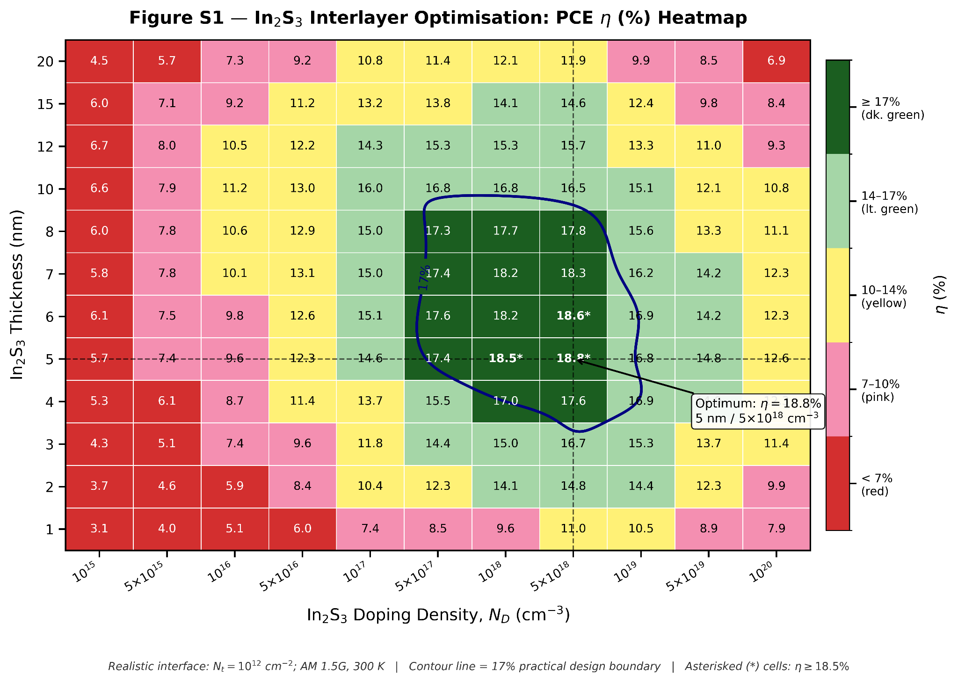
Figure S1. Thickness–doping co-sweep heatmap for In₂S₃ interlayer optimization (graphical representation of Table S6). η (%) plotted as a function of interlayer thickness (1–20 nm, y-axis) and n-type doping density (10¹⁵–10²⁰ cm⁻³, x-axis). Colour scale: dark green ≥ 17%; light green 14–17%; yellow 10–14%; pink 7–10%; red < 7%. The performance maximum at 5 nm / 5×10¹⁸ cm⁻³ (η = 18.8%) is marked with an asterisk and cross-hairs. The 17% contour defines the practical design window. All simulations: realistic interface (Nt = 10¹² cm⁻²), AM 1.5G, 300 K.
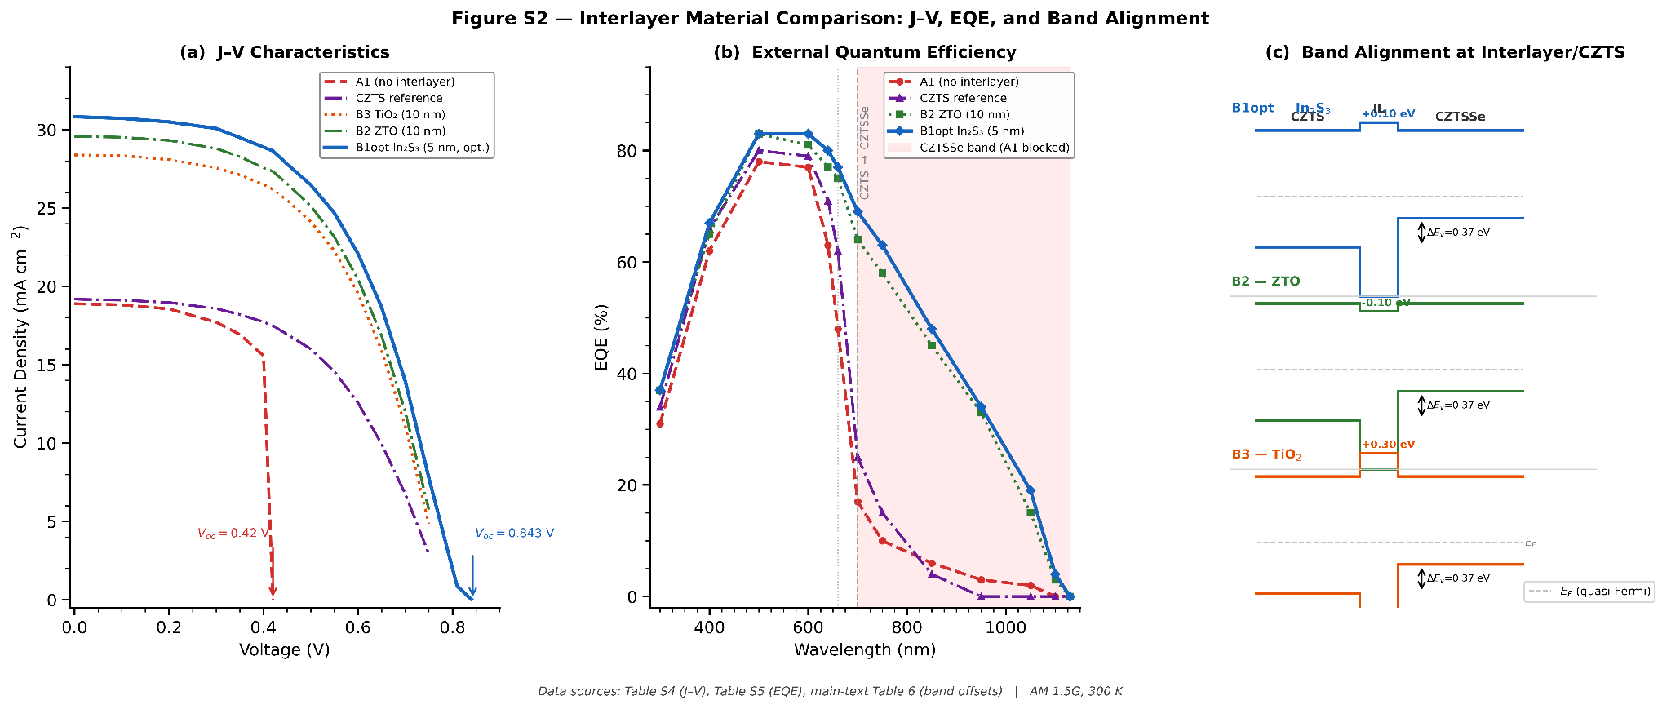
Figure S2. Interlayer material comparison — extended data for ZTO and TiO₂. (a) J-V curves for ZTO (B2) and TiO₂ (B3) variants at 10 nm and at their individually optimized thicknesses (7 nm ZTO, 10 nm TiO₂), compared to A1 baseline and B1opt reference. (b) EQE spectra confirming partial CZTSSe response recovery in ZTO and TiO₂ variants relative to A1, but below B1opt levels. (c) Band diagram comparison at the interlayer/CZTS junction, highlighting the conduction band spike differences: +0.10 eV (In₂S₃, B1opt), −0.10 eV (ZTO, B2), +0.30 eV (TiO₂, B3). Data from main-text Table 6.
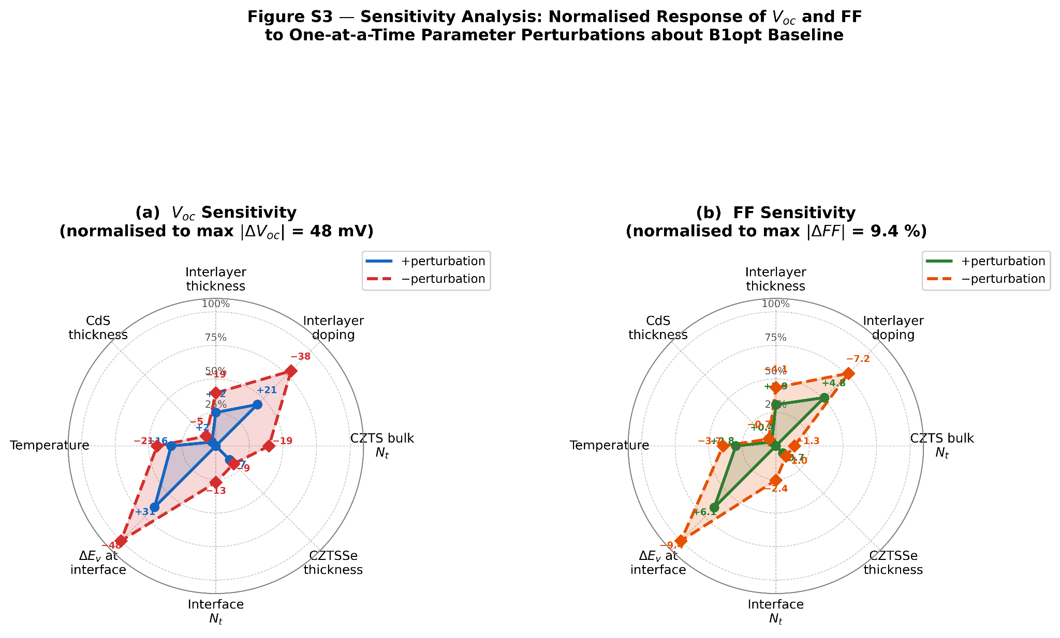
Figure S3. Sensitivity analysis spider chart (graphical representation of Table S2). Normalized performance response of Voc and FF to one-at-a-time parameter perturbations about the B1opt baseline. Radial axis = magnitude of relative change (%) upon ±perturbation. ΔEv uncertainty (±0.05 eV) and interlayer doping (±1 decade) are the two highest-sensitivity parameters, confirming that interface engineering precision governs device outcome more than absorber bulk quality.

Supplementary Note S1: Tunneling Model Implementation in SCAPS-1D
SCAPS-1D v3.3.10 implements a WKB (Wentzel–Kramers–Brillouin) parabolic barrier tunneling model at heterojunction interfaces. The tunneling probability T for carrier transport across a triangular or parabolic barrier of height ΔEv and width d is approximated as:

T ≈ exp(−2κd)
where κ = (2mt ΔEv)^(1/2) / ℏ

In this study, tunneling effective mass mt = 0.1 m₀ is used for hole tunneling at the CZTS/In₂S₃ valence band discontinuity. This value lies within the range 0.05–0.20 m₀ reported for kesterite-related materials; sensitivity to mt is tested at the bounds (Supplementary Table S2). The model does not account for field-dependent effective mass or many-body effects. For these reasons, tunneling rates extracted from SCAPS are not reported as quantitative predictions. The tunneling model is used exclusively to distinguish the thermionic transport regime (Voc linear with T, negative temperature coefficient of efficiency) from the tunneling regime (anomalous Voc saturation below 300 K, positive temperature coefficient of efficiency at low T). This distinction is the basis of the mechanistic validation in main-text Section 3.3 and Figure 5.

Experimental validation of the tunneling signature requires temperature-dependent Voc measurements (250–400 K) on ALD-deposited In₂S₃ devices. The predicted crossover temperature (270–300 K) is in a range accessible with a standard closed-cycle cryostat and is a standard measurement for thin-film cells. Confirmation of η(250 K) > η(300 K) would constitute direct experimental evidence for the recombination junction tunneling mechanism.

Supplementary Note S2: Physical Basis for ΔEv = 0.37 eV
The valence band offset at the CZTS/CZTSSe interface is the most important single parameter in this study. Its physical basis is summarized here. The CZTSSe compound spans a continuous composition range from x = 0 (pure Cu₂ZnSnSe₄, CZTSe, Eg ≈ 1.13 eV) to x = 1 (pure Cu₂ZnSnS₄, CZTS, Eg ≈ 1.50 eV), where x = S/(S+Se). As x increases from 0 to 1:

(i) The conduction band minimum (CBM) rises by approximately 0.50 eV (primarily driven by the change in S 3p vs. Se 4p orbital energies).

(ii) The valence band maximum (VBM) rises by approximately 0.13–0.16 eV (less steep, because the VBM is dominated by Cu 3d — S/Se 3p/4p hybridization, which is less composition-sensitive than the CBM).

(iii) The net valence band offset between pure sulfide (x=1, CZTS top absorber) and pure selenide (x=0, CZTSSe bottom absorber) is therefore ΔEv = VBM(CZTSe) − VBM(CZTS) ≈ 0.35–0.40 eV, with the selenide VBM higher. This is the hole-blocking offset: holes generated in CZTSSe (higher VBM) must descend an energy step ΔEv to enter the CZTS valence band and reach the back contact.

Experimental support comes from UPS/IPES measurements on CZTSSe composition series [15] showing the VBM shifting by 0.35–0.40 eV across the composition range. DFT calculations for the kesterite endpoint pair predict ΔEv = 0.34–0.42 eV using hybrid functionals [16]. The simulation uses the mid-range value of 0.37 eV; sensitivity to ±0.05 eV is explicitly propagated in Supplementary Table S2.

