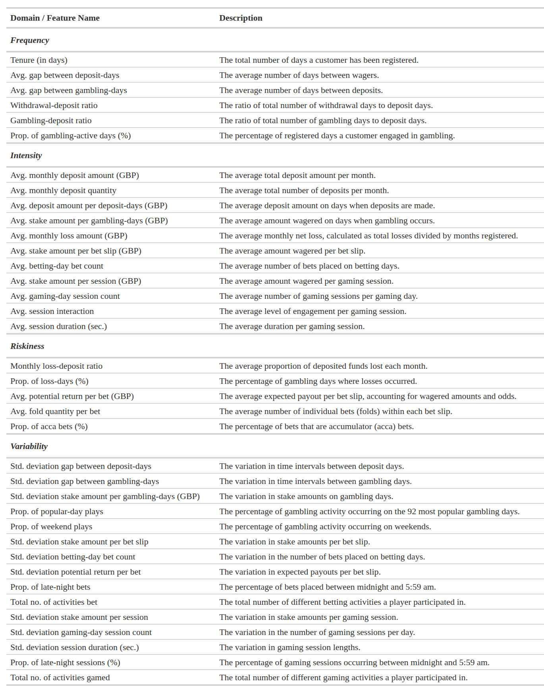
Table 1. The 37 behavioural features used as clustering inputs, organised into the four domains of frequency, intensity, riskiness and variability.

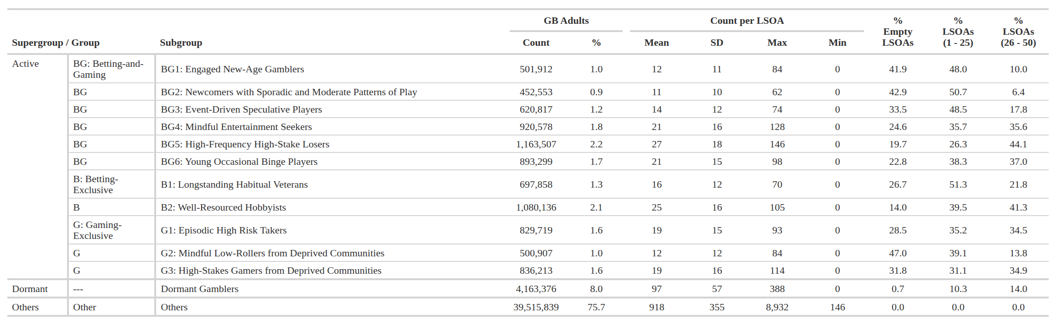
Table 2. Type names, population shares and core descriptive statistics for the 12-type classification (eleven active types plus Dormant).

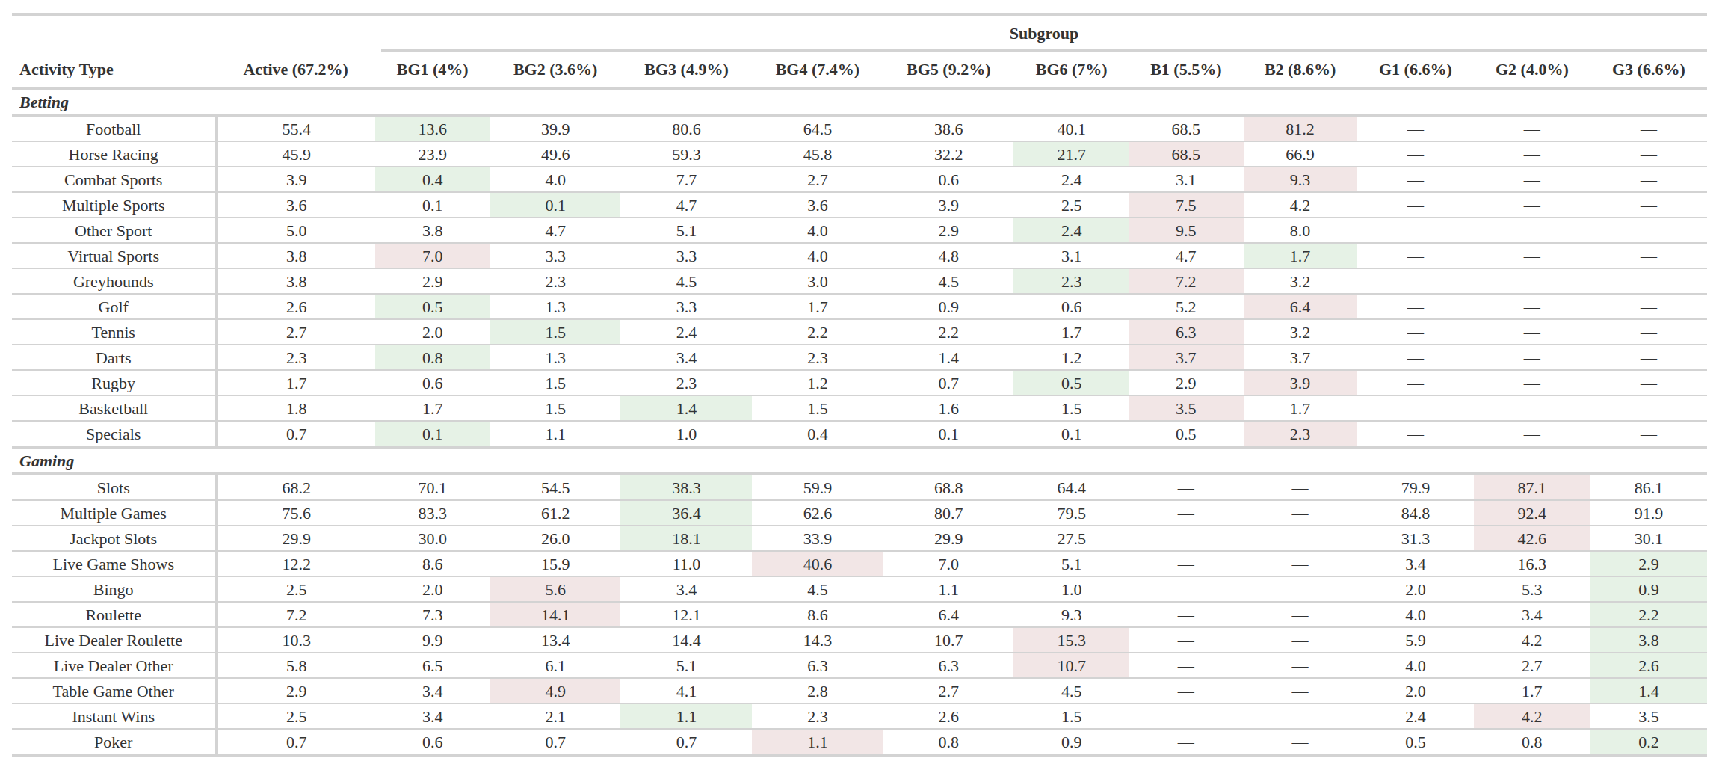
Table 3. Proportions of committed participants for each activity within each type, with row minima shown in green and row maxima in pink.

