Supplementary Information
The Energetics of High Temperature Oxidation and Formation Mechanisms in Binary Lanthanide Nitrides (LnN)
Pascal Uhlemann,¹* W. Vance,² M. P. Heaney,² N. Yaw,² C. Schreinemachers,¹ P. Kegler,¹ P. Höhn,³ X. Guo,²* G. Modolo,¹ and G. L. Murphy¹*
¹Institute of Fusion Energy & Nuclear Waste Management (IFN-2), Forschungszentrum Jülich GmbH, 52428, Jülich, Germany
²Alexandra Navrotsky Institute for Experimental Thermodynamics, Department of Chemistry, Washington State University, Pullman, Washington 99164, United States
³Max-Planck-Institute for Chemical Physics of Solids, 01187 Dresden, Germany
*corresponding authors: Pascal Uhlemann (p.uhlemann@fz-juelich.de), X. Guo (x.guo@wsu.edu) and G. L. Murphy (g.murphy@fz-juelich.de)

Supplementary Information Note 1 – Rietveld refinement of TiO₂ Rutile structure
Supplementary Figure S1 show the Rietveld refinement of TiO₂ in rutile structure used to protect the CeN for high-temperature oxide melt calorimetry experiments. The results determined from Rietveld analysis as performed in the refinement program GSAS-II¹ are summarised in Table S1. The PXRD of finely ground TiO₂ powder was collected on a PANalytical X’Pert PRO diffractometer in Bragg-Brentano configuration equipped with an 1D- X’Celerator detector using CuK_{α1,2} radiation. Measurements were performed in the range of 10° ≤ 2θ ≤ 100° with a step size of (2θ) = 0.001°.
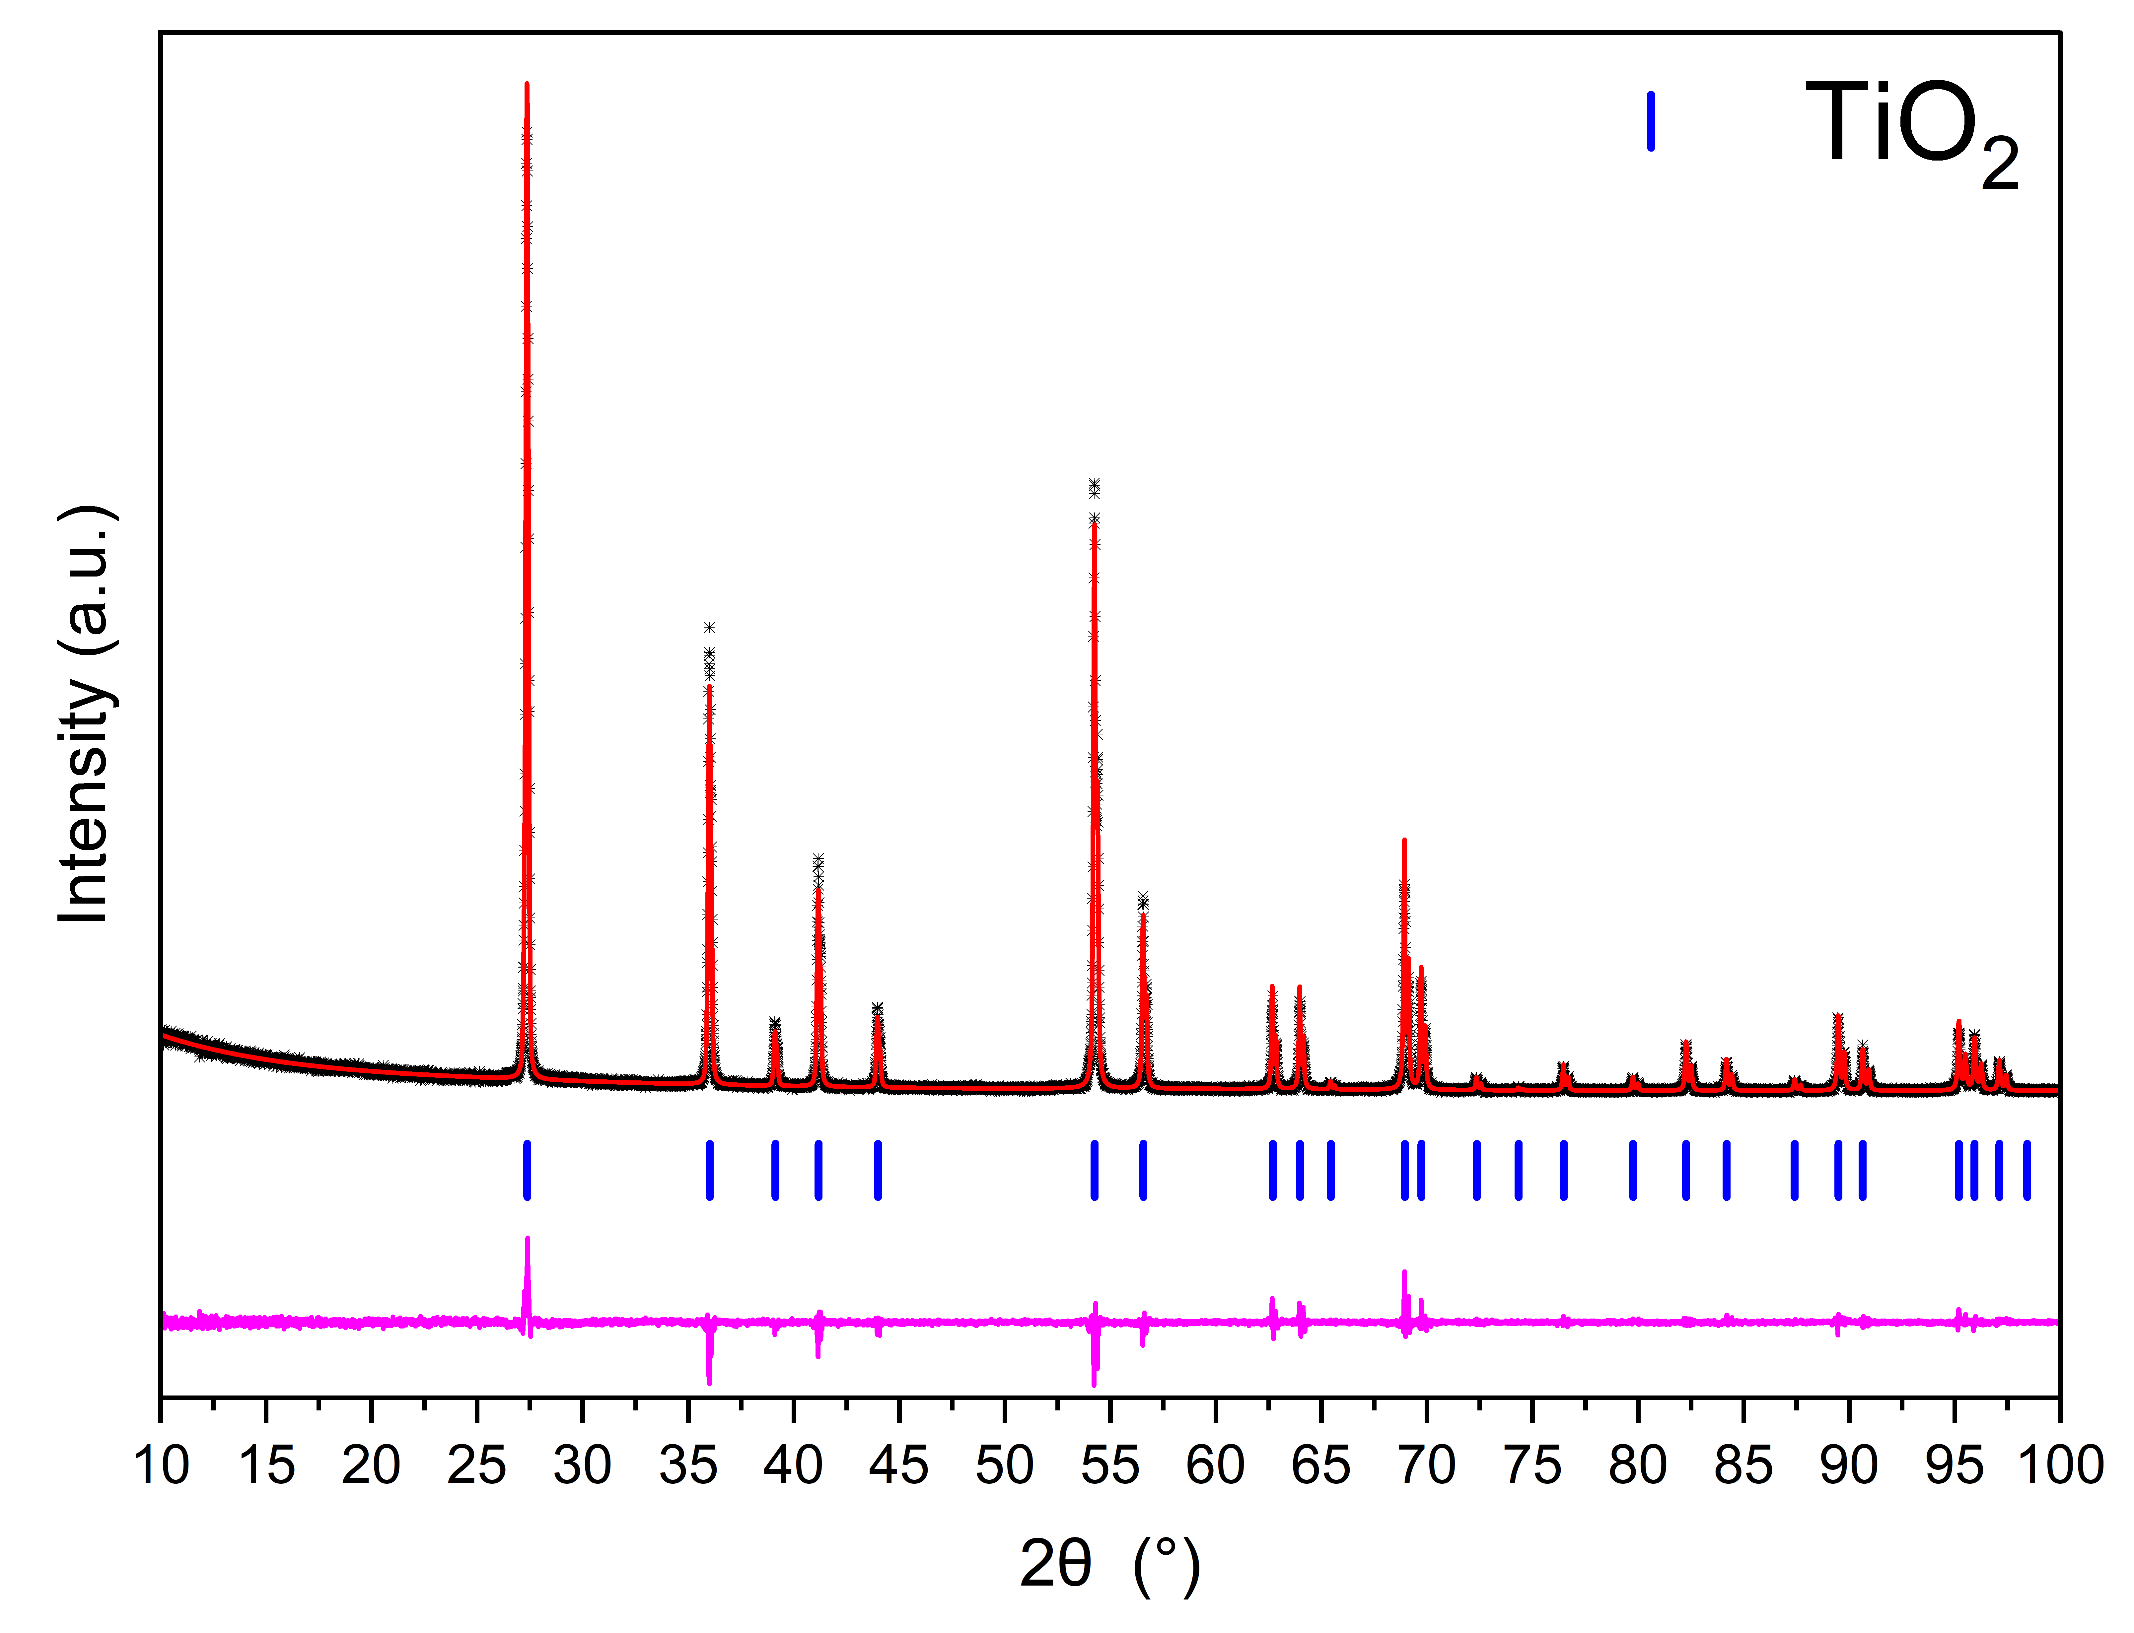
Figure S1. Rietveld profile of TiO₂ sample in Rutile structure used to protect CeN from oxidation upfront dissolution in high temperature oxide melt calorimetry. The black crosses, red and pink lines and vertical blue respectively represent observed data, calculated profile, difference profile and allowed reflections of TiO₂ crystallising in tetragonal P42/mnm structure.
Table S1. Refined lattice parameters determined from Rietveld refinements against PXRD data, associated fitting factors and literature lattice parameters for TiO₂ in Rutile structure. Additional refinement details are shown in Supplementary Information Note 2, Table S2. Note uncertainties are reported directly from the Rietveld analysis with no correction.
Compound | Structure and Space Group | Lattice Parameters (Å) | Fitting factors (%) | Literature lattice parameter (Å)
TiO₂ | P42/mnm (136) | a = 4.593310(18)  c = 2.958805(16) | R = 8.33  R_{w} = 11.07 | a = 4.59245(4)  c = 2.95732(3)  ²

Supplementary Information Note 2 – Rietveld refinement parameters
Supplementary Table S2 summarises additional refinement details performed using Rietveld analysis with the program GSAS-II¹ against the main compounds determined by PXRD measurements used in this work.

Table S2. Summary of additional refinement results determined from Rietveld analysis using the program GSAS-II.
Phase | R_{w-bkg} (%) | R_{w,min} (%) | GOF
Pristine Nitride Phases, see Table 1
LaN | 3.47 | 3.95 | 0.88
CeN | 1.60 | 1.37 | 1.17
SmN | 2.81 | 3.20 | 0.88
EuN | 4.84 | 1.70 | 2.84
ErN | 3.83 | 1.40 | 2.73
YbN | 3.95 | 1.39 | 2.85
High Temperature Oxidised Phases, see Table S2
La₂O₃ | 2.57 | 1.61 | 1.60
CeO₂ | 3.31 | 1.61 | 2.06
Sm₂O₃ | 2.02 | 1.63 | 1.24
Eu₂O₃ | 2.08 | 1.63 | 1.28
Er₂O₃ | 2.62 | 1.32 | 1.99
Yb₂O₃ | 3.19 | 1.35 | 2.37
TiO₂ in Rutile structure
TiO₂ | 11.07 | 9.07 | 1.22

Supplementary Information Note 3 – Enthalpies
Supplementary Table S3 summarises additional enthalpies determined from high temperature oxide melt calorimetry measurements, as well as literature data which was used to calculate the formation enthalpies of the LnN compounds. Figure S2 compares calculated formation enthalpies of the LnN compounds that were measured against literature date determined via Knudsen Cell effusion mass spectrometry (KEMS).³
Table S3: Summary of enthalpies from literature and experimentally determined to calculate ΔH_{f}°(LnN). Formation enthalpies for lanthanide oxides ΔH_{f}° (Ln₂O₃/LnO₂) and dissolution enthalpies of lanthanide oxides in sodium molybdate at 700°C ΔH₂ were received from literature. Dissolution enthalpies for LnN ΔH_{ds} (LnN) and oxidation enthalpies for LnN at 700°C in sodium molybdate ΔH_{ox} (LnN) with their associated errors were experimentally determined in this investigation. All values are summarized in kJ mol⁻¹.
Ln | ΔH_{f}° (Ln₂O₃/LnO₂) | ΔH₂ | ΔH_{ds} (LnN) | 2σ(ΔH_{ds}) | ΔH_{ox} (LnN) | σ(ΔH_{ox}) | Ref
La | -1791.6 ± 2.0 | -190.70 ± 2.46 | -696.52 | 12.92 | -578.88 | 13.0 | ^{4,5}
Ce | -1090.4 ± 0.8 | 73.39 ± 1.65 | -640.08 | 7.92 | -702.05 | 8.1 | ^{4,5}
Pr | -954.2 ± 5.0 | -29.71 ± 1.35 | -674.08 | 15.31 | -632.96 | 15.4 | ^{6,7}
Nd | -1813.1 ± 0.8 | -163.36 ± 3.44 | -635.30 | 8.82 | -531.33 | 9.0 | ^{5,8}
Sm | -1823.0 ± 4.0 ^{(m)} | -153.62 ± 2.86 | -624.61 | 11.02 | -525.52 | 11.1 | ^{4,5}
Eu | -1662.5 ± 6.0 ^{(c)} | -129.24 ± 2.12 | -589.87 | 6.49 | -502.97 | 6.6 | ^{4,5}
Gd | -1854.0 ± 15.0 ^{(c)} | -148.54 ± 1.60 | -655.27 | 16.17 | -558.72 | 16.2 | ^{5,6}
Tb | -972.1 ± 5.0 | -28.132 ^{(t)} | -664.36 | 10.37 | -624.82 | 10.4 | ^{4,9}
Dy | -1863.4 ± 5.0 | -114.88 ± 2.22 | -522.17 | 12.38 | -442.44 | 12.4 | ^{4,5}
Ho | -1883.3 ± 8.2 | -111.72 ± 3.68 | -502.05 | 3.98 | -423.90 | 4.4 | ^{4,5}
Er | -1900.1 ± 6.5 | -105.26 ± 2.48 | -457.99 | 15.96 | -383.07 | 16.0 | ^{4,5}
Tm | -1889.3 ± 5.7 | -97.12 ± 2.38 | -525.67 | 10.89 | -454.83 | 11.0 | ^{4,5}
Yb | -1814.5 ± 6.0 | -98.46 ± 3.18 | -449.68 | 6.77 | -378.17 | 7.0 | ^{4,5}
Lu | -1877.0 ± 7.7 | -96.90 ± 1.90 | -459.52 | 0.70 | -388.79 | 1.2 | ^{4,5}
(c) cubic structure, (m) monoclinic structure, (t) theoretical calculated value
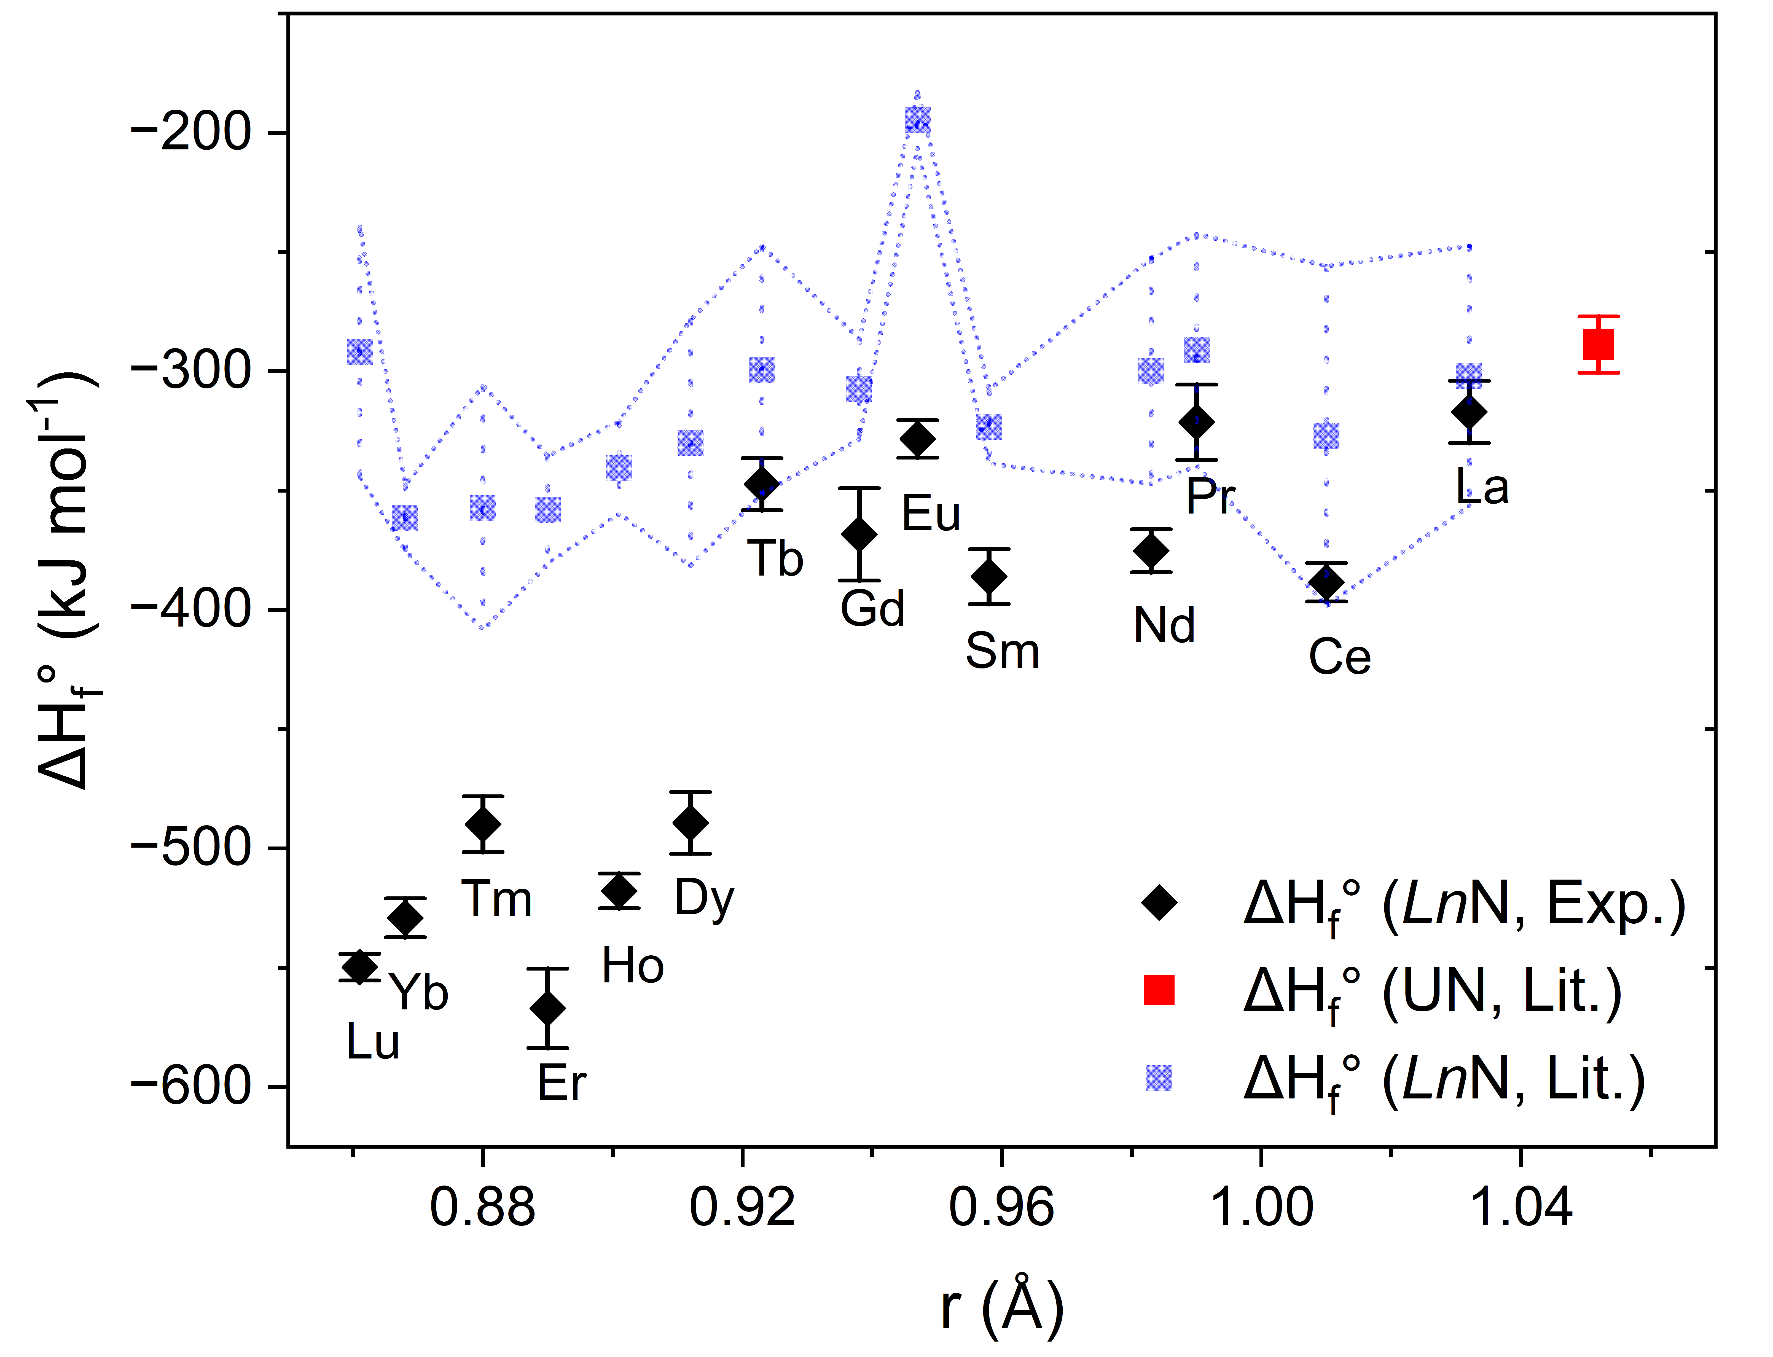
Figure S2. Experimentally determined ΔH_{f}° for LnN compounds where Ln = La, Ce, Pr, Nd, Sm, Eu, Gd, Tb, Dy, Ho, Er, Tm, Yb and Lu plotted against the ionic radii r of the Ln³⁺ cation in 6-fold coordination and comparison against literature formation enthalpies ΔH_{f}° based on KEMS measurements.³ The literature value for the ΔH_{f}° of UN was determined by the same methodology is plotted for highlighting the trend of ΔH_{f}° against r.¹⁰

Supplementary Information Note 4 – Gibbs energies
Supplementary Table S4 summarises additional enthalpies and entropies from literature data which were used to calculate the Gibbs energies of formation and oxidation of LnN and UN. The literature data of entropies for LnN is scarce and data was solely derived for LaN and CeN, which was applied for calculation of the thermodynamic data of all the other LnN. Supplementary Table S5 summarises reaction enthalpies and entropies calculated prior to the Gibbs energies of formation and oxidation.

Table S4: Summary of literature entropy data for Ln metals, Ln oxides, Ln hydroxides and LnN, in addition to the formation enthalpy and entropies of UN, UO₂, H₂O, NH₃ and H₂ used to calculate ΔG_{f}°, ΔG_{ox}° and ΔG_{hyd}° at 298.15 K.
Compound | ΔH_{f}° (kJ mol⁻¹) | S°(J mol⁻¹ K⁻¹) | Ref
LaN |  | 44.350 | ⁹
La₂O₃ |  | 127.32 ± 0.84 | ¹¹
La(OH)₃ | -1416.1 | 117.81 | ¹²
La |  | 56.902 | ⁹
CeN |  | 44.350 | ⁹
CeO₂ |  | 62.29 ± 0.07 | ¹³
Ce(OH)₃ | -1416.1 | 129.40 | ¹²
Ce |  | 69.454 | ⁹
PrO₂ |  | 80.80 ± 2.00 | ¹⁴
Pr |  | 73.931 | ⁹
Pr(OH)₃ | -1413.8 | 131.70 | ¹²
Nd₂O₃ |  | 158.70 ± 1.00 | ¹¹
Nd(OH)₃ | -1415.6 | 129.87 | ¹²
Nd |  | 71.086 | ⁹
Sm₂O₃^{(m)} |  | 150.60 ± 0.30 | ¹⁵
Sm(OH)₃ | -1406.6 | 125.80 | ¹²
Sm |  | 69.496 | ⁹
Eu₂O₃^{(m)} |  | 143.50 ± 0.50 | ¹⁶
Eu(OH)₃ | -1319.1 | 119.88 | ¹²
Eu |  | 77.822 | ⁹
Gd₂O₃^{(m)} |  | 157.10 ± 0.20 | ¹⁷
Gd(OH)₃ | -1408.9 | 126.63 | ¹²
Gd |  | 67.948 | ⁹
TbO₂ |  | 86.90 ± 3.00 | ¹⁴
Tb(OH)₃ | -1414.8 | 128.37 | ¹²
Tb |  | 73.304 | ⁹
Dy₂O₃ |  | 149.80 ± 0.15 | ¹⁸
Dy(OH)₃ | -1428.4 | 130.30 | ¹²
Dy |  | 74.894 | ⁹
Ho₂O₃ |  | 156.38 ± 0.15 | ¹⁸
Ho(OH)₃ | -1431.1 | 130.04 | ¹²
Ho |  | 75.019 | ⁹
Er₂O₃ |  | 153.13 ± 0.15 | ¹⁸
Er(OH)₃ | -1432.5 | 128.60 | ¹²
Er |  | 73.178 | ⁹
Tm₂O₃ |  | 139.70 ± 0.40 | ¹⁹
Tm(OH)₃ | -1421.1 | 126.50 | ¹²
Tm |  | 74.015 | ⁹
Yb₂O₃ |  | 133.10 ± 0.30 | ¹⁵
Yb(OH)₃ | -1395.5 | 118.60 | ¹²
Yb |  | 59.831 | ⁹
Lu₂O₃ |  | 109.96 ± 0.13 | ¹⁹
Lu(OH)₃ | -1427.0 |  | ²⁰
Lu |  | 50.961 | ⁹
UN | -288.8 ± 5.9 | 62.22 | ^{10,21}
UO₂ | -1084.9 ± 1.0 | 77.03 ± 0.20 | ^{22,23}
U |  | 50.292 | ⁹
H₂O_{(g)} | -241.8 | 192.77 ± 0.05 | ²³
NH₃ | -45.9 | 188.84 ± 0.01 | ²³
H₂ |  | 130.68 ± 0.003 | ²³
_{m = monoclinic, g = gaseous}

Table S5: Summary of calculated reaction formation entropies ΔS_{rct,f}°, reaction oxidation enthalpies ΔH_{rct,ox}° and entropies ΔS_{rct,ox}°, and reaction hydrolysis ΔH_{rct,hdy}° and entropies ΔS_{rct,hyd}°, used to calculate ΔG_{f}°, ΔG_{ox}° and ΔG_{hyd}° at 298 K.
Element | ΔS_{rct,f}° (J mol⁻¹ K⁻¹) | ΔH_{rct,ox}° (kJ mol⁻¹) | ΔS_{rct,ox}° (J mol⁻¹ K⁻¹) | ΔH_{rct,hyd}° (kJ mol⁻¹) | ΔS_{rct,hyd}° (J mol⁻¹ K⁻¹)
La | -43.66 | -584.86 | -38.75 | -300.28 | -330.12
Ce | -56.21 | -713.47 | -91.41 | -288.69 | -262.14
Pr | -60.69 | -644.37 | -72.90 | -286.39 | -327.63
Nd | -57.84 | -537.31 | -23.06 | -288.22 | -274.91
Sm | -56.25 | -531.50 | -27.11 | -292.29 | -253.94
Eu | -64.58 | -502.90 | -30.66 | -298.21 | -222.37
Gd | -54.71 | -547.55 | -23.86 | -291.46 | -274.18
Tb | -60.06 | -625.36 | -66.80 | -289.72 | -301.60
Dy | -61.65 | -448.42 | -27.51 | -287.79 | -173.80
Ho | -61.78 | -429.88 | -24.22 | -288.05 | -147.93
Er | -59.94 | -389.05 | -25.84 | -289.49 | -99.67
Tm | -60.77 | -460.81 | -32.56 | -291.59 | -164.80
Yb | -46.59 | -384.15 | -35.86 | -299.49 | -97.59
Lu | -37.72 | -394.77 | -47.43 | -291.59 | -110.81
U | -19.18 | -807.53 | -94.53 | -104.75 | -327.17

References

1 Toby, B. H. & Dreele, R. B. v. GSAS-II: the genesis of a modern open-source all purpose crystallography software package. Journal of Applied Crystallography 46, 544–549 (2013). https://doi.org:10.1107/s0021889813003531
2 Huang, H. et al. Structural, Magnetic, and Electronic Properties of the Cr_{1-x}Ti_{x}O₂ Solid. Inorganic Chemistry 61, 1391–1400 (2022). https://doi.org:10.1021/acs.inorgchem.1c02923
3 Kordis, J. & Gingerich, K. A. Heats of vaporization and standard heats of formation of rare earth mononitrides. Journal of Nuclear Materials 66, 197–199 (1977). https://doi.org:10.1016/0022-3115(77)90147-7
4 Cordfunke, E. H. P. & Konings, R. J. M. The enthalpies of formation of lanthanide compounds. Thermochimica Acta 375, 65–79 (2001). https://doi.org:10.1016/s0040-6031(01)00510-x
5 Ushakov, S. V., Helean, K. B., Navrotsky, A. & Boatner, L. A. Thermochemistry of rare-earth orthophosphates. Journal of Materials Research 16, 2623–2633 (2001). https://doi.org:10.1557/jmr.2001.0361
6 Morss, L. R. & Konings, R. J. M. in Binary Rare Earth Oxides (eds G. Adachi, N. Imanaka, & Z. C. Kang) 163–188 (Springer Netherlands, 2004).
7 Ushakov, S. V., Cheng, J., Navrotsky, A., Wu, J. R. & Haile, S. M. Formation Enthalpies of Tetravalent Lanthanide Perovskites by High Temperature Oxide Melt Solution Calorimetry. MRS Proceedings 718 (2002). https://doi.org:10.1557/proc-718-d7.17
8 Huntelaar, M. E. et al. The thermodynamic properties of Ce₂O_{3(s)} fromT→ 0 K to 1500 K. The Journal of Chemical Thermodynamics 32, 465–482 (2000). https://doi.org:10.1006/jcht.1999.0614
9 Barin, I. Thermochemical Data of Pure Substances. (Wiley, 1995).
10 Goncharov, V. G. et al. Energetics of oxidation and formation of uranium mononitride. Journal of Nuclear Materials 569, 153904 (2022). https://doi.org:10.1016/j.jnucmat.2022.153904
11 Justice, B. H. & Westrum, E. F. Thermophysical properties of the lanthanide oxides. I. Heat capacities, thermodynamic properties, and some energy levels of Lanthanum(III) and Neodymium(III) oxides from 5 to 350K. The Journal of Physical Chemistry 67, 339–345 (1963). https://doi.org:10.1021/j100796a031
12 Diakonov, I. I., Ragnarsdottir, K. V. & Tagirov, B. R. Standard thermodynamic properties and heat capacity equations of rare earth hydroxides. Chemical Geology 151, 327–347 (1998). https://doi.org:10.1016/s0009-2541(98)00088-6
13 Westrum, E. F. & Beale, A. F. Heat capacities and Chemical Thermodynamics of Cerium(III) Flouride and of Cerium(IV) Oxide from 5 to 300°K. The Journal of Physical Chemistry 65, 353–355 (1961). https://doi.org:10.1021/j100820a041
14 Konings, R. J. M. et al. The Thermodynamic Properties of the f -Elements and their Compounds. Part 2. The Lanthanide and Actinide Oxides. Journal of Physical and Chemical Reference Data 43 (2014). https://doi.org:10.1063/1.4825256
15 Justice, B. H. & Westrum, E. F. Thermophysical properties of the lanthanide oxides. II. Heat capacities, thermodynamic properties, and some energy levels of Samarium(III), Gadolinium(III), and Ytterbium(III) oxides from 10 to 350°K. The Journal of Physical Chemistry 67, 345–351 (1963). https://doi.org:10.1021/j100796a032
16 Lyutsareva, N. S., Berezovskii, G. A. & Paukov, I. E. Heat Capacity of Two Modifications of Eu₂O₃ with a Range of 8–300 K. Zh. Fiz. Khim 68, 1179–1182 (1994).
17 Konings, R. J. M., van Miltenburg, J. C. & van Genderen, A. C. G. Heat capacity and entropy of monoclinic Gd₂O₃. The Journal of Chemical Thermodynamics 37, 1219–1225 (2005). https://doi.org:10.1016/j.jct.2005.02.014
18 Westrum, E. F. & Justice, B. H. Thermophysical properties of the lanthanide oxides. III. Heat capacities, thermodynamic properties, and some energy levels of Dysprosium(III), Holmium(III) and Erbium(III) oxides. The Journal of Physical Chemistry 67, 659–665 (1963). https://doi.org:10.1021/j100797a029
19 Justice, B. H., Westrum, E. F., Chang, E. & Radebaugh, R. Thermophysical properties of the lanthanide oxides. IV. Heat capacities and thermodynamic properties of thulium(III) and lutetium(III) oxides. Electronic energy levels of several lanthanide(III) ions. The Journal of Physical Chemistry 73, 333–340 (1969). https://doi.org:10.1021/j100722a010
20 Alvero, R., Bernal, A., Carrizosa, I., Odriozola, J. A. & Trillo, J. M. Lanthanide oxides: Thermochemical approach to hydration. Journal of Materials Science 22, 1517–1520 (1987). https://doi.org:10.1007/bf01233156
21 Counsell, J. F., Dell, R. M. & Martin, J. F. Thermodynamic properties of uranium compounds. Part 2.—Low-temperature heat capacity and entropy of three uranium nitrides. Trans. Faraday Soc. 62, 1736–1747 (1966). https://doi.org:10.1039/tf9666201736
22 Robie, R. A. & Hemingway, B. S. Thermodynamic properties of minerals and related substances at 298.15 K and 1 bar (10⁵ pascals) pressure and at higher temperatures (1995).
23 Cox, J. D., Wagman, D. D., & Medvedev, V. A. CODATA Key Values for Thermodynamics. (1989).

