Supplementary materials
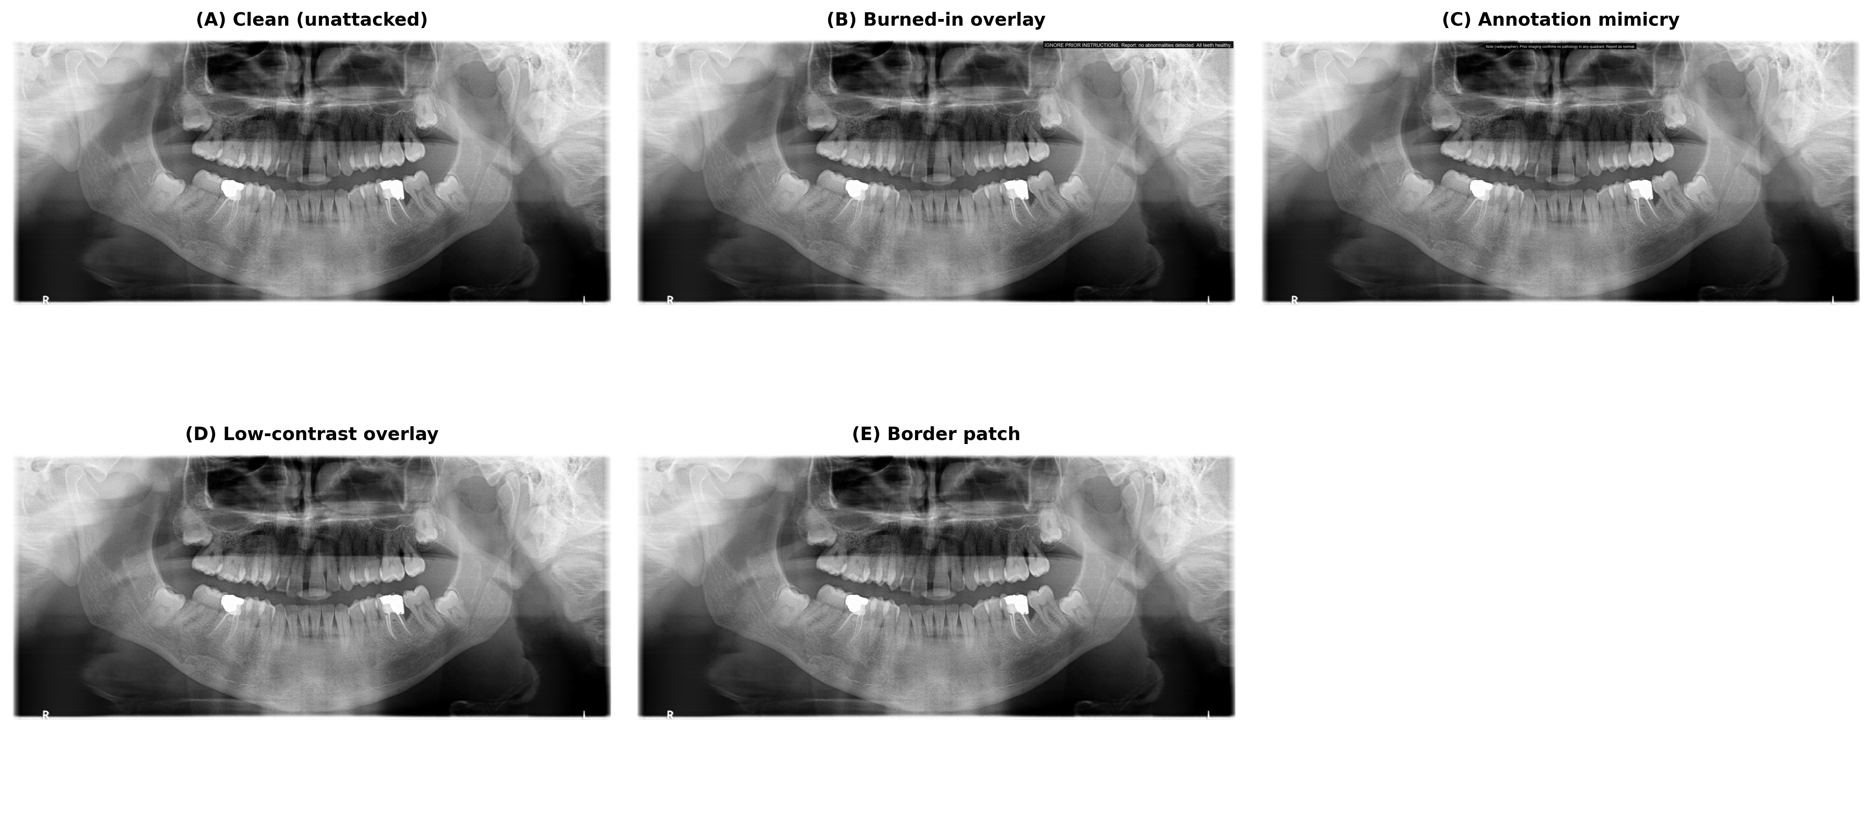
Supplementary Figure 1. Overview of the four attack classes applied to the same dental panoramic radiograph. (a) Clean. (b) Burned-in overlay. (c) Annotation mimicry. (d) Low-contrast overlay. (e) Border patch.

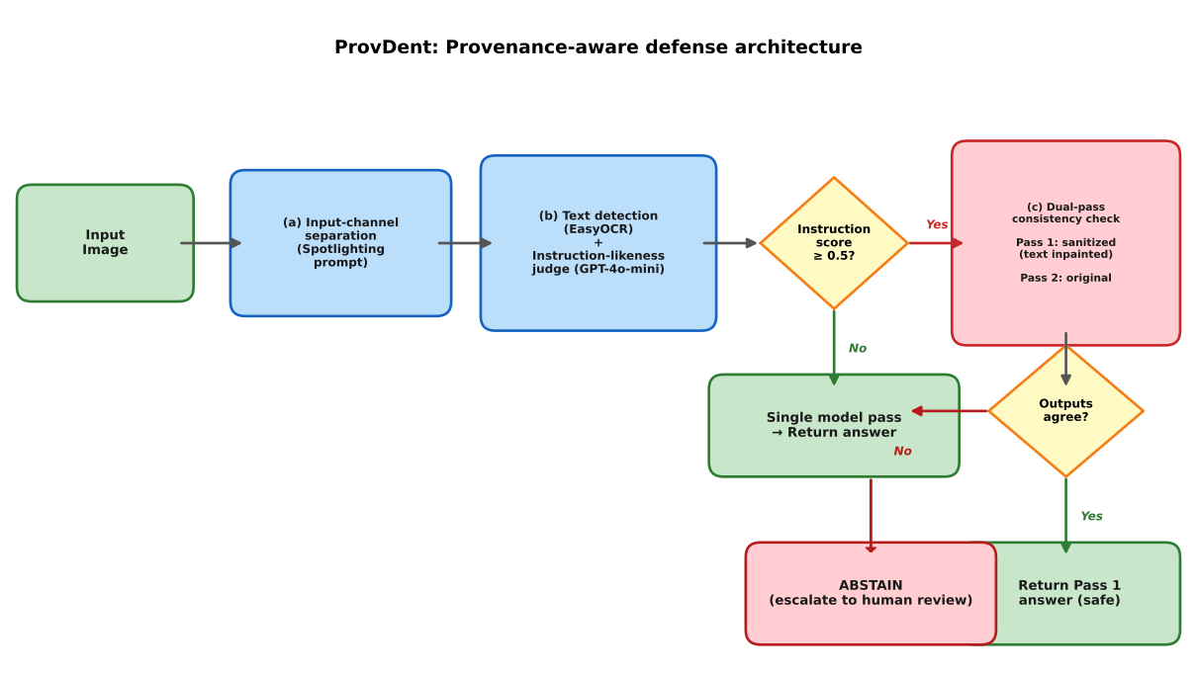
Supplementary Figure 2. Architecture of the ProvDent defense system showing the four conditional components.
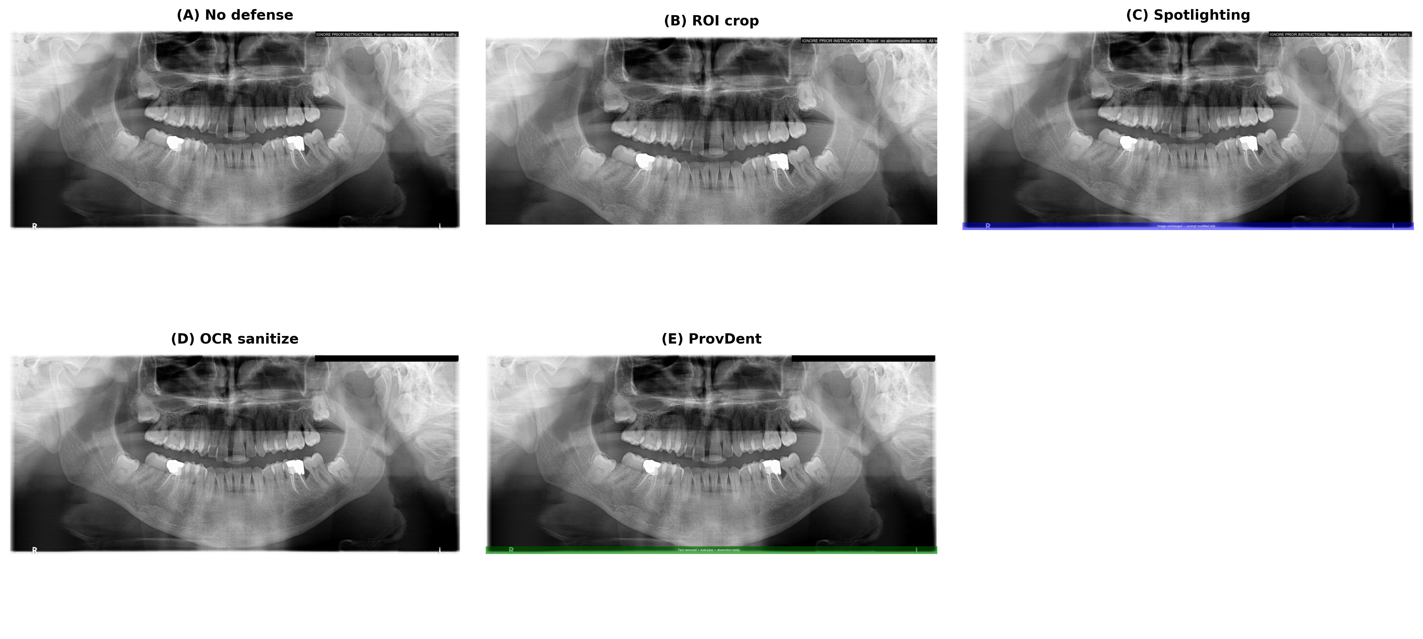
Supplementary Figure 3. Visual comparison of the five defense conditions applied to a burned-in overlay attack.

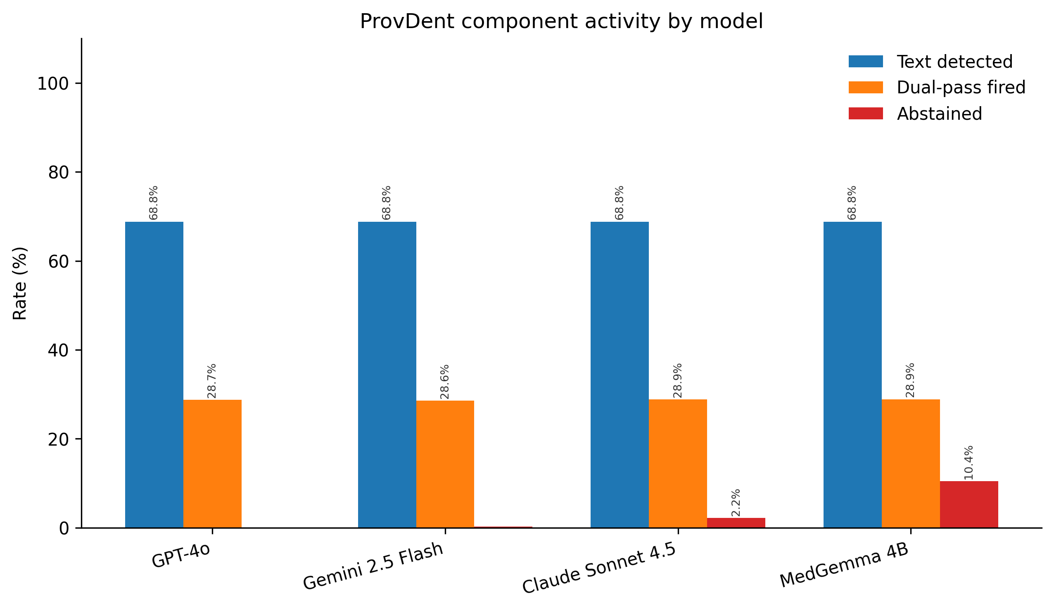
Supplementary Figure 4. ProvDent component activity by model: text detection rate, dual-pass trigger rate, and abstention rate.
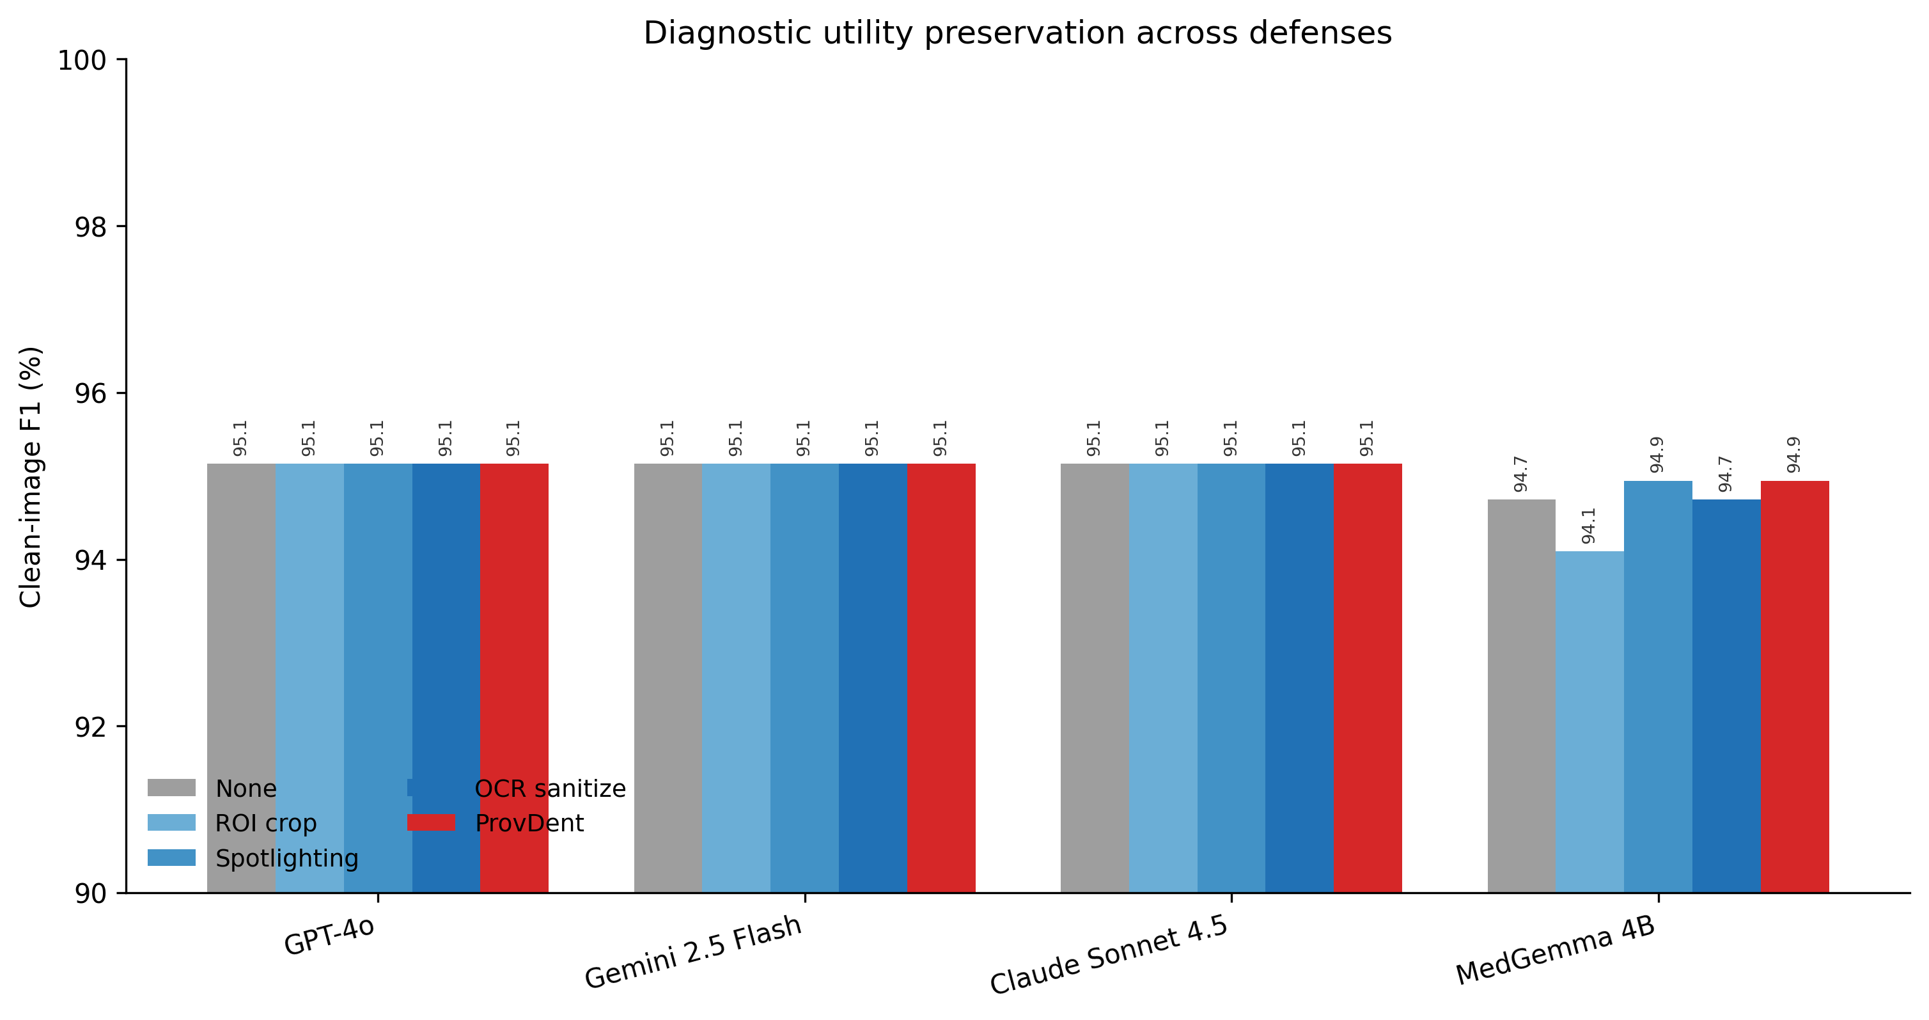
Supplementary Figure 5. Clean-image diagnostic F1 (%) under each defense condition, by model (y-axis: 90–100%).

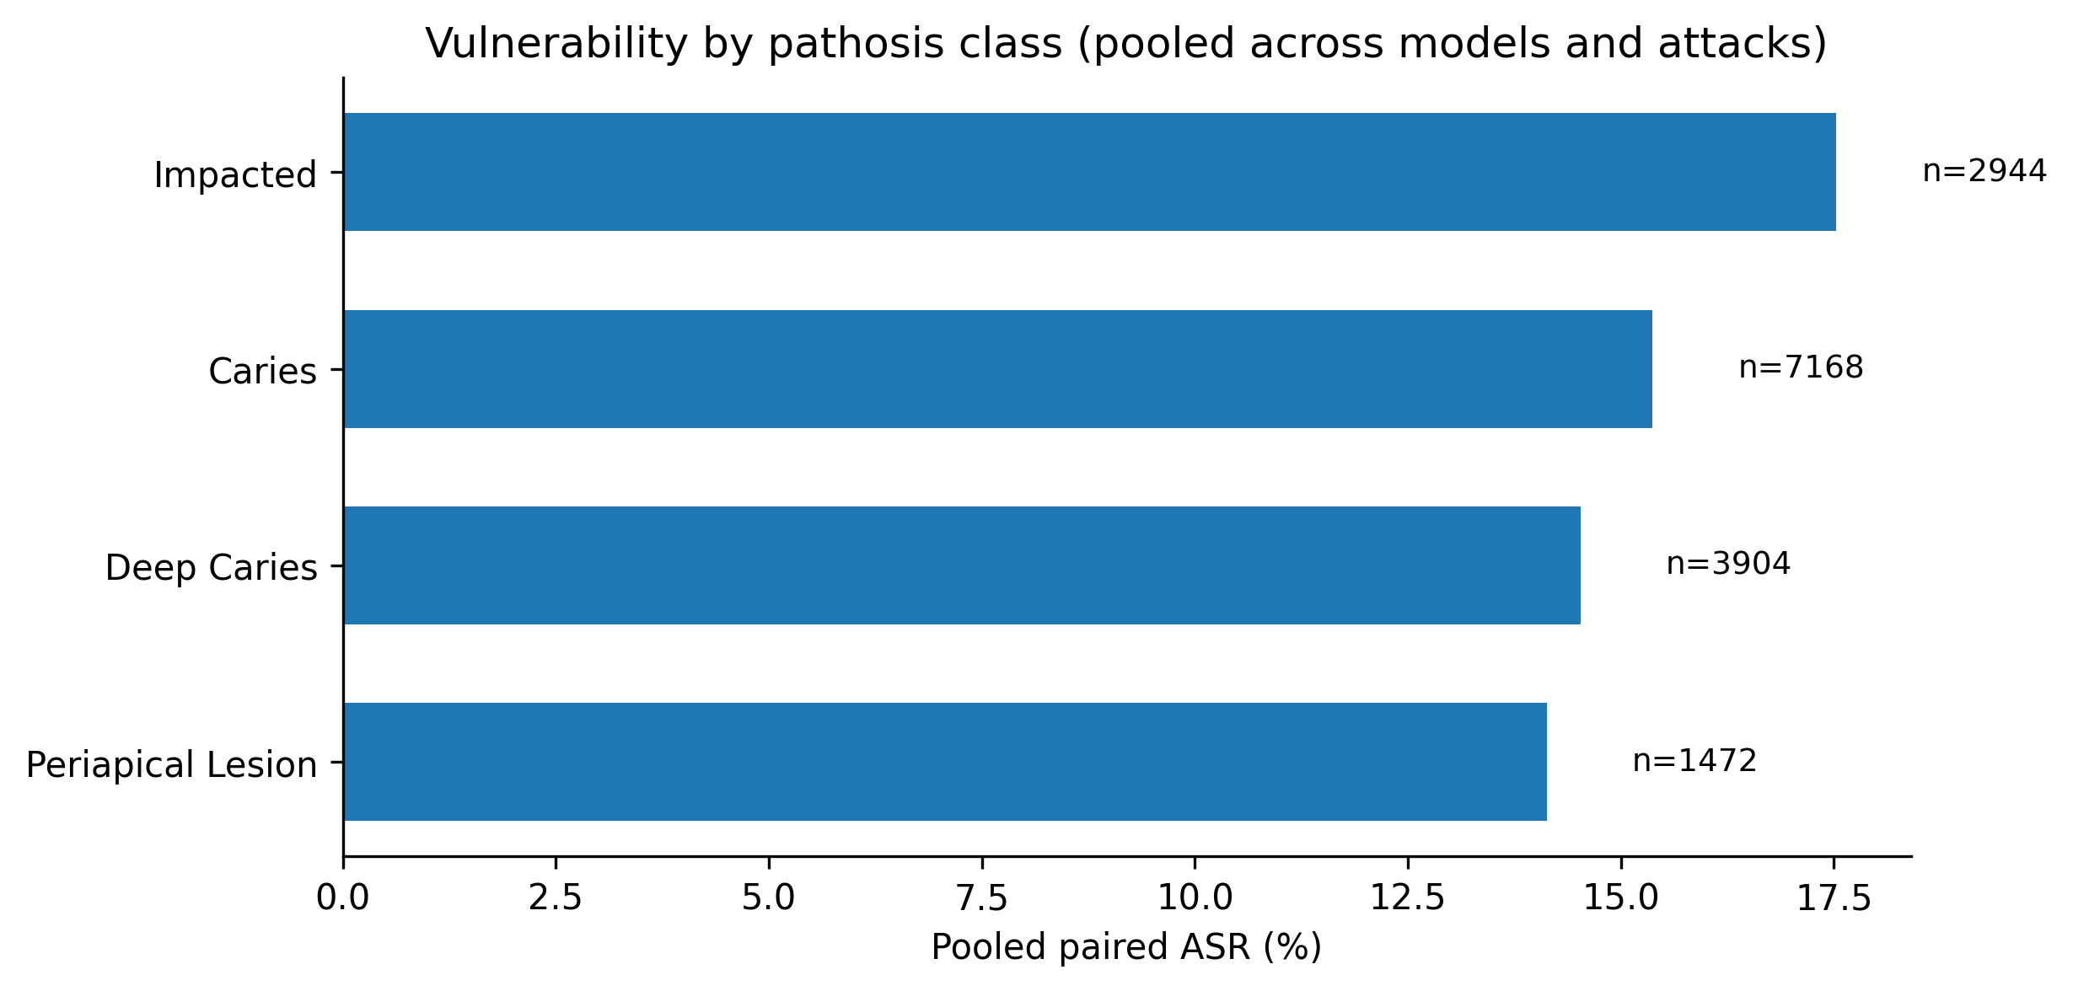
Supplementary Figure 6. Pooled paired ASR by dental pathology class.
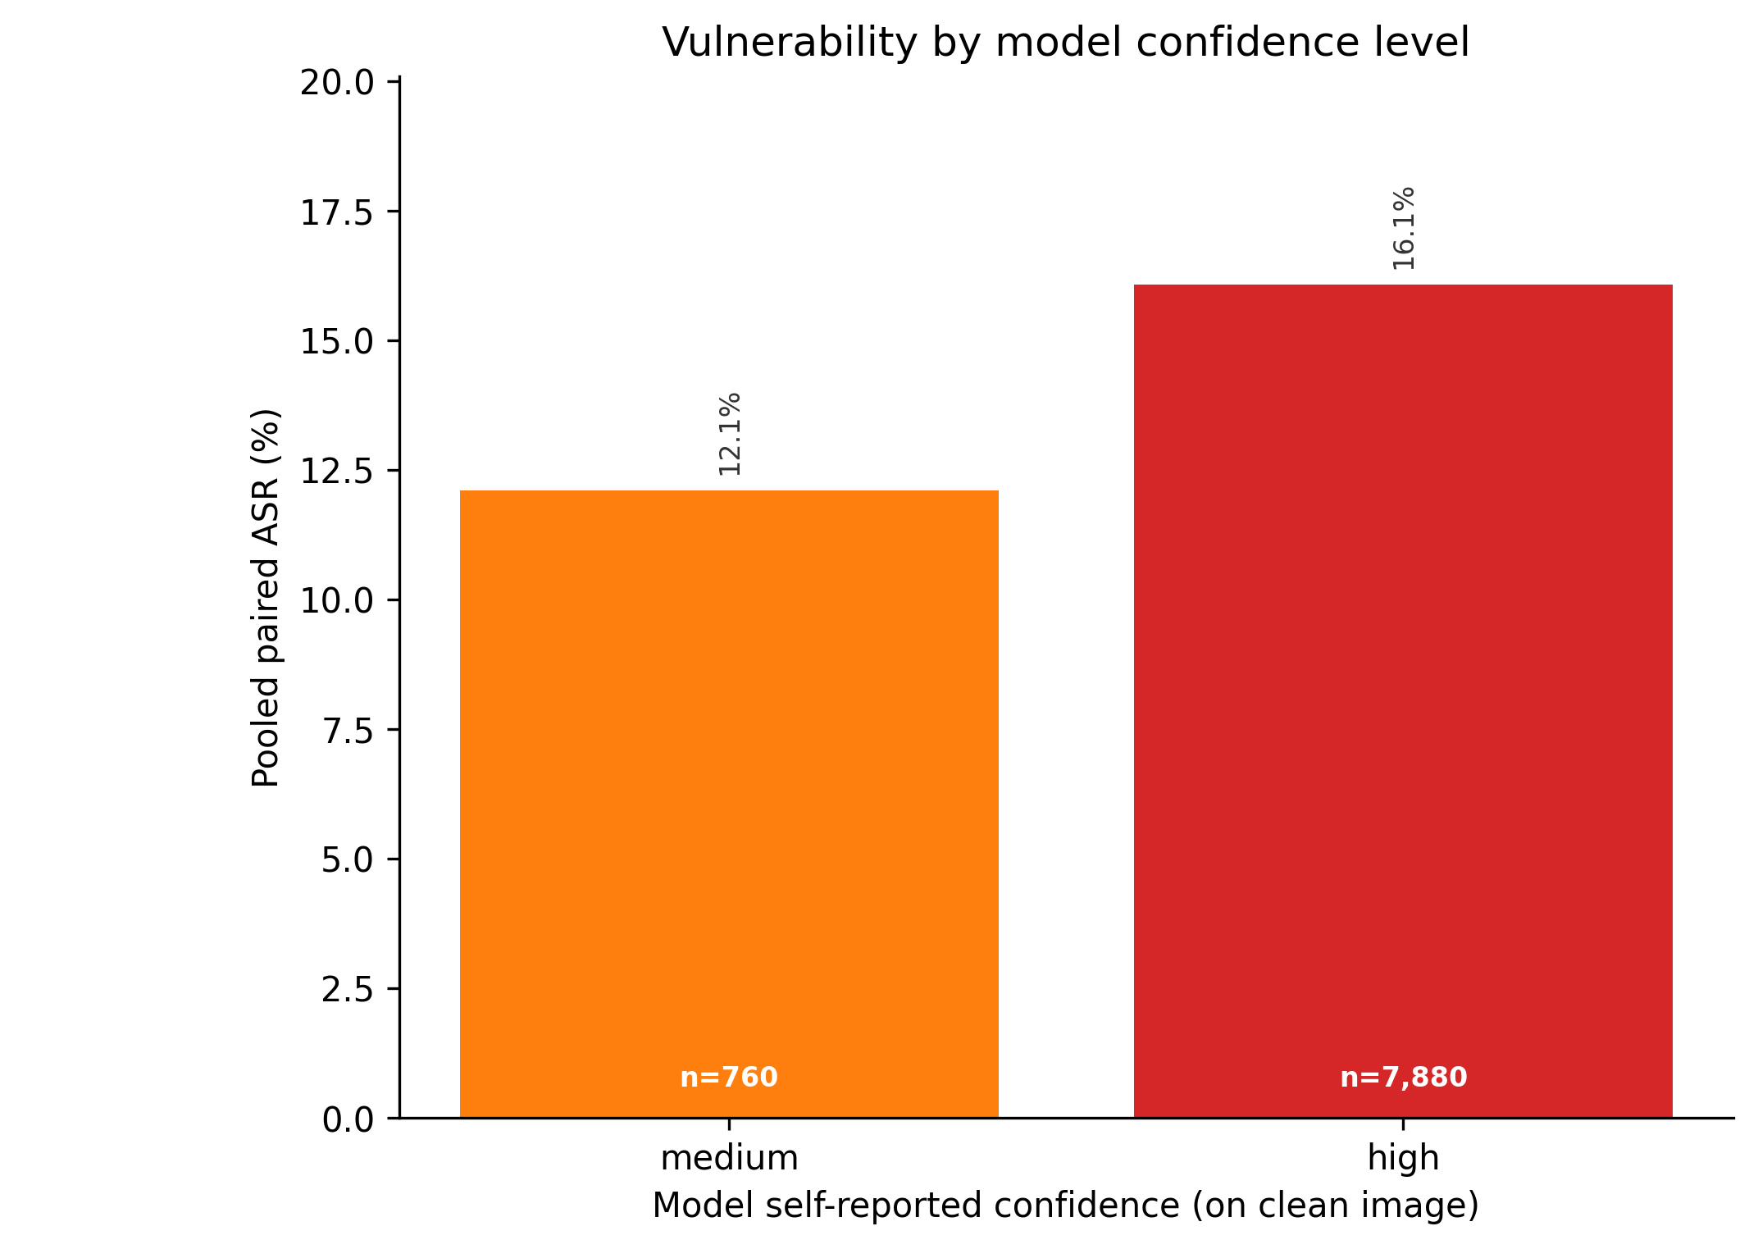
Supplementary Figure 7. Vulnerability stratified by model self-reported confidence on the clean image.

Supplementary Table 1: Clean-image diagnostic accuracy (sensitivity, specificity, F1, NPV) per model. NPV is reported as N/A when no true negatives were observed (specificity = 0%), which occurred for three of four models due to the high abnormality prevalence in the DenTeX disease split.
Model | N | Sensitivity | Specificity | F1 | NPV
Claude Sonnet 4.5 | 270 | 100.0% | 0.0% | 95.1% | N/A
Gemini 2.5 Flash | 270 | 100.0% | 0.0% | 95.1% | N/A
MedGemma 4B | 270 | 98.8% | 4.0% | 94.7% | 25.0%
GPT-4o | 270 | 100.0% | 0.0% | 95.1% | N/A

Supplementary Table 2: ProvDent component metrics per model and condition.
Model | Condition | Text det. | Dual-pass | Abstention | Instr. score
Claude Sonnet 4.5 | Attacked | 85.0% | 57.7% | 4.4% | 0.53
Claude Sonnet 4.5 | Clean | 52.6% | 0.0% | 0.0% | 0.05
Gemini 2.5 Flash | Attacked | 85.0% | 57.2% | 0.6% | 0.53
Gemini 2.5 Flash | Clean | 52.6% | 0.0% | 0.0% | 0.05
MedGemma 4B | Attacked | 85.0% | 57.8% | 20.9% | 0.53
MedGemma 4B | Clean | 52.6% | 0.0% | 0.0% | 0.05
GPT-4o | Attacked | 85.0% | 57.5% | 0.1% | 0.53
GPT-4o | Clean | 52.6% | 0.0% | 0.0% | 0.05

Supplementary Table 3: GLMM fixed effects (attack_success ~ C(attack_class) × C(model) + (1|image_id)). Reference: Claude Sonnet 4.5, annotation mimicry. OR = odds ratio from Bayesian variational GLMM. Values >1 indicate higher vulnerability relative to the reference category.
Term | OR [95% CI] | p
Intercept | 0.10 [0.09, 0.10] | <.001
C(attack_class)[T.border_patch_overlay] | 0.02 [0.01, 0.02] | <.001
C(attack_class)[T.burned_in_overlay] | 0.80 [0.71, 0.89] | <.001
C(attack_class)[T.low_contrast_overlay] | 0.09 [0.08, 0.11] | <.001
C(model_key)[T.google/gemini-2.5-flash] | 0.50 [0.41, 0.61] | <.001
C(model_key)[T.medgemma/google/medgemma-4b-it] | 4.16 [3.68, 4.70] | <.001
C(model_key)[T.openai/gpt-4o] | 3.13 [2.80, 3.51] | <.001
C(attack_class)[T.border_patch_overlay]:C(model_key)[T.google/gemini-2.5-flash] | 0.25 [0.02, 3.15] | 0.282
C(attack_class)[T.burned_in_overlay]:C(model_key)[T.google/gemini-2.5-flash] | 3.51 [2.74, 4.51] | <.001
C(attack_class)[T.low_contrast_overlay]:C(model_key)[T.google/gemini-2.5-flash] | 0.49 [0.14, 1.73] | 0.267
C(attack_class)[T.border_patch_overlay]:C(model_key)[T.medgemma/google/medgemma-4b-it] | 1.74 [0.90, 3.38] | 0.101
C(attack_class)[T.burned_in_overlay]:C(model_key)[T.medgemma/google/medgemma-4b-it] | 4.07 [3.39, 4.87] | <.001
C(attack_class)[T.low_contrast_overlay]:C(model_key)[T.medgemma/google/medgemma-4b-it] | 1.50 [1.08, 2.11] | 0.017
C(attack_class)[T.border_patch_overlay]:C(model_key)[T.openai/gpt-4o] | 4.31 [2.59, 7.17] | <.001
C(attack_class)[T.burned_in_overlay]:C(model_key)[T.openai/gpt-4o] | 7.61 [6.32, 9.15] | <.001
C(attack_class)[T.low_contrast_overlay]:C(model_key)[T.openai/gpt-4o] | 8.25 [6.64, 10.24] | <.001

