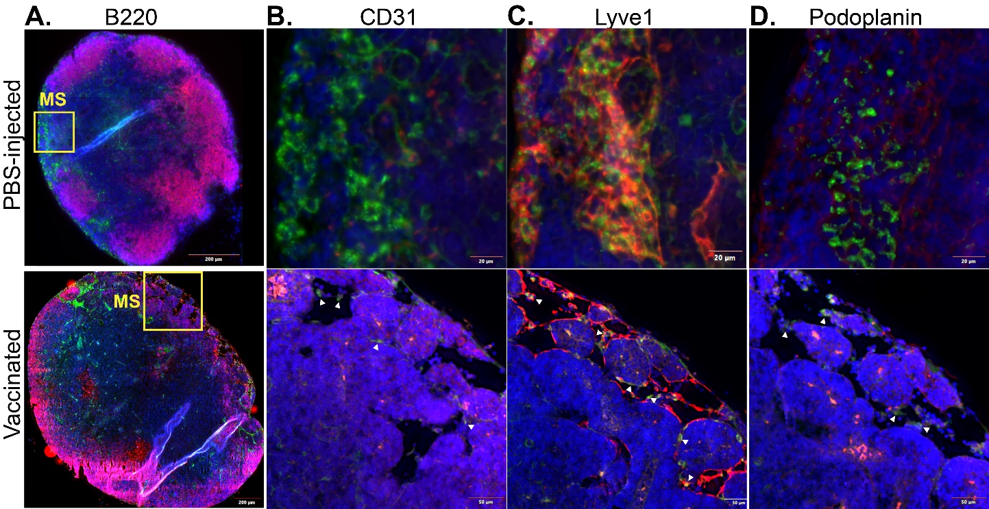
Extended Data Figure 1. HMW FITC-dextran accumulates in the medullary sinus of both naïve and vaccinated lymph nodes. Lymph nodes depicted in Figure 1A-E. A. Distribution of 70kDa dextran (green) and B220 (red) in the lymph node 7 days after PBS or NP-Ova vaccination, counterstained with DAPI (blue). Boxes mark areas of medullary sinus examined in B-D. The medullary sinus region identified in A, stained for anti-CD31 (B, red), Anti-LYVE-1 (C, red), or anti-podoplanin (D, red). Green staining in all sections is 70kDa FITC-dextran. All sections are imaged at 20x magnification. White arrows indicate areas of FITC-dextran staining.

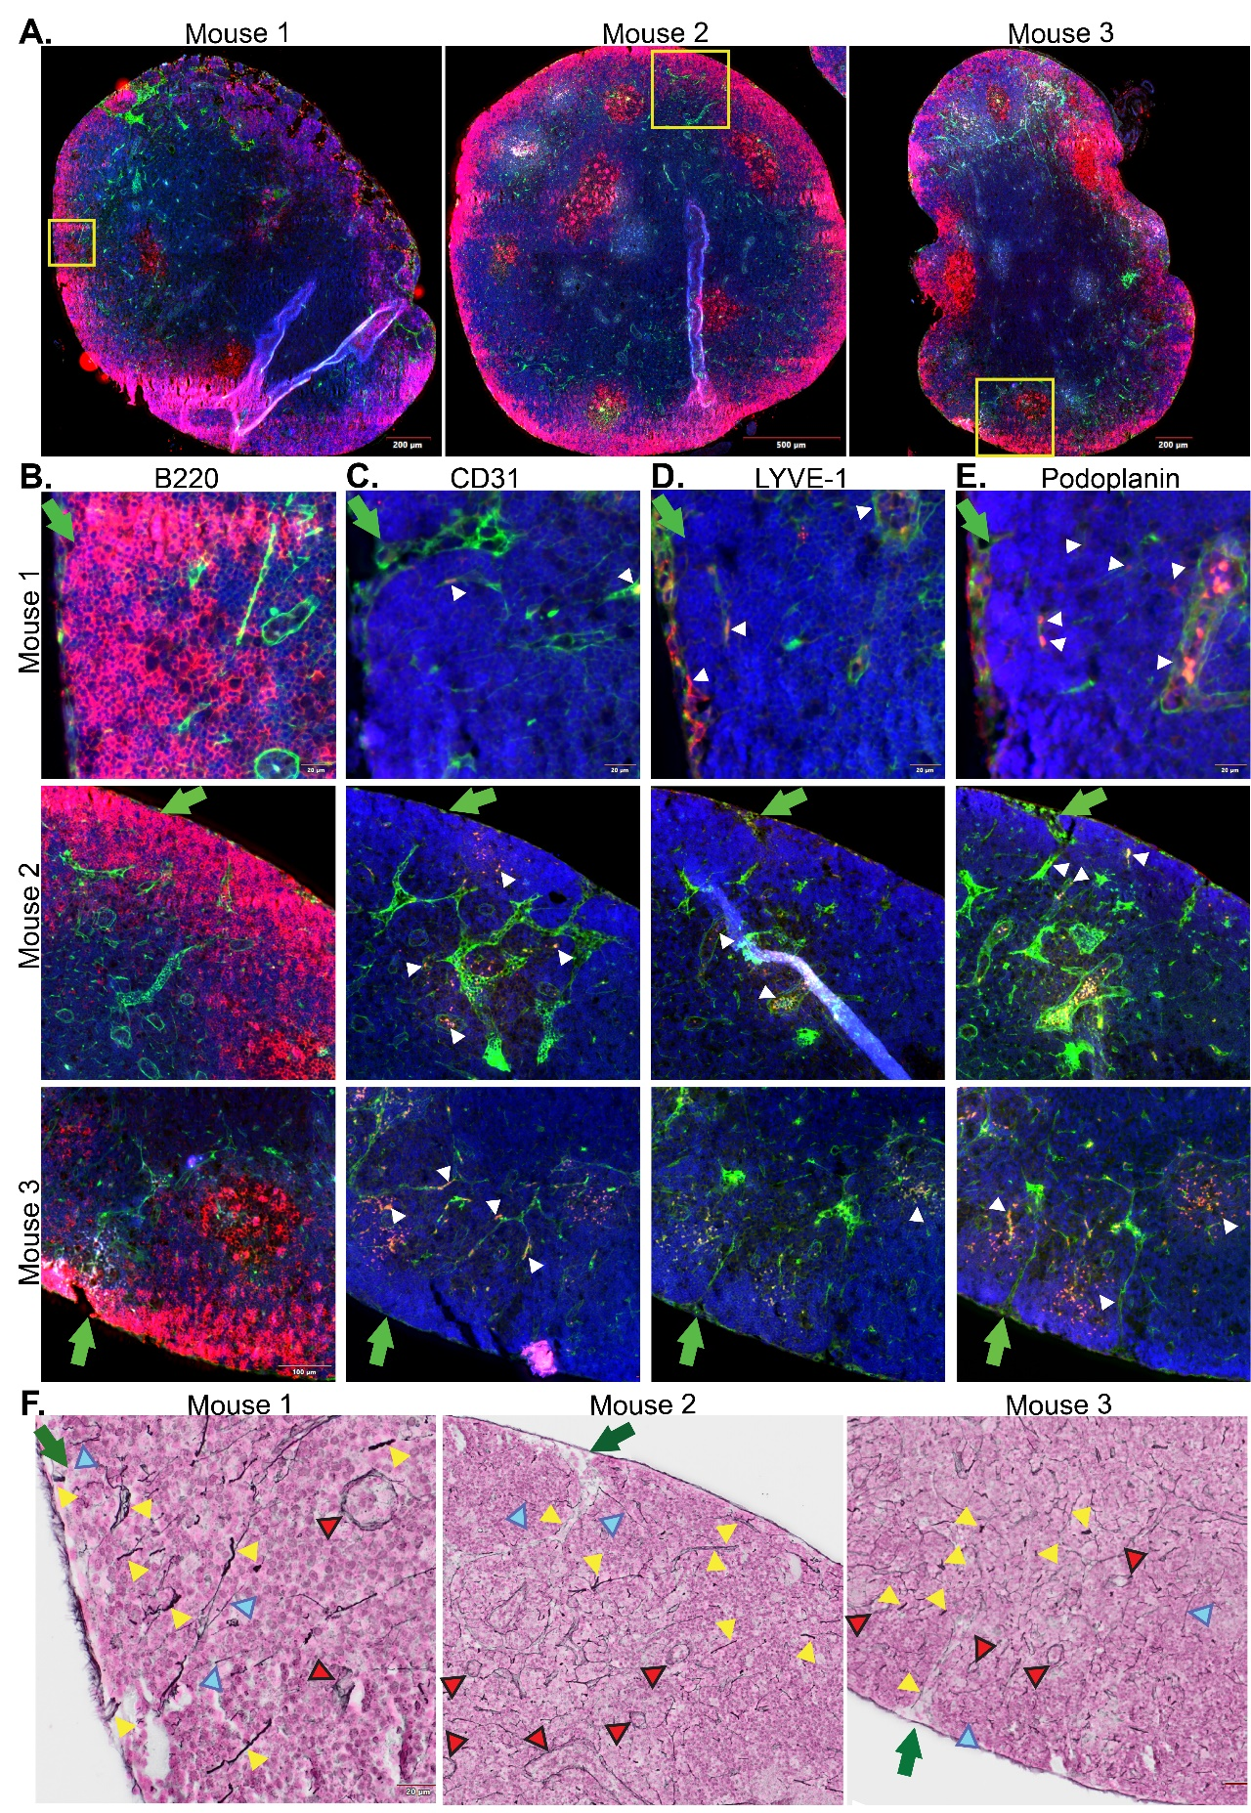
Extended Data Figure 2. Identification of regions of lymph node for quantification of reticulin fiber remodeling and diameter. A-F. Lymph nodes from 3 mice vaccinated with NP-Ova in the footpad 7 days prior to injection of 70kDa FITC-dextran in the footpad and euthanasia. A. Sections of popliteal lymph nodes stained for B220 (red) and DAPI (blue) and identified for penetration of FITC-dextran (green) from the subcapsular sinus in B cell areas (yellow boxes). B. The region of interest identified in the yellow boxes in A enlarged to show detail. Green arrow indicates region where dextran enters the lymph node from the SCS, either in this section or in serial sections. C. Serial sections of the same lymph node stained for CD31 (red), DAPI (blue) and visualized for the high molecular weight FITC-Dextran (green). White arrows represent areas of positive CD31 staining. D. A serial section of the same lymph node, stained for LYVE-1 (red), DAPI (blue) and visualized for the high molecular weight FITC-Dextran (green). White arrows represent areas of positive LYVE-1 staining. E. A serial section of the same lymph node, stained for podoplanin (red), DAPI (blue) and visualized for the high molecular weight FITC-Dextran (green). White arrows represent areas of positive podoplanin staining. F. A serial section of the same lymph nodes, stained for reticulin fiber using a modified gomorri’s stain (black staining). Lymph nodes counterstained with nucleofast red (red staining). Yellow arrows indicate reticulin fiber structures included in our analysis for diameter. These structures were selected based on the density of the staining, proximity to the subcapsular sinus, and presence in B cell areas. Large structures that connect to the subcapsular sinus were evaluated first for dextran positivity, a lack of CD31 and LYVE-1 staining indicating this is not the marginal sinus or large blood vessels before inclusion in our analysis of reticulin fiber diameter. Red arrows with a black outline indicate structures excluded from our analysis due to stronger staining on the borders resembling blood vessels or lymphatic vessels. Blue arrows indicate structures excluded from our analysis due to the lighter, finer staining we associated with the conduit system. Representative of 3 experimental cohorts, 9 mice vaccinated with NP-Ova and 9 mice vaccinated with NP-KLH.

Extended Data Figure 3. Adrenergic nerves are required for remodeling of reticulin fiber trabeculae and permeability of the lymph node to HMW dextran after immune challenge. A. Experimental schematic. C57Bl6 mice were either treated with 6OHDA or mock treated in 3 consecutive treatments. Two weeks after the final treatment, mice were either vaccinated with Ova in alum or infected with S. aureus in the footpad. One week after vaccination or infection, mice were injected with a mix of 70kDa TRITC dextran and 2kDa FITC dextran in the footpad, and euthanized 5 minutes post-dextran injection. B,C. Lymph nodes 7 days post-Ova vaccination (B) or S. aureus infection (C) imaged for 70kDa TRITC dextran (red), 2kDa FITC-dextran (green), and DAPI (blue). Serial section stained for reticulin fiber (black) and nucleofast red (red). dextran accumulation, and a serial section stained for reticulin fiber (black) to identify trabeculae and counterstained with nucleofast red (red). D,E. The average trabeculae diameter per lymph node was determined after Ova vaccination (D) or S. aureus infection (E).

Extended Data Figure 4. TH-iDTR mouse characterization. A,B. TH-iDTR mice were treated with 0.1ng/g of DT in the footpad twice, two days apart. The depletion of TH+ nerve fibers in the DT-draining and non-draining inguinal and popliteal lymph nodes was determined 14 days after the last DT treatment. A. Representative image of TH+ nerve staining (green) in a DT-draining and non-draining inguinal LN. B. Representative image of TH+ nerve staining (green) in a DT-draining and non-draining popliteal LN. Green is TH staining, blue is DAPI. Representative of 3 individuals. C. The percent of CD11b+ F4/80+ macrophages expressing TH was determined by flow cytometry either 2 days after the final depletion or 2 weeks after the final depletion in both the treatment-draining popliteal lymph node and the treatment-naïve popliteal lymph node. Composite of 2 experimental cohorts for 2 days post-depletion, and one experimental cohort for 2 weeks post-depletion. Symbols represent individual animals. *p<0.05. D,E. The draining popliteal lymph node was isolated 14 days post-vaccination and the mass (D) and total cellularity (F) determined. Composite of 2 (NP-Ova vaccinated) or 3 (NP-KLH vaccinated) experimental cohorts. Symbols represent individual mice.

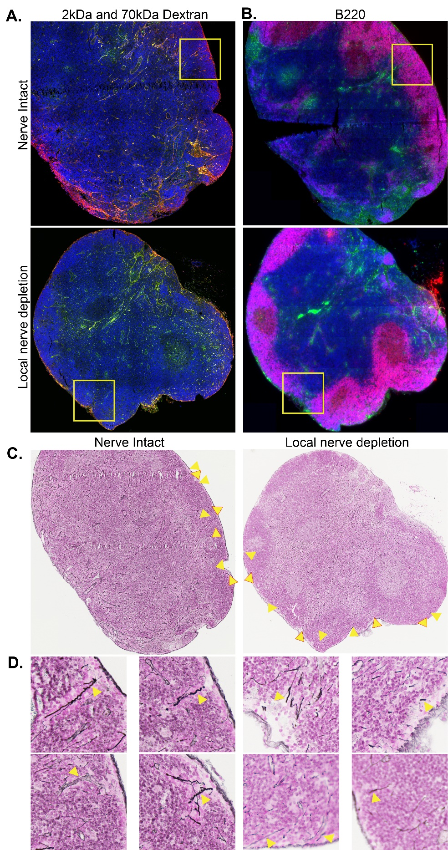
Extended Data Figure 5. Source images of local nerve depleted lymph node with dextran penetration. Cre- nerve intact and TH-cre iDTR nerve-depleted lymph nodes depicted in Figure 1H and I. Mice were treated with DT in the footpad and vaccinated with NP-Ova in the same footpad 2 weeks post-treatment. On day 7 post-vaccination, mice were injected with 2kDa FITC-dextran and 70kDa TRIC-dextran in the footpad 5 minutes prior to euthanasia. Draining popliteal lymph nodes were isolated, fixed, and embedded in paraffin. A. Draining popliteal lymph nodes imaged for DAPI (blue), 2kDa FITC-dextran (green) and 70kDa TRIC-dextran (red). B. The same lymph nodes as in A, stained for B220 (red). Green is 2kDa FITC dextran, blue is DAPI. Yellow boxes correspond to region of the lymph node shown in Figure 3. C. The same lymph nodes as in A and B, stained for reticulin fiber. Arrows correspond to structures included in the analysis for putative trabeculae diameter. Arrows with red outline are regions shown in J in greater detail.

Extended Data Figure 6. Gating strategy for flow cytometry and serological impact of TH-Cre expression. A. Gating strategy to identify germinal center B cells. CD19+ B220+ B cells were gated to define Bcl-6+ GL-7+ germinal center B cells. These cells were overwhelmingly Fas+. B. Gating strategy to identify T follicular helper cells. CD4+ T cells were gated to identify CXCR5+ PD-1+ cells. These cells were further gated to identify Bcl-6+ T follicular helper cells as CD44-high Bcl-6+. C. Nerve-intact controls depicted in figure 2G-J include diphtheria toxin treated Cre- iDTR mice (yellow), diphtheria toxin treated TH-cre+ iDTR- mice (purple), and PBS-treated TH-cre+ iDTR mice (red). No differences were observed in either recall potential or total NP-specific plasmablast generation between these different nerve-intact controls.

Extended Data Figure 7. Red-KLH and FITC-Ova distribution in the lymph node of nerve-intact and locally nerve-depleted lymph nodes. A. Representative images of entire lymph node from nerve-intact and nerve-depleted cohorts stained for DAPI (blue) and visualized for Crimson-KLH (red) and FITC-Ova (green) at 10X magnification. B. Representative images of entire lymph node from nerve-intact and nerve-depleted cohorts stained for DAPI (blue), IgD (white), and GL-7 (red) at 10X magnification. Red-KLH is also present in these tissues and contributes to fluorescence in the red channel. C. Images depicted in Figure 3B, without the green channel to allow for better visualization of Red-KLH at 20X magnification. Representative of 2 experimental cohorts, n=7 mice in each group. Symbols represent individual lymph nodes. Mice are TH-iDTR treated with DT and cre- iDTR littermates treated with DT.

