SUPPLEMENTARY DOCUMENTS

High configuration-entropy multi-defects hydroxide-spinel coexisting with micro-diamond

Akira Yoshiasa, Satoko Ishimaru, Makoto Tokuda, Tadao Nishiyama, Ukyo Nishi, Kenneth T. Koga, Kenji Shimizu, Takayuki Ushikubo, Shoji Arai, Kazumasa Sugiyama

Corresponding author: yoshiasa@kumamoto-u.ac.jp

Abstract: Hydrogen incorporation in spinel group materials has been extensively investigated. Natural Cr-Al spinel is usually completely anhydrous. We have found euhedral single crystals of hydroxide spinel (3-8 wt%H₂O) in a diamond-bearing serpentinite mélange exhumed from depths greater than 90 km. A significant H is incorporated into the spinel structure along with the formation of cation vacancies. The hydroxide spinel can be approximated by (□_{1-y}B_{3+y}) A²⁺B³⁺ [O_{1+3y}(OH)_{3-3y}]. The substitution by tetravalent Si or Ti stabilizes the hydroxide spinel structure. The formation of this high configuration-entropy multi-defects hydroxide spinel indicates an abundant supply of hydrogen, therefore must have occurred under water-saturated conditions. The occurrence of the hydroxide spinel provides compelling evidence that the cold subduction plates transport water deep into the mantle, hydrating the transition zone reservoir.

The PDF file includes:

Materials and Methods
Figs. S1 to S3
Tables S1
References

Other Supplementary Materials for this manuscript include the following:

Data S1

Materials and Methods
Materials, Elemental mapping and quantitative chemical analysis by electron microprobe analysis
Specimens are deposited in the collections of the National Museum of Nature and Science, Tsukuba, Ibaraki, Japan (NSM-M48058). The Commission on New Minerals, Nomenclature and Classification number is 2021-023a. The X-ray elemental mappings were taken using a wavelength-dispersive X-ray spectroscopy (WDS) via elecrtron-probe microanalyzer (EPMA, WDS: EPMA-1720H, SHIMADZU) of Engineering Research Equipment Center at Kumamoto University. For the map analyses, the accelerating voltage, probe current, probe diameter, and scan speed were 15 kV, 20nA, <1 µm, and 40 msec/point (150 msec/point), respectively. For the quantitative analyses, the accelerating voltage, probe current, probe diameter and number of analyses were 15 kV, 20nA, 5 µm, and 5 points, respectively. The counting time for each peak and background position was 10 s for both. WDS was conducted using the crystals LiF for Fe Kα and Cr Kα, RAP for Mg Kα and PET for Si Kα, respectively.
Micro-FT/IR and Micro-Raman spectroscopies
FTIR measurements were performed by a reflection method, with a Bruker HYPERION IR microscope equipped with an attenuated total reflection objective in University of Clermont Auvergne. For each spot, a FTIR spectra was collected with a x15 IR objective and a nitrogen-cooled mercury cadmium telluride detector, acquired over the range of 700 to 4000 cm⁻¹ with 2 cm⁻¹ resolution with a minimum of 500 scans. The spot size was adjusted with a variable aperture depending on the sample. The IR source was a mid-IR lamp and a KBr beam splitter was used.
Raman spectra were measured with a Raman spectrometer (Horiba Jovin Yvon LabRAM HR800) equipped with a diode-pumped solid state laser (Fandango 50, 514.5 nm) at Kumamoto University. A silicon standard was used for calibration before each measurement. The laser power was set at 50 mW on the sample surface, and the laser was focused on the sample using a microscope (Olympus BX41) with a 100× objective lens (LMPlan FL: NA = 0.80). The operating conditions were a 1000 μm pinhole, a 25 μm slit, an 1800 line/mm grating, and an acquisition time of 30 s.
Micro-XAFS spectroscopies
Micro-XAFS measurements of Fe K-edge were performed using beamlines BL-4A and BL-9A in fluorescence mode, equipped with a Si (111) double-crystal monochromator at the Photon Factory, KEK, Tsukuba, Japan. The storage ring operation voltage was 2.5 GeV, and the electric current was 450 mA in top-up mode. X-ray energy calibration was performed by setting the copper metal pre-edge absorption peak to 8978.8 eV.
SIMS measurement
Prior to secondary ion mass spectroscopy (SIMS) measurement, presence of light elements especially lithium and boron were examined using a laser ablation - inductively coupled plasma - mass spectrometry (LAM-ICP-MS) installed at University of Clermont Auvernge. While precise quantification was failed as crystal size was less than 0.04 mm, no significant Li, Be, nor B were detected which were the element difficult to be detected by EPMA.
Concentration of H₂O, CO₂, F, S, and Cl were determined by a SIMS (Cameca IMS-1280HR of Kochi Institute for Core Sample Research, JAMSTEC, Japan) following the procedure described by Shimizu et al. (51). In brief, a 20 keV (10 keV at the ion source and 10 keV at the sample surface) Cs⁺ ion beam of 300–500 pA was defocused to be 10–15 µm in diameter. Secondary ions were accelerated at 10 kV. A –10 keV electron beam with a diameter of ~100 µm was applied for electrostatic charge compensation of the analysis area. The field aperture was set at the size corresponding to 5 x 5 µm on the sample surface. A mass resolving power of ~6000 was required for separating mass interferences. Negative secondary ions of ¹²C, ¹⁶O, ¹⁶OH, ¹⁹F, ³⁰Si, ³¹P, ³²S, and ³⁵Cl and the mass position of 11.9 amu were measured by an axial Faraday cup (for ¹⁶O) or an axial electron multiplier (for other ions) using the peak switching method. An analysis consisted of 10 cycles, and the total measurement time for each analysis was ~6 min. SIMS analysis requires a set of calibration standards which have similar chemical and physical characters. However, such standards for this unknown mineral are not available. To accommodate low SiO₂ concentration of the mineral, ¹⁶O was used as the internal reference mass. Due to lack of an appropriate reference spinel sample, the measured ¹⁶OH/¹⁶O ratio was compared with the estimated H₂O concentration by EPMA (Fig. S2), and the correction factors of the EPR-G3 basaltic glass were tentatively applied for estimation of CO₂, F, P, S, and Cl concentrations. Location of the beam craters were verified by secondary electron microscope after the SIMS analysis.

Single crystal X-ray diffraction analysis
The single crystal was picked from the analysed hydrogen rich-area. Single-crystal X-ray diffraction measurement was carried out with XtaLAB Synergy diffractometer with HyPix6000 detector. Measured and independent reflection number of 13568 and 279, respectively, were observed. The structure was solved using SHELXT (52) to confirm the spinel-type structure. Refinement was performed by full-matrix least-squares using SHELXL-2016 (53). In the first cycles of refinements, occupancy parameters of Fe at the T- and M-sites were refined to estimate the total numbers of electrons at the sites. The crystal has a total of 19.39(16) and 20.42(15) electrons at the T- and M-sites, respectively. The O sites were set to be full occupancy. The cation site occupancy was constrained using the average chemical composition of the specimen. The distribution of cations other than iron was modeled considering the site occupancy observed in spinel group minerals (the CIF file (Data S1)). The crystal structure and the three-dimensional difference Fourier electron density map were drawn with VESTA (54).
Cation distribution and estimation of bond distances from effective ionic radii
The average bond distance is related to the following equations if we assume that the bond lengths are kept constant in the spinel solid-solutions and that the average distance is determined only by the substitution ratio of each cation-oxygen distance and the vacant does not contribute to the size:
T_{(Fe2+, Fe3+, Si, Mg, Mn, Zn)}-O = 1/(1-P_{T}(□))・ ∑ P_{T}(X) × (T_{X}-O)
^{X =} ^{Fe2+,} ^{Fe3+, Si, Mg, Mn, Zn}
M(Cr, Fe3+, Fe2+, Ni, Ti, Ca, Al)-O = 1/(1-P_{M}(□))・ ∑= P_{M}(Y) × (M_{Y}-O),
^{Y =} ^{Cr, Fe3+, Fe2+, Ni, Ti, Ca, Al}
where T_{X}-O and M_{Y}-O represents the local bond distances between specific cation (X and Y) and oxygen in the tetrahedrally and octahedrally coordinated sites, respectively. The Shannon effective ionic radii (in Å) are: ^{IV}O²⁻=1.38, ^{IV}OH⁻=1.35, ^{IV}Fe²⁺=0.63, ^{IV}Fe³⁺=0.49, ^{IV}Si⁴⁺=0.26, ^{IV}Mg²⁺=0.57, ^{IV}Mn²⁺ = 0.66, ^{IV}Zn²⁺=0.60, ^{VI}Cr³⁺=0.615, ^{VI}Fe²⁺=0.78, ^{VI}Fe³⁺=0.645, ^{VI}Ni²⁺=0.69, ^{VI}Ti⁴⁺=0.605, ^{VI}Ca²⁺=1.00 and ^{VI}Al³⁺=0.535 (55)), where the Roman numerals indicate the coordination numbers. The ratio of ^{IV}O and ^{IV}OH was calculated as 0.625:0.375.

Fig. S1.
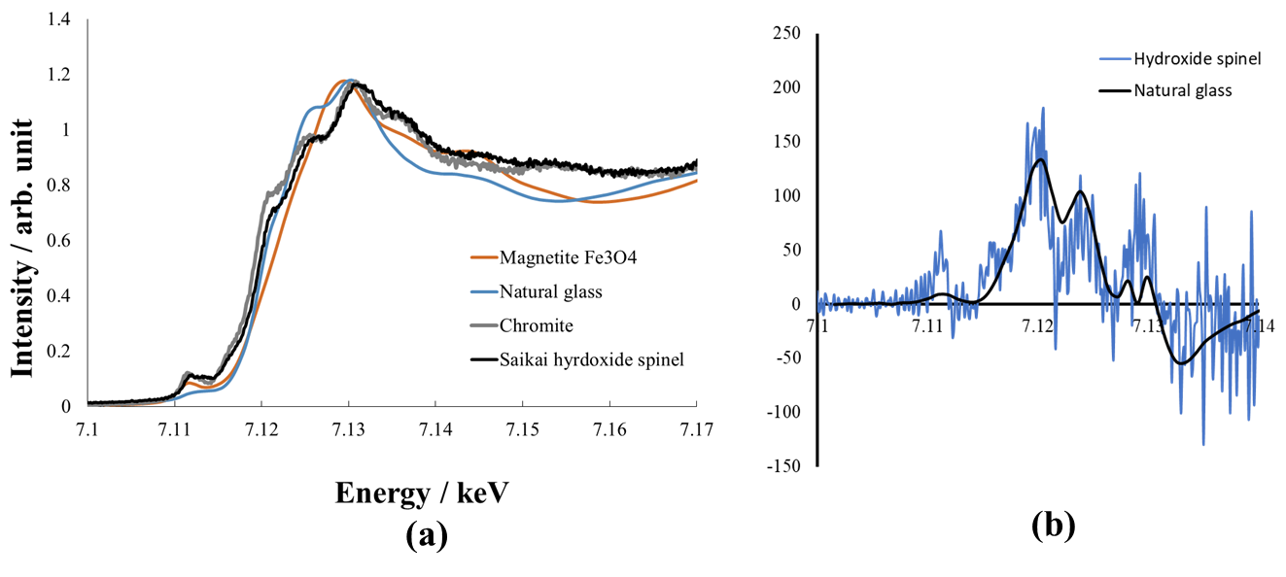
Fe K-edge XANES spectra of sakaiite (black solid line) and comparison with those of iron-bearing minerals and natural glasse (a). The threshold energy of Saikai hydroxide spinel (Fe²⁺/(Fe²⁺+Fe³⁺)=0.63(2)) lies just between those of magnetite and chromite [(Fe²⁺_{0.80} Mg_{0.16} Mn_{0.04})(Cr_{1.70} Fe³⁺_{0.07} Al_{0.23})O₄ ; Fe²⁺/(Fe²⁺ + Fe³⁺) =0.92]. The first derivative of Saikai hydroxide spinel agrees with that of natural glass with the ratio of Fe²⁺/(Fe²⁺+Fe³⁺)=0.63 (27) (b).

Fig. S2.
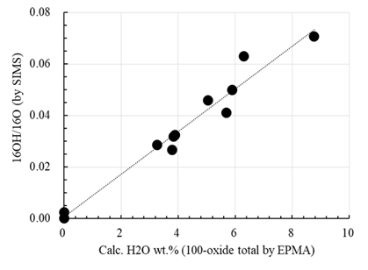
Comparison of hydrogen contents obtained from residuals of EPMA analyses versus hydrogen content by SIMS analyses. A clear linear relationship attests the agreement of SIMS and EPMA analyses.

Fig. S3.

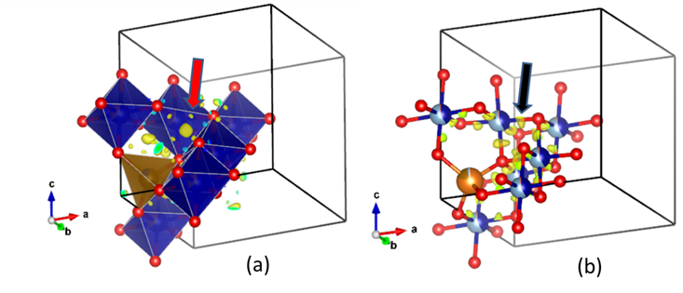
A portion of three-dimensional residual electron-density distributions in the Saikai hydroxide spinel (a) and ordinary chromite (b) by difference Fourier transform without hydrogen atom. Red sphere indicates oxide ion. Hydrogen atom position is at a distance of about 0.9 Å from the oxygen position (red arrow) and had an electron density higher than 0.2 e/Å³. In addition to the electron density corresponding to hydrogen atom, it is possible to identify the slight cation occupation in normally unoccupied octahedral and tetrahedral positions and the binding electron as residual electron densities in the Saikai hydroxide spinel. On the other hand, only the binding covalent electrons (black arrow) between the M-site and oxygen atoms are identified as the residual electron density in ordinary chromite.

Table S1.
Site x y z
H1 0.1564 0.2833 0.2064
H2 0.2940 0.3352 0.1887

D-H …A d(D-H) d(H..A) ∡D-H..A d(D..A)
O-H1…O 1.014 2.310 151.7 3.2382(8)
O-H2…O 0.904 2.147 115.2 2.6606(8)
2.137 150.3 2.9565(8)

Hydrogen atom positions and hydrogen bond geometry in Saikai hydroxide spinel.

References
- K. Shimizu, T. Ushikubo, M. Hamada, S. Itoh, Y. Higashi, E. Takahashi, M. Ito, H₂O, CO₂, F. S. Cl, and P₂O₅ analyses of silicate glasses using SIMS: Report of volatile standard glasses. Geochemical Journal 51, 283-313 (2017). https://doi.org/10.2343/geochemj.2.0470
- G.M. Sheldrick, SHELXT – Integrated space-group and crystal-structure determination. Acta Crystallographica, A71, 3–8 (2015a). https://doi.org/10.1107/S2053273314026370
- G.M. Sheldrick, Crystal structure refinement with SHELXL. Acta Crystallographica, C71, 3–8 (2015b). https://doi.org/10.1107/S2053229614024218
- K. Momma, F. Izumi, VESTA 3 for three-dimensional visualization of crystal, volumetric and morphology data. Journal of Applied Crystallography 44, 1272-1276 (2011). https://doi.org/10.1107/S0021889811038970
- R.D. Shannon, Revised effective ionic radii and systematic studies of interatomic distances in halides and chalcogenides. Acta Crystallographica, A32, 751–767 (1976). https://doi.org/10.1107/S0567739476001551

Data S1. (separate file)
CIF file

