Supporting Information
Loosely Crosslinked Liquid Crystal Elastomers of High Compliance with Prolonged Creep Lifetime
Robert J. Chambers¹, Marcus Wu², Tyler Woodard², Richey Li², David Liu², Raja Annapooranan², and Shengqiang Cai^{1,2, *}
¹ Materials Science and Engineering Program, University of California San Diego, La Jolla, CA 92093, USA.
² Department of Mechanical and Aerospace Engineering, University of California San Diego, La Jolla, CA 92093, USA.

* Corresponding author. Email: s3cai@ucsd.edu (S.C.)

Table S1. Summary of Uniaxial Tension Properties at strain rate of 0.1 s⁻¹
Material | Secant Modulus at 100% strain [MPa] | UTS [MPa] |  | $ε$_{break} [%]
PDMS 15:1 | 0.247 ± 0.011 | 0.24 ± 0.02 |  | 100 ± 4
PDMS 20:1 | 0.154 ± 0.007 | 0.19 ± 0.01 |  | 147 ± 20
PDMS 25:1 | 0.090 ± 0.015 | 0.12 ± 0.02 |  | 162 ± 28
PDMS 30:1 | 0.032 ± 0.003 | 0.05± 0.00 |  | 175 ± 17
LCE 9% | 0.126 ± 0.024 | 1.56 ± 0.14 |  | 459 ± 14
LCE 6% | 0.103 ± 0.016 | 1.79 ± 0.14 |  | 624 ± 30
LCE 3% | 0.064 ± 0.014 | 1.68 ± 0.22 |  | 1228 ± 54
Scotch 15 | 0.272 ± 0.007 | 0.33 ± 0.01 |  | 298 ± 7
VHB | 0.098 ± 0.003 | 0.50 ± 0.01 |  | 804±39
Scotch 20 | 0.080 ± 0.005 | 0.37 ± 0.02 |  | 963 ± 42

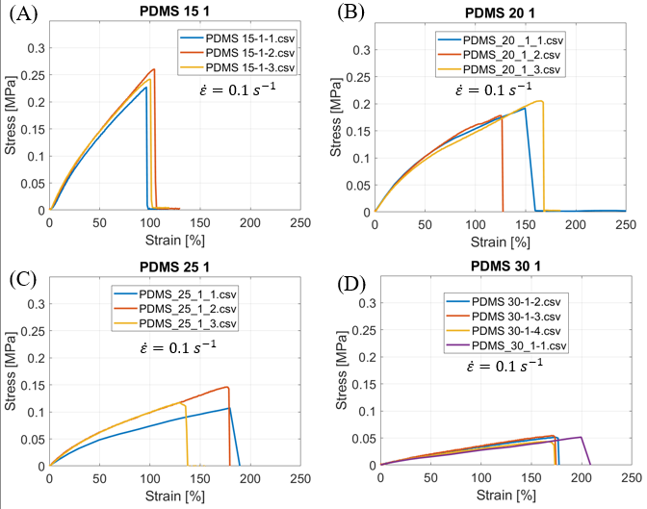
Figure S1. Uniaxial tensile stress-strain response of Sylgard 184 (PDMS) formulations prepared at base-to-curing-agent ratios of 15:1 (A), 20:1 (B), 25:1 (C), and 30:1 (D), tested at a nominal strain rate of 0.1 s⁻¹. Each panel shows three replicate specimens. Increasing base-to-curing-agent ratio reduced stiffness and strength while increasing extensibility, consistent with decreased crosslink density in the more lightly cured PDMS formulations.

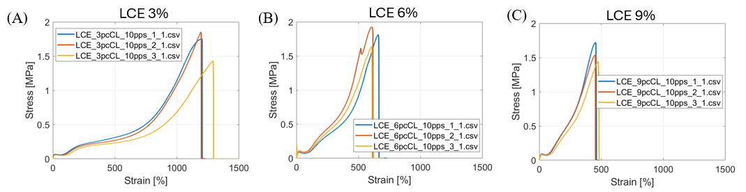
Figure S2. Uniaxial tensile stress-strain response of liquid crystal elastomer (LCE) networks with crosslink densities of 3% (A), 6% (B), and 9% (C), tested at a nominal strain rate of 0.1 $s^{-1}$. Each panel shows three replicate specimens. The 3% LCE exhibited the greatest extensibility and pronounced strain stiffening at large strain, whereas the 9% LCE showed the highest initial stiffness but failed at substantially lower strain. The 6% LCE displayed intermediate behavior, reflecting the effect of increasing crosslink density on stiffness, strength, and elongation at break.

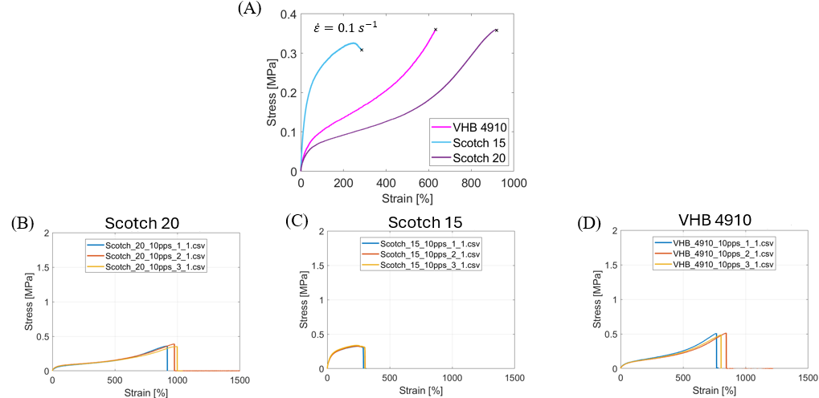
Figure S3. Tensile response of commercial pressure-sensitive adhesives. (A) Representative uniaxial stress-strain curves for VHB 4910, Scotch 15, and Scotch 20 tested at a nominal strain rate of 0.1 s⁻¹. (B–D) Replicate stress-strain curves for Scotch 20 (B), Scotch 15 (C), and VHB 4910 (D), respectively.

