Supplementary Information for
Global Assessment of Satellite Altimetry for Observing Extreme Coastal Sea Levels
G. P. Quadrado^{1,2}, T. Wahl^{1,2}, A. R. Enriquez³, M. Nagaraj^{1,2}, M. Passaro⁴, and I. D. Haigh^{1,2}
¹Department of Civil, Environmental, and Construction Engineering, University of Central Florida, Orlando, FL, USA
²Center for Integrated Coastal Research, University of Central Florida, Orlando, FL, USA
³School of Geosciences, University of South Florida, Tampa, FL, USA
⁴Deutsches Geodätisches Forschungsinstitut der Technischen Universität München, Munich, Germany
Text S1. To pair NTR_{SAT} with NTR_{TG}, we select altimetry observations within circular search areas centered on individual tide gauges. We test search radii ranging from 0.25° to 2.00° in 0.25° increments (0.25° ≈ 27.8 km) to determine the optimal circle size. Circles are constructed using spherical distances to account for Earth’s curvature and the decrease in longitudinal spacing toward higher latitudes. All satellite observations falling within each circle are used to reconstruct NTR_{SAT} records by merging measurements from multiple satellite missions into hourly time series and retaining only observations with coincident timestamps between satellite and tide gauge records. When multiple altimetry measurements occur within the same hour, the hourly maximum NTR_{SAT} value is retained. The optimal search radius is selected based on statistical agreement between NTR_{SAT} and NTR_{TG}, including Pearson correlation coefficient (r), root-mean-square-error (RMSE), bias, and the Modified Mielke Index (MMI). This analysis is conducted along the western North Atlantic coastline, where numerous GESLA-4 tide gauges are available. The North Atlantic region also provides a balanced representation of coastal settings, including open-ocean, semi-enclosed, and sheltered sites, as well as diverse tidal regimes, from the microtidal U.S. Southeast to the macrotidal coasts of Canada¹, and exposure to both tropical and extratropical storms^{2,3}, making it representative for testing circle size. CMEMS data are used to determine the optimal search circle size, as this product provides the largest sample size due to its broad mission ensemble and near-global coverage (Tables S2 and S3).

Results show that statistical agreement between NTR_{SAT} and NTR_{TG} decreases with increasing search radius (Figure S11). Pearson correlation and MMI decrease progressively with increasing radius, while RMSE and bias increase. The smallest radius (i.e., 0.25°) yields the best statistical performance but results in the smallest sample size, which is particularly limiting for the analysis of extremes, as these are inherently rare. A radius of 0.5° (~55 km) is therefore selected as the optimal search size, as it provides the second-best statistical performance across all radii while maintaining a sufficiently large sample size for statistical estimates. This choice is further supported by temporal sampling limitations inherent to satellite altimetry, as satellite repeat cycles (i.e., ~10–35 days) limit coincident sampling of extreme storm surge events, which last from hours to a few days, and a larger search radius thus increases the likelihood of capturing observations from the same storm system observed at the tide gauge.

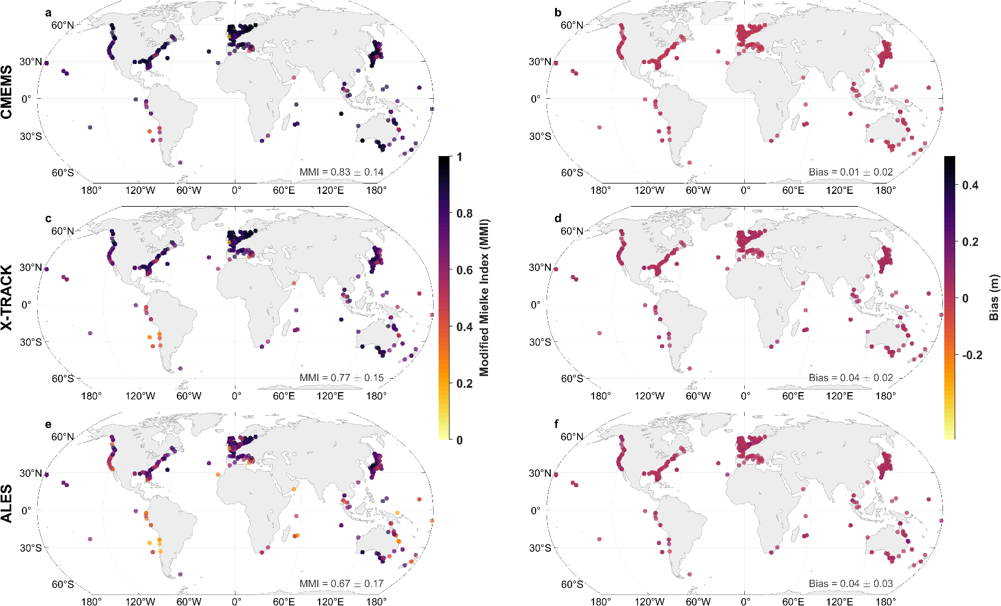
Figure S1. Global performance of satellite altimetry products in reproducing tide gauge-derived nontidal residuals. (a, c, e) Modified Mielke Index (MMI), and (b, d, f) bias computed between tide gauge-derived nontidal residuals (NTR_{TG}) and satellite-derived nontidal residuals (NTR_{SAT}) for the altimetry products (a, b) CMEMS, (c, d) X-TRACK, and (e, f) ALES. Colors indicate the magnitude of each statistical metric, with light shades representing lower values and dark shades representing higher values. Results are shown for 498 tide gauge locations with hourly data common to all three products.

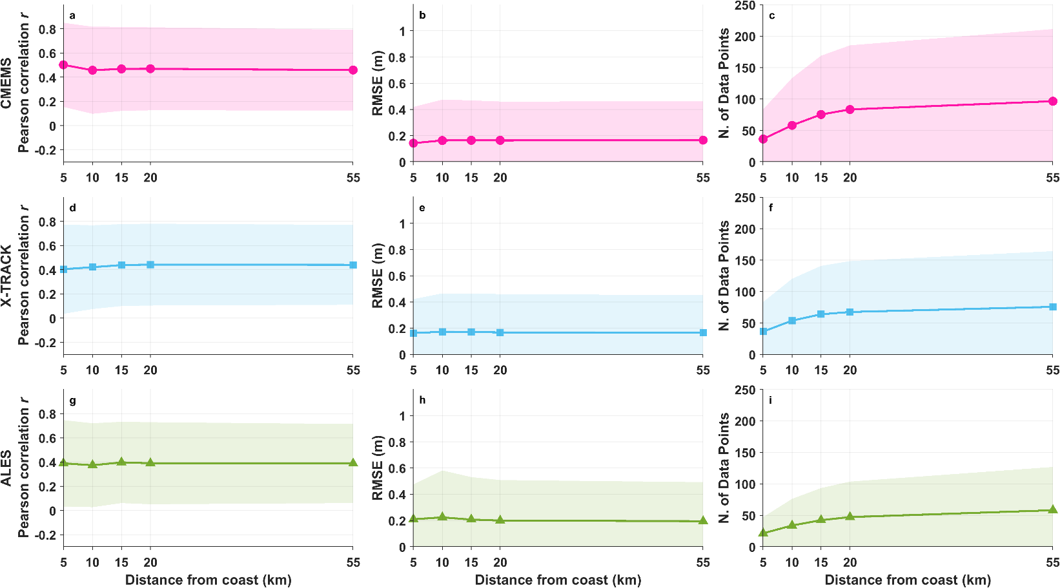
Figure S2. Sensitivity of altimetry performance metrics to offshore sampling distance for extreme tide gauge-derived nontidal residual (NTR_{TG}) values. (a, d, g) Pearson correlation coefficient (r), (b, e, h) root-mean-square-error (RMSE), and (c, f, i) number of available satellite-derived nontidal residual (NTR_{SAT}) observations are shown as a function of distance from the coastline for (a–c) CMEMS, (d–f) X-TRACK, and (g–i) ALES. Performance metrics are computed independently for each product and percentile threshold using available NTR_{SAT}–NTR_{TG} pairs within each distance-from-coast threshold from the coastline (5, 10, 15, 20, and 55 km, where 55 km represents the full search circle and no additional coastal-distance filter). Values shown represent averages across the 90th, 95th, 98th, 99th, and 99.5th percentile thresholds and across tide gauge sites. Solid lines with markers indicate the mean values, and shaded regions represent ±1 standard deviation across tide gauge sites, with lower bounds constrained to zero for non-negative metrics (i.e., RMSE and number of NTR_{SAT} data points).

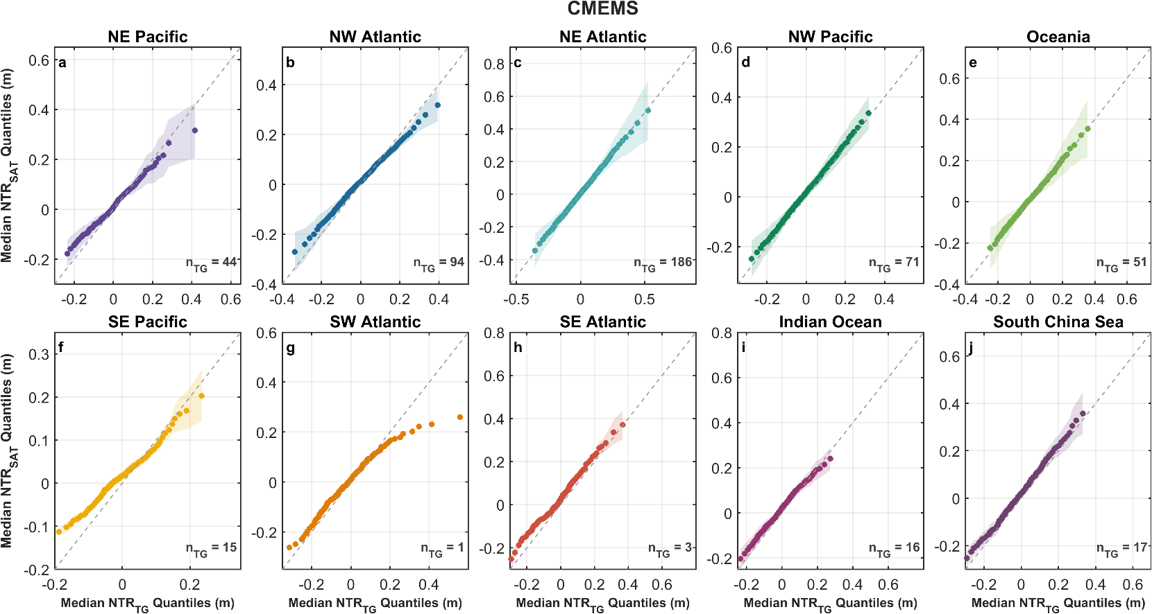
Figure S3. Quantile-quantile plot comparison between tide gauge-derived nontidal residuals (NTR_{TG}) and CMEMS satellite altimetry-derived nontidal residuals (NTR_{SAT}) in the (a) northeastern Pacific, (b) northwestern Atlantic, (c) northeastern Atlantic, (d) northwestern Pacific, (e) Oceania, (f) southeastern Pacific, (g) southwestern Atlantic, (h) southeastern Atlantic, (i) Indian Ocean, and (j) South China Sea. Points represent the median empirical quantiles across tide gauges with hourly observations common to all three altimetry products within each region, and shaded envelopes indicate ±1 standard deviation across sites. Panels without shading correspond to regions with a single tide gauge. The number of tide gauges per region is reported in the lower right corner of each panel (n_{TG}). The dashed line represents the identity line (1:1 line).

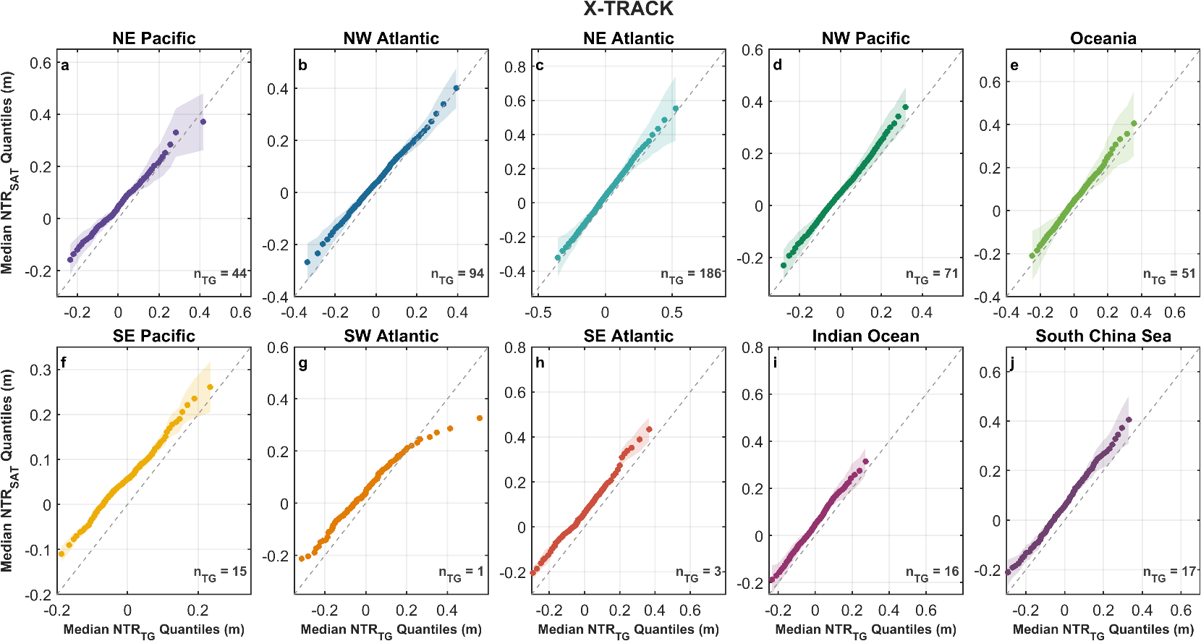
Figure S4. Quantile-quantile plot comparison between tide gauge-derived nontidal residuals (NTR_{TG}) and X-TRACK satellite altimetry-derived nontidal residuals (NTR_{SAT}) in the (a) northeastern Pacific, (b) northwestern Atlantic, (c) northeastern Atlantic, (d) northwestern Pacific, (e) Oceania, (f) southeastern Pacific, (g) southwestern Atlantic, (h) southeastern Atlantic, (i) Indian Ocean, and (j) South China Sea. Points represent the median empirical quantiles across tide gauges with hourly observations common to all three altimetry products within each region, and shaded envelopes indicate ±1 standard deviation across sites. Panels without shading correspond to regions with a single tide gauge. The number of tide gauges per region is reported in the lower right corner of each panel (n_{TG}). The dashed line represents the identity line (1:1 line).

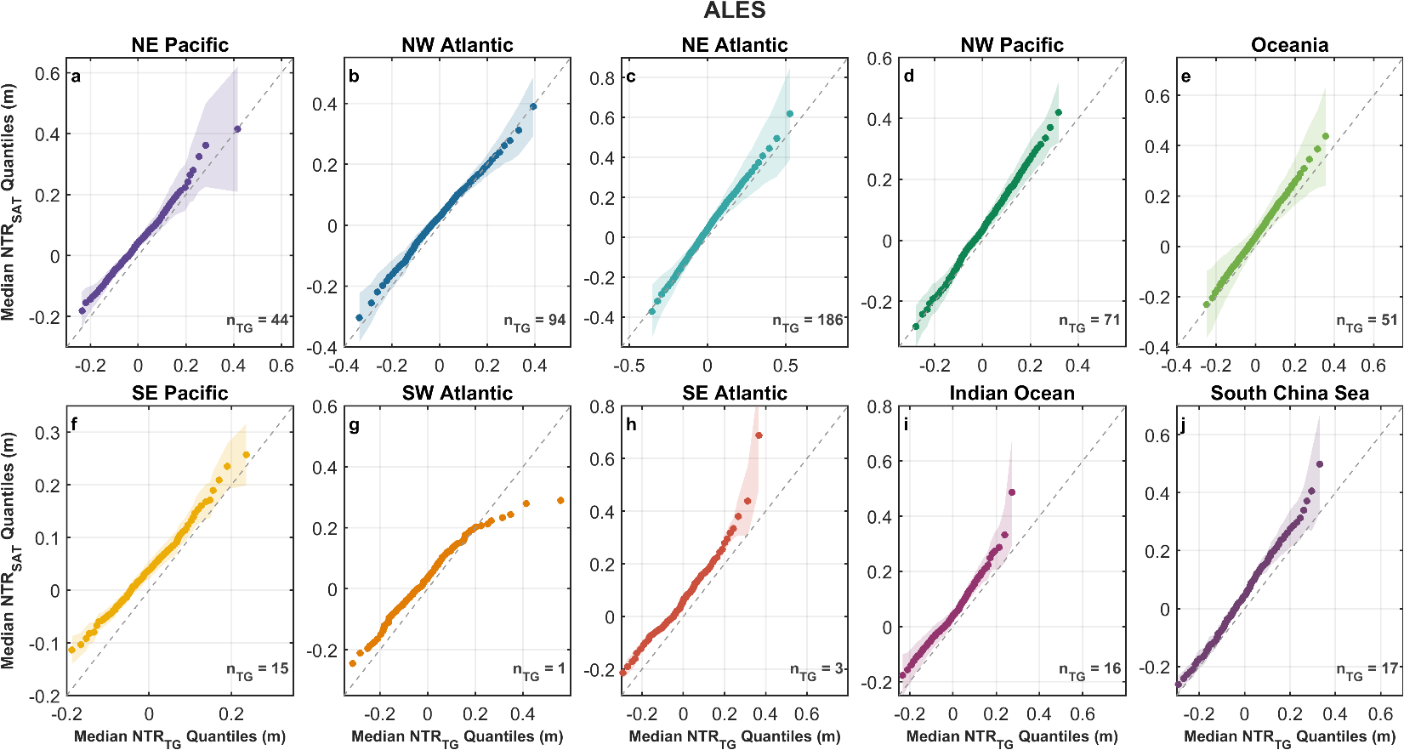
Figure S5. Quantile-quantile plot comparison between tide gauge-derived nontidal residuals (NTR_{TG}) and ALES satellite altimetry-derived nontidal residuals (NTR_{SAT}) in the (a) northeastern Pacific, (b) northwestern Atlantic, (c) northeastern Atlantic, (d) northwestern Pacific, (e) Oceania, (f) southeastern Pacific, (g) southwestern Atlantic, (h) southeastern Atlantic, (i) Indian Ocean, and (j) South China Sea. Points represent the median empirical quantiles across tide gauges with hourly observations common to all three altimetry products within each region, and shaded envelopes indicate ±1 standard deviation across sites. Panels without shading correspond to regions with a single tide gauge. The number of tide gauges per region is reported in the lower right corner of each panel (n_{TG}). The dashed line represents the identity line (1:1 line).

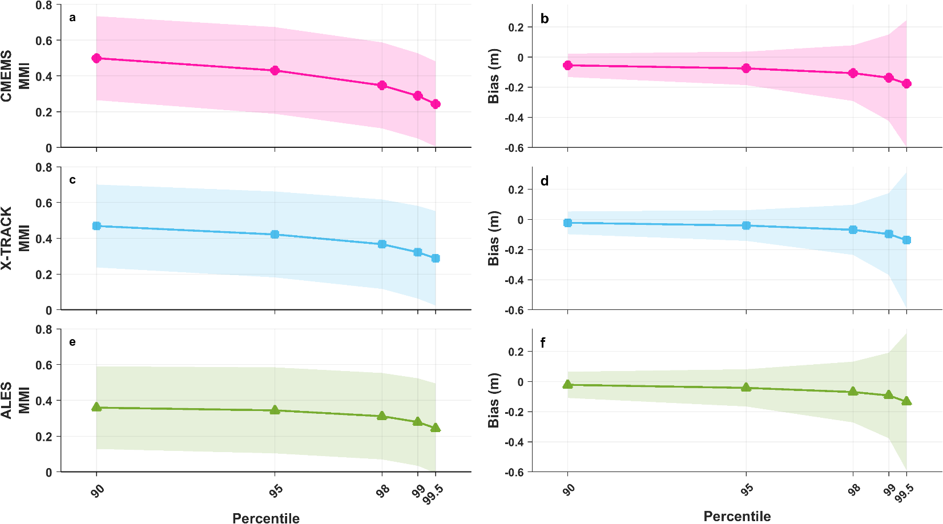
Figure S6. (a, c, e) Modified Mielke Index (MMI), (b, d, f) and bias from the global comparison between satellite and tide gauge extreme nontidal residual events across percentile thresholds (x-axis). Rows correspond to the altimetry products (a, b) CMEMS, (c, d) X-TRACK, and (e, f) ALES. Solid lines with markers represent the average, and the shaded areas indicate ±1 standard deviation across all tide gauge sites with available data for each product.

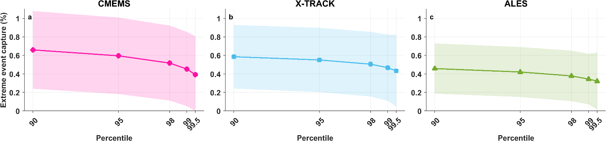
Figure S7. Percentage of extreme tide gauge-derived nontidal residual (NTR_{TG}) values captured by altimetry at the 90th, 95th, 98th, 99th, and 99.5th percentiles of the NTR_{TG} distribution. Extreme event capture is shown for (a) CMEMS, (b) X-TRACK, and (c) ALES. For each product, the metric is computed as the ratio of captured extreme values to the total number of extreme NTR_{TG} values identified in the full tide gauge record over the period overlapping with that product’s temporal coverage, regardless of whether a coincident satellite-derived nontidal residual (NTR_{SAT}) observation exists. Solid lines with markers indicate the average across tide gauge sites, and shaded regions represent ±1 standard deviation.

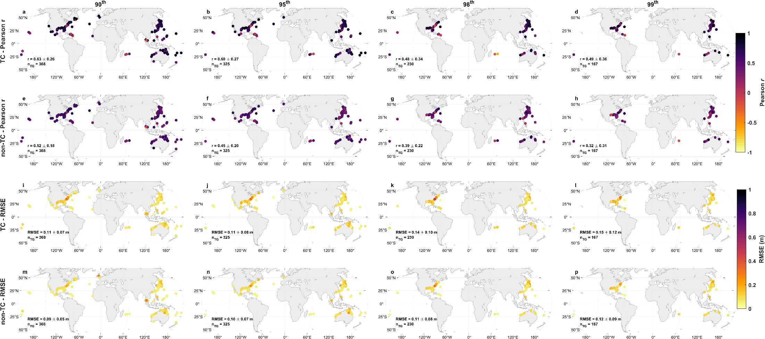
Figure S8. Global performance of satellite altimetry in representing extreme tide gauge–derived nontidal residuals (NTR_{TG}) associated with tropical cyclone (TC) events and non-tropical cyclone (non-TC) events at the (a, e, i, m) 90th, (b, f, j, n) 95th, (c, g, k, o) 98th and (d, h, l, p) 99th percentiles. Panels show (a-h) Pearson correlation coefficient (r) and (i-p) root-mean-square-error (RMSE) between NTR_{TG} and satellite-derived nontidal residuals (NTR_{SAT}) during (a-d, i-l) TC and (e-h, m-p) and non-TC conditions. The number of tide gauges (n_{TG}) is reported in the lower left corner of each panel and corresponds to locations where TC events have historically occurred. Results for the 99.5th percentile are not shown because no tide gauges met the minimum data requirements after applying the TC–non-TC classification and filtering criteria.

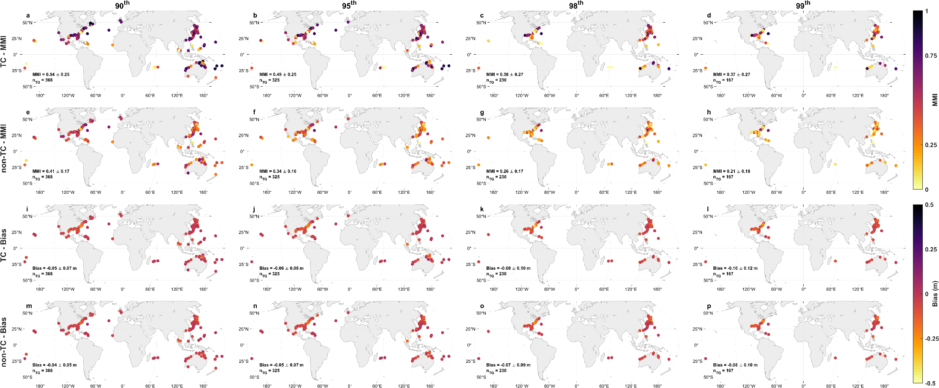
Figure S9. Global performance of satellite altimetry in representing extreme tide gauge–derived nontidal residuals (NTR_{TG}) associated with tropical cyclone (TC) events and non-tropical cyclone (non-TC) events at the (a, e, i, m) 90th, (b, f, j, n) 95th, (c, g, k, o) 98th and (d, h, l, p) 99th percentiles. Panels show (a-h) Modified Mielke Index (MMI) and (i-p) bias between NTR_{TG} and satellite-derived nontidal residuals (NTR_{SAT}) during (a-d, i-l) TC and (e-h, m-p) and non-TC conditions. The number of tide gauges (n_{TG}) is reported in the lower left corner of each panel and corresponds to locations where TC events have historically occurred. Results for the 99.5th percentile are not shown because no tide gauges met the minimum data requirements after applying the TC–non-TC classification and filtering criteria.

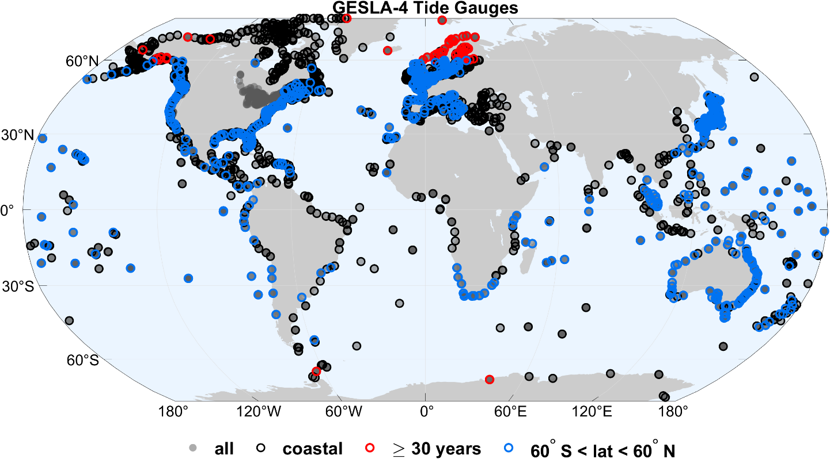
Figure S10. Map of locations of GESLA-4 tide gauges (gray circles). Coastal stations are highlighted in black, and stations that meet the record-length criterion (i.e., coastal sites with at least 30 years of data) are marked in red. Stations located between 60°N and 60°S are marked blue.

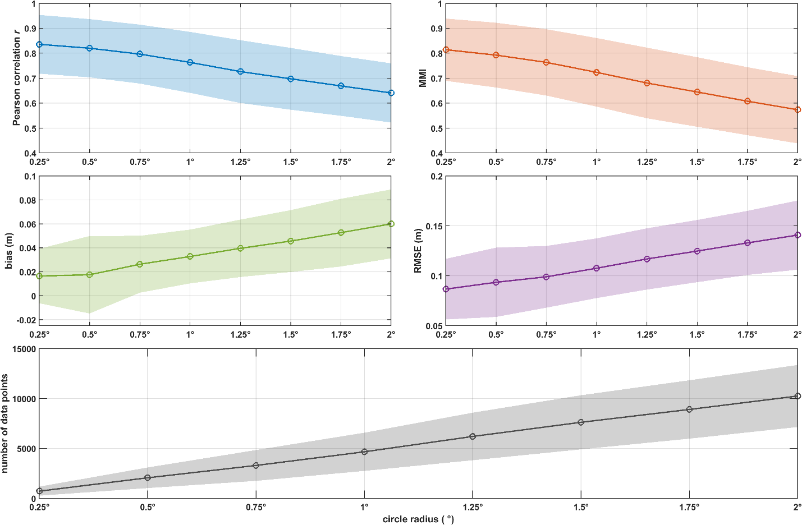
Figure S11. (a) Pearson correlation coefficient r, (b) Modified Mielke Index (MMI), (c) bias, (d) root-mean-square-error (RMSE), (e) and number of data points used to calculate metrics for comparing satellite-derived nontidal residuals (NTR_{SAT}) with tide gauge-derived nontidal residuals (NTR_{TG}) along the Western North Atlantic coastline. The x-axis shows circle radii varying from 0.25° to 2.00° in 0.25° increment steps, and the y-axes show the respective metric values. Solid lines with open circles represent the average metrics calculated across tide gauges, and shaded areas represent the corresponding standard deviations.

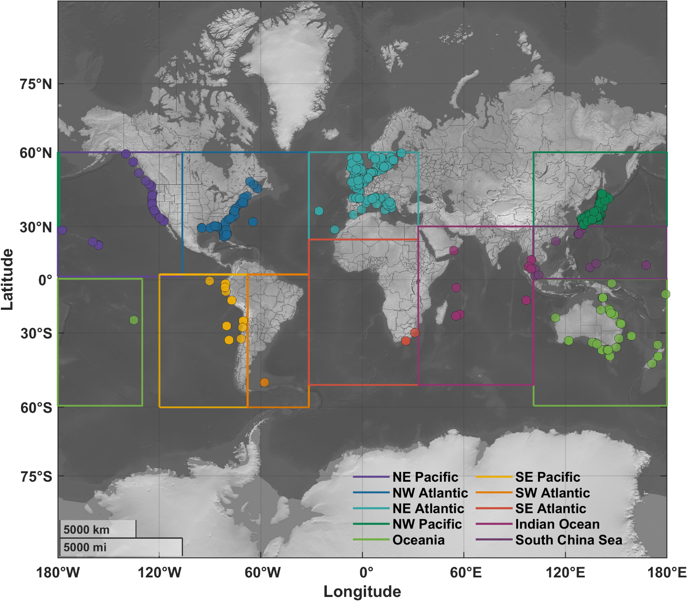

Figure S12. Global distribution of tide gauges classified into ten regions based on ocean basin and dominant climate-ocean dynamics. Each region is outlined and color-coded, with tide gauge locations shown as filled markers. The northeastern Pacific is violet, the northwestern Atlantic is dark blue, the northeastern Atlantic is light blue, the northwestern Pacific is dark green, Oceania is light green, the southeastern Pacific is yellow, the southwestern Atlantic is orange, the southeastern Atlantic is red, the Indian Ocean is dark magenta, and the South China Sea is dark purple.

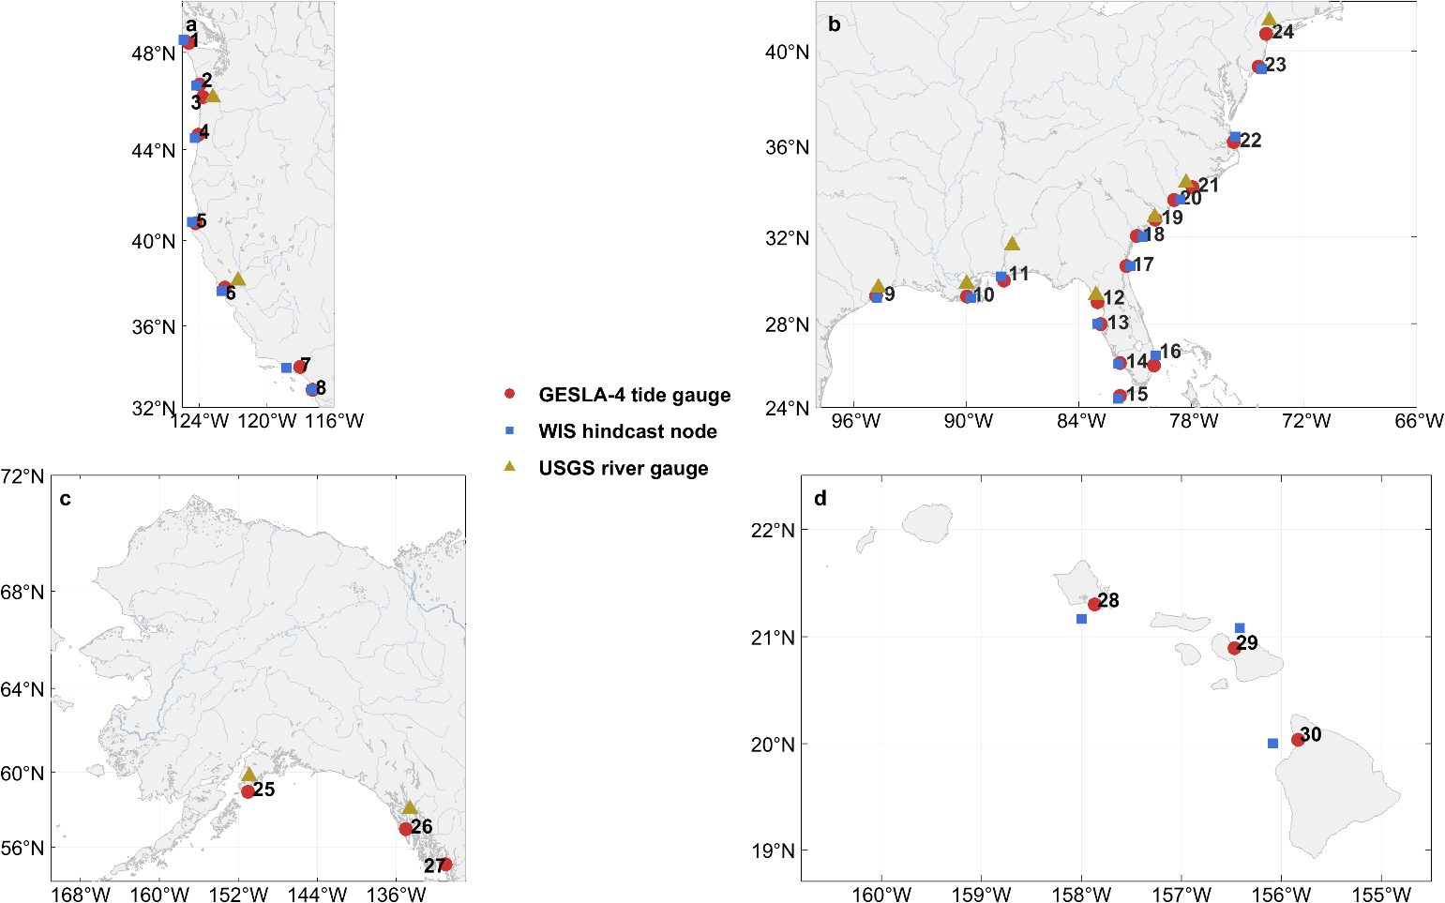
Figure S13. Geographic distribution of tide gauges, wave hindcast nodes, and river gauges across U.S. coastlines. Panels show (a) U.S. Pacific coast, (b) U.S. Gulf and Atlantic coasts, (c) Alaska, and (d) Hawaii. Red circles indicate GESLA-4 tide gauge locations, blue squares indicate WIS hindcast nodes, and yellow triangles indicate USGS river gauges. Numbers adjacent to tide gauge markers denote station identifiers corresponding to Table S4.

Table S1. Statistical relationships between significant wave height (H_{S}) and river discharge (Q) and the bias between tide gauge-derived and satellite-derived nontidal residuals (NTR_{TG} − NTR_{SAT}) at selected tide gauge sites. For each tide gauge, Pearson correlation coefficients (r) and Spearman rank correlation coefficients (ρ), along with their corresponding p-values (p-val_{r} and p-val_{ρ}), are reported separately for H_{S} and Q. Dashes (-) indicate that a given parameter was not estimated at that station.

Tide Gauge | ID | r - H_{S} | p-val_{r} H_{S} | ρ - H_{S} | p-val_{ρ} H_{S} | r - Q | p-val_{r} Q | ρ - Q | p-val_{ρ} Q
Neah Bay, WA | 1 | 0.50 | p < 0.001 | 0.44 | p < 0.001 | - | - | - | -
Toke Point, WA | 2 | 0.75 | p < 0.001 | 0.71 | p < 0.001 | - | - | - | -
Astoria, OR | 3 | - | - | - |  | 0.60 | p < 0.001 | 0.59 | p < 0.001
South Beach, OR | 4 | 0.58 | p < 0.001 | 0.51 | p < 0.001 | - | - | - | -
North Spit, CA | 5 | 0.12 | 0.01 | 0.05 | 0.25 | - | - | - | -
San Francisco, CA | 6 | 0.03 | 0.51 | p < 0.001 | 0.99 | 0.35 | p < 0.001 | 0.30 | p < 0.001
Santa Monica, CA | 7 | 0.02 | 0.62 | 0.02 | 0.69 | - | - | - | -
La Jolla, CA | 8 | -0.19 | p < 0.001 | -0.13 | 0.01 | - | - | - | -
Galveston, TX | 9 | 0.25 | p < 0.001 | 0.25 | p < 0.001 | - | - | - | -
Grand Isle, LA | 10 | 0.23 | p < 0.001 | 0.19 | p < 0.001 | 0.04 | 0.10 | 0.05 | 0.03
Dauphin Island, AL | 11 | 0.27 | p < 0.001 | 0.21 | p < 0.001 | 0.26 | p < 0.001 | 0.24 | p < 0.001
Cedar Key, FL | 12 | - | - | - | - | -0.01 | 0.70 | -0.02 | 0.47
Clearwater Beach, FL | 13 | 0.07 | 0.08 | 0.12 | p < 0.001 | - | - | - | -
Naples, FL | 14 | 0.01 | 0.80 | 0.02 | 0.68 | - | - | - | -
Key West, FL | 15 | -0.02 | 0.57 | p < 0.001 | 0.97 | - | - | - | -
Lake Worth Pier, FL | 16 | 0.27 | p < 0.001 | 0.31 | p < 0.001 | - | - | - | -
Fernandina Beach, FL | 17 | 0.32 | p < 0.001 | 0.31 | p < 0.001 | - | - | - | -
Fort Pulaski, GA | 18 | 0.04 | 0.40 | -0.02 | 0.63 | - | - | - | -
Charleston, SC | 19 | - | - | - | - | -0.11 | 0.12 | -0.19 | 0.01
Springmaid Pier, SC | 20 | 0.03 | 0.40 | p < 0.001 | 0.93 | - | - | - | -
Wilmington, NC | 21 | - | - | - | - | 0.35 | p < 0.001 | 0.32 | p < 0.001
Duck, NC | 22 | 0.36 | p < 0.001 | 0.36 | p < 0.001 | - | - | - | -
Atlantic City, NJ | 23 | -0.07 | 0.10 | p < 0.001 | 0.94 | - | - | - | -
The Battery, NY | 24 | - | - | - | - | 0.13 | p < 0.001 | 0.11 | p < 0.001
Seldovia, AK | 25 | - | - | - | - | 0.08 | p < 0.001 | 0.17 | p < 0.001
Sitka, AK | 26 | - | - | - | - | 0.06 | p < 0.001 | 0.05 | 0.01
Ketchikan, AK | 27 | - | - | - | - | 0.07 | 0.04 | 0.14 | p < 0.001
Honolulu, HI | 28 | p < 0.001 | 0.90 | -0.02 | 0.63 | - | - | - | -
Kahului, HI | 29 | -0.09 | 0.02 | -0.07 | 0.05 | - | - | - | -
Kawaihae, HI | 30 | 0.03 | 0.45 | 0.10 | p < 0.001 | - | - | - | -

Table S2. Main attributes of the altimetry products used in this study, including CMEMS, X-TRACK, and ALES. The table summarizes product type, spatial extent, temporal coverage, mean sea surface (MSS) model, and the primary range and geophysical corrections applied, including wet tropospheric correction, tidal correction, dynamic atmospheric correction (DAC), and sea state bias (SSB).

Attribute | CMEMS | X-TRACK | ALES
Product Type | Standard, multimission along-track (L3) | Coastal, multimission along-track (L3, derived from L2P) | Coastal, retracked along-track (L2, multimission dataset)
Spatial Extent | Global, -78.52° to 87.98° | Regional (29 pre-defined regions) | Global, -82.00° to 82.00°
Temporal Coverage | 12 Oct 1992 - 19 Nov 2024 | 23 Oct 1992 - 01 Dec 2024 | 15 May 1995 - 14 Nov 2024
Mean Sea Surface (MSS) Model | Hybrid MSS 2023 (region-dependent blending of CNES/CLS, SCRIPPS, and DTU models) | X-TRACK MSS (multimission, track-based inversion of sea surface heights) | DTU15^{4,5}
Wet Tropospheric Correction | Mission-dependent (radiometer- and model-based) | Mission-dependent (radiometer- and model-based), with along-track filtering (coastal-optimized) | Mission-dependent (primarily model-based, with limited use of radiometer-based corrections)
Tidal Correction | FES2022⁶ | FES2022⁶ | EOT20⁷
Sea State Bias | Mission-dependent (primarily non-parametric models) | Mission-dependent, along-track filtered (coastal-optimized) | Retracker-consistent (estimated from ALES-derived significant wave height and wind)
Dynamic Atmospheric Correction | TUGO high-frequency DAC forced by ERA5/ECMWF winds + inverse barometer | TUGO high-frequency DAC forced by ERA5/ECMWF winds + inverse barometer | MOG2D DAC forced by ECMWF pressure and winds + inverse barometer
Reference | ^{8,10} | ^{11,12} | ^{13–15}

Table S3. Satellite altimetry missions included in each product used in this study, including CMEMS, X-TRACK, and ALES. Check marks indicate the availability of data from each mission within each product.
Mission | CMEMS | X-TRACK | ALES
CryoSat-2* | ✔
Envisat* | ✔ | ✔ | ✔
ERS-1 | ✔ | ✔
ERS-2 | ✔ | ✔ | ✔
GEOSAT Follow-On | ✔ | ✔
HaiYang-2A* | ✔ | ✔
HaiYang-2B | ✔ | ✔
Jason-1* | ✔ | ✔ | ✔
Jason-2* | ✔ | ✔ | ✔
Jason-3* | ✔ | ✔ | ✔
Saral/AltiKa* | ✔ | ✔ | ✔
Sentinel-3A | ✔ | ✔ | ✔
Sentinel-3B | ✔ | ✔ | ✔
Sentinel-6A | ✔ | ✔ | ✔
TOPEX/Poseidon* | ✔ | ✔
SWOT** | ✔

*Records include nominal and extended mission phases, including interleaved orbits and long-repeat (geodetic) orbit.

**Although SWOT data are available within CMEMS, they are excluded from this analysis due to their short record length and distinct wide-swath (two-dimensional) sampling geometry, which is not directly comparable to the one-dimensional nadir altimetry used here.

Table S4. Tide gauge stations from GESLA-4 used to assess relationships between significant wave height and river discharge to bias at selected sites, along with corresponding Wave Information Study (WIS) hindcast node and/or U.S. Geological Survey (USGS) river gauge. Some tide gauges are associated with only a WIS node or a USGS river gauge, reflecting the specific selection of sites for wave and river analyses. Dashes indicate that no corresponding dataset is used for a given site. The WIS node depth is also provided in meters.
ID | GESLA-4/NOAA Tide Gauge | WIS Node | WIS Node Depth (m) | USGS River Gauge
1 | Neah Bay, WA | 83001 | 93 |  | –
2 | Toke Point, WA | 83012 | 18 |  | –
3 | Astoria, OR | - | - |  | 14246900
4 | South Beach, OR | 83025 | 69 |  | –
5 | North Spit, CA | 83047 | 155 |  | –
6 | San Francisco, CA | 83066 | 38 |  | 11455420
7 | Santa Monica, CA | 84086 | 52 |  | –
8 | La Jolla, CA | 84150 | 156 |  | –
9 | Galveston, TX | 73071 | 5 |  | 8042558
10 | Grand Isle, LA | 73131 | 10 |  | 7374525
11 | Dauphin Island, AL | 73151 | 5 |  | 2428400
12 | Cedar Key, FL | – | – |  | 2323592
13 | Clearwater Beach, FL | 73263 | 11 |  | –
14 | Naples, FL | 73301 | 5 |  | –
15 | Key West, FL | 63500 | 89 |  | –
16 | Lake Worth Pier, FL | 63462 | 265 |  | –
17 | Fernandina Beach, FL | 63401 | 15 |  | –
18 | Fort Pulaski, GA | 63368 | 15 |  | –

Table S4. Continued.
19 | Charleston, SC | – | – |  | 21720677
20 | Springmaid Pier, SC | 63314 | 17 |  | –
21 | Wilmington, NC | – | – |  | 2105769
22 | Duck, NC | 63216 | 18 |  | –
23 | Atlantic City, NJ | 63141 | 20 |  | –
24 | The Battery, NY | – | – |  | 1375000
25 | Seldovia, AK | – | – |  | 15239070
26 | Sitka, AK | – | – |  | 15101490
27 | Ketchikan, AK | – | – |  | 15101490
28 | Honolulu, HI | 83357 | 530 |  | –
29 | Kahului, HI | 83380 | 369 |  | –
30 | Kawaihae, HI | 83467 | 726 |  | –

Table S5. Number of tide gauges (TGs) and tide gauge-satellite nontidal residual pairs (NTR_{TG}–NTR_{SAT}) used in analyses performed without requiring common timestamps across products. The table reports the total number of NTR_{TG}–NTR_{SAT} pairs, expressed in millions (×10⁶), and the mean ± standard deviation of the number of NTR_{TG}–NTR_{SAT} pairs per TG, computed across all global tide gauges with available satellite data for each product.
Product | Number of Tide Gauges (TGs) | Total Number of  NTR_{TG}–NTR_{SAT} Pairs (×10⁶) | Mean ± Standard Deviation Number of NTR_{TG}–NTR_{SAT}  Pairs per TG
CMEMS | 991 | 2.52 | 2,541 ± 1,217
X-TRACK | 944 | 1.93 | 2,044 ± 963
ALES | 980 | 1.55 | 1,587 ± 754

References
1. Graafeiland, K. V. Global Tidal Range Classification - Overview. Arcgis https://www.arcgis.com/home/item.html?id=74f515f206734aafbb080d76e20ef7f2 (2022).
2. Booth, J. F., Rieder, H. E. & Kushnir, Y. Comparing hurricane and extratropical storm surge for the Mid-Atlantic and Northeast Coast of the United States for 1979–2013. Environmental Research Letters 11, 094004 (2016).
3. Keim, B. D., Muller, R. A. & Stone, G. W. Spatial and temporal variability of coastal storms in the North Atlantic Basin. Marine Geology 210, 7–15 (2004).
4. Andersen, O. B., Stenseng, L., Piccioni, G. & Knudsen, P. The DTU15 MSS (Mean Sea Surface) and DTU15LAT (Lowest Astronomical Tide) reference surface: ESA Living Planet Symposium 2016. (2016).
5. Andersen, O. B. & Knudsen, P. Deriving the DTU15 Global high resolution marine gravity field from satellite altimetry: ESA Living Planet Symposium 2016. (2016).
6. Lionel, T. M. et al. The New FES2022 Tidal Atlas. https://meetingorganizer.copernicus.org/EGU23/EGU23-9008.html (2023) doi:10.5194/egusphere-egu23-9008.
7. Hart-Davis, M. G. et al. EOT20: a global ocean tide model from multi-mission satellite altimetry. Earth System Science Data 13, 3869–3884 (2021).
8. Ballarotta, M. & Pujol, M.-I. CMEMS Quality Information Document. (2025).
9. Carrère, L. & Lyard, F. Modeling the barotropic response of the global ocean to atmospheric wind and pressure forcing - comparisons with observations. Geophysical Research Letters 30, (2003).
10. CMEMS, E. U. C. M. S. I. (CMEMS). Global Ocean Along Track L 3 Sea Surface Heights Reprocessed 1993 Ongoing Tailored For Data Assimilation. Marine Data Store (MDS) https://doi.org/https://doi.org/10.48670/moi-00146 (2025).
11. Birol, F. et al. Coastal applications from nadir altimetry: Example of the X-TRACK regional products. Advances in Space Research 59, 936–953 (2017).
12. CTOH-LEGOS. Along-Track Sea Level Anomalies regional products (X-TRACK-L2P) User Handbook. CNES https://doi.org/10.24400/527896/A01-2022.020 (2025).
13. Passaro, M. User Manual: COSTA v1.0 DGFI-TUM Along Track Sea Level Product for ERS-2 and Envisat (1996-2010) in the Mediterranean Sea and in the North Sea. DGFI-TUM (2017).
14. Passaro, M., Cipollini, P., Vignudelli, S., Quartly, G. D. & Snaith, H. M. ALES: A multi-mission adaptive subwaveform retracker for coastal and open ocean altimetry. Remote Sensing of Environment 145, 173–189 (2014).
15. Schwatke, C. et al. OpenADB: DGFI-TUM’s Open Altimeter Database. Geoscience Data Journal 11, 573–588 (2024).

