Sesquiterpene lactones isolated from Carpesium abrotanoides L. by LC-MS combined with HSCCC inhibit liver cancer through suppression of the JAK2/STAT3 signaling pathway

Bingbing Shenª, Yupei Yang^{b}, Dan Wanª, Huanghe Yu^{b}, Yuan Caiª, Xionglong Wang^{c}, Daifeng Tang^{c}, Chunyu Tang^{c}, Shuihan Zhang^{a*}

ª Research Institute of Chinese Medicine, Hunan academy of Chinese Medicine, Changsha, China;
^{b} School of Pharmacy, Hunan university of Chinese Medicine, Changsha, China;
^{c} Hunan Times Sunshine Pharmaceutical Co., Ltd., Yongzhou, China.

Corresponding author
* Research Institute of Chinese Medicine, Hunan Academy of Chinese Medicine,
Changsha, Hunan, China, 410013, P. R. China
E-mail address: zhangshuihan0220@126.com, Tel.: (+86)-136-3740-0650

Contents
Fig. S1 HR-MS of 1
Fig. S2 ¹H NMR (600 MHz, CDCl₃) spectrum of 1
Fig. S3 ¹³C NMR (151 MHz, CDCl₃) spectrum of 1
Fig. S4 DEPT 135°NMR ((151 MHz, CDCl₃) spectrum of 1
Fig. S5 HR-MS of 2
Fig. S6 ¹H NMR (600 MHz, CDCl₃) spectrum of 2
Fig. S7 ¹³C NMR (151 MHz, CDCl₃) spectrum of 2
Fig. S8 DEPT 135°NMR ((151 MHz, CDCl₃) spectrum of 2
Fig. S9 HR-MS of 3
Fig. S10 ¹H NMR (600 MHz, CDCl₃) spectrum of 3
Fig. S11 ¹³C NMR (151 MHz, CDCl₃) spectrum of 3
Fig. S12 DEPT 135°NMR ((151 MHz, CDCl₃) spectrum of 3

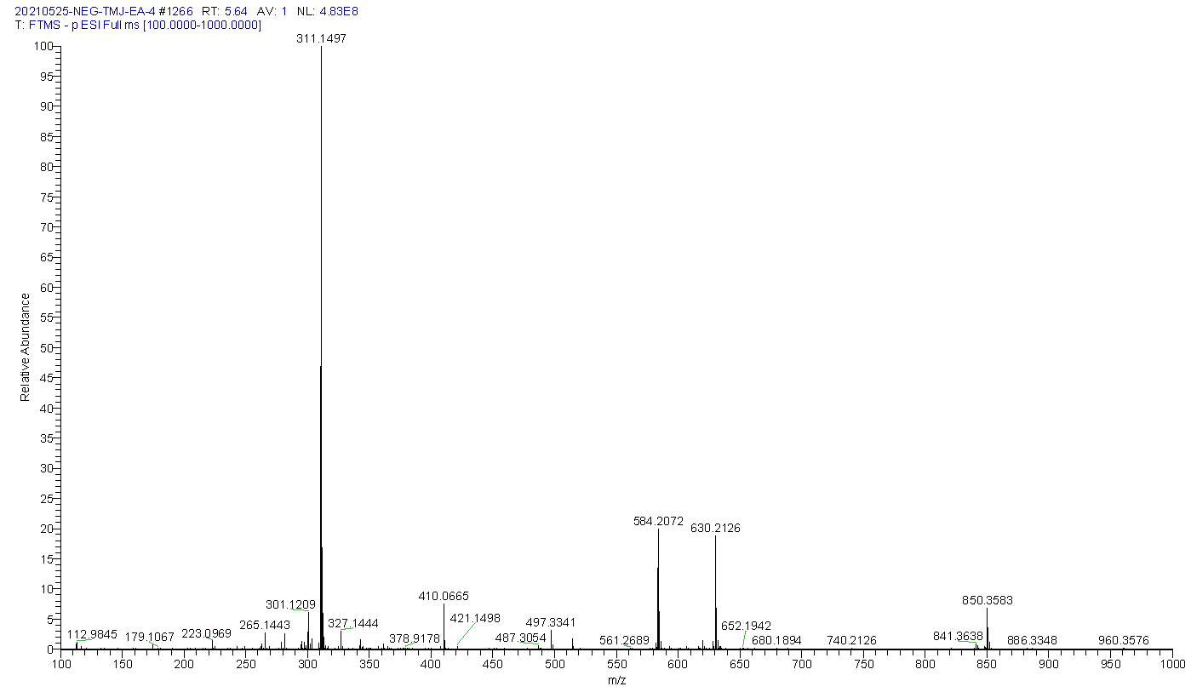
Fig. S1 HR-MS of 1

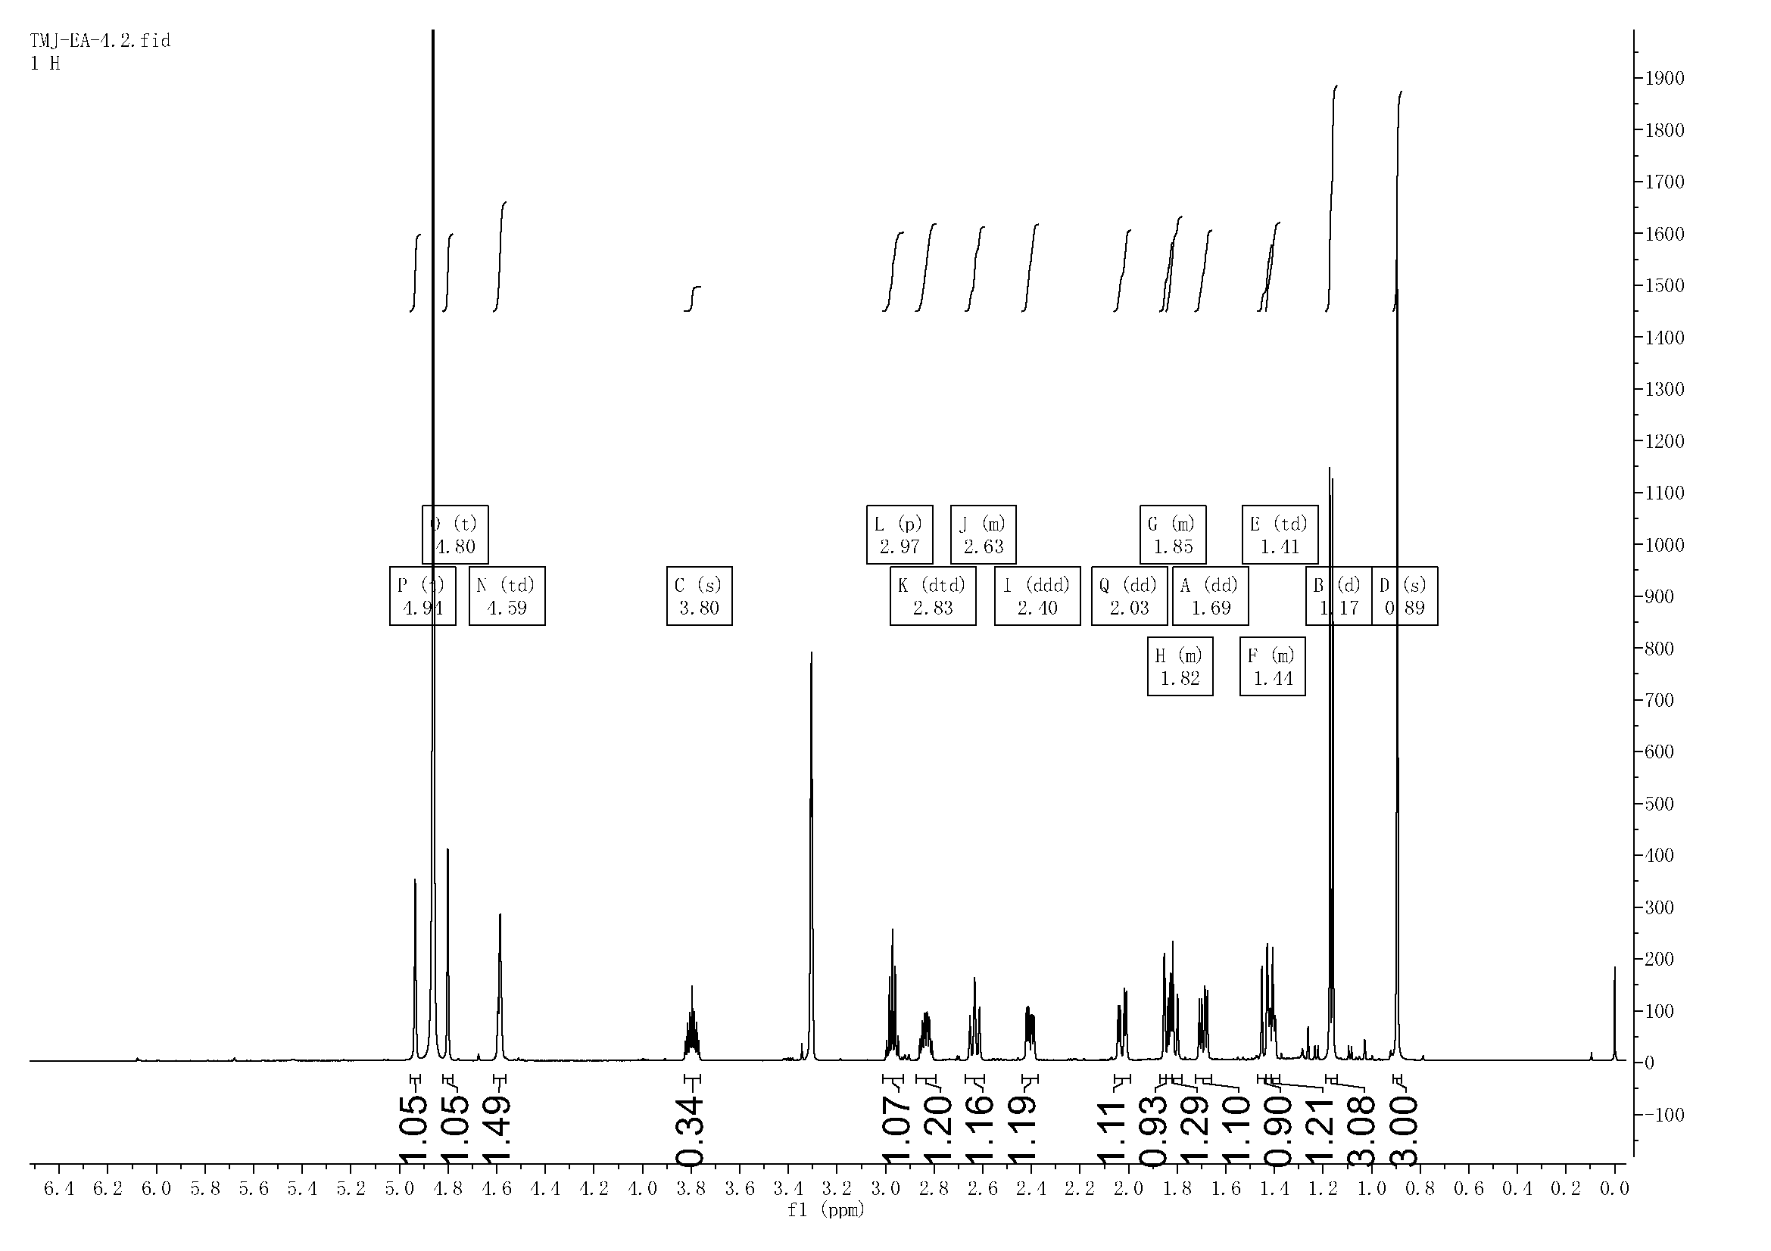
Fig. S2 ¹H NMR (600 MHz, CDCl₃) spectrum of 1
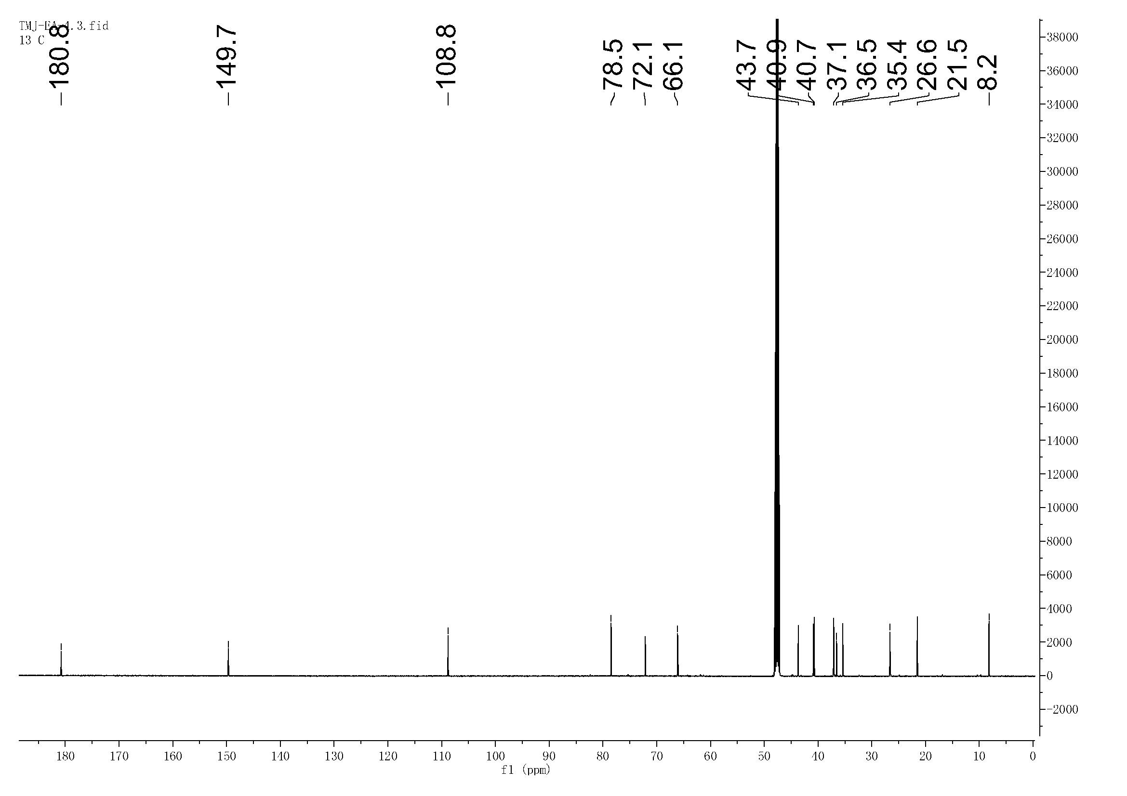
Fig. S3 ¹³C NMR (151 MHz, CDCl₃) spectrum of 1
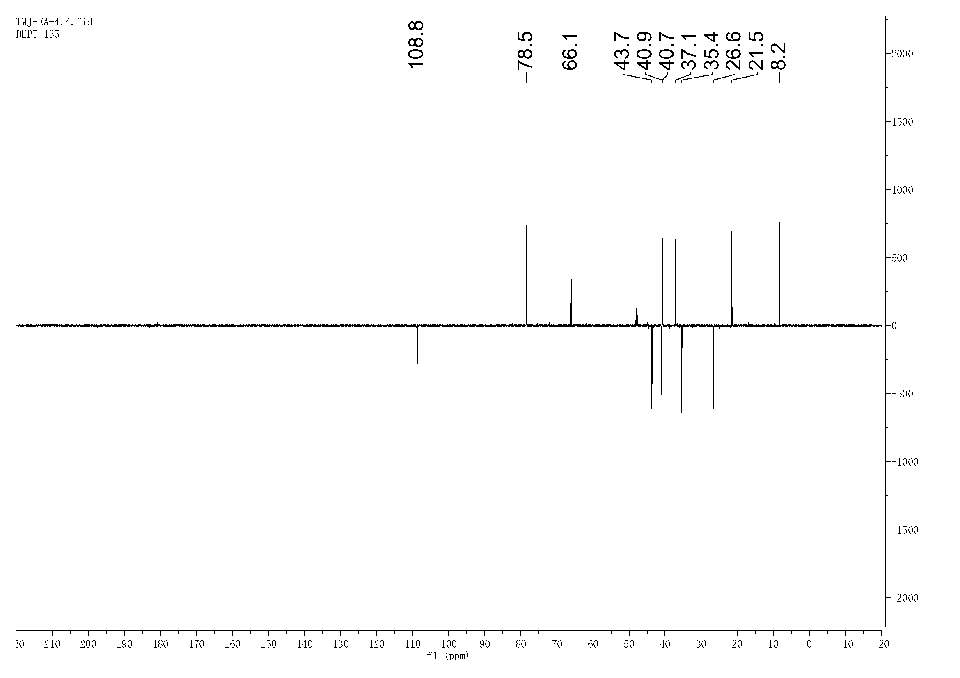
Fig. S4 DEPT 135°NMR ((151 MHz, CDCl₃) spectrum of 1

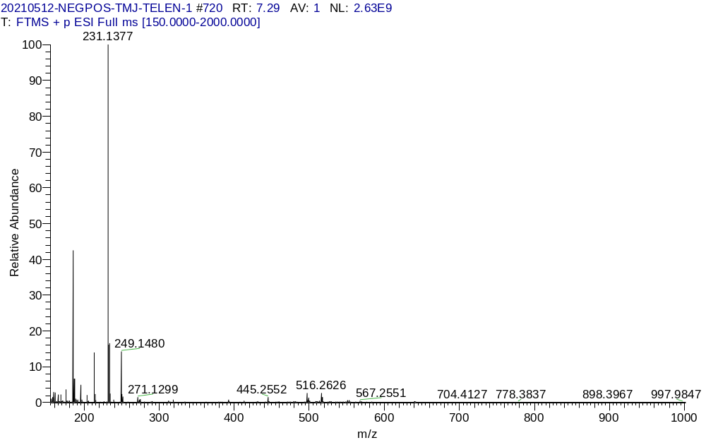
Fig. S5 HR-MS of 2

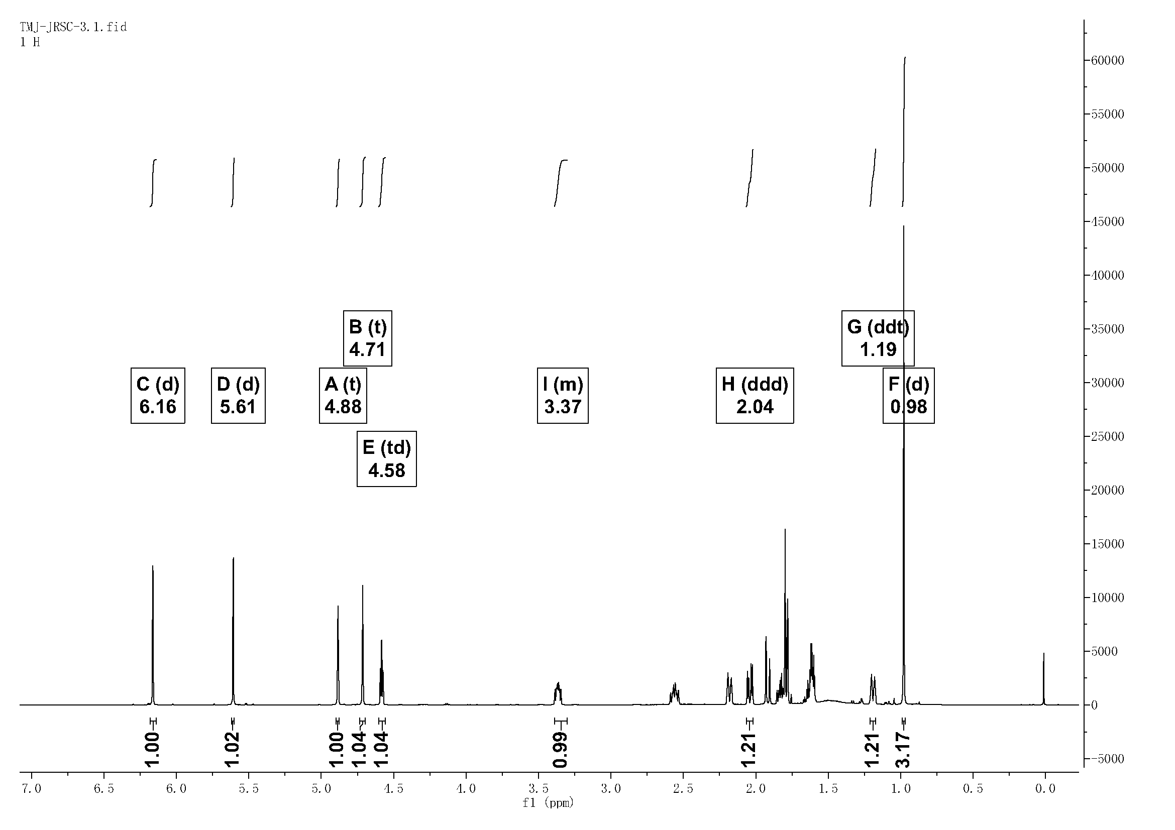
Fig. S6 ¹H NMR (600 MHz, CDCl₃) spectrum of 2
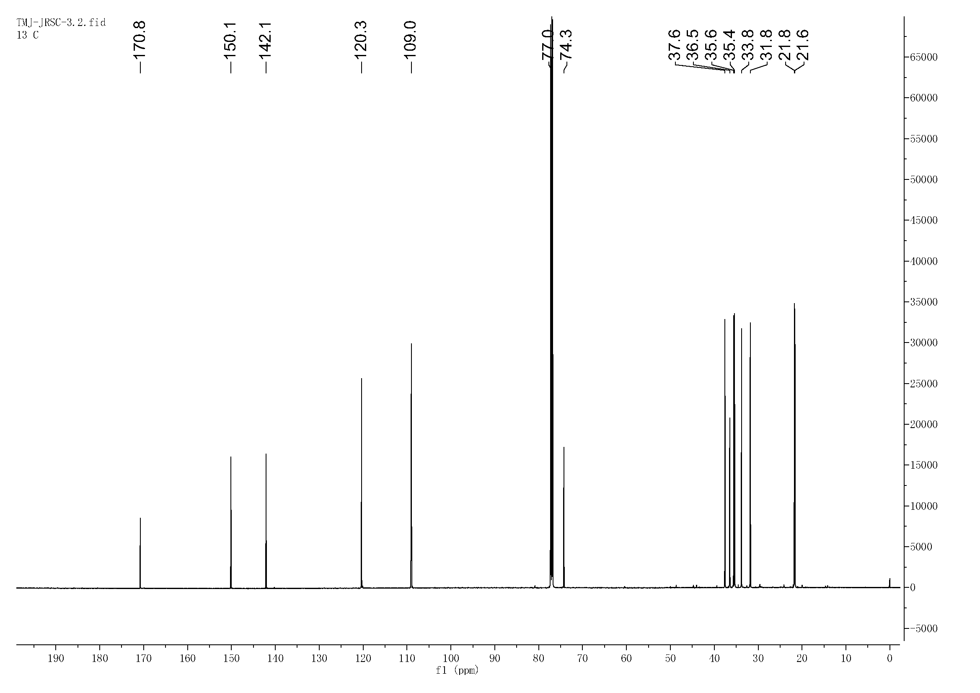
Fig. S7 ¹³C NMR (151 MHz, CDCl₃) spectrum of 2

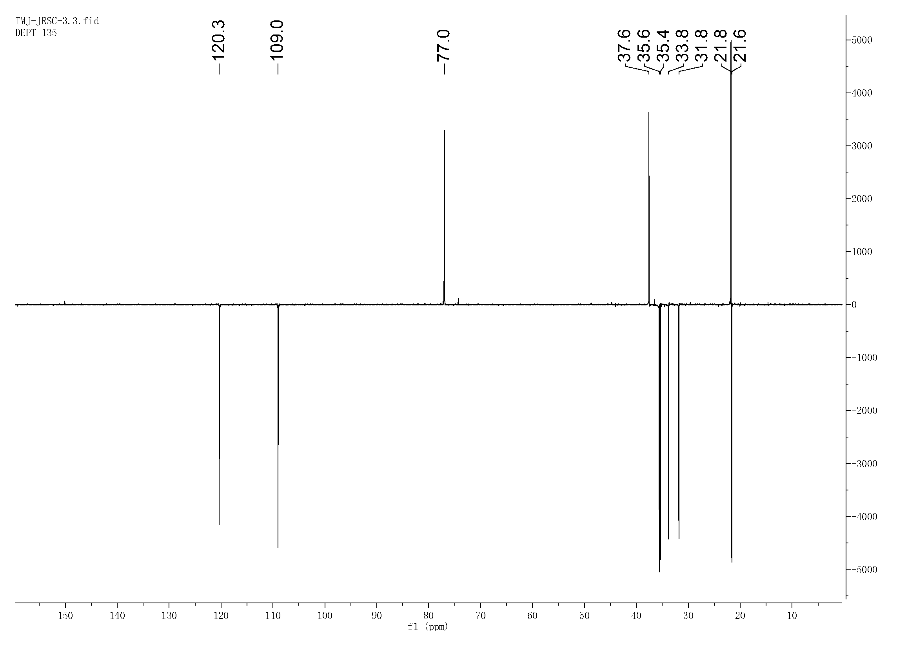
Fig. S8 DEPT 135°NMR (151 MHz, CDCl₃) spectrum of 2
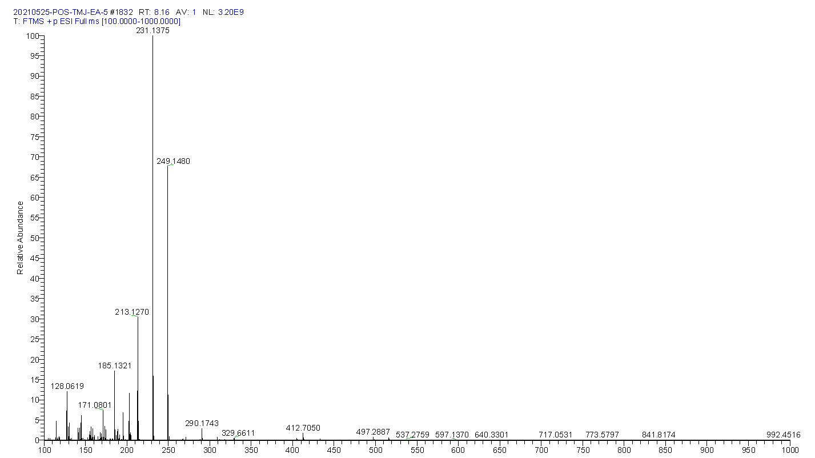
Fig. S9 HR-MS of 3

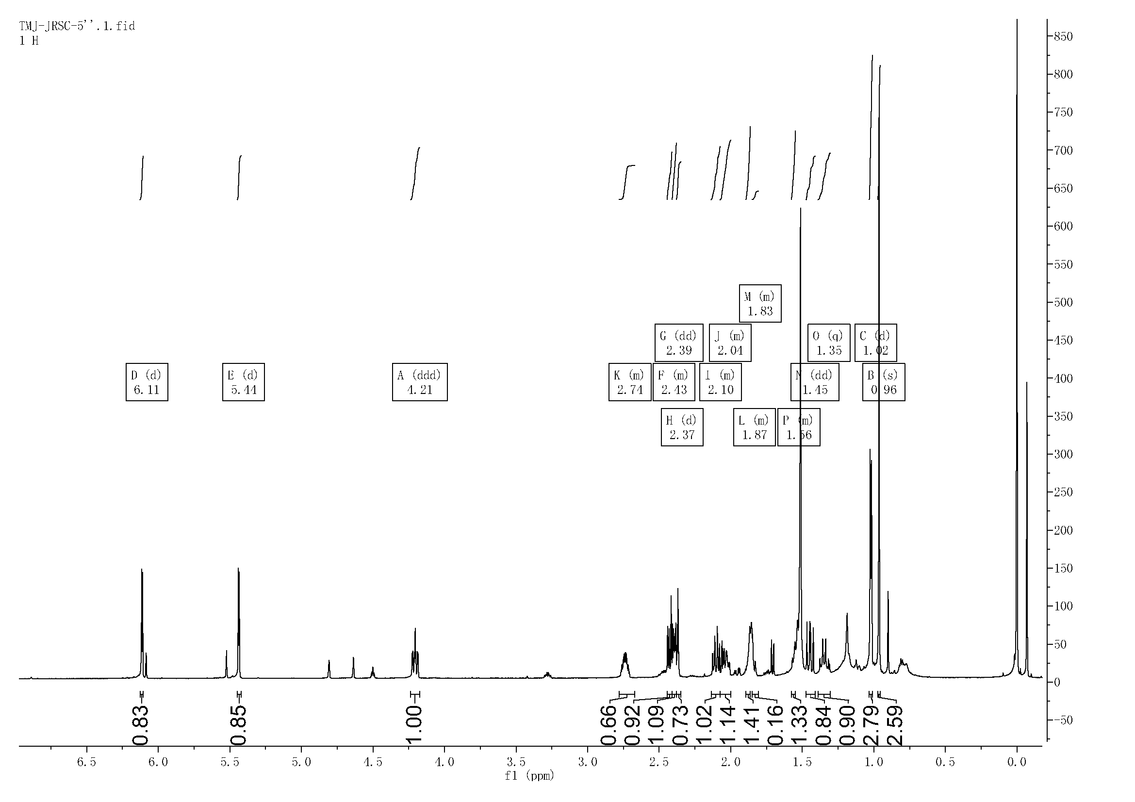
Fig. S10 ¹H NMR (600 MHz, CDCl₃) spectrum of 3
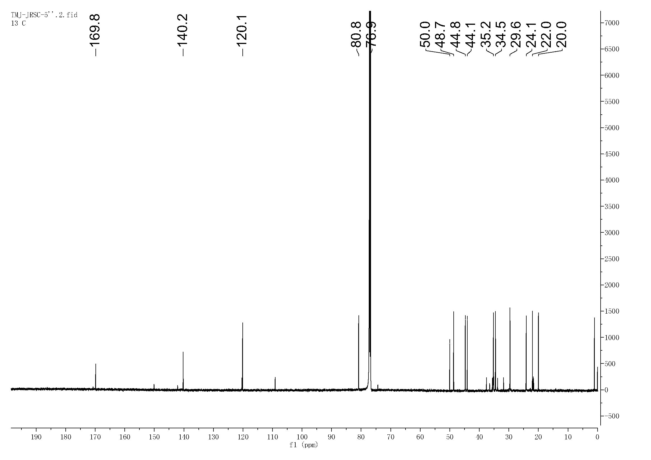
Fig. S11 ¹³C NMR (151 MHz, CDCl₃) spectrum of 3
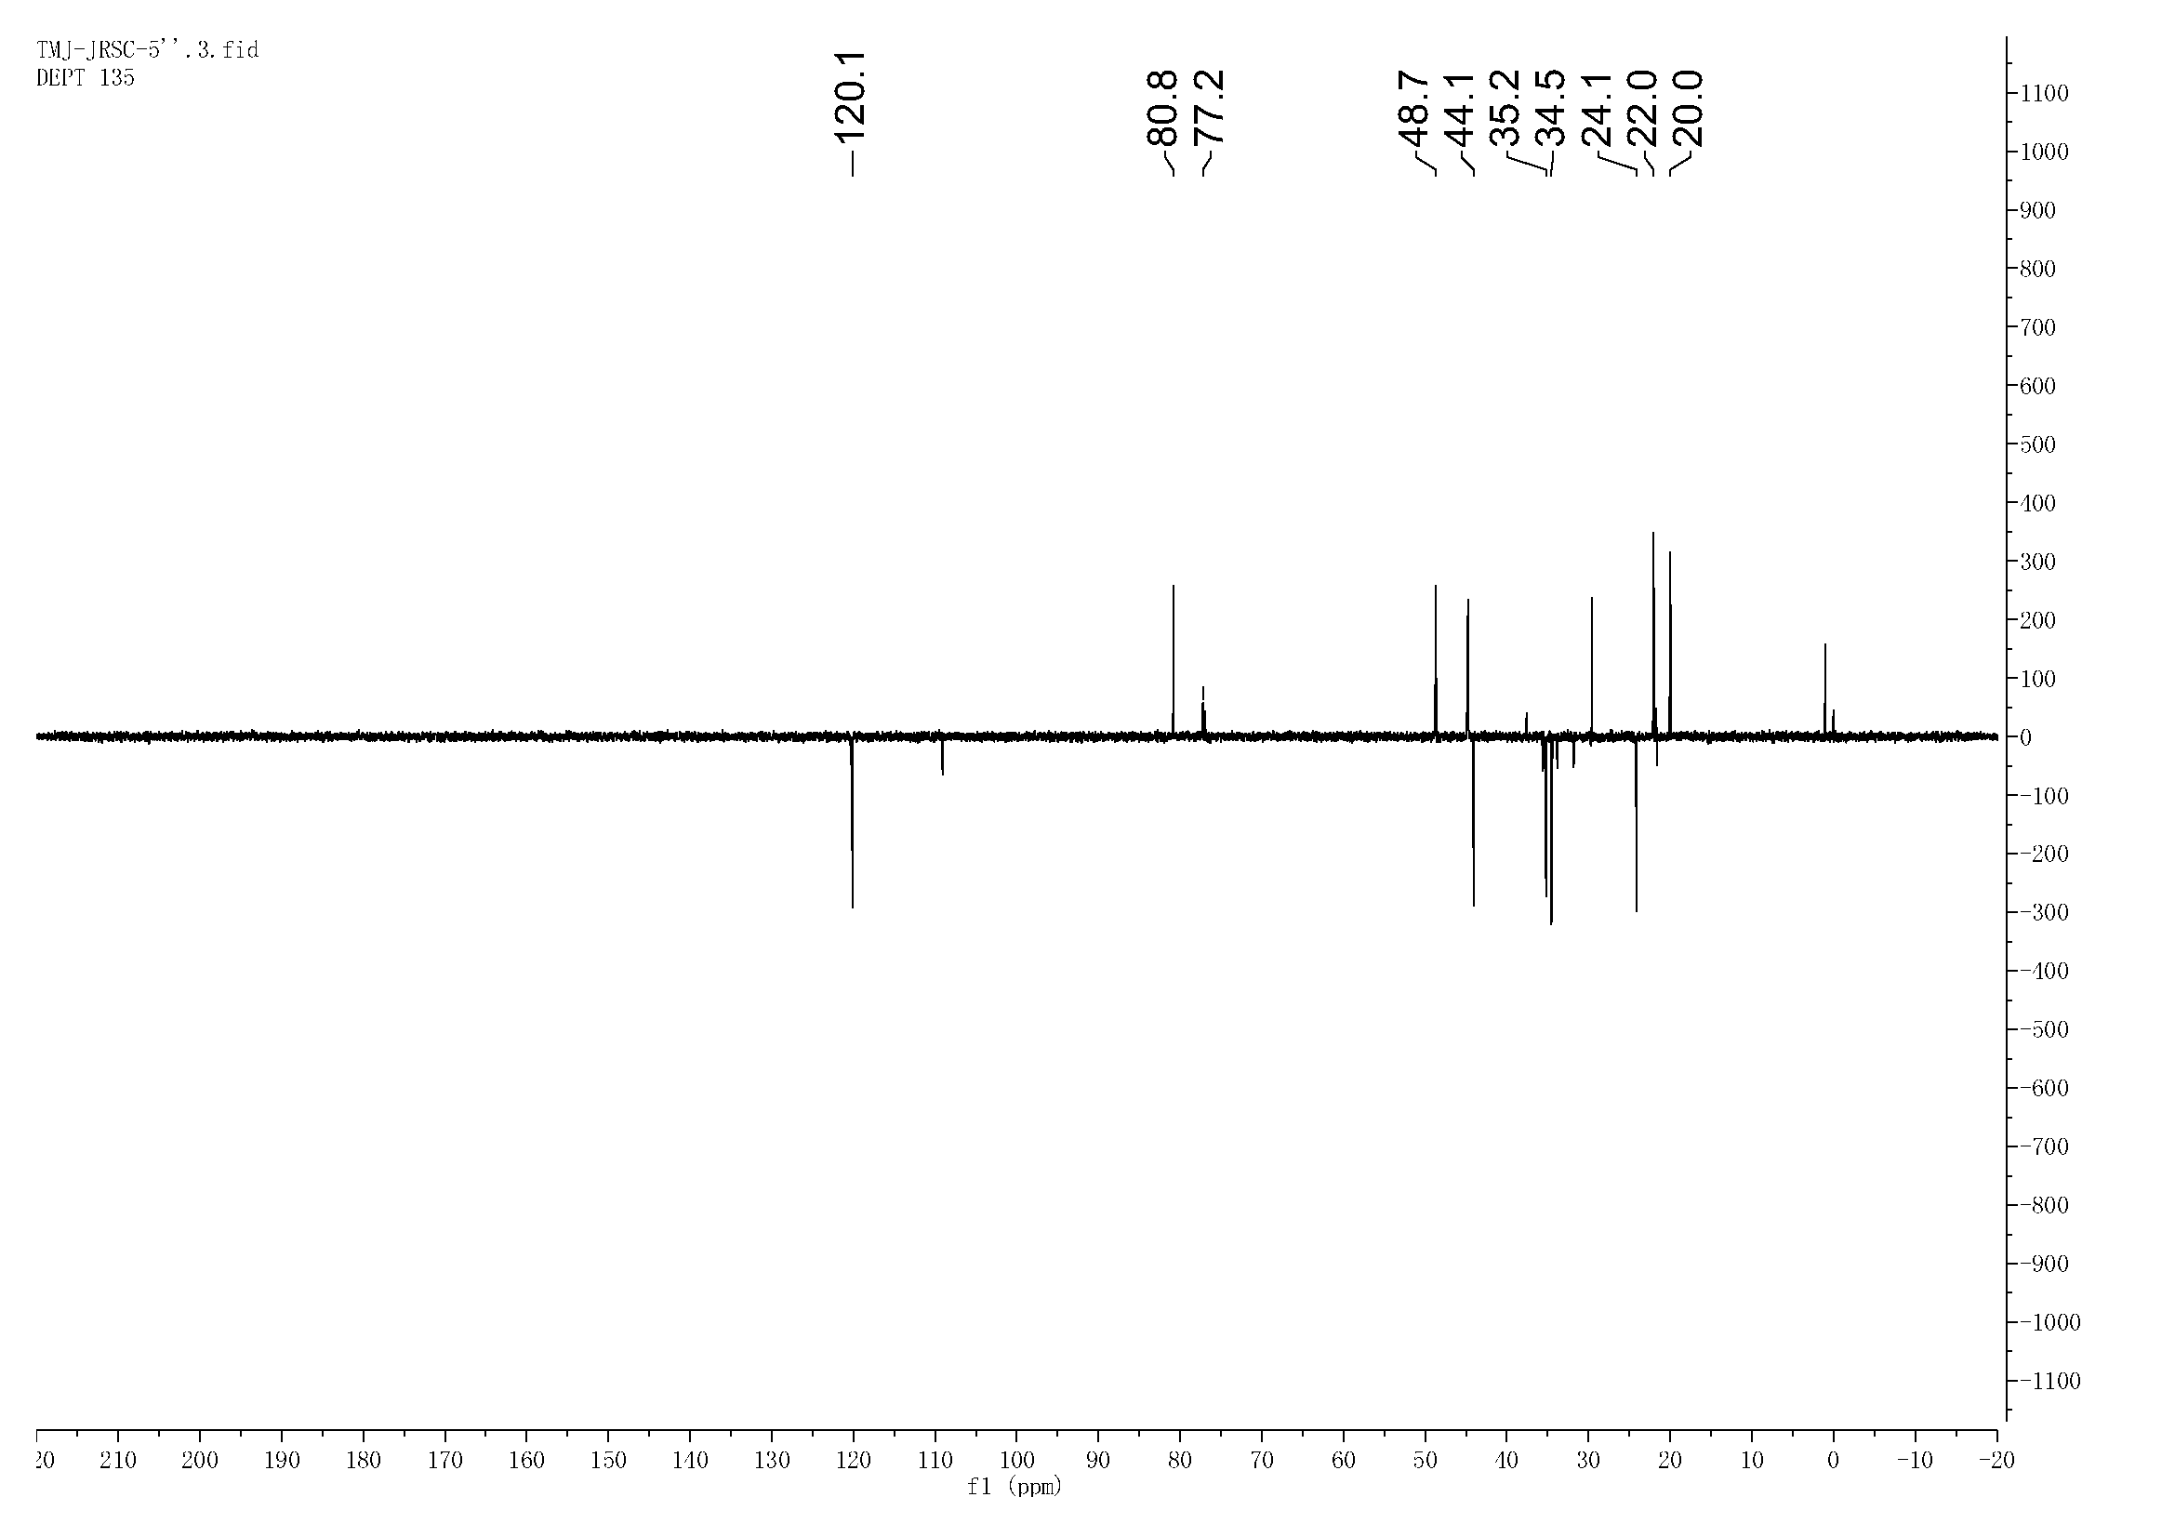
Fig. S12 DEPT 135°NMR ((151 MHz, CDCl₃) spectrum of 3

