Supplementary Information
Folic acid-modified lysozyme-protected gold nanoclusters as anti-inflammatory nanomedicine for gout flares
Jiachen Sunª Pengfei Zhuangª Shan Wenª Minghao Geª ZiPeng Zhouª Dan Liª* Chang Liu^{b}* Xifan Mei^{a*}
a Department of Orthopedic, First Affiliated Hospital of Jinzhou Medical University, Jinzhou, PR China
b Department of Endocrinology, First Affiliated Hospital of Jinzhou Medical University,Jinzhou,PR China
*Corresponding author.
- mail address:meixifan@jzmu.edu.cn (Xifan Mei)
liuchang1971mei@jzmu.edu.cn (Chang liu)
danli@jzmu.edu.cn(Dan Li)

Table of contents
Fig. S1 A Toxicity of fla
Fig. S1 B Diagram of the toxicology section
Fig. S1 C Pathological sections at 24h
Fig. S1 D Pathological sections at 14 days
Fig. S2 Zeta potential of RAW264.7 cells.

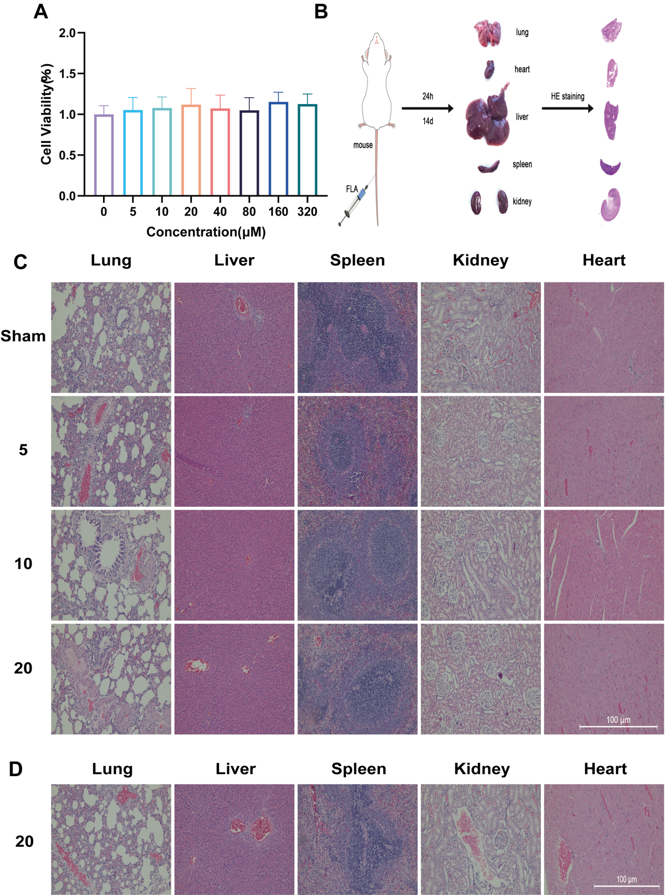

Fig. S1 Toxicity of fla to Raw 264.7 cells treated with various concentrations of FLA (0, 5, 10, 20, 40, 80, 160, 320 μM) based on MTT kit (A). Diagram of the toxicology section (B). Pathological sections of normal and FLA injected heart, liver, spleen, lung and kidney at different concentrations for 1 day, magnification 200x (C). Pathological sections of heart, liver, spleen, lung and kidney injected with 20 mg/kg FLA for 14 days, magnification 200x (D).
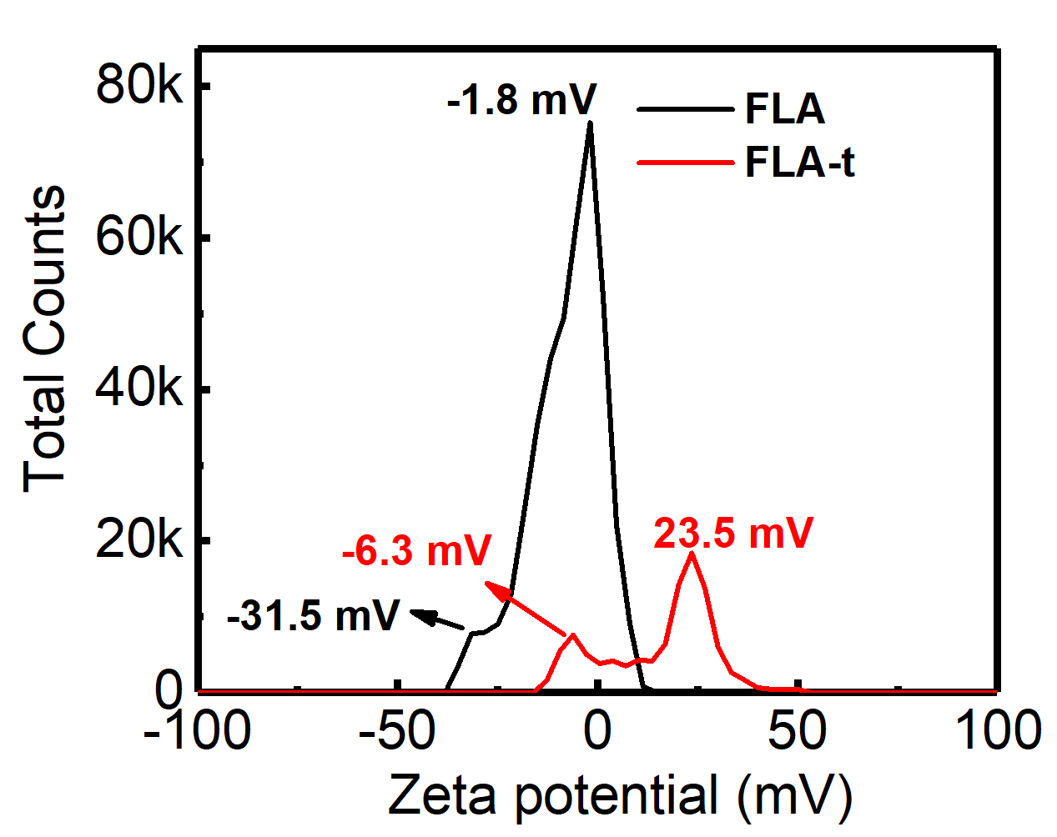
Figure S2 Zeta potential of FLA before and after the treatment (FLA-t) of RAW264.7 cells.

