Supplementary Information - Fragmented consensus: industry challenges in defining sustainable wheat
Nicolas Giordano¹, Katherine S. Nelson², Victor O. Sadras^{3,4,5}, Terry Griffin⁶, Kelsey Andersen Onofre⁷, Stephen Welch¹, Aastha Gautam¹, Mary J. Guttieri⁸, Nirmal Gelal⁹, Aryan S. Dalal⁹, Jean R. Francois¹⁰, Deborah Kohl¹¹, Xiaomao Lin¹, Claudio Dias da Silva Jr.⁷, Carlos B. Pires¹², Sanaz Saki Norouzi⁹, Pascal Hitzler⁹, Hande K. McGinty⁹, Romulo P. Lollato¹.

Table S1. Concepts extracted from definitions of sustainability given by wheat value chain stakeholders. Answers to the question: “What does sustainability mean to you?” and concepts extracted from the definitions. Asterisks (*) were written when words were not legible.
Group | ID | Sustainability definition | Concepts
Group | ID | Sustainability definition | c1 | c2 | c3 | c4 | c5 | c6
Agronomy | 1 | A system that works within the limits of its inputs | input limitation
Agronomy | 2 | Producing nutritional food while improving soil health and environment factors. | input/output quality | soil health | environmental responsibility
Agronomy | 3 | Ability to maintain production while responsibly using resources, both **** and protecting the environment | stewardship of resources | environmental responsibility | productivity | continue into future
Agronomy | 4 | The ability to continue practicing an activity. This could be environmental or economical in basis. | economic viability | environmental responsibility | continue into future
Agronomy | 5 | It is the balance of interactions of environment, social, and economic factors in a desired outcome | environmental responsibility | social responsibility | economic viability
Agronomy | 6 | Ability to produce food fuel and fiber in environmentally sound and economically positive manner | economic viability | productivity | environmental responsibility
Agronomy | 7 | Consumer confidence that food is produced with lowest environmental impact | consumer confidence | environmental responsibility
Breeding | 8 | Ability to make continental improvement in wheat genetics while not outstripping our environmental limitations (e.g., soil fertility water etc.). | genetic improvement | environmental responsibility
Breeding | 9 | Protecting our yield gains why managing impacts, technology, and farming practices within changing environments. | yield gains | environmental responsibility | agronomy and technology | environmental variability
Breeding | 10 | equivalent to durability. Optimization of resource use to sustain production and the environment (soil/water/air/people) that supports it. | optimization of resource use | environmental responsibility | productivity | continue into future
Breeding | 11 | the ability to produce a safe, affordable food supply to feed the world with economic benefit throughout the supply chain. | food security | economic viability | value chain reach and collaboration
Breeding | 12 | growing up on a farm. Sustainability to me means passing the farm to the next generation in as good or better shape than what it was to begin with. Economically, environmentally, impact on the community, etc. This can be applied to any sector. Leaving it better than what it was to begin with. | continue into future | environmental responsibility | economic viability | impact on community
Breeding | 13 | Has some desirable and measurable property that is more constant in time than the environment in which the object is built, used or "exported". All models are wrong, but some are useful. I go through life making things that are wrong out of the gate. "Sustainable" means to me something that, for whatever reason, is useful longer. | continue into future | measurable property | Stability over time
Consumer | 14 | Carbon neutrality throughout the wheat supply chain. | carbon neutrality | environmental responsibility | value chain reach and collaboration
Consumer | 15 | Maximizing output through minimizing inputs towards the end goal of creating a product that can continue to be produced with those same sustained inputs into perpetuity. | optimization of resource use | continue into future
Consumer | 16 | The ability to produce and function today without denying myself or others the ability to do the same. | long-term viability | continue into future | social responsibility
Consumer | 17 | Asset I can use to sell grains to costumers. Ability to supply other costumers. | resource for market
Consumer | 18 | Ability to bring together a set of valued data points to achieve a desired out-come that brings a consumable value. | data usage | consumable value
Consumer | 19 | Marketing strategy that accounts for all segments of the production marketing chain. | marketing strategy | value chain reach and collaboration
Consumer | 20 | Sustainability means equitable growth and production in a way that we can provide for future generations years to come. | equitable growth and production | continue into future
Input supply | 21 | Sustainability would be the efficient use of resources in the production of products, and the distribution of products. | optimization of resource use | productivity | distribution
Input supply | 22 | It means to me that you don't want to deplete the resources you have but use them wisely and effectively. | continue into future | optimization of resource use
Input supply | 23 | Being efficient with our inputs to deliver highest quality. | optimization of resource use | input/output quality
Input supply | 24 | The ability to persist in a cost effective and socioeconomically responsible way. | continue into future | cost effective | social responsibility | economic viability
Input supply | 25 | A stable production of inputs that meets customer demand - neither exceeding or not meeting demand. | productivity | stability over time | balanced supply-demand
Input supply | 26 | The ability to produce crops in a manner that promotes economic, environmental and social excellence throughout the chain from the product production to the end product for costumers. | economic viability | environmental responsibility | social responsibility | value chain reach and collaboration
Milling and baking | 27 | A resilient approach and perspective that aligns vision across the value chain participants for the outcome of human goodness and thriving. | value chain reach and collaboration | human goodness and thriving | adaptation and resilience
Milling and baking | 28 | Sustainability is about guaranteeing food security for all people globally. Protect the planet and supply chain. | food security | global reach | environmental responsibility | value chain reach and collaboration
Milling and baking | 29 | Continuing to source wheat that has the right quality parameters (protein, rheological properties) and yield, with disease resistant properties for years to come that will adapt to its changing climate and environment to feed the growing population. | food security | adaptation and resilience | continue into future | productivity | input/output quality | disease resistant properties
Milling and baking | 30 | Sustainability is the improvement of the entire process from growing to processing products. Each part of the industry is at different starting points so decelerating the progress as the biggest challenge. | process improvement | value chain reach and collaboration
Milling and baking | 31 | To continue to be able to provide the consumer with a safe and cost-effective food system. All members of the chain work together to provide. | continue into future | food security | value chain reach and collaboration
Milling and baking | 32 | Being a good steward of the resources and considering the generational impacts of one's activities. | stewardship of resources | continue into future
Growers | 33 | Staying in business while not only maintain the land but also improving it, leaving it better than it was when we received it. | continue into future | economic viability | land maintainance and improvement
Growers | 34 | The opposite of unsustainable. It means a system that will adapt and survive through struggle. | adaptation and resilience
Growers | 35 | Producing a product in a way that is continuously repeatable while being energy and environmentally neutral. | repeatability | energy neutral | environmental responsibility
Growers | 36 | Responsible production of a product or outcome that respects the environment and society facilitating sustained production while limiting negative effects | productivity | environmental responsibility | social responsibility | continue into future | limiting negative effects
Growers | 37 | The ability to maintain a successful operation over an extended period of time. | adaptation and resilience | continue into future
Growers | 38 | Continued access to health resources (natural, economic, human) necessary for success across time. | continue into future | accessibility to resources
Growers | 39 | The ability to raise a crop that is profitable without depleting the soils. | productivity | economic viability | soil health
Growers | 40 | 1: Profitability-operation must be profitable to continue on. 2: maintain/enhance natural resources for the future. Conservation is not preservation. | economic viability | stewardship of resources | continue into future

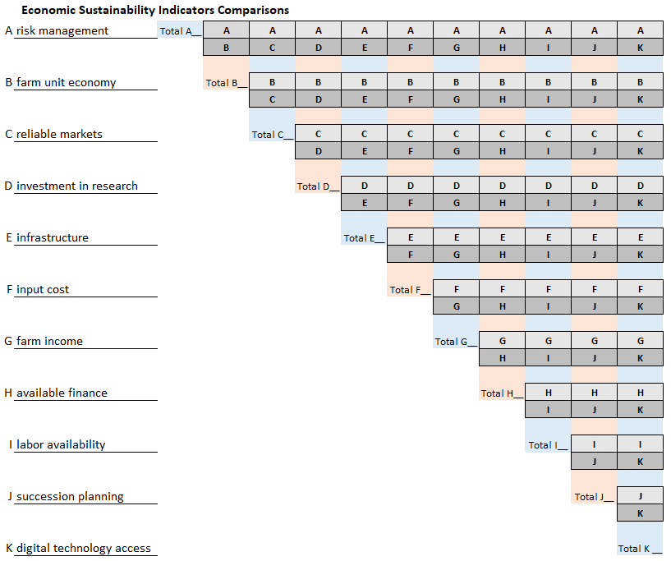
Fig. S1. Paired comparisons matrix used to rank sustainability indicators. An example of a paired comparisons matrix used to rank sustainability indicators in each domain. This example corresponds to sustainability indicators proposed within the “Economic” dimension by the “Breeding” group. If a participant ranked “risk management” higher than “farm unit economy,” then option “A” would be circled in the A/B cell in the top left of the matrix.
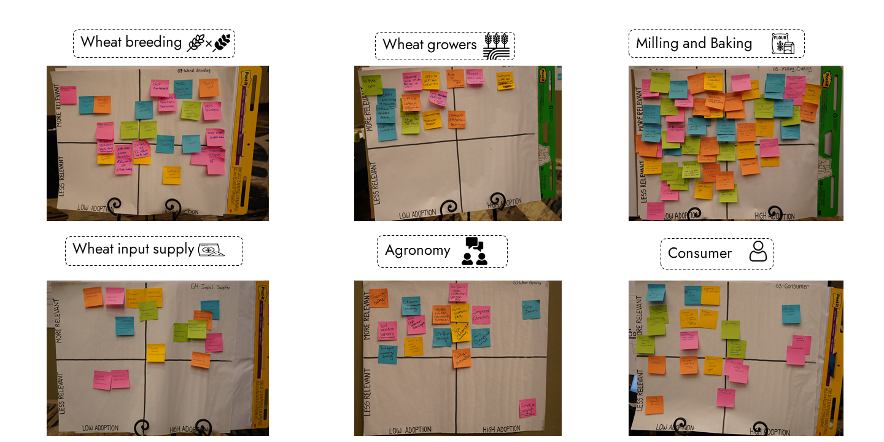
Fig. S2. Photos of quadrants used to classify technologies and practices according to their relevance to sustainability and their current level of adoption in the wheat industry. Each quadrant corresponds to a group discussion, in which participants were sorted into six sectors representing the wheat industry. In each table, one facilitator guided the group discussion and helped participants complete the activities, while two scribers created a written record of the group discussions.
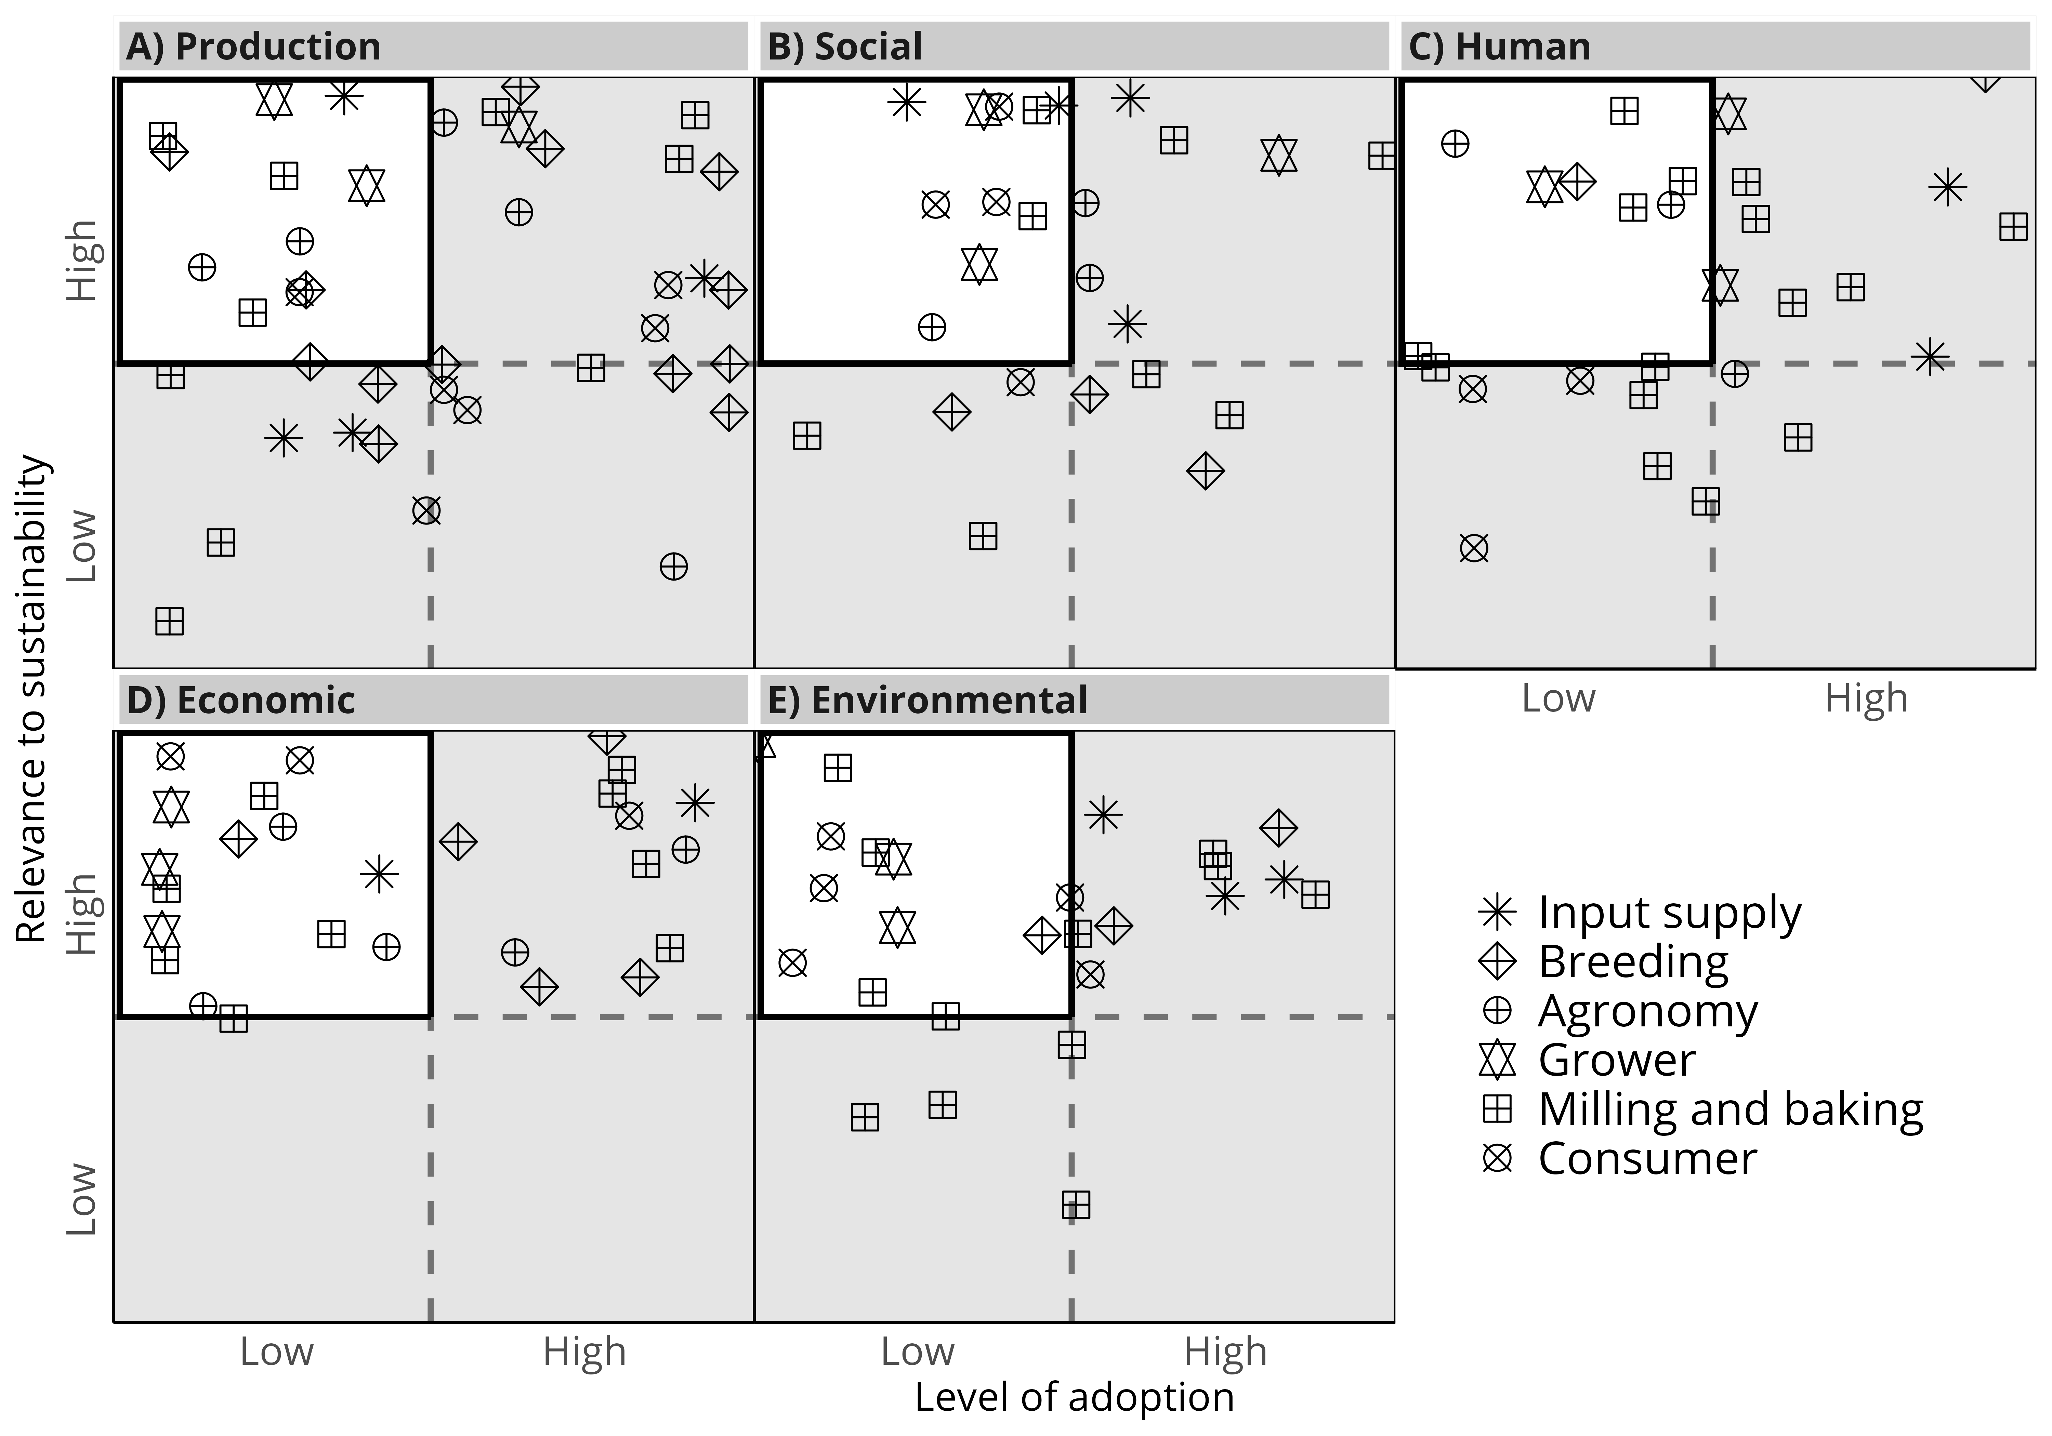
Fig. S3. Classification of technologies and practices in quadrants according to their level of adoption and their relevance to sustainability in five sustainability dimensions. Each symbol represents a technology or practice listed by different sectors of the value chain. The white-colored area of the plot represents technologies and practices of high relevance to sustainability and low adoption, and are listed in Error! Reference source not found..

Supplementary section 1 - Sustainability indicators within sectors and across the wheat value chain
Experts listed sustainability indicators using their own jargon. For example, “water use” was also referred to as “water use efficiency” or “irrigation water use efficiency.” Another pattern was that sustainability indicators were oftentimes listed as abstract sustainability goals, e.g., “realistic goals” or “generational sustainability” (Fig. S3). In general, indicators such as “profitability,” “risk mitigation,” “water use,” and “supply chain accountability” were identified as relevant across multiple sectors and dimensions of sustainability (Fig. S4).

Production sustainability
Four sustainability indicators within the production sustainability dimension were shared across sectors: “profitability” (input supply, grower and consumer), “grain yield” (breeding, agronomy and grower), “water use” (breeding, agronomy and input supply), “resource preservation” (agronomy, growers, input supply). Notably, the milling and baking sector reported indicators of production sustainability goals that differed markedly from those of all other sectors (Fig. S3A). This sector shared only a single indicator, ‘risk mitigation’, with another sector, input supply. Out of the 31 indicators listed in the production sustainability dimension, 26 were sector-specific (Fig. S3A). The agronomy group referred to “yield resiliency” and “yield stability” as similar indicators. These indicators were ranked low due to group concerns about “stability of low yields.”

Social sustainability
Four indicators within the social domain were shared across sectors: “agricultural literacy” (agronomy, growers), “societal benefits” (input supply, growers, agronomy), “risk mitigation” (breeding, agronomy, milling and baking), and “worker education and training” (breeding, input supply, milling and baking). For the agronomy sector, concerns regarding “agricultural literacy” were seen as particularly important, with participants stating that “we are not telling the story to individuals outside of agriculture” and pointing to a “lack of consumer understanding of production practices” in association with “disconnect between farm to fork.”
Participants in the input supply sector highlighted that positive impacts on the “societal benefits” indicator can be achieved through “investing in community activities or creating opportunities for the community”, while others suggested “this [dimension] would be more effective if coordinated by local decision-makers or supported by broader-level policies that address community-level needs, particularly access to resources”.
The perception of social sustainability indicators by the consumer sector was highlighted by abstract sustainability indicators, such as “assessment” or “engagement”, with no clear connection to indicators listed by other sectors (Fig. S3B). Other sectors also had sector-specific and abstract indicators of social sustainability. For example, the agronomy group referred to “generational sustainability” as an indicator associated with issues such as how “public perception made many tobacco producers leave production”, which made it difficult for “individuals to return to family operations”.

Human sustainability
Six indicators within the human domain were shared across sectors: “worker education and training” (all sectors), “quality of life and well-being” (input supply, growers, agronomy, consumer), “access to nutritional and healthy food” (breeding, agronomy, milling and baking, consumer), “food security” (breeding, milling and baking), “supply chain accountability” (agronomy, consumer), and “worker safety” (input supply, agronomy).
Some concerns arose in group discussions on how to achieve human sustainability goals. For example, the consumer group agreed that the human dimension, not the economic dimension, should be the starting point of a more sustainable wheat value chain. Furthermore, for this group, product traceability provides means to achieve “supply chain accountability.” Concerns on traceability centered on the fact that “each country has different rules” and that “sustainability labels are not specific.” While the “access to nutritional and healthy food” was a relevant indicator across four sectors of the value chain, the consumer group highlighted a trade-off where “people want no additives at all, but that [bread] would not last more than three days on [a] countertop.”

Economic sustainability
Five indicators within the economic domain were shared across sectors: “profitability” (input supply, agronomy, growers, consumer), “risk mitigation” (input supply, agronomy), “supply chain accountability” (growers, consumers), “on-farm income” (breeding, consumer), and “accessible and reliable markets” (breeding, growers). The milling and baking sector highlighted its own unique indicators to achieve economic sustainability, such as improving “flour yield” and “resource preservation” through reducing the use of additives and improvers in wheat flour.
Within sector-specific indicators, growers proposed “policy”; however, the ranking of this indicator was low because they argued “we cannot directly control agricultural policy even [though] we may lobby with policymakers”. The agronomy group highlighted interactions among three indicators: “access to reliable markers” allows for more “stable profits” over time and can positively impact economic “risk mitigation”.

Environmental sustainability
Sectors shared five indicators within environmental sustainability domain: “water use” (all sectors except for input supply), “soil conservation” (breeding, agronomy, growers, consumer), “resource preservation” (agronomy, input supply, milling and baking), “risk mitigation” (input supply, milling and baking) and “nitrogen use” (agronomy, breeding).
“Soil conservation” was listed as a relevant sustainability indicator across multiple groups, who referred to it as a factor in improving “water infiltration,” “soil physical properties,” or “soil structure.” The agronomy group discussed how “managing your soil microbiome can prevent nitrogen loss,” drawing a clear connection between “soil conservation” and “nitrogen use”. Other sectors drew links between “soil conservation” and “soil health,” suggesting that the latter concept is hard to define and measure: “soil health, [it is a] tricky thing to say.” The group representing the consumer sector, discussed “soil conservation” to highlight concerns about a temporal misalignment of sustainability priorities, stating that: “if people know preventing soil loss would lead to long term good, people might still need to ensure short term gain first.”
The milling and baking sector centered the discussion around environmental sustainability on four indicators. The group expanded on the use of wastewater, the challenges of water recycling, and its impacts in local communities, which are partially linked to a lack of regulation on wastewater treatment. Regarding resource preservation, they mostly referred to minimizing landfill waste and the need for alternative uses of waste products, such as animal consumption.
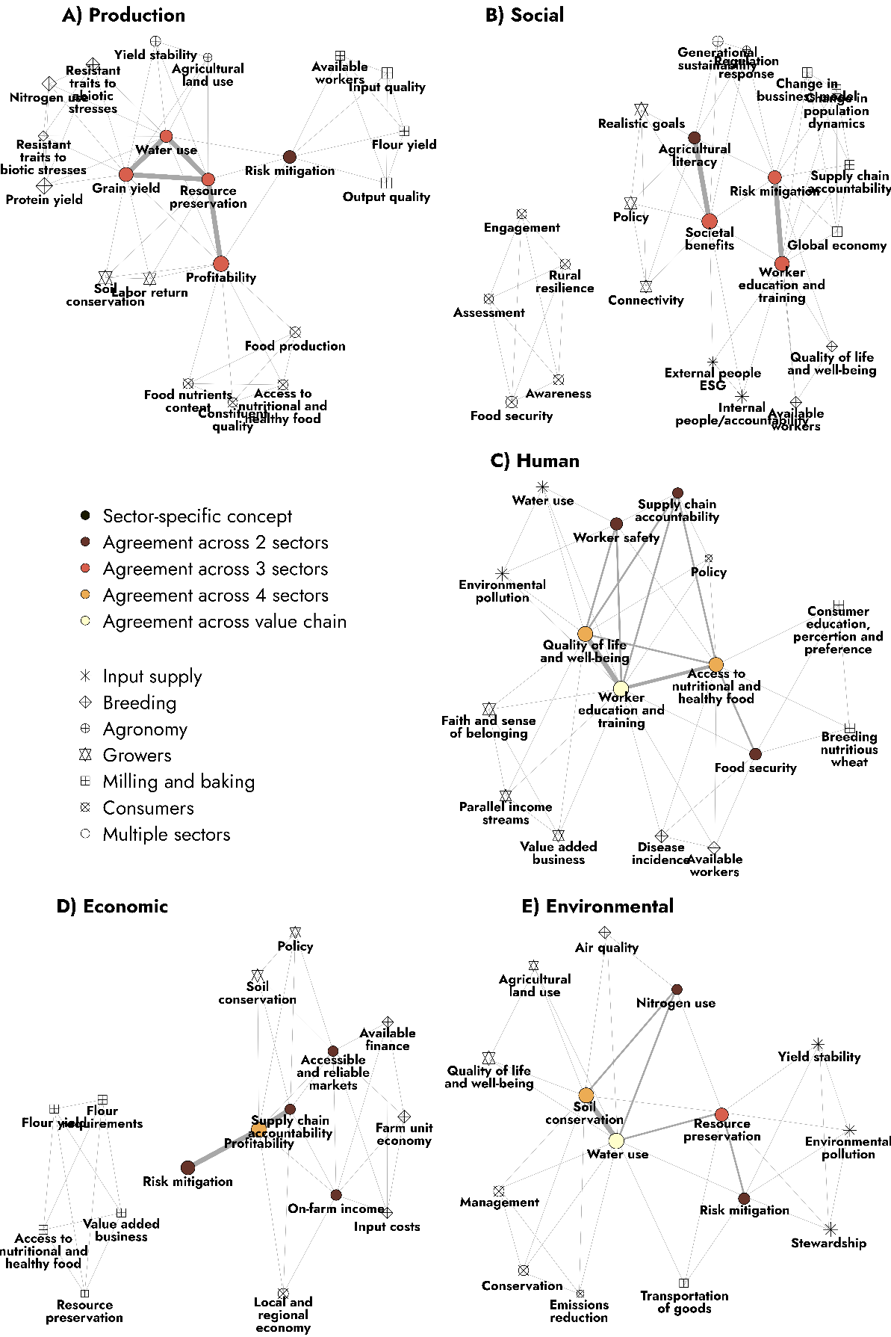
Supplementary Fig. S4. Network of indicators in five sustainability dimensions (A- production, B- social, C-human, D-economic, E-environmental) and across the wheat value chain. Custom symbols represent each individual sector, and open circles represent multiple sectors of the wheat value chain. The size of open circles is relative to the sum of the rankings for a given indicator (see Methods for details on how rankings were established). Ties (i.e., -----) connect indicators that were considered relevant by the same sector. The color of open circles represents the number of sectors that listed a given indicator as relevant.

Table S2. Coded sustainability indicators and written indicators by workshop participants. The ranking score shows the mean, minimum, and maximum ranks assigned to an indicator in the paired comparisons matrix exercise (see Fig. S1). The sustainability dimensions and value chain sectors corresponding to each sustainability indicator are listed.
Coded sustainability indicator | Written sustainability indicator | Ranking score | Sustainability dimensions assigned | Value chain sectors
profitability | profitability, return on investment, profitability, long-term profit, ROI | 0.20 (0.11; 0.30) | Economic, Production | Agronomy, Consumers, Growers, Input supply
risk mitigation | crop input price stability, profit stability, risk management, innovation/technology, risk, risk management, technology improving plant production yield, innovation, resiliency, technology, tech adoption, access to technology, automation | 0.13 (0.09; 0.19) | Economic, Environmental, Production, Social | Agronomy, Input supply, Milling and baking, Breeding
accessible and reliable markets | reliable markets, access to market | 0.12 (0.10; 0.14) | Economic | Breeding, Growers
available finance | available finance | 0.11 (0.11; 0.11) | Economic | Breeding
farm unit economy | farm unit economy | 0.15 (0.15; 0.15) | Economic | Breeding
input costs | input cost | 0.10 (0.10; 0.10) | Economic | Breeding
on-farm income | farm income, on farm income | 0.14 (0.12; 0.16) | Economic | Breeding, Consumers
local and regional economy | local economy, regional economy | 0.12 (0.10; 0.14) | Economic | Consumers
supply chain accountability | pay for value, payed for sustainability, information access, traceability, information collaboration | 0.12 (0.09; 0.14) | Economic, Human, Social | Consumers, Growers, Agronomy, Milling and baking
policy | policies, policy, legislation | 0.10 (0.08; 0.14) | Economic, Human, Social | Growers, Consumers
soil conservation | soil heath value, soil conservation, soil health, soil, soil conservation, soil health, soil health | 0.16 (0.12; 0.24) | Economic, Environmental, Production | Growers, Agronomy, Breeding, Consumers
access to nutritional and healthy food | food safety, nutrition, access to nutritional food, access to healthy food, food as a medicine, food quality | 0.17 (0.10; 0.28) | Economic, Human, Production | Milling and baking, Agronomy, Breeding, Consumers
flour requirements | flour requirements | 0.14 (0.14; 0.14) | Economic | Milling and baking
flour yield | yield | 0.12 (0.12; 0.12) | Economic, Production | Milling and baking
resource preservation | reduction of additives, crop protection use efficiency, reduced input loss, input reduction, minimizing waste, efficient energy use, input efficiency | 0.11 (0.08; 0.15) | Economic, Environmental, Production | Milling and baking, Agronomy, Input supply, Growers
value added business | value capture, value added business | 0.11 (0.10; 0.13) | Economic, Human | Milling and baking, Growers
nitrogen use | nitrogen use efficiency, NUE | 0.12 (0.09; 0.16) | Environmental, Production | Agronomy, Breeding
water use | water-use efficiency, water access, water quality, efficient use of water, water supply, water quality, irrigation WUE, water use efficiency | 0.13 (0.07; 0.19) | Environmental, Human, Production | Agronomy, Breeding, Consumers, Growers, Milling and baking, Input supply
air quality | air quality | 0.12 (0.12; 0.12) | Environmental | Breeding
conservation | conservation | 0.19 (0.19; 0.19) | Environmental | Consumers
emissions reduction | carbon sequestration | 0.09 (0.09; 0.09) | Environmental | Consumers
management | management | 0.22 (0.22; 0.22) | Environmental | Consumers
agricultural land use | diverse crop system, cropping system intensity | 0.09 (0.09; 0.09) | Environmental, Production | Growers, Agronomy
quality of life and well-being | human health, quality of life/mental health, quality of life, mental and physical health, individual well-being, health care cost | 0.18 (0.10; 0.30) | Environmental, Human, Social | Growers, Agronomy, Consumers, Input supply, Breeding
environmental pollution | reduce pollution, reduce pollution | 0.16 (0.14; 0.18) | Environmental, Human | Input supply
stewardship | stewardship | 0.20 (0.20; 0.20) | Environmental | Input supply
yield stability | yield resilience, yield stability | 0.15 (0.13; 0.16) | Environmental, Production | Input supply, Agronomy
transportation of goods | transportation of goods | 0.12 (0.12; 0.12) | Environmental | Milling and baking
worker education and training | skilled labor, knowledge gap in practical application, education, knowledge and education, labor ability, training and development, access to education, skill set, new skills | 0.14 (0.12; 0.18) | Human, Social | Agronomy, Breeding, Consumers, Growers, Input supply, Milling and baking
worker safety | farm safety, employee safety | 0.20 (0.16; 0.23) | Human | Agronomy, Input supply
available workers | labor participation rate, workforce, labor availability | 0.11 (0.10; 0.13) | Human, Production, Social | Breeding, Milling and baking
disease incidence | disease incidence | 0.14 (0.14; 0.14) | Human | Breeding
food security | affordable food supply, food insecurity, food security | 0.20 (0.11; 0.25) | Human, Social | Breeding, Milling and baking, Consumers
faith and sense of belonging | faith and sense of belonging | 0.15 (0.15; 0.15) | Human | Growers
parallel income streams | parallel income streams | 0.10 (0.10; 0.10) | Human | Growers
breeding nutritious wheat | breeding nutritious wheat | 0.14 (0.14; 0.14) | Human | Milling and baking
consumer education, perception and preference | consumer perception/education, consumer preference | 0.09 (0.09; 0.09) | Human | Milling and baking
grain yield | yield, grain yield, yield production | 0.17 (0.09; 0.25) | Production | Agronomy, Breeding, Growers
protein yield | protein yield | 0.26 (0.26; 0.26) | Production | Breeding
resistant traits to abiotic stresses | abiotic stress resistance | 0.14 (0.14; 0.14) | Production | Breeding
resistant traits to biotic stresses | biotic stress resistance | 0.07 (0.07; 0.07) | Production | Breeding
constituent quality | constituent quality | 0.11 (0.11; 0.11) | Production | Consumers
food nutrients content | nutrients content | 0.14 (0.14; 0.14) | Production | Consumers
food production | food production | 0.16 (0.16; 0.16) | Production | Consumers
labor return | labor return | 0.11 (0.11; 0.11) | Production | Growers
input quality | input quality (protein, test weight, ...) | 0.18 (0.18; 0.18) | Production | Milling and baking
output quality | quality of outputs | 0.17 (0.17; 0.17) | Production | Milling and baking
agricultural literacy | ag literacy, relation b/w grower and consumer | 0.15 (0.15; 0.15) | Social | Agronomy, Growers
generational sustainability | generational sustainability | 0.19 (0.19; 0.19) | Social | Agronomy
regulation response | regulation response | 0.10 (0.10; 0.10) | Social | Agronomy
societal benefits | rural community economic health, community resources, community outreach, company reputation | 0.16 (0.10; 0.23) | Social | Agronomy, Growers, Input supply
assessment | assessment | 0.14 (0.14; 0.14) | Social | Consumers
awareness | awareness | 0.17 (0.17; 0.17) | Social | Consumers
engagement | engagement | 0.15 (0.15; 0.15) | Social | Consumers
rural resilience | rural resilience | 0.16 (0.16; 0.16) | Social | Consumers
connectivity | connectivity | 0.12 (0.12; 0.12) | Social | Growers
realistic goals | realistic goals | 0.17 (0.17; 0.17) | Social | Growers
external people esg | external people ESG | 0.10 (0.10; 0.10) | Social | Input supply
internal people/accountability | internal people/accountability | 0.14 (0.14; 0.14) | Social | Input supply
change in business model | change in business model | 0.14 (0.14; 0.14) | Social | Milling and baking
change in population dynamics | change in population dynamics | 0.12 (0.12; 0.12) | Social | Milling and baking
global economy | global economy | 0.15 (0.15; 0.15) | Social | Milling and baking

Supplementary section 2 - guide for structured discussions during the two-day expert elicitation workshop

Day 1

What does sustainability mean to you?
The facilitator will raise this with the group.
To be done within the initial presentation, before the introductory talk on sustainability frameworks.
Participant completes card.

Overview of the sessions and shared expectations (9 – 9.15).
Jay (overall facilitator) will outline the activities.
Shared expectations. Complete individual Best-Worst Scenario cards. Main facilitator guides, and table facilitators help writing for the whole group.
- Facilitator 1 and Facilitator 2 volunteered to be writing

Small group introductions (9.15-9.30).
Main facilitator will give instructions to the entire group (1 min).
Facilitators provide the participants with a card each.
Each participant will design a card that represents you
Design cards (5 min). Participants work independently.
Share cards (9 min). Participants introduce themselves to the group (~1 min each).

Identify sustainability indicators for each domain (9:30 – 10:30).
Materials: Color post-it notes, domains placemats, flip charts, sticky dots.
Objective: Get the group thinking about sustainability indicators and metrics.
Actions:
Are there any questions on how domains are defined? (5-10 min max) where participants can ask questions about the different domains; if no questions, move straight to activity.
Activity will be performed by domain in the order:
- productivity (pink),
- economics (blue),
- environmental (green),
- human (brown) and
- social (yellow)
Within each domain:
- 5 min for individual writing of sustainability indicators
  - They should write on the placement directly as well as on post-it notes.
- 10 min for discussion on sustainability indicators
  - Facilitator will need five easel pads (one per domain).
  - Facilitator will be posting the post it notes on the easel pad.
  - If a given response comes from more than one participator, stick it on top of each other.
Questions:
- Can you say more about this indicator?
- What do others think?
- Is this discussion raising questions to anyone else?
- What about those people who haven’t spoken so far?
- Are those two indicators associated? How?
- How frequently you think about that indicator when you make decisions?
- If needed (e.g., stalled discussion), facilitators can use the pre-populated list of indicators to foment discussion.
Make sure you cover at least 2, preferably 3, domains before the break.
Give sticky dots to the participants just before the break. Let them vote in the top three most important indicators prior to the break.
BREAK (10:30 – 11:00)

Continued. Identify sustainability indicators for each domain.
Materials: Color post-it notes, domains placemats, flip charts, sticky dots.
Objective: Get the group thinking about sustainability indicators and metrics.
Actions:
By domain (order: productivity, economics, environmental, human and social):
- 5 min for individual writing of sustainability indicators on post it notes.
- 10 min for discussion on sustainability indicators.
Each participant gets three sticky dots and place them in the indicator top three indicators they consider more relevant in order of importance following colors of dots.
Questions:
- Use the pre-populated list of indicators in case needed.
- Can you say more about that?
- What do others think?
- Is this discussion raising questions to anyone else?
- What about those people who haven’t spoken so far?
- Are those two indicators associated? How?
- How frequently you think about that indicator when you make decisions?
Scribers
- Fulfill the excel sheet with the indicators that came up in the discussion
- Make sure that each indicator is listed under its own domain
- Let Nico know that the excel sheet is ready to print
LUNCH (12:00 – 1:00) – print pair comparison sheets with indicators per sector.

Rank indicators by importance (1:00 – 2:00)
Materials: paired comparisons sheets.
Objective: rank indicators by importance. Compare indicators against the others using the paired comparisons tool.
Actions:
Help participants complete the paired comparisons.
Participants sum each total for each indicator and report the value to the group.
Remember them to sum up and across.
One scriber takes the summation of votes and the other records totals in the correspondent worksheet.
The ranking activity should take about 30 min.
The remaining 30 minutes should be used for discussion.
Questions:
- Do these rankings make sense?
- What is emerging here?
- Maybe the most and least important will come up clearly; however, it is important to foment discussion on those that were very important to a few participants but not important to others. Scribers would take notes on these discussions.

Identify technologies and practices (2:00 – 2:30)
Materials: colored Post-it notes, timer.
Objective: Identify technologies and practices relevant to the top-3 most relevant sustainability indicators.
Actions:
- 20 min - By domain, select the three most important indicators from the previous ranking activity.
- Each participant will be asked to think through each indicator and write on individual Post-it notes any technologies or practices that can improve that indicator. Ask them to write on the sticky note the indicator and the technology/practice.
1-minute per indicator (use a timer).
- 10 min – Indicator by indicator, go around the group. Each participant shares one tool/practice Post-it notes, placing it with the indicator. Continue going around the group
  - Ask them to group technologies spreading sticky notes on the table
Questions:
- Use pre-populated technologies list in case needed.

Categorize technologies and practices according to degree of adoption (2:30-3:00)
Materials: colored Post-it notes, flip chart with quadrants.
Objective: categorize the technologies according to degree of adoption and their relevance to overall sustainability. As an example: most relevant technologies are the ones impacting more than one sustainability domains.
Actions:
- 20 min - As a group using the technologies/practices pages, place technologies/practices (colored post it notes) on taped quadrants.
  - Prioritize (less relevant more relevant) (~7min)
  - Classify the according to degree of adoption. (~7min).
- 15 min – The spokesperson for each table shares the technologies and practices that are highly relevant but low adoption for each sector with the entire workshop.
How does the technology impact the other domains?
If participants come out with many technologies give some time to come to ask for a consensus.

MEETING ADJOURN. Students take picture of all artifacts and label appropriately.

Day 2

Introductions to new groups (8:00-8:15).

Value chain indicator voting (8:15-9:00).
Materials:
- PowerPoint slide with QR code to access the survey.
Objective:
- Determine associations of indicators within domains.
- Determine associations of indicators across domains.
Actions:
- Participants answer the questions individually.
- Play music.
- Help participants access the survey.

Collaborate across the supply chain (9:00-10:00).
Materials: Now-how-wow chart paper and individual placemats.
Objective:
With the indicators, technologies and practices we discussed yesterday. What would a loaf of bread on the shelf bearing a sustainability stamp would look like?
Actions:
- 20 min – each participant does the now-how-wow individually in their own placements.
- 20-min – WOW. Participants report on their wow. Facilitator promotes discussion and completes the WOW in the chart paper.
  - Facilitator comes up with discussion for consensus and write on ease pad.
- 20-min – NOW. Take a moment to think about where we are with each of these domains, indicators, practices and technologies right now. Facilitator guides discussion and completes the NOW in the chart paper.
  - Facilitator comes up with discussion for consensus and write on ease pad.
BREAK (10:00 – 10:15)

Reconvene on collaboration (10:15-11:00).
Materials: Now-how-wow chart paper and individual placemats.
Objective:
With the indicators, technologies and practices we discussed yesterday. What would a loaf of bread on the shelf bearing a sustainability stamp would look like?
Actions:
- 45 min – HOW. How do we get to the WOW?
  - Facilitator comes up with discussion for consensus and write on ease pad.
- Remember to select a spokes-person for next activity.
Questions:
- What needs to happen for this to make sense for everybody?
- What kind of data needs to be collected to come up with a stamp?
- Is data collection and input from specific fields a barrier? If so, how so (time to input it, data ownership etc.)?
- How could we streamline data transfer across the value chain maintaining data ownership?
- Do we need multiple software or could we do it in a single?
- Can this data be centralized with a company or institution and offer to sell to companies who then could claim sustainability?
- Or should we continue to have individual programs bombarding growers with different requirements?

Report out to the entire group (11:00-11:30).
Spokesperson reports out to entire group. Approximately 6 minutes per group.

Wrap up and ticket out (11:30-12:00).
Ticket out:
- Fill definition of sustainability
- Fill what you want from a knowledge graph
- Sticky notes to vote on the best now-how-wow idea
LUNCH and ADJOURN

