Supplementary files
Voice-derived digital biomarker for liver cirrhosis and covert hepatic encephalopathy:
HEP-AIR
Ji Won Kim,¹* Sung-Eun Kim,²* In Gyu Park,²* Ji Sook Han,³ Chi-Hun Kim,⁴ Yeo Jin Kim,^{5†} Ki Tae Suk,^{2,3†} Hyun Suk Park^{1†}
¹ Devision of Data Science and DSC Research Center, Hallym University, Chuncheon 24252, Republic of Korea
² Division of Gastroenterology and Hepatology, Department of Internal Medicine, Hallym Medical Center, Hallym University College of Medicine, Chuncheon, Republic of Korea.
³ Institute for Liver and Digestive Diseases, Hallym University, Chuncheon 24253, Republic of Korea
⁴ Department of Neurology, Hallym University Sacred Heart Hospital, Hallym University College of Medicine, Anyang 14068, Republic of Korea
⁵Department of Neurology, Kangdong Sacred Heart Hospital, Seoul 05355, Republic of Korea

Patients
Baseline studies covered family history, diet pattern, alcohol history, abdominal ultrasound and CT scans, X-ray, ECG, CBC, electrolytes, liver function test, viral markers, and Child‒Pugh score. Blood analysis used standard methods. Serum biochemical parameters covered AST, ALT, albumin, bilirubin, alkaline phosphatase, GGT, blood urea nitrogen, creatinine, INR, α-fetoprotein, CEA, prothrombin time, blood glucose, and total cholesterol. The levels of hepatitis A, hepatitis B, and hepatitis C and other viral markers were assessed. Antinuclear antibody, antimitochondrial antibody, and antismooth muscle antibody tests were also conducted.
Although the target sample size was 172 participants (including 32 healthy controls), based on an AUROC > 0.8 with a standard error of 5%, only 140 participants were ultimately included after eligibility screening and consent verification. For development of the HEP-AIR model, data from 118 participants were allocated to the training set and 47 to the validation set using a stratified random sampling approach with a 7:3 ratio. The RJafrac package was used to determine sample size and perform random assignment.

External validation
To evaluate the performance of the HEP-AIR model proposed in this study, voice data for diagnosis were recorded from 47 participants at University Hospital using a regular mobile phone with the same voice guide as that used in the training data for 118 participants.

Seoul Neuropsychological Screening Battery Core (SNSB-C)
Scorable tests included the digit span test (forward and backward), the short form of the Korean version of the Boston Naming Test (K-BNT), the Rey Osterrieth Complex Figure Test (RCFT), the Seoul Verbal Learning Test – Elderly version (SVLT-E, three learning–free recall trials of 12 words, 20-min delayed recall trial for these 12 items, and a recognition test), the semantic and phonemic Controlled Oral Word Association Test (COWAT), the 60-second version of the Korean – Color Word Stroop Test (K-CWST-60, word and color reading of 112 items over a 60-second period), digit symbol coding (DSC), and the Korean – Trail Making Test – Elderly version (K-TMT-E).
Among the cognitive domains, attention function is indicated by the digit span (forward and backward), language function by the short form of the K-BNT, visuospatial function by the RCFT copy, the memory domain by the SVLT-E, frontal/executive function by the semantic and phonemic COWAT, the short form of the Korean – color word Stroop test, the DSC, and the K-TMT-E.

Five academic perspectives for extracting of voice features
In acoustic phonetics research, one of the core methods for analyzing and extracting the characteristics of vowel speech is studying the formant frequency and fundamental frequency. The F0 (fundamental frequency) is the rate of vocal fold vibration and determines the perceived pitch of the speech. On the other hand, formants are the most important acoustic cues for determining the identity of a vowel. Among these formants, the F1 (first formant) and F2 (second formant) values ​​provide essential information for distinguishing vowel characteristics. These two formants are visualized on a two-dimensional plane, divided into a "triangular vowel space" that reflects the place of articulation (tongue height, anterior-posterior position, etc.) as shown in Supplementary Figure 5.
F1, F2, and F3 are the first three formant frequencies, which are the resonant frequencies of the vocal tract that are crucial for identifying and differentiating vowel sounds. F1 is primarily related to tongue height (high vowels have low F1, low vowels have high F1), F2 is related to tongue backness (front vowels have high F2, back vowels have low F2), and F3 is influenced by lip rounding and vocal tract length. For example, the vowel /i/ has a low F1 and a high F2, while the vowel /a/ has a high F1 and a low F2.
This study assessed the presence of speech abnormalities by calculating the relative VSR index when comparing clear and usual speech. Furthermore, to identify characteristics of language and expressive cognitive impairments in reading easy and difficult sentences, the following five aspects were considered.
The range of formant frequencies reflects how much the articulatory configuration changes during speech. A larger range may indicate greater vowel space use or articulatory variability, while a smaller range may reflect stable articulation or vowel centralization. The standard deviation of formants represents how consistent the articulatory pattern is over time. Higher variability suggests reduced articulatory stability, whereas lower variability indicates more consistent speech production. In particular, the standard deviation of formant frequency has been used in clinical phonetics as an index of articulatory variability in conditions such as Parkinson's disease, apraxia of speech, and spasmodic dysphonia. Other indicators that indicate voice quality include HNR, Intensity, Jitter, and Shimmer.
HNR indicates the ratio of harmonic energy to noise in the voice, with higher values reflecting clearer and more stable phonation. Intensity represents the loudness level of speech based on acoustic energy. Jitter measures the variability in the timing of vocal fold vibration cycles, while Shimmer measures variations in amplitude across cycles. Higher Jitter and Shimmer values typically reflect instability in vocal fold vibration and reduced voice quality. The voice feature variables introduced below are described in supplementary table 5.
(1) Formant feature: we examine a speaker's vowel space, defined as the frequency range spanning the first and second formants. Formant frequencies are the multiple peaks found in the spectral envelope of a voice waveform and are used to analyze vocal tract characteristics of a voice. As shown in Supplementary Fig. 2A, the average of the third harmonic structure ('F1_hz_mean', 'F2_hz_mean', and 'F3_hz_mean') was extracted.
(2) Prosodic features: When the tension in the vocal cords is severe, the air pressure coming out of the lungs is high, which shortens the opening and closing cycle of the vocal cords and raises the pitch of the sound source. These prosodic features are expressed as the fundamental frequency F0. We extracted ‘F0_hz_mean’, ‘F0_hz_sd’, ‘F0_hz_range’, and ‘intensity’ from the participant’s vowel utterance. Using Praat software, the sound source x [n] is converted to a digital sound source xs [n] that satisfies stationary through a windowing process, and the fundamental frequency (F0) is extracted through Algorithm 1 (Supplementary Table 2). The fundamental frequency F0 extracted from Algorithm 1 had been imported into Python and then the mean, standard deviation, and range of the fundamental frequency were calculated. The intensity had been calculated as$intensity \left[dB\right]=20 \log_{10} \frac{1}{TP_{0} } \sum_{n}{x [n]}$. The process extracted from Praat had been shown in Supplementary Fig. 2B.
(3) Sound source features: 'Jitter', 'shimmer', and 'HNR', which represent the characteristics of the sound source, can evaluate the periodicity and sound quality of vocal cord vibration and are used as key variables for voice clarity. Jitter is a numerical expression of pitch change in acoustics. Shimmer is a numerical representation of fluctuations in loudness, specifically the difference in amplitude between adjacent periods. As shown in Supplementary Fig. C, they were estimated through the Praat program. HNR (Harmonics-to-Noise Ratio) is the ratio of the harmonic and noise components of the speech waveform.
The calculation of HNR used the normalized autocorrelation function $Υ_{x}^{'}\left(τ\right)= Υ_{x}\left(τ\right) / Υ_{x}\left(0\right)$ defined in Algorithm 1. In the 5th step of Algorithm 1, $HNR[dB] =10\log_{10}\frac{Υ_{x}^{'}(τ_{max})}{1-Υ_{x}^{'}(τ_{max})}$ was estimated using a Python program under the assumption that $Υ_{x}\left(τ_{max}\right)= Υ_{H}\left(T_{0}\right)=Υ_{H}\left(0\right)$.
Next, with clinical experience with covert HE, we designed speech variables for Korean Stroop sentence reading response and speed. This was because ‘unclear speech’ and ‘minimal cognitive impairment’ were commonly found in patients with severe liver cirrhosis or latent HE. In order to generate speech variables that reflect the characteristics of cognitive function, participants read easy and difficult sentences, and we extracted five variables corresponding to 'K-Stroop Sentence Recognition Reaction Times (KS-SRRT)', which the variables are the total reading time for each sentence, the time to pause when a Stroop word is present, and the difference between the reading time for easy and difficult sentences.
(4) MFCC feature: MFCC is an acoustic analysis method based on auditory filters and is mainly used in speech recognition. It uses the logarithmic power of the fractionated filter bank to represent the power spectrum in a small order efficiently. Local short-time Fourier transform (STFT) was used on the digital signals obtained from Praat to generate Mel-spectrogram and Mel-Frequency Cepstral Coefficients (MFCC). Two-dimensional features in the time and frequency domains were extracted from the Mel spectrogram in Fig. S3D, where the number of Mel-frequency cepstral coefficients was set to 13.
(5) KS-SRRT feature: (i) The time interval during which the amplitude value of the time series difference in the sentence waveform remained close to 0 was calculated as the pause time when reading. As explained previously in the section of Voice collection, Fig. S1 is an example of reading the difficult sentence. The Stroop sentence, in which the word for blue is expressed in pink, was visualized in Fig. S1. In the cases the total reading time took more than 4.5 seconds, and a pause of about 0.5 seconds could be confirmed in the range of about 1.9 seconds to 2.4 seconds on the time axis. This pause period was the time taken for the cognitive reaction caused by the Stroop effect.
(ii) The easy sentences of the same participant are shown in Fig. S1. In this case, the easy sentences were read about 1.5 seconds shorter than the difficult sentences, and even though the Stroop effect was added to the word expressing the color yellow in the easy sentences, the pause time was almost or short, and the total time to read the sentence was also short.
To extract KS-SRRT feature, the pause time for Stroop effect and total reading time of the easy and difficult sentences were calculated in Python, and the absolute value was applied to the difference total time between difficult and easy sentences. In this study, the definitions for distinguishing between difficulty and ease of sentences were as follows. The words in difficult sentences are difficult to pronounce sequentially because they have many consonant endings and are connected, and because the words are arranged in combinations of words that are not commonly used, more attention was needed when reading the sentences. In addition, since the number of letters in difficult sentences is greater than in easy sentences, more concentration is required when reading the sentences to the end, so the term 'difficult' was given.

Correlation between voice features and cognitive function
In the male group, several voice features showed significant correlations with cognitive function test scores, including digit span forward, digit span backward, RCFT copy, SVLT immediate recall, SVLT delayed recall, COWAT semantic, COWAT phonemic, and K-TMT-E.
For digit span forward, positive correlations were observed with long vowel /a/ usual-speech jitter and long vowel /a/ clear-speech F3 (Hz), whereas negative correlations were found with long vowel /a/ usual-speech F0 (Hz) range, long vowel /a/ clear-speech F2 (Hz), and easy-sentence pause duration. For digit span backward, positive correlations were found with long vowel /a/ clear-speech F3 (Hz) and F1 (Hz), while a negative correlation was observed with long vowel /a/ clear-speech mean F0 (Hz). For RCFT copy, positive correlations were observed with long vowel /a/ usual-speech F1 (Hz) and long vowel /a/ clear-speech F1 (Hz), whereas negative correlations were seen with long vowel /a/ usual-speech HNR and long vowel /a/ clear-speech mean F0 (Hz). For SVLT immediate recall, negative correlations were identified with long vowel /a/ clear-speech F3 (Hz) and F2 (Hz). For SVLT delayed recall, a negative correlation was observed with long vowel /a/ clear-speech F2 (Hz). For semantic COWAT, a positive correlation was found with long vowel /a/ usual-speech F0 (Hz) standard deviation, and a negative correlation was observed with long vowel /a/ clear-speech jitter. For phonemic COWAT, a negative correlation was observed with long vowel /a/ clear-speech F1 (Hz). For K-TMT-E (Part A), positive correlations were identified with long vowel /a/ clear-speech intensity and mean F0 (Hz).
In the female group, several voice features showed significant correlations with cognitive function test scores, including digit span backward, the short form of the Korean Boston Naming Test (K-BNT), RCFT copy, COWAT phonemic, and K-TMT-E Parts A and B. For digit span backward, negative correlations were observed with long vowel /a/ usual-speech F0 (Hz) range, easy-sentence reading time, easy-sentence pause duration, difficult-sentence reading time, and difficult-sentence pause duration. For the short form of the K-BNT, positive correlations were found with long vowel /a/ usual-speech HNR, long vowel /a/ usual-speech mean F0 (Hz), long vowel /a/ clear-speech HNR, and long vowel /a/ clear-speech mean F0 (Hz). Negative correlations were observed with long vowel /a/ usual-speech shimmer, long vowel /a/ usual-speech jitter, long vowel /a/ usual-speech F0 (Hz) standard deviation, and long vowel /a/ clear-speech jitter. For phonemic COWAT, a negative correlation was found with long vowel /a/ clear-speech F0 (Hz) standard deviation. For K-TMT-E Part A, positive correlations were observed with long vowel /a/ clear-speech intensity and mean F0 (Hz). For K-TMT-E Part B, negative correlations were identified with long vowel /a/ clear-speech F0 (Hz) standard deviation and range. For the SNSB-C total score, negative correlations were observed with long vowel /a/ usual-speech F1 (Hz), and with long vowel /a/ clear-speech F0 (Hz) and F0 (Hz) range.

Supervised learning models
These supervised models also provided feature importance rankings. Among several discriminative features for differentiating LC from LCCE, the average first (F1) and second (F2) formant frequencies in clear speech, for both male and female participants, were particularly informative (Table 1). These formant frequencies, which define the vowel space ratio (VSR), may serve as acoustic markers for cognitive decline in patients with cirrhosis.

CNN model
This study was validated using several deep learning models widely employed in image processing. By inputting the log-mel spectrogram, we applied it to VGG7, a convolutional neural network consisting of seven layers, four convolutional layers, and three fully connected layers proposed in the ILSVRC. To avoid overfitting, dropout was attempted by setting the drop rate to 0.5, and Adam was used to improve the optimization performance.

The primary deep learning architecture was a mini–Visual Geometry Group 7 (VGG7) convolutional neural network (CNN), consisting of four convolutional layers and three fully connected layers, originally proposed in the ImageNet Large Scale Visual Recognition Challenge (ILSVRC). To prevent overfitting, a dropout rate of 0.5 was applied, and the Adam optimizer was used to enhance convergence performance. Log mel-spectrograms of the training speech data served as model inputs. Because each participant’s recordings varied in duration, resulting in different mel-spectrogram frame counts, zero padding was applied. Edge artifacts introduced by padding were mitigated using adaptive template filtering, while spectral boundaries were enhanced with a basic differential filter. Mask padding was applied to ensure the model ignored padded regions.

Model performance was evaluated using 5-fold cross-validation. In each of the five iterations, the dataset was split into training and evaluation sets, a new model was trained, and results were averaged across all folds.

Statistical analysis
The statistics of the acoustic features and the log Mel spectrogram are explained in each table. The combinations of the 25 voice features input into the HEP-AIR model produced approximately 33 million cases. We analyzed this massive set of combinations of computational costs and time, and the analytical complexity increased our HEP-AIR learning algorithm. We selected influential features through correlation analysis, the Wilcoxon sign test, nonparametric one-way analysis (e.g., Tukey's HSD, Welch ANOVA, Games Howell, Kruskal‒Wallis H, the Benjamini‒Hochberg correlation method, and Dunn’s‒Kruskal‒Wallis multiple comparison analysis), and the dimension reduction method using random forest techniques and entered them into the HEP-AIR model. Statistical analyses were performed via R-Studio version 4.2.1.

Supplementary Table 1. Patients characteristics
Variables | Normal control (n=19) | LC (n=11) | LCCE (n=88) | p value
Age (years) | 51.7 (10.2) | 53.5 (11.9) | 57.8 (9.7) | 0.032
Female (n, %) | 12 (63) | 6 (55) | 33 (38) | 0.090
AST (IU/L) | 41.8 (33.1) | 59.5 (41.9) | 144.1 (502.7) | 0.006
ALT (IU/L) | 30.8 (30.9) | 38.7 (30.6) | 89.6 (202.9) | 0.706
Cr (mg/dL) | 0.7 (0.1) | 0.8 (0.4) | 0.7 (0.3) | 0.530
γ-GT (IU/L) | 98.3 (152.9) | 154.5 (138.3) | 268.4 (381.3) | 0.008
Alb (g/dL) | 3.9 (0.3) | 3.7 (0.6) | 3.5 (0.6) | 0.011
T. bilirubin | 0.6 (0.3) | 4.2 (7.7) | 3.0 (4.1) | <0.001
MELD | 2.0 (2.8) | 8.2 (8.7) | 8.0 (6.2) | <0.001
CPS | 5.1 (0.2) | 7.3 (3.0) | 7.1 (1.9) | <0.001
INR | 1.1 (0.2) | 1.3 (0.5) | 1.3 (0.4) | 0.016
SNSB-C
Digit span forward | 7.00 (1.33) | 7.18 (1.17) | 6.07 (1.59) | 0.010
Digit span backward | 4.84 (1.71) | 5.09 (1.64) | 3.73 (1.51) | 0.004
RCFT copy | 30.79 (4.94) | 33.45 (2.11) | 26.24 (8.13) | <0.001
SVLT recall total | 21.53 (3.20) | 23.18 (4.09) | 16.38 (5.44) | 0.027
SVLT delayed recall | 7.00 (2.08) | 8.18 (2.32) | 4.78 (3.09) | <0.001
SVLT recognition | 21.58 (1.71) | 22.18 (1.17) | 20.31 (2.80) | 0.032
COWAT animal | 18.17 (3.67) | 18.73 (2.87) | 12.78 (5.12) | 0.039
COWAT guit | 9.94 (4.76) | 11.36 (4.23) | 6.76 (3.92) | <0.001
Naming S K BNT | 12.37 (1.50) | 13.18 (1.17) | 11.92 (2.31) | 0.203
K CWST 60 color reading correct | 58.61 (22.72) | 60.27 (12.53) | 39.29 (17.29) | <0.001
Digit Symbol Coding | 74.68 (25.29) | 67.64 (20.65) | 45.42 (22.81) | <0.001
K-TMT-E part A | 15.74 (11.56) | 15.09 (6.01) | 34.77 (40.39) | <0.001
K-TMT-E part B | 41.05 (64.66) | 25.73 (10.82) | 69.99 (78.09) | <0.001
SNSB C Total | 57.69 (9.33) | 60.94 (6.38) | 48.70 (10.77) | <0.001
Time to read easy sentences | 3.62 (0.77) | 3.95 (1.17) | 4.54 (1.96) | 0.067
Time to read difficult sentences | 4.42 (0.94) | 4.68 (1.03) | 5.39 (2.09) | 0.100
Stroop word pause time in easy sentences | 0.03 (0.07) | 0.08 (0.16) | 0.22 (0.79) | 0.123
Stroop word pause time in difficult sentences | 0.07 (0.13) | 0.13 (0.19) | 0.21 (0.29) | 0.126
n, number; HC, healthy control; BMI, body mass index; AST, aspartate aminotransferase; ALT, alanine aminotransferase; Cr, creatinine; Chol, cholesterol; GGT, gamma glutamyl transpeptidase; T, total; bil, bilirubin; MELD, Model for End-stage Liver Disease; CPS, Child-Pugh score; PT, prothrombin time; INR, International Normalized Ratio; Plt, platelet.
The statistical difference between healthy control and the diseased groups measured by ANOVA (COWAT guit, K CWST 60 Colorreading correct, Digit Symbol Coding, and 11 Variables), Game-Howell (SVLT recall total and COWAT animal), and Kruskal-Wallis rank sum (the remaining 9 cognitive function indicators and 4 sentence reading time index).

Supplementary Table 2. Patients characteristics of validation set
Variables | Normal control (n=13) | LC (n=6) | LCCE (n=28) | p value
Age (years) | 44.2 (6.5) | 46.3 (6.9) | 53.6 (9.6) | 0.003
Female (n, %) | 10 (78) | 3 (50) | 11 (39) | 0.081
AST (IU/L) | 21.1 (6.4) | 79.0 (67.7) | 67.8 (48.4) | <0.001
ALT (IU/L) | 18.6 (8.7) | 40.7 (36.5) | 23.8 (25.0) | 0.085
Cr (mg/dL) | 0.8 (0.1) | 0.7 (0.2) | 0.9 (0.6) | 0.719
γ-GT (IU/L) | 18.7 (9.0) | 92.8 (62.3) | 124.6 (126.4) | <0.001
Alb (g/dL) | 4.6 (0.2) | 3.1 (0.2) | 3.0 (0.4) | <0.001
T. bilirubin | 0.5 (0.2) | 7.6 (8.9) | 4.5 (5.9) | <0.001
MELD | 3.9 (3.6) | 13.5 (6.0) | 12.0 (7.0) | <0.001
CPS | 5.0 (0.0) | 9.5 (1.5) | 8.7 (1.7) | <0.001
INR | 0.9 (0.0) | 1.7 (0.5) | 1.6 (0.4) | 0.004
SNSB-C
Digit span forward | 7.92 (0.95) | 8.50 (0.84) | 6.46 (1.45) | <0.001
Digit span backward | 6.62 (1.39) | 5.33 (0.82) | 4.04 (1.26) | <0.001
RCFT copy | 34.92 (1.12) | 33.83 (0.41) | 29.57 (7.38) | 0.001
SVLT recall total | 26.85 (3.08) | 27.33 (1.63) | 17.43 (5.26) | <0.001
SVLT delayed recall | 9.08 (1.75) | 9.33 (1.51) | 5.21 (2.92) | <0.001
SVLT recognition | 23.15 (0.90) | 23.17 (0.75) | 20.71 (2.51) | <0.001
COWAT animal | 22.31 (5.44) | 17.50 (3.08) | 12.68 (4.97) | <0.001
COWAT guit | 16.62 (5.09) | 12.33 (3.08) | 7.32 (3.88) | <0.001
Naming S K BNT | 13.54 (0.52) | 13.33 (0.82) | 12.39 (2.04) | 0.126
K CWST 60 color reading correct | 111.08 (2.40) | 96.83 (24.42) | 65.25 (29.10) | <0.001
Digit Symbol Coding | 98.92 (14.74) | 81.33 (18.55) | 47.61 (22.10) | <0.001
K-TMT-E part A | 9.85 (3.39) | 16.17 (3.43) | 32.25 (53.83) | <0.001
K-TMT-E part B | 17.85 (5.97) | 31.83 (13.20) | 65.04 (73.71) | <0.001
SNSB C Total | 67.96 (3.22) | 64.32 (1.62) | 51.42 (9.02) | <0.001
Time to read easy sentences | 3.56 (0.37) | 3.11 (0.89) | 3.90 (0.86) | 0.090
Time to read difficult sentences | 4.20 (0.56) | 3.92 (0.77) | 5.00 (1.21) | 0.008
Stroop word pause time in easy sentences | 0.03 (0.07) | 0.08 (0.14) | 0.07 (0.12) | 0.468
Stroop word pause time in difficult sentences | 0.02 (0.04) | 0.01 (0.03) | 0.11 (0.16) | 0.084
n, number; HC, healthy control; BMI, body mass index; AST, aspartate aminotransferase; ALT, alanine aminotransferase; Cr, creatinine; Chol, cholesterol; GGT, gamma glutamyl transpeptidase; T, total; bil, bilirubin; MELD, Model for End-stage Liver Disease; CPS, Child-Pugh score; PT, prothrombin time; INR, International Normalized Ratio; Plt, platelet.
The statistical difference between healthy control and the diseased groups measured by ANOVA (COWAT guit, K CWST 60 Colorreading correct, Digit Symbol Coding, and 11 Variables), Game-Howell (SVLT recall total and COWAT animal), and Kruskal-Wallis rank sum (the remaining 9 cognitive function indicators and 4 sentence reading time index).

Supplementary Table 3. Tested contents of Seoul Neuropsychological Screening Battery-Core
Cognitive domain (function) | Tests | Description
Attention | DST: forward | The examiner reads a sequence of numbers to the subject. The test begins with sequences of 3 digits and can go up to a maximum of 9 digits. The subject must repeat the numbers in the same order they were given. Each level consists of two trials. If the subject successfully repeats the sequence on the first attempt, the test progresses to the next level. If the subject fails both the first and second attempts at the same level, the test is stopped.
 | DST: backward | The examiner reads a sequence of numbers to the subject. The test begins with sequences of 2 digits and can go up to a maximum of 8 digits. The subject must repeat the numbers in the reverse order they were given. Each level consists of two trials. If the subject successfully repeats the sequence on the first attempt, the test progresses to the next level. If the subject fails both the first and second attempts at the same level, the test is stopped.
Language | S-K-BNT | The adapted version of the Boston Naming Test for the Korean context is based on the original Boston Naming Test developed by Edward Kaplan, Edith Goodglass, and Sandra Weintraub in 1983. The test involves naming objects depicted in black-and-white line drawings. The original version requires naming 60 items, while the short form only involves naming 15 items.
Visuospatial | RCFT: copy | The subject draws a standardized version of the Rey complex figure, which is based on the original developed by André Rey in 1941, within 10 minutes. The scoring is based on 18 components, with each component receiving up to 2 points, for a maximum total score of 36 points.
Memory | SVLT: IR | The examiner reads out 12 words and asks the subject to recall as many as they can. The 12 words are composed of 3 categories: flowers, housekeeping tools, and school supplies. The test is repeated 3 times using the same list of words.
 | SVLT: DR | The test is conducted 20 minutes after the immediate recall test. The examiner asks the subjects to recall the words learned during the immediate recall test without any cues.
 | SVLT: recognition | The test is conducted after the delayed recall test. The examiner reads out 24 words, and the subject determines which words were on the original list. The score is calculated as True Positives + (12-False Positives).
Frontal/  executive | COWAT: semantic | The subject is asked to list as many words as they can think of within one minute. The subject is provided with a category and lists words belonging to that category. In our study, subjects were asked to list words from the animal category.
 | COWAT: phonemic | The subject is asked to list as many words starting with a given consonant as they can think of within one minute. The subject is provided with a consonant and lists words starting with that consonant. In our study, subjects were asked to list words starting with a consonant that makes the /g/ sound.
 | K-CWST-60 | The test consists of word reading and color reading. The subject is shown words written in a color different from its meaning. The test consists of 112 words, each printed in one of four colors (blue, yellow, red, and black). In the word reading task, the subject is asked to read out the words as quickly as possible within a time limit of one minute. Then in the color reading task, done right after the word reading task, the subject is asked to name the color of the words, not the word itself, as quickly as possible within the same time limit. The score for each task is the number of items correctly identified within one minute.
 | DSC | At the top of the test sheet, the numbers 1 to 9 are presented, each paired with a corresponding symbol as a reference. Below this, the test section contains only numbers, with blank spaces underneath each number for the subject to draw the corresponding symbol. The subject is given 2 minutes to draw as many correct symbols as possible in the order, and the score is the number of correctly drawn symbols.
 | K-TMT-E | The test consists of two parts: Part A and Part B. In Part A, the numbers 1 to 15 are written in a randomized order on paper. The subject is asked to connect the numbers from 1 to 15 in order as quickly as possible. The score measures the time taken to complete the task, with a maximum time limit of 300 seconds, and the number of errors. Part B is administered after Part A and involves numbers 1 to 8 and the days of the week (Monday through Sunday) written in a randomized order on paper. The subject is asked to connect the numbers and days of the week alternately and in order, starting with number 1. The score measures the time taken to complete the task, with a maximum time limit of 300 seconds, and the number of errors, as in Part A.
DST, digit span test; S-K-BNT, Short form of the Korean-Boston Naming Test; RCFT, Rey Complex Figure Test; SVLT, Seoul-Verbal Learning Test; IR, immediate recall; DR, delayed recall; COWAT, Controlled Oral Word Association Test; K-CWST-60, 60 seconds version of the Korea-Color Word Stroop Test; DSC, Digit symbol coding; K-TMT-E, Korean-Trail Making Test-Elderly

Supplementary Table 4. Voice feature variables using Praat and Python, in the case of the ‘a’ vowel in usual and clear speech
Algorithm 1. Extractions of fundamental frequency $F_{0}$
Input: time signal $x[n]$ satisfying stationary
Ouput: Estimated fundamental frequency depending on time $F_{0}(t_{τ})$
${1: For autocorrelation calculations, γ}_{x}\left(τ\right) := \sum_{n}{ x\left[n\right]x\left[n-τ\right] }$
2: ${For processes of maximum, γ}_{x}\left(0\right) := γ_{x}\left(n T_{0}\right)$
3:$For normalizing, γ_{x}^{'}\left(τ\right)← \frac{γ_{x}\left(τ\right)}{γ_{x}\left(0\right)}$
4: for $τ=0$ to $k-1$ do
5: $τ_{max} ← \underset{τ}{argmax}{ γ_{x}^{'}\left(τ\right)}, For calculation of Local ma$xima
6: end for
7: ${For estimations of fundamental frequencies, F}_{0}\left(t_{τ}\right)← \frac{f_{s}}{τ_{max}}, f_{s} :sampling rate$
Algorithm 2. Processes of vowel space ratio
Input: A set of data points $X_{N}$ and number of clusters $k$
Ouput: Centroids of clusters $\{μ_{1}, μ_{2}, ⋯, μ_{k}\}$ of usual speech and Clear speech
Vowel space ratio ; VSR
1: repeat
2: Randomly initialize centroids $\{μ_{1}, μ_{2}, ⋯, μ_{k}\}$ from $X_{N}$
3: for $n=1, 2, ⋯, N$ do
4: $λ_{n}= \underset{i∈\{1,2,⋯,k\}}{argmin}{{\left\|x_{n}- μ_{i}\right\|}_{2}^{2}}$ and assign to corresponding cluster $C_{λ_{n}}= C_{λ_{n}} ∪\{x_{n}\}$
5: end for
6: for $i=1, 2, ⋯, k$ do
7: Update new centroids $μ_{i}= \frac{1}{\left|C_{i}\right|} \sum_{x∈C_{i}}{ x}$
8: end for
9: until no changes in all centroids
10: Calculate $VSR=\frac{A_{usual}}{A_{clear}}$ using Heron’s formula $A= \sqrt{s \prod_{i=1}^{k}{(s-μ_{i})}}$ , s = $\frac{\sum_{i=1}^{k}{μ_{i}}}{2}$

Supplementary Table 5. Voice feature variables using Praat and Python, in the case of the ‘a’ vowel in usual and clear speech ;
Factors | Variables | Descriptions
Voice features of vowel utterances | LV_A_UL/CL_F0_hz_mean | Average of F0 frequency
Voice features of vowel utterances | LV_A_UL/CL_F0_hz_sd | Standard deviation of F0 frequency
Voice features of vowel utterances | LV_A_UL/CL_F0_hz_range | Range of F0 frequencies; |F0_hz_max – F0_hz_min|
Voice features of vowel utterances | LV_A_UL/CL_jitter | The rate at which the voice waveform changes on the time axis
Voice features of vowel utterances | LV_A_UL/CL_shimmer | The rate of changes in speech amplitude on the time axis
Voice features of vowel utterances | LV_A_UL/CL_HNR | Harmonic to Noise Ratio
Voice features of vowel utterances | LV_A_UL/CL_intensity | Intensity of voice pitch
Voice features of vowel utterances | LV_A_UL/CL_F1_hz | Average of F1 frequency
Voice features of vowel utterances | LV_A_UL/CL_F2_hz | Average of F2 frequency
Voice features of vowel utterances | LV_A_UL/CL_F3_hz | Average of F3 frequency
K-Stroop Sentence Recognition Reaction Times | Time_E_Sent | Number of seconds to read easy sentences
K-Stroop Sentence Recognition Reaction Times | Time_D_Sent | Number of seconds to read difficult sentences
K-Stroop Sentence Recognition Reaction Times | P_time_E_Sent | Length of pause around the stroop word in an easy sentence
K-Stroop Sentence Recognition Reaction Times | P_time_D_Sent | Length of pause around the stroop word in a difficult sentence
K-Stroop Sentence Recognition Reaction Times | Diff_Read_ED_Sent | Absolute value of the difference between reading time for easy and difficult sentences
Voice Image Array | MelSpec | Array of Mel-spectrogram image
Voice Image Array | MFCC | Array of Mel Frequency Cepstral Coefficients image

Supplementary Table 6. Frequency and statistics by Child-Turcotte-Pugh score
GENDER | Cirrhosis group | CPS | n | VSR
Male | HC |  | 7 | 0.39
 | LC | A | 29 | 0.17
 |  | B | 25 | 0.17
 |  | C | 6 | 0.03
Female | HC |  | 12 | 0.88
 | LC | A | 17 | 0.58
 |  | B | 16 | 0.67
 |  | C | 6 | 0.19
n, number; HC, healthy control; CPS, Child-Pugh score; LC, liver cirrhosis; VSR, vowel space ratio

Supplementary Table 7. Demographic information of 3 LC female subject in covert HE

Case | Cirrhosis group | Age | CPS | MELD
0005 | LC | 45 | 13 | 23.98
0026 | LC | 79 | 7 | 7.56
0102 | LC | 45 | 11 | 9.61
CPS, Child-Pugh score; LC, liver cirrhosis; MELD, Model for End-stage Liver Disease

Supplementary Table 8. Correlation analysis between voice features and disease measure by liver cirrhosis group v.s normal group
Disease measure | GENDER | Group | Voice features | $$ϒ$$ | $$t$$ | p-value
CPS | Male | LC | F0 SD of usual speech | 0.43 | 3.66 | 0.0005
 |  |  | Shimmer of usual speech | -0.32 | -2.54 | 0.014
 |  |  | Harmonic to noise ratio of usual speech | 0.27 | 2.13 | 0.038
 |  |  | Intensity of usual speech | 0.30 | 2.43 | 0.018
 |  |  | F2 mean of usual speech | -0.27 | -2.17 | 0.034
 |  |  | F3 mean of clear speech | 0.30 | 2.42 | 0.019
MELD | Male | NC | F1 mean of usual speech | -0.86 | -3.80 | 0.013
 |  |  | F2 mean of clear speech | -0.77 | -2.71 | 0.042
 |  | LC | F0 mean of usual speech | 0.32 | 2.56 | 0.013
 |  |  | F2 mean of usual speech | -0.29 | -2.27 | 0.027
 | Female | NC | F0 SD of clear speech | 0.58 | 2.27 | 0.047
 |  |  | Range of F0 clear speech | 0.77 | 3.86 | 0.003
 |  | LC | F2 mean of clear speech  Jitter of usual speech | 0.38  0.87 | 2.46  3.21 | 0.018  0.004
Digit_span_Forward_z | Male | LC | Time to read easy sentences | -0.38 | -3.03 | 0.004
 | Female | NC | F0 mean of clear speech | -0.68 | -2.92 | 0.015
 |  |  | Range of F0 clear speech | -0.58 | -2.27 | 0.046
 |  |  | Shimmer of usual speech | 0.58 | 2.24 | 0.049
 |  |  | Intensity of usual speech | -0.69 | -3.04 | 0.012
 |  | LC | F3 mean of usual speech | -0.37 | -2.35 | 0.024
 |  |  | Time to read easy sentences | -0.33 | -2.06 | 0.046
Digit_span_Backward_z | Male | LC | F2 mean of clear speech | -0.34 | -2.59 | 0.012
 |  |  | Time to read easy sentences | -0.29 | -2.18 | 0.034
 | Female | NC | F0 mean of clear speech | -0.59 | -2.30 | 0.044
 |  | LC | Time to read easy sentences | -0.36 | -2.32 | 0.025
Rey_CFT_copy_score_z | Male | NC | Time to read easy sentences | -0.78 | -2.75 | 0.040
 | Female | NC | Jitter of clear speech | -0.76 | -0.37 | 0.004
LV_A_CL_shimmer | -0.82 | NC | Shimmer of clear speech |  | -3.31 | 0.021
 |  | LC | F1 mean of usual speech | -0.30 | -2.43 | 0.018
 |  |  | F2 mean of usual speech | -0.30 | -2.38 | 0.021
 |  |  | F3 mean of usual speech | -0.35 | -2.84 | 0.006
SVLT_Delayed_recall_z | Male | LC | F2 mean of usual speech | -0.27 | -2.15 | 0.036
 |  |  | F2 SD of usual speech | 0.26 | 2.08 | 0.042
 |  |  | Harmonic to noise ratio of clear speech | -0.32 | -2.55 | 0.013
SVLT_recognition_score_z | Male | LC | F0 mean of usual speech | -0.27 | -2.16 | 0.035
 |  |  | F2 mean of usual speech | -0.30 | -2.39 | 0.020
 |  |  | F2 mean of clear speech | -0.31 | -2.45 | 0.017
 |  |  | Jitter of clear speech | -0.29 | -2.31 | 0.024
COWAT_animal_z | Male | NC | Jitter of usual speech | -0.90 | -4.53 | 0.006
 |  | LC | Jitter of usual speech | -0.31 | -2.42 | 0.019
 |  |  | Shimmer of usual speech | -0.26 | -2.07 | 0.042
 |  |  | Harmonic to noise ratio of usual speech | 0.27 | 2.12 | 0.039
 |  |  | Time to read easy sentences | -0.28 | -2.18 | 0.033
 | Female | NC | F0 mean of clear speech | -0.84 | -4.61 | 0.001
 |  |  | Shimmer of clear speech | 0.62 | 2.35 | 0.043
 |  |  | Harmonic to noise ratio of clear speech | -0.66 | -2.66 | 0.026
 |  | LC | Time to read easy sentences | -0.34 | -2.18 | 0.036
COWAT_giut_z | Male | NC | F0 SD of usual speech | -0.89 | -4.40 | 0.007
 |  |  | Range of F0 usual speech | -0.84 | -3.48 | 0.018
 |  |  | Range of F0 clear speech | -0.76 | -2.63 | 0.047
 |  |  | F0 SD of usual speech | -0.94 | -6.45 | 0.001
 |  | LC | F1 mean of usual speech | -0.37 | -3.02 | 0.004
 |  |  | F2 mean of usual speech | -0.31 | -2.41 | 0.019
 |  |  | F0 mean of clear speech | -0.35 | -2.77 | 0.008
 |  |  | F1 mean of clear speech | -0.27 | -2.05 | 0.045
 |  |  | F1 mean of clear speech | -0.29 | -2.28 | 0.026
 | Female | LC_ | Time to read easy sentences | -0.42 | -2.70 | 0.010
Naming_S_K_BNT_z | Male | NC | Shimmer of clear speech | -0.91 | -4.95 | 0.004
 |  |  | Harmonic to noise ratio of clear speech | 0.83 | 3.27 | 0.021
 | Female | NC | F0 mean of clear speech | -0.76 | -3.71 | 0.004
 |  |  | Range of F0 clear speech | -0.60 | -2.35 | 0.040
 |  |  | Shimmer of clear speech | 0.59 | 2.28 | 0.045
 |  |  | Harmonic to noise ratio of clear speech | -0.60 | -2.37 | 0.039
 |  | LC | Jitter of usual speech | -0.36 | -2.35 | 0.024
K_CWST_60_Color reading_correct_z | Male | NC | F3 mean of clear speech | -0.85 | -3.17 | 0.034
 |  |  | Time to read easy sentences | -0.88 | -3.65 | 0.022
 |  | LC | LV_A_UL_jitter | -0.41 | -3.36 | 0.001
 |  |  | LV_A_CL_F2_hz_mean | 0.28 | 2.20 | 0.032
 |  |  | LV_A_CL_HNR | -0.30 | -2.35 | 0.022
 | Female | LC | LV_A_CL_F0_hz_sd | -0.33 | -2.09 | 0.044
 |  |  | LV_A_CL_F0_hz_range | -0.35 | -2.23 | 0.032
 |  |  | Time to read easy sentences | -0.45 | -3.02 | 0.004
DSC_correct_z | Female | NC | LV_A_CL_F0_hz_sd | -0.67 | -2.93 | 0.014
 |  |  | LV_A_CL_F0_hz_range | -0.62 | -2.52 | 0.030
 |  |  | LV_A_CL_F1_hz_mean | -0.61 | -2.45 | 0.034
K_TMT_E_A_time_z | Male | NC | F3 mean of clear speech | -0.80 | -3.00 | 0.030
 |  | LC | F3 mean of usual speech | 0.37 | 3.02 | 0.004
 | Female | NC | F0 mean of clear speech | -0.62 | -2.52 | 0.030
 |  |  | Harmonic to noise ratio of clear speech | -0.61 | -2.44 | 0.035
 |  | LC | Intensity of clear speech | 0.33 | 2.08 | 0.045
 |  |  | Time to read easy sentences | -0.47 | -3.21 | 0.003
K_TMT_E_B_time_z | Male | NC | Shimmer of clear speech | -0,76 | -2.63 | 0.047
 |  | LC | F1 mean of clear speech | -0.27 | -2.04 | 0.046
 |  |  | F2 mean of clear speech | -0.33 | -2.56 | 0.013
 |  |  | F3 mean of clear speech | -0.31 | -2.44 | 0.018
 | Female | NC | Harmonic to noise ratio of clear speech | -0.58 | -2.24 | 0.049
 |  | LC | F0 mean of clear speech | -0.39 | -2.55 | 0.015
 |  |  | Time_E_sent | -0.41 | -2.67 | 0.011
SNSB_C_Total_z | Male | LC | F2 mean of usual speech | -0.30 | -2.25 | 0.028
 |  |  | F2 mean of clear speech | -0.44 | -3.55 | 0.0008
 |  |  | Time to read easy sentences | -0.27 | -2.03 | 0.048
CPS, Child-Pugh score; LC, liver cirrhosis; MELD, Model for End-stage Liver Disease; SD, standard deviation; p-values adjusted by B-H method
DST, digit span test; S-K-BNT, Short form of the Korean-Boston Naming Test; RCFT, Rey Complex Figure Test; SVLT, Seoul-Verbal Learning Test; IR, immediate recall; DR, delayed recall; COWAT, Controlled Oral Word Association Test; K-CWST-60, 60 seconds version of the Korea-Color Word Stroop Test; DSC, Digit symbol coding; K-TMT-E, Korean-Trail Making Test-Elderly

Supplementary Table 9. Vocal characteristic indicators with significant correlation for cirrhosis group
GENDER | Positive correlation |  | Negative correlation
GENDER | Congnitive Measures | Voice Features | Congnitive Measures | Voice Features
Male | CPS | Time to read easy sentences  Time to read difficult sentences | Digit_span_Foward_z | Stroop word pause time in easy sentences
Male | MELD | Time to read easy sentences  Time to read difficult sentences | Digit_span_Backward_z | F2 mean of clear speech
Male | Digit_span_Foward_z | F3 mean of clear speech | SVLT_recall_total_score_z | F3 mean of clear speech
Male | SVLT_Delayed_recall_z | Harmonic to noise ratio of clear speech | K_CWST_60_colorreading_correct_z | Jitter of usual speech  Time to read difficult sentences
Male | COWAT_animal_z | Harmonic to noise ratio of clear speech | - | -
Male | Naming_S_K_BNT_z | Harmonic to noise ratio of clear speech | - | -
Female | CPS | Jitter of clear speech | Digit_span_Foward_z | F0 SD of clear speech
Female | MELD | Jitter of clear speech | Digit_span_Backward_z | Time to read difficult sentences  Stroop word pause time in difficult sentences
Female | Digit_span_Foward_z | Shimmer of clear speech | K_TMT_E_A_time_z | Stroop word pause time in difficult sentences
Female | COWAT_animal_z | Harmonic to noise ratio of clear speech | K_TMT_E_B_time_z | F0 SD of clear speech  F0 range of clear speech  F1 mean of clear speech
Female | Naming_S_K_MNT_z | Harmonic to noise ratio of clear speech | SNSB_C_Total_z | F0 range of clear speech  Time to read difficult sentences
Female | K_TMT_E_A_time_z | Intensity of clear speech | - | -

DST, digit span test; S-K-BNT, Short form of the Korean-Boston Naming Test; RCFT, Rey Complex Figure Test; SVLT, Seoul-Verbal Learning Test; IR, immediate recall; DR, delayed recall; COWAT, Controlled Oral Word Association Test; K-CWST-60, 60 seconds version of the Korea-Color Word Stroop Test; DSC, Digit symbol coding; K-TMT-E, Korean-Trail Making Test-Elderly

Supplementary Table 10. Vocal characteristic indicators with significant correlation for covert HE
GENDER | Positive Corr. |  | Negative Corr.
GENDER | Cognitive Measures | Voice Features | Congnitive Measures | Voice Features
Male | Digit_span_Foward_z | Jitter of usual speech  F3 mean of clear speech | Digit_span_Foward_z | F0 range of usual speech  F2 range of clear speech  Stroop word pause time in easy sentences
Male | Digit_span_Backward_z | F1 mean of clear speech  F3 mean of clear speech | Digit_span_Backward_z | F0 mean of clear speech
Male | Rey_CFT_copy_score_z | F1 mean of usual speech  F0 mean of clear speech | Rey_CFT_copy_score_z | F0 mean of clear speech  Harmonic to Noise Ratio of clear speech
Male | COWAT_animal_z | F0 mean of usual speech | SVLT_recall_total_score_z | F0 mean of clear speech  F3 mean of clear speech
Male | K_TMT_E_A_time_z | F0 SD of | SVLT_Delayed_recall_z | F2 mean of clear speech
Male | - | - | COWAT_animal_z | F1 mean of clear speech  Jitter of clear speech
Male | - | - | COWAT_giut_z | F1 mean of clear speech
Female | Rey_CFT_copy_score_z | F1 mean of usual speech | Digit_span_Backward_z | F0 range of usual speech  Time to read easy sentences  Time to read difficult sentences  Stroop word pause time in difficult sentences
Female | Naming_S_K_BNT_z | Harmonic to Noise Ratio of usual speech  F0 mean of clear speech  Harmonic to Noise Ratio of clear speech | COWAT_giut_z | F0 SD of clear speech
Female | K_TMT_E_A_time_z | F0 mean of clear speech  Intensity of clear speech | Naming_S_K_BNT_z | F0 SD of usual speech  Jitter of usual speech  Shimmer of usual speech  Jitter of clear speech
Female | - | - | K_TMT_E_B_time_z | F0 SD of clear speech  F0 range of clear speech
Female | - | - | SNSB_C_Total_z | F0 SD of usual speech  F0 range of usual speech  F1 mean of usual speech

DST, digit span test; S-K-BNT, Short form of the Korean-Boston Naming Test; RCFT, Rey Complex Figure Test; SVLT, Seoul-Verbal Learning Test; IR, immediate recall; DR, delayed recall; COWAT, Controlled Oral Word Association Test; K-CWST-60, 60 seconds version of the Korea-Color Word Stroop Test; DSC, Digit symbol coding; K-TMT-E, Korean-Trail Making Test-Elderly

Supplementary Table 11. Effectiveness of HEP-AIR models in validation set
 | Gender | Method | Accuracy | Precision |  | Recall |  | Specificity |  | F1-Score |  | Ave-PR | AUROC
Supervised learning algorithm | Diagnosis of liver cirrhosis
Supervised learning algorithm | Male | KNN7 | 0.87 | 0.87 |  | 1.00 |  | 0.00 |  | 0.93 |  | 0.95 | 0.81
Supervised learning algorithm |  | LR | 0.96 | 0.95 |  | 1.00 |  | 0.67 |  | 0.98 |  | 1.00 | 1.00
Supervised learning algorithm |  | SVM | 0.87 | 0.87 |  | 1.00 |  | 0.00 |  | 0.93 |  | 1.00 | 0.97
Supervised learning algorithm |  | RF | 0.96 | 0.95 |  | 1.00 |  | 0.67 |  | 0.98 |  | 1.00 | 1.00
Supervised learning algorithm | Female | KNN7 | 0.58 | 0.58 |  | 1.00 |  | 0.00 |  | 0.74 |  | 0.83 | 0.74
Supervised learning algorithm |  | LR | 0.96 | 1.00 |  | 0.93 |  | 1.00 |  | 0.96 |  | 0.98 | 0.96
Supervised learning algorithm |  | SVM | 0.62 | 0.65 |  | 0.79 |  | 0.40 |  | 0.71 |  | 0.92 | 0.84
Supervised learning algorithm |  | RF | 0.92 | 0.93 |  | 0.93 |  | 0.90 |  | 0.93 |  | 0.99 | 0.98
Supervised learning algorithm | Diagnosis of covert HE
Supervised learning algorithm | Male | KNN7 | 0.85 | 0.85 | 1.00 |  | 0.00 |  | 0.92 |  | 0.88 |  | 0.60
Supervised learning algorithm |  | LR | 0.85 | 0.85 | 1.00 |  | 0.00 |  | 0.92 |  | 0.96 |  | 0.76
Supervised learning algorithm |  | SVM | 0.85 | 0.85 | 1.00 |  | 0.00 |  | 0.92 |  | 0.96 |  | 0.76
Supervised learning algorithm |  | RF | 0.80 | 0.84 | 0.94 |  | 0.00 |  | 0.89 |  | 0.93 |  | 0.59
Supervised learning algorithm | Female | KNN7 | 0.79 | 0.79 | 1.00 |  | 0.00 |  | 0.88 |  | 0.89 |  | 0.70
Supervised learning algorithm |  | LR | 0.71 | 0.77 | 0.91 |  | 0.00 |  | 0.83 |  | 0.96 |  | 0.82
Supervised learning algorithm |  | SVM | 0.79 | 0.79 | 1.00 |  | 0.00 |  | 0.88 |  | 0.86 |  | 0.61
Supervised learning algorithm |  | RF | 0.64 | 0.75 | 0.82 |  | 0.00 |  | 0.78 |  | 0.87 |  | 0.56
CNN | Gender | Types of speech | Accuracy | Precision | Recall |  | Specificity |  | F1-Score |  | Ave-PR |  | AUROC
CNN | Diagnosis of liver cirrhosis
CNN | Male | Usual | 0.87 | 0.87 | 1.00 |  | 0.00 |  | 0.93 |  | 0.93 |  | 0.55
CNN |  | Clear | 0.87 | 0.87 | 1.00 |  | 0.00 |  | 0.93 |  | 0.87 |  | 0.52
CNN | Female | Usual | 0.58 | 0.58 | 1.00 |  | 0.00 |  | 0.74 |  | 0.75 |  | 0.62
CNN |  | Clear | 0.58 | 0.58 | 1.00 |  | 0.00 |  | 0.74 |  | 0.70 |  | 0.50
CNN | Diagnosis of covert HE
CNN | Male | Usual | 0.85 | 0.85 | 1.00 |  | 0.00 |  | 0.92 |  | 0.86 |  | 0.51
CNN |  | Clear | 0.85 | 0.85 | 1.00 |  | 0.00 |  | 0.92 |  | 0.90 |  | 0.55
CNN | Female | Usual | 0.86 | 0.85 | 1.00 |  | 0.33 |  | 0.92 |  | 0.95 |  | 0.82
CNN |  | Clear | 0.79 | 0.79 | 1.00 |  | 0.00 |  | 0.88 |  | 0.79 |  | 0.33
n, number; SD, standard deviation; HE, hepatic encephalopathy; CNN, convolutional neural networks; KNN, K-nearest neighbor; LR, logistic regression; SVM, support vector machine; RF, random forest

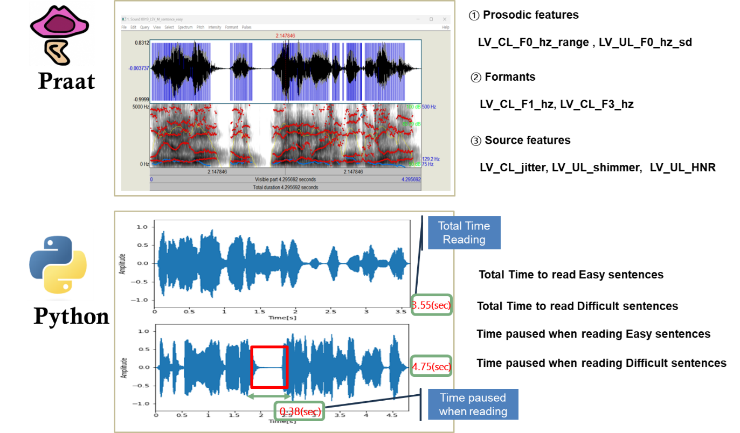
Supplementary Figure 1. Voice feature extraction process using Praat programs; For examples, prosodic, formants, and sound source features. KS-SRRT features, such as time spent uttering long vowels and reading sentences, and pause times, are assessed using Python.

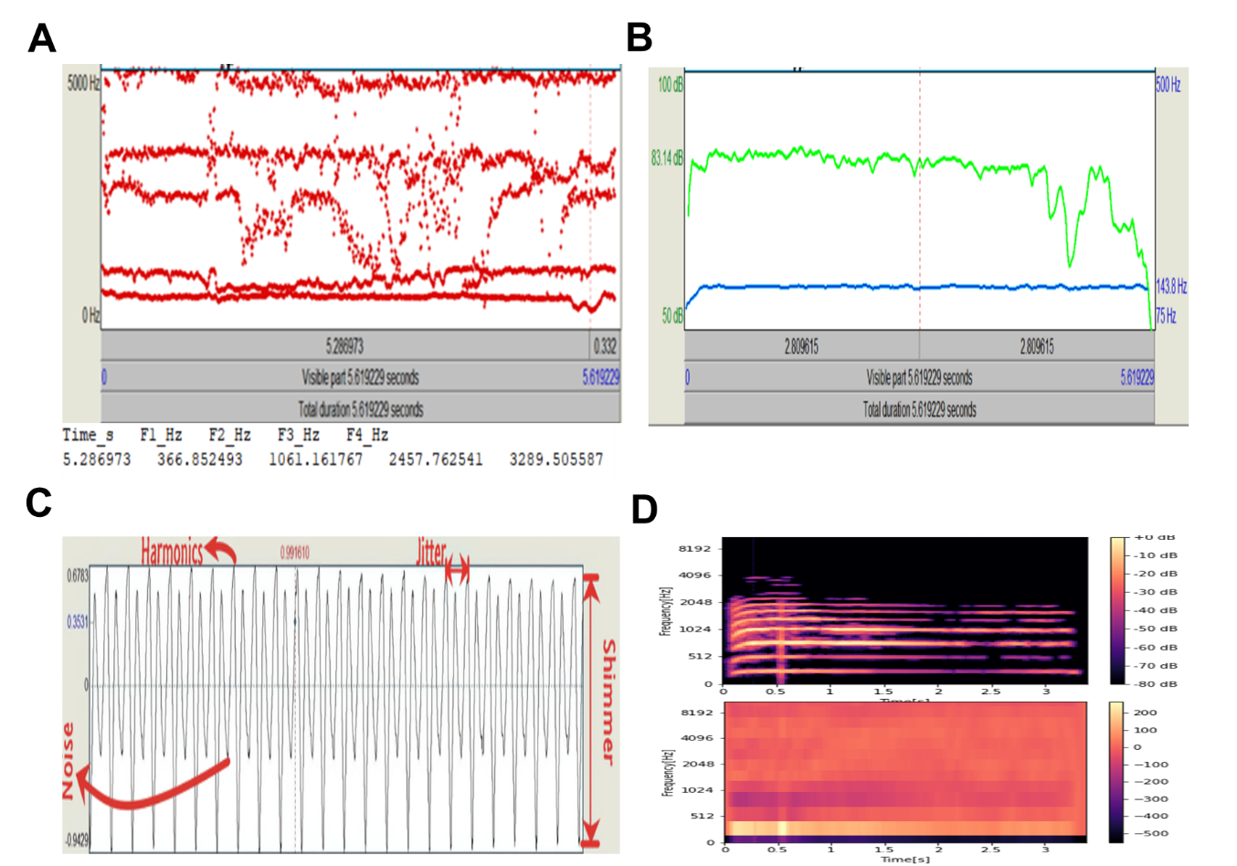
Supplemental Figure 2. Voice feature extraction (A) F1, F2, and F3 estimates extracted from Praat. (B) Fundamental frequency F0 (light-green) and intensity (blue) estimates extracted from Praat. (C) Jitter, shimmer, and HNR estimates extracted using Praat and Python. (D) Mel-spectrogram in Python Example of MFCC in Python.

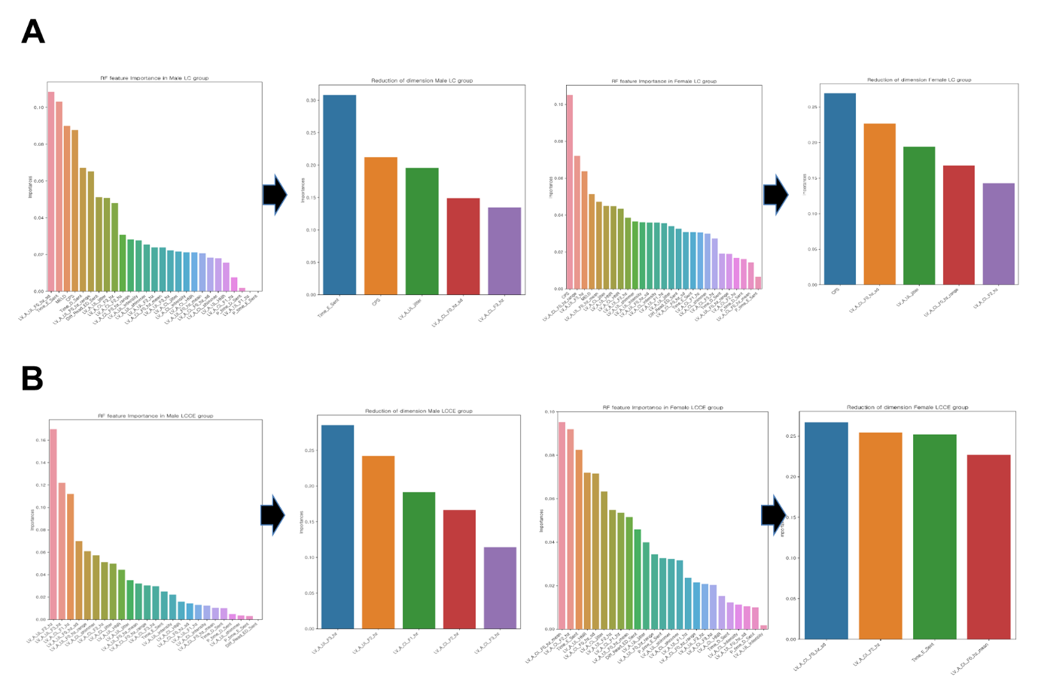
Supplemental Figure 3. To improve the performance of evaluating the HEP-AIR model, dimensionality reduction is random forest's classification accuracy and variable importance were selected. The results of dimension reduction (A) for the model of male LC group (Lt), and for female LC group (Rt) (B) for the model of male LCCE group ( left), and for female LCCE group (Rt).

Supplemental Figure 4. Machine learning architecture of the HEP-AIR model. (A) Introduction to the supervised learning method used in the HEP-AIR study: KNN (K-Nearest Neighbors; in upper left), LR (Logistic Regression; in upper right), SVM (Support Vector Machine; in lower left), and RF (Random Forest; in lower right). (B) Unsupervised learning CNN process for the HEP-AIR study.

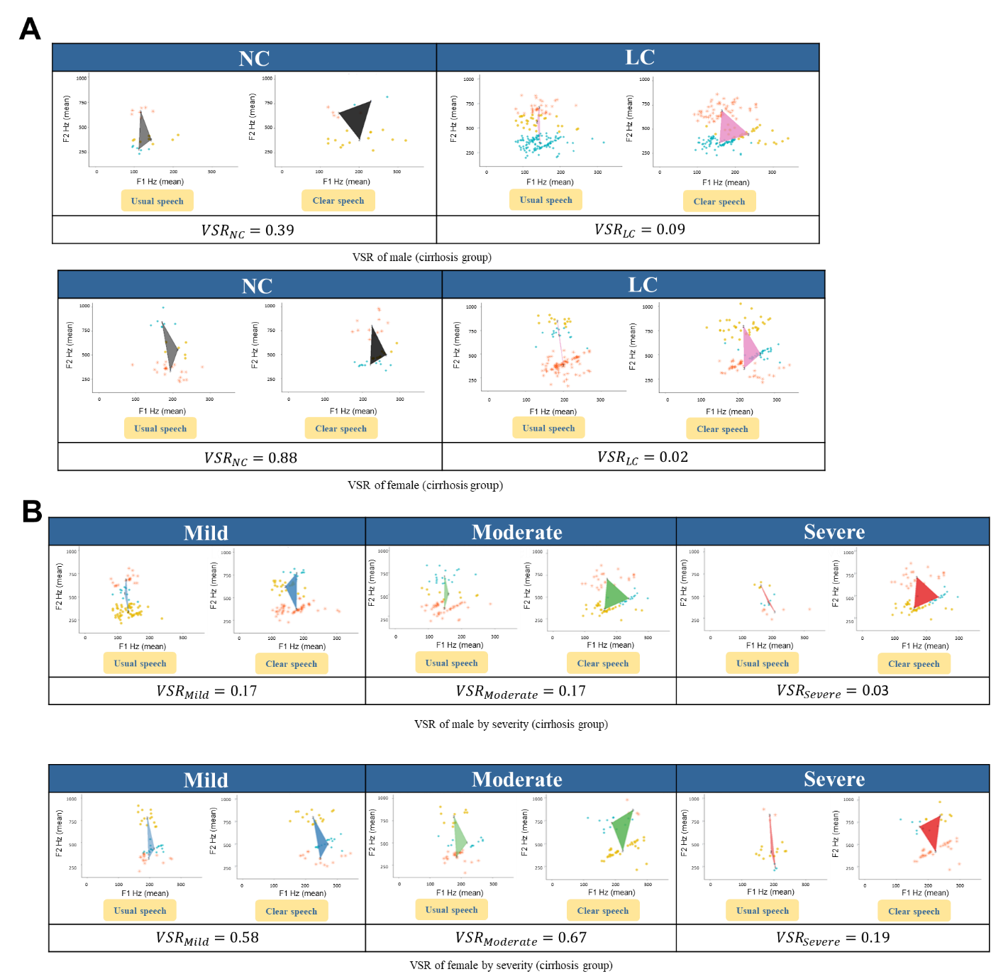
Supplemental Figure 5. (A) Comparison of VSR scale between normal control and liver cirrhosis groups: male (top) and female (bottom). (B) Comparison of VSR scales varying according to severity in a group of 99 patients with cirrhosis: male (top) and female (bottom).

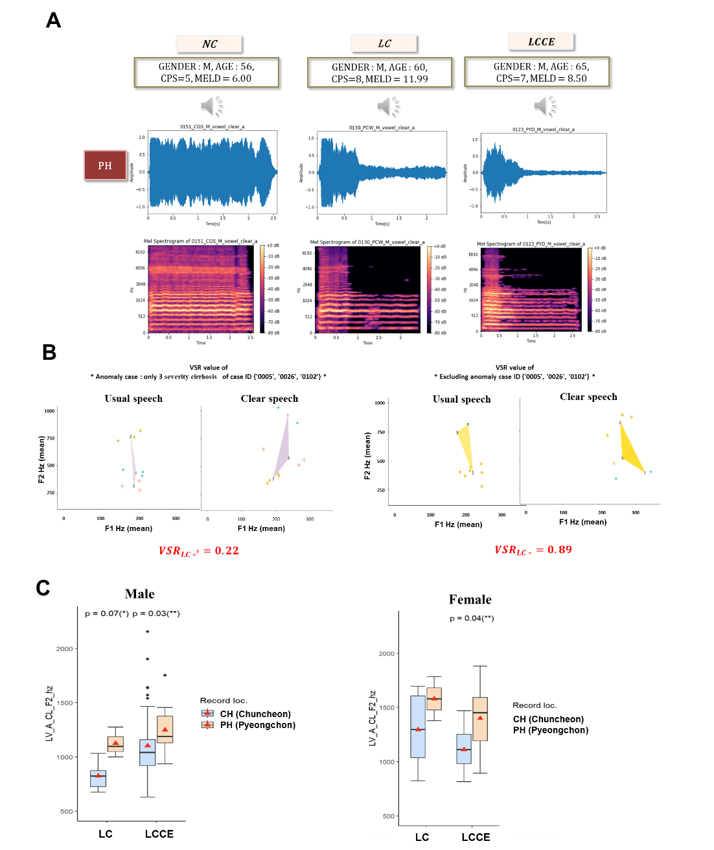
Supplemental Figure 6. (A) Voice data for NC, LC, and LCCE groups used as validation data; demographic information, recorded voice, signal wavelength, and voice Mel-Spectrum of the sample subjects are introduced. (B) The VSR for females excluding the severity of liver function in the LC group, The female LC group included three subjects with very severe liver function (e.g., CPS=13; Meld=23.98), making it difficult to distinguish whether the VSR value was due to cognitive decline or severe liver cirrhosis. Excluding them, the VSR value was 0.89. However, the VSR values of only three 3 subjects with outliers (anomaly) in the LC group was 0.22, indicating that the vowel space of usual speech was very narrow compared with that of clear speech. (C) Box plot of the average of F2 frequency in LC and LCCE groups by gender (left: male, right: female), where CH and PH are the locations where the voice was recorded, the former is used as training data, and the latter is used as diagnostic data; In the case of male, the 'LV_A_CL_F2_hz' variable showed a significant difference (p<0.1) depending on the location of the voice recording through the Mann-Whitney test, and in the case of female, there was a difference only in the LCCE group.
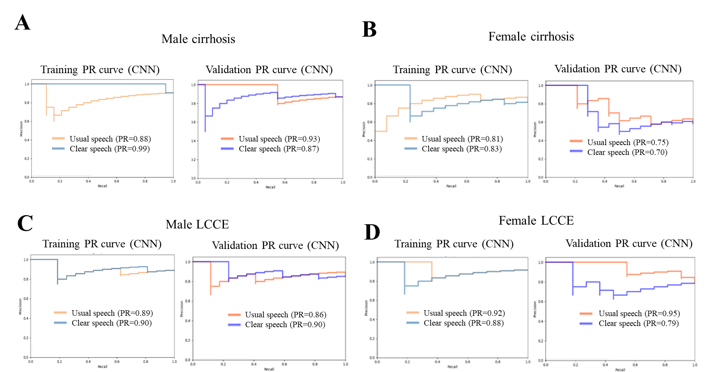
Supplemental Figure 7. To predict the LC and LCCE groups, the evaluation and diagnosis results of the HER-AIR model applying the CNN algorithm: (A) Evaluation scale results for the HEP-AIR model using the CNN algorithm based on the training data of the male LC group: usual speech (88%) and clear speech (99%). For validation, usual speech (94%) and clear speech (87%) were used; (B) assessment and diagnostic outcomes to predict LC in female: usual speech (81%) and clear speech (83%). For validation, usual speech (71%) and clear speech (68%) were used; (C) Evaluation scale results for the HEP-AIR model using the CNN algorithm based on the training data of the male LCCE group: usual speech (89%) and clear speech (90%). For validation, usual speech (82%) and clear speech (91%) were used; (D) Assessment and diagnostic outcomes to predict LCCE in female: usual speech (92%) and clear speech (88%). For validation, the usual speech (91%) and clear speech (95%) were used.

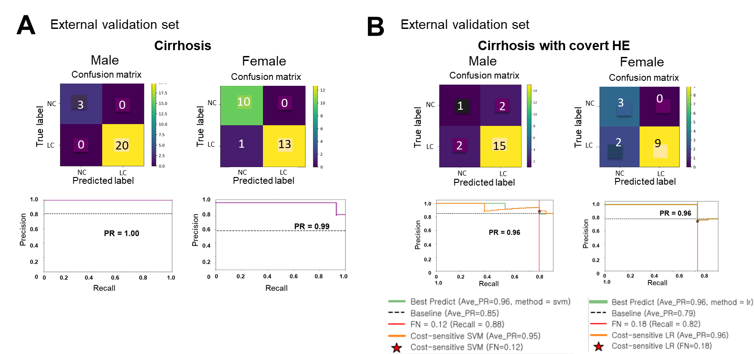
Supplemental Figure 8. Confusion matrix and PR curve. (A) LC group. The results for a total of 23 male subjects were (TP=3, TN=20, FP=0, FN=0) and the results for 24 female subjects were (TP=10, TN=10, FP=0, FN=1). Average PR values in LC group. (B) LCCE group. Precision-Recall curve (green line) and the cost-sensitive SVM PR curve (yellow line) under FN ≤ 0.12 and FN ≤ 0.18 constraints, where the average PR value is 0.96 for the male on the left and 0.96 for the female on the right, respectively. The vertical line (red) indicates the clinical safety constraint (FN = 0.12, Recall = 0.88) and (FN = 0.18; Recal = 0.82). The highlighted operating point (★) represents the cost-optimal threshold satisfying the constraint, achieving a balanced trade-off between sensitivity and precision in covert HE diagnosis.

