Detecting tumor-associated peptides from the plasma-derived soluble immunopeptidome in human hepatocellular carcinoma patients: a pilot study
Amy L. Kessler,^{1,*} Yannick S. Rakké,^{2,*} Lisa Bokhout,¹ Robbie Luijten,¹ Wouter A.S. Doff,³ Karel Bezstarosti,³ Roel F.A. Pieterman,¹ Monique T.A. de Beijer,¹ Jan N.M. IJzermans,² Michail Doukas,⁴ Dave Sprengers,¹ Jeroen A.A. Demmers,³ Sonja I. Buschow^{2,5,§}

¹Department of Gastroenterology and Hepatology, Erasmus MC Cancer Institute, University Medical Center Rotterdam, Rotterdam, the Netherlands
²Department of Surgery, division of HPB & Transplant Surgery, Erasmus MC Transplant Institute, University Medical Center Rotterdam, Rotterdam, the Netherlands
³Proteomics Center, Erasmus University Medical Center, Rotterdam, the Netherlands
⁴Department of Pathology, Erasmus University Medical Center, Rotterdam, the Netherlands
⁵Lead contact

* These authors contributed equally
§ Correspondence: Sonja Buschow, Department of Gastroenterology and Hepatology, Erasmus MC Cancer Institute, University Medical Center Rotterdam, Rotterdam, the Netherlands, s.buschow@erasmusmc.nl

Current address A. Kessler: Biomolecular Mass Spectrometry and Proteomics, Bijvoet Center for Biomolecular Research and Utrecht Institute for Pharmaceutical sciences, University of Utrecht, Utrecht, The Netherlands.
Current address L. Bokhout: Department of Radiology & Nuclear Medicine, Erasmus University Medical Center, Rotterdam, the Netherlands.

Table of contents
Supplementary Figures 4
Figure S1 4
Figure S2 5
Figure S3 7
Figure S4 8
Figure S5 9
Figure S6 11
Figure S7 13
Supplementary Tables 16
Table S1 16
Table S2 18
Table S3 19
Table S4 20
Table S5 21
Supplementary references 23

Supplementary Figures
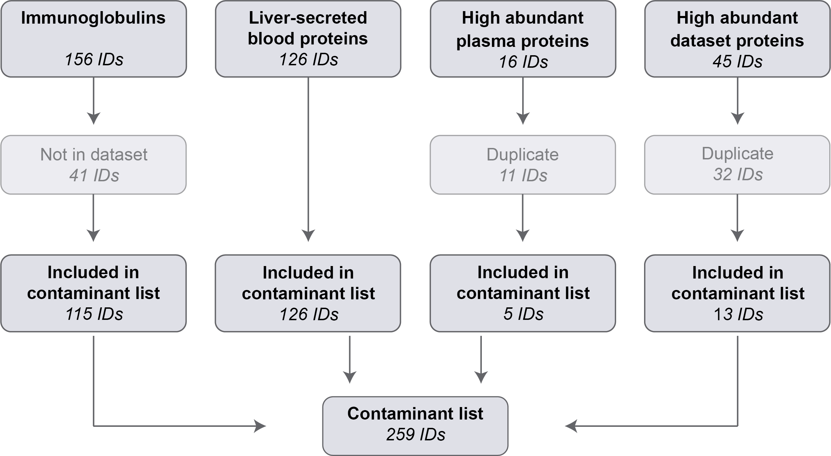
Figure S1 | Analysis workflow for the removal of contaminant peptides from sHLA immunopeptidome data. A soluble HLA (sHLA) contaminant list was compiled from four categories of source proteins. A list of all human immunoglobulin entries was extracted from Uniprot (https://www.uniprot.org/) consisting out of 156 IDs, of which 115 IDs were present in our dataset. From the Human Protein Atlas (https://www.proteinatlas.org/) a list of proteins corresponding to 126 IDs was sourced that are secreted by the liver into the bloodstream. Highly abundant plasma proteins were selected based on literature (16 IDs), of which 11 were present in the lists of liver-secreted blood proteins and immunoglobulins. Lastly, the top 45 most frequent protein accession IDs were included in the contaminant list (threshold: ≥ 500 hits in the entire dataset).

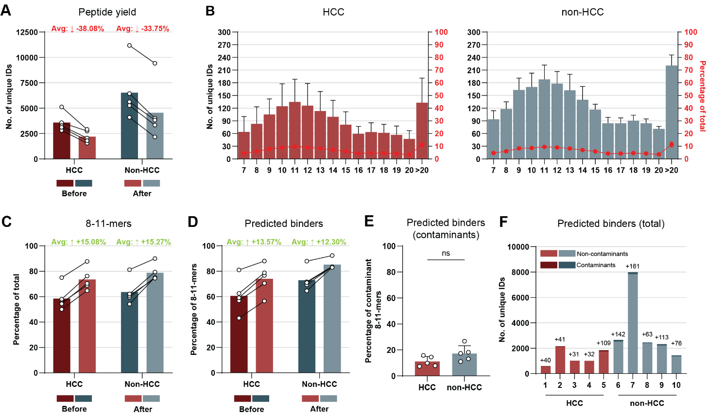
Figure S2 | Removal of contaminant source proteins increases data set quality of soluble HLA-I immunopeptidomes. (A) The number of unique peptides in each sample are displayed in a pair-wise manner before (darker bars) and after (lighter bars) removal of peptides derived from proteins in the curated list of ‘contamination source proteins (i.e., ‘contamination peptides’). (B) Length distribution analysis of all contamination peptides removed from the identified sHLA immunopeptidomes of HCC (red) and non-HCC (blue) patients. Plotted on the right y-axis is the relative contribution in percentage of each n-mer to the total list of removed contamination peptides. Shown are the (C) percentages of 8-11-mers and (D) predicted binders (NetMHCpan 4.1, < 2% binding rank) in each sample before (darker bars) and after (lighter bars) removal of contamination peptides. (E) The percentage of predicted binders (NetMHCpan 4.1, < 2% binding rank) within the pool of removed contamination peptides. (F) The cumulative numbers of predicted binders analyzed in this study. Predicted binders (NetMHCpan 4.1, < 2% binding rank) within the non-contaminant and contaminant list of 8-11-mers were combined and used for analysis in this study. Numbers above each bar correspond to the amount of contaminant-derived predicted binders that were added back to the dataset for further analysis.

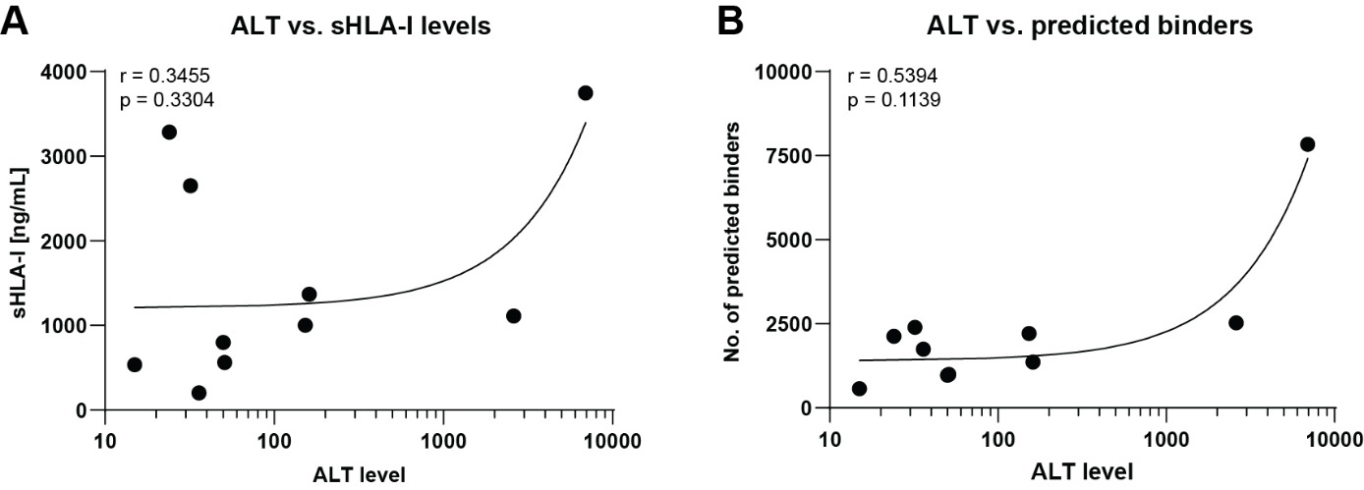

Figure S3 | Correlation of ALT levels with sHLA-I levels and the number of predicted sHLA-I binders. Correlation as determined with a Spearman correlation analysis between (A) ALT levels and sHLA-I levels (r=0.3455, p=0.3304), and (B) ALT levels and the number of predicted binders (r=0.5394, p=0.1139). Curves were fitted by a simple linear regression analysis.

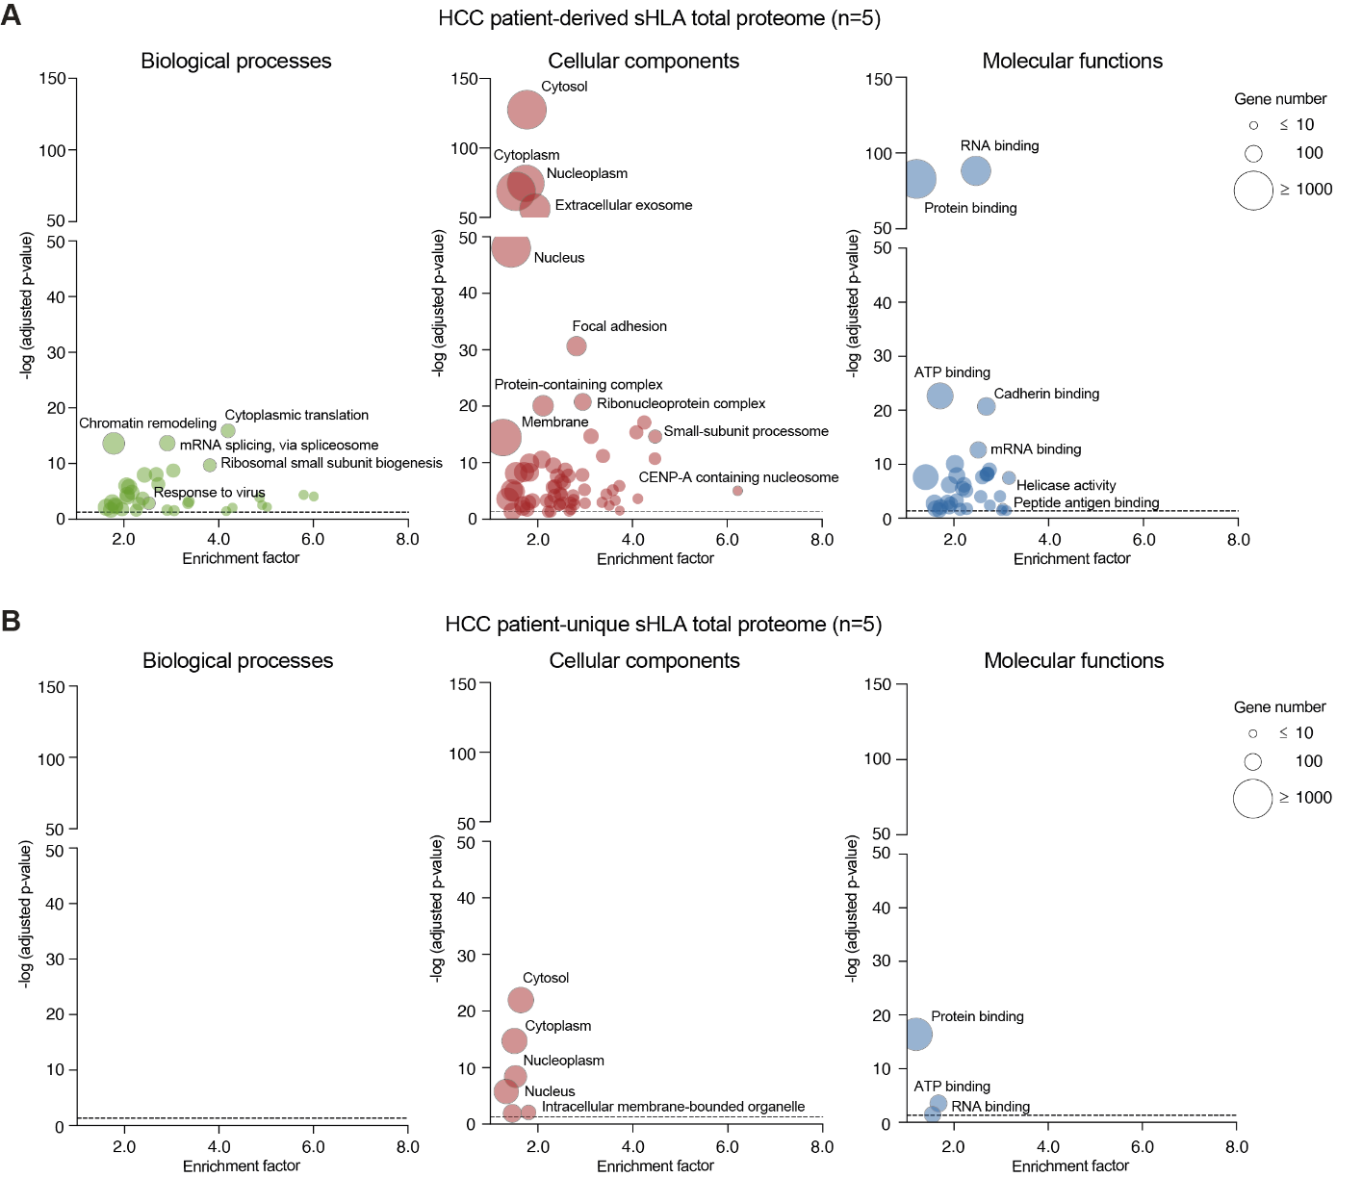
Figure S4 | Gene Ontology analysis on MHC-I peptide-related source protein from the (A) HCC patient-derived and (B) HCC-unique sHLA-I total proteome (n=5). Significantly enriched GO terms (adjusted p-value < 0.05; indicated by the dashed line) among all identified source proteins are displayed, ranked by the –log10 of the Bonferroni-corrected p-value (y-axis) and by the enrichment factor relative to the human genome (x-axis). Balloon size reflects gene count, while color denotes GO term classification. Figure’s abbreviations: GO, gene ontology; HCC, hepatocellular carcinoma; sHLA, soluble Human Leukocyte Antigen.

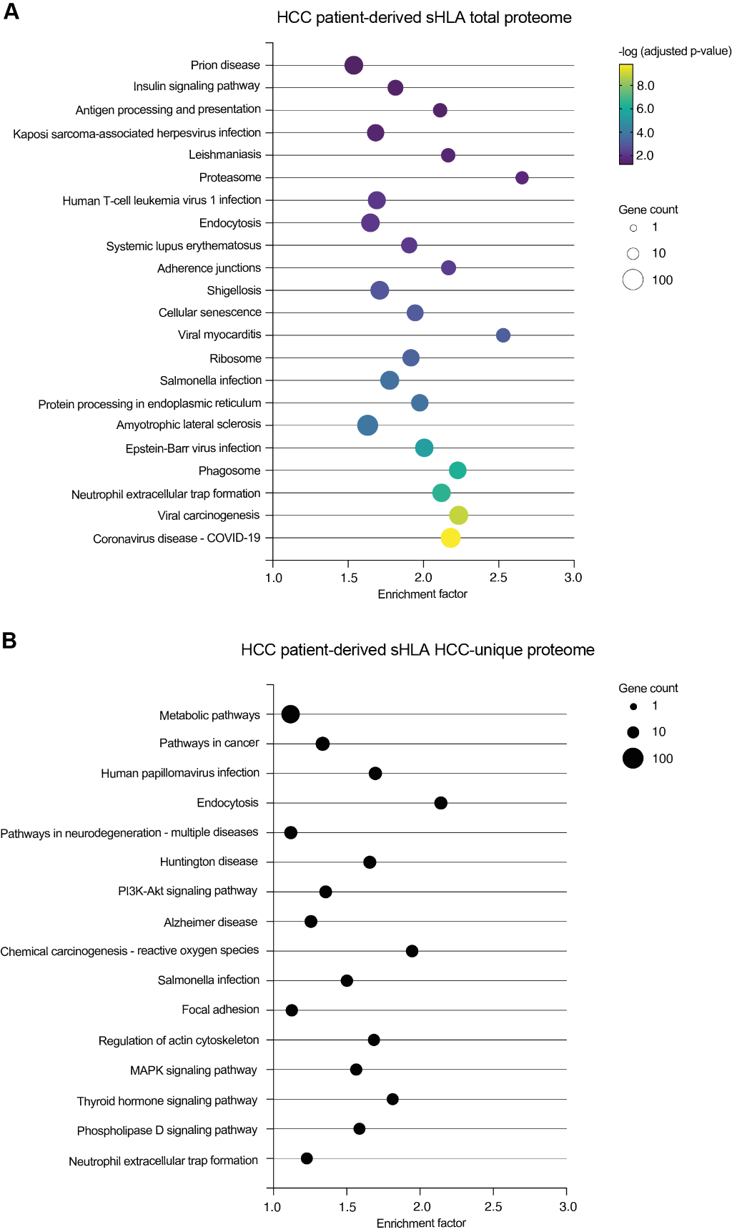
Figure S5 | Kyoto Encyclopedia of Genes and Genomes pathway analysis on MHC-I peptide-related source protein from the HCC patient-derived sHLA-I proteome (n=5). (A) Significantly enriched KEGG pathways (adjusted p-value <0.05) among all identified source proteins are displayed, ranked by the -log10 of the Bonferroni-corrected p-value (balloon color) and by the enrichment factor relative to the human genome (x-axis). Pathway analysis revealed 22 pathways to be enriched, notably those associated with viral infection/disease, viral oncogenesis, and antigen processing and presentation. (B) (Non-significantly enriched) KEGG pathways among the HCC-unique identified source proteins containing at least 15 proteins are displayed, ranked by gene count and by the enrichment factor relative to the human genome (x-axis). Balloon size reflects gene count. Figure’s abbreviations: HCC, hepatocellular carcinoma; KEGG, Kyoto encyclopedia of genes and genomes; sHLA, soluble Human Leukocyte Antigen.

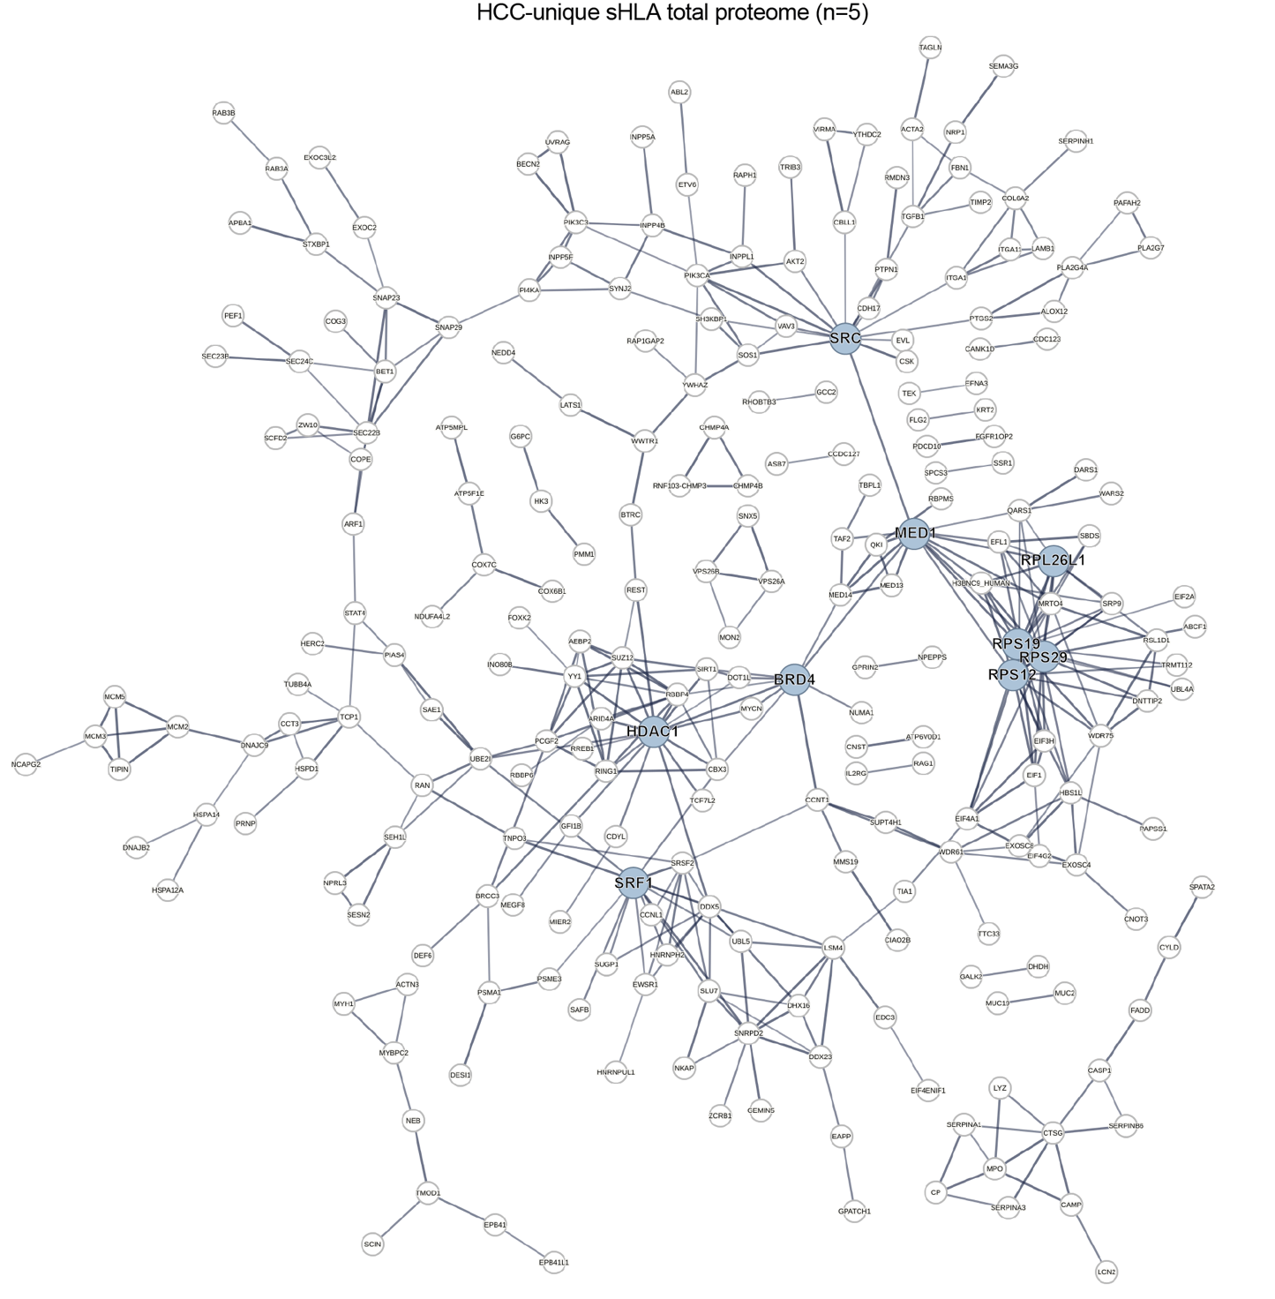
Figure S6 | HCC-unique sHLA-I cargo protein-protein network. STRING protein-protein interaction network of HCC-unique sHLA source protein cargo (n=5). Edge width reflects interaction confidence (≥ 0.7), with thicker edges indicating stronger associations. Nodes demonstrating ≥ 10 interactions are highlighted in blue. Five out of nine connecting nodes have been previously linked to HCC carcinogenesis (BRD1 [1, 2], HDAC1 [3-5], MED1 [6-8], SRC [9-11], and SRF1 [12]). Abbreviations: HCC, hepatocellular carcinoma; sHLA, soluble Human Leukocyte Antigen.
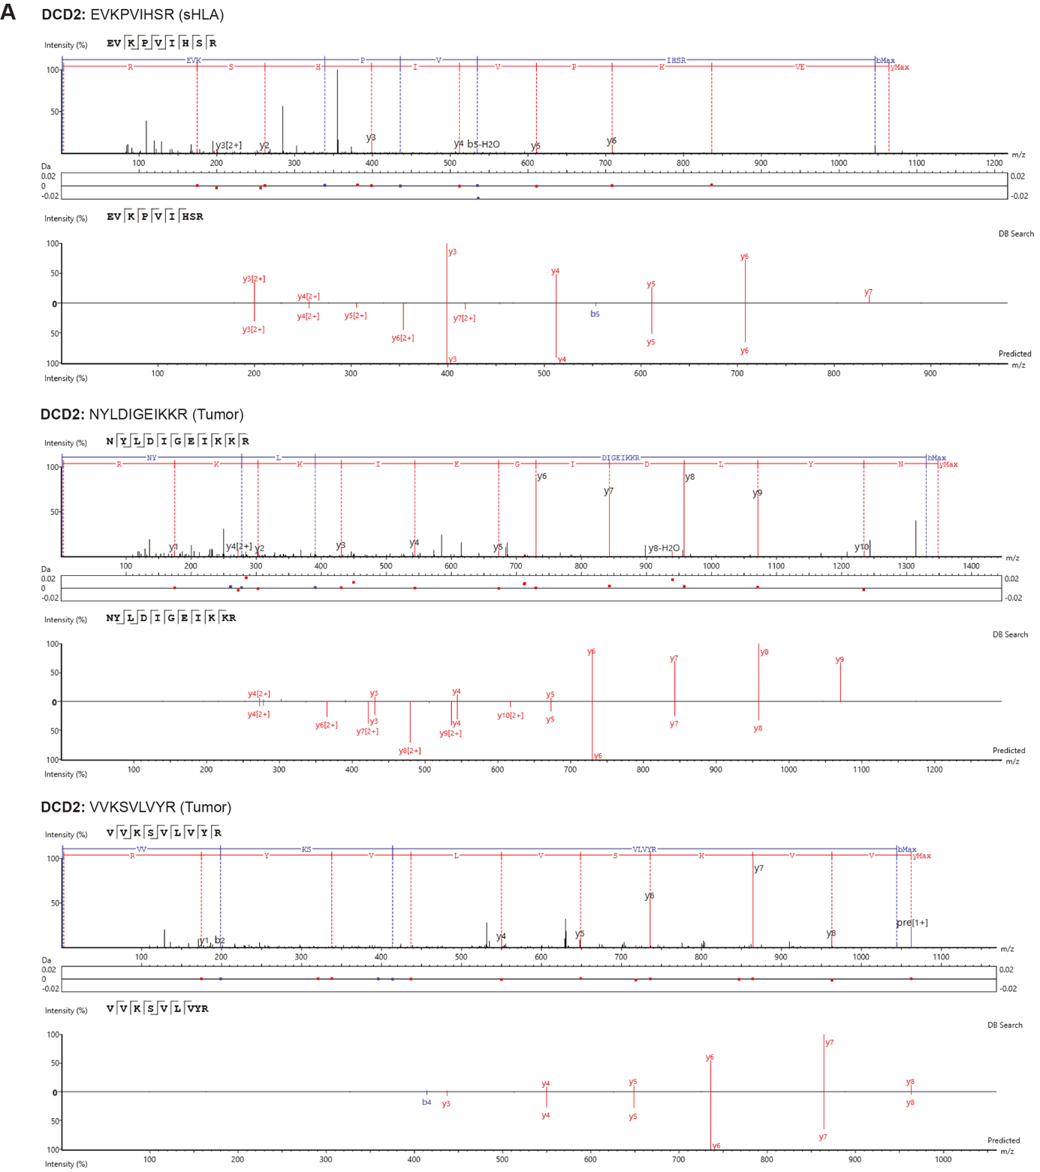

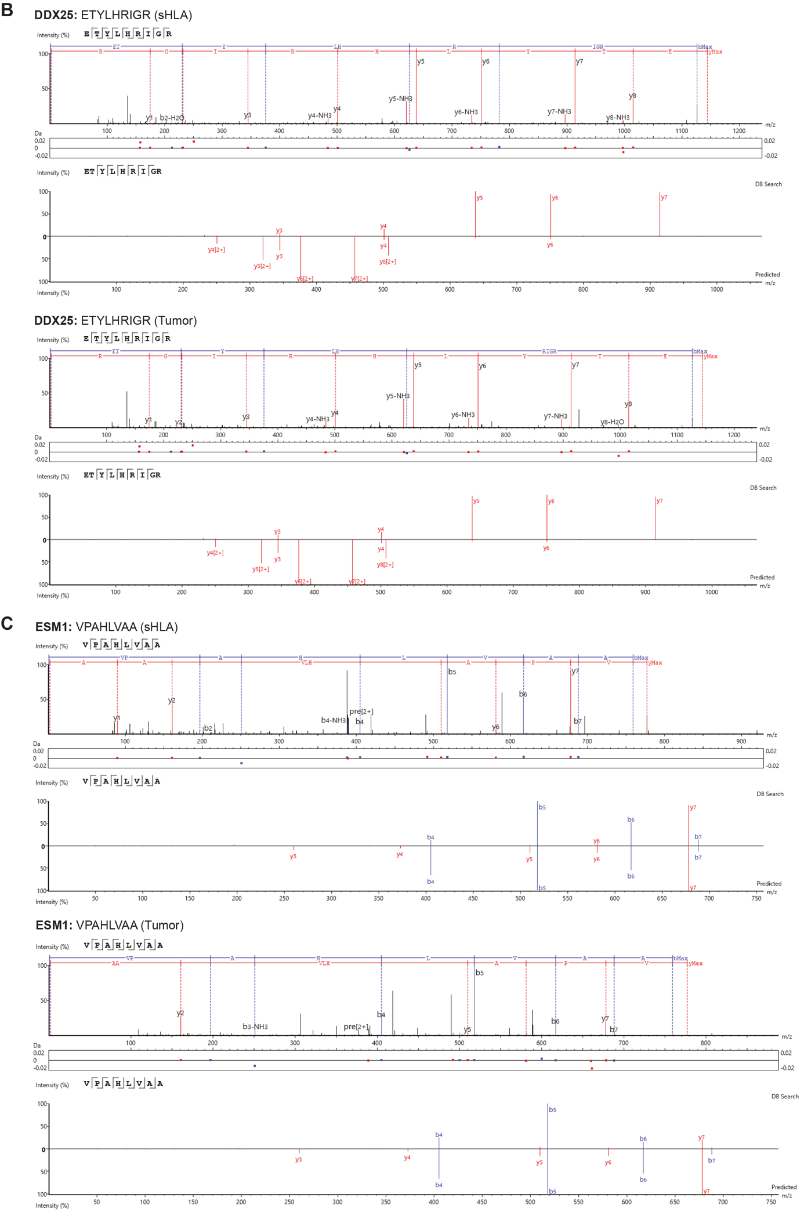
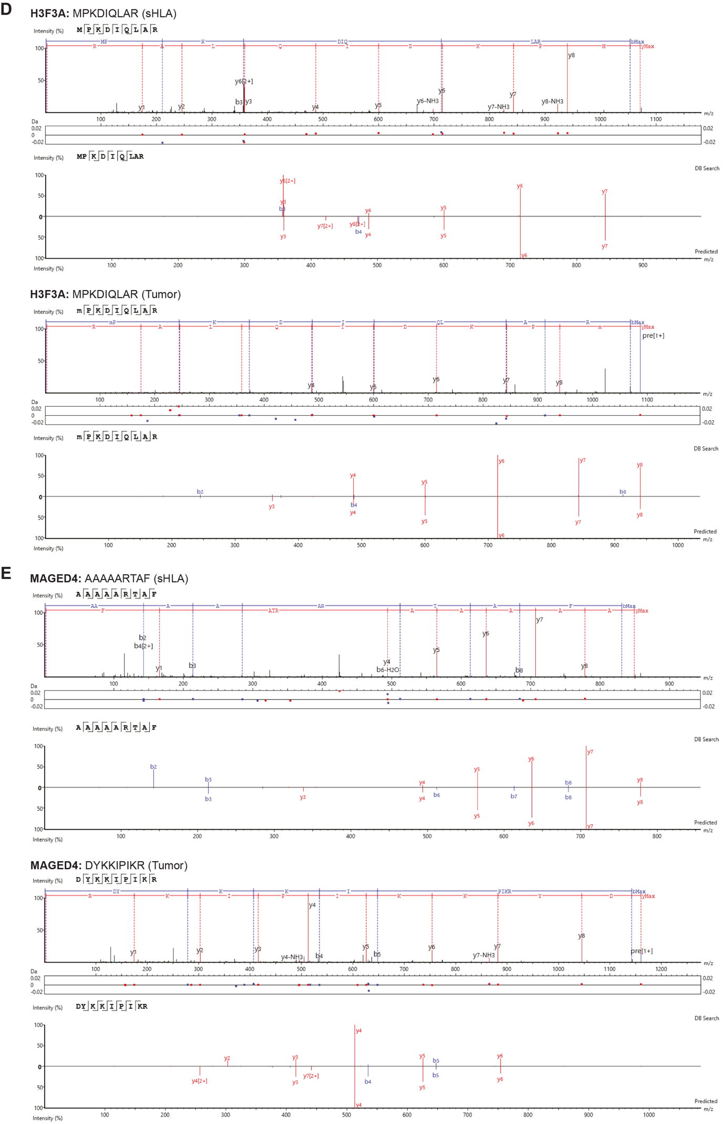Figure S7 | Comparison of recorded spectra to predicted spectra of HCC-unique, TAA-derived peptides of interest. Recorded spectra of TAA-derived peptides specific to HCC samples (Table S5; A: DCD2, B: DDX25, C: ESM1, D: H3F3A, E: MAGED4) were compared with spectra generated by PEAKS by mirroring both datasets. For each peptide detected in either the sHLA or tumor ligandome, the experimentally acquired spectrum (top) is shown together with the corresponding mirrored PEAKS-predicted spectrum (bottom) for direct spectral comparison.

Supplementary Tables
Table S1 | Patients’ characteristics.
Patient ID | Gender | Age | Etiology of disease | HBV/ HCV/HDV (sero)statusª | Cirrhosis  (CP) | Fibrosis | ALT^{b} | Max. tumor diameter^{c} | Tumor lesion no. | Differentiation  grade | MVI | AFP^{d}
HCC cohort
1 | M | 76 | HBV | P/N/N | Yes (A) | Yes | 15 | 70 | 1 | Poor/ Moderate | Yes | 23
2 | M | 52 | HBV | P/N/N | No | No | 24 | 95 | 1 | Moderate | Yes | 10709
3 | M | 59 | HBV | P/N/N | No | Yes | 51 | 109 | 2 | Moderate | Yes | 35
4 | M | 64 | Cryptogenic | N/N/N | Yes (C) | Yes | 50 | 61 | 3 | Moderate | Yes | 581
5 | M | 62 | ALD | P/N/N | Yes (B) | Yes | 36 | 20 | 3 | Good/ Moderate | Yes | 28
Non-HCC liver disease cohort
6 | M | 61 | HBV | P/N/N | No | No | 2609 | - | - | - | - | 11
7 | M | 26 | HBV | P/N/P | No | No | 6914 | - | - | - | - | ND
8 | F | 45 | ALD | N/N/N | Yes (B) | Yes | 32 | - | - | - | - | 4
9 | M | 60 | PSC | N/N/N | Yes (C) | Yes | 153 | - | - | - | - | 3
10 | M | 60 | PSC | N/N/N | Yes (C) | Yes | 161 | - | - | - | - | 2
ª HBV serostatus was deemed positive whenever HBV DNA and/or, HBsAg and/or, anti-HBc antibodies were positive. HCV serostatus was deemed positive whenever IgG anti-HCV antibodies were positive. HDV status was deemed positive whenever HDV RNA was positive.
^{b} In U/mL.
^{c} In mm.
^{d} In ng/mL.
Table’s abbreviations: AFP, alpha fetoprotein; ALD, alcohol-related liver disease; CP, Child-Pugh score; HBV, hepatitis B virus; HCC, hepatocellular carcinoma; HCV, hepatitis C virus; HDV, hepatitis D virus; MVI, microvascular invasion; ND, not determined; N, negative; P, positive; PSC, primary sclerosing cholangitis.

Table S2 | Patients’ HBV viral status.
Patient ID | HBsAg  (IU/L) | Anti-HBs  (mIU/mL) |  | Anti-HBc | Anti-HBc  (IgM) | HBeAg | Anti-HBe | HBV viral load (IU/mL) | HBV statusª | Anti-viral | Albumin (g/L)
HCC cohort
1 | >150 |  | Neg | Pos | ND | Neg | Neg | <2.0E1/Neg | C | ENT | 45
2 | >150 |  | Neg | Pos | Neg | Neg | Pos | <2.0E1/Pos | C | TDF | 47
3 | >150.000 |  | ND | Pos | Neg | 0.4030 | Pos | 5.87E4/Pos | C | TDF | 35
5 | Neg |  | Neg | Pos | ND | ND | Pos | <1.0E1/Neg | R | None | 28
Non-HCC liver disease cohort
6 | 14.3/P |  | 88.00/P | Neg | Neg | Neg | ND | 8.08E4/Pos | A | None | 27
7^{b} | >150.000 |  | ND | Pos | Neg | Neg | Pos | 1.18E3/Pos | C | None | 33
ª HBV status: acute infection (positive [pos] for HBsAg and IgM anti-HBc); chronic infection (pos for HBsAg and anti-HBc); resolved infection (HBsAg negative [neg] and anti-HBc pos).
^{b} Patient 7 was tested positive for HDV RNA.
Table’s abbreviations: A, acute infection; C, chronic infection; ENT, entecavir; Neg, negative; ND, not determined; Pos, positive; R, resolved infection; TDF, tenofovir.
Table S3 | Patients’ HLA-I genotypes. Peripheral blood mononuclear cells (PBMC) were isolated from whole blood by Ficoll density gradient separation and stored at -80°C for HLA genotyping. DNA was isolated from PBMC using the QIAamp DNA micro kit (Qiagen, Hilden, Germany) according to manufacturer’s instructions. The HLA genotype was determined through imputation-based HLA genotyping using the Infinium Global Screening Array v.3.0 plus multi-disease BeadChip (GSAMD-24v3-0-EA; Illumina, San Diego, the U.S.A.).

Patient ID | HLA-A |  | HLA-B |  | HLA-C
1 | 01:01 | 02:01 | 08:01 | 14:01 | 07:01 | 08:02
2 | 33:01 | 68:02 | 52:01 | 78:01 | 16:01 | 16:01
3 | 02:01 | 32:01 | 37:01 | 44:02 | 05:01 | 06:02
4 | 01:01 | 01:01 | 08:01 | 08:01 | 07:01 | 07:01
5 | 03:01 | 11:01 | 44:02 | 44:02 | 07:04 | 07:04
6 | 02:01 | 03:01 | 07:02 | 44:02 | 07:02 | 07:04
7 | 02:01 | 30:01 | 35:01ª | 42:01^{b} | 16:01 | 17:01
8 | 01:01 | 24:02 | 08:01 | 14:02 | 02:02 | 07:01
9 | 03:01 | 11:01 | 07:02 | 40:02 | 02:02 | 07:02
10 | 01:01 | 01:01 | 08:01 | 15:18 | 07:01 | 07:04

ª HLA-B*35:01 or 07:235.
^{b} HLA-B*42:01 or 35:87.

Table S4 | Identified mHLA-I peptides derived from the hepatitis B virus proteome. The entire dataset consisting of identified sHLA-I and mHLA-I immunopeptides was searched against 4 reference HBV proteomes. Identified HBV-derived peptides are listed below, including their length, source protein, sample and tissue of origin and their predicted binding as determined by NetMHCPan4.1 (binding rank ≤2.0%) to the respective donor HLA alleles. HBsAg = Hepatitis B surface antigen; N.A. = not applicable due to too short peptide sequence; N.B. = Predicted non-binder.

Sequence | Length | Source protein | Sample | Tissue | Predicted binder
FLGPLLVL | 8 | HBsAg | Pt.3 | Tumor adjacent | Yes
ILSPFLPLL | 9 | HBsAg | Pt.3 | Tumor adjacent | Yes
LVLQAGF | 7 | HBsAg | Pt.3 | Tumor adjacent | N.A.
LVLQAGF | 7 | HBsAg | Pt.2 | Tumor adjacent | N.A.
MENITSGFLGPL | 12 | HBsAg | Pt.2 | Tumor adjacent | N.B.
STSNPLGFFPDH | 12 | HBsAg | Pt.2 | Tumor adjacent | N.B.

Table S5 | TAAs from which peptides were found in both the plasma sHLA-I and tissue mHLA-I peptidome from HCC patients.
Source protein | Peptide  from sHLA-I | Position | HLA typeª | Donor | mHLA-I presentation |  | sHLA-I presentation  Non-HCC | IEDB^{c}
 |  |  |  |  | Tumor | Tumor-adjacent | sHLA-I presentation  Non-HCC
ABCC3 | VAVERVKEY | 1255-1263 | B*78:01  C*16:01ª | HCC 2 | No | Yes | Yes | ●
BCL2L1 | MAAVKQAL | 83-90 | B*78:01  C*16:01ª | HCC 2 | Yes^{b} | Yes^{b} | Yes | ●
BCL2L1 | MQVLVSRI | 159-166 | B*52:01 | HCC 2 | Yes | Yes | Yes^{b} | ●
CDK4 | FGLARIYSY | 159-167 | C*16:01 | HCC 2 | Yes | Yes | Yes | ○
CDK4 | ISTVREVAL | 51-59 | C*16:01 | HCC 2 | Yes | Yes | Yes | ○
DCD2 | EVKPVIHSR | 116-124 | A*33:01ª  A*68:02 | HCC 2 | Yes^{b} | No | No | NR
DDX25 | ETYLHRIGR | 426-434 | A*33:01 | HCC 2 | Yes | Yes | No | ●
ESM1 | VPAHLVAA | 12-19 | B*78:01 | HCC 2 | Yes | No | No | ●
FOXO1 | SVKTTTHSW | 644-652 | A*32:01ª  B*44:02  C*06:02 | HCC 3 | No | Yes^{b} | Yes^{b} | ○●
FOXO1 | VAQPNSRVL | 484-492 | B*52:01ª  B*78:01 | HCC 2 | No | Yes | Yes | ●
GANAB | SISDVFRQY | 371-379 | C*16:01 | HCC 2 | Yes | Yes | Yes | ○
HSDL1 | SRADLIKQY | 58-66 | B*44:02  C*06:02ª | HCC 3 | Yes | Yes | Yes^{b} | ○●
H3F3A | MPKDIQLAR | 121-129 | A*33:01ª  B*78:01 | HCC 2 | Yes | Yes | No | ○●
LZTFL1 | VAALKSEF | 215-222 | C*16:01 | HCC 2 | Yes^{b} | Yes^{b} | Yes^{b} | NR
MAGED4 | AAAAARTAF | 120-128 | C*16:01 | HCC 2 | Yes^{b} | Yes^{b} | No | ●
MFGE8 | VASYKVAY | 216-223 | C*16:01 | HCC 2 | Yes^{b} | No | Yes | ●
MIA2 | ASEFQILKY | 598-606 | A*01:01ª  C*07:01 | HCC 1 | Yes | Yes | Yes | ○●
RPTOR | FALQREQEL | 209-217 | B*52:01  B*78:01  C*16:01ª | HCC 2 | Yes^{b} | Yes | Yes | ○●
SUPT7L | TLTDVAHEY | 181-189 | C*16:01 | HCC 2 | Yes | Yes | Yes^{b} | ○
ZC3H14 | KTTNVRQTY | 139-147 | A*32:01ª  C*06:02 | HCC 3 | Yes | Yes | Yes | ○●

ª In silico predicted HLA-binding allele with the highest putative affinity for the peptide of interest.
^{b} A different peptide from the same TAA was identified from tissue mHLA.
^{c} Peptides are annotated based on their IEDB classification as HLA ligands and/or T cell epitopes. Reported sequences are marked as identified in a novel (○), the same (●), or an additional (○●) HLA supertype context. No peptides were classified as immunogenic (i.e., positive multimer binding and/or IFNg production).
Table’s abbreviations: HLA, human leukocyte antigen; IEDB, Immune Epitope Database; NR, not reported.

Supplementary references
1. Cai QQ, Dong YW, Qi B, Shao XT, Wang R, Chen ZY, et al. BRD1-Mediated Acetylation Promotes Integrin alphaV Gene Expression Via Interaction with Sulfatide. Mol Cancer Res. 2018;16(4):610-22. doi: 10.1158/1541-7786.MCR-17-0527.
2. Zhang M, Bai J, Yuan H, Duan X, Yu L, Li Y, et al. BRD1 deficiency affects SREBF1-related lipid metabolism through regulating H3K9ac/H3K9me3 transition to inhibit HCC progression. Cell Death Dis. 2025;16(1):104. doi: 10.1038/s41419-025-07404-7.
3. Buurman R, Gurlevik E, Schaffer V, Eilers M, Sandbothe M, Kreipe H, et al. Histone deacetylases activate hepatocyte growth factor signaling by repressing microRNA-449 in hepatocellular carcinoma cells. Gastroenterology. 2012;143(3):811-20 e15. doi: 10.1053/j.gastro.2012.05.033.
4. Yang J, Jin X, Yan Y, Shao Y, Pan Y, Roberts LR, et al. Inhibiting histone deacetylases suppresses glucose metabolism and hepatocellular carcinoma growth by restoring FBP1 expression. Sci Rep. 2017;7:43864. doi: 10.1038/srep43864.
5. Freese K, Seitz T, Dietrich P, Lee SML, Thasler WE, Bosserhoff A, et al. Histone Deacetylase Expressions in Hepatocellular Carcinoma and Functional Effects of Histone Deacetylase Inhibitors on Liver Cancer Cells In Vitro. Cancers (Basel). 2019;11(10). doi: 10.3390/cancers11101587.
6. Viswakarma N, Jia Y, Bai L, Gao Q, Lin B, Zhang X, et al. The Med1 subunit of the mediator complex induces liver cell proliferation and is phosphorylated by AMP kinase. J Biol Chem. 2013;288(39):27898-911. doi: 10.1074/jbc.M113.486696.
7. Tsang FH, Law CT, Tang TC, Cheng CL, Chin DW, Tam WV, et al. Aberrant Super-Enhancer Landscape in Human Hepatocellular Carcinoma. Hepatology. 2019;69(6):2502-17. doi: 10.1002/hep.30544.
8. Chen W, Wu C, Li Y, Wang T, Huang M, Wang M, et al. Mir-483-5p-mediated activating of IGF2/H19 enhancer up-regulates IGF2/H19 expression via chromatin loops to promote the malignant progression of hepatocellular carcinoma. Mol Cancer. 2025;24(1):10. doi: 10.1186/s12943-024-02204-7.
9. Ito Y, Kawakatsu H, Takeda T, Sakon M, Nagano H, Sakai T, et al. Activation of c-Src gene product in hepatocellular carcinoma is highly correlated with the indices of early stage phenotype. J Hepatol. 2001;35(1):68-73. doi: 10.1016/s0168-8278(01)00077-0.
10. Pang Y, Liu Z, Han H, Wang B, Li W, Mao C, et al. Peptide SMIM30 promotes HCC development by inducing SRC/YES1 membrane anchoring and MAPK pathway activation. J Hepatol. 2020;73(5):1155-69. doi: 10.1016/j.jhep.2020.05.028.
11. Yang J, Zhang X, Liu L, Yang X, Qian Q, Du B. c-Src promotes the growth and tumorigenesis of hepatocellular carcinoma via the Hippo signaling pathway. Life Sci. 2021;264:118711. doi: 10.1016/j.lfs.2020.118711.
12. Park MY, Kim KR, Park HS, Park BH, Choi HN, Jang KY, et al. Expression of the serum response factor in hepatocellular carcinoma: implications for epithelial-mesenchymal transition. Int J Oncol. 2007;31(6):1309-15.

