Supplementary materials

Supplementary Methods
Net Clinical Utility (NCU) composite. From a baseline of 100, the NCU subtracted 40 points for failure to clear the stone at 1 month, 100 for any catastrophic event (sepsis, transfusion, or interventional hemostasis), 20 for postoperative fever in the absence of a catastrophic event, and 2 for every additional 10 minutes of operative time. The NCU was prespecified as a transparent analytic composite and is interpreted as a value framework rather than a validated clinical endpoint.
Causal-forest specification. A causal forest of 2000 honest trees was fitted on the NCU using nine routine preoperative features (age, BMI, sex, hypertension, diabetes, maximum stone diameter, hydronephrosis score, calyx score, and CT attenuation). Patient-level conditional average treatment effects (CATEs) were reported with 95% confidence intervals from the forest variance estimates, and the presence of heterogeneity was tested with the forest calibration test. A depth-2 policy tree was trained on the doubly robust scores, and the value of the resulting individualized policy was compared with treat-all-SMP and treat-all-sPCNL strategies using an honest training–evaluation split.
Sensitivity analyses. Robustness of each population-level estimate to unmeasured confounding was quantified with E-values. Robustness of the individualized analysis to the NCU weighting was examined across seven alternative weighting schemes plus the base weighting scheme (Supplementary Table S4). Analyses used R 4.3.1 (packages tmle, SuperLearner, grf, policytree, and EValue); missing data were handled by complete-case analysis in TMLE and by missForest imputation for the causal-forest features.

Supplementary Tables
Table S1 Intraoperative procedural parameters reported descriptively and excluded from causal models
Parameter | SMP (n = 450) | sPCNL (n = 450) | P
Tract length ≥ 10 cm | 437/450 (97.1%) | 434/450 (96.4%) | 0.571
Number of tracts (mean ± SD) | 1.06 ± 0.23 | 1.05 ± 0.22 | 0.767
Imaging guidance (US/C-arm/combined) | 324/108/18 | 322/118/10 | 0.255
All three parameters are post-treatment variables and were excluded from the TMLE and causal-forest covariate sets per the W → A → Y ordering. US, ultrasound; SD, standard deviation.
Table S2 Full 17 prespecified outcomes with crude comparisons and TMLE-adjusted average treatment effects
Outcome | SMP | sPCNL | TMLE ATE (95% CI) | P | E-value
Primary outcomes
1-day SFR | 86.4% | 85.3% | +2.18% (−0.68, +5.04) | 0.135 | —
1-month SFR | 93.6% | 92.7% | +2.05% (−0.53, +4.63) | 0.120 | —
Operative time (min) | 32.68 | 32.98 | −1.13 (−1.36, −0.91) | <0.001 | —
Secondary outcomes
Hb drop (g/L) | 16.42 | 16.98 | −0.83 (−1.14, −0.52) | <0.001 | 1.8
Transfusion | 0.4% | 1.1% | −1.19% (−1.99, −0.40) | 0.003 | —
Interventional hemostasis | 0.2% | 0.7% | −0.79% (−1.40, −0.19) | 0.010 | —
VAS-6h | 5.57 | 5.96 | −0.44 (−0.52, −0.36) | <0.001 | 2.6
VAS-24h | 2.01 | 3.00 | −1.02 (−1.08, −0.96) | <0.001 | 8.4
Length of stay (days) | 1.89 | 2.35 | −0.53 (−0.65, −0.42) | <0.001 | 2.3
Tubeless rate | 11.6% | 25.3% | −9.68% (−12.45, −6.91) | <0.001 | —
Postoperative fever | 6.7% | 9.6% | −3.63% (−6.15, −1.11) | 0.005 | 2.6
Sepsis | 1.1% | 0.9% | +0.24% (−0.72, +1.19) | 0.630 | —
Exploratory outcomes
Auxiliary treatment | 0.4% | 0.7% | −0.37% (−1.18, +0.45) | 0.377 | —
Analgesic use | 20.0% | 18.2% | +1.37% (−2.46, +5.19) | 0.483 | —
Postoperative Hb (g/L) | — | — | +0.69 (+0.38, +1.01) | <0.001 | —
Postoperative WBC (×10⁹/L) | 11.11±2.52 | 10.96±2.39 | +0.12 (−0.12, +0.36) | 0.324 | —
Postoperative creatinine (µmol/L) | 84.30±16.93 | 84.10±16.88 | −1.09 (−2.48, +0.29) | 0.123 | —
Values are % , mean, or mean ± SD as appropriate. ATE, average treatment effect after adjustment for the prespecified preoperative covariates; CI, confidence interval; SFR, stone-free rate; VAS, visual analog scale. E-values are point-estimate E-values (confidence-bound E-value for fever ≈ 1.5). Rare-event estimates (transfusion, interventional hemostasis, sepsis) and all exploratory outcomes are hypothesis-generating. Postoperative hemoglobin is reported as the TMLE estimate only.
Table S3 Doubly robust value of alternative treatment strategies based on Net Clinical Utility
Strategy | NCU value (SE) | Gain vs treat-all-SMP
Treat all with sPCNL | 86.1 (0.93) | −2.5
Treat all with SMP (reference) | 88.6 (0.77) | Reference
Individualized by CATE sign | 88.7 | +0.13
Individualized policy tree (honest, out-of-sample) | — | +1.2 (95% CI −0.8 to +3.2)
Values are doubly robust (AIPW) estimates. The individualized policy did not significantly outperform treating all patients with SMP. SE, standard error; CATE, conditional average treatment effect.
Weighting scenario | Mean CATE | Patients favoring SMP (%) | Policy-tree root split
Base (SFR 40, catastrophic 100, fever 20, time 2) | 2.40 | 91.1 | CT attenuation (1153 HU)
Catastrophic event weight 50 | 2.00 | 90.4 | CT attenuation (1153 HU)
Catastrophic event weight 150 | 2.75 | 88.2 | CT attenuation (988 HU)
Fever weight 10 | 2.00 | 89.3 | CT attenuation (988 HU)
Fever weight 40 | 3.22 | 92.1 | CT attenuation (1153 HU)
Operative-time weight 1 | 2.25 | 89.4 | CT attenuation (1153 HU)
Operative-time weight 4 | 2.60 | 93.1 | CT attenuation (988 HU)
SFR-failure weight 60 | 2.83 | 89.9 | CT attenuation (1151 HU)
Table S4 Sensitivity of the individualized analysis to the Net Clinical Utility weighting scheme
Each scenario re-estimates the causal forest and depth-2 policy tree after changing one NCU weight from its base value; the value in parentheses is the root-split threshold on CT attenuation. Across the eight weighting scenarios (base plus seven alternatives), the share of patients with a point estimate favoring SMP stayed within 88–93%, and CT attenuation remained the primary policy-tree split, indicating that the central findings do not depend on the specific NCU weights. To keep these sensitivity re-fits computationally tractable, this analysis used 1000 trees; the base row therefore differs slightly from the main-text estimate obtained with 2000 trees (mean CATE +2.61; 92.1% favoring SMP). CATE, conditional average treatment effect; HU, Hounsfield units; SFR, stone-free rate.

Supplementary Figures
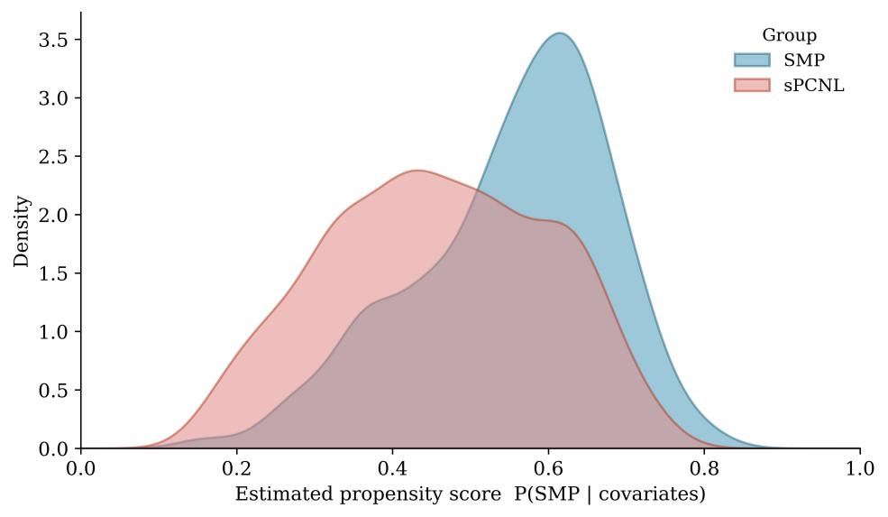
Fig. S1 Propensity-score overlap between SMP and sPCNL. Broad common support and the absence of extreme propensity scores support the positivity assumption
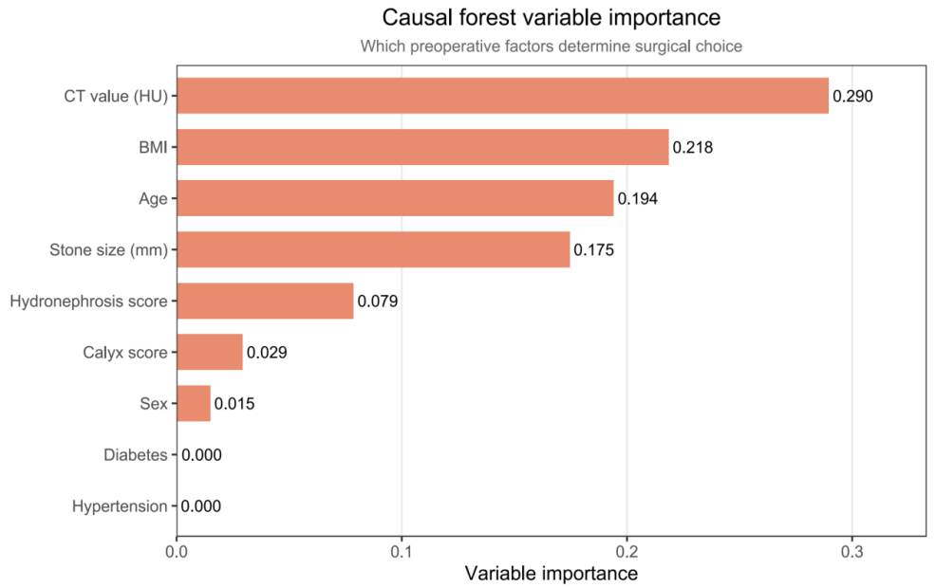
Fig. S2 Causal-forest variable importance. Permutation-based importance for nine preoperative covariates. CT attenuation, BMI, age, and maximum stone diameter accounted for most of the treatment-effect heterogeneity, whereas diabetes and hypertension contributed negligibly
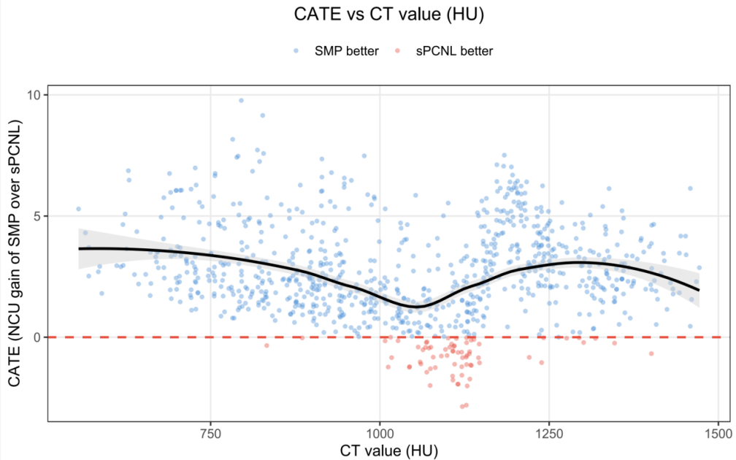
Fig. S3 CATE versus CT attenuation. Each point is a patient-level conditional average treatment effect (expected Net Clinical Utility gain of SMP over sPCNL) against CT attenuation. Blue points have CATE > 0 (point estimate favoring SMP); red points have CATE < 0 (point estimate favoring sPCNL); the dashed line marks CATE = 0 and the solid curve is a LOESS fit with a 95% band
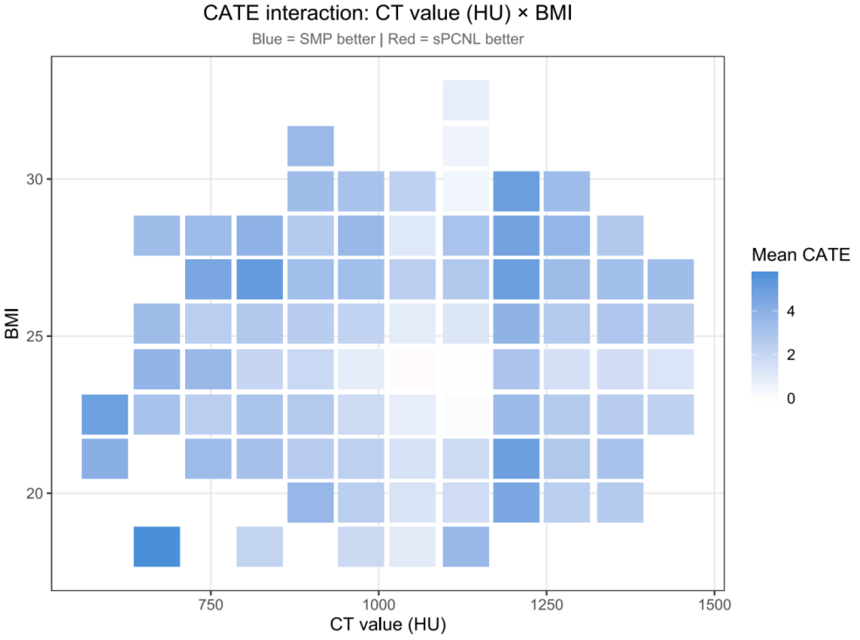
Fig. S4 CATE interaction on the CT attenuation × BMI plane. CT attenuation and BMI were each binned into equal-width intervals; mean CATE was computed for cells containing at least three patients. Darker blue indicates greater SMP benefit and white denotes approximate equivalence
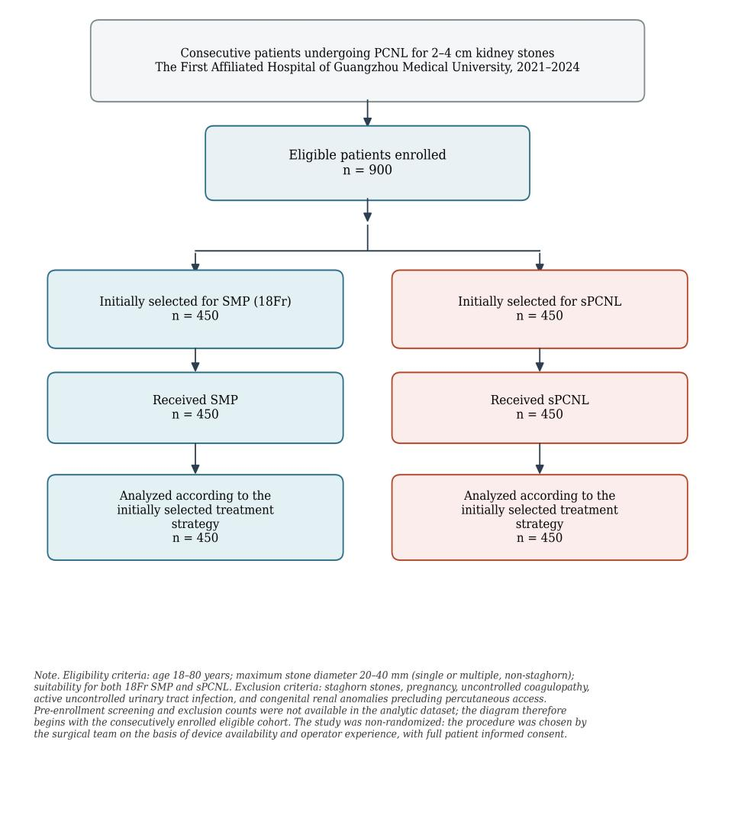
Fig. S5 Participant flow diagram. The cohort was non-randomized; the procedure was selected by the surgical team on the basis of device availability and operator experience. Pre-enrollment screening and exclusion counts were not available in the analytic dataset, so the diagram begins with the consecutively enrolled eligible cohort. All 900 enrolled patients were included in the main treatment-strategy analysis

STROBE checklist for cohort studies
Item locations refer to the main manuscript and to the supplementary materials above. Paraphrased STROBE cohort-study items are used for brevity.
Section | Item | STROBE cohort-study item (paraphrased) | Location in manuscript | Assessment / notes
Title and abstract | 1a | Indicate the observational design using a common term in the title or abstract. | Title; Abstract, Methods sentence: “prospective, single-center observational cohort”. | Addressed.
Title and abstract | 1b | Provide a balanced abstract summarizing the study question, methods, main findings, and interpretation. | Abstract: Background/Objectives, Methods, Results, Conclusions. | Addressed.
Introduction | 2 | Explain the scientific background and rationale for the investigation. | Introduction, paragraphs on mini-PCNL/sPCNL evidence, limitations of ATE-only analyses, and need for individualized treatment-effect analysis. | Addressed.
Introduction | 3 | State specific objectives and, where applicable, prespecified hypotheses. | End of Introduction: two aims—17-outcome comparison and test whether individualized tailoring improves over a uniform strategy. | Addressed.
Methods | 4 | Present the key elements of the study design early in the paper. | Methods 2.1: prospective, single-center, parallel-cohort observational study. | Addressed.
Methods | 5 | Describe setting, location, relevant dates, exposure period, follow-up, and data collection context. | Methods 2.1: single institution, 2021–2024 enrollment; postoperative outcomes include 1-day and 1-month SFR. | Mostly addressed; add exact follow-up windows if the journal requests more detail.
Methods | 6a | Give eligibility criteria and the sources and methods of selecting participants; describe follow-up methods. | Methods 2.1: consecutive patients, inclusion/exclusion criteria, PCNL for 2–4 cm kidney stones, 450 per group. | Addressed. Supplementary Figure S5 provides the flow diagram; screened/excluded pre-enrollment counts were unavailable and this is stated in the figure legend.
Methods | 6b | For matched studies, describe matching criteria and the number of exposed/unexposed participants. | Not applicable. The study was not matched. | N/A.
Methods | 7 | Define all outcomes, exposures, predictors, confounders, and candidate effect modifiers; give diagnostic criteria where relevant. | Methods 2.2–2.3: SMP/sPCNL procedures; preoperative covariates; 17 outcomes; Sepsis-3; Clavien–Dindo. | Addressed.
Methods | 8 | For each variable of interest, describe sources of data and methods of measurement; if more than one group, assess comparability of measurement methods. | Methods 2.3: preoperative CT/laboratory/clinical variables and postoperative outcomes; Methods 2.2 describes procedural definitions. | Mostly addressed; if available, add one sentence that outcome measurement and CT/lab definitions were identical in both groups.
Methods | 9 | Describe efforts to address potential sources of bias. | Methods 2.3–2.4: causal ordering W→A→Y, exclusion of intraoperative variables, TMLE with prespecified covariates, propensity-score overlap, E-values; Discussion limitations. | Addressed.
Methods | 10 | Explain how the study size was determined. | Methods 2.4: original cohort size planned around SFR precision and non-inferiority considerations; present analysis focused on comparative effectiveness and heterogeneity. | Partly addressed; adequate for this manuscript, but exact calculation details could be added if requested.
Methods | 11 | Explain how quantitative variables were handled, including grouping or cut-points when applicable. | Methods 2.3–2.4: continuous/categorical summaries, CT >950 HU indicator, causal-forest features, exploratory CATE plots, and Table 1 summaries. | Addressed; exploratory cut-points in supplementary figures are descriptive and not clinical decision thresholds.
Methods | 12a | Describe statistical methods, including methods used to control for confounding. | Methods 2.4: group comparisons, SMDs, TMLE with Super Learner, E-values, causal forest, policy-value estimation. | Addressed.
Methods | 12b | Describe methods used to examine subgroups and interactions. | Methods 2.4: causal forest CATE estimation, forest calibration test, variable importance, policy tree. | Addressed.
Methods | 12c | Explain how missing data were addressed. | Methods 2.4: complete-case analysis in TMLE; missForest imputation for causal-forest features. | Addressed; consider reporting missingness per variable in supplementary material if nonzero.
Methods | 12d | For cohort studies, describe how loss to follow-up was addressed. | Methods/Results: 1-day and 1-month SFR outcomes specified; no separate attrition table reported. | Partly addressed; add follow-up completeness or attrition counts if available.
Methods | 12e | Describe sensitivity analyses. | Methods 2.4: E-values; NCU weight-sensitivity across seven alternative weighting schemes plus the base scheme. | Addressed; NCU sensitivity results are provided in Supplementary Table S4.
Results | 13a | Report numbers of individuals at each study stage, such as eligible, included, exposed, followed, and analyzed. | Methods 2.1 and Results 3.1: 900 included/analyzed, 450 SMP and 450 sPCNL. A participant flow diagram is provided (Supplementary Figure S5). | Addressed within available data; Supplementary Figure S5 provides participant flow from the enrolled eligible cohort, and the absence of pre-enrollment counts is disclosed.
Results | 13b | Give reasons for non-participation or exclusion at each stage. | Eligibility criteria are described, but screened/excluded counts and reasons are not separately tabulated. | Not fully reported; add only if these data are available.
Results | 13c | Consider a flow diagram. | Participant flow diagram provided (Supplementary Figure S5). | Addressed.
Results | 14a | Give characteristics of study participants, including exposures and potential confounders. | Results 3.1 and Table 1: selected baseline characteristics and SMDs; Supplementary Table S1: intraoperative procedural parameters. | Addressed; a complete covariate-balance table could be supplementary if desired.
Results | 14b | Indicate the number of participants with missing data for each variable of interest. | Methods 2.4 states missing-data handling, but missingness per variable is not tabulated. | Partly addressed; add a short missingness statement/table if missingness was non-negligible.
Results | 14c | For cohort studies, summarize follow-up time, such as average and total follow-up. | Outcomes include 1-day and 1-month SFR; follow-up time distribution is not summarized. | Partly applicable; add follow-up completeness for 1-month SFR if available.
Results | 15 | Report outcome event numbers or summary measures over time. | Results 3.2; Table 2 primary/secondary outcomes; Supplementary Table S2 exploratory outcomes. | Addressed.
Results | 16a | Give unadjusted and adjusted estimates and precision; state which covariates were adjusted for and why. | Results 3.2; Table 2; Supplementary Table S2; Methods 2.3–2.4 define prespecified covariates and causal rationale. | Addressed.
Results | 16b | Report category boundaries when continuous variables are categorized. | Methods 2.3: CT >950 HU indicator; Supplementary Figures S3 and S4 show exploratory CATE patterns across CT and BMI. | Addressed; exploratory graphical thresholds should not be interpreted as validated clinical cut-offs.
Results | 16c | If relevant, translate relative measures into absolute risks over a meaningful time period. | The manuscript primarily reports absolute risk differences/ATEs for binary outcomes and mean differences for continuous outcomes. | Addressed; relative-risk translation not central here.
Results | 17 | Report other analyses, such as subgroup, interaction, and sensitivity analyses. | Results 3.3–3.4: CATE distribution, calibration, variable importance, policy-value analysis; Supplementary Figures S2–S4 and Supplementary Table S4 provide exploratory and sensitivity analyses. | Addressed.
Discussion | 18 | Summarize key results in relation to study objectives. | Discussion first paragraphs and Conclusions: SMP default strategy; heterogeneity detected but not actionable. | Addressed.
Discussion | 19 | Discuss limitations, considering possible bias or imprecision. | Discussion limitations: single-center cohort, domestic devices, unmeasured confounding, learning-curve trend, wide CATE intervals, unstable policy tree, NCU weights, rare events, lack of long-term outcomes. | Addressed.
Discussion | 20 | Give a cautious overall interpretation considering objectives, limitations, multiplicity, and other evidence. | Discussion and Conclusions: fever/Hb effects cautious; policy tree exploratory; CT attenuation as future candidate effect modifier. | Addressed.
Discussion | 21 | Discuss generalisability or external validity. | Discussion limitations and Conclusions: need external, prospective, multicenter validation; standard PCNL remains comparable when SMP not feasible. | Addressed.
Other information | 22 | Give the funding source and role of funders. | Funding statement: no external funding. | Addressed.
STROBE reference: von Elm E, Altman DG, Egger M, Pocock SJ, Gøtzsche PC, Vandenbroucke JP; STROBE Initiative (2008) The Strengthening the Reporting of Observational Studies in Epidemiology (STROBE) Statement: guidelines for reporting observational studies. J Clin Epidemiol 61:344–349.

