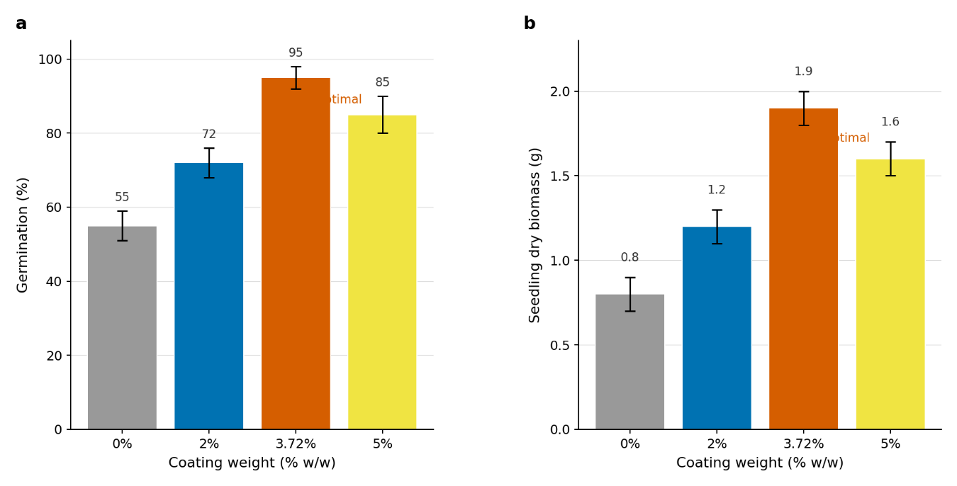
Supplementary Figure S1. Dose-response relationship between coating weight and seedling dry biomass under drought stress (-0.8 MPa). (a) Germination percentage and (b) seedling dry biomass across four coating weights (0%, 2%, 3.72%, and 5% w/w). Data are mean ± SEM (n=3 biological replicates, 50 seeds per replicate). The optimal coating weight of 3.72% (indicated by dashed line) maximizes biomass without impeding germination. Values at 0% and 5% are significantly lower than at 3.72% (P < 0.05, Tukey's HSD test).

