Creation of elite rice with high-yield, superior-quality and strong resistance to brown planthopper based on molecular design

Manman Liu†, Fengfeng Fan†, Shihao He, Yu Guo, Gaili Chen, Nannan Li, Nengwu Li, Huanran Yuan, Fengfeng Si, Fang Yang, Shaoqing Li*

State Key Laboratory of Hybrid Rice, Hongshan Laboratory of Hubei Province, Key Laboratory for Research and Utilization of Heterosis in Indica Rice of Ministry of Agriculture, Engineering Research Center for Plant Biotechnology and Germplasm Utilization of Ministry of Education, College of Life Science, Wuhan University, Wuhan 430072, China.

*Corresponding author:
Shaoqing Li
Email: shaoqingli@whu.edu.cn

†Manman Liu and Fengfeng Fan contributed equally to this work.

Supplementary materials

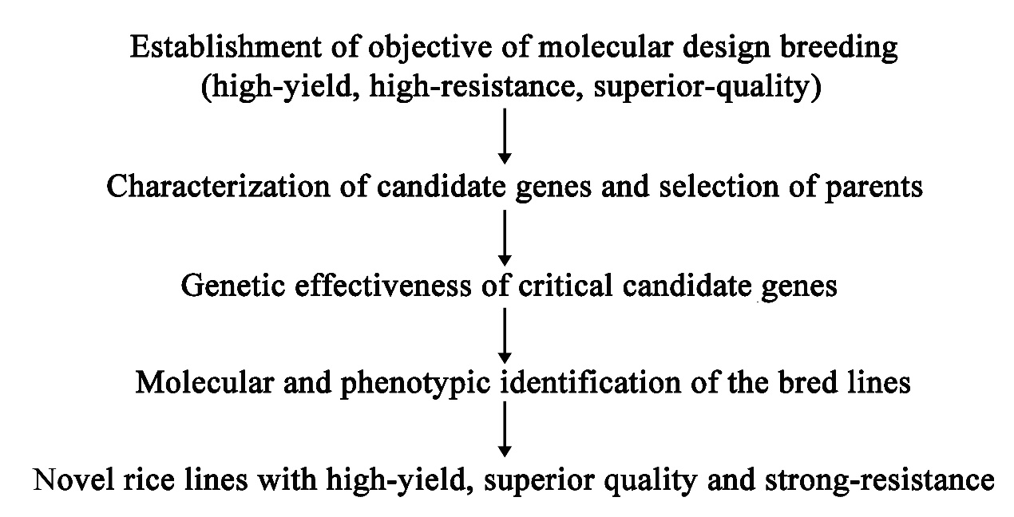
Fig. S1 Flow chart of breeding by molecular design.

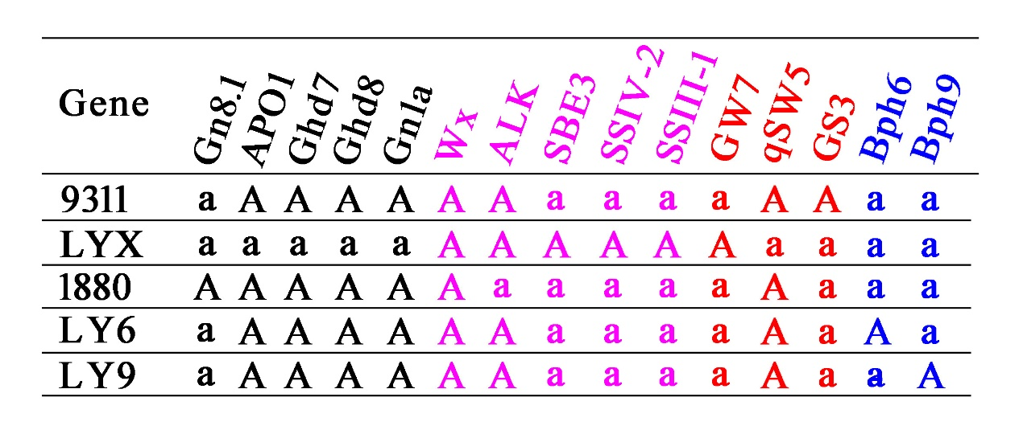
Fig. S2 Distribution of the target genes in selected parent lines. Black represents yield-related genes, pink represents eating and cooking quality related genes, red represents appearance quality related genes, bule represents rice BPH-resistance related genes. Capital letters represent dominant allelic segments. The same as below.

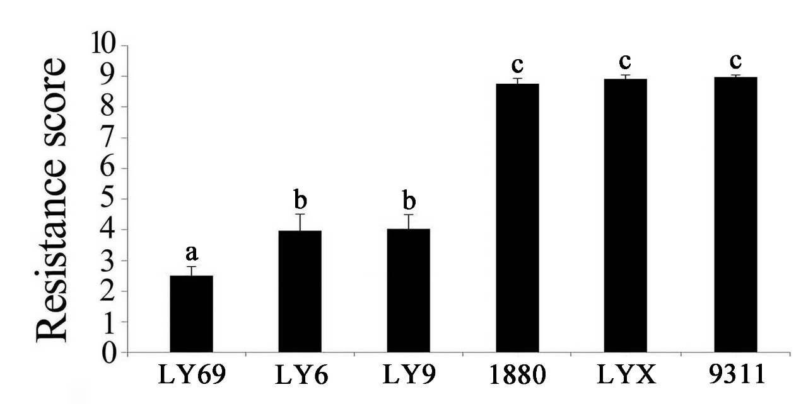
Fig. S3 BPH-resistance score of the parents at the seedling stage. 9311 used as susceptible control, LY69 used as resistance control. Values are the means ± s.d., n=30. Letters indicate a significant difference at the 5% significance level by the least significant difference test.

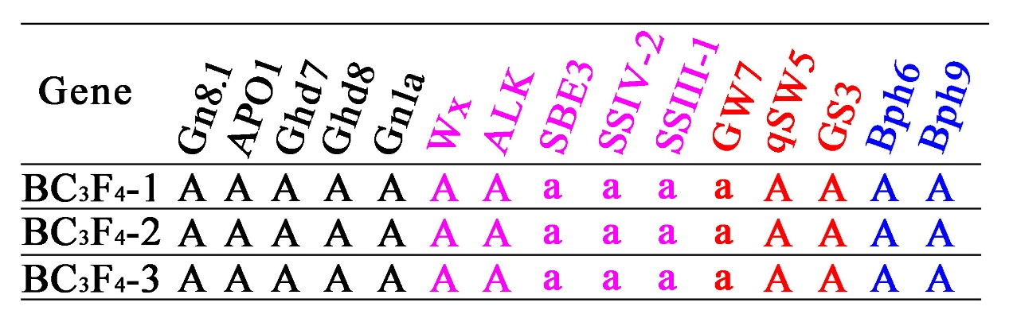
Fig. S4 Genotyping of the target genes in BC₃F₄ lines.

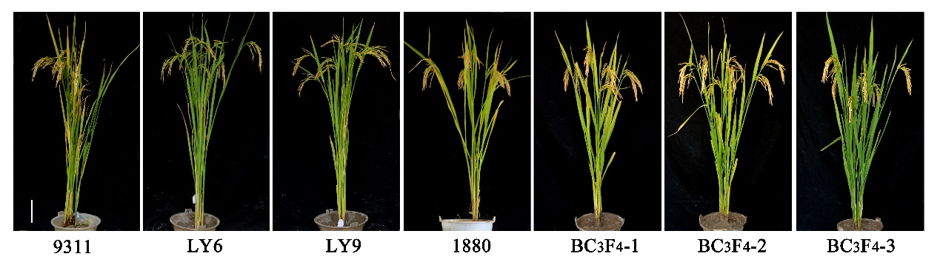
Fig. S5 Gross plant and panicle morphologies of the BC₃F₄ lines and their parents. Scale bars, 10 cm.

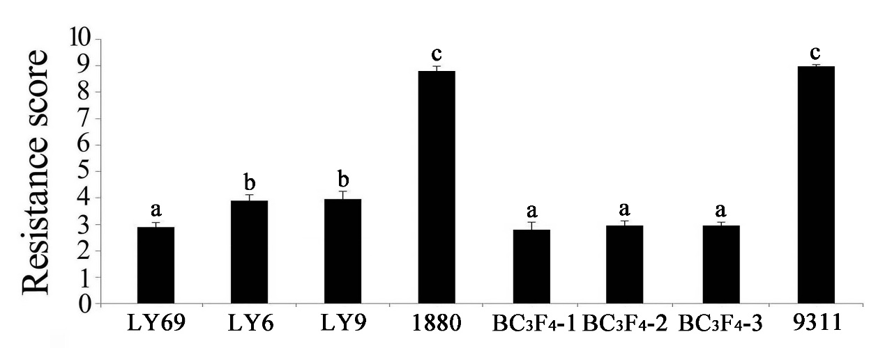
Fig. S6 BPH-resistance test of the BC₃F₄ lines and their parents at the seedling stage. 9311 used as susceptible control, LY69 used as resistance control. Values are the means ± s.d., n=30. Letters indicate a significant difference at the 5% significance level by the least significant difference test.

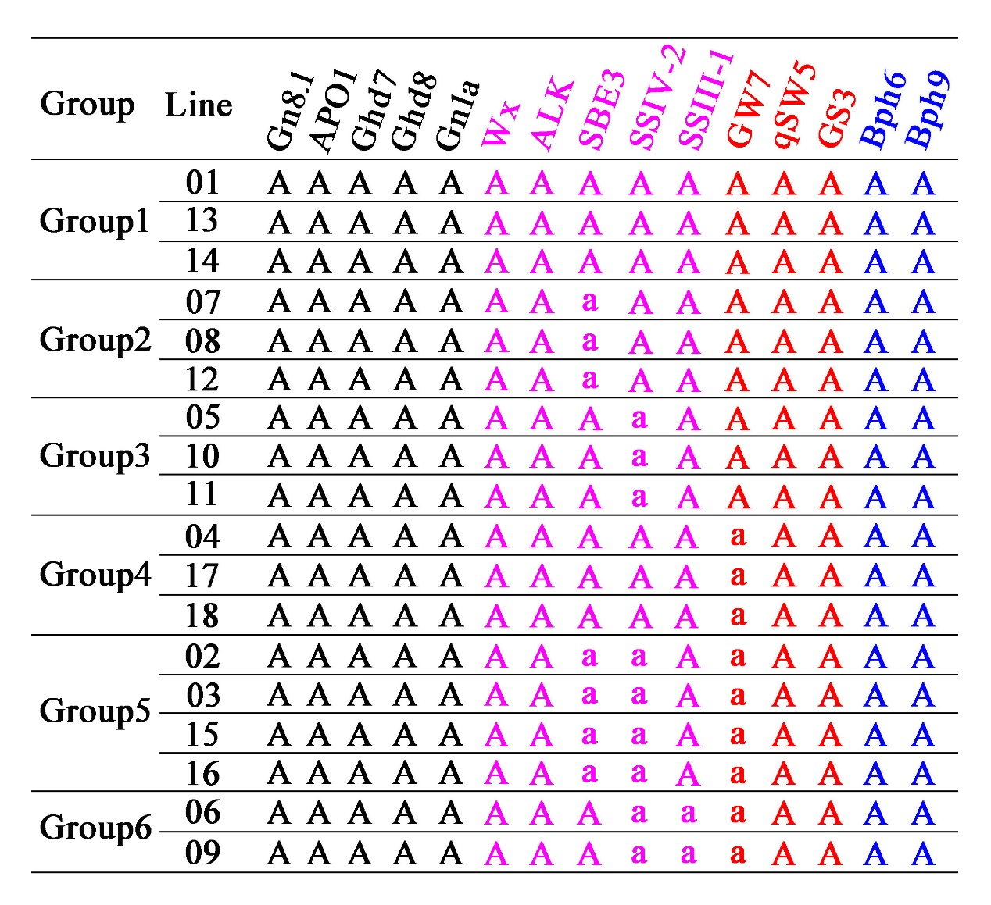
Fig. S7 Genotypes of the selected lines based on the 15 target genes.

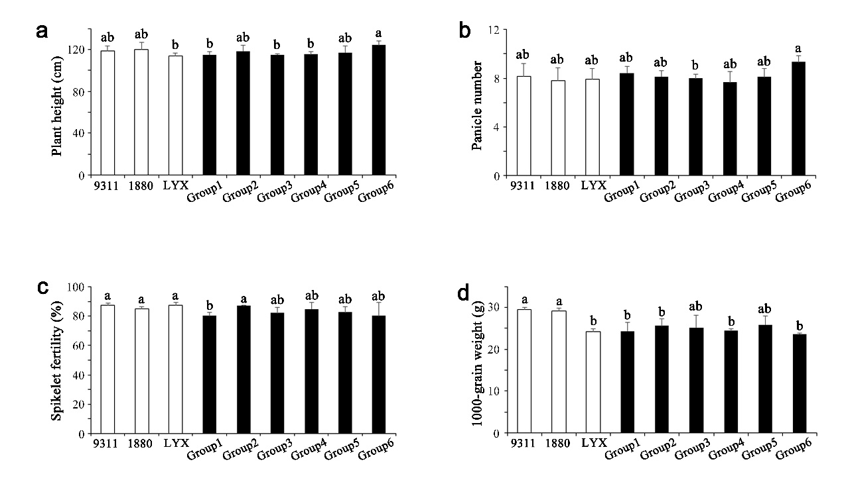
Fig. S8 Yield-related traits in groups with different target gene combinations. a: Plant height (cm); b: Panicle number; c: Spikelet fertility (%); d: 1000-grian weight (g). Values are the means ± s.d.. Letters indicate a significant difference at the 5% significance level by the least significant difference test.

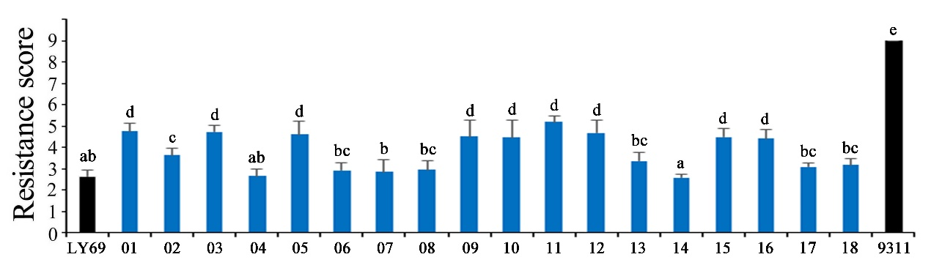
Fig. S9 BPH-resistance test of the designed breeding lines at the seedling stage. Values are the means ± s.d., n=30. Letters indicate a significant difference at the 5% significance level by the least significant difference test.

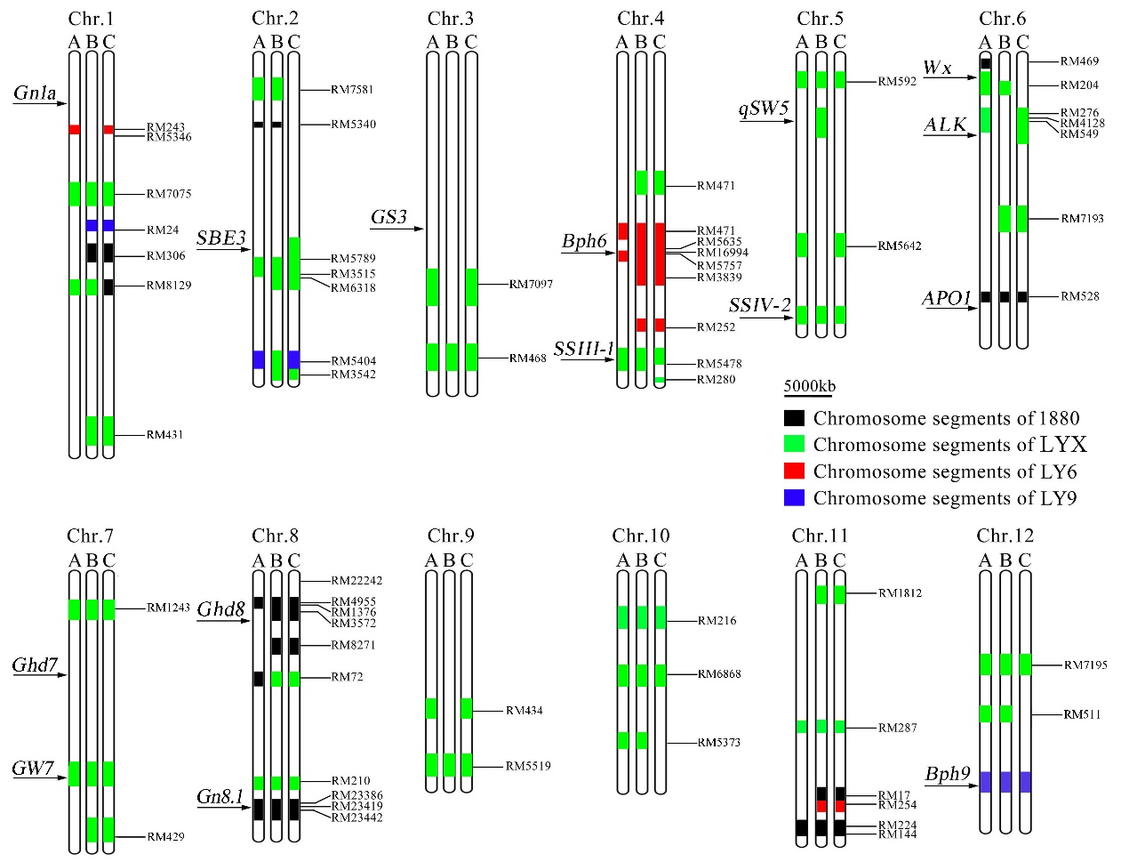
Fig. S10 Target genes and genetic background analysis of the molecular designed breeding lines. Letters A, B and C represent the molecular design breeding lines MD1, MD2 and MD3, respectively. The black, green, red and blue boxes indicate substituted chromosome segments of the donor parents 1880, Luo-Yu-Xiang, Luoyang-6 and Luoyang-9, respectively.

