A Reporting Guideline for Observational Studies in Metabolomic Epidemiology: Explanation and Elaboration of the Strobe-MetEpi Checklist
Authors
Rachel S Kelly, PhD*; Stacey N Reinke, PhD*; Georgia Lorentzen BSc, Anastasia Chrysovalantou Chatziioannou, PhD, Ruey Leng Loo, PhD, Lorraine Brennan, PhD, Majken K. Jensen, PhD, Elena Colicino, PhD, Robert van Vorstenbosch, PhD, Amir Hossein Alizadeh Bahmani, PharmD, PhD, Antonio Checa, PhD, Burcu F. Darst, PhD, Hector Gallart-Ayala, PhD, Shu-Yi Liao, MD, MPH, ScD , Salman Siddiqui MD, PhD, Maria A. Valdivia-Garcia, Anisha Wijeyesekera, PhD, David Broadhurst, PhD, Steven C. Moore PhD, Timothy Ebbels**; Matthias Egger**; Royston Goodacre**; Julian Little**; Craig E. Wheelock,**; Jessica Lasky-Su**
* co-first
** Co-senior
Supplementary Tables
Supplementary Table 1. Glossary of commonly used terms in Metabolomic epidemiology

Term | Definition | Reference
Adduct | An ion formed by interaction of two species, usually an ion and a molecule, and often within the ion source, to form an ion containing all the constituent atoms of one species as well as an additional atom or atoms. | (1)
Analytical Platform | An analytical platform is an integrated set of separation and detection technologies used to comprehensively detect, characterize, and quantify small-molecule metabolites in biological samples. | (2)
Batch Effect | A batch effect in metabolomics is the systematic, non-biological variation in measured metabolite signals that arises from acquiring metabolomic data in separate batches. Batch effects can occur within-batch (linear non-linear systematic “drift”) and/or between-batch (typically “step” differences). Batch effects can be caused by variation in sample preparation, an instrument's reproducibility and/or drift over time, and the necessary preventive maintenance performed on instruments between analytical batches. | (3)
Biological matrix | A biological matrix is discrete material of biological origin that can be sampled and processed in a reproducible manner. | (4)
Blank | A sample not containing biological matrix, but otherwise treated the same as the biological samples, e.g. one containing solvent only. Typically used to detect contamination or background signal. | (4)
Centering | Centering converts all the metabolite concentrations to fluctuations around zero instead of the mean of the metabolite concentrations. | (5)
Chromatographic Alignment | Chromatographic alignment is the computational process of correcting retention time variability across multiple chromatographic runs so that signals originating from the same analyte are matched consistently between samples. | (6)
Chromatography | A physical method of separation in which the components to be separated are distributed between two phases, one of which is stationary (stationary phase) while the other (the mobile phase) moves in a definite direction. | (7)
Data Processing | Data processing in metabolomics refers to the series of computational steps, often including data filtering, normalization, transformation, scaling, and quality control, applied to raw metabolomic data to make samples comparable and suitable for downstream statistical analysis and biological interpretation. | (8)
Deconvolution | Deconvolution is the computational process of separating overlapping spectral signals in mass spectrometry data into their individual component spectra so that each metabolite’s characteristic peaks can be accurately identified and quantified. | (9)
Derivatization | Derivatization is a chemical modification step in which metabolites are chemically transformed to improve their volatility, stability, detectability, or chromatographic behavior prior to analysis, particularly in GC–MS. | (10)
Feature | A metabolic feature is a reproducible signal detected in metabolomics data, defined by a specific combination of analytical properties such as mass-to-charge ratio (m/z), retention time, and intensity, which may correspond to a single metabolite, an adduct or a fragment of a metabolite. | (6)
Fragmentation | In mass spectrometry, fragmentation is the process by which an ionized molecule breaks into smaller characteristic charged fragments patterns used for structural elucidation and compound identification. | (11)
Independent Validation | Independent validation is the process of confirming the association of a metabolite or metabolite profile with the exposure or outcome of interest using a separate set of data or samples with an unbiased experiment distinct from the one used for its initial discovery. | (12)
Instrument Drift | Instrument drift is the gradual, sample-to-sample variation in measured retention times (and other signal characteristics) that occurs during LCMS data acquisition due to small changes in the instrument’s performance, which must be corrected so that the same metabolite features can be accurately compared across all analyzed samples. | (6)
Inter-Study QC | Inter-Study QC is a type of quality control in analytical workflows that uses consistent reference or pooled quality control samples to assess and monitor the comparability and reproducibility of data across separate studies conducted at different times, enabling evaluation of systematic differences between those studies. | (13)
Internal Standard | Internal Standards (IS) are test compounds (e.g., structurally similar analogs, stable isotope labeled compounds) added to both calibration standards and samples at known and constant concentrations to facilitate quantification of the target analyte(s). | (4)
Intra-Study QC | Intra-Study QC refers to quality control procedures performed within a single study or batch to monitor the consistency, precision, and reliability of measurements across all samples in that study. It typically involves using pooled samples, or standard reference materials analyzed repeatedly throughout the experiment to detect instrumental drift, batch effects, or technical variability during the course of that specific study. | (13)
Ionization | In mass spectrometry, ionization is the process by which neutral atoms or molecules are converted into charged ions, enabling them to be manipulated, separated, and detected based on their mass-to-charge (m/z) ratios. | (14)
Isotopic Pattern | An isotopic pattern (or distribution) refers to the distinctive pattern of peaks that arises from the presence of naturally occurring isotopes of the atoms within a molecule, showing the relative abundances of molecules with different isotopic compositions | (15)
LC–MS | A hyphenated analytical technique that combines liquid chromatography (LC) to separate complex mixtures of molecules in solution with mass spectrometry (MS) to detect, identify, and quantify the separated compounds based on their mass-to-charge ratios. | (6)
GC–MS | A hyphenated technique that combines gas chromatography (GC) to separate volatile and thermally stable compounds in the gas phase with mass spectrometry (MS) to detect, identify, and quantify them. | (6)
Mass-to-Charge Ratio (m/z) | This ratio is defined as the mass (m) of an ion divided by its charge (z). It is expressed in units of Daltons (Da) or atomic mass units (amu) and is a dimensionless quantity. The notation m/z is commonly used in mass spectrometry to represent this ratio, where m is the mass of the ion and z is its charge number. | (16)
Metabolome | The metabolome represents the complete set of metabolites in a biological cell, tissue, organ, or organism, which are the end products of cellular processes. | (17)
Metabolomic Epidemiology | Metabolomic epidemiology is the study of the relationship between metabolites and health-related traits, offering insights into disease mechanisms and potential biomarkers for early detection and prevention. | (18)
NMR Spectroscopy | Powerful analytical technique that uses a magnetic field and radio waves to identify metabolites based on their resonance signal, offering non-destructive analysis, high reproducibility, and detailed structural information about metabolites. | (19)
Transformation | The application of a deterministic mathematical function to replace each measurement with a transformed value.  Transformation is typically used to making a non-normal data distributions appear more Gaussian (a requirement for parametric statistical models), to stabilize variance, or reduce outlier impact - while retaining information about the relative value of individual measurements. | (5)
Pathway Enrichment Analysis | Pathway enrichment analysis is a bioinformatics technique that assesses whether specific biological pathways are overrepresented in a list of metabolites derived from high-throughput experiments. This analysis helps researchers understand the biological processes that are most relevant to their data. | (20)
Retention Time | Retention time in chromatography is the time taken for a specific compound to travel through the chromatography column from the moment of sample injection until it reaches the detector. This time is crucial for identifying and quantifying compounds in a mixture, as it acts as a unique "fingerprint" for each substance under consistent experimental conditions. | (21)
Scaling | The process of modifying the range or magnitude of data points to a similar scale (e.g., 0–1 or standard deviation). Scaling ensures variables with large magnitudes do not dominate multivariable/multivariate models. It allows multiple univariate models to be directly compared. It also assists in clarifying data visualization (heatmaps) and often important for algorithms utilizing distance measures. | (5)
Signal Intensity Drift Correction | A preprocessing technique used to remove variations in spectral data that are orthogonal to the property of interest. This method helps in enhancing the accuracy of predictive models by eliminating noise and irrelevant information from the data | (22)
System Suitability mix | A system suitability mix is used in chromatography to evaluate the performance of a chromatographic system. | (23)
Targeted Metabolomics | Targeted metabolomics is the measurement of pre-defined groups of chemically characterized and biochemically annotated metabolites | (24)
Untargeted Metabolomics | Analytical approach that aims to comprehensively identify and quantify a wide range of metabolites in biological samples without prior knowledge of which specific metabolites will be present. | (24)

For other useful glossaries see (25-27)

Supplementary Methods

Protocol to identify 50 metabolomic epidemiology papers to include in our review

STEP 1: Identification of 500 Metabolomic Epidemiology Studies

Search conducted at the University of Bern library by researchers not involved in the Strobe Met Epi Initiative

Date of Search: July 2023

Full search strategy per database

Remarks:
- Thesaurus terms have been majored/focused, to harvest studies where metabolomics is a main topic. We did not add a textword search, since one of the goals of this search is to find out how authors have described the topic/study type in the title resp. abstract (in studies that are indexed with the mentioned thesaurus terms,).
- We used relevance ranking (where possible) to extract the first 500 most relevant studies for screening.

Database 1 - Embase.com (Elsevier)
('metabolomics'/exp/mj OR 'metabolome'/mj OR 'metabolite'/mj) AND ('case control study'/de OR 'retrospective study'/de OR 'control group'/de OR 'cohort analysis'/de OR 'longitudinal study'/de OR 'follow up'/de OR 'prospective study'/de OR 'cross-sectional study'/de OR 'epidemiology'/de OR 'epidemiological study'/de) NOT ([animals]/lim NOT [humans]/lim) NOT ([conference abstract]/lim OR [letter]/lim OR [note]/lim OR [editorial]/lim OR [preprint]/lim OR [review]/lim OR [systematic review]/lim) AND [2019-2023]/py

Database 2 - Medline ALL (Ovid) Search History Link
(exp *Metabolomics/ OR exp *Metabolome/) AND (Case-Control Studies/ or Control Groups/ or Matched-Pair Analysis/ or Retrospective Studies/ or Cohort Studies/ or Longitudinal Studies/ or Follow-Up Studies/ or Cross- Sectional Studies/ or Prevalence/ or Incidence/ or Epidemiologic Studies/) not (exp animals/ NOT humans/) not (letter or news or comment or editorial or congress or preprint or review or systematic review or meta-analysis).pt.
limit to yr="2019 -Current"

Database 3 - PubMed (NLM)
("Metabolomics"[Majr] OR "Metabolome"[Majr]) AND (“Case-Control Studies”[Mesh:noexp] OR "retrospective studies"[mesh:noexp] OR “Control Groups”[Mesh:noexp] OR cohort studies[mesh:noexp] OR longitudinal studies[mesh:noexp] OR follow-up studies[mesh:noexp] OR prospective studies[mesh:noexp] OR Cross-Sectional Studies[Mesh:noexp] OR Prevalence[mesh:noexp] OR Incidence[mesh:noexp] OR “Epidemiologic Studies”[Mesh:noexp]) NOT ("animals"[mesh] NOT "humans"[mesh]) NOT (letter[pt] OR news[pt] OR comment[pt] OR editorial[pt] OR congress[pt] OR preprint[pt] OR review[pt] OR systematic review[pt] OR meta-analysis[pt]) AND "2019/01/01"[CRDT] : "3000"[CRDT]

STEP 2: Identify 50 papers for inclusion in the review

Two Strobe MetEpi reviewers working independently worked through the list of 500 abstracts ordered by relevance by the university of Bern team. They each selected the first 50 papers that met the following criteria
Inclusion criteria
- Human Study
- Epidemiological design
- Metabolomic profiling by MS or NMR conducted on human biosamples
- At least 100 samples overall
Exclusion criteria
- Multi-omics study (metabolomics, plus one additional omic)
- Review/systematic review
- Meta-analysis of already published studies (meta-analysis of original findings as a means of replication/validation is not criteria for exclusion)

The two reviewers then cross referenced their 50 and where disagreements arose, they continued to work through the 500 hundred until they could identify 50 papers that they both agreed on for inclusion. We recorded information on country; population; biosample; profiling platform; phenotype/disease/exposure; authors and journal to ensure among the 50 there was diversity.

STEP 3: Recruit a review team

We advertised via LinkedIn and X and via our networks for researchers working in the field of metabolomic epidemiology. We asked people to apply via a google form, and then the initial STROBE MetEpi team selected 14 researchers across a range of seniorities, from PhD candidates to Professors, and of subject areas within the field.

STEP 4: Assessment of Manuscripts

Each reviewer was provided with 11 manuscripts selected at random, this ensured each manuscript was reviewed by at least 3 reviewers independently. Reviewers were provided with the checklist and for each checklist item they had to score that manuscript as good, moderate, poor, or not applicable. Not applicable was selected when the item could not be rated for a certain approach, e.g. independent validation or pathway analysis was not conducted. We held two meetings with the full review team to discuss this approach, identify any concerns, and to identify redundancies and finesse the wording of the checklist.

STEP 5: Collation of results

The reviews were collated centrally. For each checklist item, we counted the number of instances of a good, moderate, poor and not applicable rating across all reviewers for all papers. As some papers were reviewed by three people and some by four, the total number of reviews for the 50 papers was 162, and we used this value to compute the percentages. For each checklist item the percentages for good moderate and poor were computed by (Count of that category/162)*100.

Supplementary Table S1: Performance of each of the 50 papers included in the review
For each anonymised paper the percentage of checklist items ranked as good, moderate, poor or non-applicable is shown

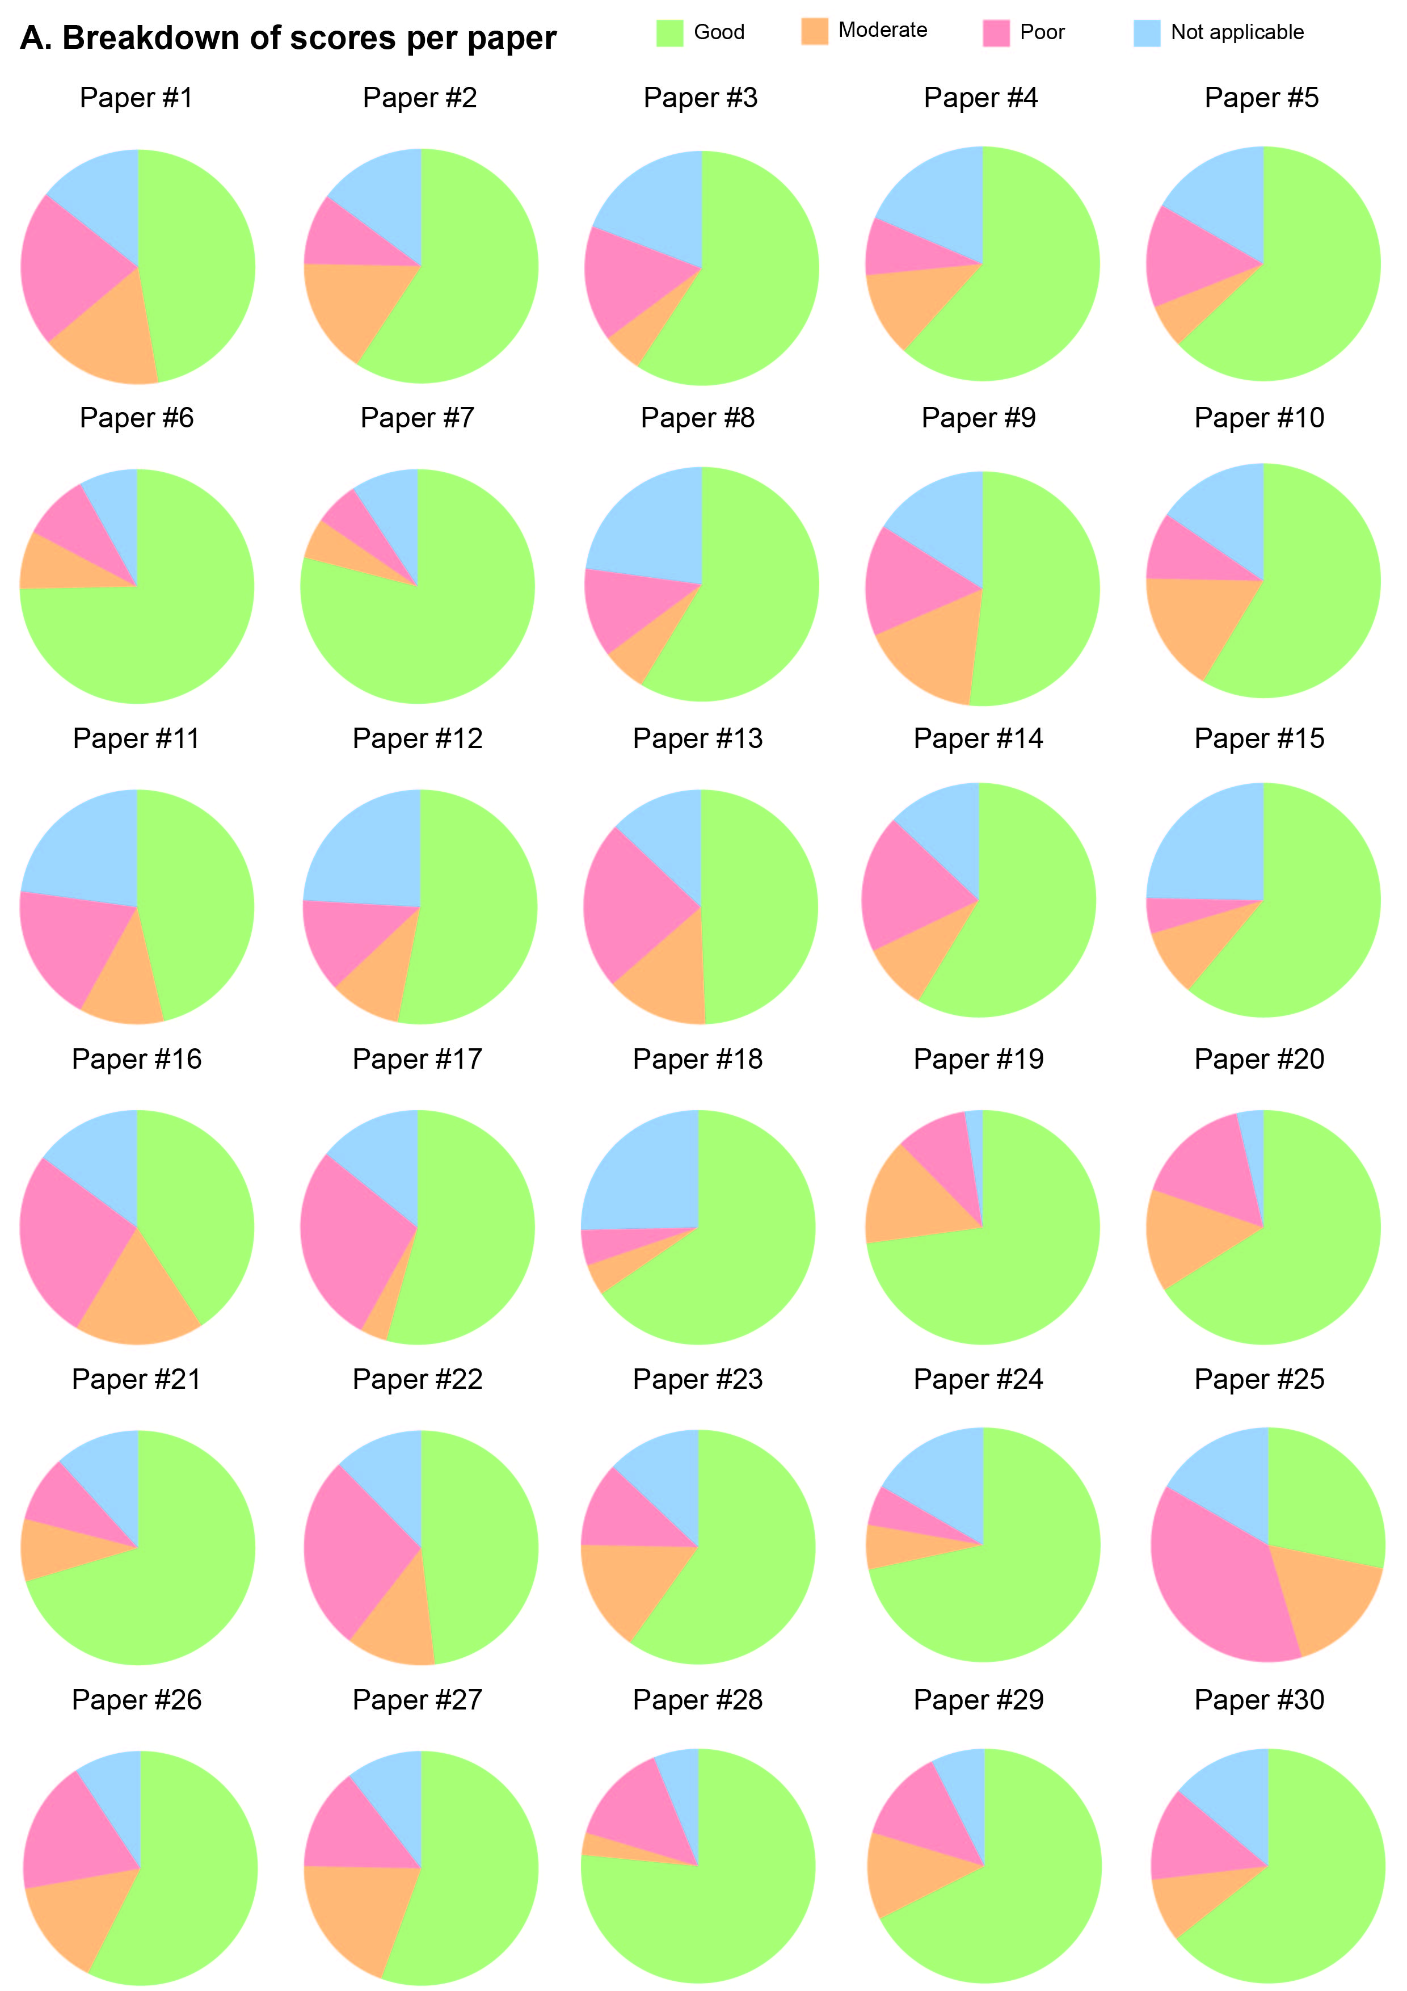
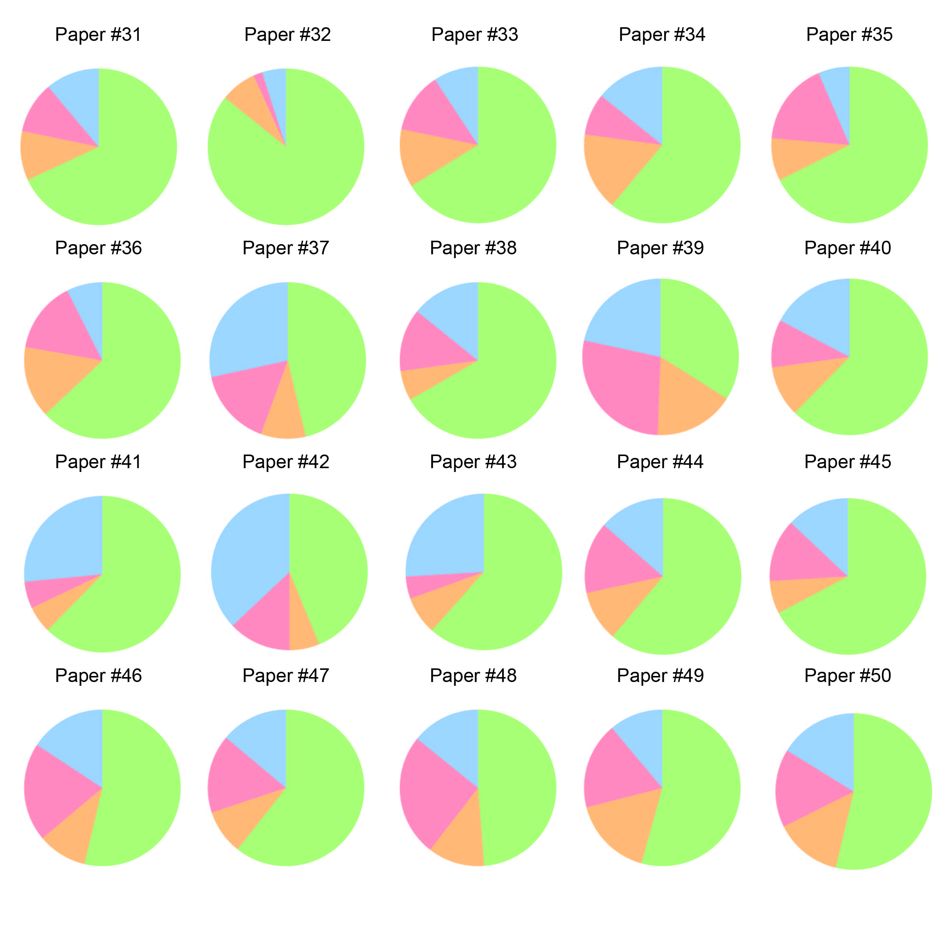

1. Todd JF. Recommendations for Nomenclature and Symbolism for Mass Spectroscopy. Pure & Applied Chemistry 1991; 63: 1541-1566.
2. Marchev AS, Vasileva LV, Amirova KM, Savova MS, Balcheva-Sivenova ZP, Georgiev MI. Metabolomics and health: from nutritional crops and plant-based pharmaceuticals to profiling of human biofluids. Cell Mol Life Sci 2021; 78: 6487-6503.
3. Broadhurst D, Goodacre R, Reinke SN, Kuligowski J, Wilson ID, Lewis MR, Dunn WB. Guidelines and considerations for the use of system suitability and quality control samples in mass spectrometry assays applied in untargeted clinical metabolomic studies. Metabolomics 2018; 14: 72.
4. Services USDoHaH. Bioanalytical Method Validation: Guidance for Industry; 2018.
5. van den Berg RA, Hoefsloot HC, Westerhuis JA, Smilde AK, van der Werf MJ. Centering, scaling, and transformations: improving the biological information content of metabolomics data. BMC Genomics 2006; 7: 142.
6. Smith CA, Want EJ, O'Maille G, Abagyan R, Siuzdak G. XCMS: processing mass spectrometry data for metabolite profiling using nonlinear peak alignment, matching, and identification. Anal Chem 2006; 78: 779-787.
7. L.S E. Nomenclature For Chromatography (IUPAC Recommendations 1993). Pure & Applied Chemistry 1993; 65: 819-872.
8. Xia J, Wishart DS. Metabolomic data processing, analysis, and interpretation using MetaboAnalyst. Curr Protoc Bioinformatics 2011; Chapter 14: 14 10 11-14 10 48.
9. Pang Z, Lu Y, Zhou G, Hui F, Xu L, Viau C, Spigelman AF, MacDonald PE, Wishart DS, Li S, Xia J. MetaboAnalyst 6.0: towards a unified platform for metabolomics data processing, analysis and interpretation. Nucleic Acids Res 2024; 52: W398-W406.
10. Fiehn O. Extending the breadth of metabolite profiling by gas chromatography coupled to mass spectrometry. Trends Analyt Chem 2008; 27: 261-269.
11. Domon B, Aebersold R. Mass spectrometry and protein analysis. Science 2006; 312: 212-217.
12. Ou FS, Michiels S, Shyr Y, Adjei AA, Oberg AL. Biomarker Discovery and Validation: Statistical Considerations. J Thorac Oncol 2021; 16: 537-545.
13. Kirwan JA, Gika H, Beger RD, Bearden D, Dunn WB, Goodacre R, Theodoridis G, Witting M, Yu LR, Wilson ID, metabolomics Quality A, Quality Control C. Quality assurance and quality control reporting in untargeted metabolic phenotyping: mQACC recommendations for analytical quality management. Metabolomics 2022; 18: 70.
14. M GEZ. Mass Spectrometer. 2024.
15. Bocker S, Letzel MC, Liptak Z, Pervukhin A. SIRIUS: decomposing isotope patterns for metabolite identification. Bioinformatics 2009; 25: 218-224.
16. Babele PY, A.K. Back2Basics: mass-to-charge ratio (m/z) in proteomics. Journal of Proteins and Proteomics 2023; 14: 223-226.
17. Oliver SG, Winson MK, Kell DB, Baganz F. Systematic functional analysis of the yeast genome. Trends Biotechnol 1998; 16: 373-378.
18. Lasky-Su J, Kelly RS, Wheelock CE, Broadhurst D. A strategy for advancing for population-based scientific discovery using the metabolome: the establishment of the Metabolomics Society Metabolomic Epidemiology Task Group. Metabolomics 2021; 17: 45.
19. Wurtz P, Kangas AJ, Soininen P, Lawlor DA, Davey Smith G, Ala-Korpela M. Quantitative Serum Nuclear Magnetic Resonance Metabolomics in Large-Scale Epidemiology: A Primer on -Omic Technologies. Am J Epidemiol 2017; 186: 1084-1096.
20. Reimand J, Isserlin R, Voisin V, Kucera M, Tannus-Lopes C, Rostamianfar A, Wadi L, Meyer M, Wong J, Xu C, Merico D, Bader GD. Pathway enrichment analysis and visualization of omics data using g:Profiler, GSEA, Cytoscape and EnrichmentMap. Nat Protoc 2019; 14: 482-517.
21. Zhang Y, Liu F, Li XQ, Gao Y, Li KC, Zhang QH. Generic and accurate prediction of retention times in liquid chromatography by post-projection calibration. Commun Chem 2024; 7: 54.
22. Brunius C, Shi L, Landberg R. Large-scale untargeted LC-MS metabolomics data correction using between-batch feature alignment and cluster-based within-batch signal intensity drift correction. Metabolomics 2016; 12: 173.
23. M DTREN. Universal HPTLC Mix (UHM) for Simplified System Suitability Tests: A Novel Concept for HPTLC Suitability Test. Analytix Reporter 2023.
24. Roberts LD, Souza AL, Gerszten RE, Clish CB. Targeted metabolomics. Curr Protoc Mol Biol 2012; Chapter 30: Unit 30 32 31-24.
25. Viant MR, Ebbels TMD, Beger RD, Ekman DR, Epps DJT, Kamp H, Leonards PEG, Loizou GD, MacRae JI, van Ravenzwaay B, Rocca-Serra P, Salek RM, Walk T, Weber RJM. Use cases, best practice and reporting standards for metabolomics in regulatory toxicology. Nat Commun 2019; 10: 3041.
26. Joshi AD, Rahnavard A, Kachroo P, Mendez KM, Lawrence W, Julian-Serrano S, Hua X, Fuller H, Sinnott-Armstrong N, Tabung FK, Shutta KH, Raffield LM, Darst BF, Group CECSW. An epidemiological introduction to human metabolomic investigations. Trends Endocrinol Metab 2023; 34: 505-525.
27. Fuller H, Zhu Y, Nicholas J, Chatelaine HA, Drzymalla EM, Sarvestani AK, Julian-Serrano S, Tahir UA, Sinnott-Armstrong N, Raffield LM, Rahnavard A, Hua X, Shutta KH, Darst BF. Metabolomic epidemiology offers insights into disease aetiology. Nat Metab 2023; 5: 1656-1672.

