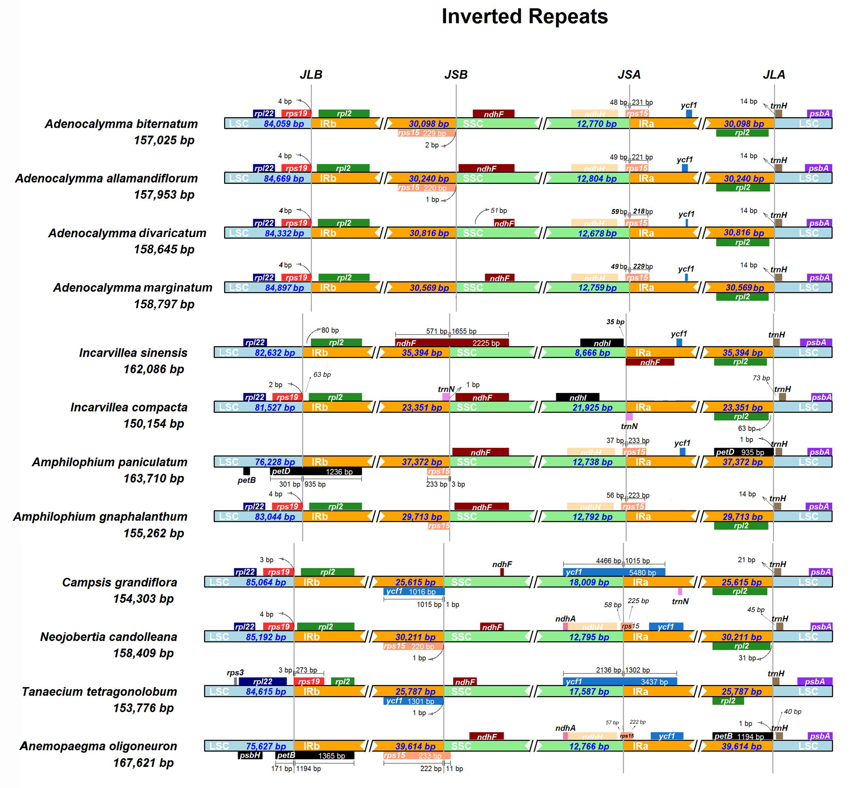
Figure S5. Each species and its corresponding chloroplast genome sequence length are described on the left side of each track. Genes transcribed with positive and negative strands appear above and below the corresponding pathways in right-to-left and left-to-right directions, respectively. The arrow shows the bp distance between the start or end coordinates of a given gene and the corresponding junction site. For genes that extend from one region to another, a T-bar at the top or bottom shows the extent of the part and the corresponding value. Connecting nearby genes is the scaled projection of the bp distance at each locus. JLB(IRB /LSC), JSB (IRB /SSC), JSA (SSC/ IRA) and JLA (IRA /LSC) represent the connection sites between corresponding regions in the genome respectively

