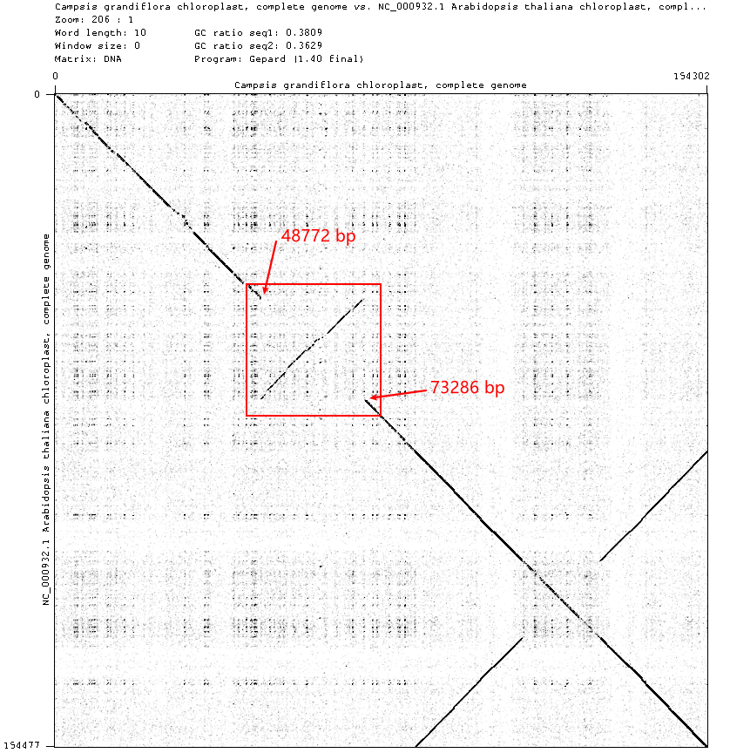
Figure S1. The Gepard dot plot image of Campsis grandiflora (Compare with Arabidopsis thaliana). There are two sequences respectively formed into the length and width of the rectangle in the picture, the horizontal sequence in C. grandiflora, the vertical sequence in A.thaliana. The area closed by the red box indicated a gene rearrangement in the chloroplast genome of Campsis grandiflora.

