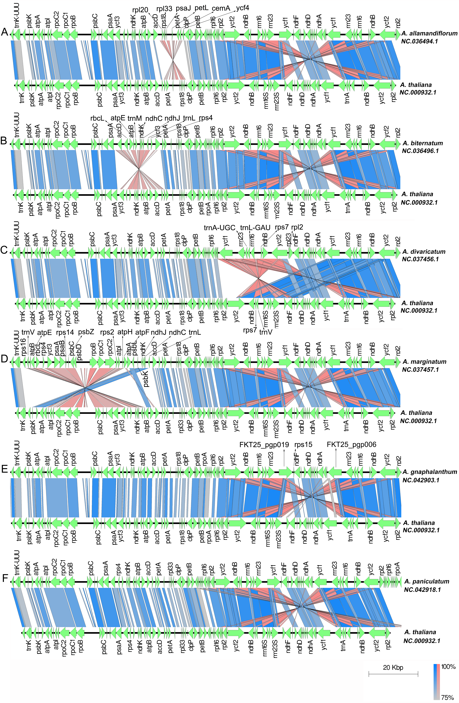
Figure S2. Panel A to F shown that the 6 types of genome structure respectively from A. allamandiflorum, A. biternatum, A. divaricatum, A marginatum, A. gnaphalanthum, A. paniculatum.

