Context-adaptive organic replacements for chemical fertilizers result in synergistic outcomes across China
Supplementary Information
This supplementary includes:
Supplementary Figures 1-12 Supplementary Tables 1-6

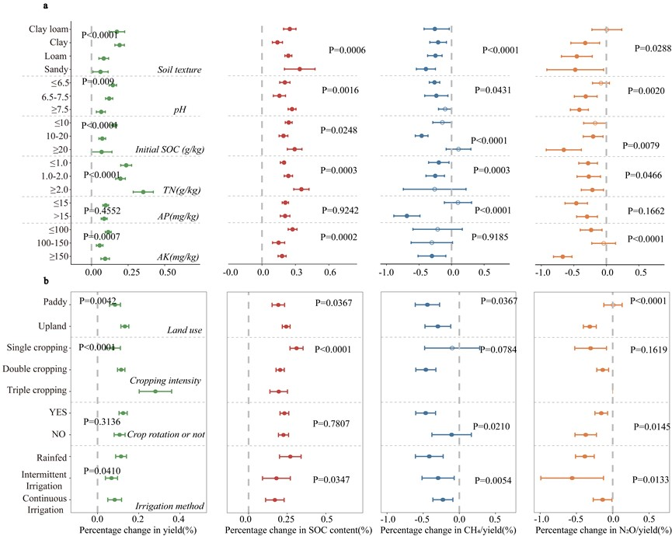
Fig 1. Influencing factors on carbon sequestration, GHG reduction, and crop yield. (a) Effects of soil properties on soil carbon sequestration, GHG reduction, and crop yield; (b) Effects of field management practices on carbon sequestration, GHG reduction, and crop yield.

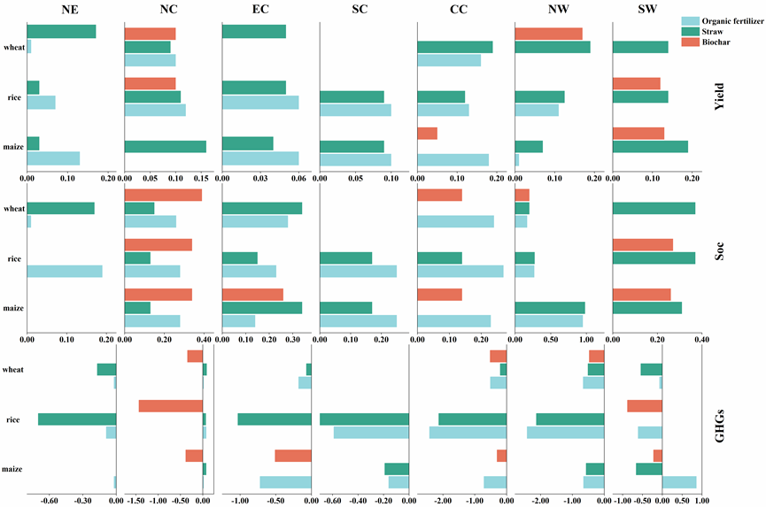
Fig 2. Yield increase, carbon sequestration and GHG reduction benefits (%) of organic replacements strategies across agricultural regions. Blank segments in the bar chart indicate that the strategy does not generate positive benefits in the cropping systems of those agricultural regions.

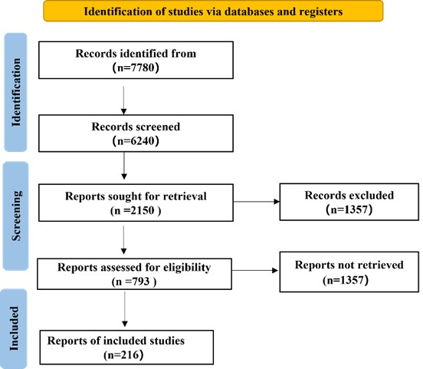
Fig 3. The flowchart for screening the research report of this study was developed in accordance with the manual issued by the PRISMA Development Committee.

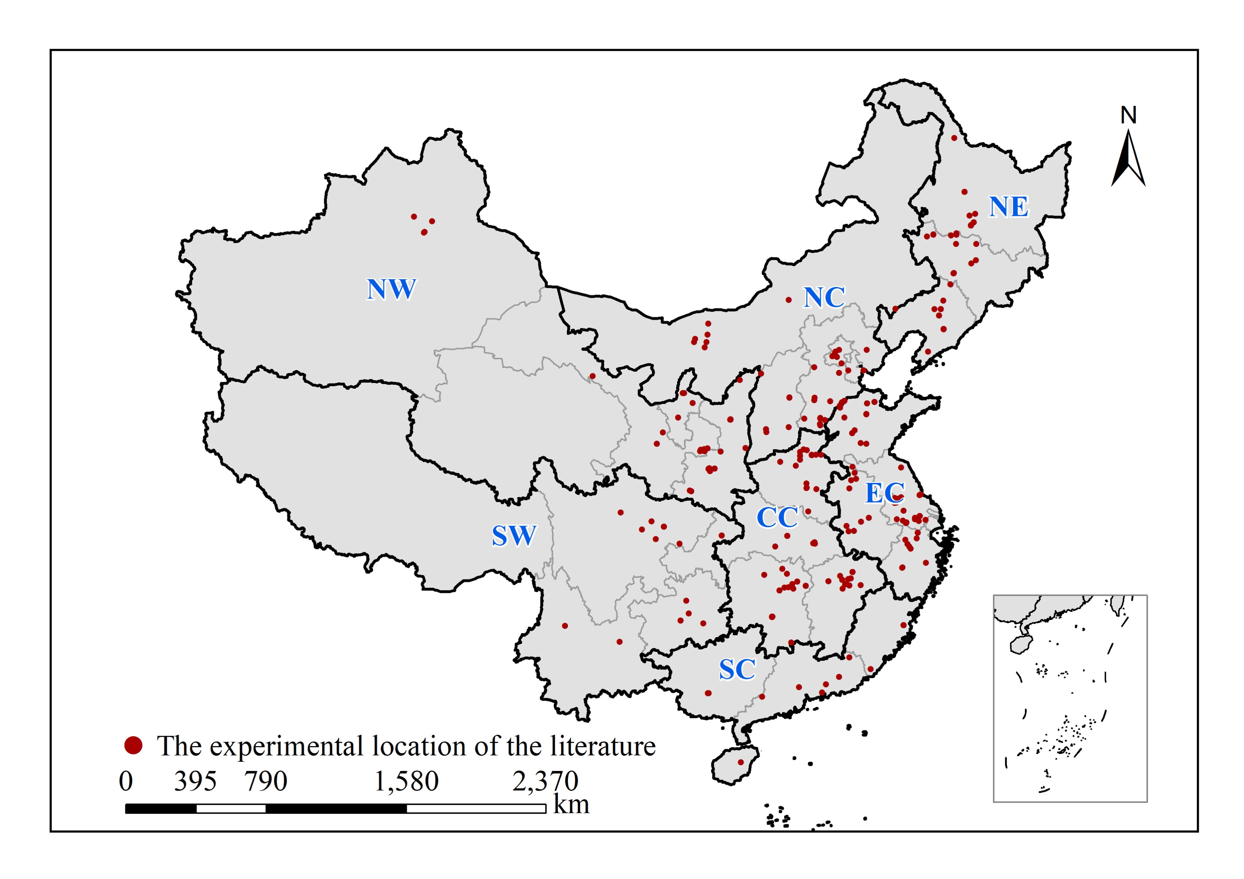
Fig 4. Experimental sites in the literature and the division of seven major agricultural regions. China is divided into seven major agricultural production areas: Northeast (Heilongjiang, Liaoning, Jilin), North China (Beijing, Tianjin, Hebei, Shanxi and Inner Mongolia), East China (Anhui, Shandong, Jiangsu, Zhejiang and Shanghai), Central China (Hubei, Hunan, Henan, Jiangxi), South China (Guangdong, Guangxi, Fujian and Hainan), Northwest China (Shaanxi, Gansu, Qinghai, Ningxia and Xinjiang) and Southwest China (Chongqing, Sichuan, Guizhou and Yunnan).

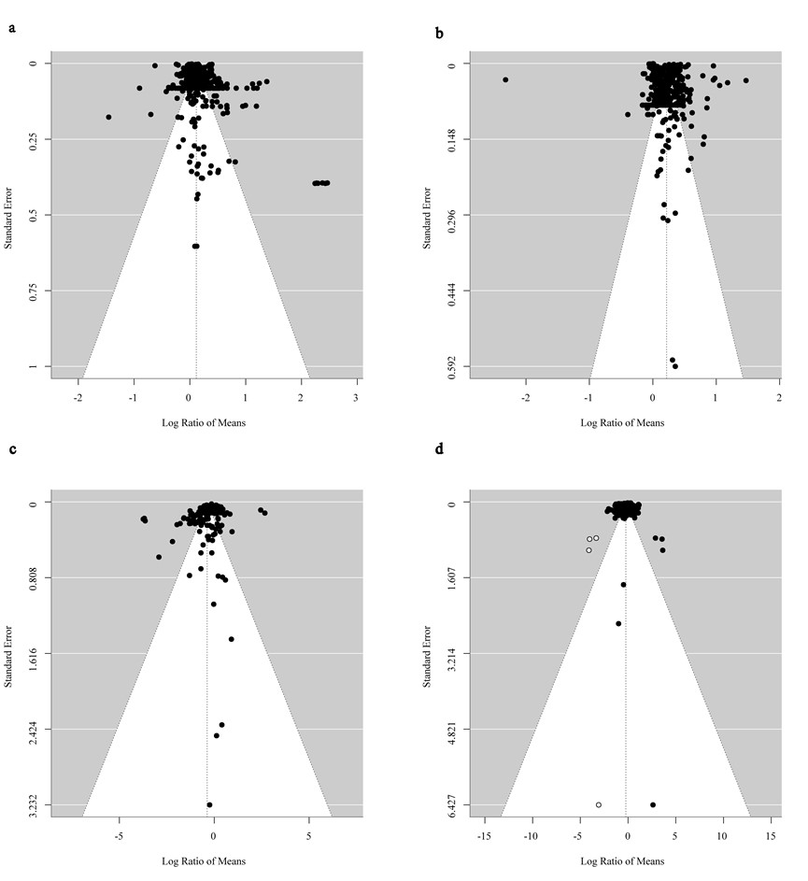
Fig 5. Funnel plot of organic replacements on carbon sequestration, GHG reduction in cropland soil and crop yield. a, organic replacements on organic carbon content. b, organic replacements on CH₄ emission per unit yield. c, organic replacements on N₂O emission per unit yield. d, organic replacements on crop yield.

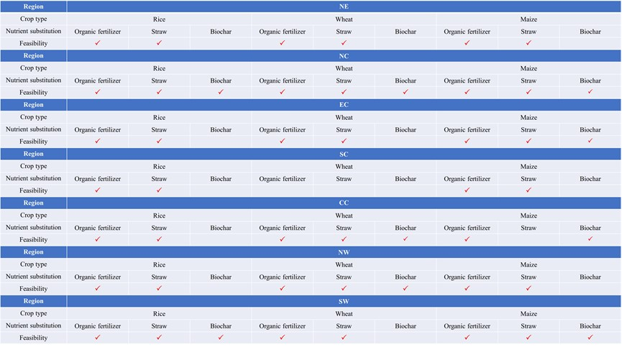
Fig 6. Organic replacements strategies that can be adopted for the three major staple grains in the seven agricultural regions of China (a tick indicates adoptability).

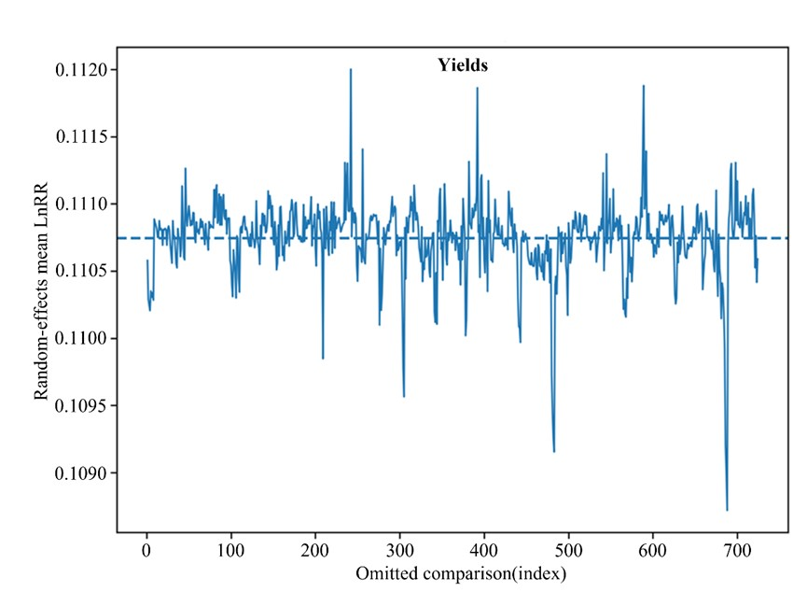
Fig 7. Leave-one-out sensitivity analysis for the pooled effect of organic replacements relative to conventional fertilization on crop yield (lnRR). Each point shows the pooled estimate after omitting one comparison; error bars indicate 95% confidence intervals.

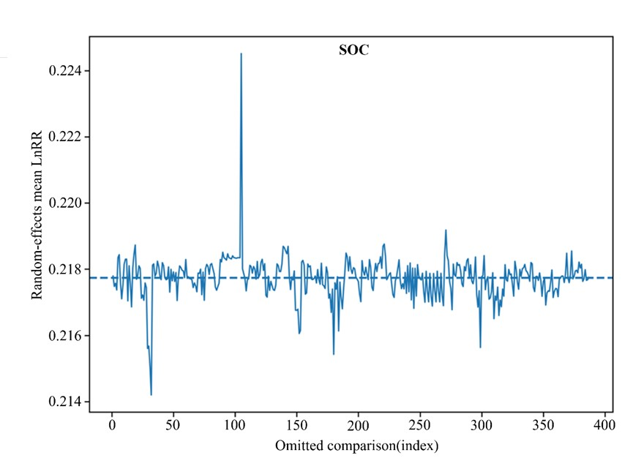
Fig 8. Leave-one-out sensitivity analysis for the pooled effect of organic replacements on soil organic carbon (SOC; lnRR). Each point shows the pooled estimate after omitting one comparison; error bars indicate 95% confidence intervals.

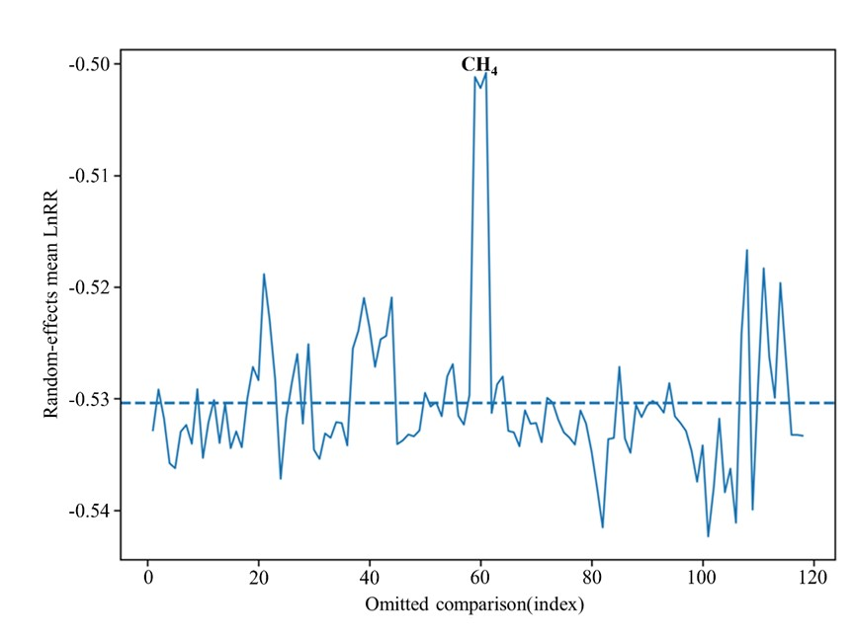
Fig 9. Leave-one-out sensitivity analysis for the pooled effect of organic replacements on yield-scaled CH₄ emissions (lnRR). Each point shows the pooled estimate after omitting one comparison; error bars indicate 95% confidence intervals.

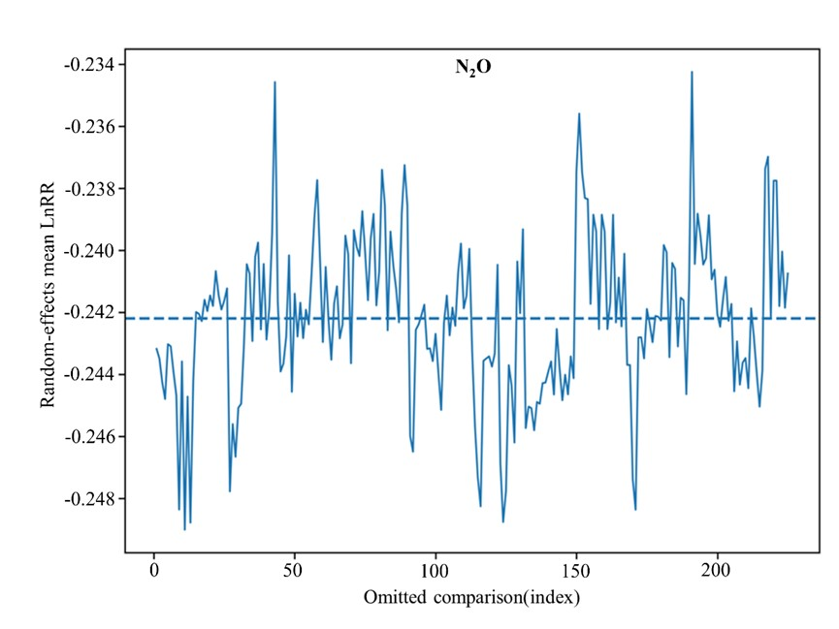
Fig 10. Leave-one-out sensitivity analysis for the pooled effect of organic replacements on yield-scaled N₂O emissions (lnRR). Each point shows the pooled estimate after omitting one comparison; error bars indicate 95% confidence intervals.

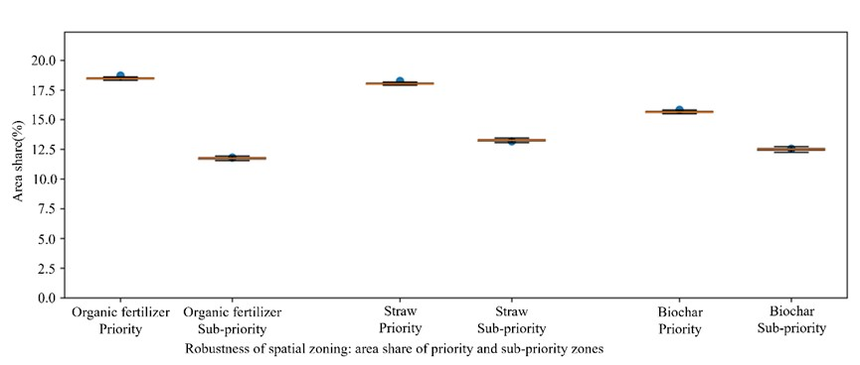
Fig 11. Robustness of spatial prioritization: area share of priority and sub-priority zones. Boxplots show the distribution (n=350 Monte Carlo perturbations) of the fraction of grid cells classified as priority (k>2) and sub-priority (1<k≤2) zones for organic fertilizer, straw and biochar strategies. Perturbations were applied as multiplicative lognormal noise on grid-level NEEB with log-scale SD σ=√τ²_yield from the yield meta-analysis. Dots indicate baseline estimates from the original NEEB maps.

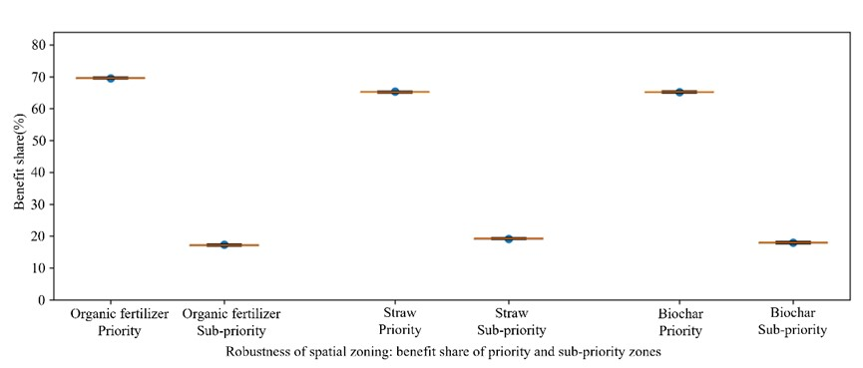
Fig 12. Robustness of spatial prioritization: benefit share of priority and sub-priority zones. Boxplots show the distribution (n = 350 Monte Carlo perturbations) of the share of total benefits (sum of grid-level NEEB) captured by grid cells classified as priority (k > 2) and sub-priority (1 < k ≤ 2) zones for organic fertilizer, straw and biochar strategies. Perturbations were applied as multiplicative lognormal noise on grid-level NEEB with log-scale SD σ = √τ²_yield from the yield meta-analysis. For each perturbed surface, grid cells were re-ranked by NEEB, the cumulative benefit curve was recomputed, and k-based zoning was repeated. Dots indicate baseline estimates from the original NEEB maps.

Table 1. Rates of OR strategies applied to different crops (rice, maize and wheat) across agricultural regions
Crop | Region  Strategy | NE | NC | EC | SC | CC | SW | SN
Rice | Organic fertilizer | 0.3-0.75 | 1-3 | 1.5-13.5 | 2.5-60 | 2.5-45 | 2.5-60 | 2.5-60
Rice | Straw | 6-8 | 3-4 | 3-5 | 3-10 | 5-10 | 3-5 | 15-37
Rice | Biochar | 15-40 | 3-40 | 6-30 | 10-30 | 10-40 | 9-20 | 6-18
Wheat | Organic fertilizer | 1.3-54 | 1.3-90 | 2-90 | / | 7.5-44.1 | 7.5-75 | 2.5-60
Wheat | Straw | 3-5 | 3-6 | 6-18 | / | 2.5-12 | 3-5 | 15-37
Wheat | Biochar | 10-47.5 | 3-40 | 5-30 | / | 3-22.5 | 3-30 | 6-18
Maize | Organic fertilizer | 3-30 | 3-40 | 7.5-10 | 3-30 | 12.6-18 | 3-30 | 12-30
Maize | Straw | 3.2-10 | 5-6 | 6-18 | 3-10 | 2.5-12 | 3-5 | 15-37
Maize | Biochar | 10-47.5 | 3-40 | 5-30 | 10-30 | 3-40 | 20-40 | 6-18
Note: The data is mainly sourced from meta-analysis datasets. For regions with missing data, the national average is used as a substitute. The unit is t ha⁻¹. Wheat is basically not grown in South China, so organic alternative strategies for wheat cultivation are not considered in this region.

Table 2. OR strategies selected for the three major staple foods in different priority scenarios across different regions
Crop | Region  Scenario | NE | NC | EC | SC | CC | NW | SW
Rice | PRO | Organic fertilizer | Organic fertilizer | Organic fertilizer | Organic fertilizer | Organic fertilizer | Straw | Straw
Rice | SOC | Organic fertilizer | Biochar | Organic fertilizer | Organic fertilizer | Organic fertilizer | Straw | Straw
Rice | GHGs | Straw | Biochar | Straw | Straw | Straw | Organic fertilizer | Biochar
Wheat | PRO | Organic fertilizer | Organic fertilizer | Straw | / | Straw | Straw | Straw
Wheat | SOC | Straw | Biochar | Straw | / | Organic fertilizer | Straw | Straw
Wheat | GHGs | Straw | Biochar | Organic fertilizer | / | Biochar | Organic fertilizer | Straw
Maize | PRO | Organic fertilizer | Straw | Organic fertilizer | Organic fertilizer | Organic fertilizer | Straw | Straw
Maize | SOC | Organic fertilizer | Biochar | Straw | Organic fertilizer | Organic fertilizer | Straw | Straw
Maize | GHGs | Organic fertilizer | Biochar | Organic fertilizer | Straw | Organic fertilizer | Organic fertilizer | Organic fertilizer
Note: wheat is basically not grown in SC, so organic alternative strategies for wheat cultivation are not considered in this region.

Table 3. Organic replacements rates, synthetic nitrogen fertilizer application rates, and prices in Chinese agricultural regions
Region | Crop | Strategies | Rate (t ha⁻¹) | Material price (CNY kg⁻¹) | N rate (kg ha⁻¹) | N price (CNY kg⁻¹)
NE | Rice | Organic fertilizer | 0.53 | 2.85 | 204.00 | 3.70
NE | Rice | Straw | 7.00 | 2.85 | 225.00 | 3.70
NE | Rice | Biochar | 27.50 | 2.85 | 307.00 | 3.70
NE | Wheat | Organic fertilizer | 27.65 | 2.86 | 240.00 | 3.70
NE | Wheat | Straw
NE | Wheat | Biochar | 28.63 | 2.86 | 240.00 | 3.70
NE | Maize | Organic fertilizer | 16.50 | 2.67 | 121.00 | 3.70
NE | Maize | Straw | 6.60 | 2.67 | 157.40 | 3.70
NE | Maize | Biochar | 28.63 | 2.67 | 200.00 | 3.70
NC | Rice | Organic fertilizer | 2.00 | 3.12 | 207.00 | 3.70
NC | Rice | Straw | 3.50 | 3.12 | 226.00 | 3.70
NC | Rice | Biochar | 21.50 | 3.12 | 225.00 | 3.70
NC | Wheat | Organic fertilizer | 45.65 | 3.17 | 193.00 | 3.70
NC | Wheat | Straw
NC | Wheat | Biochar | 21.50 | 3.17 | 193.00 | 3.70
NC | Maize | Organic fertilizer | 3.00 | 2.70 | 150.00 | 3.70
NC | Maize | Straw | 5.50 | 2.70 | 153.00 | 3.70
NC | Maize | Biochar | 21.50 | 2.70 | 232.50 | 3.70
EC | Rice | Organic fertilizer | 7.50 | 2.66 | 250.00 | 3.70
EC | Rice | Straw | 4.00 | 2.66 | 267.00 | 3.70
EC | Rice | Biochar | 18.00 | 2.66 | 216.00 | 3.70
EC | Wheat | Organic fertilizer | 46.00 | 3.00 | 187.00 | 3.70
EC | Wheat | Straw | 12.00 | 3.00 | 146.00 | 3.70
EC | Wheat | Biochar | 17.50 | 3.00 | 257.00 | 3.70
EC | Maize | Organic fertilizer | 8.75 | 2.67 | 214.00 | 3.70
EC | Maize | Straw | 12.00 | 2.67 | 135.00 | 3.70
EC | Maize | Biochar | 17.50 | 2.67 | 375.00 | 3.70
SC | Rice | Organic fertilizer | 31.25 | 3.32 | 207.00 | 3.70
SC | Rice | Straw
SC | Rice | Biochar | 20.00 | 3.32 | 225.00 | 3.70
SC | Maize | Organic fertilizer | 16.50 | 2.84 | 153.00 | 3.70
SC | Maize | Straw
SC | Maize | Biochar | 20.00 | 2.84 | 266.00 | 3.70
CC | Rice | Organic fertilizer | 23.75 | 2.50 | 174.00 | 3.70
CC | Rice | Straw | 5.00 | 2.50 | 150.00 | 3.70
CC | Rice | Biochar | 25.00 | 2.50 | 167.00 | 3.70
CC | Wheat | Organic fertilizer | 25.80 | 2.94 | 214.00 | 3.70
CC | Wheat | Straw | 7.25 | 2.94 | 172.50 | 3.70
CC | Wheat | Biochar | 12.75 | 2.94 | 222.50 | 3.70
CC | Maize | Organic fertilizer | 15.30 | 2.72 | 100.00 | 3.70
CC | Maize | Straw | 7.25 | 2.72 | 90.00 | 3.70
CC | Maize | Biochar | 21.50 | 2.72 | 220.00 | 3.70
NW | Rice | Organic fertilizer | 31.25 | 2.66 | 300.00 | 3.70
NW | Rice | Straw
NW | Rice | Biochar | 14.50 | 2.66 | 300.00 | 3.70
NW | Wheat | Organic fertilizer | 41.25 | 2.93 | 135.00 | 3.70
NW | Wheat | Straw |  | 2.93 | 135.00 | 3.70
NW | Wheat | Biochar | 16.50 | 2.93 | 135.00 | 3.70
NW | Maize | Organic fertilizer | 16.50 | 2.69 | 272.00 | 3.70
NW | Maize | Straw
NW | Maize | Biochar | 30.00 | 2.69 | 300.00 | 3.70
SW | Rice | Organic fertilizer | 31.25 | 3.10 | 165.00 | 3.70
SW | Rice | Straw | 26.00 | 3.10 | 165.00 | 3.70
SW | Rice | Biochar | 12.00 | 3.10 | 165.00 | 3.70
SW | Wheat | Organic fertilizer | 33.75 | 2.78 | 189.00 | 3.70
SW | Wheat | Straw | 26.00 | 2.78 | 134.00 | 3.70
SW | Wheat | Biochar | 12.00 | 2.78 | 233.00 | 3.70
SW | Maize | Organic fertilizer | 21.00 | 3.05 | 108.00 | 3.70
SW | Maize | Straw | 26.00 | 3.05 | 108.00 | 3.70
SW | Maize | Biochar | 12.00 | 3.05 | 108.00 | 3.70

Table 4. Uncertainty and robustness diagnostics for the meta-analytic models
Outcome | k | lnRR (RE mean) | 95% CI (lnRR) | Change (%) | 95% CI (% change) | τ² | I² (%) | Q (df) | Egger p | LOO lnRR range | LOO % change range
Yield | 724 | 0.111 | [0.096, 0.125] | 11.7 | [10.1, 13.4] | 0.035 | 98.9 | 67373.6 (723) | 0.068 | [0.109, 0.112] | [11.5, 11.9]
SOC | 387 | 0.218 | [0.193, 0.242] | 24.3 | [21.3, 27.4] | 0.057 | 99.8 | 249110.7 (386) | 5.23e-08 | [0.214, 0.225] | [23.9, 25.2]
CH₄ | 118 | -0.530 | [-0.666, -0.394] | -41.2 | [-48.6, -32.6] | 0.526 | 95.8 | 2766.1 (117) | 9.25e-05 | [-0.542, -0.501] | [-41.9, -39.4]
N₂O | 225 | -0.242 | [-0.321, -0.163] | -21.5 | [-27.5, -15.1] | 0.336 | 97.6 | 9270.8 (224) | 0.033 | [-0.249, -0.234] | [-22.0, -20.9]
Note: lnRR denotes the log response ratio. τ² and I² quantify between-comparison heterogeneity. Egger’s test is a regression-based assessment of small-study effects. Leave-one-out (LOO) ranges summarize pooled lnRR (and corresponding percentage change) after omitting each comparison in turn.

Additional uncertainty propagation and spatial robustness analyses
Table 5. Strategy-specific pooled effects and heterogeneity metrics (random-effects meta-analysis).
Strategy | Outcome | Studies | Comparisons (k) | lnRR (95% CI) | Change (%) (95% CI) | tau² | I² (%)
Organic fertilizer | Yield | 48 | 273 | 0.073 [0.050, 0.095] | 7.6% [5.1%, 10.0%] | 0.02974574060034176 | 98.4048268604244
Straw | Yield | 30 | 161 | 0.080 [0.058, 0.102] | 8.3% [6.0%, 10.7%] | 0.016123329683819486 | 99.3028239281765
Biochar | Yield | 26 | 123 | 0.101 [0.072, 0.130] | 10.6% [7.5%, 13.9%] | 0.022851491267763802 | 98.74407438329985
Organic fertilizer | SOC | 44 | 218 | 0.221 [0.185, 0.256] | 24.7% [20.3%, 29.2%] | 0.06711106474855916 | 99.77227837546688
Straw | SOC | 14 | 68 | 0.173 [0.126, 0.220] | 18.9% [13.4%, 24.7%] | 0.03518317316555295 | 99.05716736421229
Biochar | SOC | 10 | 56 | 0.300 [0.229, 0.371] | 35.0% [25.8%, 44.9%] | 0.06854496931586555 | 99.70244020647505
Organic fertilizer | CH4 | 4 | 34 | -0.549 [-0.793, -0.304] | -42.2% [-54.8%, -26.2%] | 0.4827636322681793 | 94.80058813026719
Straw | CH4 | 3 | 8 | -0.660 [-1.269, -0.050] | -48.3% [-71.9%, -4.9%] | 0.6635000396150151 | 82.69678142270017
Biochar | CH4 | 5 | 48 | -0.399 [-0.586, -0.212] | -32.9% [-44.3%, -19.1%] | 0.40266623085750497 | 95.66272454645538
Organic fertilizer | N2O | 17 | 84 | -0.317 [-0.451, -0.182] | -27.1% [-36.3%, -16.7%] | 0.3750320442688706 | 98.28937226846446
Straw | N2O | 2 | 24 | -0.220 [-0.414, -0.026] | -19.8% [-33.9%, -2.6%] | 0.21383759196742075 | 95.72728048503208
Biochar | N2O | 11 | 77 | -0.248 [-0.377, -0.120] | -22.0% [-31.4%, -11.3%] | 0.309851570807957 | 96.32383860856693
Note: table 5 summarizes strategy-specific random-effects meta-analysis results (Paule–Mandel τ²) for the three focal ORR strategies (organic fertilizer; straw: SN; biochar: NB), including pooled lnRR, corresponding percentage changes, and heterogeneity metrics.

To propagate meta-analysis uncertainty into the NEEB calculations, we performed a cluster bootstrap (resampling studies with replacement) to obtain distributions of the pooled yield response (exp(lnRR_yield)) and of a combined GHG reduction factor derived from yield-scaled CH₄ and N₂O responses. For each region–crop–strategy combination, we recalculated NEEB by scaling the yield-dependent economic term by the bootstrapped yield ratio and scaling the environmental term by the bootstrapped GHG-reduction ratio.
Table 6. Uncertainty intervals for NEEB (CNY ha⁻¹) by region, crop and organic replacements strategy (bootstrap propagation).
Region | Crop | Strategy | Net benefit (upper cost) | P (>0) upper | Net benefit (lower cost) | P (>0) lower
NE | Rice | Organic fertilizer | 24,546 [22,474, 25,714] | 100.0% | 18,105 [16,094, 19,164] | 100.0%
NE | Rice | Straw | 23,007 [20,925, 26,087] | 100.0% | 23,836 [21,707, 26,916] | 100.0%
NE | Rice | Biochar | -36,017 [-38,161, -31,162] | 0.0% | -137,524 [-140,645, -119,196] | 0.0%
NE | Wheat | Organic fertilizer | 29,101 [26,594, 30,495] | 100.0% | -22,710 [-25,301, -21,380] | 0.0%
NE | Wheat | Straw | 32,717 [29,767, 37,052] | 100.0% | 33,603 [30,605, 37,937] | 100.0%
NE | Wheat | Biochar | -10,887 [-13,046, -9,079] | 0.0% | -162,904 [-166,573, -141,214] | 0.0%
NE | Maize | Organic fertilizer | 23,969 [21,663, 25,231] | 100.0% | -2,543 [-4,794, -1,573] | 0.0%
NE | Maize | Straw | 34,099 [30,972, 38,824] | 100.0% | 34,679 [31,517, 39,403] | 100.0%
NE | Maize | Biochar | -6,779 [-9,328, -5,333] | 0.0% | -158,955 [-162,889, -137,540] | 0.0%
NC | Rice | Organic fertilizer | 25,455 [23,478, 26,595] | 100.0% | 24,216 [22,252, 25,334] | 100.0%
NC | Rice | Straw | 20,584 [18,299, 22,067] | 100.0% | 21,413 [19,130, 22,902] | 100.0%
NC | Rice | Biochar | 9,368 [7,936, 10,634] | 100.0% | -140,981 [-143,721, -122,254] | 0.0%
NC | Wheat | Organic fertilizer | 20,614 [19,006, 21,543] | 100.0% | -67,420 [-70,597, -64,750] | 0.0%
NC | Wheat | Straw | 14,528 [12,934, 15,564] | 100.0% | 15,232 [13,643, 16,275] | 100.0%
NC | Wheat | Biochar | 5,002 [4,171, 5,995] | 100.0% | -145,543 [-148,299, -126,072] | 0.0%
NC | Maize | Organic fertilizer | 27,711 [25,199, 29,096] | 100.0% | 28,256 [25,751, 29,650] | 100.0%
NC | Maize | Straw | 17,285 [15,086, 18,707] | 100.0% | 17,845 [15,649, 19,274] | 100.0%
NC | Maize | Biochar | 21,231 [18,127, 23,562] | 100.0% | -128,686 [-131,677, -111,640] | 0.0%
EC | Rice | Organic fertilizer | 29,206 [23,799, 31,714] | 100.0% | 18,186 [12,813, 20,584] | 100.0%
EC | Rice | Straw | 33,020 [29,209, 39,347] | 100.0% | 34,004 [30,190, 40,338] | 100.0%
EC | Rice | Biochar | -332 [-1,990, 145] | 7.5% | -98,074 [-100,557, -84,822] | 0.0%
EC | Wheat | Organic fertilizer | 20,165 [16,602, 21,832] | 100.0% | -67,224 [-71,703, -64,378] | 0.0%
EC | Wheat | Straw | 21,961 [19,666, 25,772] | 100.0% | 22,489 [20,182, 26,314] | 100.0%
EC | Wheat | Biochar | -2,692 [-3,798, -2,095] | 0.0% | -104,366 [-106,532, -90,555] | 0.0%
EC | Maize | Organic fertilizer | 21,290 [16,240, 23,621] | 100.0% | 19,600 [14,554, 21,885] | 100.0%
EC | Maize | Straw | 31,070 [27,547, 36,925] | 100.0% | 31,564 [28,039, 37,424] | 100.0%
EC | Maize | Biochar | 3,551 [1,839, 3,812] | 100.0% | -97,664 [-100,158, -84,455] | 0.0%
SC | Rice | Organic fertilizer | 23,831 [21,827, 24,959] | 100.0% | -32,920 [-35,259, -31,506] | 0.0%
SC | Rice | Straw | 27,855 [25,481, 31,130] | 100.0% | 28,686 [26,271, 31,967] | 100.0%
SC | Rice | Biochar | -15,195 [-16,807, -12,987] | 0.0% | -96,473 [-98,849, -83,482] | 0.0%
SC | Maize | Organic fertilizer | 12,674 [11,338, 13,392] | 100.0% | -13,770 [-15,204, -13,003] | 0.0%
SC | Maize | Straw | 16,656 [15,146, 18,900] | 100.0% | 17,336 [15,785, 19,581] | 100.0%
SC | Maize | Biochar | -26,083 [-27,377, -22,619] | 0.0% | -107,205 [-109,369, -92,981] | 0.0%
CC | Rice | Organic fertilizer | 21,573 [18,659, 23,008] | 100.0% | -20,284 [-23,374, -18,746] | 0.0%
CC | Rice | Straw | 22,386 [20,253, 25,723] | 100.0% | 22,938 [20,787, 26,267] | 100.0%
CC | Rice | Biochar | -21,471 [-23,256, -18,470] | 0.0% | -144,028 [-147,082, -124,982] | 0.0%
CC | Wheat | Organic fertilizer | 13,547 [11,254, 14,607] | 100.0% | -22,290 [-24,702, -21,024] | 0.0%
CC | Wheat | Straw | 23,595 [21,481, 26,664] | 100.0% | 24,231 [22,096, 27,298] | 100.0%
CC | Wheat | Biochar | 11,756 [9,676, 12,432] | 100.0% | -67,077 [-69,405, -58,051] | 0.0%
CC | Maize | Organic fertilizer | 14,396 [11,356, 15,802] | 100.0% | 9,385 [6,377, 10,732] | 100.0%
CC | Maize | Straw | 27,643 [25,118, 31,423] | 100.0% | 27,971 [25,434, 31,753] | 100.0%
CC | Maize | Biochar | 17,113 [14,259, 18,050] | 100.0% | -133,424 [-136,876, -115,359] | 0.0%
NW | Rice | Organic fertilizer | 20,487 [17,317, 21,980] | 100.0% | -35,948 [-39,458, -34,053] | 0.0%
NW | Rice | Straw | 22,384 [20,364, 25,358] | 100.0% | 23,493 [21,423, 26,465] | 100.0%
NW | Rice | Biochar | -11,249 [-15,934, -8,737] | 0.0% | -55,265 [-60,289, -47,429] | 0.0%
NW | Wheat | Organic fertilizer | 10,875 [8,598, 11,928] | 100.0% | -56,196 [-59,462, -53,923] | 0.0%
NW | Wheat | Straw | 20,940 [19,138, 23,443] | 100.0% | 21,430 [19,607, 23,942] | 100.0%
NW | Wheat | Biochar | 9,299 [5,577, 9,967] | 100.0% | -100,879 [-105,402, -87,577] | 0.0%
NW | Maize | Organic fertilizer | 27,423 [23,373, 29,354] | 100.0% | 1,511 [-2,485, 3,307] | 72.0%
NW | Maize | Straw | 36,642 [33,392, 41,326] | 100.0% | 37,379 [34,098, 42,063] | 100.0%
NW | Maize | Biochar | -43,943 [-50,877, -37,024] | 0.0% | -124,859 [-132,712, -107,937] | 0.0%
SW | Rice | Organic fertilizer | 25,484 [23,730, 26,620] | 100.0% | -31,408 [-33,528, -30,067] | 0.0%
SW | Rice | Straw | 30,970 [28,199, 34,979] | 100.0% | 31,578 [28,791, 35,586] | 100.0%
SW | Rice | Biochar | 3,655 [1,826, 3,929] | 100.0% | -44,966 [-47,149, -39,003] | 0.0%
SW | Wheat | Organic fertilizer | 10,588 [9,665, 11,098] | 100.0% | -51,275 [-53,626, -49,323] | 0.0%
SW | Wheat | Straw | 14,869 [13,482, 17,009] | 100.0% | 15,363 [13,953, 17,495] | 100.0%
SW | Wheat | Biochar | -11,539 [-12,557, -9,910] | 0.0% | -59,946 [-61,414, -51,880] | 0.0%
SW | Maize | Organic fertilizer | 18,648 [16,761, 19,665] | 100.0% | 1,089 [-749, 1,914] | 81.7%
SW | Maize | Straw | 33,901 [30,864, 38,304] | 100.0% | 34,298 [31,248, 38,700] | 100.0%
SW | Maize | Biochar | 6,210 [4,226, 6,615] | 100.0% | -42,502 [-44,828, -36,814] | 0.0%

