Communications Earth & Environment
Supporting Information for
High-resolution global flood projections constrained by observations reveal increasing extremes
Shugao Xu^{1,6}, Gang Zhao², Yu Zhang³, Qianyang Wang⁴, Haoyu Ji⁵, Jingshan Yu¹, Bruno Merz^{6,7}
¹ College of Water Sciences, Beijing Normal University, Beijing, China, 100875
² Department of Transdisciplinary Science and Engineering, Tokyo Institute of Technology, Tokyo, Japan
³ Key Laboratory of Water Cycle and Related Land Surface Processes, Institute of Geographic Sciences and Natural Resources Research, Chinese Academy of Sciences, Beijing 100101, China
⁴ Department of Civil & Environmental Engineering, University of Waterloo, Waterloo, ON, Canada
⁵ Civil and Environmental Engineering, The Pennsylvania State University, University Park, PA, United States
⁶ Section Hydrology, GFZ Helmholtz Centre for Geosciences, Potsdam, Germany
⁷Institute for Environmental Sciences and Geography, University of Potsdam, Germany

Contents of this file
Text S1 to S5
Figures S1 to S10
Tables S1 to S4

Text S1. Historical Design Flood Estimation Using Bias-Corrected Runoff from GRADES
As a comparison to uncorrected cascade models, we derived historical design flood estimates using bias-corrected runoff from the Global Reach-level A priori Discharge Estimates for SWOT (GRADES) dataset (Lin et al., 2019). GRADES provides 35-year (1979-2014) daily naturalized runoff generated by the Variable Infiltration Capacity (VIC) land surface model driven by Multi-Source Weighted-Ensemble Precipitation (MSWEP v2.2) forcing (Beck et al., 2019), which merges gauge observations, satellite retrievals, and reanalysis estimates. The runoff underwent two-stage bias correction: VIC parameters were calibrated against machine learning-derived global runoff characteristics (Beck et al., 2015), then sparse cumulative distribution function (CDF) matching corrected systematic biases against nine runoff percentiles from ~4,000 naturalized catchments. Validation against >14,000 stream gauges showed 35% achieved percentage bias within ±20%.

GRADES runoff was routed through CaMa-Flood at 0.25° resolution (Yamazaki et al., 2011), which explicitly simulates river water levels and floodplain inundation dynamics. The model excludes anthropogenic regulations, consistent with GRADES naturalized flow assumptions. Annual maximum daily discharge was extracted and fitted to the three-parameter Generalized Extreme Value (GEV) distributions using L-moment estimation (Hosking, 1990). Reaches with mean annual discharge <0.01 mm d⁻¹ were excluded. Design floods for 2-, 5-, 10-, 20-, 50-, 100-, and 200-year return periods were computed across the global river network.

The reach-level GRADES design floods were downscaled to 1-km resolution following the procedure described in Section 4.2: MERIT Hydro matching linked each reach to its outlet pixel, then Random Forest models trained on these matched pixels predicted design floods for all ungauged pixels using catchment characteristics and climatological factors (1979-2014 mean conditions).

Text S2. Observation-Based Design Flood Benchmark
We utilized the global design flood dataset from Zhao et al. (2021) as historical benchmarks. This dataset provides flood peaks for 2-, 5-, 10-, 20-, 50-, 100-, and 200-year return periods at 1-km resolution across the MERIT Hydro river network, derived from 11,793 gauging stations in the Global Streamflow Indices and Metadata (GSIM) archive. The methodology combined Bayesian MCMC flood frequency analysis at individual stations, K-means clustering into 16 homogeneous regions using 12 catchment descriptors, and regional Support Vector Machine (SVM) regression to predict design floods from catchment characteristics. Cross-validation against 3,485 independent stations showed relative bias <20% across all climate zones.

All three design flood estimates—uncorrected cascade-type models (Section 2.1), GRADES bias-corrected approach (Text S1), and observation-based benchmarks (Zhao et al., 2021)—use the identical MERIT Hydro river network at 1-km resolution, enabling pixel-by-pixel bias evaluation (Section 2.1) and EFBC correction (Section 2.2).

Text S3. EFBC Validation through Artificial Perturbation Experiments
EFBC assumes bias patterns remain consistent between historical and future periods. Since this assumption cannot be validated directly due to lack of future observations, we designed artificial perturbation experiments where unperturbed model outputs serve as reference values.

We systematically applied random perturbations (−50% to +200%) to both historical (1965–2014) and future (2051–2100) runoff from EC-Earth3 SSP5-8.5 projections. These runoff perturbations propagate through the cascade-type model chain to produce design flood biases spanning the full spectrum observed in Section 2.1, from severe underestimation to overestimation. Both perturbed and unperturbed runoff were routed through CaMa-Flood, and 100-year design floods were derived by fitting GEV distributions to annual maximum discharge. The resulting perturbed design floods show systematic deviations from unperturbed reference values across all flood magnitudes (Figure S3a), confirming successful replication of diverse bias patterns characteristic of cascade-type model limitations.

EFBC was applied to correct perturbed future floods using the multiplicative ratio in Equation (1) of the main text. Results show strong agreement with unperturbed reference values across 121,001 pixels spanning 0–250,000 m³/s: KGE = 0.972, RMSE = 772.1 m³/s, and PBIAS = −1.62% (Figure S3b), confirming EFBC effectively corrects systematic magnitude biases while preserving climate change signals.

However, this validation represents an idealized scenario assuming stationary bias patterns. In reality, bias non-stationarity may arise from evolving climate-vegetation feedbacks, structural model deficiencies under extreme warming, or regime transitions. Despite these limitations, the high correction accuracy supports EFBC's reliability when bias characteristics remain reasonably stable across time periods.

Text S4. EFBC Validation Against ISIMIP3 Multi-Model Ensembles
To independently validate EFBC, we compare our results with ISIMIP3a/3b multi-model ensembles. This comparison addresses two questions: (1) whether systematic overestimation of historical design floods is a common problem across different global hydrological modeling frameworks, and (2) whether EFBC's direct correction of design floods reduces projection uncertainty more effectively than ISIMIP's approach of correcting meteorological forcing before hydrological simulation.

We extracted discharge simulations from six global hydrological models in the ISIMIP3 Global Water sector: CWatM, H08, JULES-W2, MIROC-INTEG-LAND, WaterGAP2-2e, and WEB-DHM-SG (Table S4). For ISIMIP3a, models were driven by observational forcing (20CRv3-W5E5). For ISIMIP3b, both historical (1965–2014) and future (2051–2100, SSP5-8.5) periods used five bias-corrected CMIP6 climate models: GFDL-ESM4, IPSL-CM6A-LR, MPI-ESM1-2-HR, MRI-ESM2-0, and UKESM1-0-LL. Among the hydrological models, only WaterGAP2-2e incorporates discharge calibration. Design floods for multiple return periods were derived by fitting GEV distributions to annual maximum discharge, generating 6 estimates for ISIMIP3a and 30 ensemble members (6×5) for ISIMIP3b.

We focus on the 30 largest global river basins distributed across continents (Figure S5) because both our cascade-type models and ISIMIP exhibit highest skill at these scales, providing the most rigorous benchmark for validation. Despite resolution differences (ISIMIP: 0.5°; our study: 1-km), drainage-area-based matching enabled direct comparison by pairing river reaches with equivalent upstream catchment areas across resolutions.

Text S5. Model performance metrics
We evaluate Random Forest model performance using the coefficient of determination (R²), Nash-Sutcliffe Efficiency (NSE), Kling–Gupta efficiency (KGE), Root Mean Squared Error (RMSE), and relative bias RBIAS.
$R^{2}$ is expressed as
${ R}^{2}=r^{2}$ (1)
where r represents Pearson’s correlation and is expressed as
$$r=\frac{\sum{(S_{i}-\overline{S})(O_{i}-\overline{O})}}{\sqrt{\sum{{(S_{i}-\overline{S})}^{2}}\sum{{(O_{i}-\overline{O})}^{2}}}}$$ | (2)
where Si and Oi denote simulations and observations, respectively, and are applicable to all following equations; $\overline{S}$ is the simulated mean and Ō is the observed mean.
NSE is expressed as
$$NSE=1-\frac{\sum{{(O_{i}-S_{i})}^{2}}}{\sum{{(O_{i}-\overline{O})}^{2}}}$$ | (3)
KGE is expressed as
$$KGE=1-\sqrt{{(r-1)}^{2}+{(β-1)}^{2}+{(γ-1)}^{2}}$$ | (4)
where β and γ bias ratio, and variability ratio, respectively, and are expressed as
$$β=\overline{S}/\overline{O}$$ | (5)
$$γ=\frac{σ_{S}/\overline{S}}{σ_{O}/\overline{O}}$$ | (6)
RMSE is expressed as
$$RMSE=\sqrt{\frac{1}{n}\sum{{(O_{i}-S_{i})}^{2}}}$$ | (7)
RBIAS is expressed as
$$RBIAS=\frac{1}{n}\sum{\frac{(O_{i}-S_{i})}{O_{i}}}$$ | (8)

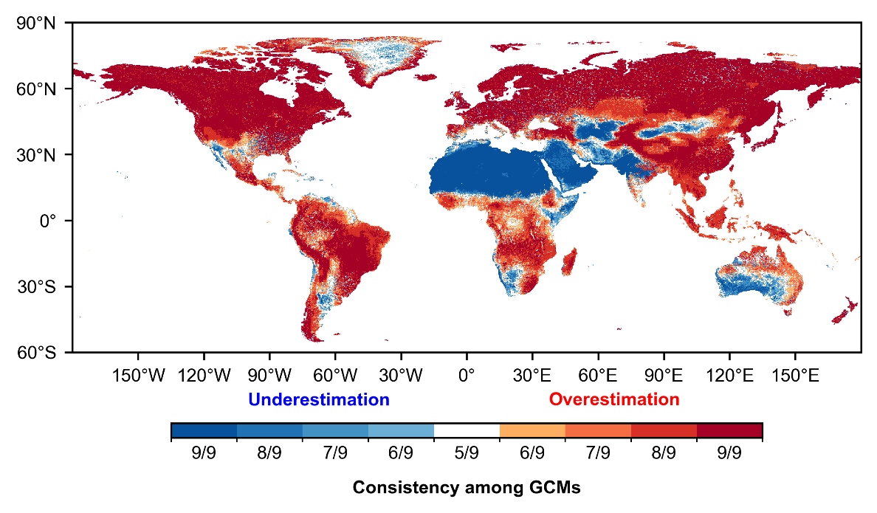

Figure S1. Multi-model consistency in design flood biases across nine uncorrected CMIP6 cascade-type models. Colors show the fraction of models agreeing on bias direction relative to observation-based benchmarks (Zhao et al., 2021).

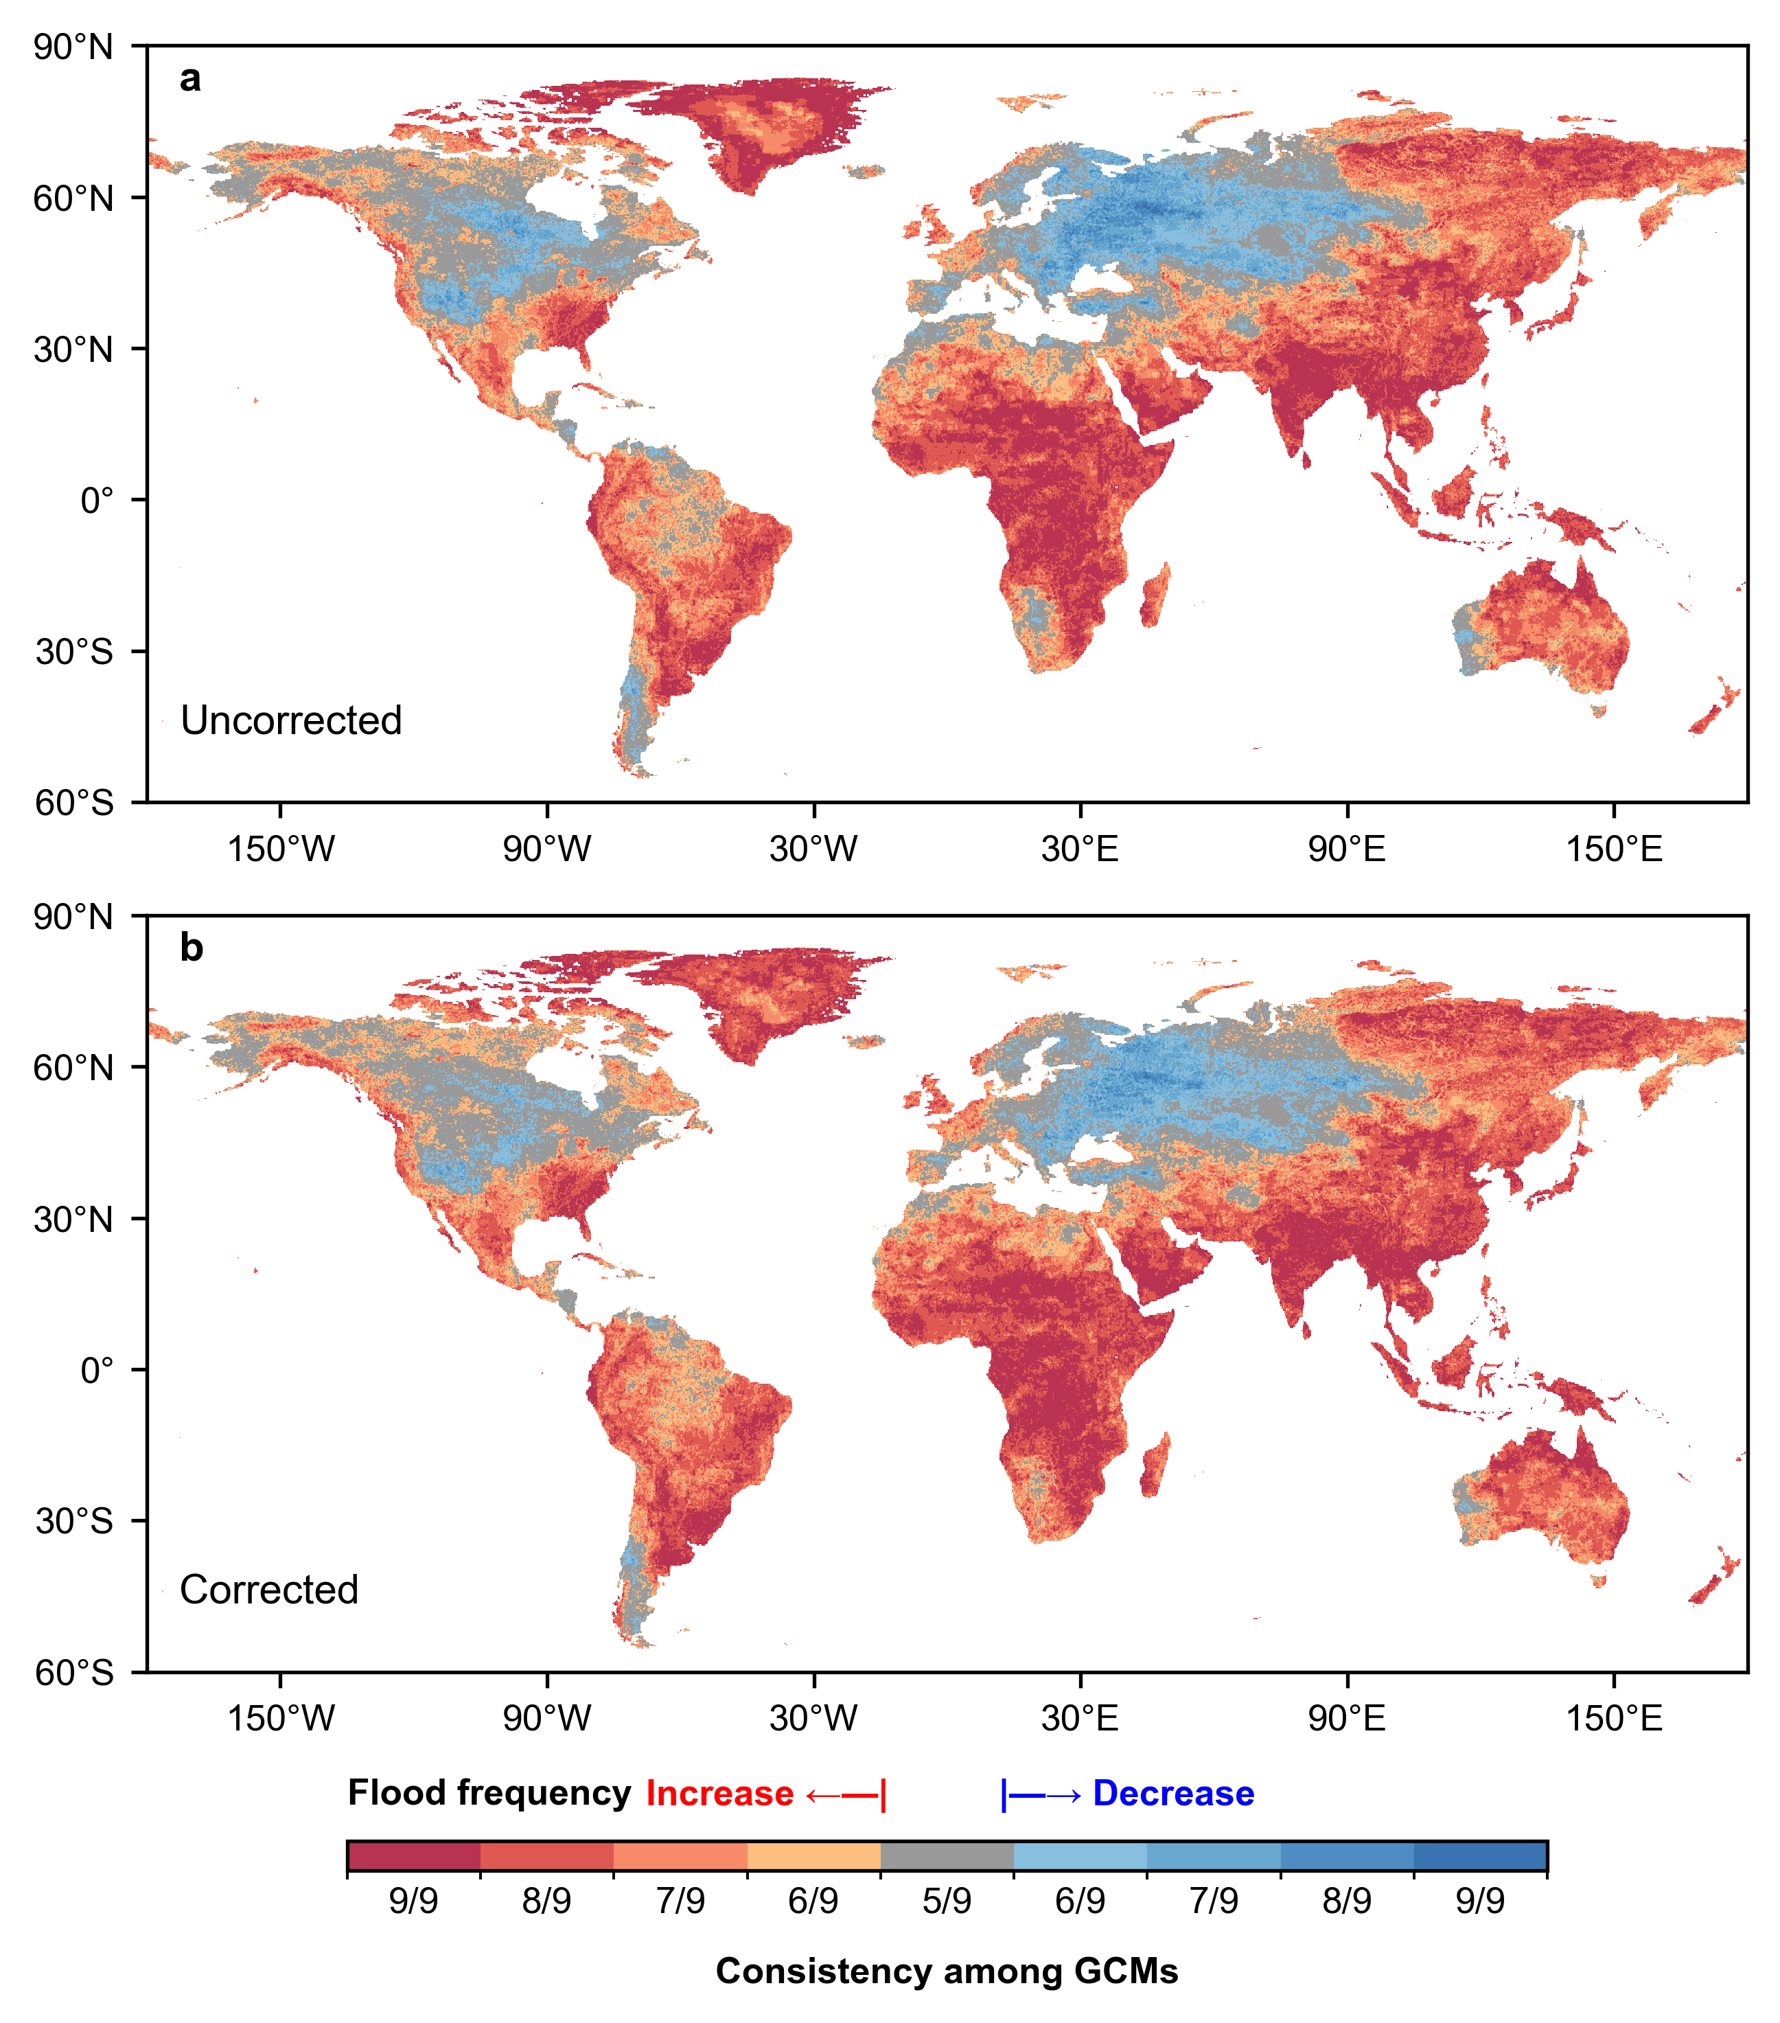

Figure S2. Multi-model consistency in projected frequency changes of historical 100-year floods under SSP5-8.5 (2051-2100). Fraction of models (out of 9) agreeing on change direction for (a) uncorrected CMIP6 cascade-type models and (b) EFBC-corrected projections. Red indicates flood frequency increase (shorter return periods), blue indicates frequency decrease (longer return periods).

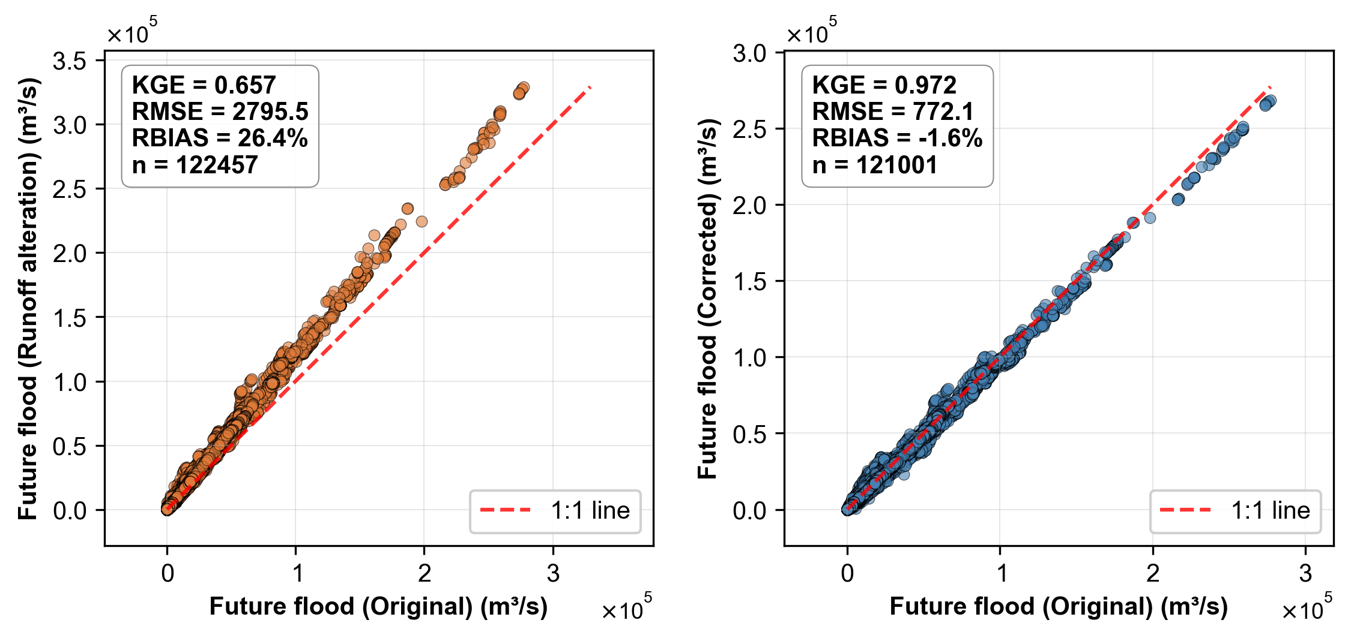

Figure S3. EFBC validation using artificial perturbation experiments. Comparison of future 100-year design floods (2051-2100, SSP5-8.5) from perturbed versus unperturbed EC-Earth3 runoff (a) without correction and (b) with EFBC correction.

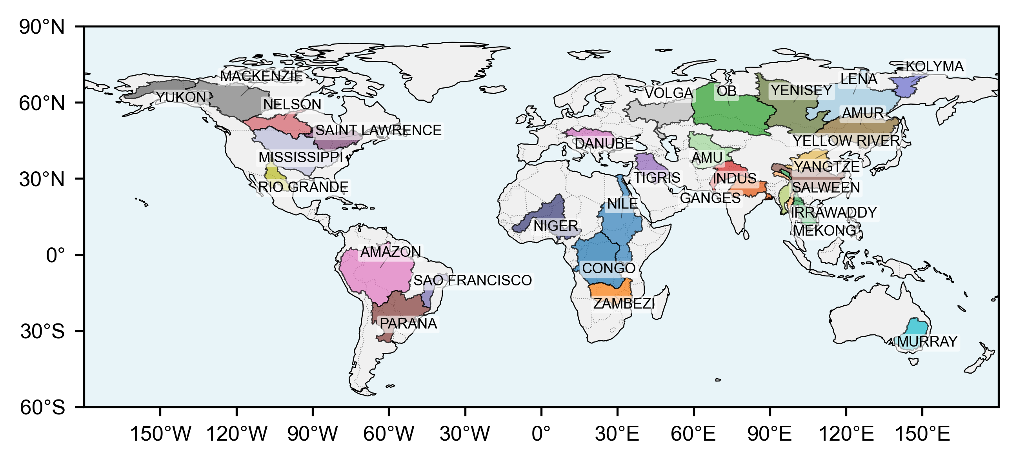

Figure S4. Drainage basins of the 30 largest river basins worldwide.

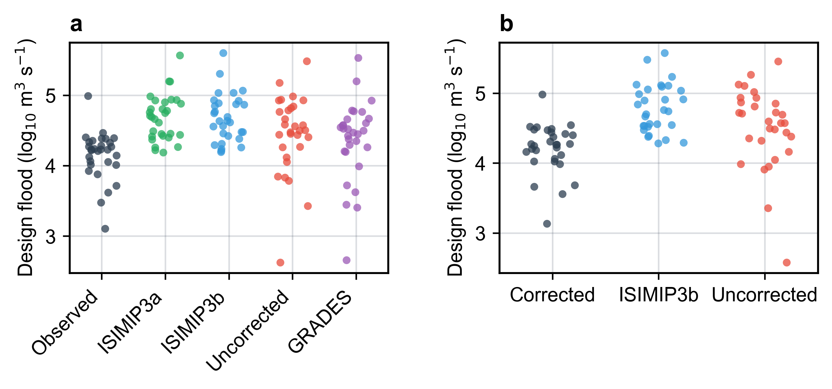

Figure S5. Design flood comparison across modeling frameworks for the 30 largest global river basins. Historical 100-year design floods from (a) ISIMIP3a, ISIMIP3b, uncorrected cascade-type models, and GRADES bias-corrected approach, compared against observation-based benchmarks (gray). (b) Future 100-year design floods (2051-2100, SSP5-8.5) from EFBC-corrected projections, ISIMIP3b, and uncorrected cascade-type models. Each dot represents one basin.

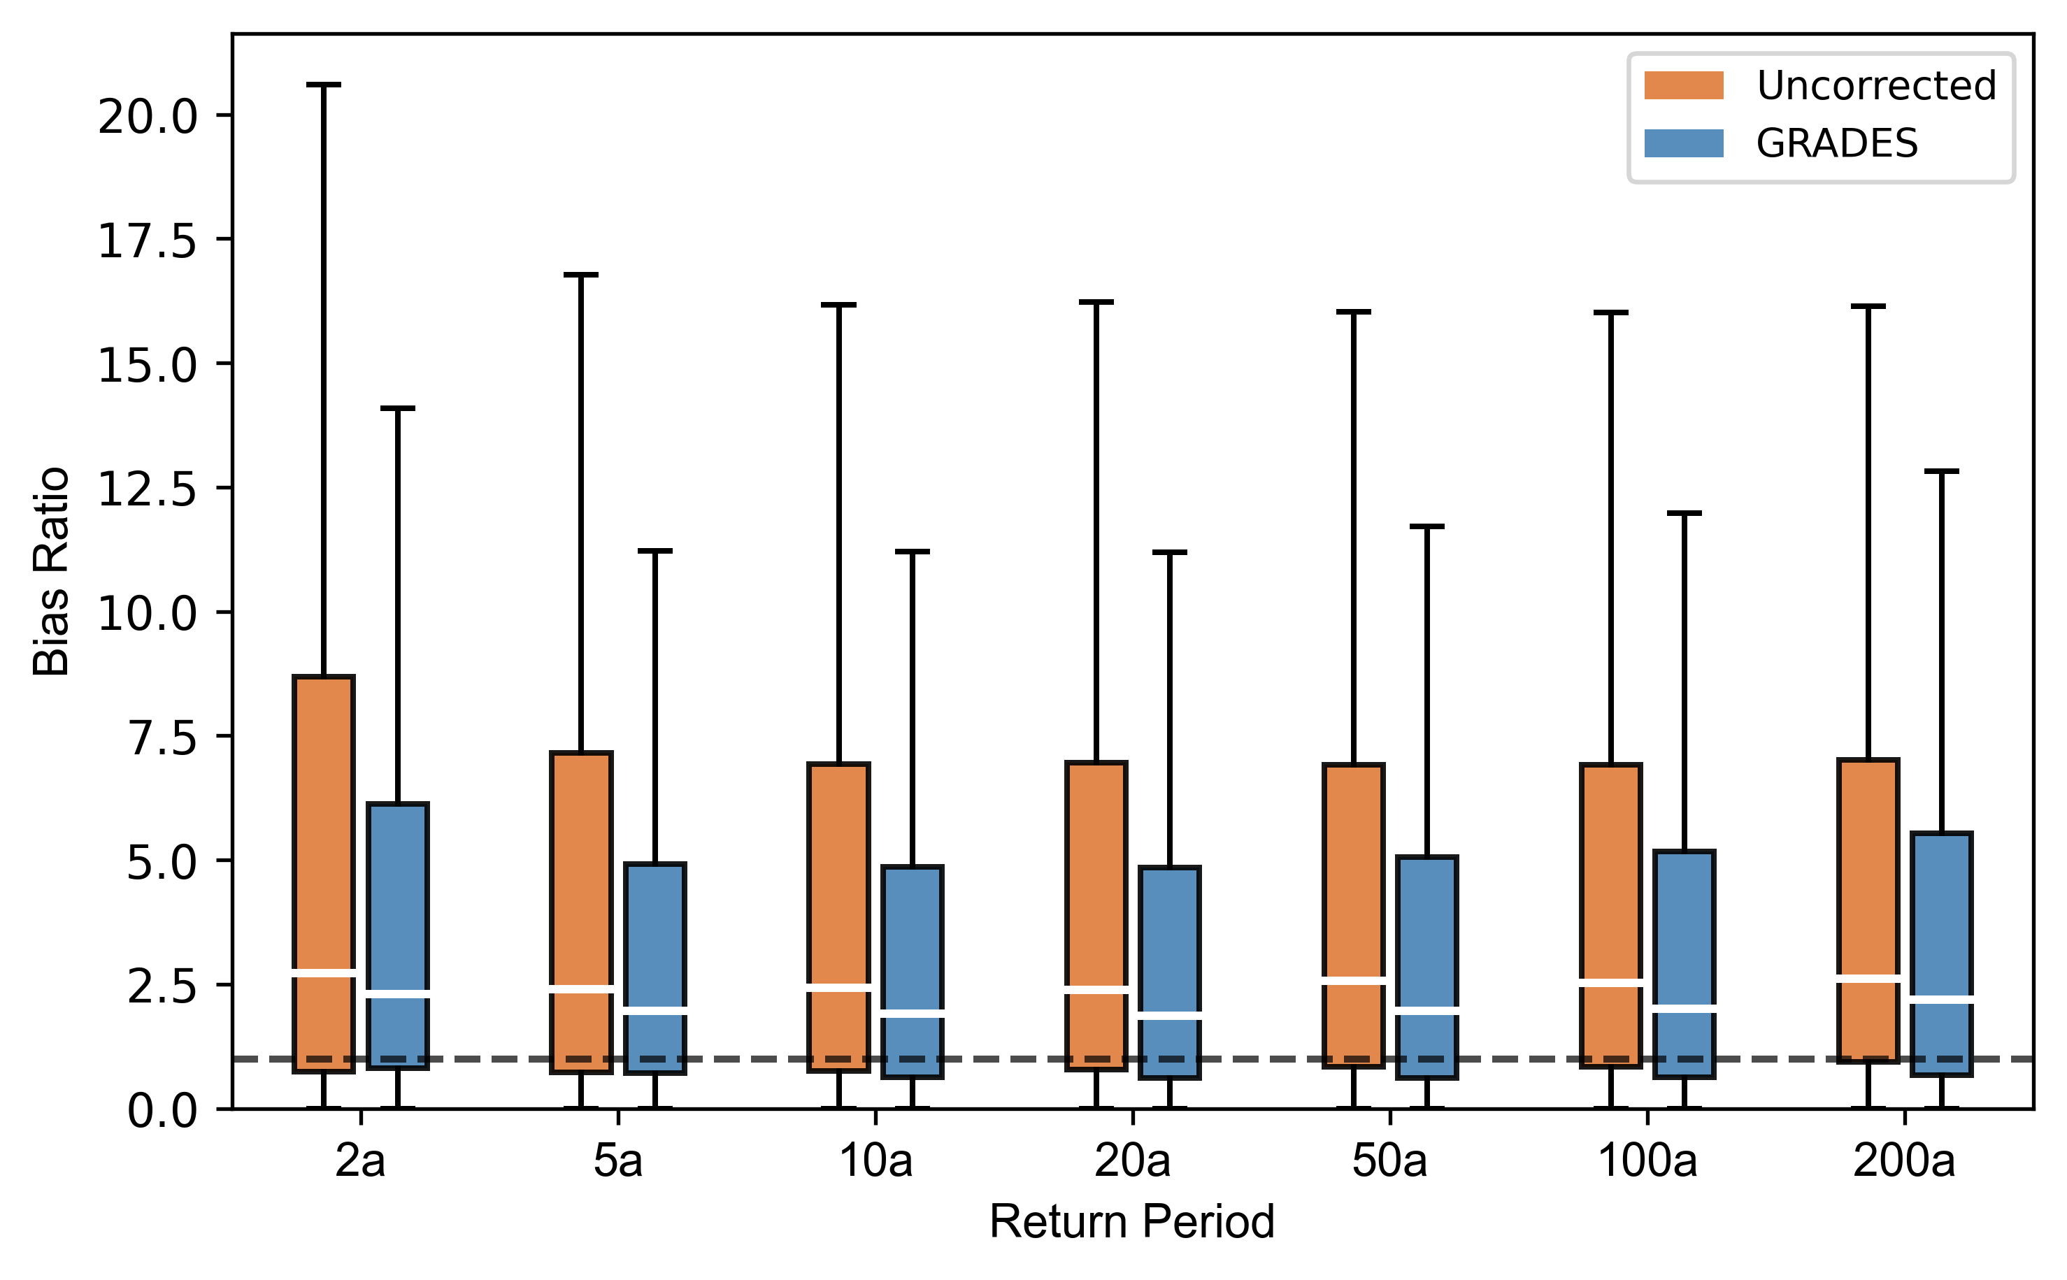

Figure S6. Bias ratio (simulated/observed) for historical design floods across return periods (2- to 200-year) using uncorrected CMIP6 runoff (orange) and bias-corrected GRADES runoff (blue).

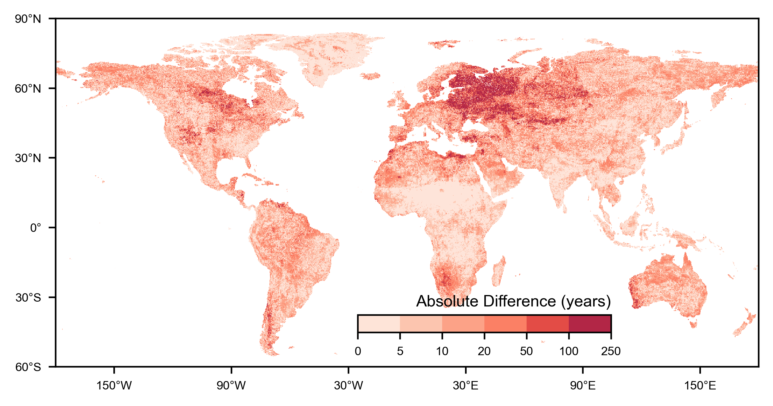

Figure S7. Absolute magnitude of projection differences between EFBC-corrected and uncorrected cascade-type models. Absolute differences (|Corrected minus Uncorrected|) for projected return periods of historical 100-year floods (2051-2100, SSP5-8.5).

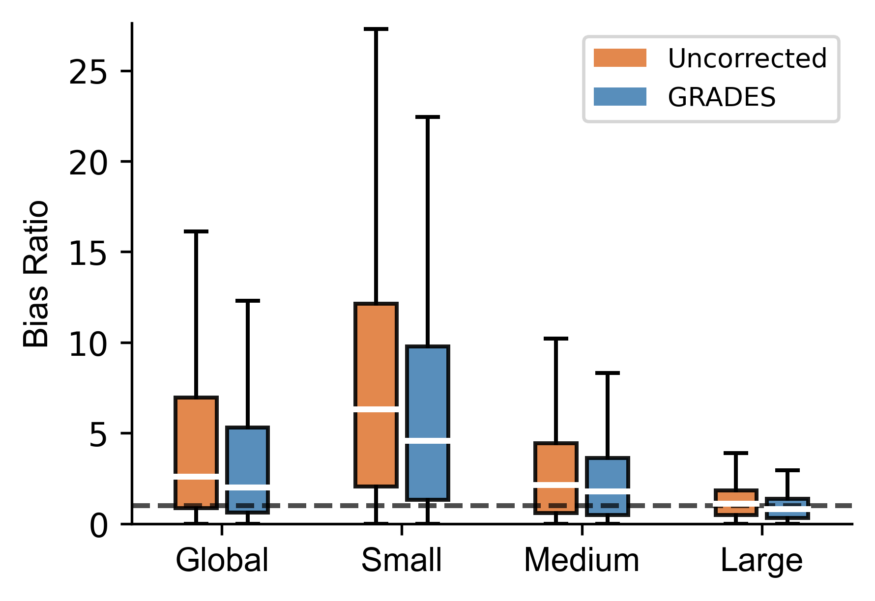

Figure S8. Bias ratio (simulated/observed) for historical 100-year flood discharges stratified by catchment size category, for uncorrected CMIP6 cascade-type models and bias-corrected GRADES runoff. Small: 1–100 km²; Medium: 100–1,000 km²; Large: >1,000 km². Dashed line indicates unbiased ratio (bias ratio = 1).
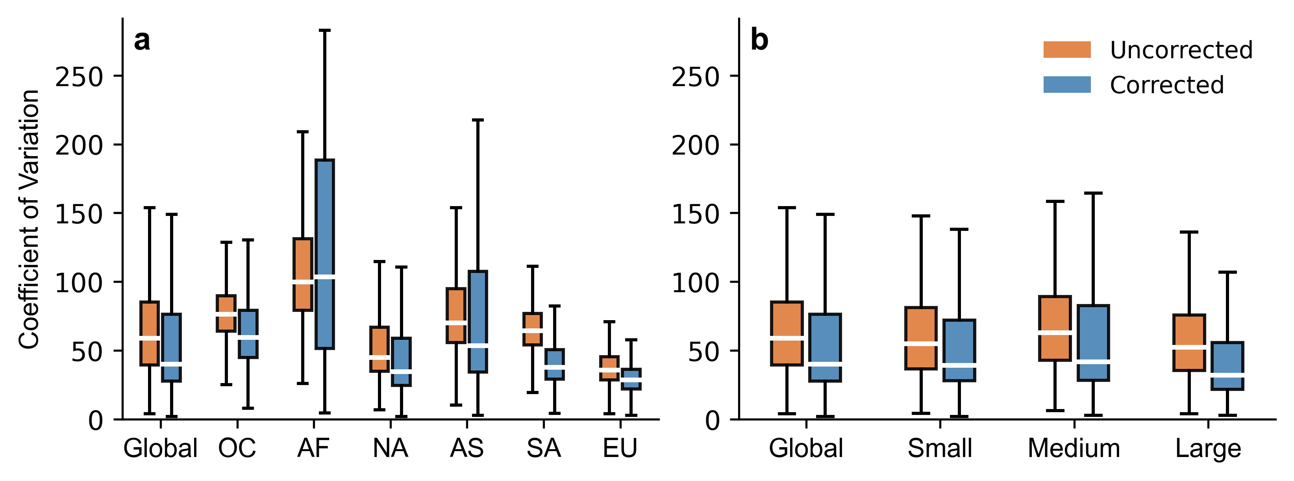

Figure S9. Coefficient of variation (CV) of projected 100-year flood discharges (2051–2100, SSP5-8.5) before and after EFBC correction, stratified by (a) continent and (b) catchment size category. Small: 1–100 km²; Medium: 100–1,000 km²; Large: >1,000 km².
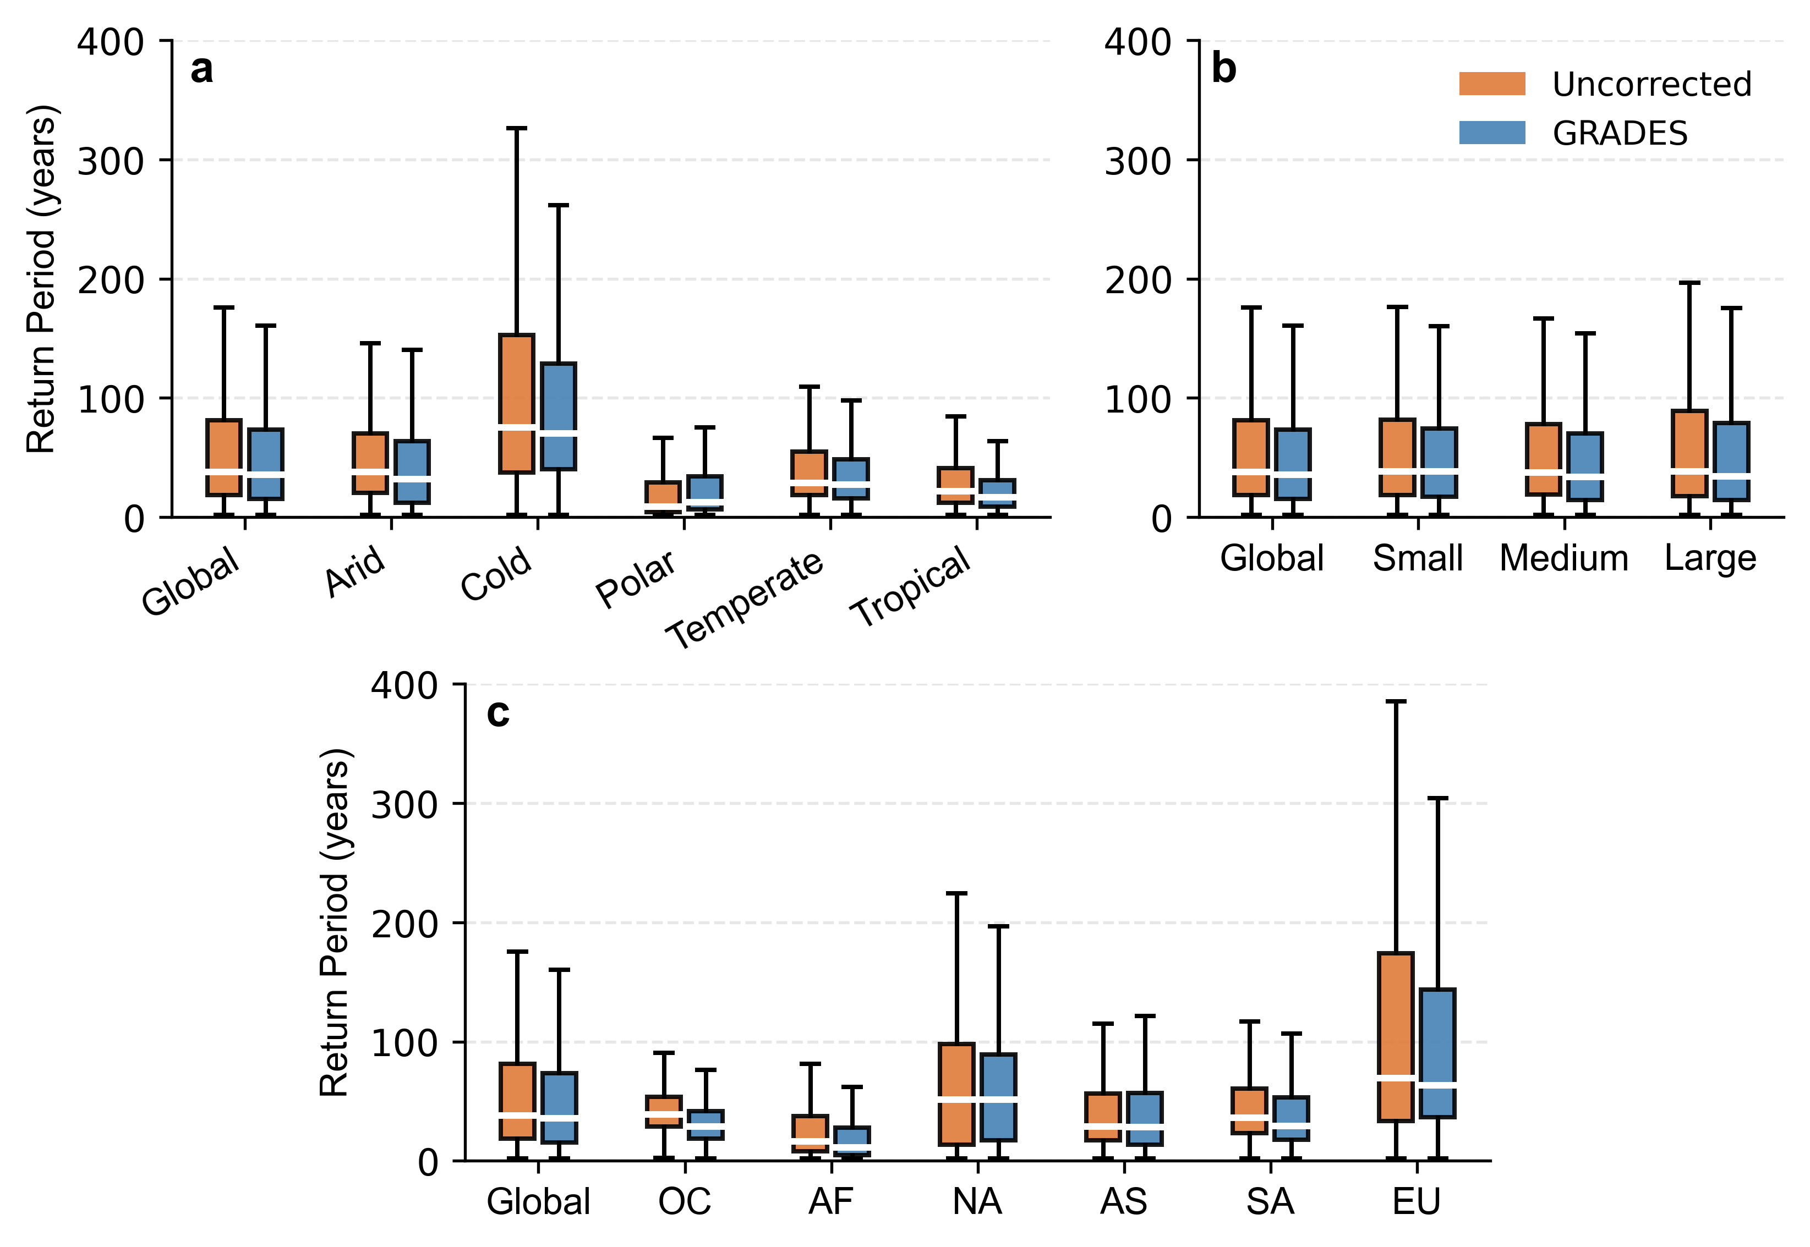

Figure S10. Projected return periods (2051–2100, SSP5-8.5) of the historical (1965–2014) 100-year flood discharge from uncorrected cascade-type models and after EFBC correction, stratified by (a) climate zone, (b) catchment size category, and (c) continent. Small: 1–100 km²; Medium: 100–1,000 km²; Large: >1,000 km².

Table S1. 9 CMIP6 models used in this study.
No. | Model | Variant label | Resolution(lon× lat) | ECS (°C)
1 | ACCESS-CM2 | r1i1p1f1 | 1.9° × 1.3° | 4.7
2 | CanESM5 | r1i1p1f1 | 2.8° × 2.8° | 5.6
3 | EC-Earth3 | r1i1p1f1 | 0.7° × 0.7° | 4.3
4 | INM-CM5-0 | r1i1p1f1 | 2° × 1.5° | 1.9
5 | IPSL-CM6A-LR | r1i1p1f1 | 2.5° × 1.3° | 4.6
6 | MIROC6 | r1i1p1f1 | 1.4° × 1.4° | 2.6
7 | MPI-ESM1-2-HR | r1i1p1f1 | 0.9° × 0.9° | 3.0
8 | MRI-ESM2-0 | r1i1p1f1 | 1.1° × 1.1° | 3.1
9 | NorESM2-MM | r1i1p1f1 | 1.25° × 0.94° | 2.5

Table S2. Data sources used in this study.
No. | Factor name (abbreviation) | Data source
1 | Annual precipitation (AP) | CMIP6 (Eyring et al., 2016)
2 | Precipitation seasonality (PS) | CMIP6 (Eyring et al., 2016)
3 | Annual mean temperature (AT) | CMIP6 (Eyring et al., 2016)
4 | Temperature annual range (TR) | CMIP6 (Eyring et al., 2016)
5 | Mean slope (SL) | MERIT DEM (Yamazaki et al., 2017)
6 | Lake fraction (LF) | GLWD (Lehner and Döll, 2004)
7 | River width (RW) | MERIT Hydro (Yamazaki et al., 2019)
8 | Catchment area (CA) | MERIT Hydro (Yamazaki et al., 2019)
9 | Flow distance (FL) | MERIT Hydro (Yamazaki et al., 2019)
10 | Curve number (CN) | NRCS CN dataset (Zeng et al., 2017)

Table S3 (a). Random Forest performance for RFFA during the historical period (1965-2014).
No. | Model | R2 | KGE | RMSE | RBIAS
1 | ACCESS-CM2 | 0.920 | 0.905 | 3410 | -0.15
2 | CanESM5 | 0.934 | 0.931 | 4784 | -0.37
3 | EC-Earth3 | 0.945 | 0.945 | 3553 | -0.2
4 | INM-CM5-0 | 0.944 | 0.942 | 3315 | -0.16
5 | IPSL-CM6A-LR | 0.926 | 0.926 | 3323 | -0.16
6 | MIROC6 | 0.917 | 0.906 | 5297 | -0.22
7 | MPI-ESM1-2-HR | 0.922 | 0.917 | 2065 | -0.28
8 | MRI-ESM2-0 | 0.934 | 0.931 | 3606 | -0.33
9 | NorESM2-MM | 0.939 | 0.933 | 4061 | -0.11

Table S3 (b). Random Forest performance for RFFA under SSP5-8.5 scenario (2051-2100).

No. | Model | R2 | KGE | RMSE | RBIAS
1 | ACCESS-CM2 | 0.928 | 0.906 | 3310 | -0.14
2 | CanESM5 | 0.942 | 0.935 | 4884 | -0.32
3 | EC-Earth3 | 0.935 | 0.930 | 3353 | -0.18
4 | INM-CM5-0 | 0.942 | 0.937 | 3115 | -0.15
5 | IPSL-CM6A-LR | 0.922 | 0.921 | 3423 | -0.17
6 | MIROC6 | 0.908 | 0.899 | 4897 | -0.2
7 | MPI-ESM1-2-HR | 0.921 | 0.915 | 2365 | -0.24
8 | MRI-ESM2-0 | 0.920 | 0.906 | 3306 | -0.28
9 | NorESM2-MM | 0.937 | 0.928 | 3661 | -0.12

Table S4. 6 ISIMIP hydrologic models used in this study.
No. | Model | Resolution(lon× lat)
1 | CWatM | 0.5° × 0.5°
2 | H08 | 0.5° × 0.5°
3 | JULES-W2 | 0.5° × 0.5°
4 | MIROC-INTEG-LAND | 0.5° × 0.5°
5 | WaterGAP2-2e | 0.5° × 0.5°
6 | WEB-DHM-SG | 0.5° × 0.5°

