Chemical Barrier Modulation by Bile Salts Drives Spatially Resolved Viscoelastic Reconfiguration in Buccal Epithelia

Supplementary Information

Figure S1. Phase-contrast imaging of TR146 buccal epithelial cells. Representative phase-contrast images of TR146 monolayers under untreated control, low GDC (1 mM), and high GDC (2 mM) conditions following 30 min exposure. Scale bar=50 µm

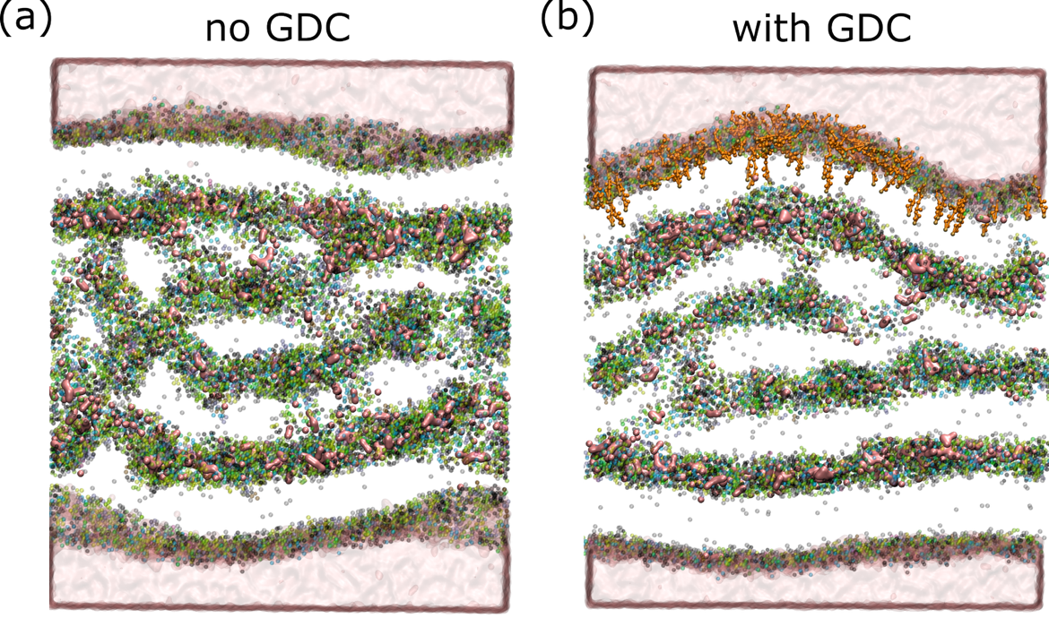
Figure S2: Final configurations of the simulated buccal lipid membrane model after 6 μs of simulation lipid tails removed for clarity. (a) and (b) show the systems without and with GDC, respectively.

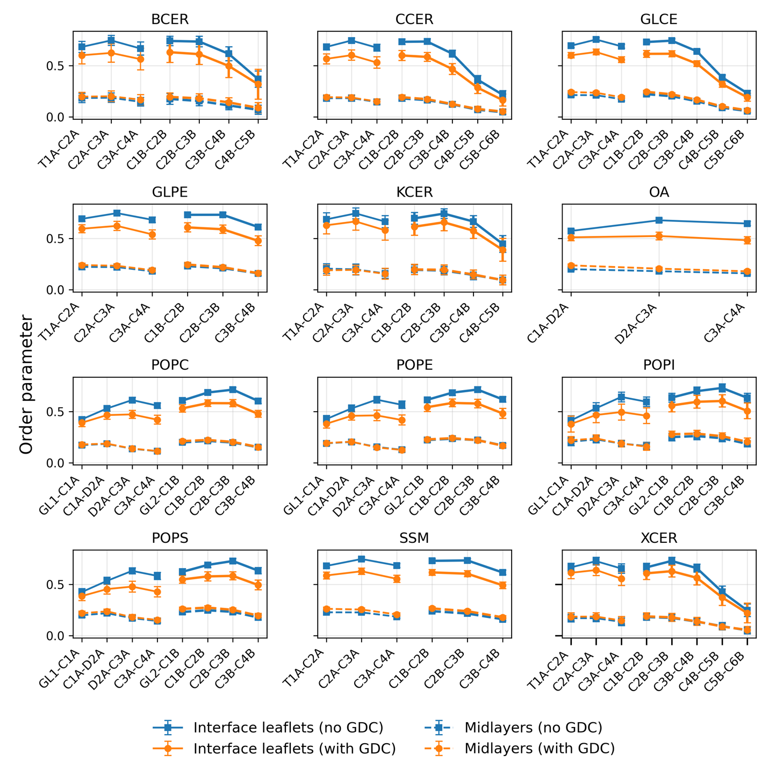
Figure S3. Lipid-specific order parameters for the sn1 and sn2 acyl chains in the interfacial and mid-layer regions for systems without and with GDC. Bonds corresponding to the sn1 and sn2 tails are labelled A and B, respectively, at the end of each bond name.

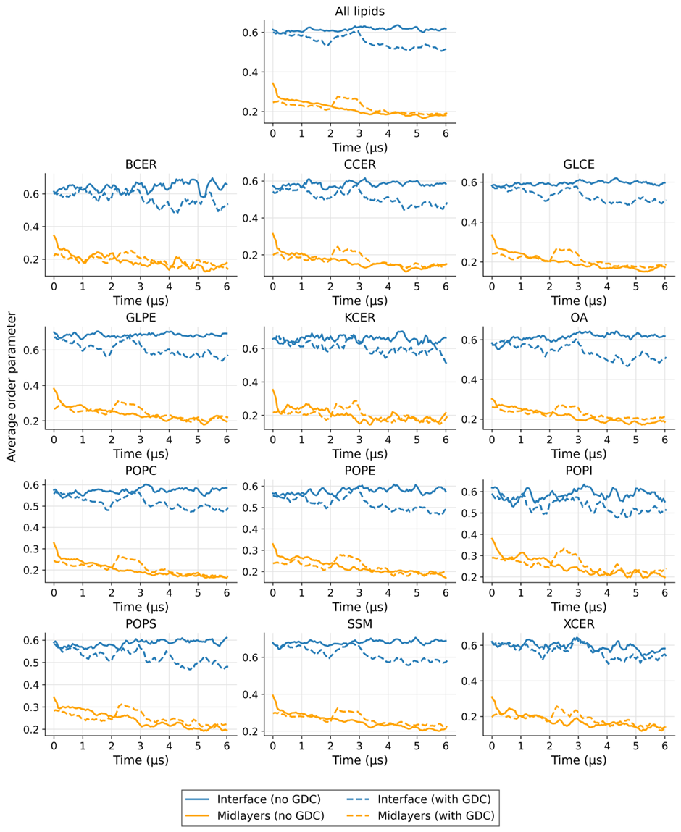
Figure S4: Time evolution of average lipid order parameters in multilamellar membranes in the absence and presence of GDC. Average order parameters for all lipids and individual lipid species are plotted as a function of simulation time for multilamellar membranes simulated without GDC (solid lines) and with GDC (dashed lines). Blue lines denote the interfacial leaflets and orange lines denote the middle bilayers. The full names of the lipid species and their abbreviations are provided in Table S1.
Figure S5. (A) Percentage of octreotide (OCT) remaining in the donor chamber 2 h after its addition (2 mg/ml) and following 30 or 60 min of 30 mM GDC pre-exposure to porcine buccal mucosae. (B) Percentage of GDC retained in the donor chamber 2 h after OCT exposure. (C) Percentage of GDC associated with buccal tissue at the same time point, consistent with partial partitioning of GDC into the epithelial membrane. Mean ± SD (n = 3 independent porcine buccal mucosae).

Figure S6. Time-dependent penetration of 1mg/ml FD4 across porcine buccal mucosae following GDC exposure. Representative 3D pixel intensity surface plots showing FD4-associated fluorescence in buccal tissue at (A) 30 min, (B) 60 min, and (C) 120 min following apical addition in the presence of GDC.
Figure S7. Time-dependent fluorescence intensity distribution profiles of FD4 penetration into porcine buccal mucosae following GDC exposure.

Table S1. Lipid composition of the buccal membrane model and corresponding Martini 3 molecule representations.
Lipid | Molecule  (Martini 3) | wt % | Percentage (%)
Cholesterol | CHOL | 16.6 | 17
Cholesterol sulfate | CHOS | 0.9 | 1
Cholesteryl oleate (cholesterol ester) | CHOO | 3.6 | 4
Triglyceride (e.g. TO, representative) | TG | 5.2 | 5
Free fatty acid (e.g. oleic acid, OA) | FA | 11.8 | 12
Ceramide 2, C20:0 | KCER | 1.303 | 1
Ceramide 2, C22:0 | BCER | 0.96 | 1
Ceramide 2, C24:0 | XCER | 1.843 | 2
Ceramide 2, C26+ (proxy ≥26C) | CCER | 3.566 | 4
Glycosylceramide (monohexosylceramide) | GLPE | 19 | 6
Glycosylceramide (monohexosylceramide, CCER-based) | GLCE |  | 13
Sphingomyelin | SM (SSM) | 11.9 | 12
Phosphatidylethanolamine | POPE | 6 | 6
Phosphatidylserine | POPS | 5.1 | 5
Phosphatidylinositol | POPI | 2.2 | 2
Phosphatidylcholine | POPC | 9.4 | 9

Table S2. Semiquantitative summary of FD4 permeation derived from fluorescence pixel intensity analysis.
Tissue | Arithmetic mean intensity | SD
30 min | 13.1 | 4.8
60 min | 95.8 | 37.5
120 min | 104.1 | 42.5

