Supporting Information
Self-Assembled Mesoporous Scaffold Enabled Hybrid Hole-Transport Layer for Efficient Perovskite Solar Cells

Bingxin Ding ^{1,2‡}, Yuheng Li^{2‡}, Huangjie Zou³, Jianxing He¹, Jiyuan Gao¹, Yongqi Ma¹, Luping Deng¹, Shu Tian¹, Chang Shi⁴, Wuchen Xiang⁵, Hao Wang², Xinzhao Zhao², Wenwen Zheng¹, Liang Ma¹, Xiangbai Chen¹, Haibing Wang⁶, Weijun Ke⁶, Guojia Fang⁶, Gang Li^{7,}*, Neng Li³, Haisheng Song^{2,}*, Jiang Tang², Pingli Qin^{1,}*

¹Hubei Key Laboratory of Optical Information and Pattern Recognition, School of Optoelectronic Information and Energy Engineering, Wuhan Institute of Technology, Wuhan, Hube, P. R. China.
²Wuhan National Laboratory for Optoelectronics (WNLO) and School of Optical and Electronic Information (SOEI), Huazhong University of Science and Technology, Wuhan, P. R. China.
³School of Materials Science and Engineering, Wuhan University of Technology, Wuhan, P. R. China.
⁴Beijing Institute of Nanoenergy and Nanosystems, Chinese Academy of Sciences, Beijing, P. R. China.
⁵College of Electronie Information and Optical Engineering, Nankai University, Tianjin, P.R. China.
⁶School of Physics and Technology, Key Laboratory of Artificial Micro- and Nano-structures of the Ministry of Education and School of Physics and Technology, Wuhan University, Wuhan, Hubei, P. R. China.
⁷Department of Electrical and Electronic Engineering, Research Institute for Smart Energy (RISE), Photonic Research Institute (PRI), The Hong Kong Polytechnic University, Kowloon, Hong Kong, P. R. China.
‡These authors contributed equally: Bingxin Ding, Yuheng Li.
*e-Mail: gang.w.li@polyu.edu.hk; songhs-wnlo@mail.hust.edu.cn; qpl2015@wit.edu.cn
Table of contents
Supplementary note 1
Supplementary Fig. S1-53
Supplementary table S1-7
Supplementary references
Supplementary Note 1:
The calculation process of work functions (WF) and valence band maximum (E_{VBM}) based on UPS measurements was outlined in the following:
$$\begin{aligned}w_{F}=21.22-E_{cutoff} \#\left(1\right)\end{aligned}$$
$$\begin{aligned}VBM=-\left(Φ+E_{onset}\right)\#\left(2\right)\end{aligned}$$
where E_{cutoff} is the high binding energy cutoff, and E_{onset} is the onset energy in valence-band region.
The photo-excited time-resolved conductivity (Δ𝜎(𝜏)) was calculated by the following equation:
$$\begin{aligned}∆σ\left(τ\right)=-\frac{ε_{0}C\left(n_{a}+n_{b}\right)}{L}∙\frac{∆T\left(τ\right)}{T_{0}\left(τ\right)} \#\left(3\right)\end{aligned}$$
where ɛ₀ represents the permittivity of free space, C is the speed of light, L is the skin depth of the sample, and n_{a} and n_{b} are the refractive indices of the media on the front and back sides of the sample in the THz frequency range, respectively.
The photocurrent density (J_{ph})-the effective internal voltage (V_{eff}) analysis:
J_{ph} can be calculated with the following equation:
$$\begin{aligned}J_{ph}=J_{L}-J_{D} \#\left(4\right)\end{aligned}$$
where J_{L} and J_{D} stand for the current density under illumination and the current density in the dark, respectively.
The charge collection probability (P_{coll}) is defined as:
$$\begin{aligned}P_{coll}=\frac{J_{sc}}{J_{ph,sat}}\#\left(5\right)\end{aligned}$$
The exciton dissociation efficiencies (P_{diss}) is defined as:
$$\begin{aligned}P_{diss}=\frac{J_{max}}{J_{ph,sat}} \#\left(6\right)\end{aligned}$$
where J_{ph,sat} represents the saturate photocurrent density at high V_{eff} (can be calculated with the equation of $V_{eff}=V_{0}-V$, where V₀ represents the voltage at zero net current, and V represents the applied voltage).
Decay curves were fitted to a biexponential decay function to analyze the carrier extraction at the perovskite/GHK-Cu, which was fitted by an empirical double exponential model:
$$\begin{aligned}y=y_{0}+A_{1}\exp\left(-\frac{t}{τ_{1}}\right)+A_{2}\exp\left(-\frac{t}{τ_{2}}\right) \#\left(7\right)\end{aligned}$$
where y₀ is the attenuation constant, A₁ and A₂ represent the attenuation amplitude of photoluminescence, τ₁ refers to the rapid decay process from quenching of trap states or interfacial charge transfer, τ₂ is a slow decay process caused by interfacial non-radiative recombination.
The average PL decay times ($τ_{ave}$) are further estimated using the following expression:
$$\begin{aligned}τ_{ave}=\frac{A_{1}τ_{1}^{2}+A_{2}τ_{2}^{2}}{A_{1}τ_{1}+A_{2}τ_{2}} \#\left(8\right)\end{aligned}$$
The trap density was calculated using the following equation:
$$\begin{aligned}N_{trap}=\frac{2V_{TFL}ε_{0}ε_{r}}{qL^{2}} \#\left(9\right)\end{aligned}$$
where L is the thickness of the perovskite film, ε_{r}= 62.23 is the relative dielectric constant of the perovskite, ε₀ is the vacuum permittivity, V_{TFL} is the onset voltage of the trap filled limit region, and q is the electron charge.
The relationship between V_{OC}, J_{SC} and light intensity (P_{light}) is elucidated by the following equations, respectively:
$$\begin{aligned}V_{OC}∝\frac{nKT}{e}\ln\left(P_{light}\right)\#\left(10\right)\end{aligned}$$
$$J_{SC}∝P_{light}^{α}$$
where n, α, k, T, and e representing the ideality factor, index factor, Boltzmann constant, temperature in Kelvin, and elementary charge, respectively.
The maximum FF value (FF_{max}) can be empirically calculated according to the following equation：
$$\begin{aligned}{FF}_{max}=\frac{υ_{OC}-\ln\left(υ_{OC}+0.72\right)}{υ_{OC}+1} \#\left(11\right)\end{aligned}$$
where $υ_{OC}=\frac{V_{OC}}{nKT/e}$, which can be derived from V_{OC} measurements dependent on light intensity. In the process of calculating the FF_{SQ-limit}, the value of n is taken as the constant 1.
The built-in voltage (V_{bi}) was extracted from the following equation:
$$\begin{aligned}\frac{1}{C^{2}}=\frac{2\left(V_{bi}-V\right)}{A^{2}qεε_{0}N} \#\left(12\right)\end{aligned}$$
where A is the device area, ε is the dielectric constant, ε₀ is the vacuum permittivity, and N is the charge density.
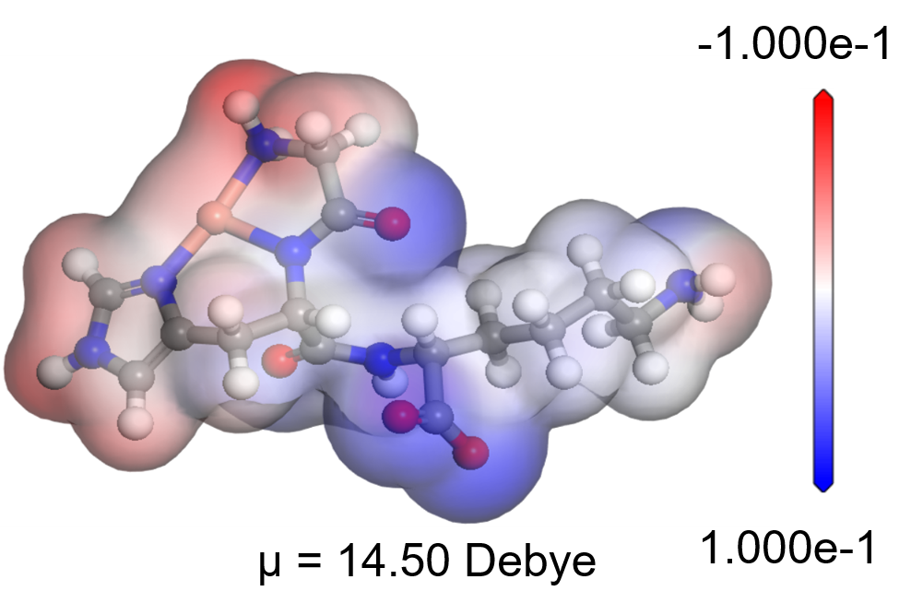
Supplementary Fig. 1 ∣ Structure and ESP of GHK-Cu.

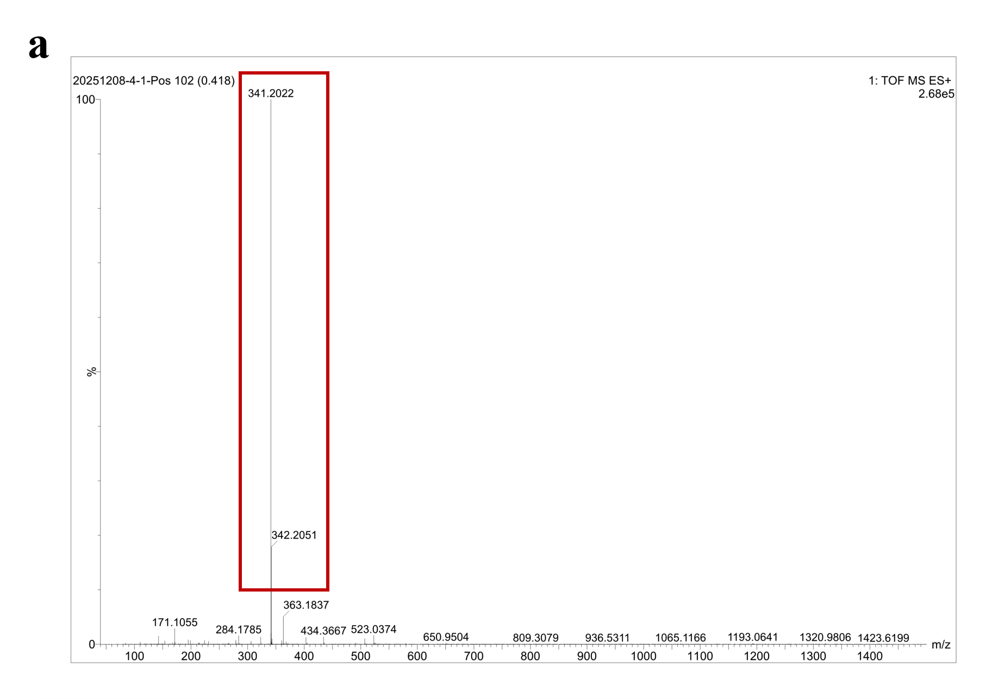
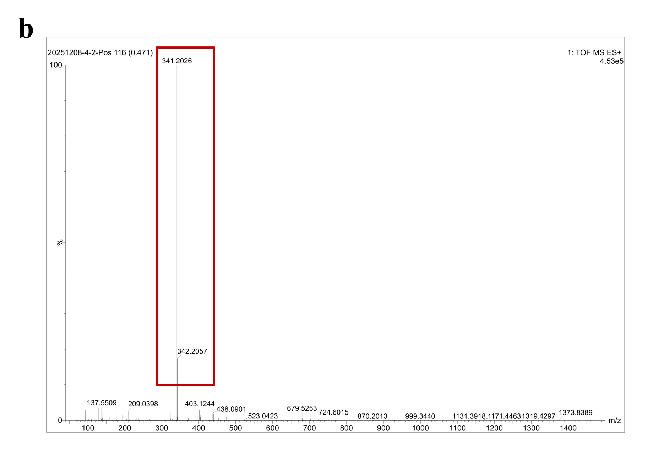
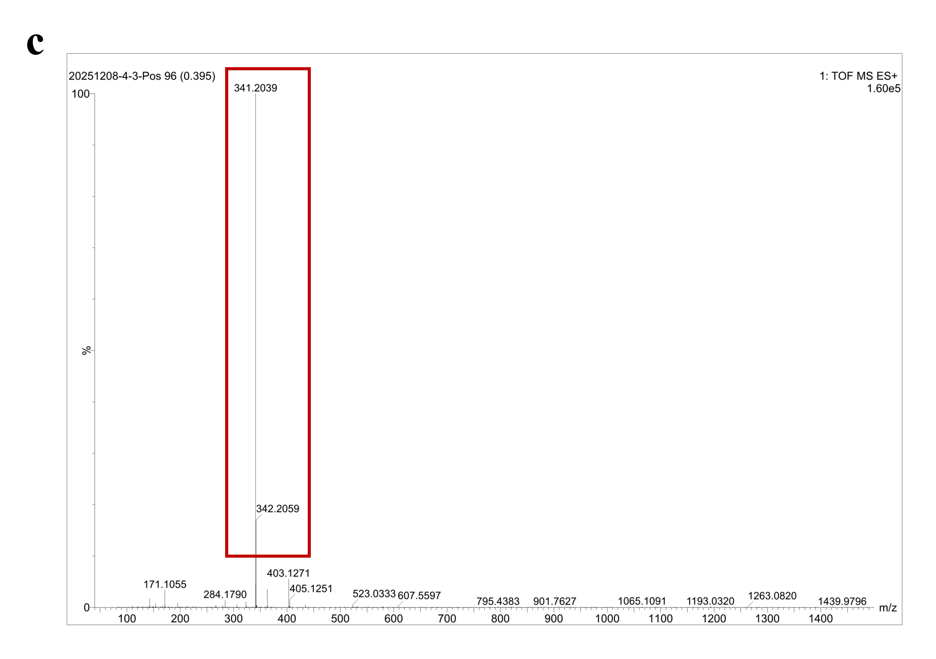
Supplementary Fig. 2 ∣ The MS spectrum of the (a) GHK-Cu and PbI₂ mixture in UPW/DMF solution, (b) GHK-Cu and FAI mixture in UPW solution and (c) GHK-Cu, PbI₂ and FAI mixture in UPW/DMF solution. In all solvent systems investigated, GHK-Cu exhibited a dominant molecular ion peak at m/z = 341.2, consistent with a stoichiometric complex of GHK, confirming the presence of Cu²⁺ in its free (uncoordinated) state, although it was coordinated by three donor atoms from the tripeptide—the histidine imidazole nitrogen, the glycine α-amino nitrogen, and the deprotonated amide nitrogen of the glycine-histidine peptide bond. It facilitated the redox activity and incorporation into the self-assembled network.
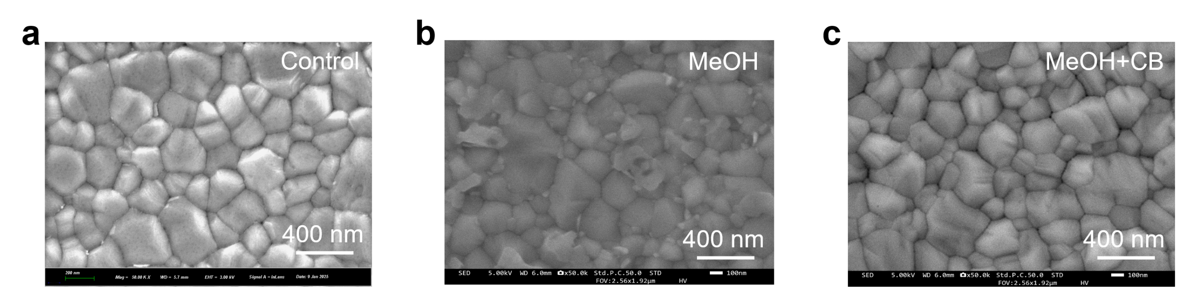
Supplementary Fig. 3 ∣ The SEM spectra of the perovskite films (a) without treated, treated with (b) MeOH and (c) MeOH+CB with a volume ratio of 3:7. Compared to the control film, the surface of perovskite film subjected to treatment with pure MeOH exhibited noticeable dissolution and damage, while films exposed to the mixed solvent of MeOH and CB with a volume ratio of 3:7 exhibited no discernible alterations. This finding suggested that CB, functioning as a diluent, could lead to a reduction in the MeOH amount and provide protective effects for the perovskite films.
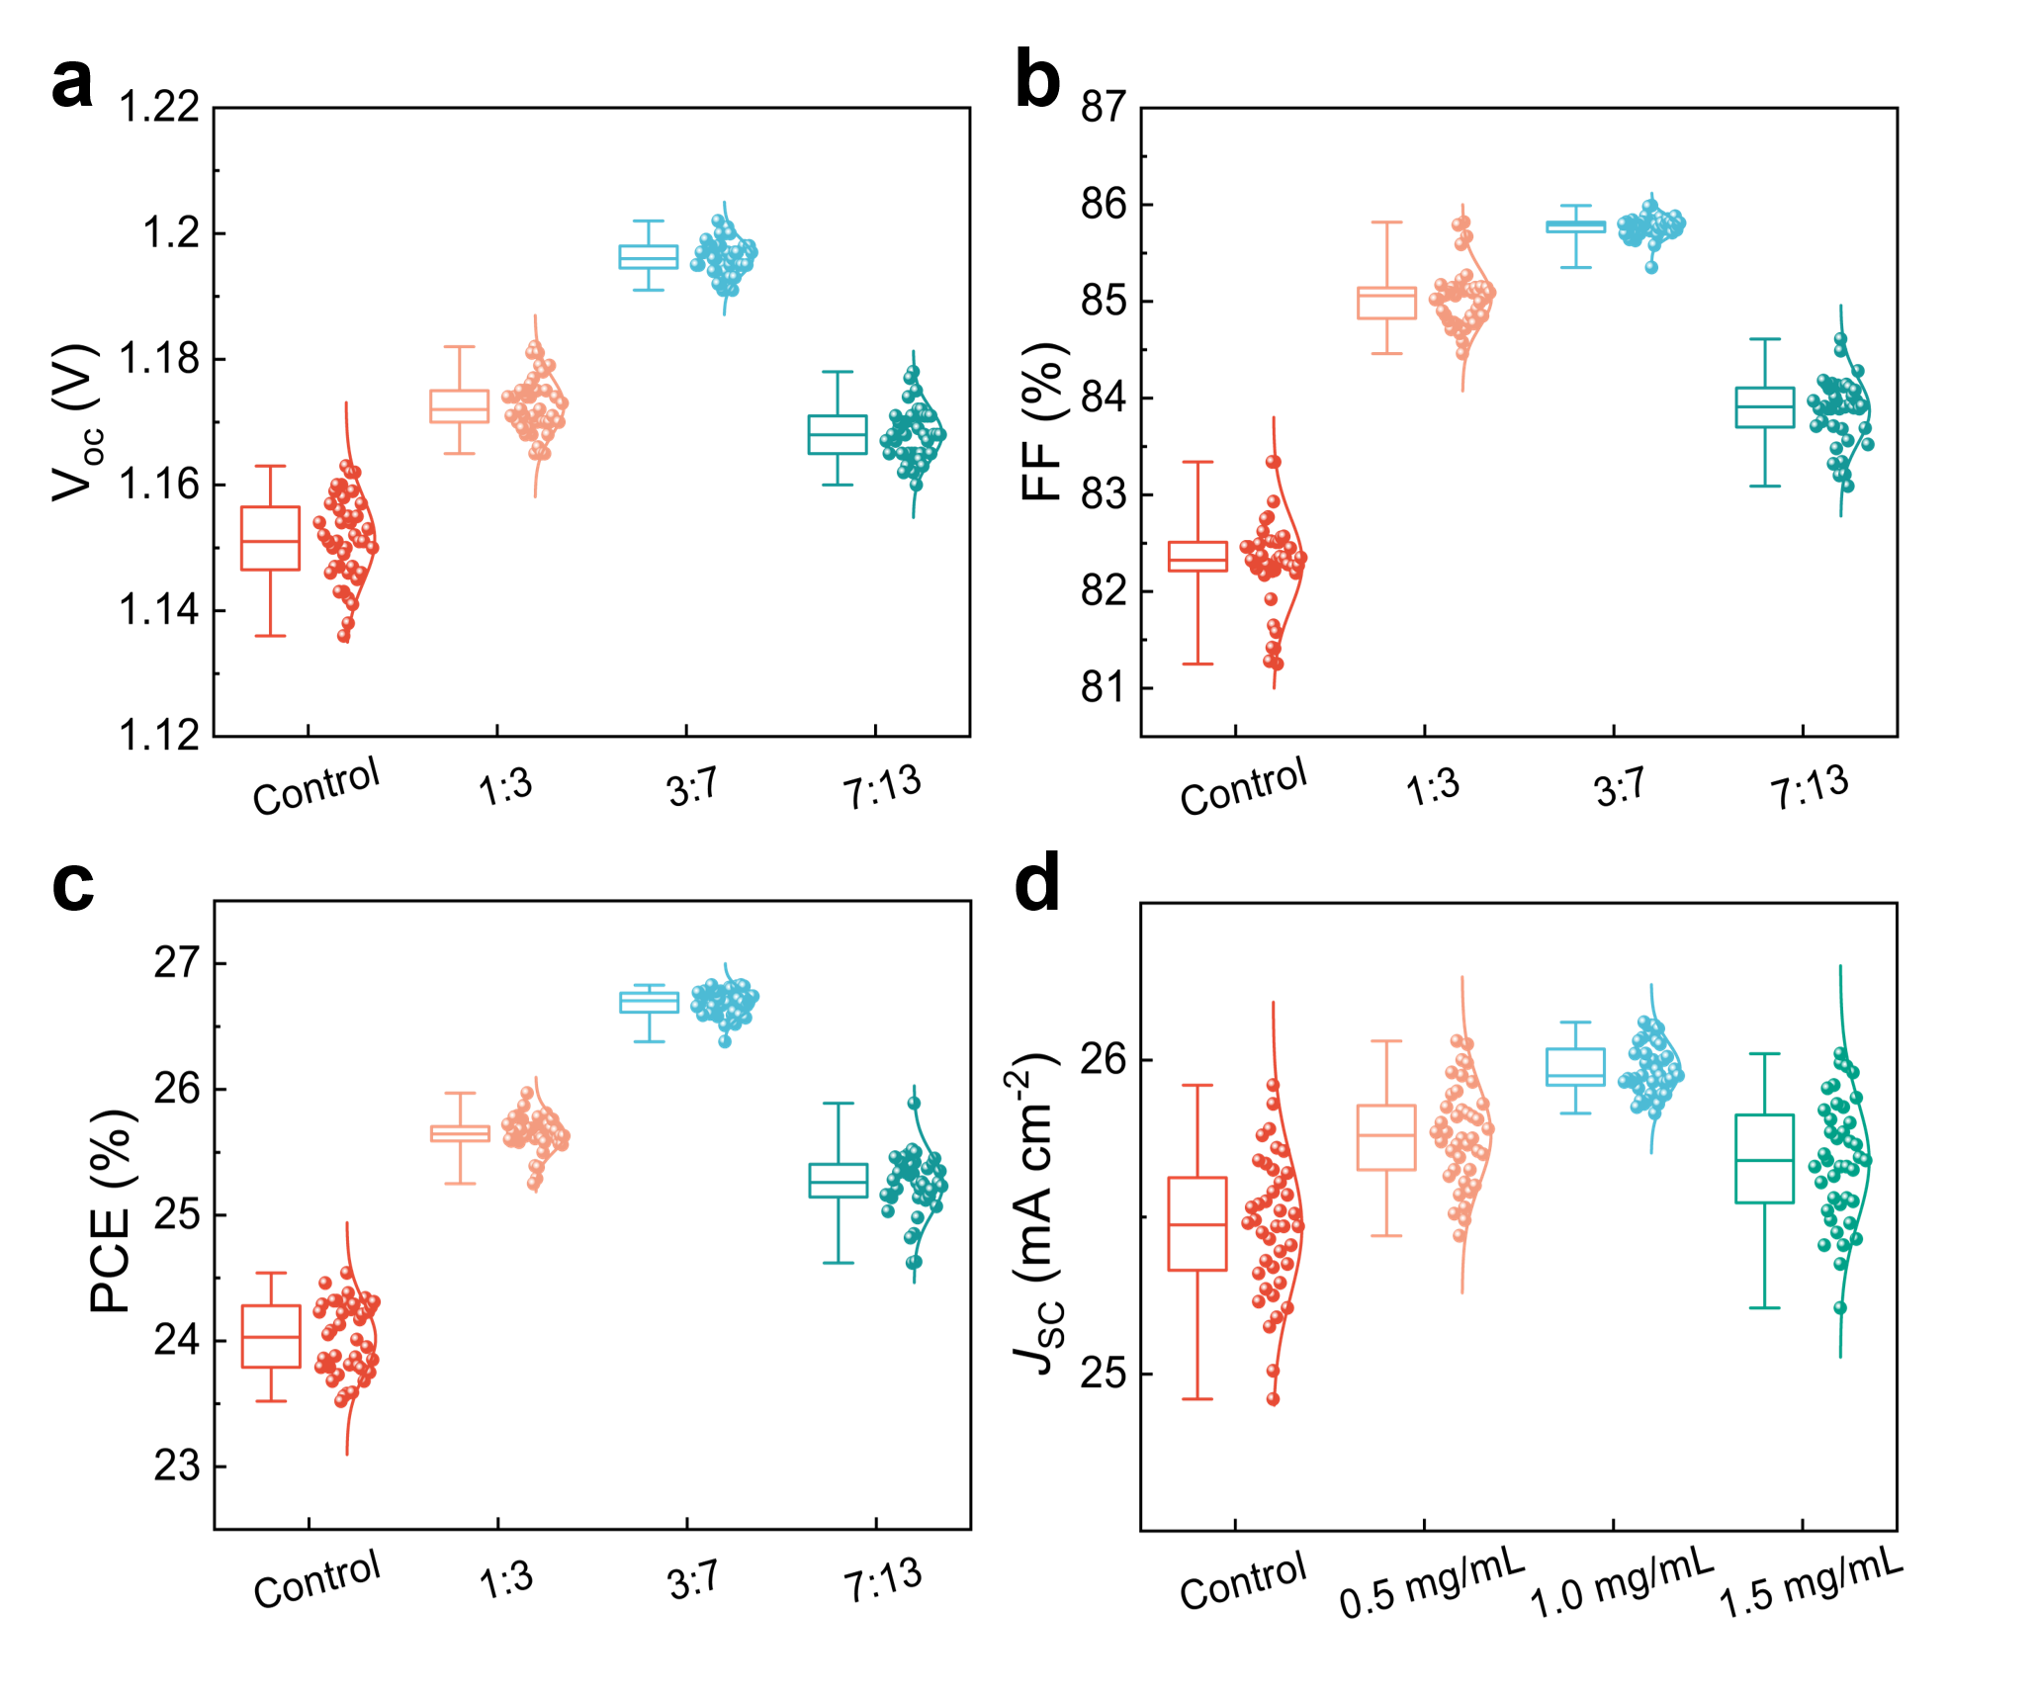
Supplementary Fig. 4 ∣ (a) V_{OC}, (b) FF, (C) PCE and (d) J_{SC} statistics distribution of PSCs based on 1.0 mg/mL, there were 40 devices for the statistics.
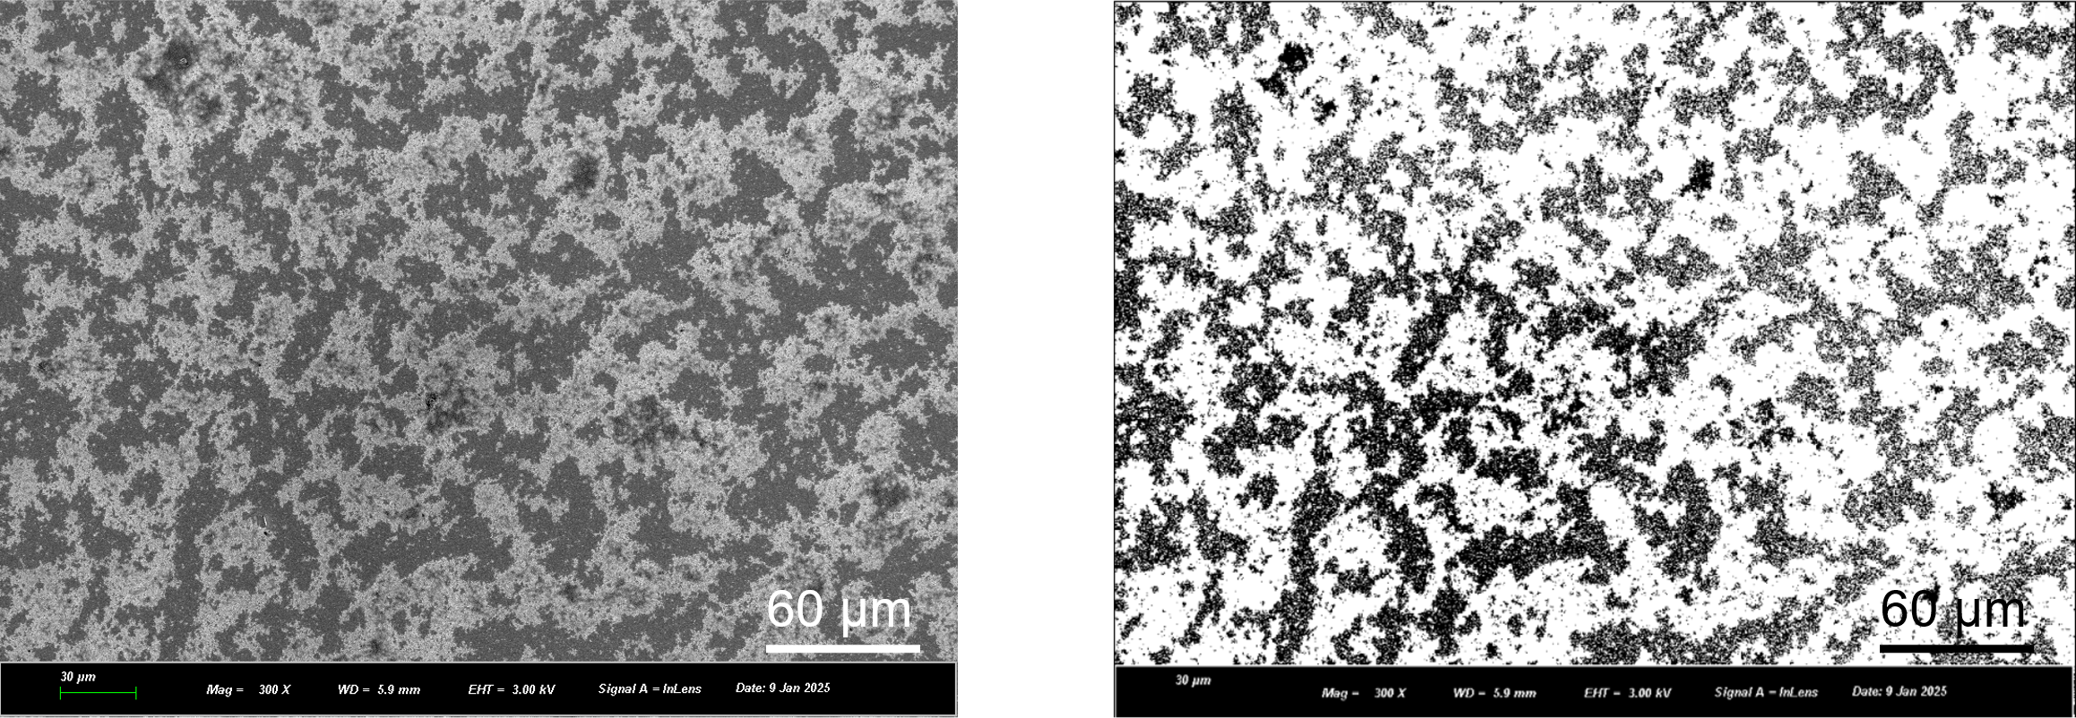
Supplementary Fig. 5 ∣ Binary image processed from the SEM image of the target film was used to assist the prediction of coverage fraction¹. Here, the mesoporous architecture coverage fraction was ~67.18%.
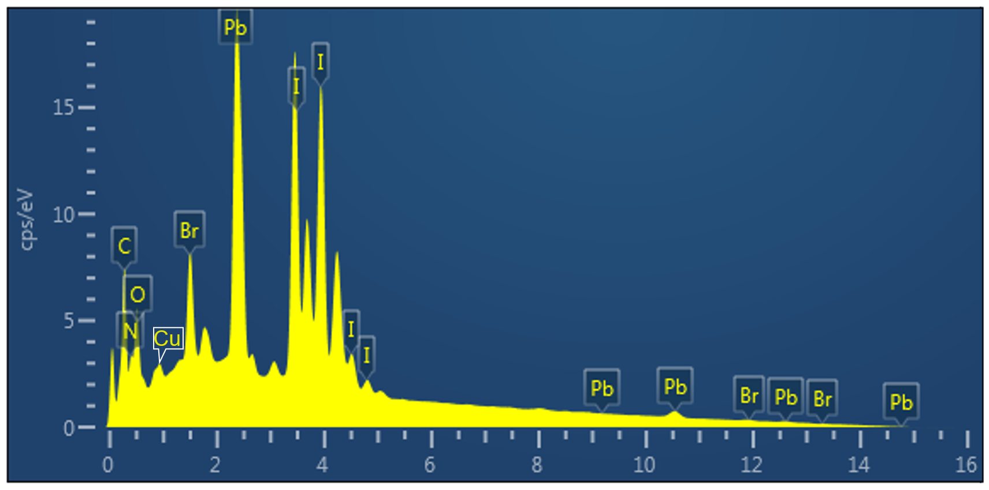
Supplementary Fig. 6 ∣ EDS pattern of the target film.
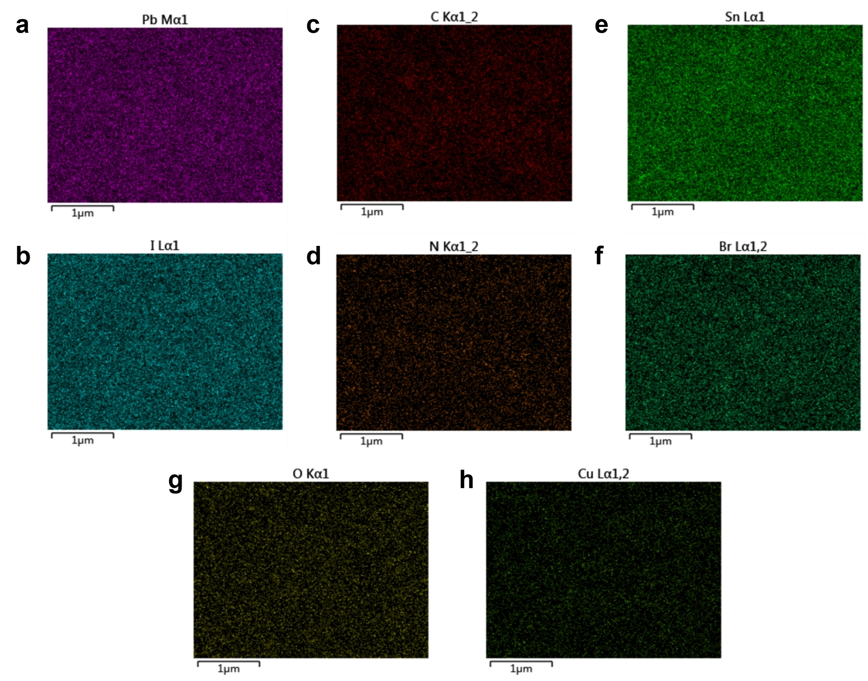

Supplementary Fig. 7 ∣ EDS mapping spectra of the target film: (a) Pb, (b) I, (c) C, (d) N, (e) Sn, (f) Br, (g) O and (h) Cu elements.
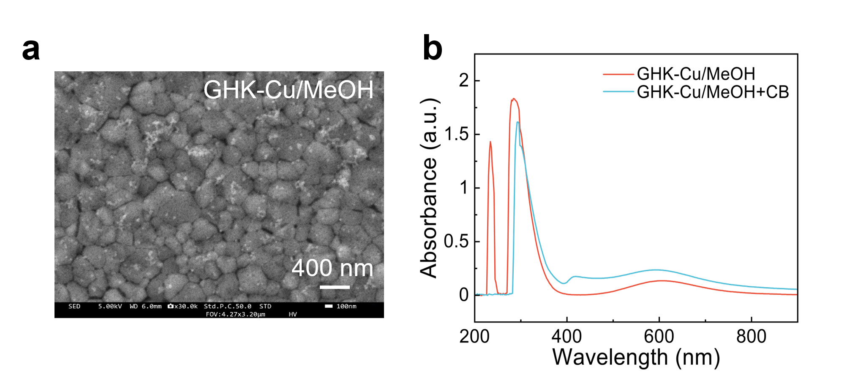
Supplementary Fig. 8 ∣ (a) The SEM spectra of the perovskite films treated with GHK-Cu/MeOH and (b) UV-vis absorption spectra of GHK-Cu dissolved in pure MeOH and MeOH/CB mixed solvent (3:7 v/v), respectively. The polar solution of MeOH promoted the solvation and ionization of GHK peptide chains to enhance the intermolecular hydrogen bond formation energy or dipole-dipole force, followed by the addition of a non-polar solution of CB to reduce the medium polarity and drive hydrophobic interactions, forcing the GHK-Cu molecules to aggregate via π-π stacking of imidazole rings and metal coordination, triggering peptide nanofiber nucleation.

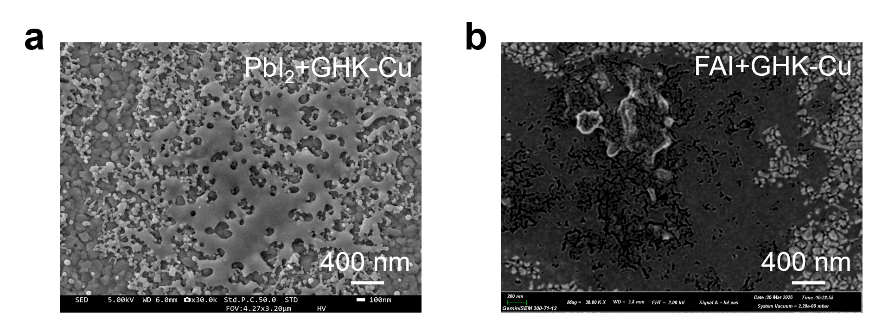
Supplementary Fig. 9 ∣ The SEM spectra of (a) PbI₂ and (b) FAI films treated with GHK-Cu in the solution of MeOH and CB with a volume of 3:7.
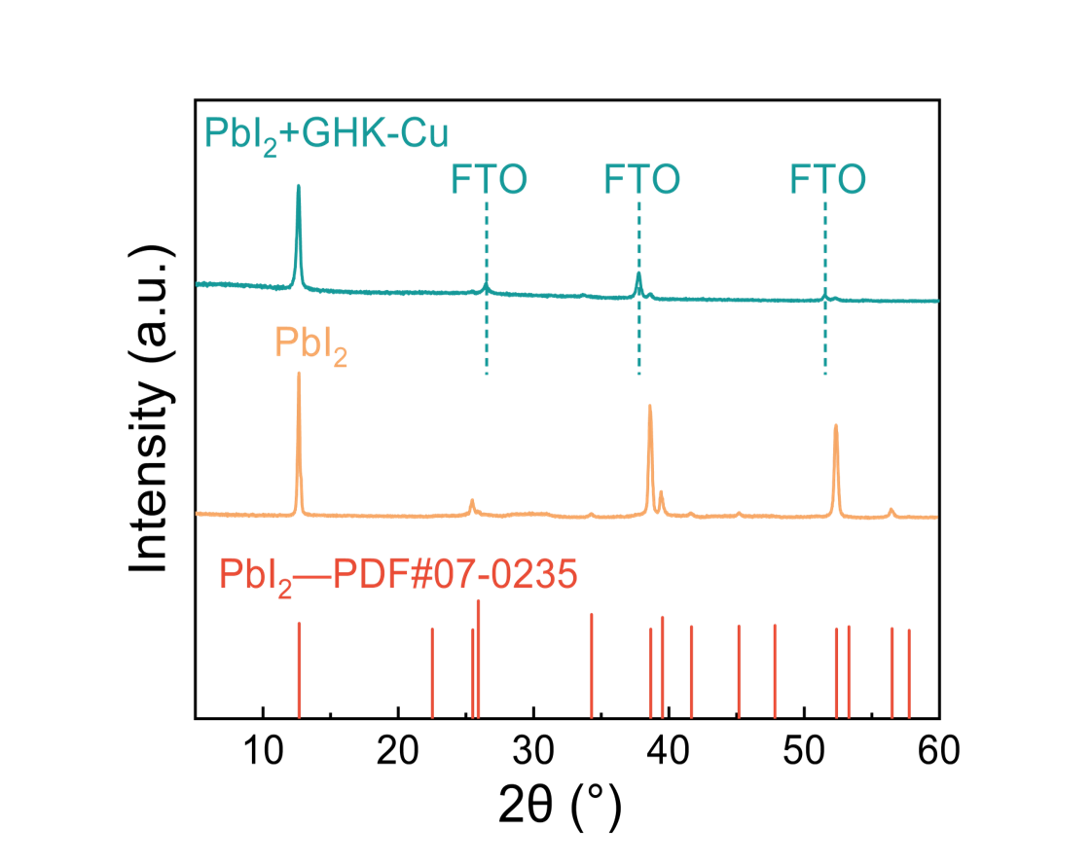
Supplementary Fig. 10 ∣ The XRD pattern of PbI₂ powder and PbI₂+GHK-Cu film on FTO.
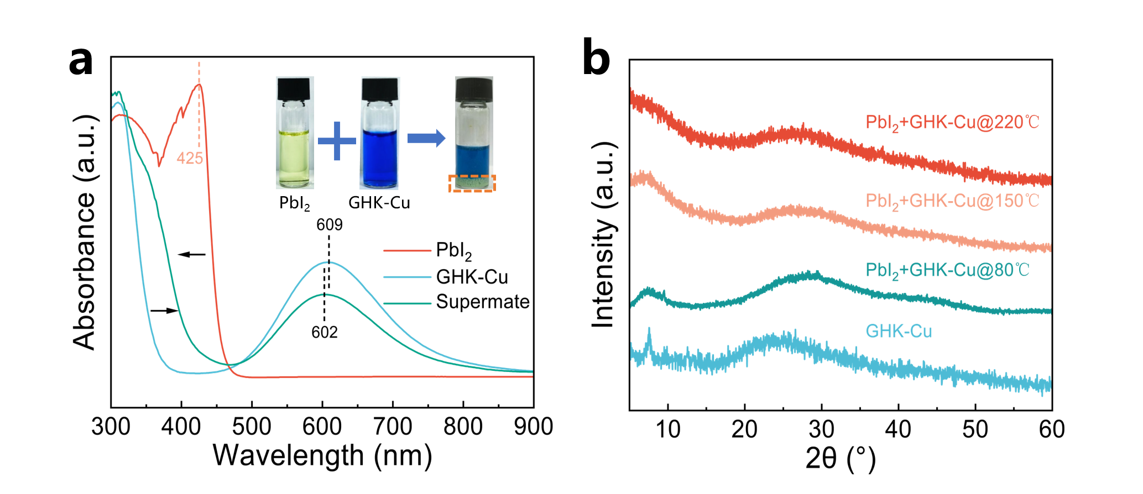
Supplementary Fig. 11 ∣ (a) UV-vis absorption spectra of PbI₂, GHK-Cu and supernate dissolved in IPA and UPW with a molar ratio of 1:1. (b) The XRD spectra of GHK-Cu power and flocculent precipitate annealed for 10 min at 80, 150 and 220℃, respectively. We prepared separate solutions of GHK-Cu (in water) and PbI₂ (in DMF), then mixed them at a 1:1 molar ratio to allow thorough reaction. Upon mixing, an indigo-blue supernatant immediately formed, accompanied by the generation of an olive-colored flocculent precipitate. Compared with the GHK-Cu solution, the indigo-blue supernatant exhibited no absorption peak at 425 nm (characteristic of PbI₂). Instead, it showed a blueshift and decreased intensity of the peak at 602 nm, along with a redshift in the 350-400 nm range.
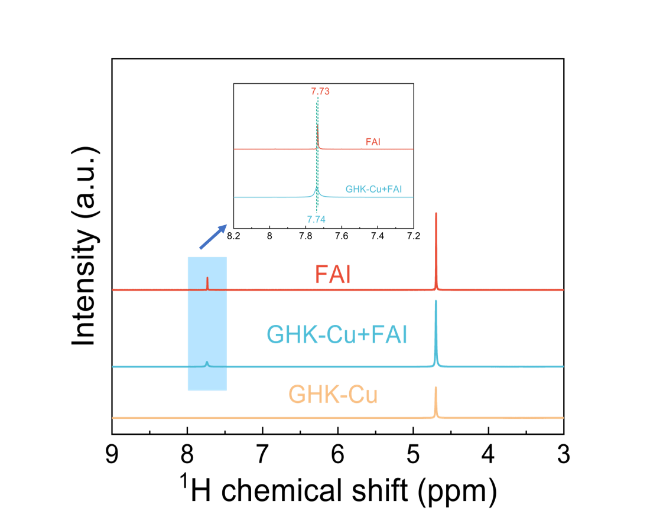
Supplementary Fig. 12 ∣ ¹H-NMR spectra of GHK-Cu, FAI and GHK-Cu+FAI solutions in UPW. Upon mixing FAI with GHK-Cu, the NH₂ proton signal of FAI exhibits a downfield shift from 7.73 to 7.74 ppm. This indicated the formation of N–H⋯I hydrogen bonds between GHK-Cu and FAI. Such intermolecular interactions modulated the self-assembly behavior of GHK-Cu, enhancing its conformational freedom and thereby facilitating the formation of the mesoporous architecture.

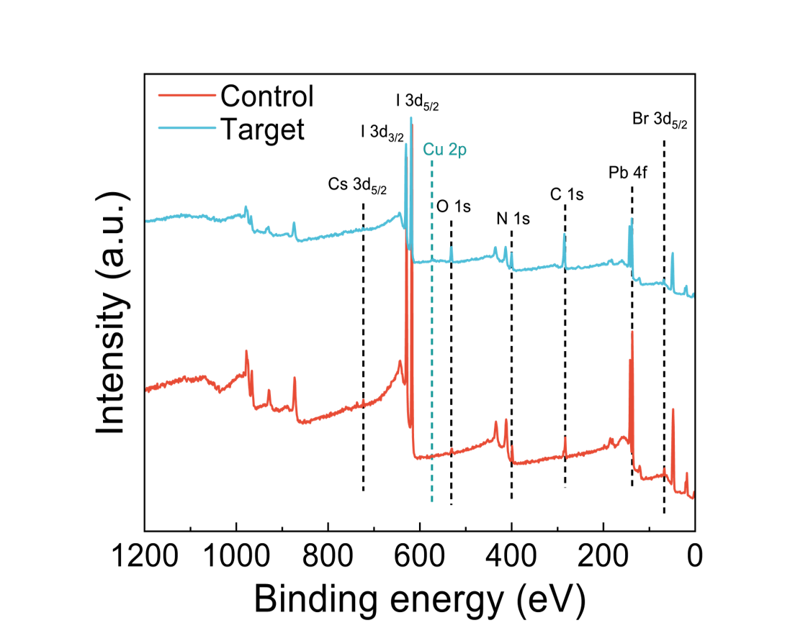
Supplementary Fig. 13 ∣ The XPS survey spectrum of the control and target films.

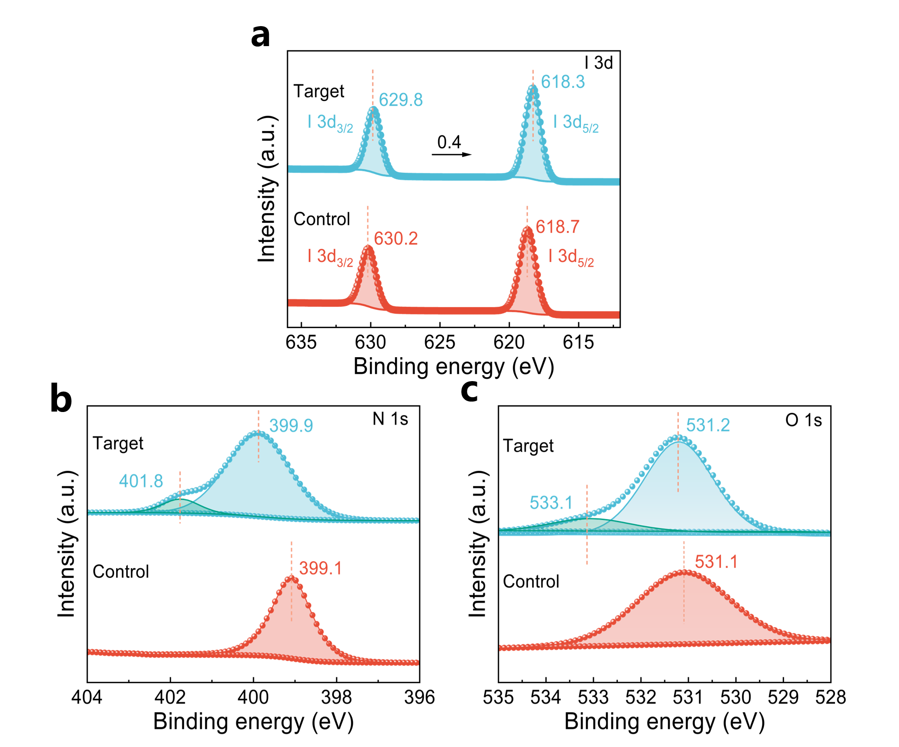
Supplementary Fig. 14 ∣ XPS spectras of (a) I 3d, (b) N 1s and (c) O 1s of control and target films, respectively. The N 1s peak shifted from 399.1 to 399.9 eV ascribed to the formation of Pb-N coordination bonds^{2,3}, and a new peak appeared at 401.8 eV corresponding to the imidazole ring of GHK-Cu⁴. Concomitantly, the peak of O 1s moved from 531.1 to 531.2 eV accompanied with a new peak of Pb-O=C at 533.1 eV⁴.
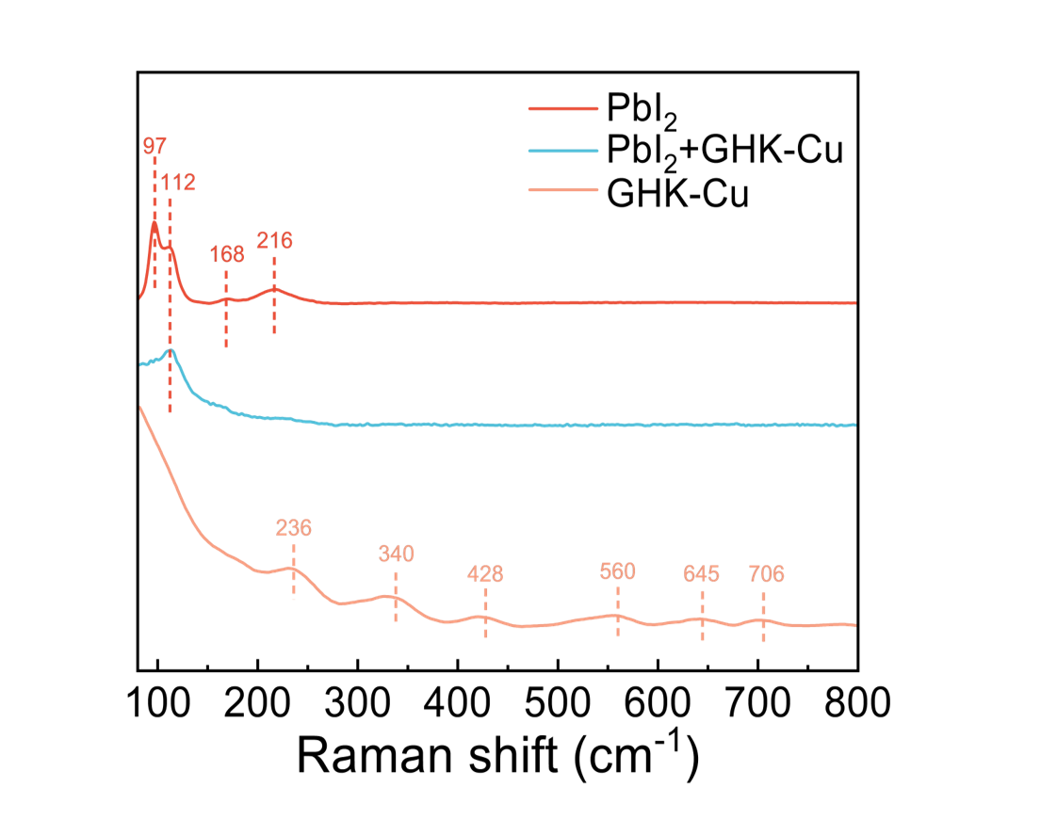
Supplementary Fig. 15 ∣ Raman spectras of PbI₂, GHK-Cu and PbI₂+GHK-Cu. Upon GHK-Cu treatment, the characteristic peaks of PbI₂ at 97, 168, and 216 cm⁻¹, as well as the C–N and C=O vibration peaks of GHK-Cu at 236, 340, 428, 560, 645, and 706 cm⁻¹, disappeared. (The detailed Raman information of GHK-Cu is listed in Supplementary Table 1).
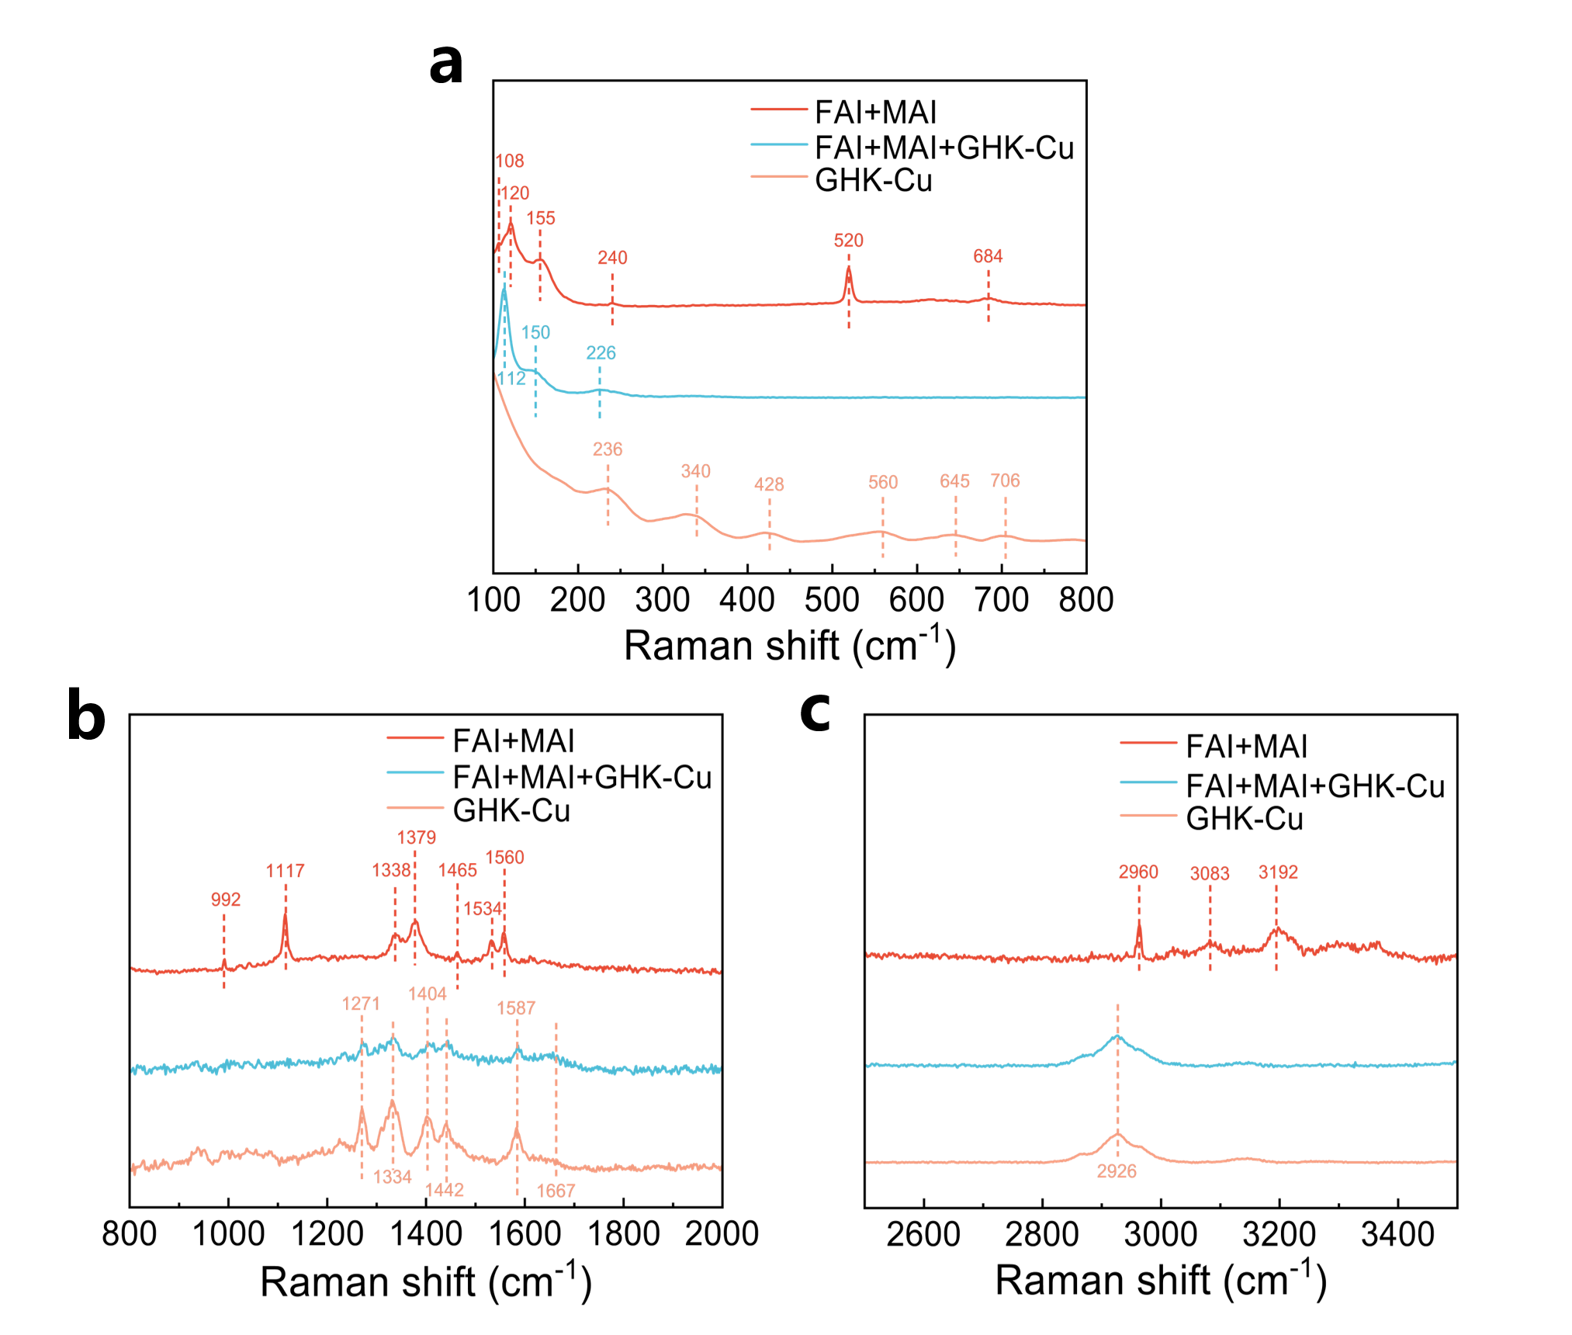
Supplementary Fig. 16 ∣ Raman spectras of FAI+MAI, GHK-Cu and FAI+MAI+GHK-Cu in the range of (a) 100-800 cm⁻¹, (b) 800-2000 cm⁻¹ and (c) 2500-3500 cm⁻¹, respectively. Upon GHK-Cu treatment, the Raman scattering peaks of FAI/MAI (120 and 155 cm⁻¹), and GHK-Cu (236 cm⁻¹) were observed to redshift to 112, 150, and 226 cm⁻¹, respectively. Meanwhile, the characteristic peaks of FAI/MAI (108, 240, 520, 684, 992, 1117, 1338, 1379, 1465, 1534, 1560, 2960, 3083, and 3192 cm⁻¹) and those of GHK-Cu (340, 428, 560, 645, and 706 cm⁻¹) disappeared.
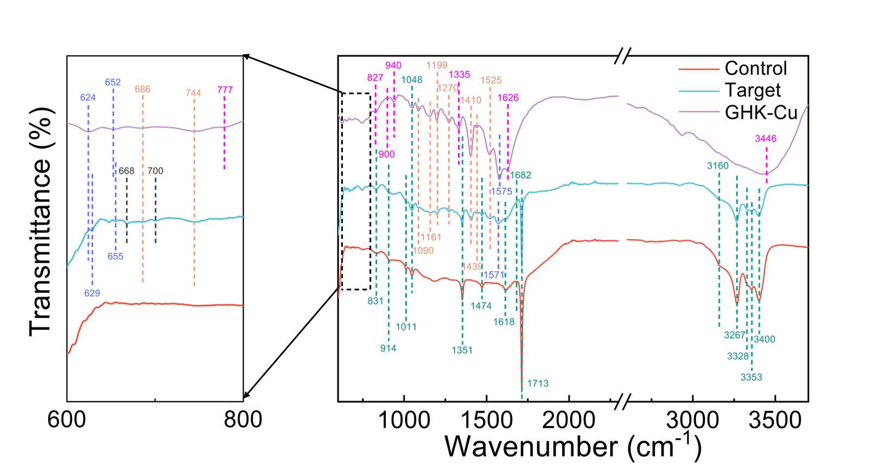
Supplementary Fig. 17 ∣ FTIR spectra of the GHK-Cu power, control and target films. FTIR spectroscopy revealed distinct spectral changes upon GHK-Cu incorporation onto the perovskite surface. A new peak at 668 cm⁻¹, attributed to CuI formation, emerges and aligns with XRD data⁵. The characteristic imidazole ring peaks of GHK-Cu (624 and 1575 cm⁻¹) shift to 629 and 1571 cm⁻¹, respectively, accompanied by the disappearance of peaks at 777, 827, and 940 cm⁻¹ (Supplementary Table 2). These shifts suggested that the MeOH-CB cosolvents induce transient deligandization or protonation of the imidazole ring. Furthermore, the ─COOH peak shifted from 652 to 655 cm⁻¹, along with the disappearance of the peak at 1335 cm⁻¹, indicating strong electron donation from GHK-Cu to uncoordinated Pb²⁺. Crucially, the emergence of a new peak corresponding to the bending vibration of ─NH₂ (700 cm⁻¹) and the disappearance of its peaks at 900, 1626, and 3446 cm⁻¹ provided direct evidence for the role of MeOH in bending the flexible peptide chain and facilitating Pb–N bond formation⁶. Importantly, both the control and target films retained the characteristic organic cation peaks (831, 914, 1011, 1048, 1351, 1474, 1618, 1682, 1713, 3160, 3267, 3328, 3353, and 3400 cm⁻¹)^{7,8}, further demonstrating that the solvent synergy of MeOH and CB did not compromise the crystal structure of the perovskite film.
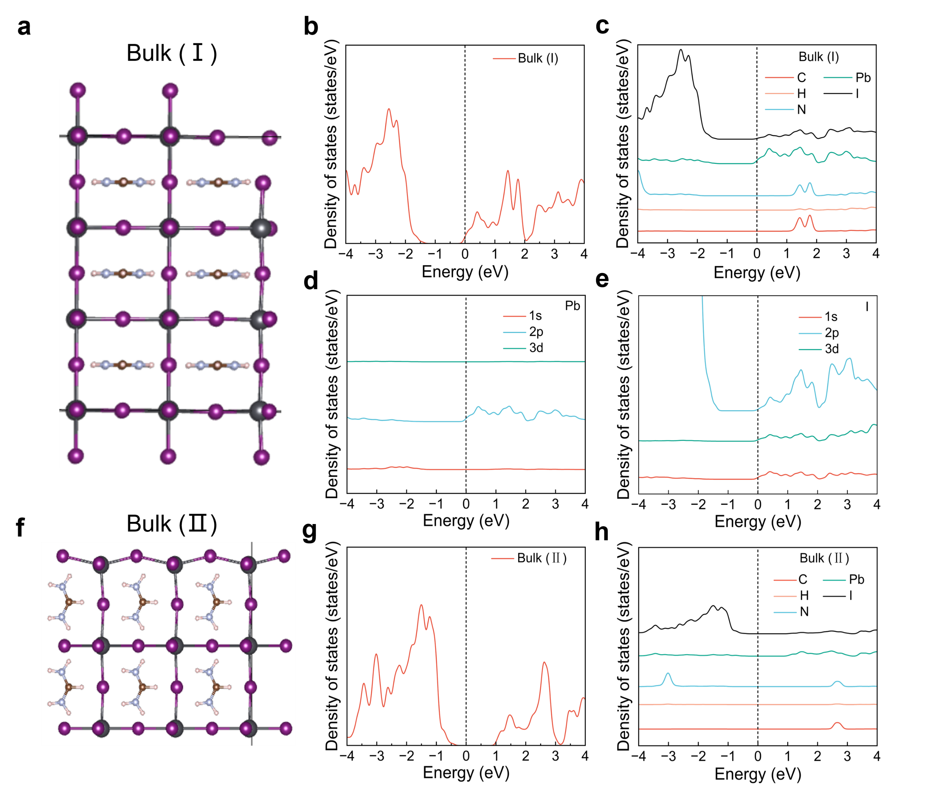
Supplementary Fig. 18 ∣ (a) Side view, (b) tDOS and (c), (d), (e) pDOS of Bulk (Ⅰ). (f) Front view, (g) DOS and (h) pDOS of Bulk (Ⅱ).
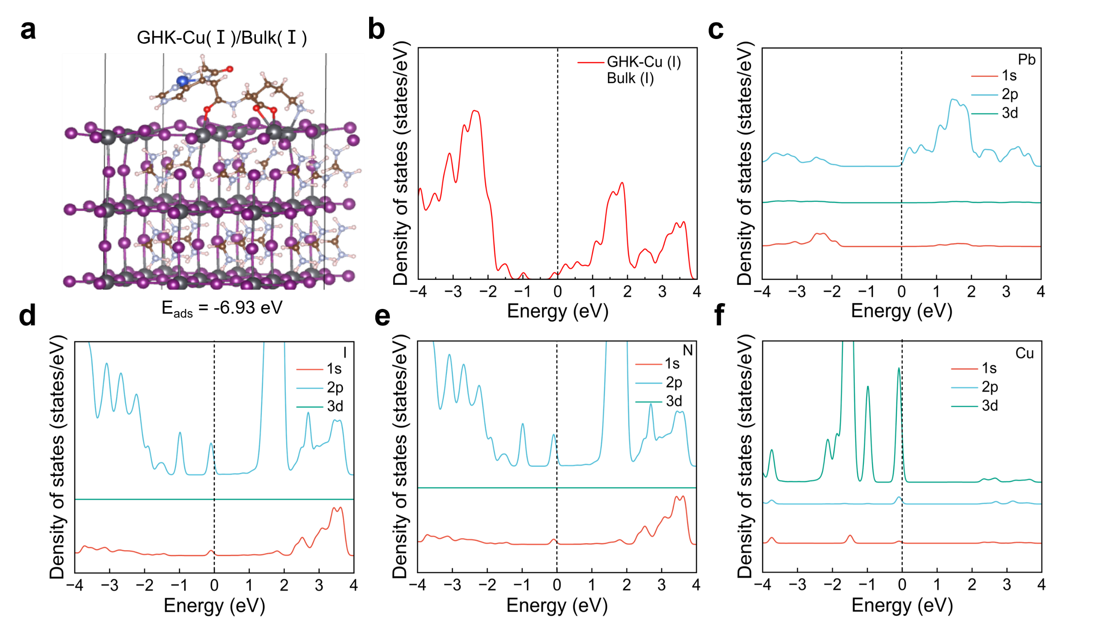
Supplementary Fig. 19 ∣ (a) The optimized adsorption models, (b) tDOS and (c), (d), (e), (f) pDOS of adsorption mode in the case of GHK-Cu (Ⅰ) and Bulk (Ⅰ).
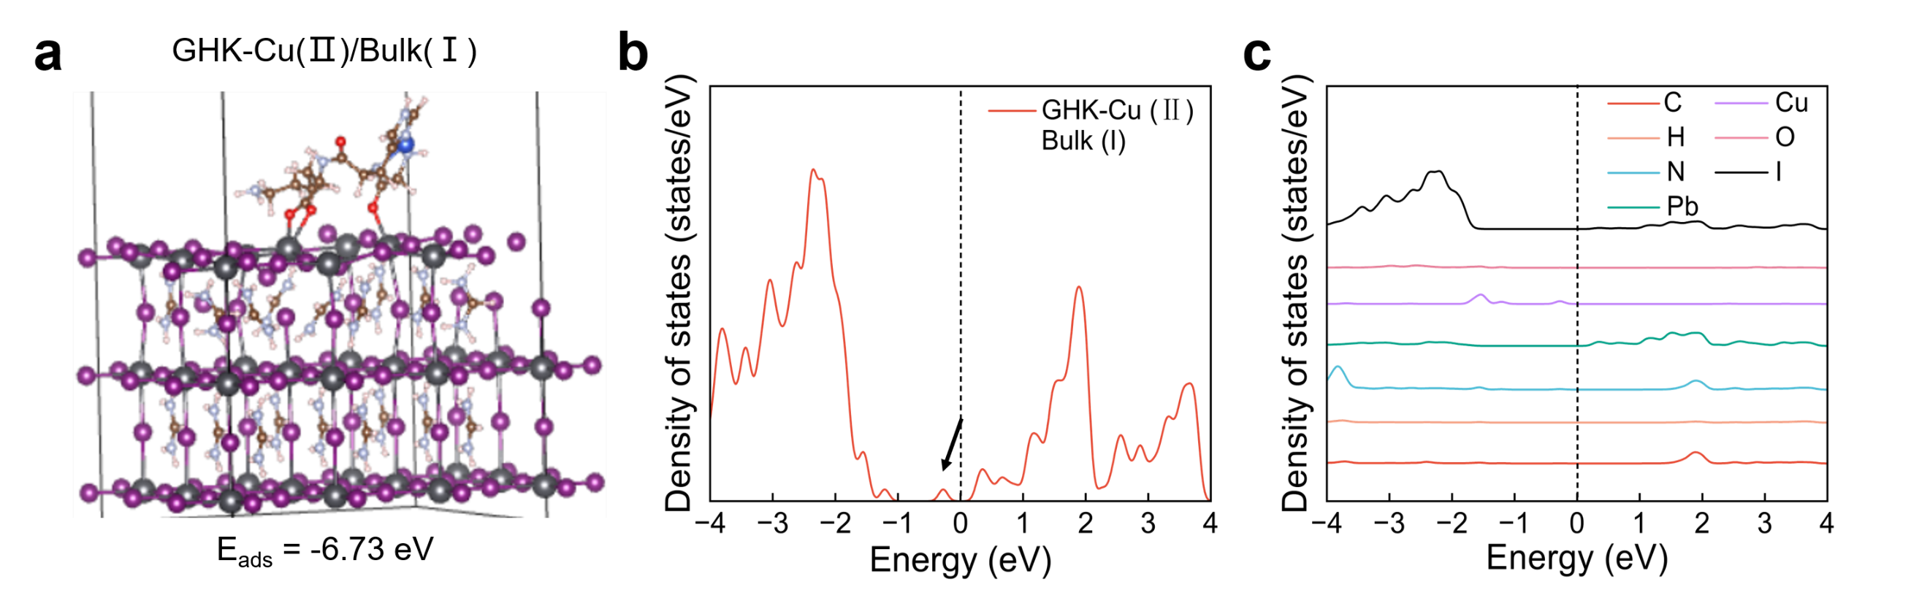
Supplementary Fig. 20 ∣ (a) The optimized adsorption model, (b) tDOS and (c) pDOS in the case of GHK-Cu (Ⅱ) and Bulk (Ⅰ). Because each atom made no contribution to the state density at the E_{F} in this adsorption configuration, we did not perform a detailed analysis of their s, p, and d orbitals.
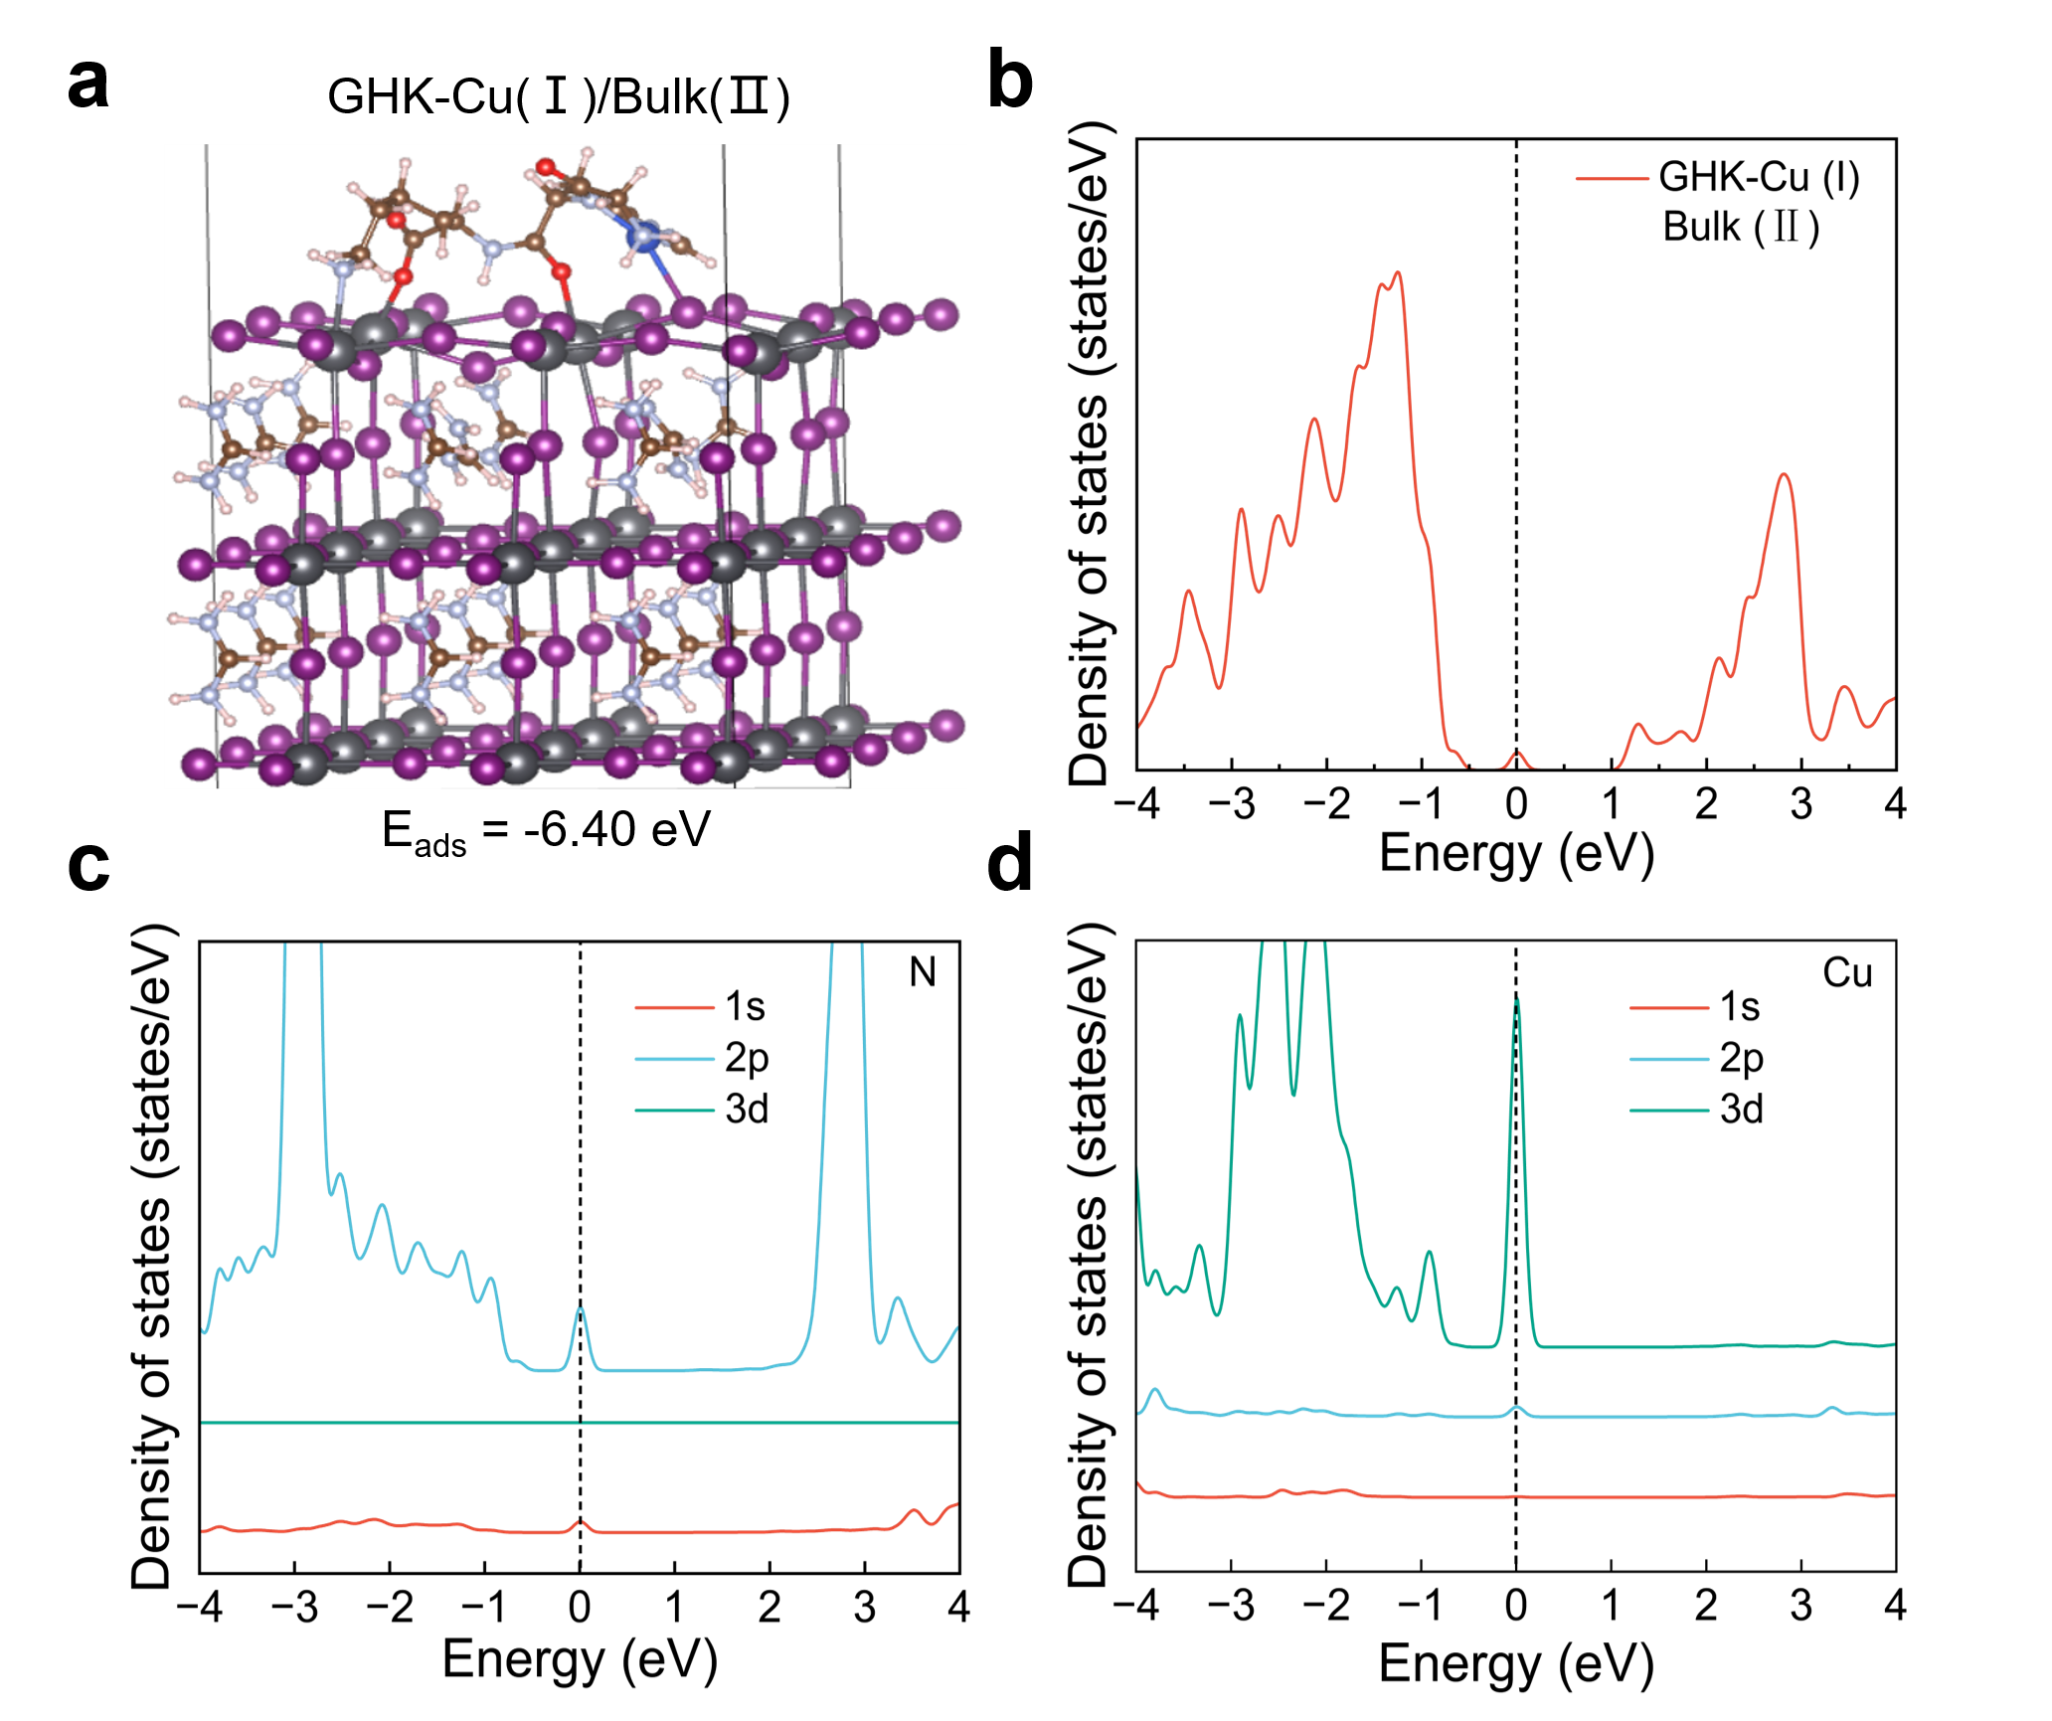
Supplementary Fig. 21 ∣ (a) The optimized adsorption model, (b) tDOS and (c), (d) pDOS of adsorption mode in the case of GHK-Cu (Ⅰ) and Bulk (Ⅱ).
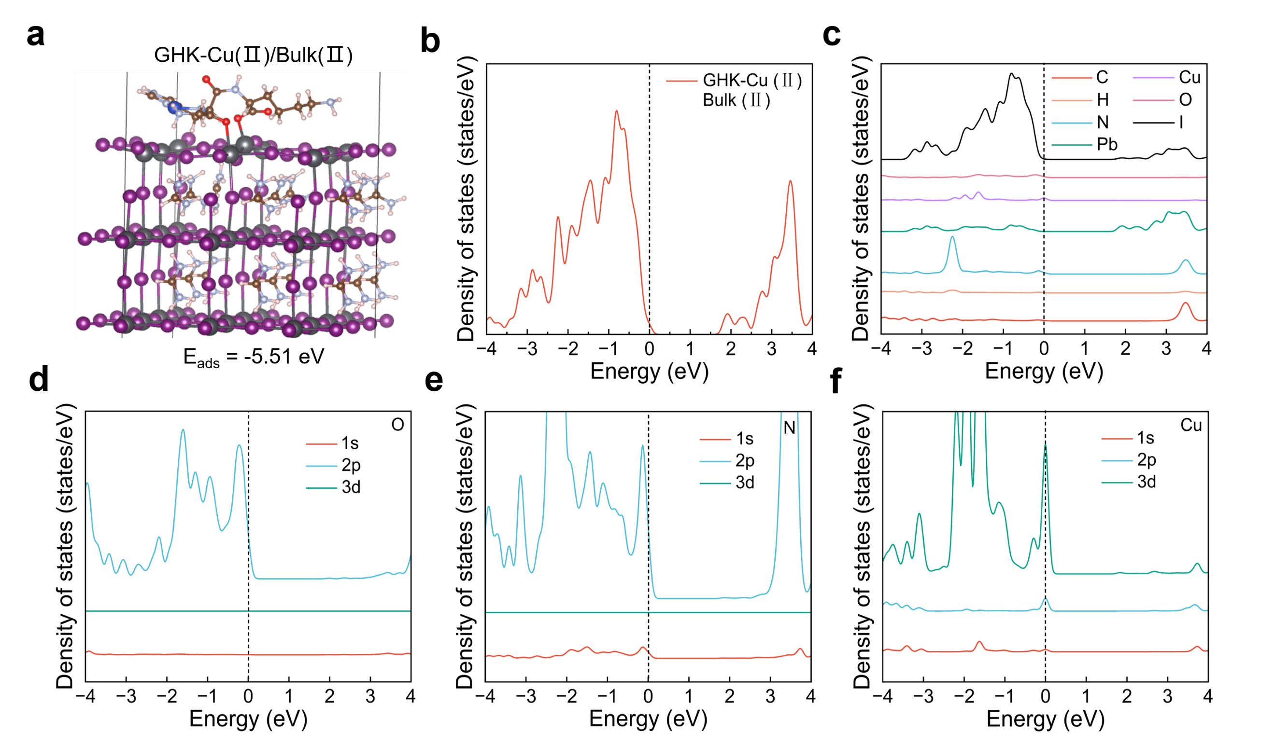
Supplementary Fig. 22 ∣ (a) The optimized adsorption model, (b) tDOS and (c), (d), (e), (f) pDOS in the case of GHK-Cu (Ⅱ) and Bulk (Ⅱ).
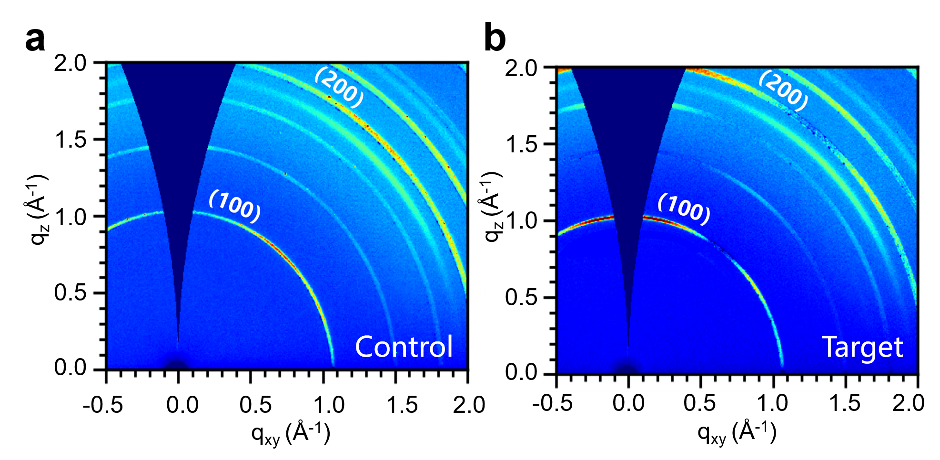Supplementary Fig. 23 ∣ Two-dimensional GIWAXS of the (a) control and (b) target films.

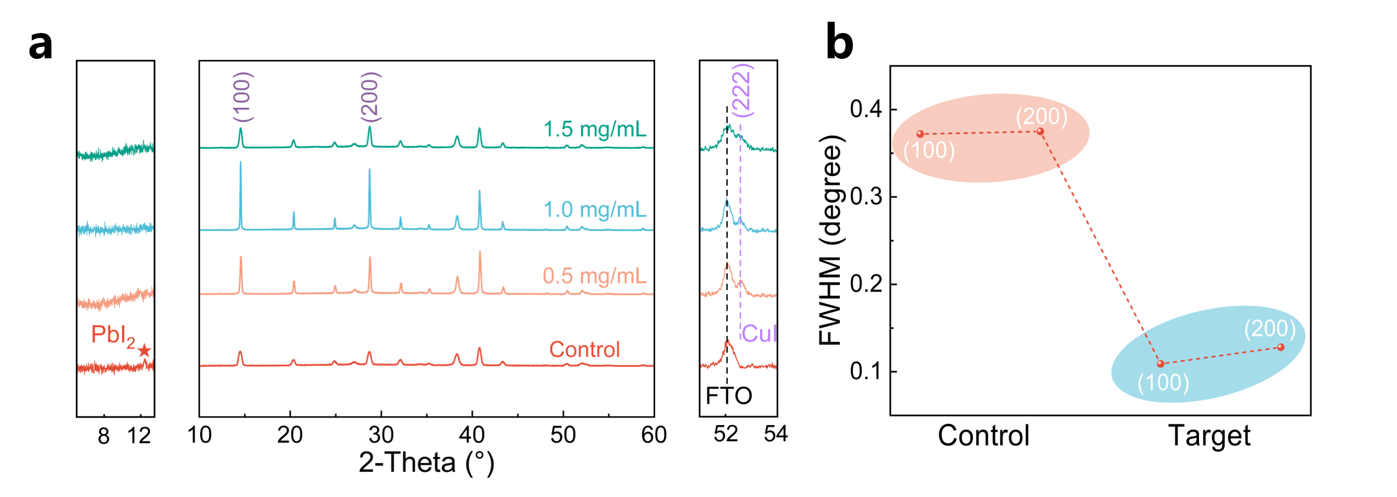
Supplementary Fig. 24 ∣ (a) XRD patterns of perovskite films with different concentrations of GHK-Cu treatment and (b) the FWHM of (100) and (200) of the control and target films, respectively. With GHK-Cu treated, the ordered growth of the target film along the (100) and (200) facets was significantly amplified with a quite redution of the full width at half-maximum and strain from 1.21×10⁻³ to 4.84×10⁻⁴ (Supplementary Table 3). These findings collectively indicated a substantial enhancement of both the crystallinity and structural stability of perovskite films⁹. Concurrently, the characteristic peak at 12.7° assigned to PbI₂ disappeared associated with the synchronously surprising appearance of a peak corresponded to (222) plane of γ-CuI located at 52.55°⁵, which had a significant enhancement to hole conductivity¹⁰.
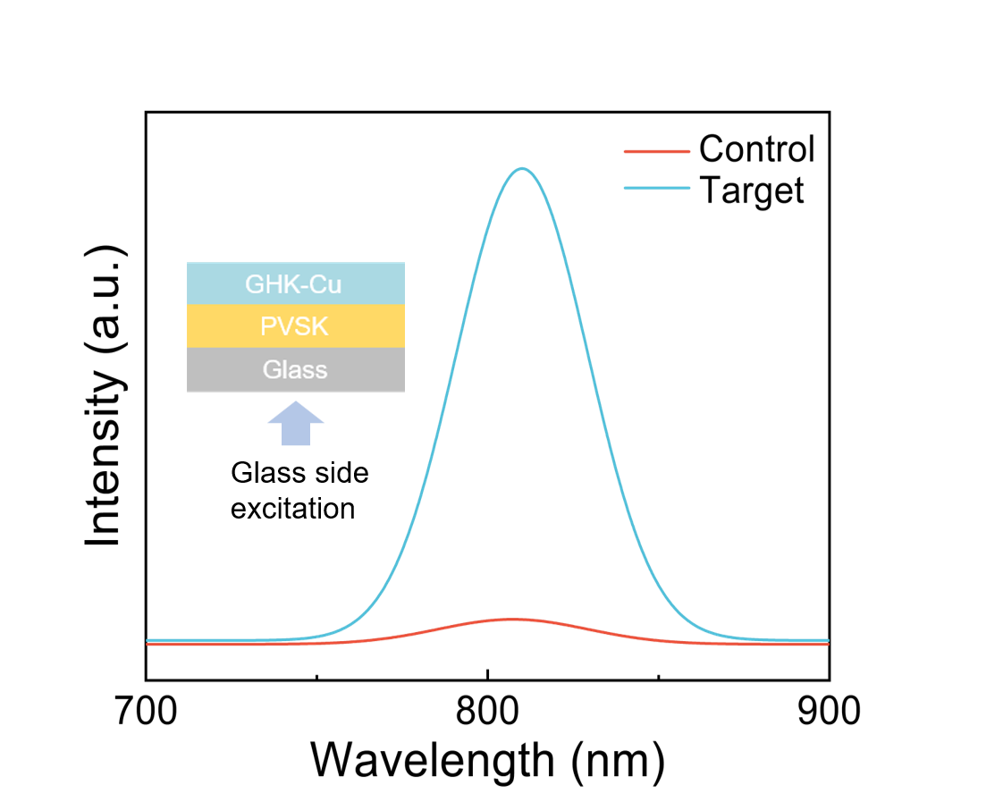
Supplementary Fig. 25 ∣ Steady-state PL spectra of the control and target films measured from the glass side.

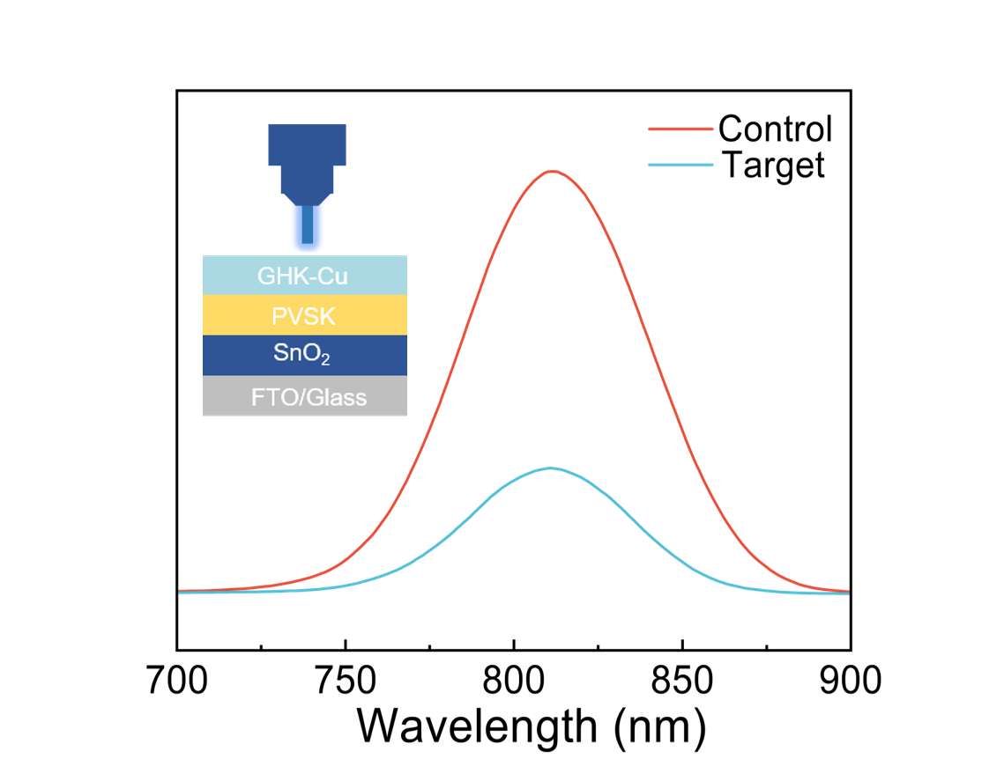
Supplementary Fig. 26 ∣ PL spectra of the control and target films measured from the perovskite side.

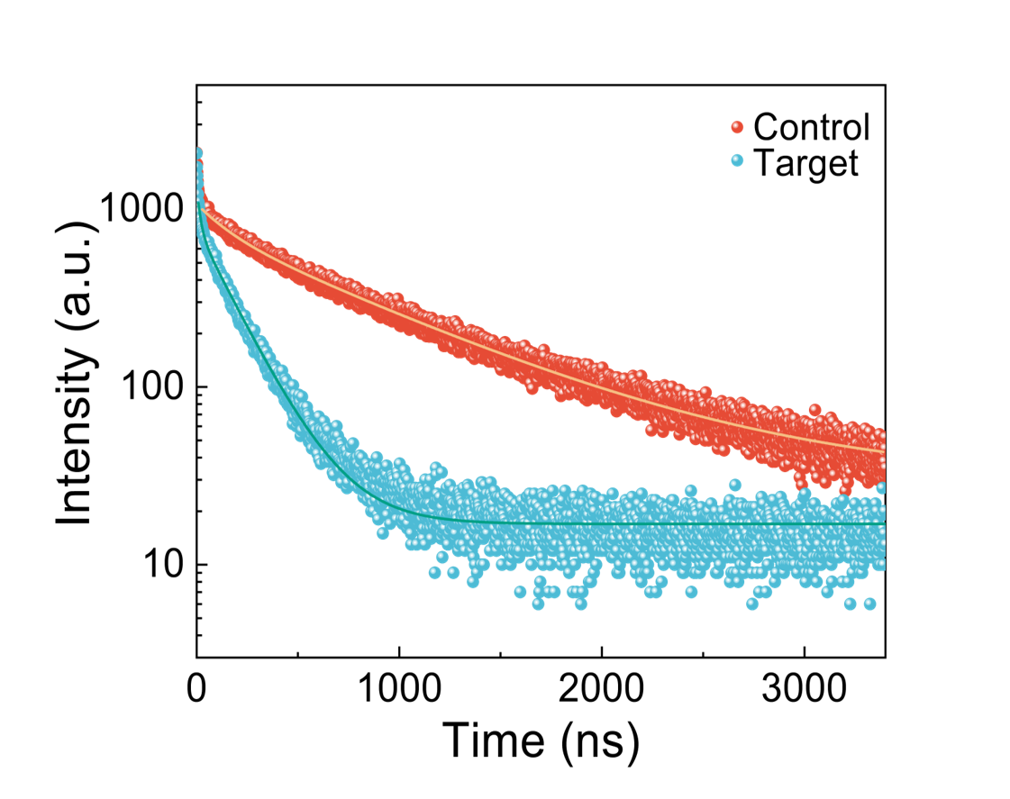
Supplementary Fig. 27 ∣ TRPL spectra of the control and target films with the structure of FTO/SnO₂/PVSK/WO/W GHK-Cu.
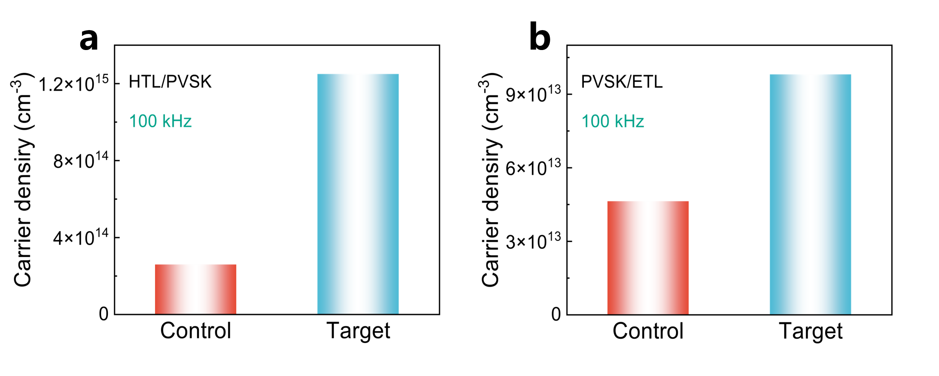
Supplementary Fig. 28 ∣ Free carrier density at (a) HTL/PVSK interface and (b) PVSK/ETL interface in control and target devices extracted from DLCP measurement under 100 kHz AC bias.

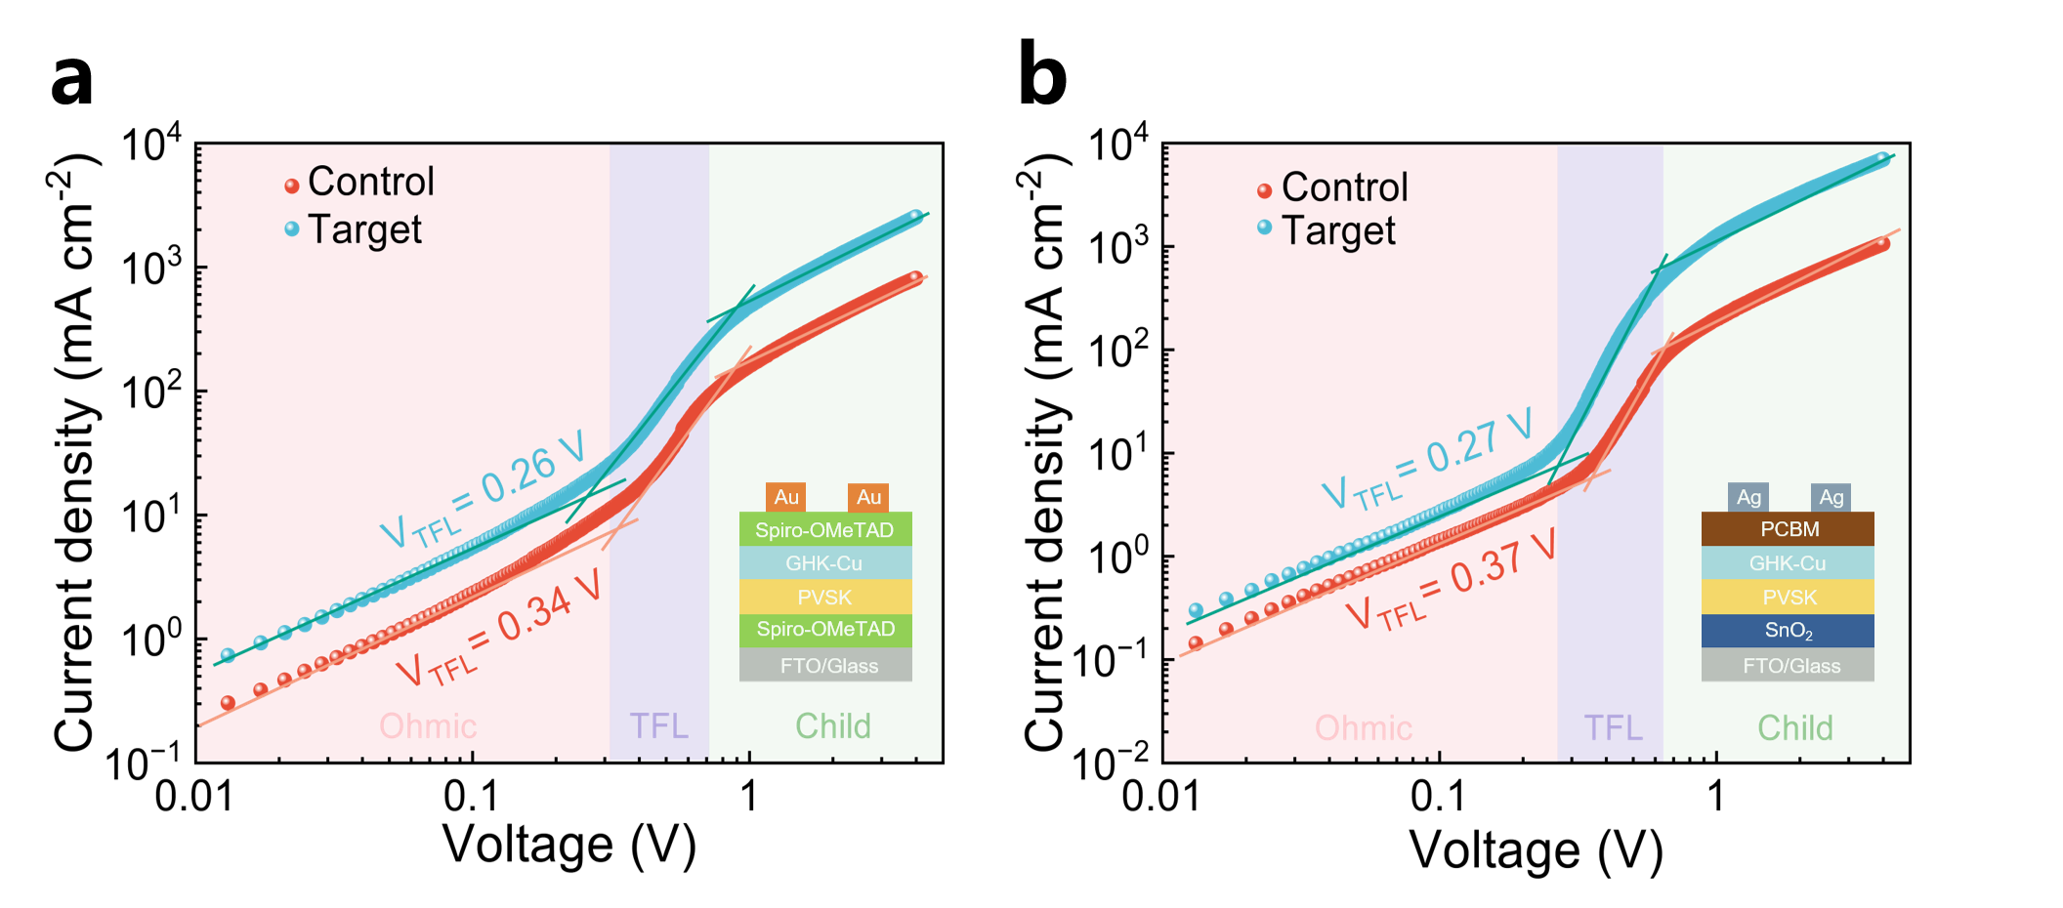
Supplementary Fig. 29 ∣ The J-V characteristics of (a) hole-only and (b) electron-only devices without/with GHK-Cu treated in the darkness with the schematic diagram of the devices shown in the illustration, respectively.
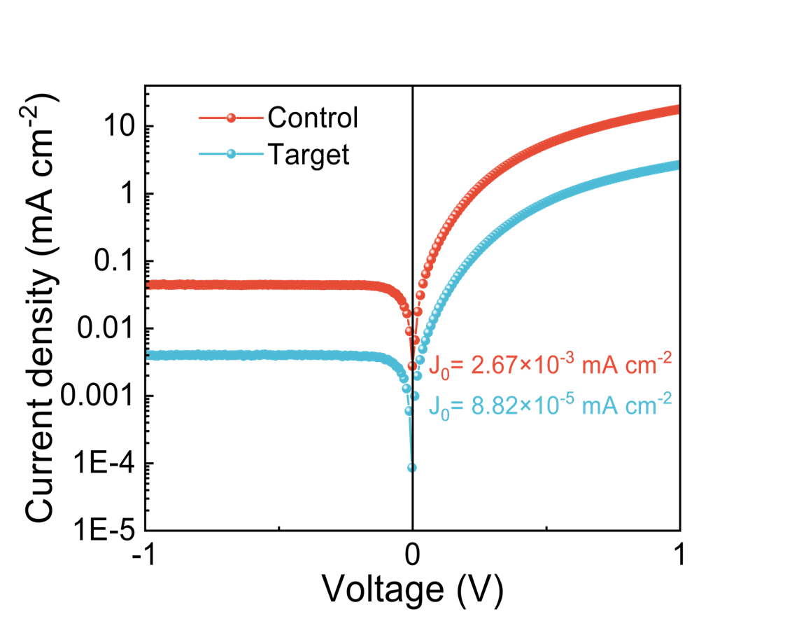
Supplementary Fig. 30 ∣ The leakage current curve of the control and target devices.

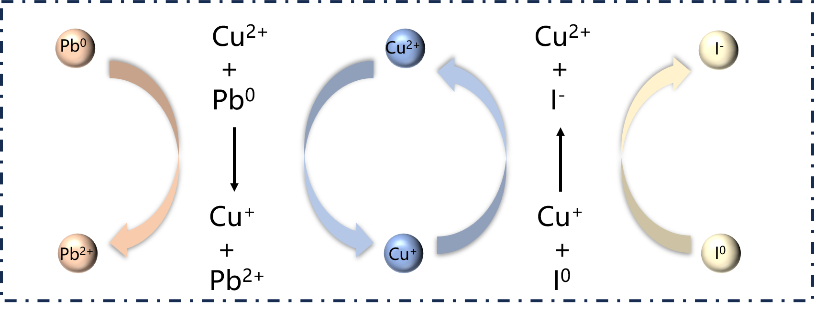
Supplementary Fig. 31 ∣ Schematic diagram of redox reaction mechanism.

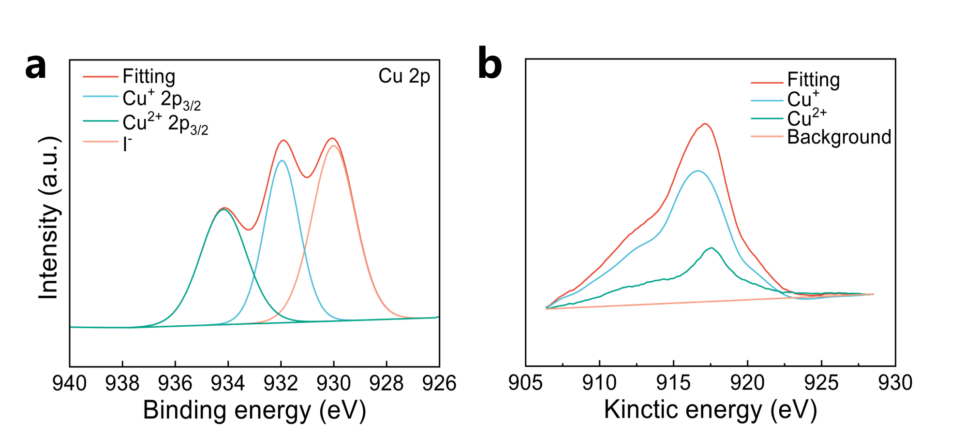
Supplementary Fig. 32 ∣ (a) XPS spectra of Cu 2p_{3/2} core level peaks for the target film. (b) The Auger spectrum of Cu element.

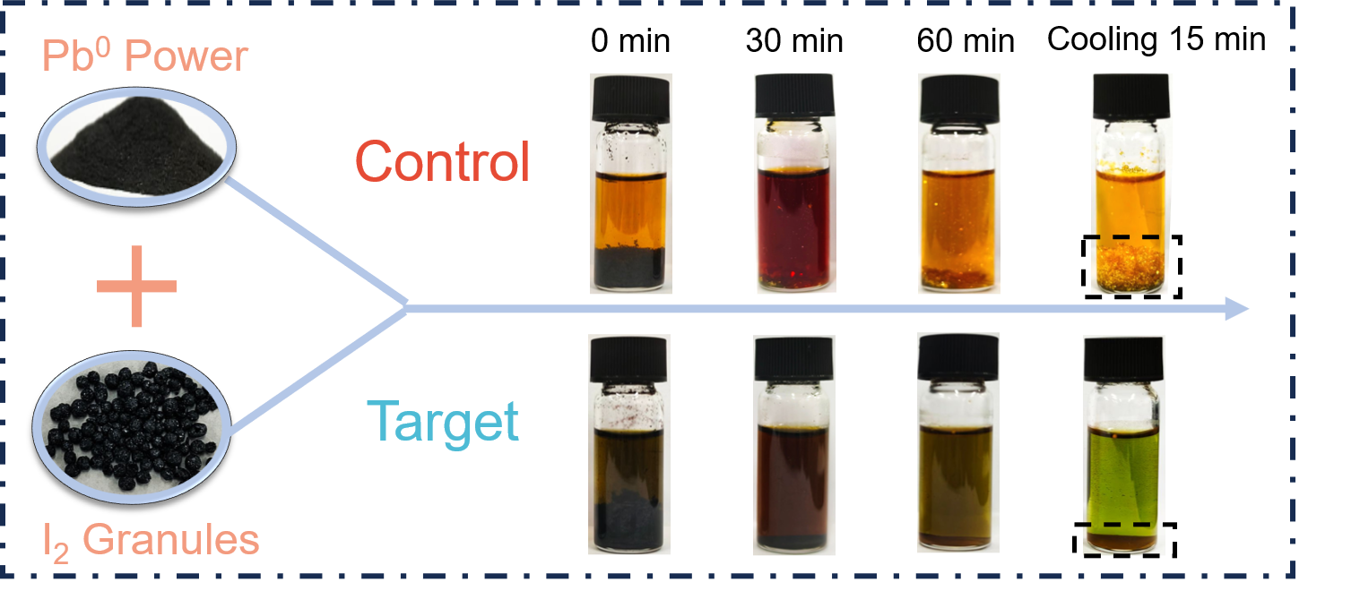
Supplementary Fig. 33 ∣ The following process flowchart of I₂ granules, Pb⁰ power and GHK-Cu dissolved in a mixed solvent of IPA and UPW with a volume ratio of 1:9, followed by stirring at 100°C for 60 min. Following a cooling period of 15 min, a significant quantity of golden yellow precipitate was observed to form in the control solution deviod of GHK-Cu, while the brownish-yellow precipitate belonging to the characteristic color of CuI as the dominant color appeared at the bottom of the target solution containing GHK-Cu.

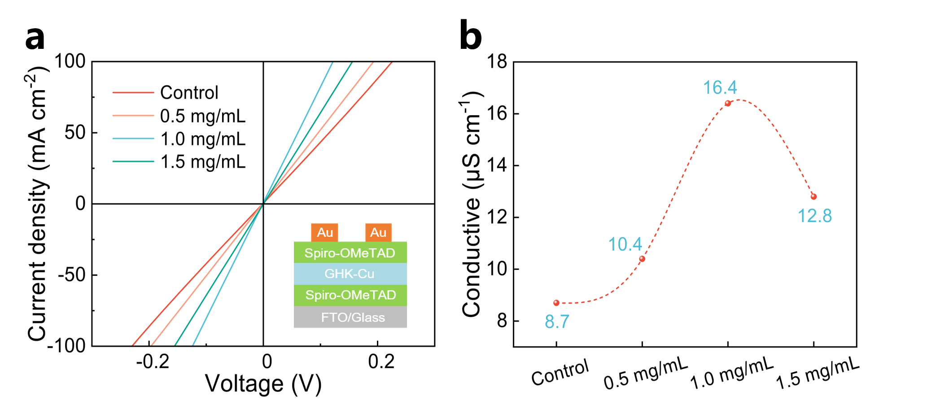
Supplementary Fig. 34 ∣ (a) J-V curves of hole-only devices, the structure was shown in the inset. (b) The conductivity of hole-only devices under different concentrations.

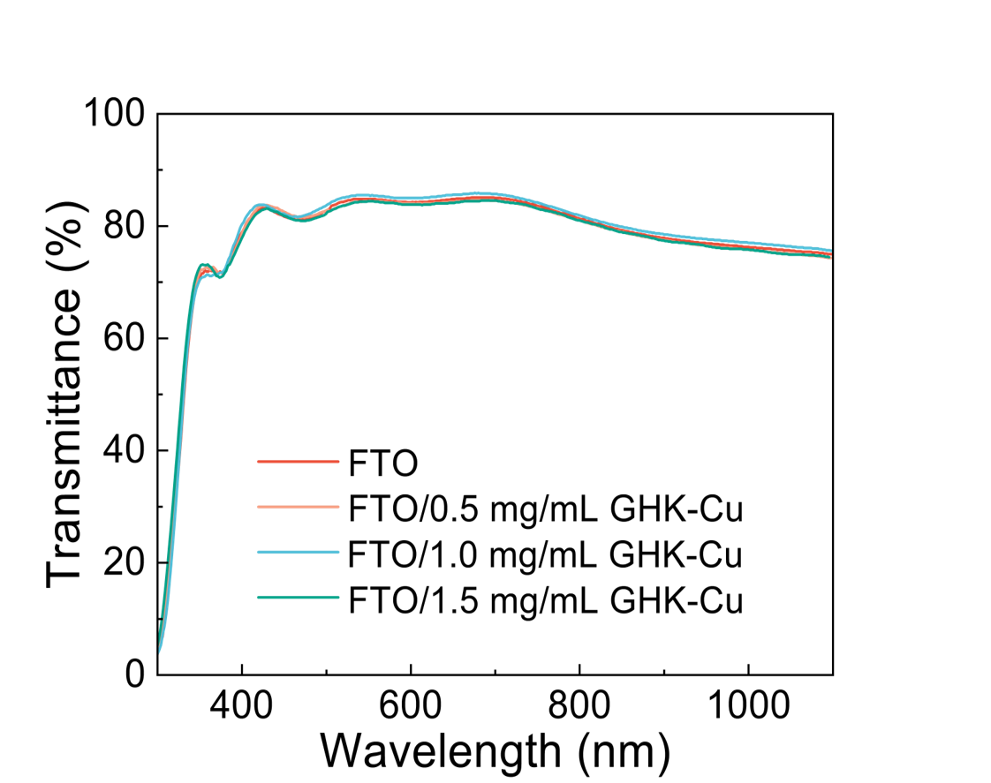
Supplementary Fig. 35 ∣ Transmission spectra of different concentrations of GHK-Cu on FTO substrates.
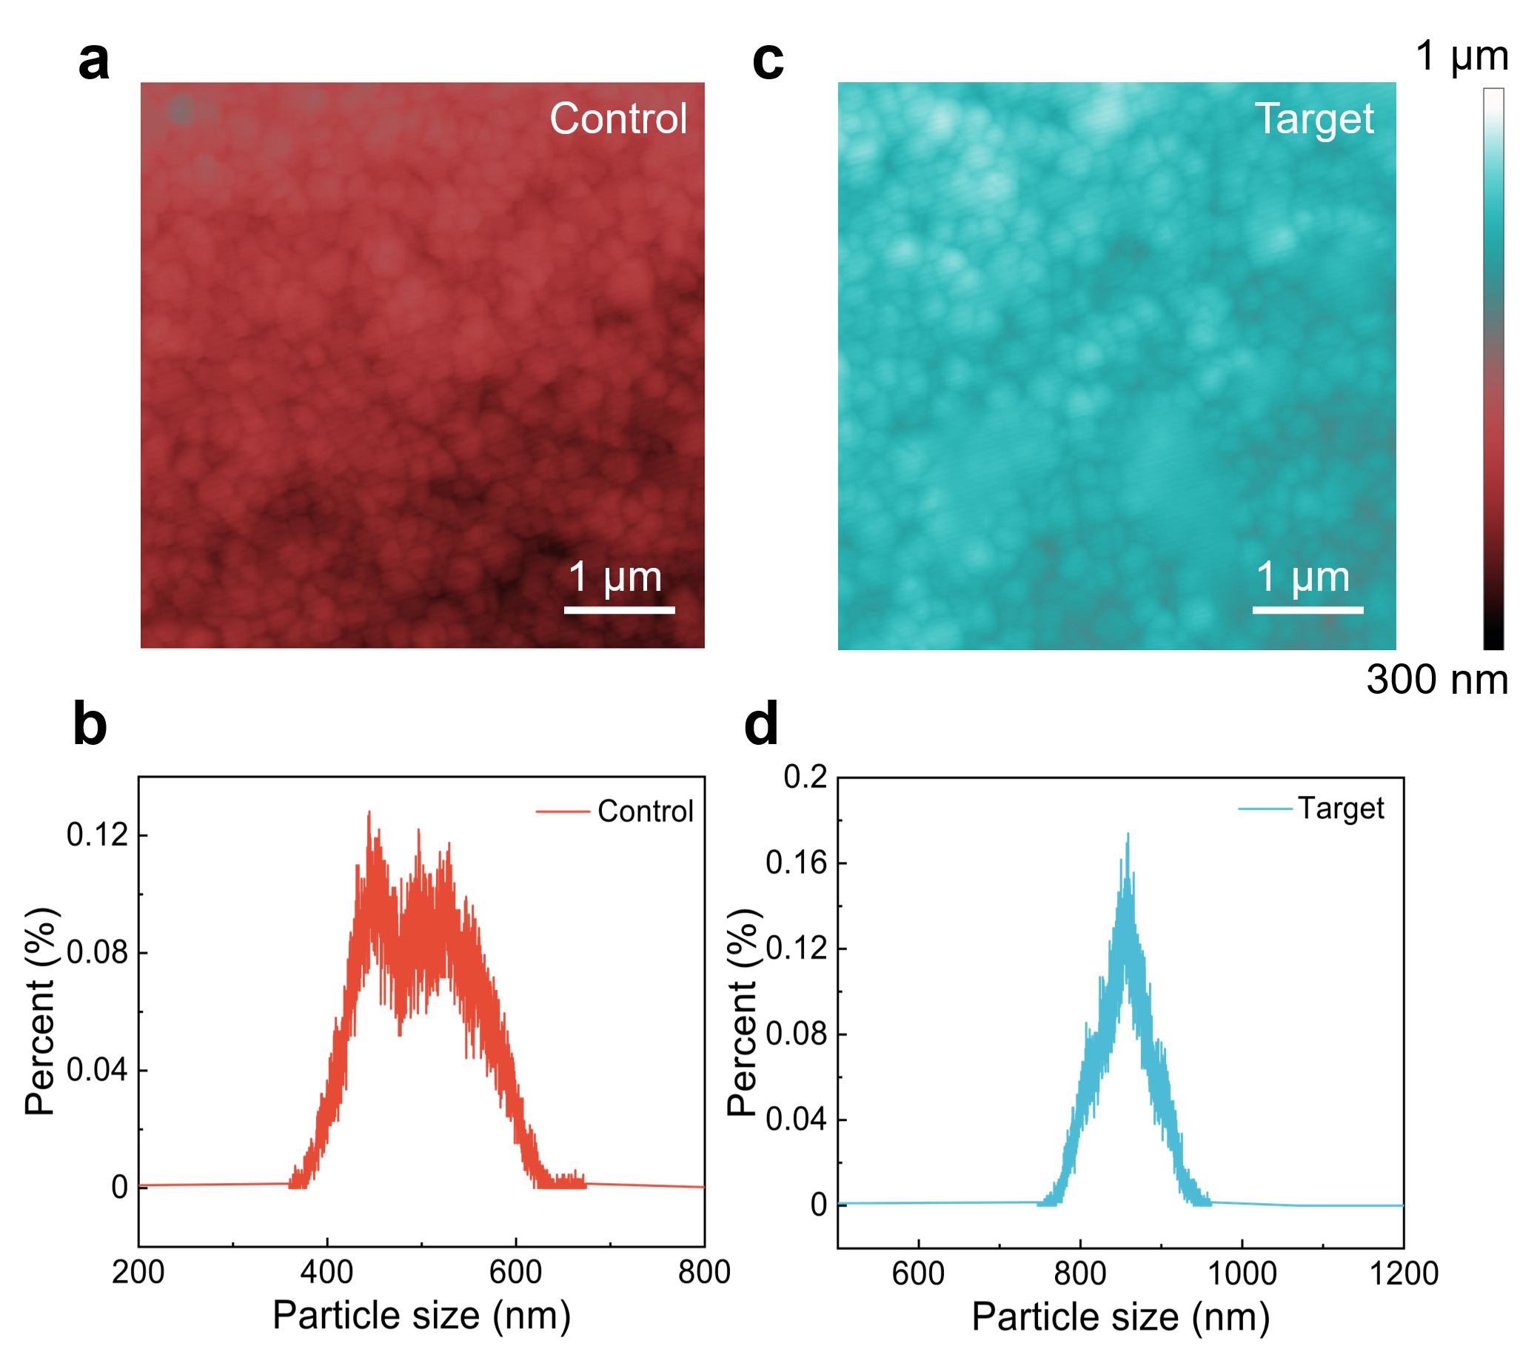
Supplementary Fig. 36 ∣ AFM and particle size statistics spectrum of the (a), (b) control and (c), (d) target films, respectively.
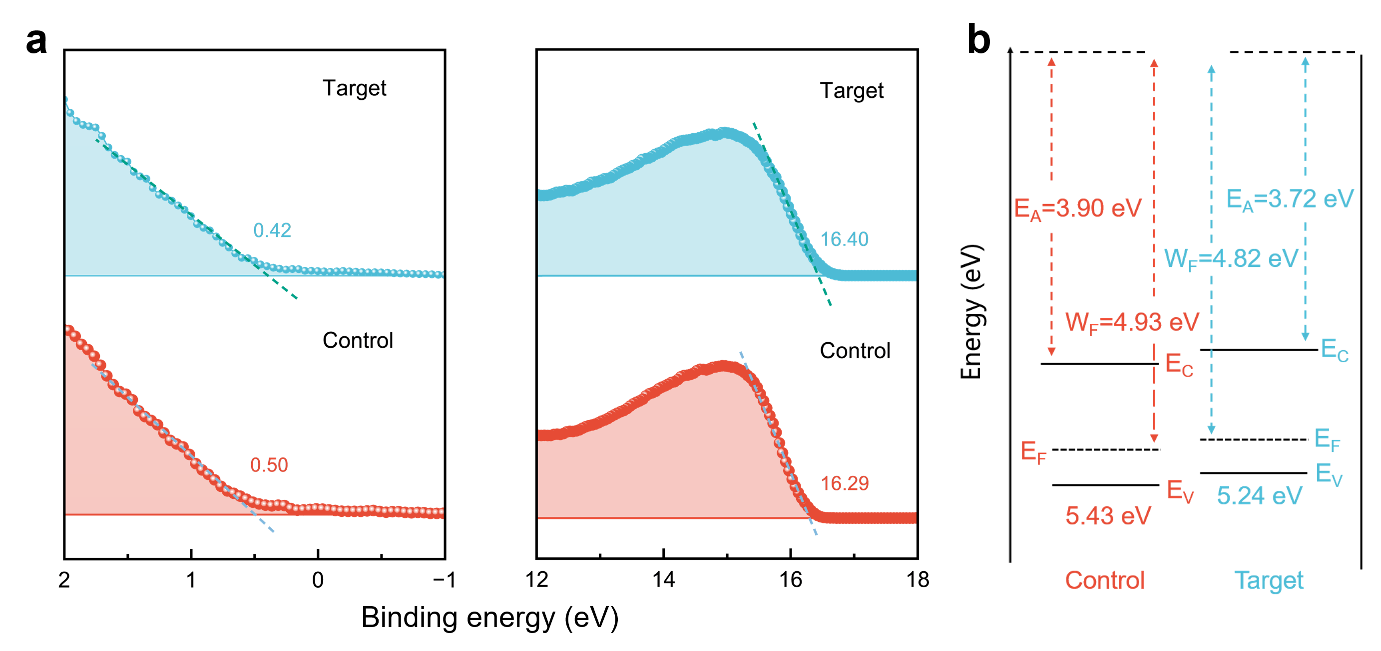
Supplementary Fig. 37 ∣ (a) The valence band region and secondary electron cutoff region extracted from UPS spectra and (b) energy level diagrams of the control and target films, respectively.

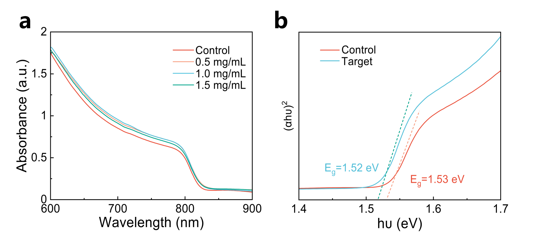
Supplementary Fig. 38 ∣ (a) The absorption spectra of perovskite films with different concentrations of GHK-Cu treatment. (b) (αhυ)²~hυ curves of the control and target films. The absorption spectra of perovskite films treated with different concentrations of GHK-Cu were obtained. It was evident that GHK-Cu-treated perovskite films exhibit an enhanced absorbance intensity within the 600-900 nm range, which was credited to the pronounced light scattering in the mesoporous architecture and the elevated crystallinity of perovskite films^{11,12}. Subsequently, the E_{g} of 1.53 and 1.52 eV were calculated by derivation of the (αhυ)₂=A(hυ-E_{g}), which led to the determination of the E_{C} of 3.90 and 3.72 eV, respectively.
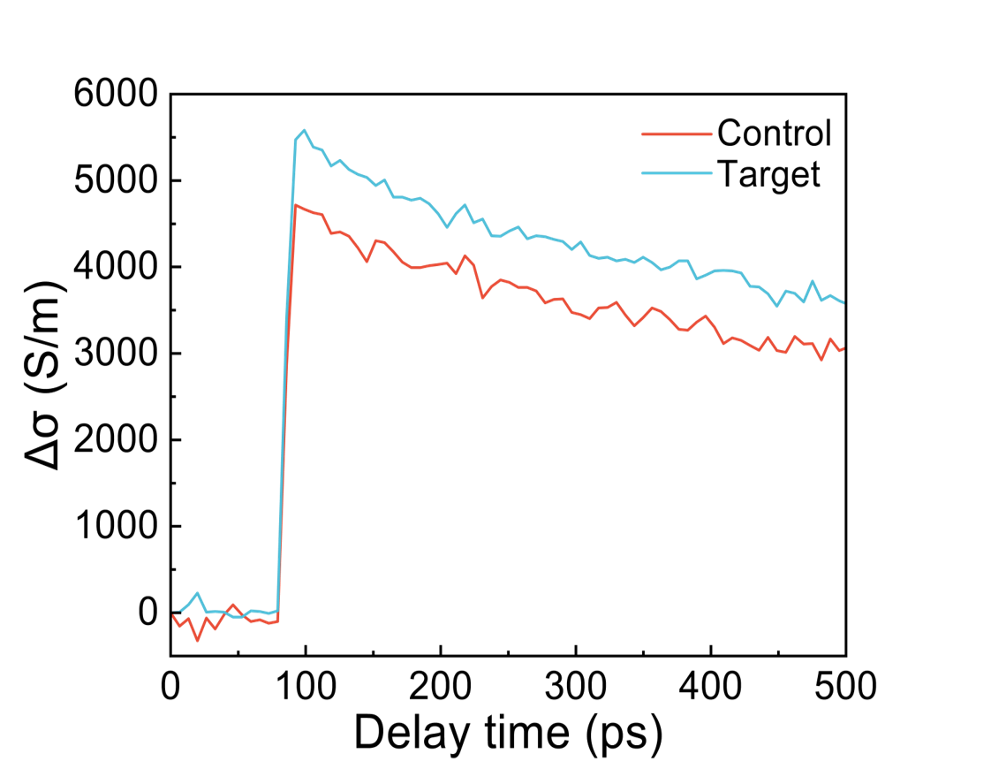
Supplementary Fig. 39 ∣ Time-resolved conductivity of the control and target films on Glass/SnO₂ substrate. The OPTP spectroscopy was used to comprehend the complete ultrafast dynamics of photogenerated carriers in perovskite film, encompassing their generation, transportation and recombination in the Glass/SnO₂/PVSK overall configuration. Under the condition of consistent excitation carrier concentration, the photo-induced THz transmission change (ΔT/T₀, ΔT = T-T₀ is the disparity in transmission intensity of the THz peak before and after excitation) of the GHK-Cu-based structure was the most pronounced with the optimal time-resolved conductivity.
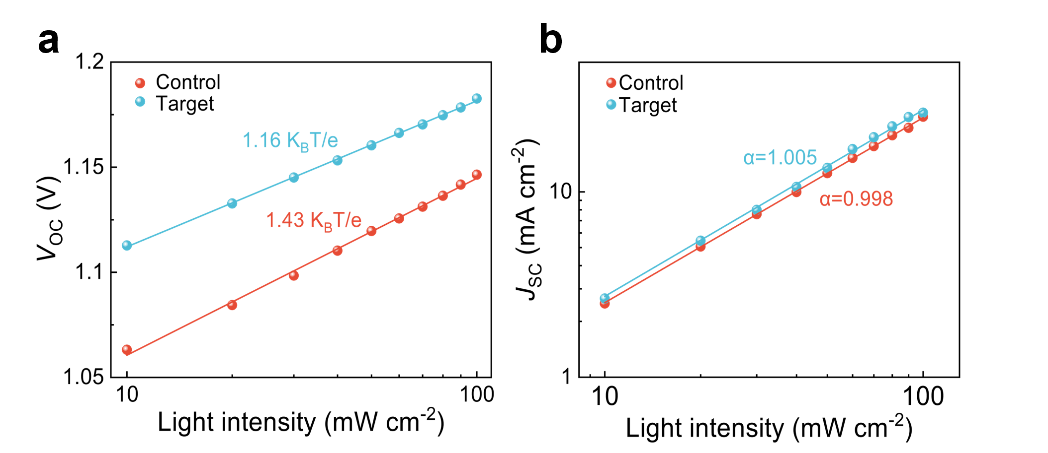
Supplementary Fig. 40 ∣ (a) V_{OC} as a function of light intensity and (b) Light intensity dependent J_{SC} of the control and target devices, respectively.
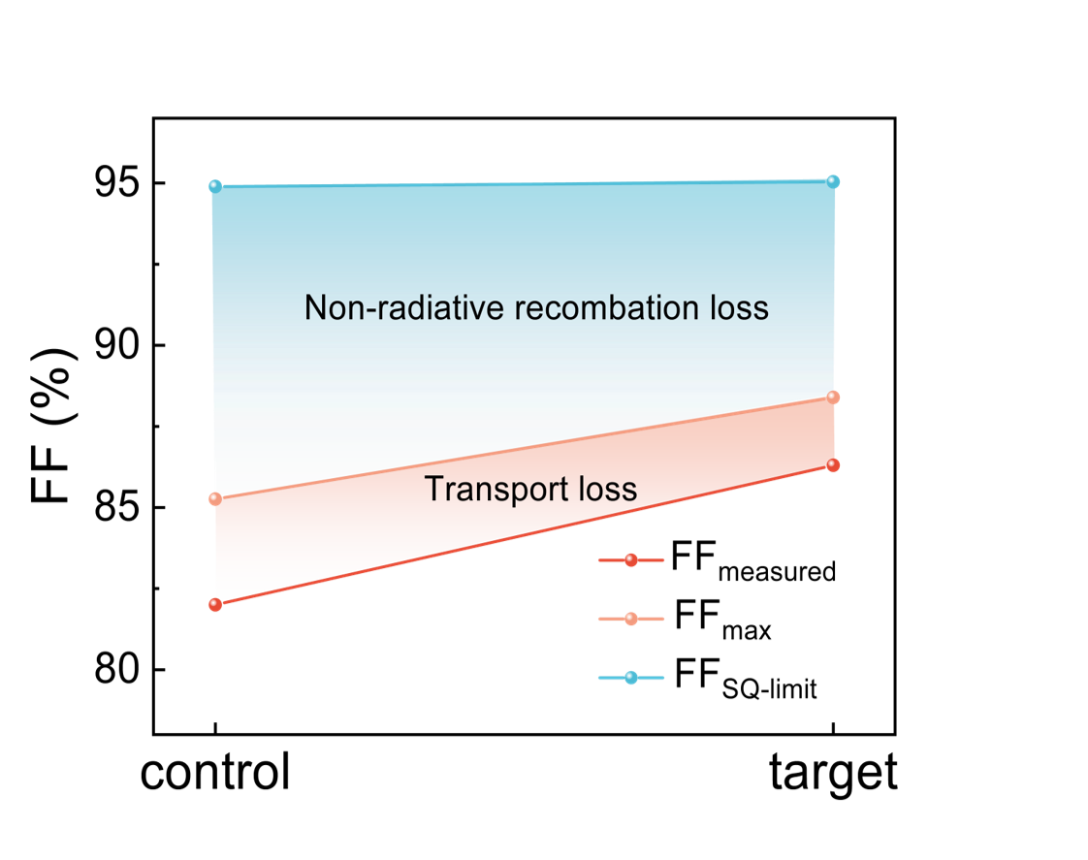
Supplementary Fig. 41 ∣ Detailed V_{OC} loss analysis of the control and target devices.

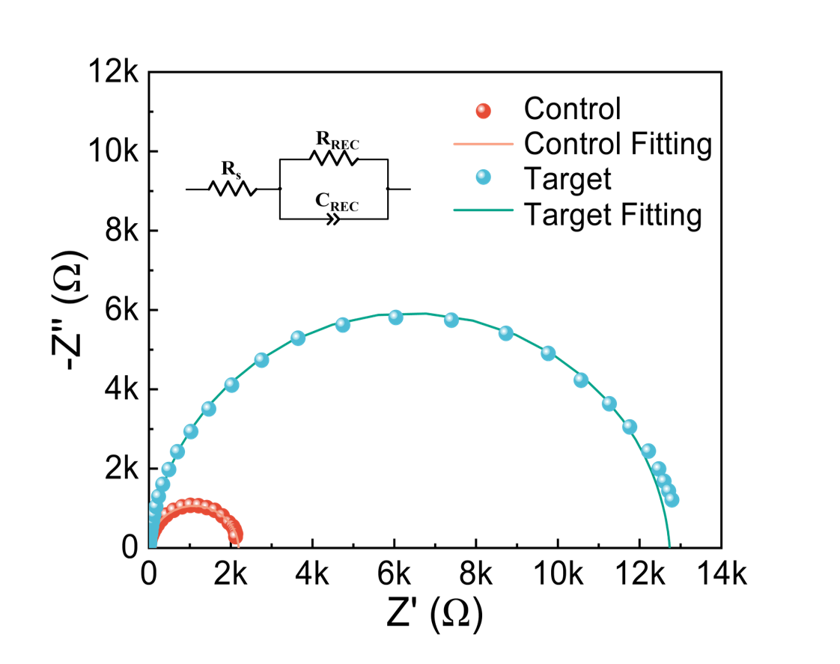
Supplementary Fig. 42 ∣ Nyquist (the inset is the equivalent circuit for the EIS analysis) of the control and target devices.

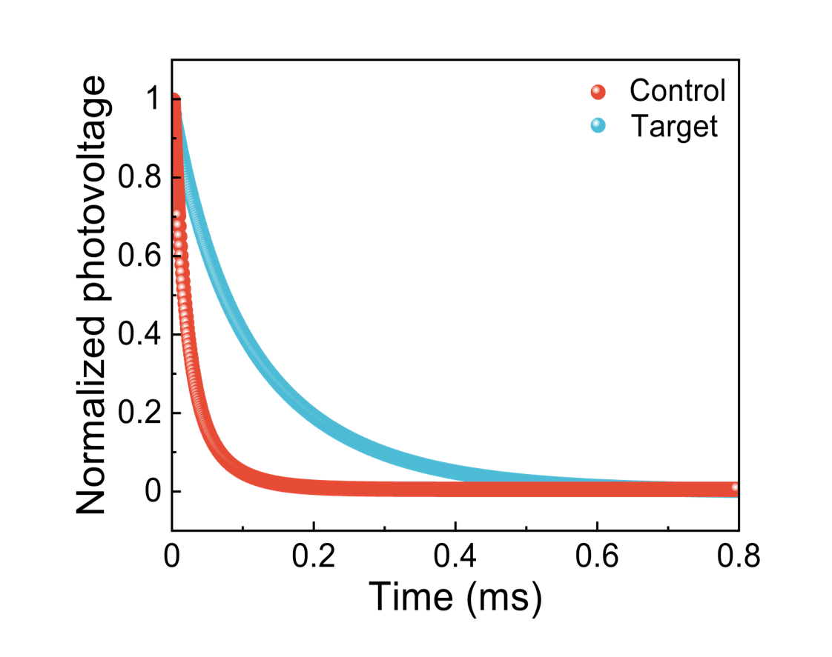
Supplementary Fig. 43 ∣ TPV decay curve of the control and target devices.
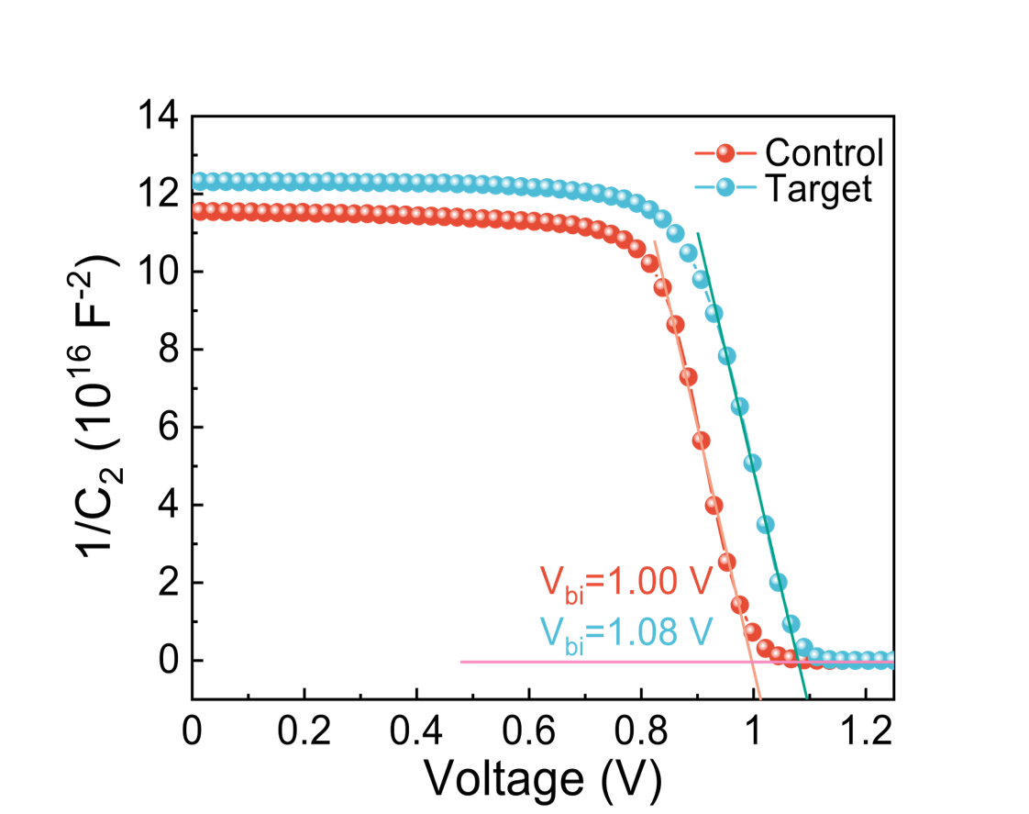
Supplementary Fig. 44 ∣ Mott-Schottky plots of the control and target devices.
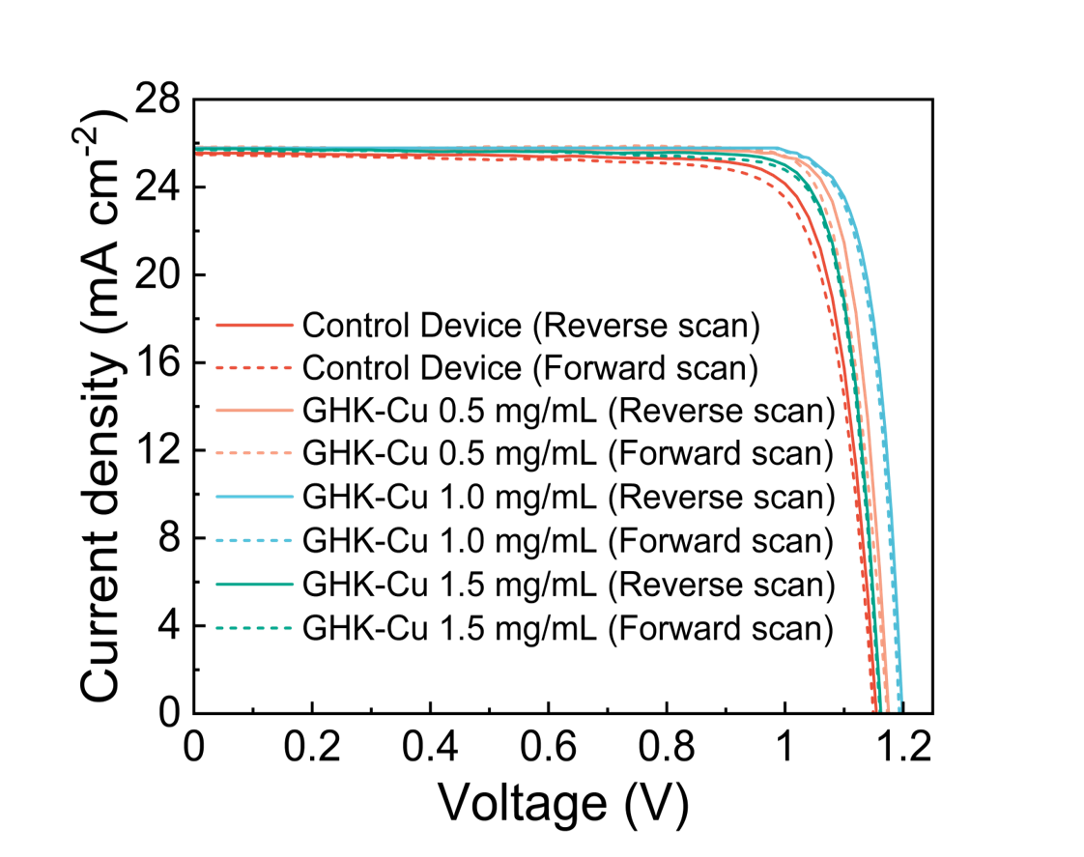
Supplementary Fig. 45 ∣ Forward and reverse scanning J-V curves of PSCs without/with different GHK-Cu concentrations treated.
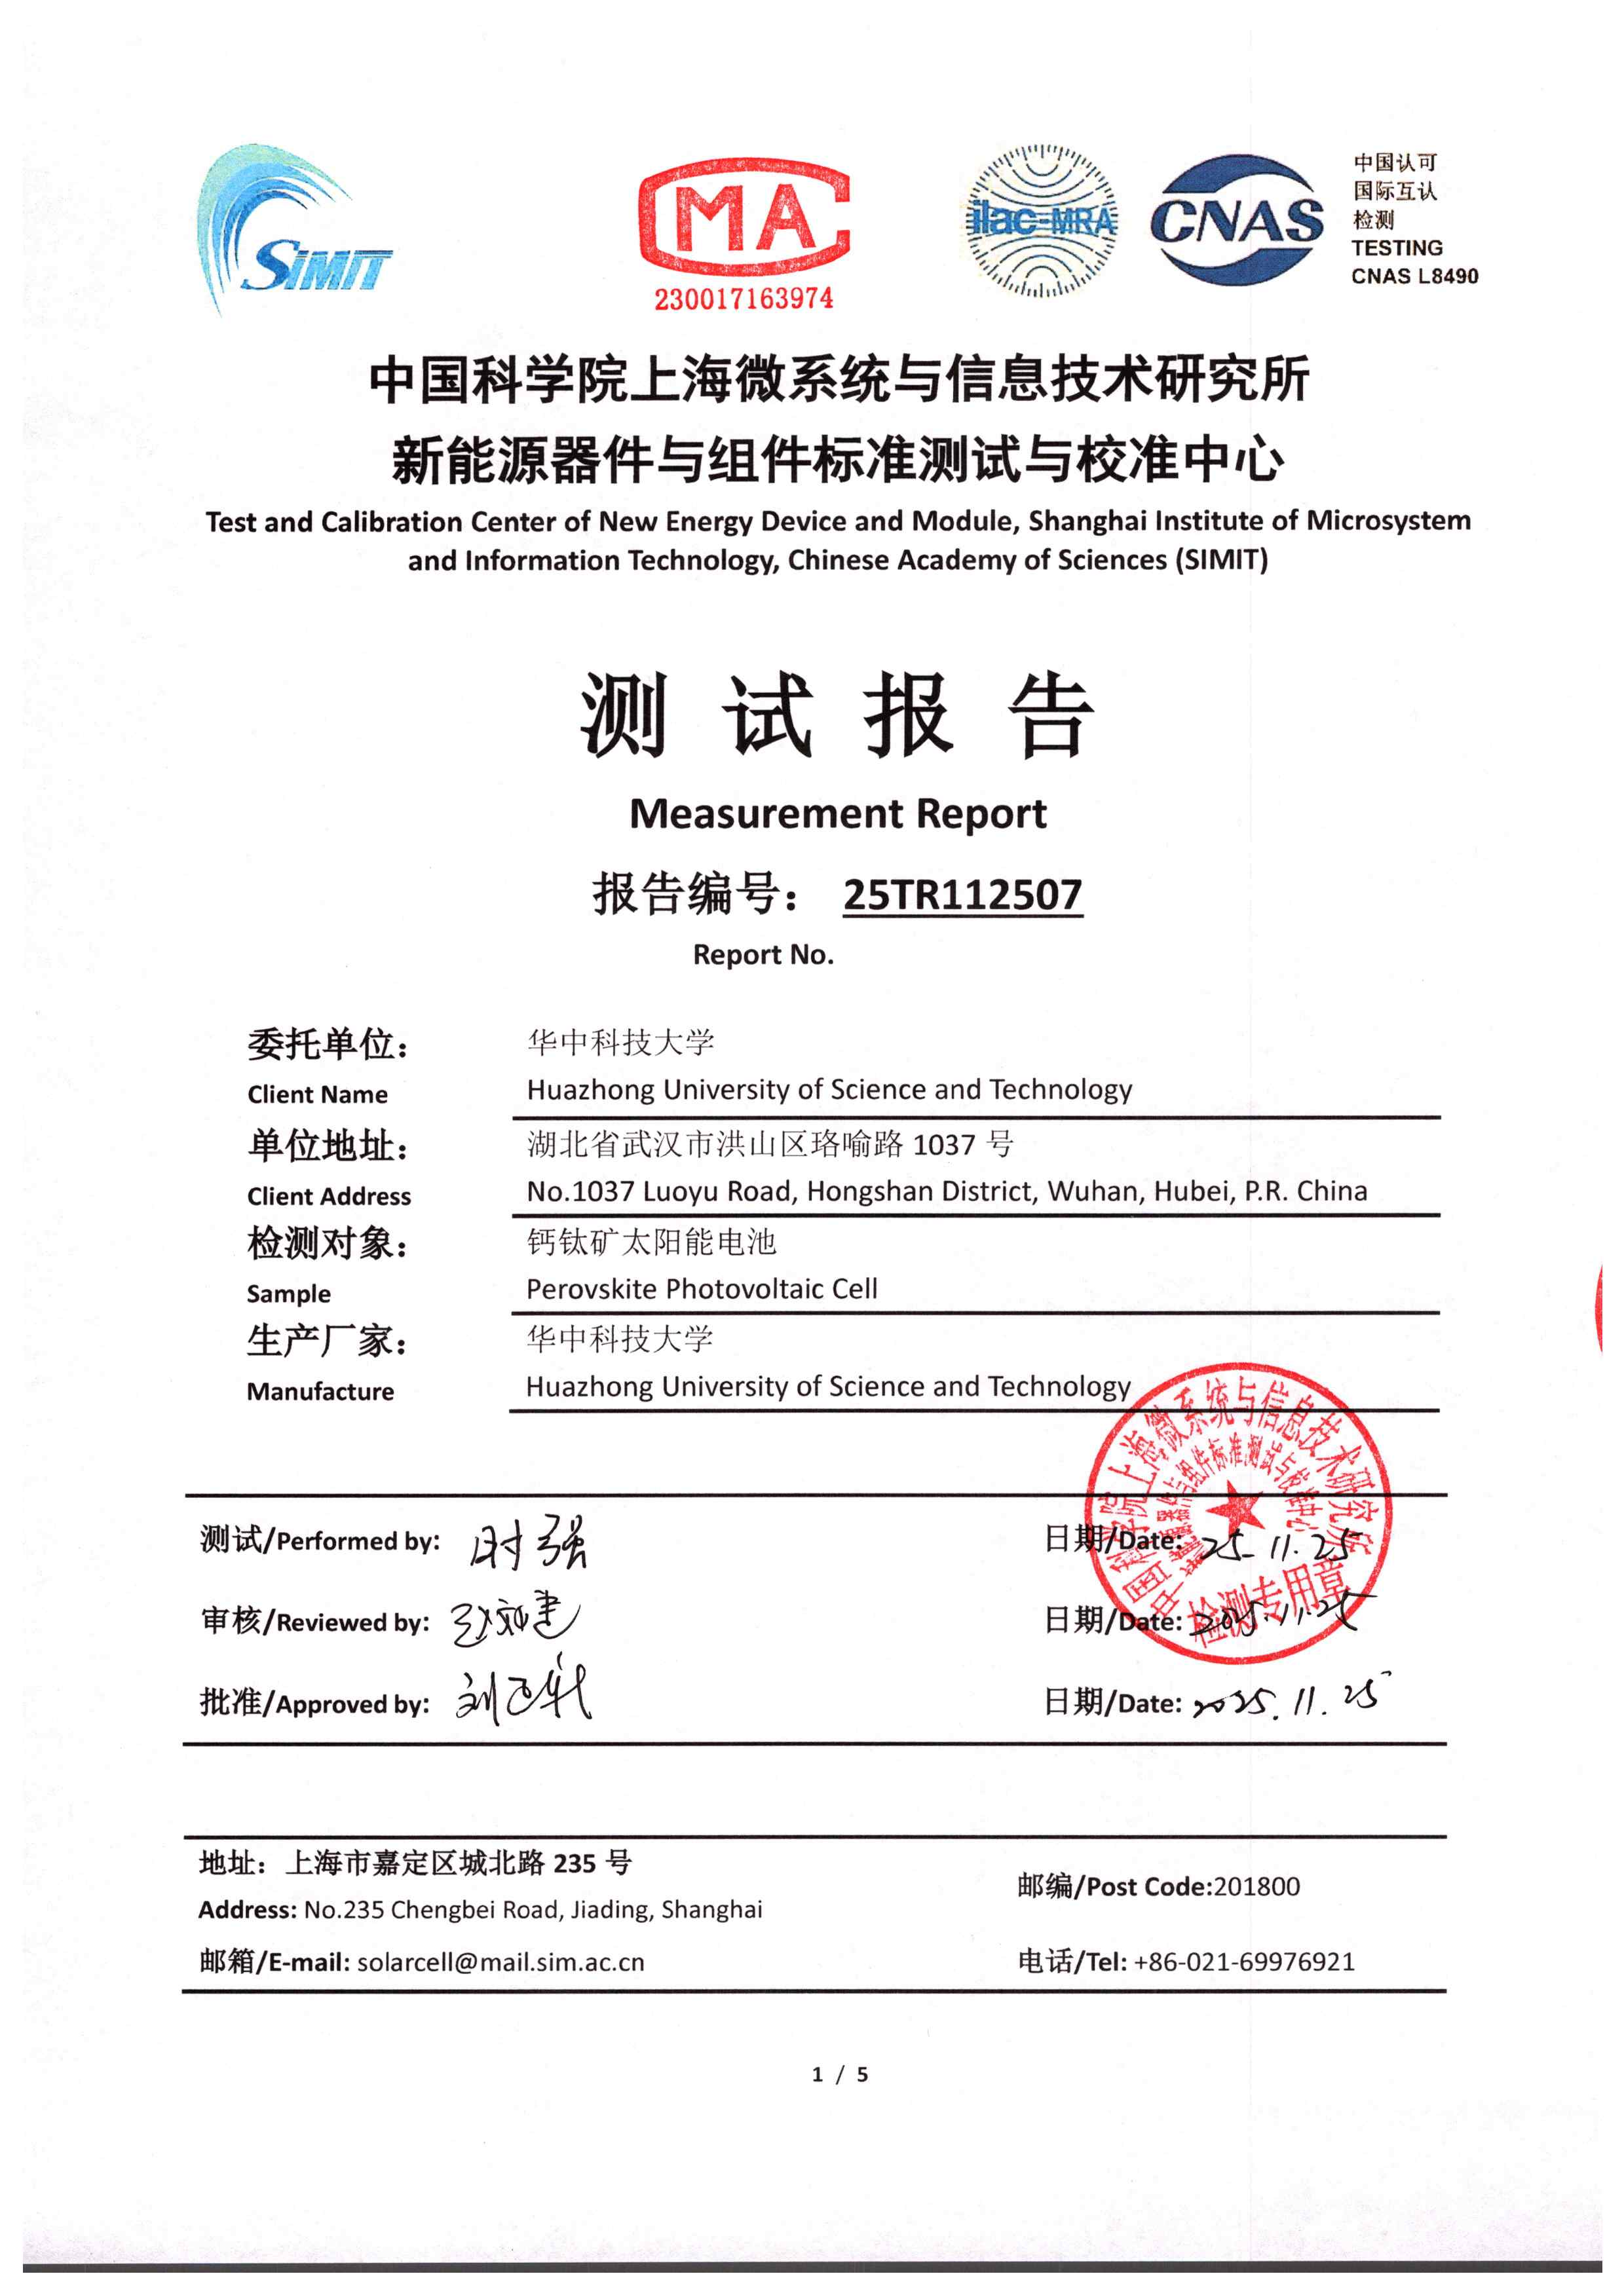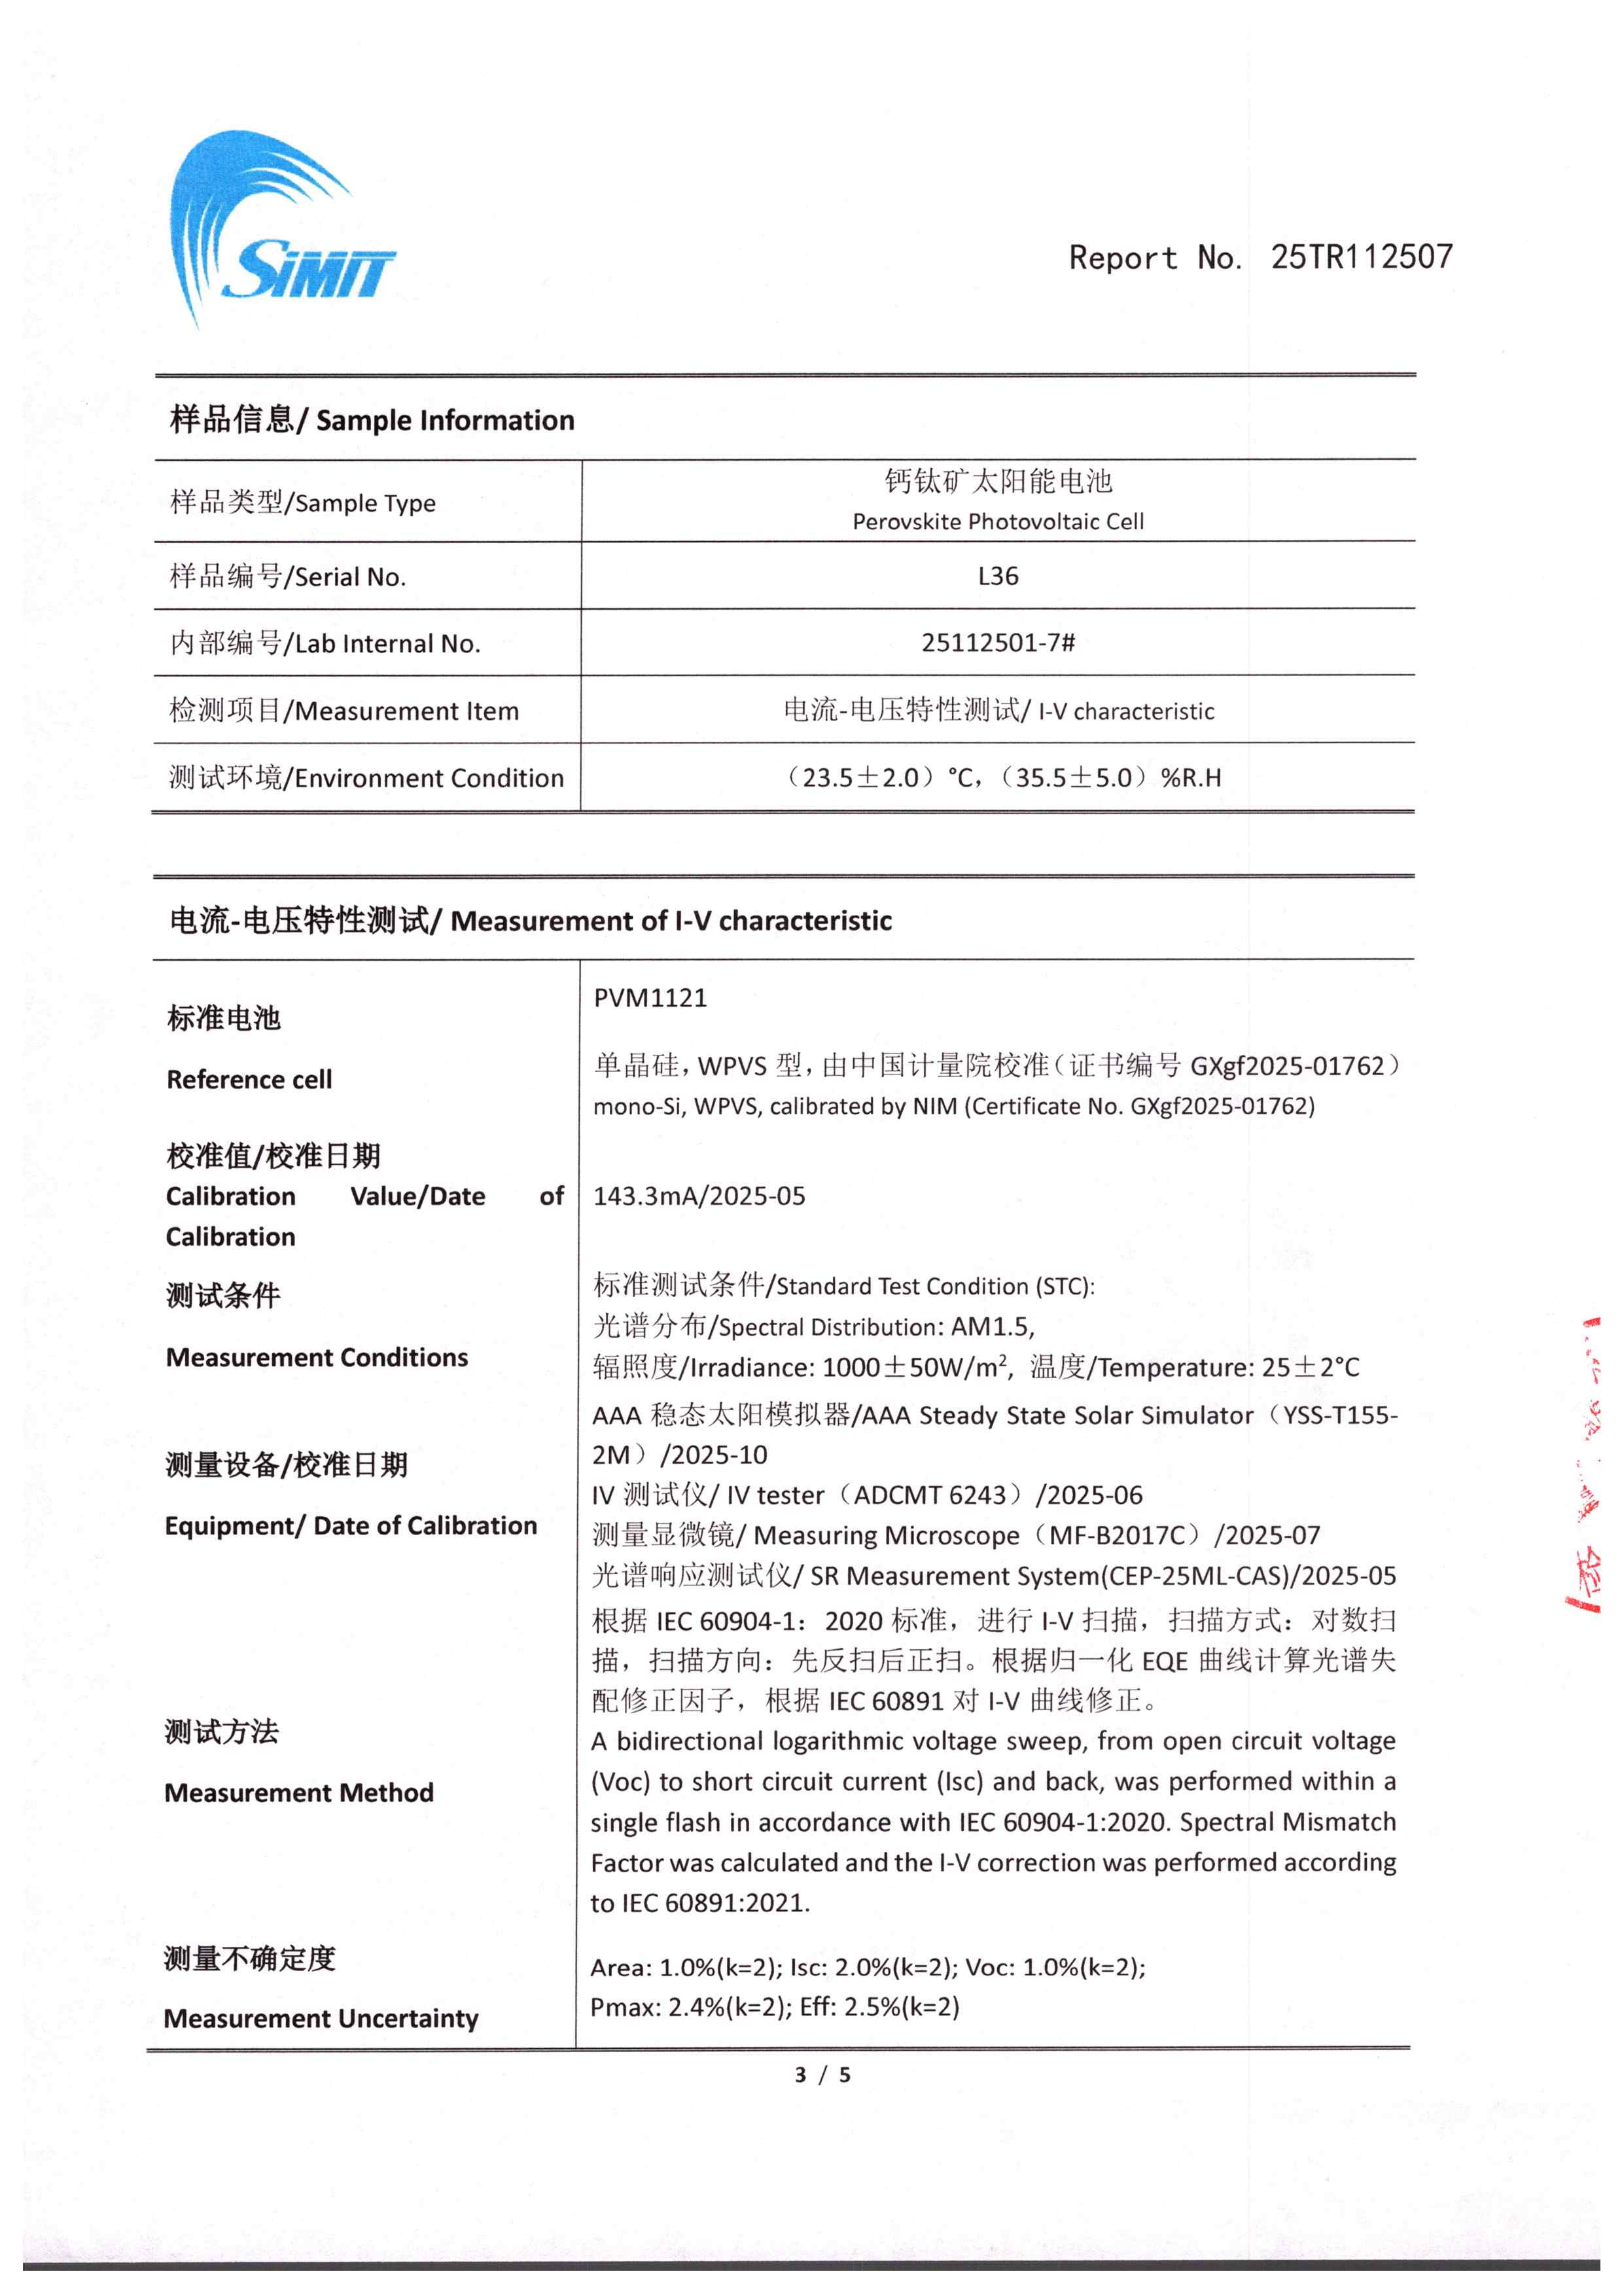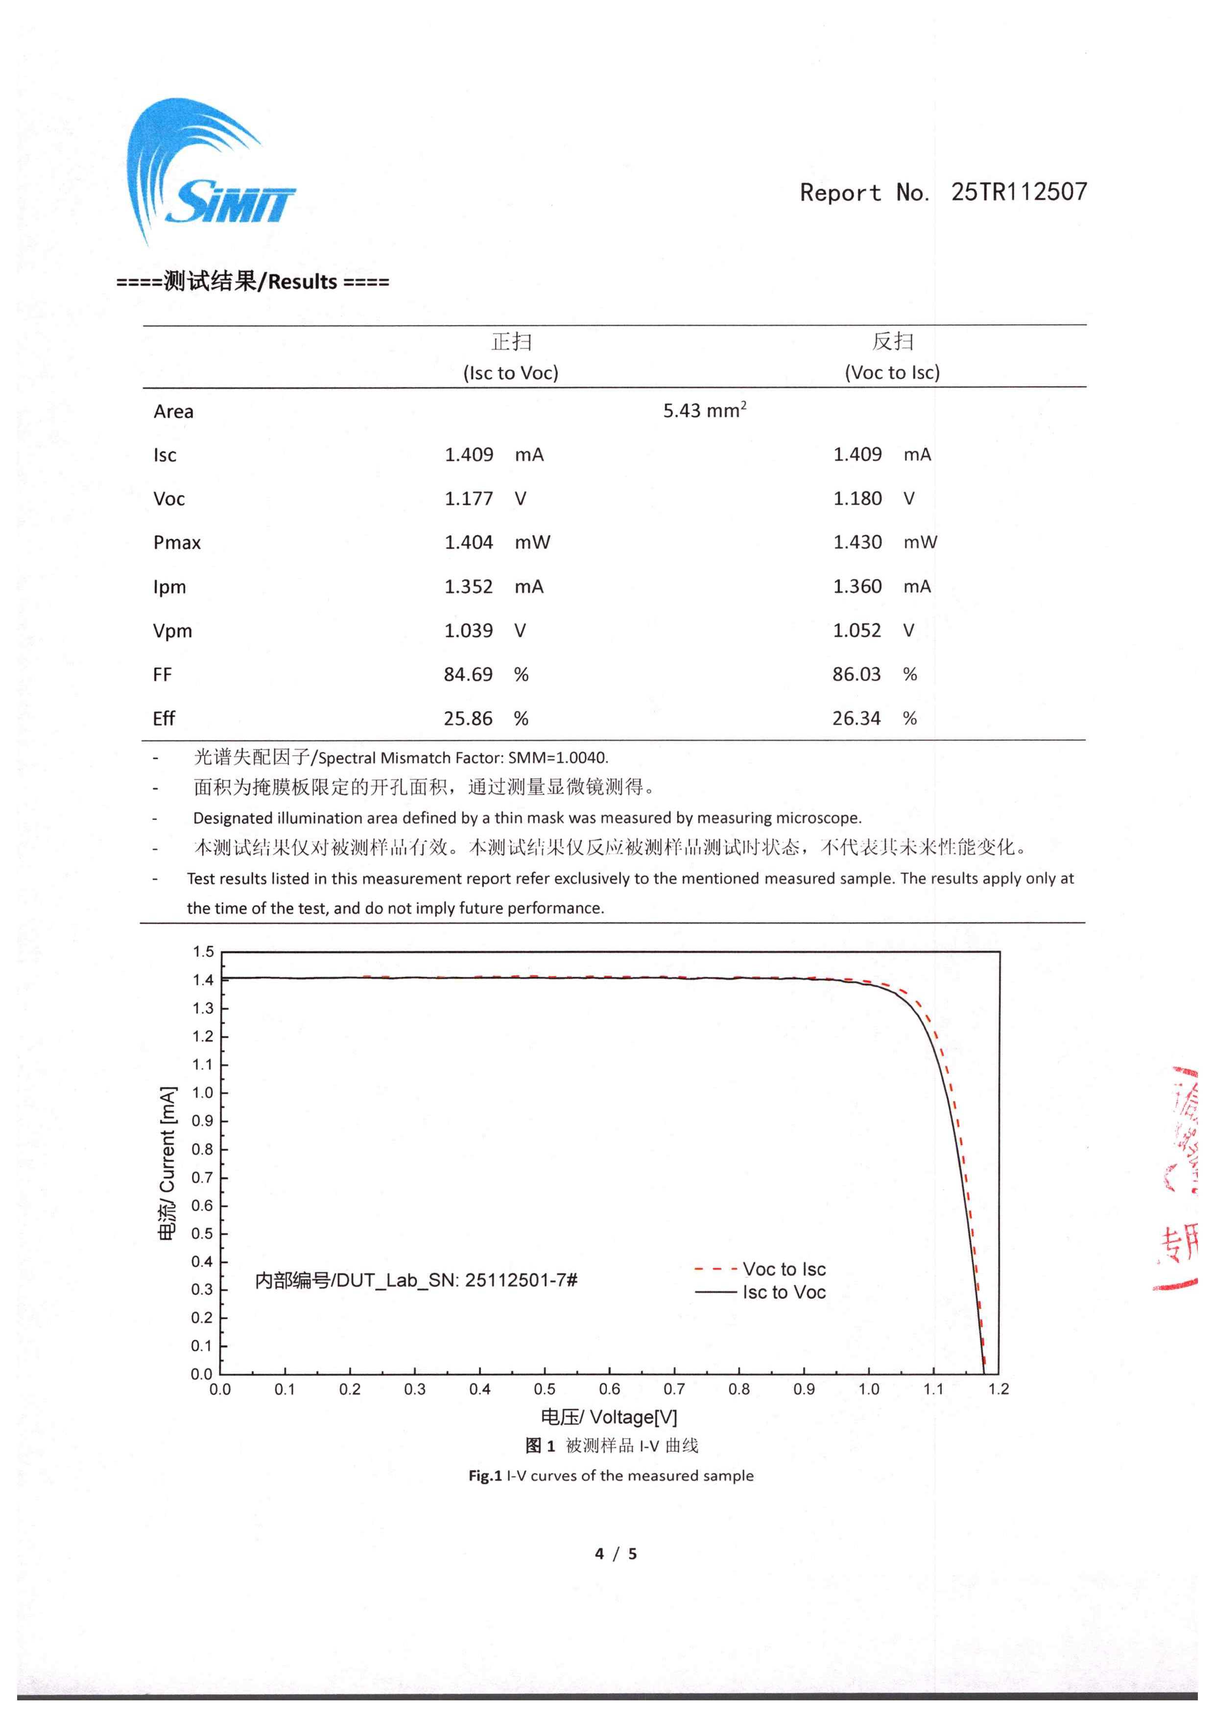
Supplementary Fig. 46 ∣ Certification results of a representative single-junction n-i-p PSC measured by Shanghai Institute of Microsystem and Information Technology.

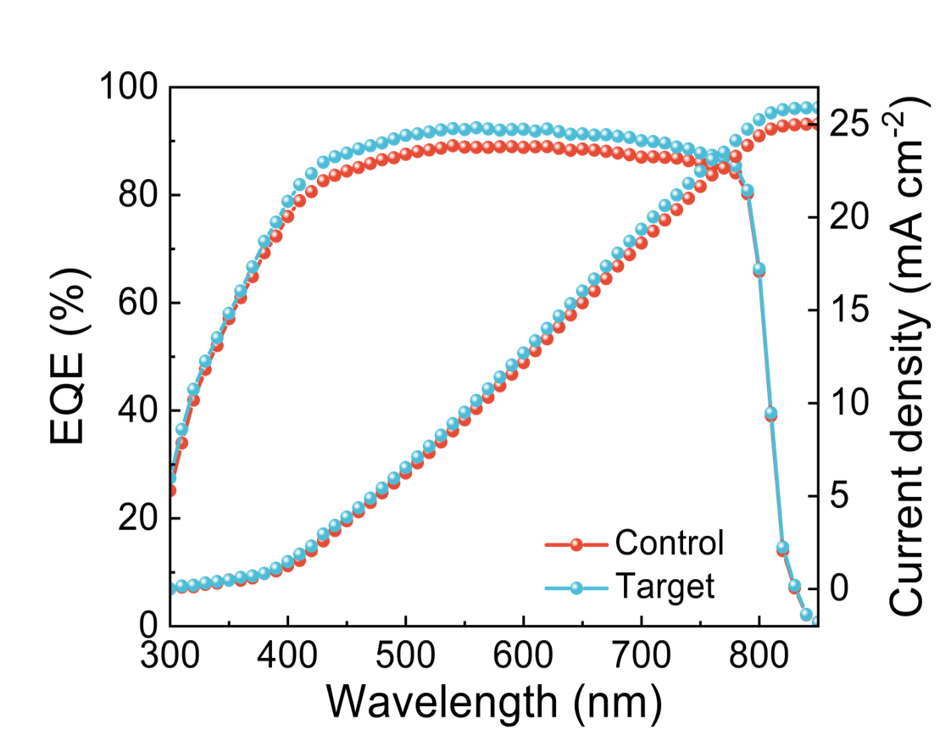
Supplementary Fig. 47 ∣ EQE spectra of the control and target devices.
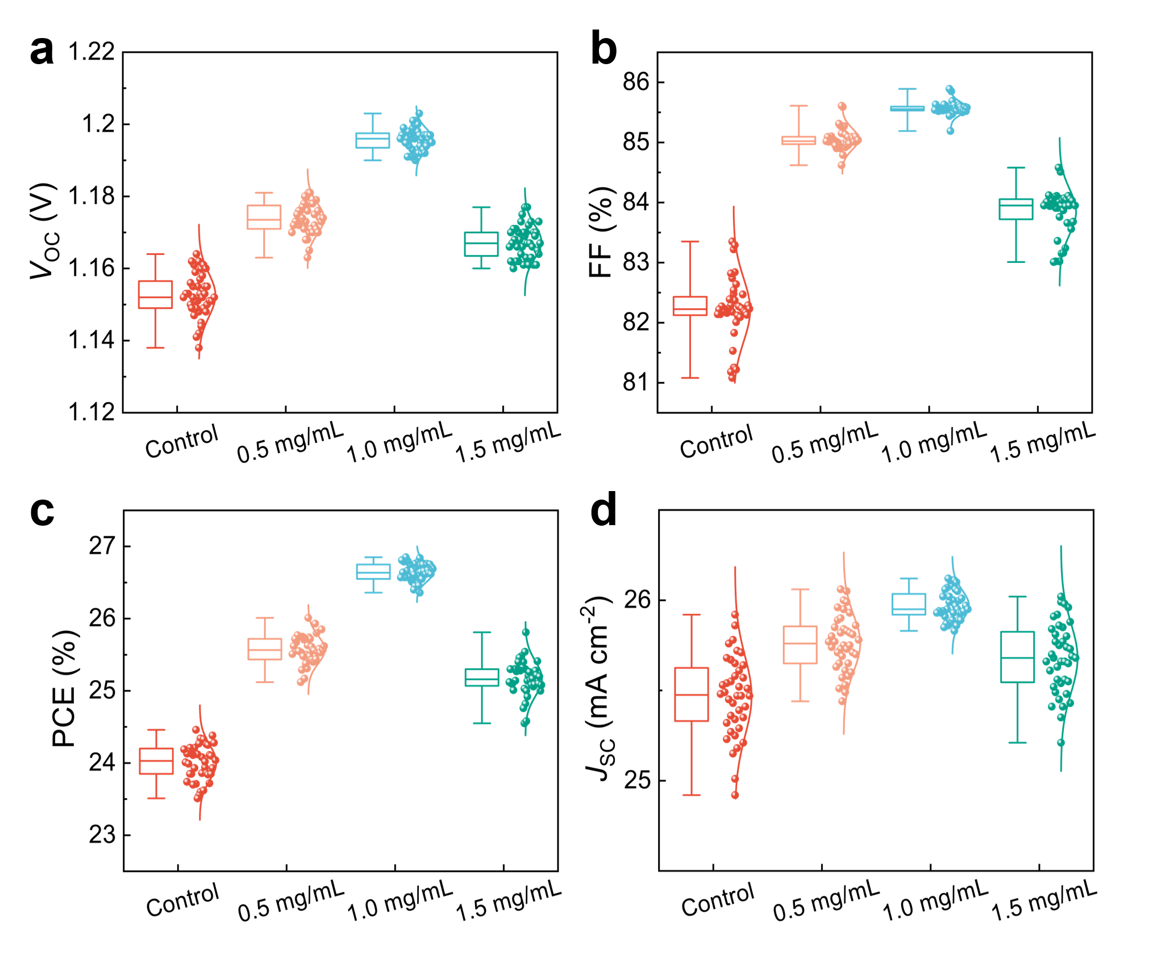
Supplementary Fig. 48 ∣ (a) V_{OC}, (b) FF, (C) PCE and (d) J_{SC} statistics distribution of PSCs, there were 40 devices for the statistics.
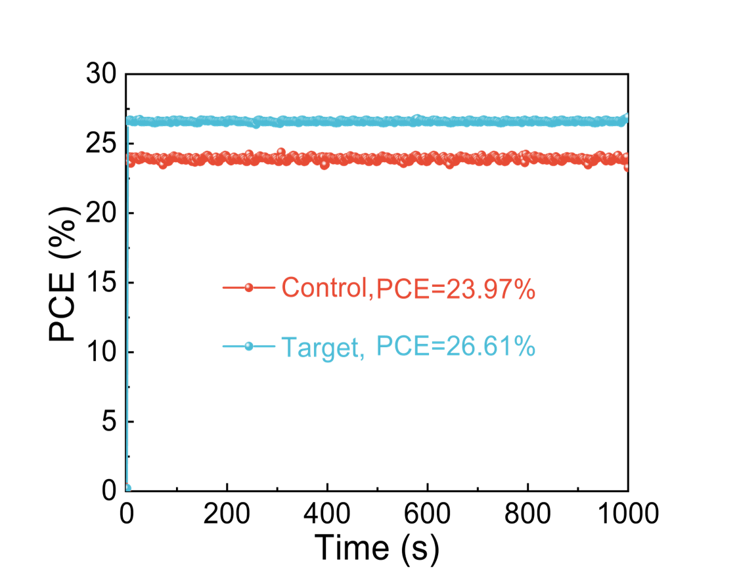
Supplementary Fig. 49 ∣ Stabilized power output of the control and target devices.
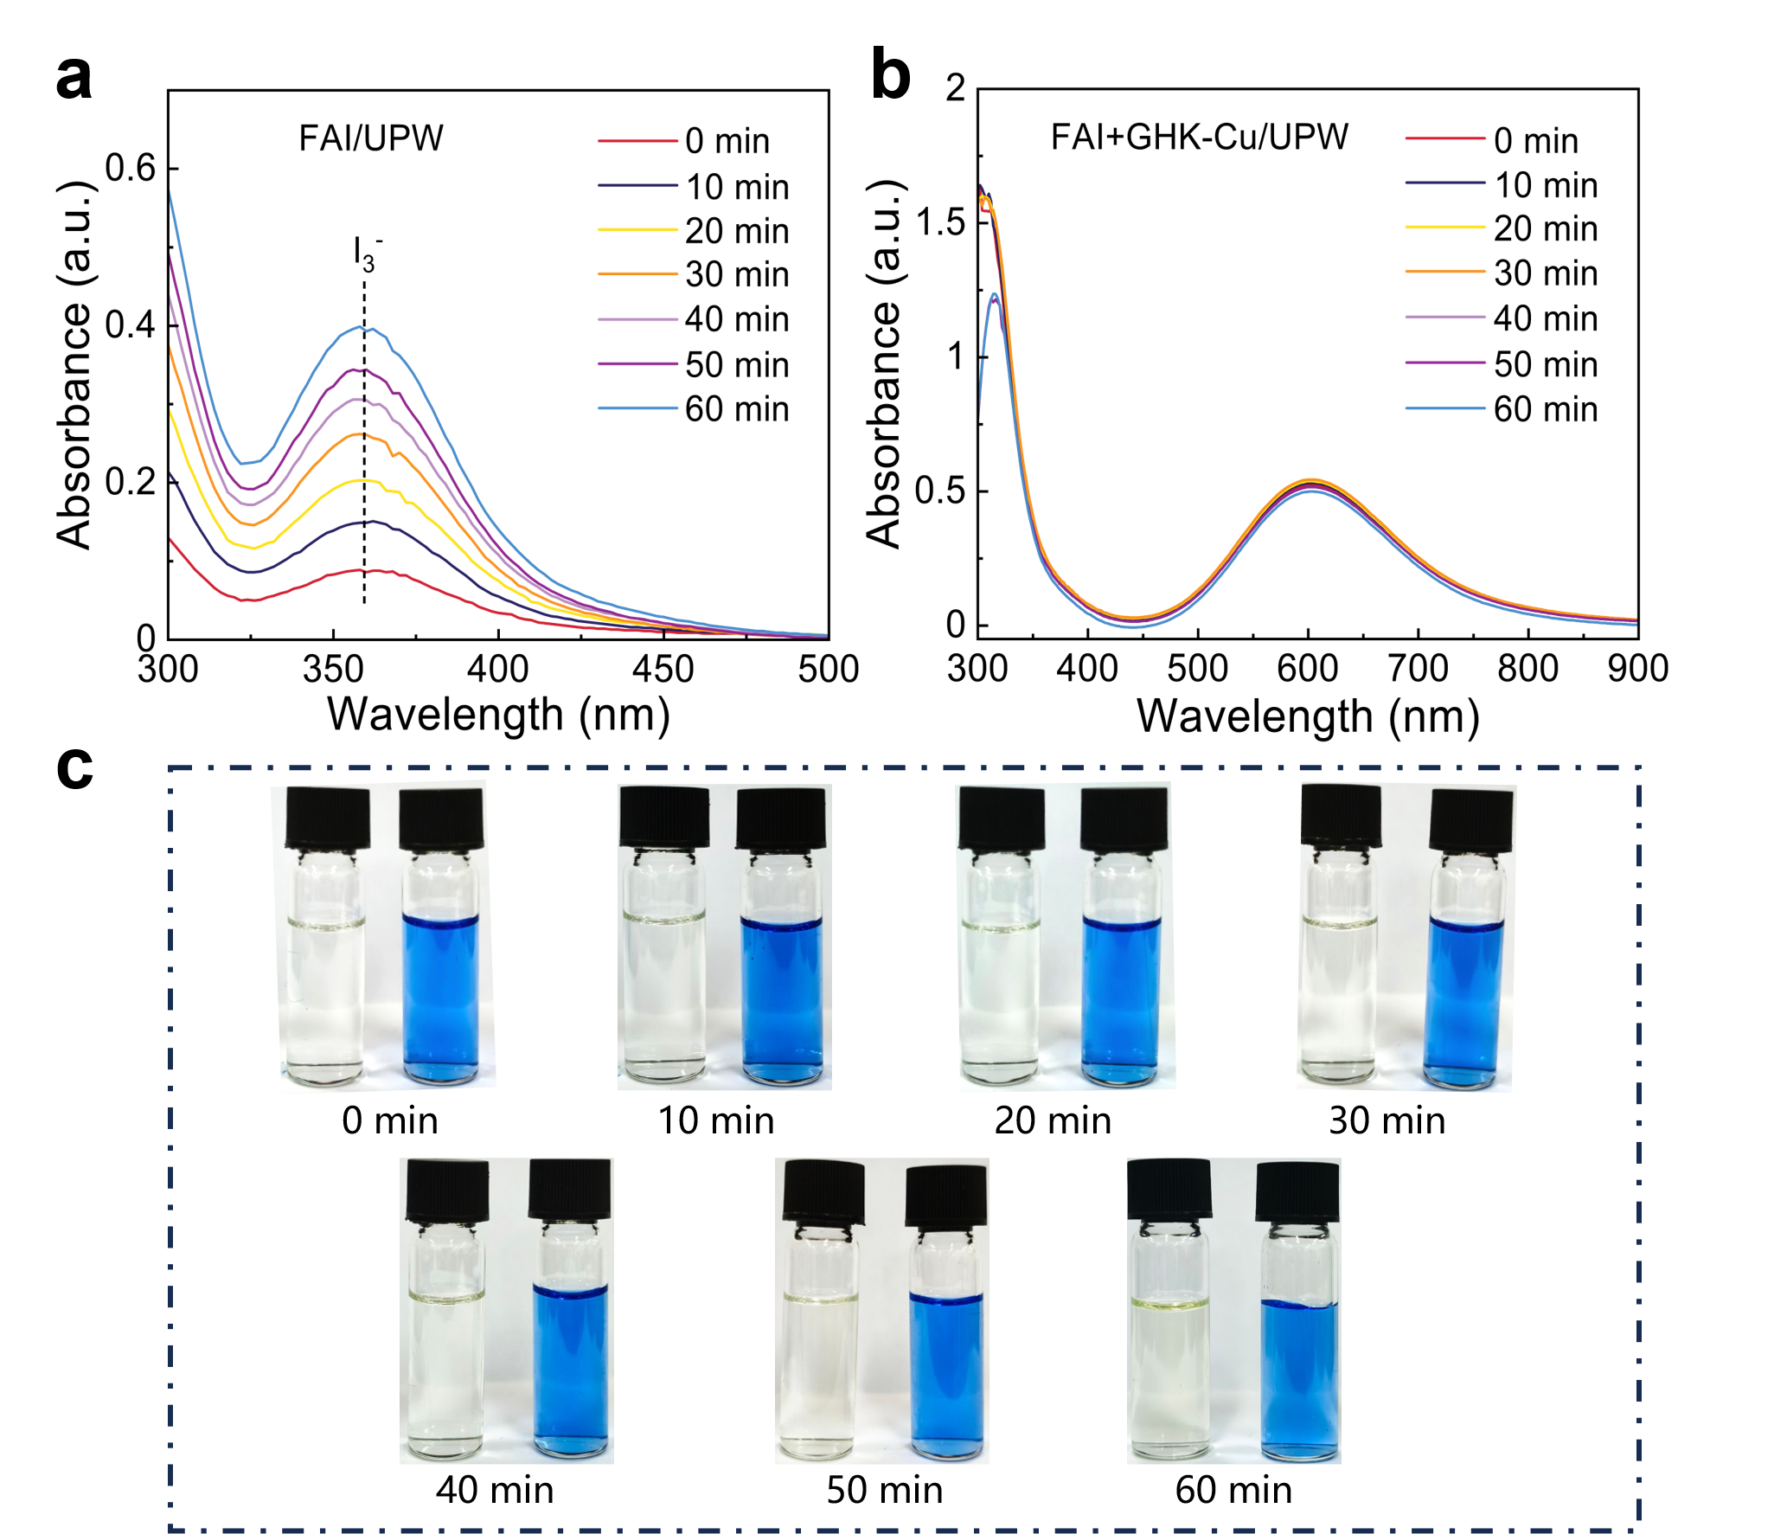
Supplementary Fig. 50 ∣ (a), (b) UV-vis absorption spectra of FAI/UPW and FAI+GHK-Cu/UPW solutions under 150 W wLED illumination for 60 min. (c) The process record images. With increasing illumination time, the absorption peak at 360 nm corresponding to I₃⁻ progressively intensified with distinct color change in pure FAI solution¹³. In contrast, the incorporation of GHK-Cu completely eliminated this degradation-related feature. It indicated that GHK-Cu could prevent phase segregation in the perovskite^{14,15}.
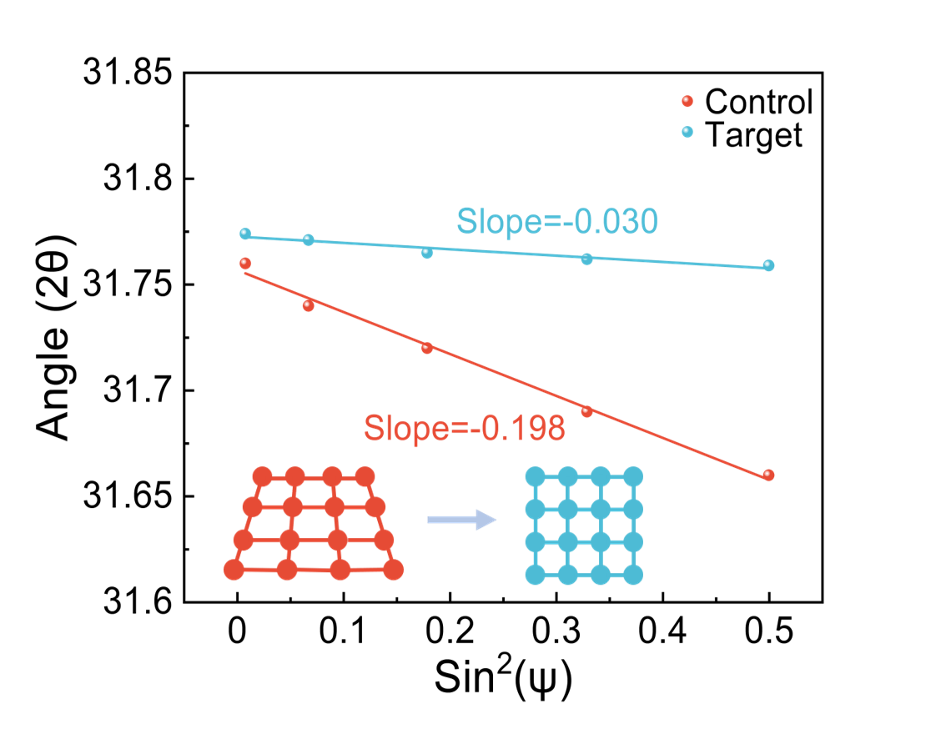
Supplementary Fig. 51 ∣ The linear fitting of 2θ-sin²ψ for the control and target films after 200 thermal cycles.

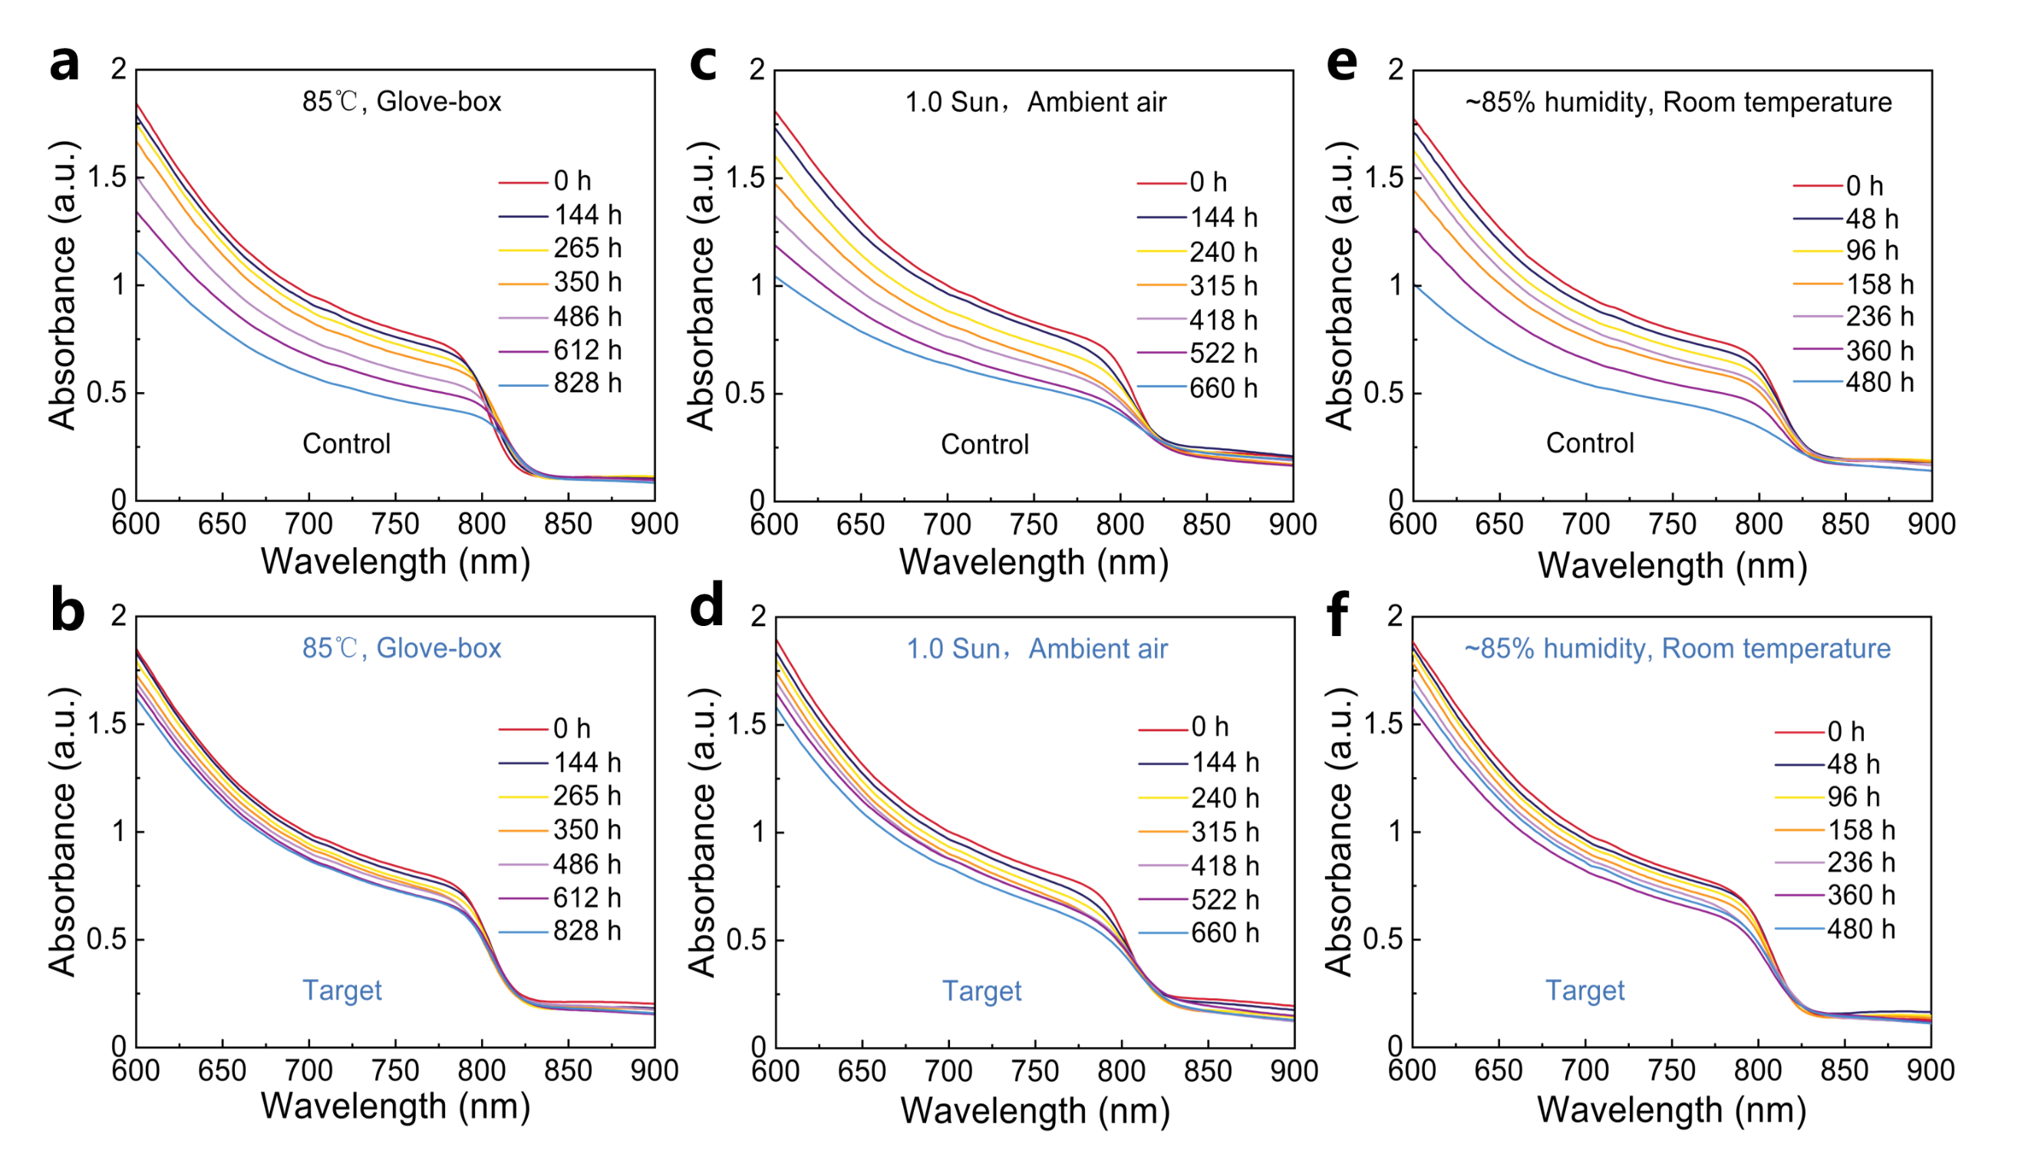
Supplementary Fig. 52 ∣ UV-vis absorption spectra of the control (a, c, e) and target (b, d, f) films under different harsh conditions.
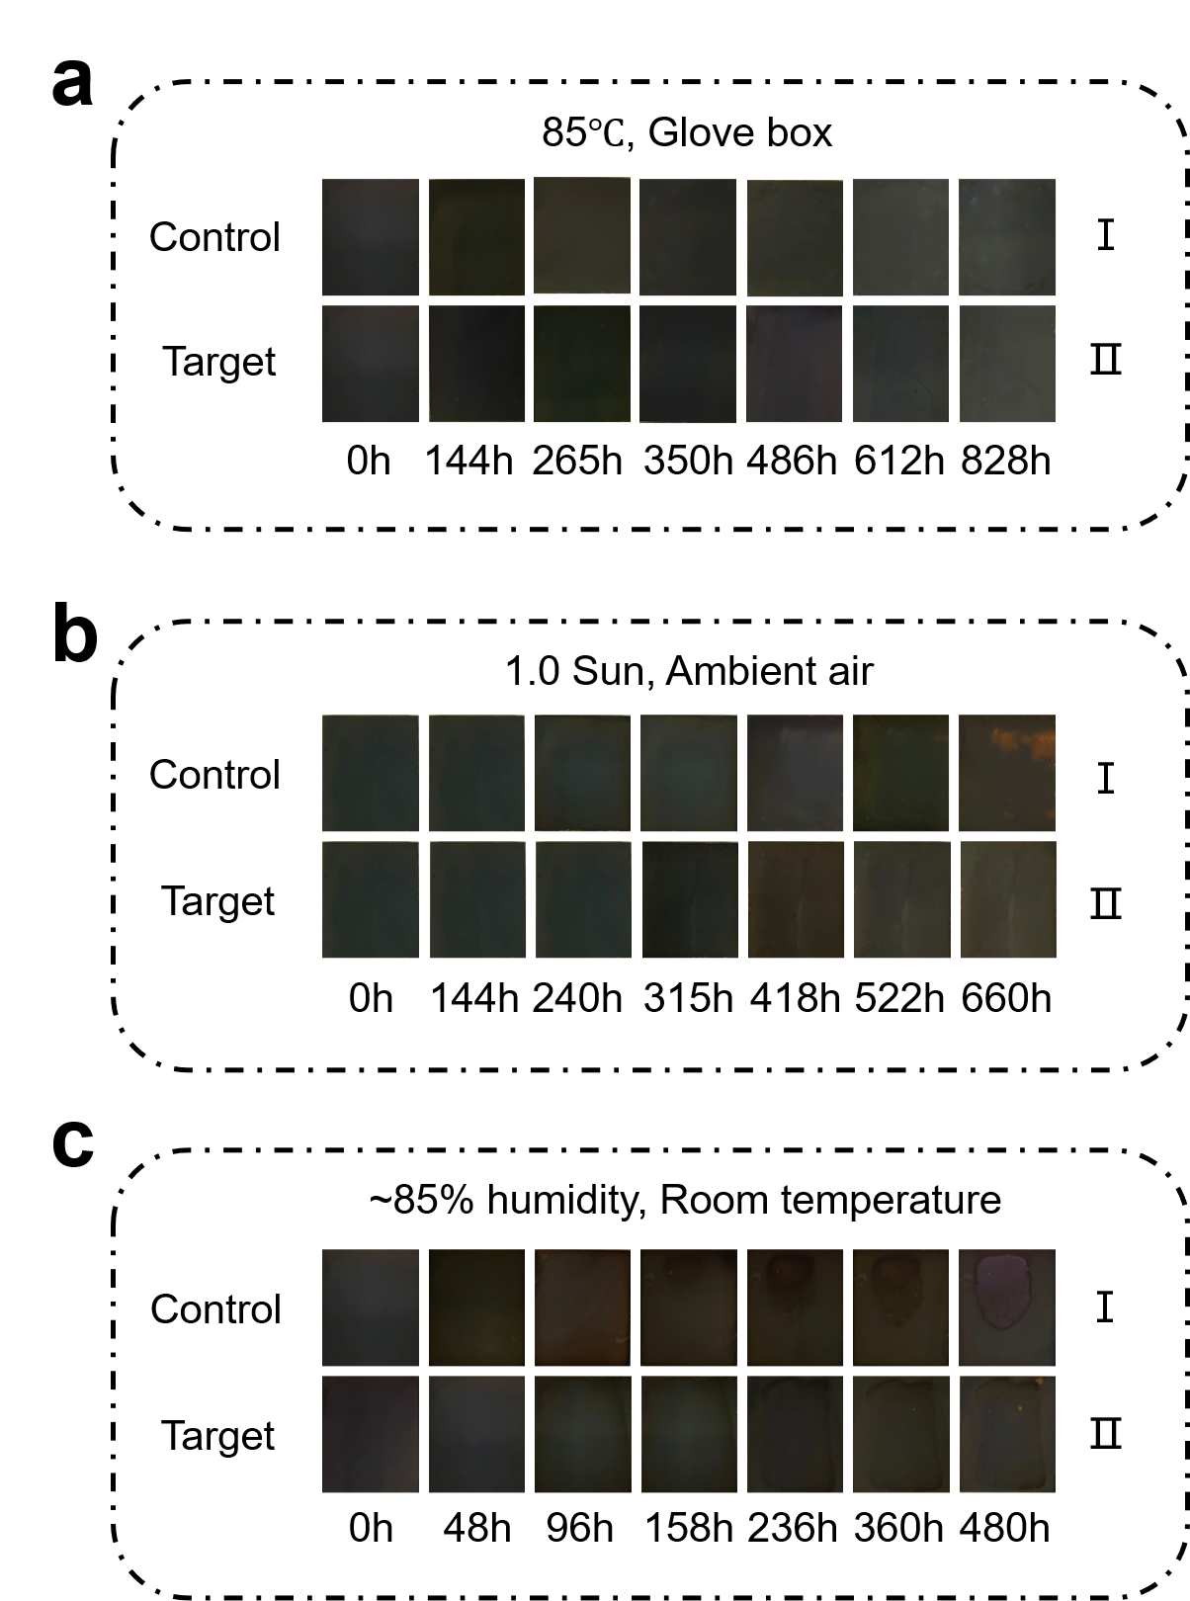
Supplementary Fig. 53 ∣ Degradation photographs of the perovskite films exposed in the different conditions: (a) annealed at 85°C in a glovebox, (b) illumination under a 150 W wLED with 1.0 sun in ambient air and (c) humidity of 85% at room temperature, respectively.
Supplementary Table 1. Tabular form of Raman of GHK-Cu powder.
Peaks (cm⁻¹) | Description
236 | Gly, γ(HNCH) ¹⁶
340 | δ(CCN) ¹⁶
428 | δ(CCN) ¹⁶
560 | γCOOH(carboxyl) ¹⁶
645 | δCCO(carboxyl) ¹⁶
706 | γCCOH(carboxyl) ¹⁶
1271 | -NH₂ twist vibration ¹⁷
1334 | ring breathing mode of GHK-Cu ¹⁷
1404 | Lys, δ(CCH)wagg ¹⁶
1438 | ν(C-N) ¹⁷
1587 | ν(C4=C5) ¹⁷
1667 | Gly, ν(C=O) ¹⁶
2926 | His, ν(CH) ¹⁶
Abbreviations: Gly-Glycine, Lys-Lysine, His-Histidine, γ-out of plane bending, δ-bending, ν- stretching, wagg-wagging vibration.
Supplementary Table 2. Tabular form of FTIR of GHK-Cu powder.
Peaks (cm⁻¹) | Description
624 | γCNCC(ring) ¹⁶
652 | δCCO(carboxyl) ¹⁶
686 | the torsion of the His ring ¹⁶
744 | Lys, δ(CCH) ¹⁶
777 | γCNCH(ring) ¹⁶
827 | γCNCH(ring) ¹⁶
900 | Gly, δ(NCH) ¹⁶
940 | δNCN(ring) ¹⁶
1048 | Lys, ν(CN) ¹⁶
1090 | His, ν(CN) ¹⁶
1161 | His, ν(CN), δ(CH) ¹⁸
1199 | His, ν(CN), δ(NH) ¹⁸
1270 | His, γ(CH₂) ¹⁸
1335 | δCOH(carboxyl) ¹⁶
1410 | Gly, δ(HCH)scis ¹⁶
1439 | His⁻, δ(CH₃), ν(CN) ¹⁸
1525 | Lys, δ(HNH)scis ¹⁶
1575 | His, ν(C=C) ¹⁹
1626 | Lys, δ_{as}(NH³⁺) ¹⁹
3446 | ─N-H ²⁰
Abbreviations: Gly-Glycine, Lys-Lysine, His-Histidine, γ-out of plane bending, δ-bending, ν- stretching, scis-scissoring vibration.
Supplementary Table 3. FWHM of (100) and (200), strain of the control and target films.
Sample | (100) | (200) | Strain (×10⁻⁴)
Control | 0.293° | 0.291° | 12.11
Target | 0.109° | 0.128° | 4.84

Supplementary Table 4. TRPL fitted decay times of the control and target films.
Sample | A₁ | A₂ | τ₁ (ns) | τ₂ (ns) | τ_{ave} (ns)
Control | 223.45 | 715.02 | 149.82 | 835.48 | 799.09
Target | 152.96 | 677.41 | 17.43 | 187.84 | 184.34

Supplementary Table 5. Fitting parameters of the TPC of the control and target devices.
Sample | A₁ | A₂ | τ₁ (μs) | τ₂ (μs) | τ_{ave} (μs)
Control | 0.65 | 0.60 | 1.27 | 1.27 | 1.29
Target | 0.72 | 0.67 | 0.62 | 0.62 | 0.62

Supplementary Table 6. Fitting parameters of the TPV of the control and target devices.
Sample | A₁ | A₂ | τ₁ (μs) | τ₂ (μs) | τ_{ave} (μs)
Control | 0.76 | 0.34 | 16.19 | 47.67 | 34.08
Target | 0.29 | 0.70 | 52.90 | 150.64 | 138.23

Supplementary Table 7. J-V parameters summary of PSCs without/with GHK-Cu treatment with different concentrations.
Device | Direction | V_{OC} | J_{SC} | FF | PCE
Device | Direction | (V) | (mA*cm⁻²) | (%) | (%)
Control Device | Reverse Scan | 1.155 | 25.54 | 81.90 | 24.16
Control Device | Forward Scan | 1.150 | 25.50 | 80.29 | 23.53
0.5 mg/mL GHK-Cu | Reverse Scan | 1.176 | 25.80 | 85.57 | 25.95
0.5 mg/mL GHK-Cu | Forward Scan | 1.173 | 25.81 | 84.63 | 25.63
1.0 mg/mL GHK-Cu | Reverse Scan | 1.198 | 25.97 | 85.88 | 26.72
1.0 mg/mL GHK-Cu | Forward Scan | 1.193 | 25.85 | 85.22 | 26.28
1.5 mg/mL GHK-Cu | Reverse Scan | 1.162 | 25.72 | 84.12 | 25.15
1.5 mg/mL GHK-Cu | Forward Scan | 1.161 | 25.70 | 83.56 | 24.92

Reference
1. Mao, K. et al. Passivated porous light-management structure resolves emission-photovoltaic trade-off in thick perovskite diodes. Joule 10, 102389 (2026).
2. Xu, C. et al. Molecular ferroelectric self-assembled interlayer for efficient perovskite solar cells. Nat. Commun. 16, 835 (2025).
3. Du, S. et al. Inhibiting perovskite decomposition by a creeper-inspired strategy enables efficient and stable perovskite solar cells. Nat. Commun. 15, 5223 (2024).
4. Deng, L. et al. Converting residual unstable PbI₂ into robust 2D perovskite via spacer cation engineering toward operationally stable perovskite solar cells. Angew. Chem. Int. Ed. 64, e202516433 (2025).
5. Johan, MR. et al. Synthesis and characterization of copper (I) iodide nanoparticles via chemical route. Int. J. Electrochem. Sci. 7, 4942-4950 (2012).
6. Du, S. et al. Bottom directional deposition perovskite heterojunctions for efficient and stable lead halide perovskite/silicon tandem solar cells. Energy Environ. Sci. 18, 8827-8837 (2025).
7. Wu, R. et al. Eco-friendly small molecule with polyhydroxyl ketone as buried interface chelator for enhanced carrier dynamics toward high-performance perovskite solar cells. Sci. China Mater. 68, 1249-1258 (2025).
8. Wang, Z. et al. Copper‐poor copper sulfide enables high‐efficiency and stable perovskite solar cells via interface modification. Adv. Funct. Mater. 35, 2415709 (2025).
9. Zhao, Y. et al. Interface parallel dipole regulation in all-perovskite tandem solar cells. Energy Environ. Sci. 18, 8527-8536 (2025).
10. Sepalage, GA. et al. Copper(I) iodide as hole‐conductor in planar perovskite solar cells: probing the origin of J–V hysteresis. Adv. Funct. Mater. 25, 5650-5661 (2015).
11. Sun, H. et al. A novel conductive mesoporous layer with a dynamic two‐step deposition strategy boosts efficiency of perovskite solar cells to 20%. Adv. Mater. 30, 1801935 (2018).
12. Zheng, J. et al. Selective crystallization delay in wide‐bandgap perovskites enables initial homogeneous phase for square centimeter perovskite/organic tandem solar cells. Adv. Mater. 37, e10437 (2025).
13. Fei, C. et al. Limiting phosphonic acid interlayer–perovskite reactivity to stabilize perovskite solar modules. Science 391, eadz7969 (2026).
14. Gao, Y. et al. Blocking multifaceted degradation pathways via fluorinated hydrogen-bond armor for stable perovskite solar cells. Energy Environ. Sci. 19, 691-701 (2026).
15. Zhi, C. et al. Boosting efficiency and UV resistance in perovskite solar cells via sunscreen ingredient octinoxate. Adv. Funct. Mater. 34, 2403321 (2024).
16. Kokcu, Y. et al. Structural analysis, molecular dynamics and docking calculations of skin protective tripeptide and design, characterization, cytotoxicity studies of its PLGA nanoparticles. J. Mol. Struct. 1200, 127046 (2020).
17. Huang, J. et al. ZnO nanoparticles modified with biomaterial GHK-Cu as electron transport layer to fabricate highly efficient inverted polymer solar cells. Chem. Eng. J. 428, 131366 (2022).
18. Barth, AJPib, biology m. The infrared absorption of amino acid side chains. Prog. Biophys. Mol. Biol. 74, 141-173 (2000).
19. Barth, A, Zscherp C. What vibrations tell about proteins. Q. Rev. Biophys. 35, 369-430 (2003).
20. Huang, J. et al. Efficient ternary polymer solar cells with tunable crystallinity and phase separation of active layers via incorporating GHK-Cu. ACS Appl. Mater. Inter. 13, 46927-46937 (2021).

