Supporting Information

Vacancy-Clustered Molybdenum Oxide for Charge-Driven Laser Desorption/Ionization Mass Spectrometry in Serum and Spatial Metabolomics
Tao Ning^{1,6,7#}, Yushu Shi^{3,7#}, Da Xu^{2#}, Xu Liu^{4#}, Yunlong Shang^{5,7}, Pengwei Guan^{1,6,7}, Wangshu Qin^{1,6}, Chenfan Dong^{1,6}, Tiantian Chen^{1,6,7}, Yangyue Yang^{3,7}, Bina Fu^{5,7}, Junqi Niu⁴, Liang Feng^{3,7*}, Xinyu Liu^{1,6,7*}, Xianzhe Shi^{1,6,7*}, Guowang Xu^{1,6,7*}

¹ Metabolomics Subcenter of the National Genomics Data Center, Dalian Institute of Chemical Physics, Chinese Academy of Sciences, Dalian, 116023, China
² Hepatobiliary Surgery Center, Department of General Surgery, Huashan Hospital, Fudan University, Shanghai 200040, China
³ Department of Instrumentation and Analytical Chemistry, Dalian Institute of Chemical Physics, Chinese Academy of Sciences, Dalian, 116023, China
⁴ Department of Hepatology, First Hospital of Jilin University, Changchun, 130021, China
⁵ State Key Laboratory of Chemical Reaction Dynamics, Dalian Institute of Chemical Physics, Chinese Academy of Sciences, Dalian, 116023, China
⁶ Liaoning Province Key Laboratory of Metabolomics, Dalian, 116023, China
⁷ University of Chinese Academy of Sciences, Beijing, 100049, China

* Corresponding authors:
Prof. Dr. Guowang Xu, Dalian Institute of Chemical Physics, Chinese Academy of Sciences, Dalian 116023, China. E-mail: xugw@dicp.ac.cn.
Dr. Xianzhe Shi, Dalian Institute of Chemical Physics, Chinese Academy of Sciences, Dalian 116023, China. E-mail: shixianzhe@dicp.ac.cn.
Prof. Dr. Xinyu Liu, Dalian Institute of Chemical Physics, Chinese Academy of Sciences, Dalian 116023, China. E-mail: liuxy2012@dicp.ac.cn.
Prof. Dr. Liang Feng, Department of Instrumentation and Analytical Chemistry, Dalian Institute of Chemical Physics, Chinese Academy of Sciences, Dalian, 116023, China, e-mail: fengl@dicp.ac.cn.

Contents
Chemicals and Reagents 7
Statistical Analysis and Metabolites Annotation 7
Density functional theory (DFT) calculations 8
Supplementary Fig. 1. X-ray diffraction (XRD) analysis of MoO_{x} samples. 9
Supplementary Fig. 2. Raman spectra of MoO_{x}-0/2/5/10/15. 10
Supplementary Fig. 3. Digital photographs and scanning electron microscopy (SEM) images of MoO_{x}-0/2/5/10/15. 11
Supplementary Fig. 4. High-resolution transmission electron microscopy (HRTEM) and High-angle annular dark-field scanning transmission electron microscopy (HAADF-STEM) of MoO_{x}-0. 12
Supplementary Fig. 5. HRTEM and HAADF-STEM of MoO_{x}-2. 13
Supplementary Fig. 6. TEM, HRTEM and HAADF-STEM of MoO_{x}-5. 14
Supplementary Fig. 7. Electron paramagnetic resonance (EPR) analysis of MoO_{x} samples. 15
Supplementary Fig. 8. X-ray photoelectron spectroscopy (XPS) investigation of MoO_{x} samples. 16
Supplementary Fig. 9. EXAFS analysis of Mo foil, MoO₂, MoO₃, MoO_{x}-2 and MoO_{x}-5. 17
Supplementary Fig. 10. Ultraviolet-visible (UV-vis) absorption spectra of MoO_{x}-0/2/5. 18
Supplementary Fig. 11. Thermal desorption performance using 4-MeBP⁺ as a probe ion and charge desorption performance using TBA⁺ as a probe ion. 19
Supplementary Fig. 12. Comparative photothermal conversion performance of MoO_{x}-0/2/5. 20
Supplementary Fig. 13. (a) Photoluminescence (PL) and (b) time-resolved photoluminescence (TRPL) of MoO_{x}-0/2/5. 21
Supplementary Fig. 14. Transient absorption spectroscopy (TAS) of MoO_{x}-0, MoO_{x}-2 and MoO_{x}-5. 22
Supplementary Fig. 15. In situ electrochemical impedance spectroscopy (EIS) of MoO_{x}-0/2/5 before and after 355 nm irradiation. 24
Supplementary Fig. 16. Transient photocurrent response of MoO_{x}-0/2/5. 25
Supplementary Fig. 17. Surface photovoltage spectroscopy of MoO_{x}-0/2/5. 26
Supplementary Fig. 18. Kelvin probe force microscopy (KPFM) mapping of MoO_{x}-0 and MoO_{x}-5 under dark and illumination conditions. 27
Supplementary Fig. 19. In situ XAFS of MoO_{x}-5. 28
Supplementary Fig. 20. In situ EPR of MoO_{x}-0/2/5 under laser irradiation. 29
Supplementary Fig. 21. In situ diffuse reflectance infrared Fourier transform spectroscopy (DRIFTS) of MoO_{x}-0. 30
Supplementary Fig. 22. In situ DRIFTS of MoO_{x}-2. 31
Supplementary Fig. 23. In situ DRIFTS of MoO_{x}-5. 32
Supplementary Fig. 24. In situ Raman spectra of MoO_{x}-0/2/5. 33
Supplementary Fig. 25. Fs TAS of MoO_{x}-5 and in situ fs TAS of the tryptophan-adsorbed MoO_{x}-5 sample. 34
Supplementary Fig. 26. Free-energy profiles for proton-coupled desorption of [Arg+H]⁺ on MoO₃, MoO_{x}-0, MoO_{x}-2, and MoO_{x}-5, as calculated by density functional theory. 35
Supplementary Fig. 27. Differential charge density and density of states (DOS) for MoO_{x}-5 substrate upon interaction with arginine (Arg). 36
Supplementary Fig. 28. Reproducibility and deposition uniformity of DHB, CHCA, SA, TiO₂ and MoO_{x}-5. 37
Supplementary Fig. 29. Structural stability of MoO_{x}-5 under laser irradiation. 38
Supplementary Fig. 30. Dispersion stability of MoO_{x} in aqueous solution over 24 hours. 39
Supplementary Fig. 31. Comparison background interference among DHB, CHCA and MoO_{x} in mouse brain analysis. 40
Supplementary Fig. 32. (a) Ion images and (b) corresponding intensity signals of representative metabolites with different solvents for matrix spraying. 41
Supplementary Fig. 33. (a) Ion images and (b) corresponding intensity signals of representative metabolites with different ratio solvents for matrix spraying. 41
Supplementary Fig. 34. (a) Ion images and (b) corresponding intensity signals of representative metabolites of the sample stability after 0-36 h. 42
Supplementary Fig. 35. Study workflow of integrated serum and spatial metabolomics for HCC. 43
Supplementary Fig. 36. Discovery (a) and validation (b) cohort information of serum clinical samples. 44
Supplementary Fig. 37. High-throughput fluid chip of serum cohort for metabolic analysis. 44
Supplementary Fig. 38. Metabolomics data assessment displayed by score plot of PCA model and QCs distribution in (a-b) discovery cohort and (c-d) validation cohort. 45
Supplementary Fig. 39. (a) Score plot and (b) permutation test PLS-DA model for LR vs NC in discovery cohort. (c) Volcano plot for LR vs NC in discovery cohort. (d) Heatmap of significantly changed metabolites with FDR-adjusted p < 0.05 for LR and NC group in discovery cohort. (e) KEGG metabolic pathways differentially regulated in LR compared to NC. Each circle was colored by the -log10(p-value). 46
Supplementary Fig. 40. (a) Score plot and (b) permutation test PLS-DA model for HCC vs NC in discovery cohort. (c) Volcano plot for HCC vs NC in discovery cohort. (d) Heatmap of significantly changed metabolites with FDR-adjusted p < 0.05 for HCC and NC group in discovery cohort. (e) KEGG metabolic pathways differentially regulated in HCC compared to NC. Each circle was colored by the -log10(p-value). 47
Supplementary Fig. 41. (a) Score plot and (b) permutation test PLS-DA model for HCC vs LR in discovery cohort. (c) Volcano plot for HCC vs LR in discovery cohort. (d) Heatmap of significantly changed metabolites with FDR-adjusted p < 0.05 for HCC and LR group in discovery cohort. (e) KEGG metabolic pathways differentially regulated in HCC compared to LR. Each circle was colored by the -log10(p-value). 48
Supplementary Fig. 42. Serum lipid-class remodeling across the discovery cohort. 49
Supplementary Fig. 43. Analysis of specific dysregulated pathways driving the pathogenesis of HCC. 50
Supplementary Fig. 44. Representative metabolites imaged by the MoO_{x}-5-assisted MALDI-MSI platform. 51
Supplementary Fig. 45. Boxplot of seven serum biomarkers across normal controls, high-risk liver disease and hepatocellular carcinoma (HCC vs NC or LR vs NC) in discovery cohort and validation cohort. 52
Supplementary Fig. 46. Comparison of AFP and AFP combined with 7-Panel biomarker for HCC vs high-risk liver disease discrimination in the discovery and validation cohorts. AFP-based analysis was restricted to the HCC vs LR comparison because AFP measurements were not available for normal controls. 53
Supplementary Fig. 47. Diagnostic performance of the 7-Panel biomarker in AFP-negative HCC. 54

Supplementary Table 1. Results of structural analysis obtained from XRD Rietveld refinement of MoO_{x}-0, MoO_{x}-2 and MoO_{x}-5. 55
Supplementary Table 2. Positron annihilation spectroscopy parameters of MoO_{x}-0, MoO_{x}-2 and MoO_{x}-5. 56
Supplementary Table 3. EXAFS parameters of MoO_{x}-0, MoO_{x}-2 and MoO_{x}-5. 57
Supplementary Table 4. Detailed information of identified metabolites from mouse brain tissue in positive ion mode. 58
Supplementary Table 5. Detailed information of seven serum biomarkers across normal controls, high-risk liver disease and hepatocellular carcinoma (HCC vs NC or LR vs NC) in discovery cohort and validation cohort. 59
Supplementary Table 6. Detailed information of seven serum biomarkers across high-risk liver disease and hepatocellular carcinoma (HCC vs LR) in discovery cohort and validation cohort. 60
References 61

Chemicals and Reagents
Ammonium molybdate tetrahydrate ((NH₄)₆Mo₇O₂₄⋅4H₂O), anhydrous ethanol and hydrochloric acid (HCl) were obtained from Shanghai Macklin Biochemical Co., Ltd (Shanghai, China). 2,5-Dihydroxybenzoic acid (DHB), sinapinic acid (SA) and α-Cyano-4-hydroxycinnamic acid (CHCA) were bought from Shanghai Macklin Biochemical Co., Ltd (Shanghai, China). Histidine, glucose, arginine and tryptophan were bought from Sigma-Aldrich. Deionized water was prepared by ultrapure water from Milli-Q system (Merck KgaA). Indium tin oxide (ITO)-coated glass plates were purchased from Beijing Yihong Guangjie Biotechnology Co., Ltd (Beijing, China). Brain tissues were obtained from healthy adult C57 mice and purchased from Servicebio Technology Co., Ltd (Wuhan, China). All chemicals were analytical grade and used without further purification.

Statistical Analysis and Metabolites Annotation
Data processing and metabolite annotation. Raw serum metabolomics data acquired from the LDI-MS platform were processed using a custom Python script for peak extraction and alignment. Stable characteristic ions were screened with thresholds of intensity greater than 10 and a detection rate exceeding 60% across all samples. To monitor analytical performance and correct for signal drift during large-scale batch acquisition, pooled quality control (QC) samples were injected at regular intervals throughout the analytical sequence. Data normalization and drift correction were performed using the Systematic Error Removal using Random Forest (SERRF) algorithm, which applies a machine learning-based approach to model and remove systematic technical variation while preserving biological variance¹. The resulting normalized data matrix was used for downstream statistical analyses. Tentative metabolite annotation was performed by matching accurate mass against the Human Metabolome Database (HMDB), LIPID MAPS and in-house database, with a mass error tolerance of less than 10 ppm.
Statistical analysis. Multivariate statistical analyses, including principal component analysis (PCA) and partial least squares-discriminant analysis (PLS-DA), were conducted in SIMCA-P software (v13.0, Umetrics). Statistical significance between group comparisons was assessed using the Wilcoxon rank-sum test. Data visualization plots, such as Venn diagrams, volcano plots, heatmaps, and ROC curves, were conducted using the R language. Metabolic pathway enrichment and topology analyses were carried out using MetaboAnalyst (https://www.metaboanalyst.ca/).

Density functional theory (DFT) calculations
All the calculations were performed using the density functional theory with the projector augmented-wave (PAW) method, as implemented in the Vienna Ab initio Simulation Package^{2, 3}. The exchange-correlation interactions were described using the Perdew-Burke-Ernzerhof (PBE) functional within the generalized gradient approximation (GGA)⁴. The long range van der Waals interactions were described using the DFT-D3 approach⁵. The plane-wave cut-off energy was set to 450 eV.
The energy criterion was set to 10⁻⁵ eV in iterative solution of the Kohn-Sham equation. A vacuum layer of 15 Å is added perpendicular to the slab to avoid artificial interaction between periodic images. The Brillouin zone integration is performed using a 2x2x1 Monkhorst-Pack k-point mesh. All the structures were relaxed until the residual forces on each atom was less than 0.03 eV/Å. The differential charge density was obtained using the VASPKIT package and visualized with VESTA^{6, 7}.

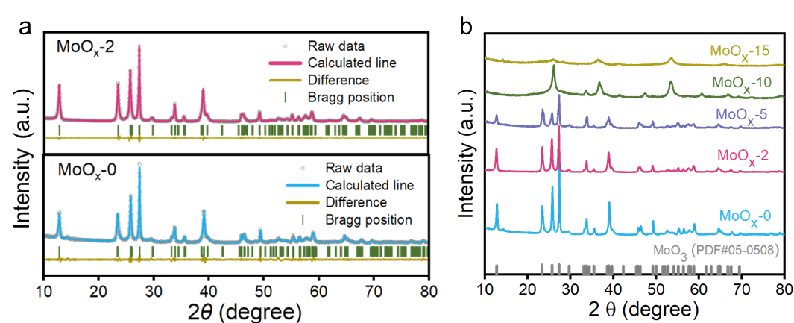

Supplementary Fig. 1. X-ray diffraction (XRD) analysis of MoO_{x} samples.
(a) Refined XRD patterns of MoO_{x}-0 and MoO_{x}-2. (b) XRD patterns of MoO_{x}-0/2/5/10/15.
Refined XRD patterns of MoO_{x}-0 and MoO_{x}-2 can be well fitted using the orthorhombic α-MoO₃ structural model, as indicated by the close agreement between the experimental and calculated profiles and the small residual difference curves. The refined values of GOF, Rₚ, and R_{wp} are within acceptable ranges, further supporting the reliability of the refinement. Across the full series, MoO_{x}-0, MoO_{x}-2, and MoO_{x}-5 retain the same overall diffraction framework, whereas more substantial changes appear only in MoO_{x}-10 and MoO_{x}-15. These data indicate that moderate reduction introduces oxygen deficiency within an α-MoO₃-derived lattice before more pronounced bulk structural reorganization occurs at higher reduction degree.

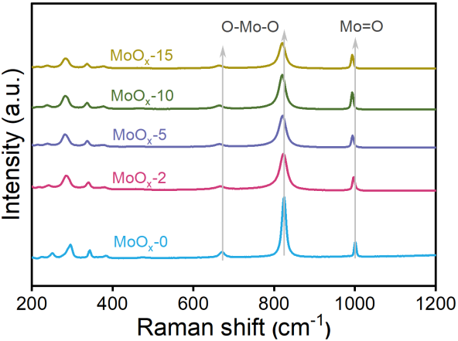

Supplementary Fig. 2. Raman spectra of MoO_{x}-0/2/5/10/15.
Raman spectra of the MoO_{x} series show progressive perturbation of the local Mo-O bonding environment during reduction. The α-MoO₃-derived O-Mo-O (~820 cm⁻¹) and terminal Mo=O (~995 cm⁻¹) modes remain observable across the series, but both bands become progressively broader and less well defined from MoO_{x}-0 to MoO_{x}-15 under identical acquisition conditions. Because absolute intensity can depend on local sampling conditions, the interpretation here is based mainly on band persistence and line-shape evolution rather than on peak height alone. These spectral changes indicate continuous distortion of both bridging-oxygen-related and terminal-oxygen-related motifs, with MoO_{x}-5 already showing substantial local coordination perturbation relative to MoO_{x}-0.
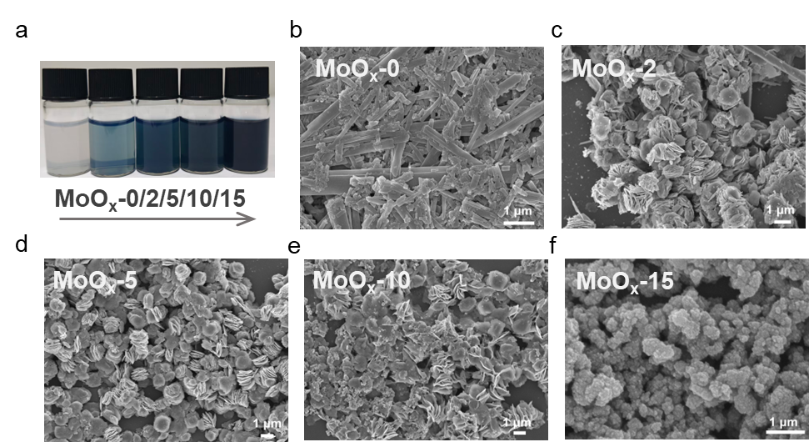

Supplementary Fig. 3. Digital photographs and scanning electron microscopy (SEM) images of MoO_{x}-0/2/5/10/15.
(a) Digital photographs of MoO_{x}-0/2/5/10/15 dispersed in aqueous solution. (b-f) Corresponding SEM images of MoO_{x}-0/2/5/10/15.
The dispersions gradually darken from MoO_{x}-0 to MoO_{x}-15, indicating continuous macroscopic changes during reduction. MoO_{x}-0 is dominated by sheet-like nanostructures, whereas SEM images show that MoO_{x}-2 and MoO_{x}-5 evolve into flower-like nanosheet assemblies. Under stronger reduction, MoO_{x}-10 becomes more strongly reconstructed and MoO_{x}-15 develops a more aggregated particulate morphology. These results indicate that defect evolution is accompanied by progressive structural reorganization rather than by simple defect accumulation alone.
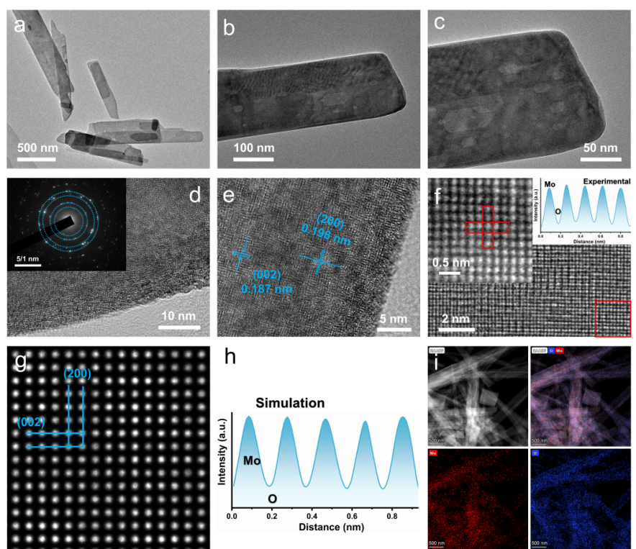

Supplementary Fig. 4. High-resolution transmission electron microscopy (HRTEM) and High-angle annular dark-field scanning transmission electron microscopy (HAADF-STEM) of MoO_{x}-0.
(a-c) Low- and intermediate-magnification TEM images of MoO_{x}-0, showing elongated sheet-like crystallites with relatively uniform contrast. (d) HRTEM images of MoO_{x}-0 and corresponding SAED pattern, indicating good crystallinity. (e) HRTEM image showing lattice fringes with interplanar spacings of 0.198 and 0.187 nm, corresponding to the (200) and (002) planes of orthorhombic α-MoO₃, respectively. (f-h) Atomic-resolution HAADF-STEM analysis of MoO_{x}-0, including the experimental image, enlarged atomic-column image, and simulated intensity profile. (i) STEM elemental maps of Mo and O in MoO_{x}-0.
HRTEM images of MoO_{x}-0 (a-e) reveal clear lattice fringes with interplanar spacings of 0.198 nm and 0.187 nm, corresponding to the (200) and (002) planes of crystalline MoO₃, confirming that the lattice structure of MoO_{x}-0 matches that of MoO₃. HAADF-STEM images of MoO_{x}-0 (f-i) further display well-ordered atomic columns without detectable lattice distortion, and the corresponding intensity profile agrees well with the MoO₃ lattice model, indicating that MoO_{x}-0 contains negligible oxygen vacancies and retains a crystal structure essentially identical to stoichiometric MoO₃. Together, these results support that MoO_{x}-0 behaves as a vacancy-lean reference with a largely preserved MoO₃-derived lattice and without obvious local distortion or defect-rich domains.
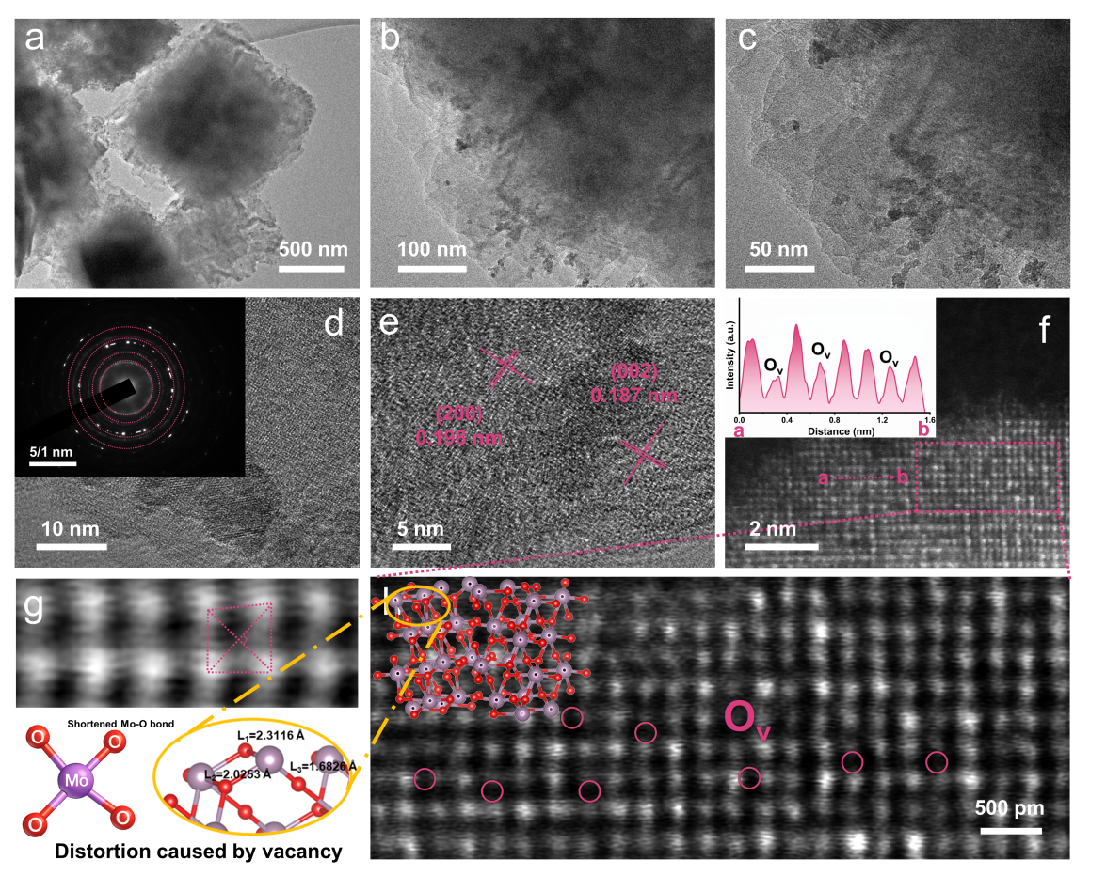

Supplementary Fig. 5. HRTEM and HAADF-STEM of MoO_{x}-2.
(a-c) Low- and intermediate-magnification TEM images of MoO_{x}-2. (d) HRTEM image of MoO_{x}-2 and corresponding SAED pattern. (e) High-resolution TEM image showing lattice fringes with interplanar spacings of 0.198 and 0.187 nm, corresponding to the (200) and (002) planes of orthorhombic alpha-MoO₃, respectively.
Compared with MoO_{x}-0, MoO_{x}-2 retains the MoO₃-derived lattice framework but shows local lattice distortions in HRTEM and HAADF-STEM images, consistent with isolated oxygen-vacancy point defects rather than extended defect clusters.
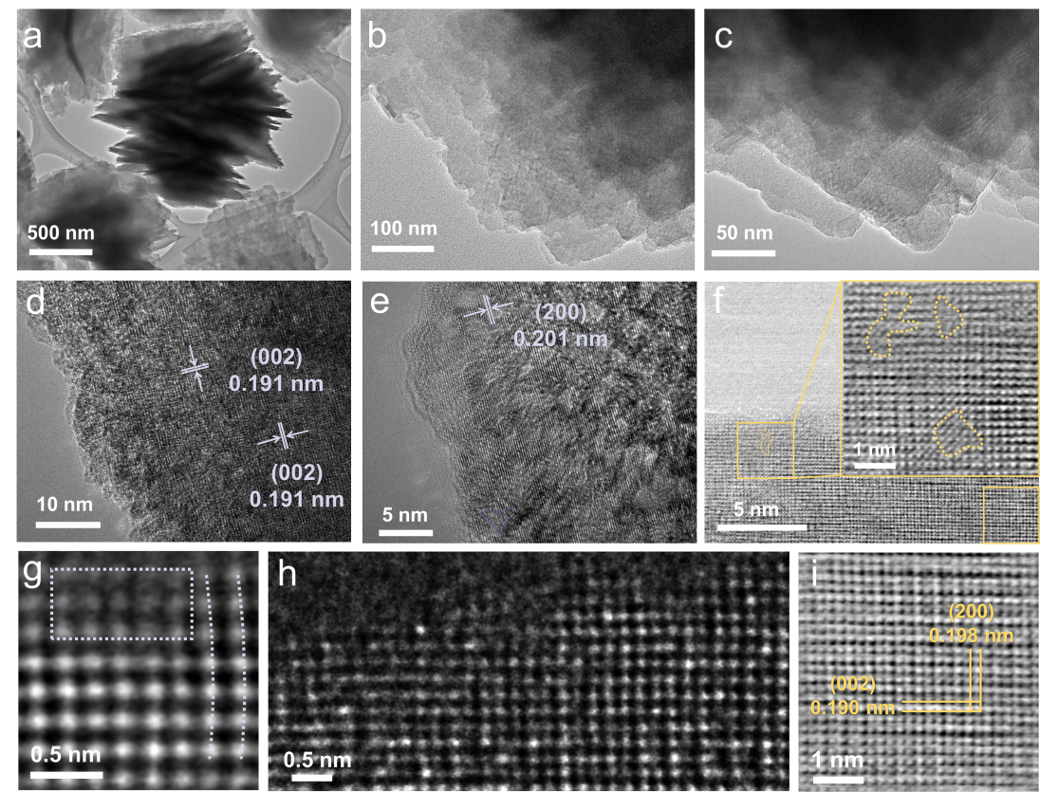

Supplementary Fig. 6. TEM, HRTEM and HAADF-STEM of MoO_{x}-5.
(a-c) TEM images of MoO_{x}-5, showing flower-like nanosheet assemblies. (d,e) HRTEM images of MoO_{x}-5, revealing lattice fringes that can still be indexed to the MoO₃-derived framework. (f-i) Atomic-resolution lattice images of MoO_{x}-5, highlighting the coexistence of ordered regions and defect-rich domains with reduced atomic periodicity.

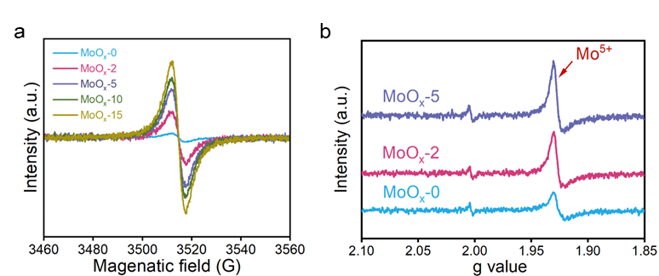

Supplementary Fig. 7. Electron paramagnetic resonance (EPR) analysis of MoO_{x} samples.
(a) EPR spectra of MoO_{x}-0/2/5/10/15, indicating the evolution of defect-related paramagnetic signals. (b) EPR spectra of MoO_{x}-0, MoO_{x}-2 and MoO_{x}-5, highlighting the Mo⁵⁺ signals related to oxygen vacancies.

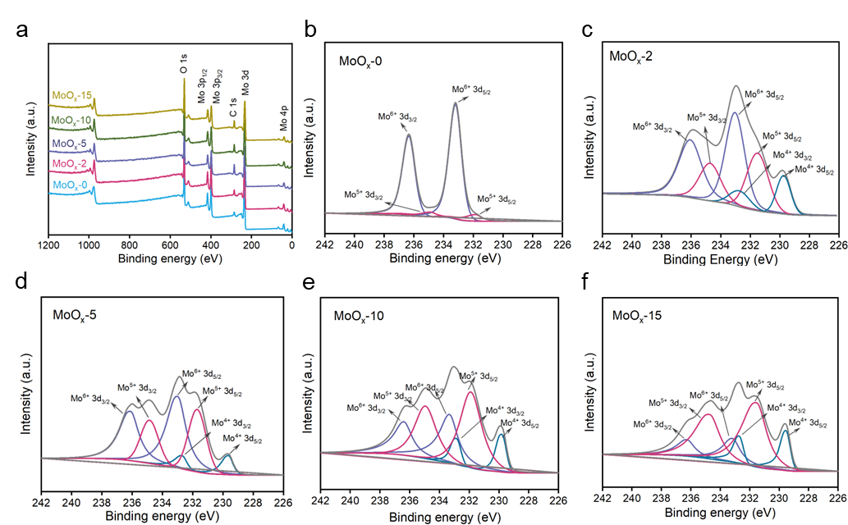

Supplementary Fig. 8. X-ray photoelectron spectroscopy (XPS) investigation of MoO_{x} samples.
(a) Survey XPS spectra of MoO_{x}-0/2/5/10/15. (b-f) High-resolution Mo 3d spectra of MoO_{x}-0/2/5/10/15.
Survey spectra confirm the presence of Mo and O without detectable impurity-derived signals. High-resolution Mo 3d spectra show progressive enrichment of lower-valent Mo species from MoO_{x}-0 to MoO_{x}-15, indicating that defect-state evolution is accompanied by partial reduction of Mo centers and continuous surface electronic-state reconstruction.
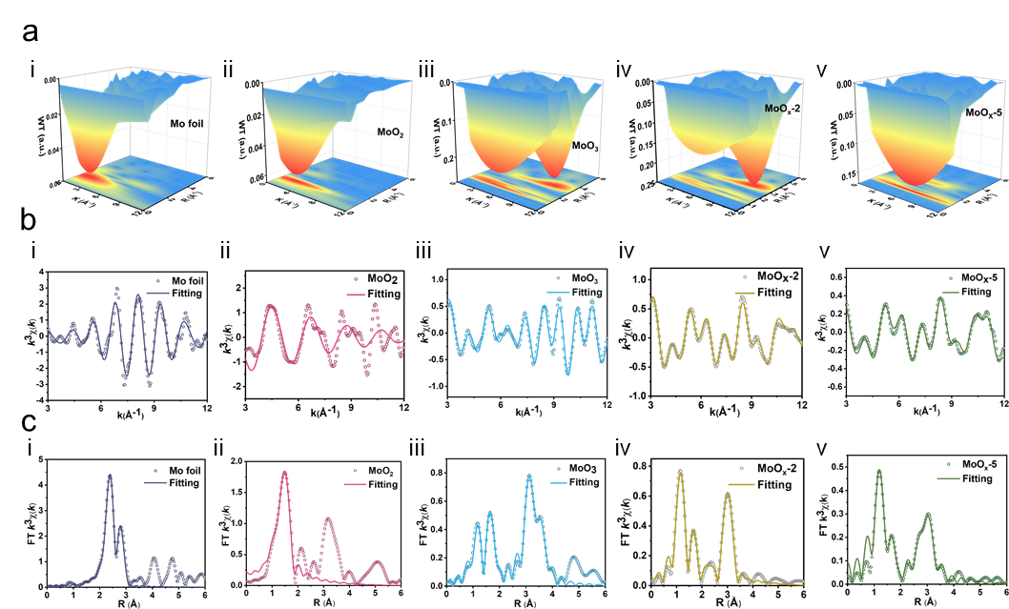

Supplementary Fig. 9. EXAFS analysis of Mo foil, MoO₂, MoO₃, MoO_{x}-2 and MoO_{x}-5.
(a) Wavelet-transform EXAFS spectra of Mo foil, MoO₂, MoO₃, MoO_{x}-2 and MoO_{x}-5. (b) K-space EXAFS fitting curves. (c) Fourier-transformed EXAFS fitting curves.
XANES and EXAFS results show that MoO_{x}-2 and MoO_{x}-5 both retain oxygen-coordinated Mo environments while evolving toward more reduced local states. Relative to MoO_{x}-2, MoO_{x}-5 exhibits a more distorted local coordination environment and a more pronounced reconstruction of the coordination shell. The absence of detectable metallic Mo-Mo coordination supports that defect evolution remains confined within an oxide lattice rather than proceeding to metallic segregation.

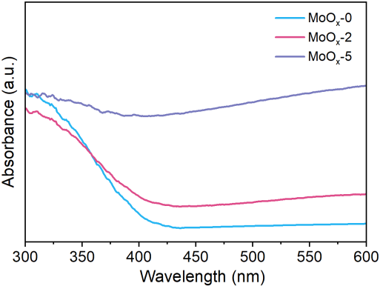

Supplementary Fig. 10. Ultraviolet-visible (UV-vis) absorption spectra of MoO_{x}-0/2/5.
UV-vis spectra show progressive enhancement of optical absorption from MoO_{x}-0 to MoO_{x}-5, with the strongest response observed for MoO_{x}-5. This trend is already evident near 355 nm, the excitation wavelength used for LDI, indicating that defect evolution increases optical accessibility under the experimental conditions. The stronger absorption of MoO_{x}-5 near 355 nm is consistent with improved photon harvesting under the excitation conditions used for LDI-MS.

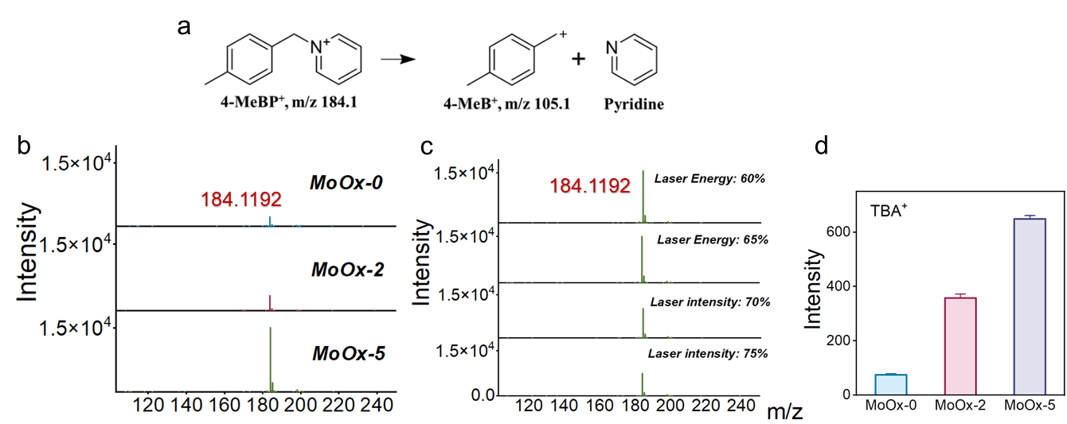

Supplementary Fig. 11. Thermal desorption performance using 4-MeBP⁺ as a probe ion and charge desorption performance using TBA⁺ as a probe ion.
(a) Bond cleavage of 4-MeBP⁺ resulting in the formation of 4-MeB⁺ and pyridine. (b) Total ion intensity of 4-MeBP⁺ detected on MoO_{x}-0/2/5 with 65% laser energy. (c) Total ion intensity of 4-MeBP⁺ on MoO_{x}-5 at different relative laser energies. (d) Total ion intensity of TBA⁺ on MoO_{x}-0/2/5.
4-MeBP⁺ was selected as a thermometer ion because benzylpyridinium salts undergo a simple and well-defined bond-cleavage pathway, allowing internal energy transfer during desorption to be assessed from characteristic fragmentation. Under laser irradiation, no diagnostic thermal-fragmentation product of 4-MeBP⁺ is observed, indicating that photothermal dissociation is not dominant in MoO_{x}-assisted LDI. By contrast, TBA⁺ was used as a charge-desorption probe because it is a permanently charged, non-protonatable cation, and its signal enhancement therefore cannot be attributed to protonation chemistry. Together, these probes distinguish thermal activation from charge-mediated desorption and indicate that the enhanced LDI performance of vacancy-cluster-rich MoO_{x} is not primarily governed by photothermal heating.
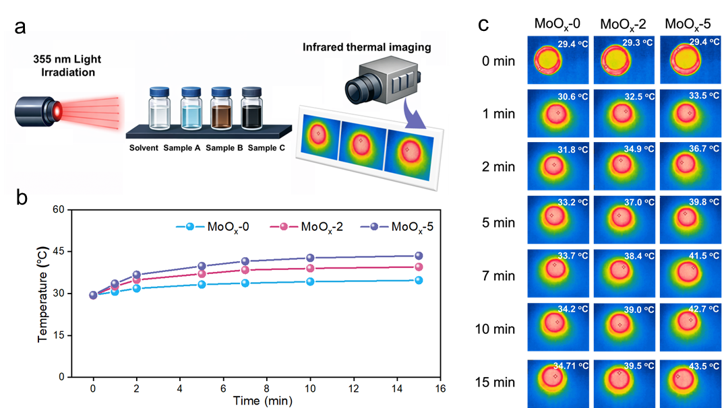

Supplementary Fig. 12. Comparative photothermal conversion performance of MoO_{x}-0/2/5.
(a) Schematic illustration of photothermal imaging. (b) Temperature evolution of MoO_{x}-0/2/5 under continuous 355 nm irradiation. (c) Corresponding thermal images of MoO_{x}-0/2/5 under continuous 355 nm irradiation.
Temperature evolution and thermal images of MoO_{x}-0, MoO_{x}-2, and MoO_{x}-5 were recorded under continuous laser irradiation. The temperature increase remains gradual across the tested time window, with MoO_{x}-5 showing only a modest rise after prolonged irradiation. These data indicate that irradiation induces only limited photothermal accumulation under the present conditions and provide a thermal profile consistent with the absence of 4-MeBP⁺ fragmentation.

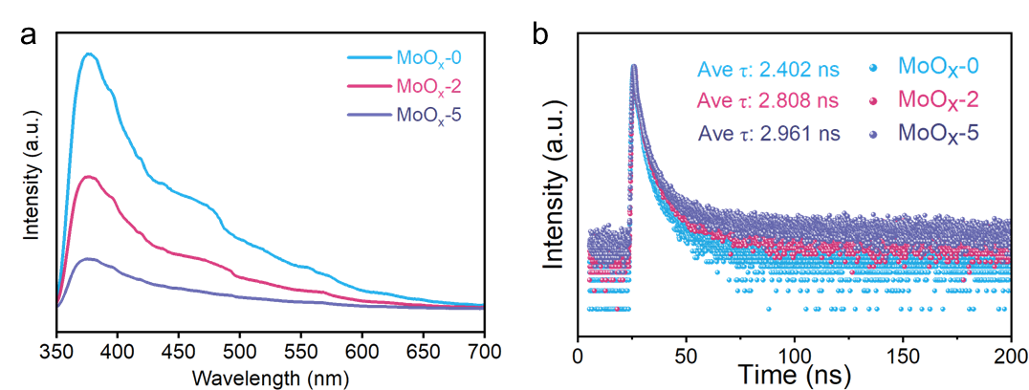

Supplementary Fig. 13. (a) Photoluminescence (PL) and (b) time-resolved photoluminescence (TRPL) of MoO_{x}-0/2/5.
PL and TRPL measurements were used here as complementary probes of early-stage excited-state dynamics in the MoO_{x} series. The strongly quenched PL of MoO_{x}-5 indicates that radiative recombination is effectively suppressed in the vacancy-cluster-rich state. Importantly, this PL quenching is accompanied by a monotonic increase in the average TRPL lifetime from 2.402 ns for MoO_{x}-0 to 2.808 ns for MoO_{x}-2 and 2.981 ns for MoO_{x}-5, showing that the excited-state carrier population persists progressively longer before recombination as the defect state evolves from vacancy-lean to vacancy-cluster-rich. The longer decay lifetime does not simply indicate weaker emission, but instead supports reduced prompt carrier loss after excitation and a more favorable kinetic condition for subsequent surface charge accumulation.
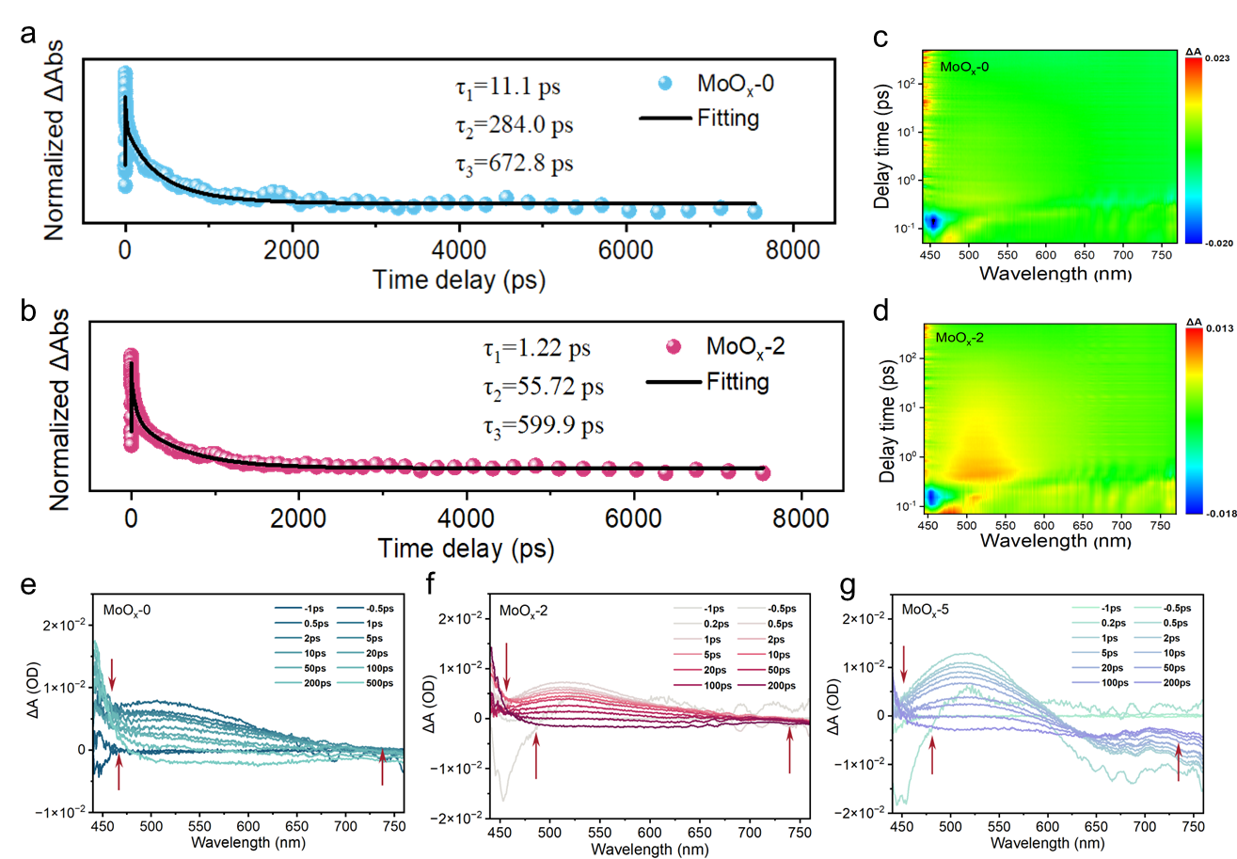

Supplementary Fig. 14. Transient absorption spectroscopy (TAS) of MoO_{x}-0, MoO_{x}-2 and MoO_{x}-5.
TAS in the 400-800 nm shows a clear defect-configuration-dependent acceleration of excited-state relaxation across the MoO_{x} series. The fitted decay components decrease progressively from MoO_{x}-0 to MoO_{x}-2 and further to MoO_{x}-5, while the corresponding contour maps show increasingly pronounced visible-region transient features, especially in the ~500-650 nm. These results indicate that oxygen-vacancy introduction, particularly vacancy clusters, accelerates the redistribution of the initially excited population into defect-associated intermediate states. The comparison therefore shows that point vacancies already establish a defect-coupled excited-state pathway, whereas vacancy clusters strengthen this process further and produces the most effective excited-state reorganization. Supplementary Fig. 14e-g MoO_{x}-0 shows weak visible transient modulation with broad, low intensity features that gradually attenuate over the measured delay window, indicating limited defect coupled carrier perturbation in the vacancy lean state. MoO_{x}-2 displays more discernible photoinduced absorption across the visible region, especially within the 500 to 600 nm range, suggesting that isolated point vacancies begin to couple with carrier relaxation and introduce intermediate defect related transient features. In MoO_{x}-5, the transient response becomes the strongest and most structured, with pronounced visible region photoinduced absorption and clearer long wavelength evolution between approximately 650 and 750 nm. This progressive spectral evolution from weak transient modulation in MoO_{x}-0, through point defect coupled response in MoO_{x}-2, to the strongly modulated spectra of MoO_{x}-5 supports a defect state dependent evolution of photogenerated carrier dynamics, in which the vacancy-clustered state produces the most prominent transient spectral response. These selected-delay spectra provide direct spectral line evidence that complements the pseudo-colour fs TAS maps and supports the carrier dynamics analysis discussed in the main text.

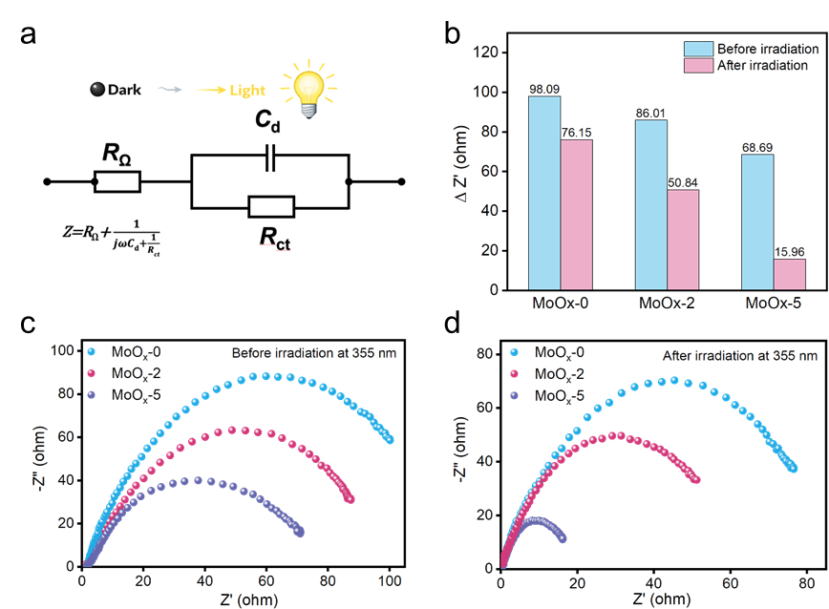

Supplementary Fig. 15. In situ electrochemical impedance spectroscopy (EIS) of MoO_{x}-0/2/5 before and after 355 nm irradiation.
(a) Schematic illustration of the electrochemical impedance measurement. (b-d) Electrochemical impedance results of MoO_{x}-0, MoO_{x}-2, and MoO_{x}-5 before and after laser irradiation at 355 nm.
The interfacial charge-transfer resistance decreases progressively from MoO_{x}-0 to MoO_{x}-5 under dark conditions, indicating facilitated intrinsic charge transport with defect-state evolution. Under 355 nm irradiation, all samples show reduced Nyquist semicircle diameters, confirming light-accelerated charge transfer. The strongest photoresponse is observed for MoO_{x}-5, with ΔZ decreasing from 68.89 Ω to 15.96 Ω, whereas MoO_{x}-0 decreases only from 94.09 Ω to 76.15 Ω. This behavior supports that the vacancy-clustered state combines lower baseline resistance with the strongest light-induced interfacial charge-transport enhancement.
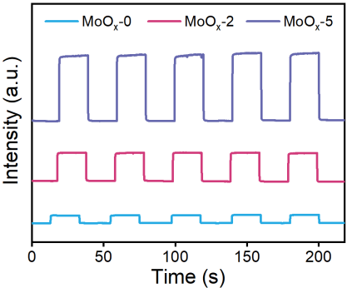

Supplementary Fig. 16. Transient photocurrent response of MoO_{x}-0/2/5.
MoO_{x}-5 delivered the highest photocurrent intensity, followed by MoO_{x}-2 and MoO_{x}-0, demonstrating that defect-state evolution toward vacancy clusters promote photogenerated charge separation and transport.

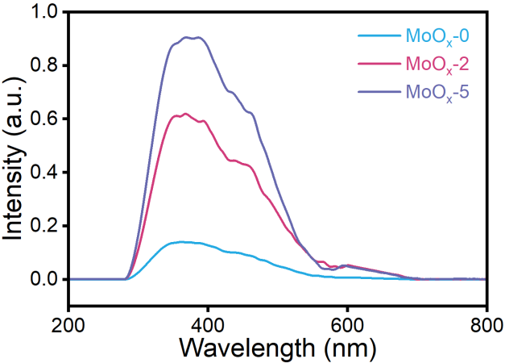

Supplementary Fig. 17. Surface photovoltage spectroscopy of MoO_{x}-0/2/5.
All MoO_{x} samples exhibit SPV responses in the ~320 to 550 nm range, with the amplitude increasing from MoO_{x}-0 to MoO_{x}-2 and reaching a maximum in MoO_{x}-5. These spectra indicate progressively stronger photoinduced surface potential build-up as the defect state evolves toward vacancy clusters, supporting more effective conversion of photoexcitation into surface-directed charge accumulation.

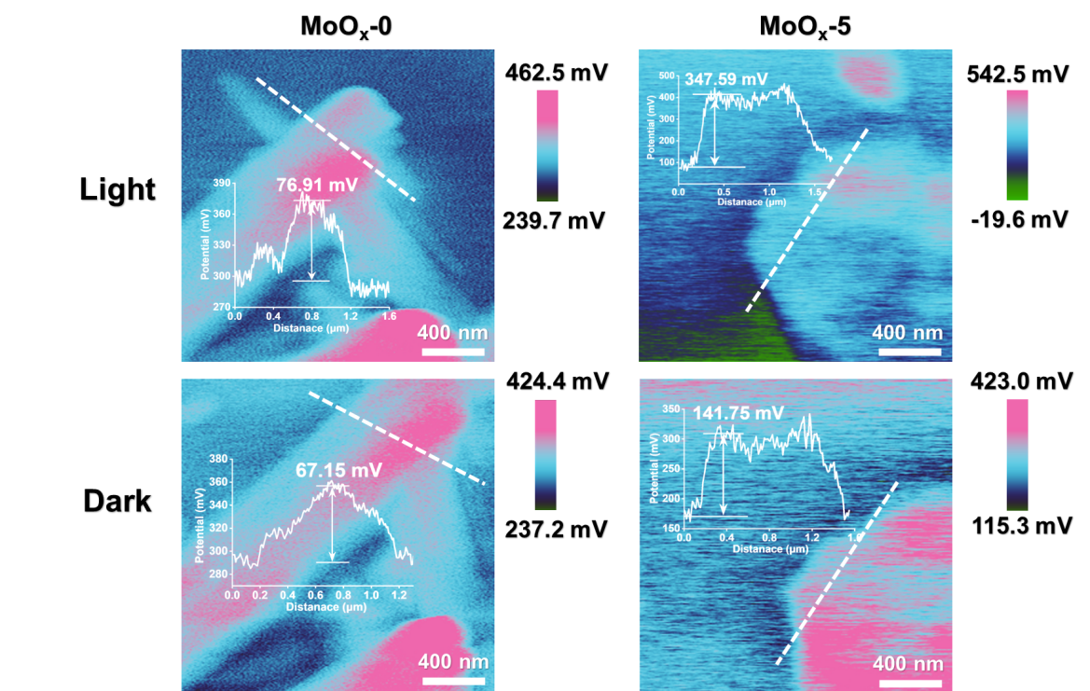

Supplementary Fig. 18. Kelvin probe force microscopy (KPFM) mapping of MoO_{x}-0 and MoO_{x}-5 under dark and illumination conditions.
(a) KPFM images of MoO_{x}-0 under dark and laser irradiation conditions, showing a minor change in surface potential difference from 67.15 mV to 76.91 mV. (b) KPFM images of MoO_{x}-5 under dark and laser irradiation conditions. Insets show the corresponding surface-potential differences.
MoO_{x}-0 shows only a weak light-induced change in surface-potential difference, from 67.15 mV in the dark to 76.91 mV under illumination, whereas MoO_{x}-5 exhibits both a larger dark-state potential contrast of 141.75 mV and a much stronger increase to 347.59 mV upon illumination. These results indicate that the vacancy-clustered state enhances not only static electronic polarization, but also dynamic photoinduced surface potential build-up, consistent with more effective surface charge accumulation.
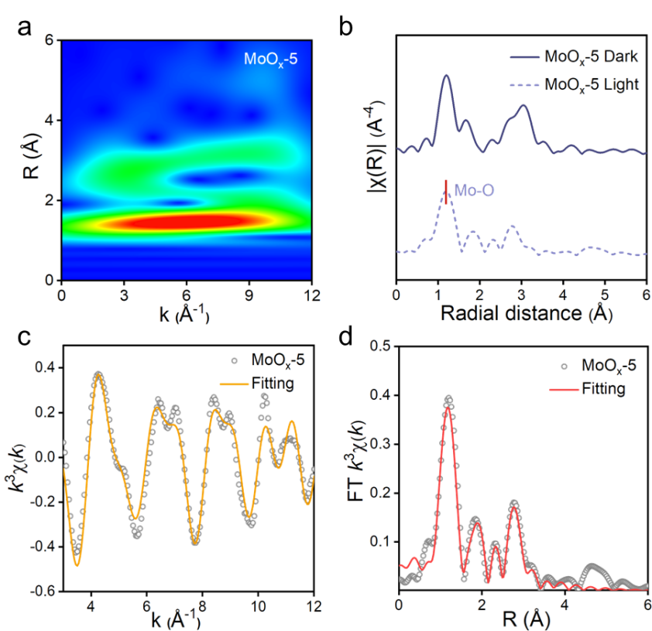

Supplementary Fig. 19. In situ XAFS of MoO_{x}-5.
In situ Mo K-edge XAFS spectra of MoO_{x}-5 were collected under dark and 355 nm irradiation conditions to support the light-responsive local coordination analysis discussed in the main text. The spectra include the corresponding XANES and FT-EXAFS profiles, together with the fitting results used to extract the Mo-O coordination parameters.

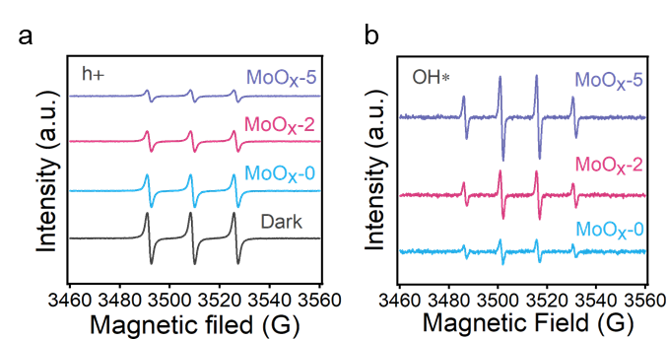

Supplementary Fig. 20. In situ EPR of MoO_{x}-0/2/5 under laser irradiation.
(a) Hole-related in situ EPR signals of MoO_{x}-0/2/5 under irradiation. (b) OH-related radical signals of MoO_{x}-0/2/5 under irradiation.
The hole-related signal decreases from MoO_{x}-0 to MoO_{x}-5, whereas the OH-related signal increases. These results indicate that defect-state evolution strengthens light-triggered hole retention and promotes its coupling to surface hydroxyl activation, with the strongest response observed in the vacancy-clustered state.

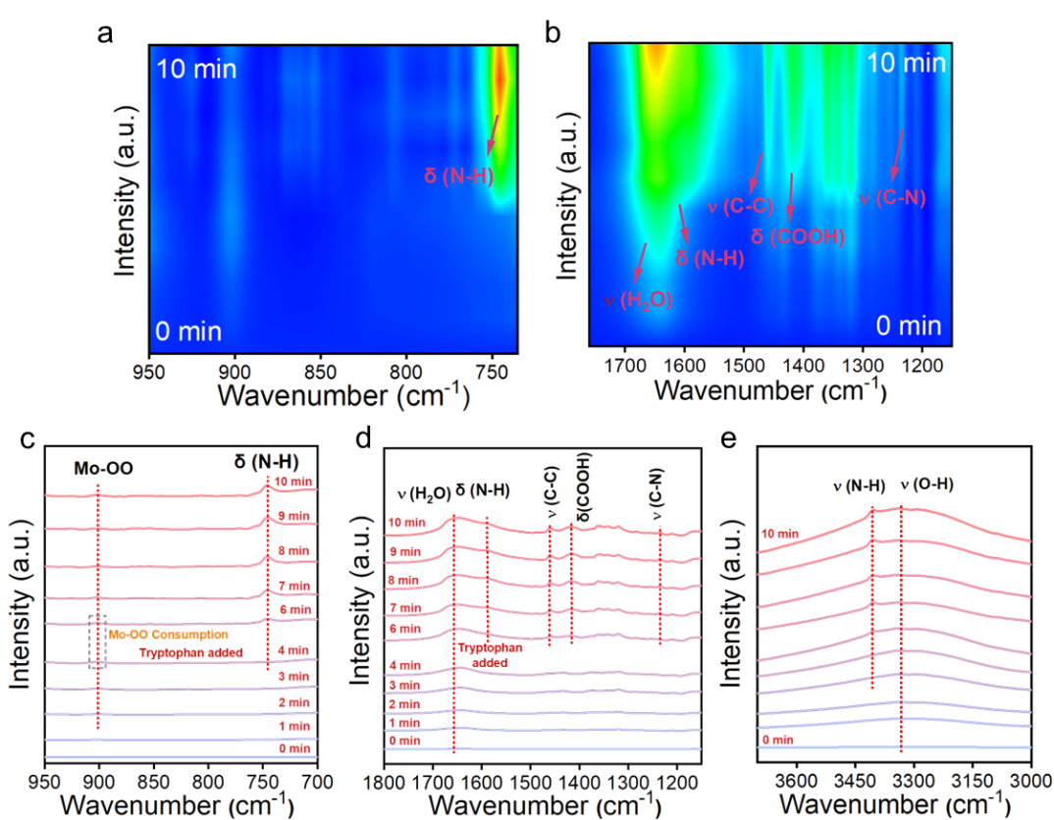

Supplementary Fig. 21. In situ diffuse reflectance infrared Fourier transform spectroscopy (DRIFTS) of MoO_{x}-0.

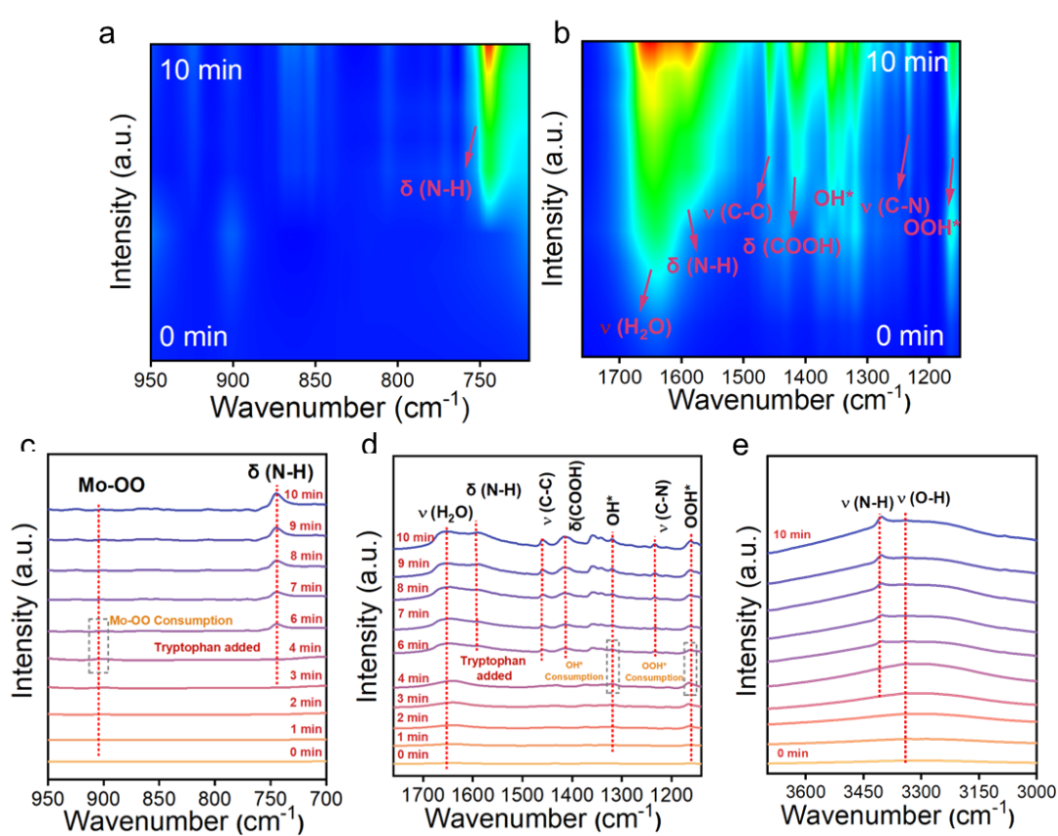

Supplementary Fig. 22. In situ DRIFTS of MoO_{x}-2.

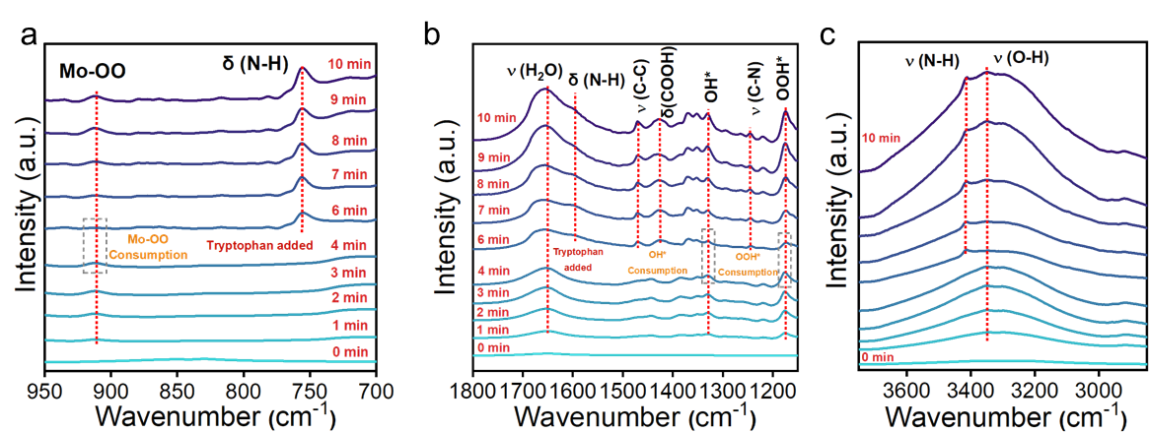

Supplementary Fig. 23. In situ DRIFTS of MoO_{x}-5.
Supplementary Figs. 21 to 23 present the full-time dependent DRIFTS datasets used to compare the interfacial spectral evolution of MoO_{x}-0, MoO_{x}-2, and MoO_{x}-5. During the irradiation stage, MoO_{x}-0 shows only weak spectral changes, whereas MoO_{x}-2 displays clearer evolution of oxygenated surface features and MoO_{x}-5 exhibits the most developed spectral response. After analyte addition, analyte associated vibrations become more evident, with the strongest spectral evolution observed on MoO_{x}-5. The concurrent attenuation of oxygenated intermediate bands and growth of analyte associated bands in MoO_{x}-5 records a more complete transition from light activated oxygenated surface chemistry to analyte coupled interfacial reactions. These spectra provide the full temporal DRIFTS evidence for the vacancy dependent interfacial chemistry discussed in the main text.
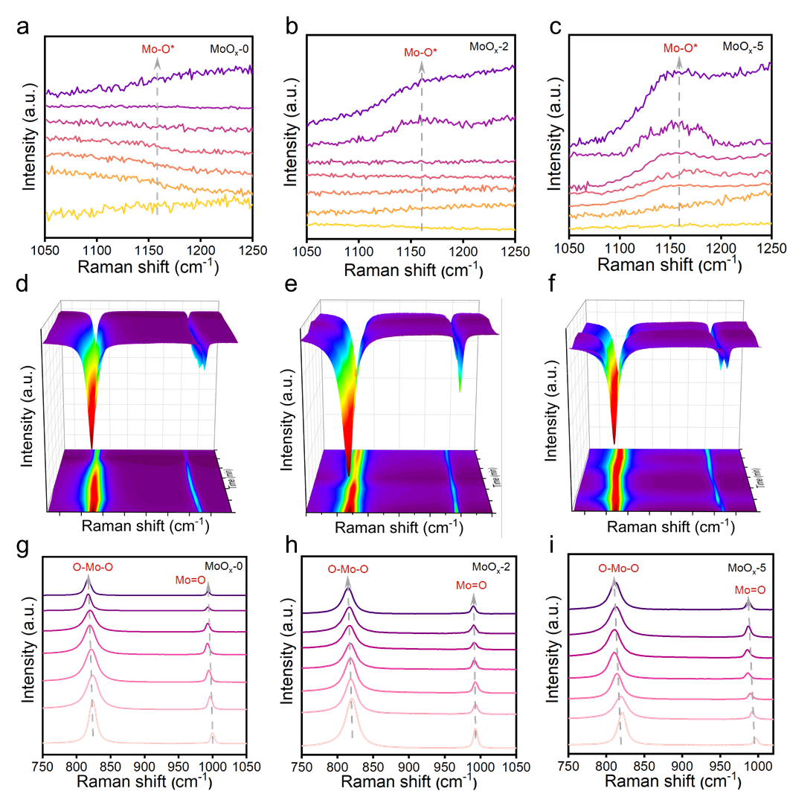

Supplementary Fig. 24. In situ Raman spectra of MoO_{x}-0/2/5.
In situ Raman shows vacancy-dependent evolution of Mo-O and O-Mo-O vibrations under irradiation. MoO_{x}-5 exhibits the strongest Mo-O response and the slowest attenuation of the O-Mo-O vibration, indicating stabilization of an activated oxygenated surface state.

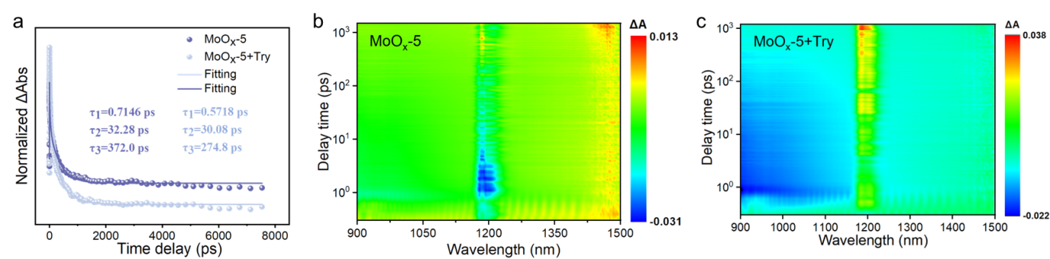

Supplementary Fig. 25. Fs TAS of MoO_{x}-5 and in situ fs TAS of the tryptophan-adsorbed MoO_{x}-5 sample.
The 900-1500 nm transient absorption maps show that tryptophan adsorption induces a clear redistribution of the defect-associated NIR response of MoO_{x}-5. Compared with pristine MoO_{x} 5, which exhibits a relatively localized transient feature near ~1180-1220 nm, the tryptophan-adsorbed MoO_{x}-5 sample displays a broader and more reorganized NIR spectral profile. Tryptophan does not merely reside on the MoO_{x}-5 surface, but perturbs both the relaxation kinetics and the defect-associated NIR transient response, indicating active molecule-surface coupling under irradiation.

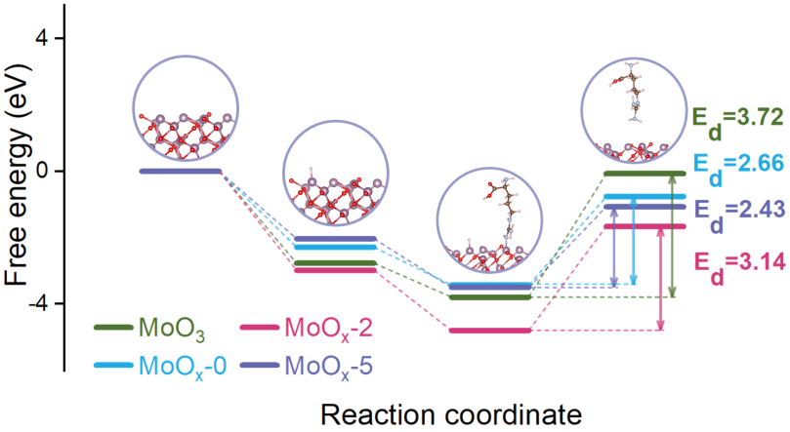

Supplementary Fig. 26. Free-energy profiles for proton-coupled desorption of [Arg+H]⁺ on MoO₃, MoO_{x}-0, MoO_{x}-2, and MoO_{x}-5, as calculated by density functional theory.
The free-energy profiles provide the energetic counterpart to the operando spectroscopic evidence. The calculated pathways show that the vacancy clusters also most effectively lowers the barrier for final ion release. In particular, the desorption barrier of [Arg+H]⁺ decreases to 2.43 eV on MoO_{x}-5, compared with 2.66 eV on MoO_{x}-0, 3.14 eV on MoO_{x}-2, and 3.72 eV on MoO₃. This trend indicates that vacancy clusters does not simply modify adsorption strength, but reorganizes the proton-coupled release pathway itself, thereby making the final desorption step more energetically accessible.

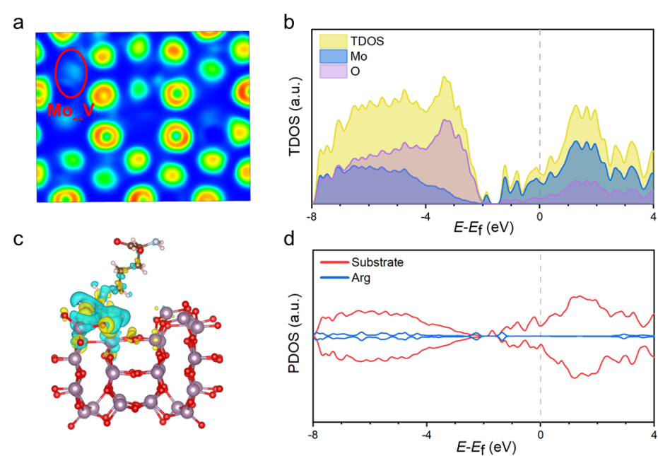

Supplementary Fig. 27. Differential charge density and density of states (DOS) for MoO_{x}-5 substrate upon interaction with arginine (Arg).
(a) Differential charge density of MoO_{x}-5 (blue represents regions of charge accumulation, red represents regions of charge depletion). (b) TDOS of MoO_{x}-5. (c) Differential charge density of MoO_{x}-5 with Arg. (d) DOS of MoO_{x}-5 with Arg.

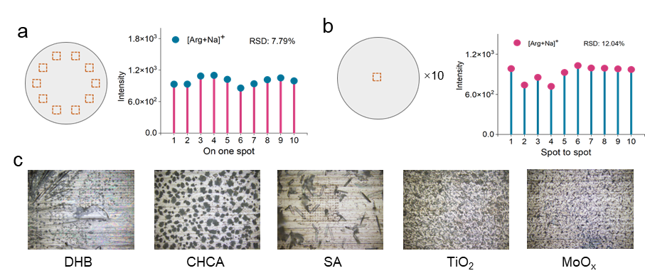

Supplementary Fig. 28. Reproducibility and deposition uniformity of DHB, CHCA, SA, TiO₂ and MoO_{x}-5.
(a) Shot-to-shot reproducibility evaluated on one spot (n = 10). (b) Spot-to-spot reproducibility assessed across ten spots (n = 10). Data are presented as the means ± SD. (c) Brightfield micrographs of DHB, CHCA, SA, TiO₂ and MoO_{x}-5 deposited on target plates.

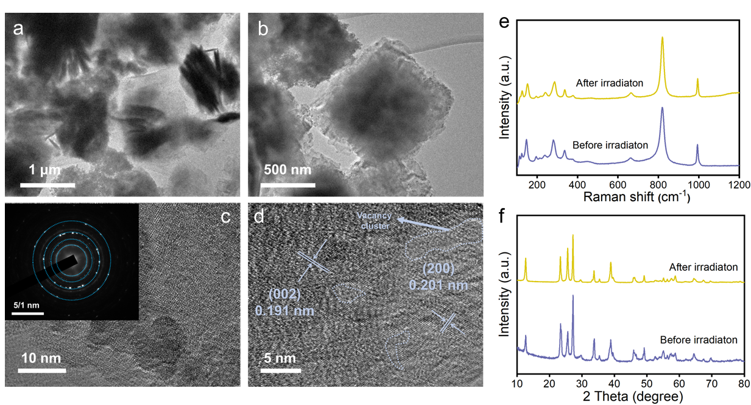

Supplementary Fig. 29. Structural stability of MoO_{x}-5 under laser irradiation.
(a,b) Low- and intermediate-magnification TEM images of MoO_{x}-5 after laser irradiation. (c,d) HRTEM images of MoO_{x}-5 after laser irradiation. (e) Raman spectra and (f) XRD patterns of MoO_{x}-5 before and after laser irradiation at 355 nm.
The structural response of MoO_{x}-5 under laser irradiation remains confined to a locally modulated but globally retained oxide framework. Electron microscopy shows that the nanosheet-based architecture is preserved after irradiation, and HRTEM still resolves both the MoO₃-derived lattice fringes and the defect-rich regions associated with the vacancy-clustered state. This observation indicates that the laser stimulus used in LDI does not destroy the underlying structural scaffold of the matrix. The spectroscopic data support the same conclusion. Raman spectra recorded before and after irradiation retain the same principal vibrational features, and the XRD patterns show no additional diffraction peaks or obvious loss of the parent framework. In the context of the proposed mechanism, these results indicate that the superior LDI performance of MoO_{x}-5 cannot be attributed to laser-induced bulk reconstruction or substrate decomposition, but instead arises from reversible local electronic and coordination responses that remain embedded within a structurally stable oxide lattice.
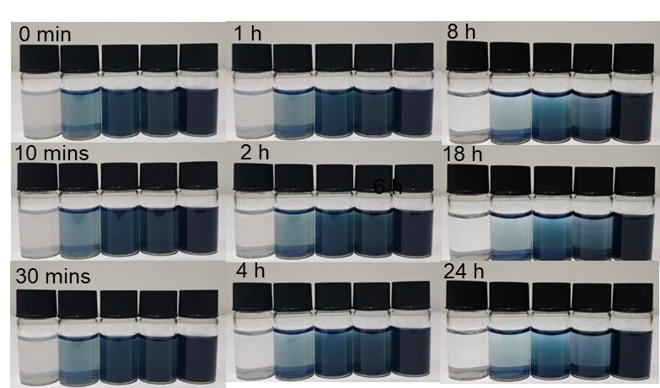

Supplementary Fig. 30. Dispersion stability of MoO_{x} in aqueous solution over 24 hours.
From left to right: MoO_{x}-0, MoO_{x}-2, MoO_{x}-5, MoO_{x}-10, and MoO_{x}-15.

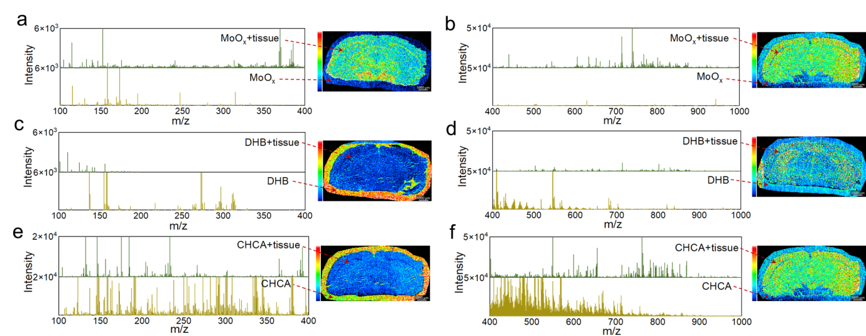

Supplementary Fig. 31. Comparison background interference among DHB, CHCA and MoO_{x} in mouse brain analysis.
Representative spectra and corresponding total ion images obtained from matrix coated mouse brain tissue and from the corresponding matrix alone for DHB, CHCA and MoO_{x}-5 in the m/z 100-400 and 400-1000 ranges.

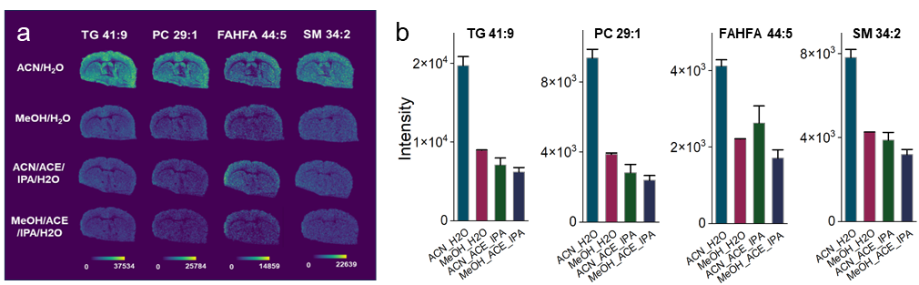

Supplementary Fig. 32. (a) Ion images and (b) corresponding intensity signals of representative metabolites with different solvents for matrix spraying.

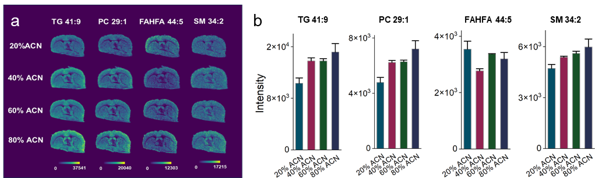

Supplementary Fig. 33. (a) Ion images and (b) corresponding intensity signals of representative metabolites with different ratio solvents for matrix spraying.

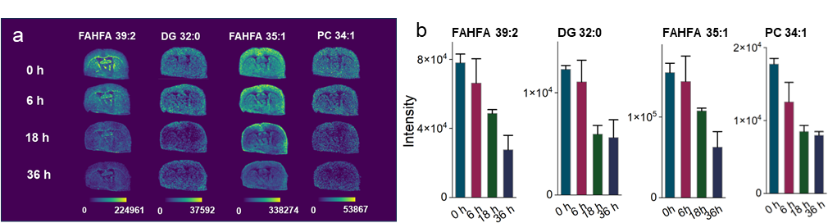

Supplementary Fig. 34. (a) Ion images and (b) corresponding intensity signals of representative metabolites of the sample stability after 0-36 h.

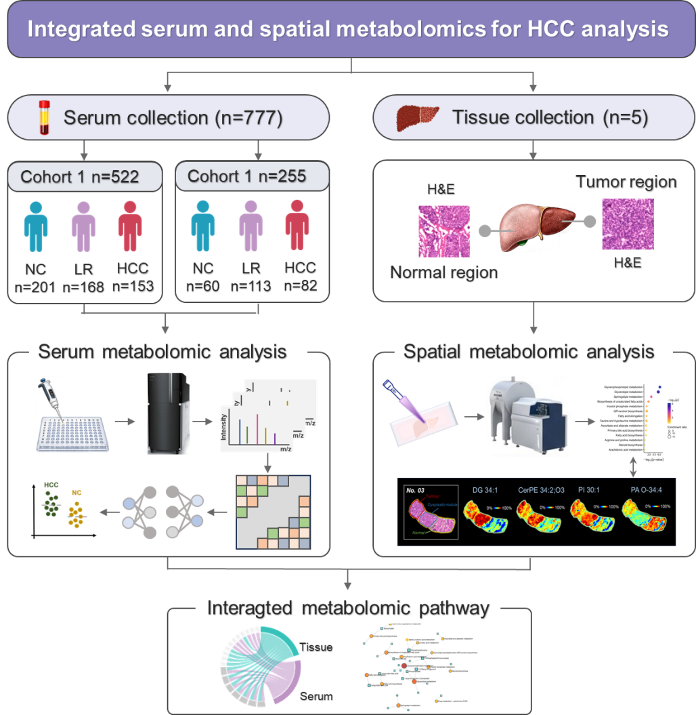

Supplementary Fig. 35. Study workflow of integrated serum and spatial metabolomics for HCC.

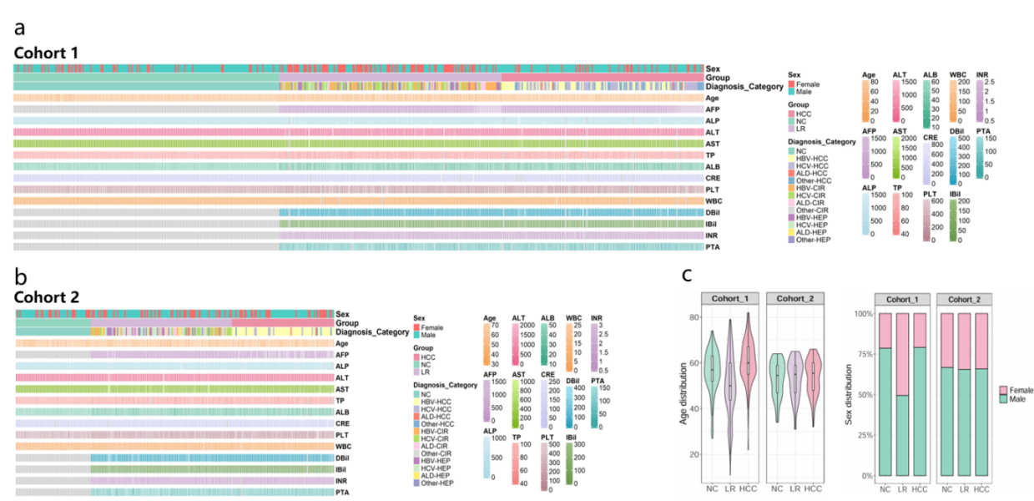

Supplementary Fig. 36. Discovery (a) and validation (b) cohort information of serum clinical samples.

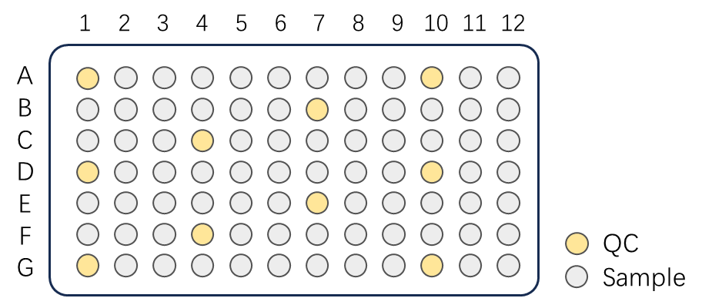

Supplementary Fig. 37. High-throughput fluid chip of serum cohort for metabolic analysis.

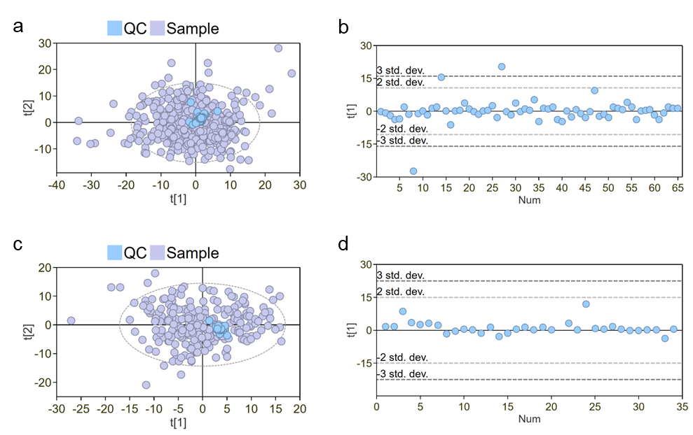

Supplementary Fig. 38. Metabolomics data assessment displayed by score plot of PCA model and QCs distribution in (a-b) discovery cohort and (c-d) validation cohort.

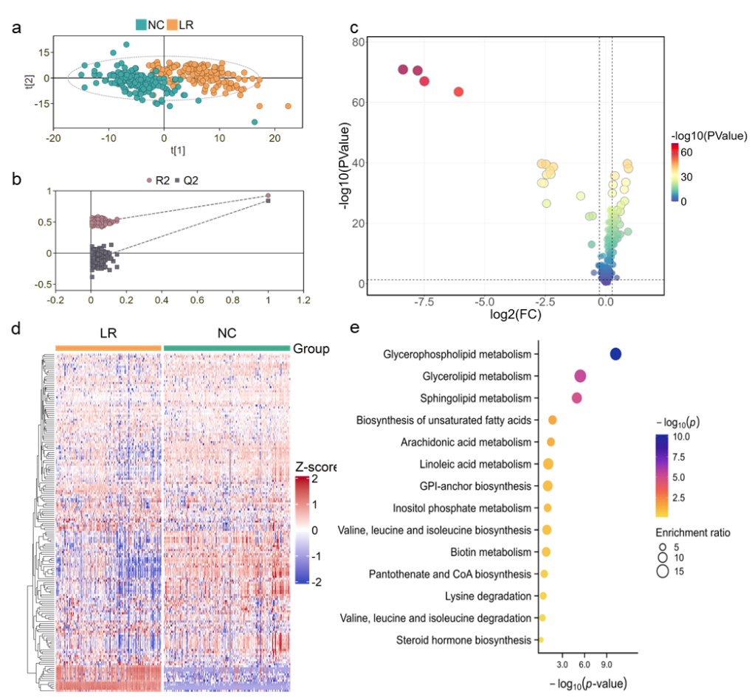
Supplementary Fig. 39. (a) Score plot and (b) permutation test PLS-DA model for LR vs NC in discovery cohort. (c) Volcano plot for LR vs NC in discovery cohort. (d) Heatmap of significantly changed metabolites with FDR-adjusted p < 0.05 for LR and NC group in discovery cohort. (e) KEGG metabolic pathways differentially regulated in LR compared to NC. Each circle was colored by the -log10(p-value).
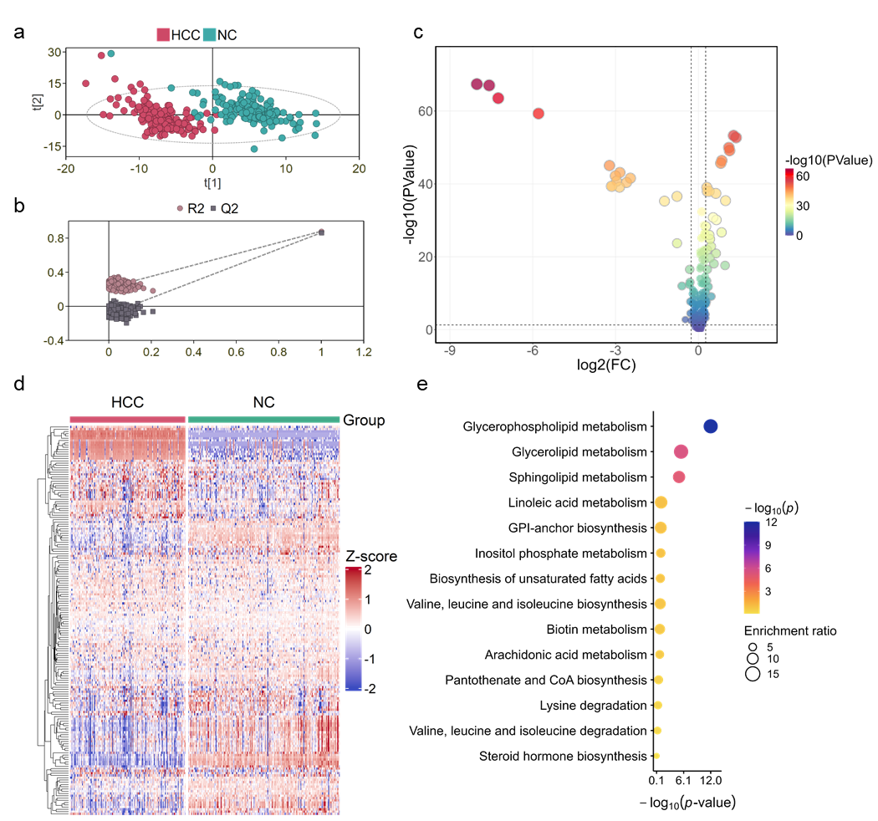
Supplementary Fig. 40. (a) Score plot and (b) permutation test PLS-DA model for HCC vs NC in discovery cohort. (c) Volcano plot for HCC vs NC in discovery cohort. (d) Heatmap of significantly changed metabolites with FDR-adjusted p < 0.05 for HCC and NC group in discovery cohort. (e) KEGG metabolic pathways differentially regulated in HCC compared to NC. Each circle was colored by the -log10(p-value).
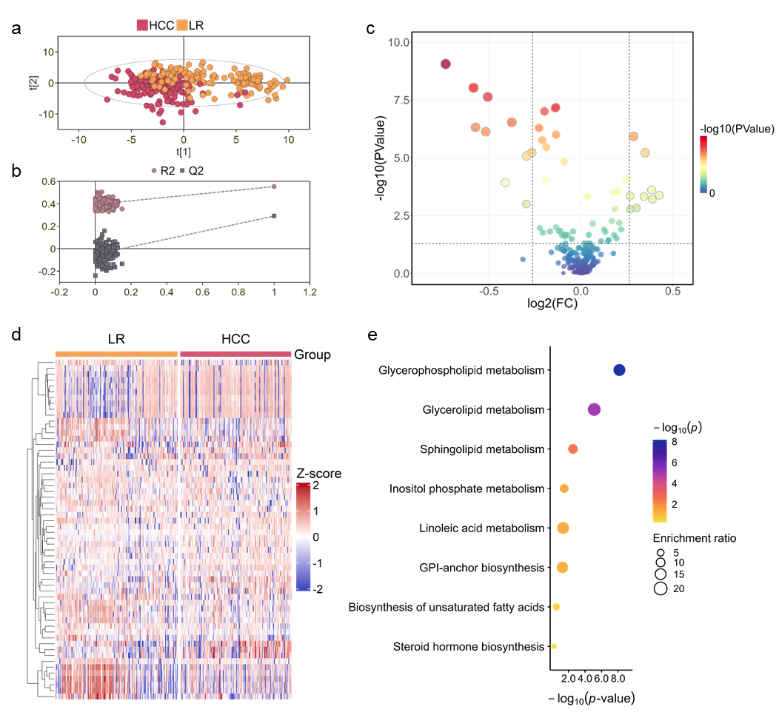
Supplementary Fig. 41. (a) Score plot and (b) permutation test PLS-DA model for HCC vs LR in discovery cohort. (c) Volcano plot for HCC vs LR in discovery cohort. (d) Heatmap of significantly changed metabolites with FDR-adjusted p < 0.05 for HCC and LR group in discovery cohort. (e) KEGG metabolic pathways differentially regulated in HCC compared to LR. Each circle was colored by the -log10(p-value).
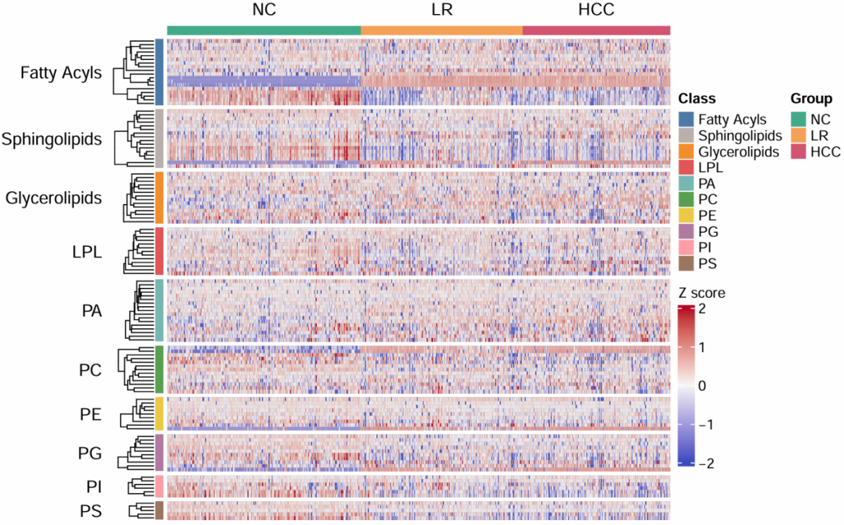

Supplementary Fig. 42. Serum lipid-class remodeling across the discovery cohort.
Heatmap showing row-scaled abundance patterns of annotated serum lipid metabolites across NC, LR and HCC samples in the discovery cohort. Metabolites are grouped by lipid class, including fatty acyls, sphingolipids, glycerolipids, lysophospholipids (LPL), phosphatidic acids (PA), phosphatidylcholines (PC), phosphatidylethanolamines (PE), phosphatidylglycerols (PG), phosphatidylinositols (PI) and phosphatidylserines (PS). Columns represent individual serum samples ordered by clinical group. Red and blue indicate relatively increased and decreased abundance, respectively, after row-wise Z-score scaling.

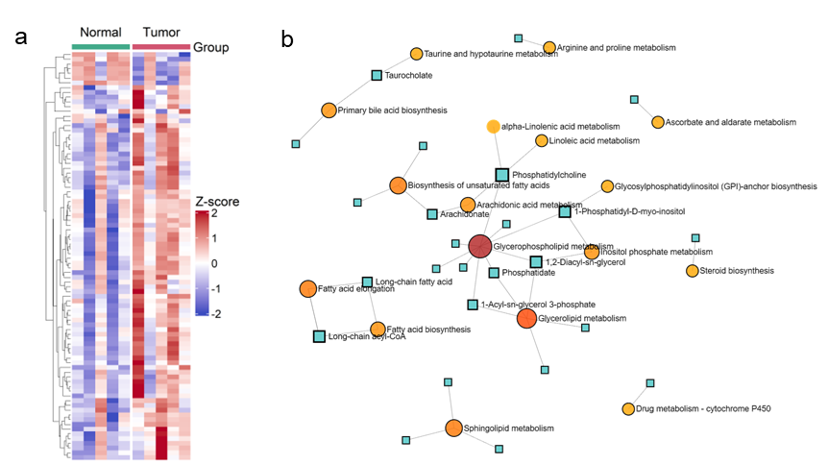

Supplementary Fig. 43. Analysis of specific dysregulated pathways driving the pathogenesis of HCC.
(a) Heatmap of differential metabolites (p < 0.05) between HCC tumour tissues and normal tissues. (b) Pathway topology analysis showing interconnections between key dysregulated metabolic pathways.
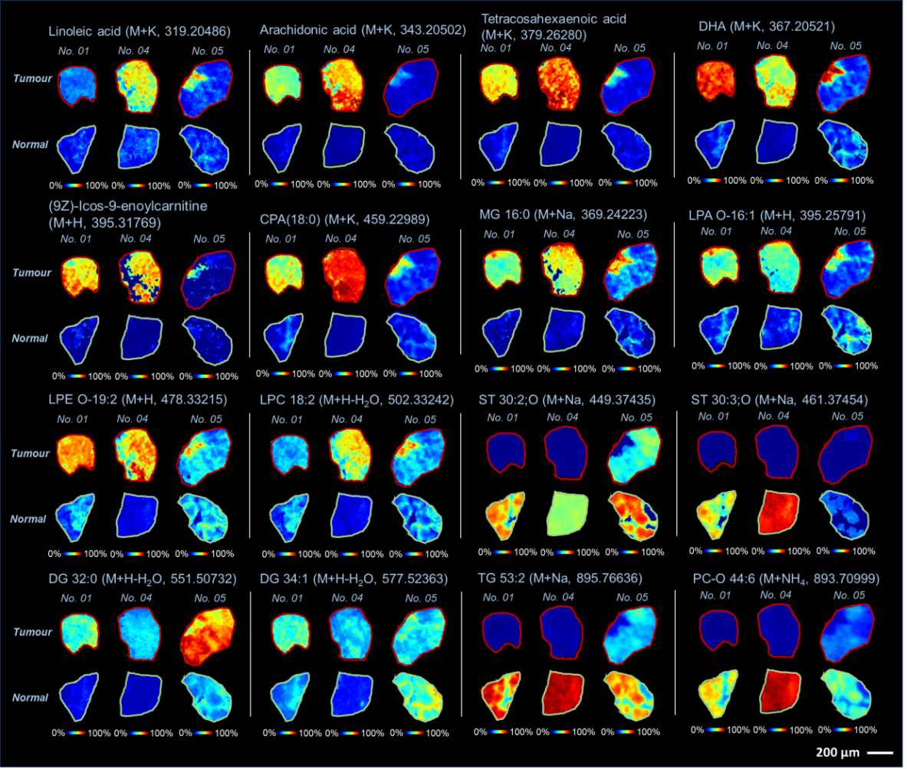

Supplementary Fig. 44. Representative metabolites imaged by the MoO_{x}-5-assisted MALDI-MSI platform.

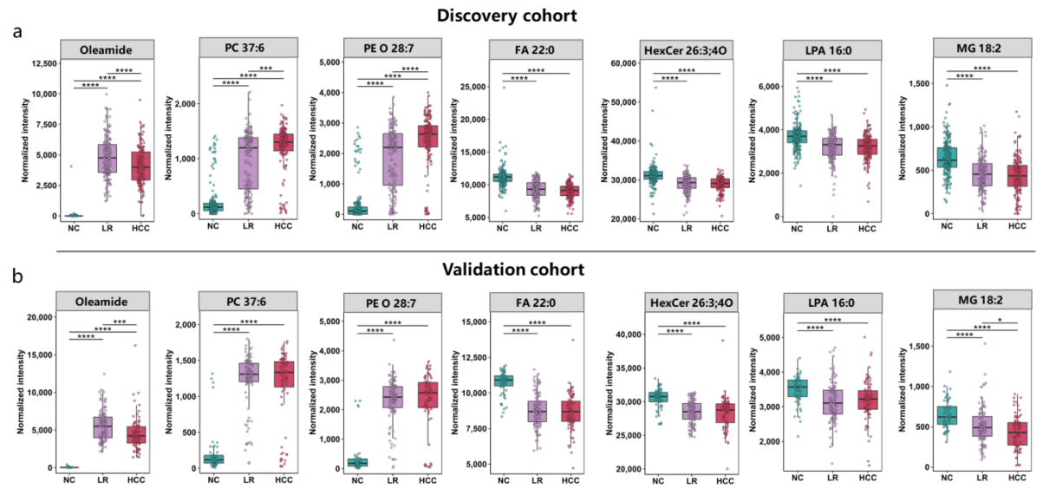

Supplementary Fig. 45. Boxplot of seven serum biomarkers across normal controls, high-risk liver disease and hepatocellular carcinoma (HCC vs NC or LR vs NC) in discovery cohort and validation cohort.

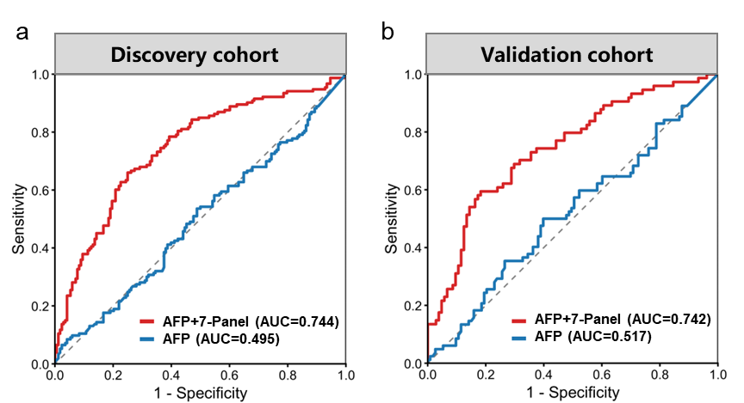

Supplementary Fig. 46. Comparison of AFP and AFP combined with 7-Panel biomarker for HCC vs high-risk liver disease discrimination in the discovery and validation cohorts. AFP-based analysis was restricted to the HCC vs LR comparison because AFP measurements were not available for normal controls.

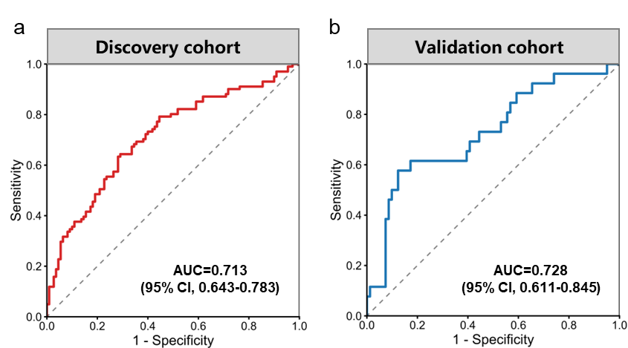

Supplementary Fig. 47. Diagnostic performance of the 7-Panel biomarker in AFP-negative HCC.
AFP-negative samples were defined as AFP < 20 ng/mL. In this strict AFP-negative analysis, both HCC and LR samples were restricted to AFP < 20 ng/mL. ROC curves show the performance of the 7-metabolite panel for discriminating AFP-negative HCC from AFP-negative LR in the discovery and validation cohorts. AUC values and 95% confidence intervals are shown in each panel.

Supplementary Table 1. Results of structural analysis obtained from XRD Rietveld refinement of MoO_{x}-0, MoO_{x}-2 and MoO_{x}-5.
Sample | a(Å) | b(Å) | c(Å) | α=β=γ (º) | R_{wp} | R_{p} | Simulated Phase name
MoO_{x}-0 | 3.9535(6) | 13.8297(7) | 3.6929(5) | 90 | 8.90% | 6.42% | MoO₃
MoO_{x}-2 | 3.9528(4) | 13.8826(2) | 3.7034(8) | 90 | 9.17% | 7.07% | Mo₂₀O₅₇
MoO_{x}-5 | 3.9476(6) | 13.9036(2) | 3.7052(2) | 90 | 6.35% | 4.69% | Mo₂₀O₅₃

Supplementary Table 2. Positron annihilation spectroscopy parameters of MoO_{x}-0, MoO_{x}-2 and MoO_{x}-5.
Sample | τ1 (ps) | I₁ (%) | τ2 (ps) | I₂ (%) | τ3 (ns) | I₃ (%)
MoO_{x}-0 | 223.7 | 55.37 | 338.7 | 43.22 | 3.321 | 1.41
MoO_{x}-2 | 230.5 | 42.11 | 344.4 | 57.68 | 4.257 | 0.21
MoO_{x}-5 | 246.8 | 34.16 | 459.8 | 65.58 | 4.555 | 0.26

Supplementary Table 3. EXAFS parameters of MoO_{x}-0, MoO_{x}-2 and MoO_{x}-5.
Sample | Shell | CNª | R (Å) ^{b} | σ² (Å²) ^{c} | ΔE₀ (eV) ^{d} | R factor
Mo foil | Mo-Mo1 |  | 2.72 ± 0.01 | 0.003 ± 0.001 | -7.32 ± 0.53 | 0.005
Mo foil | Mo-Mo2 |  | 3.14 ± 0.01 | 0.003 ± 0.001
MoO₂ | Mo-O | 5.97 | 2.01 | 0.0020 | -3.89 ± 0.50 | 0.014
MoO₃ | Mo-O | 6.52 | 2.05 | 0.0033 | 8.47 ± 0.37 | 0.006
MoO_{x}-2 | Mo-O | 5.32 | 1.97 | 0.0077 | -6.89 ± 0.84 | 0.006
MoO_{x}-5 | Mo-O | 4.11 | 1.91 | 0.0060 | -6.48 ± 0.53 | 0.030
MoO_{x}-5-light | Mo-O | 3.79 | 1.86 | 0.0023 | -6.28 ± 0.29 | 0.005
a CN, coordination number; b R, distance between absorber and backscatter atoms; c σ², Debye-Waller factor to account for both thermal and structural disorders; d ΔE₀, inner potential correction; R factor indicates the goodness of the fit. Fitting range: 3 < k (Å⁻¹) < 17.431 and 1 < R < 3 Å for Mo foil; 3 < k (Å⁻¹) < 12 and 1.05< R (Å)< 4.

Supplementary Table 4. Detailed information of identified metabolites from mouse brain tissue in positive ion mode.
No. | ID | Observed m/z | Theoretical m/z | Adduct | Error (ppm) | MS/MS fragments
1 | Choline | 104.1070 | 104.10699 | [M+H]⁺ | 0.10 | 58.0660
2 | Adenine | 136.0618 | 136.06232 | [M+H]⁺ | 3.82
3 | Creatinine | 152.0226 | 152.02206 | [M+K]⁺ | 3.55 | 70.0650
4 | FA 22:0 | 379.2978 | 379.29783 | [M+K]⁺ | 0.08
5 | 4-Cholesten-3-one | 385.3465 | 385.34649 | [M+H]⁺ | 0.03 | 95.0870, 105.0710, 119.0870, 145.1020, 159.1170
6 | 7-Ketocholesterol | 439.2978 | 439.29783 | [M+K]⁺ | 0.07
7 | FAHFA 35:1 | 551.5034 | 551.50393 | [M+H]⁺ | 0.96
8 | LPC 26:1 | 634.4806 | 634.48062 | [M+H]⁺ | 0.03 | 184.0739
9 | CE 16:1 | 661.5326 | 661.53258 | [M+K]⁺ | 0.03
10 | Cer 42:2 | 686.5853 | 686.58534 | [M+K]⁺ | 0.06
11 | SM d31:2 | 697.4687 | 697.46871 | [M+K]⁺ | 0.01
12 | SM 35:6;2O | 707.5098 | 707.51225 | [M+H]⁺ | 3.46 | 184.0739, 707.5123
13 | MGDG 31:6 | 713.4599 | 713.45990 | [M+Na]⁺ | 0.01 | 639.4232
14 | SHexCer 30:1;3O | 740.4626 | 740.46132 | [M+H]⁺ | 1.73 | 264.2686
15 | PC 33:0 | 748.5851 | 748.58508 | [M+H]⁺ | 0.03 | 184.0733
16 | PA 38:2 | 767.4993 | 767.49931 | [M+K]⁺ | 0.01
17 | PS 38:5 | 848.4844 | 848.48439 | [M+K]⁺ | 0.01
18 | PE 44:12 | 874.4789 | 874.47891 | [M+K]⁺ | 0.01

Supplementary Table 5. Detailed information of seven serum biomarkers across normal controls, high-risk liver disease and hepatocellular carcinoma (HCC vs NC or LR vs NC) in discovery cohort and validation cohort.
No. | ID | Obsmz | Theomz | Formula | Monoisotopic  mass | Adduct | Error (ppm) |  | Validated by LC-MS/MS
1 | FA 22:0 | 417.2548 | 417.2532 | C₂₂H₄₄O₂ | 340.3341307 | [M+2K-H]⁺ | 3.79 |  | √
2 | HexCer 26:3;4O | 638.3879 | 638.3875 | C₃₂H₅₇NO₁₀ | 615.39824702 | [M+Na]⁺ | 0.17 |  | √
3 | LPA 16:0 | 433.2300 | 433.2326 | C₁₉H₃₉O₇P | 410.2433406 | [M+Na]⁺ | 5.84 |  | √
4 | MG 18:2 | 377.2642 | 377.2662 | C₂₁H₃₈O₄ | 354.2770097 | [M+Na]⁺ | 5.27 |  | √
5 | Oleamide | 304.2611 | 304.2611 | C₁₈H₃₅NO | 281.27186474 | [M+Na]⁺ | 0.09 |  | √
6 | PC 37:6 | 830.5118 | 830.5097 | C₄₅H₇₈NO₈P | 791.5465054 | [M+K]⁺ | 2.63 |  | √
7 | PE O-28:7 | 608.3773 | 608.3711 | C₃₃H₅₄NO₇P | 607.3637901 | [M+H]⁺ | 9.34 |  | √

Supplementary Table 6. Detailed information of seven serum biomarkers across high-risk liver disease and hepatocellular carcinoma (HCC vs LR) in discovery cohort and validation cohort.
No. | ID | Obsmz | Theomz | Formula | Monoisotopic  mass | Adduct | Error (ppm) | Validated by LC-MS/MS
1 | DG 30:5 | 575.3674 | 575.3648 | C₃₃H₅₄O₅ | 530.397125 | [M+2Na-H]⁺ | 2.57 | √
2 | LPC 22:6 | 585.3612 | 585.3663 | C₃₀H₅₀NO₇P | 567.3324899 | [M+NH₄]⁺ | 8.68 | √
3 | LPE 22:6 | 490.2686 | 490.2717 | C₂₇H₄₄NO₇P | 525.2855397 | [M+H-2H₂O]⁺ | 8.55 | √
4 | LPI 18:0 | 601.3371 | 601.3347 | C₂₇H₅₃O₁₂P | 600.3274641 | [M+H]⁺ | 4.03 | √
5 | Palmitoleoyl ethanolamide (POEA) | 320.2553 | 320.2560 | C₁₈H₃₅NO₂ | 297.266779359 | [M+Na]⁺ | 3.75 | √
6 | SHexCer 28:1;2O | 696.4297 | 696.4351 | C₃₄H₆₅NO₁₁S | 695.4278331 | [M+H]⁺ | 8.50 | √
7 | Oleamide | 304.2611 | 304.2611 | C₁₈H₃₅NO | 281.27186474 | [M+Na]⁺ | 0.09 | √

References
1. Fan, S., et al. Systematic error removal using random forest for normalizing large-scale untargeted lipidomics data. Anal. Chem. 91, 3590-3596 (2019).
2. Kresse, G. & Joubert, D. From ultrasoft pseudopotentials to the projector augmented-wave method. Phys. Rev. B 59, 1758-1775 (1999).
3. Kresse, G. & Furthmüller, J. Efficiency of ab-initio total energy calculations for metals and semiconductors using a plane-wave basis set - ScienceDirect. Comput. Mater. Sci. 6, 15-50 (1996).
4. Perdew, J. P., Burke, K. & Ernzerhof, M. Generalized gradient approximation made simple. Phys. Rev. Lett. 77, 3865-3868 (1996).
5. Grimme, S., Antony, J., Ehrlich, S. & Krieg, H. A consistent and accurate ab initio parametrization of density functional dispersion correction (DFT-D) for the 94 elements H-Pu. J. Chem. Phys. 132, 154104 (2010).
6. Wang, V., Xu, N., Liu, J. C., Tang, G. & Geng, W. T. VASPKIT: A user-friendly interface facilitating high-throughput computing and analysis using VASP code. Comput. Phys. Commun. 267, 108033 (2021).
7. Momma, K. & Izumi, F. VESTA3 for three‐dimensional visualization of crystal, volumetric and morphology data. J. Appl. Crystallogr. 44, 1272-1276 (2011).

