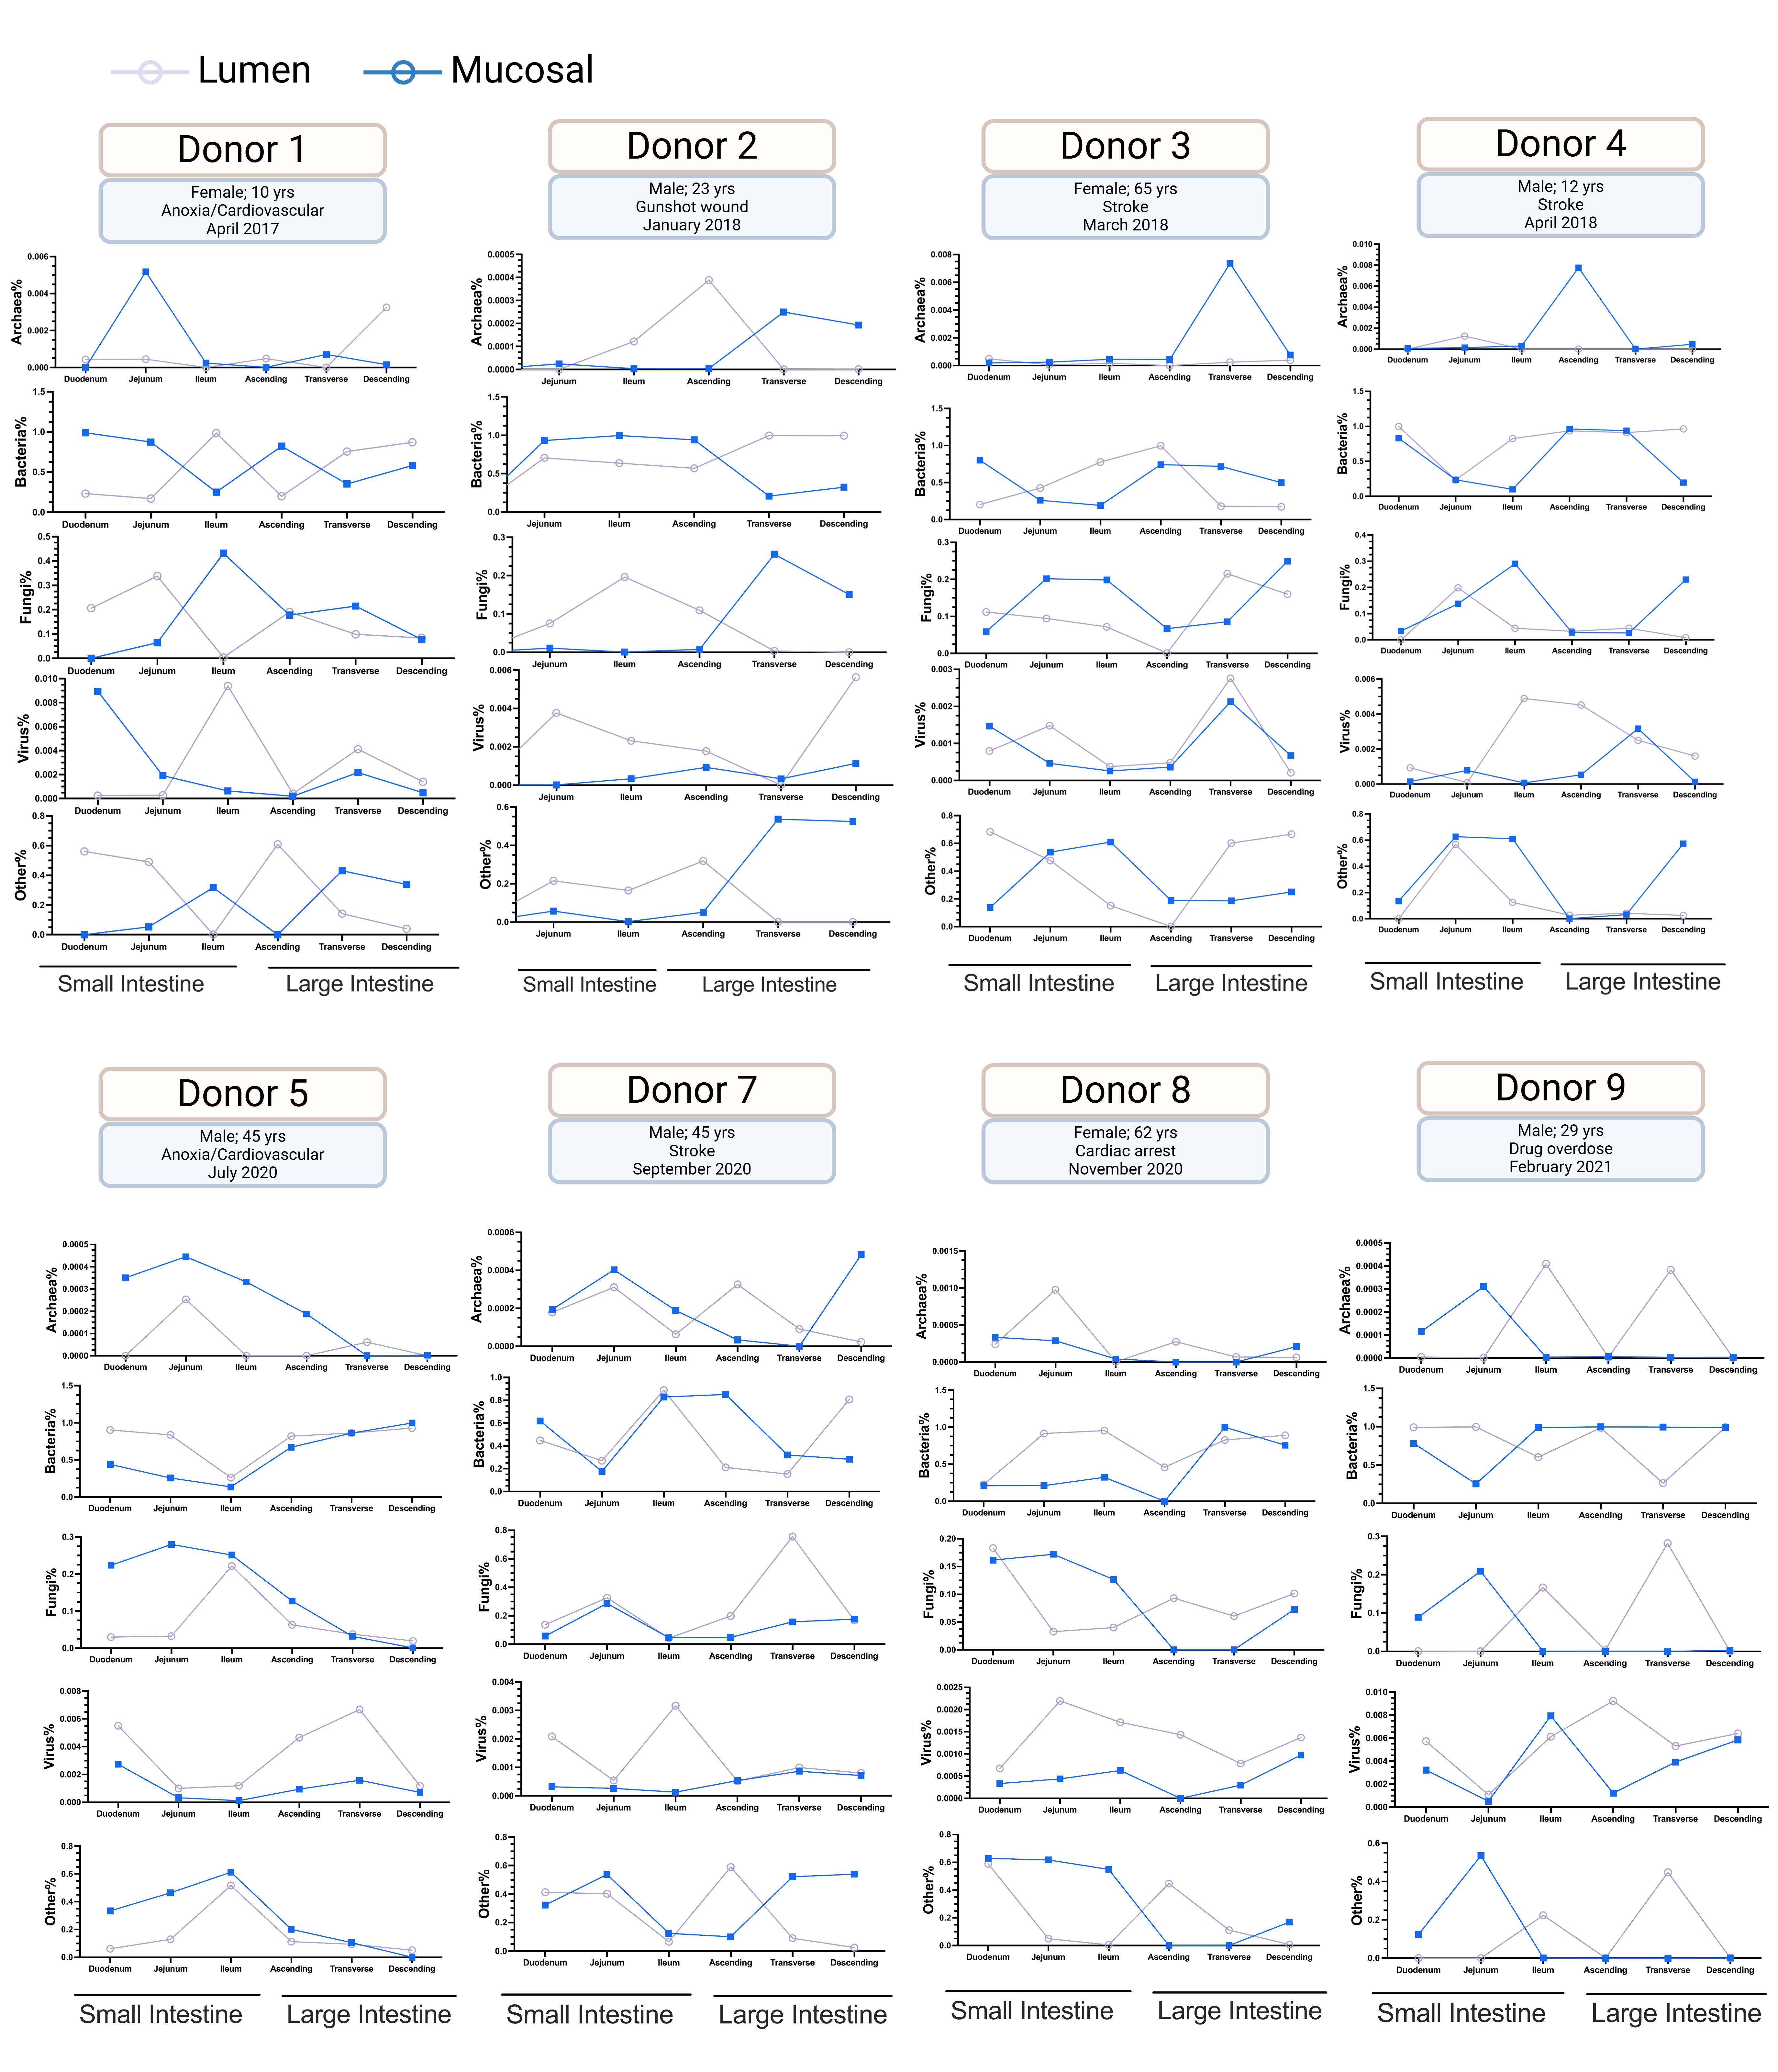
Figure S1. Kingdom-level microbial composition across intestinal segments in human donors. Line plots show the relative abundance of major microbial kingdoms (bacteria, fungi, viruses, and others) derived from whole-genome shotgun (WGS) sequencing across intestinal segments, including the duodenum, jejunum, ileum, ascending colon, transverse colon, and descending colon. Purple lines denote lumen content samples, and blue lines denote mucosal samples. Donor metadata, including sex, age, cause of death, and sample collection year, are provided.
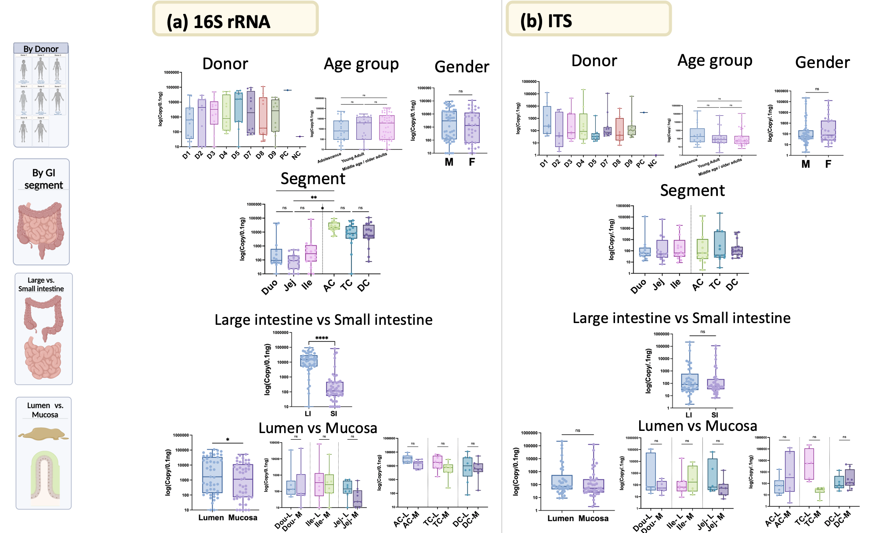
Figure S2. Absolute microbial abundance measured by qPCR across donors and sample characteristics. Quantitative PCR (qPCR) measurements of absolute microbial abundance using (a) 16S rRNA gene primers (bacterial load) and (b) internal transcribed spacer (ITS) primers (fungal load). Data are stratified by donor, age, sex, intestinal segment (Duo, duodenum; Jej, jejunum; Ile, ileum; AC, ascending colon; TC, transverse colon; DC, descending colon), section (large intestine versus small intestine), and sample milieu (lumen versus mucosa), illustrating variation in microbial load across host and spatial factors.

Figure S3. Phylogenetic trees of the most abundant microbial taxa. (a) Phylogenetic tree of the bacteriome based on species with ≥5,000 reads and ≥20% prevalence. (b–e) Phylogenetic trees of the mycobiome, archaeome, virome, and other non-fungal eukaryotic microbiome, respectively, based on species with ≥1,000 reads and ≥10% prevalence. For all panels (a–e), concentric heatmaps illustrate the relative abundance of taxa across intestinal regions, sample milieus, and donors. Bars in the outer ring indicate the number of donors (0–8) in which each species was observed.

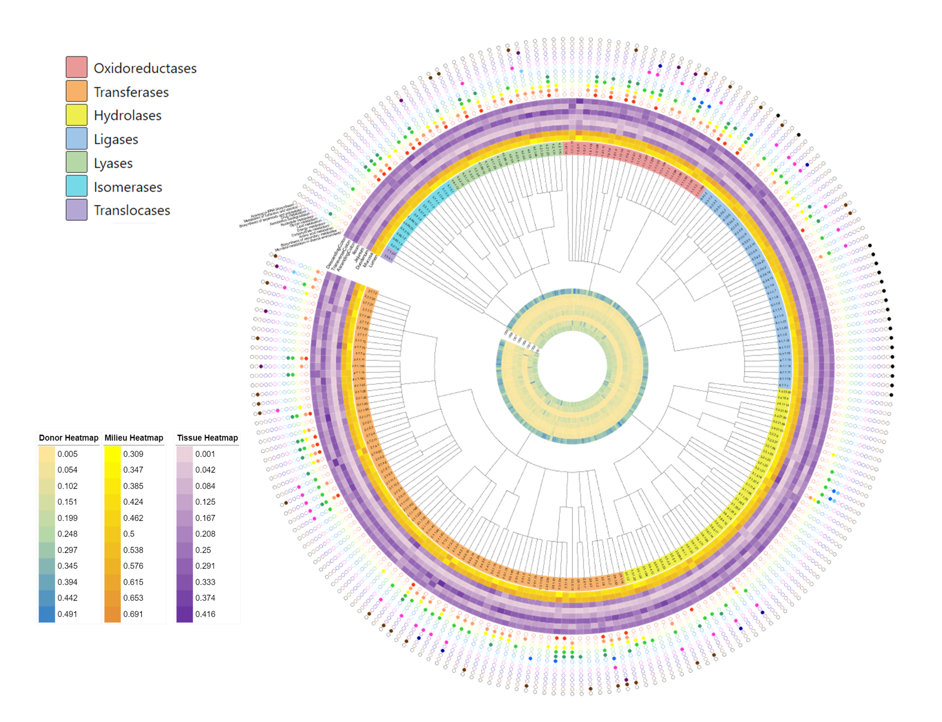
Figure S4. Phylogenetic tree of core functional Enzyme Commission (EC) categories. Core functional properties are represented using the Enzyme Commission (EC) classification system. Core EC features are defined based on a relative abundance ≥0.0001 and a prevalence ≥50%. The outer concentric circles indicate the major metabolic pathways associated with each EC number.

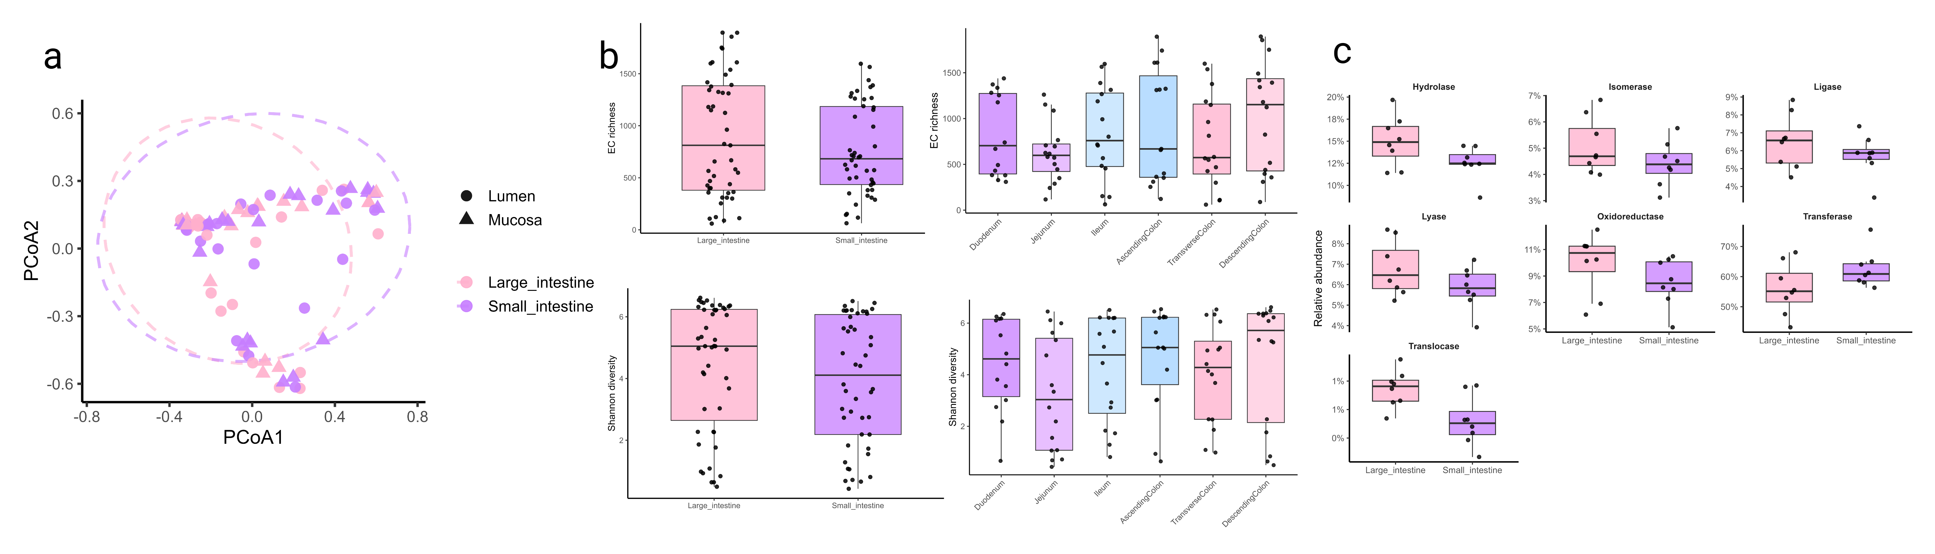

Figure S5. EC functional diversity across intestinal regions. (a) Beta diversity of EC profiles comparing sample milieu (lumen versus mucosa) and intestinal sections (large versus small intestine). (b) Alpha diversity, including richness and Shannon diversity, across intestinal sections (large versus small intestine) and individual segments (duodenum, jejunum, ileum, ascending colon, transverse colon, and descending colon). (c) Relative abundance of seven major enzyme classes across the large and small intestine.
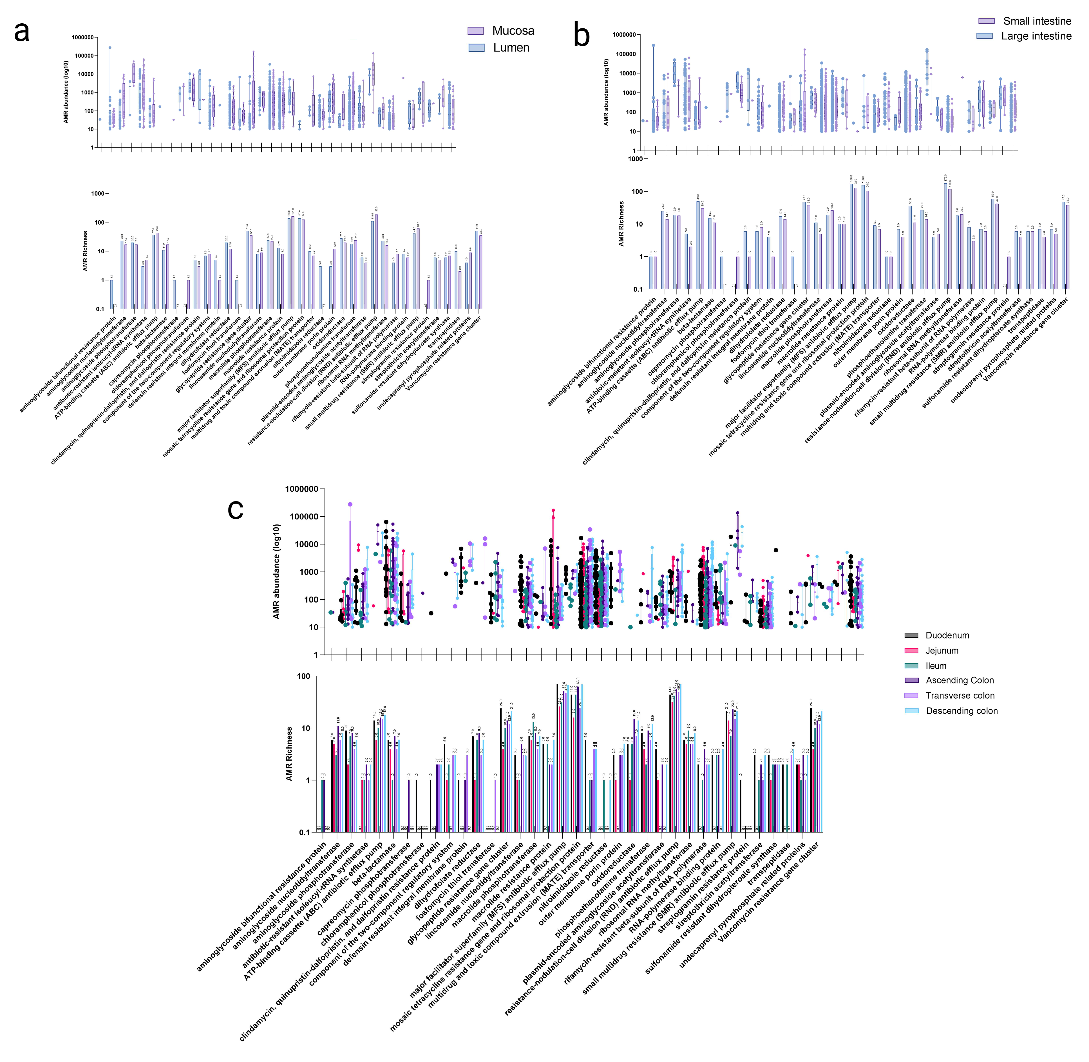
Figure S6. Antimicrobial resistance (AMR) gene family abundance and richness across intestinal environments. Abundance and richness of AMR gene families are shown across (a) sample milieu (mucosa versus lumen), (b) intestinal sections (small versus large intestine), and (c) individual segments (duodenum, jejunum, ileum, ascending colon, transverse colon, and descending colon).
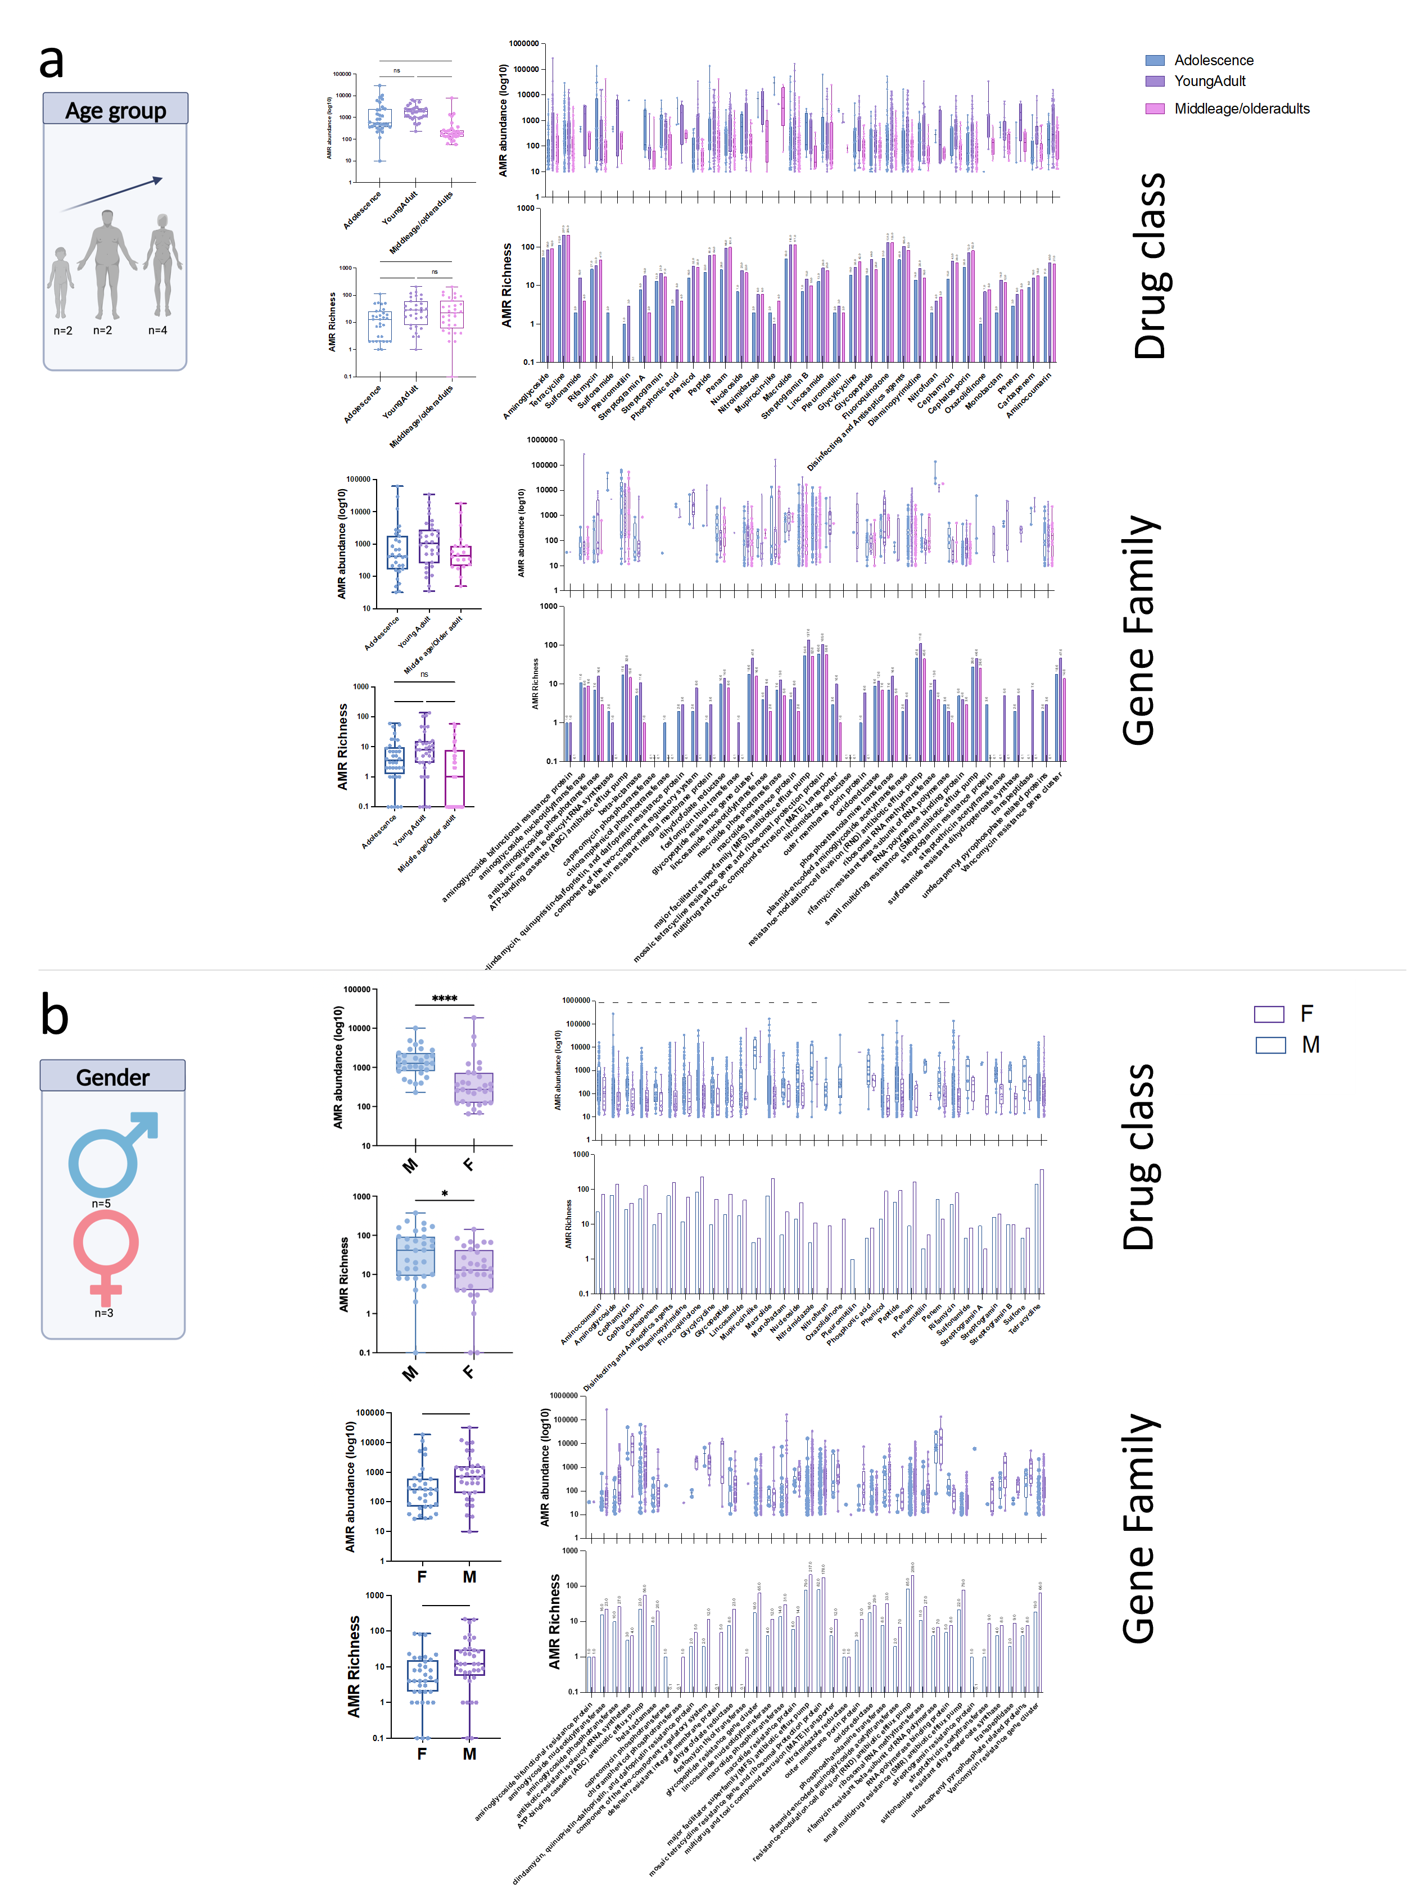
Figure S7. AMR gene class and family diversity stratified by host demographics.
Abundance and richness of antimicrobial resistance (AMR) gene drug classes and gene families are shown stratified by (a) age and (b) gender.
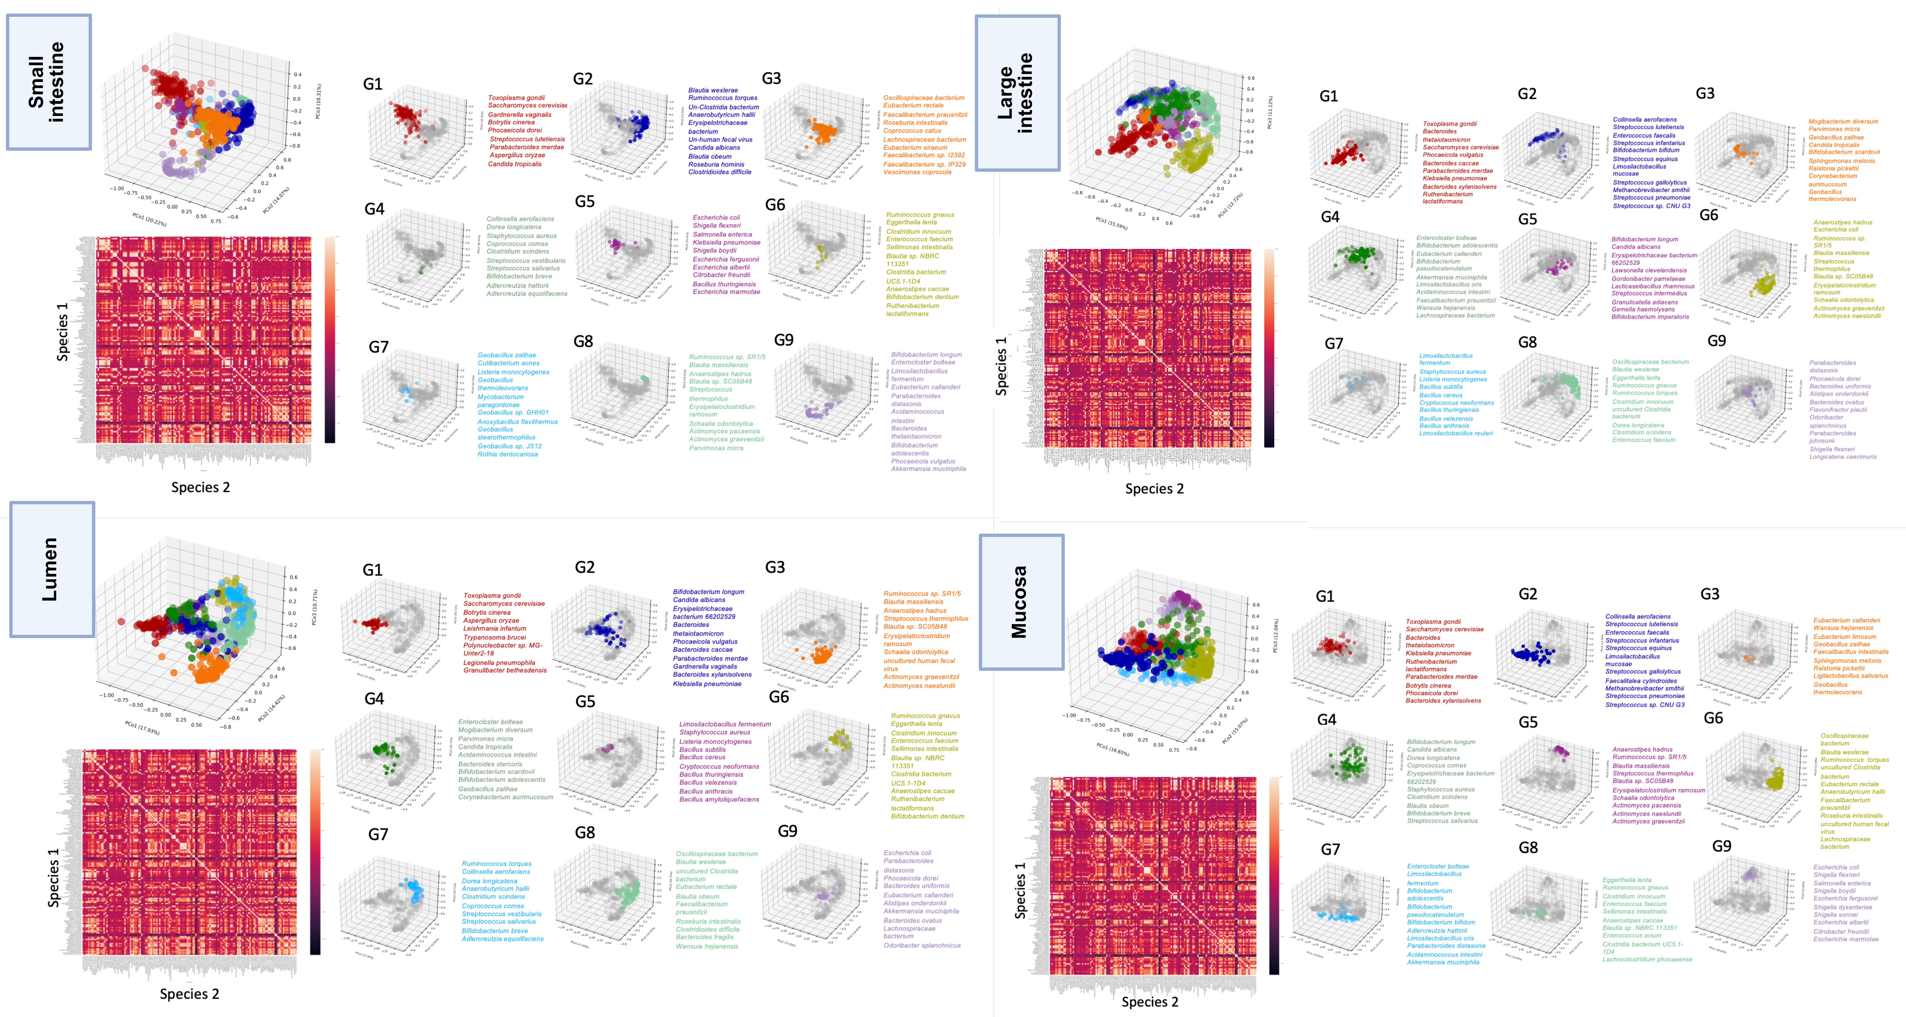

Figure S8. Microbial community clustering and correlation structure across intestinal regions and milieus. Cluster analysis based on CCrepe-derived correlations of species relative abundance identified distinct microbial community structures. Four panels represent the small intestine, large intestine, lumen, and mucosa, respectively. Niche-associated communities, which we determined as Persistent microbial community states (PMCs), were identified. Within each cluster, correlation analysis of the top 10 most abundant taxa defined smaller units of correlation structure (UCS).

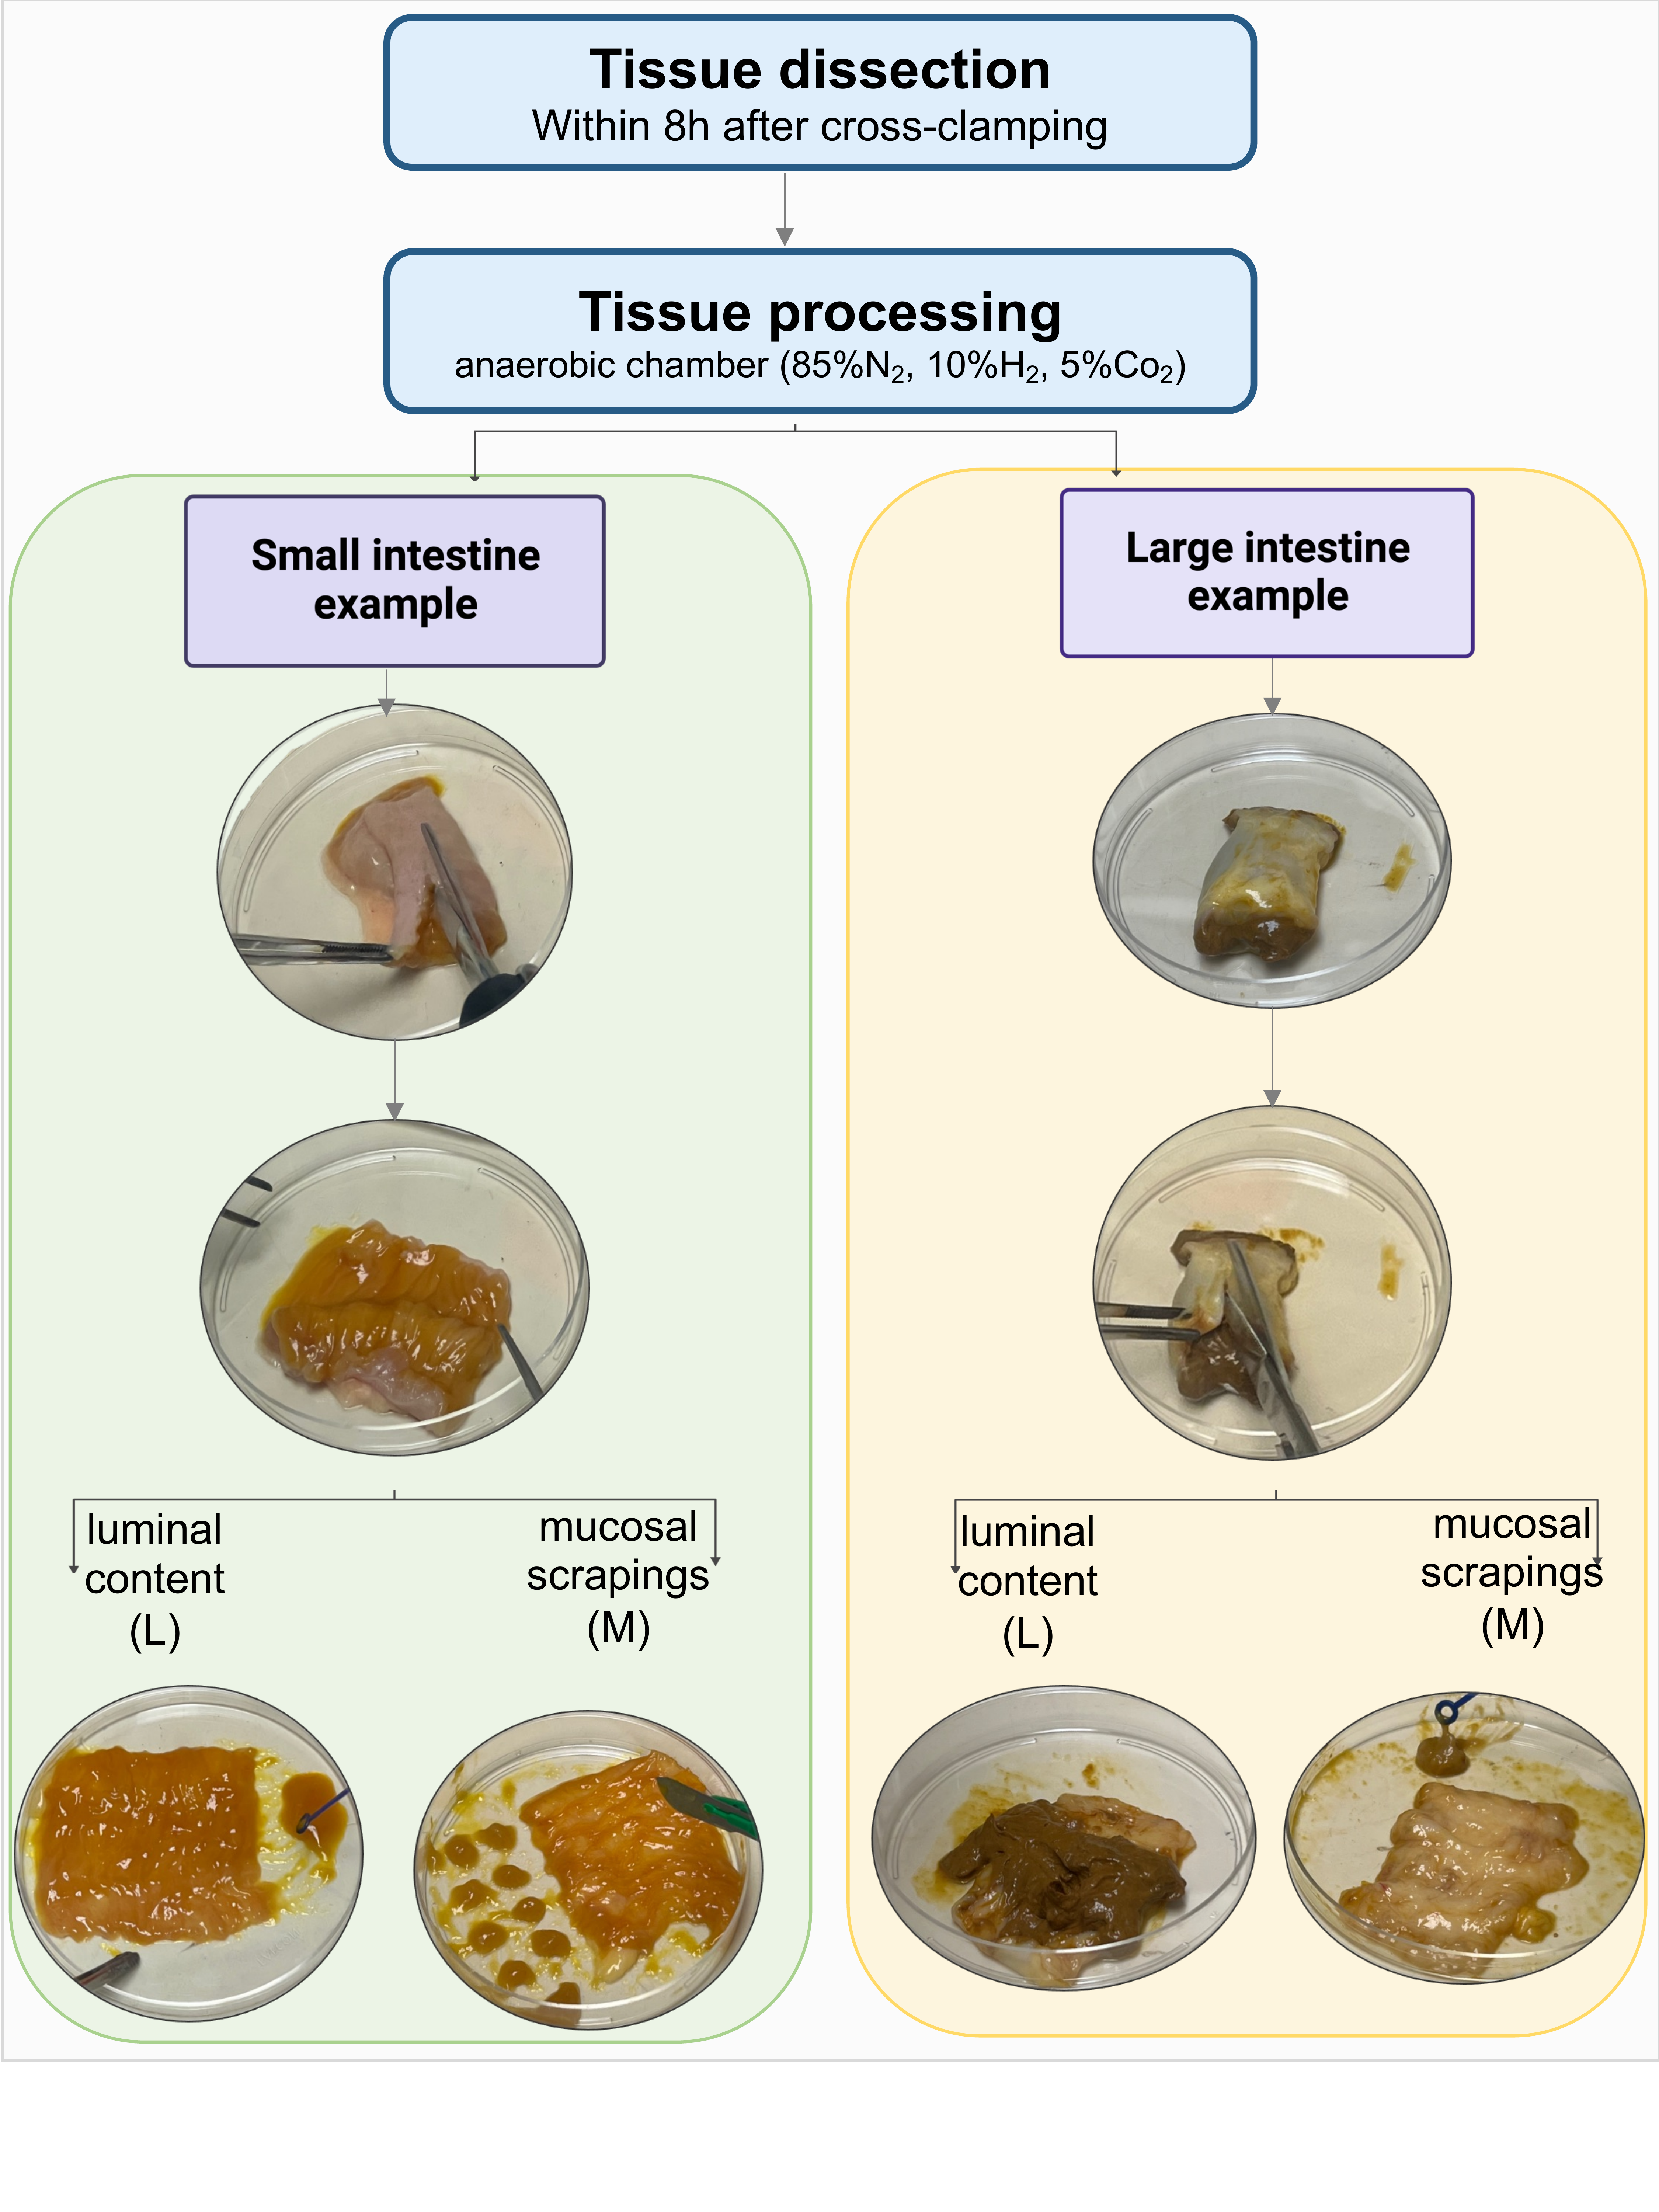
Figure S9. Tissue collection and sample processing. The intestinal samples were obtained from six segments (duodenum, jejunum, ileum, ascending colon, transverse colon, and descending colon), and each fragment was subdivided into luminal contents and mucosal scrapings, yielding 12 samples per donor. Mucosal scrapings were collected using a sterile surgical blade, and luminal contents were obtained using sterile disposable culture loops.

