ONLINE SUPPLEMENT

Brief Report: Invisible at Birth: State Administrative Capacity, Subnational Development Inequality, and Civil Registration Completeness — Cross-National Evidence from 150 Countries

Contents
Figure S1. Distribution of Birth Registration Completeness and Governance Quality by Region
Figure S2. Standardised Regression Coefficients for Governance Quality (WGI Composite) with 95% Confidence Intervals across Four Model Specifications
Figure S3. HDI–Registration Relationship by Governance Quality Tertile

Figure S1
Distribution of Birth Registration Completeness (Panel A) and Composite Governance Quality (Panel B) by World Region
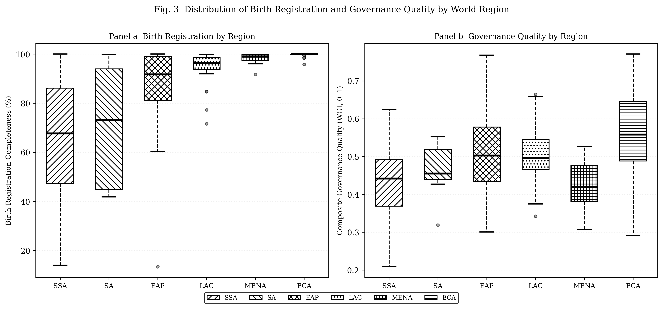Note. SSA = Sub-Saharan Africa; SA = South Asia; EAP = East Asia and Pacific; LAC = Latin America and Caribbean; MENA = Middle East and North Africa; ECA = Europe and Central Asia. Box fill patterns distinguish regions in black-and-white print.

Figure S2
Standardised Regression Coefficients for Governance Quality (WGI Composite) with 95% Confidence Intervals across Four Model Specifications
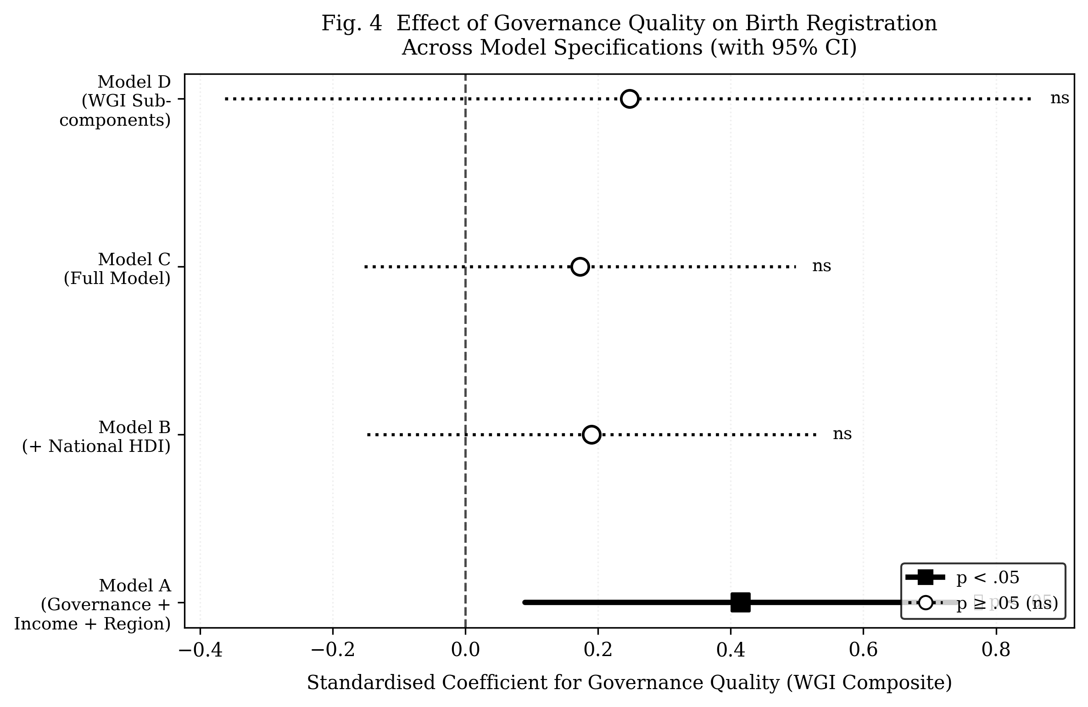
Note. Filled squares (solid line) indicate p < .05; open circles (dotted line) indicate p ≥ .05. Coefficients from Models A–D (see Table 2). WGI = Worldwide Governance Indicators.

Figure S3
Relationship between National HDI and Birth Registration Completeness, Stratified by Governance Quality Tertile
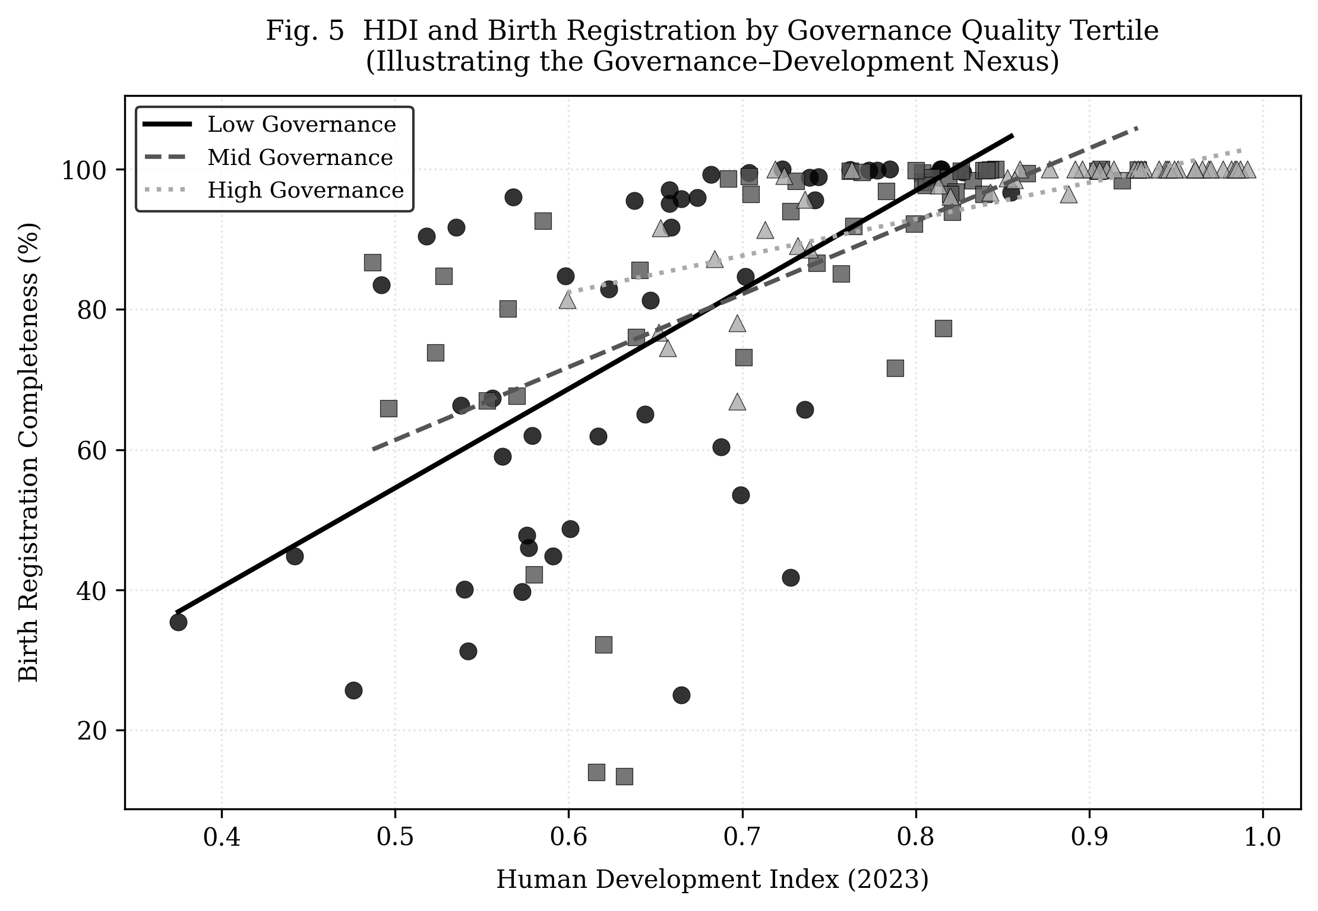
Note. Points represent individual countries; lines show OLS fits within each tertile. Dark solid line = low governance tertile; mid-grey dashed = mid governance tertile; light grey dotted = high governance tertile. HDI = Human Development Index; OLS = ordinary least squares.

Level 2 heading
Sensitivity Analysis: OLS Regression Results for Low- and Lower-Middle-Income Countries (n = 67)

Among the 67 low- and lower-middle-income countries, governance quality was directionally positive but did not reach statistical significance (β = 0.38, SE = 0.30, p = .204), while national HDI remained significant (β = 1.03, SE = 0.40, p = .013). Regional effects were especially pronounced in this subsample: Sub-Saharan African low- and middle-income countries showed registration rates nearly three logit units below income-comparable countries in other regions, net of governance and HDI. This points to region-specific institutional and historical factors — including the post-colonial configuration of civil registration systems — that current WGI scores do not fully capture within the low-income stratum. A full tabular presentation of the sensitivity analysis models is available from the authors upon request.

Note. OLS = ordinary least squares; HDI = Human Development Index; WGI = Worldwide Governance Indicators. All continuous predictors standardised (M = 0, SD = 1). Reference region = Europe and Central Asia.

