Supplementary Figures

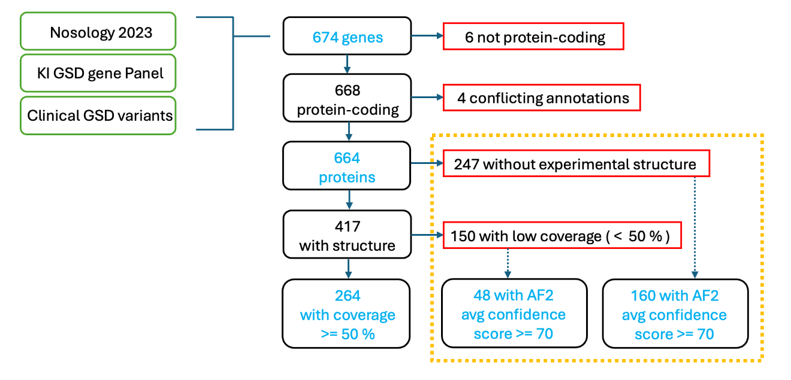
Supplementary Fig. 1 Overview of structural knowledge statistics across GSD-associated proteins.
Summary of experimental structure availability, sequence coverage, AlphaFold2 model confidence, and observed multimeric states across the GSD protein dataset. The figure highlights systematic gaps in structural knowledge and illustrates how predicted models and multimeric context contribute complementary information for variant interpretation.

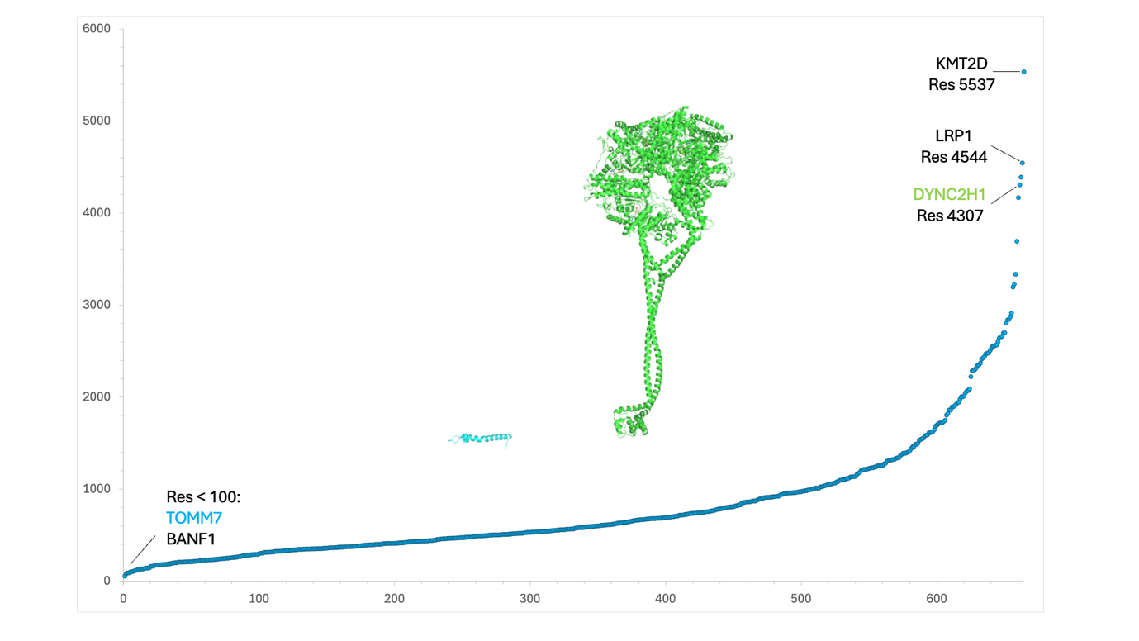
Supplementary Fig. 2 Protein size distribution of genetic skeletal disorder–associated proteins.
Distribution of canonical protein lengths for the 664 protein-coding genes included in this study. Protein sizes span more than two orders of magnitude, reflecting the functional and structural heterogeneity of genetic skeletal disorder (GSD) proteins. The inset highlights representative extremes, with DYNC2H1 among the largest proteins and TOMM7 among the smallest, illustrating challenges for experimental structural characterization of large multidomain proteins.

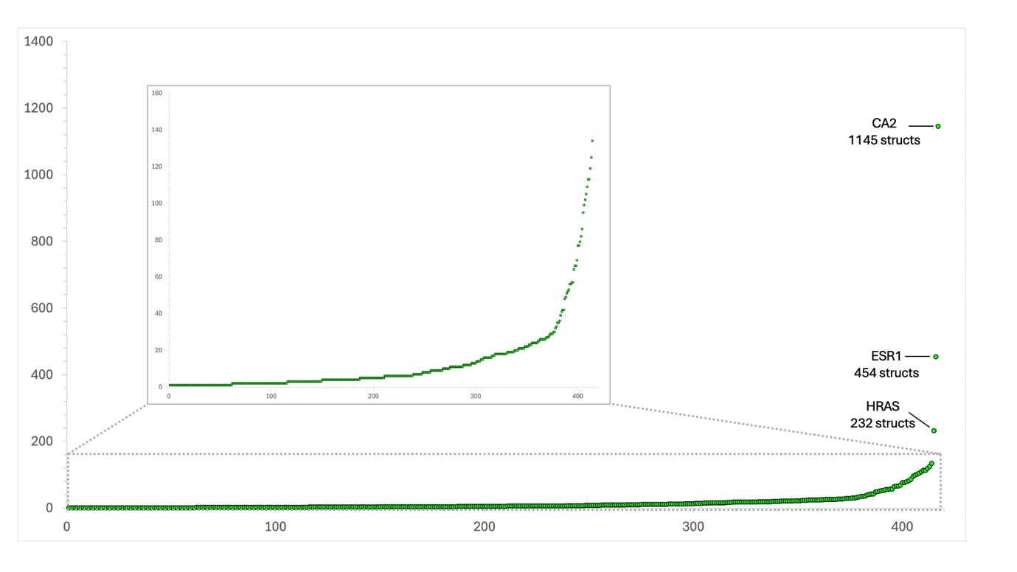
Supplementary Fig. 3 Availability of experimental protein structures across GSD-associated genes.
Number of experimentally determined structures per GSD-associated protein based on Protein Data Bank entries. While a subset of proteins shows extensive structural representation—often due to intensive study in non-skeletal disease contexts—the majority of proteins are represented by relatively few structures, and 37% lack experimental structures entirely. The inset shows proteins represented by fewer than 200 structures.

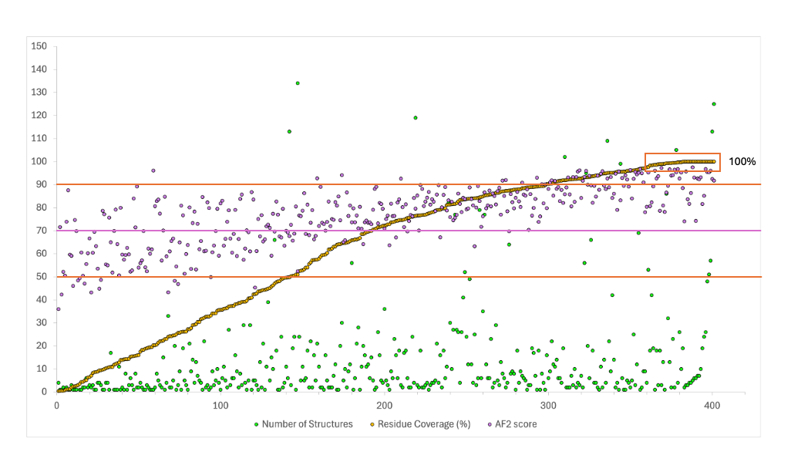
Supplementary Fig. 4 Sequence coverage of GSD proteins by experimental structures.
Distribution of experimental sequence coverage, defined as the fraction of residues in the canonical protein sequence observed in at least one experimental structure. Many proteins exhibit partial or fragmentary coverage, limiting structure-based interpretation of genetic variants to specific domains rather than full-length architectures. Overlap between the number of experimental structures and AlphaFold2 average confidence score (AF2 score). Lines are depicted for 50% and 90% for the coverage and 70% for AF2 score. The square includes structures with 100% coverage. Proteins with more than 200 structures are not included.

Supplementary Tables
Large datasets are provided as separate supplementary files (Additional Files 1–5), while smaller tables are included in the Supplementary Information document.
Supplementary Table S1
Gene lists integrated in this study, including the Karolinska University Hospital GSD diagnostic panel (KI_PAN), Nosology 2023 (NOS23), and clinically investigated GSD genes (KI_CLI).
Datasets | Abbreviation | Description | Reference
Karolinska Hospital Gene Panel | KI_Pan | Genes used in the screening panel in clinical practice at Karolinska Hospital | n.a.
Karolinska Hospital Clinical Cases | KI_Cli | Pathology-driving genes found in GSD patients at Karolinska Hospital in 2015-2022 | ¹
GSD Nosology 2023 | NOS23 | List of genes included in the later nosology paper for genetic skeletal disorders of 2023 | ²
¹ Manuscript in preparation, Lindelöf et al 2026
² Unger S et al. Am J Med Genet A. 2023;191:1164–209.
n.a.= not applicable
Supplementary Table S2
Genes with discrepant nomenclature between Nosology 2023 and official HGNC gene symbols, with manual resolution.
Genes from NOS23 with different names | Correct namesª
PPGB | CTSA
EVC1 | EVC
FUCA | FUCA1
GBA | GBA1
DHPAT | GNPAT
CGAF | LYSET
ZAK | MAP3K20
CIAS1 | NLRP3
PTHR1 | PTH1R
OPG | TNFRSF11B
IMPAD1 | BPNT2
FAM58A | CCNQ
DDX58 | RIGI
ARSE | ARSL
TCTEX1D2 | DYNLT2B
WDR34 | DYNC2I2
WDR60 | DYNC2I1
WISP3 | CCN6
ªAccording to HUGO Gene Nomenclature Committee (HGNC) database [23], accessed January 2025
Supplementary Table S3
Excluded NOS23 entries corresponding to loci, regulatory elements, or non–protein-coding annotations.
Genes or loci | Reason for exclusion
10q24 | Locus encompassing several genes
11p15.5 | Locus encompassing several genes
14q32 | Locus encompassing several genes
2p14‐p13.3 | No gene identified
2q35‐36 | Locus deletion involved in abnormal PAX3 expression (PAX3 is included in the study)
8q22.1 | Locus encompassing several genes
MAENLI | lncRNA regulating EN1 (EN1 is included in the study)
ZRS | Regulatory element for SHH gene in intron of LMBR1 gene (both SHH and LMBR1 genes are included in the study)
Supplementary Table S4 – Additional File 1
Final curated list of GSD-associated genes with HGNC identifiers, UniProt accessions, and primary gene names.
Supplementary Table S5
Excluded genes due to non–protein-coding status or unresolved protein–gene mapping conflicts.
Gene Name | HGNC id | Reason for exclusion
HAGLR | 43755 | non protein-coding
MIR140 | 31527 | non protein-coding
MIR17HG | 23564 | non protein-coding
RMRP | 10031 | non protein-coding
RNU12 | 19380 | non protein-coding
RNU4ATAC | 34016 | non protein-coding
GNAS | 4392 | Conflicting gene-protein mapping
RAB34 | 16519 | Conflicting gene-protein mapping
VCP | 12666 | Conflicting annotations unrelated to GSD

Supplementary Table S6 – Additional File 1
Final dataset of 664 protein-coding GSD genes included in structural and functional analyses.
Supplementary Table S7 – Additional File 2
Protein structural statistics, including canonical sequence length, number of experimental structures, sequence coverage, AlphaFold2 model availability, and average pLDDT confidence scores.
Supplementary Table S8
AlphaFold2 confidence scores for GSD proteins with and without experimental structures.
 | Proteins without structures | Proteins with structures | Proteins with low coverage (<50%)ª | Proteins with high coverage (>=50%)ª
N | 247 | 417 | 150 | 264
No AF2 | 5 | 11 | 8 | 3
Correct N | 242 | 406 | 142 | 261
Confidence Score | N (%) | N (%) | N (%) | N (%)
Very high (pLDDT>90) | 35 (14%) | 67 (17%) | 1 (1%) | 65 (25%)
High  (90>pLDDT>70) | 125 (52%) | 227 (56%) | 47 (33%) | 179 (68%)
Low  (70>pLDDT>50) | 69 (29%) | 98 (24%) | 80 (56%) | 17 (7%)
Very low (pLDDT<50) | 13 (5%) | 14 (3%) | 14 (10%) | 0 (0%)
pLDDT >=70 | 160 (66%) | 294 (73%) | 48 (34%) | 244 (93%)
pLDDT <70 | 82 (34%) | 112 (27%) | 94 (66%) | 17 (7%)
 | Confidence Score | Confidence Score | Confidence Score | Confidence Score
MIN | 39.88 | 35.93 | 35.93 | 52.42
MAX | 95.81 | 97.53 | 96.04 | 97.53
AVERAGE | 75.12 | 77.17 | 65.62 | 83.41
ª for three proteins it was not possible to calculate the coverage, so the sum of the numbers in the low and high coverage columns don’t always coincide with the “protein with structure columns”

Supplementary Table S9
High-confidence AlphaFold2 models for structural homologs of GSD proteins without experimental structures or with low experimental coverage (“rescued” proteins).
Gene Names | AF2 scoreª | FS Results^{b} | Closer Homolog^{c} | E-value^{d}
MANBA | 95.81 | 93 | GUSB^{e} | 2.19E-24
PGM3 | 95.41 | 26 | PGM1^{f} | 8.06E-11
PRKACB | 95.23 | 595 | PRKACA^{e} | 1.03E-58
PEX7 | 95.03 | 604 | RBBP4 | 1.12E-25
MAB21L2 | 94.86 | 120 | MAB21L1 | 1.86E-56
MAN2C1 | 94.48 | 11 | GALM | 8.56E-04
PHEX | 94.48 | 7 | MME | 3.32E-56
FAR1 | 94.27 | 132 | GMDS | 1.16E-09
TGDS | 94.21 | 103 | GMDS | 1.54E-25
ALG12 | 93.3 | 4 | STT3B | 1.78E-05
KDELR2 | 93.3 | 3 | CTNS | 2.61E-03
ARSL | 93.17 | 68 | ARSA | 8.96E-43
PRMT7 | 93.16 | 234 | PRMT3 | 1.27E-19
FAM20B | 93.09 | 16 | FAM20A | 8.33E-36
PLOD1 | 92.79 | 289 | PLOD3^{h} | 0.00^{g}
TRAPPC2 | 92.44 | 5 | TRAPPC4 | 1.68E-04
PGAP3 | 92.4 | 2 | LPAR1 | 9.02E-03
IFT80 | 92.3 | 317 | WDR35e | 1.97E-32
DHCR24 | 92.29 | 12 | D2HGDH | 1.30E-10
PLOD2 | 92.13 | 291 | PLOD3^{h} | 0.00^{g}
MTX2 | 92.03 | 231 | GDAP1 | 1.56E-05
DPM2 | 91.83 | 0 | n.a. | n.a.
HS2ST1 | 91.67 | 12 | SULT2A1 | 6.56E-04
EOGT | 91.43 | 8 | POMGNT2 | 7.12E-17
FBXW4 | 91.43 | 611 | FBXW7 | 1.41E-20
MAN2B1 | 91.43 | 0 | n.a. | n.a.
TBXAS1 | 91.35 | 288 | CYP3A7 | 2.67E-35
DHCR7 | 91.3 | 0 | n.a. | n.a.
SERPINH1 | 91.17 | 236 | SERPINB1 | 4.53E-37
UFSP2 | 91.1 | 5 | ZUP1 | 1.88E-09
CYP26B1 | 90.39 | 287 | CYP51A1 | 1.20E-22
B3GALT6 | 90.31 | 274 | B3GNT2 | 2.13E-17
ARSK | 90.3 | 64 | IDS^{e} | 3.52E-25
RFT1 | 90.27 | 0 | n.a. | n.a.
PIGV | 90 | 3 | STT3A^{i} | 1.89E-03
NANS | 96.04 | 6 | OGA | 5.41E-06
ª AF2 average confidence score
^{b} FoldSeek (FS) result,s meaning the number of chains in PDB structures of HUMAN proteins retrieved using the AF2 model of the protein as query
^{c} gene name of the first result ranked by E-value
^{d} corresponding E-value of the closer homolog
^{e} known GSD gene
^{f} MIM:614921; short stature
^{g} probable error in E-value
^{h} MIM:612394 BCARD syndrom; Bone abnormalities
^{i} MIM:619714; short stature
n.a.= not applicable
Supplementary Table S10 – Additional File 3
Annotated biological pathways associated with GSD proteins
Supplementary Table S11 – Additional File 3
GSD Genes associated with statistically significant pathways
Supplementary Table S12 – Additional File 4
Observed multimeric states of GSD proteins based on experimental structures, including monomeric and oligomeric assemblies.
Supplementary Table S13 – Additional File 4
Protein co-occurrence analysis showing GSD protein partners captured within the same experimental structures.
Supplementary Table S14
Proteins without partners in the experimental structures
ACP5, ADI1, AGA, ALPL, ARHGAP25, ARID1B, ARSB, ASAH1, B3GAT3, B4GALT7, BMP1, CA2, CANT1, CDH3, CEP120, CFAP410, CLCN5, COG4, COL10A1, COLEC11, COMP, COPB2, CTSC, CTSK, CYP2R1, CYP3A4, DDX59, DHODH, DIS3L2, DLL4, DLX5, DSE, EBP, EIF2AK3, ERF, EXTL3, FAM111A, FBN1, FERMT3, FIG4, FKBP14, FLNB, FUCA1, GALNS, GBA1, GJA1, GLB1, GNPNAT1, GNPTAB, GPX4, GREM1, GSC, GUSB, HAAO, HOXA13, HPGD, HSPG2, HYAL1, IDH1, IDS, IDUA, IFT172, KIF22, KYNU, LBR, LONP1, LRRK1, LTBP1, MAP3K20, MID1, MMP9, NADSYN1, NAGLU, NANS, NEK1, NFIX, NOTCH2, NSDHL, NSMCE2, PAPSS2, PAX3, PHGDH, PIK3C2A, PIR, PRKAR1A, PRKG2, PSAT1, PSPH, PTDSS1, PYCR1, RAB23, RARG, RBM10, RECQL4, ROR2, RPGRIP1L, SATB2, SERPINF1, SGK3, SGSH, SIK3, SLC13A1, SLC17A5, SLC25A24, SLC26A2, SMCHD1, SMS, SOX9, TALDO1, TBCE, TBX3, TFAP2B, TMEM67, TOP2B, TRAF3IP1, TRAF7, TRIM37, USP9X, ZIC3, ZNF462.

Supplementary Table S15
Protein co-occurrence analysis showing GSD–GSD protein partners.
Number of components | Co-occurring partners
2 | AGRN, LRP4
2 | ALX4, TWIST1
2 | ANAPC1, ANAPC5
2 | CBFB, RUNX2
2 | CCDC22, VPS35L
2 | CLCN7, OSTM1
2 | EDN1, EDNRA
2 | EFL1, SBDS
2 | EP300, TP63
2 | EXT1, EXT2
2 | FBLIM1, FLNA
2 | FUZ, INTU
2 | GH1, GHR
2 | HHAT, SHH
2 | NPPC, NPR3
2 | NOTCH1, RBPJ
2 | PTH1R, PTHLH
2 | SEC23A, SEC24D
2 | TNFSF11, TNFRSF11B
3 | AXIN1, LRP6, SOST
3 | BANF1, LMNA, ZMPSTE24
3 | BMP2, GDF5, NOG
3 | CASR, GNAI2, GNAI3
3 | CEP63, CEP152, PLK4
3 | CRTAP, P3H1, PPIB
3 | EED, EZH2, SUZ12
3 | FGF8, FGF10, FGFR2
3 | IL11RA, IL6ST, LIFR
3 | PIK3CA, PIK3R1, PDGFRB
3 | PORCN, WNT3A, WLS
4 | DYNC2I1, DYNC2I2, DYNC2H1, DYNC2LI1
4 | RAD21, SMC1A, SMC3, NIPBL
4 | RPL13, DDRGK1, TMCO1, ETF1
5 | TGFBR2, TGFB1, TGFB2, TGFB3, TGFBR1
5 | H3-3A, TONSL, DNMT3A, SETD2, CDC73
6 | SMAD2, SMAD4, SKI, LEMD3, CREBBP, PIN1
6 | ACTB, SMARCA4, SMARCB1, SRCAP, SMARCE1, ARID1A
6 | FGFR1, FGF9, CSF1R, KL, FGF23, FGFR3
6 | IFT140, IFT43, IFT122, TTC21B, WDR19, WDR35
6 | POLR1A, POLR1B, POLR1C, POLR1D, POLR3A, POLR3B
8 | EFTUD2, SNRPB, ZMAT2, EIF4A3, RBM8A, SF2B4, CRIPT, TXNL4A
8 | COL1A1, COL1A2, COL9A1, COL9A2, COL9A3, FN1, ESR1, PTPN11
12 | MCM5, MCM7, GINS2, CDC45, MCM3, POLE, ORC6, ORC1, ORC4, CDC6, CDT1, GMNN
Supplementary Table S16
ClinVar pathogenicity re-classification.
Pathogenic (5) | Likely Pathogenic (4) | Uncertain Significance (3) | Likely Benign (2) | Benign (1) | Not provided (0)
"Pathogenic; other" | "Pathogenic/Likely pathogenic" | "Uncertain significance; association" | "Likely benign; other" | "Benign; other" | "no classification for the individual variant"
"Pathogenic; risk factor" | "Pathogenic/Likely pathogenic; other" | "Uncertain significance; other" | "Likely benign; risk factor" | "Benign; risk factor" | "no classification for the single variant"
"Pathogenic; confers sensitivity" | "Pathogenic/Likely pathogenic; association" | "Uncertain significance; risk factor" | "Likely benign; drug response" | "Benign; association" | "no classifications from unflagged records"
"Pathogenic; association" | "Pathogenic/Likely pathogenic; risk factor" | "Uncertain significance; drug response" | "Likely benign; association" | "Benign; drug response"
"Pathogenic; drug response" | "Pathogenic/Likely pathogenic; drug response" | "Uncertain significance; confers sensitivity" | "Likely benign; confers sensitivity" | "Benign; confers sensitivity"
"Pathogenic, low penetrance" | "Pathogenic/Likely pathogenic; confers sensitivity" | "Uncertain risk allele" | "Benign/Likely benign"
"Established risk allele" | "Likely pathogenic; other" | "Uncertain significance/Uncertain risk allele" | "Benign/Likely benign; other"
"Oncogenic" | "Likely pathogenic; risk factor" | "Likely risk allele" | "Benign/Likely benign; risk factor"
 | "Likely pathogenic; association" | "other" | "Benign/Likely benign; drug response"
 | "Likely pathogenic; drug response" | "drug response" | "Benign/Likely benign; association"
 | "Likely pathogenic; confers sensitivity" | "association" | "Benign/Likely benign; confers sensitivity"
 | "Likely pathogenic, low penetrance" | "confers sensitivity"
 | "Pathogenic/Likely pathogenic/Pathogenic, low penetrance" | "Affects"
 | "Likely oncogenic" | "risk factor"
 |  | "vus"
 |  | "Conflicting classifications of pathogenicity"
 |  | "Conflicting classifications of pathogenicity; other"
 |  | "Conflicting classifications of pathogenicity; risk factor"
 |  | "Conflicting classifications of pathogenicity; association"
 |  | "Conflicting classifications of pathogenicity; drug response"
 |  | "Conflicting classifications of pathogenicity; confers sensitivity"
 |  | "conflicting data from submitters"

Supplementary Table S17
Subset of GSD proteins selected for detailed clinical variant mapping, including criteria based on sequence coverage (>= 95 %), protein length (>=400), and structural representation (<= 3).
Gene Name | Number of Structures | Residue Coverage | Residue Coverage (%) | Partners? | GSD Partners?
BBS1 | 1 | 567 | 95.6 | YES
EFL1 | 2 | 1120 | 100 | YES | SBDS
HYAL1 | 1 | 416 | 95.6 | NO
KYNU | 3 | 448 | 96.3 | NO
NADSYN1 | 1 | 696 | 98.6 | NO
NAGLU | 1 | 720 | 96.9 | NO
SGSH | 2 | 482 | 96 | NO
TTC21B | 3 | 1316 | 100 | YES | IFT140, IFT43, IFT122, WDR19, WDR35
VPS33A | 2 | 592 | 99.3 | YES

Supplementary Table S18 – Additional File 5
Overlap between GSD-associated genes and cancer-associated genes from publicly available Cancer Gene Census resources.
Supplementary Information

Additional file 1 Tables S4 & S6. Gene curation and protein dataset definition.
Supplementary Table S4. Final curated list of GSD-associated genes with HGNC identifiers, UniProt accessions, and primary gene names.
Supplementary Table S6. Final dataset of 664 protein-coding GSD genes included in structural and functional analyses.
Additional file 2 Table S7. Structural statistics and AlphaFold2 confidence scores.

Supplementary Table S7. Structural statistics for GSD proteins, including canonical sequence length, number of experimental structures, sequence coverage, AlphaFold2 model availability, and average pLDDT confidence scores.

Additional file 3 Tables S10–S11. Pathway enrichment analysis of GSD proteins.
Supplementary Table S10. Annotated biological pathways associated with GSD proteins identified using PANTHER pathway analysis.
Supplementary Table S11. GSD genes associated with statistically significant pathways.

Additional file 4 Tables S12–S13. Multimeric assemblies and protein co-occurrence.
Supplementary Table S12. Observed multimeric states of GSD proteins based on experimental structures.
Supplementary Table S13. Protein co-occurrence analysis showing interacting partners captured within the same experimental structures.

Additional file 5 Table S18. Overlap with cancer-associated genes.
Supplementary Table S18. Overlap between GSD-associated genes and cancer-associated genes derived from the Cancer Gene Census dataset.

