Supplementary material

Cerebral Blood Flow during Early Antipsychotic Treatment in First Episode Psychosis

Junyu Sun¹, Andrew J Lawrence³, Bridget King¹, Cecila Casetta¹, Fernando Zelaya², Kira Griffiths¹, Laura Marchant¹, Nathalie Rich⁴, Oliver Howes¹, Paola Dazzan³, Rebecca Pollard³, James H MacCabe¹, Alice Egerton¹

¹Department of Psychosis Studies, Institute of Psychiatry, Psychology & Neuroscience, King’s College London, London, United Kingdom
²Department of Neuroimaging, Institute of Psychiatry, Psychology & Neuroscience, King’s College London, London, United Kingdom
³Department of Psychological Medicine, Institute of Psychiatry, Psychology & Neuroscience, King’s College London, London, United Kingdom
⁴Department of Psychiatry, University College London, London, United Kingdom

Supplementary Tables 2
Table S1. Between-study differences in baseline CBF data before and after combat harmonization. 2
Table S2. Intraclass correlation coefficients attributable to study for CBF data before and after harmonization. 3
Table S3. Comparison of linear, quadratic, and logarithmic models for the effect of antipsychotic treatment duration (antipsychotic days) on CBF. 4
Table S4. Associations between days on antipsychotic prior to baseline and CBF at baseline. 5
Table S5. Associations between change in CBF and improvement in PANSS scores. 6
Supplementary Figures 7
Figure S1. Reduction of study-related variance in baseline CBF data after harmonization. 7
Figure S2. Relationship between global CBF and duration of antipsychotic treatment in FEP. 8
Figure S3. Relationship between regional CBF and antipsychotic dose. 9
Figure S4. Model-predicted association between baseline regional CBF and PANSS Total. 10
Figure S5. Within- and between-subject associations between ACC CBF and PANSS Positive. 11
References 12

Supplementary Tables

Table S1. Between-study differences in baseline CBF data before and after combat harmonization.

Baseline CBF | Test Statistics
 | $$t$$ | $$p$$
Raw: Study effect
- Global | -7.64 | < 0.001***
- ACC | -7.86 | < 0.001***
- Striatum | -6.51 | < 0.001***
- Hippocampus | -6.54 | < 0.001***
- Thalamus | -4.17 | < 0.001***
Harmonized: Study effect
- Global | -1.61 | 0.113
- ACC | -1.61 | 0.114
- Striatum | -0.75 | 0.456
- Hippocampus | -1.25 | 0.217
- Thalamus | 0.18 | 0.858
ACC, Anterior Cingulate Cortex; CBF, Cerebral Blood Flow; *** $p$ $≤$ 0.001.

Table S2. Intraclass correlation coefficients attributable to study for CBF data before and after harmonization.

Baseline CBF | Test Statistics
 | $$LB$$ | $$ICC$$ | $$UB$$
Raw: Study effect
- Global | 0.53 | 0.66 | 0.78
- ACC | 0.54 | 0.67 | 0.78
- Striatum | 0.45 | 0.60 | 0.73
- Hippocampus | 0.43 | 0.58 | 0.71
- Thalamus | 0.15 | 0.39 | 0.60
Harmonized: Study effect
- Global | 0.00 | 0.05 | 0.30
- ACC | 0.00 | 0.05 | 0.30
- Striatum | 0.00 | 0.00 | 0.20
- Hippocampus | 0.00 | 0.02 | 0.22
- Thalamus | 0.00 | 0.00 | 0.17
The intraclass correlation coefficients attributable to the study (ICC (study)) was estimated as the proportion of variance attributable to the study relative to the total variance. Values closer to zero indicate minimal study-related effects. LB and UB denote the 95% confidence interval lower and upper bounds, respectively. ACC, Anterior Cingulate Cortex; CBF, Cerebral Blood Flow.

Table S3. Comparison of linear, quadratic, and logarithmic models for the effect of antipsychotic treatment duration (antipsychotic days) on CBF.

CBF | Test Statistics
 | Without global CBF |  | With global CBF
 | $$AIC$$ | $$BIC$$ | $$AIC$$ | $$BIC$$
ACC
- Linear | 772.16 | 788.42 | 537.22 | 556.18
- Quadratic | 772.29 | 791.25 | 537.38 | 556.34
- Log | 773.17 | 789.43 | 539.20 | 560.87
Striatum
- Linear | 710.51 | 726.76 | 597.75 | 616.72
- Quadratic | 709.51 | 728.48 | 598.82 | 620.50
- Log | 712.01 | 728.26 | 598.47 | 617.43
Hippocampus
- Linear | 722.41 | 738.67 | 573.80 | 592.76
- Quadratic | 723.89 | 742.86 | 574.36 | 596.04
- Log | 723.33 | 739.59 | 573.19 | 592.16
Thalamus
- Linear | 728.69 | 744.94 | 571.62 | 590.59
- Quadratic | 727.33 | 746.29 | 572.39 | 594.07
- Log | 729.22 | 745.47 | 571.55 | 590.52
ACC, Anterior Cingulate Cortex; AIC, Akaike Information Criterion; BIC, Bayesian Information Criterion; CBF, Cerebral Blood Flow.

Table S4. Associations between days on antipsychotic prior to baseline and CBF at baseline.

 | Test Statistics
Region | $$β[95\% CI]$$ | $$p$$ | $$N$$
Without covarying for global CBF
Global | 0.20 [-0.07, 0.46] | 0.14 | 53
ACC | 0.20 [-0.09, 0.50] | 0.17 | 53
Striatum | 0.18 [-0.06, 0.42] | 0.14 | 53
Hippocampus | 0.16 [-0.11, 0.44] | 0.24 | 53
Thalamus | 0.05 [-0.20, 0.31] | 0.68 | 53
Covarying for global CBF
ACC | 0.00 [-0.12, 0.12] | 0.99 | 53
Striatum | 0.04 [-0.11, 0.20] | 0.59 | 53
Hippocampus | -0.00 [-0.17, 0.17] | 0.97 | 53
Thalamus | -0.11 [-0.24, 0.02] | 0.08 | 53
Data are presented as β [95% Confidence Interval], with p-values reported in a separate column. ACC, Anterior Cingulate Cortex; CBF, Cerebral Blood Flow.

Table S5. Associations between change in CBF and improvement in PANSS scores.

Region | PANSS
CBF | Total | Positive | Negative | General
Without covarying for global CBF
Global | 0.05 [-0.34, 0.44], p=0.79 | 0.02 [-0.11, 0.15], p=0.73 | -0.05 [-0.20, 0.10], p=0.49 | 0.07 [-0.14, 0.28], p=0.53
ACC | -0.06 [-0.40, 0.29], p=0.75 | -0.03 [-0.14, 0.09], p=0.66 | -0.06 [-0.19, 0.07], p=0.35 | 0.02 [-0.16, 0.21], p=0.80
Striatum | 0.12 [-0.33, 0.57], p=0.60 | 0.00 [-0.15, 0.16], p=0.96 | -0.01 [-0.18, 0.17], p=0.94 | 0.10 [-0.14, 0.35], p=0.41
Thalamus | -0.13 [-0.54, 0.29], p=0.55 | -0.05 [-0.19, 0.09], p=0.51 | -0.06 [-0.22, 0.10], p=0.48 | -0.05 [-0.27, 0.18], p=0.69
Hippocampus | 0.20 [-0.22, 0.62], p=0.35 | 0.06 [-0.08, 0.19], p=0.43 | 0.03 [-0.14, 0.19], p=0.77 | 0.10 [-0.13, 0.32], p=0.40
Covarying for global CBF
ACC | -0.81 [-1.77, 0.16], p=0.10 | -0.38 [-0.70, -0.05], p=0.02 | -0.16 [-0.52, 0.21], p=0.40 | -0.26 [-0.79, 0.27], p=0.34
Striatum | 0.19 [-0.57, 0.95], p=0.62 | -0.05 [-0.31, 0.21], p=0.70 | 0.11 [-0.17, 0.40], p=0.44 | 0.12 [-0.30, 0.53], p=0.58
Thalamus | -0.75 [-1.60, 0.10], p=0.08 | -0.29 [-0.57, -0.01], p=0.04 | -0.04 [-0.36, 0.29], p=0.83 | -0.46 [-0.91, -0.01], p=0.04
Hippocampus | 0.56 [-0.25, 1.37], p=0.18 | 0.13 [-0.14, 0.39], p=0.35 | 0.29 [-0.04, 0.61], p=0.08 | 0.13 [-0.30, 0.56], p=0.54
Data is presented as β [95% CI], p unless otherwise specified. ACC, Anterior Cingulate Cortex; CBF, Cerebral Blood Flow.

Supplementary Figures

Figure S1. Reduction of study-related variance in baseline CBF data after harmonization.
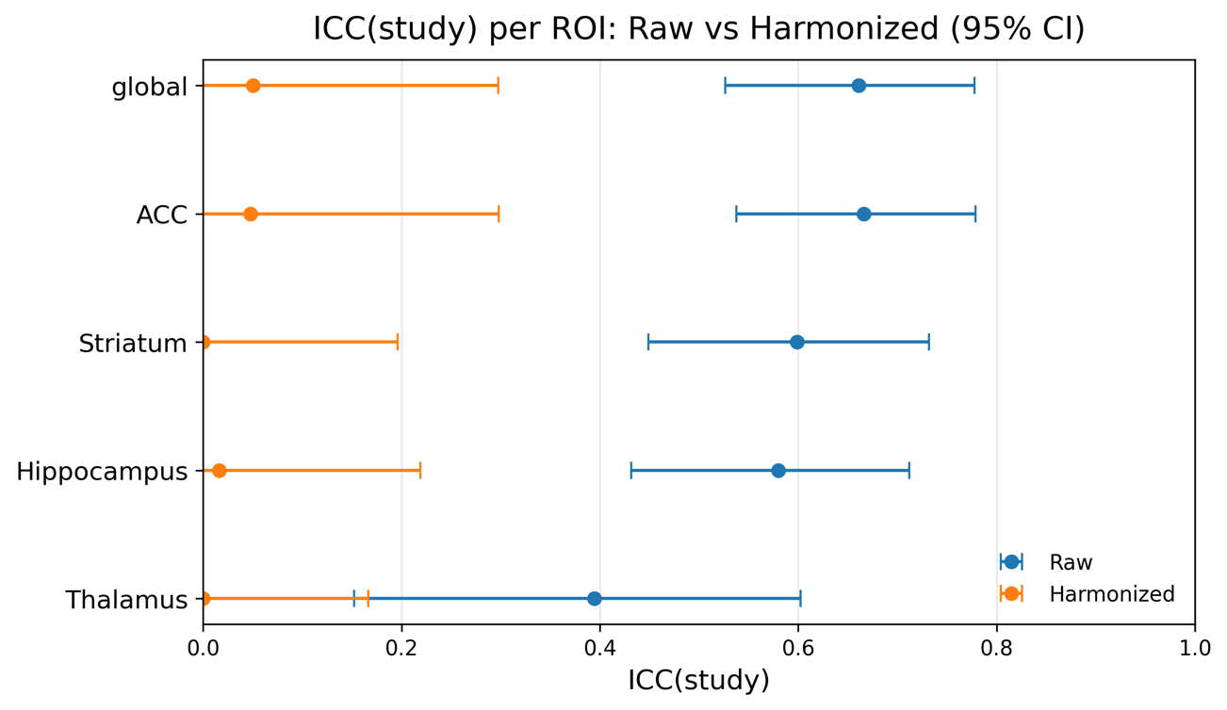
Estimates of ICC (study) for CBF data before (Raw) and after (Harmonized) harmonization are shown. Points represent ICC (study) values with corresponding 95% confidence intervals across the global as well as four regions of interest: anterior cingulate cortex (ACC), striatum, hippocampus, and thalamus. Lower ICC (study) values indicate diminished variance attributable to study differences. Harmonization substantially reduced study effects across all regions.

Figure S2. Relationship between global CBF and duration of antipsychotic treatment in FEP.
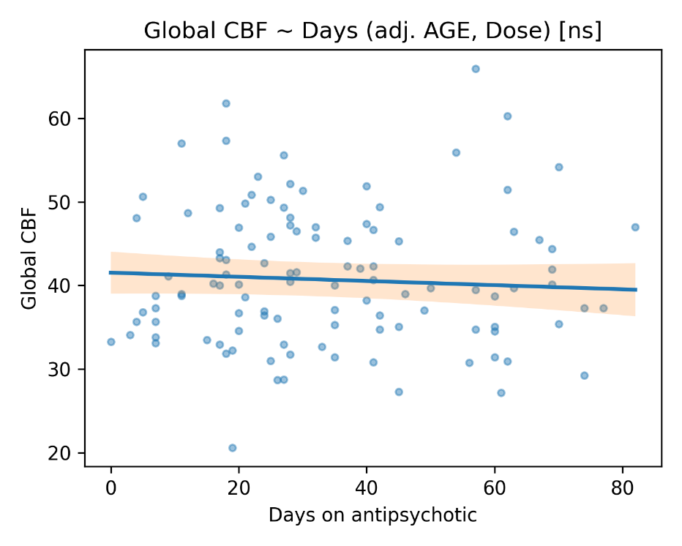

Scatterplot illustrating the adjusted relationship between days on antipsychotic and global CBF. The regression line represents the model-estimated marginal relationship between days on antipsychotic treatment and global CBF from a model adjusted for age and antipsychotic dose, with the shaded area indicating the 95% confidence interval around the regression line. No significant association was observed, suggesting that duration of antipsychotic treatment was not related to changes in global CBF (ns, $p$ > 0.05).

Figure S3. Relationship between regional CBF and antipsychotic dose.
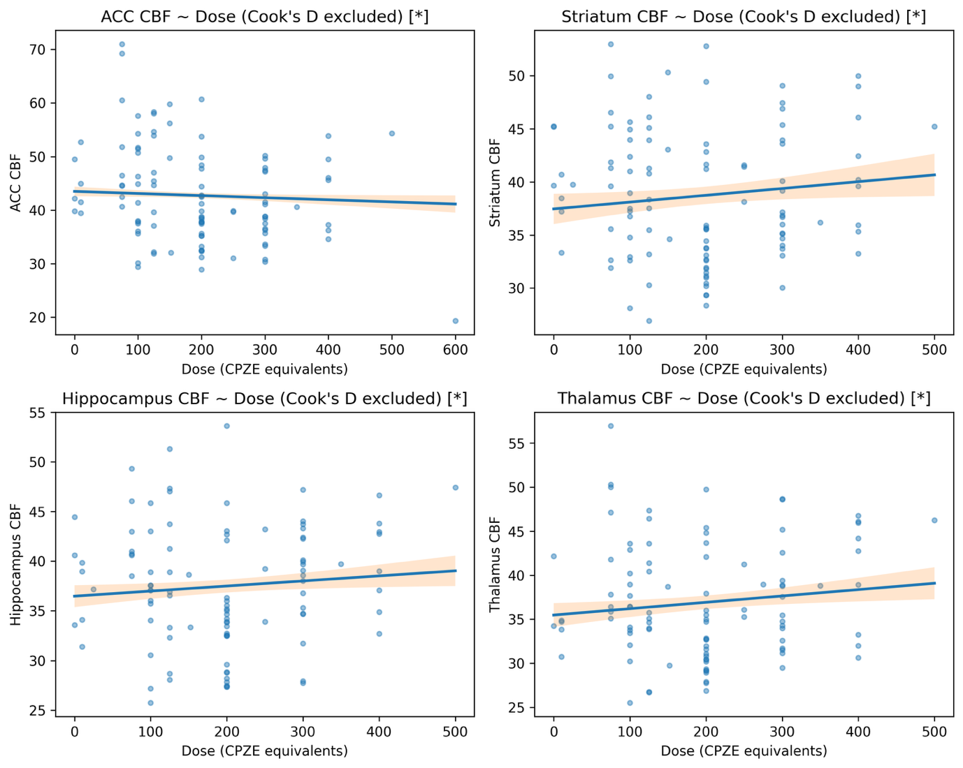

Scatterplots illustrate the relationships between antipsychotic dose and CBF in the anterior cingulate cortex (ACC), striatum, hippocampus, and thalamus after excluding observations flagged as influential by Cook’s distance. Regression lines and shaded bands represent linear mixed-effects model estimates and 95% confidence intervals, adjusted for age, days on antipsychotic, and global CBF. Antipsychotic dose was significantly associated with CBF in all four regions (* p < 0.05), with a negative association in the ACC and positive associations in the striatum, hippocampus, and thalamus.

Figure S4. Model-predicted association between baseline regional CBF and PANSS Total.
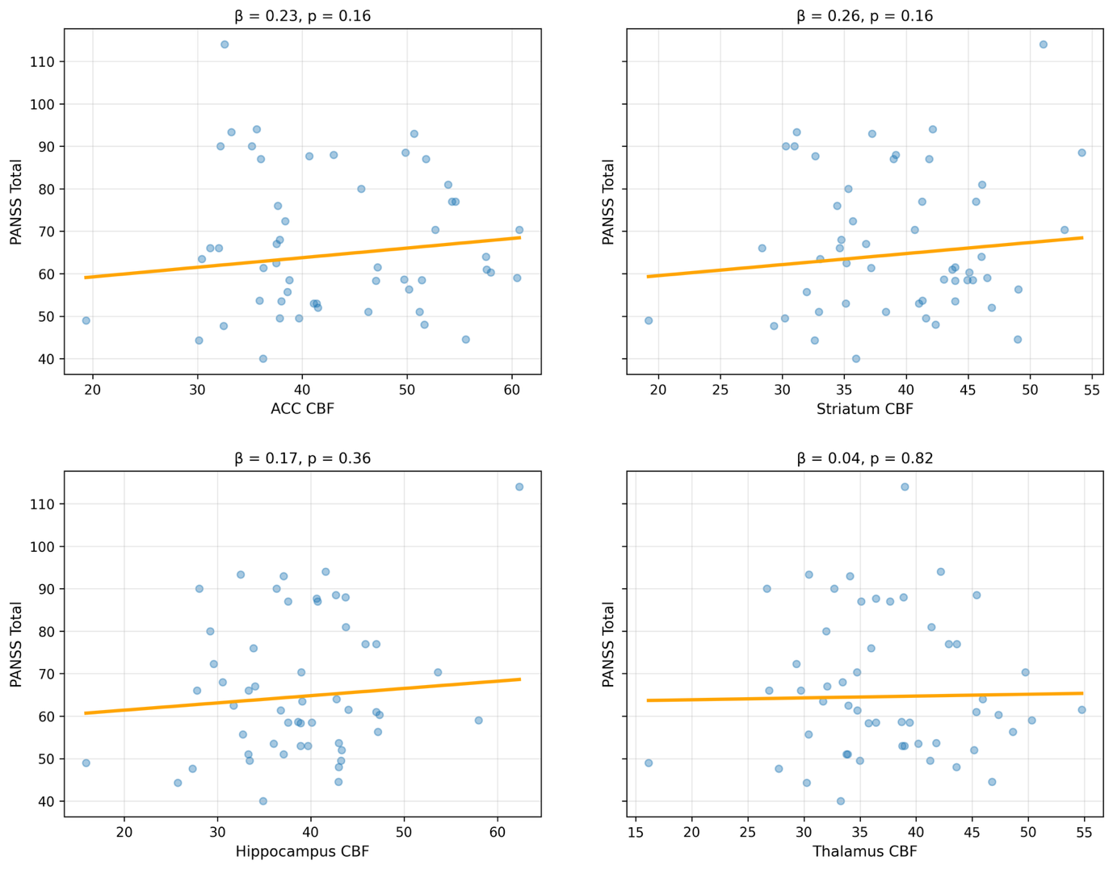

Model-predicted associations between baseline regional CBF and PANSS Total are shown for the anterior cingulate cortex (ACC), striatum, hippocampus, and thalamus. Lines represent predicted PANSS Total values from linear mixed-effects models, with baseline ROI CBF as the predictor and covariates (antipsychotic days, age, time-varying antipsychotic dose, baseline PANSS, and global CBF) held at their mean values. Points represent subject-level mean PANSS Total values. Across all regions, baseline regional CBF was not significantly associated with PANSS Total.

Figure S5. Within- and between-subject associations between ACC CBF and PANSS Positive.
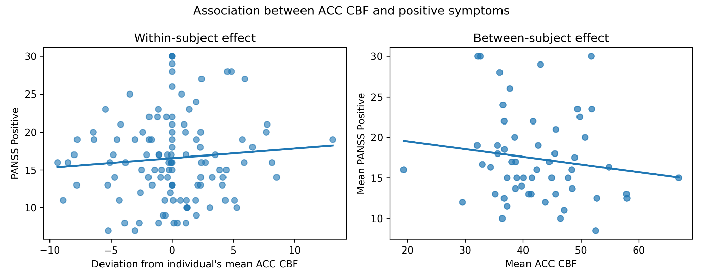

Points represent observed data, and lines indicate the fitted linear relationships. The left panel illustrates the within-subject association, where each point reflects deviations in ACC CBF (mL/100g/min) from an individual’s mean across visits, plotted against PANSS positive symptom scores. The right panel illustrates the between-subject association, where each point represents an individual’s mean ACC CBF (mL/100g/min) and mean PANSS positive symptom score across visits. Slopes indicate that lower within-subject ACC CBF and higher between-subject mean ACC CBF are associated with lower positive symptom severity.

References
1 Mato Abad, V., Garcia-Polo, P., O'Daly, O., Hernandez-Tamames, J. A. & Zelaya, F. ASAP (Automatic Software for ASL Processing): A toolbox for processing Arterial Spin Labeling images. Magn Reson Imaging 34, 334-344 (2016). https://doi.org/10.1016/j.mri.2015.11.002
2 Gaser, C., Dahnke, R., Thompson, P. M., Kurth, F. & Luders, E. CAT – A Computational Anatomy Toolbox for the
Analysis of Structural MRI Data (2023). https://doi.org/10.1101/2022.06.11.495736
3 Ashburner, J. & Friston, K. J. Unified segmentation. Neuroimage 26, 839-851 (2005). https://doi.org/10.1016/j.neuroimage.2005.02.018
4 Ashburner, J. A fast diffeomorphic image registration algorithm. Neuroimage 38, 95-113 (2007). https://doi.org/10.1016/j.neuroimage.2007.07.007

