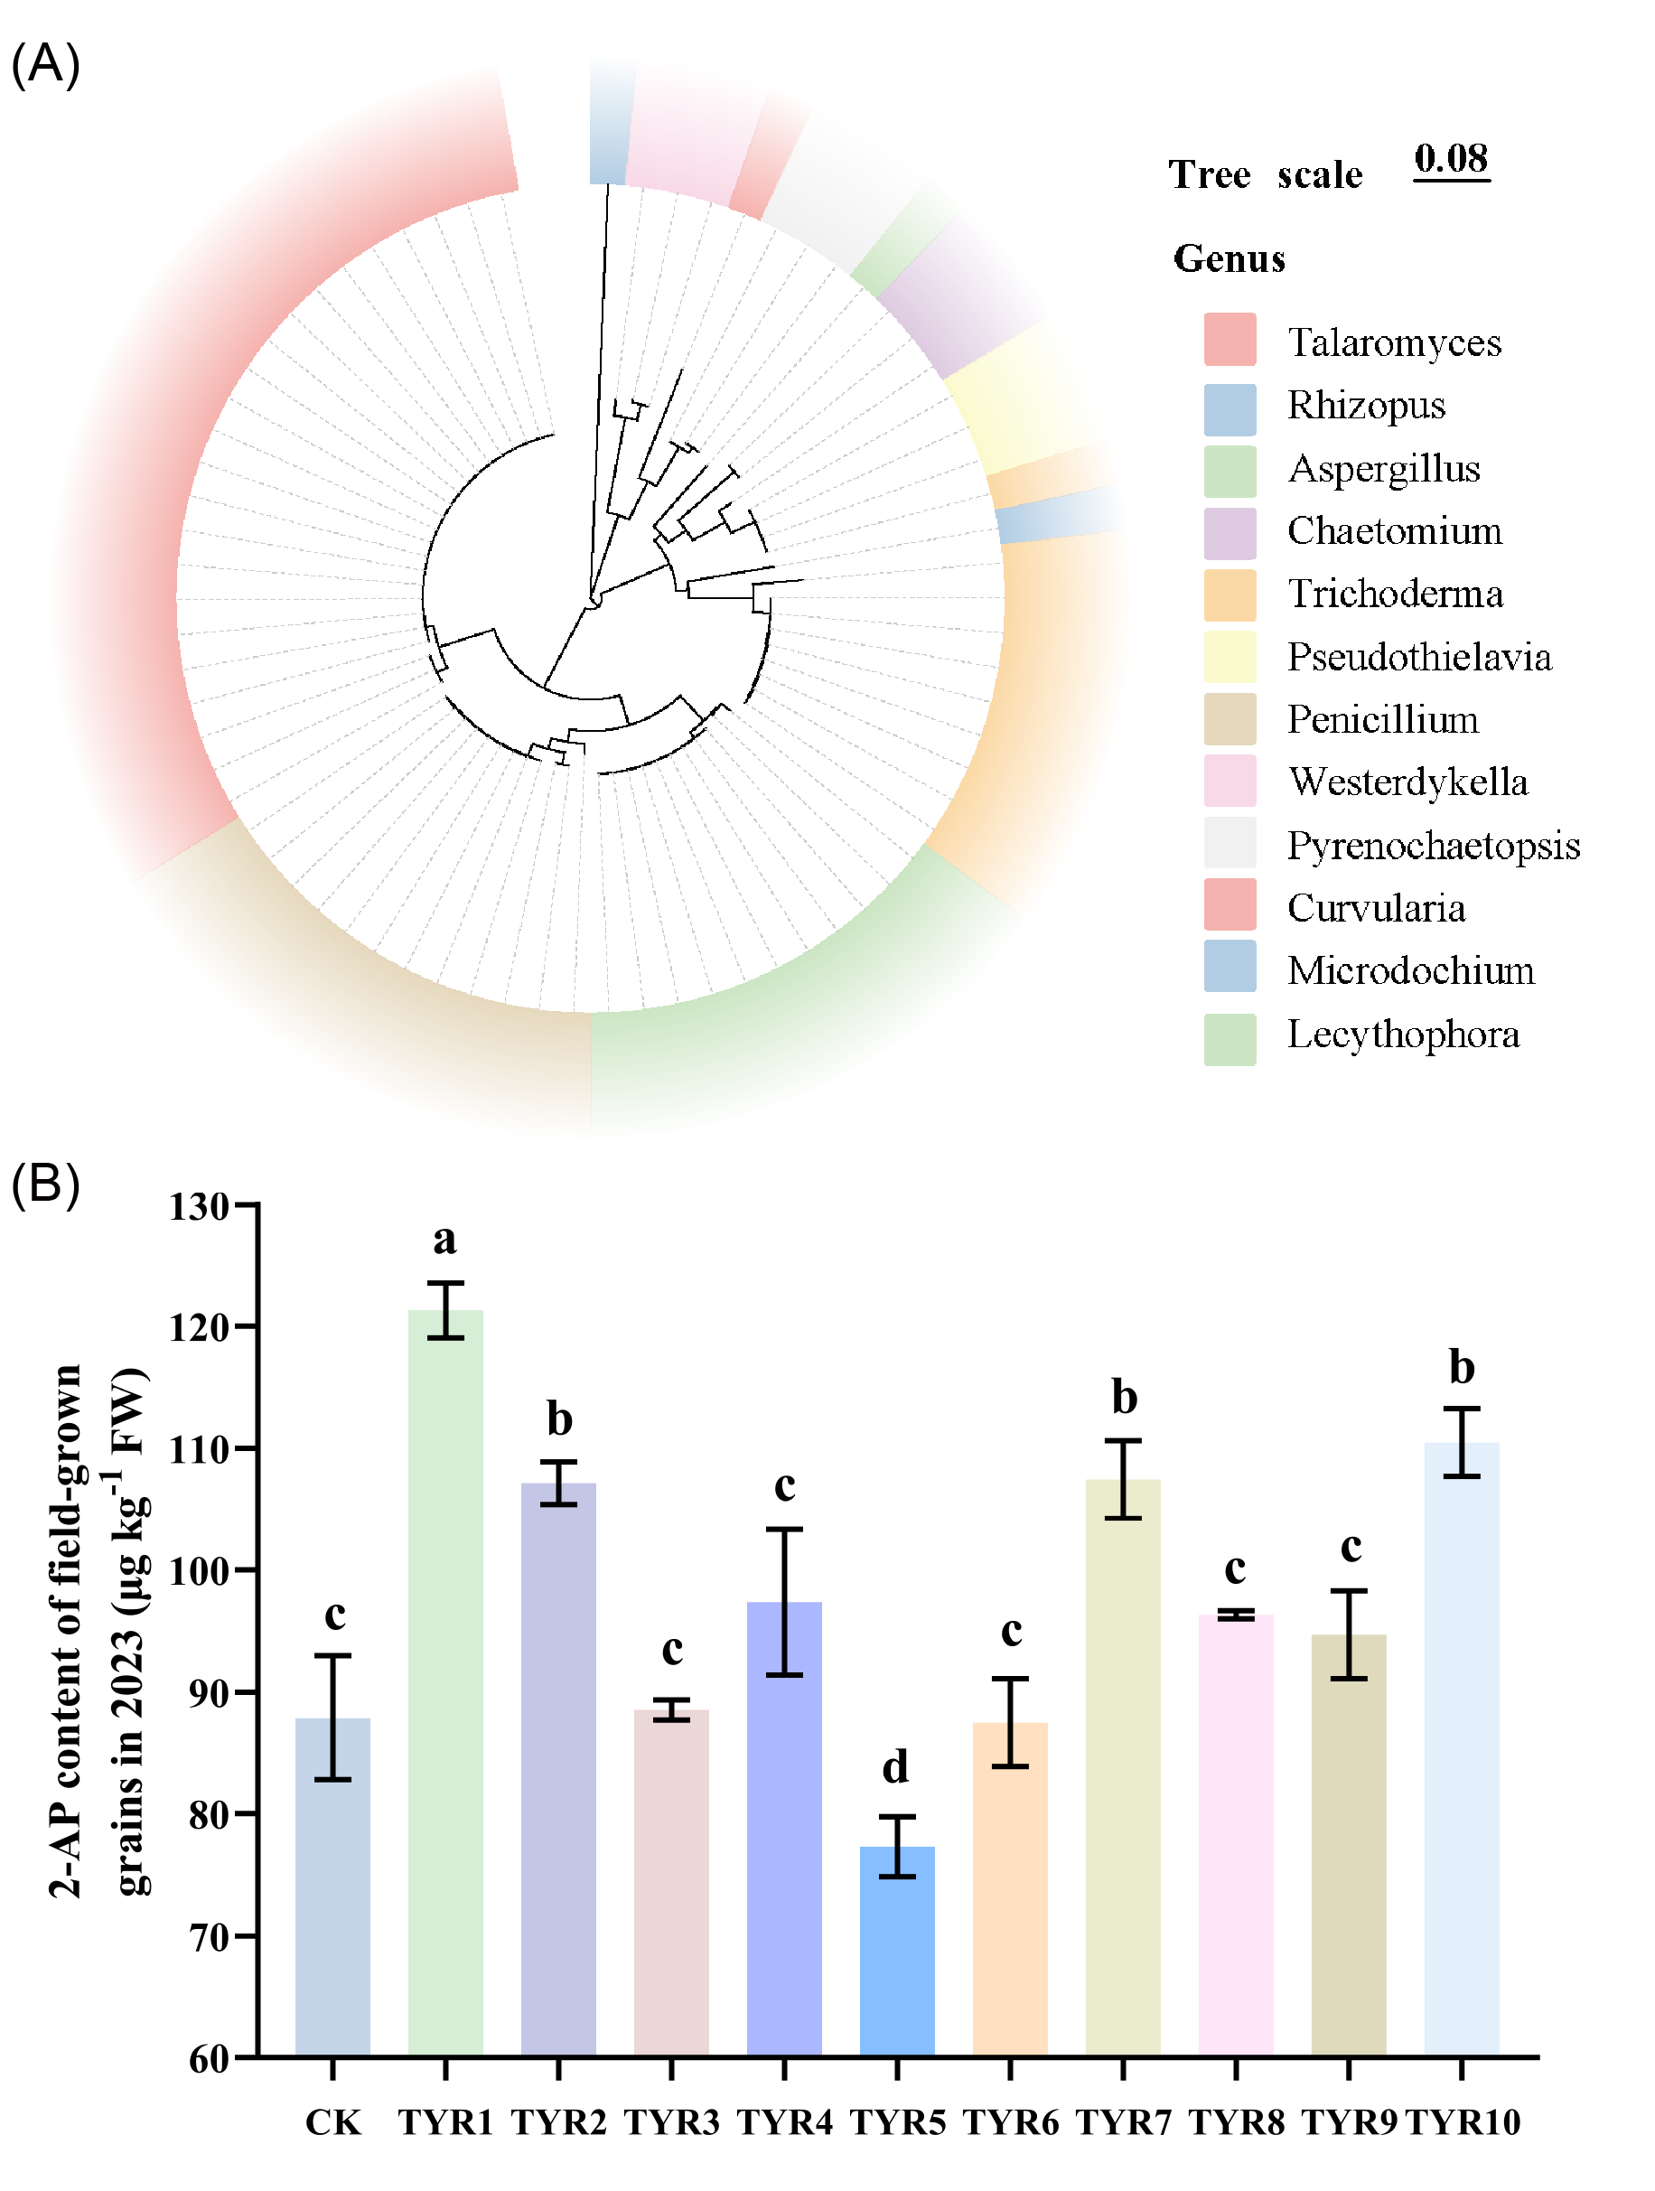
Supplemental figure 1. Identification of rhizosphere soil isolates and their effects on 2-AP content in rice. (A) Phylogenetic tree of fungal strains isolated from rhizosphere soil, constructed based on ITS sequences. (B) 2-AP content in NJ46 grains after treatment with 10 fungal strains in the 2023 field trial. Values are presented as means ± SD (n = 3). Different letters above the bars indicate significant differences between groups as determined by one-way analysis of variance (ANOVA) followed by Tukey's honestly significant difference (HSD) test (P < 0.05), while the same letters indicate no significant differences.

Supplemental figure 2. The standard chromatogram and mass spectrum diagram of 2-AP. (A) GC chromatogram of 2-AP and the internal standard TMP. (B) Mass spectrum of 2-AP. 2-AP: 2-Acetyl-1-pyrroline; TMP: 2,4,6-trimethylpyridine.
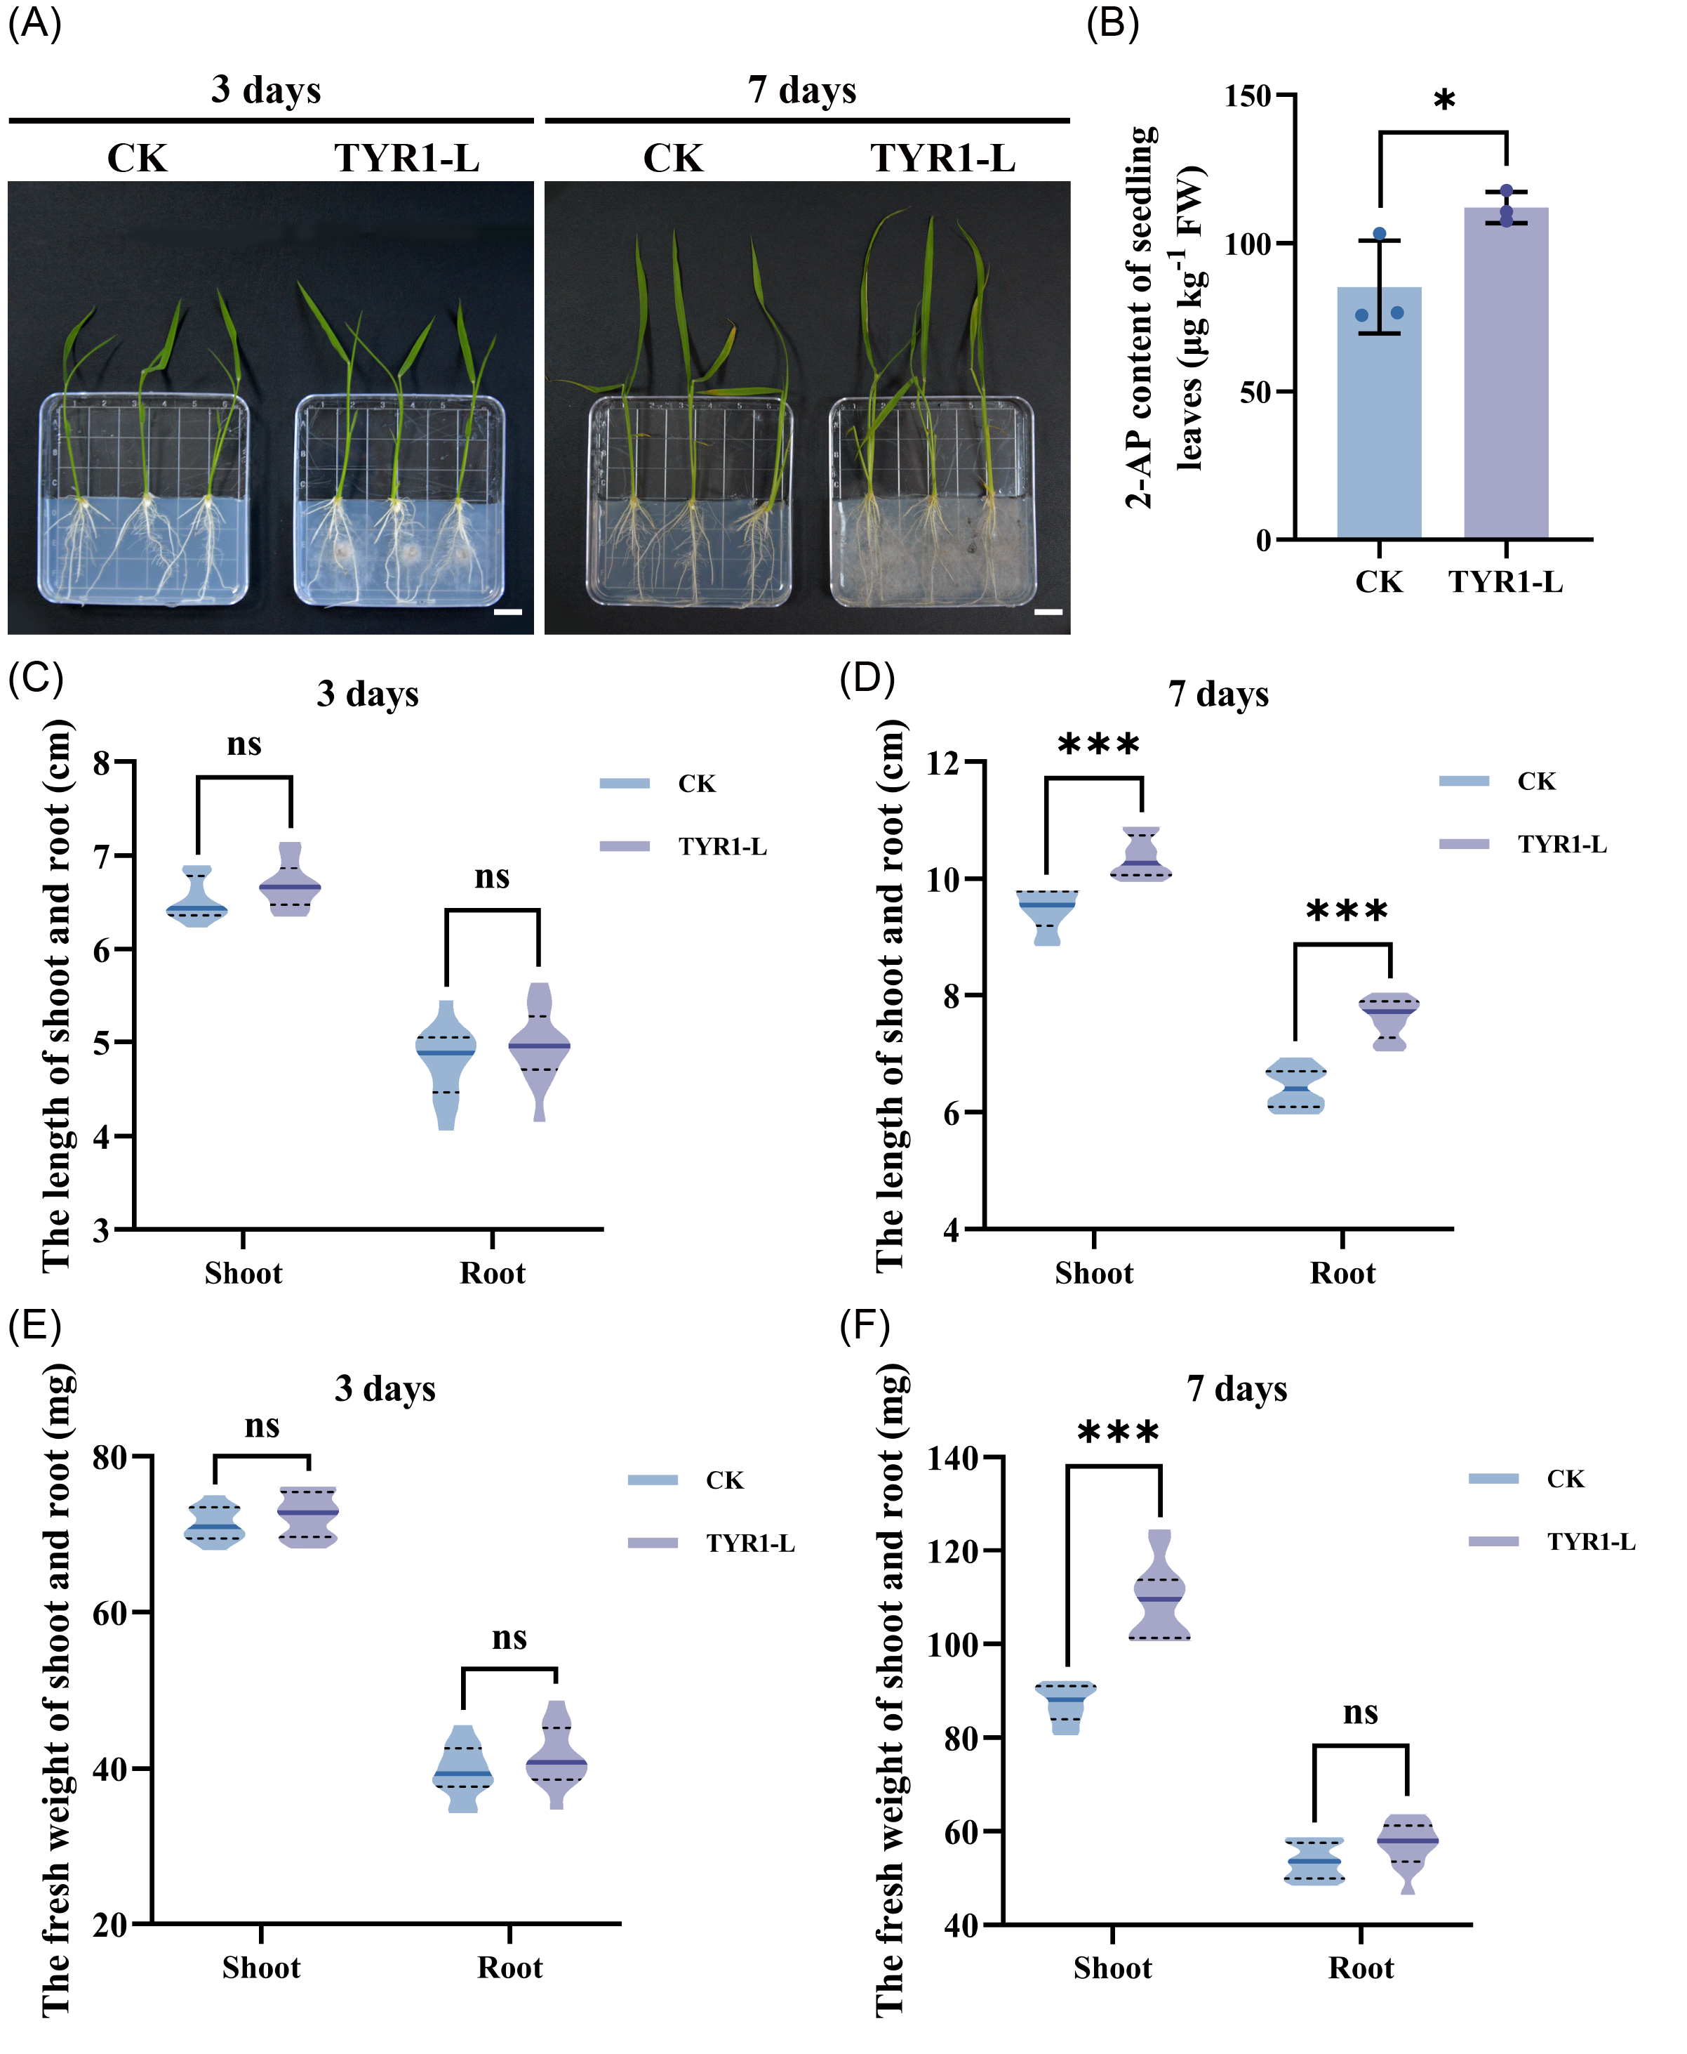
Supplemental figure 3. Effects of live TYR1 treatment (TYR1-L) on 2-AP content and growth phenotypes of fragrant rice NJ46 seedlings. (A) Morphological phenotypes of rice seedlings at 3 and 7 days post-TYR1-L inoculation (scale bar = 1 cm). (B) 2-AP content in leaves 7 days after TYR1-L treatment. (C-D) Shoot and root lengths at 3 (C) and 7 (D) days post-TYR1-L inoculation. (E-F) Fresh weights of shoots and roots at 3 (E) and 7 (F) days post-TYR1 inoculation. Values are presented as means ± SD (2-AP content: n = 3; length and fresh weight: n = 12). Asterisks indicate significance levels compared to no strain treatment (CK) using Student’s t-test (*: P < 0.05, ***: P < 0.001, ns: not significant).
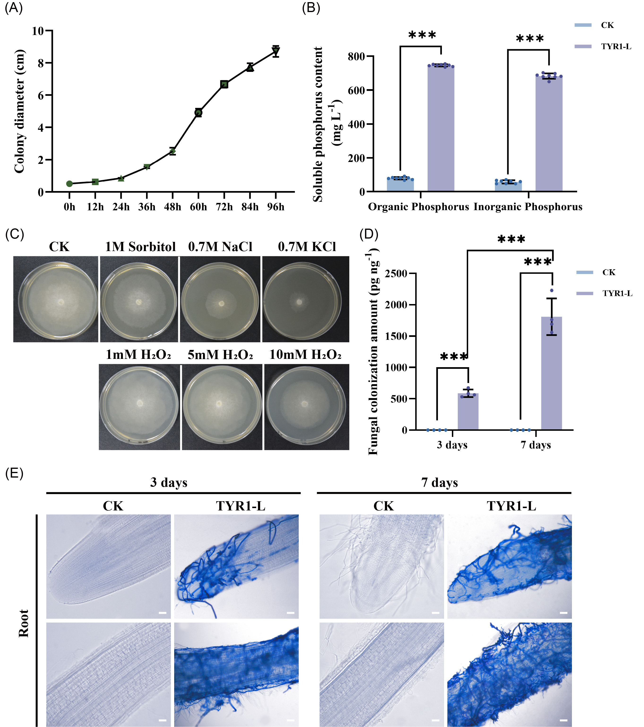
Supplemental figure 4. Colonization characteristics of TYR1 strain in fragrant rice NJ46 seedlings using a sterile plate assay. (A) Growth rate of the TYR1-L strain. (B) Phosphate-solubilizing capacity of the TYR1 strain. (C) Effects of drought stress, salt stress, and oxidative stress on the growth status of the TYR1 strain. (D) Quantitative PCR analysis of fungal colonization amounts in roots at 3 and 7 days post-TYR1-L treatment. (E) Trypan Blue staining of NJ46 seedling roots at 3 and 7 days post-TYR1-L inoculation, scale bar = 0.1 mm. Values are presented as means ± SD (soluble phosphorus content: n = 8; fungal colonization amounts: n = 4). Asterisks indicate significance levels compared to CK using Student’s t-test (***: P < 0.001).
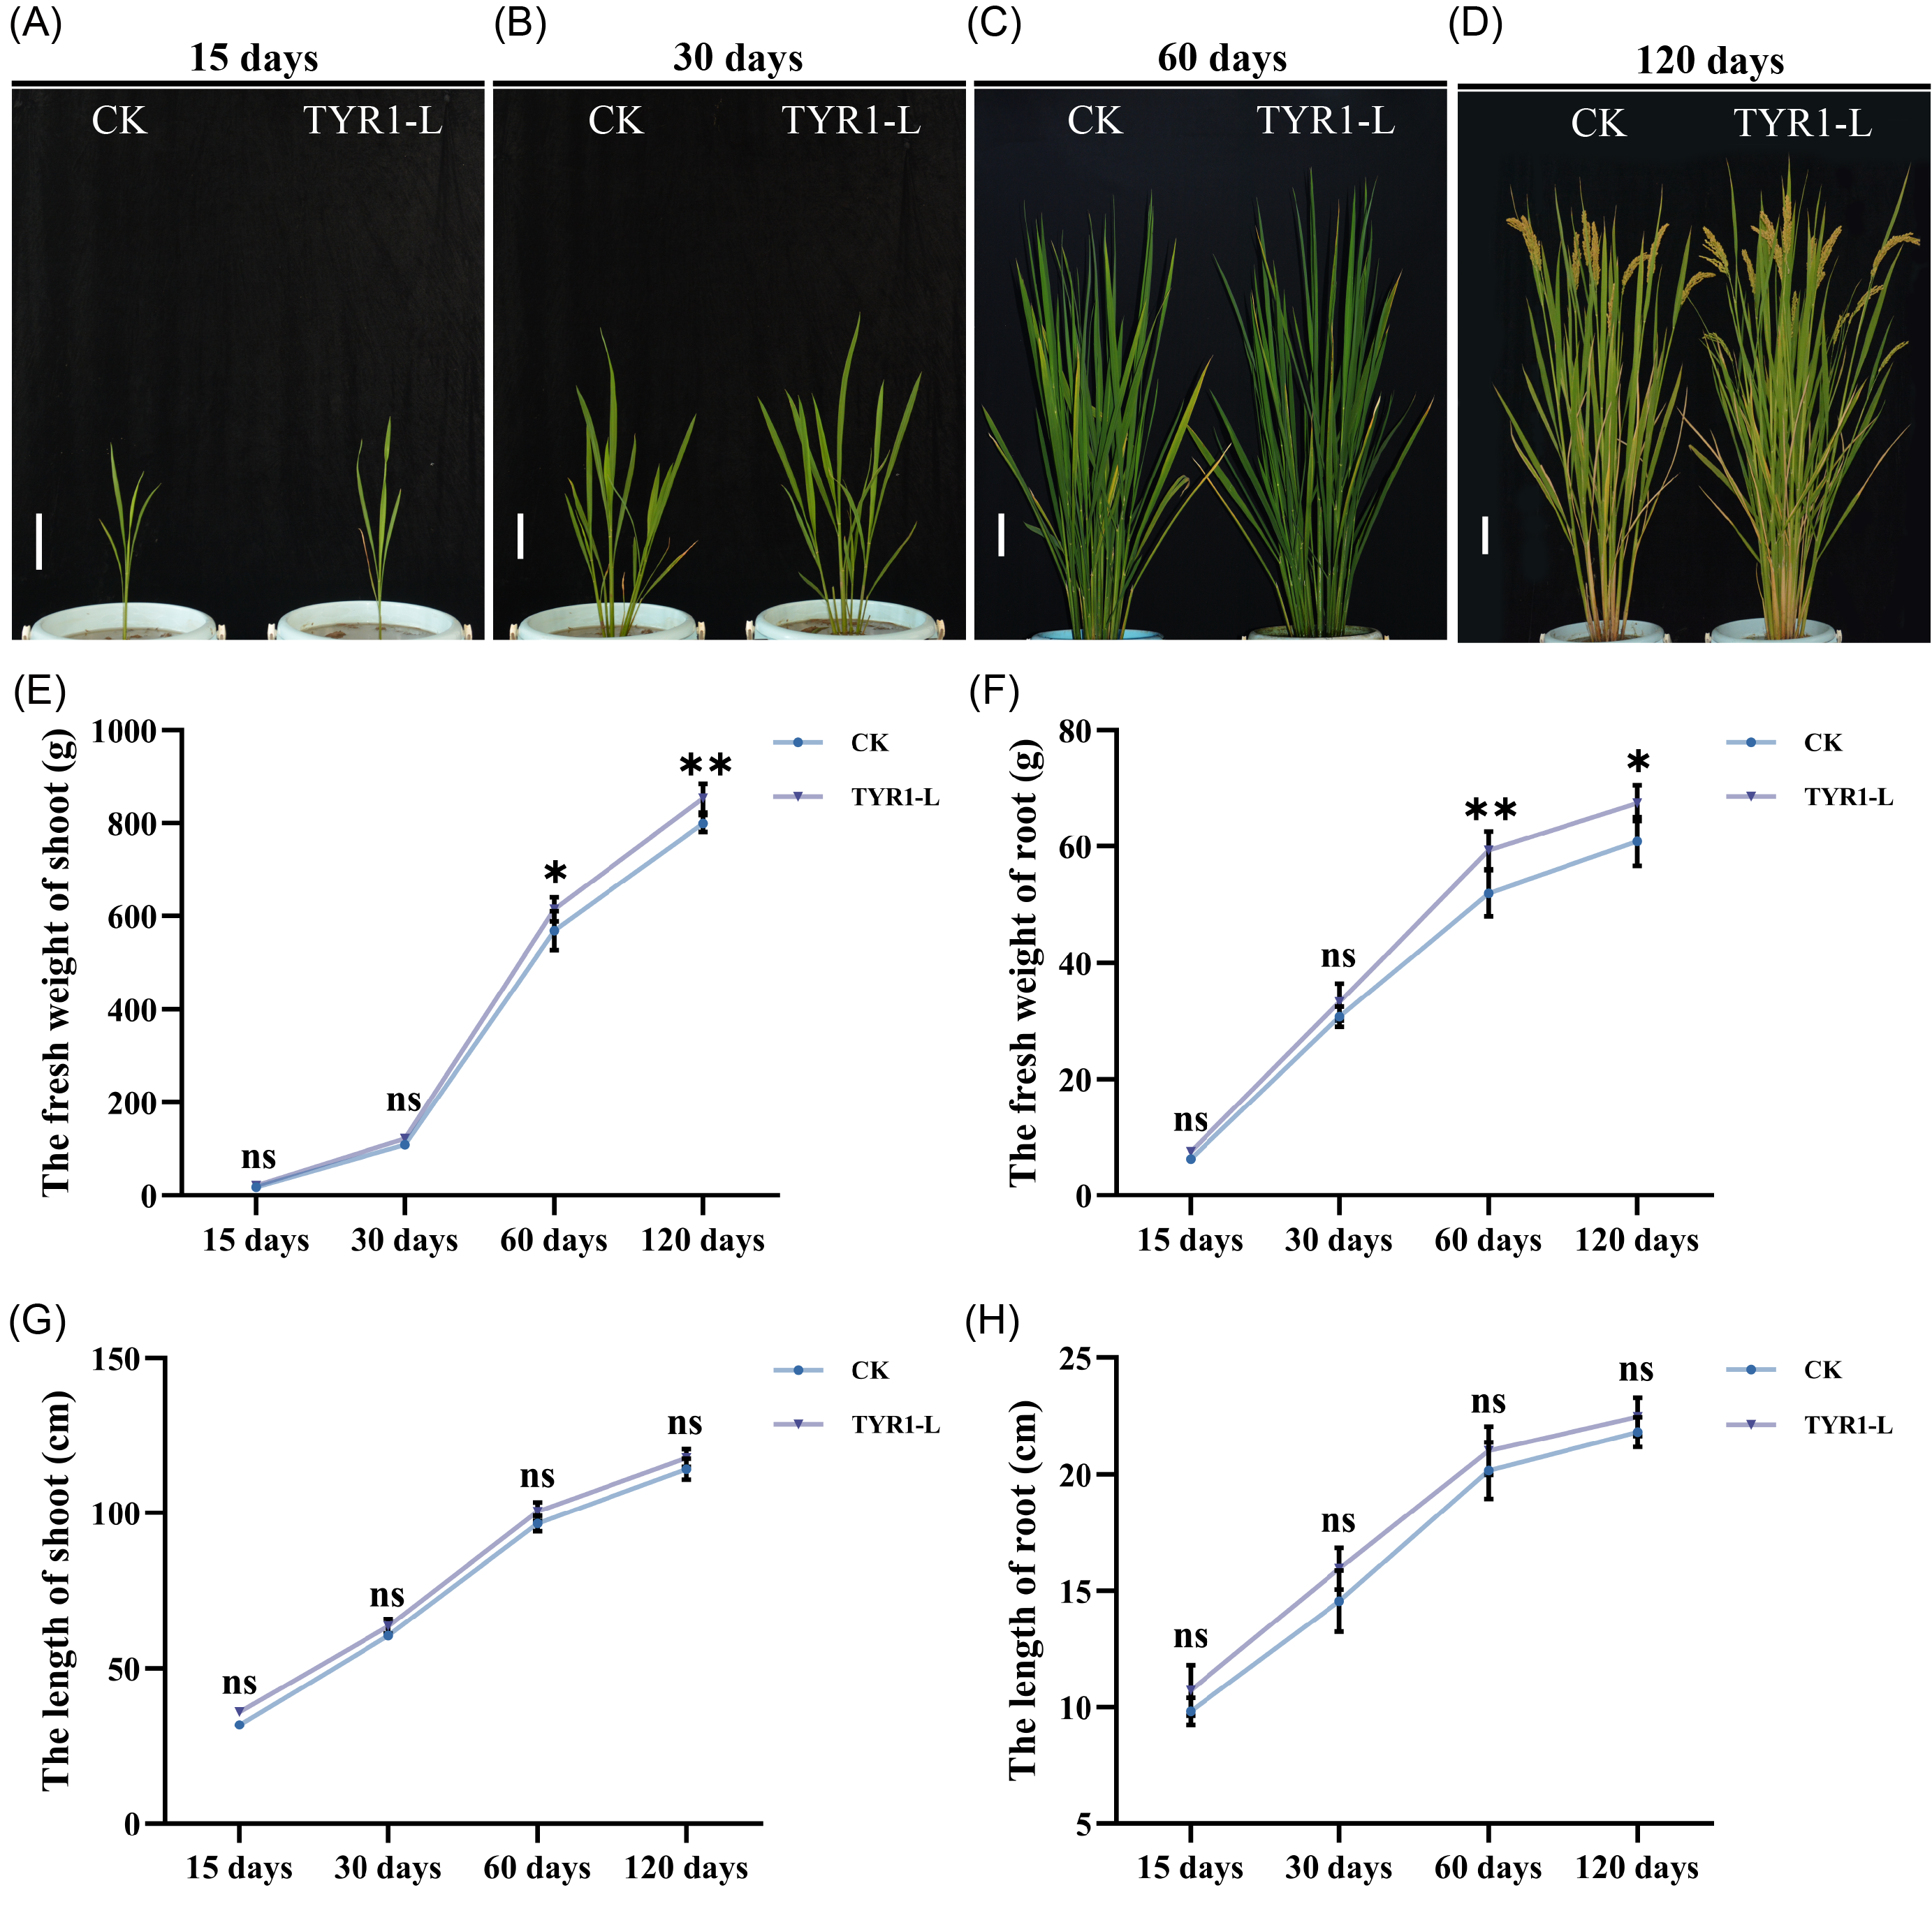
Supplemental figure 5. Effects of TYR1-L treatment on growth phenotypes of fragrant rice NJ46 in pot experiments. (A-D) Growth conditions of NJ46 at 15 days (A), 30 days (B), 60 days (C), and 120 days (D) after TYR1-L treatment and transplantation into pots; scale bar = 10 cm. (E-H) Shoot fresh biomass (E), root fresh biomass (F), plant height (G), and root length (H) of NJ46 at 15, 30, 60, and 120 days after TYR1-L treatment and transplantation into pots. Values are presented as means ± SD (n = 4). Asterisks indicate significance levels compared to CK using Student’s t-test (*: P < 0.05, **: P < 0.01, ns: not significant).
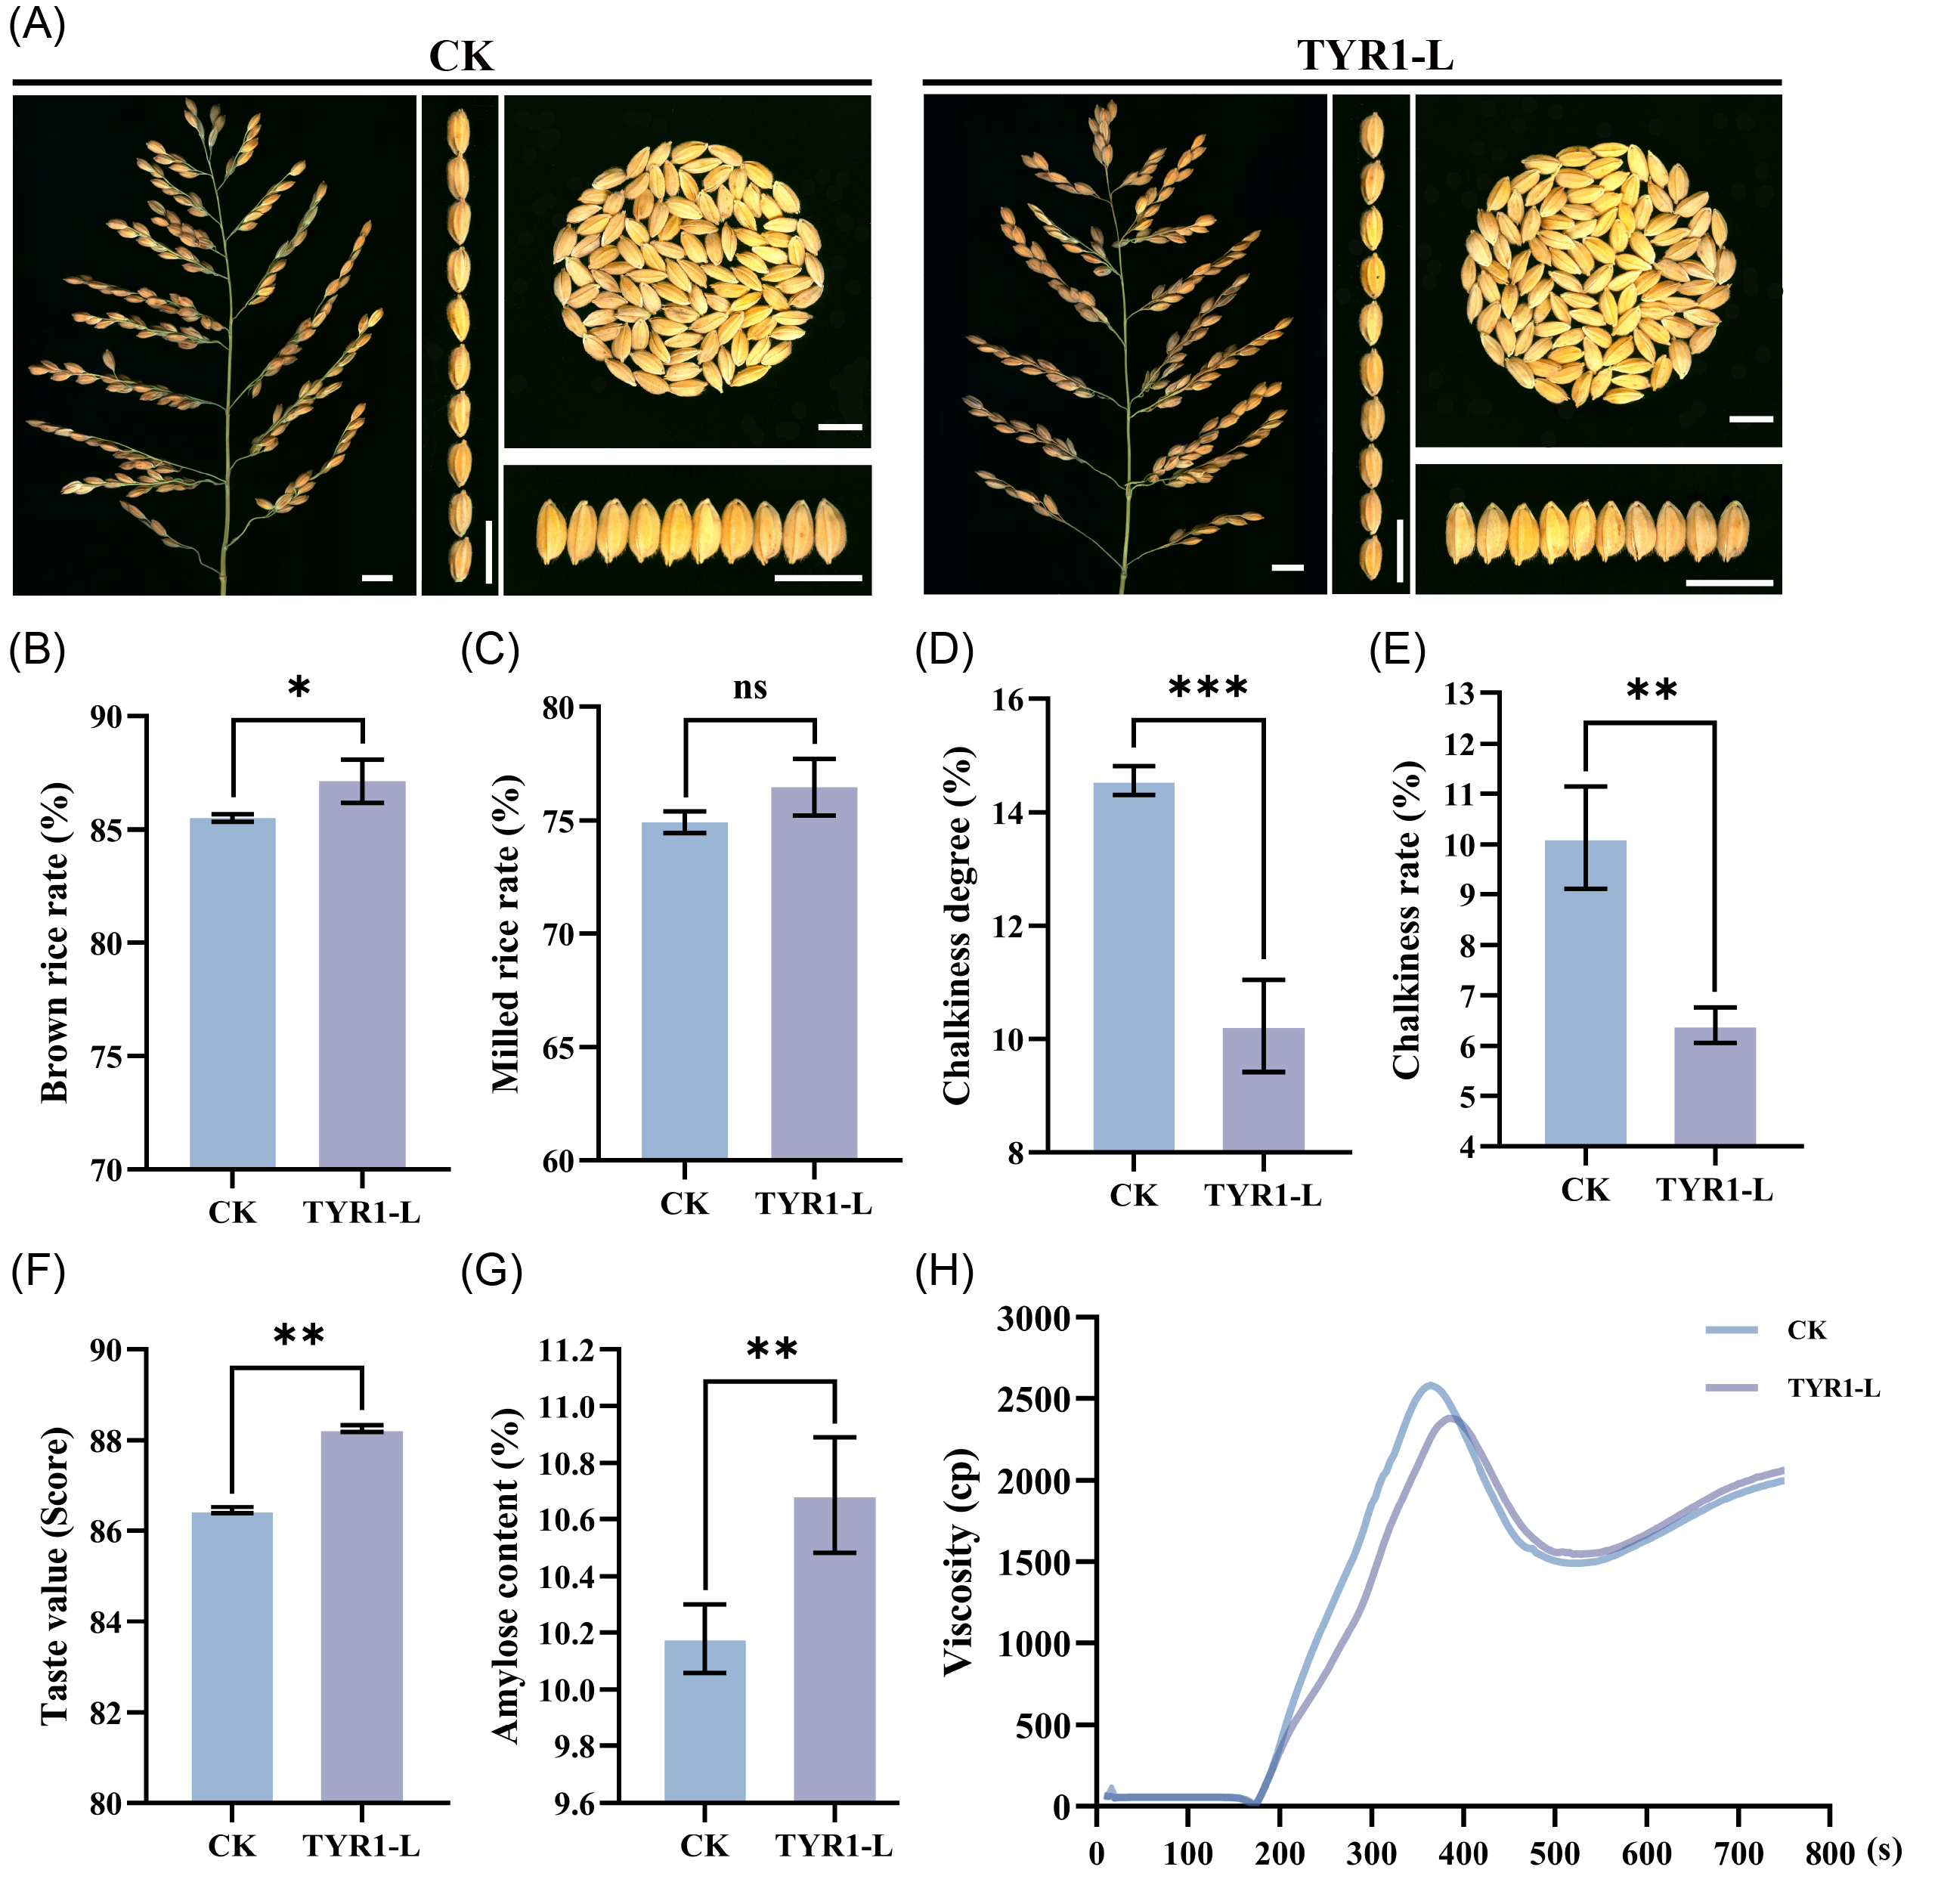
Supplemental figure 6. Quality assessment of fragrant rice NJ46 grains after TYR1-L treatment in the 2024 field trial. Samples included grains of from the 2024 pot experiment at MS. (A) Grain phenotypes (scale bar = 10 cm); (B) Brown rice rate; (C) Milled rice rate; (D) Chalkiness degree; (E) Chalkiness rate; (F) Taste value; (G) Amylose content; (H) Paste viscosity. Values are presented as means ± SD (n = 3 for brown rice rate, milled rice rat, chalkiness degree and chalkiness rate; n = 2 for taste value; n = 4 for amylose content). Asterisks indicate significance levels compared to CK using Student’s t-test (*: P < 0.05, **: P < 0.01, ***: P < 0.001, ns: not significant).
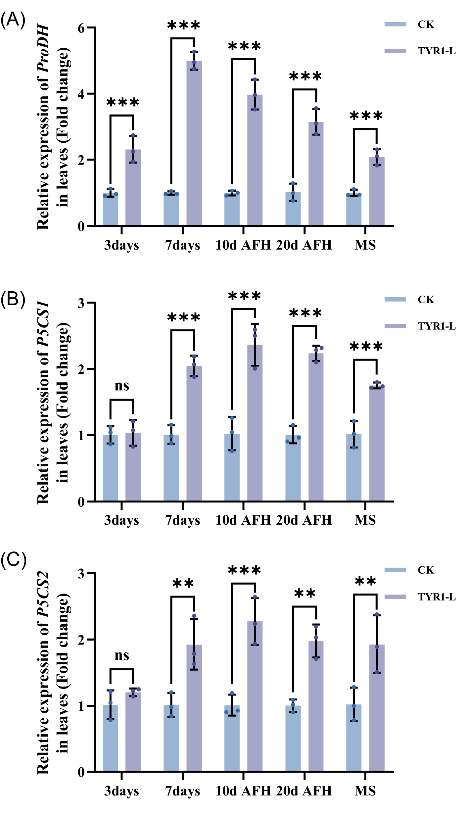
Supplemental figure 7. Expression analysis of upregulated genes involved in proline metabolism in leaves of fragrant rice NJ46. Samples included leaves of co-cultured seedlings at 3 and 7 days, as well as leaves from the 2024 pot experiment at 10d AFH, 20d AFH, and MS. (A) Expression level of ProDH; (B) Expression level of P5CS1; (C) Expression level of P5CS2. Values are presented as means ± SD (n = 3). Asterisks indicate significance levels compared to CK as determined by two-way ANOVA followed by Tukey's HSD test (*: P < 0.05, **: P < 0.01, ***: P < 0.001, ns: not significant). P5CS1/2: Δ¹-pyrroline-5-carboxylate synthetase 1/2; ProDH: proline dehydrogenase; 10d AFH: 10 days after heading; 20d AFH: 20 days after heading; MS: mature stage.

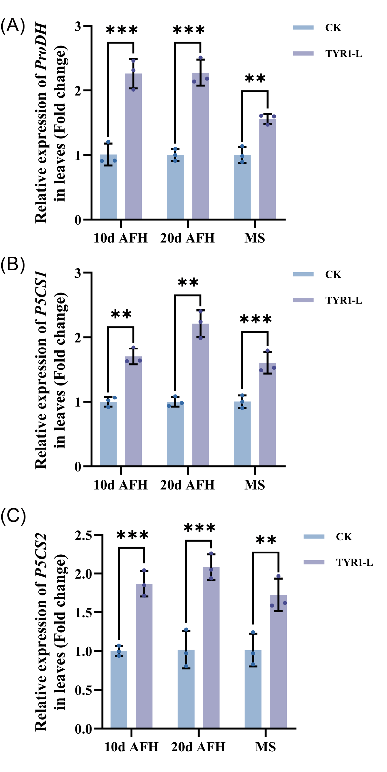
Supplemental figure 8. Expression analysis of upregulated genes involved in proline metabolism in grains of fragrant rice NJ46. Samples included grains from the 2024 pot experiment at 10d AFH, 20d AFH, and MS. (A) Expression level of ProDH; (B) Expression level of P5CS1; (C) Expression level of P5CS2. Values are presented as means ± SD (n = 3). Asterisks indicate significance levels compared to CK as determined by two-way ANOVA followed by Tukey's HSD test (*: P < 0.05, **: P < 0.01, ***: P < 0.001, ns: not significant).
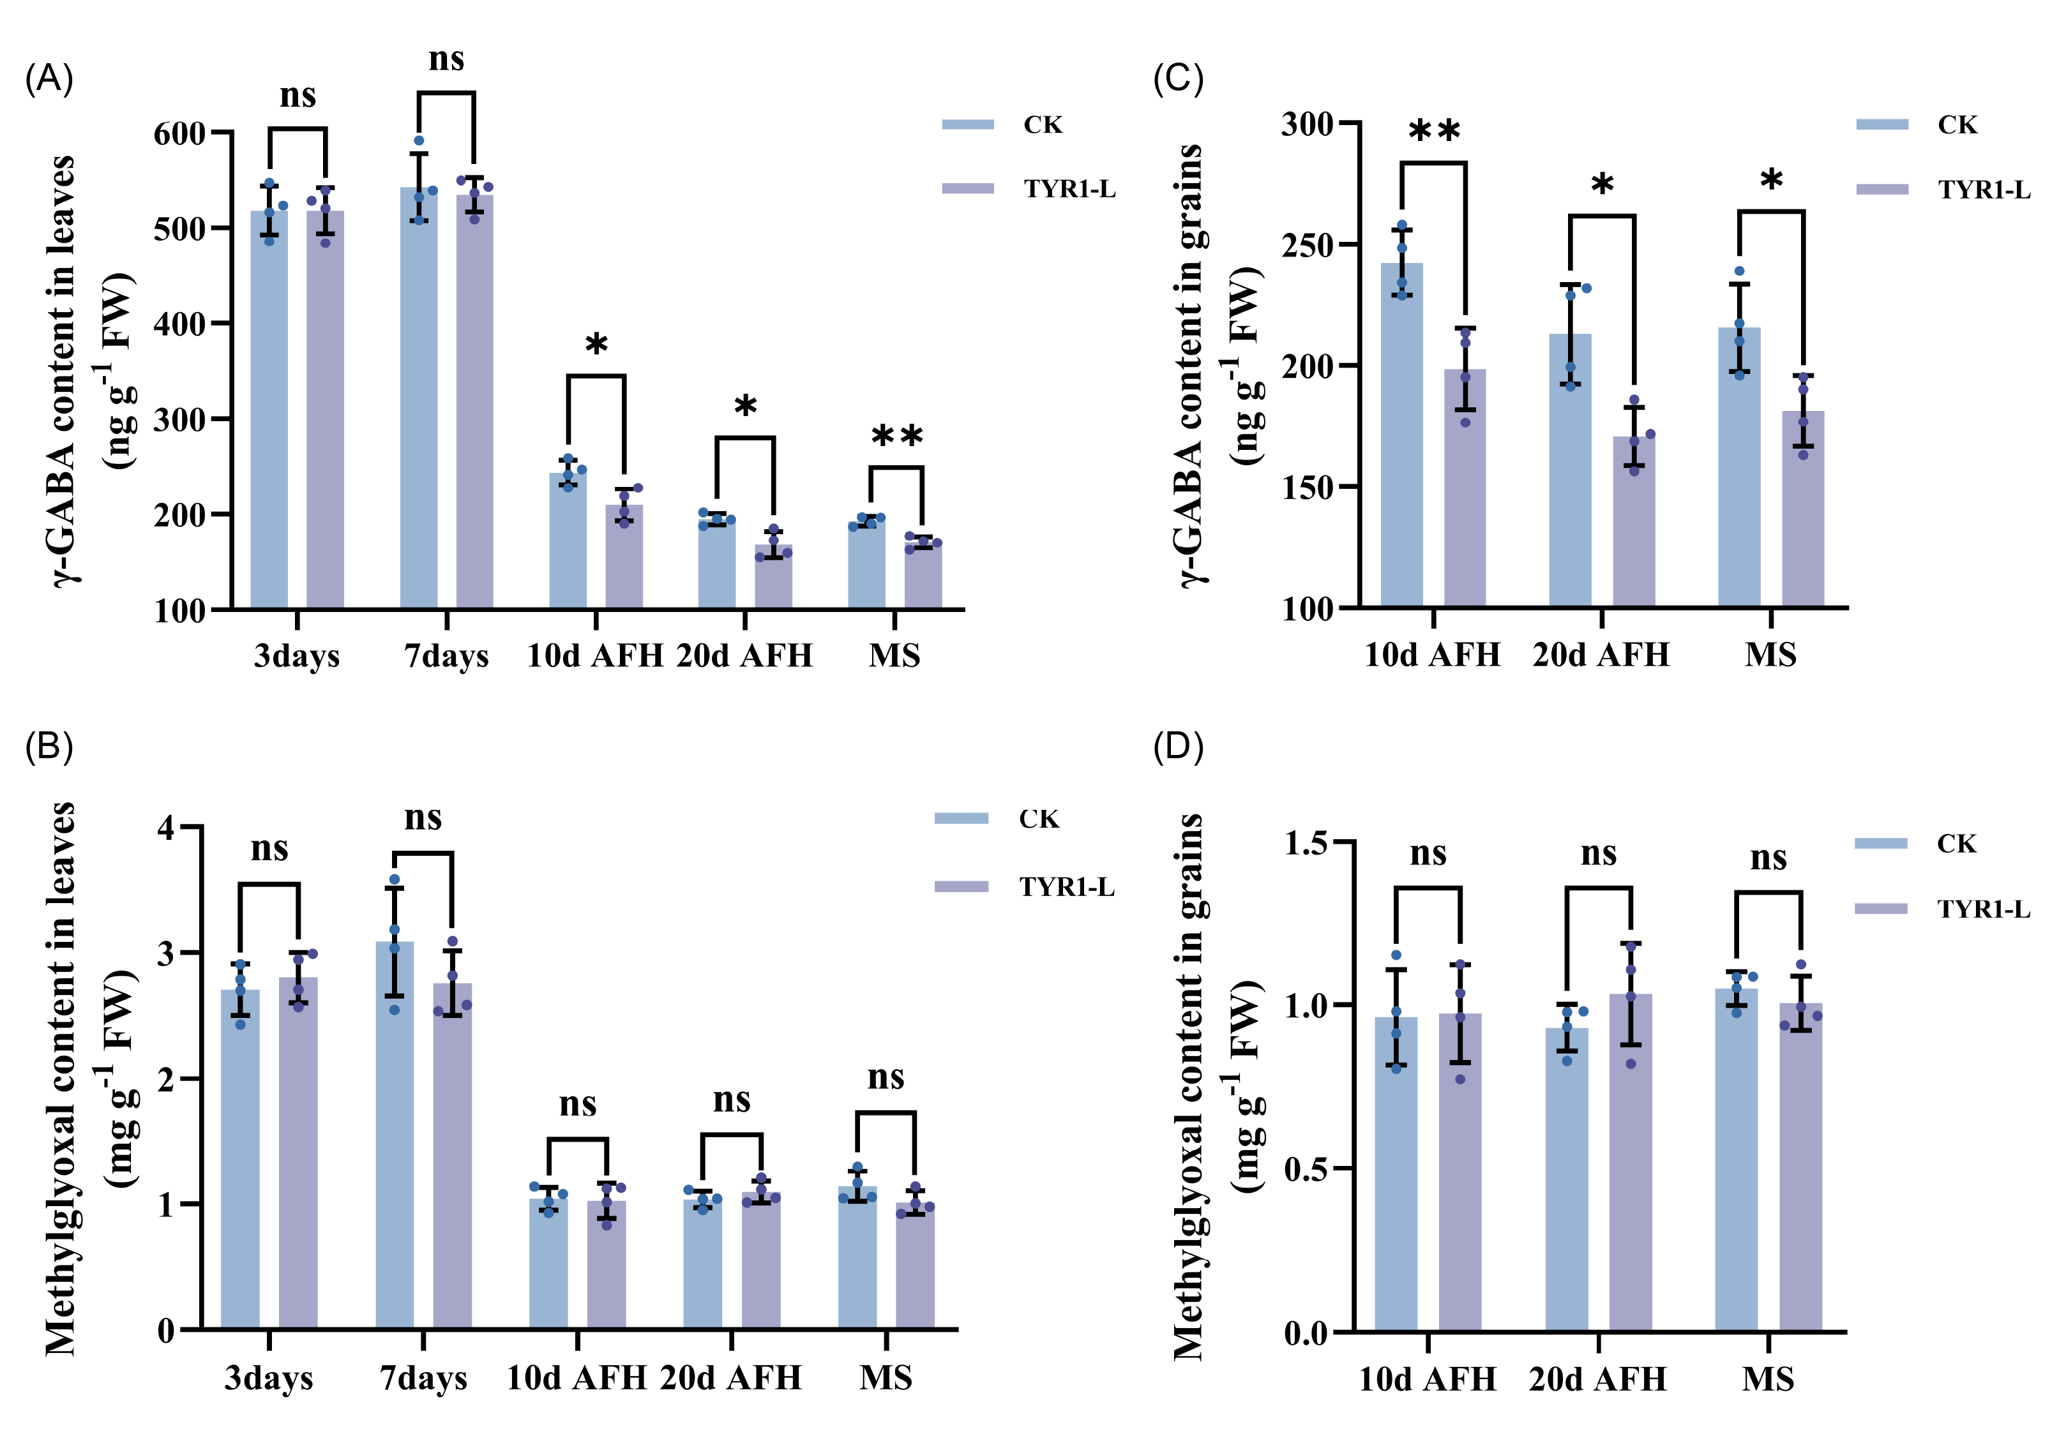
Supplemental figure 9. Contents of γ-GABA and methylglyoxal, precursors in the 2-AP biosynthetic pathway, in leaves and grains of fragrant rice NJ46. Samples included leaves of co-cultured seedlings at 3 and 7 days, as well as leaves from the 2024 pot experiment at 10d AFH, 20d AFH, and MS. (A) γ-GABA content in leaves; (B) Methylglyoxal content in leaves; (C) γ-GABA content in grains; (D) Methylglyoxal content in grains. Values are presented as means ± SD (n = 4). Asterisks indicate significance levels compared to CK using Student’s t-test (*: P < 0.05, **: P < 0.01, ns: not significant). γ-GABA: γ-aminobutanal.
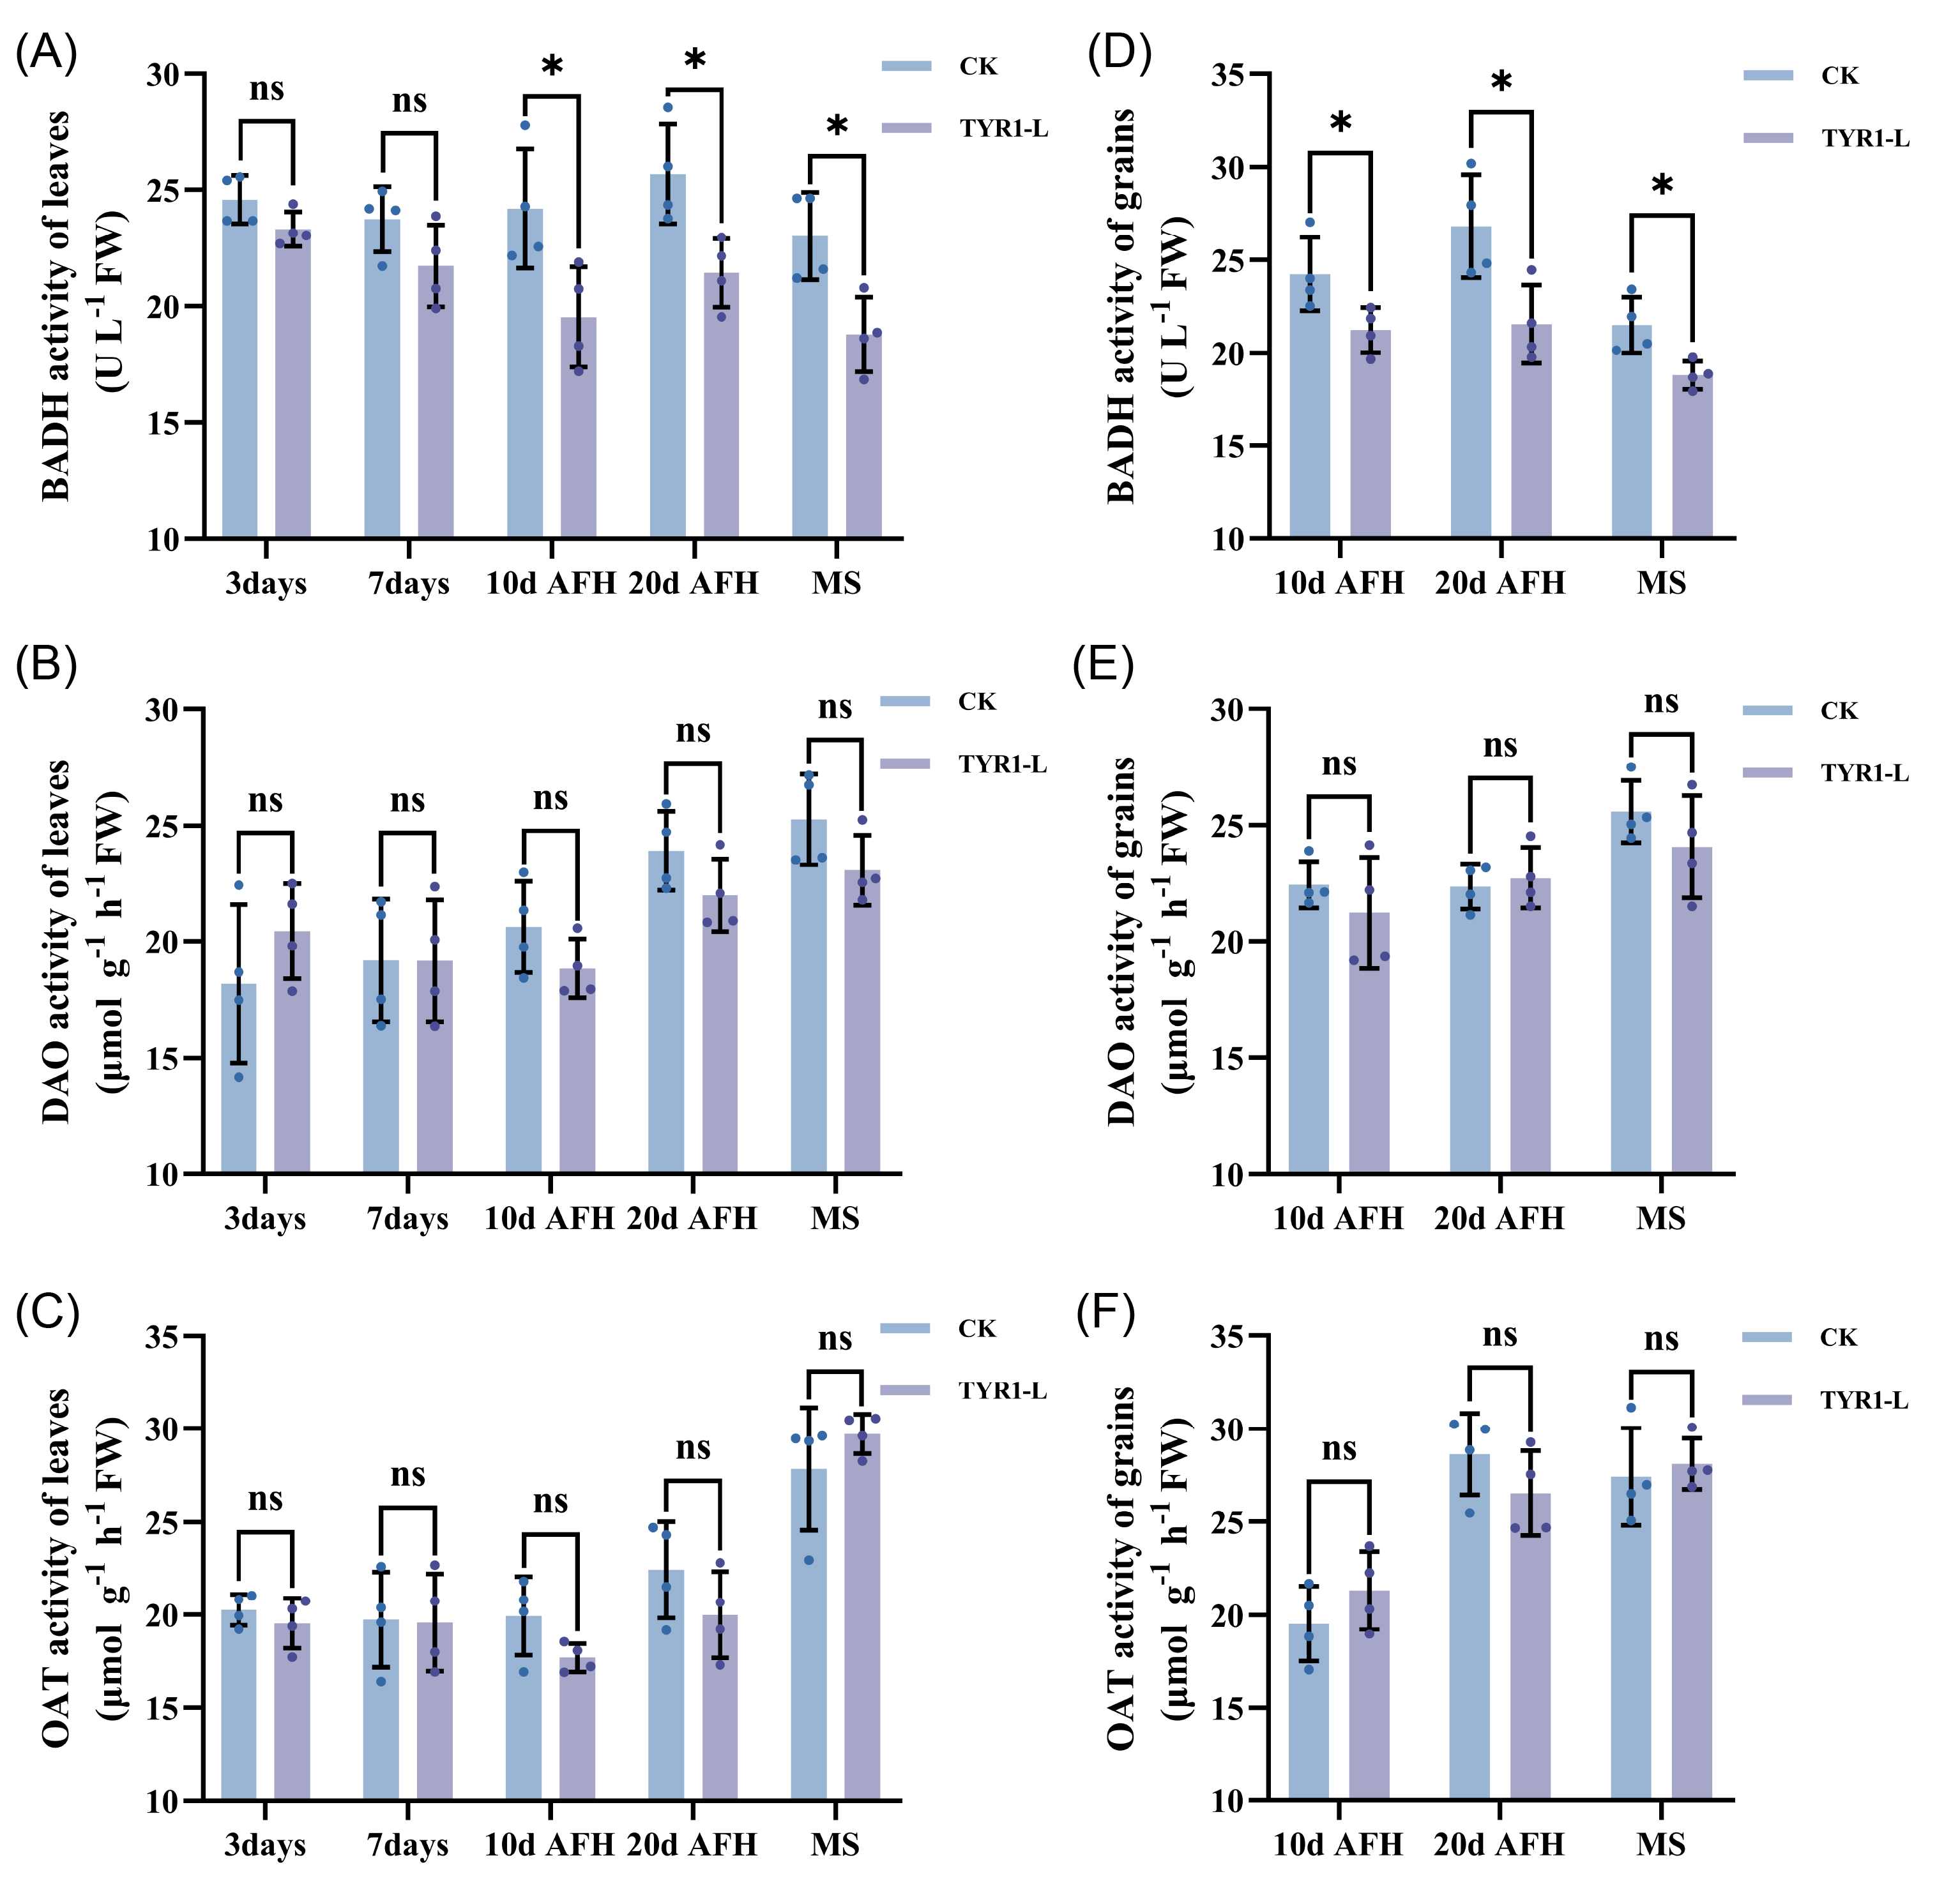
Supplemental figure 10. Activities of 2-AP metabolism-related enzymes in leaves and grains of fragrant Rice NJ46. Samples included grains from the 2024 pot experiment at 10d AFH, 20d AFH, and MS. (A) BADH activity in leaves; (B) DAO activity in leaves; (C) OAT activity in leaves; (D) BADH activity in grains; (E)DAO activity in grains; (F) OAT activity in grains.Values are presented as means ± SD (n = 4). Asterisks indicate significance levels compared to CK using Student’s t-test (*: P < 0.05, ns: not significant). BADH: betaine aldehyde dehydrogenase; OAT: ornithine transcarbamylase; DAO: diamine oxidase.

