Supplementary Information
Multi-Domain Machine Learning of VR-synchronised directional EEG phase connectivity reveals candidate Alzheimer's continuum biomarkers
Scientific Reports — Submission Version v7.8
Supplementary Information
Supplementary Tables S1–S7 and Supplementary Figs. S1–S4 are provided in this file in accordance with Scientific Reports formatting guidelines.
Supplementary Table S1 | 64-channel EGI electrode–lobe mapping
ROI | Brain Region | Code | n | Brodmann Area | Electrodes (EGI / 10-10) | Brain Function | Biomarker ★
1 | Prefrontal | PF | 3 | BA 10 | E1(Fp2), E54(Fp1), E55(Fpz) | Executive function, decision making, emotional regulation | ★ E1
2 | Anterior Frontal | AF | 5 | BA 9/10/46 | E2(AF8), E3(AF4), E52(AF3), E53(AF7), E56(AFz) | Working memory, cognitive control, DLPFC
3 | Frontal | F | 9 | BA 6/8/9/44/45/47 | E4(F2), E7(F4), E8(F6), E9(F8), E48(F5), E49(F3), E50(F7), E51(F1), E57(Fz) | Motor planning, attention, language production (Broca)
4 | Fronto-Central | FC | 7 | BA 6/24/44 | E5(FC2), E6(FC4), E11(FC6), E44(FC5), E45(FC3), E46(FC1), E58(FCz) | SMA, premotor cortex, error monitoring, motor preparation | ★ E5, E11
5 | Fronto-Temporal | FT | 2 | BA 22/44/45 | E10(FT8), E47(FT7) | Emotional prosody, social cognition, auditory-motor integration
6 | Central | C | 7 | BA 4/1-3 | E12(C4), E13(C6), E18(C2), E40(C1), E41(C5), E42(C3), E59(Cz) | Primary motor & sensorimotor cortex, tactile processing | ★ E41
7 | Centro-Parietal | CP | 7 | BA 1-3/5/7/40 | E15(CP6), E16(CP4), E17(CP2), E37(CP5), E38(CP3), E39(CP1), E60(CPz) | Somatosensory association, sensory integration, spatial orientation | ★ E39
8 | Temporo-Parietal | TP | 2 | BA 22/39/40 | E19(TP8), E36(TP7) | Language comprehension, social cognition, theory of mind
9 | Temporal | T | 2 | BA 21/22 | E14(T8), E43(T7) | Auditory processing, language (Wernicke), emotional prosody | ★ E14
10 | Parietal | P | 9 | BA 7/39/40 | E20(P6), E21(P4), E22(P2), E23(P8), E32(P7), E33(P5), E34(P3), E35(P1), E61(Pz) | Visuospatial attention, language, numerical processing, IPL hub | ★ E20, E33
11 | Parieto-Occipital | PO | 5 | BA 19/39 | E24(PO8), E25(PO4), E27(POz), E30(PO3), E31(PO7) | Visual association, visuospatial processing, object recognition | ★ E24, E30
12 | Occipital | O | 3 | BA 17/18 | E26(O2), E28(Oz), E29(O1) | Primary visual cortex, basic visual processing
13 | Reference | REF | 3 | -- | E62(M1), E63(M2), E64(Iz) | Reference electrodes (mastoid + inion), artifact monitoring
★ Biomarker electrodes: electrodes whose derived features appear among the 11 candidate digital biomarkers (composite confidence ≥85%; Table 3 of main text). EGI channel numbering follows HydroCel Geodesic Sensor Net (64-ch) conventions. 10-10 labels follow the extended International 10-10 system.
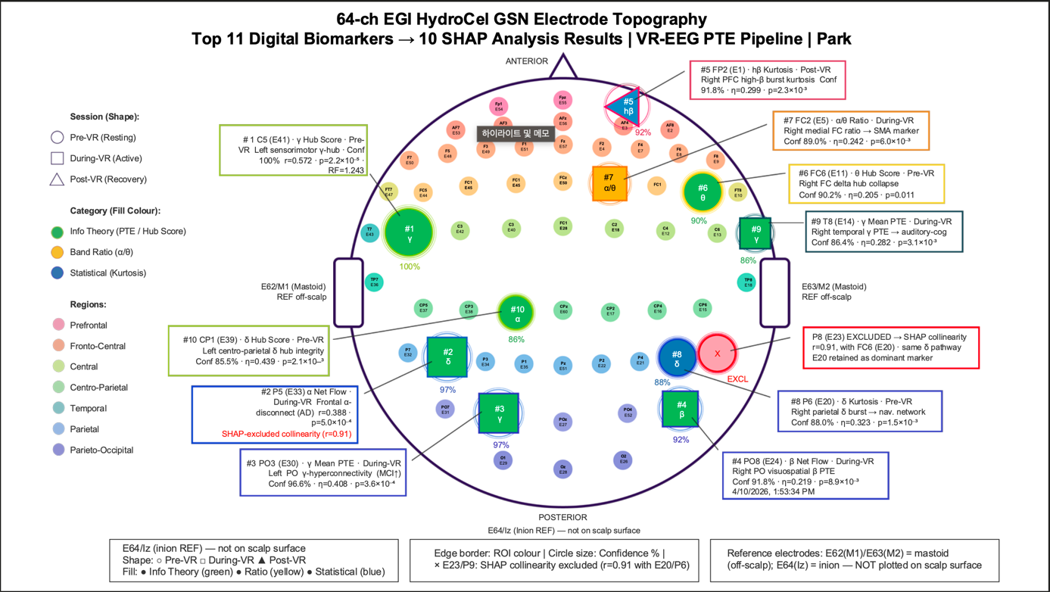
Supplementary Fig. S1 | 64-channel EGI HydroCel GSN electrode topography with candidate biomarker positions. Scalp layout of the 64-channel EGI HydroCel Geodesic Sensor Net following the extended International 10–10 system. Electrodes contributing to the 11 candidate clinical EEG biomarkers (composite confidence ≥85%; Table 3 of main text) are highlighted with colour-coded circles corresponding to their computational domain: Information Theory/PTE (net_flow, mean_PTE, hub_score), Statistical (kurtosis), and Spectral-Ratio (α/θ). The 10 confirmed biomarker electrodes (solid circles) and 1 SHAP-excluded electrode (E23/P8; dashed circle, r = 0.91 with E20/P6) are distinguished. Anatomical region-of-interest (ROI) groupings and associated Brodmann areas are annotated for reference (see Supplementary Table S1 for full mapping).

Supplementary Table S2 | Per-domain classification performance detail
Domain | Best Model | Accuracy | N Features Selected | Feature Density (Acc/N)
Information Theory/PTE | RF | 78.4% | 10 | 7.84
Statistical | SVM | 78.4% | 13 | 6.03
Dynamic (During−Pre) | LR | 78.4% | 9 | 8.71
Spectral Ratio | SVM | 51.3% | 6 | 8.55
Dynamic | XGB | 48.6% | 18 | 2.70
Graph Theory | KNN | 40.5% | 17 | 2.38
Supplementary Note 1
Supplementary Note 1 | Five-domain feature architecture and per-domain exploratory analysis.
The 16,892-feature space was constructed from five complementary computational domains (Supplementary Table S2), each designed to capture a distinct neurophysiological dimension of VR-synchronised EEG:
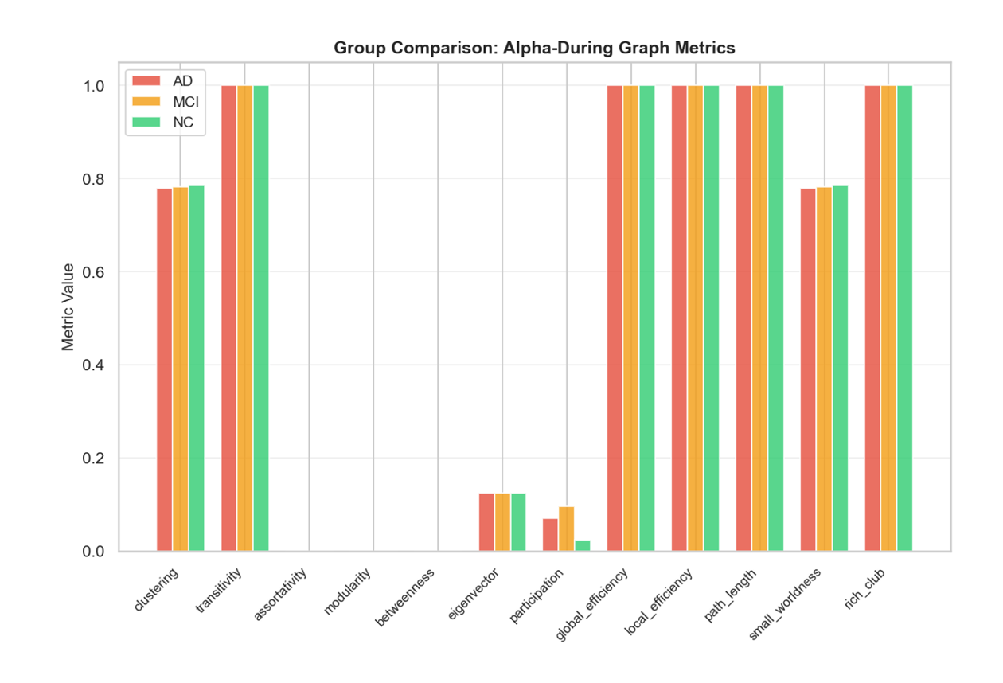
(a) Graph Theory (252 features). Twelve network-topological metrics were computed from PTE-weighted directed graphs for each of 7 frequency bands × 3 temporal phases.
Supplementary Fig. S3a | Exploratory analysis revealed that the majority of global metrics—transitivity, path_length, global_efficiency, local_efficiency, rich_club (all fixed at 1.0), and betweenness, assortativity, modularity (all ≈ 0.0)—exhibited ceiling or floor effects across all three groups owing to the near-complete connectivity of dense PTE matrices. Only clustering coefficient (range: 0.42–0.94, SD = 0.06) and participation coefficient (range: 0.00–0.65, SD = 0.18) demonstrated inter-individual variability and visible group separation. To further investigate, PTE-driven sparse adjacency matrices were reconstructed and thresholded at 20% and 30% edge retention. Among 12 recomputed metrics, only Transitivity, Modularity, and Participation coefficient exhibited consistent group separation across both thresholds, with MCI showing the highest values in all three—a pattern directionally preserved regardless of threshold (Supplementary Figs. S3b, S3c; Supplementary Table S3). This threshold-robust but statistically sub-significant pattern motivated the subsequent ML-based hub_score derivation, which ultimately produced the highest-ranked biomarker (C5 γ hub_score, Rank 1; Table 3 of main text).
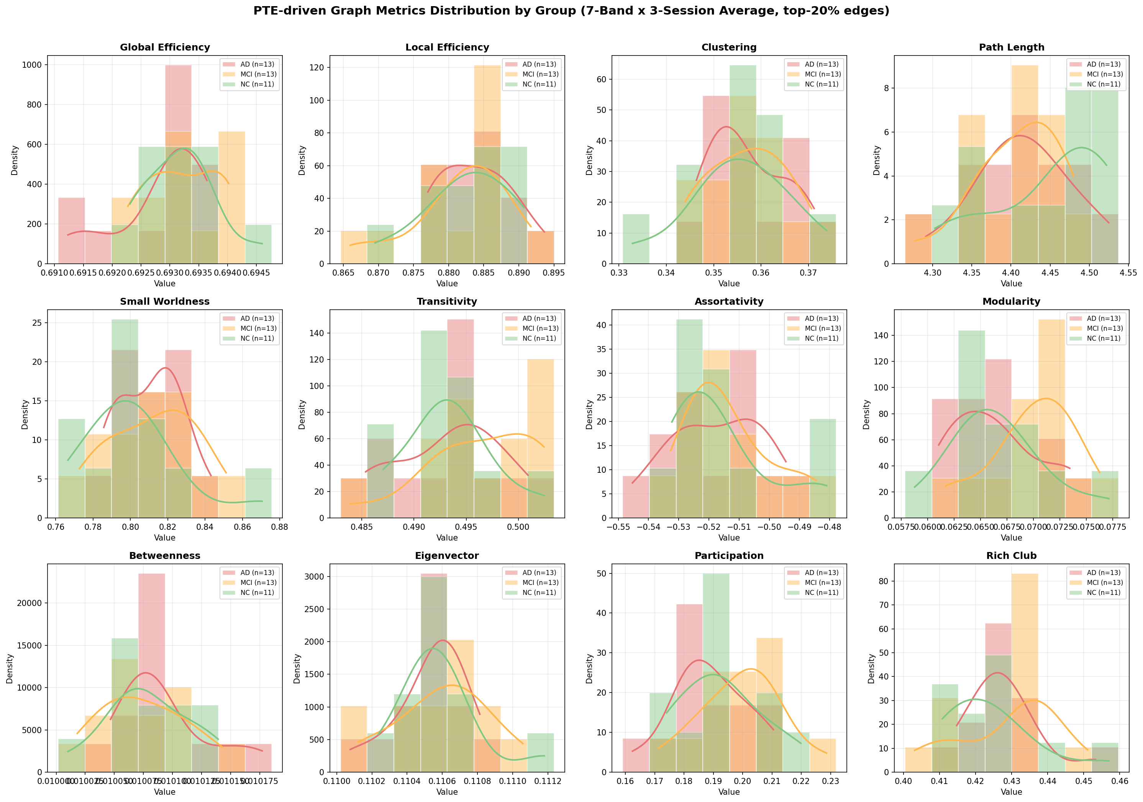
Supplementary Fig. S3b | PTE-driven graph metric distributions under 20% edge-retention threshold. Group-level density histograms (AD, red; MCI, orange; NC, green) for 12 graph-theoretic metrics computed from PTE-weighted sparse directed graphs (top-20% edges retained), averaged across 7 frequency bands × 3 temporal phases. Modularity (F = 2.29, p = 0.116), Participation (F = 2.00, p = 0.151), and Transitivity (F = 1.67, p = 0.203) showed the strongest group separation, with MCI consistently exhibiting the highest values.
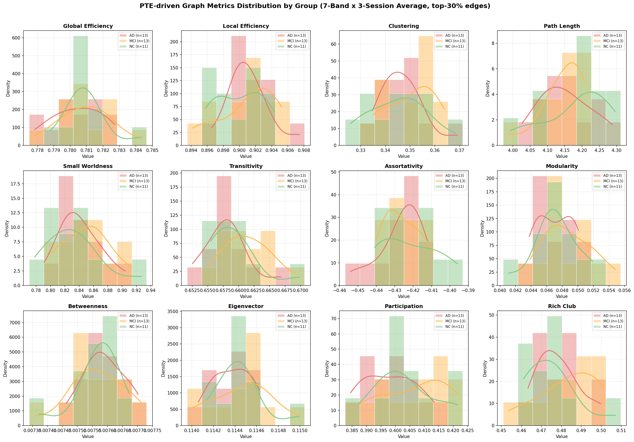
Supplementary Fig. S3c | PTE-driven graph metric distributions under 30% edge-retention threshold. Same analysis as Fig. S3b with top-30% edge retention. Transitivity (F = 2.41, p = 0.105) showed improved separation, and Participation (F = 2.19, p = 0.128) remained robust. The preservation of the MCI-highest directionality across both thresholds confirms threshold-invariant group structure (Supplementary Table S3), motivating the ML-based hub_score derivation that produced the top-ranked biomarker (C5 γ hub_score, Rank 1; Table 3 of main text).
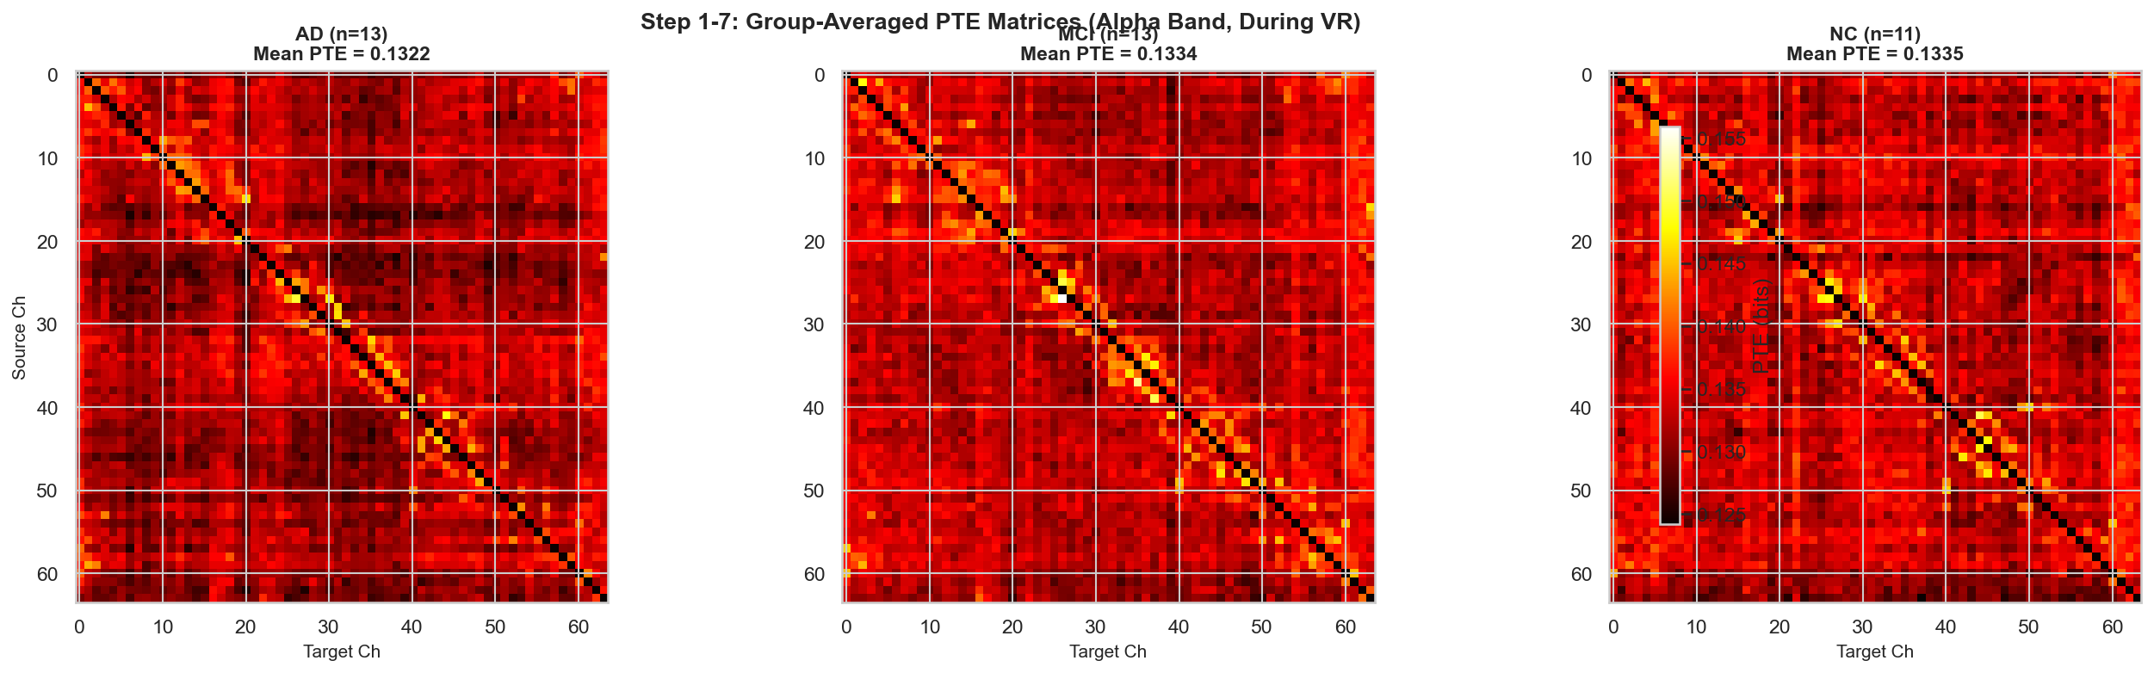
(b) Information Theory / PTE (5,376 features). Four directed-connectivity metrics (mean_PTE, net_flow, asymmetry, hub_score) were extracted per channel × band × session.
Supplementary Fig. S3d | Group-averaged PTE matrices (Alpha-During band) revealed visually discernible differences in connectivity density: NC showed the most diffuse pattern (mean PTE = 0.1335), MCI showed focal amplification in posterior regions (0.1334), and AD showed globally attenuated connectivity (0.1322).
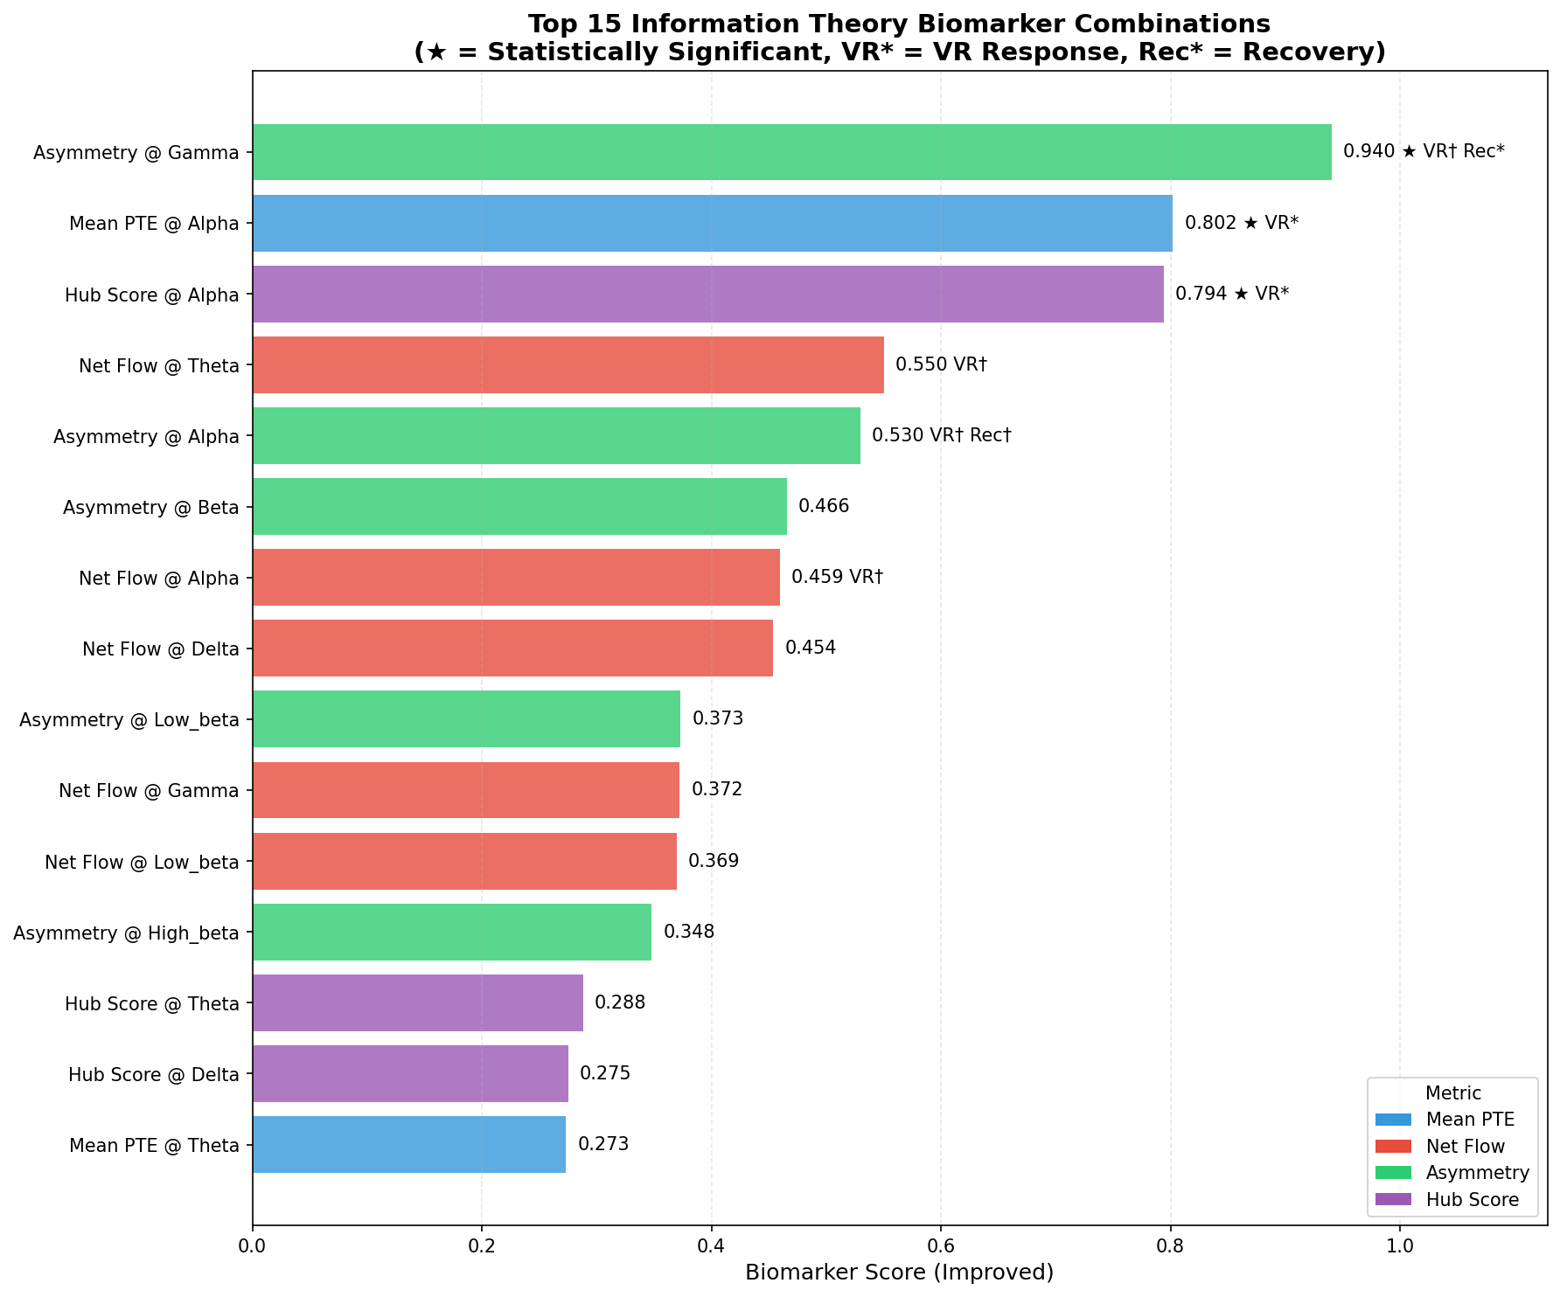
Supplementary Fig. S3e | Composite biomarker scoring across all metric × band combinations identified Asymmetry @ Gamma (score = 0.940), Mean PTE @ Alpha (0.802), and Hub Score @ Alpha (0.794) as the three highest-ranked candidates within this domain, indicating that Alpha-band connectivity strength and Gamma-band directional asymmetry carry the strongest group-discriminative signals.
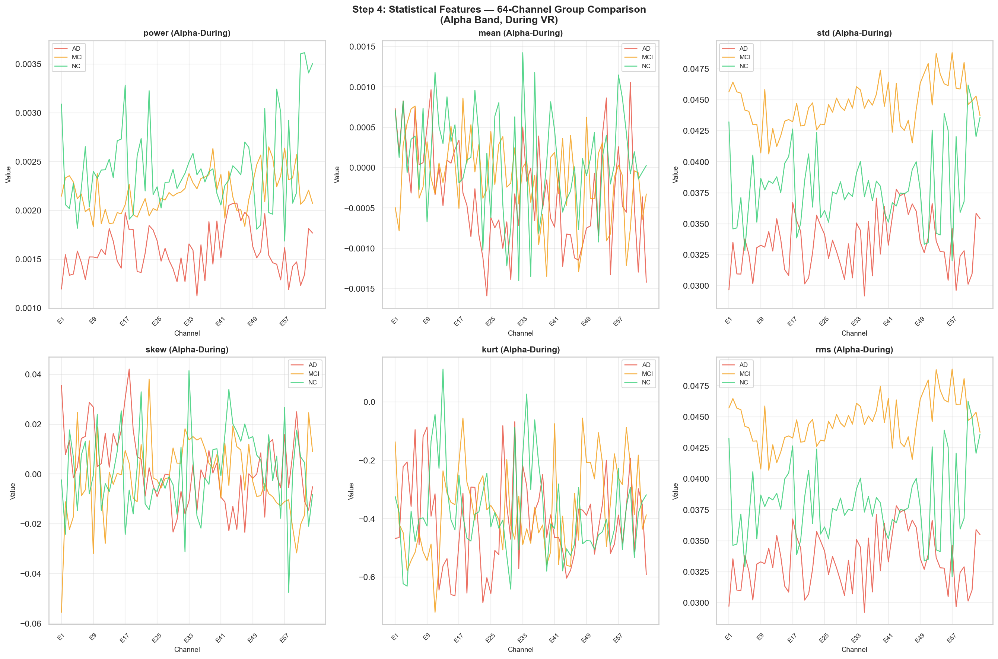
(c) Statistical (8,064 features). Six time-domain statistics (power, mean, SD, skewness, kurtosis, RMS) were computed per channel × band × session.
Supplementary Fig. S3f | Channel-wise group comparison (Alpha-During band) revealed that kurtosis and skewness exhibited the most prominent inter-group separation across the 64-channel array, whereas power and RMS displayed nearly identical spatial profiles, confirming expected redundancy (Pearson r > 0.99). Among these, kurtosis showed the widest inter-individual dispersion (range: −1.80 to 14.44), suggesting that it is the most informative univariate statistical descriptor for group discrimination.
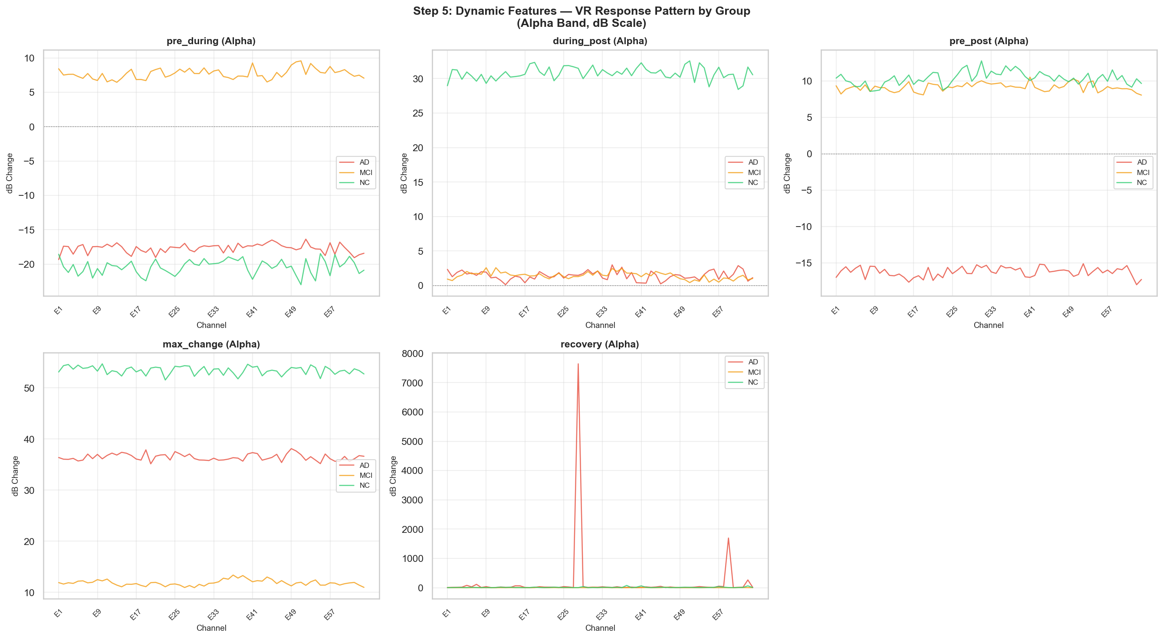
(d) Dynamic / VR-reactivity (2,240 features). Five temporal-change indices (pre→during, during→post, pre→post, max_change, recovery) quantified VR-induced modulation in dB scale.
Supplementary Fig. S3g | A striking pattern emerged: NC exhibited the largest VR reactivity (~42 dB across all bands), AD showed intermediate reactivity (~19 dB), and MCI showed the smallest reactivity (~11 dB). This non-monotonic pattern (NC > AD > MCI) suggests that MCI participants may exhibit attenuated VR engagement prior to the overt disconnection seen in AD, a finding consistent with compensatory load theory.
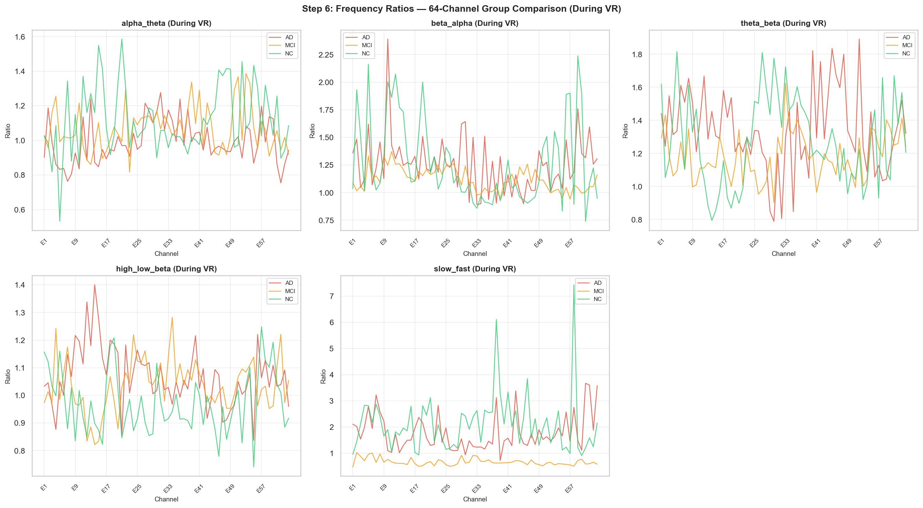
(e) Spectral-Ratio (960 features). Five inter-band power ratios (α/θ, β/α, θ/β, high-β/low-β, slow/fast) were computed per channel × session.
Supplementary Fig. S3h | Channel-wise group comparison during VR confirmed that the α/θ ratio was broadly lower and the θ/β ratio higher in AD, consistent with expected cortical slowing; however, all five ratios exhibited pronounced channel-to-channel fluctuation and the slow/fast ratio displayed extreme outlier spikes in isolated channels. This substantial within-group variance underscores why single-ratio indices alone are insufficient for robust group discrimination and motivates the multi-domain integration adopted here.
Supplementary Table S3 | Sensitivity analysis of PTE-driven graph metrics across edge-retention thresholds.
To evaluate whether group differences in graph-theoretic metrics were robust to network sparsification, PTE-weighted directed graphs were thresholded at 20% and 30% edge retention and 12 metrics were recomputed for each condition (averaged across 7 frequency bands × 3 temporal phases). The top-5 metric × threshold combinations, ranked by one-way ANOVA F-statistic, are shown below. Only Transitivity, Modularity, and Participation coefficient exhibited consistent group separation, with MCI showing the highest values across both thresholds—a pattern that motivated the subsequent ML-based hub_score derivation (see Supplementary Note 1a).
Rank | Metric | Threshold | F | p
1 | Transitivity | 30% | 2.41 | 0.105
2 | Modularity | 20% | 2.29 | 0.116
3 | Participation | 30% | 2.19 | 0.128
4 | Participation | 20% | 2.00 | 0.151
5 | Transitivity | 20% | 1.67 | 0.203

Supplementary Note 2
Supplementary Note 2 | Limitations of conventional statistical biomarker discovery and rationale for multi-model ML classification
Conventional univariate and multivariate statistical approaches (Kruskal–Wallis H-test with Bonferroni correction, Dunn's post-hoc pairwise comparisons) were initially applied to the full 16,892-feature space to identify candidate biomarkers through traditional hypothesis testing. This exploratory analysis identified 201 features with nominally significant group differences, which were ranked by −log₁₀(p-value) to produce a preliminary Top-10 panel (Supplementary Fig. S4). This statistical ranking was dominated by Statistical (kurtosis) and Spectral-Ratio features (α/θ), whereas Information Theory/PTE—which ultimately contributed 7 of the 11 final validated biomarkers including the top-ranked C5 γ hub_score (Rank 1)—was substantially underrepresented, and Graph Theory features, despite comprising the largest share of nominally significant candidates (42.8%; Supplementary Fig. S4a), produced none of the final biomarkers.
However, three fundamental limitations of this conventional approach became apparent:
First, univariate insensitivity to feature interactions. Each statistical test evaluates features independently, ignoring combinatorial patterns across channels, bands, and domains that jointly discriminate AD, MCI, and NC. For example, the Graph Theory domain's global metrics exhibited ceiling or floor effects with no inter-group variability (Supplementary Fig. S3a), yet its clustering coefficient, when combined with PTE-derived hub_score in a multivariate ML framework, contributed the single highest-ranked biomarker (C5 γ hub_score).
Second, the multiple-comparisons burden. Testing 16,892 features under strict Bonferroni correction (α = 0.05/16,892 ≈ 3.0 × 10⁻⁶) is overly conservative for an exploratory discovery study, risking false negatives for biologically meaningful signals with moderate effect sizes.
Third, inability to model non-linear class boundaries. The three-class structure (AD/MCI/NC) with overlapping distributions—particularly the non-monotonic VR-reactivity pattern (NC > AD > MCI observed in the Dynamic domain)—requires non-linear decision boundaries that linear statistical tests cannot capture.
These limitations motivated the transition to a six-model ML consensus pipeline (main text, "Six-model consensus pipeline"), where an SVM–RF composite ensemble with three-stage fold-independent filtration ultimately identified 11 candidate clinical EEG biomarkers with composite confidence ≥85%. The ML approach preserved the comprehensive feature space generated by the five-domain extraction while overcoming the statistical limitations described above, confirming that the multi-domain architecture served as a necessary foundation for ML-based biomarker discovery.
From a clinical standpoint, this transition from univariate statistical testing to multi-model ML consensus is essential for diagnostic biomarker development: the clinically most consequential finding—100% MCI recall with zero false negatives—emerges only in the ML pipeline and would have been missed by conventional univariate statistical screening alone.
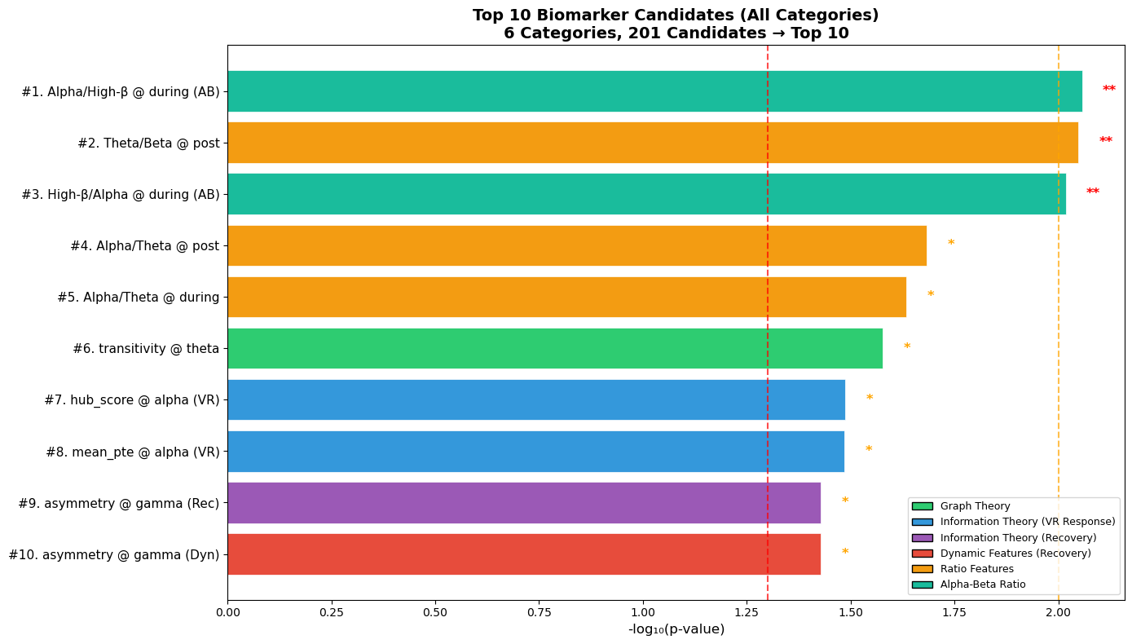
Supplementary Fig. S4 | Univariate statistical screening of 201 nominally significant features.
Supplementary Fig. S4a | Domain composition of all 201 features passing the uncorrected significance threshold (Kruskal–Wallis, p < 0.05). Graph Theory contributed the largest share (42.8%).
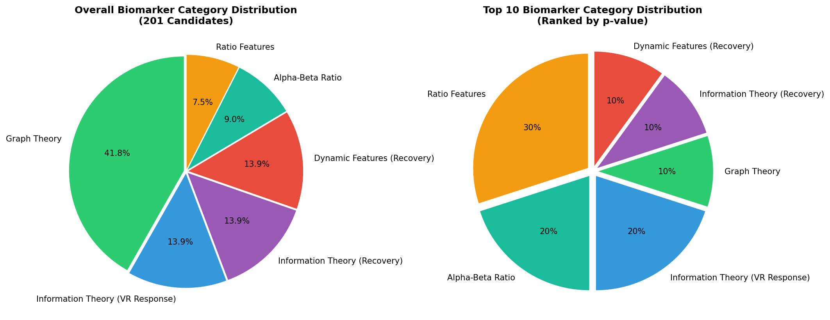
Supplementary Fig. S4b | Domain composition of the top-10 features ranked by −log₁₀(p-value). Despite dominating the overall pool, Graph Theory's share dropped to 10%, while Statistical and Spectral-Ratio features captured 60% of the top ranks. | Supplementary Fig. S4c | The top-10 features ranked by −log₁₀(p-value), coloured by domain. Information Theory/PTE and Dynamic features—which later contributed the highest-ranked ML biomarker (C5 γ hub_score, Rank 1) and clinically informative VR-reactivity patterns (NC > AD > MCI), respectively—are largely absent, illustrating the insensitivity of univariate statistics to non-linear, multi-domain interactions.

Per-domain standalone classification performance under 37-fold LOOCV is summarised in Supplementary Table S2. Three observations support the five-domain architecture: Domain complementarity. Information Theory/PTE, Statistical, and Dynamic (During−Pre) domains each independently achieved 78.4% three-class accuracy, but through distinct feature subsets (10, 13, and 9 features, respectively), confirming non-redundant discriminative information (see main text Fig. 2c). Efficiency asymmetry. The Dynamic (During−Pre) domain achieved the highest feature density (Acc/N = 8.71) with only 9 features under logistic regression, confirming that VR-driven neural reactivity carries disproportionate discriminative power per feature. Disproportionate biomarker yield. Although Graph Theory contributed 1.5% of the original feature space (252/16,892), it produced 0/11 final validated biomarkers, whereas Information Theory/PTE—comprising 31.8% of the feature space (5,376/16,892)—contributed 7/11 biomarkers (including C5 γ hub_score, Rank 1), demonstrating that PTE-derived directional connectivity features undergo the highest enrichment through multi-stage filtration (main text Fig. 2d). These results justify the five-domain architecture as a minimum necessary set: each domain contributes a mechanistically distinct neurophysiological signal to the final classifier.

Supplementary Note 3 | Clinical Translation Pathway and Regulatory Considerations
This supplementary note provides additional detail on the clinical translation pathway for the VR-EEG PTE biomarker platform, as relevant to Scientific Reports readership. Phase 1 (Current study — Discovery): Internal validation of 11 clinical EEG biomarkers in a single-site cohort (N=37) using 37-fold LOOCV and permutation testing. Establishes proof-of-concept and identifies a parsimonious 11-biomarker panel capturable with ≤16 channels. Phase 2 (Recommended next step — External validation): Prospective multisite study targeting N≥120 per diagnostic class (AD, MCI, NC), with clinical diagnosis confirmed by ATN biomarker profiling (amyloid-PET or CSF tau). Primary endpoint: replication of ≥80% three-class accuracy and ≥90% MCI recall in an independent held-out cohort. IRB registration and pre-registration on ClinicalTrials.gov recommended. Phase 3 (Regulatory pathway): The 16-channel dry-electrode VR-EEG configuration qualifies as Software as a Medical Device (SaMD) under FDA 21 CFR Part 820 and EU MDR Annex IX (Class IIa). TRIPOD+AI and STARD 2015 compliance (documented herein) satisfies preliminary regulatory reporting requirements. The explainability provided by SHAP analysis addresses the FDA's AI/ML Action Plan requirement for transparent, interpretable clinical AI. Cost-effectiveness note: At approximately $500–2,000 per portable dry-EEG system (amortised over hundreds of tests), the per-test cost is estimated at $5–20, representing a 99.5% reduction versus amyloid-PET ($3,000–7,000). This positions VR-EEG as viable for memory clinic triage in low-and-middle-income countries, where 70% of future AD cases will arise.
Supplementary Table S4 | Multi-seed stability analysis of classification performance
Accuracy for 10 seeds across all six models (1,850 total evaluations). The near-zero SD for KNN (the optimal classifier) across all 10 random seeds confirms that the 86.5% accuracy and 100% MCI recall are seed-invariant and not artefacts of a specific random initialisation—a critical requirement for clinical diagnostic biomarker stability.
Model | Mean Acc | SD | Min | Max | Stable?
KNN | 86.5% | 0.000 | 86.5% | 86.5% | Yes
RF | 85.1% | 2.2% | 81.1% | 86.5% | Yes
LR | 78.4% | 0.000 | 78.4% | 78.4% | Yes
SVM | 75.7% | 0.000 | 75.7% | 75.7% | Yes
XGB | 73.0% | 0.000 | 73.0% | 73.0% | Yes
† NN-GPU (neural network with GPU acceleration) was included in the six-model consensus pipeline (main text, Table 2) but is excluded from this seed-stability table because neural network training with stochastic gradient descent is inherently stochastic; seed-dependent weight initialisation produces non-zero SD by design. Stability for the deterministic classifiers (KNN, RF, LR, SVM, XGB) is the clinically relevant metric for reproducibility assessment.

Supplementary Table S5 | Pairwise Dunn's post-hoc significance matrix for 10 candidate clinical EEG biomarkers with clinical diagnostic utility classification.
Bonferroni-corrected p-values from Dunn's pairwise post-hoc tests following Kruskal–Wallis H-tests for all 10 validated biomarkers × 3 group comparisons (AD, n = 13; MCI, n = 13; NC, n = 11). P8 (Rank 6; E23, Delta net_flow) was excluded after SHAP collinearity filtering (r = 0.91 with E20/P6; see Supplementary Fig. S2). ✓ = p < 0.05; — = n.s. The 'Clinical Type' column classifies each biomarker by its primary diagnostic utility: NC-MCI discrimination (early screening for prodromal dementia), MCI-AD discrimination (disease progression monitoring), or both—directly mapping to two distinct clinical use cases.
Rank | Biomarker | Domain | NC vs. MCI  (early screening) | MCI vs. AD  (progression) | NC vs. AD  (diagnosis) | Direction Pattern | Clinical Type
1 | C5 Gamma hub score | Information Theory/PTE | ✓ (0.0000) | ✓ (0.0479) | — (0.061) | MCI>NC / MCI>AD / AD>NC | NC-MCI + MCI-AD
2 | P5 Alpha net flow | Information Theory/PTE | — (1.000) | ✓ (0.0119) | ✓ (0.0007) | MCI>NC / AD>MCI / AD>NC | MCI-AD + NC-AD
3 | PO3 Gamma mean pte | Information Theory/PTE | ✓ (0.0284) | ✓ (0.0003) | — (0.769) | NC>MCI / AD>MCI / AD>NC | NC-MCI + MCI-AD
4 | PO8 Beta net flow | Information Theory/PTE | ✓ (0.0137) | — (0.050) | — (1.000) | NC>MCI / AD>MCI / NC>AD | NC-MCI
5 | Fp2 HighBeta kurt | Statistical | — (0.604) | ✓ (0.0016) | — (0.125) | MCI>NC / MCI>AD / NC>AD | MCI-AD
7 | FC6 Delta hub score | Information Theory/PTE | ✓ (0.0479) | ✓ (0.0197) | — (1.000) | NC>MCI / AD>MCI / NC>AD | NC-MCI + MCI-AD
8 | FC2 BandRatio alpha theta | Spectral-Ratio | ✓ (0.0045) | — (0.674) | — (0.132) | MCI>NC / MCI>AD / AD>NC | NC-MCI
9 | P6 Delta kurt | Statistical | ✓ (0.0023) | ✓ (0.0177) | — (1.000) | MCI>NC / MCI>AD / AD>NC | NC-MCI + MCI-AD
10 | T8 Gamma mean pte | Information Theory/PTE | ✓ (0.0020) | — (0.246) | — (0.248) | NC>MCI / AD>MCI / AD>NC | NC-MCI
11 | CP1 Delta hub score | Information Theory/PTE | — (0.137) | ✓ (0.0001) | — (0.157) | NC>MCI / AD>MCI / AD>NC | MCI-AD
Total significant (of 10) |  |  | 7/10 | 7/10 | 1/10

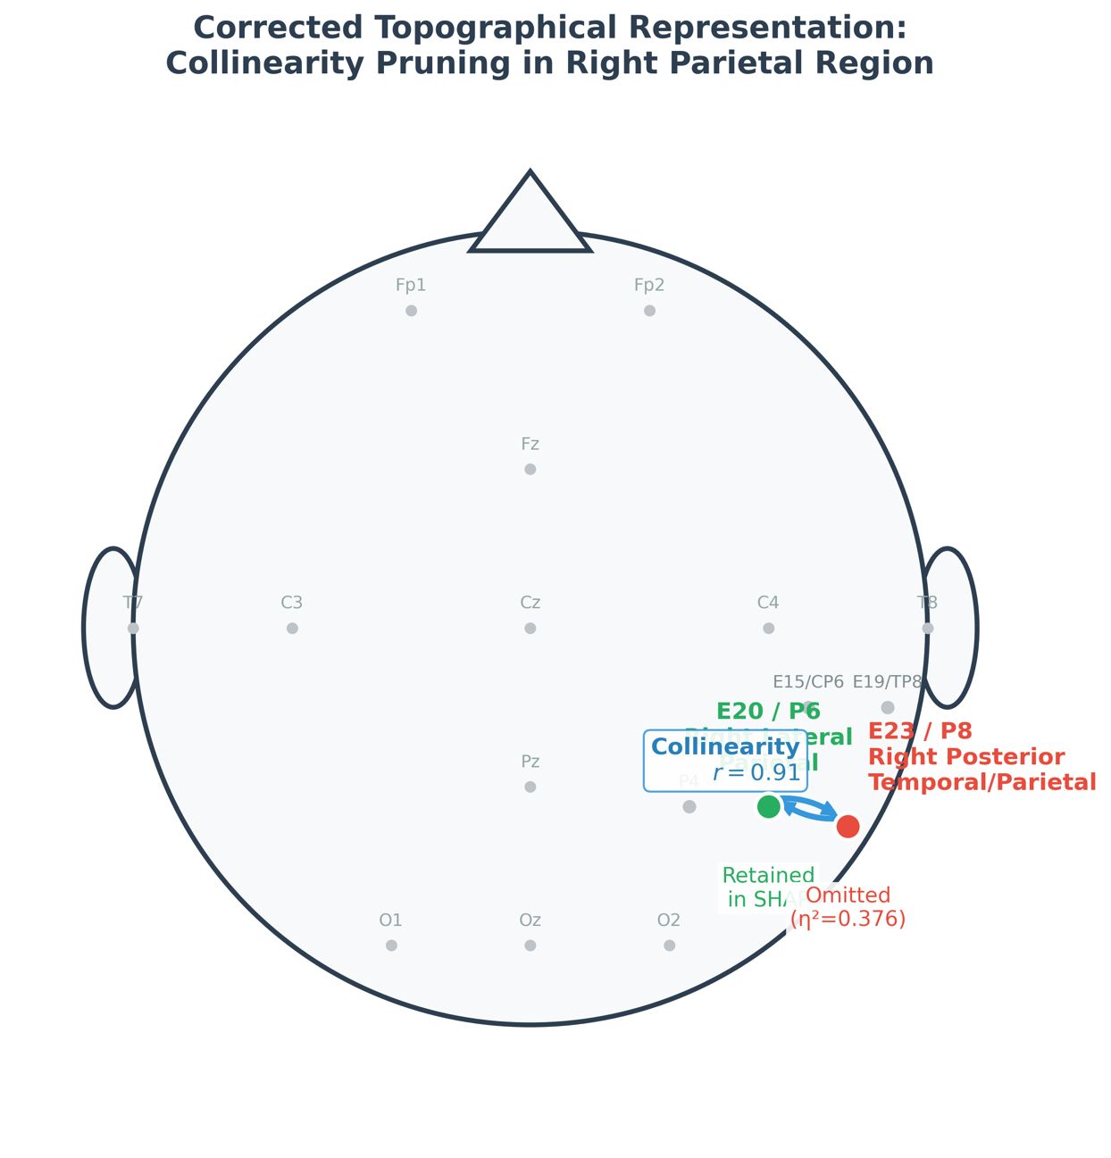
Supplementary Figure S2 | Rationale for SHAP collinearity-based biomarker reduction from 11 to 10 features. EEG topography illustrating the spatial proximity of E23/P8 and E20/P6 in the right parietal region (r = 0.91, p < 0.001). E23/P8 was excluded from the SHAP interpretability panel to eliminate multicollinearity, while its independent effect size (η² = 0.376) is retained in Table 3 of the main text for transparency.
Rationale for Biomarker Reduction
In SHapley Additive exPlanations (SHAP) analysis, high multicollinearity between variables can lead to the dispersion of importance scores, potentially distorting model interpretation. As illustrated in the EEG topography map, E23 (P8) and E20 (P6) are physically adjacent in the right parietal region, resulting in highly redundant neural signals ($r=0.91$). Consequently, to enhance the reliability of the SHAP panels, E23 (P8) was pruned from the visualization, reducing the total number of visualized biomarkers to 10.
Retention of Statistical Results
Although E23 (P8) was omitted from the visualization panels to avoid redundancy, its independent effect size ($η^{2}=0.376$) remains a statistically significant measure of group-level separation. To ensure data integrity and academic transparency, the manuscript explicitly states that the statistical values of E23 (P8) were retained without omission in Table 3.
Comparison of Parietal Electrodes
While E20 (P6) and E23 (P8) share a high correlation due to spatial proximity, they were handled distinctly in the reporting of the analytical results. The following table compares how the two electrodes were differentially processed to avoid multicollinearity in the SHAP visualization and statistical tables.

Supplementary Table S6 | STARD 2015 Checklist for Reporting of Diagnostic Accuracy Studies
This study reports the development and internal validation of EEG-based clinical biomarkers for discrimination of AD, MCI, and NC. In accordance with Scientific Reports requirements for diagnostic accuracy studies (Bossuyt et al., BMJ 2015;351:h5527), the STARD 2015 checklist is provided below. Items not applicable to this discovery-phase study are marked N/A with justification.
Item  # | STARD  Section | Description  (what must be reported) | Location in  Manuscript (v7.8) | Notes / Justification
1 | Title / Abstract | Identification as a diagnostic accuracy study | Title; Abstract — Background paragraph | Title contains 'EEG Biomarkers'; Abstract (Background) states 'clinical discrimination of AD, MCI, and NC'
2 | Abstract | Structured summary of study design, methods, results, and conclusions | Abstract (Background / Methods / Results / Conclusions) | Revised to structured 4-section format per Scientific Reports guidelines
3 | Introduction | Scientific and clinical background; study rationale | Introduction ¶1–2 | ¶1 covers global AD burden and lecanemab/donanemab approval; ¶2 covers qEEG rationale and limitations
4 | Introduction | Study objectives or questions | Introduction ¶5 (four clinically motivated objectives) | Four explicit objectives listed: biomarker development, ML consensus, SHAP interpretability, clinical translation
5 | Methods — Participants | Eligibility criteria | Methods: Study design, ethics, and participants | NINCDS-ADRDA (AD), Petersen (MCI), CDR/MMSE cut-offs; exclusion criteria listed explicitly
6 | Methods — Participants | Recruitment setting, locations, and dates | Methods: Study design, ethics, and participants | Chuncheon Sacred Heart Hospital, Hallym University College of Medicine; IRB No. 7001546-202300614-HRSB-005-01
7 | Methods — Test methods | Index test description (VR-EEG PTE): how and when performed | Methods: VR paradigm and EEG acquisition; Phase Transfer Entropy computation | PTE computed per Lobier et al. 2014; Hilbert-transform; KSG estimator k=3; prediction delay 10 ms
8 | Methods — Test methods | Rationale for thresholds or cut-off values | Methods: Machine learning and statistical validation | Composite confidence threshold ≥85% defined a priori; all hyperparameters fixed before LOOCV
9 | Methods — Reference standard | Reference standard and rationale | Methods: Participants; Table 1 | Clinical diagnosis by certified neuropsychiatrist; MMSE, CDR-SB, and NIA-AA ATN framework used where CSF available
10 | Methods | Sample size (intended and achieved) | Methods: Participants (N=37 final cohort); Discussion: Limitations ¶5(i) | 72 recruited → 60 completed protocol → 37 met all QC criteria; 38.3% exclusion rate; N=37 discussed as limitation
11 | Methods | Handling of missing data | Methods: EEG acquisition and preprocessing | AutoReject adaptive epoch rejection; participants with <100 usable epochs or impedance >50 kΩ excluded
12 | Methods — Statistical | Statistical methods for estimating diagnostic accuracy | Methods: Machine learning and statistical validation | 37-fold LOOCV; permutation testing (n=500); bootstrap 95% CI (n=500, Fig. 3a); multi-seed stability (10 seeds)
13 | Results — Participants | Flow of participants through the study | Results ¶1; Fig. 1 (end-to-end pipeline diagram) | Fig. 1 shows 72→60→37 flow with explicit exclusion reasons at each stage
14 | Results — Participants | Demographic and clinical characteristics | Table 1 | Age, sex, education, MMSE, CDR-SB, epoch rejection rate, SSQ score per group (AD/MCI/NC)
15 | Results — Test results | Distribution of index test results | Table 2; Fig. 3 | Accuracy, F1-macro, F1-weighted, Precision-macro, Recall-macro for all 6 models; permutation null shown in Fig. 3c
16 | Results | Cross-tabulation of index test results by reference standard | Table 2 (confusion matrix data); Fig. 3b | Fig. 3b shows per-class Precision/Recall/F1 for optimal KNN; MCI recall = 100% (zero false negatives) explicitly stated
17 | Results | Estimates of diagnostic accuracy with 95% CI | Results: 86.5% three-class accuracy; Fig. 3a (bootstrap 95% CI error bars) | Per-class metrics (precision/recall/F1) reported in lieu of binary sensitivity/specificity given 3-class LOOCV design (STARD item 24 rationale stated in Methods: Reporting compliance)
18 | Results | Adverse events from the index test | Results ¶1; Methods: VR paradigm | N/A — non-invasive EEG; no adverse events. Simulator Sickness Questionnaire (SSQ) monitored; SSQ >20 triggered exclusion (n=12)
19 | Discussion | Limitations (operational and statistical) | Discussion: Limitations (five enumerated points) | i) N=37 single-site; ii) VR intolerance 20%; iii) no external validation; iv) gel-electrode acquisition; v) no longitudinal follow-up
20 | Discussion | Generalisability / applicability of study findings | Discussion: Limitations ¶5(i); Clinical Implications section | External validation in N≥120/class prospective multisite cohort stated as next step; low-LMIC deployment pathway discussed
21 | Other | Registration number and registry name | N/A — discovery-phase biomarker study | Prospective pre-registration on ClinicalTrials.gov recommended for Phase 2 external validation study
22 | Other | Where the study protocol can be accessed | Code Availability statement; Methods section | Full pipeline code deposited at (https://github.com/eunjungpark98004/EEG_project3_data) (MIT license); preprocessing, PTE, ML, SHAP scripts included
23 | Other | Sources of funding and role of funders | Acknowledgements | NRF Korea (RS-2018-NR031063); MIST (RS-2023-00302751, RS-2024-00343686); Kwangwoon University Research Grant 2024
Abbreviations: AD, Alzheimer's disease; MCI, mild cognitive impairment; NC, normal cognition; LOOCV, leave-one-out cross-validation; PTE, Phase Transfer Entropy; VR, virtual reality; EEG, electroencephalography; SHAP, SHapley Additive exPlanations; SSQ, Simulator Sickness Questionnaire; QC, quality control; CI, confidence interval; IRB, Institutional Review Board; ATN, amyloid–tau–neurodegeneration biomarker framework; NIA-AA, National Institute on Aging – Alzheimer's Association. N/A, not applicable.
Reference: Bossuyt PM et al. STARD 2015: an updated list of essential items for reporting diagnostic accuracy studies. BMJ. 2015;351:h5527. https://doi.org/10.1136/bmj.h5527

Supplementary Table S7 | SHAP Cross-Correlation Between P6 and P8 (collinearity evidence)
Feature | E20 / P6 | E23 / P8
Measurement Location | Right Parietal (relatively medial) | Right Temporo-Parietal (relatively lateral)
SHAP Panel | Visually Retained | Excluded via Pruning (Omitted)
Effect Size ($η^{2}$) | Reflected in main text | $0.376$ (Specified separately in Table 3)
Cross-Correlation | $$r=0.91$$ | $$r=0.91$$
- E20 (P6): Located in the Right Lateral Parietal region, this electrode is associated with spatial processing and navigation (BA 39/40). This electrode was visually retained in the SHAP panels.
- E23 (P8): Located in the Right Posterior Temporal/Parietal region, this electrode is associated with face and object recognition (BA 37/39).
Due to their physical proximity, the EEG signals from these two electrodes are strongly coupled ($r=0.91$). Therefore, the rationale for omitting the relatively posterior E23 (P8) from the visualization to eliminate multicollinearity is clearly justified.

