Supplementary Information
Accompanying manuscript ‘Lunar apatite reveals localized sulfur heterogeneities in late-stage lunar magmas

Samples description
Representing all six Apollo landing sites, the fifteen Apollo thin section samples studied here were supplied by NASA’s Curation and Analysis Planning Team for Extraterrestrial Materials (CAPTEM). The samples are polished rock thin-sections of ~30 μm thickness. A diverse selection of lunar basalts, including low-Ti mare basalts (pigeonite basalts, olivine basalts and gabbroic basalts) and high-Al mare basalts with a range of crystallisation ages from ~3.1 Ga to ~3.9 Ga, and a KREEP-rich basalt (15386) were used in this study. With the exception of sample 14053, all of the mare basalts are pristine with no signs of alteration from secondary processes such as metamorphism or impact shock. In addition, apatite in feldspathic granulitic impactite (79215) and feldspathic polymict breccia (67915) was analysed in this study to perform inter-laboratory comparisons with the existing published data¹ and to check mass balance calculations with δ³⁴S values known for troilite², respectively. Furthermore, apatite in a lunar meteorite, Sayh al Uhaymir (SaU) 169, a hot desert ‘find’ from Oman, was analysed as proof of concept for the adapted nano-scale secondary ion mass spectrometry (NanoSIMS) S-Cl isotope protocol.

Apollo 11:
- High-Ti basalt: 10044,645: A high-Ti, low-K basalt that belongs to the Group B1 of Apollo 11 basalts, 10044 is a coarse-grained porphyritic basalt predominantly composed of pyroxene, plagioclase and ilmenite^{3,4}. The mesostasis areas of 10044,645 are composed of silica, troilite, Fe-metal, K-rich glass, tranquillityite (rare) and apatite^{3,4}. Symplectite is also observable within the mesostasis region. Apatite grains in 10044,645 are commonly subhedral to anhedral (Supplementary Fig. 1) and can vary considerably in size from <10 μm to >~200 μm in the longest dimension. Potts et al. (2016) reconstructed the bulk-mesostasis composition of this sample, showing that the bulk-mesostasis has ca. 70wt.% SiO₂, much higher than the bulk-rock SiO₂ of 42.2 wt.%. The bulk-mesostasis also has low TiO₂ content (1.5wt.%), FeO content of 10.8wt.%, CaO 6.4wt.% and Al₂O₃ is 9.3 wt.%, MgO is 0.3wt.% and 0.5wt.% K₂O. Mg# =38.

Apollo 12:
- Pigeonite Basalt: 12031,7: As coarse-grained basalt, 12031 is predominantly composed of large pyroxene and plagioclase grains (up to 3 mm and 3.5 mm in the longest dimension, respectively)⁶⁻⁹. Contrasting gabbroic and graphic textures are seen within the specific sample 12031,7 (the same section is studied here) involving the juxtaposition of more granular textures against regular intergrowths of plagioclase and pyroxene⁶. The mesostasis regions are very coarse grained and contain large apatite grains (up to ~100 μm in the longest dimension) (Supplementary Fig. 1).
- Pigeonite Basalt: 12039,45: A microgabbro and a low-Ti mare basalt, 12039 is a medium- to coarse-grained ophitic rock, predominantly composed of pyroxene and plagioclase. The acquisition of cathodoluminescence (CL) images of apatites in thestudied sample (12039,45) reveal notable concentric and oscillatory zoning within multiple grains. Same as for 12039,42, apatite in 12039,45 occurs within the mesostasis pockets, predominantly having euhedral-basal with a few being subhedral crystals (Supplementary Fig. 1). The grains occur as clusters, with sizes ranging from <20 μm up to ~60 μm in the longest dimension, that are surrounded by similarly sized potassium feldspar, troilite, tridymite and tranquillityite grains.

Apollo 14
- High-Al Basalt: 14053,19: An ophitic coarse-grained low-Ti basalt that belongs to the Group C high-Al Apollo 14 basalts and has ~50 vol.% of large pyroxene grains (up to 5 mm) alongside lesser quantities (~40 vol.%) of plagioclase grains (up to 2 mm)^{10,11}. Apollo sample 14053 is dubbed the most reduced rock from the Moon because mineral reduction reactions, such as the breakdown of fayalitic olivine and chromite-ulvöspinel, have been observed within the rock. As no impact-melt texture has been detected within the sample, the cause of the reduction is thought to have been due to subsequent solar wind (hydrogen) implantation to the exterior of the rock, post-crystallisation¹⁰. The apatite grains present within the studied sample (14053,19) are euhedral (sparse), subhedral and anhedral and are between 20 μm and 100 μm in the longest dimension (Supplementary Fig. 1).

Apollo 15
We selected 9 samples collected during the Apollo 15 mission, representing the two main petrological sub-groups distinguishable by whole rock major element chemistry¹²: olivine-normative basalts (bulk rock 44–46 wt% SiO₂, 22–23 wt% FeO and 2–3 wt% TiO₂ ) and quartz-normative basalts bulk rock (47–49 wt% SiO₂, 19–20 wt% FeO and 1–2 wt% TiO₂)¹². The selected samples display a wide variety of textures (vuggy vs. vesicular) and grain size (fine- vs. coarse-grained), potentially representing different petrogenetic and cooling histories¹².

Olivine normative basalts
- Olivine basalt: 15016,7: Sample 15016 is a low-Ti medium-grained, olivine-normative, vesicular basalt that contains large vesicles of 0.7–5 mm in diameter³ that comprise ~60% of the rock. Many vesicles are thinly lined with black glass and ilmenite plates within their interior walls (^{13,14}). Sample 15016 is porphyritic due to its large phenocrysts of pyroxene (1 – 2 mm) and olivine (0.8 – 1 mm). The plagioclase grains make up ~20–22 vol.% of the rock (^{3,10,15,16}). Mesostasis regions (~0.3 vol.%) contain troilite and traces of Fe-Ni metal inclusions³ and, within the specific sample studied (15016,7), this is the region where apatite is predominantly found but it also occurs in non-mesostasis regions where it is surrounded by pyroxene and plagioclase. There are many small euhedral, basal sections of apatite as well as anhedral grains in 15016,7 with sizes ranging from <10 μm to ~40 μm in the longest dimension (Supplementary Fig. 1). One apatite analysed with NanoSIMS was found to be zoned with respect to S and Cl (Supplementary Fig. 2).

- Pigeonite basalt: 15058,15: Sample 15058 is a coarse-grained, low-Ti porphyritic basalt¹³ with phenocrysts of clinopyroxene and laths of plagioclase¹⁵. The specific sample studied (15058,15) has apatites that range from euhedral, to subhedral, to anhedral and some with a very thin and long straw-like appearance, the latter of which are predominantly found surrounded by pyroxene and potassium feldspar grains. Other apatites are immediately adjacent to silica, ilmenite, troilite and, occasionally, symplectite. Some apatite grains of <5 μm in size are found clustered together, making their boundaries harder to discern, whereas other straw-like apatite grains are up to 200 μm in the longest dimension (Supplementary Fig. 1). Bulk-mesostasis compositions were reconstructed from sample 15058,20, which may still differ from the compositional point of view, with FeO = 11.1wt%; TiO₂ + 3.6wt%; CaO = 6.4wt% and Al2O3 is 9.2wt%. MgO = 1.7 and K₂O is 0.9wt%⁴. Bulk-rock is 47.8wt%¹² and bulk-mesostasis has 66wt%.

- Gabbroic basalt: 15065,85: A coarse-grained, low-Ti mare basalt¹⁷, sample 15065 is predominantly composed of zoned clinopyroxenes and plagioclase ^{13,15}. This sample shows textural heterogeneities and it is mainly composed of two distinct regions: one is mafic and with vuggy texture, and one of felsic composition¹¹,possibly due to magma chamber zoning or contamination from non-gabbroic material¹⁸. The specific sample studied (15065,85) has apatite included within pyroxene grains and also in contact with plagioclase, potassium feldspar, ilmenite, tridymite and troilite. Apatites frequently exist in tight clusters (<2 μm – ~80 μm in the longest dimension) and are euhedral to anhedral. Fewer larger apatite grains, up to 200 μm in the longest dimension, are found as very fine laths that cross-cut pyroxene (Supplementary Fig. 1). Apatite zonation is detectable when analysed with cathodoluminescence but not seen in backscatter electron images. Like 15016, one apatite analysed with NanoSIMS was found to be zoned with respect to S and Cl (Supplementary Fig. 3).

- Pigeonite Basalt: 15085,15: Sample 15085 is a coarse-grained, low-Ti basalt which contains vugs of a few milimeters in size that represent ~3–5 vol.% of the rock¹⁹. As a quartz-normative basalt that lacks olivine, 15085 is predominantly composed of very large pyroxene and plagioclase grains (up to 10 mm in the longest dimension)¹⁵. Apatites are located within both the mesostasis regions of the sample studied (15085,15) alongside large troilite grains (often up to ~50 μm), ilmenite, silica, potassium feldspar and symplectite, and away from mesostasis regions where they are enclosed in pyroxene grains. Sample 15085 contains the largest apatite analysed in the mare basalts of this study: ~200 μm in longest dimension, but there are also much smaller grains of <~10 μm. Apatites vary in shape from small euhedral to (predominantly) anhedral and lath-shaped (Supplementary Fig. 1).

KREEP basalt: 15386,46
Potassium, rare earth element, phosphorous (KREEP) basalt 15386 is a non-mare basalt sample that has incompatible trace element enrichment of 100 to 150 times that of chondritic (primitive) meteorite compositions (e.g. ref. ²⁰). It is subophitic, pristine volcanic basalt that is predominantly composed of plagioclase and interstitial pyroxene. The mesostasis in the specific sample studied (15386,46) includes potassium feldspar, tranquillityite, baddeleyite, apatite, merrillite, ilmenite, plagioclase and silica. Exclusively found in mesostasis pockets, the apatite is between ~25 μm and ~250 μm in the longest dimension and varies from subhedral to anhedral or appears as long, straw-shaped grains (Supplementary Fig. 1).

Porphyritic Pigeonite Basalt: 15475,17 and 15475,127
Described as a coarse-grained (porphyritic), low-Ti, quartz-normative mare basalt, 15475 contains 2–20 vol.% vuggy pore space and is visibly fractured at the scale of the thin sections¹⁴. Pyroxene represents ~64–74 vol.% of the sample^{13,16} with large grains of up to 15 mm²². Mesostasis regions represent ~1 vol.% of the sample and are exclusively where apatite grains in the specific samples studied (15475,17 and 15475,127) are situated. The mesostasis regions contain silica, ilmenite, potassium feldspar, troilite, plagioclase and pyroxene. Potassium feldspar commonly appears as inclusions within apatite grains. The apatites are mostly euhedral to subhedral and are some of the largest observed in the samples studied (second to apatites of 15085,15) being ~50 μm to ~100 μm in the longest dimension (Supplementary Fig. 1).

Olivine normative basalt: 15545,7
Sample 15545 is described as a porphyritic olivine mare basalt with late-stage interstitial plagioclase¹³. The major constituents are pyroxene, plagioclase and olivine. Mesostasis regions are scattered throughout the thin section sample studied in this project (15545,7) and are where all of the analysed apatites are located. The typical mesostasis regions include potassium feldspar, ilmenite, troilite, Fe-Ni metal, olivine and pyroxene (Supplementary Fig. 1). The majority of apatite grains (typically <10 μm to ~30 μm) are anhedral and contain inclusions of potassium feldspar or are surrounded by intricate lace patterns of potassium feldspar.

Olivine normative basalt: 15555,991
Sample 15555 is a large coarse-grained (porphyritic), vuggy, low-Ti olivine-normative basalt¹⁶. The major constituents are pyroxene, plagioclase and olivine (e.g. refs. ^{3,14,16,21}). The apatite grains of the specific sample studied (15555,991) are predominantly located within the mesostasis regions (0.2-5 vol.%) alongside troilite, potassium feldspar, silica and ilmenite but apatite is also found enclosed within Fe-rich pyroxene grains, often with plagioclase inclusions. Typically, the apatite grains are between <5 μm and ~40 μm in the longest dimension (Supplementary Fig. 1) and appear as clusters of small euhedral or larger anhedral grains. Apatite grains with long, thin straw-like appearances (up to ~100 μm in the longest dimension) that give the impression of having been splashed into the rock, are also common.

Vesicular olivine normative basalt: 15556,137
Sample 15556 is a fine-grained, low-Ti, vescicular mare basalt. ~50 vol.% of the rock contains vesicles of up to ~5 mm, and theyare often lined with opaque minerals (e.g. ilmenite) or glass³. Olivine phenocrysts (~0.1 –0.4 mm) comprise ~5 vol.% of the sample and appear to be less abundant and smaller in regions of the rock where there are more vesicles²². Approximately 50 vol.% of the sample is composed of pyroxene phenocrysts¹³. The matrix of the rock contains granular pyroxene and tabular-shaped plagioclase along with glass and opaque minerals of ilmenite, ulvöspinel and chromite between the larger silicate grains^{3,16}. The mesostasis regions of the specific sample studied (15556,137) typically contain ilmenite, troilite, silica, potassium feldspar, plagioclase and pyroxene (Supplementary Fig. 1). A sample of very few apatites that are all located in mesostasis regions, the grains are anhedral or as needles and relatively small with sizes ranging from <5 μm to ~30 μm in the longest dimension.

Apollo 16:
Feldspathic polymict breccia: 67915,75
Composed of two main polymict lithologies, 67915 is a heavily shocked rock containing many large clasts of anorthosite, ferrogabbro and troctolite. The specific sample studied (67915,75) is dominated by plagioclase and has lesser quantities of olivine and pyroxene (Supplementary Fig. 1). Apatites are found within small mesostasis regions which typically feature ilmenite, troilite and olivine grains, all surrounded by a plagioclase matrix. The apatites are predominantly anhedral (Supplementary Fig. 1) and contain many fractures. For the most part, the grains are small (<10 μm), but narrow apatites of up to ~60 μm in the longest dimension also exist in the studied sample.

Apollo 17:
Feldspathic granulitic impactite: 79215,50
A KREEP-poor sample, 79215 is a holocrystalline, feldspar-rich rock that consists of both relict lithic and single mineral clasts that intermingle with a crushed, mixed and annealed granoblastic matrix. The matrix accounts for ~72% of the rock which was formed by prolonged annealing, crushing and limited mixing of clasts of anorthite plagioclase, olivine, orthopyroxene, clinopyroxene and small quantities of spinel, ilmenite, metal and troilite^{23,24}. The remaining ~28% of the rock is composed of mafic, anorthositic and mineral clasts²⁴. For the specific sample studied (79215,50), apatite exists as large (up to ~500 μm in the longest dimension) subhedral to anhedral grains (Supplementary Fig. 1), located almost exclusively outside of the main matrix area. The apatites are predominantly found as megacryst clasts (smaller ones are ~10 μm) and are believed to have formed during the annealing process because they are observed to enclose some of the matrix material such as plagioclase and olivine^{1,14}.

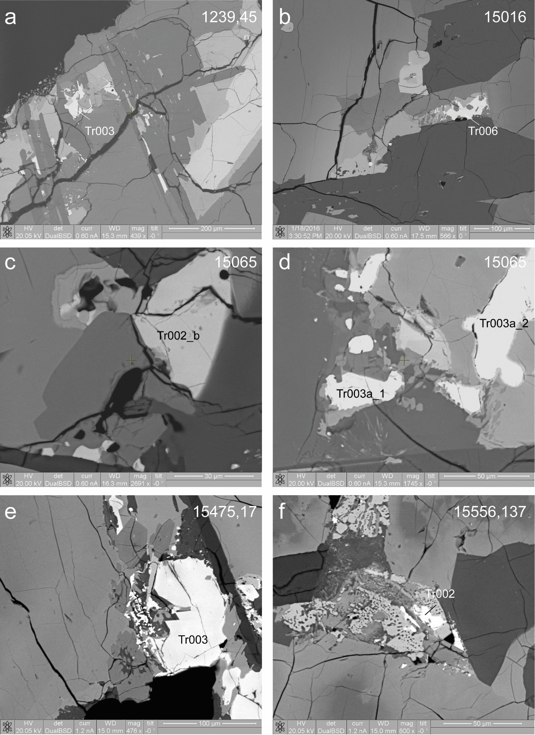
Supplementary Fig. 1. Backscatter electron (BSE) images of troilite grains analysed in this study.

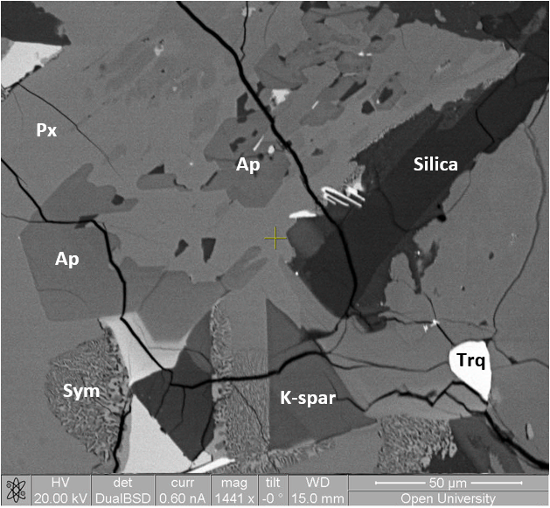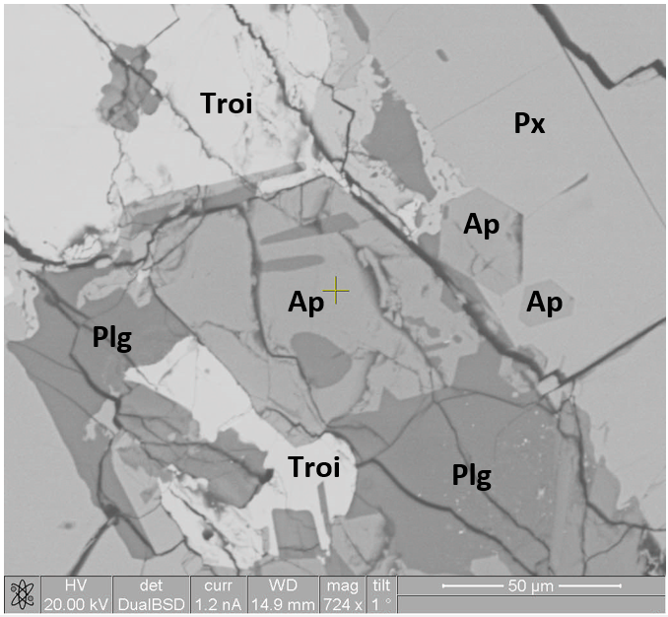
d
b
c
a
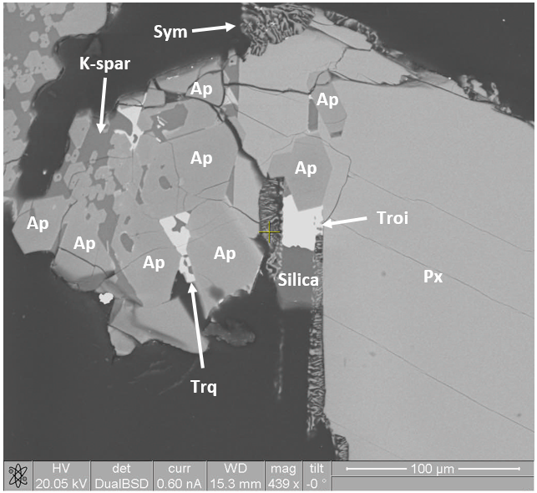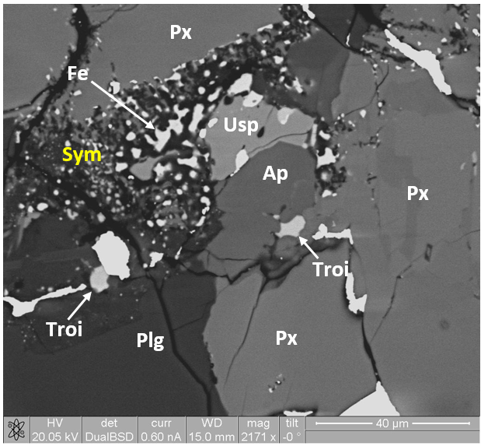
f

e

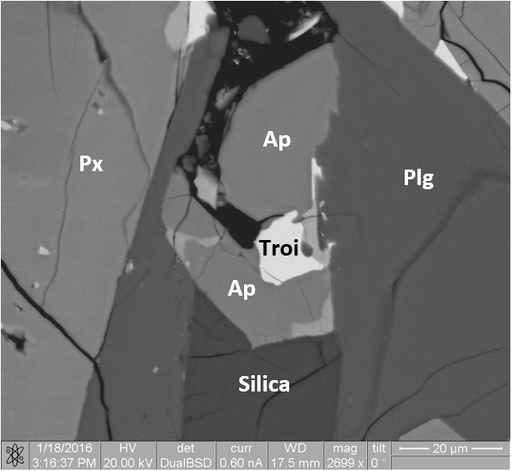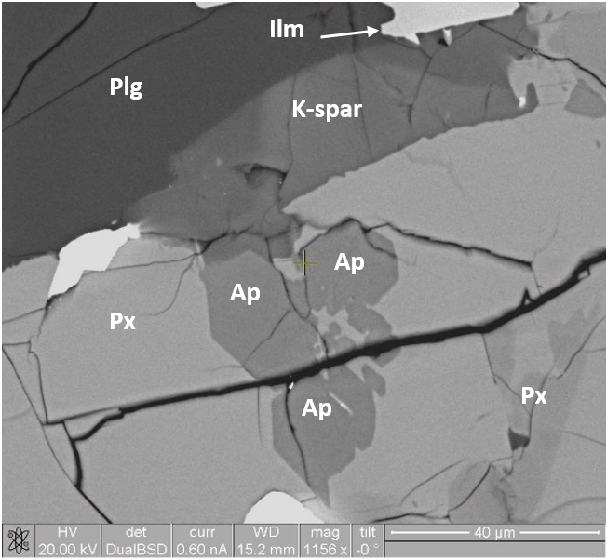
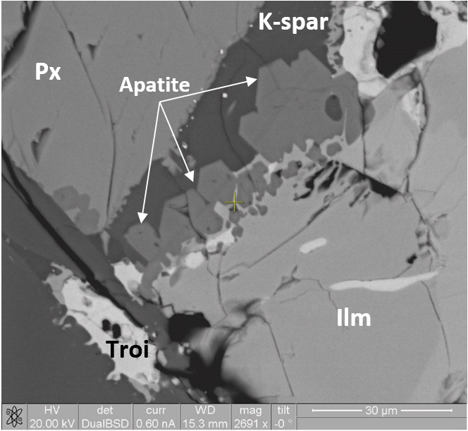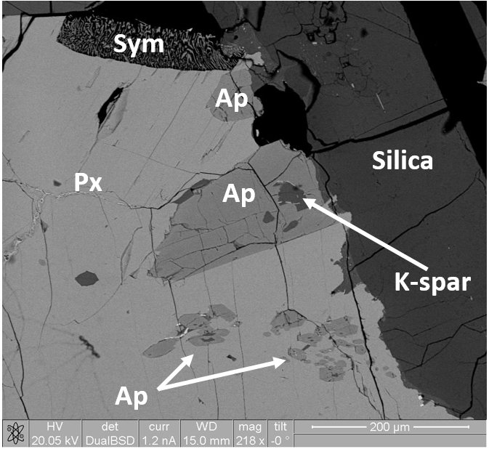
i

j

h

g

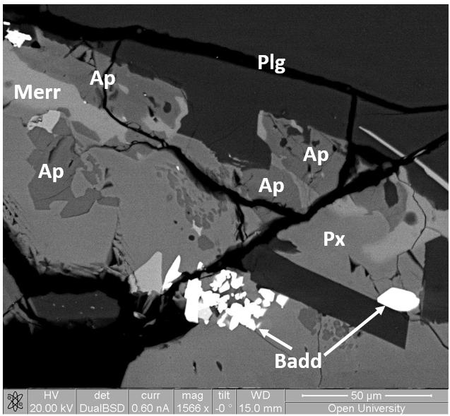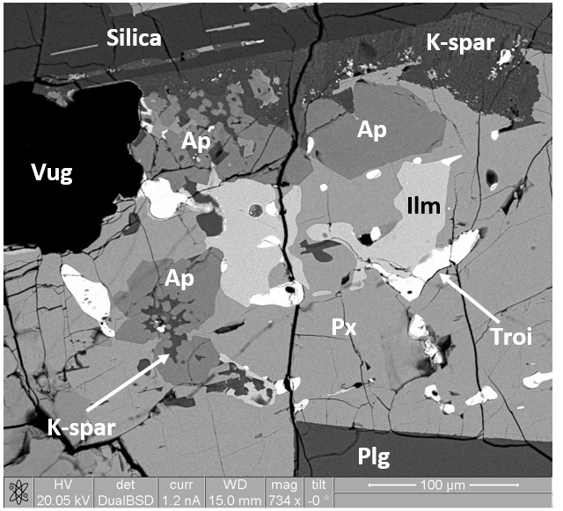
k

l

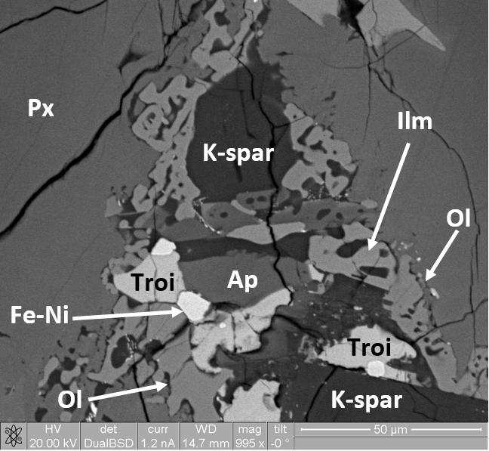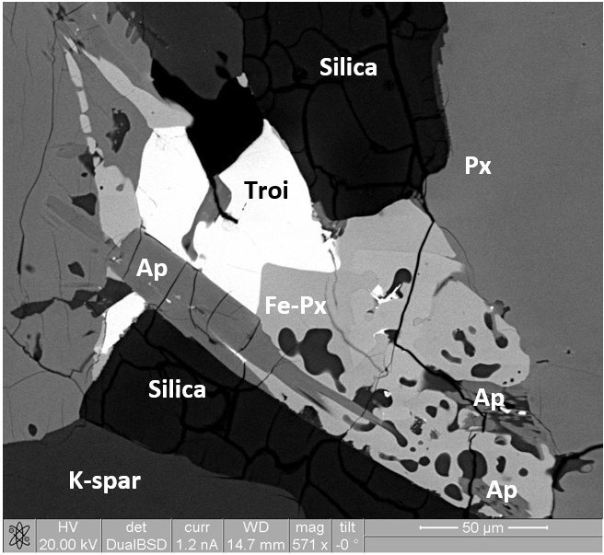
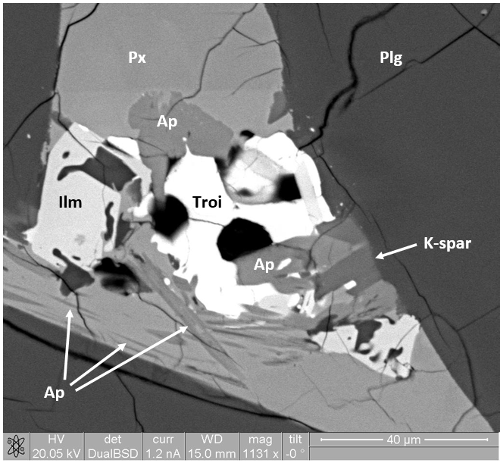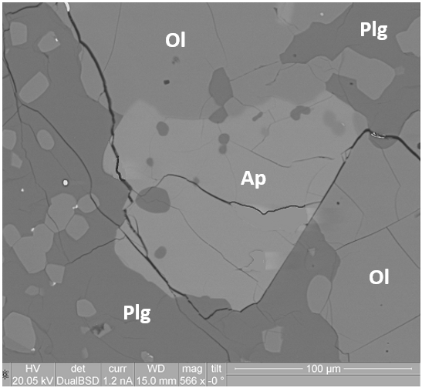
p

m

n

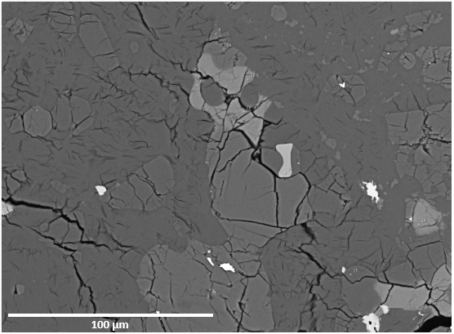
Px
Plg
Troi
Ap
Ap
llm
Ol
Supplementary Fig. 2. Backscatter electron (BSE) images of the apatite grains analysed in this study and petrographic context. a, 10044,645 (image courtesy of Jessica Barnes, The Open University); b, 12031,7; c, 12039,45; d, 14053,19; e, 15016,7; f, 15058,15; g, 15065,85; h, 15085,15; i, 15386,46; j, 15475,17; k, 15545,7; l, 15555,991; m, 15556,137; n, 79215,50; p, 67915,75. Where the mineral abbreviations are: Ap = apatite, Badd = baddeleyite, Fe = iron, Fe-Ni = iron-nickel, Ilm = Ilmenite, K-spar = potassium feldspar, Merr = merrillite, Ol = olivine, Plg = plagioclase, Px = pyroxene, Sym = symplectite, Troi = troilite, Trq = tranquillityite, Usp = Ulvöspinel.

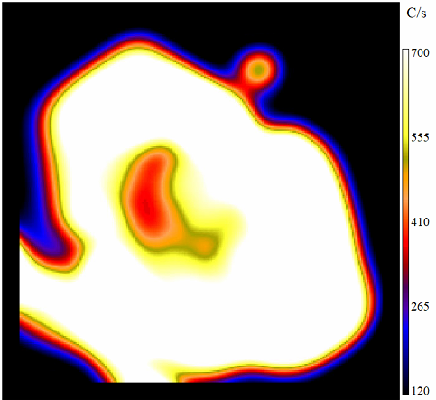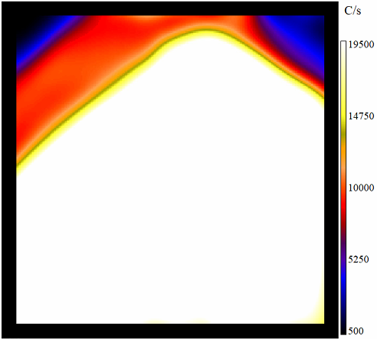
a
b
~ 1,210 ppm S
+28.9 ± 8.3‰
~ 2,760 ppm S
+30.5 ± 5.1‰
~412 ppm S
-27.4 ± 6.5‰

~1,500 ppm S
-18.0 ± 2.4‰
Supplementary Fig. 3. Secondary ion images of zoned apatites acquired with NanoSIMS. a, Apollo sample 15016, apatite grain Ap42 showing clear zonation with respect to S. b, Apollo sample 15065, apatite grain Ap005b, with sharp boundary zonation with respect to S. Where C/s is counts per second of ³²S and where a probe size of ~2 pA and ~25 pA was employed for 15016 and 15065, respectively.

Methods
Ion microprobe analysis
Image processing
Each ion imaging analysis performed with Cameca NanoSIMS 50L typically consisted of between 50 and 500 frames (dependent upon the S or Cl abundances within the sample) which were stitched together and processed using the L’image software (Larry Nittler, Carnegie Institution of Washington) to form one image. All images were corrected for detector dead time and aligned for possible stage shifts. Typically, homogeneous ROIs selected for an apatite standard were ~7 μm x 7 μm. For the samples, only regions with little, to negligible, variation were isolated and used for data processing, with heterogeneous regions such as hotspots of S and cracks or apatite grain boundaries excluded.

X-ray absorption near-edge structure spectroscopy
For the May 2019 analytical session, fresh thin section samples prepared by NASA’s Curation and Analysis Planning Team for Extraterrestrial Materials (CAPTEM) were used to ensure that samples had not previously been exposed to other X-ray measurement techniques (e.g. EPMA or XANES) that might have caused prior beam damage. The X-ray beam was defocussed to give a larger beam size of ~20 x 20 µm, which required apatite grains to be larger than those analysed in the January session and meant that only Apollo samples containing apatites of >~50 µm in the longest dimension were included for S-XANES analysis. Compared with the January analytical session, the S-XANES spectra collection range was 2450 eV – 2550 eV with steps of 0.5 eV and 1 s per energy point.
The larger apatite grains analysed in May have relatively low S abundances when compared with those analysed in January and, with the above instrument setup, little to no S signal reached the detector. Phosphorous swamped the low S signals. In order to increase the S signal, the beam size was reduced to ~>10 x 10 µm and to maintain a low P signal, the Kapton tape was increased to ~25 µm and the detector was positioned further away from the sample during analysis. This improved the S signal, but only very low levels of S were detected.

Peak area integration analysis, background removal and S peak area ratio
The raw S spectra were edge-step normalized in the X-ray absorption spectroscopy (XAS) data processing software Athena²⁵. Normalization involved regressing a line both to the pre-edge and to the post edge region of a spectrum and extrapolating both lines back to the absorption edge of the spectrum. The pre-edge line was subtracted from the post-edge line at the point where both lines passed through E0 to give the ‘edge-step’ parameter. The subtracted data was divided by the edge-step value which flattened the pre- and post-edge regions and assigned values of 0 and 1, respectively.
Supplementary Table 1 shows the reference materials used in this study and Supplementary Fig. 4 shows the normalized S-XANES spectra of those materials used to define the peak energy positions of S oxidation states (S⁶⁺, S⁴⁺ and S²⁻) that could exist in apatite. Anhydrite and terrestrial apatite (Durango) define the S⁶⁺ peak at an energy of ~2483 eV. The Durango also has another peak at ~2478 eV which is thought to represent the presence of S⁴⁺ and, therefore, multiple S oxidation states in terrestrial apatite (e.g. ref. ²⁵). Troilite (FeS) from two different lunar samples (Apollo 15058 and lunar meteorite SaU 169) show a sharp peak at ~2471 eV that represents S²⁻. It is reported that a broad peak also exists for S²⁻ at ~2476.8 eV (e.g. ref. ²⁶), therefore, both the sharp and the broad peaks (~2477 eV in Supplementary Fig. 4) were used in this study to identify S²⁻ in lunar apatite samples. Sodium sulfite appears to have two prominent peaks in Supplementary Fig. 4, with one at ~2478 eV and the other at ~2483 eV. Whilst anhydrous (used in this study) is more stable than hydrous sodium sulfite, it can become oxidized to sodium sulfate if it is not kept completely dry and it is likely that the second peak (~2483 eV) represents partial oxidation²⁶. Therefore, only the first peak (~2478 eV) was used to identify S⁴⁺ in lunar apatites in this study. The energy peak for elemental sulfur (S⁰) is positioned at ~2473 eV.

Supplementary Table 1. Reference standard material used for S-XANES spectroscopy.
Reference standard | Known sulfur oxidation state* | Location/ source
Troilite (FeS) | 2- | Contained within Apollo sample 15058 and lunar meteorite SaU 169.
Elemental S | 0 | Supplied by I18 beamline scientist.
Sodium-sulfite (Na₂SO₃) (anhydrous) | 4+ | Purchased from Fisher Scientific.
Terrestrial apatite (Durango) | 6+ | Durango, Mexico. Supplied by Excalibur Mineral Corp, USA.
Rose gypsum  (anhydrite: CaSO₄) | 6+ | Courtesy of Peter Landsberg, The Open University

* refs. ^{41,66} and European Synchrotron Radiation Facility (ESRF).

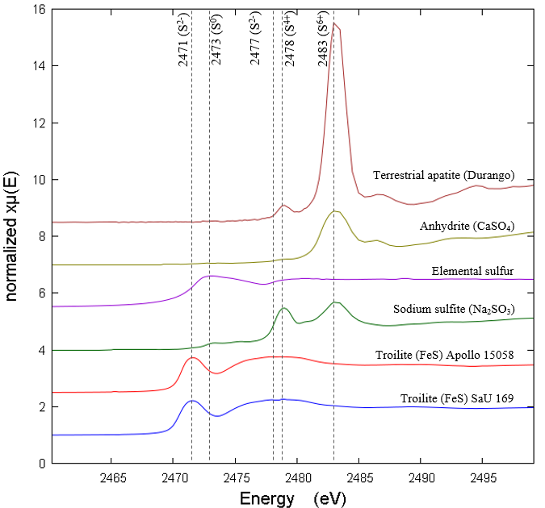
Supplementary Fig. 4. Edge-step normalized XANES spectra at the S K-edge of S reference materials. Individual spectra are offset vertically for clarity.

The normalized data was exported from Athena and loaded into the non-linear curve fitting software Fityk (version 1.3.1)²⁷ to perform peak area integration analysis. The background signal of each S-XANES spectrum was removed, using a similar method to Konecke et al.²⁵, with an exponentially modified Gaussian (EMG) function in Fityk. For all spectra, the pre- and post-edges of the EMG function were set to 0 and 1, respectively, with the EMG function inflection point set to ~2479 eV (Supplementary Fig. 5). The peak fitting method with background removal is reported to be a semi-quantitative method, whereby the derived peak area ratios are proportional to the abundance of each S oxidation state in an apatite grain²⁵.
With use of the known peak energy positions of S⁶⁺ (~2483 eV), S⁴⁺ (~2478 eV) and S²⁻ (~2471 eV and ~2477), individual Gaussian curves were positioned onto the background-subtracted S-XANES spectrum in Fityk so that the highest point (the peak) of the Gaussian curve was positioned at a known absorption energy. Peak fitting of each spectrum was performed with the Gaussian area (Gaussian-A) function in Fityk. The peak area fitting energy range was truncated so that only S-XANES data between ~2465 eV and ~2485 eV (the S K-edge) were included within the peak fitting (Supplementary Fig. 5).
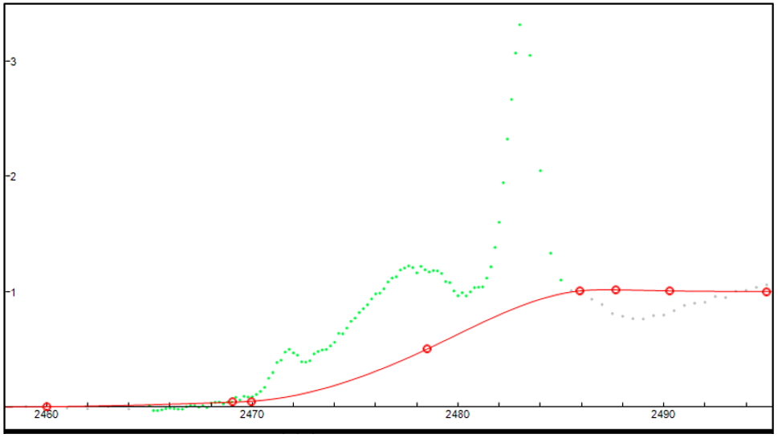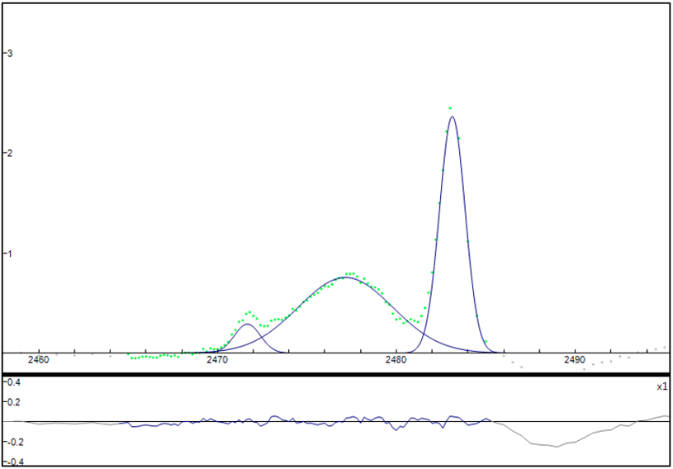
a
b
Supplementary Fig. 5. An example of background removal and peak fitting of S-XANES in Fityk. The normalized S-XANES spectrum of data collected from a single point on an apatite within Apollo sample 15065 is shown in a, where the green dotted line is the spectrum and the red line is the EMG function (fitted background) before subtraction. The y-axis is the absorption intensity. Visible grey dots represent data that was excluded from the fit (in the pre- and post-edge regions). b, The same spectrum is shown but the background has been subtracted and the Gaussian-A functions (added peaks, in blue) have been fitted. The lower panel of b, shows the peak fitting residual, which represents the difference between the best-fitting model and the data points, and is based on weighted sum of squared residuals (WSSR) (chi-square)⁶⁷.

The peak fitting process determined the individual area values of peaks representing S⁶⁺, S⁴⁺ and S²⁻ (where present) and the corresponding residual standard deviation for all of the fitted spectra. To calculate the S⁶⁺ content of a lunar apatite sample, the peak area value of S⁶⁺ was divided by the sum of the peak area values of all sulfur (e.g. S⁶⁺ + S⁴⁺ + S²⁻) to give a peak area ratio of ‘S⁶⁺ to total sulfur’: S⁶⁺/ΣS_{tot}.

Reproducibility
In order to confirm the reproducibility of the S-XANES measurements (and the data reduction technique), repeated S-XANES measurements were made of the Durango apatite (Supplementary Fig. 6) which resulted in an average integrated S⁶⁺/ΣS_{tot} peak area ratio of 0.95 ± 0.01 (2σ standard deviation). An average integrated S⁶⁺/ΣS_{tot} peak area ratio of Durango apatite has been previously reported by²⁵ as 0.956 ± 0.002 (2σ) based on an average of twenty S-XANES scans. Supplementary Fig. 6 shows that, within error, the measurements performed were also accurate based on the external average value reported by²³.

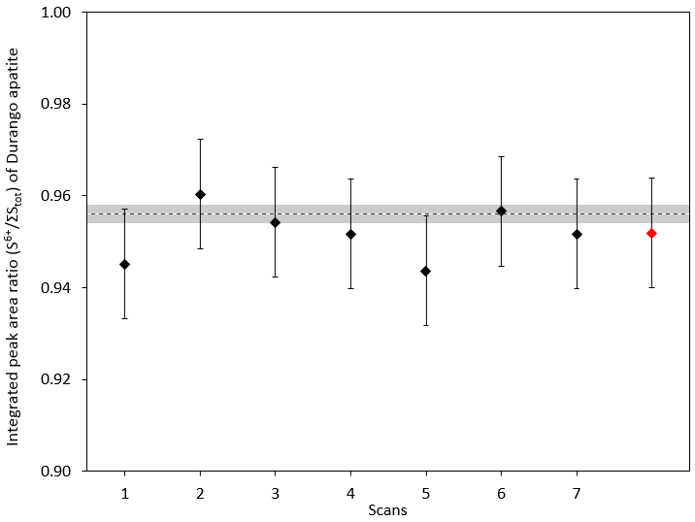
Supplementary Fig. 6. The precision and accuracy of S-XANES analyses. Individual S-XANES data collection scans of Durango apatite are plotted as the integrated peak area ratios (S⁶⁺/ΣS_{tot}) (black diamonds). The dashed line at 0.956 represents the average S⁶⁺/ΣS_{tot} (n = 20) of Durango apatite, derived independently⁴¹, where the grey band denotes the reported 2σ uncertainty (0.002). The red diamond represents the average of the measurements (n = 7) made in this study, where S⁶⁺/ΣS_{tot} = 0.95 ± 0.01 (2σ). The error bars associated with each of the measurement points represent the residual standard deviation (c.f. Supplementary Fig. 5).

Results and discussion

NanoSIMS

Sulfur and chlorine compared
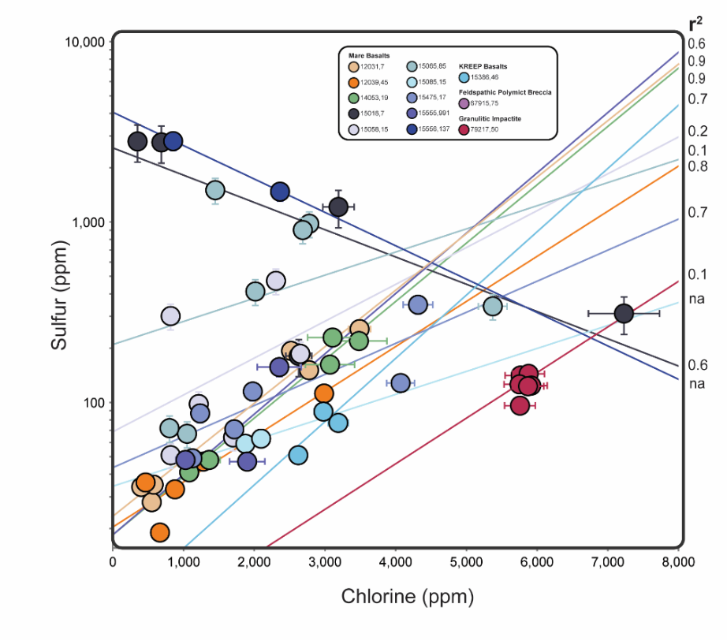
Supplementary Fig. 7. Plot of S abundance (ppm) against Cl abundance (ppm) for the measured apatite grains. Correlation coefficients are shown for each Apollo sample. Apatite grains show significant positive correlation between sulfur and chlorine across the majority of Apollo samples. See text for further details. The error bars are the 2σ uncertainty associated with the measurements. Note the log scale on the y-axis.

Sulfur hotspots
It is worth mentioning that some differences in sulfur abundances when compared to literature data from simial samples could be due to incorporation of S hotpots within the grains that would not be detected with prior investigative techniques (e.g. electron probe microanalysis or scanning electron microscopy) given their very small sizes (<<1 μm). Using the NanoSIMS imaging mode, sulfur hotspots were clearly observed in apatites of 12039 and 14053 (Supplementary Fig. 8), but, importantly, not in 79215. The S hotspots contained far higher counts of S relative to the homogeneous apatite regions and could either be avoided during analysis or removed during image processing.

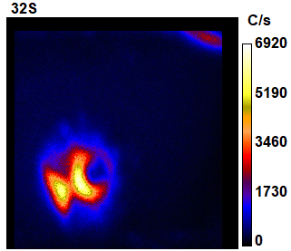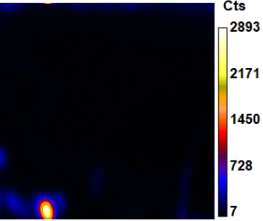
b
a
³²S
³²S
Supplementary Fig. 8. Sulfur hotspots in lunar apatite. a, 10 x 10 µm NanoSIMS image of an apatite in Apollo sample 14053 is shown with a sulfur (³²S) hotspot just towards the bottom-left of centre with up to ~6,900 counts per second. b, An equivalent image for Apollo sample 12039 is shown with a sulfur hotspot at the bottom left of an apatite grain with up to ~2,800 counts per second.

Mass balance
Given the dominance of troilite (FeS) within mare basalts, the more restricted S isotope values reported for bulk-rocks predominantly reflect the δ³⁴S value of troilite, which is masking the far greater δ³⁴S range measured in situ in the minor S constituent apatite phase. Unlike apatite which crystallises from the silicate melt, troilite precipitates from an immiscible sulfide melt that is segregated from the silicate melt (Fe²⁺ + S²⁻ ↔ FeS_{(liquid)}) if the concentration of sulfide in the silicate melt exceeds the sulfur content at sulfide saturation (SCSS)⁷⁹. Mass balance calculations show that if bulk-rock δ³⁴S values of ~ -1.6‰ to +0.5‰ (refs. ¹¹⁻¹³) for the mare basalt samples are adopted and assuming that, firstly, 85-99% of the bulk-rock S is contained in troilite and, secondly, that troilite has an approximate δ³⁴S value of -1‰ to -3‰ (ref. ¹⁵), the δ³⁴S values measured in apatite in this study (-33.3‰ to +36.4‰) do not make a significant impact on the S isotopic composition of the bulk-rock. Troilite would have crystallised from the sulfide melt, which is likely to have experienced limited S isotope fractionation during H₂S degassing (e.g. ref. ³⁶), unlike the late-stage silicate melt from which apatite crystallised.

S-XANES
Not all of the apatites analysed with NanoSIMS could be analysed with S-XANES due to the limited beam time available at the synchrotron facility, low levels of S, small grain sizes and the proximity of FeS to some of the apatites. The number of S-XANES scans carried out on each apatite grain varied depending on practical considerations such as the size of the apatites and the need to avoid cracks, if present.
The individual S-XANES spectroscopy scan results for nine apatites in five different Apollo low-Ti mare basalt samples (12039, 15016, 15058, 15065 and 15475,127), lunar meteorite SaU 169, a terrestrial apatite (Durango) and non-apatite materials (pyroxene, symplectite glass and epoxy) of an Apollo sample are shown in Supplementary Table 5. A summary of the results is shown in Supplementary Table 5 which gives an average S⁶⁺/ΣS_{tot} value for the S-XANES scans of each analysed apatite. All of the apatite S-XANES spectra reported in this study have S⁶⁺/ΣS_{tot} ratios of >0, which means that the oxidation state of S in lunar apatite can provide an indication of the oxygen fugacity (fO₂) of a late-stage silicate melt and can, therefore, act as an oxybarometer (e.g. refs. ^{23,41}). Whilst S⁴⁺ was observed in the apatite of the Durango and lunar meteorite SaU 169, it was not detected in any apatites of the Apollo samples.
Supplementary Fig. 11 shows a selection of the Fityk peak-fitted S-XANES spectra of apatite grains from the five Apollo samples. A combination of three absorption features, with variable intensities, related to S⁶⁺ (~2483 eV) and S²⁻ (sharp peak at ~2471 eV and broad peak at ~2476.8 eV) are apparent in the apatites. Additionally, S-XANES analyses of symplectite glass and pyroxene in close proximity to grain Ap012a of sample 15058 (Supplementary Tables 3 and 4 and Supplementary Fig. 12) were carried out and show no spectral similarities with apatite Ap012a (Supplementary Fig. 11). The epoxy of sample 15058 was also analysed but, because the S content was below the level of S-XANES detection, no S spectra could be acquired which suggests that S signals from the epoxy are unlikely to have affected apatite S-XANES measurements.

Supplementary Table 2. A summary of the S-XANES results. The average S⁶⁺/ΣS_{tot} ratio of the measurements made for individual apatite grains is recorded in the table. The corresponding S isotope values and S abundances determined in this study with NanoSIMS are also included. The individual S-XANES scan results are shown in Supplementary Table 5.
Session | Sample type | Sample I.D. | Analysis I.D. | Avg. S⁶⁺/ΣS_{tot} | δ³⁴S (‰) | 2σ (‰) | S (ppm) | 2σ (ppm)
January 2019 | Olivine basalt | 15016,7 | Ap42 | 0.55 | 29.7 * | 6.7 | 1,987 * | 464
 | Gabbroic basalt | 15065,85 | Ap007^{ǂ} | 0.27 | -29.1 | 2.4 | 903 | 146
 | Gabbroic basalt |  | Ap005b | 0.29 | -22.7 * | 4.5 | 957 * | 155
 | Gabbroic basalt |  | Ap001b | 0.25 | -18.0 | 2.8 | 341 | 55
 | Gabbroic basalt |  | Ap003 | 0.36 | -14.1 | 2.6 | 978 | 158
 | Pigeonite basalt | 15058,15 | Ap012a | 0.32 | -7.9 | 3.2 | 472 | 76
 | Pigeonite basalt |  | Ap016 | 0.30 | -0.2 | 2.7 | 301 | 49
 | Pigeonite basalt | 12039,45 | Ap001_a | 0.23 | 9.0 | 9.2 | 47 | 5
 | Pigeonite basalt |  | Ap001_f | 0.39 | -2.1 | 7.0 | 112 | 12
 | Symplectite glass | 15058,15 | - | 0.12 | N/A | N/A | N/A | N/A
 | Epoxy | 15058,15 | - | b.d. | N/A | N/A | N/A | N/A
 | Pyroxene | 15058,15 | - | 0.06 | N/A | N/A | N/A | N/A
 | Impact melt breccia  (lunar meteorite) | SaU 169 | SOI 7 | 0.86 | 1.4 | 4.2 | 245 | 19
 | Impact melt breccia  (lunar meteorite) |  | SOI 14 | 1.00 | 6.8 | 3.6 | 340 | 26
 | Impact melt breccia  (lunar meteorite) |  | SOI 15 | 1.00 | 29.9 | 3.5 | 477 | 37
 | Terrestrial apatite | Durango | - | 0.95 | - | - | - | -
May 2019 | Gabbroic basalt | 15065,85 | Ap007^{ǂ} | 0.19 | -29.1 | 2.4 | 903 | 146
 | Porphyritic pigeonite basalt | 15475,127 | Ap002 | 0.05 | 3.7 | 1.0 | 2332 | 227
 | Porphyritic pigeonite basalt |  | Ap003a | 0.12 | 2.9 | 1.2 | 1329 | 130
 | Porphyritic pigeonite basalt |  | Ap003b | 0.09 | -1.2 | 1.3 | 646 | 63

b.d. = below level of detection. * Average of the core and rim S isotope and S contents values for the zoned grain. ^{ǂ} Same apatite grain measured in both January and May 2019.

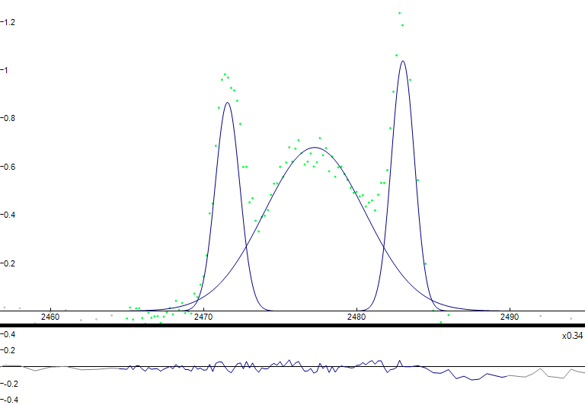
a
b
S⁶⁺/ΣS_{tot} = 0.21
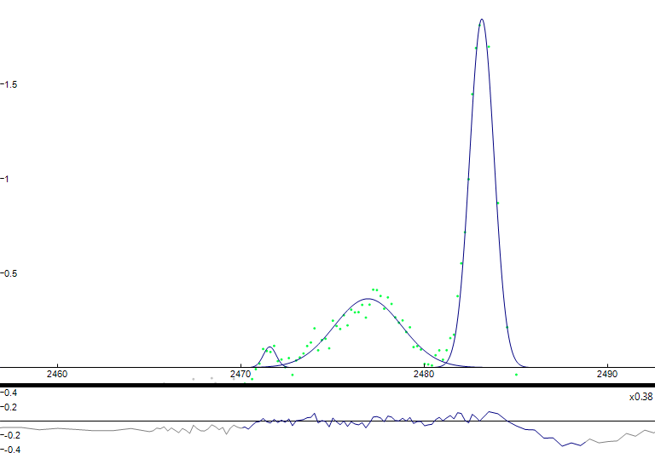
S⁶⁺/ΣS_{tot} = 0.56
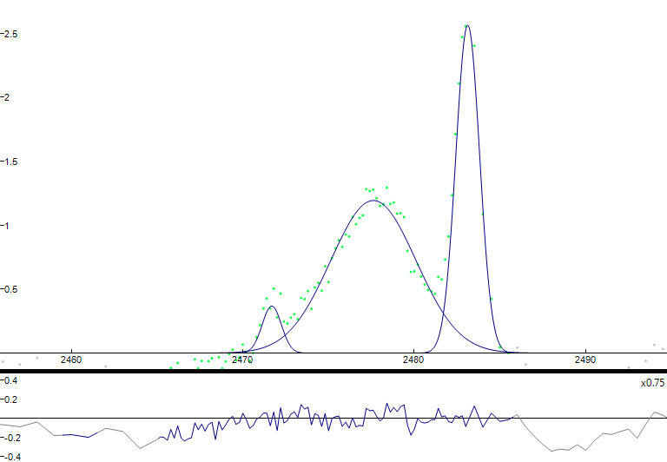
c
d
S⁶⁺/ΣS_{tot} = 0.36
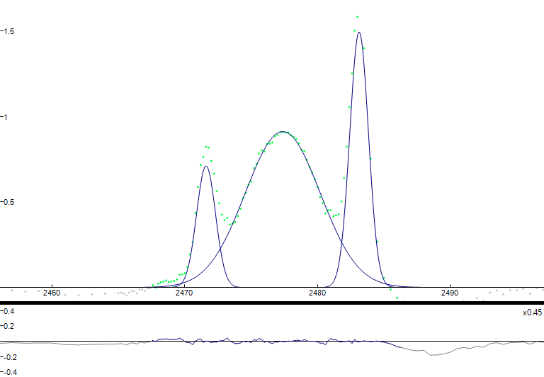
S⁶⁺/ΣS_{tot} = 0.25
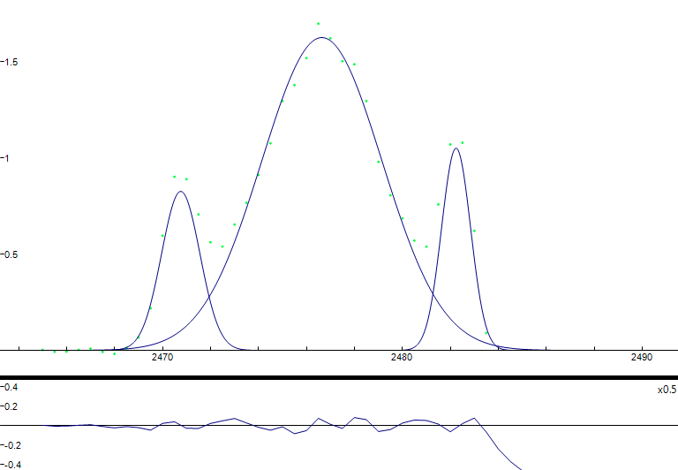
e
S⁶⁺/ΣS_{tot} = 0.12
Supplementary Fig. 9. Typical Fityk peak-fitted S-XANES spectra of apatite in Apollo samples. a, 12039 Ap001_a; b, 15016 Ap42; c, 15058 Ap012a; d, 15065 Ap005b; e, 15475 Ap003b.

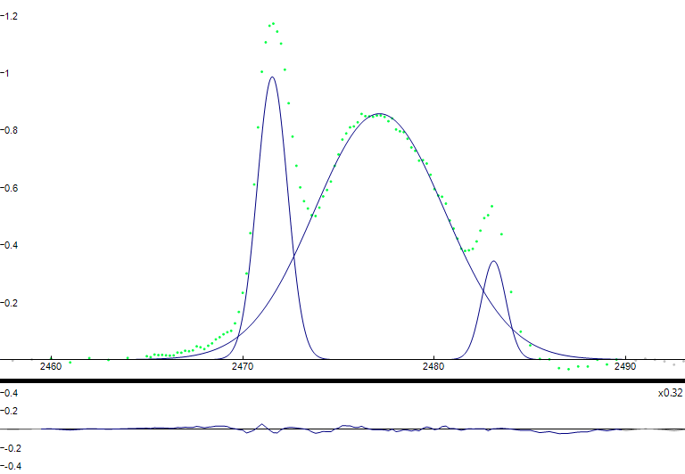
b
a
S⁶⁺/ΣS_{tot} = 0.06
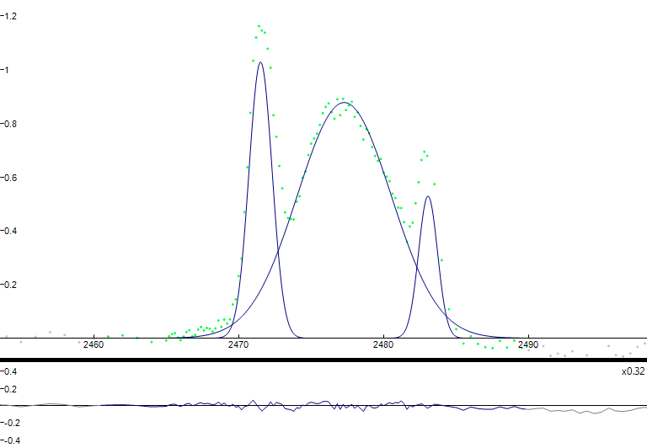
S⁶⁺/ΣS_{tot} = 0.09
Supplementary Fig. 10. Fityk peak-fitted S-XANES spectra of a, a pyroxene grain in Apollo sample 15058; b, symplectite glass in Apollo sample 15058. The spectra of a, and b, show different peak characteristics when compared with apatite Ap012a from the same (15058) Apollo sample (c.f. Supplementary Fig. 11 C) above).

With the exception of sample 15016, a correlation between S abundance and S oxidation state (S⁶⁺/ΣS_{tot}) was not observed (unlike for S isotopes (see main article)) for the apatites studied with S-XANES. For example, the apatites of samples 15016 and 15065 both contain high levels of S (Supplementary Table 2) and yet 15016 has an average S⁶⁺/ΣS_{tot} value of 0.55, whereas 15065 has average S⁶⁺/ΣS_{tot} values of 0.25 to 0.36. For terrestrial apatite high S abundances are positively correlated with high oxygen fugacity (fO₂) (ref. ²⁵). When S-XANES analyses on a natural terrestrial apatite and an experimentally crystallised apatite were compared with their corresponding electron backscatter diffraction (EBSD) patterns⁴¹, the S oxidation state as a function of crystallographic orientation was found to vary, suggesting that there was evidence for the simultaneous incorporation of S⁶⁺ and S^{2–} at different crystallographic sites within the apatite (T-site and X-site, respectively). Thermodynamic modelling has also shown that S²⁻ might be stable in the X-site, with a prediction that S²⁻ resides closest to Cl⁻ in natural apatite⁴².

An explanation for the high S abundances, the lack of positive correlation with fO₂ and the dominance of S²⁻ (with the exception of sample 15016) for lunar apatites studied in this project, might be that S is situated within both the crystallographic T- and X-sites of apatite. Sample 15016 has high S contents and a higher S oxidation state which might suggest that S is predominantly situated within the T-site.

Oxidized melts are not expected because the oxygen fugacity (fO₂) of the lunar mantle is estimated to be ~1 log unit below the iron-wüstite (IW) redox buffer, with certain Apollo basalts and volcanic glasses recording an fO₂ of ~IW+0.2 to IW-1 (e.g. refs. ³⁸⁻⁴⁰). The reduced form of sulfur, S²⁻, is expected to be the only oxidation state of sulfur to exist under such conditions (e.g. refs. ⁴¹⁻⁴⁴). The current study has shown that the more oxidized state of S (S⁶⁺) is present in every lunar apatite analysed and both S⁶⁺ and S²⁻ exist simultaneously in late-stage lunar silicate melts when apatite is a crystallising phase. It has recently been suggested²³ that S⁶⁺ could be present at very low levels (currently undetectable) in a reduced (≤FMQ redox buffer) silicate melt. Apatite will preferentially incorporate the more oxidized S⁶⁺ relative to S²⁻ into its crystallographic structure (the T-site)^{19,22,23} which means that even if S⁶⁺ is not abundant enough to be measured in a reduced silicate melt, it can be preferentially sequestered and, therefore, more easily detected in apatite²³.

The S-XANES analyses has complemented the NanoSIMS work by providing further evidence of which S species resided in the late-stage basaltic silicate melt from which apatite crystallised and, therefore, the S species that was degassed. A melt dominated by S²⁻ contained the reduced form of S, whereas a melt dominated by SO₄²⁻ contained the oxidized form of sulfur, S⁶⁺. The three distinct S isotope groups can, therefore, be partially explained by variable levels of S degassing from reduced, oxidized or a combination of both reduced and oxidized late-stage silicate melts.

References

- Treiman, A. H. et al. Phosphate-halogen metasomatism of lunar granulite 79215: Impact-induced fractionation of volatiles and incompatible elements. Am. Mineral. 99, 1860–1870 (2014).
- Shearer, C. K. et al. Origin of sulfide replacement textures in lunar breccias. Implications for vapor element transport in the lunar crust. Geochim. Cosmochim. Acta 83, 138–158 (2012).
- McGee, P., Warner, J. &Simonds, C. Introduction to the Apollo collections. Part 1: Lunar igneous rocks. Technical Report No. 77: 22034 (1977).
- Potts, N.J., Tartèse, R., Anand, M., van Westrenen, W., Griffiths, A.A., Barrett, T.J. and Franchi, I.A. Characterization of mesostasis regions in lunar basalts: Understanding late-stage melt evolution and its influence on apatite formation. Meteorit Planet Sci, 51: 1555-1575 (2016).
- Beaty, D. W. & Albee, A. L. Comparative petrology and possible genetic relations among the Apollo 11 basalts. Proc. 9th Lunar Planet. Sci. 1, 359-463 (1978).
- Beaty, D. W., Hill, S. M. R., Albee, A. L. & Baldridge, W. S. Apollo 12 feldspathic basalts 12031, 12038 and 12072 - Petrology, comparison and interpretations. Proc. 10th Lunar Planet. Sci. 1, 115-139 (1979).
- Rhodes J. M., Blanchard D. P., Dungan M. A., Brannon J. C. & Rodgers K.V. Chemistry of Apollo 12 mare basalts: Magma types and fractionation processes. Proc. 8th Lunar Planet. Sci. 2, 1305-1338 (1977).
- Neal, C. R. et al. Basalt generation at the Apollo 12 site, Part 1: New data, classification, and re-evaluation. Meteorit. Planet. Sci. 29, 334-348 (1994).
- Nyquist, L. E., Shih C.-Y., Wooden, J. L., Bansal, B. M. & Wiesmann H. The Sr and Nd isotopic record of Apollo 12 basalts: Implications for lunar geochemical evolution. Proc. 10th Lunar Planet. Sci. 1, 77-114 (1979).
- Papike, J. J., Hodges, F. N., Bence, A. E., Cameron, N. & Rhodes, J. M. Mare basalts: Crystal chemistry, mineralogy, and petrology. Rev. Geophys. Space Phys. 14, 475-540 (1976).
- Taylor, L. A., Patchen, A., Mayne, R. G. & Taylor, D.-H. The most reduced rock from the moon, Apollo 14 basalt 14053: Its unique features and their origin. Am. Mineral. 89, 1617-1624 (2004).
- Rhodes, J. M., and Hubbard, N. J. 1973. Chemistry, Classification, and Petrogenesis of Apollo 15 Mare Basalts. 4th Lunar and Planetary Science Conference, p. 1127
- NASA Lunar Sample Information Catalog Apollo 15, 51-265 (1971).
- Bence, A. E. & Papike, J. J. Pyroxenes as recorders of lunar basalt petrogenesis: chemical trends due to crystal-liquid interaction. Proc. 3rd Lunar Planet. Sci. 1, 431-469 (1972).
- Ryder, G. Catalog of Apollo 15 Rocks: Part 1. NASA, Curatorial Branch Publication 72, JSC no. 20787, 1-338 (1985).
- Rhodes, J. M. & Hubbard, N. J. Chemistry, classification, and petrogenesis of Apollo 15 mare basalts. Proc. 4th Lunar Planet. Sci. 2, 1127-1148 (1973).
- Nava, D. F. Chemical compositions of some soils and rock types from the Apollo 15, 16 and 17 lunar sites. Proc. 5th Lunar Planet. Sci. 2, 1087-1096 (1974).
- Cuttita, R. et al. Chemistry of twenty-one igneous rocks and soils returned by the Apollo 15 mission. Proc. 4th Lunar Planet. Sci. 2, 1081-1096 (1973).
- NASA Apollo 15 Preliminary Science Report, 5-1 – 6-1 (1972).
- Wieczorek, M. A. et al. in Reviews in Mineralogy and Geochemistry: New Views of the Moon, 60 (eds Jolliff, B. L., Wieczorek, M. A., Shearer, C. K. & Neal, C. R.) 221-364 (The Mineralogical Society of America, Virginia, 2006).
- Nord, G. L. et al. Petrologic study of igneous and metaigneous rocks from Apollo 15 and 16 using high voltage transmission electron microscopy. Proc. 4th Lunar Planet. Sci. 1, 953-970 (1973).
- Ryder, G. Catalog of Apollo 15 Rocks: Part 3. NASA, Curatorial Branch Publication 72, JSC no. 20787, 779-1296 (1985).
- Bickel, C. E., Warner, J. L. & Phinney, W. C. Petrology of 79215: Brecciation of a lunar cumulate. Proc. 7th Lunar Planet. Sci. 2, 1793–1819 (1976).
- McGee, J. J., Bence, A. E., Eichhorn, G. & Schaeffer, O. A. Feldspathic granulite 79215: Limitations on T-ƒO₂ conditions and time of metamorphism. Proc. 9th Lunar Planet. Sci. 1, 743–772 (1978).
- Konecke, Brian A., Fiege, Adrian, Simon, Adam C., Parat, Fleurice and Stechern, André. "Co-variability of S⁶⁺, S⁴⁺, and S²⁻ in apatite as a function of oxidation state: Implications for a new oxybarometer" American Mineralogist, vol. 102, no. 3, 2017, pp. 548-557. https://doi.org/10.2138/am-2017-5907
- Jugo, P. J., Wilke, M. & Botcharnikov, R. E. Sulfur K-edge XANES analysis of natural and synthetic basaltic glasses: Implications for S speciation and S content as function of oxygen fugacity. Geochim. Cosmochim. Acta 74, 5926–5938 (2010).
- Wojdyr, M. Fityk: A general-purpose peak fitting program. J. Appl. Cryst. 43, 1126–1128 (2010).
- Potts, N. J., Barnes, J. J., Tartèse, R., Franchi, I. A. & Anand, M. Chlorine isotopic compositions of apatite in Apollo 14 rocks: Evidence for widespread vapor-phase metasomatism on the lunar nearside ~4 billion years ago. Geochim. Cosmochim. Acta 230, 46–59 (2018).
- Gibson, E. K. Jr. & Moore, G. W. Sulfur abundances and distributions in the valley of Taurus-Littrow: Evidence of mixing. Proc. 5th Lunar Planet. Sci. 2, 1823–1837 (1974).
- Kerridge, J. F., Kaplan, I. R. & Petrowski, C. Light element geochemistry of the Apollo 16 site. Geochim. Cosmochim. Acta 39, 137-162 (1975).
- Kerridge, J. F., Kaplan, I. R. & Petrowski, C. Evidence for meteoritic sulfur in the lunar regolith. Proc. 6th Lunar Planet. Sci. 2, 2151-2162 (1975).
- Bombardieri, D. J., Norman, M. D., Kamenetsky, V. S. & Danyushevsky, L. V. Major element and primary sulfur concentrations in Apollo 12 mare basalts: The view from melt inclusions. Meteorit. Planet. Sci. 40, 679-693 (2005).
- Hauri, E. H., Weinreich, T., Saal, A. E., Rutherford, M. C. & Van Orman, J. A. High pre-eruptive water contents preserved in lunar melt inclusions. Science 333, 213-215 (2011).
- Chen, Y. et al. Water, fluorine, and sulfur concentrations in the lunar mantle. Earth Planet. Sci. Lett. 427, 37-46 (2015).
- Ni, P., Zhang, Y., Chen, S. & Gagnon, J. A melt inclusion study on volatile abundances in the lunar mantle. Geochim. Cosmochim. Acta 249, 17–41 (2019).
- Boyce, J. W. et al. Lunar apatite with terrestrial volatile abundances. Nature 466, 466-469 (2010).
- Greenwood, J. P., Itoh, S., Sakamoto, N., Warren, P., Taylor, L., Yurimoto, H. Hydrogen isotope ratios in lunar rocks indicate delivery of cometary water to the Moon. Nat. Geo. 4, 79-82 (2011).
- Konecke, B. A., Fiege, A., Simon, A. C. & Holtz, F. Cryptic metasomatism during late-stage lunar magmatism implicated by sulfur in apatite. Geology 45, 739-742 (2017).
- Baker, D. R. & Moretti, R. in Sulfur in Magmas and Melts: Its Importance for Natural and Technical Processes (eds Behrens, H. & Webster, J. D.) 167-213 (Reviews in Mineralogy and Geochemistry 73, Mineralogical Society of America, 2011).
- Sato M., Hickling N. L. & McLane J. E. Oxygen fugacity values of Apollo 12, 14, and 15 lunar samples and reduced state of lunar magmas. Proc. 4th Lunar Planet. Sci. 4, 1061-1079 (1973).
- Longhi, J. Experimental petrology and petrogenesis of mare volcanics. Geochim. Cosmochim. Acta 56, 2235-2251 (1992).
- Wadhwa, M. in Reviews in Mineralogy and Geochemistry: Oxygen in the Solar System, 68 (eds MacPherson, G. J.) 493-510 (The Mineralogical Society of America, Virginia 2008).
- Fincham, C. J. B. & Richardson, F. D. The behaviour of sulphur in silicate and aluminate melts. Proc. R. Soc. A: Mathematic. Phys. Eng. Sci. 223, 40-62 (1954).
- Carroll, M. R. & Rutherford, M. J. Sulfide and sulfate saturation in hydrous silicate melts. J. Geophys. Res. 90, C601–C612 (1985).
- Wallace, P. & Carmichael, I. S. E. Sulfur in basaltic magmas. Geochim. Cosmochim. Acta 56, 1863-1874 (1992).
- Wilke, M. et al. The origin of S⁴⁺ detected in silicate glasses by XANES. Am. Mineral. 93, 235-240 (2008).

