Supplemental material
Supplemental material 1: Women’s experience questionnaire.
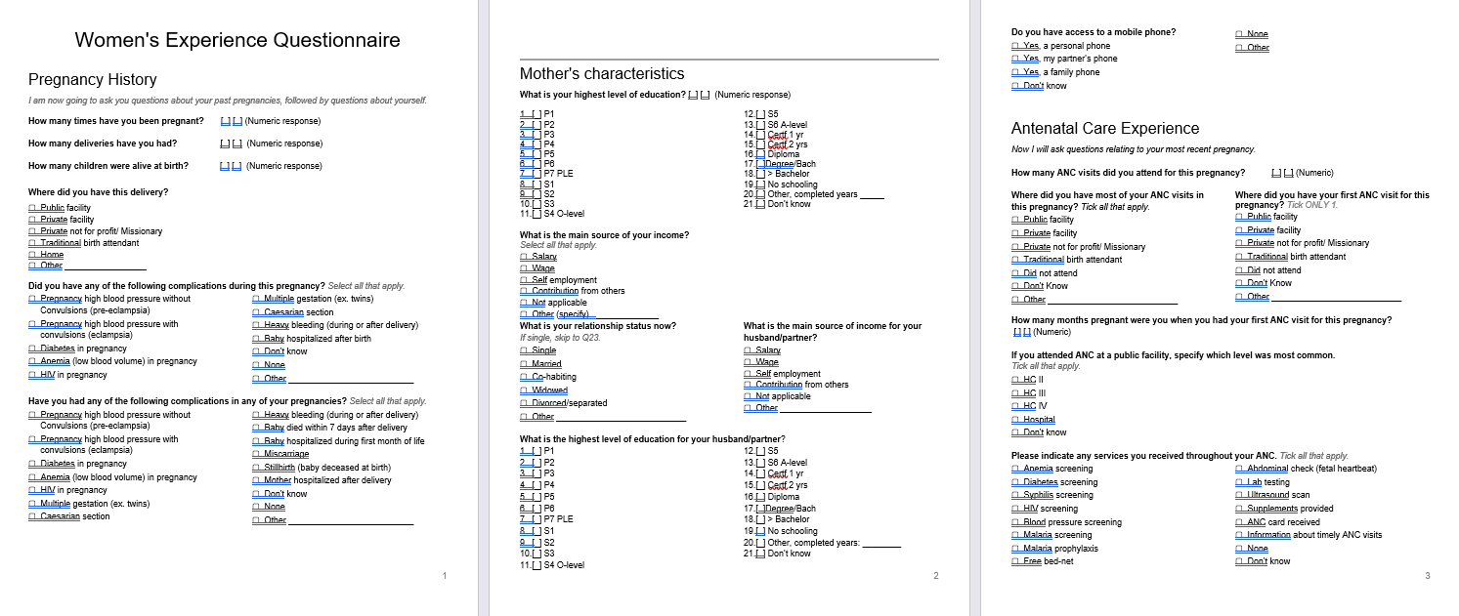

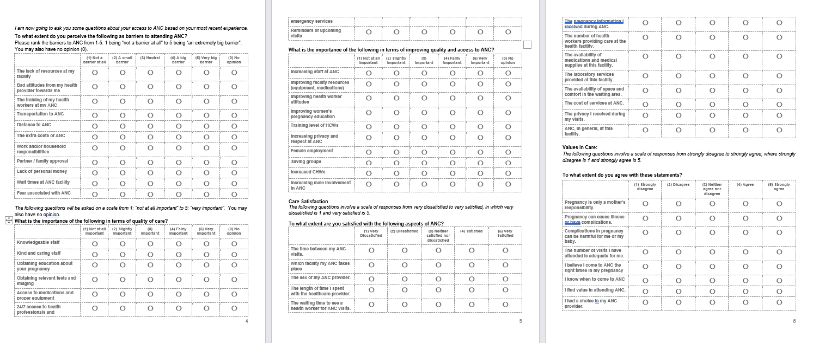

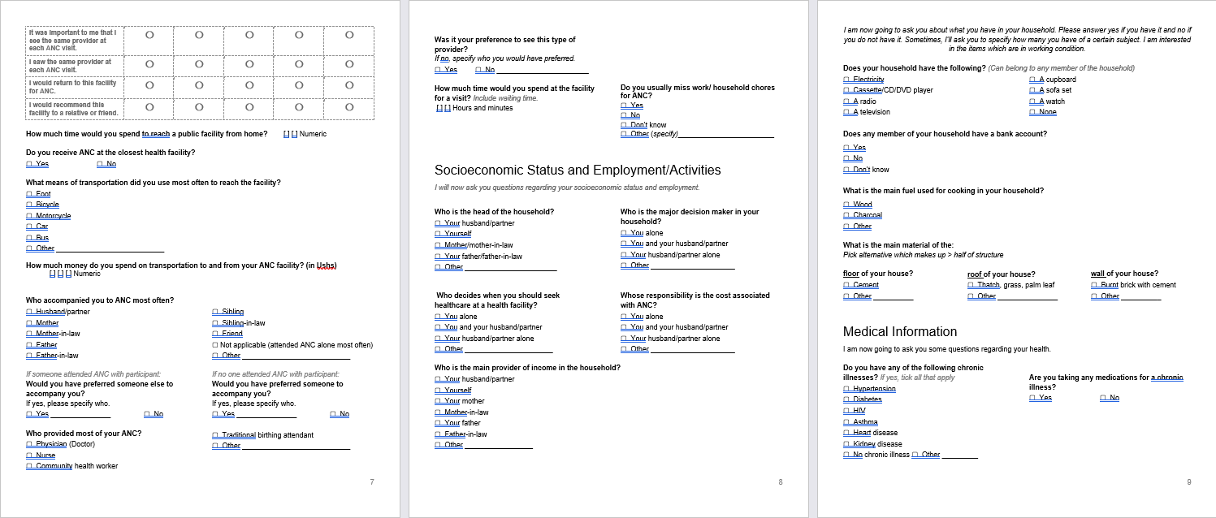

Supplementary Table 1. ANC service uptake.
 | N | %
ANC service received
Received anaemia screening
No | 93 | 26%
Yes | 265 | 74%
Received diabetes screening
No | 227 | 63%
Yes | 131 | 37%
Received syphilis screening
No | 94 | 26%
Yes | 264 | 74%
Received HIV screening
No | 16 | 4%
Yes | 342 | 96%
Received blood pressure screening
No | 31 | 9%
Yes | 327 | 91%
Received malaria screening
No | 30 | 8%
Yes | 328 | 92%
Received malaria prophylaxis
No | 23 | 6%
Yes | 335 | 94%
Received free bed net
No | 40 | 11%
Yes | 318 | 89%
Received abdominal check
No | 8 | 2%
Yes | 350 | 98%
Received ultrasound scan
No | 237 | 66%
Yes | 121 | 34%
Received supplements (iron, folic acid)
No | 107 | 30%
Yes | 251 | 70%
Received ANC card
No | 66 | 18%
Yes | 292 | 82%
Received information about timely ANC visits
No | 17 | 5%
Yes | 341 | 95%

Supplementary Table 2. Characteristics of study participants by educational level and by wealth index tertile.
 | Educational level |  |  |  | Wealth Index (tertiles)
 | Primary school or lower |  | Secondary school or higher |  | Low |  | Middle |  | High
 | N | % | N | % | N | % | N | % | N | %
Age (years)
<20 | 38^{c} | 18% | 17 | 12% | 13^{c} | 11% | 26 | 22% | 16 | 13%
20-29 | 110 | 52% | 104 | 70% | 68 | 56% | 70 | 60% | 76 | 64%
≥30 | 62 | 30% | 27 | 18% | 41 | 33% | 21 | 18% | 27 | 23%
Maternal Occupation
Does not work | 89 | 42% | 53 | 36% | 45 | 37% | 56 | 48% | 41 | 34%
Salary/wage or self-employed | 121 | 58% | 95 | 64% | 77 | 63% | 61 | 52% | 78 | 66%
Pregnancy history
Parity
1 | 52^{c} | 25% | 50 | 34% | 22^{c} | 18% | 42 | 36% | 38 | 32%
2-3 | 83 | 40% | 72 | 49% | 51 | 42% | 50 | 43% | 54 | 45%
4 or more | 75 | 35% | 26 | 17% | 49 | 40% | 25 | 21% | 27 | 23%
Pregnancy complications in last pregnancy ª
Yes | 50 | 24% | 26 | 18% | 14^{c} | 11% | 37 | 32% | 25 | 21%
No | 160 | 76% | 122 | 82% | 108 | 89% | 80 | 68% | 94 | 79%
Health services uptake
ANC attendance
Less than 4 contacts | 38 | 18% | 24 | 16% | 19 | 16% | 18 | 15% | 25 | 21%
4 contacts or more | 172 | 82% | 124 | 84% | 103 | 84% | 99 | 85% | 94 | 79%
ANC initiation
After 3 months | 157 | 75% | 100 | 68% | 94^{c} | 77% | 88 | 75% | 75 | 63%
Before or at 3 months | 53 | 25% | 48 | 32% | 28 | 23% | 29 | 25% | 44 | 37%
Received adequate ANC services ^{b}
No | 97 | 46% | 66 | 45% | 60 | 49% | 52 | 44% | 51 | 43%
Yes | 113 | 54% | 82 | 55% | 62 | 51% | 65 | 56% | 68 | 57%
Satisfied with ANC
No | 11 | 5% | 7 | 5% | 4 | 3% | 9 | 8% | 5 | 4%
Yes | 199 | 95% | 141 | 95% | 118 | 97% | 108 | 92% | 114 | 96%
ANC access constraints
Time required to reach HF
<30 minutes | 50 | 24% | 40 | 27% | 25 | 21% | 34 | 29% | 31 | 26%
30-59 minutes | 65 | 31% | 55 | 37% | 38 | 31% | 38 | 33% | 44 | 37%
≥60 minutes | 95 | 45% | 53 | 36% | 59 | 48% | 45 | 38% | 44 | 37%
Means of transportation to HF
Walk / bicycle | 114^{c} | 54% | 65 | 44% | 75^{c} | 61% | 57 | 49% | 47 | 40%
Motorcycle/Car/ Public transportation | 96 | 46% | 83 | 56% | 47 | 39% | 60 | 51% | 72 | 60%
Cost of transportation
No cost | 107 | 51% | 63 | 43% | 70^{c} | 57% | 53 | 45% | 47 | 40%
Low cost (≤4000 Ushs) | 64 | 30% | 48 | 32% | 34 | 28% | 34 | 29% | 44 | 37%
High cost (>4000 Ushs) | 39 | 19% | 37 | 25% | 18 | 15% | 30 | 26% | 28 | 24%
Time spend at HF during ANC
<1 hour | 19 | 9% | 16 | 11% | 9 | 8% | 9 | 8% | 17 | 14%
1-2 hours | 48 | 23% | 38 | 26% | 26 | 21% | 30 | 26% | 30 | 25%
>2 hours | 143 | 68% | 94 | 64% | 87 | 71% | 78 | 67% | 72 | 61%
Missed work or household chores due to ANC
No | 85 | 40% | 70 | 47% | 49 | 40% | 59 | 50% | 47 | 40%
Yes | 125 | 60% | 78 | 53% | 73 | 60% | 58 | 50% | 72 | 60%
Autonomy and preferences for healthcare services
ANC accompaniment
None | 94 | 45% | 62 | 42% | 57 | 47% | 53 | 45% | 46 | 39%
Partner/husband | 94 | 45% | 75 | 51% | 55 | 45% | 55 | 47% | 59 | 50%
Other relative/friend | 22 | 10% | 11 | 7% | 10 | 8% | 9 | 8% | 14 | 11%
Preference for accompaniment
Not as preferred | 56 | 27% | 47 | 32% | 32 | 26% | 38 | 32% | 33 | 28%
As preferred | 154 | 73% | 101 | 68% | 90 | 74% | 79 | 68% | 86 | 72%
Preference for ANC provider
Not as preferred | 150 | 71% | 111 | 75% | 85 | 70% | 83 | 71% | 93 | 78%
As preferred | 60 | 29% | 37 | 25% | 37 | 30% | 34 | 29% | 26 | 22%
Household decision maker
Woman alone | 12 | 6% | 6 | 4% | 8^{c} | 7% | 3 | 3% | 7 | 6%
Jointly with partner/husband | 38 | 18% | 31 | 21% | 32 | 26% | 21 | 18% | 16 | 13%
Others only | 160 | 76% | 111 | 75% | 82 | 67% | 93 | 79% | 96 | 81%
Decision maker for seeking healthcare
Woman alone | 115 | 55% | 88 | 59% | 50^{c} | 41% | 67 | 57% | 86 | 72%
Jointly with partner/husband | 45 | 21% | 35 | 24% | 40 | 33% | 22 | 19% | 18 | 15%
Others only | 50 | 24% | 25 | 17% | 32 | 26% | 28 | 24% | 15 | 13%
Responsible for cost of ANC
Woman alone | 15 | 7% | 4 | 3% | 10 | 8% | 2 | 2% | 7 | 6%
Jointly with partner/husband | 22 | 11% | 17 | 11% | 17 | 14% | 14 | 12% | 8 | 7%
Others only | 173 | 82% | 127 | 86% | 95 | 78% | 101 | 86% | 104 | 87%
Main household income provider
Woman | 7 | 3% | 1 | 1% | 6^{c} | 5% | 1 | 1% | 1 | 1%
Partner/husband | 187 | 89% | 135 | 91% | 105 | 86% | 111 | 95% | 106 | 89%
Other relatives | 16 | 8% | 12 | 8% | 11 | 9% | 5 | 4% | 12 | 10%
ª Gestational diabetes, anaemia, gestational hypertension, eclampsia or preeclampsia.
^{b} Adequate ANC services are including anaemia, syphilis, HIV, blood pressure screening and malaria prophylaxis.
^{c} p-value for chi-square test <0.05.

Supplementary Table 3. Distribution of Likert scale replies for each of the five perception constructs and each components.
Perception contruct and components | Likert scale replies (%)
ANC perceived satisfaction
 | (1) Very Dissatisfied | (2) Dissatisfied | (3) Neither satisfied nor dissatisfied | (4) Satisfied | (5) Very Satisfied
Time between ANC visits | 5.3 | 3.1 | 7.3 | 26.5 | 57.5
Health facility of received ANC | 6.2 | 4.8 | 5.0 | 38.0 | 45.8
ANC health provider sex | 1.4 | 1.7 | 3.1 | 39.4 | 54.5
Time spent with health provider during ANC | 3.6 | 7.5 | 7.5 | 36.6 | 44.7
Waiting time to ANC | 10.3 | 12.6 | 9.2 | 36.3 | 31.6
Pregnancy information received in ANC | 3.1 | 2.5 | 1.7 | 41.1 | 51.4
Number of health providers at HC | 5.0 | 5.3 | 4.5 | 41.6 | 43.6
Availability of medication and supplies at health facility | 6.2 | 5.0 | 7.5 | 42.7 | 38.3
Availability of space and comfort in the waiting area | 4.2 | 2.8 | 5.0 | 41.9 | 46.1
Laboratory services provided | 5.6 | 3.1 | 3.1 | 42.2 | 46.1
Cost of ANC | 4.5 | 2.2 | 6.4 | 42.7 | 44.1
Privacy at ANC | 0.6 | 0.8 | 1.4 | 40.5 | 56.7
ANC perceived quality
 | (1) Not at all important | (2) Slightly important | (3) Important | (4) Fairly important | (5) Very important
Knowledgable staff | 0.0 | 1.4 | 3.4 | 10.1 | 85.2
Kind and caring staff | 0.0 | 1.7 | 2.5 | 23.7 | 72.1
Obtaining pregnancy education | 0.6 | 0.8 | 2.5 | 33.0 | 63.1
Obtaining tests and imaging | 0.8 | 0.8 | 6.7 | 29.1 | 62.6
Access to medications and equipment | 0.3 | 0.3 | 2.8 | 25.4 | 70.7
24/7 access to health provider and emergency serices | 0.0 | 0.8 | 1.4 | 27.1 | 70.7
Reminders of upcoming visits | 0.0 | 1.4 | 2.2 | 24.0 | 72.4
ANC barriers
 | (1) Not a barrier at all | (2) A small barrier | (3) Neutral | (4) A big barrier | (5) Very big barrier
Lack of resources at HC | 28.5 | 10.3 | 6.7 | 15.1 | 39.4
Bad attitudes of health provider | 42.5 | 13.7 | 3.6 | 15.9 | 24.0
Training (lack of) of health provider | 33.0 | 9.8 | 7.0 | 16.5 | 33.0
Transportation to ANC | 46.7 | 17.0 | 3.9 | 14.5 | 17.6
Distance to ANC | 48.3 | 18.2 | 5.6 | 13.1 | 14.8
Extra cost of ANC | 58.4 | 16.8 | 6.4 | 9.2 | 9.2
Work and/or household responsibilities | 69.8 | 13.7 | 5.0 | 5.6 | 5.9
Partner/family approval | 81.8 | 7.3 | 2.8 | 4.2 | 3.9
Lack of personal money | 38.3 | 17.9 | 6.4 | 13.4 | 24.0
Waiting time to ANC | 45.0 | 21.5 | 12.3 | 9.2 | 12.0
Fear associated with ANC | 64.8 | 10.3 | 3.4 | 5.0 | 12.3
ANC improvements
 | (1) Not at all important | (2) Slightly important | (3) Important | (4) Fairly important | (5) Very important
Increasing staff at ANC | 0.6 | 2.2 | 5.6 | 12.6 | 79.1
Improving health facility resources | 0.8 | 0.6 | 2.8 | 21.8 | 74.0
Improving health provider attitudes | 0.0 | 0.6 | 2.2 | 29.6 | 67.6
Improving women's pregnancy education | 0.8 | 0.8 | 4.8 | 28.2 | 65.4
Training level of health provider | 0.3 | 1.4 | 3.1 | 30.7 | 64.5
Increasing privacy and respect at ANC | 0.3 | 0.8 | 3.4 | 23.7 | 71.8
Female employment | 0.6 | 1.4 | 2.5 | 25.7 | 69.8
Saving groups | 1.1 | 1.7 | 3.1 | 21.5 | 72.6
Increased community outreach (CHWs) | 0.3 | 2.0 | 2.8 | 24.6 | 70.4
Increasing male involvement in ANC | 6.2 | 5.6 | 4.8 | 18.7 | 64.8
Beliefs and values related to pregnancy and ANC
 | (1) Strongly disagree | (2) Disagree | (3) Neither agree nor disagree | (4) Agree | (5) Strongly agree
Pregnancy is only a mother's responsibility | 81.8 | 8.1 | 1.1 | 3.9 | 5.0
Pregnancy can cause illness or have complications | 3.1 | 3.6 | 2.5 | 37.2 | 53.6
Complications in pregnancy can be harmful for me or my baby | 2.8 | 2.2 | 2.0 | 38.0 | 55.0
The number of visits I have attended is adequate for me | 6.7 | 3.1 | 7.0 | 34.9 | 48.3
I believe I come to ANC the right times in my pregnancy | 3.9 | 2.0 | 3.6 | 37.4 | 53.1
I know when to come to ANC | 2.5 | 0.8 | 3.9 | 33.5 | 59.2
I find value in attending ANC | 0.6 | 0.6 | 0.6 | 20.7 | 77.7
I had a choice in my ANC provider | 65.6 | 8.1 | 2.0 | 12.6 | 11.7
It was important to me that I see the same provider at each ANC visit | 34.9 | 10.6 | 8.4 | 12.6 | 33.2
I saw the same provider at each ANC visit | 55.6 | 7.5 | 3.6 | 11.7 | 21.5
I would return to this facility for ANC | 0.6 | 0.3 | 1.4 | 13.1 | 84.6
I would recommend this facility to a relative or friend | 1.1 | 0.6 | 1.8 | 10.1 | 87.4

Supplemental Table 4. Differences by category and multivariate associations between socio-demographic and ANC-related characteristics with the composite score of perceived ANC satisfaction.
 | N | Median | IQR | Beta | 95%CI
Age (years)
<20 | 55 | 4.3 | 0.8 | 0.0
20-29 | 214 | 4.2 | 0.7 | -0.1 | (-0.3, 0.1)
≥30 | 89 | 4.3 | 0.6 | -0.1 | (-0.3, 0.2)
Wealth Index (tertiles)
Low | 122 | 4.2 | 0.7 | 0.0
Middle | 117 | 4.2 | 0.7 | -0.01 | (-0.2,0.1)
High | 119 | 4.3 | 0.6 | -0.01 | (-0.2,0.1)
Educational level
Primary school or lower (≤7 years) | 210 | 4.3 | 0.5 | 0.0
Secondary school or higher (≥8 years) | 148 | 4.2 | 0.8 | -0.02 | (-0.1,0.1)
Maternal Occupation
Does not work | 142 | 4.2 | 0.8 | 0.0
Salary/wage or self-employed | 216 | 4.3 | 0.6 | 0.1 | (-0.04,0.2)
Pregnancy history
Parity
1 | 102 | 4.1 | 0.7 | 0.0
2-3 | 155 | 4.3 | 0.7 | 0.1 | (-0.1,0.3)
4 or more | 101 | 4.3 | 0.6 | 0.2 | (-0.11,0.4)
Pregnancy complications in last pregnancy ª
No | 282 | 4.3 | 0.7 | 0.0
Yes | 76 | 4.2 | 0.5 | -0.03 | (-0.2,0.1)
Health services uptake
ANC attendance
Less than 4 contacts | 62 | 4.3 | 0.7 | 0.0
4 contacts or more | 296 | 4.2 | 0.7 | 0.02 | (-0.1,0.2)
ANC initiation
After 3 months | 257 | 4.3 | 0.75 | 0.0
Before or at 3 months | 101 | 4.2 | 0.6 | -0.1 | (-0.2,0.1)
Received adequate ANC services ^{b}
No | 163 | 4.3 | 0.6 | 0.0
Yes | 195 | 4.2 | 0.6 | -0.03 | (-0.2,0.1)
Satisfied with ANC
No | 18 | 3.9 ^{c} | 1.1
Yes | 340 | 4.3 | 0.7
ANC access constraints
Time required to reach HF
<30 minutes | 90 | 4.3 | 0.7 | 0.0
30-59 minutes | 120 | 4.3 | 0.6 | -0.1 | (-0.2,0.1)
≥60 minutes | 148 | 4.2 | 0.6 | -0.2 | (-0.3,0.0)
Means of transportation to HF
Walk / bicycle | 179 | 4.2 | 0.7
Motorcycle/Car/ Public transportation | 179 | 4.3 | 0.7
Cost of transportation
No cost | 170 | 4.2 | 0.7 | 0.0
Low cost (≤4000 Ushs) | 112 | 4.2 | 0.7 | 0.0 | (-0.1,0.1)
High cost (>4000 Ushs) | 76 | 4.3 | 0.8 | -0.1 | (-0.2,0.1)
Time spend at HF during ANC
<1 hour | 35 | 4.0 ^{c} | 0.7 | 0.0
1-2 hours | 86 | 4.2 | 0.7 | 0.3 ^{d} | (0.1,0.5)
>2 hours | 237 | 4.3 | 0.7 | 0.2 ^{d} | (0.0,0.4)
Missed work or household chores due to ANC
No | 155 | 4.2 ^{c} | 0.7 | 0.0
Yes | 203 | 4.3 | 0.6 | 0.0 | (-0.1,0.2)
Autonomy and preferences for ANC services
ANC accompaniment
None | 156 | 4.2 | 0.7 | 0.0
Partner/husband | 169 | 4.3 | 0.7 | 0.0 | (-0.2,0.1)
Other relative/friend | 33 | 4.3 | 0.6 | 0.0 | (-0.2,0.3)
Preference for accompaniment
Not as preferred | 103 | 4.2 | 0.6 | 0.0
As preferred | 255 | 4.3 | 0.7 | 0.1 | (-0.1,0.2)
Preference for ANC provider
Not as preferred | 261 | 4.3 | 0.5 | 0.0
As preferred | 97 | 4.3 | 0.7 | 0.00 | (-0.1,0.1)
Household decision maker
Woman alone | 18 | 4.0 ^{c} | 0.4 | 0.0
Jointly with partner/husband | 69 | 4.1 | 0.7 | 0.1 | (-0.3,0.4)
Others only | 271 | 4.3 | 0.6 | 0.3 | (-0.1,0.6)
Decision maker for seeking healthcare
Woman alone | 203 | 4.2 | 0.7 | 0.0
Jointly with partner/husband | 80 | 4.2 | 0.6 | 0.0 | (-0.2,0.2)
Others only | 75 | 4.3 | 0.6 | 0.1 | (-0.1,0.3)
Responsible for cost of ANC
Woman alone | 19 | 4.2 | 0.6 | 0.0
Jointly with partner/husband | 39 | 4.3 | 0.7 | 0.1 | (-0.3,0.4)
Others only | 300 | 4.3 | 0.7 | -0.1 | (-0.4,0.2)
Main household income provider
Woman | 8 | 4.0 | 0.6 | 0.0
Partner/husband | 322 | 4.3 | 0.7 | 0.0 | (-0.5,0.5)
Other relatives | 28 | 4.1 | 0.5 | 0.1 | (-0.4,0.6)
Abbreviations: ANC: antenatal care, HF: health facility, 95%CI: 95% Confidence Intervals.
ª Gestational diabetes, anaemia, gestational hypertension, eclampsia or preeclampsia.
^{b} Adequate ANC services are including anaemia, syphilis, HIV, blood pressure screening and malaria prophylaxis.
^{c} p-value for Mann-Whitney or Kruskal-Wallis non-parametric tests <0.05.
^{d} p-value <0.05 for multivariable regression model containing all variables.

Supplemental Table 5. Differences by category and multivariate associations between socio-demographic and ANC-related characteristics with the composite score of perceived ANC barriers.
 | N | Median | IQR | Beta | 95% CI
Age (years)
<20 | 55 | 2.2 | 1.0 | 0.0
20-29 | 214 | 2.3 | 1.0 | 0.0 | (-0.3,0.3)
≥30 | 89 | 2.2 | 1.0 | 0.1 | (-0.3,0.4)
Wealth Index (tertiles)
Low | 122 | 2.3 | 0.8 | 0.0
Middle | 117 | 2.2 | 1.1 | -0.1 | (-0.4,0.1)
High | 119 | 2.2 | 1.1 | -0.3 ^{d} | (-0.6,-0.1)
Educational level
Primary school or lower (≤7 years) | 210 | 2.2 | 1.0 | 0.0
Secondary school or higher (≥8 years) | 148 | 2.2 | 1.1 | 0.0 | (-0.1,0.2)
Maternal Occupation
Does not work | 142 | 2.1^{c} | 1.1 | 0.0
Salary/wage or self-employed | 216 | 2.3 | 1.0 | 0.2 | (-0.03,0.3)
Pregnancy history
Parity
1 | 102 | 2.2 | 1.0 | 0.0
2-3 | 155 | 2.3 | 1.3 | 0.2 | (-0.1,0.4)
4 or more | 101 | 2.2 | 0.7 | -0.1 | (-0.4,0.2)
Pregnancy complications in last pregnancy ª
No | 282 | 2.2^{c} | 0.9 | 0.0
Yes | 76 | 2.4 | 1.5 | 0.2 | (-0.02,0.4)
Health services uptake
ANC attendance
Less than 4 contacts | 62 | 2.2 | 1.1 | 0.0
4 contacts or more | 296 | 2.2 | 1.0 | -0.04 | (-0.3,0.2)
ANC initiation
After 3 months | 257 | 2.2 | 1.1 | 0.0
Before or at 3 months | 101 | 2.3 | 1.0 | 0.1 | (-0.1,0.3)
Received adequate ANC services ^{b}
No | 163 | 2.1^{c} | 1.1 | 0.0
Yes | 195 | 2.3 | 1.0 | 0.2 ^{d} | (0.1,0.4)
Satisfied with ANC
No | 18 | 2.8^{c} | 0.9 | 0.0
Yes | 340 | 2.2 | 1.0 | -0.2 | (-0.6,0.2)
ANC access constraints
Time required to reach HF
<30 minutes | 90 | 2.1^{c} | 1.0 | 0.0
30-59 minutes | 120 | 2.2 | 0.7 | 0.1 | (-0.2,0.3)
≥60 minutes | 148 | 2.4 | 1.2 | 0.3 ^{d} | (0.1,0.5)
Means of transportation to HF
Walk / bicycle | 179 | 2.2 | 1.2
Motorcycle/Car/ Public transportation | 179 | 2.2 | 0.9
Cost of transportation
No cost | 170 | 2.2^{c} | 1.2 | 0.0
Low cost (≤4000 Ushs) | 112 | 2.2 | 0.6 | 0.0 | (-0.2,0.2)
High cost (>4000 Ushs) | 76 | 2.4 | 1.1 | 0.3 | (0.1,0.5)
Time spend at HF during ANC
<1 hour | 35 | 2.3 | 1.3 | 0.0
1-2 hours | 86 | 2.2 | 1.3 | 0.0 | (-0.3,0.3)
>2 hours | 237 | 2.2 | 0.9 | 0.0 | (-0.2,0.3)
Missed work or household chores due to ANC
No | 155 | 2.2 | 0.9 | 0.0
Yes | 203 | 2.3 | 1.1 | 0.2 ^{d} | (0.1,0.4)
Autonomy and preferences for ANC services
ANC accompaniment
None | 156 | 2.1^{c} | 1.1 | 0.0
Partner/husband | 169 | 2.3 | 1.0 | 0.3 ^{d} | (0.1,0.5)
Other relative/friend | 33 | 2.3 | 0.7 | 0.1 | (-0.2,0.4)
Preference for accompaniment
Not as preferred | 103 | 2.1 | 0.8 | 0.0
As preferred | 255 | 2.3 | 1.1 | 0.0 | (-0.2,0.2)
Preference for ANC provider
Not as preferred | 261 | 2.2^{c} | 0.8 | 0.0
As preferred | 97 | 1.9 | 1.0 | -0.3 ^{d} | (-0.5,-0.1)
Household decision maker
Woman alone | 18 | 2.2 | 1.6 | 0.0
Jointly with partner/husband | 69 | 2.2 | 0.8 | -0.1 | (-0.5,0.4)
Others only | 271 | 2.2 | 1.0 | 0.1 | (-0.3,0.5)
Decision maker for seeking healthcare
Woman alone | 203 | 2.3^{c} | 1.1 | 0.0
Jointly with partner/husband | 80 | 2.3 | 0.8 | -0.1 | (-0.3,0.2)
Others only | 75 | 2.1 | 1.0 | -0.2 | (-0.4,0.03)
Responsible for cost of ANC
Woman alone | 19 | 2.2 | 1.3 | 0.0
Jointly with partner/husband | 39 | 2.3 | 0.7 | -0.6 ^{d} | (-1.1,-0.1)
Others only | 300 | 2.2 | 1.1 | -0.6 ^{d} | (-1.0,-0.2)
Main household income provider
Woman | 8 | 2.2 | 1.2 | 0.0
Partner/husband | 322 | 2.3 | 1.0 | 0.3 | (-0.4,1.0)
Other relatives | 28 | 2.0 | 0.7 | 0.2 | (-0.6,0.9)
Abbreviations: ANC: antenatal care, HF: health facility, 95%CI: 95% Confidence Intervals.
ª Gestational diabetes, anaemia, gestational hypertension, eclampsia or preeclampsia.
^{b} Adequate ANC services are including anaemia, syphilis, HIV, blood pressure screening and malaria prophylaxis.
^{c} p-value for Mann-Whitney or Kruskal-Wallis non-parametric tests <0.05.
^{d} p-value<0.05 for multivariable regression model containing all variables.

