Supporting Information

A trispecific DNA-origami engager programs immunological synapse architecture for B-cell elimination in rheumatoid arthritis
Ying Zhou^{1†}, Yueyang Sun^{1†}*, Jiaxian Zhou¹, Xinyan Lei¹, Heming Wang⁴, Guangqi Song⁴*, Chunhui Ma^{2,3}* and Hao Pei¹*

¹ Shanghai Key laboratory of green chemistry and chemical Processes, School of chemistry and Molecular engineering, Shanghai center of Brain inspired intelligent Materials and devices, East China normal University, Shanghai, 200241, China.
² Department of Orthopedic Surgery, Shanghai Geriatric Medical Center, Shanghai，201104, China
³ Institute of Bone and Joint Diseases, Zhongshan Hospital, Fudan University, Shanghai, 200032, China
⁴ Joint Laboratory of Biomaterials and Translational Medicine, Puheng Biomedicine Co., Ltd, Shanghai 201203, China.

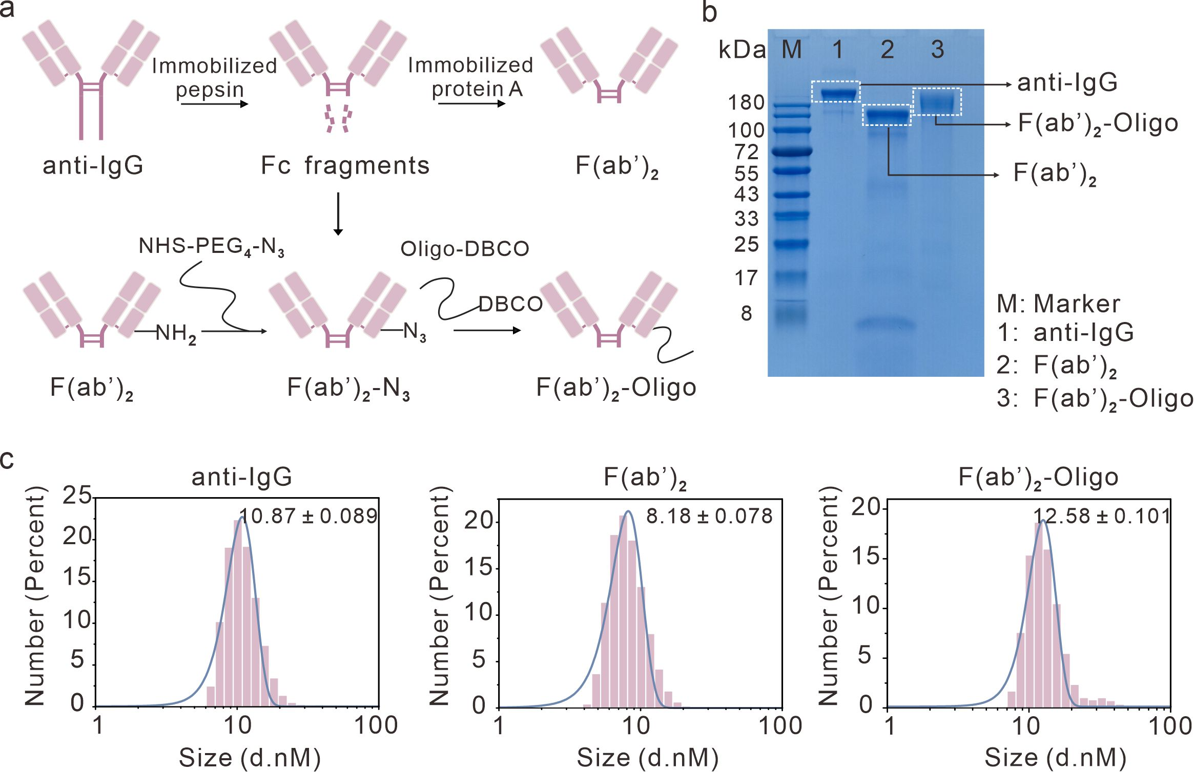 Supplementary Fig. 1 | Preparation and characterization of F(ab′)₂–Oligo. (a) Anti-IgG was digested with immobilized pepsin to generate F(ab′)₂ fragments, which was subsequently purified using immobilized protein A. The resulting F(ab′)₂ was modified with NHS–PEG₄–N₃ to introduce azide groups and then conjugated to DBCO-modified oligonucleotides via SPAAC to yield F(ab′)₂–Oligo. (b) SDS-PAGE analysis of anti-IgG, F(ab′)₂, and F(ab′)₂–Oligo. M, protein molecular weight marker; 1, anti-IgG; 2, F(ab′)₂; 3, F(ab′)₂–Oligo. (c) DLS size distribution of anti-IgG, F(ab′)₂, and F(ab′)₂–Oligo.

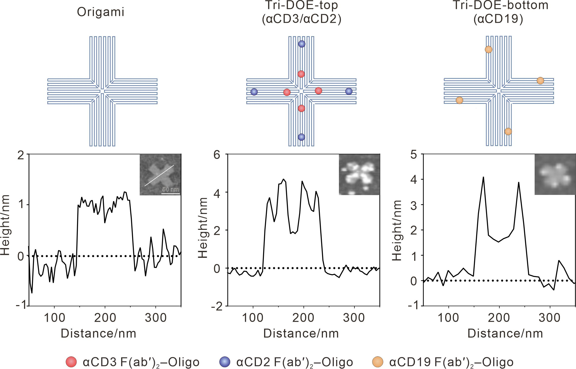
Supplementary Fig. 2 | AFM characterization of bare Origami and the two functional faces of Tri-DOE. Tri-DOE-top denotes the top face of Tri-DOE bearing αCD3 and αCD2 F(ab′)₂–Oligo, whereas Tri-DOE-bottom denotes the bottom face bearing the αCD19 F(ab′)₂–Oligo. Top, schematic illustrations of Origami, Tri-DOE-top and Tri-DOE-bottom. Bottom, corresponding AFM height profiles and representative AFM images. Scale bar, 50 nm.

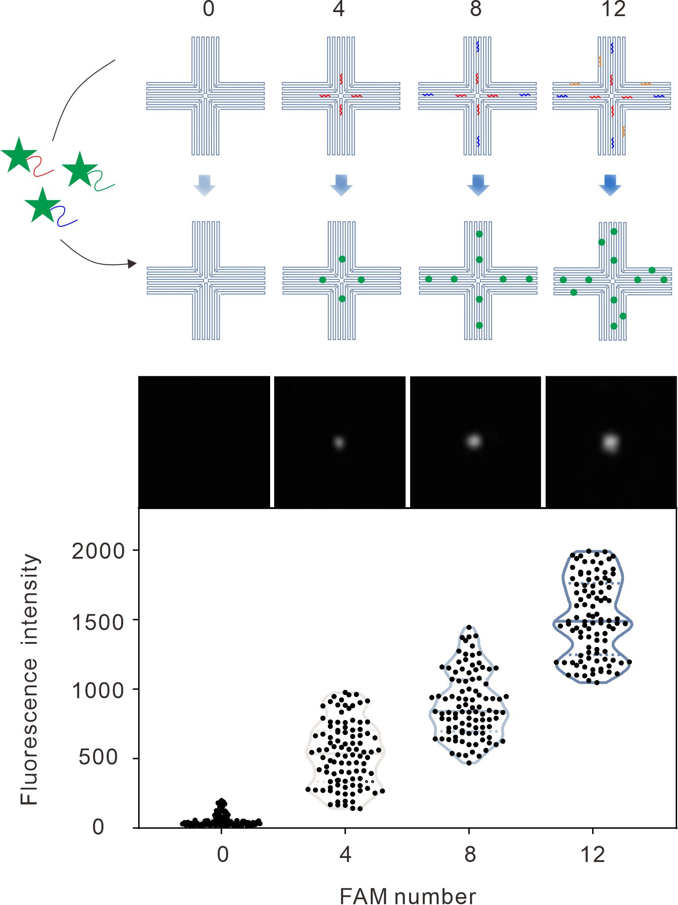
Supplementary Fig. 3 | Fluorescence validation of addressable oligonucleotide incorporation on DNA origami. Schematic illustration, representative fluorescence images, and fluorescence intensity quantification of DNA origami carrying 0, 4, 8, or 12 FAM-labeled complementary oligonucleotides. Blue and red indicate oligonucleotides corresponding to αCD2 and αCD3 modules on the top face, respectively, whereas orange indicates oligonucleotides corresponding to the αCD19 module on the bottom face.

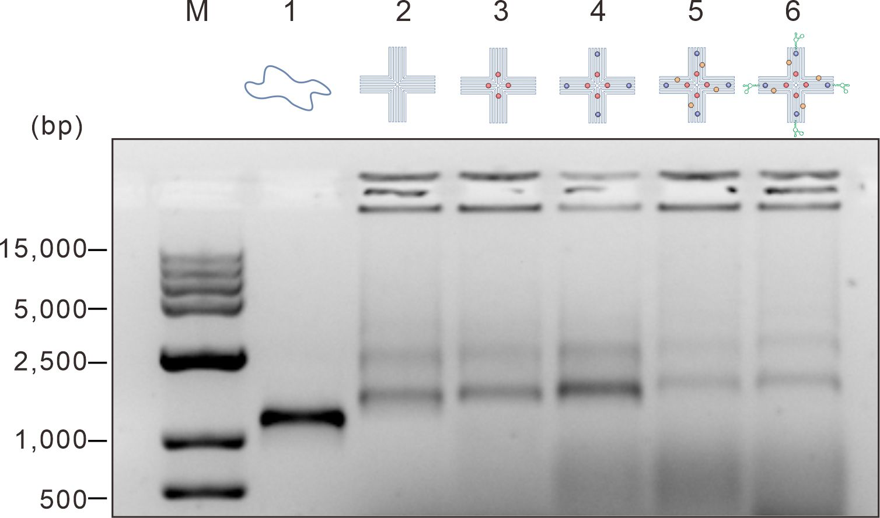
Supplementary Fig. 4 | Agarose gel electrophoresis analysis of DNA origami carrying different functional modules. M, DNA ladder; lane 1, M13 scaffold strand; lane 2, unmodified DNA origami; lane 3, DNA origami carrying the αCD3 F(ab′)₂–Oligo module; lane 4, DNA origami carrying the αCD2 and αCD3 F(ab′)₂–Oligo modules; lane 5, DNA origami carrying the αCD19, αCD2 and αCD3 F(ab′)₂–Oligo modules; lane 6, DNA origami carrying the αCD19, αCD2 and αCD3 F(ab′)₂–Oligo modules together with the E-selectin aptamer.

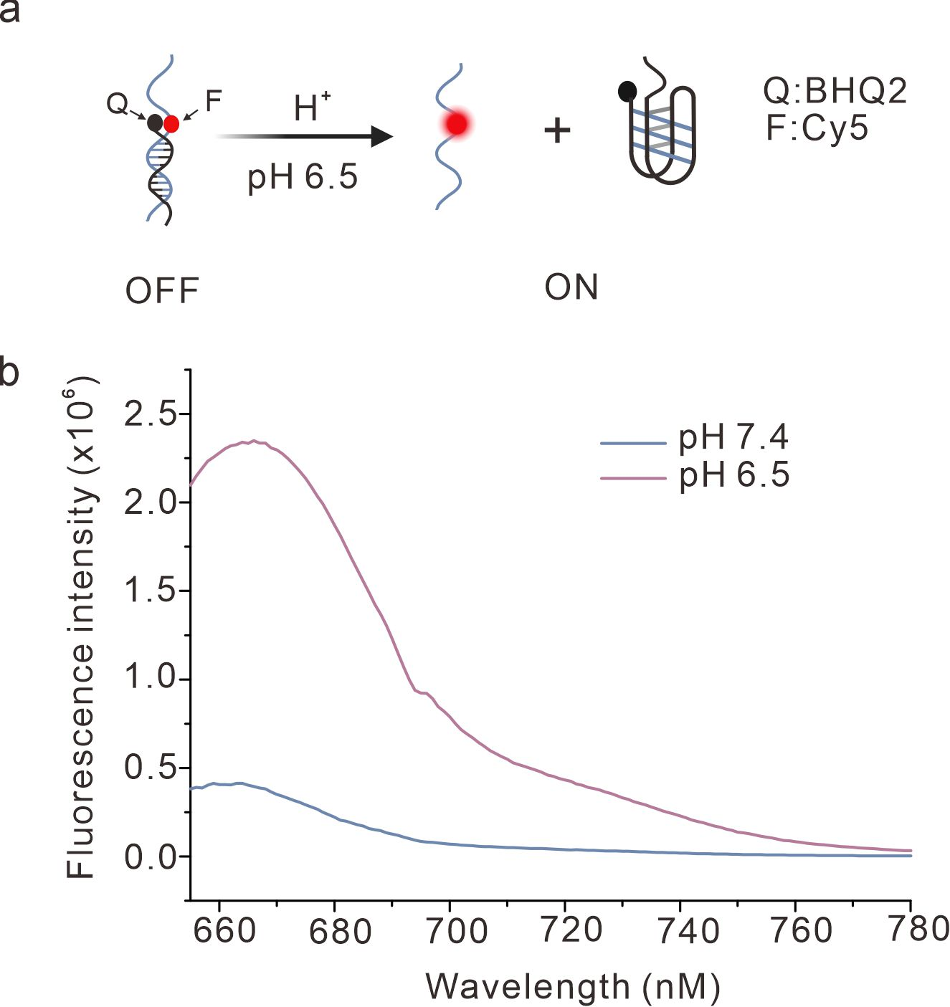
Supplementary Fig. 5 | pH-responsive fluorescence switching of the i-motif module in Tri-DOE. (a) Schematic illustration of pH-responsive conformational switching of the i-motif module in Tri-DOE, monitored using the Cy5/BHQ2 fluorophore–quencher pair. (b) Fluorescence emission spectra of the corresponding Cy5/BHQ2-labeled Tri-DOE construct at pH 7.4 and pH 6.5. The experiment was repeated three times with similar results.

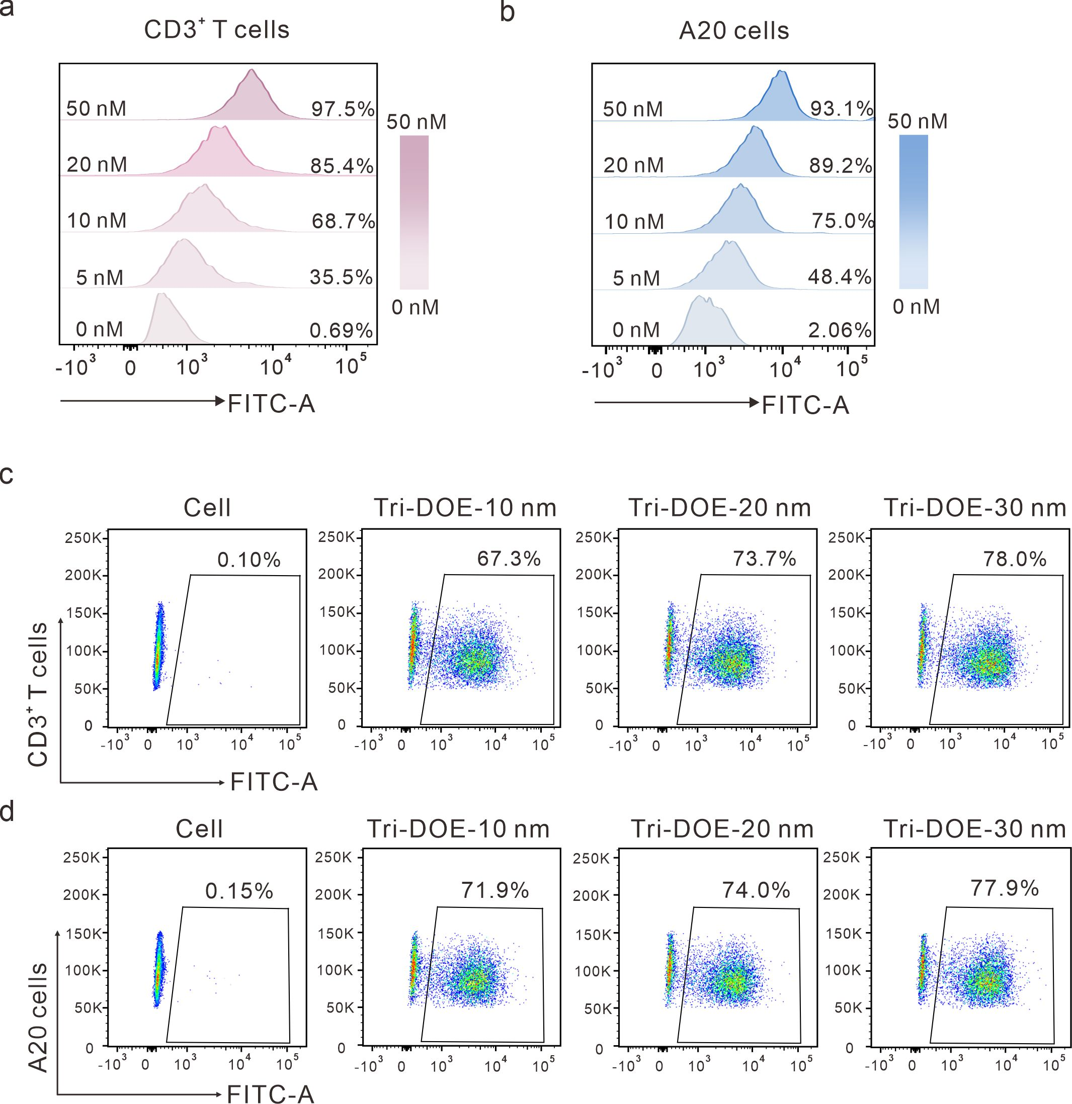
Supplementary Fig. 6 | Flow cytometric analysis of Tri-DOE binding to CD3⁺ T cells and A20 cells. (a,b) Representative FITC fluorescence histograms of CD3⁺ T cells (a) and A20 cells (b) incubated with Tri-DOE-30 nm at 0, 5, 10, 20 or 50 nM. (c,d) Representative flow cytometric dot plots of CD3⁺ T cells (c) and A20 cells (d) incubated with Tri-DOE-10 nm, Tri-DOE-20 nm or Tri-DOE-30 nm at 10 nM. Cell, untreated control. Cell denotes untreated control cells.

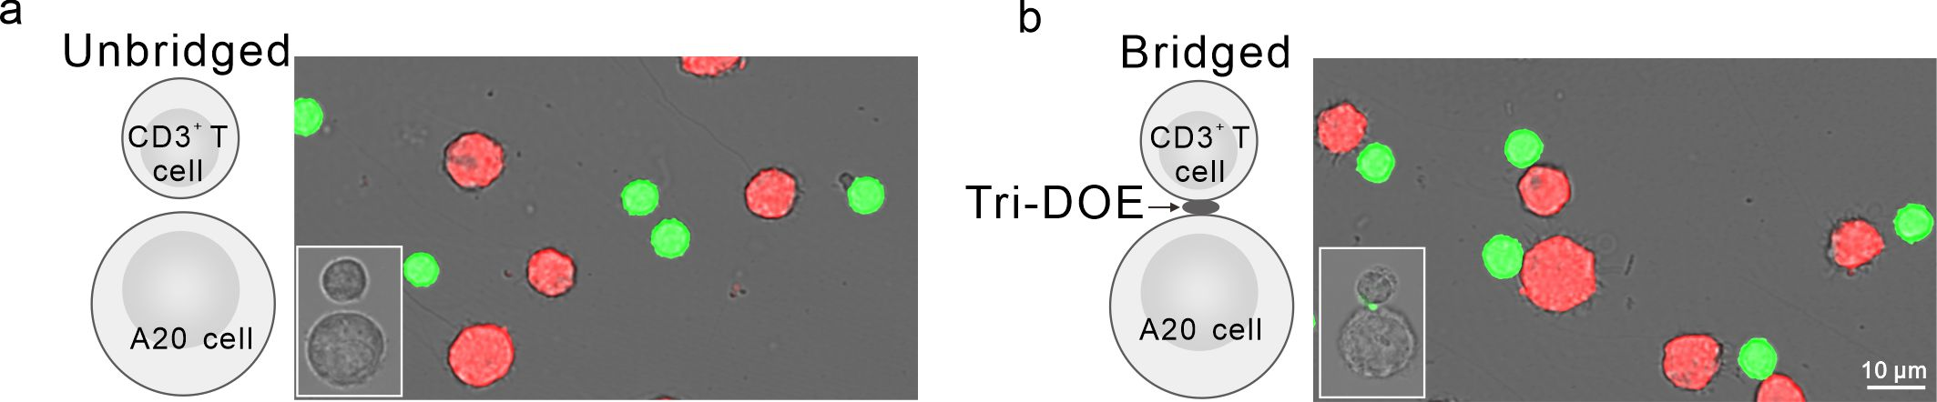
Supplementary Fig. 7 | Tri-DOE mediates CD3⁺ T cell–A20 cell engagement. Representative fluorescence images of Deep Red-labeled A20 cells (red) co-incubated with CMFDA-labeled CD3⁺ T cells (green) in the absence (a) or presence (b) of unlabeled Tri-DOE. Scale bars, 10 μm. Enlarged insets show the CD3⁺ T cell–A20 cell contact interface in the absence or presence of FAM-labeled Tri-DOE.

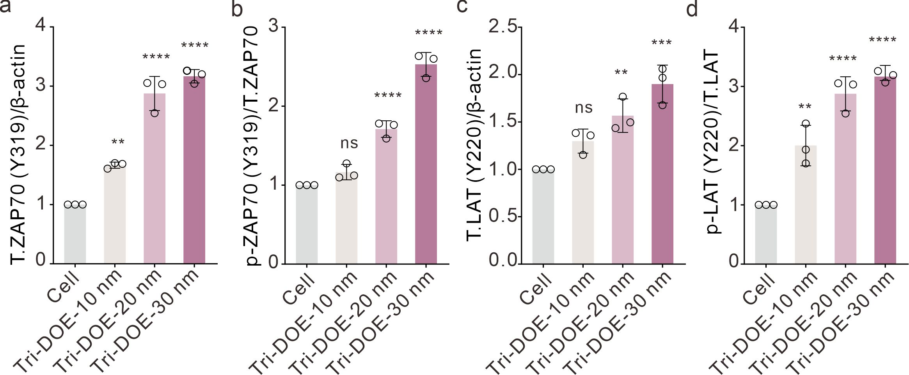
Supplementary Fig. 8 | Densitometric quantification of western blot bands in the indicated groups. Relative protein levels are presented as fold changes relative to the Cell group. (a) Total ZAP70 normalized to β-actin. (b) p-ZAP70 (Y319) normalized to total ZAP70. (c) Total LAT normalized to β-actin. (d) p-LAT (Y220) normalized to total LAT. Each dot represents an independent biological replicate. n = 3 independent experiments. Data are presented as mean ± s.d.; ****P < 0.0001, ***P < 0.001, **P < 0.01; ns, not significant; analyzed by one-way ANOVA followed by Dunnett’s multiple-comparisons test.

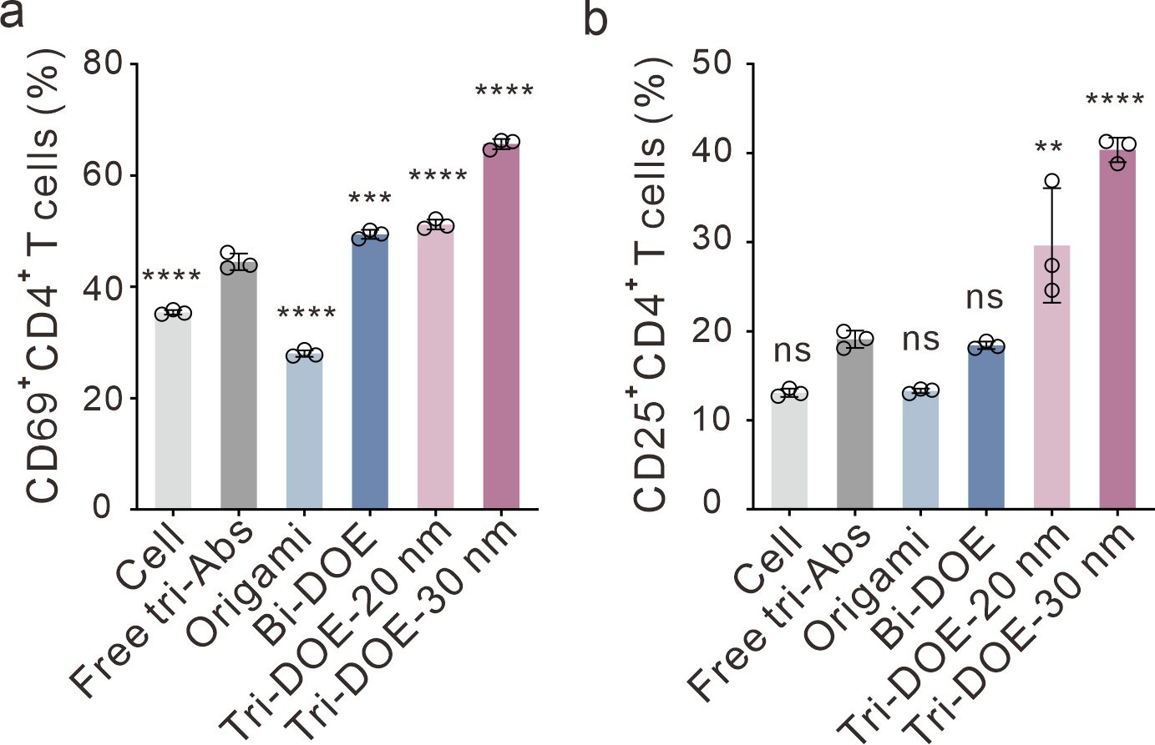
Supplementary Fig. 9 | Flow cytometric quantification of CD69 and CD25 expression in CD4⁺ T cells. (a) Quantification of the percentages of CD69⁺CD4⁺ T cells in the Cell, Free tri-Abs, Origami, Bi-DOE, Tri-DOE-20 nm, and Tri-DOE-30 nm groups. (b) Quantification of the percentages of CD25⁺CD4⁺ T cells in the indicated groups. n = 3 independent experiments. Data are presented as mean ± s.d.; ****P < 0.0001, ***P < 0.001, **P < 0.01; ns, not significant; analyzed by one-way ANOVA followed by Tukey’s multiple-comparisons test.

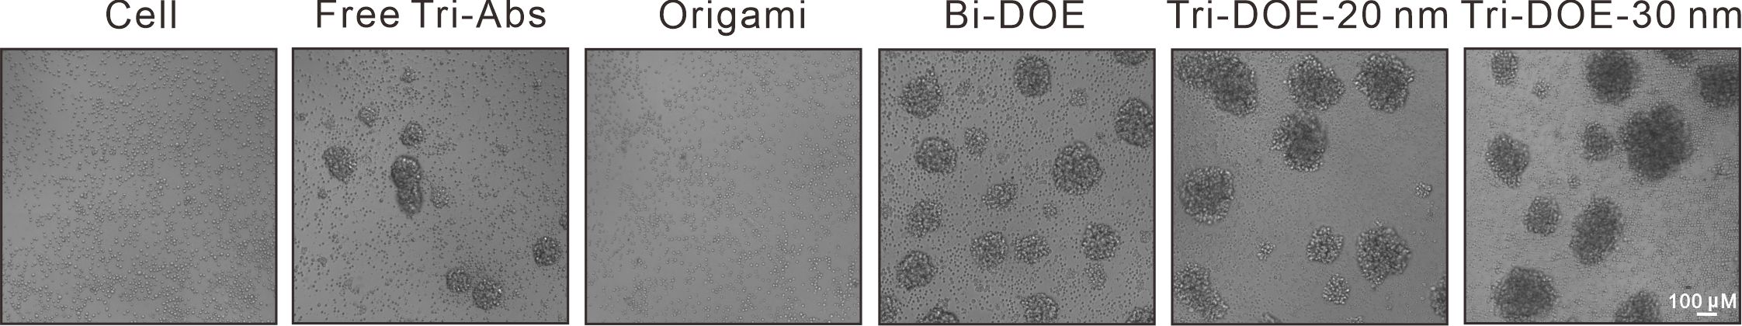
Supplementary Fig. 10 | Representative bright-field images showing T-cell clustering in the indicated groups. Scale bar, 100 μm.

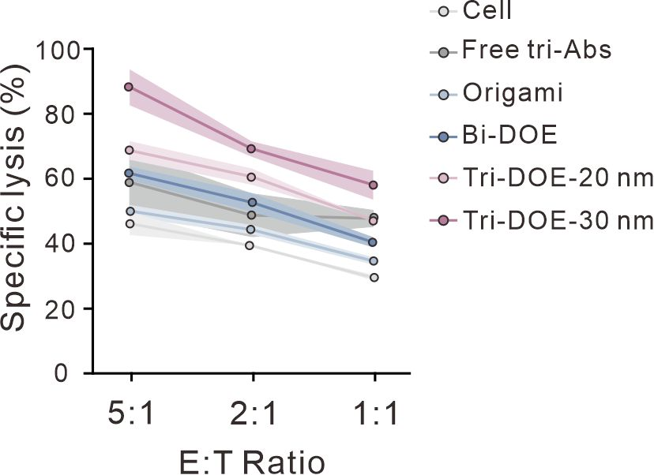

Supplementary Fig. 11 | Specific lysis of A20 target cells in the indicated groups at effector-to-target (E:T) ratios of 5:1, 2:1, and 1:1 after 24 h. n = 3 independent experiments. Data are presented as mean ± s.d.

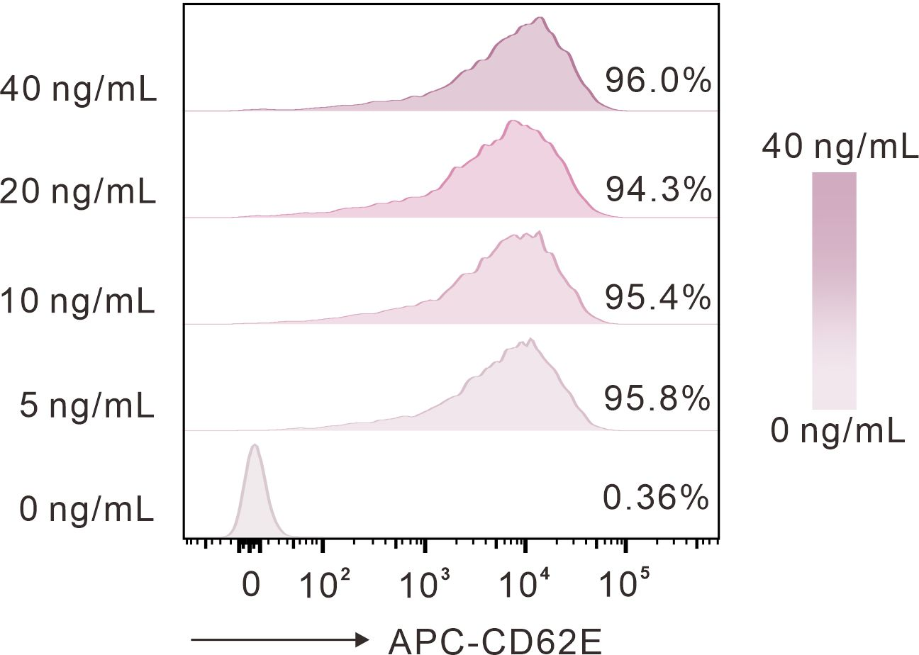
Supplementary Fig. 12 | Representative flow cytometric histograms showing E-selectin (CD62E) expression on HUVECs after stimulation with TNF-α at 0, 5, 10, 20, or 40 ng/mL for 6 h.
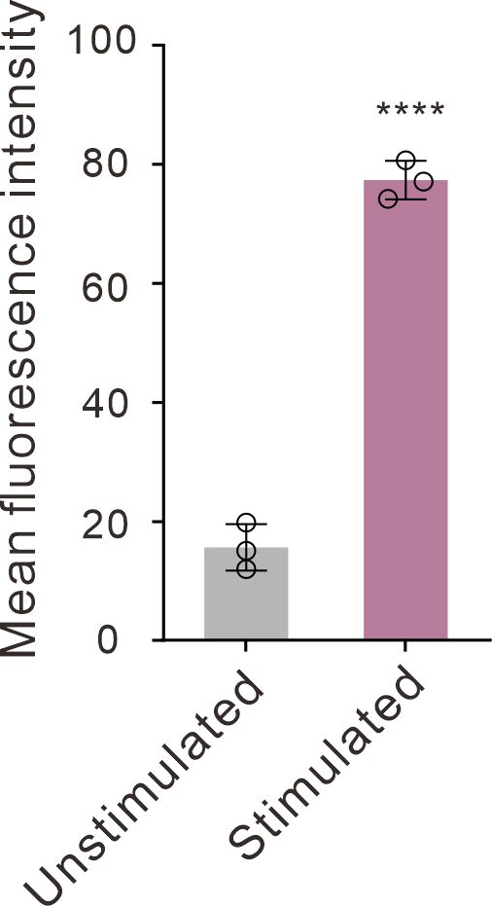
Supplementary Fig. 13 | Quantification of the mean FAM fluorescence intensity in unstimulated and TNF-α-stimulated HUVECs, corresponding to the images in Fig. 3g. n = 3 independent experiments. Data are presented as mean ± s.d.; ****P < 0.0001, analyzed by unpaired two-tailed Student’s t-test.

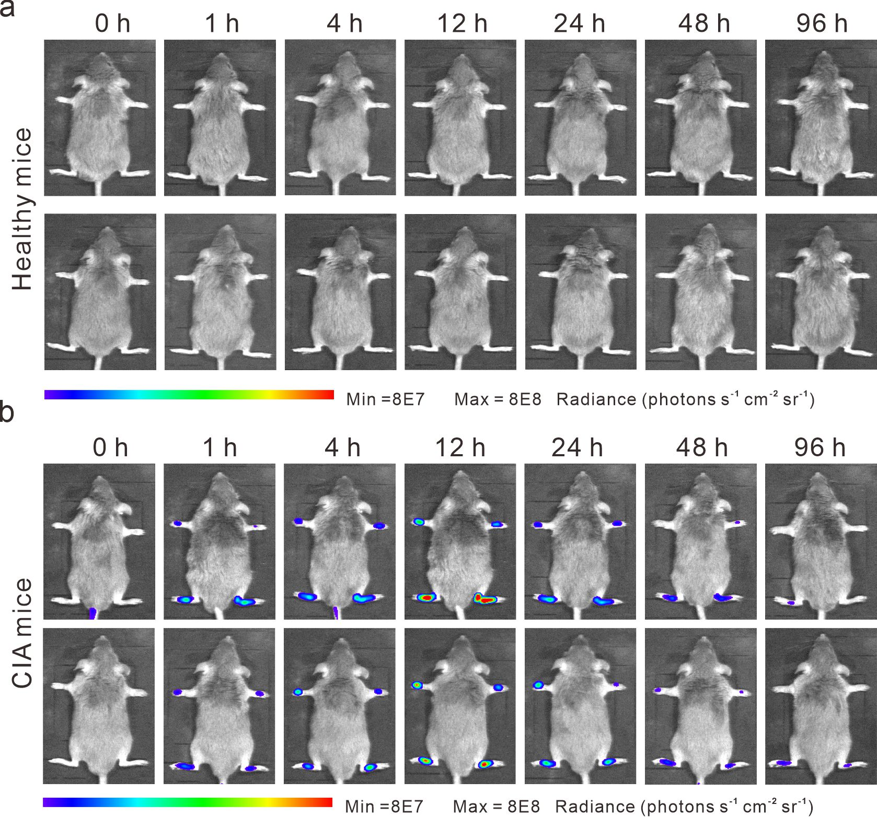
Supplementary Fig. 14 | Representative in vivo fluorescence images of healthy mice (a) and CIA mice (b) after intravenous injection with Tri-DOE-30 nm-Cy5.5 at the indicated time points.

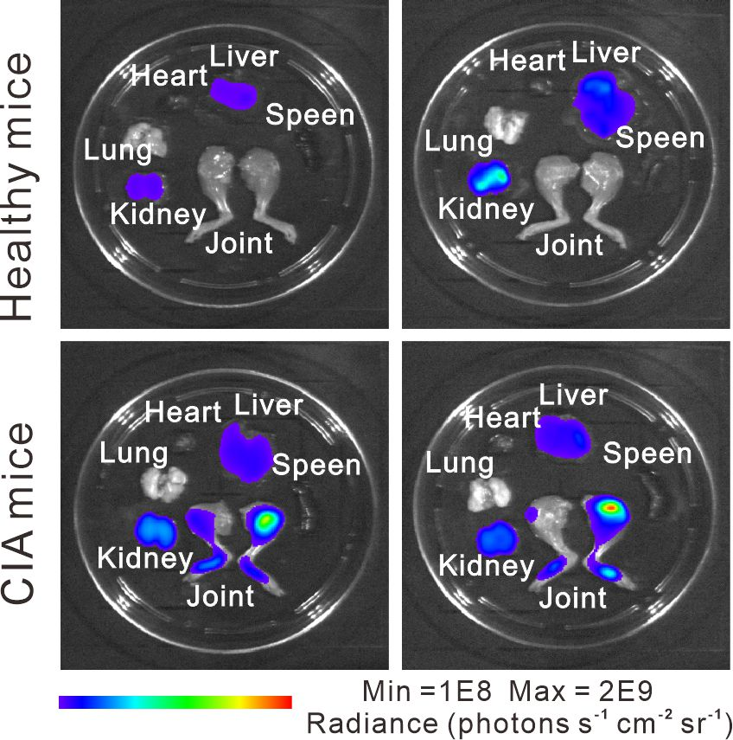
Supplementary Fig. 15 | Representative ex vivo fluorescence images of the major organs and joints harvested from the mice 96 h after intravenous injection with Tri-DOE-30 nm-Cy5.5.
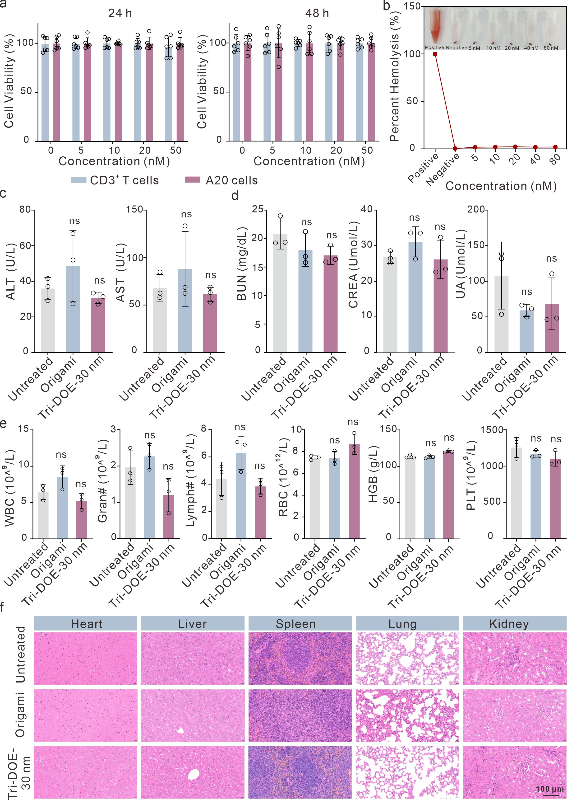
Supplementary Fig. 16 | In vitro and in vivo biosafety assessment of Tri-DOE-30 nm. (a) Viability of CD3⁺ T cells and A20 cells after incubation with Tri-DOE-30 nm at the indicated concentrations for 24 or 48 h (n = 6). (b) Hemolysis assay of red blood cells incubated with Tri-DOE-30 nm at the indicated concentrations. Inset shows representative photographs of supernatants after centrifugation. Water and PBS served as positive and negative controls, respectively. (c,d) Serum biochemical parameters in healthy mice from the untreated, Origami-treated, and Tri-DOE-30 nm-treated groups: ALT and AST (c); BUN, CREA, and UA (d). n = 3 biologically independent mice per group. Data are presented as mean ± s.d.; ns, not significant; analyzed by one-way ANOVA with Tukey’s multiple comparisons test. (e) Complete blood count parameters in healthy mice from the untreated, Origami-treated, and Tri-DOE-30 nm-treated groups, including WBC, Gran#, Lymph#, RBC, HGB, and PLT. n = 3 biologically independent mice per group. Data are presented as mean ± s.d.; ns, not significant; analyzed by one-way ANOVA with Tukey’s multiple comparisons test. (f) Representative H&E-stained sections of major organs (heart, liver, spleen, lung, and kidney) from healthy mice in the untreated, Origami-treated, and Tri-DOE-30 nm-treated groups. Scale bars, 100 μm. Representative images from n = 3 biologically independent mice per group.

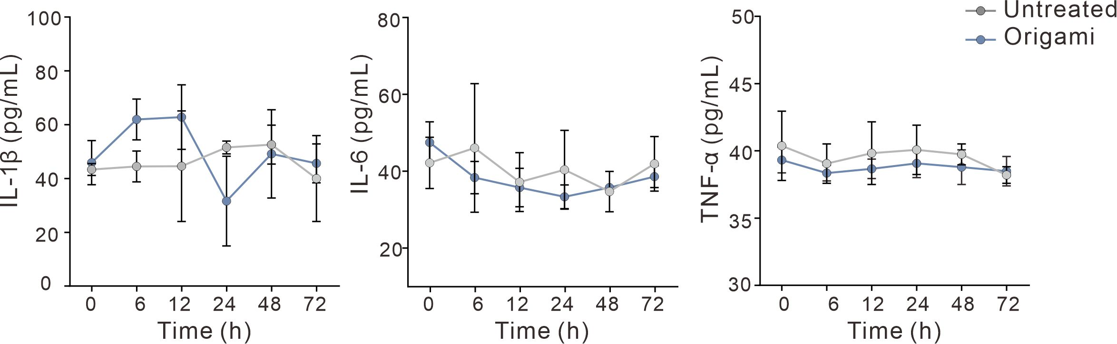
Supplementary Fig. 17 | Serum levels of representative pro-inflammatory cytokines, including IL-1β, IL-6, and TNF-α, in healthy mice from the Untreated and Origami groups at the indicated time points (0, 6, 12, 24, 48, and 72 h). n = 3 biologically independent mice per group. Data are presented as mean ± s.d.; Statistical significance was analyzed by two-way ANOVA. No significant differences were observed between groups across the indicated time course.

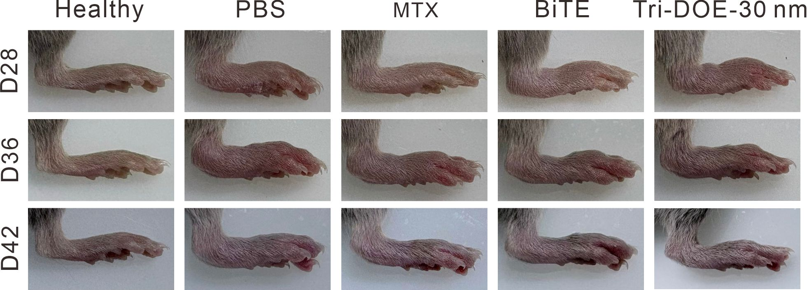
Supplementary Fig. 18 | Representative digital images of hind paws from healthy mice and CIA mice receiving the indicated treatments on days 28, 36, and 42.

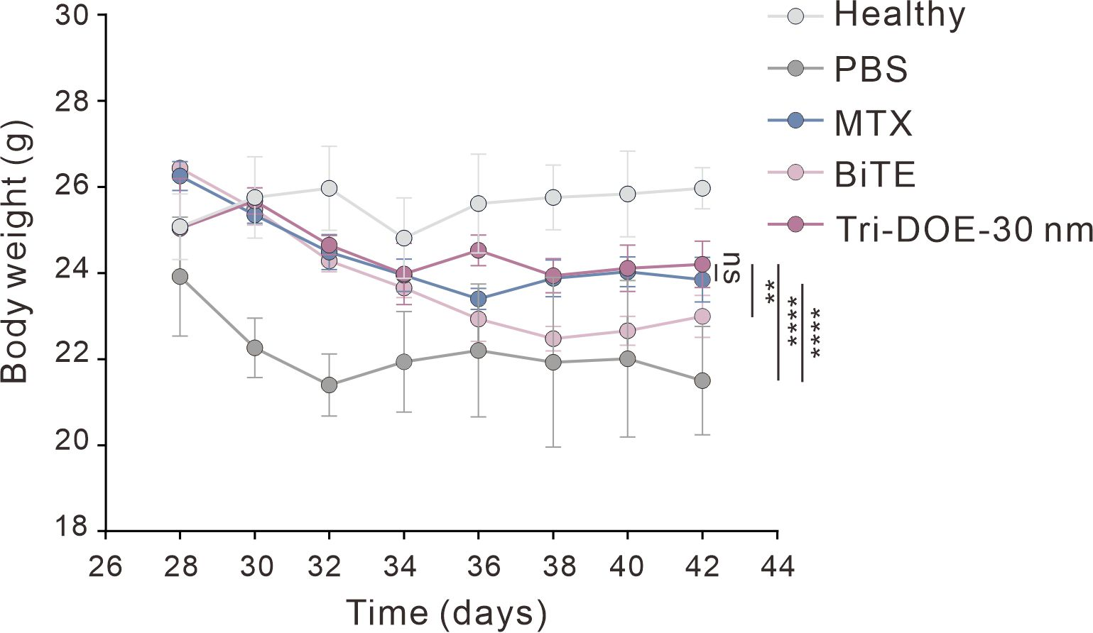
Supplementary Fig. 19 | Body weight of mice in the Healthy, PBS, MTX, BiTE, and Tri-DOE-30 nm groups over time after the indicated treatments. n = 6 biologically independent mice per group. Data are presented as mean ± s.d.; ****P < 0.0001, **P < 0.01; ns, not significant; analyzed by one-way ANOVA with Tukey’s multiple comparisons test.

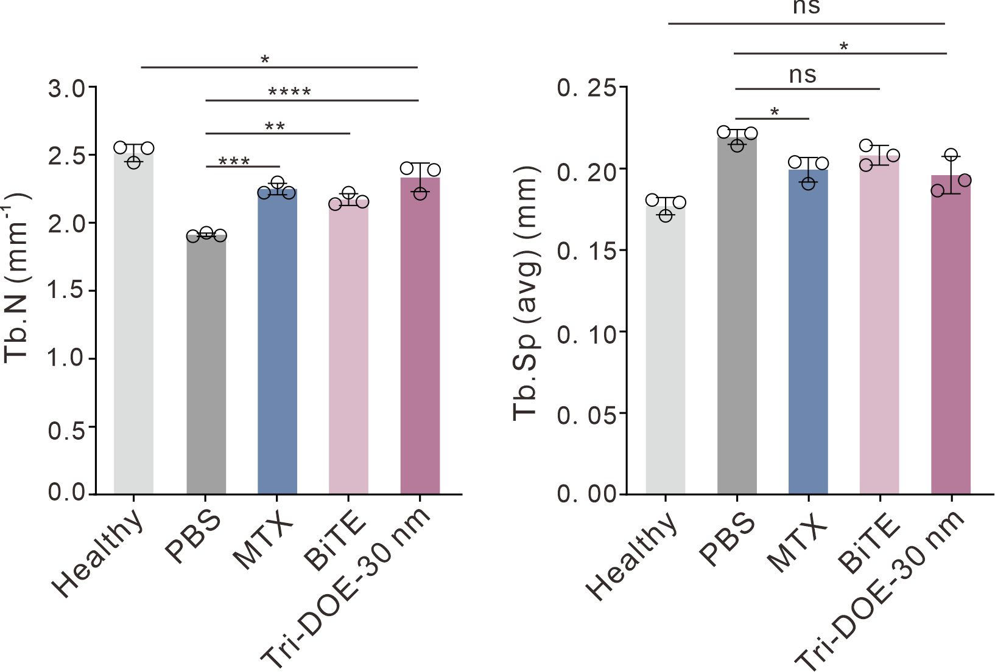
Supplementary Fig. 20 | Quantitative analysis of bone microstructural parameters, including trabecular number (Tb.N) and trabecular separation (Tb.Sp). n = 3 biologically independent mice per group. n = 3 biologically independent mice per group. Data are presented as mean ± s.d.; ****P < 0.0001, ***P < 0.001, **P < 0.01, *P < 0.05; ns, not significant; analyzed by one-way ANOVA with Tukey’s multiple comparisons test.

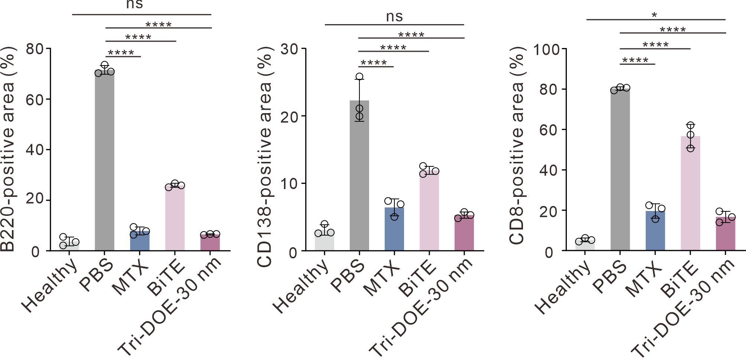
Supplementary Fig. 21 | Quantification of B220-, CD138-, and CD8-positive areas in knee joints sections after the indicated treatments, as determined by immunohistochemical analysis. n = 3 biologically independent mice per group. Data are presented as mean ± s.d.; ****P < 0.0001, *P < 0.05; ns, not significant; analyzed by one-way ANOVA with Tukey’s multiple comparisons test.

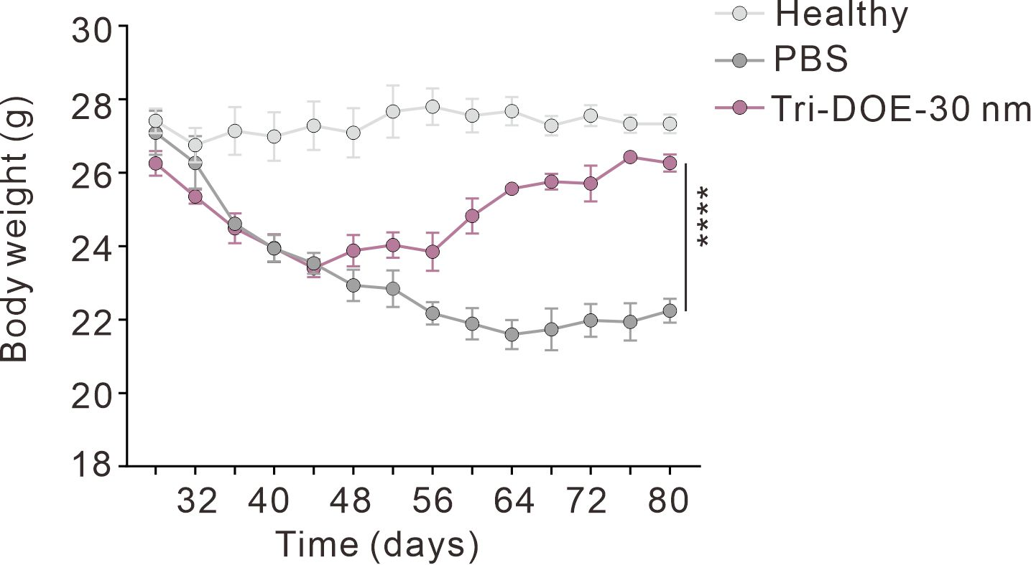
Supplementary Fig. 22 | Body weight of mice in the Healthy, PBS, and Tri-DOE-30 nm groups over time after the indicated treatments. Data are presented as mean ± s.d.; ****P < 0.0001; analyzed by one-way ANOVA with Dunnett’s post hoc test.

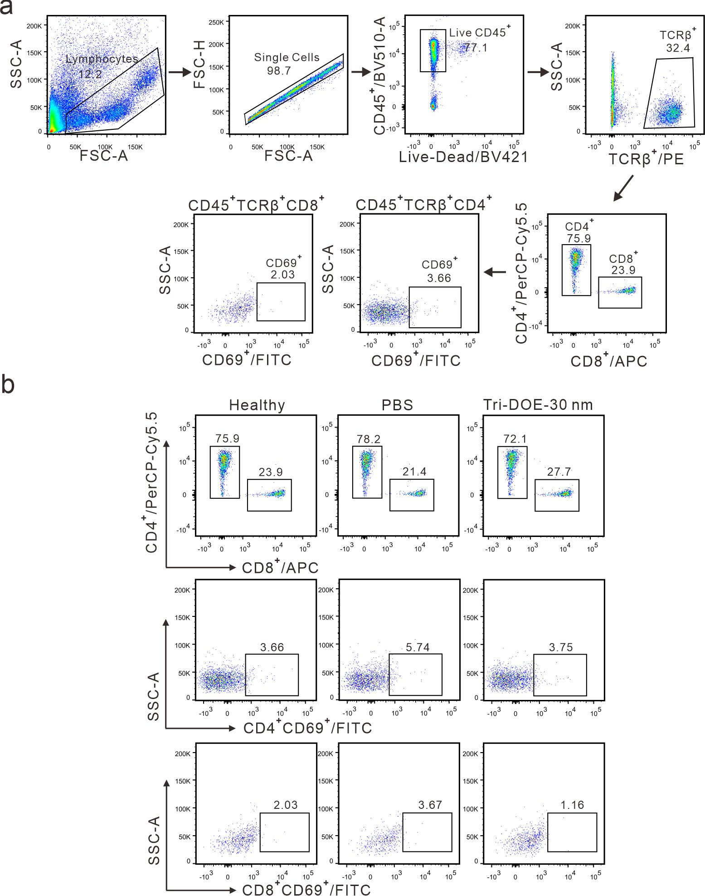
Supplementary Fig. 23 | Representative gating strategy and flow cytometric analysis of peripheral blood T-cell subsets at day 80. (a) Representative gating strategy for identifying T-cell subsets and CD69⁺ populations in peripheral blood. (b) Representative flow cytometric plots from peripheral blood of mice in the Healthy, PBS, and Tri-DOE-30 nm groups at day 80. The top panels show the frequencies of CD4⁺ and CD8⁺ T cells among CD45⁺TCRβ⁺ T cells. The middle and bottom panels show the percentages of CD69⁺ cells within the CD4⁺ and CD8⁺ T-cell subsets, respectively.
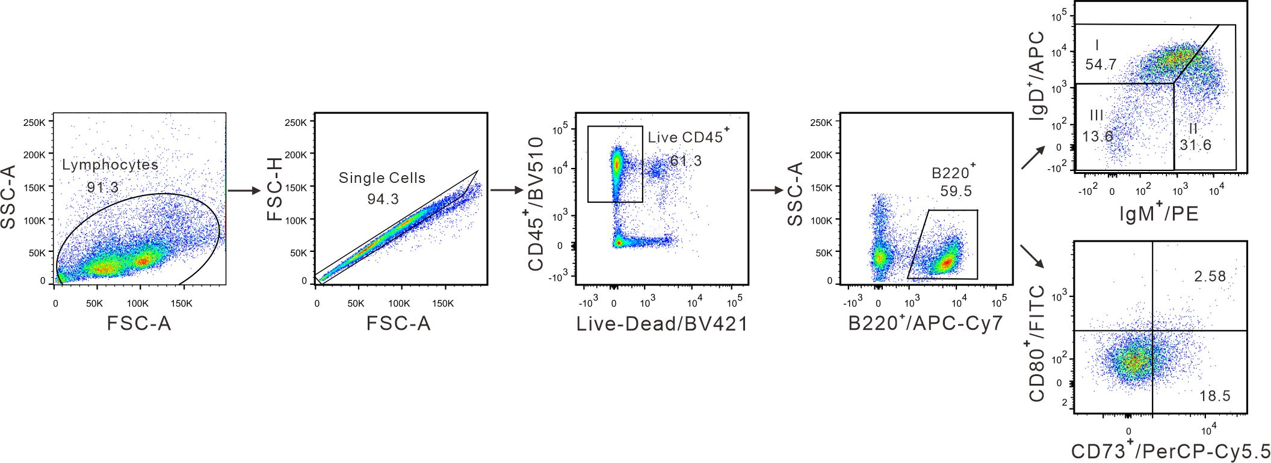

Supplementary Fig. 24 | Representative gating strategy for splenic B-cell subsets based on sequential gating of lymphocytes, singlets, live CD45⁺ cells, and B220⁺ cells, followed by subset discrimination based on IgD, IgM, CD80, and CD73 expression.

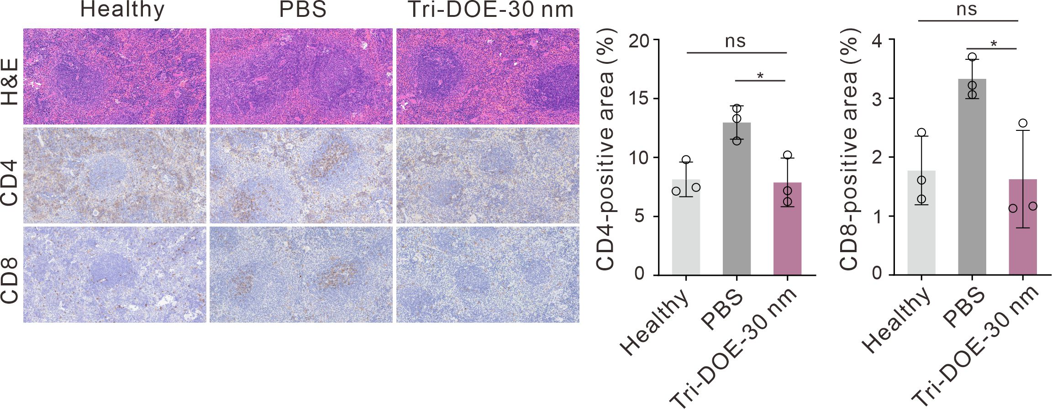
Supplementary Fig. 25 | Representative H&E staining and immunohistochemical staining for CD4 and CD8 in spleen sections from the Healthy, PBS, and Tri-DOE-30 nm groups at the endpoint. Quantification of CD4-positive and CD8-positive areas is shown on the right. n = 3 biologically independent mice per group. Data are presented as mean ± s.d.; *P < 0.05; ns, not significant; analyzed by one-way ANOVA with Tukey’s multiple comparisons test.

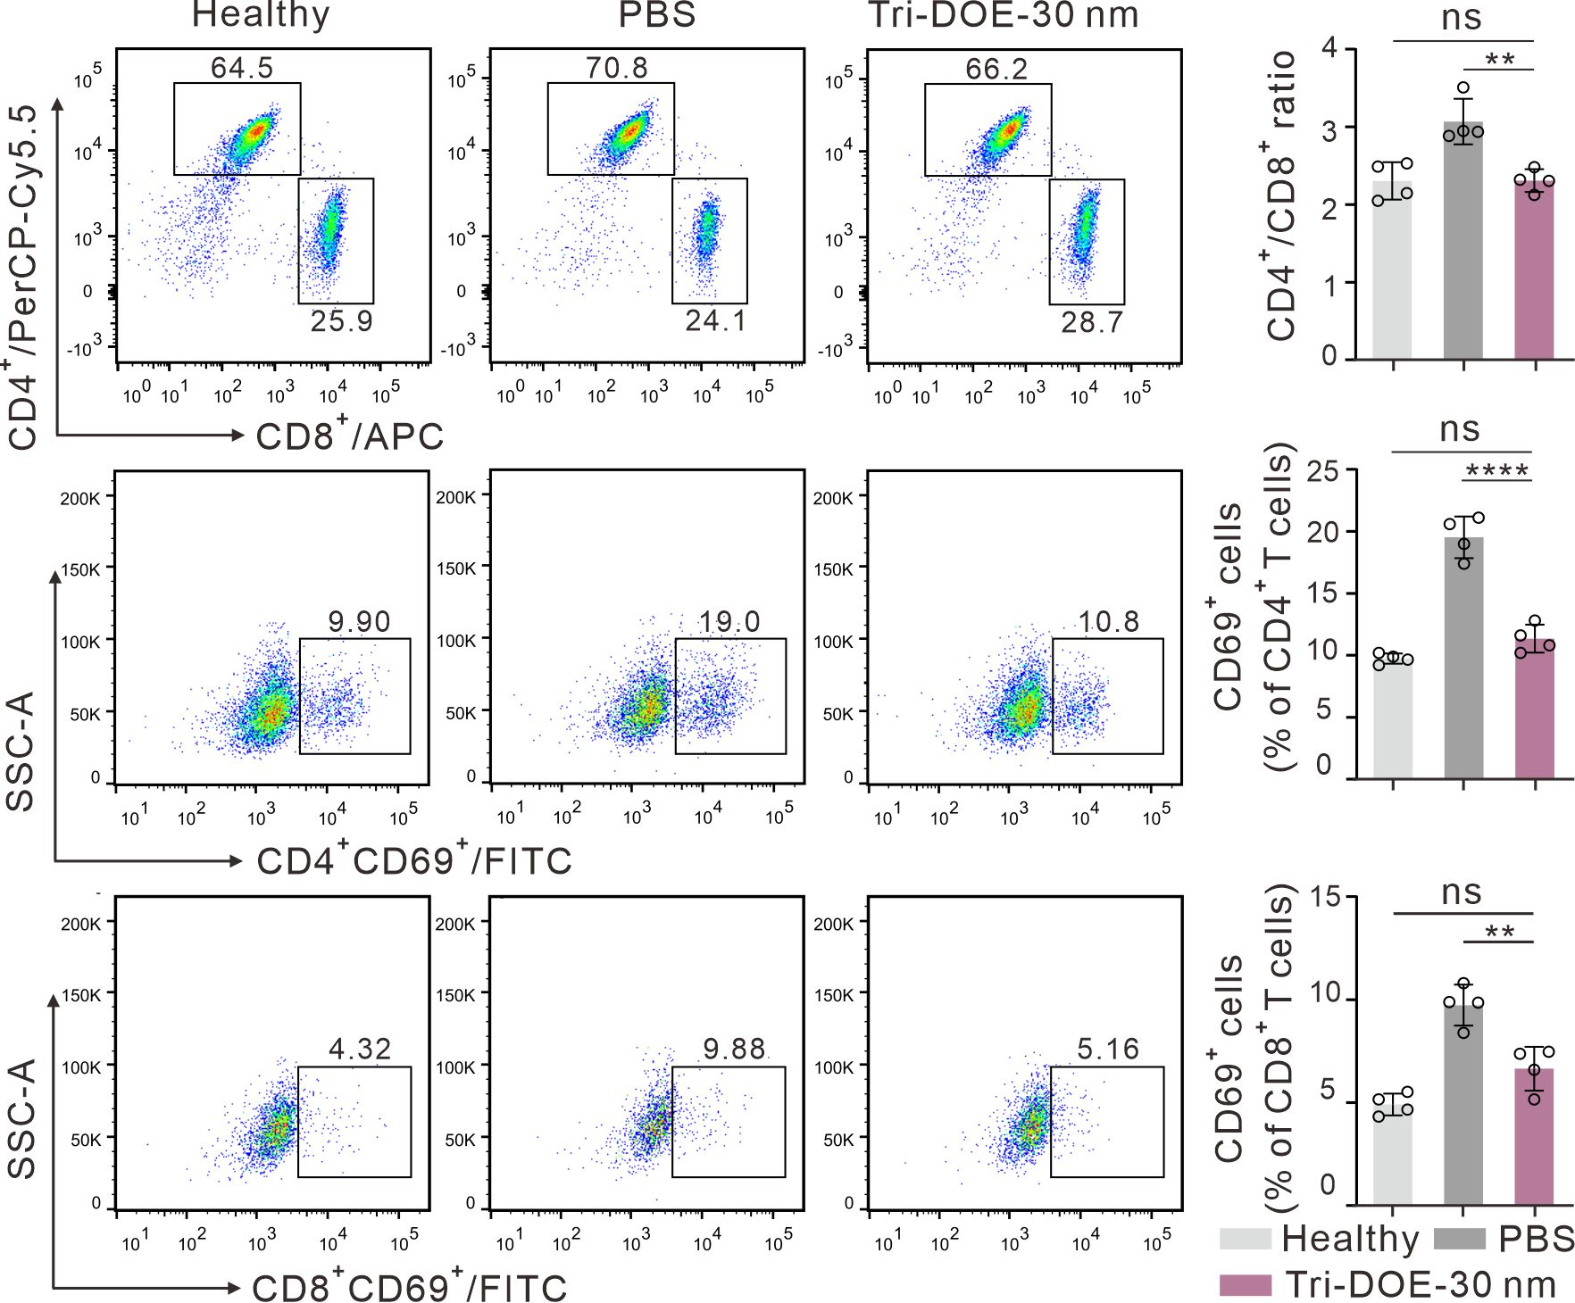
Supplementary Fig. 26 | Representative flow cytometric plots of splenocytes from the Healthy, PBS, and Tri-DOE-30 nm groups at the endpoint. The top panels show the frequencies of CD4⁺ and CD8⁺ T-cell subsets, with the CD4⁺/CD8⁺ ratio quantified on the right. The middle and bottom panels show the percentages of CD69⁺ cells within CD4⁺ and CD8⁺ T-cell populations, respectively, with quantification shown on the right. n = 4 biologically independent mice per group. Data are presented as mean ± s.d.; ****P < 0.0001, **P < 0.01, *P < 0.05; ns, not significant; analyzed by one-way ANOVA with Tukey’s multiple comparisons test.

Table S1. The sequences of staple DNA used for cross DNA origami in this work.
Name | The sequences (from 5’ to 3’)
1 | CGTGAACCATCACCCAAATCAAGTGCCGTAAA
2 | GAAAAACCGTCTATCAGGGCGATGAGCCCCCGATTTAGAGGCGCGTAC
3 | ATTAAAGAACGTGGACTCCAACGTGGCGAACG
4 | GTTCCAGTTTGGAACAAGCGAAAGGA
5 | GTCGAGGTTTTTTGGG
6 | GCACTAAATAACGTGCTTTCCTCGAGCTAAAC
7 | TGGCGAGACACACCCGCCGCGCTTGTTTTTAT
8 | GCGGGCGCTAGGGTTTTAGTCGGGAAA
9 | AGCACGTATCGGAACCCTAAAGGGGCCCACTA
10 | GCTACAGGCTTGACGGGGAAAGCCCAAAGGGC
11 | GTAACCACAAGGAAGGGAAGAAAGAGTCCACT
12 | AGCGGTCAGAGTCTGTCCATCACG
13 | AGAGCGGGTTAGAATCTACCAGTCGCTCATTA
14 | AGGAGGCCATTTTGACGCTCAATCTTACATTG
15 | TATGGTTGGACAGGAACGGTACGCGCAACAGGAAAAACGCGTAATAAA
16 | AATCAGTGTAATATCCAGAACAATAGAACCCT
17 | GTAGCAATACTTCTTTTTATTACGCCAGTTGCGTTGCGCTCACT
18 | ATACCTACGATTAAAGGGATTTTACTTTGACG
19 | CAGCCATTCAGAATCCTGAGAAGTAATGCGCC
20 | CTTGCTGGAGGCCACCGAGTAAAACGCTGCGC
21 | AGTAGAAGAACTCAAAGTGGCACAGACA
22 | TAACATCACTTGCCTGCAAATTAACCGTT
23 | TTGATTAGTAAGTCTTTAATGCTTTGATCGGTGCGGGCCTCAACTGTTGGGAAGGGC
24 | TGGATTATGTCTGAAACGGAACGATACTTAGC
25 | GCAGATTCTATCAAACCCTCAATCGCAAATCA
26 | AGGGACATAAATCTAAAGCATCACTTATCTAAAATATCTTGAATTATC
27 | TCTGACCTCAGTGCCACGCTGAGATAATAGAT
28 | GCGAACCGAA
29 | ACCTCAAAACCAGTCACACGACCATCATGGAA
30 | CAAATGAATCTGGCCAACAGAGATATTACCGC
31 | GCCTGCAAGAAAGCGTAAGAATACCTATCGGC
32 | GGTGAGGCGGTCAGTATTGAGGATTTAGAAGT
33 | CAGAAGATAAAACAGATTTTGAATGGCTATTA
34 | ATCGCCATTAAAAATACTGATAGCCCTAAAACTTTTGTTAAATCAGCTAAAATTCGCATTAAAT
35 | ACAGTTGATGGCAATTCATCAATAGATTATAC
36 | TAGAGCCGTTTGCGGAACAAAGAAAGAAATAA
37 | TCAGATGAAAGGAATTGAGGAAGGCTTGCTGA
38 | AAGGAGCGTAGGAGCACTAACAACGCCAGCAG
39 | ATTATCATTCAATAGATAATACATTTAACACC
40 | ATTAATTTTAAAAGTTTAACGTCA
41 | TTGCCCGAACGTTATTAGACTTTACAAAC
42 | TTCTGAATACCTGAGCAAAAGAAGCAAGAAAA
43 | ATCATATTCCTACCATATCAAAATAATCGCGCAGAGGCGATCATTTGA
44 | AGAAATTGTTCGCCTGATTGCTTTACATAAAT
45 | GATGAATATACAGTTTTTTAAATAAGGCGT
46 | TTTCAATTAATGGAAGGGTTAGAACCTGATTA
47 | AGTTACAATATTTGCACGTAAAACACCACCAG
48 | ATAACGGACGTAGATTTTCAGGTTTGAGTAAC
49 | TACATCGGGCTTCTGTAAATCGTCGCTATT
50 | CAAAATTAATTACATTTAACAATTATTATTCA
51 | ATTACCTTTTTTAATGGAAACAGTGAATACCA
52 | CAATATATGTGAGTGAATAACCTTGAGAAACA
53 | TCTGAGAGACTACCTTTTTAACCTTATATAAC
54 | AGAGTCAATAGTGAATTTATCAAACAATCGCAAGACAAAGAACAGTAG
55 | ACATAGCGATAGCTTAGATTAAGATTCAAATA
56 | TTAATTTTCCCTTAGAATACCTAAAT
57 | GGTTGGGTCCGGCTTA
58 | TATATGTATAACAACGCCAACATGATTTTCGA
59 | TATTTTAGTACAAATTCTTACCAGGACGACAA
60 | TTAATGGTTAGAAAAAGCCTGTTTGAACGCGC
61 | ACCGTGTGATTTTTTAACAGTACCTTT
62 | GCCATATTAATGCTGATGCAAATCATCATAGG
63 | CAACGCTCAACGCGAGAAAACTTTCGCTGAGA
64 | ATGCGTTATTAATTTCATCTTCTGCCTTGAAA
65 | ATAATTACTTGAAATACCG
66 | TAAATAAGAATAAACACTGAACAAGAATTTTCGTATTAAATCCT
67 | GCAGAGGCTAATTTAGAGCTCGAAGGGTACCG
68 | GCCAGTAAGCAAATCAGATATAGACTAAGAAC
69 | GGCTTAATACCGACAAAAGGTAAAATCGTAGGAATCATTAGACTTGCG
70 | TAAACAACTCATCGAGAACAAGCAGATTAGTT
71 | CTGTTTATTCCAAGAACGGGTATTTTATCCTG
72 | AAATACCAATCAATAATCGGC
73 | AATAGCAATAAGAGAATATAAAGTTGAGAATC
74 | TTATTTTCGTAATTCTGTCCAGACTATAAAGC
75 | TACCGCACATGTTCAGCTAATGCAAGTATCAT
76 | CTTATCATCAACAATAGATAAGTCCCGGAATC
77 | TACGAGCATGTAGAAAATATCCCATCCTAATTTTTCGAACCACCAGAATTCGACAAC
78 | CCGGTATTAGGCTTATTGGTGTAGGGTCACGT
79 | GCGAGGCGAAGTCAGAGGGTAATTGAGATAAC
80 | GGAGGTTTTAGACGGGAGAATTAATAATAAGAGCAAGAAAGTTTATTT
81 | GCTATTTTAGAGAGAATAACATAAGCTATCTT
82 | AATCTTACCAACGCTAACGAGCGTTGTCTTTC
83 | CTTTCCAGAGCCTAATTATCCCAATCCAAATA
84 | CCTGAACATTTTAGCGAACCTCCCCCGCGCCC
85 | AAGCGCATTGAAGCCTTAAATCAAAGCCGTTT
86 | GCCTTTACGCACCCAGCTACAATTAAACCAAG
87 | TTTTTTGTTTAACGTCAAAAATGAAAGCAGAT
88 | CCACAAGAATGGTTTACCAGCGCCCATTCAAC
89 | ACCGAAGCTATAAAAGAAACGCAACACCGTCA
90 | AGCCGAACACGTAGAAAATACATAGAGCCAGC
91 | AACCGAGGAAACGCAATTAAG
92 | AAATTCATATTGAGTTAAGCCCAACTGAACAC
93 | CGGAATAACAATGAAATAGCAATAAAACAGGG
94 | TGGCAACACCTTTTTAAGAAAAGTAAATAGCA
95 | GTTAGCAAAAAGTTACCAGAAGGAAGAAACGA
96 | CGATTGAGCATCTTTTCATAATCAAGCCACCA
97 | TGTCACAATTGACGGAAATTATTCTTTTCGGTCATAGCCCCCACCCTC
98 | CCGACTTGTAGCGTCAGACTGTAGACCCTCAG
99 | AAAATCACGTAATCAGTAGCGACAAGCCGCCGCCAGCATTGACAGG
100 | GCGTTTGCGGAGGGAAGGTAAATATCAATAGA
101 | CATCGGCAATTAAAGGTGAATTATAGACACCA
102 | TTTGCCTTAGCCATTTGGGAATTACATAAAGG
103 | ATAGCAGCACCCAGTAGCACCATTACCCGCAGTAT
104 | ACGTCACCAATTTTTTTCCCTCAGAGCCAC
105 | CCGGAACCGCCTCCCTCAGAGCCGCCTTATTA
106 | AGAACCGCCACCCTCAGAGCCACCCGCGTTTT
107 | AGCCGCCACCAGAACCACCACCAGGAATCAAG
108 | CGTTCCAGTAAGCGTCGGATTAGCCCAGGCGG
109 | GCCAGAATGGAAAGCGCAGTCTCTATAAGTATAGCCCGGAGTTTCGTC
110 | TGATATTCACAAACAAATAAATCCACTCAGGA
111 | GTTGAGGCAGGTCAGACGCCGCCACC
112 | GCTCAGTAGGGGTTTT
113 | ATAAGTGCAGCATTCCACAGACAGAACGATCT
114 | GGTTTAGTGCCCAATAGGAACCCATAAACAAC
115 | CTCAGAACCGCCATTTTGAAACCATCG
116 | ACGCCTGTCGTCGAGAGGGTTGATGAATTTAC
117 | AACACTGAATAGGTGTATCACCGTTCATTAAA
118 | GATAGCAAACCGCCACCCTCAGAAATTGGCCT
119 | CACCCTCAAATAGAAAGGAACAAC
120 | GTTAGCGTCCCTCATAATTGTTTGTAATCCTG
121 | AAAGTTTTCAACCATCGCCCACGCGTCGCTGA
122 | ACCAGTACTTAGTAAATGAATTTTCTTGATACCGATAGTTTTTTGCGG
123 | TTTCAACACAGCTTGCTTTCGAGGACAGCATC
124 | AATAATAATTTTTTTTTACTCCTTATTAATTAGCAAGGCCGGAA
125 | AATGACAAGTCGTCTTTCCAGACGAAACTACA
126 | TTAAACAGCTGTATGGGATTTTGCTGTACCGT
127 | CGGTTTATGTTTCAGCGGAGTGAGTTTTCAGG
128 | TCCAAAAGGAGCCTTTGAGGCTTTGAGG
129 | TCTCCAAAAAAAAGGCTAAAGGAATTGCG
130 | CACGTTGAAAAGAAGTTTCCATTTTAAAAGAACTGGCATGATAATAACGGAATACCC
131 | TATATTCGATAACCGAGTCAGTTGAATATCTG
132 | GGCTTGCAGCGACCTGCTCCATGTGGCGCAGA
133 | GATCGTCAGTATCATCGCCTGATATGACCAACTTTGAAAGATTTCAAC
134 | GGAACGAGACCAAGCGCGAAACAAGTACAGAC
135 | TAAACCAACC
136 | CGAAATCCGGGAGTTAAAGGCCGCGCGCCGAC
137 | GGAGATTTCCCTCAGCAGCGAAAGTGAATTTC
138 | GCGATTATGGTAGCAACGGCTACAAATTGTAT
139 | TAAAACACTCATCTTTCATCAAGAGTAATCTT
140 | AGGCAAAAGAATACACAAGACTTTTTCATGAG
141 | GCCACTACGAAGGCACGGGTAAAATACGTAATAAACAGCCATATTATTTTGCCAGTTACAAAAT
142 | CGGTCAATGCGATTTTAAGAACTGAGGACGTT
143 | CAGGCGCAAACGAGTAGTAAATTGGAAAGATT
144 | TACCTTATCATAAGGGAACCGAACAATTGTGT
145 | ATGGTTTAAGGACAGATGAACGGTAGTACAAC
146 | AACACCAGTAGGCTGGCTGACCTTGACCCCCA
147 | TGAATAAGGCTTGCCCACATTCAA
148 | GCTGCTCATTCAGGACAAGAACCGGATAT
149 | GGGAAGAAAAGAAGTTTTGCCAGATGTTTAGA
150 | TTTAATCAAACGAACTAACGGAACATAAAAACCAAAATAGATCGTCAT
151 | CATCAGTTACACTATCATAACCCTATGCTTTA
152 | CTAATGCAGATACTTTTTTAGTTTCATTCC
153 | TTTTGCAAAAATCTACGTTAATAATTGTGAAT
154 | AGACGACGAACATTATTACAGGTAGGCTTGAG
155 | TAAGAGCAGAGATTTAGGAATACCTGACGAGA
156 | GAATTACGCATAAATCAAAAATCAGGTCTT
157 | CTGGATAGCGTCCAATACTGCGGACGAGAGGC
158 | AAATATTCATTGAATCCCCCTCAACGTTTACC
159 | AACAGTTCAGAAAACGAGAATGACAGGCATAG
160 | GCTTCAAAGCGAACCAGACCGGAACAGGATTA
161 | CGAAAGACTTCAAATATCGCGTTTTGATAAGAGGTCATTTCATTTGGG
162 | GCGGATTGCATCAAAAAGATTAAGGCTTAATT
163 | CCCTGACTATTATAGTCACATGTTTT
164 | CAACAGGTGCAAACTC
165 | GAGAGTACATTCTACTAATAGTAGTAAATCAT
166 | GCTGAATACAAATGGTCAATAACCAAATCGGT
167 | AAATATGCGTAGATTTAGTTTGACTAATACTT
168 | GGTGTCTGGATTTTATAACGCCAAAAG
169 | TGGCATCACTTTAATTGCTCCTTTTAATTCGA
170 | TATATTTTTTGCGGATGGCTTAGAAGGAAGCC
171 | ACATTTCGTAATGCTGTAGCTCAAGAAGCAAA
172 | GCGAACGAAACTAAAGTAC
173 | ATATAACAGTTGATTCCGCAAGGATAATTTATCAACGTAACAAA
174 | ACATCCAATAGCATTAAAGGGCGAAAAGACAA
175 | ACAGGCAATCTACAAAGGCTATCATCTGGAGC
176 | GCGCGAGCAATTAAGCAATAAAGCTAATGCCGGAGAGGGTATCGTAAA
177 | TGTACCAAAATATGATATTCAACCCCGGTTGA
178 | TTGCGGGATGAGAAAGGCCGGAGAGAAGATTG
179 | AAATTCTGAGTAATGTGTAGG
180 | TTGAGAGAGGCAAAGAATTAGCAATGAAAAGG
181 | TGATAAATCTCAGAGCATAAAGCTTGTTTAGC
182 | TCACCATCAAACATTATGACCCTGCATTAGAT
183 | CAAAAGGGGAAGCCTTTATTTCAACCAATTCT
184 | ATTTTAAATGCAATGCTTTAGAACCCTCATATTTTTAAAACGAAAGTCATTACCCAA
185 | CCTGAGAGGGTCATTGATATCAGAGAGCGCTA
186 | AAACAAGATGACCGTAATGGGATAATGGGCGC
187 | ACTAGCATCGTCGGATTCTCCGTGTGAGGGGACGACGACAGGCCAGTG
188 | TAATCAGATCATCAACATTAAATGGATCGCAC
189 | TATAAGCAAATATTTAAATTGTAATAAAGATT
190 | ACGTTAATATTTTGTTCATTTTTTAACCAATA
191 | CGGCGGATGAATCGATGAACGGTAAGCTATTT
192 | TAACAACCGTCAATCATATGTACCGTTCTAGC
193 | GCCAGCTTAAAGCCCCAAAAACAGCAGTCAAA
194 | ATCAAAAATAATTCGCGTCTGGCCTCTGGTGC
195 | ATCGTAACACTCTAGAGGATCCCCTTCGTAAT
196 | TCCAGCCAGGGTTTTCCCAGTCACATACGAGC
197 | CGGAAACCGTGCTGCAAGGCGATTGGGTGCCT
198 | GCCATTCAGGCTGCGCTTCGC
199 | GCAGGTCGCGTGCATCTGCCAGTTGGAACAAA
200 | AAAACGACGTATCGGCCTCAGGAATGAGCGAG
201 | TAACGCCAGCTTTCCGGCACCGCTTTCCTGTA
202 | AGGGGGATAGGCAAAGCGCCATTCGGAACGCC
203 | CATGGTCATGATTGCCCTTCACCGTTGCAGCA
204 | CCAAGCTTGAAATTGTTATCCGCTTTTTTCTTTTCACCAGGCAGGCGA
205 | CGGAAGCAAGAGGCGGTTTGCGTAAAATCGGC
206 | AATGAGTGAGCTGCATTAATGAATTAGCCCGAGATAGGGTTGAGTG
207 | GCAACAGCTAGCTGTTTCCTGTGTGCATGCCT
208 | CAGGGTGGCACAATTCCACACAACGACGTTGT
209 | GCGCGGGGTAAAGTGTAAAGCCTGAAGTTGGG
210 | CCTGTCGTGCCAGCTAACTCACATTAACTGGCGAA
211 | GCCCGCTTTCCTTTTTTCGCTGGCAAGTGT
212 | AGCGGTCCACGCTGGTTTGCCCCATGAGACGG
213 | AAATCCTGTTTGATGGTGGTTCCGTTGGGCGC
214 | AAAATCCCTTATAAATCAAAAGAACGGCCAAC

Table S2. Sequences of functional strands
Name | The sequences (from 5’ to 3’)
5-new-OH | GTCGAGGTTTTTTGGGAAAAAAAAAAAAAAACCCCAA
57-new-OH | GGTTGGGTCCGGCTTAAAAAAAAAAAAAAAACCCCAA
112-new-OH | GCTCAGTAGGGGTTTTAAAAAAAAAAAAAAACCCCAA
164-new-OH | CAACAGGTGCAAACTCAAAAAAAAAAAAAAACCCCAA
E-selectin overhangs | CGCTCGGA*TCGA*TA*A*GCTTCGA*TCCCA*CTCTCCCGTTCA*CTTCTCCTCA*CGTCA*CGGA*TCCTCTA*GA*GCA*CTGTTGGGGTTA*TTTTTTTTTTTT
15-new-OH | CCCAAACATTCACAAATCCAGTTTGGG TTTTTATGGTTGGACAGGAACGGTACGCGCAACAGGAAAAACGCGTAATAAA
69-new-OH | CCCAAACATTCACAAATCCAGTTTGGG TTTTGGCTTAATACCGACAAAAGGTAAAATCGTAGGAATCATTAGACTTGCG
122-new-OH | CCCAAACATTCACAAATCCAGTTTGGG TTTTACCAGTACTTAGTAAATGAATTTTCTTGATACCGATAGTTTTTTGCGG
176-new-OH | CCCAAACATTCACAAATCCAGTTTGGG TTTTGCGCGAGCAATTAAGCAATAAAGCTAATGCCGGAGAGGGTATCGTAAA
CD19 overhangs | CCCAAACTGGATTTGTGAATGTTTGGG-DBCO
21-new-OH | AGTAGAAGAACTCAAAGTGGCACAGACATTTTTCACTCCCACTCACTTTCTTGGAGTGA
82-OH | TCACTCCAAGAAAGTGAGTGGGAGTGA TTTTAATCTTACCAACGCTAACGAGCGTTGTCTTTC
128-new-OH | TCCAAAAGGAGCCTTTGAGGCTTTGAGGTTTTTCACTCCAAGAAAGTGAGTGGGAGTGA
189-OH | TCACTCCAAGAAAGTGAGTGGGAGTGATTTTTATAAGCAAATATTTAAATTGTAATAAAGATT
CD3 overhangs (5’) | DBCO-TCACTCCAAGAAAGTGAGTGGGAGTGA
CD3 overhangs (3’) | TCACTCCAAGAAAGTGAGTGGGAGTGA-DBCO
27-OH | TAACCATCTACACCAACCTCATGGTTATTTTTCTGACCTCAGTGCCACGCTGAGATAATAGAT
81-OH | TAACCATCTACACCAACCTCATGGTTATTTTGCTATTTTAGAGAGAATAACATAAGCTATCTT
134-OH | TAACCATCTACACCAACCTCATGGTTATTTTGGAACGAGACCAAGCGCGAAACAAGTACAGAC
188-OH | TAACCATCTACACCAACCTCATGGTTATTTTTAATCAGATCATCAACATTAAATGGATCGCAC
CD2-1 overhangs | TAACCATGAGGTTGGTGTAGATGGTTA-DBCO
11-new | GTAACCACAAGGAAGGGAAGAAAGAGTCCACTTTTTTACCAATTCACATCATTCCTATTGGTA
48-new | ATAACGGACGTAGATTTTCAGGTTTGAGTAACTTTTTACCAATTCACATCATTCCTATTGGTA
64-new | ATGCGTTATTAATTTCATCTTCTGCCTTGAAATTTTTACCAATTCACATCATTCCTATTGGTA
102-new | TTTGCCTTAGCCATTTGGGAATTACATAAAGGTTTTTACCAATTCACATCATTCCTATTGGTA
118-new | GATAGCAAACCGCCACCCTCAGAAATTGGCCTTTTTTACCAATTCACATCATTCCTATTGGTA
155-new | TAAGAGCAGAGATTTAGGAATACCTGACGAGATTTTTACCAATTCACATCATTCCTATTGGTA
171-new | ACATTTCGTAATGCTGTAGCTCAAGAAGCAAATTTTTACCAATTCACATCATTCCTATTGGTA
209-new | GCGCGGGGTAAAGTGTAAAGCCTGAAGTTGGGTTTTTACCAATTCACATCATTCCTATTGGTA
FAM | FAM-TACCAATAGGAATGATGTGAATTGGTA
5-new-OH-BHQ2 | GTCGAGGTTTTTTGGGAAAAAAAAAAAAAAACCCCAA-BHQ2
57-new-OH-BHQ2 | GGTTGGGTCCGGCTTAAAAAAAAAAAAAAAACCCCAA-BHQ2
112-new-OH-BHQ2 | GCTCAGTAGGGGTTTTAAAAAAAAAAAAAAACCCCAA-BHQ2
164-new-OH-BHQ2 | CAACAGGTGCAAACTCAAAAAAAAAAAAAAACCCCAA-BHQ2
25-OH | TTTTCTCAACCTTCCCAAACGAGAAAATTTTGCAGATTCTATCAAACCCTCAATCGCAAATCA
79-OH | TTTTCTCAACCTTCCCAAACGAGAAAATTTTGCGAGGCGAAGTCAGAGGGTAATTGAGATAAC
132-OH | TTTTCTCAACCTTCCCAAACGAGAAAATTTTGGCTTGCAGCGACCTGCTCCATGTGGCGCAGA
186-OH | TTTTCTCAACCTTCCCAAACGAGAAAATTTTAAACAAGATGACCGTAATGGGATAATGGGCGC
CD2-3 overhangs | TTTTCTCGTTTGGGAAGGTTGAGAAAA-DBCO
26-OH-new | TACTACTCAATACTACACCCAGTAGTATTTTAGGGACATAAATCTAAAGCATCACTTATCTAAAATATCTTGAATTATC
80-OH-new | TACTACTCAATACTACACCCAGTAGTATTTTGGAGGTTTTAGACGGGAGAATTAATAATAAGAGCAAGAAAGTTTATTT
133-OH-new | TACTACTCAATACTACACCCAGTAGTATTTTGATCGTCAGTATCATCGCCTGATATGACCAACTTTGAAAGATTTCAAC
187-OH-new | TACTACTCAATACTACACCCAGTAGTATTTTACTAGCATCGTCGGATTCTCCGTGTGAGGGGACGACGACAGGCCAGTG
CD2-2 overhangs | TTTTTACTACTGGGTGTAGTATTGAGTAGTA-DBCO

Table S3. Antibodies and related reagents used in this study
Application | Target / Reagent | Company | Cat. No. | Clone
Flow cytometry | APC/Cyanine7 anti-mouse/human CD45R/B220 | Biolegend | 103224 | RA3-6B2
Flow cytometry | Brilliant Violet 510™ antimouse CD45 | Biolegend | 103138 | 30-F11
Flow cytometry | PE anti-mouse TCR β chain | Biolegend | 109207 | H57-597
Flow cytometry | Zombie UV™ Fixable Viability Kit | Biolegend | 423107 | NA
Fc blocking | Purified anti-mouse CD16/32 | Biolegend | 101302 | 93
Flow cytometry | FITC anti-mouse CD80 | Biolegend | 104705 | 16-10A1
Flow cytometry | PerCP/Cyanine5.5 anti-mouse CD73 | Biolegend | 127213 | TY/11.8
Flow cytometry | PE anti-mouse IgM | Biolegend | 406507 | RMM-1
 | APC anti-mouse IgD | Biolegend | 405713 | 11-26c.2a
Flow cytometry | FITC anti-mouse CD69 | Biolegend | 104505 | H1.2F3
Flow cytometry | FITC anti-mouse CD25 Antibody | Biolegend | 102006 | PC61
Flow cytometry | PE anti-mouse CD69 Antibody | Biolegend | 104507 | H1.2F3
Flow cytometry | APC anti-mouse CD19 Antibody | Biolegend | 152410 | 1D3/CD19
Flow cytometry | FITC anti-human/mouse Granzyme B Recombinant Antibody | biolegend | 396404 | QA18A28
Flow cytometry | PerCP/Cyanine5.5 anti-mouse CD4 Antibody | Biolegend | 100434 | GK1.5
Flow cytometry | APC anti-mouse CD8a Antibody | Biolegend | 100712 | 53-6.7
Flow cytometry | PE anti-mouse CD3 Antibody | Biolegend | 100205 | 17A2
Flow cytometry | FITC anti-mouse CD3 Antibody | Biolegend | 100204 | 17A2
Origami functionalization | Purified anti-mouse CD2 Antibody | Biolegend | 100102 | RM2-5
Origami functionalization | Purified anti-mouse CD3 Antibody | Biolegend | 100202 | 17A2
Origami functionalization | Purified anti-mouse CD19 Antibody | Biolegend | 115502 | 6D5
Western blot | Phospho-LAT (Tyr220) (E3S5L) Rabbit Monoclonal Antibody #20172 | cell signaling | 20172T | E3S5L
Western blot | Phospho-Zap-70 (Tyr319)/Syk (Tyr352) Antibody #2701 | cell signaling | 2701T | NA
Western blot | Zap-70 (99F2) Rabbit Monoclonal Antibody #2705 | cell signaling | 2705T | 99F2
Western blot | LAT Recombinant monoclonal antibody | Proteintech | 82901-1-RR | 2P13
Western blot | Beta Actin Monoclonal antibody | Proteintech | 66009-1-Ig | 2D4H5
 | Multi-rAb® HRP-Goat Anti-Rabbit Recombinant Secondary Antibody (H+L) | Proteintech | RGAR001 | NA
Western blot | Multi-rAb® HRP-Goat Anti-Mouse Recombinant Secondary Antibody (H+L) | Proteintech | RGAM001 | NA
Western blot | CoraLite® Plus 647 Anti-Human E-selectin/CD62E Rabbit Recombinant Antibody | Proteintech | CL647-98189 | 241767H6
NA: Not applicable

