Supplementary material 1
Figure 1s Flowchart of patient selection

Supplementary material 2
The definitions of 21 variables are shown in the following table.
Table1s Definitions of Predictors
Candidate predictors | Variable category | Definitions
Gender | Categorical | Male vs. female
Age of diagnosis | Continuous | Years
Marital status | Categorical | Unmarried, Married, others
Nationality | Categorical | Han, non-Han
Education | Continuous | Illiteracy(1), Primary schools(2), Junior high school(3), Senior high school(4), College(5)
BMI | Continuous | Kg/m²
History STD | Categorical | Any previous history of STD infections: Yes vs. No
Route of infection | Categorical | MSM (men who have sex with men), Heterosexual sex, Transfusion, Drugs, Others
White blood cell | Continuous | 10^9/L
Platelet | Continuous | 10^9/L
Hemoglobin | Continuous | g/L
Blood creatinine | Continuous | μmol/L
Triglyceride | Continuous | mmol/L
Total cholesterol | Continuous | mmol/L
Glucose | Continuous | mmol/L
ALT | Continuous | U/L
AST | Continuous | U/L
T.BIL | Continuous | μmol/L
CD4⁺ T-lymphocyte count (cells/μL） | Continuous | First CD4+ T-lymphocyte test value within 3 months of diagnosis of HIV infection (cells/uL)
WHO | Categorical | The world health organization(WHO) clinical staging: I, II, III, IV
Initial medication regimen | Categorical | Divided into INSTIs, NNRTIs, NRTIs and PIs by the type of medication used in the initial treatment regimen: INSTIs are 2 NRTIs + 1 INSTIs; NNRTIs are 2 in NRTIs + 1 NNRTI; PIs are 2 in NRTIs + 1 PIs; NRTIs are 3 in NRTIS^{[1]}

Supplementary material 3
Table2s describes the missing data sets in four regions, while Fig.1s-4s present the actual situation using histogram.
Table2s Missing value of four regions
Variables | Regions (Missing value(%))
Variables | Nantong  N=2292 | Nanjing  N=2829 | Shanghai  N=772 | Yangzhou  N=985
Gender | 0 (0.00) | 0 (0.00) | 0 (0.00) | 0 (0.00)
Age of diagnosis | 0 (0.00) | 0 (0.00) | 0 (0.00) | 0 (0.00)
Marital status | 3 (0.13) | 15 (0.53) | 13 (1.68) | 2 (0.20)
Nationality | 0 (0.00) | 0 (0.00) | 0 (0.00) | 0 (0.00)
Education | 0 (0.00) | 0 (0.00) | 0 (0.00) | 0 (0.00)
History STD | 127 (5.54) | 550 (19.44) | 207 (26.81) | 243 (24.67)
Route of infection | 0 (0.00) | 0 (0.00) | 0 (0.00) | 0 (0.00)
Initial medication regimen | 0 (0.00) | 0 (0.00) | 0 (0.00) | 0 (0.00)
CD4⁺ T-lymphocyte count | 0 (0.00) | 0 (0.00) | 0 (0.00) | 0 (0.00)
WHO | 0 (0.00) | 0 (0.00) | 0 (0.00) | 0 (0.00)
Weight | 88 (3.84) | 72 (2.55) | 23 (2.98) | 530 (53.81)
Height | 121 (5.28) | 111 (3.92) | 52 (6.74) | 570 (57.87)
White blood cell | 34 (1.48) | 68 (2.40) | 0 (0.00) | 50 (5.08)
Platelet | 44 (1.92) | 69 (2.44) | 0 (0.00) | 53 (5.38)
Hemoglobin | 41 (1.79) | 72 (2.55) | 0 (0.00) | 53 (5.38)
Blood creatinine | 178 (7.77) | 242 (8.55) | 0 (0.00) | 69 (7.01)
Triglyceride | 991 (43.24) | 526 (18.59) | 1 (0.13) | 167 (16.95)
Total cholesterol | 994 (43.37) | 528 (18.66) | 1 (0.13) | 164 (16.65)
Glucose | 89 (3.88) | 281 (9.93) | 1 (0.13) | 130 (13.20)
ALT | 46 (2.01) | 67 (2.37) | 0 (0.00) | 10 (1.02)
AST | 59 (2.57) | 69 (2.44) | 0 (0.00) | 16 (1.62)
T.BIL | 74 (3.23) | 96 (3.39) | 0 (0.00) | 39 (3.96)
Poor immune reconstitution | 0 (0.00) | 0 (0.00) | 0 (0.00) | 0 (0.00)
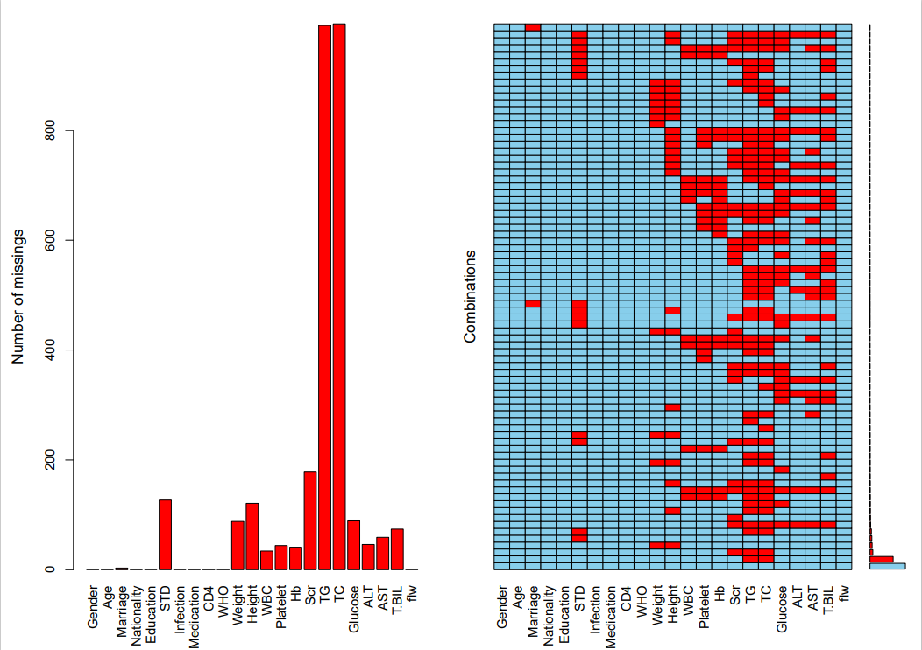
Fig.2s Histogram of missing data in Nantong
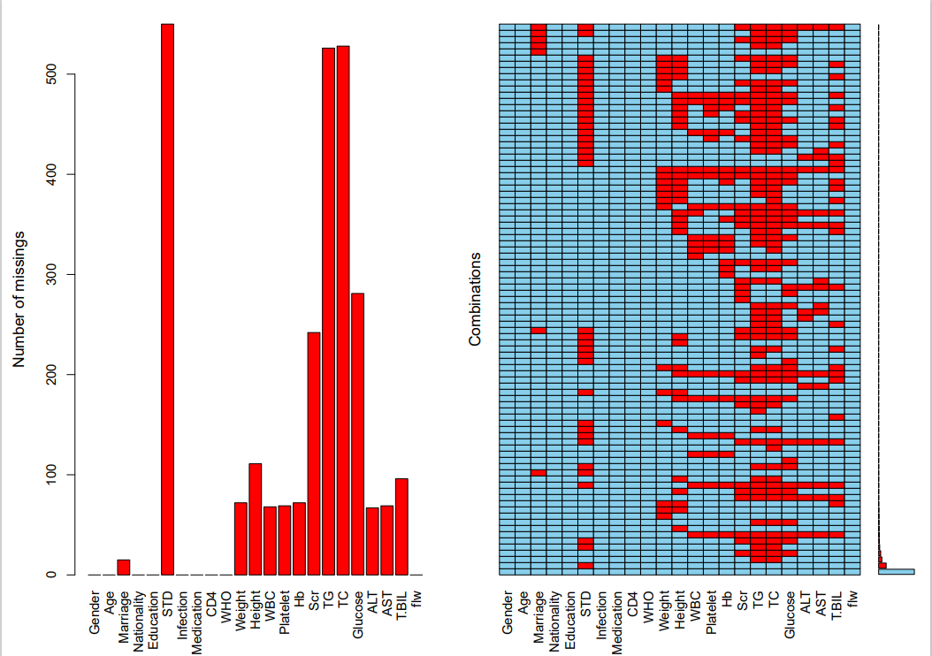
Fig.3s Histogram of missing data in Nanjing
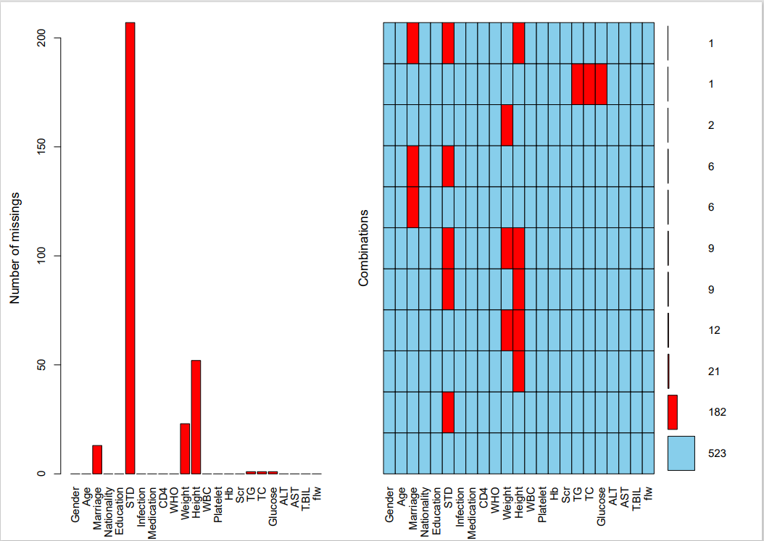
Fig.4s Histogram of missing data in Shanghai
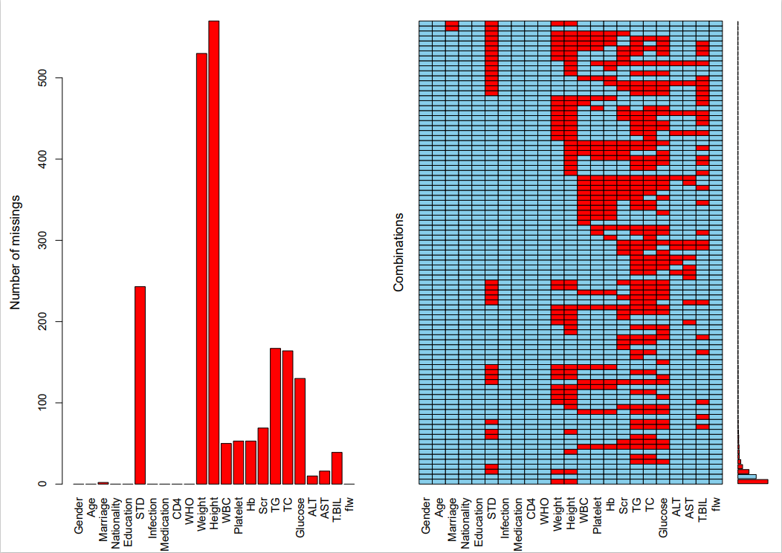
Fig.5s Histogram of missing data in Yangzhou

Supplementary material 4
Figure A shows the change of candidate predictor coefficients with the increase of Log(λ); Figure B shows the relationship between Log(λ) and Mean-Squared Error (MSE) after cross-validation, and the left dashed line represents the optimal reconciliation coefficients at the minimum time of MSE, when λ=0.0047, and a total of 10 variables were screened out; the right dashed line represents the MSE within 1 standardized error within the optimal reconciliation coefficient, at this time λ = 0.0230, a total of 5 variables were screened.
Fig.6s Screening of poor predictors of immune reconstitution based on Lasso regression

Supplementary material 5
According to the restricted cubic spline plot (knot=5), the point corresponding to OR=1 was used as the cut-off point to classify age at diagnosis (age at diagnosis = 43), The remaining continuous-type variables had a linear relationship with poor immune reconstitution.
Fig.7s Restricted Cubic Spline Plots

Supplementary material 6
The following table shows the homogeneity test between the data of three regions and Nantong after imputed.
Table3s Homogeneity test for Nanjing and Nantong data
Variable | n=5121 | Regions |  | Statistic | P-value
Variable | n=5121 | Nanjing (n=2829) | Nantong (n=2292) | Statistic | P-value
Gender |  |  |  | χ²=110.674¹ | <0.001
Male | 4547 (88.79) | 2630 (92.97) | 1917 (83.64)
Female | 574 (11.21) | 199 (7.03) | 375 (16.36)
Age of diagnosis | 37.00 (27.00, 50.00) | 33.00 (26.00, 46.00) | 43.00 (31.00, 54.00) | Z=-17.199² | <0.001
Marital status |  |  |  | χ²=459.094¹ | <0.001
Married | 2041 (39.86) | 1496 (52.88) | 545 (23.78)
Unmarried | 2379 (46.46) | 990 (34.99) | 1389 (60.60)
Others | 701 (13.69) | 343 (12.12) | 358 (15.62)
Nationality |  |  |  | χ²=14.379¹ | <0.001
Han | 5050 (98.61) | 2774 (98.06) | 2276 (99.30)
Others | 71 (1.39) | 55 (1.94) | 16 (0.70)
Education |  |  |  | χ²=822.179¹ | <0.001
Illiteracy | 93 (1.82) | 48 (1.70) | 45 (1.96)
Primary schools | 436 (8.51) | 128 (4.52) | 308 (13.44)
Junior high school | 1396 (27.26) | 449 (15.87) | 947 (41.32)
Senior high school | 1190 (23.24) | 649 (22.94) | 541 (23.60)
College | 2006 (39.17) | 1555 (54.97) | 451 (19.68)
History STD |  |  |  | χ²=0.460¹ | 0.498
No | 4121 (80.47) | 2267 (80.13) | 1854 (80.89)
Yes | 1000 (19.53) | 562 (19.87) | 438 (19.11)
Route of infection |  |  |  | χ²=206.372¹ | <0.001
MSM | 3225 (62.98) | 2019 (71.37) | 1206 (52.62)
NMHR | 1846 (36.05) | 775 (27.39) | 1071 (46.73)
Others | 50 (0.98) | 35 (1.24) | 15 (0.65)
Medication regimen |  |  |  | χ²=16.489¹ | 0.001
NNRTIs | 4487 (87.62) | 2502 (88.44) | 1985 (86.61)
NRTIs | 26 (0.51) | 5 (0.18) | 21 (0.92)
PIs | 70 (1.37) | 33 (1.17) | 37 (1.61)
INSTIs | 538 (10.51) | 289 (10.22) | 249 (10.86)
CD4⁺ T-lymphocyte count (cells/μL） | 259.00 (123.00, 378.00) | 285.00 (157.00, 411.00) | 224.00 (94.75, 327.00) | Z=12.022² | <0.001
WHO |  |  |  | χ²=976.768¹ | <0.001
I | 1429 (27.90) | 340 (12.02) | 1089 (47.51)
II | 1408 (27.49) | 1146 (40.51) | 262 (11.43)
III | 1218 (23.78) | 740 (26.16) | 478 (20.86)
IV | 1066 (20.82) | 603 (21.31) | 463 (20.20)
White blood cell (10^9/L) | 5.20 (4.10, 6.40) | 5.40 (4.38, 6.57) | 4.90 (3.81, 6.10) | Z=10.025² | <0.001
Platelet (10^9/L) | 186.00 (149.00, 228.00) | 193.00 (157.00, 232.00) | 177.00 (142.75, 220.00) | Z=7.901² | <0.001
Haemoglobin (g/L) | 140.24±20.98 | 143.06±19.56 | 136.75±22.11 | t=10.697³ | <0.001
Blood creatinine (μmol/L) | 68.62±17.47 | 70.69±14.14 | 66.08±20.59 | t=9.109³ | <0.001
Triglyceride (mmol/L) | 1.28 (0.94, 1.80) | 1.24 (0.90, 1.76) | 1.31 (1.01, 1.86) | Z=-5.514² | <0.001
Total cholesterol (mmol/L) | 4.14±1.12 | 4.18±1.23 | 4.08±0.98 | t=3.163⁴ | 0.002
Glucose (mmol/L) | 5.71±1.46 | 5.58±1.23 | 5.87±1.69 | t=-6.784³ | <0.001
Alanine aminotransferase (U/L) | 22.90 (16.00, 35.00) | 22.20 (15.70, 34.50) | 23.00 (16.00, 36.00) | Z=-2.059² | 0.04
Aspartate transaminase (U/L) | 24.00 (19.50, 31.00) | 21.40 (17.90, 27.60) | 27.00 (23.00, 36.00) | Z=-23.751² | <0.001
Total bilirubin (μmol/L) | 10.50 (7.80, 14.10) | 10.50 (7.90, 14.20) | 10.40 (7.70, 14.00) | Z=0.993² | 0.321
BMI (Kg/m²) | 21.85 (19.96, 23.94) | 21.72 (19.90, 23.88) | 22.00 (20.05, 24.06) | Z=-2.393² | 0.017
Poor immune reconstitution |  |  |  | χ²=178.077¹ | <0.001
No | 3248 (63.43) | 2023 (71.51) | 1225 (53.45)
Yes | 1873 (36.57) | 806 (28.49) | 1067 (46.55)
Notes: 1. Pearson χ2 test; 2. Mann Whitney U test; 3. variance-corrected independent samples t test; 4. independent samples t test.

Table4s Homogeneity test for Shanghai and Nantong data
Variable | n=3064 | Origin |  | Statistic | P-value
Variable | n=3064 | Shanghai (n=772) | Nantong (n=2292) | Statistic | P-value
Gender |  |  |  | χ²=38.432¹ | <0.001
Male | 2632 (85.90) | 715 (92.62) | 1917 (83.64)
Female | 432 (14.10) | 57 (7.38) | 375 (16.36)
Age of diagnosis | 41.00 (30.00, 53.00) | 35.00 (28.00, 49.00) | 43.00 (31.00, 54.00) | Z=8.077² | <0.001
Marital status |  |  |  | χ²=308.647¹ | <0.001
Married | 982 (32.05) | 437 (56.61) | 545 (23.78)
Unmarried | 1608 (52.48) | 219 (28.37) | 1389 (60.60)
Others | 474 (15.47) | 116 (15.03) | 358 (15.62)
Nationality |  |  |  | χ²=15.896¹ | <0.001
Han | 3029 (98.86) | 753 (97.54) | 2276 (99.30)
Others | 35 (1.14) | 19 (2.46) | 16 (0.70)
Education |  |  |  | χ²=363.009¹ | <0.001
Illiteracy | 49 (1.60) | 4 (0.52) | 45 (1.96)
Primary schools | 332 (10.84) | 24 (3.11) | 308 (13.44)
Junior high school | 1106 (36.10) | 159 (20.60) | 947 (41.32)
Senior high school | 716 (23.37) | 175 (22.67) | 541 (23.60)
College | 861 (28.10) | 410 (53.11) | 451 (19.68)
History STD |  |  |  | χ²=0.959¹ | 0.327
No | 2466 (80.48) | 612 (79.27) | 1854 (80.89)
Yes | 598 (19.52) | 160 (20.73) | 438 (19.11)
Route of infection |  |  |  | χ²=46.706¹ | <0.001
MSM | 1708 (55.74) | 502 (65.03) | 1206 (52.62)
NMHR | 1328 (43.34) | 257 (33.29) | 1071 (46.73)
Others | 28 (0.91) | 13 (1.68) | 15 (0.65)
Medication regimen |  |  |  | χ²=23.346¹ | <0.001
NNRTIs | 2671 (87.17) | 686 (88.86) | 1985 (86.61)
NRTIs | 22 (0.72) | 1 (0.13) | 21 (0.92)
PIs | 65 (2.12) | 28 (3.63) | 37 (1.61)
INSTIs | 306 (9.99) | 57 (7.38) | 249 (10.86)
CD4⁺ T-lymphocyte count (cells/μL） | 230.00 (106.75, 331.00) | 248.00 (137.00, 342.00) | 224.00 (94.75, 327.00) | Z=-3.255² | 0.001
WHO |  |  |  | χ²=967.521¹ | <0.001
I | 1094 (35.70) | 5 (0.65) | 1089 (47.51)
II | 287 (9.37) | 25 (3.24) | 262 (11.43)
III | 1096 (35.77) | 618 (80.05) | 478 (20.86)
IV | 587 (19.16) | 124 (16.06) | 463 (20.20)
White blood cell (10^9/L) | 5.02 (4.00, 6.27) | 5.50 (4.52, 6.67) | 4.90 (3.81, 6.10) | Z=-8.188² | <0.001
Platelet (10^9/L) | 184.00 (146.00, 228.00) | 203.50 (165.00, 244.00) | 177.00 (142.75, 220.00) | Z=-9.237² | <0.001
Haemoglobin (g/L) | 142.00 (126.00, 153.00) | 147.00 (135.00, 156.00) | 140.00 (124.00, 152.00) | Z=-8.534² | <0.001
Blood creatinine (μmol/L) | 68.02±20.34 | 73.78±18.41 | 66.08±20.59 | t=-9.227³ | <0.001
Triglyceride (mmol/L) | 1.35 (1.02, 1.91) | 1.47 (1.06, 2.13) | 1.31 (1.01, 1.86) | Z=-4.745² | <0.001
Total cholesterol (mmol/L) | 4.10±0.94 | 4.16±0.83 | 4.08±0.98 | t=-2.064⁴ | 0.039
Glucose (mmol/L) | 5.48 (5.06, 6.07) | 5.39 (4.96, 6.04) | 5.52 (5.09, 6.08) | Z=2.859² | 0.004
Alanine aminotransferase (U/L) | 23.00 (16.00, 36.00) | 23.00 (16.00, 35.00) | 23.00 (16.00, 36.00) | Z=0.697² | 0.486
Aspartate transaminase (U/L) | 26.00 (21.00, 34.00) | 23.00 (19.00, 30.00) | 27.00 (23.00, 36.00) | Z=11.955² | <0.001
Total bilirubin (μmol/L) | 10.88 (8.10, 14.60) | 12.20 (9.28, 16.53) | 10.40 (7.70, 14.00) | Z=-8.554² | <0.001
BMI (Kg/m²) | 22.27±3.51 | 22.53±4.52 | 22.18±3.08 | t=-2.376³ | 0.018
Poor immune reconstitution |  |  |  | χ²=229.949¹ | <0.001
No | 1875 (61.19) | 650 (84.20) | 1225 (53.45)
Yes | 1189 (38.81) | 122 (15.80) | 1067 (46.55)
Notes: 1. Pearson χ2 test; 2. Mann Whitney U test; 3. independent samples t test; 4. variance-corrected independent samples t test; 5. fisher's exact probability method based on Monte Carlo estimation.

Table5s Homogeneity test for Yangzhou and Nantong data
Variable | n=3277 | Origin |  | Statistic | P-value
Variable | n=3277 | Yangzhou(n=985) | Nantong (n=2292) | Statistic | P-value
Gender |  |  |  | χ²=0.269¹ | 0.604
Male | 2748 (83.86) | 831 (84.37) | 1917 (83.64)
Female | 529 (16.14) | 154 (15.63) | 375 (16.36)
Age of diagnosis | 42.88±13.97 | 42.26±13.82 | 43.15±14.03 | t=-1.683² | 0.092
Marital status |  |  |  | χ²=3.182¹ | 0.204
Married | 803 (24.50) | 258 (26.19) | 545 (23.78)
Unmarried | 1980 (60.42) | 591 (60.00) | 1389 (60.60)
Others | 494 (15.07) | 136 (13.81) | 358 (15.62)
Nationality |  |  |  | χ²=0.082¹ | 0.775
Han | 3255 (99.33) | 979 (99.39) | 2276 (99.30)
Others | 22 (0.67) | 6 (0.61) | 16 (0.70)
Education |  |  |  | χ²=16.478¹ | 0.002
Illiteracy | 70 (2.14) | 25 (2.54) | 45 (1.96)
Primary schools | 442 (13.49) | 134 (13.60) | 308 (13.44)
Junior high school | 1305 (39.82) | 358 (36.35) | 947 (41.32)
Senior high school | 759 (23.16) | 218 (22.13) | 541 (23.60)
College | 701 (21.39) | 250 (25.38) | 451 (19.68)
History STD |  |  |  | χ²=21.296¹ | <0.001
No | 2716 (82.88) | 862 (87.51) | 1854 (80.89)
Yes | 561 (17.12) | 123 (12.49) | 438 (19.11)
Route of infection |  |  |  | χ²=2.531¹ | 0.282
MSM | 1737 (53.01) | 531 (53.91) | 1206 (52.62)
NMHR | 1514 (46.20) | 443 (44.97) | 1071 (46.73)
Others | 26 (0.79) | 11 (1.12) | 15 (0.65)
Medication regimen |  |  |  | χ²=22.983¹ | <0.001
NNRTIs | 2895 (88.34) | 910 (92.39) | 1985 (86.61)
NRTIs | 26 (0.79) | 5 (0.51) | 21 (0.92)
PIs | 49 (1.50) | 12 (1.22) | 37 (1.61)
INSTIs | 307 (9.37) | 58 (5.89) | 249 (10.86)
CD4⁺ T-lymphocyte count (cells/μL） | 240.00 (111.00, 350.00) | 272.00 (160.00, 406.00) | 224.00 (94.75, 327.00) | Z=8.443³ | <0.001
WHO |  |  |  | χ²=340.526¹ | <0.001
I | 1800 (54.93) | 711 (72.18) | 1089 (47.51)
II | 451 (13.76) | 189 (19.19) | 262 (11.43)
III | 508 (15.50) | 30 (3.05) | 478 (20.86)
IV | 518 (15.81) | 55 (5.58) | 463 (20.20)
White blood cell (10^9/L) | 4.90 (3.88, 6.10) | 4.93 (4.05, 6.10) | 4.90 (3.81, 6.10) | Z=1.270³ | 0.204
Platelet (10^9/L) | 175.00 (140.00, 217.00) | 173.00 (134.00, 212.00) | 177.00 (142.75, 220.00) | Z=-3.063³ | 0.002
Haemoglobin (g/L) | 137.81±21.49 | 140.29±19.75 | 136.75±22.11 | t=4.533⁴ | <0.001
Blood creatinine (μmol/L) | 67.95±20.90 | 72.30±20.98 | 66.08±20.59 | t=7.885² | <0.001
Triglyceride (mmol/L) | 1.33 (1.01, 1.87) | 1.37 (1.00, 1.89) | 1.31 (1.01, 1.86) | Z=1.086³ | 0.278
Total cholesterol (mmol/L) | 4.03±0.94 | 3.91±0.82 | 4.08±0.98 | t=-5.221⁴ | <0.001
Glucose (mmol/L) | 5.54 (5.11, 6.08) | 5.56 (5.19, 6.07) | 5.52 (5.09, 6.08) | Z=1.967³ | 0.049
Alanine aminotransferase (U/L) | 23.10 (16.00, 36.20) | 23.20 (15.90, 37.00) | 23.00 (16.00, 36.00) | Z=0.021³ | 0.984
Aspartate transaminase (U/L) | 26.00 (21.00, 34.53) | 23.80 (18.71, 31.16) | 27.00 (23.00, 36.00) | Z=-10.893³ | <0.001
Total bilirubin (μmol/L) | 10.40 (7.80, 14.00) | 10.40 (8.10, 13.90) | 10.40 (7.70, 14.00) | Z=0.580³ | 0.562
BMI (Kg/m²) | 22.36±3.35 | 22.77±3.86 | 22.18±3.08 | t=4.627² | <0.001
Poor immune reconstitution |  |  |  | χ²=5.189¹ | 0.023
No | 1794 (54.75) | 569 (57.77) | 1225 (53.45)
Yes | 1483 (45.25) | 416 (42.23) | 1067 (46.55)
Notes: 1. Pearson χ2 test; 2. independent samples t test; 3. Mann Whitney U test; 4. variance-corrected independent samples t test.

Supplementary material 7
Figure A, B, C, D represents the differentiation validation of the data in Nantong, Nanjing, Shanghai and Yangzhou regions, respectively. The grey ROC represents the bootstrap per resampling result and the blue ROC represents the mean.
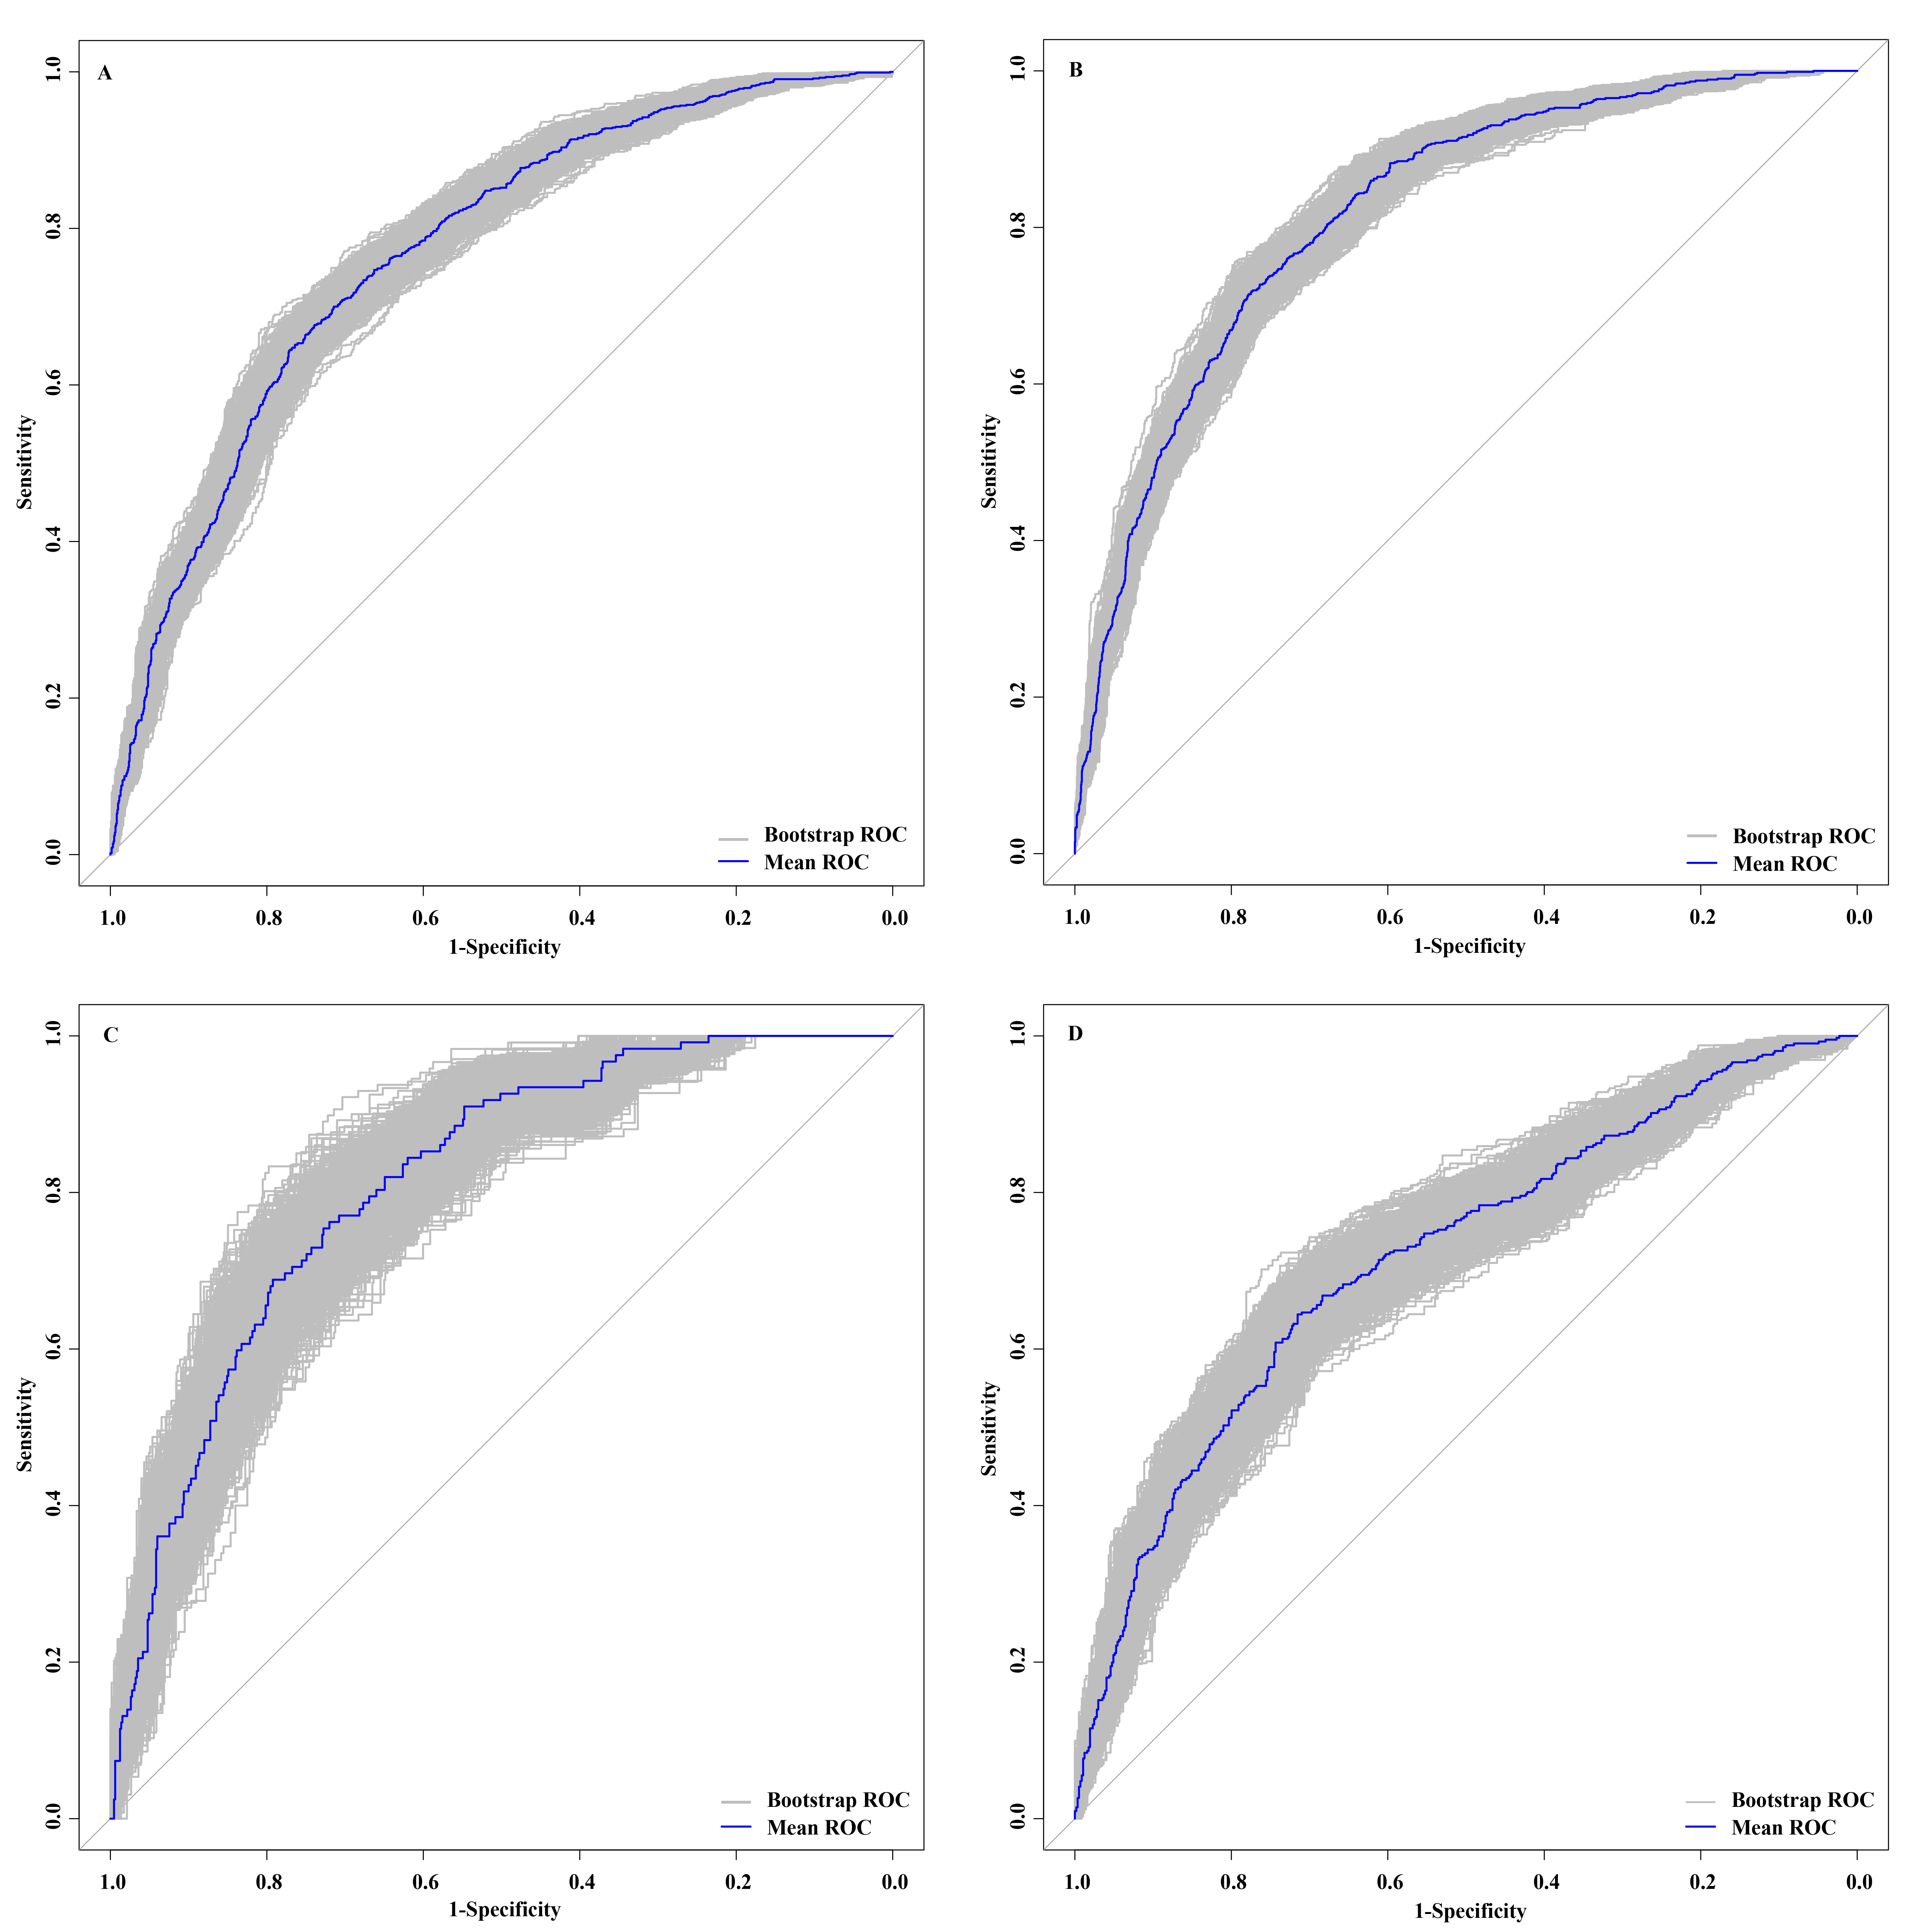
Figure 8s ROC curves for internal and spatial validation

Figure A, B, C, D represents the calibration of the data in Nantong, Nanjing, Shanghai and Yangzhou regions respectively.
Figure 9s Calibration curves for internal and spatial validation

Figure A, Figure B, Figure C, and Figure D represent Nantong, Nanjing, Shanghai, and Yangzhou, respective. In the DCA curves, the black horizontal line represents the clinical benefit of no intervention for all patients, which is usually 0; the red line represents the clinical benefit of intervention for all patients and its 95% confidence interval; and the blue line represents the clinical benefit of intervention based on the risk predicted by the model and its 95% confidence interval.
Figure 10s Decision curves for internal and spatial validation.

Supplementary material 8
Table 6s and 7s describe the association between risk stratification and the risk of poor immune reconstitution in four regions by log-binomial regressions in 4 regions.
Table 6s The comparison on incidence of poor immune reconstitution
among different risk stratification in 4 regions
Regions | Risk stratification | Poor immune reconstitution, n (%) |  | χ2 | P
Regions | Risk stratification | No | Yes | χ2 | P
Nantong | Low (<144.06) | 604 (79.79%) | 153 (20.21) | 422.620 | <0.001
 | Medium (144.06-154.14) | 416 (53.47) | 362 (46.53)
 | High (≥154.15) | 205 (27.08) | 552 (72.92)
Nanjing | Low (<144.06) | 1304 (90.68) | 134 (9.32) | 681.200 | <0.001
 | Medium (144.06-154.14) | 481 (65.98) | 248 (34.02)
 | High (≥154.15) | 238 (35.95) | 424 (64.05)
Shanghai | Low (<144.06) | 312 (97.20) | 9 (2.80) | 119.37 | <0.001
 | Medium (144.06-154.14) | 224 (85.17) | 39 (14.83)
 | High (≥154.15) | 114 (60.64) | 74 (39.36)
Yangzhou | Low (<144.06) | 319 (74.19) | 111 (25.81) | 84.865 | <0.001
 | Medium (144.06-154.14) | 176 (46.07) | 206 (53.93)
 | High (≥154.15) | 74 (42.77) | 99 (57.23)

Table 7s The association between risk stratification and risk of poor immune reconstitution estimated by log-binomial regressions in 4 regions
Regions | Risk stratification | β | S.E | RR (95%CI) | P
Nantong | Low | Reference
 | Medium | 0.834 | 0.082 | 2.302 (1.961-2.703) | <0.001
 | High | 1.283 | 0.076 | 3.608 (3.111-4.184) | <0.001
Nanjing | Low | Reference
 | Medium | 1.295 | 0.097 | 3.651 (3.018-4.416) | <0.001
 | High | 1.928 | 0.087 | 6.873 (5.793-8.155) | <0.001
Shanghai | Low | Reference
 | Medium | 1.666 | 0.360 | 5.289 (2.611-10.715) | <0.001
 | High | 2.642 | 0.341 | 14.039 (7.199-27.377) | <0.001
Yangzhou | Low | Reference
 | Medium | 0.737 | 0.094 | 2.089 (1.736-2.514) | <0.001
 | High | 0.796 | 0.105 | 2.217 (1.805-2.723) | <0.001
S.E: standard error; RR: relative risk

Supplementary material 9
CD4⁺T lymphocytes^{[2]}, platelets^{[3]}, and BMI were classified as categorical variables according to the literature or norms, and the above analysis was repeated to evaluate model stability.
Fig.11s Nomogram in sensitivity analysis

In internal validation, the AUC was 0.74 (0.72-0.76), the Brier score was 0.205, and the intervention was beneficial at risk thresholds of 0.32-0.73 or cost-benefit ratios of 8:17-73:27.
Fig.12s Internal validation in sensitivity analysis

In external validation, The AUCs in Nanjing, Shanghai, and Yangzhou regions were 0.78 (0.76-0.80), 0.77 (0.73-0.81), and 0.69 (0.65-0.72) respectively, which indicates good model differentiation; The Brier scores in Nanjing, Shanghai, and Yangzhou are 0.176, 0.202, and 0.217, respectively, which are all less than 0.25, and the surface model is well calibrated; In the Nanjing, Shanghai, and Yangzhou data, the risk thresholds (or cost-benefit ratios) in which interventions were rewarding were 0.16-0.63 (4:21-63:37), 0.10-0.32 (1:9-8:17), and 0.37-0.69 (37:63-69:31).
Note: Fig. A Fig. B Fig. C shows the ROC curves for Nanjing, Shanghai and Yangzhou regions respectively; Fig. D Fig. E Fig. F shows the calibration curves for Nanjing, Shanghai and Yangzhou areas respectively; Fig. G Fig. H Fig. I shows the decision curves for Nanjing, Shanghai and Yangzhou regions respectively.
Fig.13s External validation in sensitivity analysis
Reference
[1] Tate, D. L. et al. Comparison of two combined antiretroviral treatment regimens in the management of HIV in pregnancy: an observational study. J Matern Fetal Neonatal Med 34, 3723-3729 (2021). https://doi.org:10.1080/14767058.2019.1691987
[2] Manaye, G. A., Abateneh, D. D., Kebede, K. M. & Belay, A. S. Immunological Response During HAART and Determinants of Current CD4(+) T-Cell Count Among HIV/AIDS Patients Attending University of Gondar Referral Hospital, Northwest Ethiopia. HIV AIDS (Auckl) 12, 295-306 (2020). https://doi.org:10.2147/hiv.S255751
[3] Smock, K. J. & Perkins, S. L. Thrombocytopenia: an update. Int J Lab Hematol 36, 269-278 (2014). https://doi.org:10.1111/ijlh.12214

