Additional File 2 — Supplementary Figures
Oral health burden and behavioural determinants of dental caries among Ukrainian civilians attending humanitarian dental missions in 2025 and 2026: a two-wave cross-sectional cohort study in Korosten and Ternopil
Yen E-T, Chiu S-H, Maistrova R, Cheng C-Y, Yen C-C, Tsai K-Z, Tsai W.
All figures generated in Stata 19 for Mac at 300 dpi.
Contents
Figure S1a. Distribution of total DMFT across the pooled cohort.
Figure S1b. Q-Q plot of total DMFT against a normal distribution.
Figure S2. Total DMFT against age, stratified by mission wave, with lowess smoother.
Figure S3. Deviance residuals against predicted DMFT for the primary negative-binomial GLM.
Figure S4. Calibration plot for the logistic regression model of any untreated decay.
Figure S1a. Distribution of total DMFT
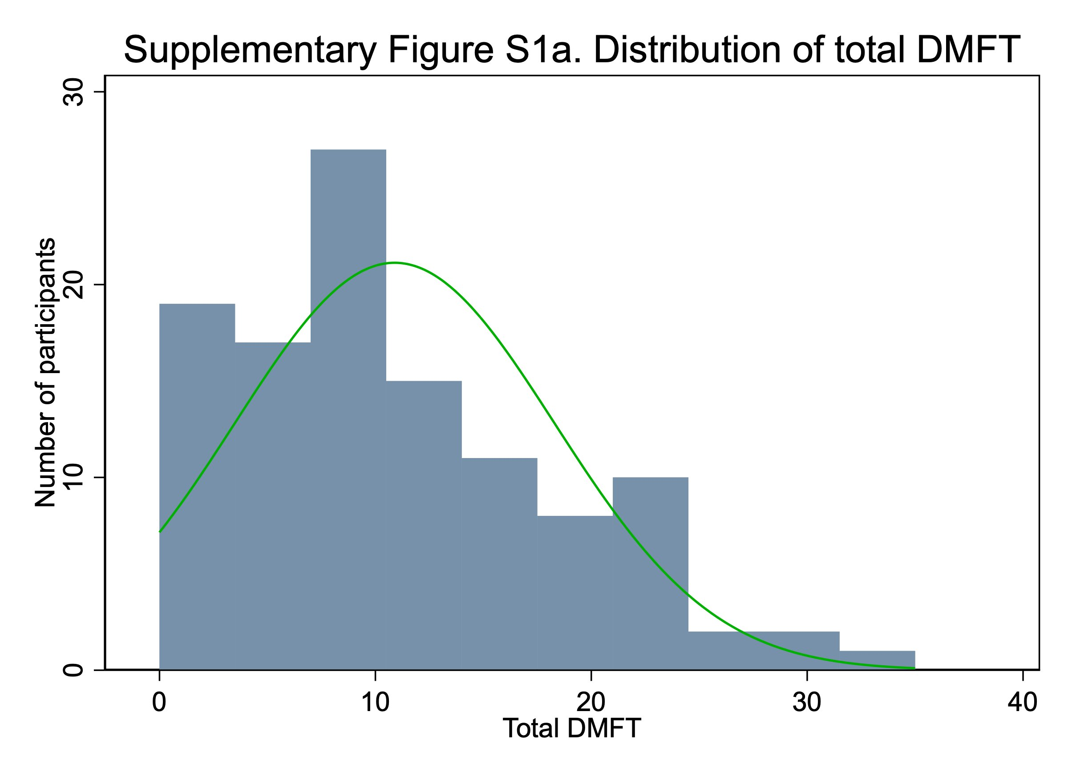
Figure S1a. Histogram of total DMFT across the pooled cohort (N = 112), with the best-fitting normal density overlaid in green. The distribution is right-skewed (skewness 0.62, kurtosis 2.50), with a small excess of zero counts. The skew motivated the use of non-parametric tests for descriptive contrasts and a negative-binomial generalised linear model for the primary multivariable analysis.
Figure S1b. Q-Q plot of DMFT vs Normal
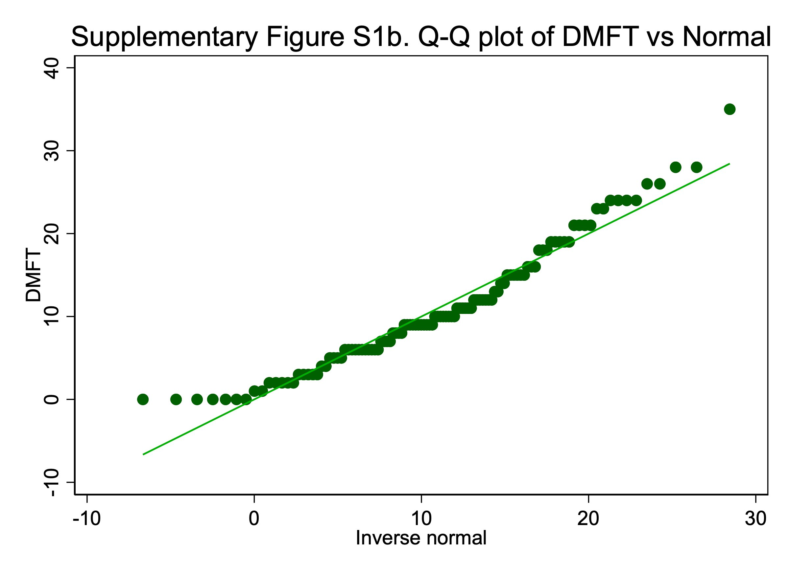
Figure S1b. Normal Q-Q plot of total DMFT. The departure from the reference line at both tails, particularly the floor effect at DMFT = 0 and the right tail beyond DMFT = 20, confirms that total DMFT is not normally distributed. Shapiro–Wilk W = 0.949, p < 0.001. This finding justifies the use of non-parametric tests and a negative-binomial GLM rather than ordinary least-squares linear regression.
Figure S2. DMFT against age, by wave
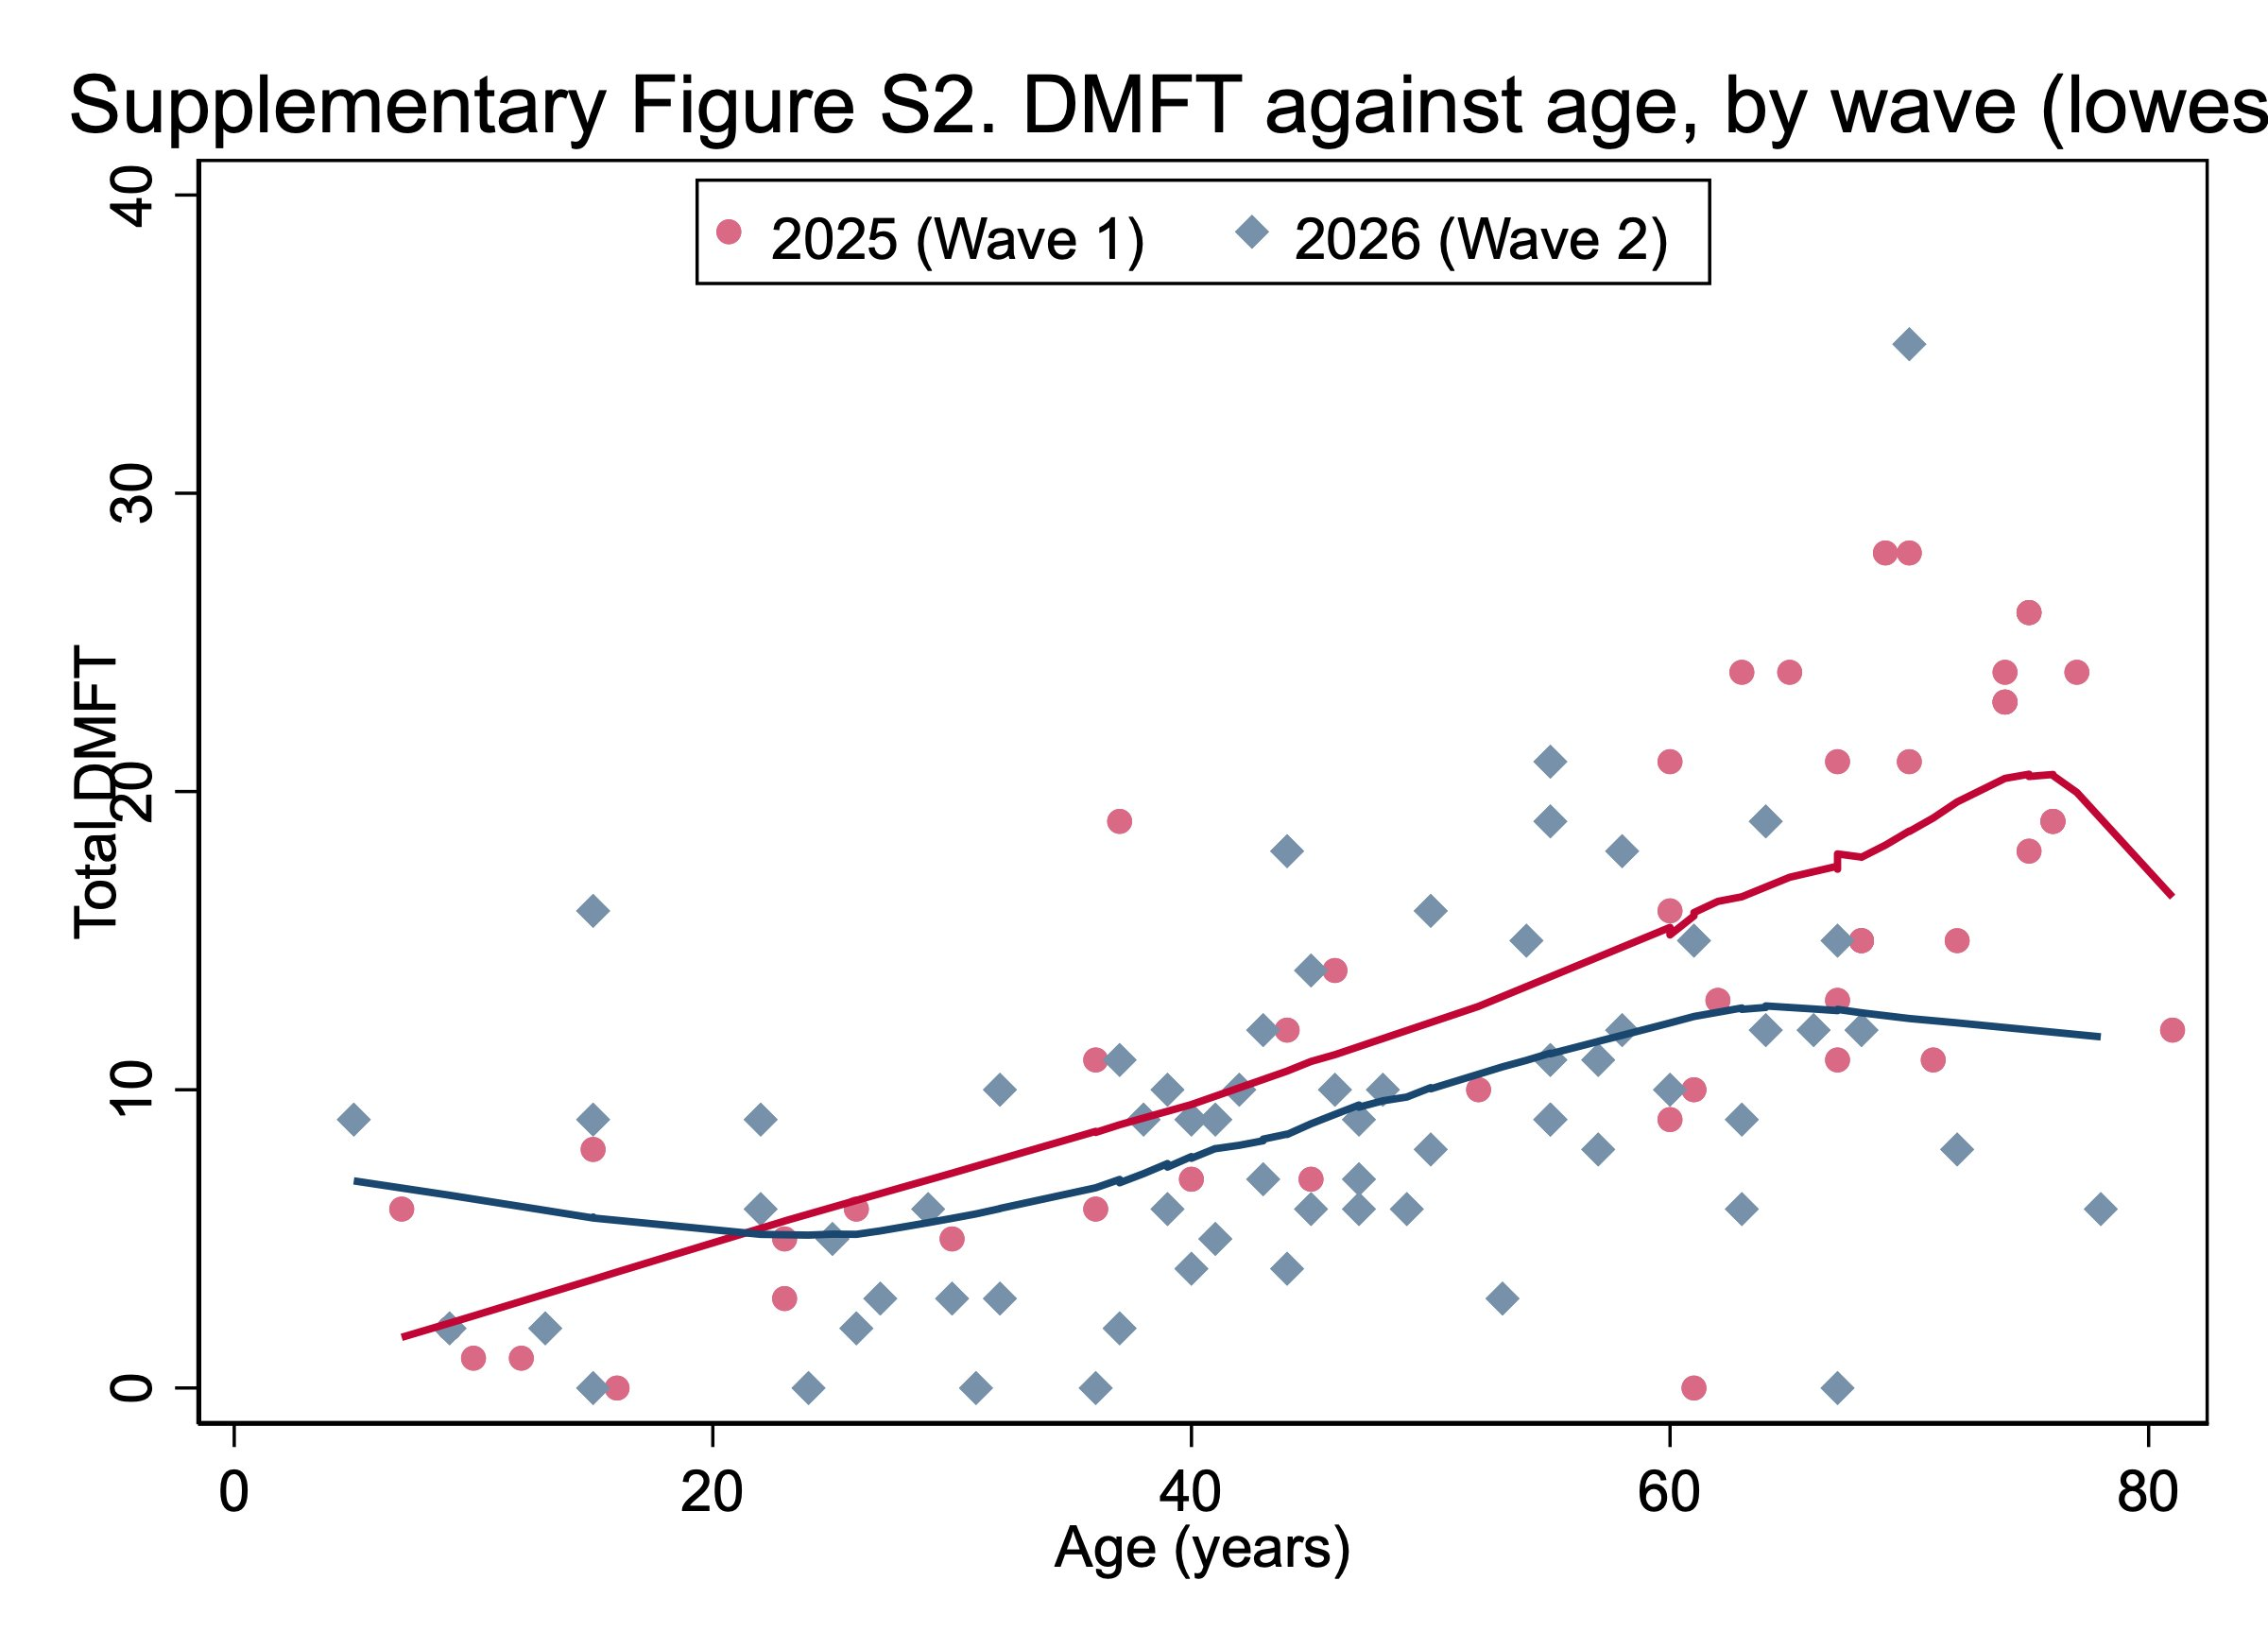
Figure S2. Scatterplot of total DMFT against age, with lowess smoothers fitted separately for the 2025 (Wave 1) and 2026 (Wave 2) cohorts. Both curves show a monotonic increase from childhood through the sixth decade, consistent with the natural accumulation of dental caries with age. The 2025 curve sits above the 2026 curve across most of the age range — explained largely by the older age distribution of the 2025 cohort (median 61.5 vs 45.0 years). The plot supports modelling age with a flexible restricted cubic spline rather than a single linear term.
Figure S3. Deviance residuals vs predicted DMFT
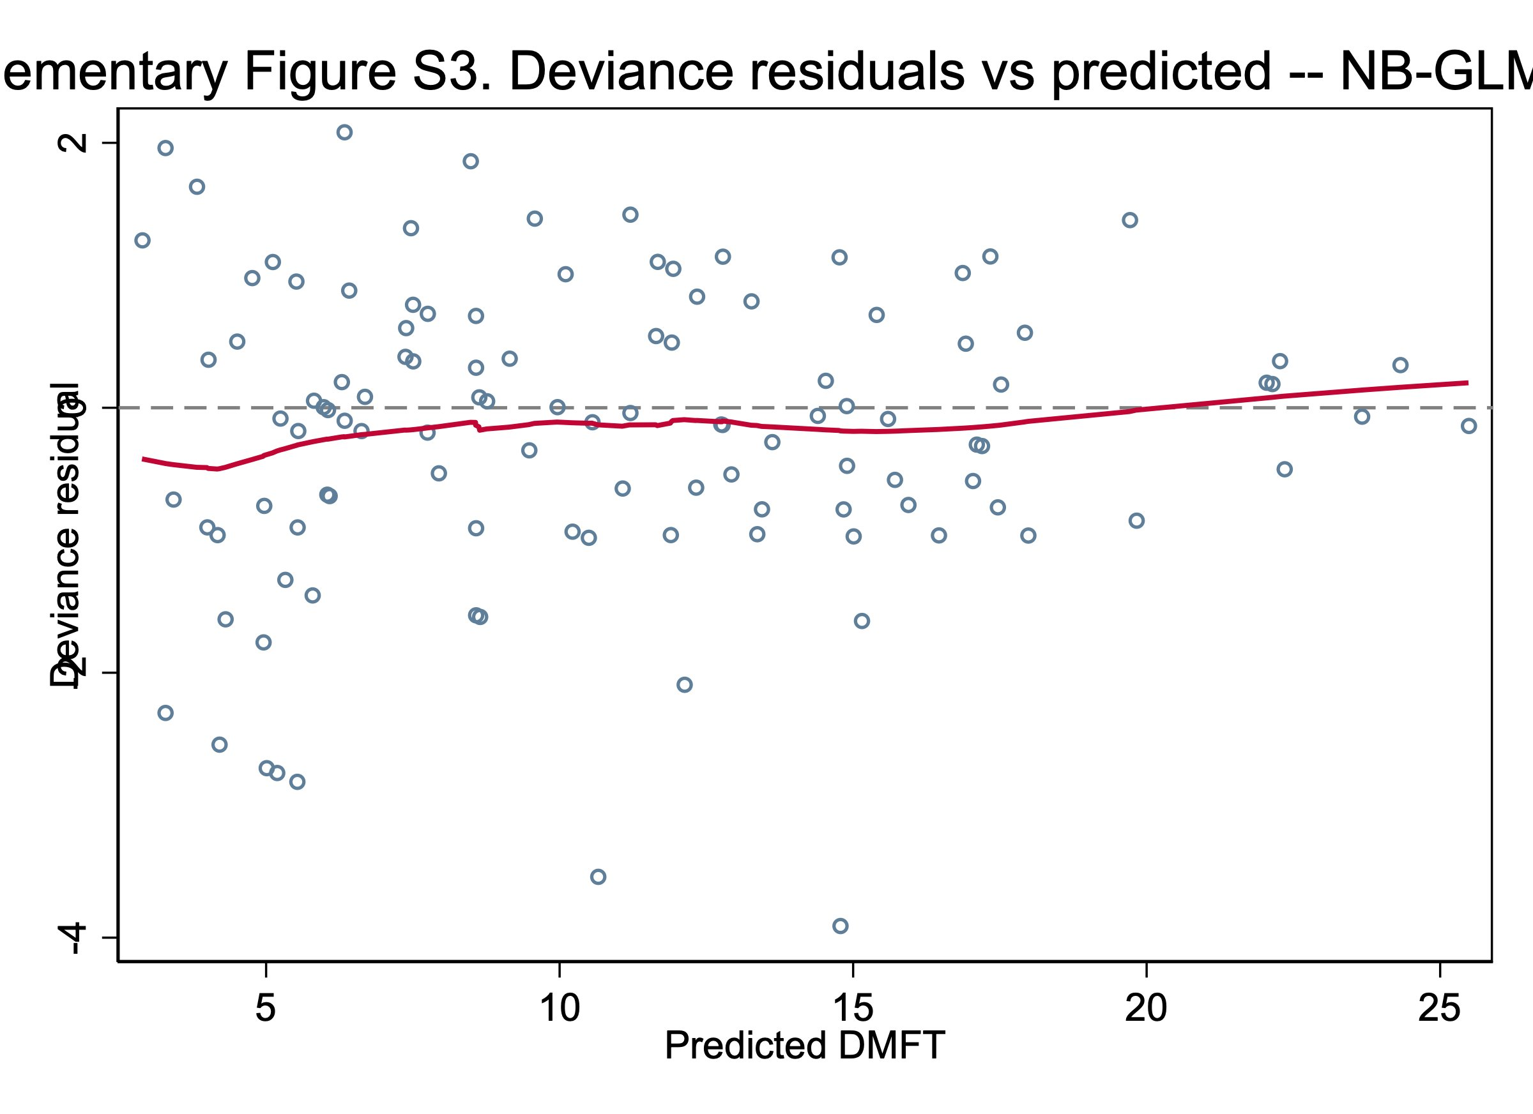
Figure S3. Deviance residuals plotted against fitted (predicted) DMFT for the primary negative-binomial GLM (Table 4 in the main manuscript). The lowess smoother is essentially flat and lies close to zero across the range of predicted values, indicating no systematic over- or under-prediction. Pearson dispersion = 1.09, consistent with adequate model fit and no residual overdispersion beyond what the negative-binomial family already accounts for.
Figure S4. Calibration plot — logistic model
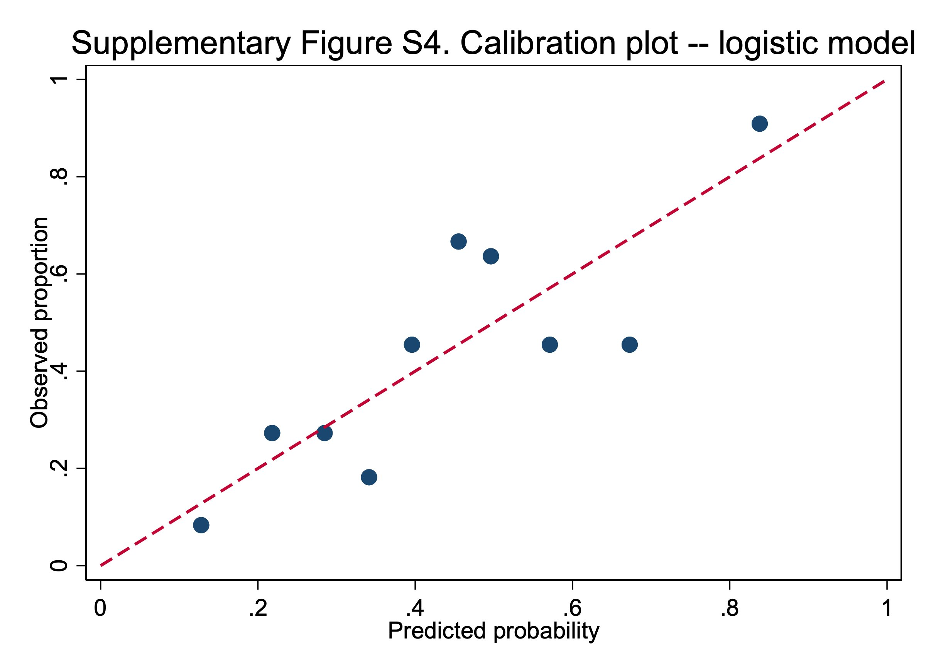
Figure S4. Calibration plot for the multivariable logistic regression model of any untreated decay (D ≥ 1; Table 5 in the main manuscript). Predicted probabilities were grouped into deciles; observed proportions within each decile are plotted against the mean predicted probability. The dashed red line represents perfect calibration (slope = 1, intercept = 0). Points scatter around the line without systematic departure. Hosmer–Lemeshow χ²(8) = 8.24, p = 0.410; area under the ROC curve = 0.73; pseudo R² = 0.135.

