Supplementary Information

Design of Horizontally Oriented Emitters through Three-Dimensional Geometric Analysis Enabling OLEDs with 40% Efficiency
Heng-Yuan Zhang, Hao Zhuo, Jing-Long Chen, Wen-Xin Xiang, Xiao-Yang Du, Hui Wang, Hui Lin, Si-Lu Tao, Cai-Jun Zheng* and Xiao-Hong Zhang

Synthesis
As the subsequent sterically hindered Suzuki reaction between phenanthroline and m-xylene necessitated a strong base that could compromise the quinone structure, the quinone of phenanthroline was protected by the addition reaction¹.
Synthesis of 5,10-dibromo-2,2-dimethyl-[1,3]dioxolo[4,5-f][1,10]phenanthroline (1)
To a 250 mL round bottom flask 3,8-dibromo-1,10-phenanthroline-5,6-dione (2.72 mmol, 1.0 g) and Na₂CO₃ (2.7 mmol, 288 mg) were added. 2-Nitropropane (272 mmol, 24.2 g) was added to the mixture under nitrogen atmosphere. A solution of 160 ml ACN:H₂O (1:1) was added prior to being heated to 90 ℃ and stirred for 24 h under nitrogen atmosphere. The reaction was detected by TLC. Water and dichloromethane were added for extraction subsequent to the reaction system was cooled to room temperature. The organic layer was dried with anhydrous magnesium sulfate. After being concentrated by rotary evaporation, the residual solid was purified by column chromatography and recrystallisation to give a yellow powder (925.6 mg, yield 83%). ¹H NMR (400 MHz, Chloroform-d) δ 9.03 (d, J = 2.3 Hz, 2H), 8.40 (d, J = 2.3 Hz, 2H), 1.86 (s, 6H). MALDI-TOF-MS: m/z: calculated for C₁₅H₁₀Br₂N₂O₂: 409.9089, found: 410.1127.
Synthesis of 5,10-bis(2,6-dimethylphenyl)-2,2-dimethyl-[1,3]dioxolo[4,5-f][1,10]phenanthroline (2)
The solid reactants intermediate 1 (860 mg, 2.1 mmol), (2,6-dimethylphenyl)boronic acid (945 mg, 6.3 mmol), Ba(OH)₂‧8H₂O (3.8g, 8.4 mmol) and tetrakis(triphenylphosphine)palladium (115 mg, 0.1 mmol) were sequentially added to a 100 mL flask. 30 mL DME:H₂O (9:1) was added into the mixture with the protection of N₂. The was heated to 100 ℃ under nitrogen atmosphere and stirred for 12 hours. After cooling to room temperature, the reaction mixture was concentrated by rotary evaporation, and the residual solid was purified by column chromatography and recrystallisation to give a lime-green powder (608 mg, yield 63%). ¹H NMR (600 MHz, Methylene Chloride-d₂) δ 8.84 (d, J = 2.2 Hz, 2H), 8.08 (d, J = 2.2 Hz, 2H), 7.25 (dd, J = 8.4, 6.8 Hz, 2H), 7.20 (d, J = 7.2 Hz, 4H), 2.10 (s, 12H), 1.87 (s, 6H). MALDI-TOF-MS: m/z: calculated for C₃₁H₂₈N₂O₂: 460.2151, found: 461.5104.
Synthesis of 10-(2,7-bis(2,6-dimethylphenyl)dipyrido[3,2-a:2',3'-c]phenazin-11-yl)-10H-spiro[acridine-9,9'-fluorene] (SAF-27MXNP)
Intermediate 2 (368 mg, 0.8 mmol) was added into a 50 mL round bottom flask. 10 mL concentrated HNO₃ was added dropwise at 0 ℃ under N₂. The reaction was stirred at room temperature for 10 min. Subsequently, ice water was added and yellow precipitate was observed. The mixture was filtrated using a Büchner funnel. The filter cake was washed with water. The yellow solid obtained after drying was used directly in the next reaction without further purification. Intermediate 3 (250 mg, 0.6 mmol) and 4-(10H-spiro[acridine-9,9'-fluoren]-10-yl)benzene-1,2-diamine (262.2 g, 0.6 mmol), which was synthesized according a to previous report, were added to a 100 mL double-necked round-bottom flask. 20 mL n-Butanol was added to the mixture and heated to 120 °C and refluxed with stirring overnight under nitrogen. After cooling to room temperature, the reaction mixture was concentrated by rotary evaporation, and the residual solid was purified by column chromatography and recrystallisation to give an orange powder (364 mg, yield 74%). ¹H NMR (400 MHz, Methylene Chloride-d₂) δ 9.61 (dd, J = 21.6, 2.2 Hz, 2H), 9.14 (dd, J = 6.3, 2.1 Hz, 2H), 8.68 (d, J = 8.9 Hz, 1H), 8.57 (d, J = 2.3 Hz, 1H), 8.03 (dd, J = 9.0, 2.3 Hz, 1H), 7.89 – 7.83 (m, 2H), 7.53 – 7.38 (m, 4H), 7.36 – 7.21 (m, 8H), 6.93 (ddd, J = 8.6, 7.1, 1.6 Hz, 2H), 6.61 (t, J = 7.4 Hz, 2H), 6.46 (ddd, J = 21.6, 8.0, 1.4 Hz, 4H), 2.20 (d, J = 12.8 Hz, 12H). ¹³C NMR (101 MHz, Methylene Chloride-d₂) δ 156.74, 153.91, 144.29, 143.45, 142.77, 142.72, 142.38, 141.48, 139.82, 138.06, 138.01, 137.05, 137.01, 134.86, 134.57, 133.40, 132.63, 128.95, 128.81, 128.78, 128.36, 128.26, 128.18, 127.92, 127.86, 126.04, 125.75, 121.57, 120.67, 115.37, 57.31, 21.47, 21.44. MALDI-TOF-MS: m/z: calculated for [M−1H]⁻ (M: C₅₉H₄₁N₅): 818.3362, found: 818.4022.
Synthesis of 6,9-dibromo-2,2-dimethyl-[1,3]dioxolo[4,5-f][1,10]phenanthroline (4)
The synthetic procedures were similar with those of intermediate 1, only to replace 3,8-dibromo-1,10-phenanthroline-5,6-dione with 2,9-dibromo-1,10-phenanthroline-5,6-dione and the reaction temperature was 60 ℃. Yellow solid: 1.14 g, yield 91%. ¹H NMR (600 MHz, Methylene Chloride-d₂) δ 8.11 (d, J = 8.5 Hz, 2H), 7.76 (d, J = 8.5 Hz, 2H), 1.86 (s, 6H). MALDI-TOF-MS: m/z: calculated for C₁₅H₁₀Br₂N₂O₂: 409.9089, found: 410.1420.
Synthesis of 6,9-bis(2,6-dimethylphenyl)-2,2-dimethyl-[1,3]dioxolo[4,5-f][1,10]phenanthroline (5)
The synthetic procedures were similar with those of intermediate 2, only to replace intermediate 1 with intermediate 4. Lime-green solid: 842.6 mg, yield 74%. ¹H NMR (600 MHz, Methylene Chloride-d₂) δ 8.33 (d, J = 8.3 Hz, 2H), 7.56 (d, J = 8.3 Hz, 2H), 7.20 (t, J = 7.6 Hz, 2H), 7.12 (d, J = 7.6 Hz, 4H), 2.07 (s, 12H), 1.92 (s, 6H). MALDI-TOF-MS: m/z: calculated for C₃₁H₂₈N₂O₂: 460.2151, found: 461.5719.
Synthesis of 10-(3,6-bis(2,6-dimethylphenyl)dipyrido[3,2-a:2',3'-c]phenazin-11-yl)-10H-spiro[acridine-9,9'-fluorene] (SAF-36MXNP)
The synthetic procedures were similar with those of SAF-27MXNP, only to replace intermediate 3 with intermediate 6. Orange solid: 410 mg, yield 81%. ¹H NMR (600 MHz, Methylene Chloride-d₂) δ 9.87 – 9.74 (m, 2H), 8.77 (dt, J = 8.8, 1.8 Hz, 1H), 8.67 (q, J = 2.1 Hz, 1H), 8.07 (dq, J = 8.7, 2.1 Hz, 1H), 7.89 (dd, J = 7.7, 2.8 Hz, 2H), 7.87 – 7.74 (m, 2H), 7.53 (dd, J = 7.6, 2.8 Hz, 2H), 7.45 (tdd, J = 7.5, 2.6, 1.3 Hz, 2H), 7.36 (tdd, J = 7.3, 2.6, 1.3 Hz, 2H), 7.22 (dtd, J = 45.4, 7.3, 2.4 Hz, 6H), 6.97 (ddd, J = 8.9, 7.3, 2.1 Hz, 2H), 6.70 – 6.61 (m, 2H), 6.60 – 6.52 (m, 2H), 6.46 (dd, J = 7.9, 2.4 Hz, 2H), 2.17 (d, J = 9.1 Hz, 12H). ¹³C NMR (151 MHz, Methylene Chloride-d₂) δ 163.43, 163.41, 156.90, 149.16, 149.11, 144.34, 143.33, 142.83, 142.68, 142.33, 141.57, 140.86, 140.84, 139.87, 136.45, 136.44, 134.67, 134.61, 134.38, 133.42, 132.70, 128.99, 128.72, 128.71, 128.39, 128.27, 128.24, 128.23, 127.96, 126.50, 126.43, 126.24, 126.10, 125.74, 121.60, 120.71, 115.46, 57.36, 20.77, 20.75. MALDI-TOF-MS: m/z: calculated for [M−1H]⁻ (M: C₅₉H₄₁N₅): 818.3362, found: 818.3159.
Synthesis of 4,4'-(2,2-dimethyl-3a,11b-dihydro-[1,3]dioxolo[4,5-f][1,10]phenanthroline-6,9-diyl)bis(3,5-dimethylbenzonitrile) (7)
The synthetic procedures were similar with those of intermediate 2, only to replace intermediate 1 with intermediate 4 and (2,6-dimethylphenyl)boronic acid with (4-cyano-2,6-dimethylphenyl)boronic acid. Dark-yellow solid: 510 mg, yield 57%. ¹H NMR (400 MHz, Chloroform-d) δ 8.40 (dd, J = 8.4, 1.0 Hz, 2H), 7.56 (dd, J = 8.4, 1.0 Hz, 2H), 7.41 (s, 4H), 2.17 (s, 12H), 1.94 (s, 6H). MALDI-TOF-MS: m/z: calculated for [M-1H]⁻ (M: C₃₃H₂₈N₄O₂): 512.2212, found: 511.6188.
Synthesis of 4,4'-(11-(10H-spiro[acridine-9,9'-fluoren]-10-yl)dipyrido[3,2-a:2',3'-c]phenazine-3,6-diyl)bis(3,5-dimethylbenzonitrile) (SAF-36CNNP)
The synthetic procedures were similar with those of SAF-27MXNP, only to replace intermediate 3 with intermediate 8. Red solid: 440 mg, yield 85%. ¹H NMR (600 MHz, Methylene Chloride-d₂) δ 9.88 (d, J = 8.1 Hz, 1H), 9.83 (d, J = 8.2 Hz, 1H), 8.79 (d, J = 8.8 Hz, 1H), 8.68 (d, J = 2.2 Hz, 1H), 8.09 (dd, J = 8.8, 2.3 Hz, 1H), 7.89 (d, J = 7.5 Hz, 2H), 7.79 (dd, J = 19.5, 8.1 Hz, 2H), 7.55 – 7.44 (m, 8H), 7.36 (td, J = 7.4, 1.1 Hz, 2H), 6.97 (ddd, J = 8.5, 7.1, 1.6 Hz, 2H), 6.65 (ddd, J = 8.1, 7.1, 1.1 Hz, 2H), 6.55 (dd, J = 8.5, 1.1 Hz, 2H), 6.47 (dd, J = 7.9, 1.5 Hz, 2H), 2.20 (d, J = 10.0 Hz, 12H). ¹³C NMR (151 MHz, Methylene Chloride-d₂) δ 161.46, 161.44, 156.86, 149.38, 149.33, 145.35, 145.33, 144.46, 143.60, 142.94, 142.45, 142.10, 141.52, 139.87, 138.20, 138.19, 135.05, 135.01, 134.71, 133.46, 132.75, 131.85, 131.84, 128.99, 128.41, 128.31, 127.95, 127.10, 127.04, 126.07, 125.78, 125.65, 121.65, 120.73, 119.47, 115.41, 112.49, 57.34, 20.67, 20.65. MALDI-TOF-MS: m/z: calculated for [M-1H]⁻ (M: C₅₉H₄₁N₅): 868.3267, found: 868.4340.
Synthesis of 6,9-dibromo-2,2-dimethylphenanthro[9,10-d][1,3]dioxole (9)
The synthetic procedures were similar with those of intermediate 1, only to replace 3,8-dibromo-1,10-phenanthroline-5,6-dione with 3,6-dibromophenanthrene-9,10-dione and the reaction temperature was 60 ℃. Light green solid: 1.05 g, yield 89%. ¹H NMR (400 MHz, Chloroform-d) δ 8.73 – 8.63 (m, 2H), 7.81 – 7.61 (m, 4H), 1.84 (s, 6H). MALDI-TOF-MS: m/z: calculated for [M-1H]⁻ (M: C₁₇H₁₂Br₂O₂): 407.9184, found: 408.2042.
Synthesis of 6,9-bis(2,6-dimethylphenyl)-2,2-dimethylphenanthro[9,10-d][1,3]dioxole (10)
The synthetic procedures were similar with those of intermediate 2, only to replace intermediate 1 with intermediate 9. Light green solid: 930 mg, yield 83%. ¹H NMR (400 MHz, Chloroform-d) δ 8.40 – 8.35 (m, 2H), 7.99 (d, J = 8.2 Hz, 2H), 7.47 – 7.41 (m, 2H), 7.21 – 7.10 (m, 6H), 2.06 (d, J = 0.7 Hz, 12H), 1.94 – 1.87 (m, 6H). MALDI-TOF-MS: m/z: calculated for [M−1H]⁻ (M: C₃₃H₃₀O₂): 458.2246, found: 458.5788.
Synthesis of 10-(3,6-bis(2,6-dimethylphenyl)dibenzo[a,c]phenazin-11-yl)-10H-spiro[acridine-9,9'-fluorene] (SAF-36MXBP)
The synthetic procedures were similar with those of SAF-27MXNP, only to replace intermediate 3 with intermediate 11. Yellow solid: 320 mg, yield 88%. ¹H NMR (600 MHz, Methylene Chloride-d₂) δ 9.57 (d, J = 8.1 Hz, 1H), 9.52 (d, J = 8.1 Hz, 1H), 8.72 (d, J = 8.7 Hz, 1H), 8.62 (d, J = 2.2 Hz, 1H), 8.40 (dd, J = 3.3, 1.5 Hz, 2H), 7.99 (dd, J = 8.8, 2.2 Hz, 1H), 7.89 (d, J = 7.6 Hz, 2H), 7.64 (ddd, J = 21.2, 8.1, 1.5 Hz, 2H), 7.54 (d, J = 7.5 Hz, 2H), 7.45 (td, J = 7.4, 1.1 Hz, 2H), 7.36 (td, J = 7.4, 1.2 Hz, 2H), 7.26 – 7.13 (m, 6H), 6.97 (ddd, J = 8.5, 7.0, 1.5 Hz, 2H), 6.63 (ddd, J = 8.0, 7.0, 1.2 Hz, 2H), 6.58 (dd, J = 8.5, 1.1 Hz, 2H), 6.46 (dd, J = 7.9, 1.5 Hz, 2H), 2.14 (d, J = 10.6 Hz, 12H). ¹³C NMR (151 MHz, Methylene Chloride-d₂) δ 156.94, 144.54, 144.52, 144.00, 143.79, 143.42, 142.52, 142.51, 141.89, 141.86, 141.68, 139.86, 136.44, 136.42, 133.44, 133.25, 133.15, 133.11, 132.50, 130.07, 130.05, 129.45, 129.37, 128.99, 128.35, 128.17, 128.03, 128.01, 127.99, 127.97, 127.95, 127.17, 127.12, 126.14, 125.66, 124.46, 121.45, 120.67, 115.53, 57.39, 21.29, 21.27. MALDI-TOF-MS: m/z: calculated for [M−1H]⁻ (M: C₆₁H₄₃N₃): 816.3457, found: 816.3688.

Figs. and Tables

Fig. S1 The synthetic route of SAF-27MXNP, SAF-36MXNP, SAF-36CNNP and SAF-36MXBP.

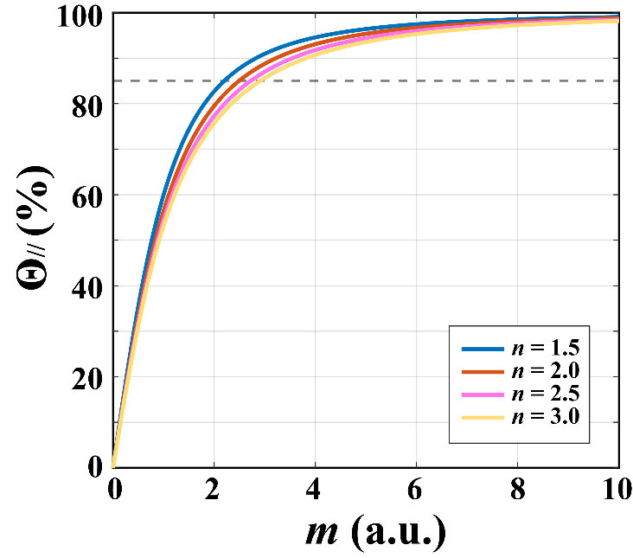

Fig. S2. Calculated Θ//-m curves at different n values using Equation 1.

To evaluate the probability that the cuboid finally lands on either of the two YZ faces, the solid angle subtended by a single YZ face is calculated. Taking the centroid as the origin, one YZ face is located at X = L_{x}/2, with coordinates (L_{x}/2, u, v). The infinitesimal solid angle is
Thus, the solid angle of one YZ face is
Because the two equivalent YZ faces, then

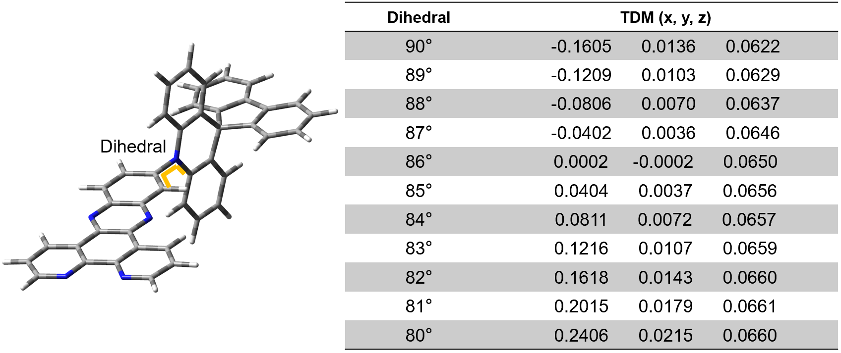
Fig. S3. TDM vectors of SAF-2NP under different donor-acceptor dihedral angles.

For an electric-dipole-allowed transition i→j, the transition dipole moment (TDM) is defined as . When one NTO pair dominates, the transition can be viewed as density flowing from the hole to the electron orbital. The direction of the net charge displacement (i.e., the vector connecting the centroids of the hole and electron NTO densities) then coincides with the TDM direction. In highly twisted TADF emitters, the orbital overlap is extremely small and the TDM magnitude becomes extremely small, making the Cartesian TDM components numerically unreliable; however, the direction of charge redistribution can be captured by the NTO hole→electron displacement. Therefore, we represent the TDM direction by the line connecting the centroids of the hole and electron NTOs obtained from the same TD-DFT calculation.
Taking SAF-2NP as an example, a flexible potential surfaces scanning of the donor-acceptor dihedral angle was performed, followed by excited-state calculations. The x component of the TDM vector changes markedly with the dihedral angle. It is nearly zero at 86° but increases to 0.24 at 80°, indicating a direction change from almost perpendicular to the acceptor plane to horizontal orientation.

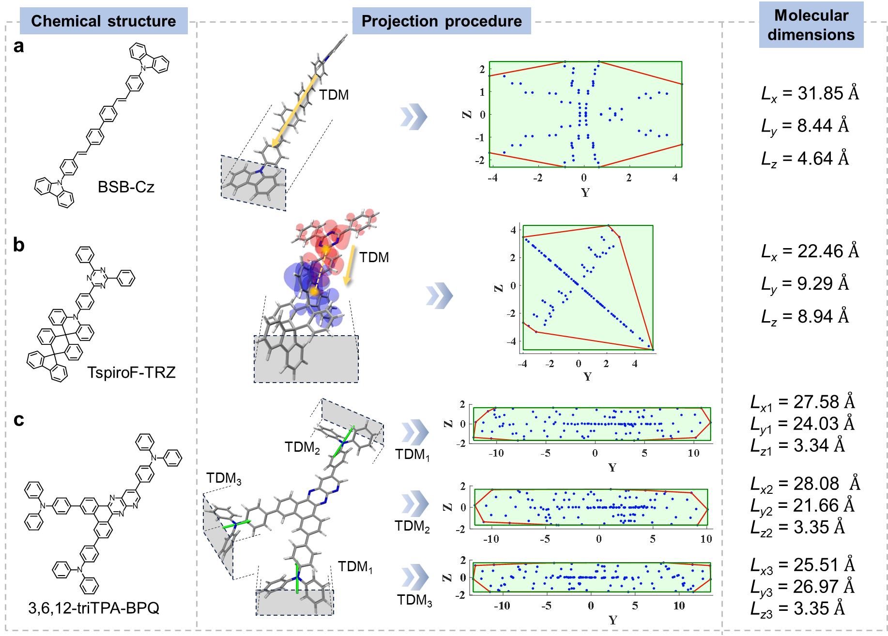
Fig. S4. Illustration of projection procedures of different types of emitters. (a) BSB-Cz. (b) TspiroF-TRZ. (c) 3,6,12-triTPA-BPQ. TspiroF-TRZ is an example with minimal TDM vectors (yellow dots: orbital centroids; blue: hole distribution; red: electron distribution). 3,6,12-triTPA-BPQ stands for emitters with multiple CT pathways.

Table S1. Decomposed TDM vectors of emitters with multiple intramolecular pathways, the corresponding geometric parameters and Θ// values.
Compound | L_{x}  (Å) | L_{y}  (Å) | L_{z}  (Å) | m | Θ//  (%)
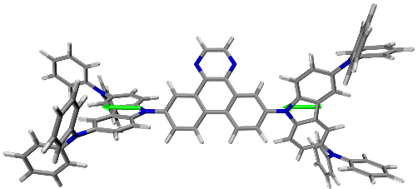  DQBC | 26.82 | 17.10 | 11.00 | 2.44 | 92
 | 26.82 | 17.10 | 11.00 | 2.44 | 92
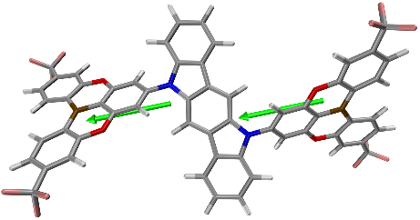  2BOICz | 22.80 | 13.00 | 10.39 | 2.19 | 91.6
 | 22.80 | 13.00 | 10.40 | 2.19 | 91.6
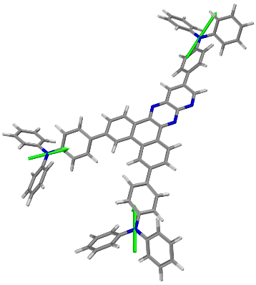  3,6,12-triTPA-BPQ | 27.58 | 24.03 | 3.34 | 27.58 | 92
 | 28.08 | 21.66 | 3.35 | 8.38 | 92
 | 25.51 | 26.97 | 3.35 | 7.61 | 92
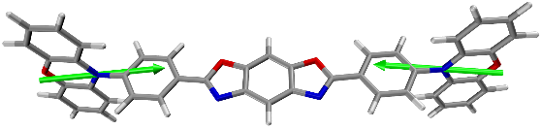  cis-BOX2 | 25.46 | 9.41 | 5.52 | 4.61 | 94
 | 25.46 | 9.41 | 5.52 | 4.61 | 94
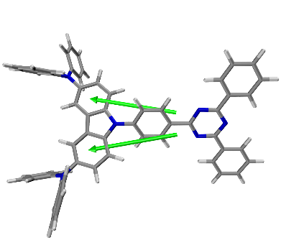  DACT-II | 20.89 | 16.57 | 8.74 | 2.39 | 88
 | 20.89 | 16.57 | 8.74 | 2.39 | 88
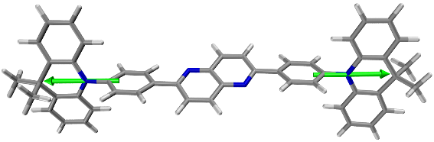  NyDPAc | 25.69 | 9.01 | 4.92 | 5.22 | 92
 | 25.66 | 7.71 | 5.89 | 4.36 | 92
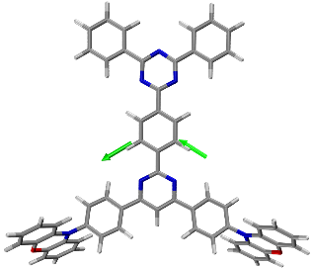  PXZTAZPM | 22.12 | 22.92 | 8.20 | 2.70 | 86
 | 22.14 | 22.93 | 8.22 | 2.69 | 86
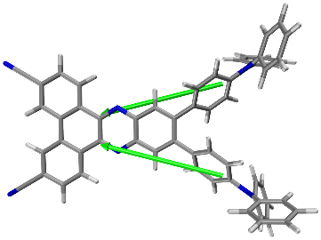  TPA-PZCN | 20.54 | 15.25 | 9.17 | 2.24 | 88
 | 20.54 | 15.25 | 9.17 | 2.24 | 88
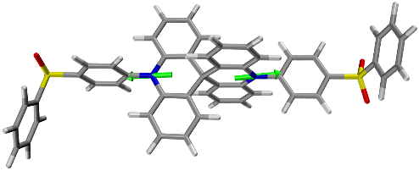  SBA-2DPS | 21.38 | 8.69 | 7.46 | 2.87 | 87
 | 21.39 | 8.75 | 7.34 | 2.91 | 87
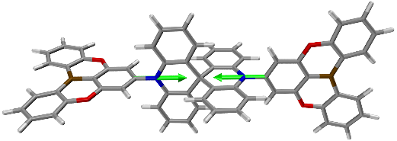  DBA-SAB | 24.53 | 7.65 | 6.89 | 3.56 | 89
 | 24.53 | 7.65 | 6.89 | 3.56 | 89
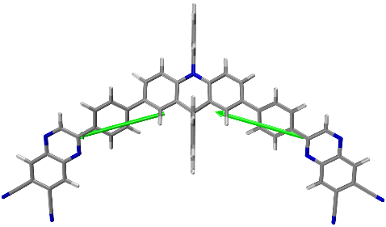  QCN-PhSAC-QCN | 28.14 | 19.10 | 8.56 | 3.29 | 90
 | 28.14 | 19.10 | 8.56 | 3.29 | 90
Table S2. TDM vectors of heteroleptic phosphors, the corresponding geometric parameters and Θ// values.
Compound | L_{x}  (Å) | L_{y}  (Å) | L_{z}  (Å) | m | Θ//  (%)
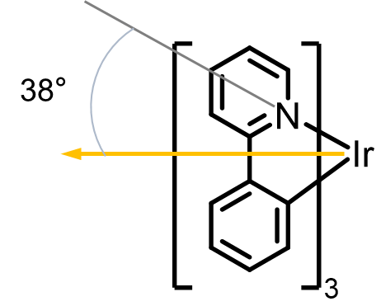  Ir(ppy)₃ | 9.31 | 9.04 | 8.53 | 1.09 | 69
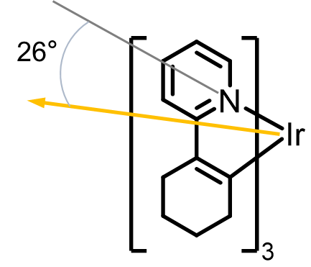  Ir(chpy)₃ | 10.60 | 8.73 | 8.71 | 1.22 | 77
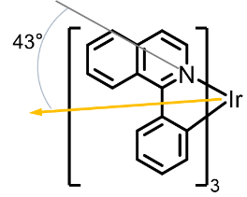  Ir(piq)₃ | 14.04 | 9.83 | 9.80 | 1.43 | 78

Fig. S5. CV oxidation and reduction curves of SAF-27MXNP, SAF-36MXNP, SAF-36MXBP and SAF-36CNNP.

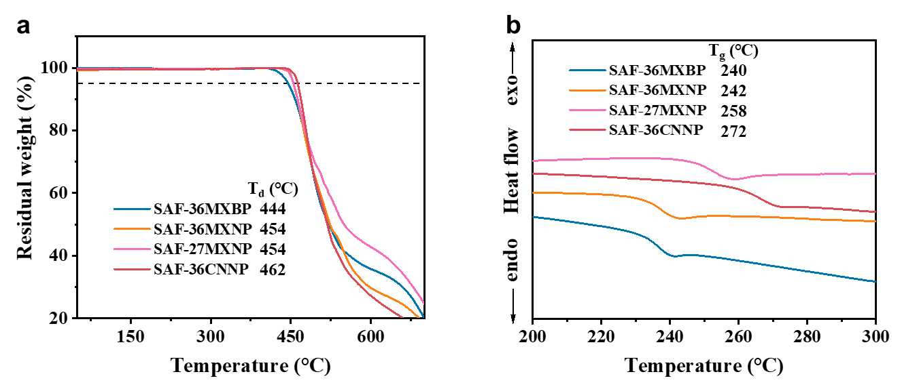
Fig. S6. Thermal properties. (a) TGA and (b) DSC curves of SAF-27MXNP, SAF-36MXNP, SAF-36MXBP and SAF-36CNNP.

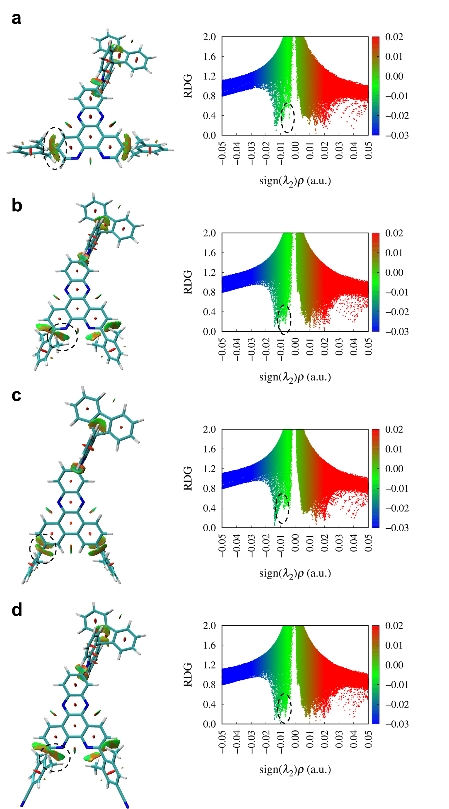
Fig. S7. Reduced density gradient analysis of (a) SAF-27MXNP, (b) SAF-36MXNP, (c) SAF-36MXBP and (d) SAF-36CNNP.

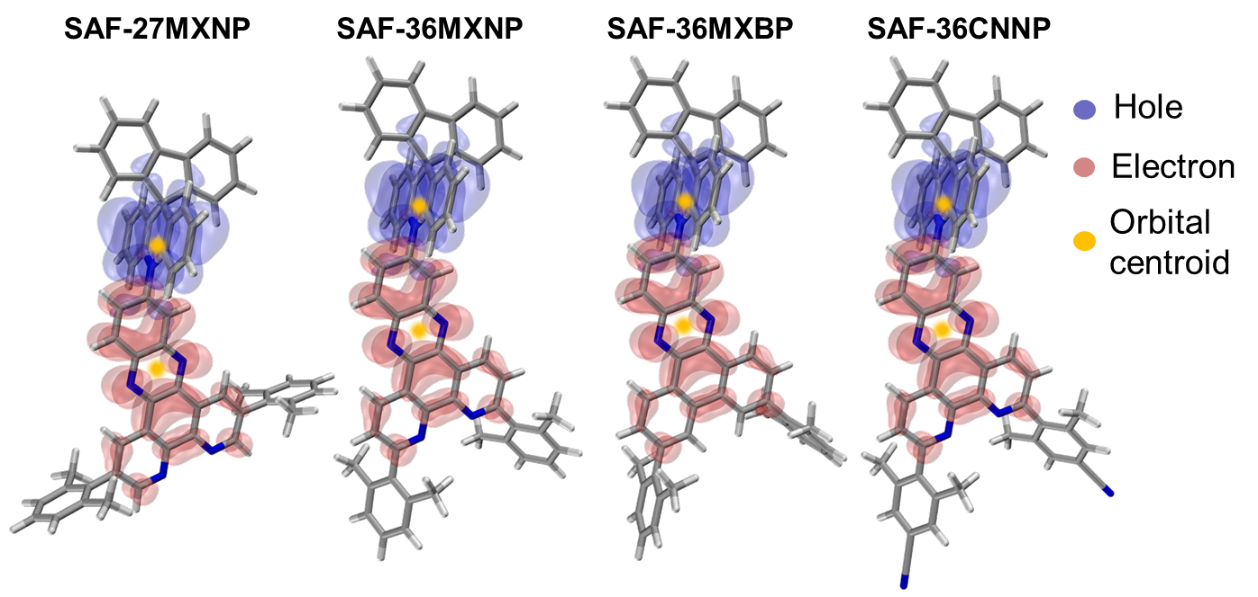
Fig. S8. NTO distribution of the four emitters.

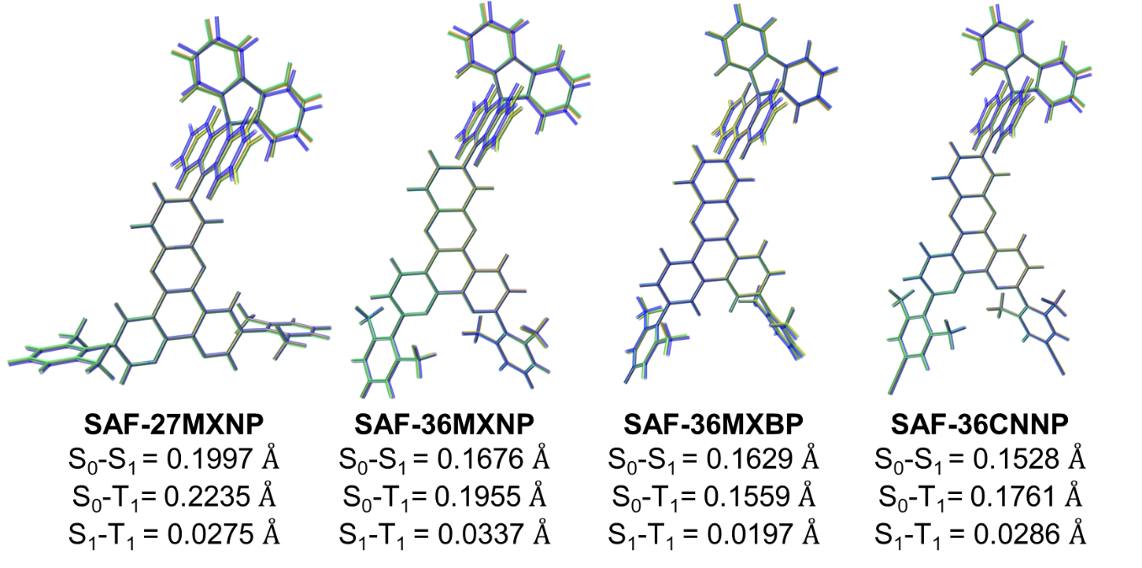
Fig. S9. S₀, S₁ and T₁ (in blue, orange and green, respectively) geometric variations of the five emitters and the corresponding root-mean-square displacements.

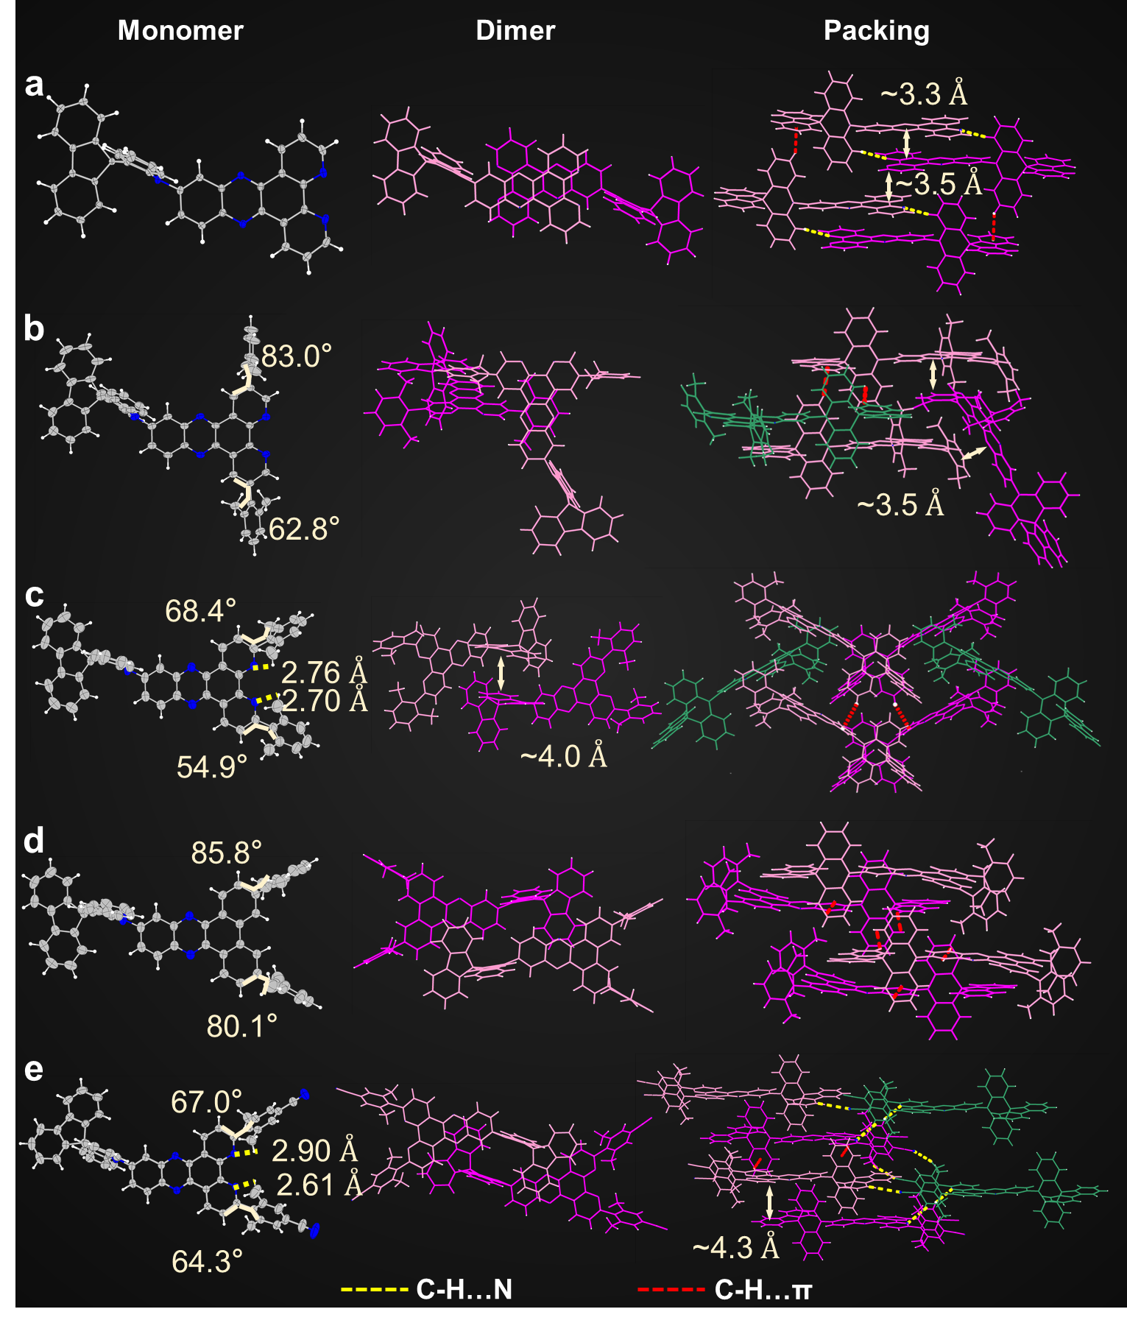
Fig. S10. Crystal structures. Monomer, dimer structures and packing modes of (a) SAF-2NP (b) SAF-27MXNP, (c) SAF-36MXNP, (d) SAF-36MXBP and (e) SAF-36CNNP.

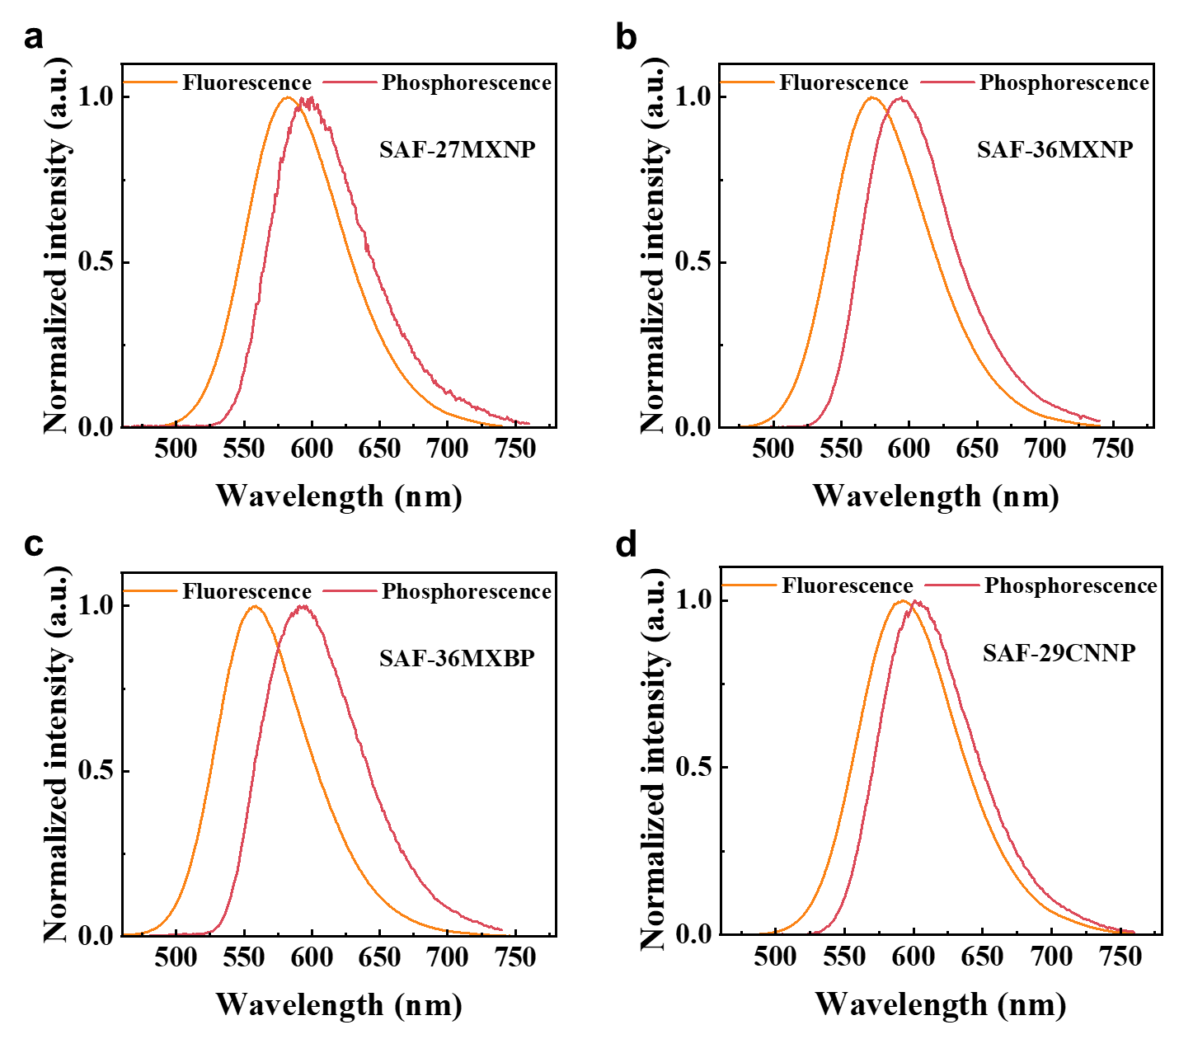
Fig. S11. PL spectra. Fluorescence and phosphorescence spectra of (a) SAF-27MXNP, (b) SAF-36MXNP, (c) SAF-36MXBP and (d) SAF-36CNNP measured at 77K.

Table S3. Summary of physical properties of SAF-27MXNP, SAF-36MXNP, SAF-36MXBP and SAF-36CNNP.
Compound | λ_{PL}*,†  (nm) | Φ_{PL}*  (%) | Θ//*  (%) | HOMO/  LUMO‡  (eV) | S₁/T₁/  ΔE_{ST}*,§  (eV) | τ_{p}*  (ns) | τ_{d}*  (μs) | k_{f}  (10⁷ s⁻¹) | k_{nr}  (10⁵ s⁻¹) | k_{RISC}  (10⁵ s⁻¹)
SAF-27MXNP | 582 | 91.0 | 87.9 | −5.38/−3.05 | 2.39/2.29/  0.10 | 15.0 | 9.7 | 1.78 | 17.56 | 3.52
SAF-36MXNP | 572 | 95.0 | 92.4 | −5.37/−3.04 | 2.42/2.29/  0.13 | 12.9 | 9.1 | 2.49 | 5.59 | 3.35
SAF-36MXBP | 559 | 99.3 | 92.3 | −5.34/−2.92 | 2.50/2.31/  0.19 | 9.8 | 13.1 | 4.76 | 3.35 | 1.63
SAF-36CNNP | 592 | 93.6 | 94.0 | −5.37/−3.12 | 2.35/2.27/  0.08 | 17.1 | 6.5 | 1.84 | 12.57 | 4.58
*Measured using the film of CBP:10 wt% emitter. †Emission peaks of fluorescence spectra. ‡Estimated according to the CV results. §Obtained from the onsets of the fluorescence and phosphorescence spectra at 77 K.

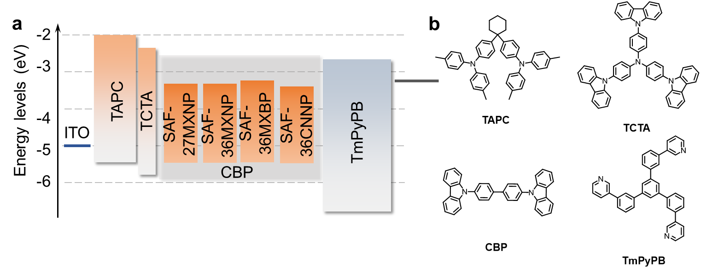
Fig. S12. OLED devices. (a) Device structures and corresponding energy levels. (b) Chemical structures of materials used in OLEDs.

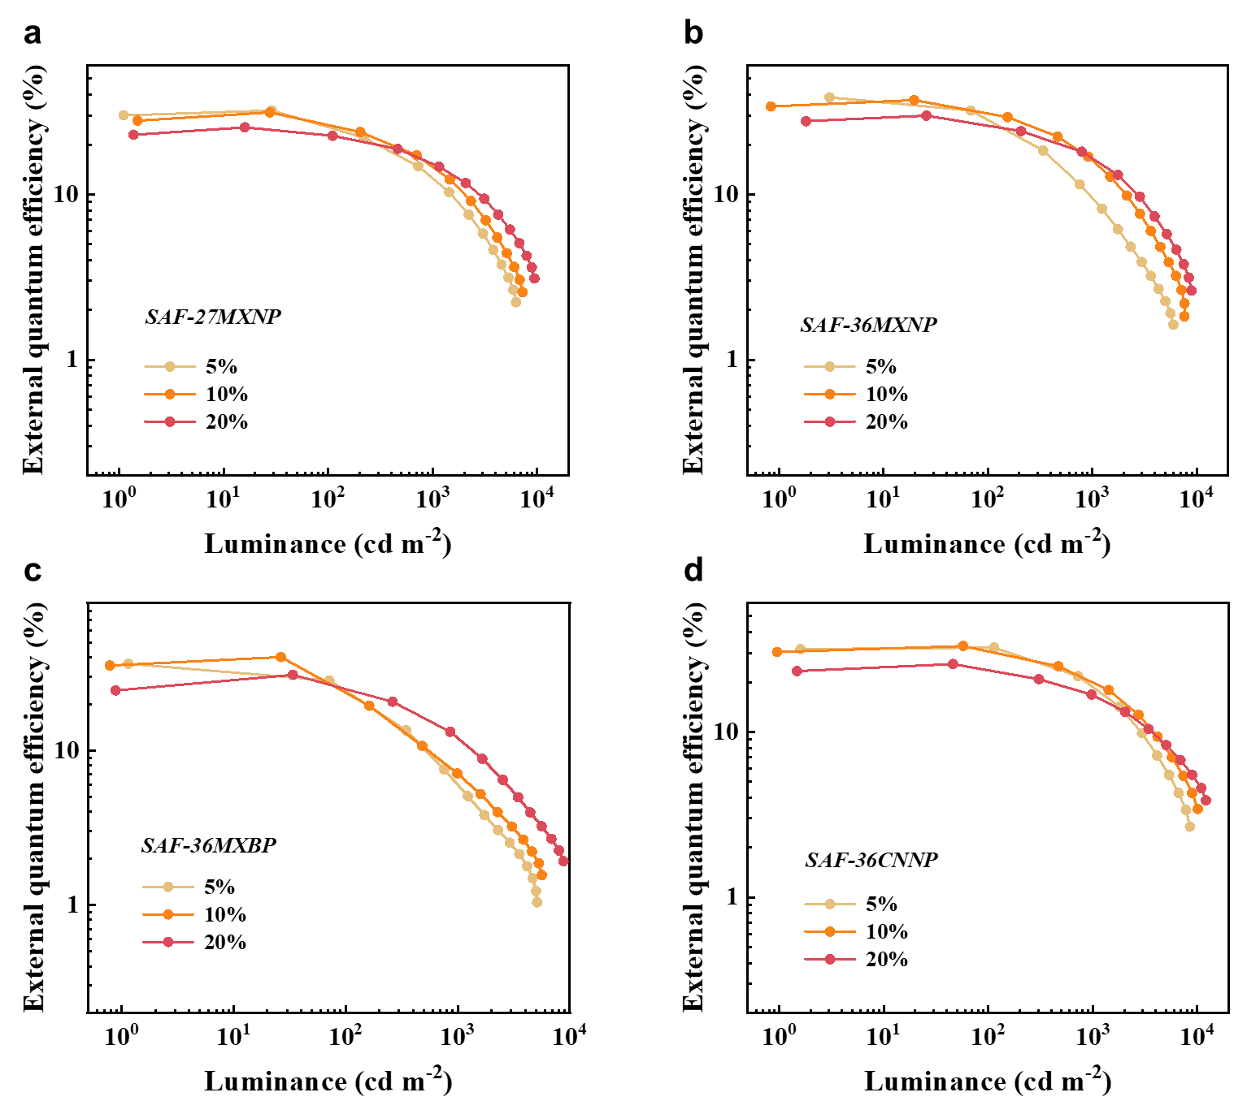
Fig. S13. Device EQEs under different doping concentrations. (a) SAF-27MXNP. (b) SAF-36MXNP. (c) SAF-36MXBP. (d) SAF-36CNNP.

Table S4. The performance of devices based on SAF-27MXNP, SAF-36MXNP, SAF-36MXBP and SAF-36CNNP.
Emitter | Weight  ratio (%) | V_{on}*  (V) | λ_{EL}†  (nm) | Maximum  CE/PE/EQE  (cd A⁻¹/lm W⁻¹/%) | EQE at 100  and 1000  cd m⁻² (%) | CIE‡  (x,y)
SAF-27MXNP | 5 | 3.5 | 580 | 88.6/72.2/32.1 | 25.2/12.4 | (0.52,0.48)
SAF-27MXNP | 10 | 3.3 | 588 | 75.1/62.1/30.9 | 26.4/14.8 | (0.54,0.46)
SAF-27MXNP | 20 | 3.2 | 596 | 54.8/48.2/25.4 | 22.6/15.2 | (0.57,0.43)
SAF-36MXNP | 5 | 3.3 | 572 | 117/105/38.6 | 28.2/9.4 | (0.49,0.51)
SAF-36MXNP | 10 | 3.3 | 580 | 104/88.1/37.1 | 30.8/16.0 | (0.51,0.49)
SAF-36MXNP | 20 | 3.1 | 584 | 76.0/66.1/29.9 | 25.8/16.5 | (0.53,0.46)
SAF-36MXBP | 5 | 3.1 | 564 | 118/117/36.4 | 24.3/6.0 | (0.46,0.53)
SAF-36MXBP | 10 | 3.1 | 568 | 129/113/40.3 | 23.6/7.0 | (0.48,0.52)
SAF-36MXBP | 20 | 2.9 | 572 | 93.2/86.1/30.9 | 25.0/12.0 | (0.50,0.50)
SAF-36CNNP | 5 | 3.1 | 588 | 81.1/74.7/32.3 | 32.2/18.7 | (0.54,0.46)
SAF-36CNNP | 10 | 3.0 | 596 | 68.6/62.6/33.0 | 30.8/20.1 | (0.57,0.43)
SAF-36CNNP | 20 | 2.9 | 608 | 42.9/41.8/25.7 | 23.5/16.7 | (0.60,0.40)
*Voltage at 1 cd m⁻². †EL spectra peaks. ‡At 1000 cd m⁻².

Table S5. Device performance of representative yellow-to-red TADF OLEDs with host-guest emitting layer.
Emitter | λ_{max}  (nm) | EQE_{max}  (%) | CIE  (x,y) | Ref.
SAF-27MXNP | 580 | 32.1 | (0.52,0.48) | This work
SAF-36MXNP | 572 | 38.6 | (0.49,0.51) | This work
SAF-36MXBP | 568 | 40.3 | (0.48,0.52) | This work
SAF-36CNNP | 596 | 33.0 | (0.57,0.43) | This work
SAF-2NP | 576 | 32.5 | (0.49,0.50) | ²
NAI-DPAC | 584 | 29.2 | (0.52,0.47) | ³
PzTDBA | 576 | 30.3 | (0.49,0.50) | ⁴
DCPPr-α-NDPA | 606 | 31.5 | (0.58,0.42) | ⁵
TPA–PZCN | 628 | 27.4 | (0.65,0.35) | ⁶
BPPZ-PXZ | 604 | 25.2 | (0.57,0.43) | ⁷
SpAcDBA | 567 | 30 | (0.46,0.52) | ⁸
QCN-PhSAC-QCN | 620 | 39.1 | (0.60,0.40) | ⁹
TCZ-F-DABNA | 588 | 39.2 | (0.54,0.44) | ¹⁰
BPSPXZ | 604 | 33.4 | (0.59, 0.41) | ¹¹
S-BN | 600 | 39.9 | (0.61,0.39) | ¹²
BNIP-tBuDPAC | 554 | 39.4 | (0.41,0.56) | ¹³
BBCz-R | 616 | 22 | (0.67,0.33) | ¹⁴
DBSN | 556 | 21.8 | (0.42,0.57) | ¹⁵
QAD-mTDPA | 589 | 26.3 | (0.55,0.44) | ¹⁶

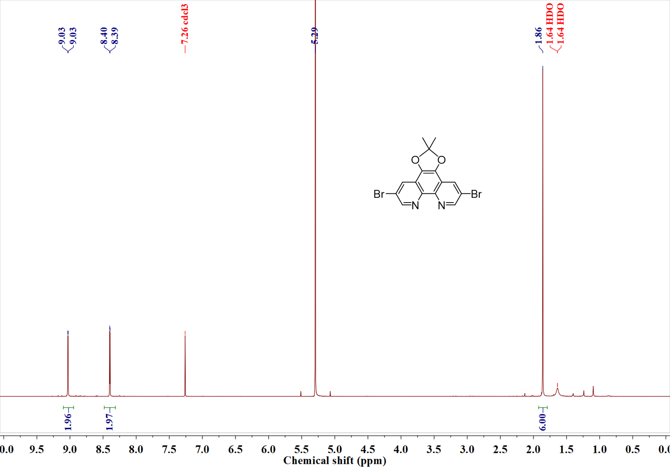
Fig. S14. ¹H NMR spectra of intermediate 1 in CDCl₃ (the peak at 5.29 ppm corresponds the residual dichloromethane).
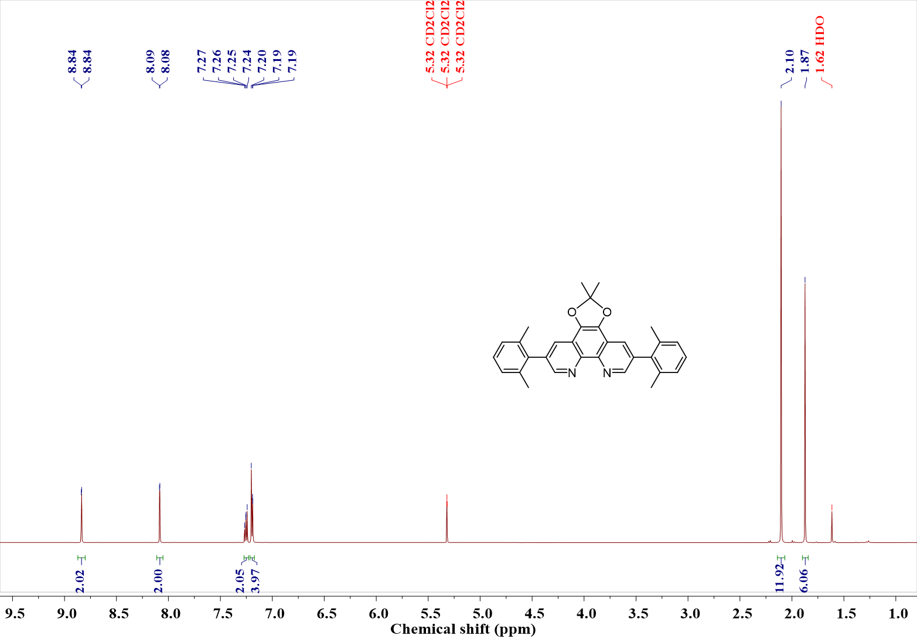
Fig. S15. ¹H NMR spectra of intermediate 2 in CD₂Cl₂.
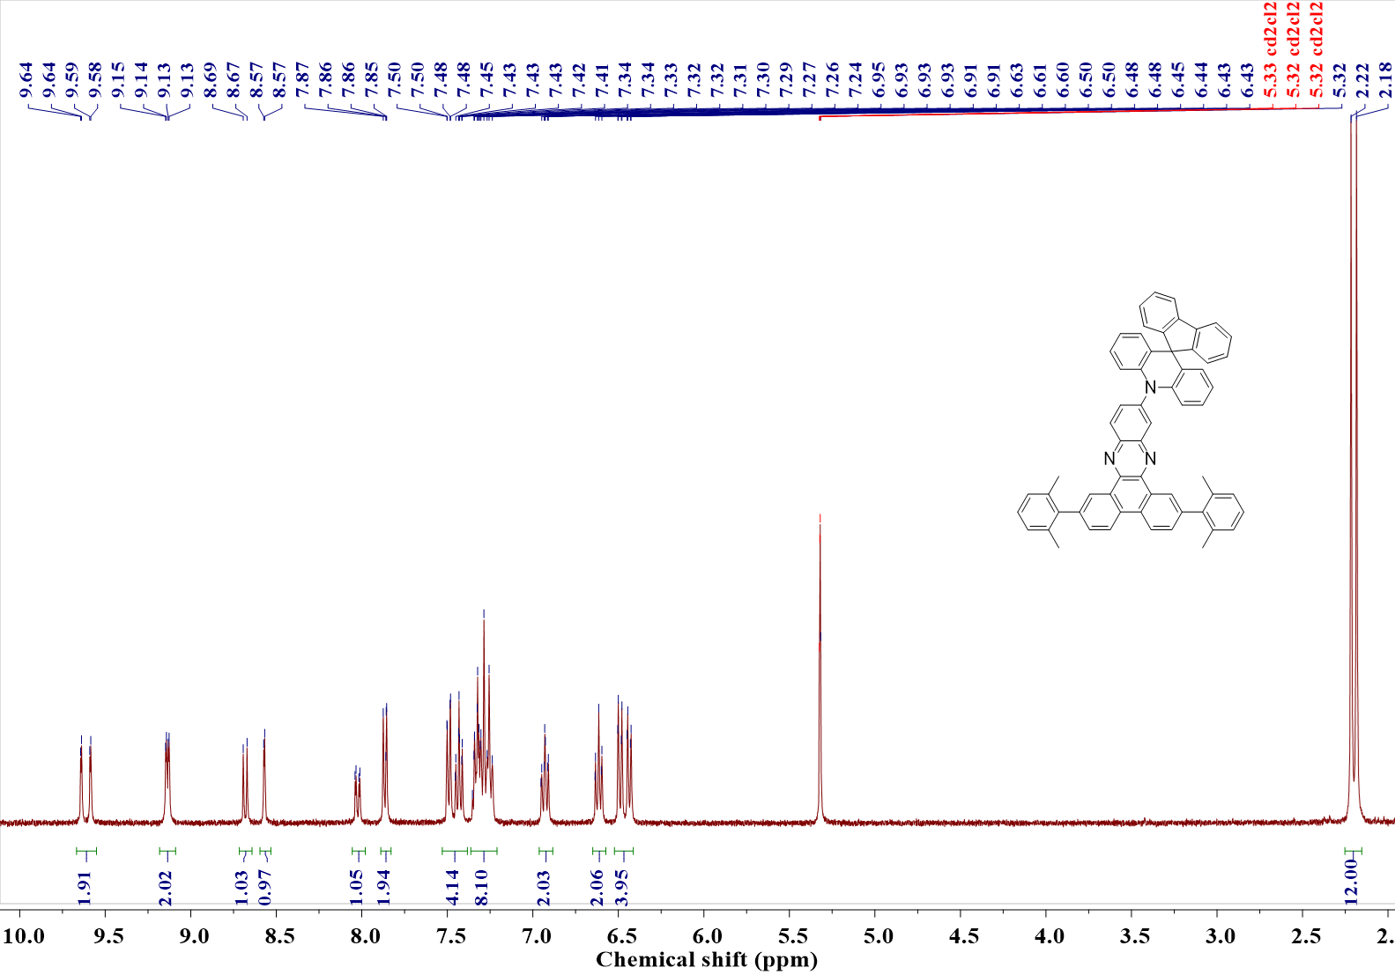
Fig. S16. ¹H NMR spectra of SAF-27MXNP in CD₂Cl₂.
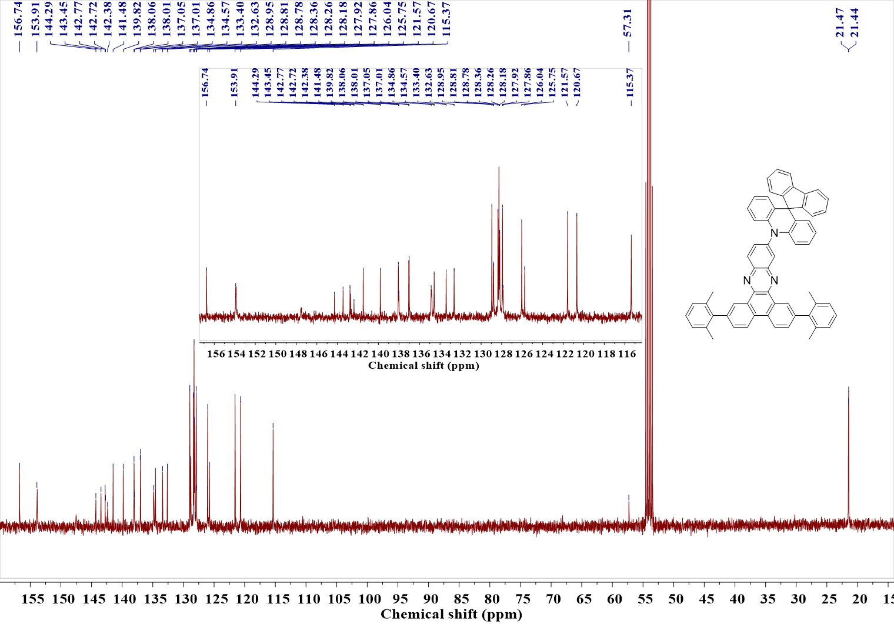
Fig. S17. ¹³C NMR spectra of SAF-27MXNP in CD₂Cl₂.
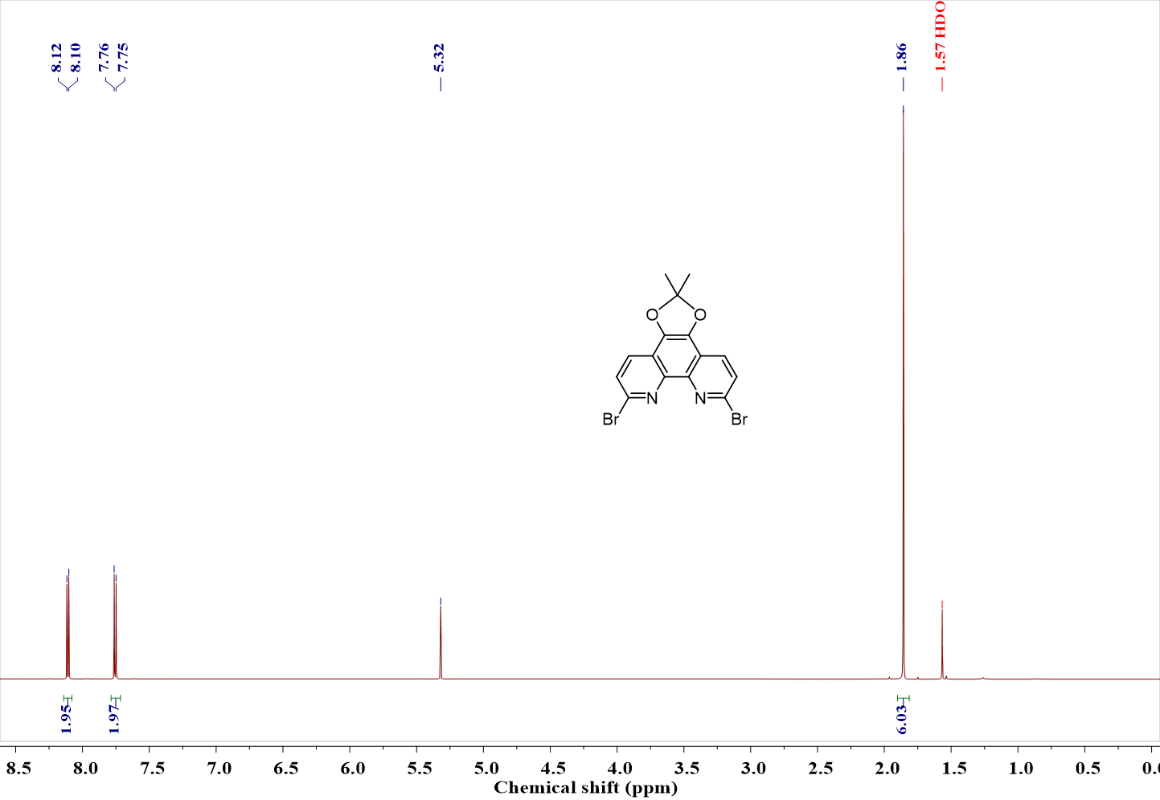
Fig. S18. ¹H NMR spectra of intermediate 4 in CD₂Cl₂.
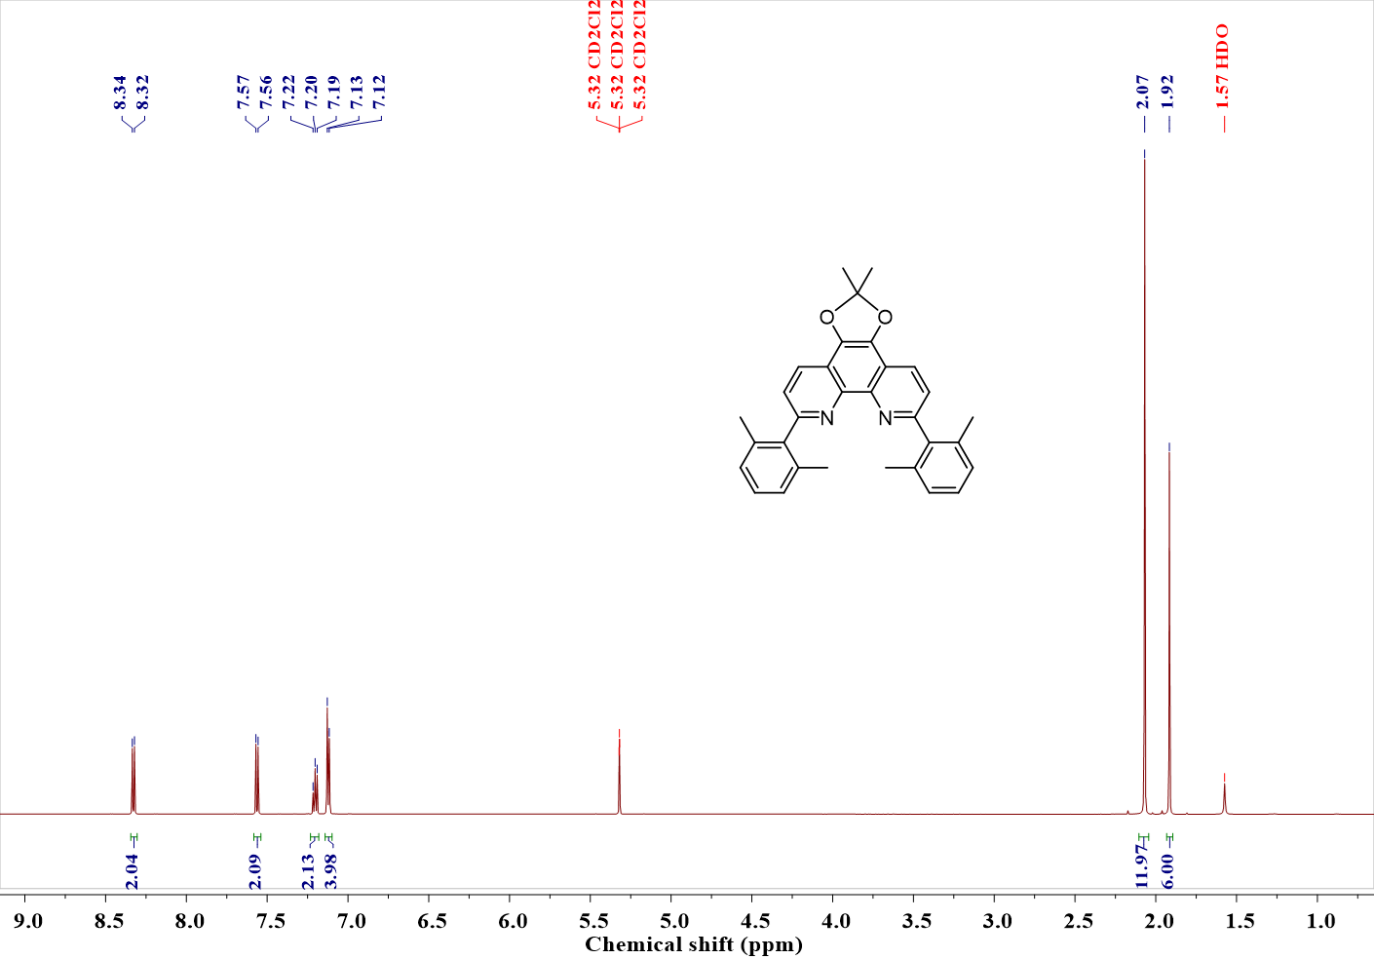
Fig. S19. ¹H NMR spectra of intermediate 5 in CD₂Cl₂.
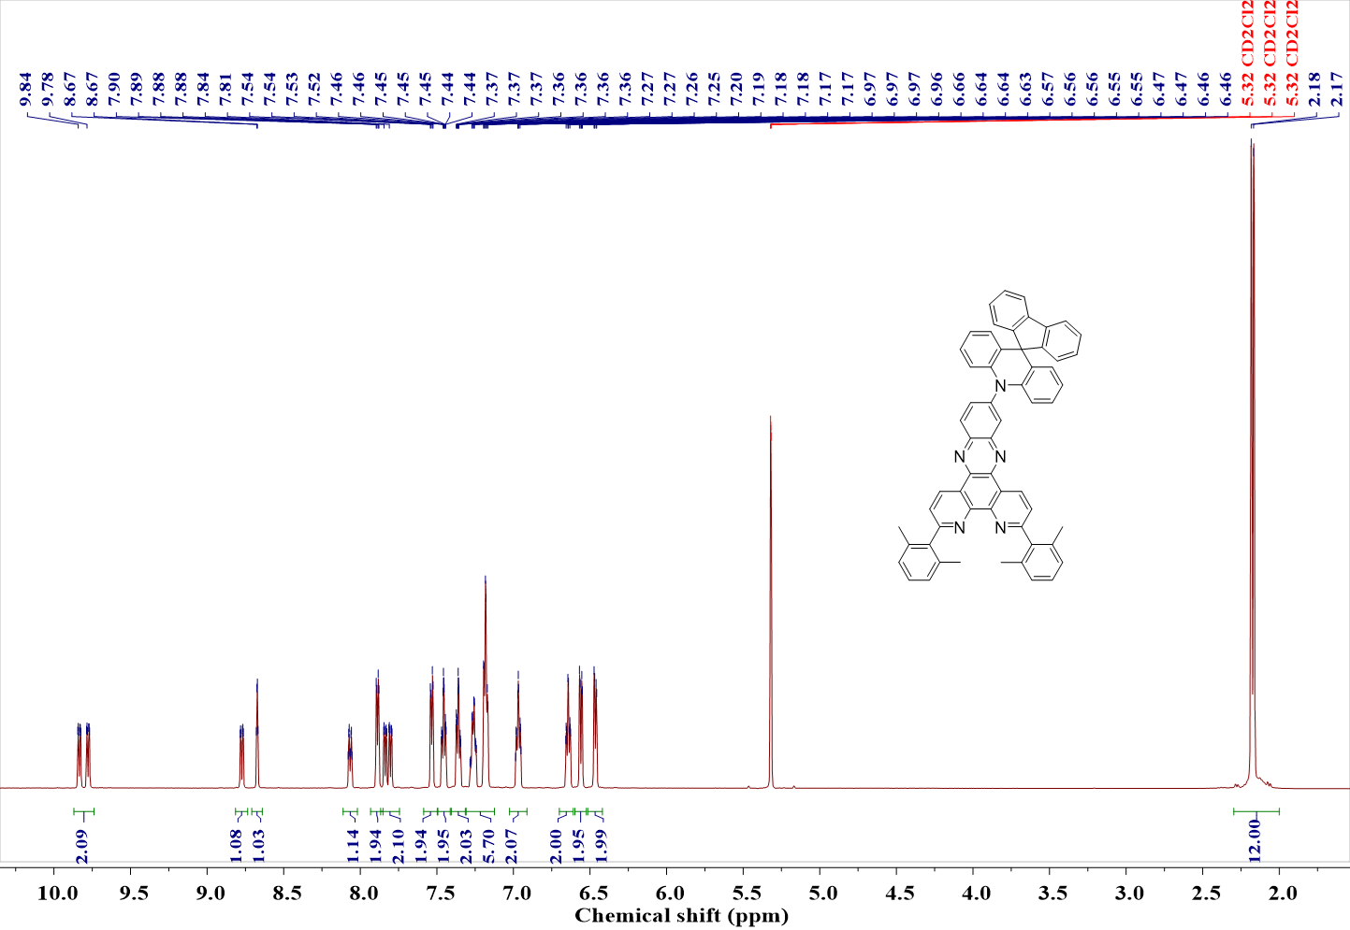
Fig. S20. ¹H NMR spectra of SAF-36MXNP in CD₂Cl₂.
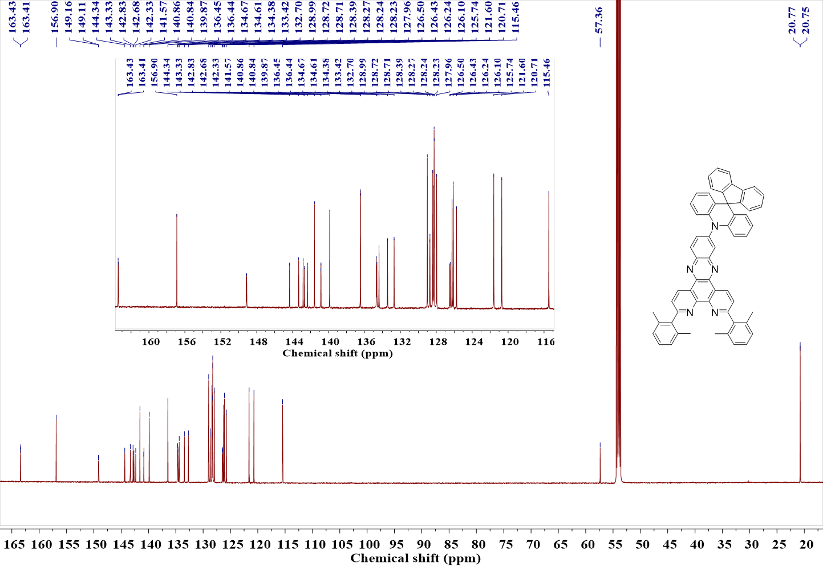
Fig. S21. ¹³C NMR spectra of SAF-36MXNP in CD₂Cl₂.
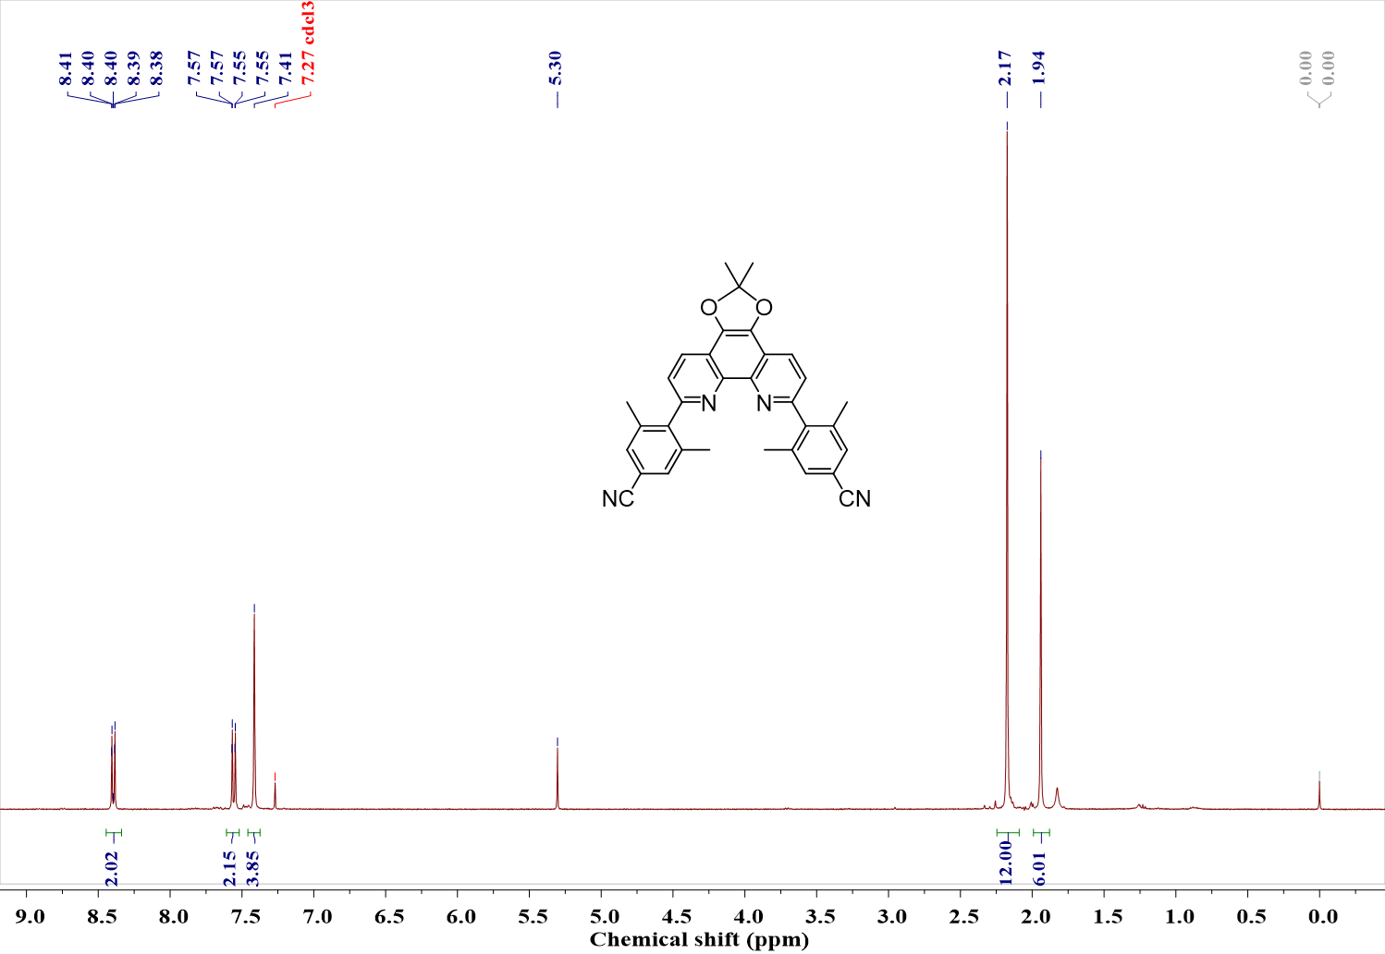
Fig. S22. ¹H NMR spectra of intermediate 7 in CDCl₃ (the peak at 5.30 ppm corresponds the residual dichloromethane).
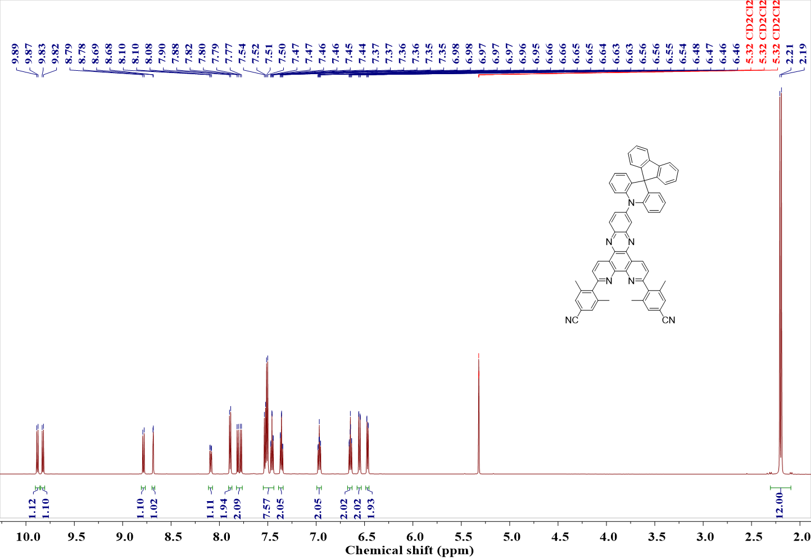
Fig. S23. ¹H NMR spectra of SAF-36CNNP in CD₂Cl₂.

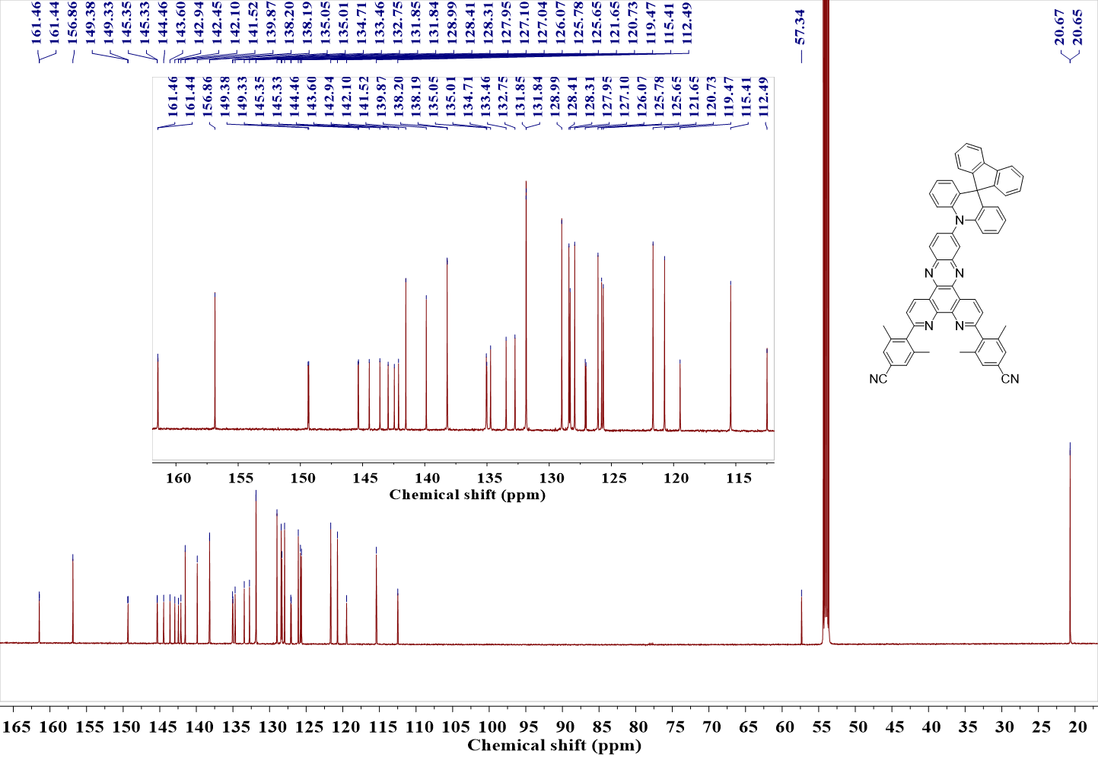
Fig. S24. ¹³C NMR spectra of SAF-36CNNP in CD₂Cl₂.
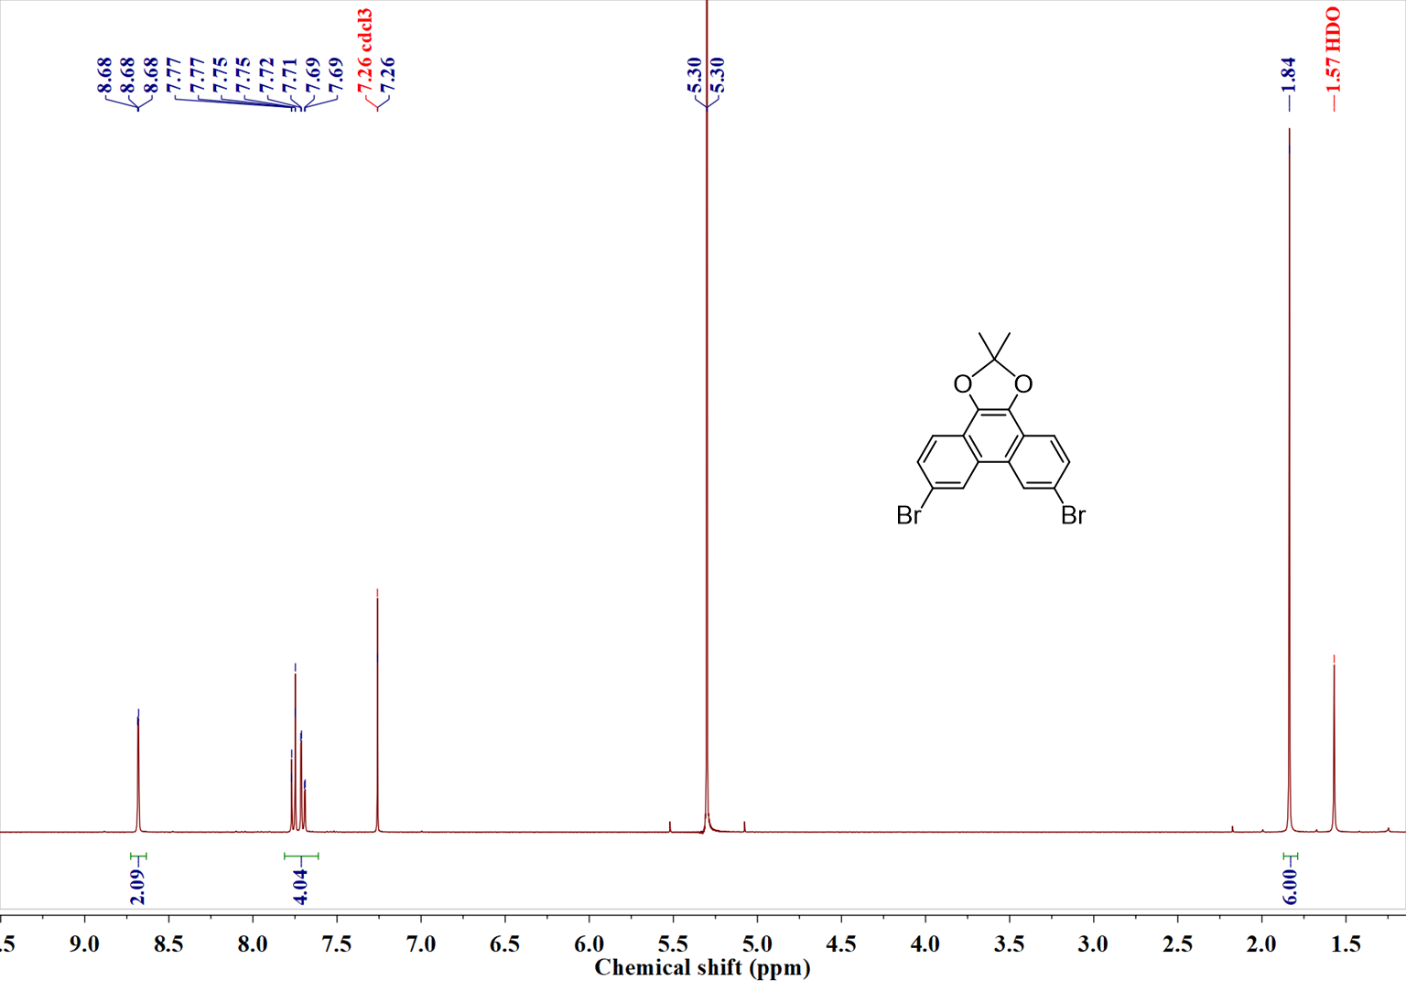
Fig. S25. ¹H NMR spectra of intermediate 9 in CDCl₃ (the peak at 5.30 ppm corresponds the residual dichloromethane).
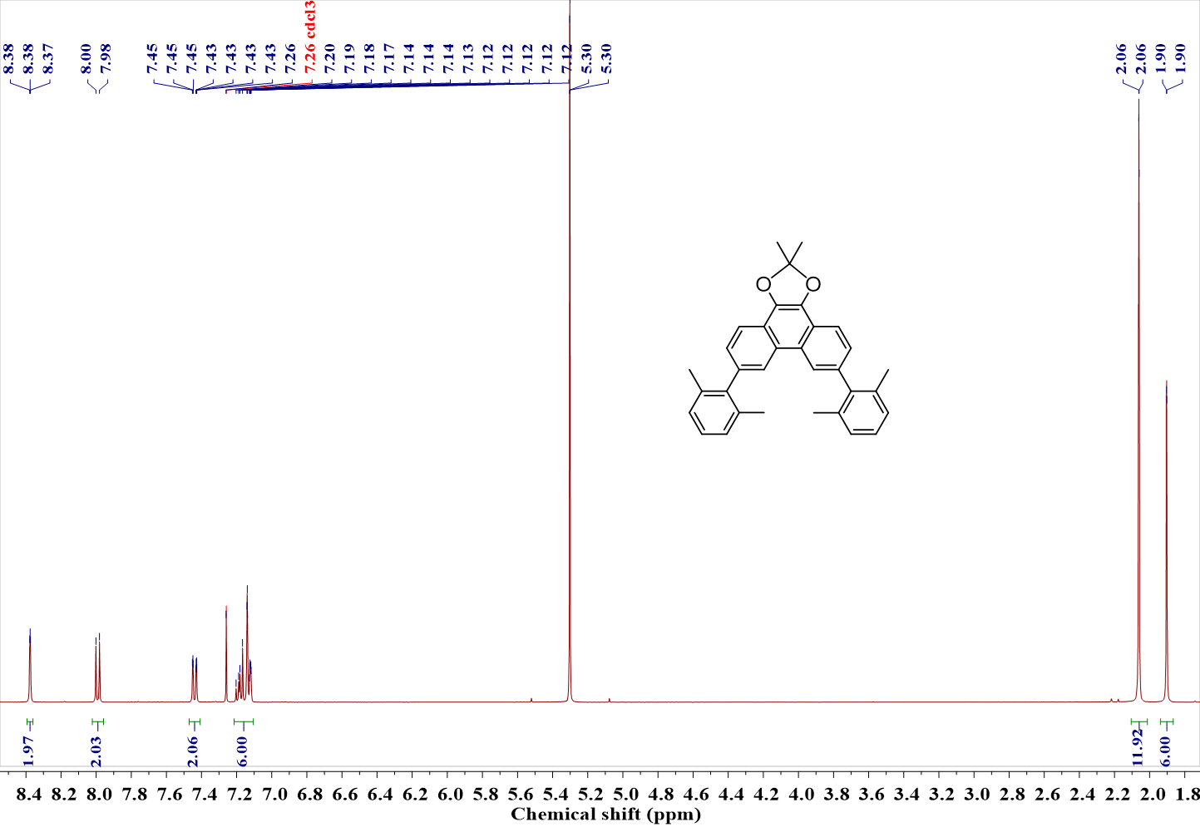
Fig. S26. ¹H NMR spectra of intermediate 10 in CDCl₃ (the peak at 5.30 ppm corresponds the residual dichloromethane).
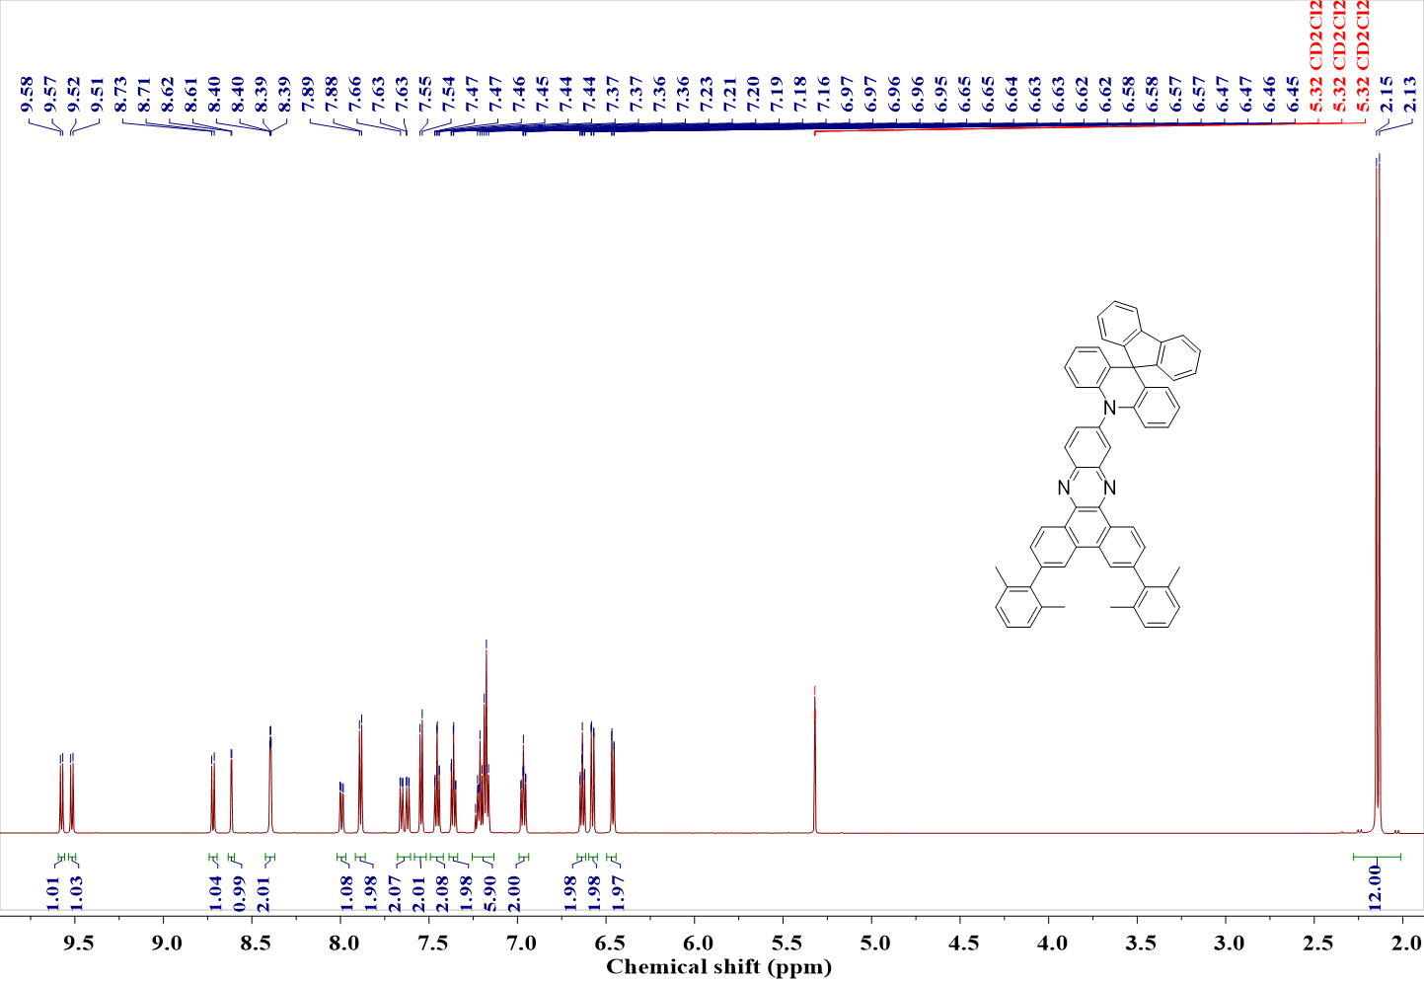
Fig. S27. ¹H NMR spectra of SAF-36MXBP in CD₂Cl₂
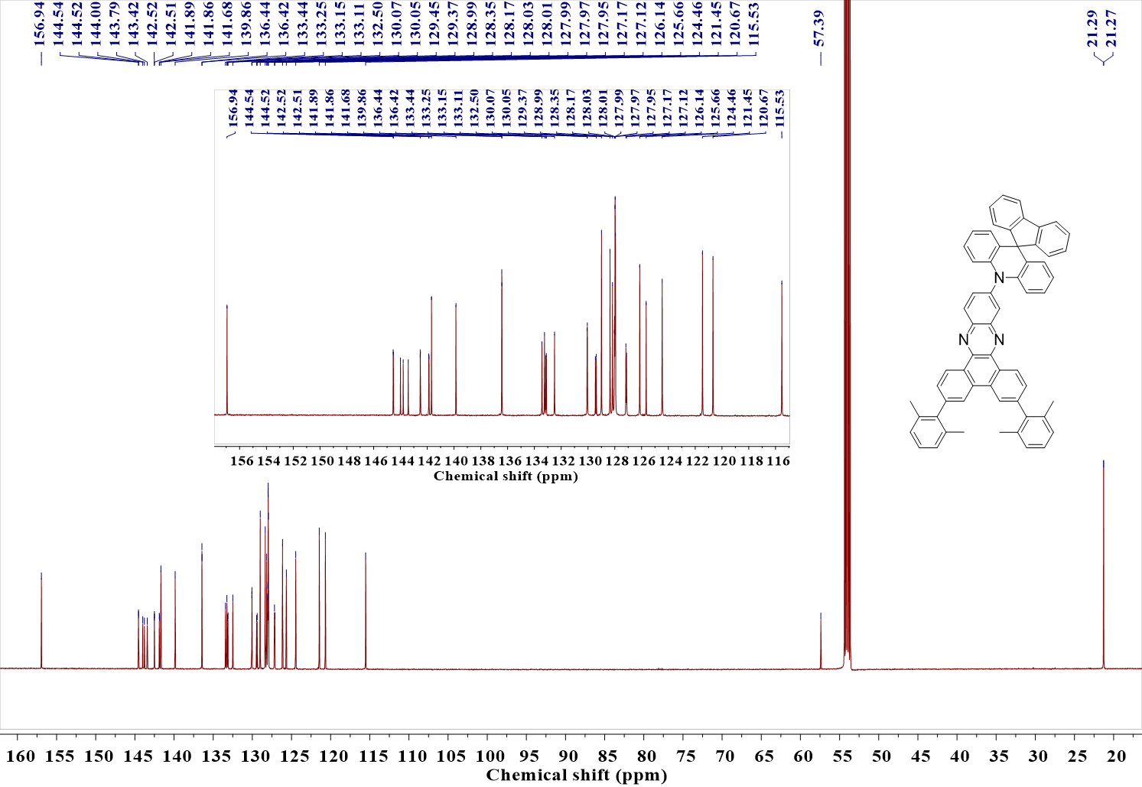
Fig. S28. ¹³C NMR spectra of SAF-36MXBP in CD₂Cl₂.

Table S6. X-ray crystallographic data of SAF-27MXNP.
Temperature [K] | 150
Crystal system | monoclinic
Space group | P2₁/n
a [Å] | 36.234(3)
b [Å] | 8.6361(7)
c [Å] | 36.862(3)
α [°] | 90
β [°] | 117.064(5)
γ [°] | 90
Volume [Å³] | 10271.7(16)
Z | 4
F(000) | 3964
Crystal colour | orange
Radiation | CuK_{α} (λ=1.54178 Å)
Index ranges | −43 ≤ h ≤ 42  −10 ≤ k ≤ 8  −43 ≤ l ≤ 43
Completeness to  θ = 67.14° | 98.5%
Data / Parameters | 18110/1461
Goodness-of-fit on F² | 0.9852
Final R indexes  [I≥2σ(I)] | R₁ = 0.0815  wR₂ = 0.1966
Final R indexes  [all data] | R₁ = 0.1116  wR₂ = 0.2148

Table S7. X-ray crystallographic data of SAF-36MXNP.
Temperature [K] | 150
Crystal system | monoclinic
Space group | P2₁/n
a [Å] | 36.234(3)
b [Å] | 8.6361(7)
c [Å] | 36.862(3)
α [°] | 90
β [°] | 117.064(5)
γ [°] | 90
Volume [Å³] | 10271.6(16)
Z | 4
F(000) | 3964
Crystal colour | orange
Radiation | CuK_{α} (λ=1.54178 Å)
Index ranges | −43 ≤ h ≤ 42  −10 ≤ k ≤ 8  −43 ≤ l ≤ 43
Completeness to  θ = 67.135° | 98.5%
Data/Parameters | 18110/1470
Goodness-of-fit on F² | 1.005
Final R indexes  [I≥2σ(I)] | R₁ = 0.0827  wR₂ = 0.1995
Final R indexes  [all data] | R₁ = 0.1140  wR₂ = 0.2186

Table S8. X-ray crystallographic data of SAF-36MXBP.
Temperature [K] | 297
Crystal system | monoclinic
Space group | C2/c
a [Å] | 37.6633(4)
b [Å] | 9.2281(1)
c [Å] | 26.2109(4)
α [°] | 90
β [°] | 107.948(1)
γ [°] | 90
Volume [Å³] | 8666.56(19)
Z | 8
F(000) | 3440.0
Crystal colour | orange
Radiation | CuK_{α} (λ=1.54178 Å)
Index ranges | −40 ≤ h ≤ 47  −11 ≤ k ≤ 11  −33 ≤ l ≤ 32
Completeness to  θ = 77.922° | 98.4%
Data/Parameters | 9131/581
Goodness-of-fit on F² | 1.051
Final R indexes  [I≥2σ(I)] | R₁ = 0.0731  wR₂ = 0.2294
Final R indexes  [all data] | R₁ = 0.0686  wR₂ = 0.2240

Table S9. X-ray crystallographic data of SAF-36CNNP.
Temperature [K] | 295
Crystal system | triclinic
Space group | P$\overline{1}$
a [Å] | 8.7528(1)
b [Å] | 14.7194(2)
c [Å] | 21.2500(3)
α [°] | 101.908(1)
β [°] | 96.141(1)
γ [°] | 95.227(1)
Volume [Å³] | 2645.39(6)
Z | 11
F(000) | 1018.0
Crystal colour | orange
Radiation | CuK_{α} (λ=1.54178 Å)
Index ranges | −8 ≤ h ≤ 10  −18 ≤ k ≤ 18  −25 ≤ l ≤ 26
Completeness to  θ = 77.837° | 94.0%
Data/Parameters | 10598/617
Goodness-of-fit on F² | 0.938
Final R indexes  [I≥2σ(I)] | R₁ = 0.0502  wR₂ = 0.1564
Final R indexes  [all data] | R₁ = 0.0597  wR₂ = 0.1666

References
1. Pellegrin, Y. et al. New Heteroleptic Bis-Phenanthroline Copper(I) Complexes with Dipyridophenazine or Imidazole Fused Phenanthroline Ligands: Spectral, Electrochemical, and Quantum Chemical Studies. Inorg. Chem. 50, 11309–11322 (2011).
2. Zhang, H.-Y. et al. A novel orange-red thermally activated delayed fluorescence emitter with high molecular rigidity and planarity realizing 32.5% external quantum efficiency in organic light-emitting diodes. Mater. Horiz. 9, 2425–2432 (2022).
3. Zeng, W. et al. Achieving Nearly 30% External Quantum Efficiency for Orange–Red Organic Light Emitting Diodes by Employing Thermally Activated Delayed Fluorescence Emitters Composed of 1,8-Naphthalimide-Acridine Hybrids. Adv. Mater. 30, 1704961 (2018).
4. Karthik, D. et al. Acceptor–Donor–Acceptor-Type Orange–Red Thermally Activated Delayed Fluorescence Materials Realizing External Quantum Efficiency Over 30% with Low Efficiency Roll-Off. Adv. Mater. 33, 2007724 (2021).
5. Cai, Z. et al. Realizing Record-High Electroluminescence Efficiency of 31.5 % for Red Thermally Activated Delayed Fluorescence Molecules. Angew. Chem. Int. Ed. 60, 23635–23640 (2021).
6. Zhang, Y. et al. High‐Efficiency Red Organic Light‐Emitting Diodes with External Quantum Efficiency Close to 30% Based on a Novel Thermally Activated Delayed Fluorescence Emitter. Adv. Mater. 31, 1902368 (2019).
7. Chen, J. et al. Red/Near‐Infrared Thermally Activated Delayed Fluorescence OLEDs with Near 100 % Internal Quantum Efficiency. Angew. Chem. Int. Ed. 58, 14660–14665 (2019).
8. Hsieh, C.-M. et al. Diboron-Based Delayed Fluorescent Emitters with Orange-to-Red Emission and Superior Organic Light-Emitting Diode Efficiency. ACS Appl. Mater. Interfaces 12, 23199–23206 (2020).
9. Wang, H. et al. An A-D-A-Type Thermally Activated Delayed Fluorescence Emitter with Intrinsic Yellow Emission Realizing Record-High Red/NIR OLEDs upon Modulating Intermolecular Aggregations. Adv. Mater. 36, 2307725 (2024).
10. Cheng, Y.-C. et al. A Highly Twisted Carbazole-Fused DABNA Derivative as an Orange-Red TADF Emitter for OLEDs with Nearly 40 % EQE. Angew. Chem. Int. Ed. 61, e202212575 (2022).
11. Chen, J. et al. Optimizing Intermolecular Interactions and Energy Level Alignments of Red TADF Emitters for High‐Performance Organic Light‐Emitting Diodes. Small 18, 2201548 (2022).
12. Pu, Y. et al. Sulfur-locked multiple resonance emitters for high performance orange-red/deep-red OLEDs. Nat. Commun. 16, 332 (2025).
13. Yang, W. et al. An Effective Approach toward Yellow-to-Orange Multi-Resonance TADF Emitters by Integrating Strong Electron Donor into B/N-Based Polycyclic Architecture: High Performance OLEDs with Nearly 40% EQE. Adv. Funct. Mater. 33, 2213056 (2023).
14. Yang, M., Park, I. S. & Yasuda, T. Full-Color, Narrowband, and High-Efficiency Electroluminescence from Boron and Carbazole Embedded Polycyclic Heteroaromatics. J. Am. Chem. Soc. 142, 19468–19472 (2020).
15. Luo, X.-F. et al. High-Efficiency and Narrowband OLEDs from Blue to Yellow with Ternary Boron/Nitrogen-Based Polycyclic Heteroaromatic Emitters. Adv. Opt. Mater. 10, 2200504 (2022).
16. Huang, F. et al. Approaching Efficient and Narrow RGB Electroluminescence from D–A-Type TADF Emitters Containing an Identical Multiple Resonance Backbone as the Acceptor. ACS Appl. Mater. Interfaces 13, 36089–36097 (2021).

