Supporting Information for
Efficient H₂O₂ Synthesis from Seawater via Na,Pb-codoped SnSe under a Small Temperature Gradient

Yuyan Xu,¹ Xinyue Zhang,^{1,2} Yangyang Wan,^{3*} Bingchao Qin,⁴ Jun Pei,⁵ Hong Liu,¹ Xiaoxue Song,¹ Shutong Jiang,¹ Yuqiao Zhang,¹ Long Zhang,¹ Yong Liu,² Qian Yu,⁶ Li-Dong Zhao,^{4*} Shun Li,^{1*} and Jianming Zhang^{1*}

¹ School of Chemistry and Chemical Engineering, Jiangsu University, Zhenjiang, Jiangsu 212013 China
² Foshan (Southern China) Institute for New Materials, Foshan 528231, China
³ Institute for Advanced Materials, School of Materials Science and Engineering, Jiangsu University, Zhenjiang, Jiangsu 212013 China
⁴ School of Materials Science and Engineering, Beihang University, Beijing 100191, China
⁵ Beijing Municipal Key Laboratory of New Energy Materials and Technologies, School of Materials Science and Engineering, University of Science and Technology Beijing, Beijing 100083, China
⁶ School of Life Sciences, Jiangsu University, Zhenjiang, Jiangsu 212013 China
*Corresponding author emails: yangyang.wan@ujs.edu.cn; zhaolidong@buaa.edu.cn; shun@ujs.edu.cn; zhangjm@ujs.edu.cn

Supplemental Figures
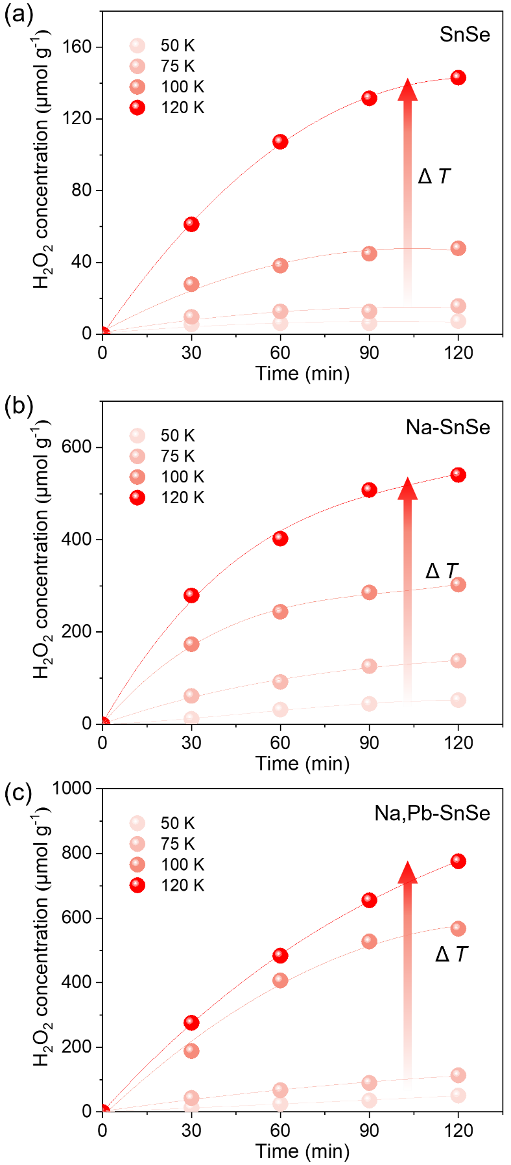
Supplementary Fig. 1. TEC H₂O₂ generation in 2 h under different ΔT using SnSe (a), Na-SnSe (b) and Na,Pb-SnSe (c) nanocatalysts in O₂-saturated DI water.

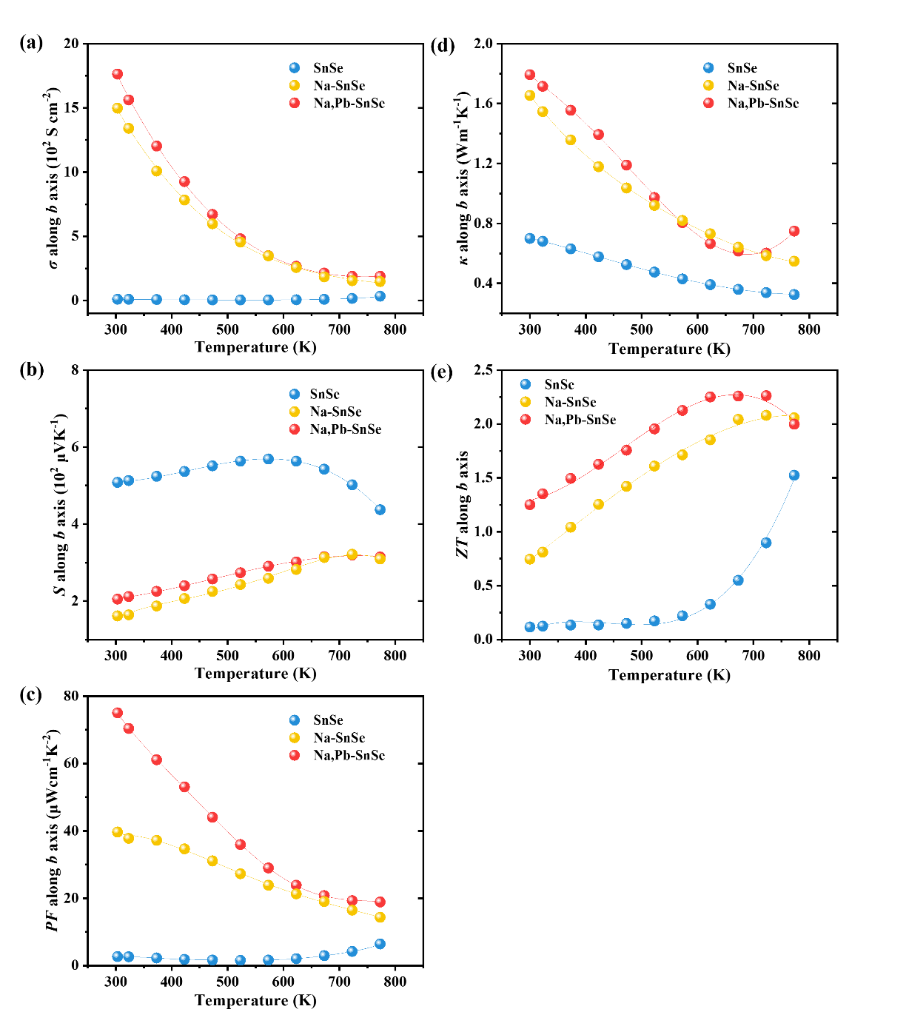
Supplementary Fig. 2. Thermoelectric properties as a function of temperature for SnSe, Na-SnSe and Na,Pb-SnSe crystals along the b axis: (a) electrical conductivity, (b) Seebeck coefficient, (c) power factor (PF), (d) total thermal conductivity, and (e) ZT values. The data were taken from Refs. S1-S3.

At low temperature range (300–400 K), Na-SnSe and Na,Pb-SnSe exhibited much higher electrical conductivity than pristine SnSe bulk crystal (Supplementary Fig. 2a), which are beneficial to supply charge carriers under a small temperature gradient. The Na,Pb-SnSe sample exhibited the highest power factor (PF) value (Supplementary Fig. 2c), calculated from Seebeck coefficient (Supplementary Fig. 2b). The thermal conductivity for both Na-SnSe and Na,Pb-SnSe is largely greater than that of SnSe (Supplementary Fig. 2d). The calculated ZT values of the three bulk samples along b axis are presented in Supplementary Fig. 2e.
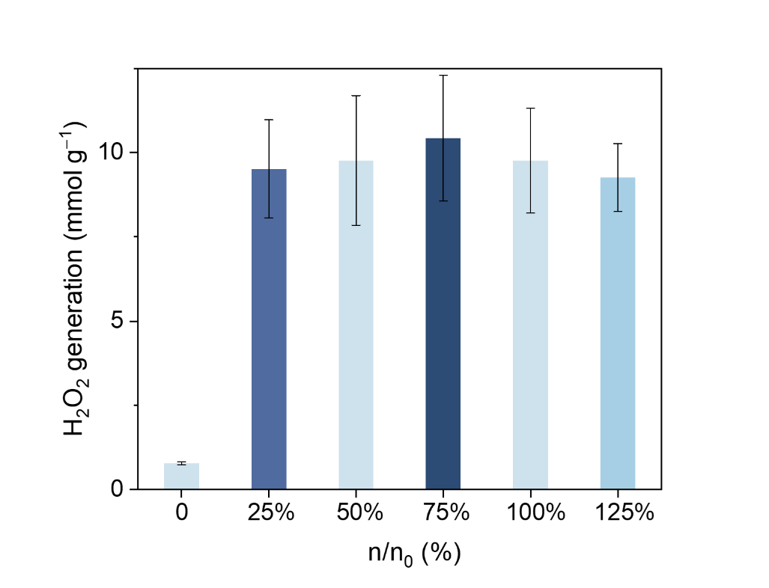
Supplementary Fig. 3. TEC reactions conducted across varying artificial seawater concentration. n₀ is the concentration of the suggested standard artificial seawater, and n is the concentration of diluted or concentrated artificial seawater.

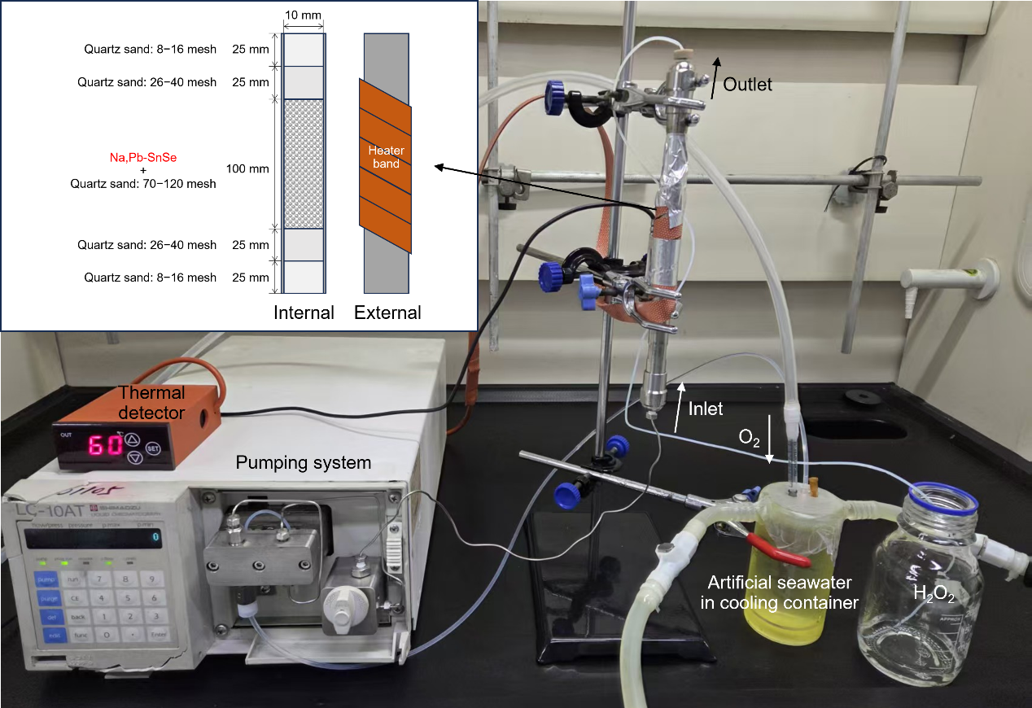
Supplementary Fig. 4. Photograph of the continuous-flow TEC reactor and schematic of the commercial stainless-steel reaction column with the internal packing structure.

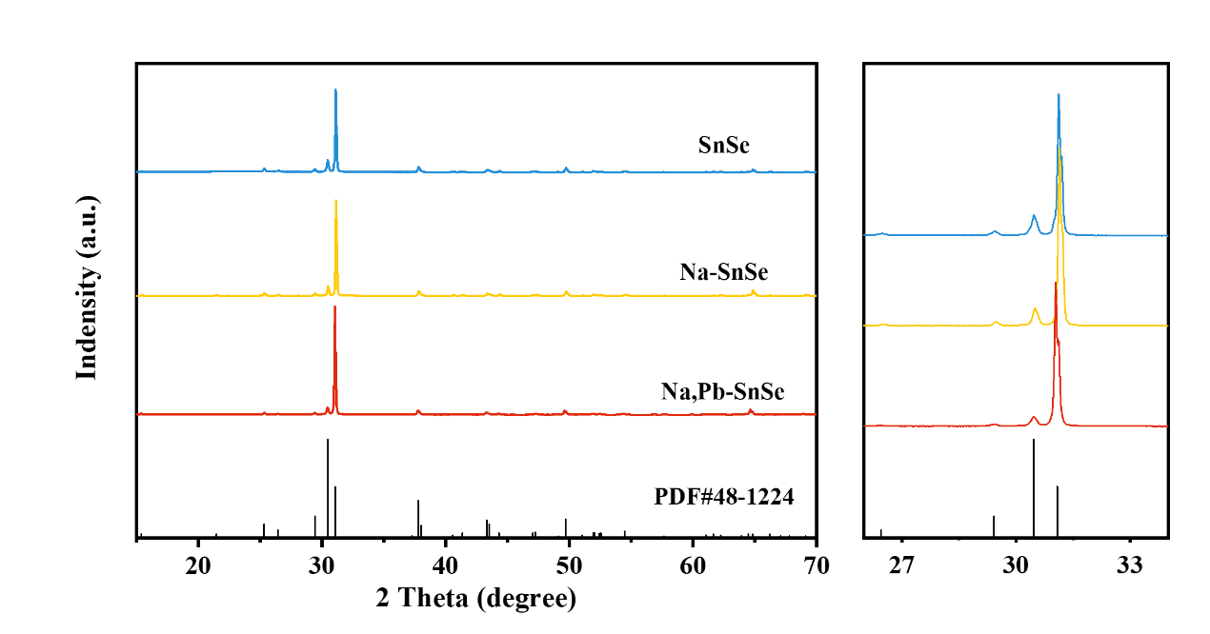
Supplementary Fig. 5. XRD patterns of powdered SnSe, Na-SnSe and Na,Pb-SnSe samples. Standard PDF card No. 48-1224 of orthorhombic Pnma phase of SnSe is also shown for comparison.

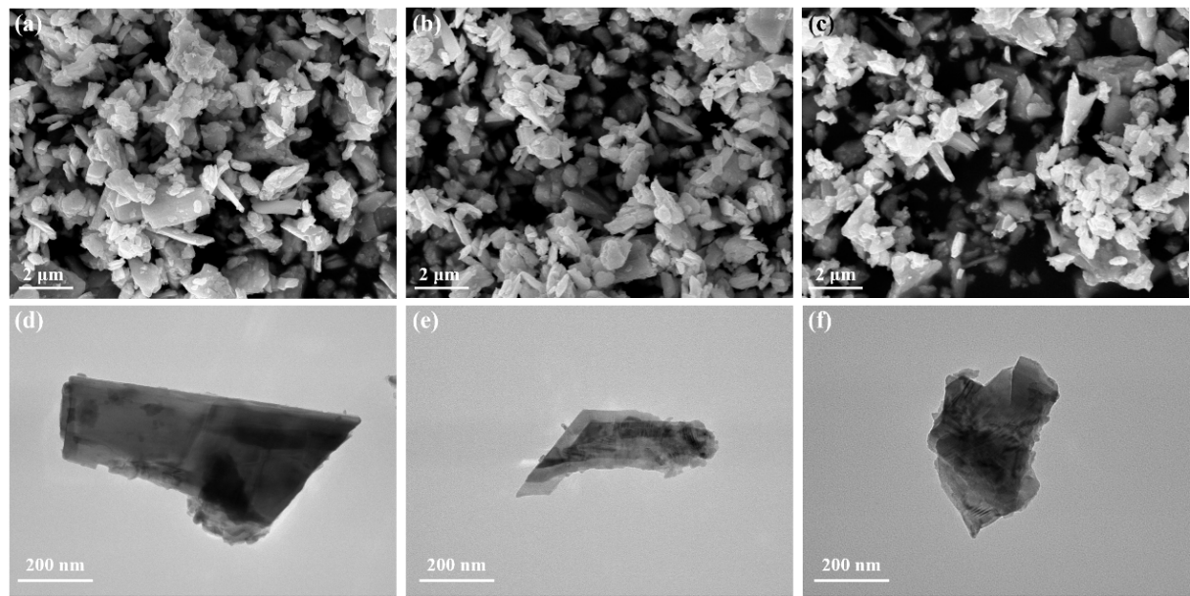
Supplementary Fig. 6. SEM images of exfoliated powdered nanocatalysts from bulk crystals: (a) SnSe, (b) Na-SnSe and (c) Na,Pb-SnSe. Corresponding TEM images of (d) SnSe, (e) Na-SnSe and (f) Na,Pb-SnSe.

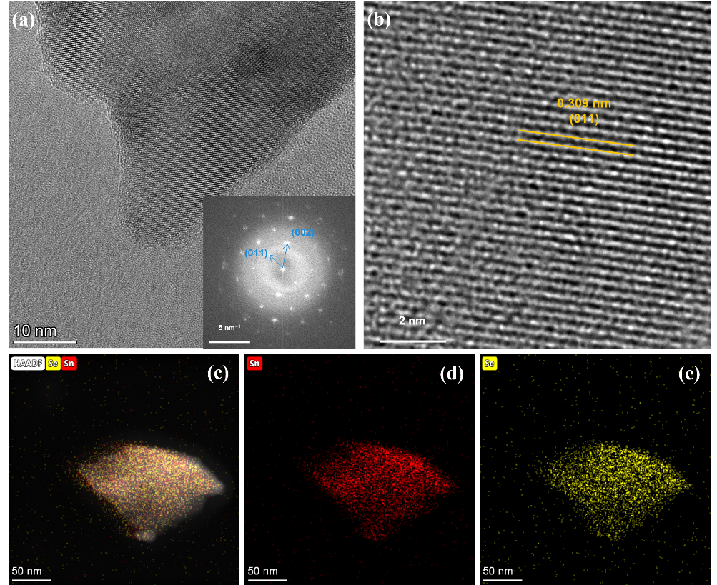
Supplementary Fig. 7. (a, b) HRTEM images (inset of a shows SAED patterns) and (c-e) EDS mappings of exfoliated SnSe nanosheets from bulk crystal.

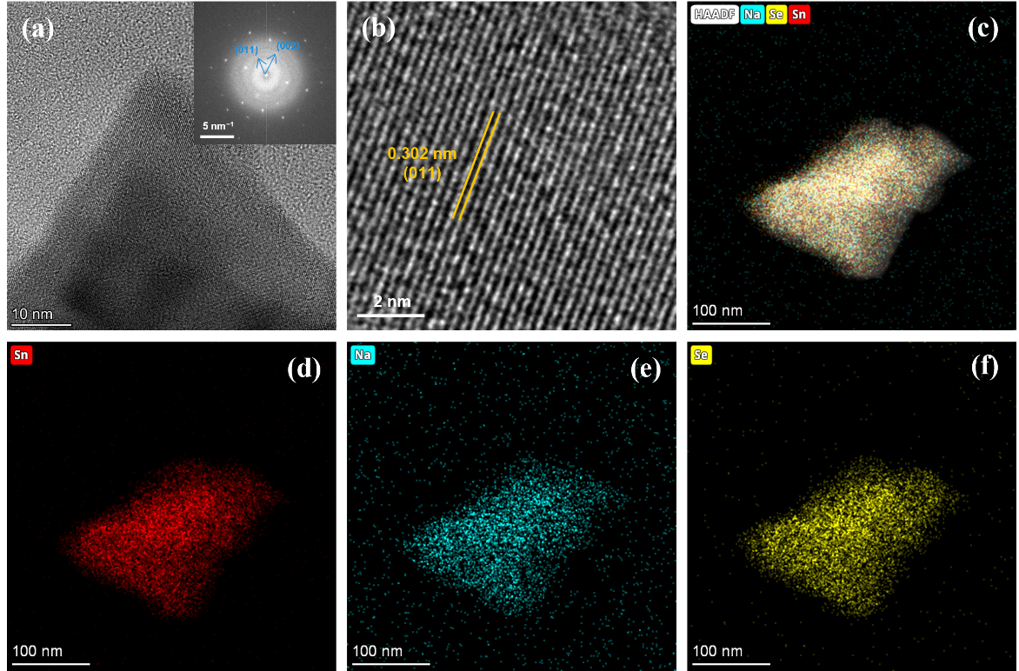
Supplementary Fig. 8. (a, b) HRTEM images (inset of a shows SAED patterns) and (c-f) EDS mappings of exfoliated Na-SnSe nanosheets from bulk crystal.

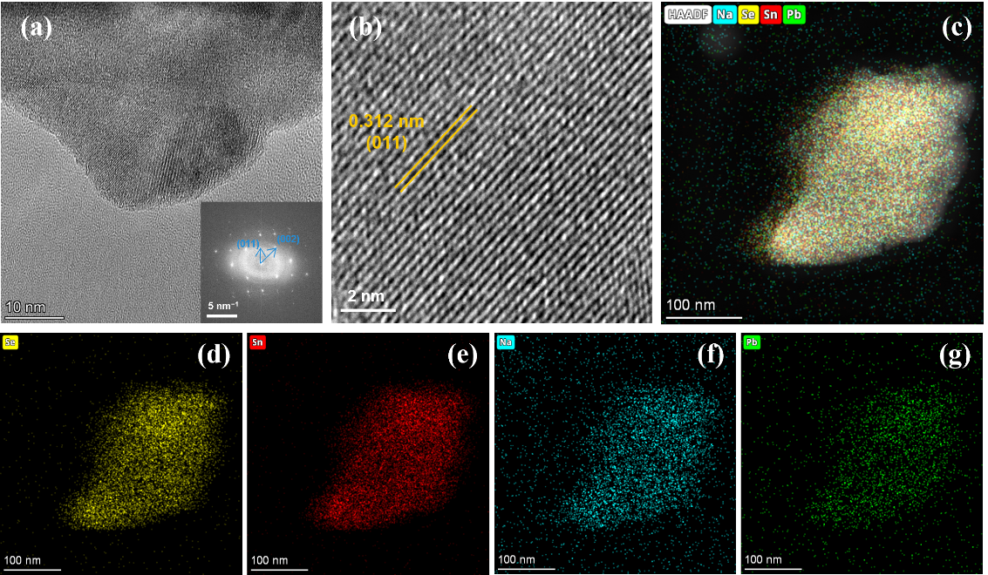
Supplementary Fig. 9. (a, b) HRTEM images (inset of a shows SAED patterns) and (c-g) EDS mappings of exfoliated Na,Pb-SnSe nanosheets from bulk crystal.

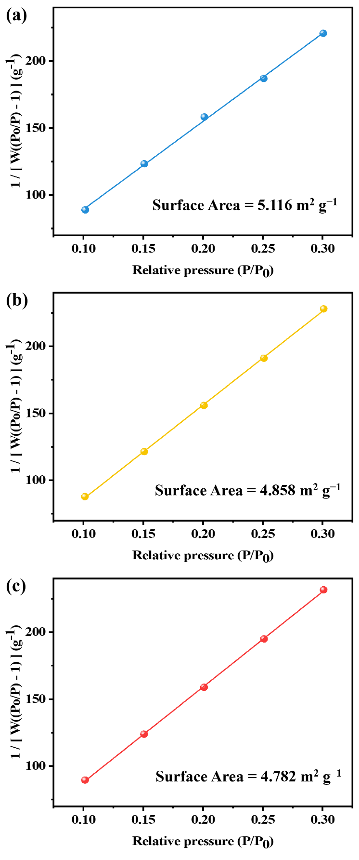
Supplementary Fig. 10. Specific surface area analysis of (a) SnSe, (b) Na-SnSe and (c) Na,Pb-SnSe nanosheets exfoliated from bulk crystals.

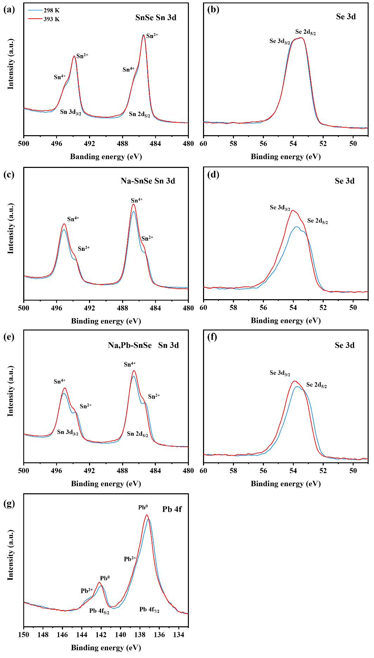
Supplementary Fig. 11. High-resolution XPS spectra of (a, b) SnSe, (c, d) Na-SnSe and (e-g) Na,Pb-SnSe nanosheets under different temperatures.

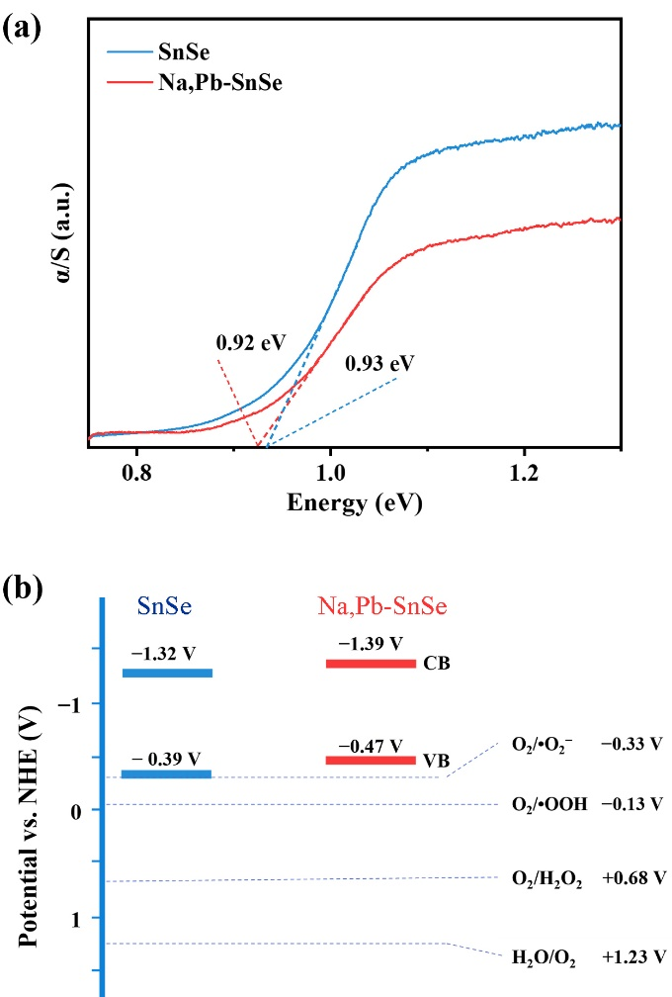
Supplementary Fig. 12. (a) Bandgap calculation and (b) schematic band structure of SnSe and Na,Pb-SnSe. The bandgap was achieved by converting reflectance data obtained by UV-Vis DRS to absorption data through the Kubelka-Munk equation: α/S = (1/2R)²/(2R), where R is the reflectance, and α and S are the absorption and scattering coefficients, respectively. E_{g} is estimated by the Tauc plots. The conversion from vacuum energy (E_{VB-vac}) to the potential versus the normal hydrogen electrode (E_{VB-NHE}) is achieved through the following relation: E_{VB-NHE} = − E_{VB-vac} − 4.5.

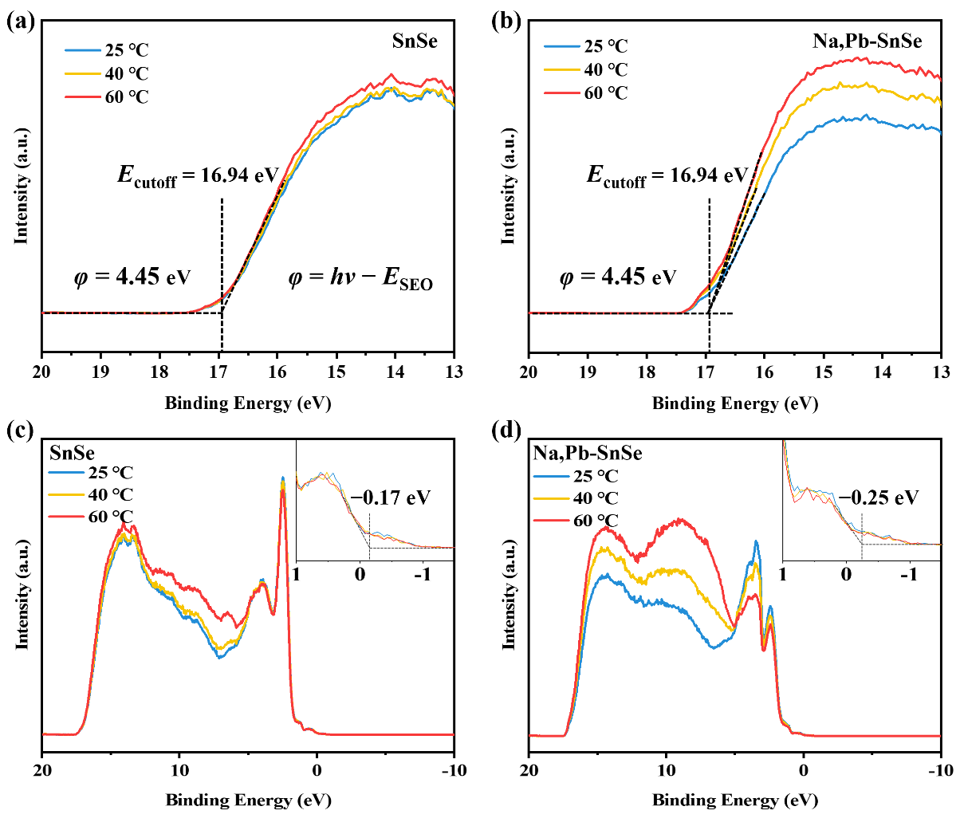
Supplementary Fig. 13. UPS spectra of (a, c) SnSe and (b, d) Na,Pb-SnSe under different temperatures. The photon energy hν (21.22 eV) corresponds to monochromatic ionizing radiation, whereas E_{cutoff} refers to the secondary-electron cutoff derived from the linear extrapolation in UPS spectra. The work function (φ) is calculated by the formula: φ = hν – E_{cutoff}. The valence band potential (E_{VB}) was determined using the formula: E_{VB} = E_{F} – E_{VBE}.^{1, 2} Here, E_{f} represents the Fermi level (E_{f} = –φ), and E_{VBE} is the valence band edge energy derived from extrapolation of UPS spectrum onsets.

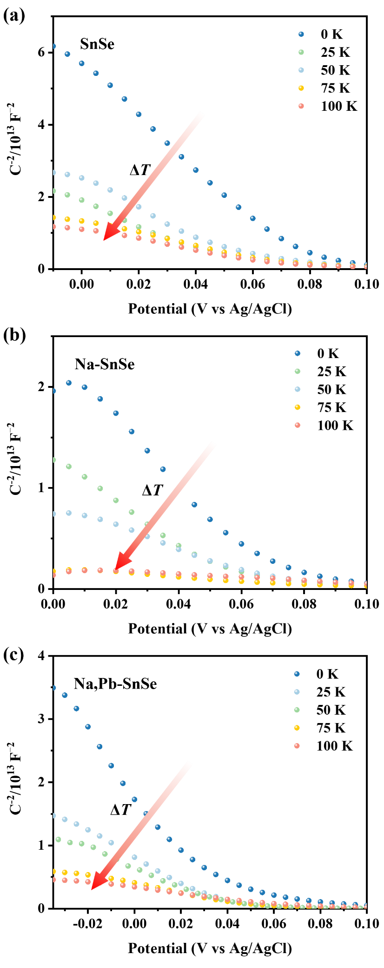
Supplementary Fig. 14. Mott-Schottky plots of (a) SnSe, (b) Na-SnSe and (c) Na,Pb-SnSe nanosheets-based electrodes under different ΔT.

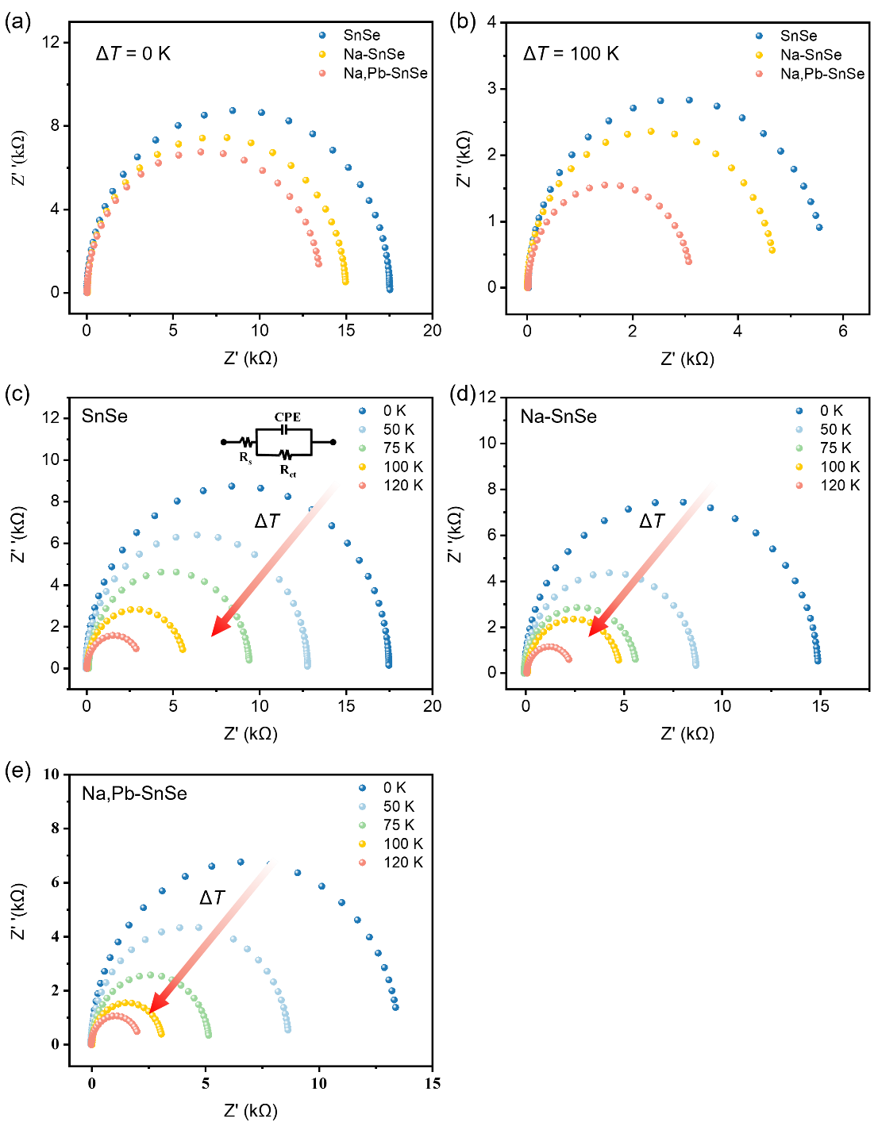
Supplementary Fig. 15. EIS Nyquist plots of SnSe, Na-SnSe and Na,Pb-SnSe nanosheets-based electrodes without ΔT (a), under the same ΔT = 100 K, (b) and under different ΔT (c–e).

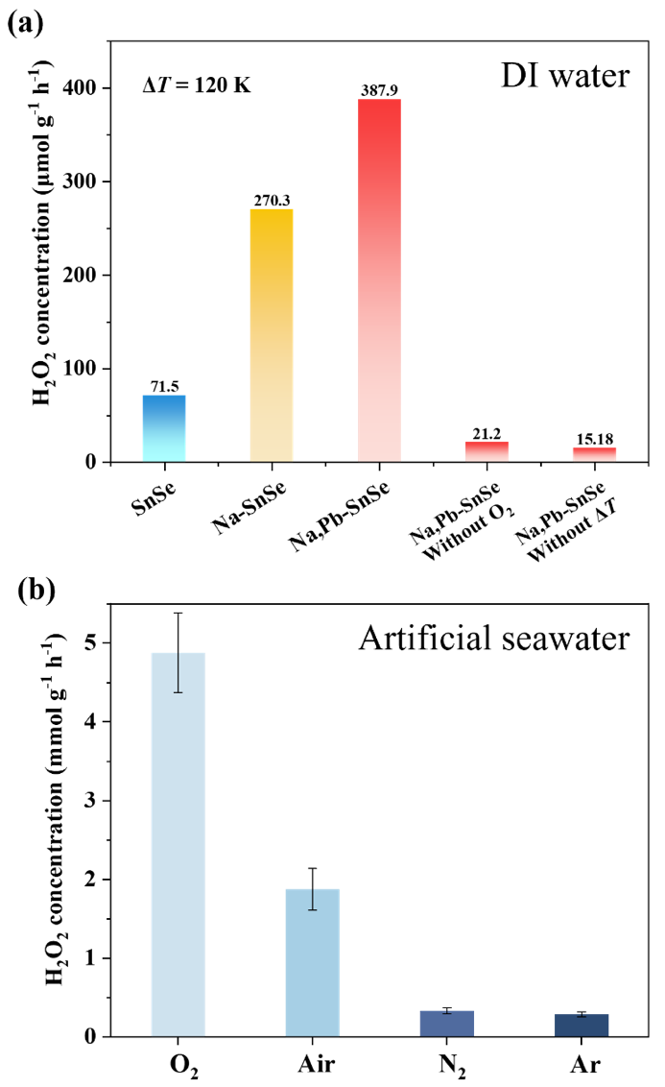
Supplementary Fig. 16. (a) Comparison of H₂O₂ evolution in DI water of different samples under different conditions. (b) Comparison of H₂O₂ evolution in artificial seawater over Na,Pb-SnSe nanosheets under different atmospheres.

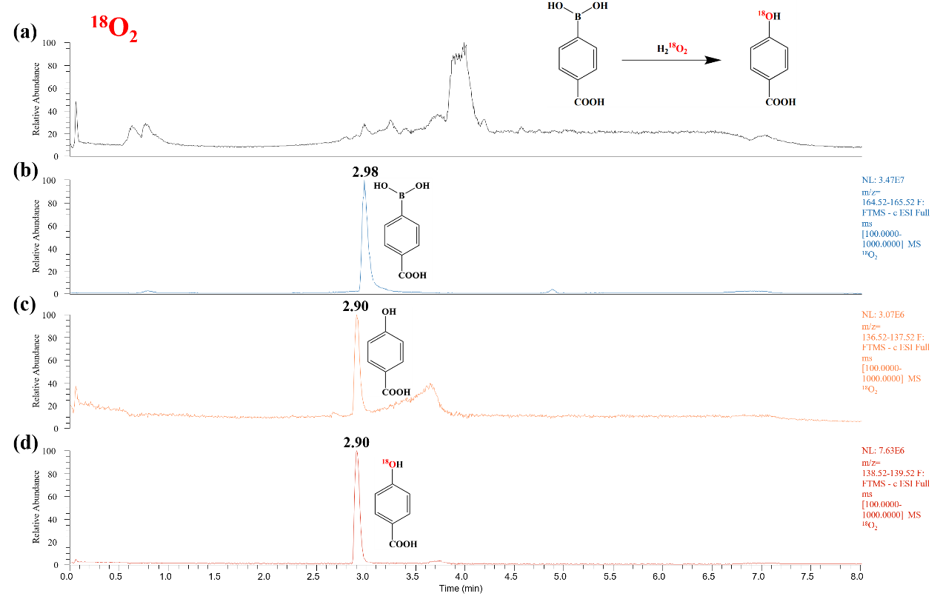
Supplementary Fig. 17. Total ion chromatogram (a) and extracted Ion Spectra (b–d) for ¹⁸O₂ labelled experiment.

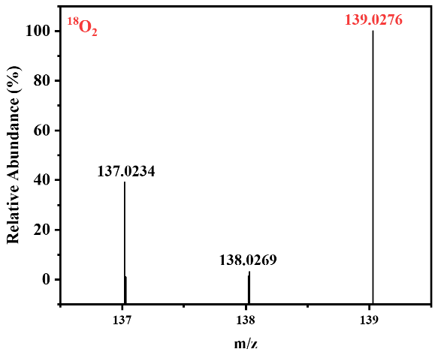
Supplementary Fig. 18. LC-MS spectrum of ¹⁸O₂ labeled experiments.

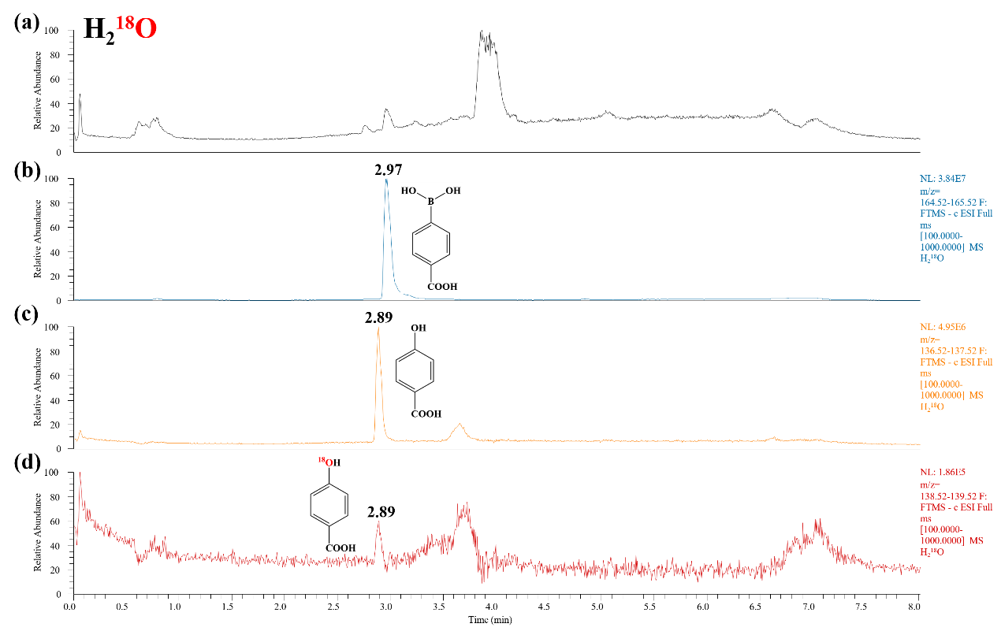
Supplementary Fig. 19. Total Ion Chromatogram (a) and extracted Ion Spectra (b–d) for H₂¹⁸O labelled experiment.

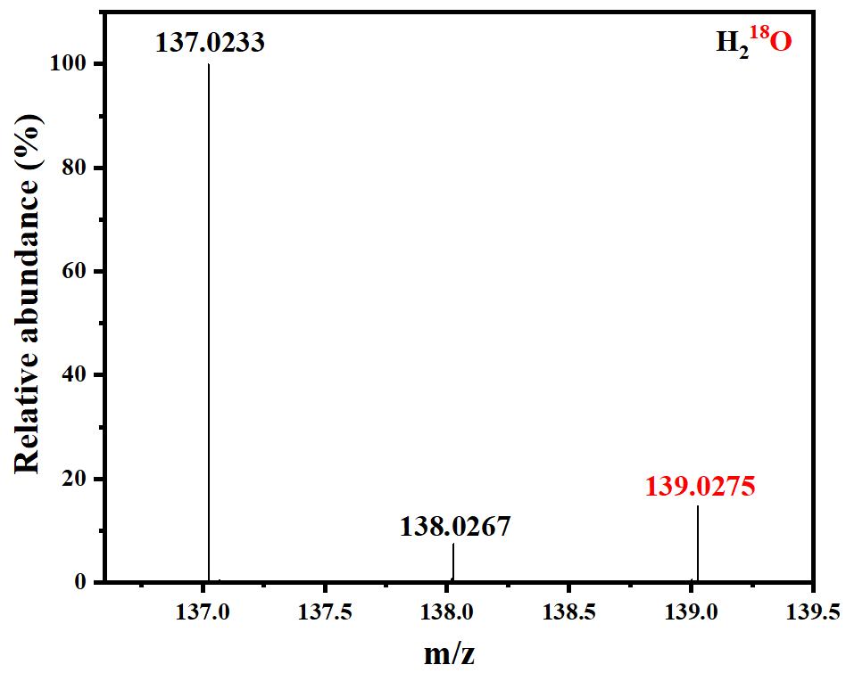
Supplementary Fig. 20. Mass spectrum of H₂¹⁸O labeled experiments.

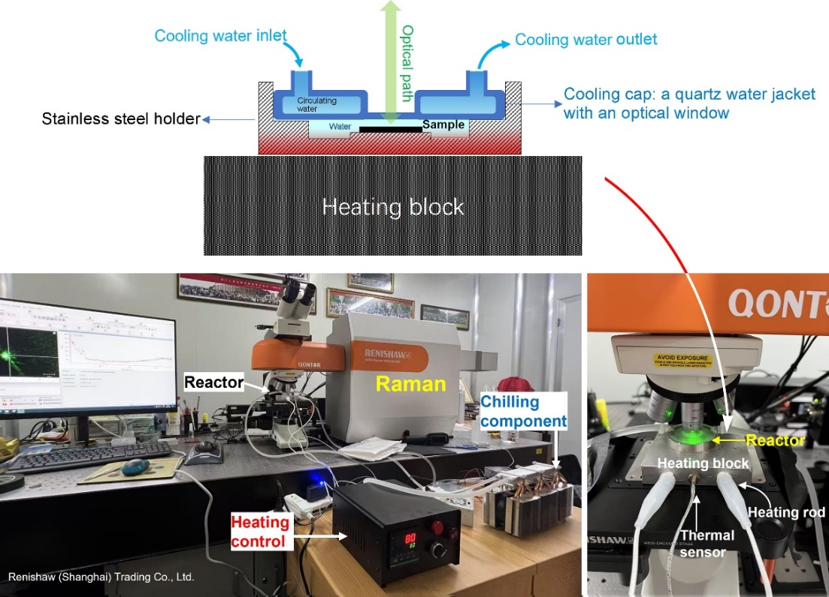
Supplementary Fig. 21. Schematic illustration of the experimental setup for in situ Raman tests (upper) and photo-images of the home-designed measurement system (lower).

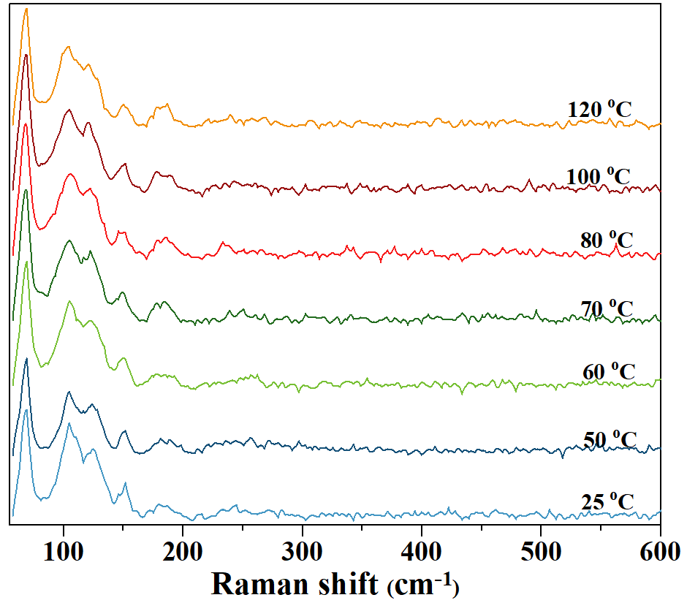
Supplementary Fig. 22. In situ Raman spectra of Na,Pb-SnSe dry powder catalyst at different temperatures in air.

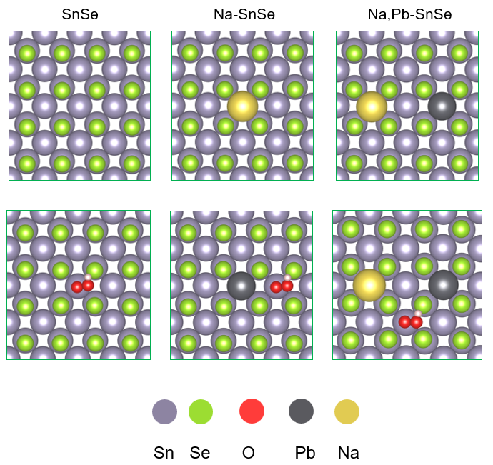
Supplementary Fig. 23. Computational models and the most stable OOH adsorption configurations for SnSe, Na-SnSe, and Na,Pb-SnSe, respectively.

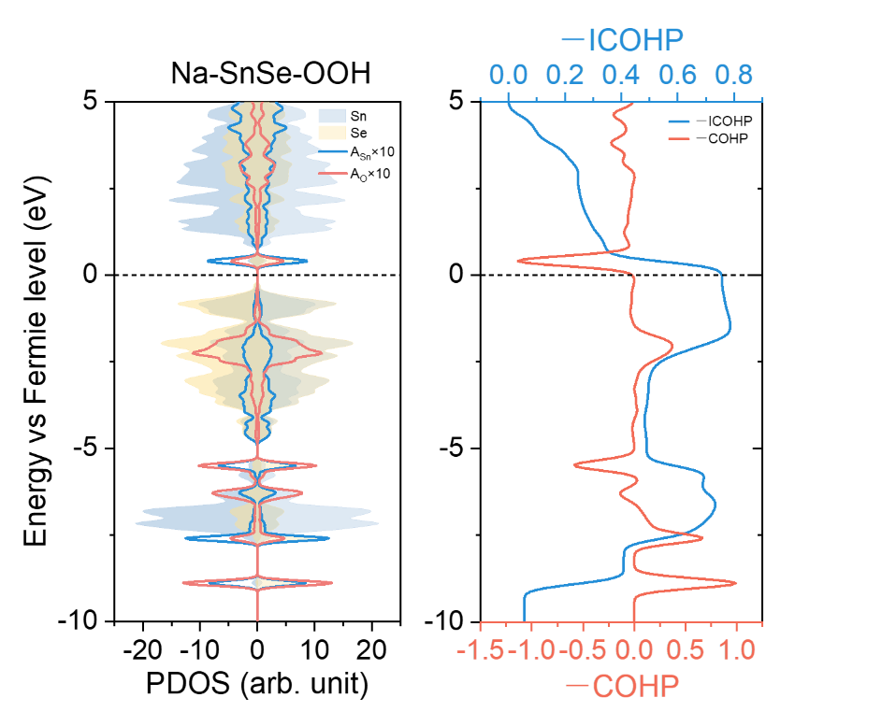
Supplementary Fig. 24. PDOS and COHP analysis of the Sn‒OOH interaction on Na-SnSe.
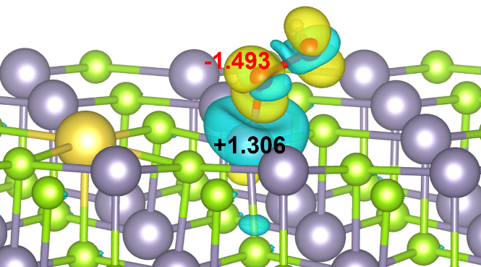
Supplementary Fig. 25. Differential charge-density plots of OOH adsorption on Na,Pb-SnSe; yellow and blue regions denote electron accumulation and depletion, respectively.

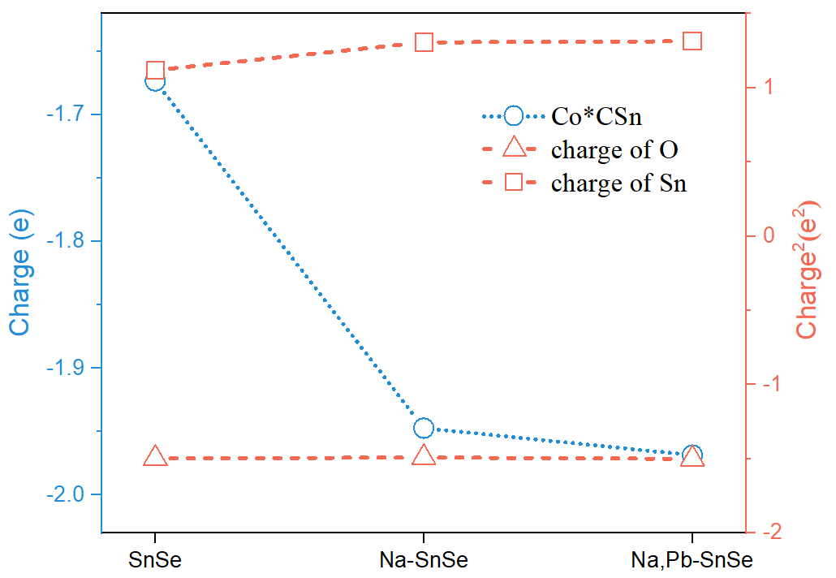
Supplementary Fig. 26. Bader charge analysis of Sn and O atoms for the O‒OOH bond on SnSe, Na-SnSe and Na,Pb-SnSe.

Table S1. Comparison of represented work of photocatalysis and piezocatalysis for H₂O₂ production.
Catalysts | Catalytic  conditions | H₂O₂ evolution rates (mmol·g⁻¹·h⁻¹) | Refs.
Co-N@G | Sunlight | 0.35 | Nat. Commun. 2023, 14, 2493
ZnIn₂S₄ nanosheets | Visible-light | 1.7 | J. Am. Chem. Soc. 2023, 145, 27757
COTh-PAFs | Visible-light | 3.9 | Angew. Chem. Int. Ed. 2024, 63, e202402095
CN-PDA | Visible-light | 0.74 | Angew. Chem. Int. Ed. 2024, 63. e202319216
DPT-MOF | Visible-light | 1.7 | J. Am. Chem. Soc. 2024, 146, 11319
COF-S-OH | Visible-light | 10.2 | Angew. Chem. Int. Ed. 2025, 64, e202511024
COF/MoS₂ | Visible-light | 8.2 | Angew. Chem. Int. Ed. 2025, 64, e202505491
COF-TPT-Azo | Visible-light | 1.5 | Angew. Chem. Int. Ed. 2024, 63, e202409250
BTT-H3 COF | λ = 467 nm | 1.6 | Nat. Commun. 2025, 16, 503
DBS-C/Z | Visible-light | 1.42 | Angew. Chem. Int. Ed. 2025, e202508226
PBCPs | Visible-light | 2.6 | Angew. Chem. Int. Ed. 2025, 64, e202425054
Si-CDs | Visible-light | 1.4 | Angew. Chem. Int. Ed. 2025, 64, e202509790
TpAP | Visible-light | 2.3 | J. Am. Chem. Soc. 2025, 147, 16, 13618
DT₂TA-TAPB | Visible-light | 8.6 | Nat. Commun. 2025, 16, 5658
Au/Cu-Zn₃In₂S₆ | UV-vis light | 5.7 | Adv. Mater. 2025, 37, e11422
O-Ru-ZIS | λ = 350-780 nm | 3.7 | Adv. Mater. 2025, 37, e09867
CTN | Ultrasonication 100 W/40 kHz | 4.1 | Angew. Chem. Int. Ed. 2025, 64, e202419867
CQDs-C₃N₅ | Ultrasonication 100 W/40 kHz | 5.0 | Angew. Chem. Int. Ed. 2025, 64, e202502390
Sn_{0.9}Se nanosheets | 40 ℃, pure water | 2.6 | Nat. Catal. 2025, 8, 465
Na,Pb-SnSe | ΔT = 120 K seawater | 6.1 | This work

Table S2. Comparison of H₂O₂ production activity from seawater with previously reported representative work.
Catalysts | Catalytic  conditions | H₂O₂ evolution rates in seawater (mmol·g⁻¹·h⁻¹) | H₂O₂ evolution rates in DI water (mmol·g⁻¹·h⁻¹) | Refs.
PM-CDs | Visible light | 1.8 | 1.3 | Nat. Commun. 2021, 12, 483
TD-COF | White LED light (400-700 nm) | 3.4 | 4.1 | Angew. Chem. Int. Ed. 2023, 62, e202309624
TB-COF | White LED light (400-700 nm) | 4.1 | 5.2 | ACS Catal. 2024, 14, 4728
3D COFs | Visible light | 6.9 | 7.9 | Adv. Funct. Mater. 2024, 34, 2411077
ECUT-COF | Xenon lamp light | 2.4 | 3.4 | Nano Lett. 2024, 24, 3819
TBA-COF | Visible light | 8.9 | 3.9 | Adv. Funct. Mater. 35, 2025, 2421514
UP-TP | Visible light | 3.8 | 2.1 | Adv. Funct. Mater. 35, 2025, 2414755
BiOBr | Ultrasonication 110 W/37 kHz | 0.23 | 0.46 | Adv. Funct. Mater. 2024, 34, 2411464
Bi₂O₂(OH)(NO₃) | Ultrasonication 300 W/40 kHz | 0.20 | 0.97 | Adv. Mater. 2025, 37, 2505592
Na,Pb-SnSe | ΔT = 120 ℃ | 6.1 | 0.39 | This work

References:
(1) Su, B.; Zheng, M.; Lin, W.; Lu, X. F.; Luan, D.; Wang, S.; Lou, X. W. S-scheme Co₉S₈@Cd_{0.8}Zn_{0.2}S-DETA hierarchical nanocages bearing organic CO₂ activators for photocatalytic syngas production. Adv. Energy Mater. 2023, 13 (15), 2203290. DOI: https://doi.org/10.1002/aenm.202203290.
(2) Braun, S.; Salaneck, W. R.; Fahlman, M. Energy-Level Alignment at Organic/Metal and Organic/Organic Interfaces. Adv. Mater. 2009, 21 (14-15), 1450-1472. DOI: https://doi.org/10.1002/adma.200802893.

