Supplementary Table 1 | Soil properties and total elemental composition. Soil chemical properties and elemental composition. Total element composition was obtained by X-ray fluorescence (SPECTRO XEPOS, SPECTRO Analytical Instrument).
Soil | OC  class | pH_{CaCl2}¹  [-] | Al_{XRF}  [%] | Ca_{XRF}  [%] | Fe_{XRF}  [%] | K_{XRF}  [%] | Si_{XRF}  [%]
Clay | High-OC | 5.67 | 6.9 | 0.8 | 3.4 | 1.4 | 28.7
Clay | Low-OC | 5.91 | 8.1 | 0.6 | 4.0 | 3.0 | 32.6
Loam | High-OC | 4.63 | 2.9 | 4.9 | 2.7 | 1.1 | 24.2
Loam | Low-OC | 5.79 | 6.5 | 1.7 | 2.1 | 2.2 | 33.8
Sand | High-OC | 5.25 | 2.2 | 1.6 | 0.7 | 0.7 | 21.9
Sand | Low-OC | 6.66 | 2.1 | 0.2 | 0.3 | 0.7 | 40.7
¹obtained ref.¹

Supplementary Table 2 | Mid-infrared spectra subtraction factors. Subtraction factor for each sample used in EQ. 1 to obtain the organic matter enhanced spectra.
Soil | OC  class | SF
Clay | High-OC | 0.45
Clay | Low-OC | 0.79
Loam | High-OC | 0.35
Loam | Low-OC | 0.63
Sand | High-OC | 0.29
Sand | Low-OC | 0.59

Supplementary Table 3 | Organic matter composition by mid-infrared. Relative composition of organic matter in the fine fraction determined by relative peak area of peaks linked to organic functional groups, all analyzed on one composite per soil.
Soil | OC  class | Aliphatic  (C-H) | Amide II  (C-N) | Phenol  (C-OH) | Carboxylic/  Aromatic  (C=O)/(C=C) | Polyphenol/  Aromatic  (C-H)
 |  | [-] | [-] | [-] | [-] | [-]
Clay | High-OC | 0.58 | 0.03 | 0.10 | 0.15 | 0.15
Clay | Low-OC | 0.35 | 0.06 | 0.15 | 0.28 | 0.17
Loam | High-OC | 0.68 | 0.02 | 0.06 | 0.15 | 0.10
Loam | Low-OC | 0.44 | 0.03 | 0.14 | 0.22 | 0.17
Sand | High-OC | 0.75 | 0.02 | 0.05 | 0.10 | 0.08
Sand | Low-OC | 0.44 | 0.03 | 0.10 | 0.24 | 0.19
Excluding aliphatic
Clay | High-OC | - | 0.07 | 0.21 | 0.36 | 0.36
Clay | Low-OC | - | 0.09 | 0.22 | 0.43 | 0.26
Loam | High-OC | - | 0.06 | 0.17 | 0.45 | 0.32
Loam | Low-OC | - | 0.06 | 0.24 | 0.39 | 0.31
Sand | High-OC | - | 0.08 | 0.21 | 0.38 | 0.33
Sand | Low-OC | - | 0.05 | 0.18 | 0.45 | 0.33

Supplementary Table 4 | Organic matter composition from fitting of total carbon STXM C NEXAFS spectra. Relative contribution determined by peak deconvolution for all C K-edge spectra, with number of analyzed stacks per sample ± the standard error of the mean.
Soil | OC  class | n | O-alkyl | Carboxylic | Aromatic | Phenolic
 |  |  | [-] | [-] | [-] | [-]
Clay | High-OC | 4 | 0.21 ± 0.01 | 0.39 ± 0.03 | 0.16 ± 0.04 | 0.24 ± 0.01
Clay | Low-OC | 2 | 0.23 ± 0.01 | 0.46 ± 0.04 | 0.13 ± 0.07 | 0.18 ± 0.02
Loam | High-OC | 3 | 0.20 ± 0.01 | 0.44 ± 0.02 | 0.11 ± 0.02 | 0.24 ± 0.01
Loam | Low-OC | 2 | 0.23 ± 0.03 | 0.51 ± 0.01 | 0.13 ± 0.04 | 0.13 ± 0.01
Sand | High-OC | 4 | 0.18 ± 0.01 | 0.35 ± 0.03 | 0.22 ± 0.01 | 0.26 ± 0.02
Sand | Low-OC | 3 | 0.21 ± 0.01 | 0.43 ± 0.02 | 0.12 ± 0.02 | 0.24 ± 0.03

Supplementary Table 5 | NanoSIMS particle coverage. Total analyzed particle areas and proportion of mineral surfaces, organic matter dominated and ¹³C co-located to mineral surfaces and organic matter for all analysed regions (in brackets the proportion of total ¹³C co-located organic matter).
Soil | OC  class | Area | Mineral dominated | Organic matter dominated | Mineral co-located ¹³C | Organic matter co-located ¹³C
 |  | [µm²] | [%] | [%] | [%] | [%]
Clay | High-OC | 163.1 | 88.4 | 11.2 | 0.29 (73) | 0.11 (28)
Clay | Low-OC | 194.8 | 93.4 | 6.5 | 0.06 (86) | 0.01 (14)
Loam | High-OC | 302.7 | 79.2 | 20.1 | 0.26 (36) | 0.46 (64)
Loam | Low-OC | 580.2 | 94.6 | 4.8 | 0.50 (83) | 0.10 (17)
Sand | High-OC | 335.9 | 62.3 | 35.6 | 0.38 (18) | 1.69 (82)
Sand | Low-OC | 393.5 | 90.7 | 8.8 | 0.36 (71) | 0.15 (29)

Supplementary Table 6 | Overlap of total organic carbon established with the multimodal methods. After aligning STXM C NEXAFS and NanoSIMS for each region of interest of each sample, the proportion of overlap was calculated for both methods. In addition, the proportion of locations where one of each method showed separate carbon signals were calculated. For this, the total carbon area of each method were masked to remove noise, similar to the data presented in Fig. 3 and Supplementary Figure 5. All values are shown as average with standard error of the mean and ranges in brackets.
Soil | OC  class | n | Overlap | NanoSIMS only | STXM C NEXAFS only
 |  |  | [%] | [%] | [%]
Clay | High-OC | 4 | 47 ± 5 (35-61) | 20 ± 7 (11-39) | 33 ± 8 (13-48)
Clay | Low-OC | 2 | 14 ± 3 (9-19) | 32 ± 1 (30-34) | 54 ± 4 (47-61)
Loam | High-OC | 3 | 45 ± 8 (31-59) | 22 ± 1 (20-24) | 33 ± 9 (17-49)
Loam | Low-OC | 2 | 23 ± 4 (18-31) | 38 ± 6 (28-49) | 39 ± 3 (33-42)
Sand | High-OC | 4 | 45 ± 8 (22-61) | 44 ± 12 (20-73) | 14 ± 4 (5-21)
Sand | Low-OC | 3 | 35 ± 5 (27-44) | 32 ± 5 (21-38) | 34 ± 3 (28-38)

Supplementary Table 7 | Relative composition of ¹³C co-located organic matter. Relative composition of ¹³C co-located with mineral and organic matter as average with standard error of the mean for the included STXM C NEXAFS spectra determined after alignment with NanoSIMS masks.
 | n | O-alkyl | Carboxylic | Aromatic | Phenolic
 |  | [-] | [-] | [-] | [-]
Mineral co-located ¹³C | 5 | 0.22 ± 0.02 | 0.44 ± 0.03 | 0.13 ± 0.04 | 0.21 ± 0.02
Organic matter co-located ¹³C | 6 | 0.16 ± 0.02 | 0.35 ± 0.04 | 0.27 ± 0.08 | 0.20 ± 0.03

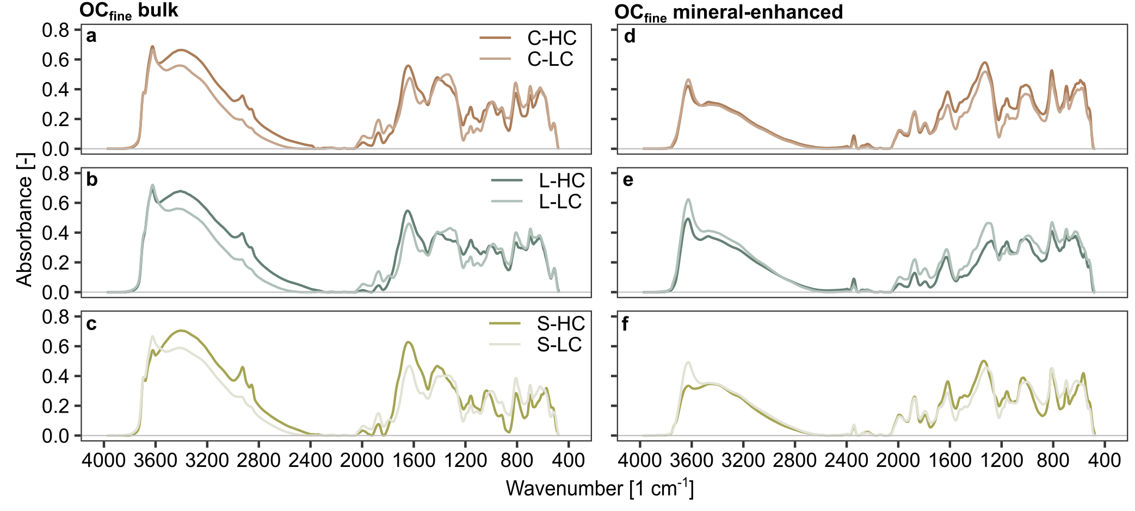Supplementary Figure 1 | Fine fraction bulk and mineral enhanced MIR spectra. (a-c) Bulk and (d-f) mineral-enriched spectra of the fine fraction of the six soils. These spectra were used for the spectral subtraction and to obtain the organic matter enhanced spectra shown in Fig.1.

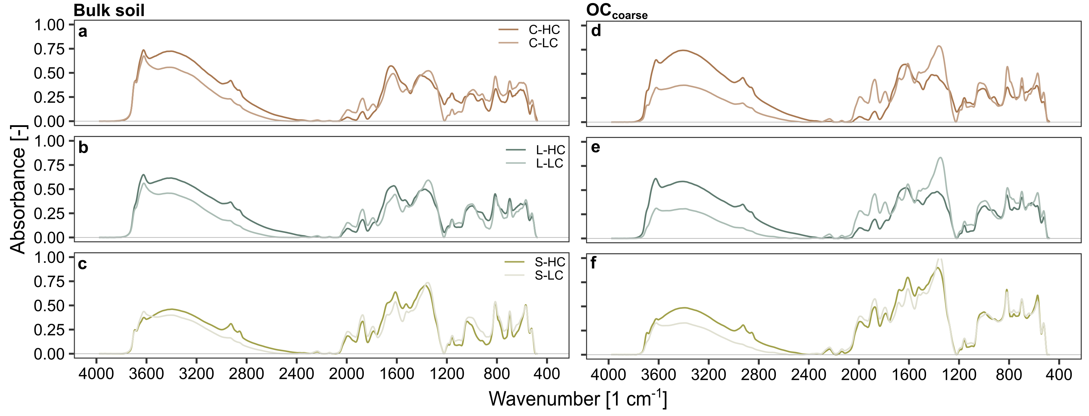
Supplementary Figure 2 | Bulk soil and coarse fraction MIR spectra. (a-c) MIR spectra of bulk soil and (d-f) OC_{coarse} fraction of the six soils.

Supplementary Text 1 - STXM C NEXAFS Inorganic-organic C separation
STXM C NEXAFS analysis identified that the clay low-OC sample had inorganic carbon (290.1 eV), which was consistently present in all spectra generated from this sample (Supplementary Fig. 3). This inorganic carbon could have precipitated from the CaCl₂ added to settle the sample during size fractionation. The presence of the inorganic carbon dominated and warped the OC signal. We thus used C Fe STXM Image Reader to separate organic from inorganic carbon in the clay low-OC sample STXM C NEXAFS stacks thereby isolating and enhancing the OC signal in the carbon K-edge spectra.
To characterize the inorganic and organic components separately, we mapped the distribution of inorganic carbon (290.1 eV) using the Sum in Band feature, normalizing average values to its shoulder with the Arithmetic function. We then used the Boolean function to separate pixels associated with inorganic carbon from OC, and separate the signal from the total carbon spectra. We checked the subtraction of inorganic carbon (reported in Fig. S3) did not affect the OC spectra. Total carbon spectra for the clay low-OC sample are presented for OC pixels that did not contain inorganic carbon, while NanoSIMS comparison spectra were removed if they contained inorganic carbon (n=1), due to the limited number of pixels present in both correlated datasets from each mask.

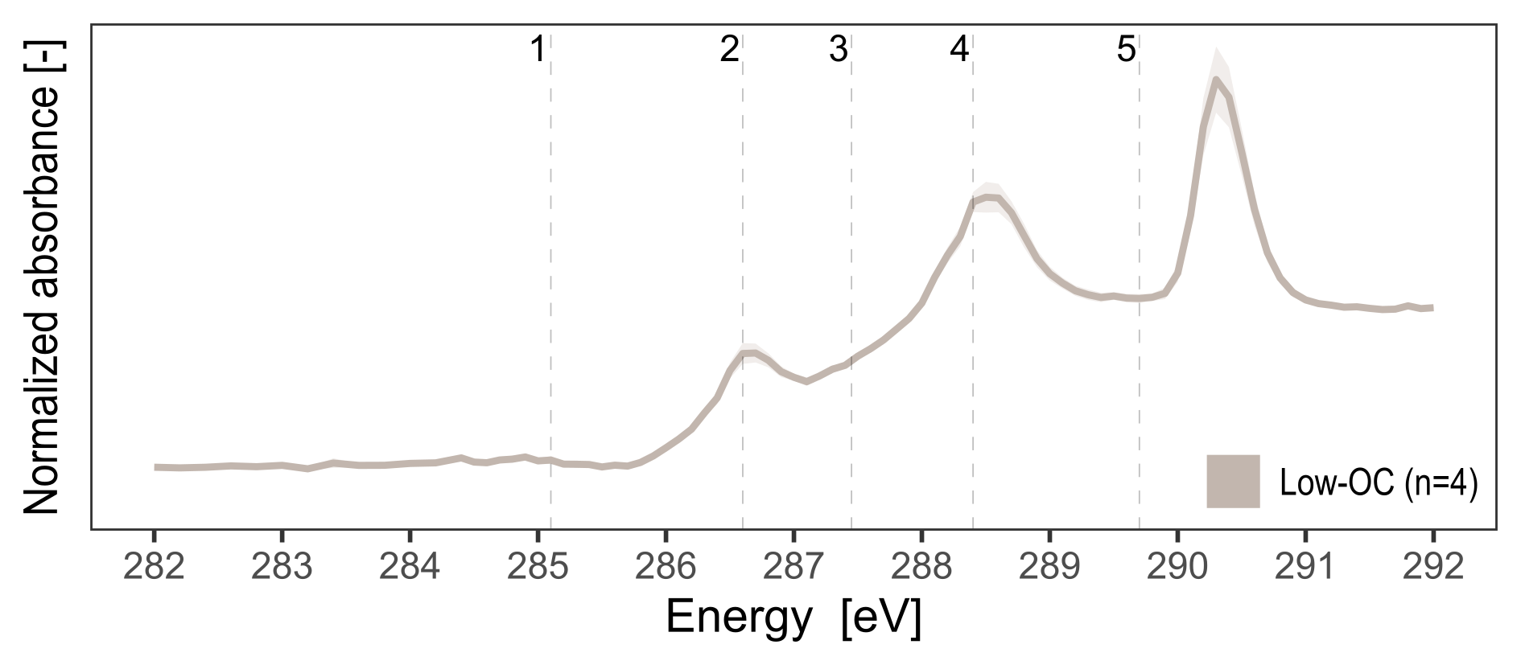
Supplementary Figure 3 | Total carbon NEXAFS spectra of the clay low carbon sample. The NEXAFS total carbon K-edge spectra for the clay low-OC as average of the regions of interest and standard error of the mean prior to inorganic carbon correction. Shaded area indicates the standard error of the mean of the replicates. Numbered annotations represent the OC forms with 1: aromatic (C=C at 285.1 eV), 2: phenolic (C=N, C-N, C=O, C-OH at 286.7 eV), 3: aliphatic (C-H at 288.0 eV), 4: carboxylic (R-COOH, COO, C=O at 288.4 eV) and 5: O-alkyl (C-OH at 289.7 eV)^{2,3}.

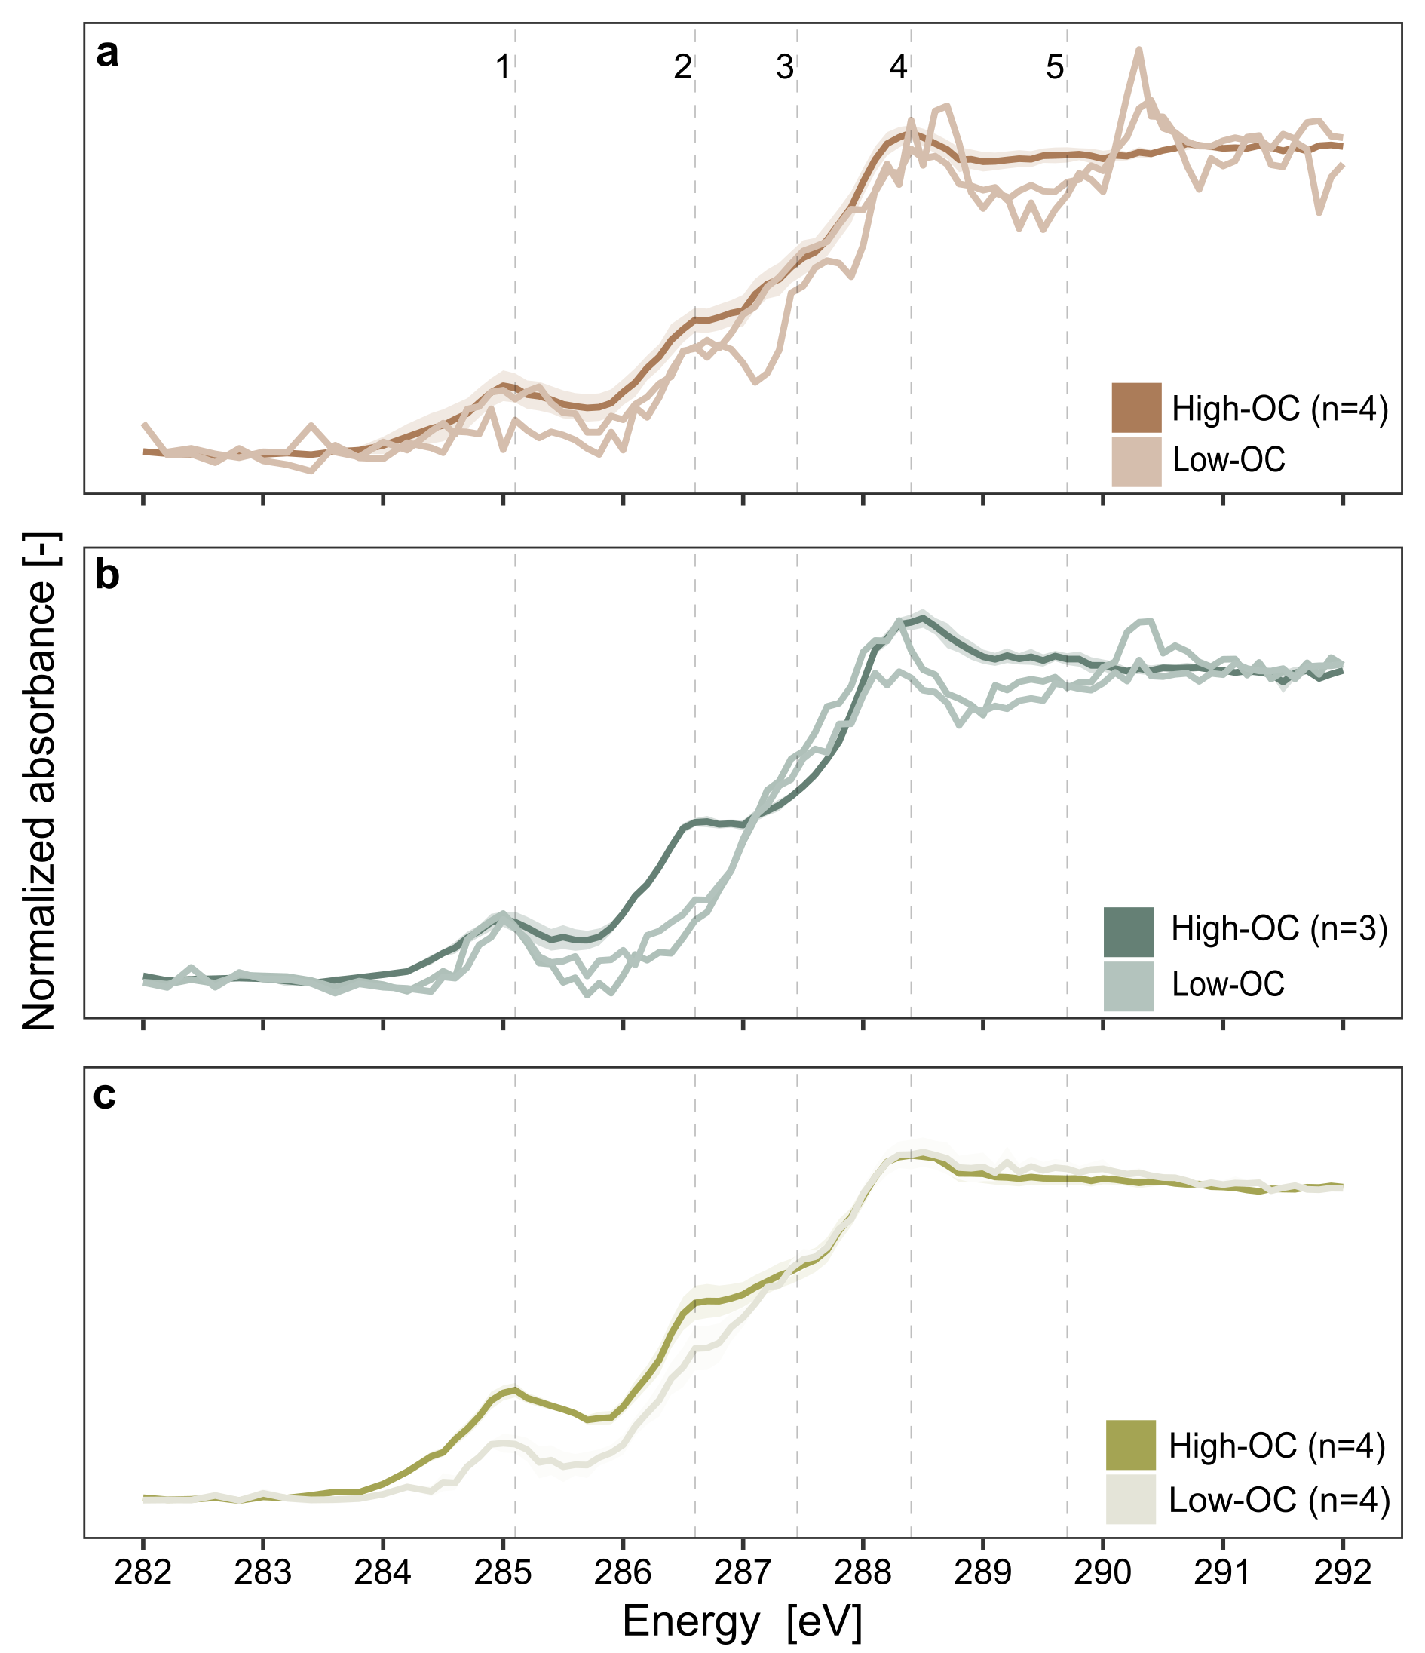
Supplementary Figure 4 | Total organic carbon STXM C NEXAFS spectra. Individual replicates and no averages for the samples with less than three regions of interests. Shaded area indicates the standard error of the mean of the replicates, when n ≥ 3. Annotation represent the OC forms with 1: aromatic (C=C at 285.1 eV), 2: phenolic (C=N, C-N, C=O, C-OH at 286.7 eV), 3: aliphatic (C-H at 288.0 eV), 4: carboxylic (R-COOH, COO, C=O at 288.4 eV) and 5: O-alkyl (C-OH at 289.7 eV)^{2,3}.

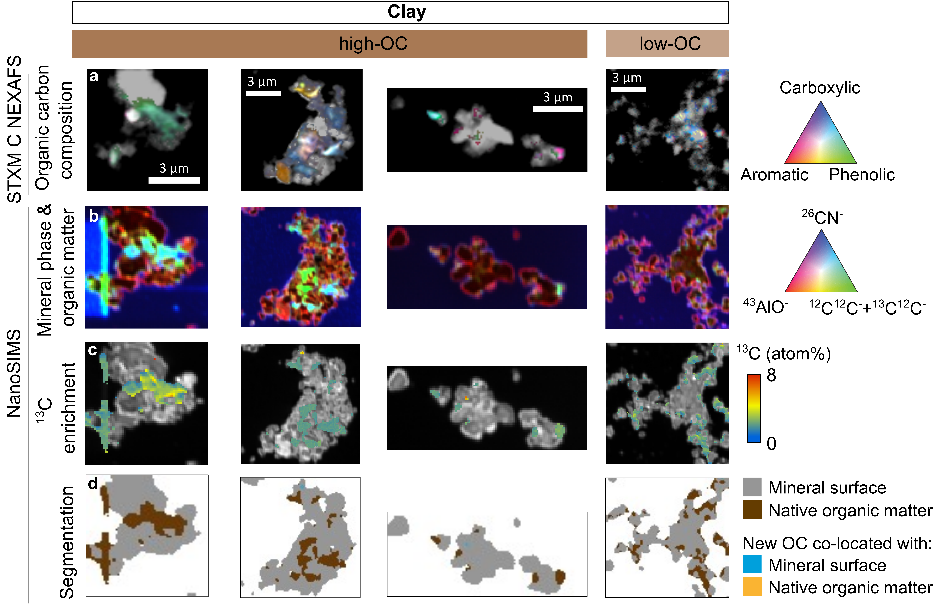
Supplementary Figure 5 | Organic matter composition and ¹³C enrichment of all the clay, loam, and sand sample pseudoreplicates (a) Multi-composition STXM C NEXAFS showing distribution carboxylic, aromatic and phenolic organic carbon (OC; grey scale indicates the optical density or thickness of particles), (b) NanoSIMS based mineral (⁴³AlO⁻), carbon (¹²C¹²C⁻+¹³C¹²C⁻) and nitrogen rich (²⁶CN⁻) elemental distribution, (c) ¹³C enrichment and (d) segments of mineral- and native organic matter-dominated regions as well as ¹³C co-located with mineral- and native organic matter-dominated regions.

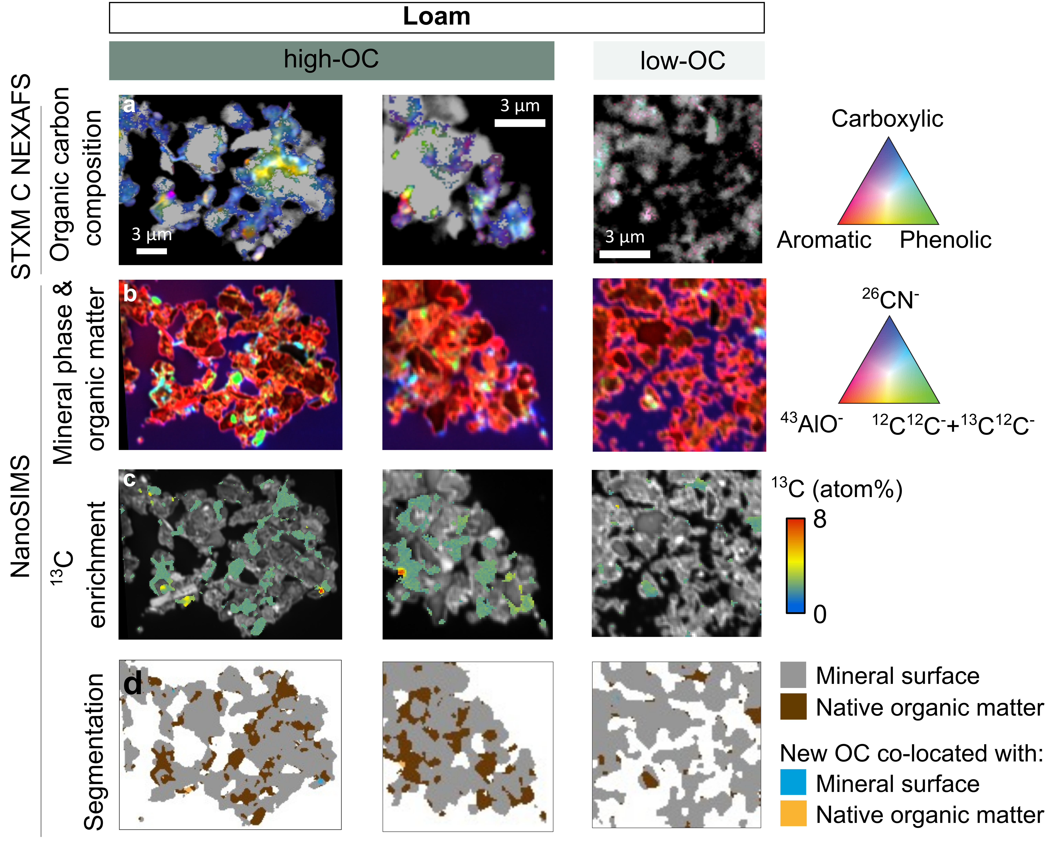
Supplementary Figure 5 |Continued

Supplementary Figure 5 |Continued

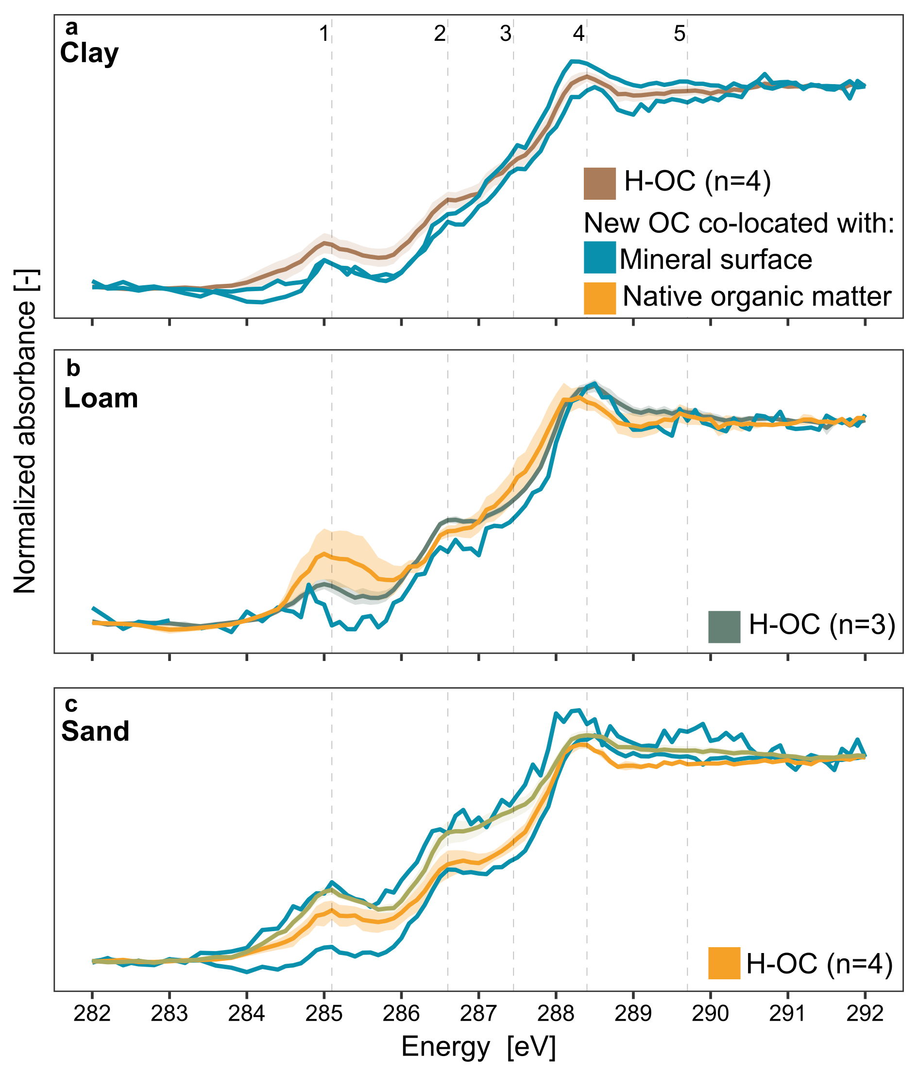
Supplementary Figure 6 | Total organic carbon and ¹³C STXM C NEXAFS spectra. STXM C NEXAFS spectra of mineral and organic matter co-located new OC identified by ¹³C masked with NanoSIMS and total OC spectra for the three soils that are shown in Fig. 4. Shaded area shows corresponding error of the mean. Numbered annotations represent the OC forms with 1: aromatic (C=C at 285.1 eV), 2: phenolic (C=N, C-N, C=O, C-OH at 286.7 eV), 3: aliphatic (C-H at 288.0 eV), 4: carboxylic (R-COOH, COO, C=O at 288.4 eV) and 5: O-alkyl (C-OH at 289.7 eV)^{2,3}.

Supplementary information references
1. Poeplau, C. et al. Erste Bodenzustandserhebung Landwirtschaft – Kerndatensatz. OpenAgrar https://doi.org/10.3220/DATA20200203151139 (2020).
2. Le Guillou, C., Bernard, S., De La Pena, F. & Le Brech, Y. XANES-Based Quantification of Carbon Functional Group Concentrations. Anal. Chem. 90, 8379–8386 (2018).
3. Lehmann, J. et al. Synchrotron‐Based Near‐Edge X‐Ray Spectroscopy of Natural Organic Matter in Soils and Sediments. in Biophysico‐Chemical Processes Involving Natural Nonliving Organic Matter in Environmental Systems (eds. Senesi, N., Xing, B. & Huang, P. M.) 729–781 (Wiley, 2009). doi:10.1002/9780470494950.ch17.

