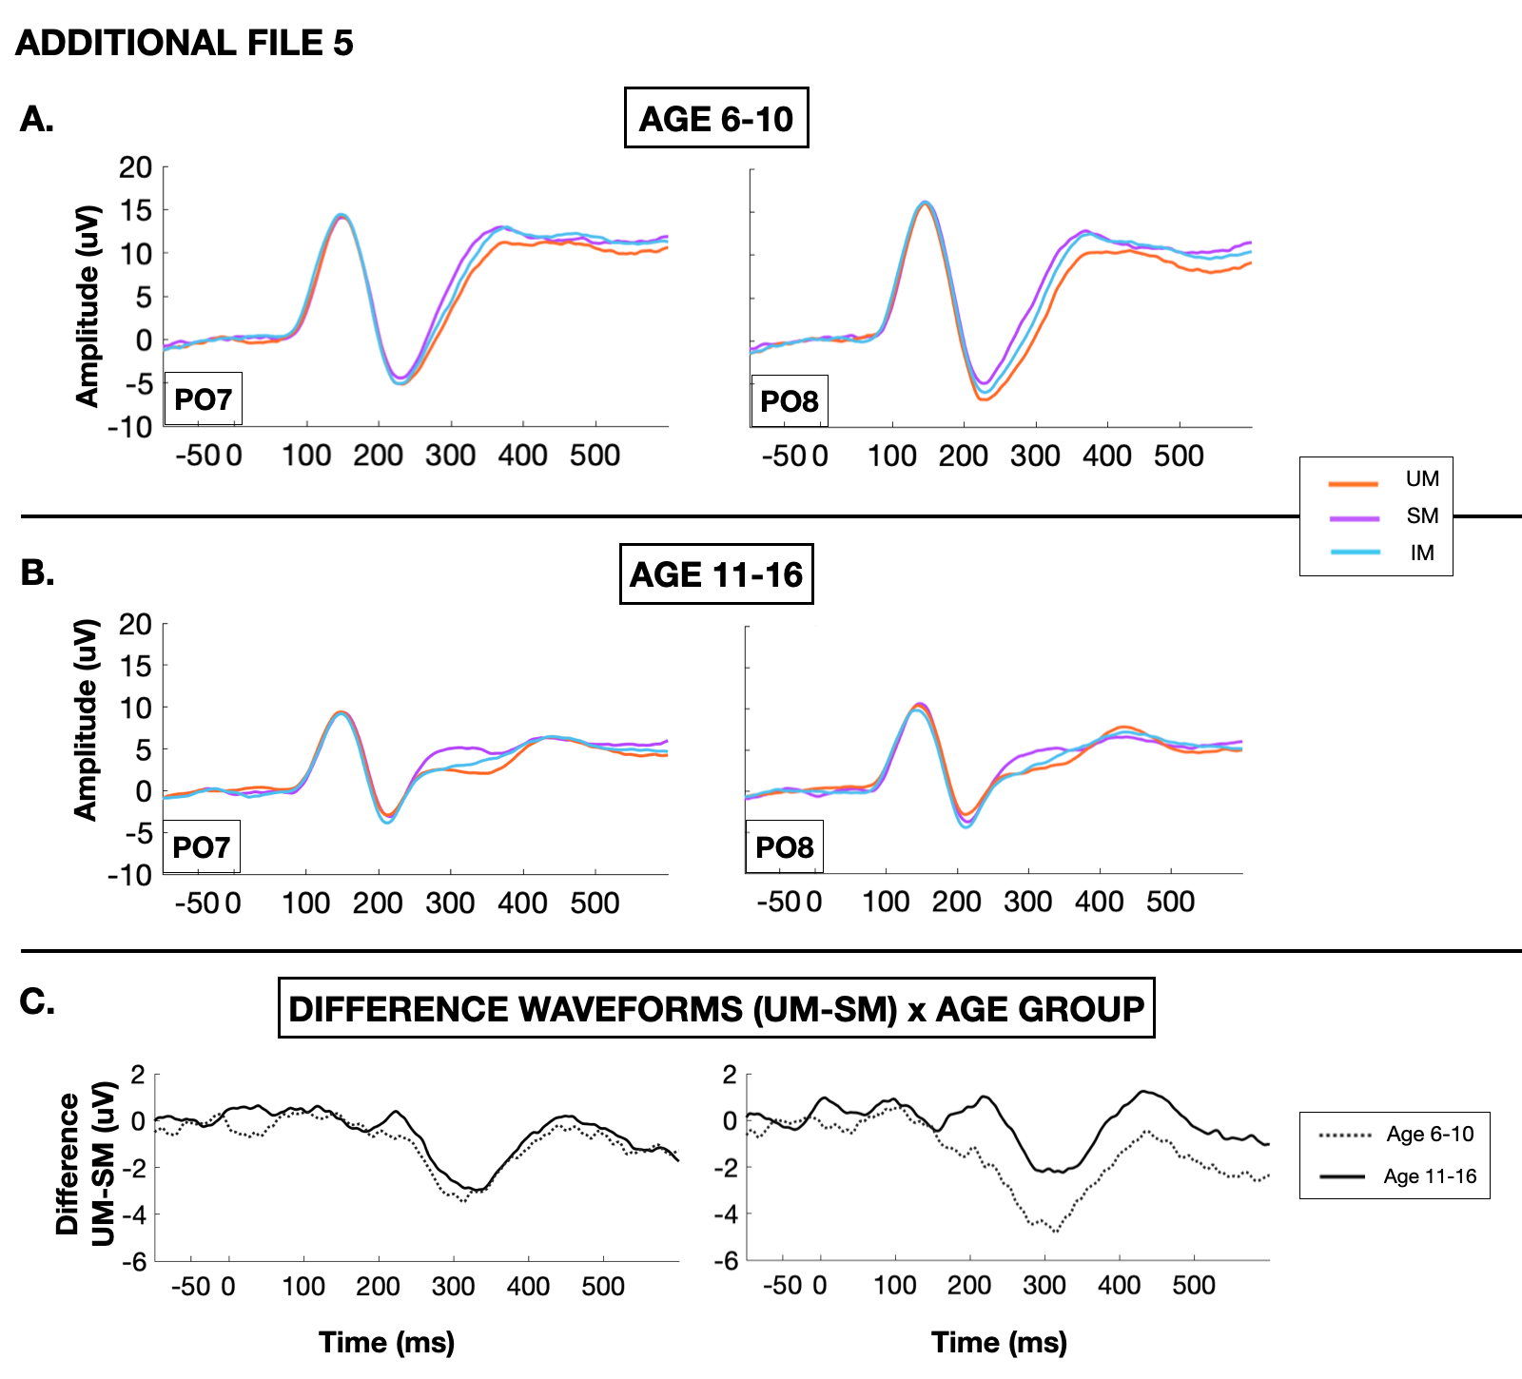
Additional File 5. Grand average visual evoked potentials at bilateral parieto-occipital sites (PO7 and PO8) obtained in A) younger participants (age 6-10) and B) older participants (age 11-16) to UM (orange), SM (purple), and IM (blue) collapsed across groups and tasks. C) Difference waveform of the evoked potential to UM minus SM in younger (dotted line) and older (solid line) participants.

