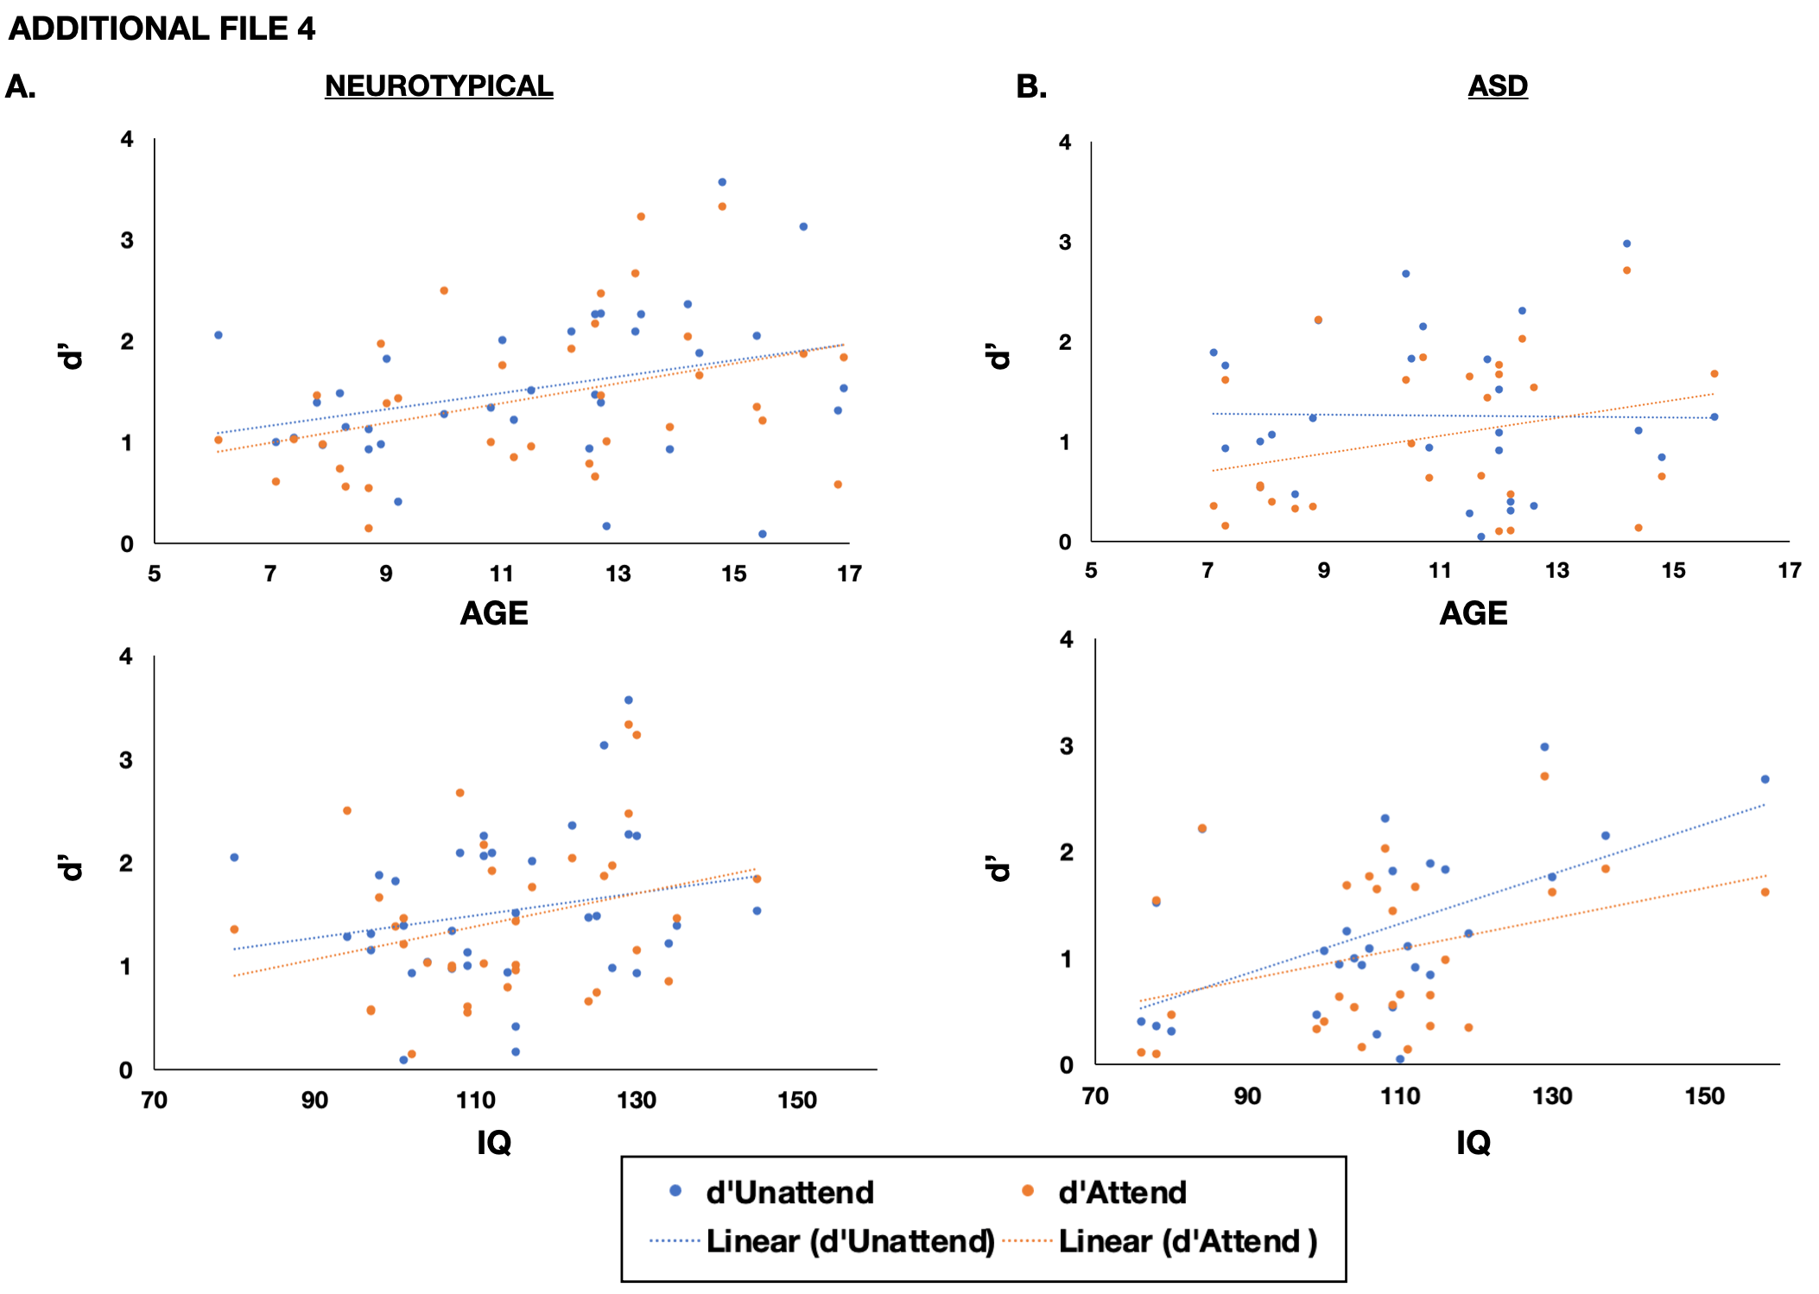
Additional File 4. Scatter plot depicting in d’ in the unattended (blue) and attended (orange) tasks with age (top panel) and IQ (bottom panel) for A) NT and B) ASD participants.

