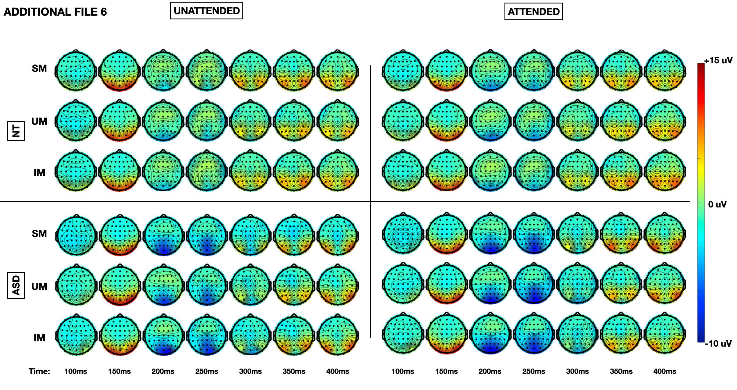
Additional File 6. Topographic representation of the instantaneous amplitude of evoked response to each of SM, UM and IM in the unattended and attended tasks for NT and ASD participants at 50ms intervals between 100-400ms post-stimulus onset.

