A Universal Size-dependent Law for Photocatalysis in Organic Nanocrystals
Junqiang Mao^{1,2,10}, Yimin Zhang^{3,4,10}, Qingrui Fan^{1,7}*, Xiaoran Chen¹, Bo Guan², Shasha Li², Jing Li¹, Sheng Meng^{4,5,6}*, Zihao Xu²*, Jianjun Wang^{1,7,8,9}*

¹Interdisciplinary Research Center for Advanced Materials, Technical Institute of Physics and Chemistry, Chinese Academy of Sciences, Beijing 100190, China.
²Institute of Chemistry, Chinese Academy of Sciences, Beijing 100190, China.
³Key Laboratory of Material Physics, Ministry of Education, School of Physics, Zhengzhou University, Zhengzhou 450001, China.
⁴Institute of Physics, Chinese Academy of Sciences, Beijing 100190, China.
⁵Beijing National Laboratory for Condensed Matter Physics and Institute of Physics, Chinese Academy of Sciences, Beijing 100190, China.
⁶Songshan Lake Materials Laboratory, Dongguan, Guangdong 523808, China.
⁷School of Future Technology, University of Chinese Academy of Sciences, Beijing 100049, P. R. China.
⁸School of Chemistry and Materials Science, University of Science and Technology of China, 230026, Hefei, Anhui, P. R. China.
⁹Feringa Nobel Prize Scientist Joint Research Center, School of Chemistry and Molecular Engineering, East China University of Science and Technology, Shanghai, China.
¹⁰These authors contributed equally: Junqiang Mao, Yimin Zhang.
Corresponding authors:
wangjianjun@mail.ipc.ac.cn; zihaoxu@iccas.ac.cn; fanqingrui@mail.ipc.ac.cn; smeng@iphy.ac.cn

Methods
Assembly of Y6 nanocrystals (NCs) with various size.
1 mg Y6 (2,2’-((2Z,2’Z)-((12,13-bis(2-ethylhexyl)-3,9-diundecyl-12,13-dihydro-[1,2,5]thiadiazolo[3,4-e]thieno[2,"3’’:4’,5’]thieno[2’,3’:4,5]pyrrolo[3,2-g]thieno[2’,3’:4,5]thieno[3,2-b]indole-2,10-diyl)bis(methanylylidene))bis(5,6-difluoro-3-oxo-2,3-dihydro-1H-indene-2,1-diylidene))dimalononitrile) (Nanjing Zhiyan Technology Co., Ltd) and 15 mg TEBS (sodium 2-(3-thienyl)ethyloxybutylsulfonate) (Suna Tech Inc.) was mixed in 10 mL 1,4-dioxane (Peking Reagent) under ultrasonication for 20 minutes. This step was to allow the dissolved Y6 and insoluble TEBS to be fully mixed to facilitate the dispersion of the nanocrystals in water afterwards. Then the solution was quickly frozen by dropping onto precooled cryo-stage (< 150 ºC, liquid N₂ as cold source). The sample was kept at -60 ^{ο}C for 10 min. Subsequently, the sample was freezing dried and nanocrystals (NCs) powders were obtained. 20 mL deionized water was added into the above NCs powder. After ultrasonication for 30 min, a clarified NCs dispersion with concentration of 0.05 mg mL⁻¹ was obtained.
For NCs with larger size, the temperature of frozen samples was increased from -60 ^{ο}C to specific temperature, such as -55, -50, -40, -30 and -20 ^{ο}C, at a rate of 2 ^{ο}C min⁻¹ (Instec mk2000). Under higher temperature, the solvent crystal grains can undergo Ostwald-ripening process, that is, large crystals grow with the expenditure of small crystals. During this process, the Y6 molecules can be driven to aggregate into NCs. The higher the assembly temperature, the larger the NCs.
NCs characterization.
The shape and size of Y6 NCs are characterized by transmission electron microscopy (TEM, JEOL JEM-2100F). The size distribution of Y6 NCs was obtained by measuring more than 100 NCs. The absorption spectra of NCs dispersion were measured on Shimadzu UV-1601 spectrometer. The crystallization of pure Y6 NCs (without surfactant TEBS) was tested by powder X-ray diffraction (PXRD) with the angular range of 10º to 50º (2θ) at a scanning speed of 5º min⁻¹ by using an X-ray diffractometer (Rigaku SmartLab) and the wavelength of the Cu Kα radiation (λ = 1.54056 Å). The Bragg equation 2dsinθ = nλ was used to calculate the interlayer spacing. The temperature-dependent photoluminescence spectra of Y6 NCs (dried film) was measured on FLS980 fluorescence spectrometer (Edinburgh Instruments).
Femtosecond transient absorption (fs-TA) spectroscopy.
Transient absorption (TA) spectroscopy was carried out by using a Helios pump-probe system (Ultrafast Systems) combined with a regenerative-amplified Ti: sapphire laser system with the central wavelength of 800 nm, the pulse duration of 25 fs and the repetition rate of 1 kHz (Legend Elite-1K-HE). The output light of regenerative-amplified Ti: sapphire laser with central wavelength of 800 nm was split into two beams. The main part of the fundamental beam (800 nm) was directed to synchronized optical parametric amplifiers (TOPAS-C), which generated a pump pulse with wavelength of 700 nm. A small part of the fundamental beam (800 nm) was introduced into the TA spectrometer to generate the probe light. The optical path difference between the pump light and the probe light, which was controlled by the motorized optical delay-line, was used to get the relative time delay between the probe light and the pump light. After passing through a motorized optical delay line, the probe beam was attenuated with a neutral density filter and focused on a YAG crystal, which was used to generate the white-light continuum pulses with wavelength of 800 to 1500 nm. The probe beam and the pump beam were focused and overlapped onto the sample. After sampling, the probe beam was collimated and then coupled into a fiber-coupled spectrometer, which was detected at a frequency of 1 KHz. A synchronized chopper operating at frequency of 500 Hz modulated the pump pulses, enabling alternate recording of TA spectra with and without pump excitation. The intensity of the pump pulse used in the experiment was controlled by a variable neutral-density filter wheel. All experiments were performed at room temperature. The analysis was carried out by using Surface Xplorer software.
The concentration of NCs was 0.05 mg mL⁻¹. The solution was stirred during test.
Photocatalytic hydrogen evolution reaction (HER).
Ascorbic acid (AA) was added to 40 mL NCs dispersion to obtain a 0.2 M concentration, and the headspace volume was 180 mL. H₂PtCl₆ aqueous solution (0.8 wt%) was used as Pt source, the co-catalyst Pt NP was in-situ photo deposited by illumination. The reaction system was top-irradiated under simulated solar light illumination (AM 1.5G, 100 mW cm⁻²).

Figure S1. Solvent (1,4-dioxane) crystal size at different freezing assembly temperatures. (a-g) Optical images of solvent crystals at -60 ^{ο}C, -55 ^{ο}C, -50 ^{ο}C, -40 ^{ο}C, -30 ^{ο}C, -20 ^{ο}C and -10 ^{ο}C, the recrystallization time is 10 min. Scale bars: 100 μm. (h) Statistical result of solvent crystal size at different temperatures. (i) Change of Y6 NCs size with solvent crystal size.

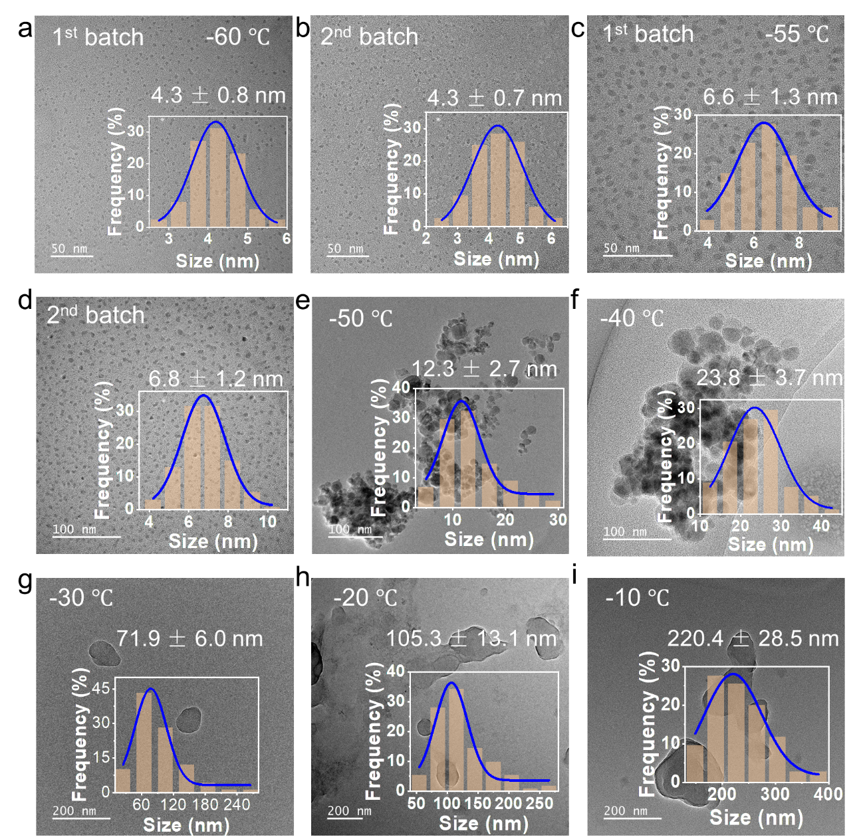
Figure S2. TEM images and size distribution of different-sized Y6 NC assembled under specific temperatures. (a-b) Two batches of ultrasmall Y6 NCs assembled under -60 ^{ο}C. (c-d) Two batches of ultrasmall Y6 NCs assembled under -55 ^{ο}C. (e) 12.3 nm Y6 NCs assembled under -50 ^{ο}C. (f) 23.8 nm Y6 NCs assembled under -40 ^{ο}C. (g) 71.9 nm Y6 NCs assembled under -30 ^{ο}C. (h) 105.3 nm Y6 NCs assembled under -20 ^{ο}C. (i) 220.4 nm Y6 NCs assembled under -10 ^{ο}C. Insets are size distribution fitted by Gaussian model, each size distribution plot is obtained by analyzing the lateral dimensions of more than 100 NCs imaged by TEM.

Figure S3. High resolution TEM images of nanocrystals. These nanocrystals have well-defined lattice fringes. Scale bars: 5 nm.

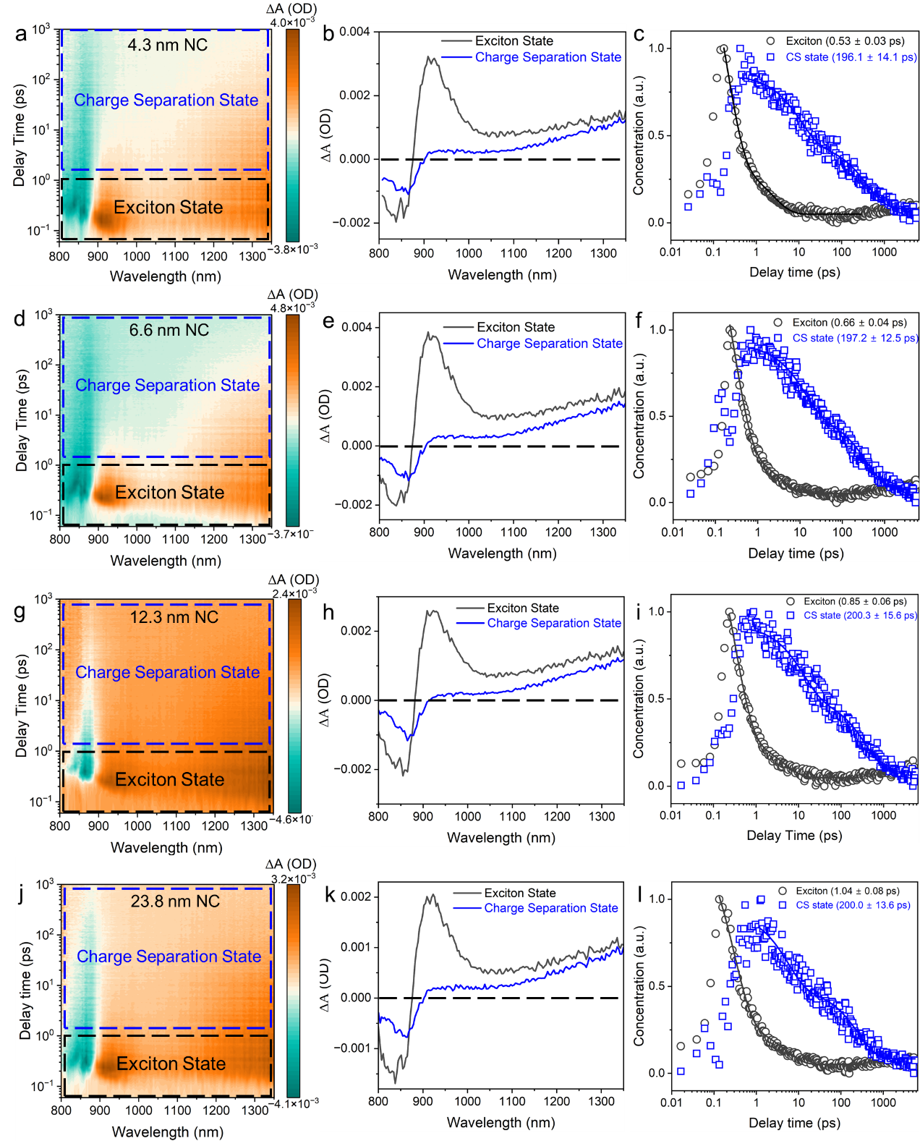
Figure S4. Global fitting of fs-TA spectroscopy. (a) fs-TA of 4.3 nm NC dispersion. (b) Evolution-associated difference spectra of 4.3 nm Y6 NC. (c) Kinetics of exciton and charge separation state in 4.3 nm Y6 NC. (d) fs-TA of 6.6 nm NC dispersion. (e) Evolution-associated difference spectra of 6.6 nm Y6 NC. (f) Kinetics of exciton and charge separation state in 6.6 nm Y6 NC. (g) fs-TA of 12.3 nm NC dispersion. (h) Evolution-associated difference spectra of 12.3 nm Y6 NC. (i) Kinetics of exciton and charge separation state in 12.3 nm Y6 NC. (j) fs-TA of 23.8 nm NC dispersion. (h) Evolution-associated difference spectra of 23.8 nm Y6 NC. (i) Kinetics of exciton and charge separation state in 23.8 nm Y6 NC.

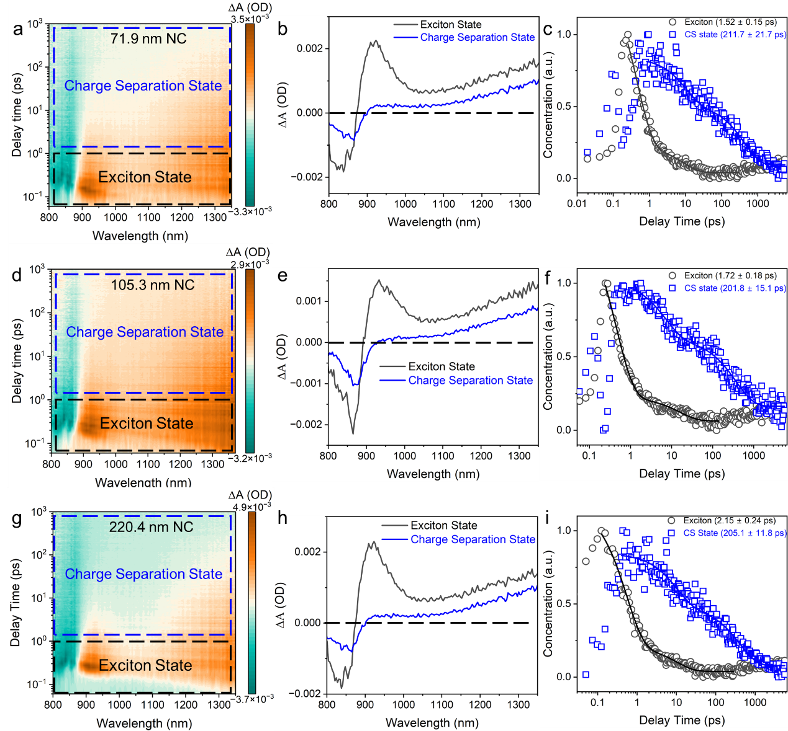
Figure S5. Global fitting of fs-TA spectroscopy. (a) fs-TA of 71.9 nm NC dispersion. (b) Evolution-associated difference spectra of 71.9 nm Y6 NC. (c) Kinetics of exciton and charge separation state in 71.9 nm Y6 NC. (d) fs-TA of 105.3 nm NC dispersion. (e) Evolution-associated difference spectra of 105.3 nm Y6 NC. (f) Kinetics of exciton and charge separation state in 105.3 nm Y6 NC. (g) fs-TA of 220.4 nm NC dispersion. (h) Evolution-associated difference spectra of 220.4 nm Y6 NC. (i) Kinetics of exciton and charge separation state in 220.4 nm Y6 NC.

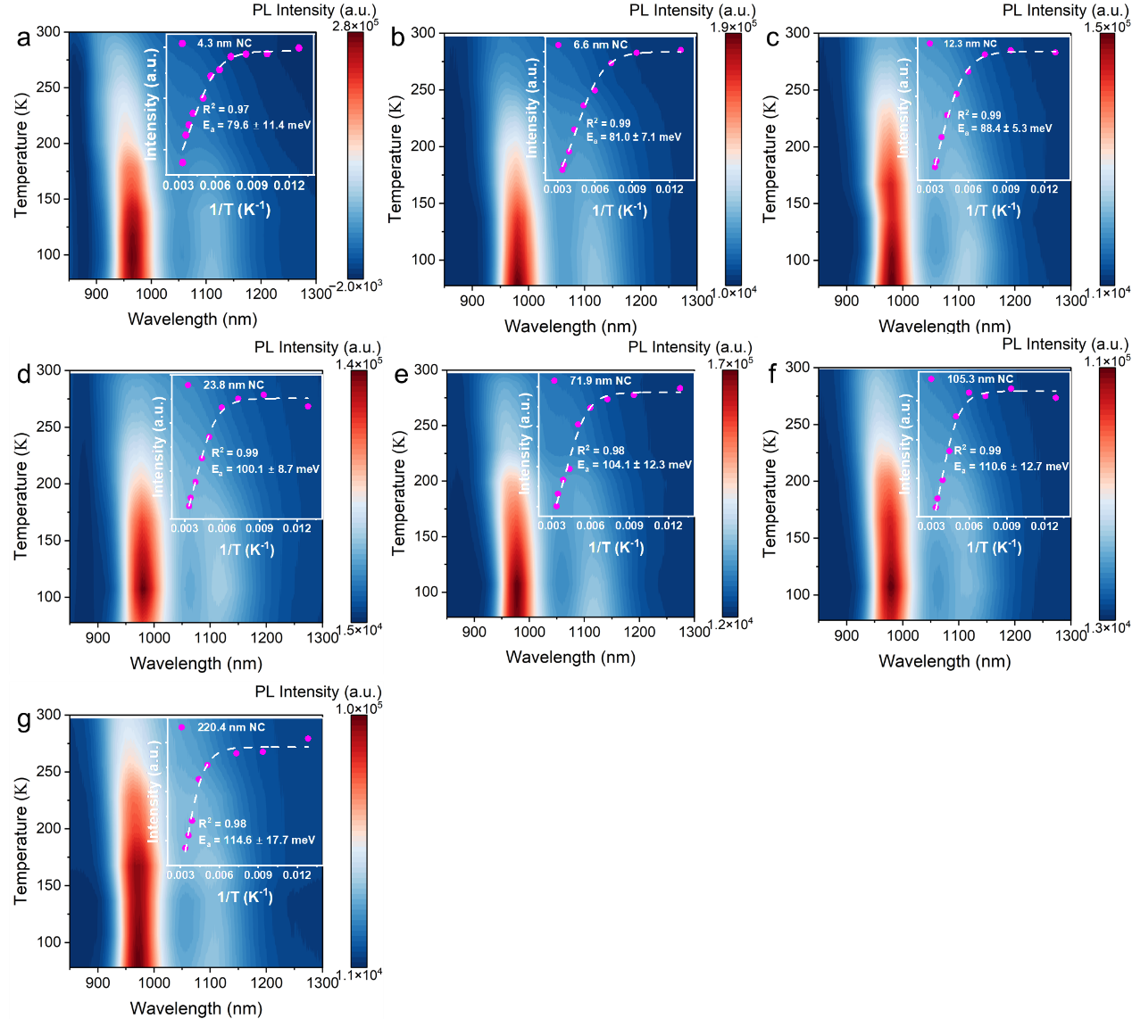
Figure S6. Temperature-dependent PL spectroscopy and corresponding fitting of exciton dissociation activation energy (E_{a}) of Y6 NCs. (a) 4.3 nm (E_{a} = 79.6 ± 11.4 meV). (b) 6.6 nm (E_{a} = 81.0 ± 7.1 meV). (c) 12.3 nm (E_{a} = 88.4 ± 5.3 meV). (d) 23.8 nm (E_{a} = 100.1 ± 8.7 meV). (e) 71.9 nm (E_{a} = 104.1 ± 12.3 meV). (f) 105.3 nm (E_{a} = 110.6 ± 12.7 meV). (g) 220.4 nm (E_{a} = 114.6 ± 17.7 meV). Insets are fitting results of E_{a}. The error values are from fitting error.
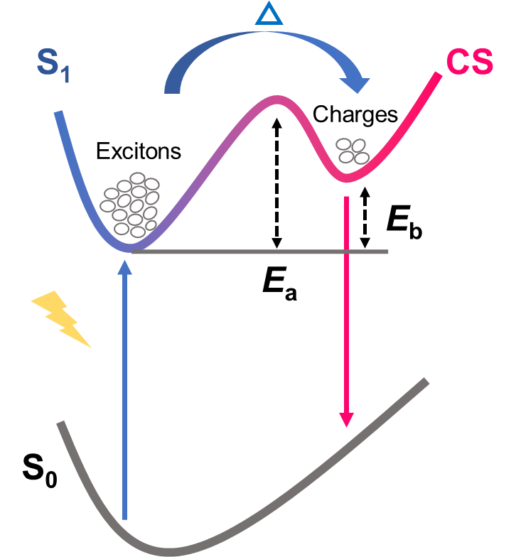
Figure S7. Illustration of mutual transitions between the charge separation state (CS) and the lowest singlet excited state (S₁) in common materials in which the value of exciton binding energy (E_{b}) is positive and E_{a} is the activation energy from S₁ to CS. When the temperature is risen to higher values, the E_{a} can be gradually overcome and more excitons can be dissociated into free charges, resulting in the decrease of photoluminescence.

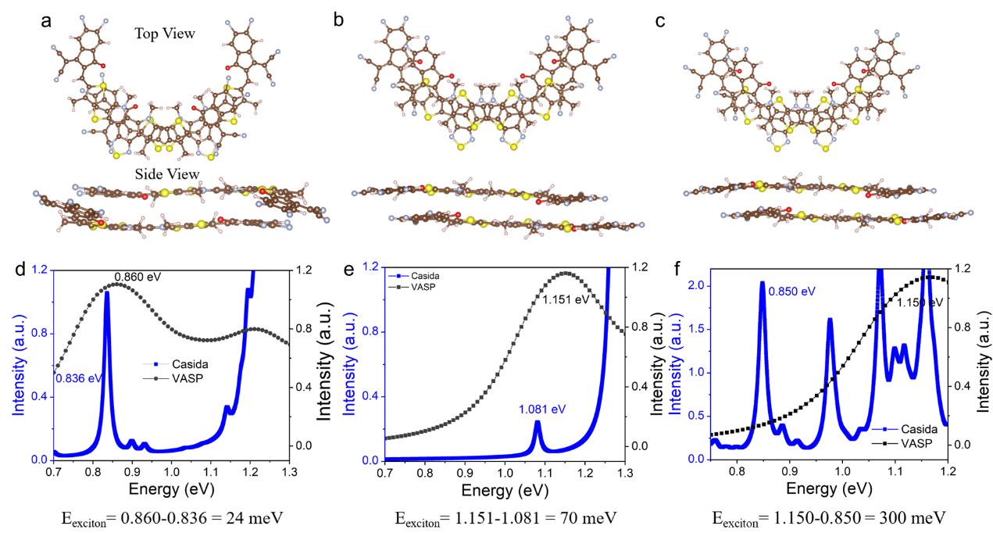
Figure S8. Simulation of exciton dissociation activation energy (E_{a}). (a-c) Three π-π interaction configurations of Y6 dimers represent small (a) moderate (b) and big (c) Y6 nanocrystals. (d-f) E_{a} calculated by VASP and Casida model.

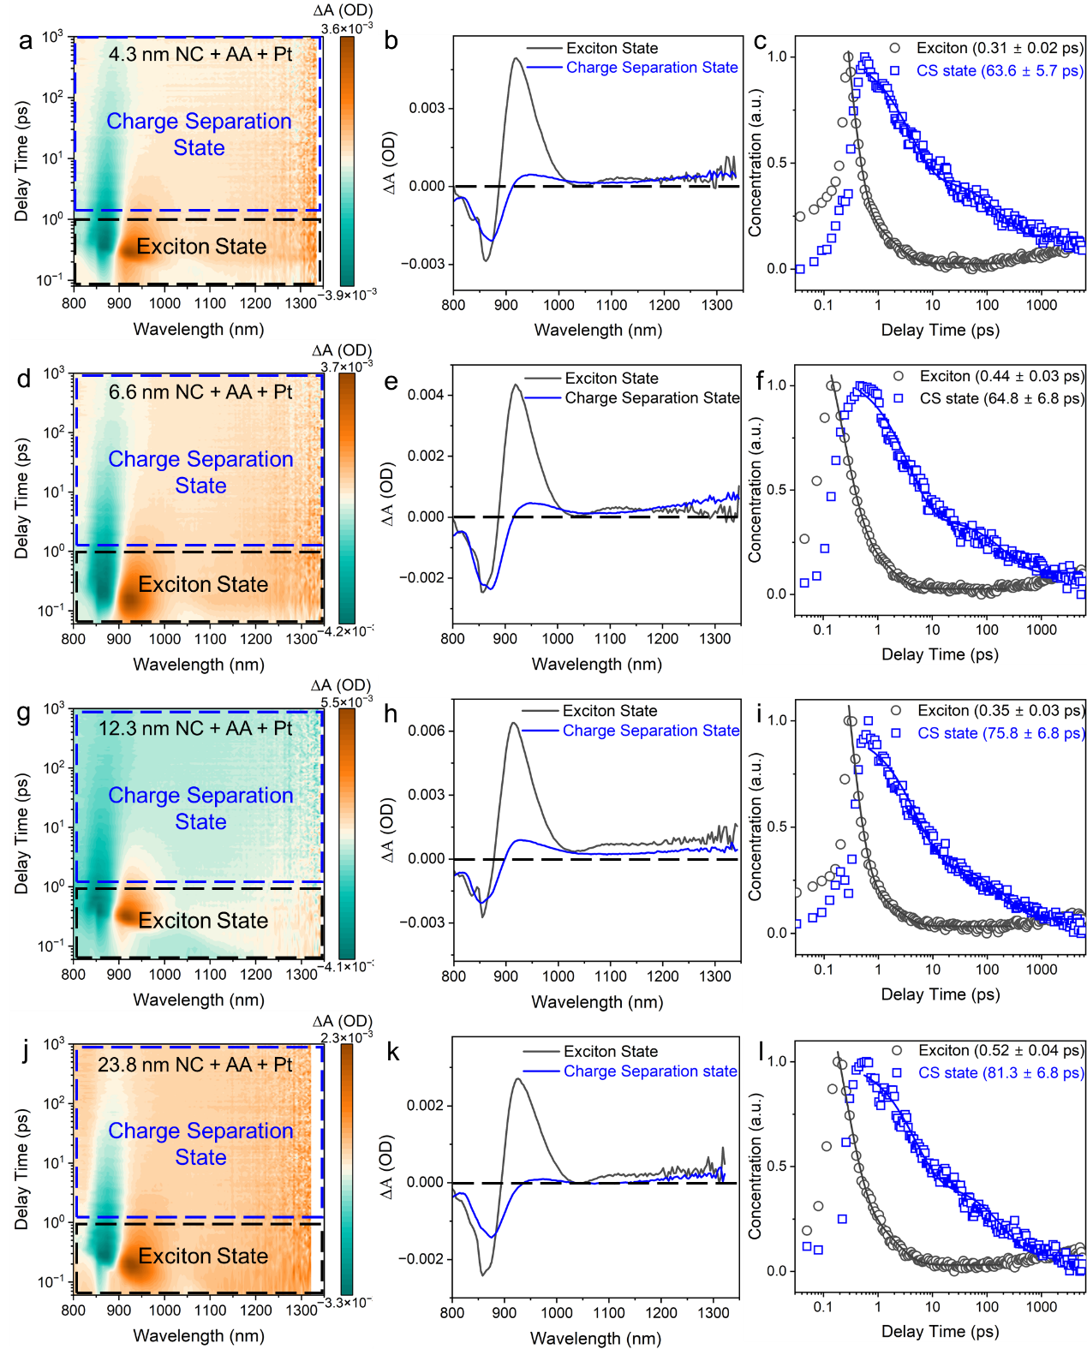
Figure S9. Global fitting of fs-TA spectroscopy of Y6 NC under photocatalytic HER conditions (NC + AA + Pt). (a) fs-TA of 4.3 nm NC + AA + Pt. (b) Evolution-associated difference spectra of (a). (c) Kinetics of exciton and charge separation state in 4.3 nm NC under reaction conditions. (d) fs-TA of 6.6 nm NC + AA + Pt. (e) Evolution-associated difference spectra of (d). (f) Kinetics of exciton and charge separation state in 6.6 nm NC under reaction conditions. (g) fs-TA of 12.3 nm NC + AA + Pt. (h) Evolution-associated difference spectra of (g). (i) Kinetics of exciton and charge separation state in 12.3 nm NC under reaction conditions. (j) fs-TA of 23.8 nm NC + AA + Pt. (k) Evolution-associated difference spectra of (j). (l) Kinetics of exciton and charge separation state in 23.8 nm NC under reaction conditions.
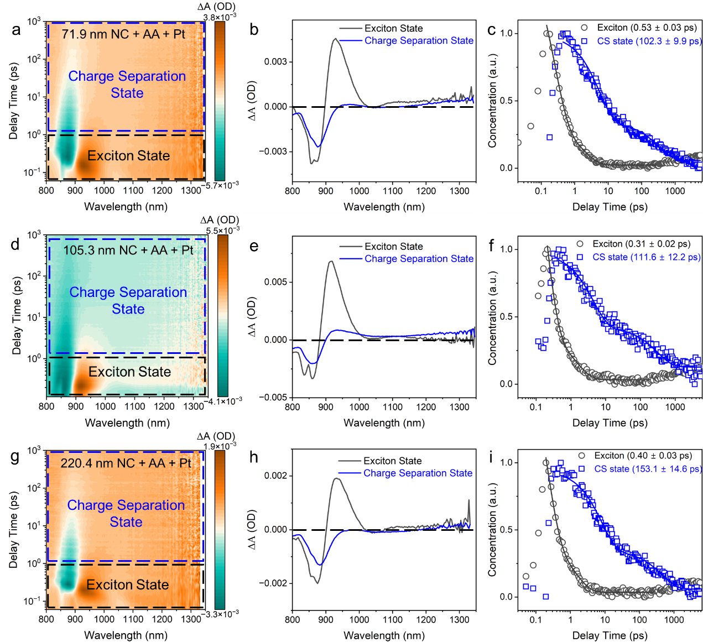
Figure S10. Global fitting of fs-TA spectroscopy of Y6 NC under photocatalytic HER conditions (NC + AA + Pt). (a) fs-TA of 71.9 nm NC + AA + Pt. (b) Evolution-associated difference spectra of (a). (c) Kinetics of exciton and charge separation state in 71.9 nm NC under reaction conditions. (d) fs-TA of 105.3 nm NC + AA + Pt. (e) Evolution-associated difference spectra of (d). (f) Kinetics of exciton and charge separation state in 105.3 nm NC under reaction conditions. (g) fs-TA of 220.4 nm NC + AA + Pt. (h) Evolution-associated difference spectra of (g). (i) Kinetics of exciton and charge separation state in 220.4 nm NC under reaction conditions.

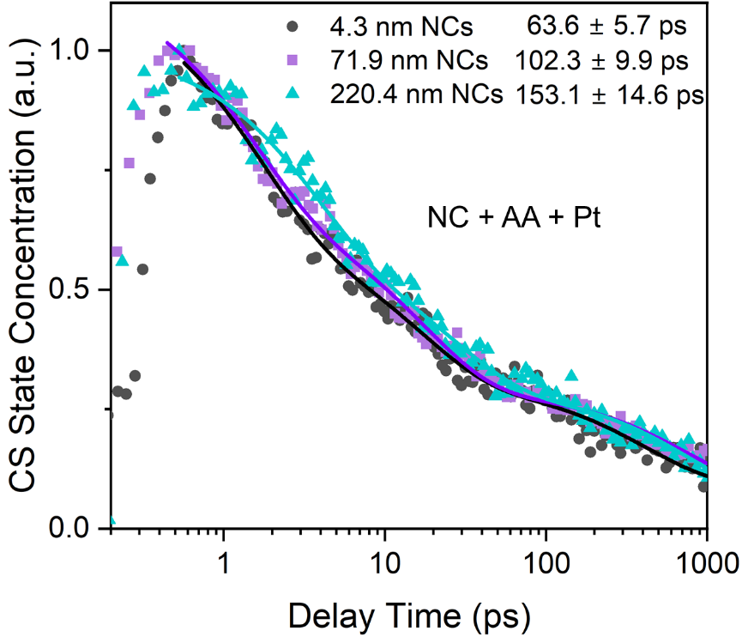
Figure S11. Charge separation state lifetime of 4.3 nm, 71.9 nm and 220.4 nm NCs in HER reaction condition (NC + AA + Pt).
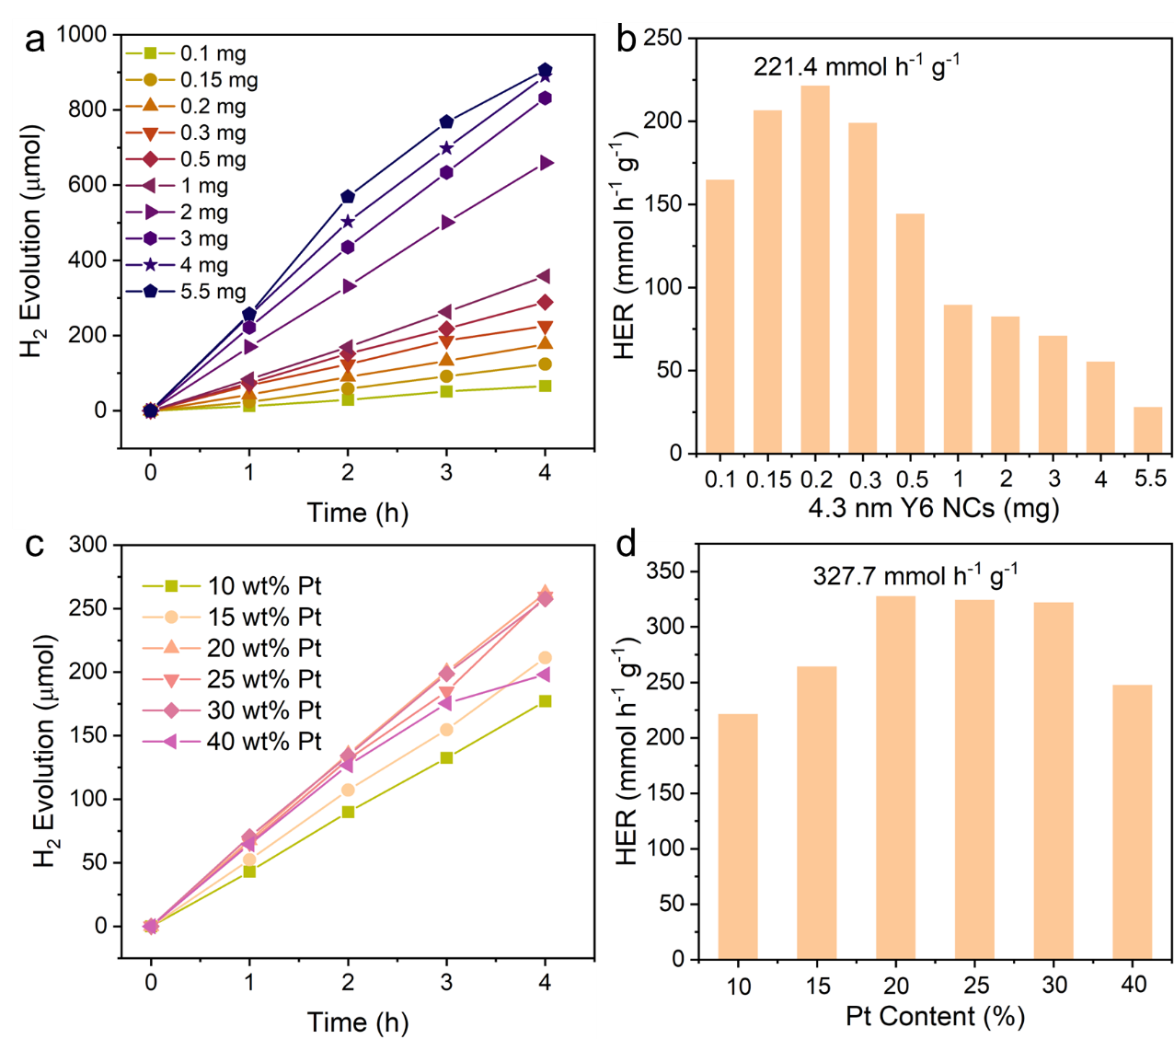
Figure S12. (a) H₂ Evolution in 4 h varied with NC (4.3 nm) mass from 0.1 mg to 5.5 mg. (b) Mass-normalized HER rate of different NCs mass. 10 wt% Pt is in-situ photo-deposited as catalyst. 0.8 wt% H₂PtCl₆ is used as Pt source. 0.2 M ascorbic acid is sacrificial agent. (c) H₂ Evolution in 4 h varied with photo-deposited Pt NPs from 10 wt% to 40 wt%. (d) Mass-normalized HER rate of different Pt content. NCs mass is 0.2 mg. Conditions: dispersion volume is 40 mL; illumination area is 38.5 cm². Light source is Xenon lamp installed with AM 1.5G filter, optical power density is set to 100 mW cm⁻². 0.2 M ascorbic acid is sacrificial agent.

Table S1. Kinetics of exciton dissociation time constant and charge separation state lifetime of Y6 NCs
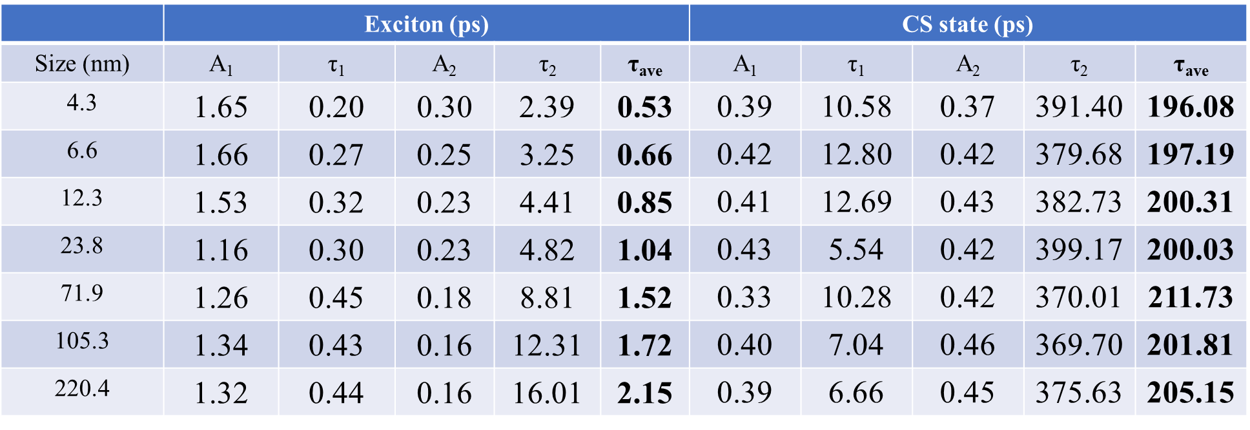

Supplementary Note 1. Comparison of exciton dissociation rate calculated from E_{a} and tested from fs-TA spectroscopy.
The exciton dissociation rate (k) follows the k ∝ exp(-E_{a}/k_{B}T), where E_{a} is exciton dissociation activation energy, k_{B} is Boltzmann constant, T is temperature. The rate k of 4.3 nm NCs is termed as k_{4.3} and set as benchmark 1. Then the rate ratio between larger NCs (k_{L}) and 4.3 nm can be calculated as follows: k_{L}/k_{4.3} = exp((E_{a}(4.3 nm)-E_{a}(Large))/k_{B}T). The T is 298K, which is the room temperature.
The exciton dissociation rate tested from fs-TA (k_{TA}) is also normalized by setting the rate value of 4.3 nm as 1.
The relative exciton dissociation rates of Y6 NCs predicted from E_{a} and tested from fs-TA experiment are listed in the following table:
Table S2. The relative exciton dissociation rate of Y6 NCs.
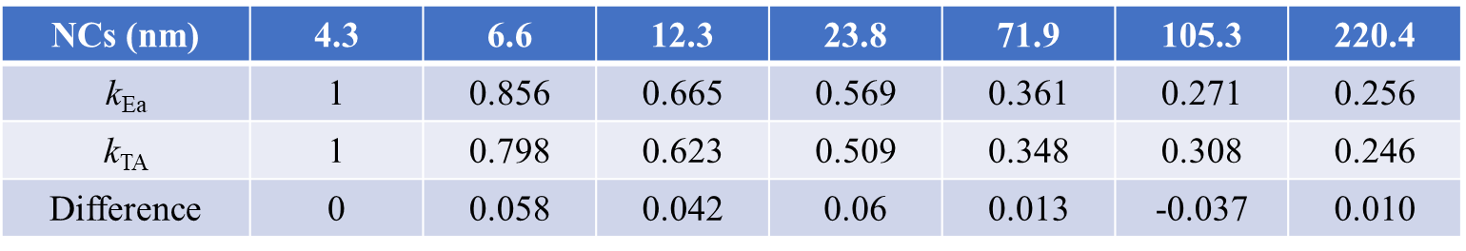

Supplementary Note 2. Theoretical calculation of E_{a} in different packing structures of Y6 dimers.
By default, the dielectric function and thus the absorption spectrum were calculated using regular density functional theory (DFT) scheme, it does not include electron–hole interactions, that is, excitonic effects are neglected. Although excitonic effects can be incorporated through the Bethe–Salpeter equation (BSE) module, which requires additional calculations and is computationally expensive. To incorporate the excitonic effect, we use the Casida method. The Casida approach is explicitly based on the Casida formulation of time-dependent density functional theory (TDDFT) and is specifically designed for computing excited states of molecules or finite systems. In the Casida formalism of TDDFT, electronic excitations are expressed as linear combinations of single-particle excitations, and excitation energies along with oscillator strengths are obtained by solving an eigenvalue problem (the Casida equation). This method inherently includes electron–hole interactions through the exchange–correlation kernel and is better suited for molecules, clusters, and low-dimensional systems. Based on the above discussion, we can obtain the exciton dissociation activation energy E_{a} = E_{c} – E_{v}, where E_{c} and E_{v} denote the energy corresponding to the first main absorption peak in the two absorption spectra calculated with the Casida approach and regular DFT, respectively.
Ground-state DFT simulations is performed via the xTB¹ package and Vienna Ab initio Simulation Package (VASP).^{1,2} Here, the GFN2-xTB level with BFGS algorithm is used for the structure optimization. The ground state optical property is calculated with the projector-augmented wave (PAW) pseudopotential in conjunction with the Perdew–Burke–Ernzerhof (PBE) functional and plane-wave basis set with energy cutoff at 400 eV and a 1×1×1 Monkhorst Pack k-point mesh. The atomic structure of systems is positioned in a cubic supercell of 37×37×37 Å³ with vacuum regions larger than 15.0 Å along three directions and fully relaxed until the convergence of energy and force on each atom are less than 10⁻⁴ eV and 0.02 eV/Å, respectively.
The optical absorption spectra are performed with the linear-response Casida method via the real-time TDDFT code OCTOPUS.³⁻⁵ The simulation zone is defined by assigning a sphere around each atom with a radius of 6.0 Å. The spacing between grid points is 0.3 Å. A time step of 0.002 fs is used in the calculations. An additional >200 unoccupied states are included to get a converged absorption spectrum. The selected simulation parameters can make a good balance between the calculation precision and cost.

Considering that the Y6 thin film (crystalline or amorphous) consists of various dimers, which influences the formation of the crystalline structure and the transport properties.⁶ In addition, the π-π interaction can be modulated via the alignment extent of five-membered ring or six-membered ring, the distance between the up and down Y6 molecules, the species of side chains and additives, and so on. Hence, we construct three different packing Y6 dimers to represent different sized Y6 nanocrystals, that is, small, moderate, and big. Here, we choose the typical T-T configurations as an example without the side chains and additives.⁷ Further, the exciton dissociation activation energy of the three configurations is calculated via the density functional theory and time-dependent density functional theory, 24, 70, and 300 meV, corresponding the small, moderate, and big nanocrystals, respectively. The E_{a} increases with the weakness of the π-π interaction, that is, the increase of the size for the Y6 nanocrystals, which has a moderate agreement with our experiment above in trend and magnitude. Notedly, the deviation for E_{a} between the theory and the experiment may stem from that the alkyl side chains are neglected in our model, while the alkyl side chains are nonpolar and can locally lower the dielectric constant, reducing dielectric screening, and ultimately making exciton dissociation more difficult.

Table S3. Kinetic fitting results of exciton lifetime and CS state of Y6 NCs under HER reaction
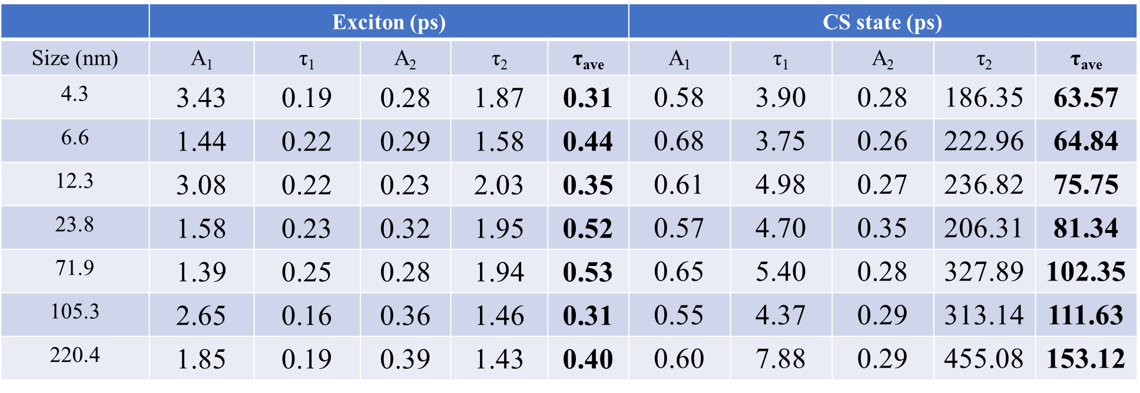

Table S4. Electron transfer rate (k_{ET}) and efficiency (Ф_{ET}) of different Y6 NCs
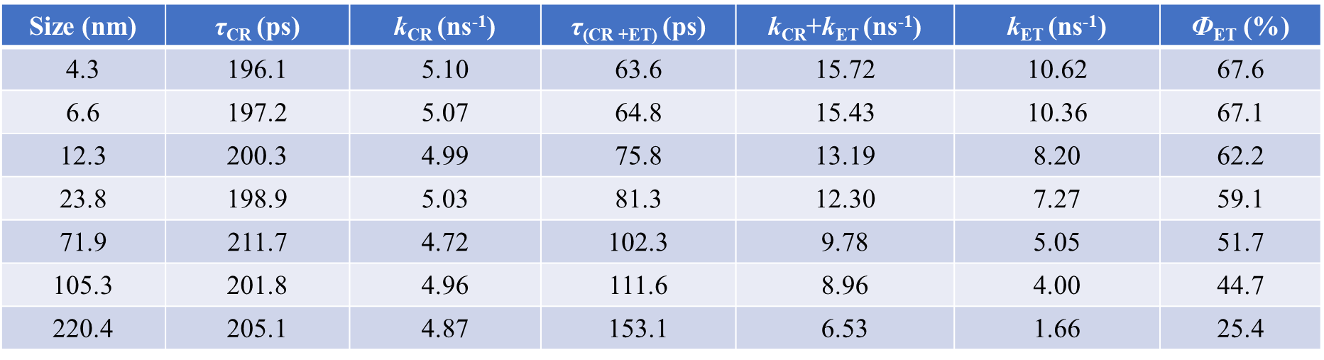
Supplementary Note 3. The correlation between electron transfer rate (k_{ET}) and nanocrystal diameter (d) based on Marcus theory.
In this study, electron transfer is between Y6 nanocrystal (Donor, D) and Pt nanoparticle (Acceptor, A). The Marcus theory for electron transfer between donor and acceptor is:
$$k_{ET}=\frac{2π}{ℏ}{|V_{DA}|}^{2}\frac{1}{\sqrt{4πλk_{B}T}}exp⁡[-\frac{{\left({ΔG}^{0}+λ\right)}^{2}}{4λk_{B}T}]$$
V_{DA} is electronic coupling between donor (D) and acceptor (A), which depicts the overlap of electron wave function. ΔG⁰ is free energy of reaction. λ is total reorganization energy of molecule and solvent. k_{B} is Boltzmann constant. T is temperature. $ℏ$ is reduced Plank constant.
The absence of quantum confinement effect in organic semiconductors results in an invariant LUMO energy level across varying nanocrystal sizes. Consequently, the energy offset (ΔG⁰) between the LUMO of organic nanocrystals and the Fermi level of Pt remains constant upon size reduction. The reorganization energy (λ), being primarily dependent on the molecular structure and local dielectric environment, exhibits negligible correlation with nanocrystal size.
The influence of d on k_{ET} is realized by the electronic coupling |V_{DA}| between nanocrystal and Pt. As the increase of distance (R) between D and A, the |V_{DA}| declines following as:
|V_{DA}| ∝ e^{-βR}
β is a decay constant governed by the height of the potential barrier through the intervening medium (e.g., a ligand, solvent, or void).
Therefore,
k_{ET} ∝ |V_{DA}|² ∝ e^{-2βR}
In a spherical nanocrystal of diameter d, an electron generated within the bulk must migrate to Pt surface, covering an average transport distance proportional to the nanocrystal’s radius r. Thus, the effective tunneling distance R from the charge generation site to the Pt surface is given by:
R ≈ γd/2
Here, γ is a geometric factor of approximately unity, which quantifies the relationship between the mean transport path length and the radius.
Therefore,
k_{ET} ∝ e^{-2βR} ∝ e^{-βγd} = e^{-αd}
α = βγ represents a new effective decay constant.

In conclusion, under the Marcus theory framework, if electron transfer from the nanocrystal to Pt is governed by tunneling/coupling through the nanocrystal bulk, the charge transfer rate will exhibit an exponential decay as the nanocrystal size d increases.
References
1 Kresse, G. & Furthmuller, J. Efficient iterative schemes for ab initio total-energy calculations using a plane-wave basis set. Phys. Rev. B. 54, 11169-11186 (1996).
2 Perdew, J. P., Burke, K. & Ernzerhof, M. Generalized gradient approximation made simple. Phys. Rev. Lett. 77, 3865-3868 (1996).
3 Castro, A. et al. octopus:a tool for the application of time‐dependent density functional theory. Phys. Status Solidi B 243, 2465-2488 (2006).
4 Andrade, X. et al. Time-dependent density-functional theory in massively parallel computer architectures: the octopus project. J. Phys. Condens. Mat. 24, doi:10.1088/0953-8984/24/23/233202 (2012).
5 Andrade, X. et al. Real-space grids and the Octopus code as tools for the development of new simulation approaches for electronic systems. Phys. Chem. Chem. Phys. 17, 31371-31396 (2015).
6 Zhang, G. et al. Delocalization of exciton and electron wavefunction in non-fullerene acceptor molecules enables efficient organic solar cells. Nat. Commun. 11, 3943 (2020).
7 Xia, X. et al. Revealing the crystalline packing structure of Y6 in the active layer of organic solar cells: the critical role of solvent additives. J. Mater. Chem. A 11, 21895-21907 (2023).

