Supplement materials:

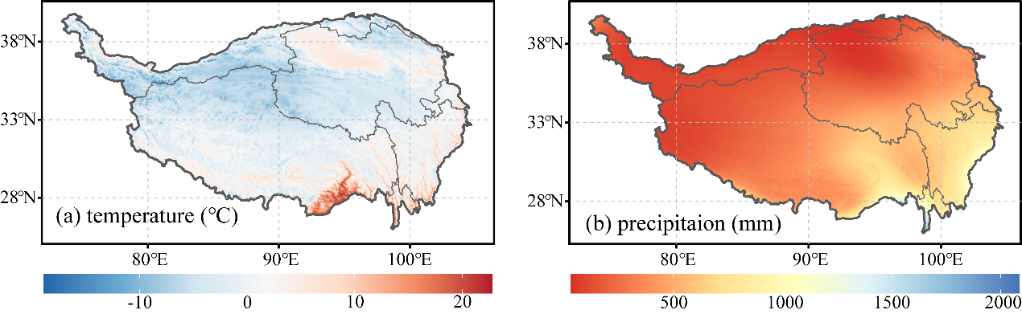
Figure S1. Spatial patterns of the multi-year means of the (a) precipitation and (b) temperature on the Tibetan Plateau during 1982–2015.

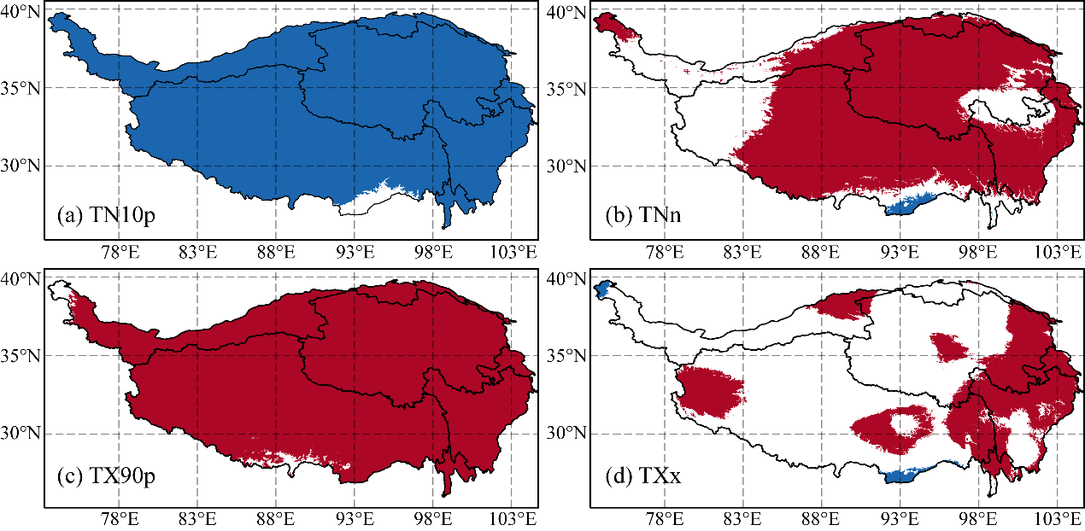
Fig. S2. The significant linear trends (p < 0.05) of the extreme temperature indices at the grid scale during 1980–2015. The red and blue grids denote increasing and decreasing trends, respectively. (a) TN10p (unit: day), (b) TNn (unit: ℃), (c) TX90p (unit: day), and (d) TXx (unit: ℃).

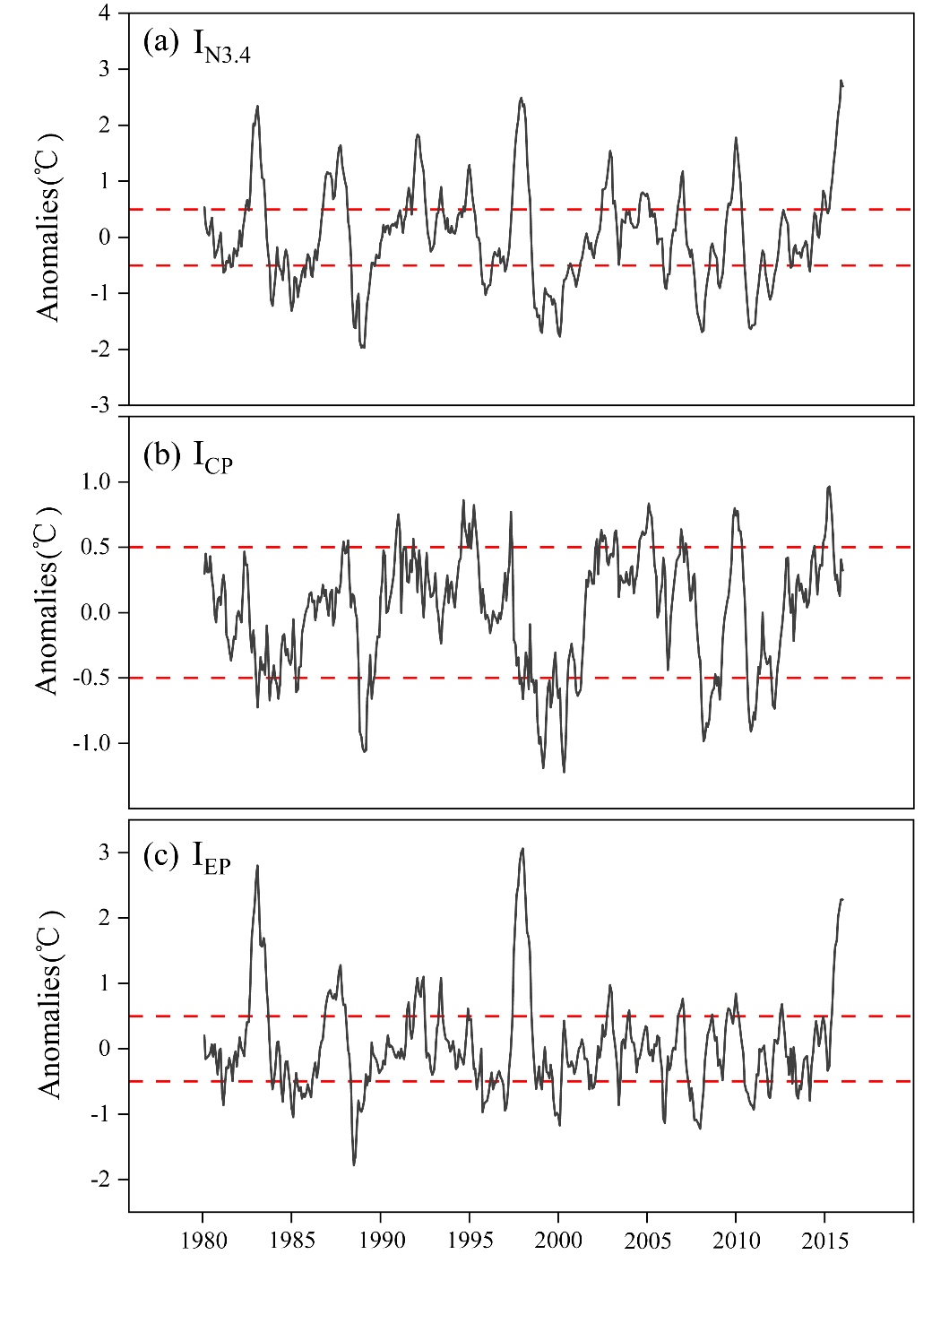
Fig. S3. Time series of the monthly ENSO index from 1980 to 2015 (unit: ℃). (a) I_{n3.4}, (b) I_{EP}, and (c) I_{CP}.

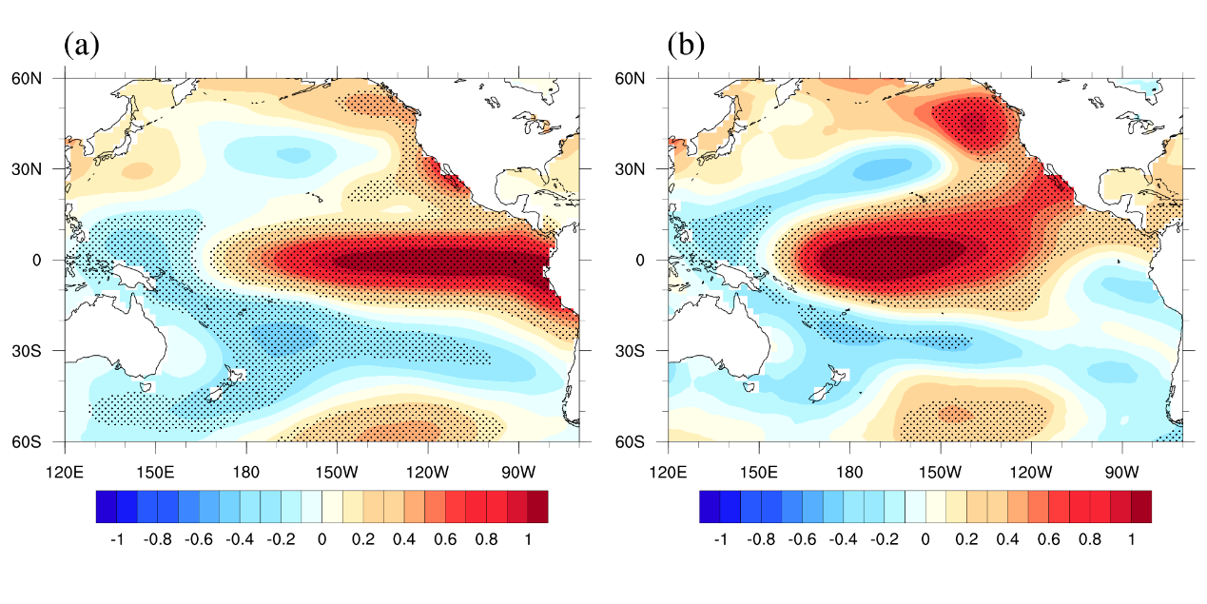
Figure S4. Typical (a) EP and (b) CP ENSO SST modes (unit: °C °C⁻¹).

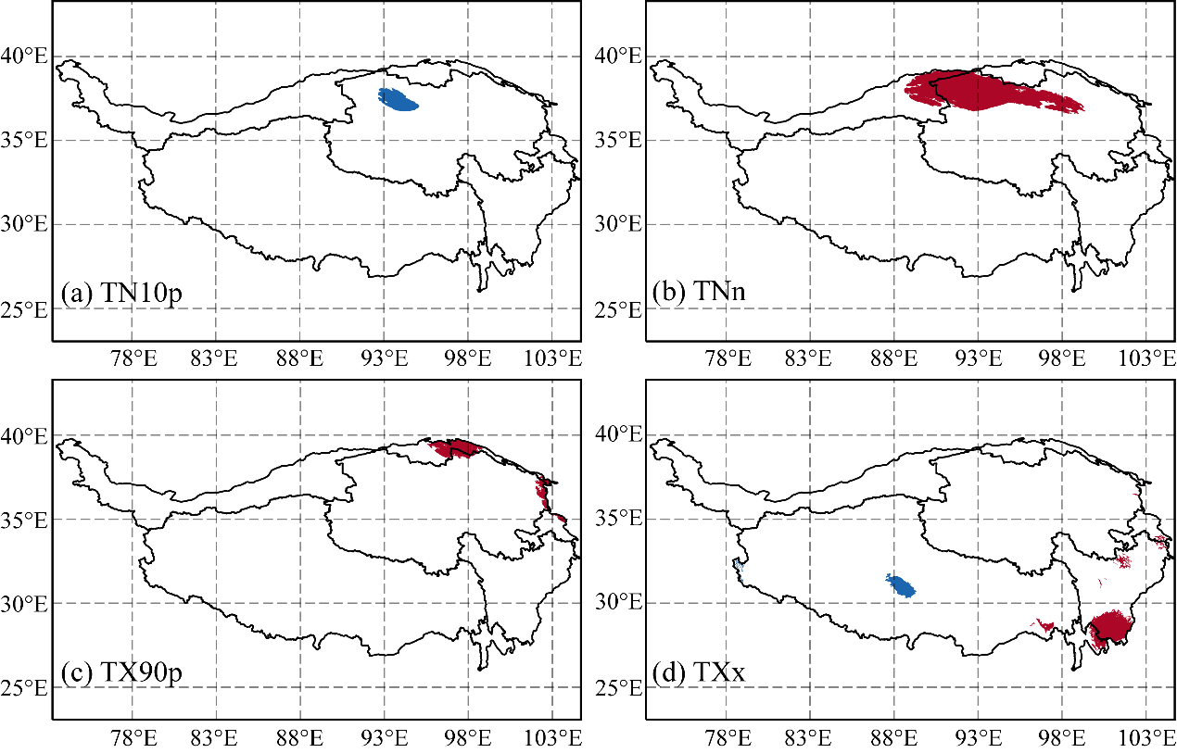
Fig. S5. The significant differences in the extreme temperature indices at the grid scale during EP E1 Niño years. The red and blue grids denote significant increasing and decreasing tends, respectively. (a) TN10p (unit: day), (b) TNn (unit: ℃), (c) TX90p (unit: day), and (d) TXx (unit: ℃).

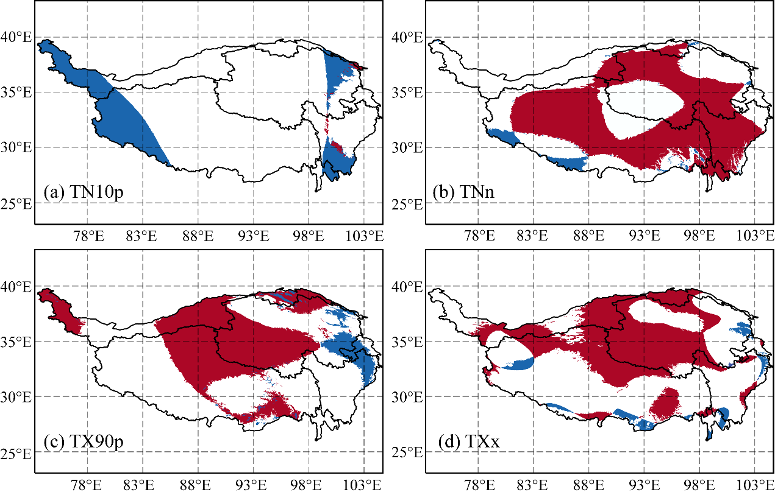
Fig. S6. The significant differences in the extreme temperature indices at the grid scale during CP E1 Niño years. The red and blue grids denote significant increasing and decreasing tends, respectively. (a) TN10p (unit: day), (b) TNn (unit: ℃), (c) TX90p (unit: day), and (d) TXx (unit: ℃).

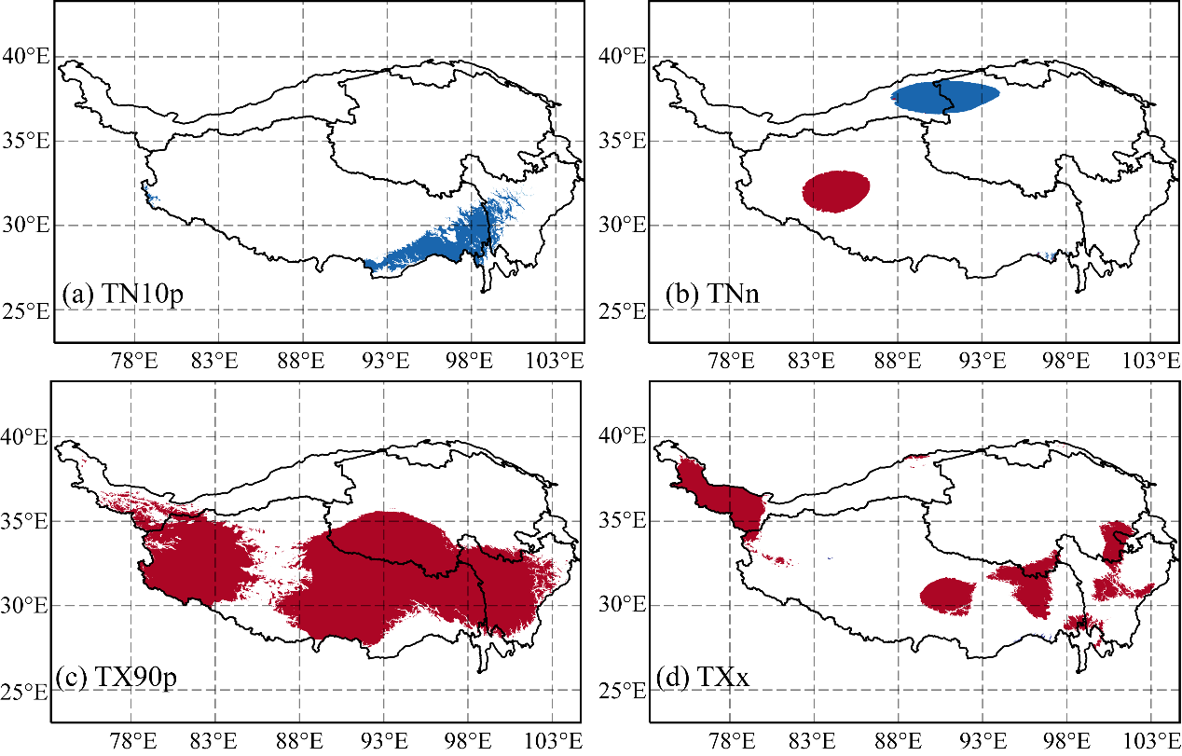
Fig. S7. The significant differences in the extreme temperature indices at the grid scale during EP La Niña years. The red and blue grids denote significant increasing and decreasing tends, respectively. (a) TN10p (unit: day), (b) TNn (unit: ℃), (c) TX90p (unit: day), and (d) TXx (unit: ℃).

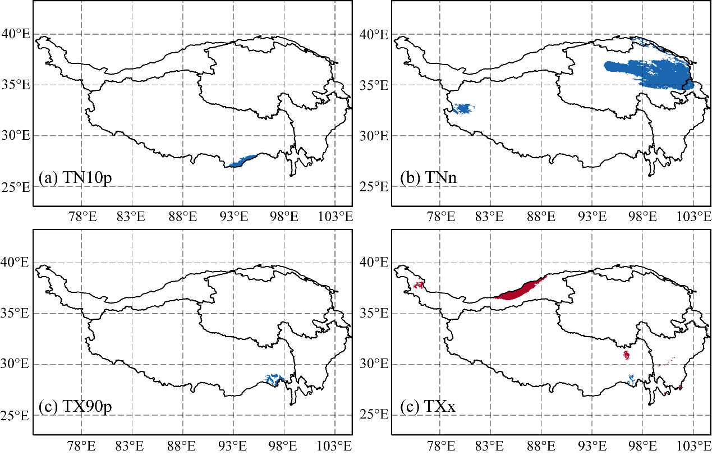
Fig. S8. The significant differences in the extreme temperature indices at the grid scale during CP La Niña years. The red and blue grids denote significant increasing and decreasing tends, respectively. (a) TN10p (unit: day), (b) TNn (unit: ℃), (c) TX90p (unit: day), and (d) TXx (unit: ℃).

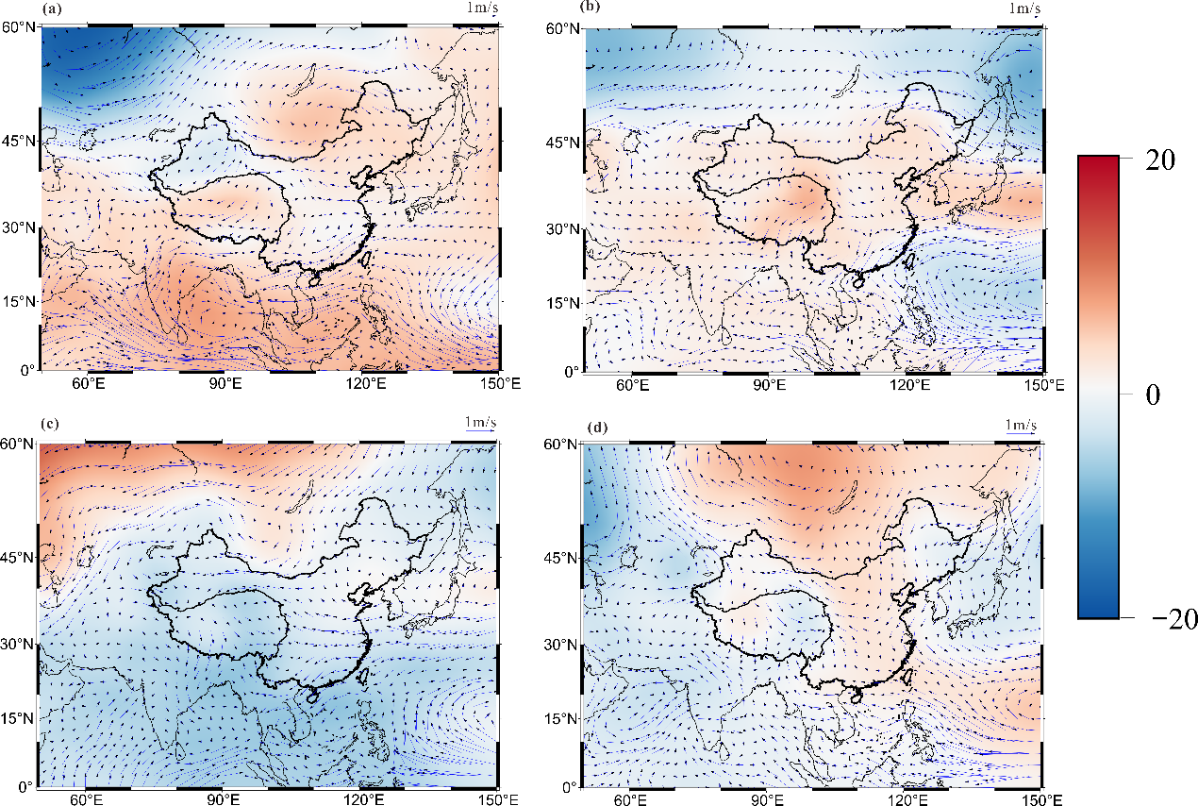
Figure S9. Changes in the average wind speed (arrows) and geopotential height (shading, unit: gpdam) at 850 hPa during the different types of ENSO events. (a) The average wind speed and geopotential height during the EP El Niño years minus those during the base period (1980–2010); (b) The average wind speed and geopotential height during the CP El Niño years minus those during the base period (1980–2010); (c) The average wind speed and geopotential height during the EP La Niña years minus those during the base period (1980–2010); (d) The average wind speed and geopotential height during the CP La Niña years minus those during the base period (1980–2010). The lengths of the arrows indicate the changes in the wind speed.

Table S1. Detailed descriptions of the temperature extreme indices
Indices | Definitions | units
TN10p | Percentage of days when the daily minimum temperature below 10th percentile | day
TX90p | Percentage of days when the daily maximum temperature above 90th percentile | day
TNn | The minimum value of the daily minimum temperature | °C
TXx | The maximum value of the daily maximum temperature | °C

